Academic Skills Reflective Report Assignment 2 2018


MARCH 2018

MODULE NAME: Academic skills(m4x01434)
Project Name: Bright art at ysgol crug glas
Name: Elliot tudor
Student Number: 1702104

Table of contents
- Introduction
  - Executive summary
  - Introduction
  - Report remit
  - Background of the project
2. Models of reflection
3.Main body
3A. Masterclass sessions
3B. Influence of sessions
4. Conclusion
5. References

List of figures
  - Lewin’s experimental learning model
  - Kolb’s ELT
  - Gibbs multi stage model

2.1 Auckland survey-1
2.2 Auckland survey-2
2.3 4x4 square

Appendices

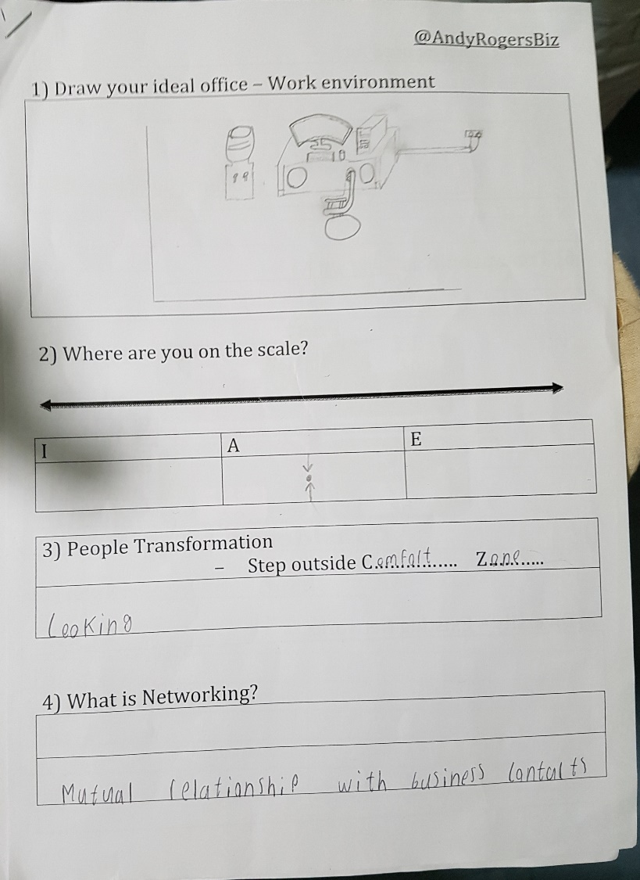
Appendix A-Work given by andy rogers

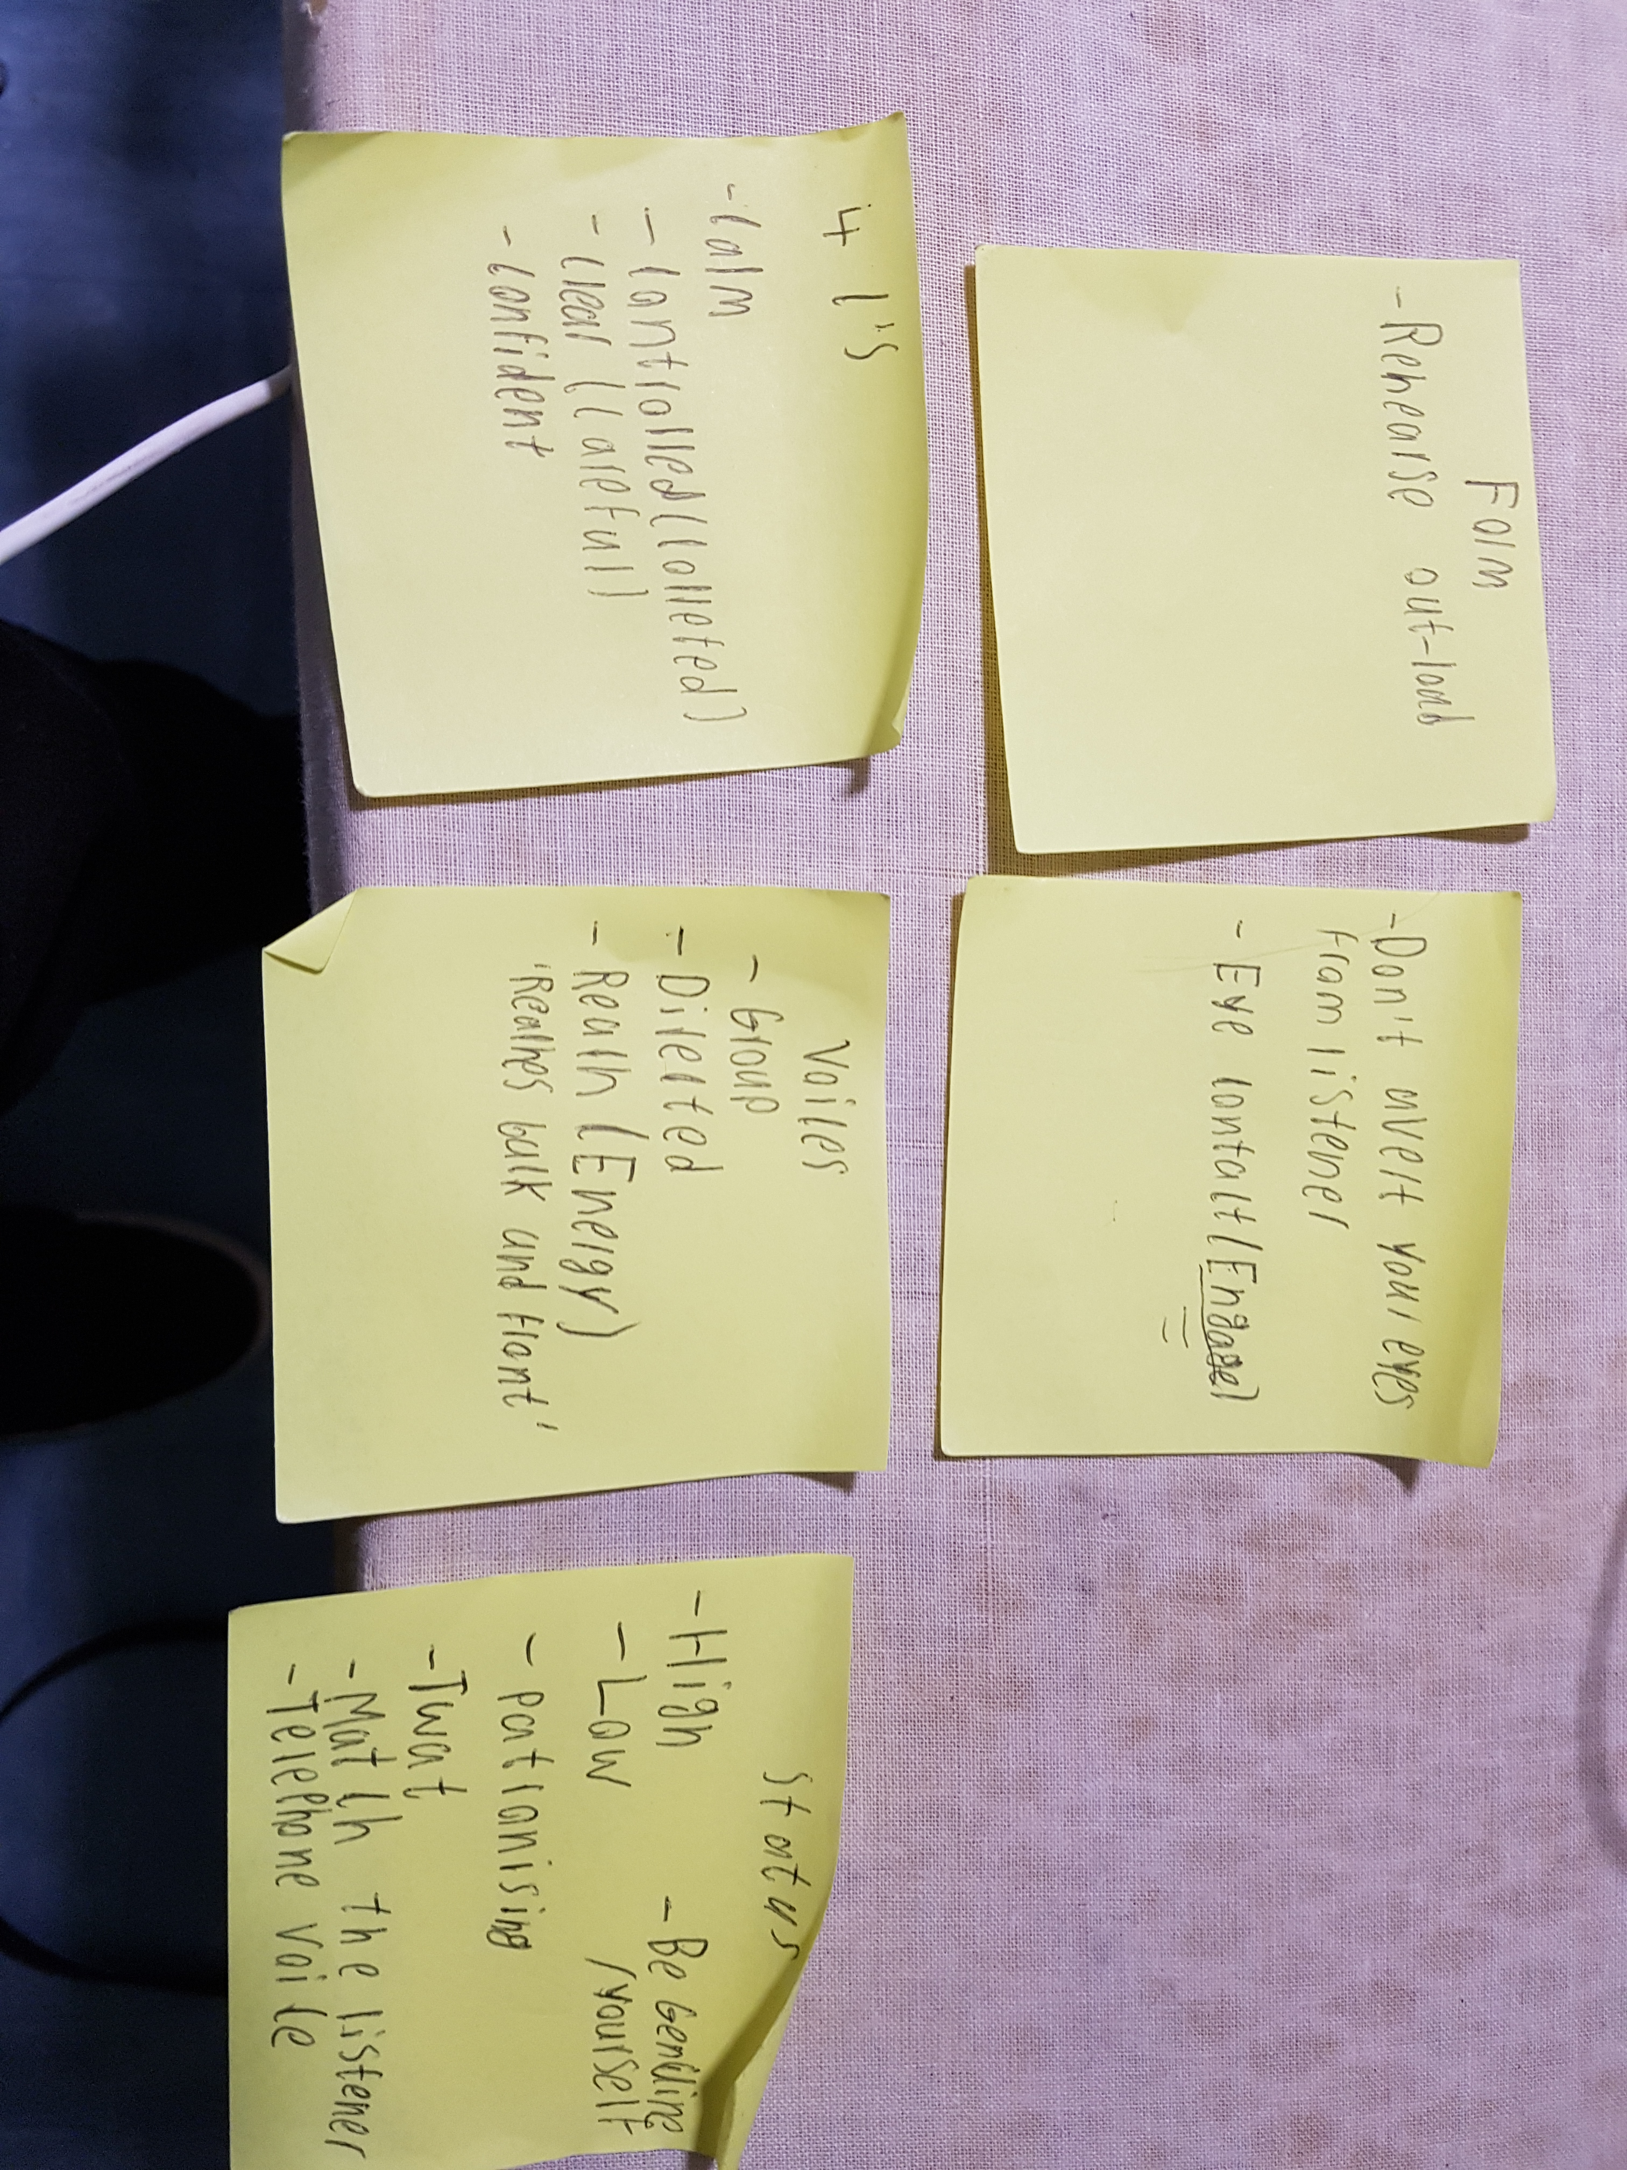

Appendix B-Notes taken on mr producer

1.1 Executive summary
The purpose of this report is to give the reader a thorough discussion of the topics discussed and how they impacted the project. The name of the project in question is Bright art at Ysgol Crug Glas and its purpose was to help fundraise money for a special school in Swansea to buy and install a UV light to help the students focus. In the report to reflect on the project I used two models of reflection which are Kolb’s ELT and Gibbs multi stage model where I talk in depth about how the project went and how it could have been improved. Next section I spent talking about the masterclasses themselves where I discussed themes I extracted from them as well as literature to support these themes, also in these sections I outlined what I witnessed in these classes along with how useful each theme is when applied to the business world. In the following section I then proceeded to speak of how these masterclasses influenced my project such as how it helped overcome challenges and form ideas. Following this I progressed to convey how these themes and others helped fortify my learning and development and others that impeded it and spoke about how this could be corrected in future. Then lastly there is a short conclusion summing up the document with references at the end.

1.1. Introduction
This report will cover the masterclasses that took place during the first semester and how they have contributed to my personal learning and development and by extension the improvement it supplemented to the implementation of the project, this will involve reflection and in-depth evaluation of the masterclasses discussing the content and the various concepts extracted from them. Further research will then be conducted into the topics discussed during the classes using supportive literature on the speaker’s behalf and contrary literature where applicable. Using information gained from both the classes and the project itself I will propose improvements that could be made to similar projects in future as well as areas where I can bolster myself such as enhancing my skills and competencies. A short summary will then be created in the form of a conclusion summing up the document in full.
1.2. Report remit
The purpose of this report is to give the reader a thorough analysis of the topics discussed in the masterclasses using relevant literature and how the topics discussed had an impact on the performance of the project with reflection on how to improve a similar project in future.
1.3. Brief background of the project
During the community engagement sessions, I was a team member of the project group Bright art at YCG which took part in Art sessions and fundraised for a special school in Swansea which is detailed in my previous work ‘The school provides education to 57 pupils aged 3-19 all with combinations of serious learning disabilities. A great deal of them have identifiable communication, behavioral and/or serious sensory problems, with a compelling amount requiring precise health care. Every pupil however impaired can develop and learn with the school acting as a catalyst to maximise their ability’ Structure and culture of current organisation(Tudor,2017) which is heavily influenced from the school’s website (Glas, 2017).

2. Models of Reflection
I will be using two models of reflection to refer to my project which I believe will give further insight into both the project and my learning experience, with this information I will be able to concisely summarise improvements to a comparable project in future. The models I will be using are Kolb’s learning cycle and Gibbs multi stage model.
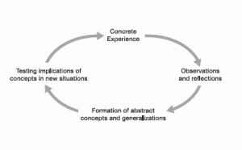

1.1A diagram of Lewin’s experimental learning model (Kolb, D.A. ,1984)

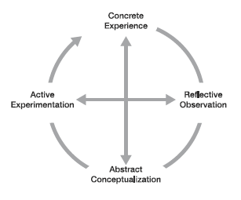
1.2 Kolb’s ELT (Kolb, D.A. ,1984)
I will apply this model to my experience in the project. My concrete experience of the project at the beginning was attending meetings where I gave ideas and discussed with the project group and later supported the group with art sessions mainly with other activities that helped fundraise being the coffee morning. sponsored walk and selling the school students handmade Christmas cards, I also created the Facebook page for the project and contributed to the blog which gave informative posts to followers about the progress of the project. I was involved in two art sessions where I contributed my first blog post speaking about my first session. On the day of the coffee morning I supplied Oreo cupcakes to be sold and then helped the group run the stand where at the end of the sale I helped count the money raised. I took part in the sponsored walk as well as gathered signatures for the fundraising venture. lastly, for the fundraising I helped run the Christmas card stand although not for the entire duration as I appeared late. I then took part in the evaluation of the project writing about the strategy, goals and objectives of the project. At the end of the experience I attended the Unit nineteen presentation where my project group illuminated the steps our project had taken with pictures and other visual aids and then presented on stage our progress in reaching our predetermined goals where we then proceeded to announce the money raised for the head teacher of the school for improving the experience of the student’s learning and development.
Through reflective observation on the project I can see many things that both me and my group could have improved for instance we could have used more advertising for our project, Personally, I feel I should have engaged more with the Facebook page and looked for ways to increase exposure to the page and I think I should have made it more interactive such as a variety of content, polls and in general more things to engage the page followers, Also I should have engaged more with the group during the evaluation stage where I was absent for a few of the meetings.
Using the reflection, we can create abstract conceptualisations such as planning some events involving the community like the idea pitched in a meeting to advertise the project at the Uplands market. We could have created more social media accounts such as a twitter page and improved the current Facebook page adding easy to find links and refining other features to make it more user-friendly.
Implementing active experimentation and learning from the problems witnessed from the project I believe that to increase the amount of exposure of the school and therefore lead to more awareness we should next time consider advertising to the wider community since a majority if our marketing focus was applied to the business school, I would also advice and put into practice more coffee mornings as they were highly successful and would consider putting up posters advertising the project and its events around Swansea.
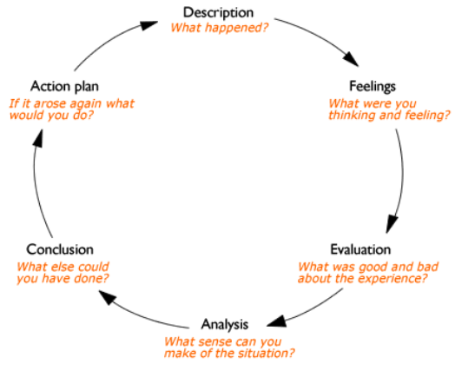
1.3 Gibbs multi stage model (Gibbs G,1988)
Again, applying the model to the project, the description simply put is a group of 6 business students including myself being assigned the project of helping a local school run art session for special needs, later we were tasked with raising money for a UV light to be purchased and installed. During the project we set our own goals with 3 main objectives with the first being to fundraise the needed amount for the ultraviolet light, second was to raise awareness of the issues of the school and its students and third was inclusion that was to be achieved through running the art sessions and involving the students in our activities. Unfortunately, the students could not make most of the activities as clashes with schedules and other concerns were raised. We had a slight nuisance when one of our group suddenly left with the remaining members being forced to pick up their workload. We finished the project having done a total of 5 art sessions, a coffee morning, Sponsored walk and a Christmas card sale.
My feelings varied throughout the project where at the beginning I was a bit apprehensive that we would not reach our fundraising goal, but as time continued forward and the project progressed I started feeling more confident in the success of the project especially after the extraordinary accomplishment of the coffee morning and at the end of the project I felt satisfied that all goals set had been reached. In the work I contributed to the project I felt a little anxious as I feared ruining the structure of the other members work.
To evaluate the project the project was a massive success with the group fundraising many times over the goal and managing to satisfy the set objectives by raising awareness through posters around the business, including the students in art sessions and raising the amount needed for the UV light. The only problems that had emerged was numerous clashes causing us having less art sessions and our original sponsored walk path along mumbles having to be changed due to adverse weather conditions.
Analysing we can perceive that the project successfully raised the necessary amount of money and met the criteria for the other objectives while also fulfilling the needed amount of work for the assignments associated with the project.
To conclude with the success of the project we seemed to have progressed splendidly, but I believe we could have done a slight bit better in terms of presentation and reach. One of my ideas would be to advertise to the community in the form of posters scattered around busy areas. Another idea to both raise money for the school and raise awareness to the community would be a fun run which would involve a lot of planning and even if brought up during the projects brainstorming sessions would have been unlikely to have been implemented due to strict time requirements, however I believe this endeavor to be worth exploring in future as due to the ‘Martyrdom effect’ proposed by Christopher Olivola (2009) it is suggested that the prospect of pain and effort such as that achieved in the rigorous exercise experienced from fun runs can cause participants to contribute more to the cause of the run, Therefore by using this event it could have been possible to fundraise substantially more.
As for an action plan if such a project arose again I would first confer with the school to create a comprehensive timetable assuring no planned clashes take place, I would then guarantee all social media platforms we make use of are easy to find and very simple to navigate through and donate. For the fundraising stage of the project I would focus on doing several coffee mornings considering the success of the one implemented by the project, The fun run if we have ample time and more art sessions if the time frame allows it. To raise awareness, I would have printed the school’s logo and the project name on T-shirts for runners in the fun run in conjunction with posters around Swansea on sign posts and buildings.

3.1 Masterclass sessions
During the first semester in our community engagement lectures we had a few guest speakers come in to speak to us, these masterclasses were tasked with delivering engaging activities that could be used to improve skills such as confidence and give insight into a multitude of different career paths. Most of these masterclasses were focused on entrepreneurship which is a very useful skill to have in future but in the immediate future the skill seems trivial.
The primary themes I got out of these masterclasses were confidence, communication and creativity. These themes were utilised heavily during my project and they are partially the reason for its success. To further illustrate how the skills, I will now use some sources to discuss each theme in turn and attempt to break each down to see their benefits to the project. First, I will speak of the importance of confidence to the project but let us start by defining confidence which is ‘ The feeling of self-assurance caused by appreciation from one’s own capabilities or qualities’ (Oxford,2018) with confidence being able to be split into two categories that is trait and state with trait-confidence being what one believes they may achieve whereas state-confidence is what one believes ‘in the moment’ of action (Vealey, 1986), It is important to point out this distinction as confidence has two stages the mindset and the action, confidence is also a way to increase productivity as it is a sense that you know what you are good at and how best to convey it with actions leading to you being more confident thus creating a virtuous cycle, confidence also raises one’s self-esteem leading to better interaction with team members and thus increased moral and therefore increased productivity. (WiseStep,2018)
The masterclass I believe this skill developed the most would be that of Mr. Producer who gave us a presentation on his life from acting to consulting where he would give us ways he would stay confident that give me new insight on how to look at confidence, It would also help that humour was added into his presentation to make it more memorable and it is interesting to look at the view of a lifelong entertainer of 35 years on confidence (Anon,2018)
The next theme to discuss is communication which is defined as ‘The exchanging of information through a medium such as speaking’ (Oxford,2018) and is a very important skill to be competent in as seen in a survey given to employers in the Auckland region of New Sealand with more than 10 staff from a variety of different sectors showed that among the most important skills these employers search for in graduates is interpersonal communication which appears in the top 10 most sought after skills being placed fourth with a mean score of around 5.82 out of a potential 7.
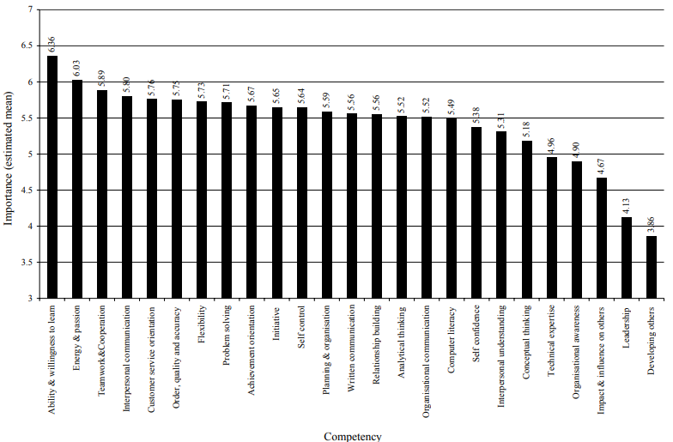
2.1 Graph of average score of competency compiled from Auckland survey (Hodges, D. and Burchell, N.,2003)
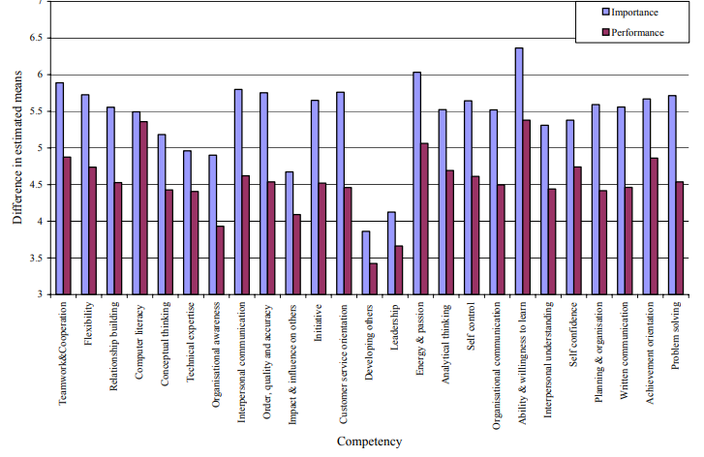
2.2 Graph of average score of competency against performance of graduates (Hodges, D. and Burchell, N.,2003)
By looking at figure 2.2 we can see that the performance is always lower then the importance meaning that graduates skills are generally lower that what is expected of their job meaning that graduates especially need to keep these skills sharp.
Using the likert scale however can prove problematic as it can fail to measure the true attitude of the respondents as peoples’ answers can be influenced by previous questions, and there is also the problem of the extremes on either side which most respondents tend to avoid due to negative connotations associated with such which happens in the figure shown in 2.1 where no competency goes over 6.
The masterclass I believe I developed this skill the most would be that of Andy Rogers who done a talk to us called ‘Networking for introverts’ where he gave us an activity sheet we would fill in as he was speaking that called for us to speak with random students therefore stepping out of my comfort zone and communicating, He also showed us how to interact with different personality types and taught us a lot about body language which is a very useful skill to possess.
The final theme that was brought up in the masterclasses that really helped me was creativity that is defined as ‘The use of the imagination or ideas to create something’ (Oxford,2018) and this skill is fundamental to the success of any business as creativity and innovation go hand in hand. Quick question how many squares can you see in the figure below?
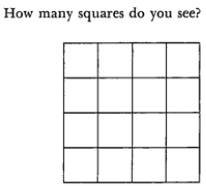
2.3 A 4x4 square (Doris J. Shallcross, 1974) (Shallcross, 1973)
One may immediately guess 16 but upon closer inspection it is possible to find 30 squares that can be easily pointed out, this activity is very similar to how creativity works where one can see things from different perspectives and come to different conclusions.
A huge impact can be seen in the world everyday through creativities effects through change from politics to business. There are two types of change that can be observed with creativity which referred to as big C and little c, the difference in the two are their levels of impact where big C may refer to a huge scientific discovery which has a major impact on society where as little c refers to events of little significance to the world such as solving a problem at home or work. Of course, many novel ideas may not be defined by either category as they may fail or have no impact and therefore creativity is defined as the development of original ideas that are useful or influential (Paulus & Nijstad, 2003). It is quite apparent why this skill is very useful as it heavily impacts how a business run and can lead to major gains or losses depending on the innovation created by the business.
The masterclasses that developed these skills the most were Ben room’s and Jon Dawkins. In Ben room’s masterclass we were tasked with creating a revamped version of bowls in groups were we ended up creating a red bull extreme sport which was loosely based of bowls that seemed just insane enough to make bowls seem fun and exhilarating, It also helped with creativity that Ben seemed to be extremely creative himself using oil from a local kebab shop to fuel his car during the 2008 recession and innovating skateboarding and snowboarding by combining them together creating all terrain boarding which he mobilises all around south wales (2018). With Jon Dawkins we had to come up with a name for a hairdresser that is unique and would draw customers which lead to many creative ideas that
3.2a. Influence of masterclass sessions on project
In this section I will speak about how the masterclass influenced the project and to do this I will be referring to the reflection section of the report where I will highlight stages in the project where the skills were a major help and lead to the success of the project. In the beginning of the project we began by discussing ideas in meetings where we would think up our fundraising efforts and marketing campaigns and to do this we needed to be creative, And this is where the efforts of the masterclasses really paid off as we started brainstorming a lot of the ideas we would end up incorporating into the project such as the Justgiving page were we would end up nearly reaching our goal with alone, The coffee morning that was hugely successful and our various social media links. Another thing the creativity developed helped with was the name of the project which changed many times before the entire group decided on Bright art at Ysgol Crug Glas.
Entrepreneurship that was also developed during the Masterclass from the likes of Kate of Gower brownies for example who started off small as a wife who loved baking brownies to a well-known brand who sells brownies all around the country, this happened to help us to gain confidence in our blog as Kate seems to be a good example of humble beginnings online to award winning brownie distributor(2018), It also helped us set up the coffee morning as the success of Kate’s brownies made the group consider selling tasty treats ourselves to create money for the fundraising goal.
Communication developed from the masterclasses helped with communicating through the social media pages as well as during the art sessions where I had to be wary as the students had a variety of disabilities that required a weary approach. The skill was used well to put ideas forward to the team and argue why they could work and during my interview where I had to put my thoughts into words during the presentation to the interviewer, and further to put my experiences and research into words for assignments and collate my work to match the overall tone of the group assignments.
Confidence was a definite benefit as I had to speak up during group meetings and had a role in presenting in a variety of tasks where confidence was key. This also allowed me to succeed in the individual tasks in the group such as the social media manager where I am communicating any information about future events related to the project to followers. Also, as mentioned in the reflection my confidence for the project at the start was quite low, but the boost in confidence gained by both the masterclass and the upward momentum of the project led to a heightened resolve and more satisfaction from each new challenge that arose.
3.2b. Influence of masterclass on personal learning and development
The masterclasses where a great help to my personal learning and development as they gave me confidence to overcome various hurdles put into place by the multitude of challenges set by the barrage of assignments. But to succeed requires more then just confidence and in this section, I will speak truthfully about my weaknesses and strengths and how through self-reflection and the knowledge gained from the masterclasses can support my growth in future.
The strengths I gained and developed throughout this experience are numerous with a few examples being teamwork, communication and clarity. I developed teamwork through simply working with the project group as well as supporting their endeavors. Communication was developed by constant contact between members as well as the masterclass that made me feel more confident in my speaking which leads me to clarity which I believe through the culmination of the other two skills mentioned started to develop since I needed to actively communicate with the other team members making my thoughts clearer when discussing with the team.
Weaknesses that I noticed during the project were time management, self-motivation and adaptability. The first two mentioned go hand in hand with my self-motivation being quite low as I started worrying over the success of the project and time management which was caused by it as I dedicated less time to the project work. I mentioned adaptability as a weakness since I am quite slow to change such as in routine which can become troublesome such as in the final few meetings had by the group that I unfortunately missed.
To improve my weaknesses and bolster my strengths I think I should use a day planner and a calendar which will definitely improve my weaknesses by laying out what needs to be done each therefore improving time management and breaking routine there by bettering my adaptability, This will also lead to better self-motivation by giving each day a purpose and raise the fortitude of the strengths as better planning leads to better clarity with team members and therefore improving communication

4. Conclusion
To conclude in the introduction section of the report I have a few figures and appendices and a short few introductory paragraphs, In the models of reflection section I have used two separate models and have applied the to the project offering ways the project could be improved in future. The main body consists of 2 sections being the masterclass section and the influence of the masterclasses section, In the masterclass section I have referred to skills I have developed from the classes and in the influence section I have shown how these skills influenced my project and my own personal learning. The final section is the references which hold all the references used throughout the sections.

References
Glas, W. t. Y. C., 2017. Ysgol Crug Glas. [Online]
Available at: https://swansea-edunet.gov.uk/en/schools/crugglas/Pages/Default.aspx
[Accessed 25 November 2017].
Paulus, P. B. & Nijstad, B. A., 2003. Introduction. In: P. B. Paulus & B. A. Nijstad, eds. Group creativity:Innovation through collaboration. Oxford: Oxford university press, pp. 3-14.
Shallcross, D. J., 1973. Creativity:Everybody's business. Journal of counseling and development, 51(9), pp. 586-691.

Anon, (2018). HOMEPAGE | Stifyn Parri. [online] Mrproducer.co.uk. Available at: https://mrproducer.co.uk/homepage/ [Accessed 12 Mar. 2018].
Tudor, E.J.,2017. ‘Structure and culture of current organisation’, M4X00800: IMW. University of Trinity Saint David. Unpublished
Kolb, D.A. (1984) Experiential Learning: Experience as the Source of Learning and Development. New Jersey: Englewood Cliffs, Prentice-Hall.
Gibbs G (1988) Learning by Doing: A guide to teaching and learning methods. Further Education Unit. Oxford Polytechnic: Oxford
Christopher Olivola and Eldar Shafir (2009),"The “Martyrdom Effect”: When the Prospect of Pain and Effort Increases Charitable Giving", in NA - Advances in Consumer Research Volume 36, eds. Ann L. McGill and Sharon Shavitt, Duluth, MN: Association for Consumer Research, Pages: 190-194.
Oxford dictionary, (2018). [online] Available at: https://en.oxforddictionaries.com/definition/confidence [Accessed 11 Mar. 2018].
Oxford dictionary, (2018). [online] Available at: https://en.oxforddictionaries.com/definition/creativity [Accessed 12 Mar. 2018].
Vealey, R. S. (1986). Conceptualisation of sport confidence and competitive orientation: Preliminary investigation and instrument development. Journal of Sport Psychology, 8, 221-246.
WiseStep. (2018). Why is Confidence Important in the Workplace? 13 Reasons - WiseStep. [online] Available at: https://content.wisestep.com/why-is-confidence-important-in-the-workplace-reasons/ [Accessed 11 Mar. 2018].
Oxford dictionary, (2018). [online] Available at: https://en.oxforddictionaries.com/definition/communication [Accessed 12 Mar. 2018].
Hodges, D. and Burchell, N. (2003). Business Graduate Competencies: Employers’ Views on Importance and Performance. Auckland: AsiaPacific Journal of Cooperative Education, pp.18-20.
LaMarca, N. (2011). The Likert Scale: Advantages and Disadvantages. [Blog] Field research in organisational psychology. Available at: https://psyc450.wordpress.com/2011/12/05/the-likert-scale-advantages-and-disadvantages/ [Accessed 12 Mar. 2018].
Brdsports.co.uk. (2018). Home - BRD Sports Mountain boarding Centre School Gower Swansea. [online] Available at: http://www.brdsports.co.uk [Accessed 12 Mar. 2018].

Gowercottagebrownies.co.uk. (2018). Testimonials. [online] Available at: http://www.gowercottagebrownies.co.uk/testimonials/ [Accessed 12 Mar. 2018].

