Unit three homework sheet
1. Practise writing the characters for number one to ten
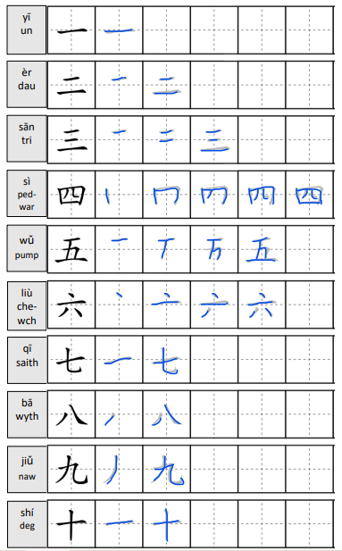

2. Translate the following numbers into English and a third language and record yourself reading the numbers
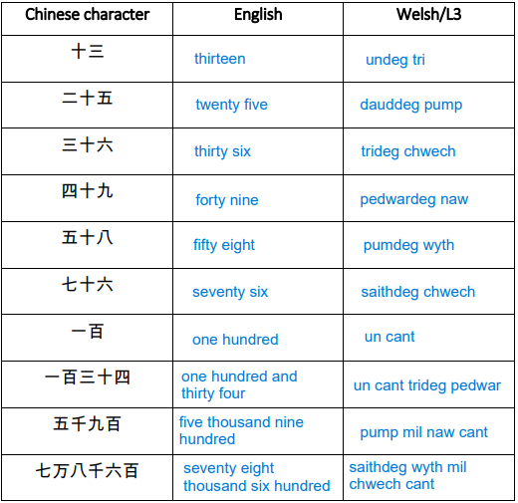

3. Answer the following questions in Chinese characters.
e.g. :
Tom duō dà
Q：Tom多大？（20）
tā èr shí suì
A：他二十岁。
Sioned duō dà
Q：Sioned多大？（17）
tā shí qī suì
A：她十七岁。
- Q： Jane 多大？（13）
A：她十三岁。
- Q：Jeremy多大？（28）
A：他二十八岁。
- Q：Alice多大？（32）
A：她三十二岁。
- Q：Ross多大？（74）
A：他七十四岁。
- Q：Mary多大？（59）
A：她五十九岁。

4. Type the following sentences in Chinese characters and then video record yourself saying them.
Hi, I’m (name). I’m (nationality). I’m xx years old. What’s your name? What nationality are you? How old are you?
你好, 我叫 Alex. 我是英格兰人. 我而是刘岁. 你叫什么名字? 你是那过人? 你多大?

5. Cultural study
https://us02web.zoom.us/rec/share/0g0Qa58GY8Sp6cTdwoJl1-l1Hy43IaXDx89gloN6N8jmuUQEOcsHwPo-HAIR48-X.h1gUjVN5Es3wZD6J
Passcode: b6fx&$J6

Research questions:
- How is Western calligraphy different from Chinese calligraphy?
Western calligraphy mostly require a flat-edged pen to achieve the result while the Chinese use a flexible hair brush. Because the writing utensil is different, the outcome varies also. For example, a stroke from a pen is lighter than a stroke from a brush dipped in ink (Wen fang si bao). Western calligraphy also mainly starts from left to right in cursive, whereas standard Chinese calligraphy starts from top to bottom for each character, with the vertical strokes usually being formed first followed by the height of the horizontal strokes (high to low).
- To what extent is the writing style determined by the writing instrument?
Pen rack: Different sized brushes are used for different sized characters and for different purposes (big – large poster style) (small – notebook handwriting). In Chinese calligraphy there are also seven different scripts which are used for different purposes.
- What are the benefits of practicing calligraphy?
It’s a form of meditation, where each stroke guides each breath you take. It helps develops fine motor skills and memory retention. It is also considered an art form which used to be regarded as one being highly educated in China.
- Do you think children should learn calligraphy in school?
Yes – it’s important to be able to read and write cursive script if it helps to save time when writing, but only specialists in China will be able to read it. It used to be compulsory in China and Taiwan to study calligraphy but not anymore. This is not common practice with Western languages – with regards to Western languages, students with reading and writing disorders such as dyslexia and dysgraphia could benefit from extra calligraphy sessions in their own language to improve their handwriting style to make it legible for not only themselves but other others reading their work. There are also rules that one can learn in order to become a great calligrapher – 8 principles of Yong.

