University of Wales Trinity Saint David

Wales Institute of Science & Art



Electronic Ignition & Fuel Injection Systems
Electronic Control Systems (ACHA4010)

Bleddyn Williams
2104564
May 2022

Contents
1 Introduction 2
2 Material Properties 3
3 Material Selection 4
4 Manufacturing Processes 5
6 Conclusion 6
7 Reference List 7

Introduction
This engineering report is going to present findings from live testing of two Vauxhall/Opel engines from varying generations. The findings are to represent usual operating conditions of the engines and its respective ignition and fuel delivery systems. The 5 stages of operation to be discussed and analysed are:
- Cold cranking
- Warm-up phase
- Idle control
- Acceleration
- Deceleration
Live data will also be retrieved during the ignition on, engine off stage to retrieve potential voltages of the various sensors via the ECU pins.
A presentation of graphs will be used to illustrate the operating characteristics of the fuel and ignition systems during these 5 stages. Following the analysis of the operational nuances of the respective systems, an analysis and comparison between the two engines is deemed useful to determine the advantages of each engine but more importantly the disadvantages. The two engines in question are the LE3 engine and its successor, the Motronic engine. In a societal incentive to reduce emissions and prolong the intended operational emissions of an engine throughout its life cycle, identifying the disadvantages and possible improvements of these systems using upgraded parts and closed loop operations, this societal objective can be achieved. Due to this consideration and objective, a close analysis will be made on the injector on time during these 5 phases of operation. Understanding of how the on time changes the stoichiometric ratio of the air/fuel mixture (14.7:1) will be crucial in finding opportunities to reduce emissions and prolong the time a stoichiometric ratio is achieved. It will give a greater understanding of how certain driving styles effect fuelling and emissions. A wide range of sources and literature dating pre and postproduction of these two engines will be used to support the findings of the simulation as well as the modifications deemed necessary to elevate the engine operating capabilities. As well as the time taken to analyse and test these engines, considerations were also made to perform these tests in a safe manner by following health and safety regulations.

Literature Review
In regard to the live test, it is a great method to simulate the ideal operating conditions of the engines when used on the road. The lab conditions provide a controlled environment to realise the potential of the fuel and ignition system as well understanding what the engines left to be desired. This environment as opposed to a road test allows engineering to retrieve data under repeatable conditions, adding value to the data retrieved. However, despite these advantages, this controlled environment doesn’t represent the extreme environments these engines will have to potentially operate. Since it’s difficult to assimilate different air density, which is experienced at different altitudes, operating conditions in this lad can simulate conditions of a country at such altitude. Furthermore, the lab has its own atmospheric air temperature, and the engines behave as such under these conditions. Therefore, conditions of a country with extreme temperature conditions can’t be simulated and the resulting behaviour of the engine can’t be interpretated.

Methodology
Before and during the live testing health and safety regulations must be followed in order to carry out the experiment without injury. This involved the correct PPE to be worn, safety glasses to prevent any possible eye injury. Dustcoats were also worn to prevent contaminants going on clothing as well to ensure there is no protruding fabric that can be caught in mi=moving parts. Safety boots were also worn to prevent foot injury in the event any heavy machinery were to land on someone’s foot. As well as PPE, exhaust extractors were used to prevent inhalation of combustion gasses inside the lab, while in use a consideration would also have to be made due to the further tripping hazard as a result of the exhaust extractor. Sensible behaviour and attention must always be present during the operation of the engines to prevent injury also. Further precautions were taken on the engine rigs also, with shielding used around the areas of moving parts to reduce the risk on a hand injury when testing the engines.
When testing the engines, a multi meter is used. Before testing and retrieving voltages and resistance values for the live data, the internal resistance of the multimeter cables are measures for greater accuracy of the data. The internal resistance of these cable are 0.2V, this value will be deducted in all the following data values, table and graphs. The multimeter is set up by finding a good earth on the inlet manifold and using the positive probe to close the circuits via the ECU pins to measure the voltages (at the 20V scale).
Firstly, with the ignition off and engines non-running, any potential permanent live feeds can be found. Secondly, with the ignition on and engine non-running potential voltages are measured. The first engine that is tested is the LE3 engine, due to the age of this engine it has two separate ECUs for the fuel and ignition system. Battery voltage is measured first to ensure the battery is fully charged in order to see the full operating potential of the engine as well as the max potential voltage readings of the ECU pins. As shown in the table below the battery voltage measures 12.41V, a fully charged battery. Testing is then carried out on the 13 pins of the fuel system ECU and the 15 pins of the ignition system ECU.
After measuring the potential voltages of the fuel and ignition ECUs, resistance measurements are then taken between the terminals of the auxiliary air valve, fuel injectors, throttle switch as well as the voltages of the amplifier (pins 1 -4).
Following the static measurements when the engine isn’t running, the engine now needs to be started to analyse the operating characteristics. Following the application of the exhaust extractor and ensuring nothing is at risk of coming into contact with moving parts, the engine is started. During this phase of operation, an oscilloscope is used to measure the fuel in jection on time by connecting the oscilloscope to pin 3 as well as measuring resistance and voltage of the NTC2 sensor (pin 8). Readings will be recorded from these pins as the engine temperature raising incrementally by 10°C from 20°C up to 60°C. Focus will also be in the time of first injection, to accommodate for cold cranking and a measurement will be made of the temperature before starting up.
Following the testing of the LE3 engine, attention is turned to its successor the Motronic. Measurements of the permanent live and potential voltages is a little more straightforward due to the engine only having one ECU. Once again, a good earth is found on the induction manifold and using a multi meter the 33 pins are probed. 2 live earths are found and 32 potential voltages >0V. Following the static measurements, the resistance between terminals of the auxiliary units; throttle potentiometer, air flow sensor, idle speed control valve and voltages of the injectors are measured.
Finally, following the same health and safety precautions taken and oscilloscope connected, the engine is started. The oscilloscope is connected to pin 16 to measure to pulse generated by the injector bank to indicate the injector on time. A further connection is also made to the idle control valve to measure percentage of idle control at 40°. As well as this there is also connections to the Lambda sensor and fuel tank ventilation actuator to determine whether when these switch on. Similar to the LE3 engine, these readings are taken as well as the resistance and voltage readings of the ETC2 sensor every 10°C from 20°C up to 80°C. the starting temperature of the engine is also measured as well as the injection on time for cold cranking.
As well as the oscilloscope injection readings and multimeter measurements, further scope traces were taken for:
- LE3
  - Primary coil voltage
  - Secondary coil voltage
  - Supply & earth
  - Spark advance & primary
  - Injector (idle)
  - Injector (acceleration)
  - Injector (deceleration)
  - Speed reference for fuel ECU
  - Crankshaft signal

- Motronic
  - Ignition – Primary coil
  - Ignition – Secondary coil
  - Rotary idle valve
  - Supply & earth
  - Potentiometer signals
  - Injectors (simultaneous)
  - Injector on time (idle)
  - Injector on time (acceleration)
  - Injector on time (deceleration)
  - Lambda sensor
  - Crankshaft sensor

Analysis

LE3 Engine
The first engine tested is the LE3, the results of the battery voltage, permanent lives and potential voltages are shown in the figure below:
Figure ‎4.1 - Battery, permanent live and Potential voltages (V) (Williams, 2022)
As shown in the table above the battery voltage displays a fully charged battery, this is essential in order to have an accurate representation of the engine’s characteristics under operation. Clearly shown above there are no permanent live voltages when the ignition is off at either ECU’s.
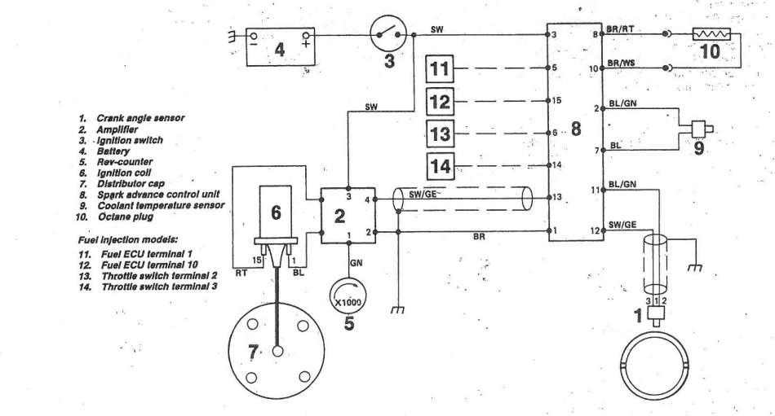
Figure ‎4.2 - Schematic diagram of LE3 engine

When analysing the figures 4.1 & 4.2 the pins connect to the following components:
- Crank angle sensor = Pin 11 & 12 (0.03 – 0.06V)
- Amplifier = Pin 1 & 13 (0.03 – 0.14V)
- Ignition switch = Pin 3 (1.91V)
- Battery = Pin 3
- NTC2 = Pin 2 & 7 (0.03 – 1.9V)
- Octane plug = Pin 8 & 10 (0.95 – 0.03V)
- Fuel ECU terminals = 5 & 15 (0.06 – 0.15V)
- Throttle switch terminals = 6 & 14 (0.02 – 5V)

The voltages retrieved at pin 11 & 12 for crank angle sensor is expected without the engine running since the voltage only occurs when the crankshaft is rotating, creating a signal waveform as a result. The potential voltages of the amplifier, fuel ECU terminals and throttle switch terminals are also to be expected with the engine non running. When the engine is in operation the potential voltages of these sensors will change due to the operation of the injectors, throttle and ignition system.
The NTC2 sensor potential voltages shows the highest and lowest voltage in which this sensor operates, as the temperature of the engine increases under operation and as a result the coolant temperature increases, voltage would decrease from 1.9V towards 0.03V.
As well as the potential voltages, resistance of the auxiliary units were measured, and these resistance values give an insight into how these units operate. These resistance measurements as well as the voltages of the fuel injectors are listed below.
Figure ‎4.3 - Auxiliary units (Resistance and Voltage) (Williams, 2022)

As shown in the table above, the throttle switch could possibly have a fault and be outside of specification, this is due to the throttle switch reading 0.8Ω between pin 2 & 18 when it should read 0Ω under the manufacturers specification. Due to this anomaly, a comparison was made to another groups test result to determine whether it was human error, equipment malfunction or a genuine fault. The comparative group data is shown below.
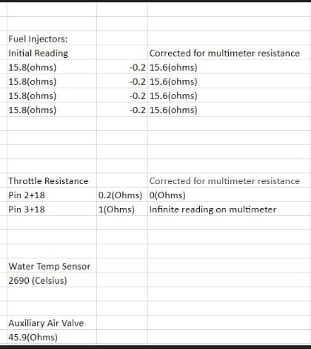
Figure ‎4.4 - Comparative data from another group (Watkins, 2022)

It can be concluded that the out of specification resistance measurement is a result of human error since this same part days later was recorded in specification. Furthermore, the resistance measurements of the auxiliary air valve, throttle switch and injector voltages were also within the specification of the manufacturer. This is helpful for gaining an accurate representation of the engineered characteristics of this engine. As a result the emissions and scope patterns retrieved will be what is expected from the engine, allowing a more accurate evaluation of the engines capability as well as its room for modification.
Due to the static voltages being within specification, live data can now be recorded from the engine via oscilloscopes to better understand the nature of the engine while running.
During the incremental increase of the engine temperature, the data retrieved from using the multimeter are below.
Figure ‎4.5 - Live data while the LE3 engine is running (Williams, 2022)

As shown in the table above, the temperature of the engine before starting phase was 19.3°C. At that temperature (cold cranking) the initial injection on time was 75.3ms. This is due to a greater mixture needed in the even that the potential cold conditions could produce a weak spark from the battery or poor firing conditions inside the combustion chamber. Therefore, a richer mixture greater increases the likelihood of a good initial burn to start the engine. Following the cold cranking phase the engine is left to idle until the internal temperature is raised to 20°C. A scope trace of the injector on time when idling is shown below.

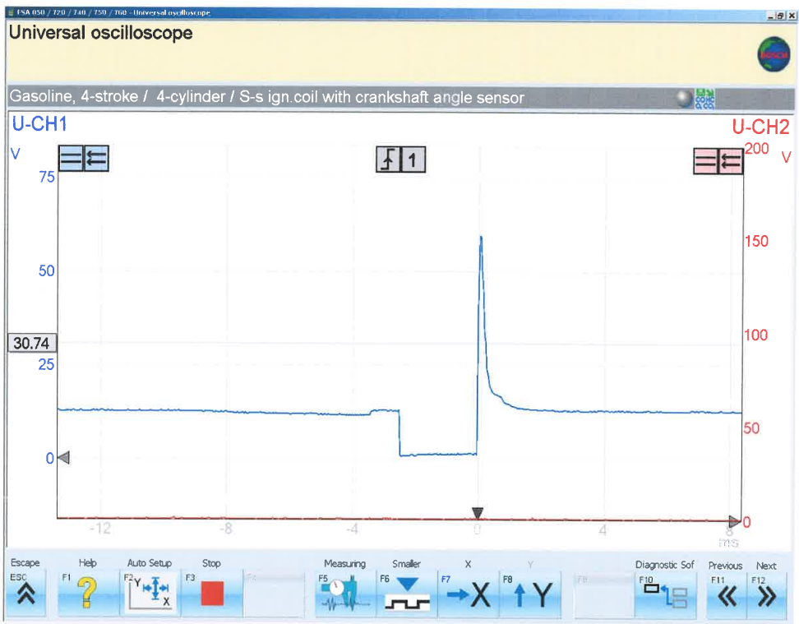
Figure ‎4.6 - LE3 injector scope when idling
This shows that when the injector is grounded at -3.7ms it has a injector on time of 3.7ms until is it turned off at the 0ms mark. A comparison will be made to the injection on time when the engine is accelerating and decelerating as the temperature raises from 20 to 30°C.
As well as this, at 20°C the NTC2 has a voltage of 1.7V and a resistance value of 1940Ω, these values are expected to decrease as the engine temperature increases to communicate to the ECU when to take procedures to cool the engine and turn on the radiator fan.
The engine load is now increased and the acceleration phase is imposed.
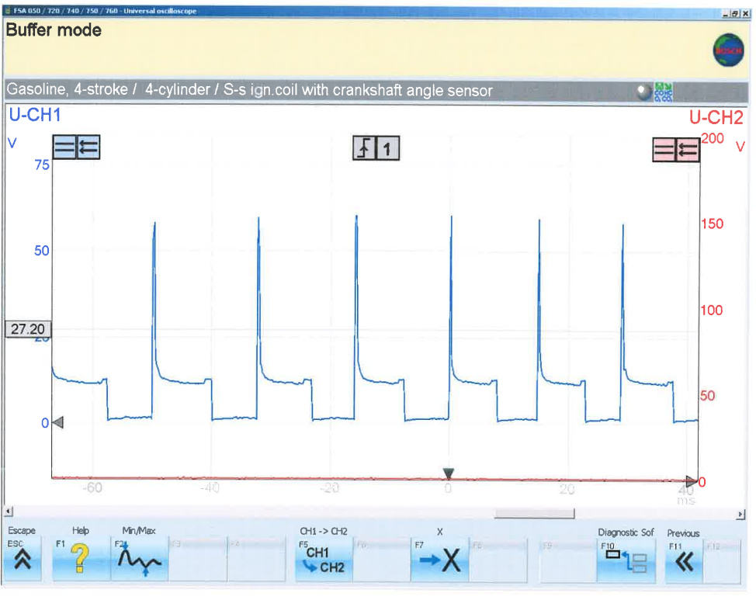
Figure ‎4.7- LE3 engine injector under acceleration
Clearly as shown in figure 4.7 above, the frequency of the injector opening has vastly increased from idle state. This is a response to the throttle switch communicating snap acceleration to the engine. As a result a greater frequency of injection to produce the desired increase in torque and power desired by the driver. As well as this increase in frequency the opening time of the injector is dramatically reduced, this is due to the engine’s increase in induction strokes as a result of the increase in RPM.
However, despite a change in frequency of injection is a response to the increase in engine speed, this isn’t the same when the engine is decelerating as shown in the figure below.

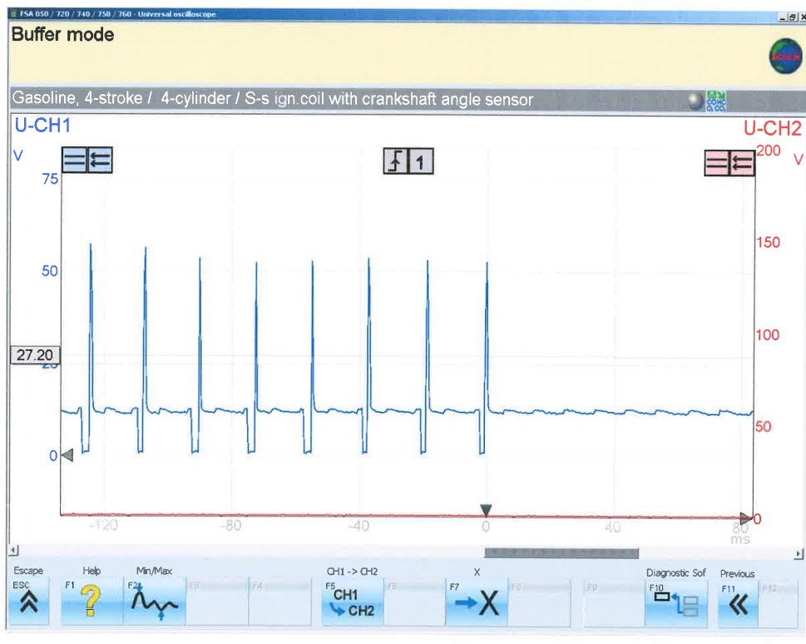
Figure ‎4.8 - LE3 engine injector under deceleration
Here instead of the frequency reducing in response to the reduction in RPM, the injectors are switched off and stay switched off to retard the power of the engine. This is also the case when the engine is in cruise conditions. As a result of the lack of fuel injection, the engine is power is retarded by the compression cycles of the engine as well as the mass of the vehicle reducing rolling speed. This is advantageous as it reduces emissions by not injecting fuel when it isn’t needed. A considerable upgrade on its predecessor, the carburettor which drew fuel in with every induction stroke.
As a result of this engine acceleration and deceleration, readings can now be taken for 30°C. Again, by looking at Figure 4.3, the idle injector on time has now reduced to 3.1ms. This reduction in injector on time will continue as the engine maintains a consistent load when approaching closer to operating temperature. Further decreases are seen at the NTC2 resistance and voltage values, now dropping to 1018Ω and 1.2V. This is a trend also expected to continue as the engine approaches operating temperature.
Between the temperatures 30 and 40°C, secondary coil voltage is measured as well as the primary coil voltage with relation to the amplifier.
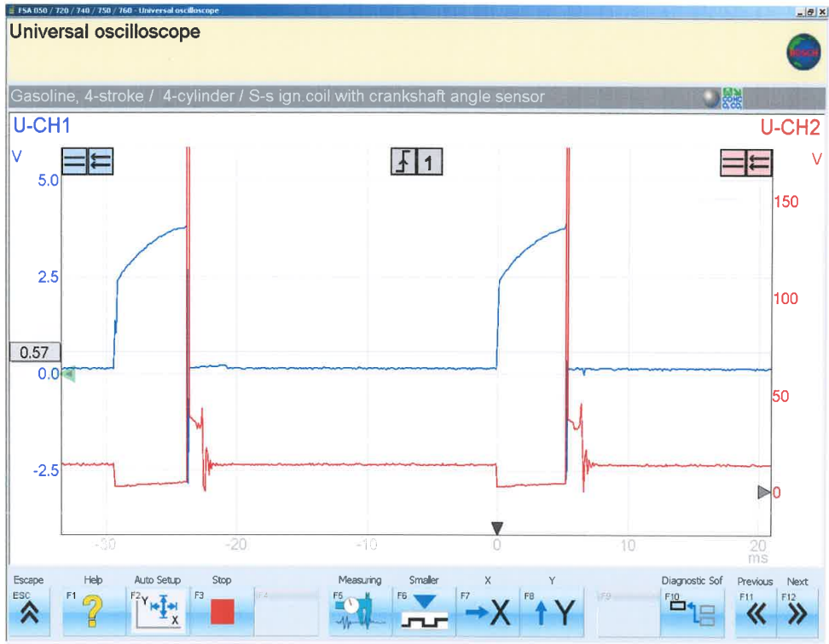
Figure ‎4.9 - LE3 engine Primary coil voltage (V)
Above is a scope retrieve from pin 1 of the primary coil voltage during a supply of a spark to the combustion chamber. As interpreted from the graph above, the Darlington’s are switched on at approximately 0ms, prior to this the primary coil is supplied with battery voltage of 12.4V and the Darlington’s which are part of the spark advance unit 0.57V. At the moment the Darlington’s are switched on and the primary is grounded for approximately 6ms,reducing the voltage to 0V and Darlington voltage to 2.5V, raising to 3.5V until the event of a spark. The Darlington’s are then switched off causing an induced voltage into the secondary coil windings. Following this induction period, the graph shows a back EMF at the primary causing the voltage to read upwards of 180V before a voltage reducing down to approximately 35V for the duration of the spark (approx. 1.2ms). The result of this voltage induction can be seen below in Figure 4.10.
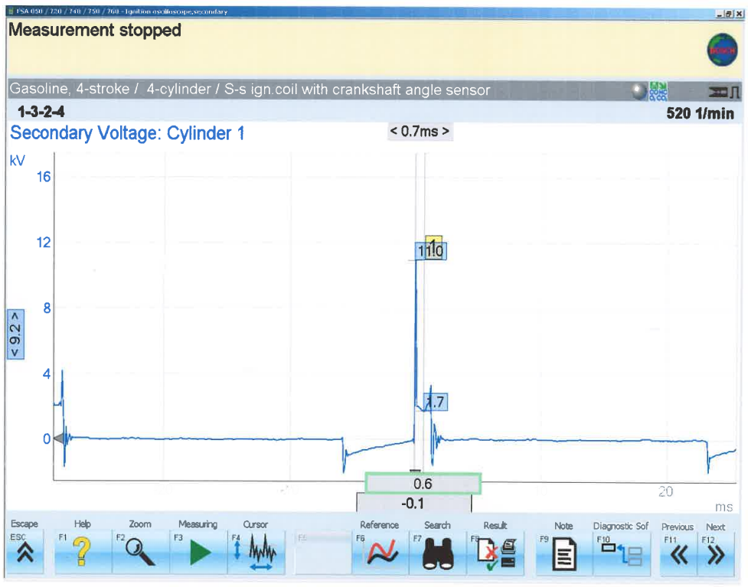
Figure ‎4.10 - LE3 engine secondary coil voltage
In the figure 4.10 above a relationship between the primary and secondary coil can be concluded. During the ‘dwell’ period of the primary coil, when it is supplied voltage at 12.4V, the secondary coil has no supply and measures 0V. however, when the Darlington’s are switched on and the primary is grounded, the induced voltage caused the secondary voltage to initially drop below zero, raise back to 0V before raising to 11kW in order to jump the spark plug gap and produce a great enough spark for 0.7ms at approximately 2kW to produce a good burn inside the combustion chamber. Following the spark, the secondary voltage oscillates between 1kW and -1kW before returning to 0V where the Darlington’s are switched off and the back EMF collapsing.
Following this retrieval of primary and secondary scope patterns, the engine has now reached 40°C. Due to this the resistance and voltage of the NTC2 has again decreased to 762Ω and 0.9V respectively and the injection on time has decreased to a further 3ms. These readings will decrease further at 50°C to 500Ω, 0.7V and 2.7ms and decrease even further to a final reading of 375Ω, 0.5V and 2.6ms of opening time at 60°C. during this final stage if the warmup phase, scope patterns of the engine speed references were retrieved, these can be evaluated on the graph below.
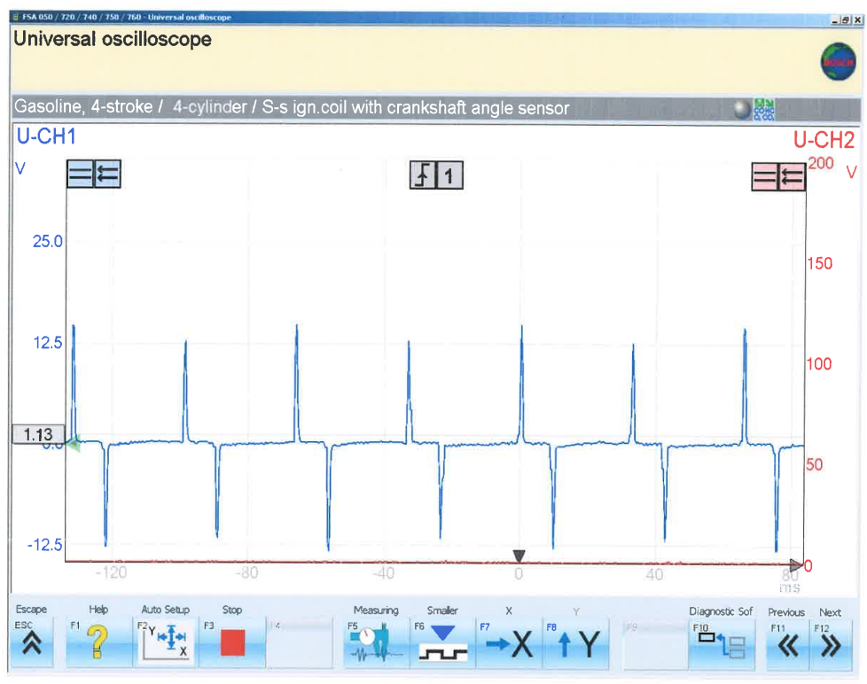
Figure ‎4.11 - A/C waveform of the crankshaft speed sensor
Above is the waveform produced by the magnetic pole sensor at the crankshaft. The nature of this sensor is the building and collapsing of a magnetic field as a tooth of the flywheel/ring wheel approaches the sensor, resulting in a positive signal of roughly 12V from the sensor, reducing to a 0V signal while the sensor and tooth are in close proximity, then producing a further negative signal of roughly -12V. the frequency of the signal will increase as the engine speed increases and similarly decrease as the engine speed decreases. This is crucial in determining the moment at which the engine is at TDC to send a spark to the combustion chamber, it also helps communicate the engine load to the ECU, resulting in an increase or decrease in fuel injection. However as shown in the graph below, the speed reference for the fuel ECU has been converted from an AC waveform to a DC digital waveform. This essential in order to interpret the moment at which the fuel must be injected.
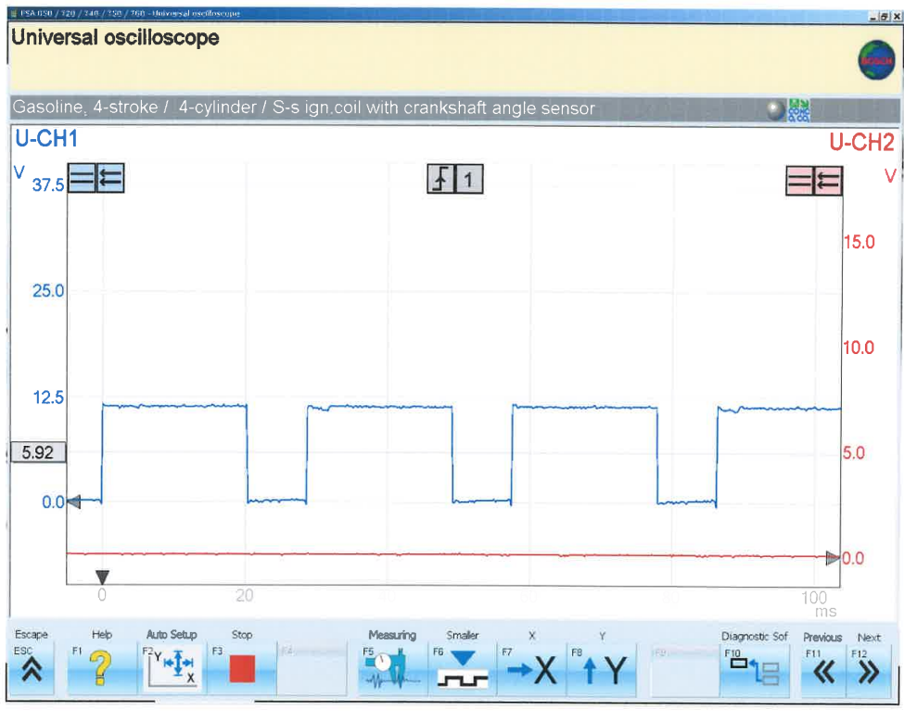
Figure ‎4.12 - DC waveform speed reference from the fuel ECU (Pin 5)
Here the signal instead of oscillating between positive and negative values in an analog form, instead it switched between 0V (off) and battery voltage, 12.4V (on). This is necessary in order for an ECU to interpret a speed reference.

Motronic Engine
The second and final engine to undergo testing was the successor to the LE3 engine, the Motronic. Due to the expected improvements on the LE3 engine, the Motronic provided certain advantages when testing. One of these advantages was the centralisation of ECUs to one single ECU. As a result, all 33 pins to be measured where found in one local area. The measurements of these pins when the ignition is turned off as well as the battery voltage are shown below.
Figure ‎4.13 - Voltages of Motronic engine with ignition off

Here again the battery is fully charged like the LE3, however, unlike the LE3 the Motronic introduced permanent lives at pins 18 & 36. Pin 18 being a permanent live for the system memory, a useful advancement to store fault codes as well as in some instances driving style and profiles along with adapted engine maps to achieve optimum efficiency under this driver style (this is introduced in later engine management). Furthermore, pin 36 is a permanent live to the ECU and its auxiliaries, again a great advancement to maintain previous adaptive measures taken by the ECU to achieve optimum efficiency and low emissions.
Following the test for permanent lives, as shown above, potential voltages were measured. Pins that are important to discuss and evaluate are listed below:
- Negative side of coil
- Earth (also found at 10, 24, 26)
- Pulsed side of rotary valve
- Pulsed side of tank vent valve
- Pulsed side of injectors (also pin 17)
- Output to Lambda sensor
- Output to on board computer (OBD)
The pins 1, 2 and 16 are also featured on the LE3 engine and will be discussed during the evaluation of the scope traces. However, further advancements have been made with the introduction of the rotary valve, an adaptive idle control measure. As well as this, a crankcase ventilation system has been introduced as an alternative to venting to atmosphere. This system has a carbon canister, which is used to encase and safely disperse crankcase fumes via the tank vent valve (Pin 5), a further improvement is the introduction of the Lambda sensor (Pin 28), a closed loop system to maintain the stoichiometric ratio under all driving conditions. And finally, the first generation of the on board computer (OBD at Pin 32). A great user-friendly access point to retrieve data from the ECU quickly regarding operating conditions and possible faults.
Following the measurement of potential voltages and the confirmation that the systems sensors are operational and in specification, live data retrieval can begin.
During the live data analysis, firstly the oscilloscope is connected to the pulse side of the injectors (pin 16), rotary idle valve (pin 4), tank vent valve (pin 5) and finally the output to Lambda sensor (pin 28) as well as these connections there will be resistance and voltage readings at pin 45 (ETC2) using a multimeter. Like the LE3, the readings will be made every 10$°$C from 20$°$C up to 80$°$C this time.
The results of the tests are shown below in figure 4.14.
Figure ‎4.14 - Live data from Motronic engine
Before live data recording, the cold cranking temperature of the engine was 18.2°C and the injection on time during cold cranking was 25.8ms. This is a dramatic reduction in injection on time in comparison to its predecessor (75.3ms). a reduction of 49.5ms despite the engine temperature being 0.9°C colder. Reducing the amount of unburnt fuel in a rich mixture.
First of all, before analysing the trends of the data, two anomalies are as follows:
- 3.3ms (pin 16) at 50°C
- 46 % (pin 4) at 40°C
Firstly, the injection on time should increase in time as the engine temperature increases unless there is an additional engine load applied. Similarly, idle control valve shouldn’t increase as engine temperature increases unless there is an additional load applied. These anomalies have been caused by human error when measuring and recording the data.
When assessing the trends in the data, similar to the LE3 engine, resistance and voltage of the NTC2 sensor decreases as the engine temperature increases. This trend is also followed by the injection on time as well as the idle control valve percentage. However, between temperatures 60-70°C, all values listed increase and go against the mentioned trend. This is due to the increased load on the engine by the radiator fan turning on, as a result the engine needs to produce a little more power to accommodate for the extra load, resulting in a spike in these figures.
As well as these relationships with engine temperature, the actuator for the crankcase vent valve turns on between 40-50°C and the output to lambda sensor starts sending between 20-30°C. This latter initiation shows an almost constant closed loop control of the fuel management system, becoming active at such low operating temperatures, a great enhancement on the LE3 for emissions control.
Further differences can also be found when analysing =g the scope patterns below.
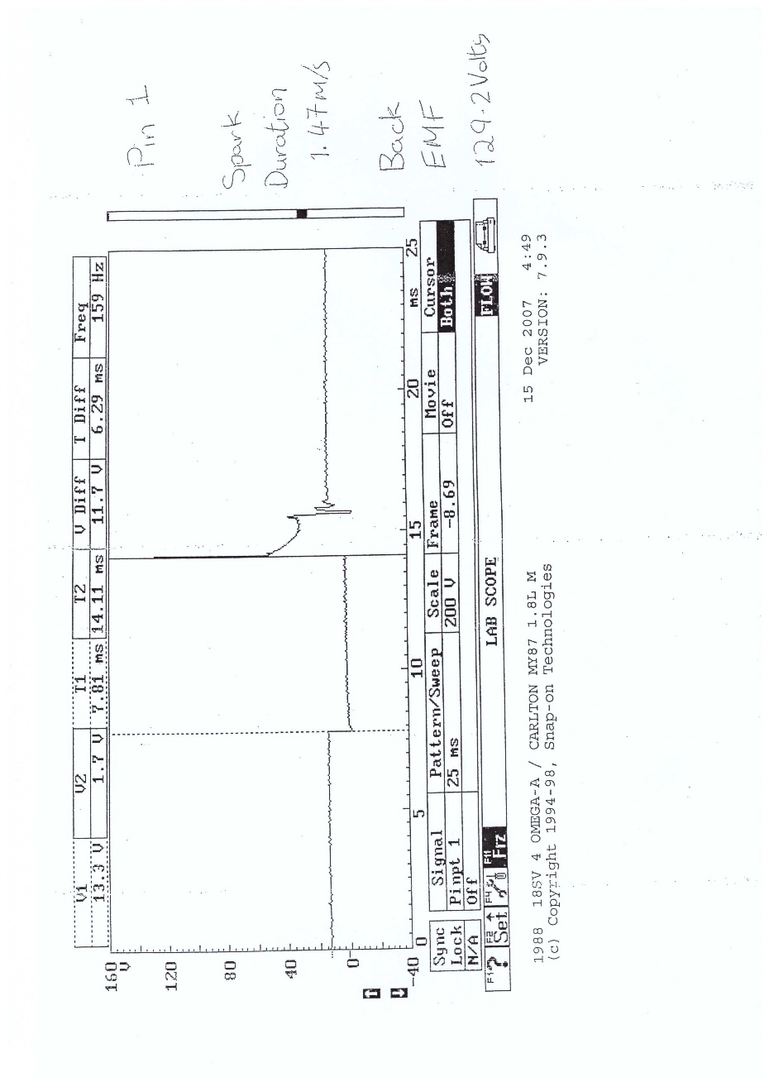
Figure ‎4.15 - Motronic Primary waveform patter
As the graph shows, the spark duration in this distributorless system is for 1.47ms, when compared to the 0.71 of the LE3, this is one of the reasons there is a reduction in injection on time. Due to the spark being greater and for longer, the previous fuel delivery is excessive.
Furthermore, this ignition system is more efficient than the LE3 due to the capability to increase sark frequency due to a reduction of injection on time as displayed in the graph below.
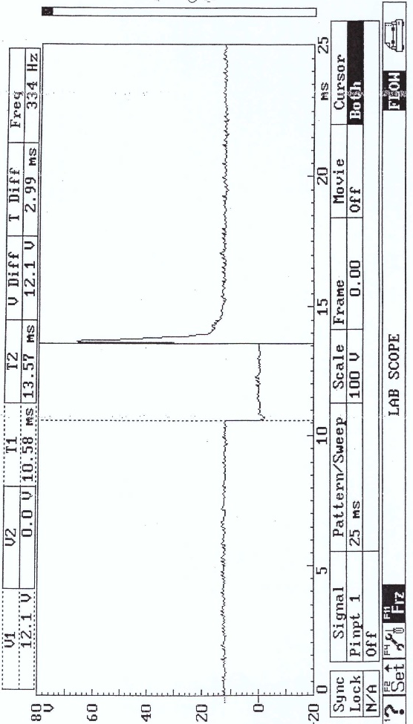
Figure ‎4.16 - Motronic injection on time (idle)
A reduction of 0.7ms of injection on time when idling, increases the capacity for a more responsive change in acceleration when compared to the LE3 as shown in figure 4.17 below.
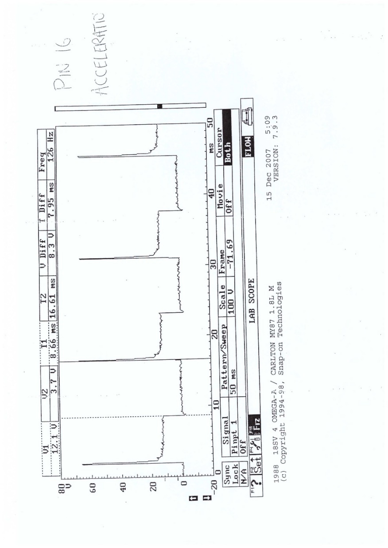
Figure ‎4.17 - 1motronic Injection on time (accelerating)
Again the injection on time is a further approx. 3ms shorter than the LE3, enabling a greater capability for more power strokes which can be further facilitated due to the removal on a contact breaker ignition system.

Conclusion
The Motronic is a great upgrade in the LE3 system, installing more closed loop control in the fuel management and emission control systems. However, further improvements can be made if its were to upgrade to the universal OBDII (autopi.io), a pre and post cat lambda sensor to greater enhance the fuel management control. An EGR valve could also utilise those crankcase gases to reduce temperature and NOx in the combustion chamber (Dieselnet.com). A further improvement to the ignition system with a coil per plug would improve the longevity of the components as well as create a more responsive system than the wasted spark system. Finally, a knock sensor (Bosch, www.boschmobilitysolutions.com) would more greatly improve the emission control and prevention of pre ignition inside the combustion chamber. A great closed loop method to ignite the air/fuel mixture at the optimum point before pre-ignition.

Reference List
Knock Sensor –
https://www.bosch-mobility-solutions.com/en/solutions/sensors/knock-sensor/#:~:text=The%20knock%20sensor%20identifies%20the,fuel%20consumption%20and%20increase%20torque.
EGR Valve - https://dieselnet.com/tech/engine_egr.php#:~:text=Exhaust%20gas%20recirculation%20(EGR)%20is%20an%20emission%20control%20technology%20allowing,%2C%20two%2Dstroke%20marine%20engines.
OBD2 –
https://www.autopi.io/blog/what-is-obd-2/#:~:text=Authored%20by%20autopi%2008%20Dec,possible%20problems%20within%20the%20vehicle.
Van Watkins – Comparative group data

