

LEVEL 4

SEMESTER 2

MODULE CODE: SHSS4078
Adventure: A Risk worth Taking

aSSESSMENT TYPE: aSSIGNMENT
Assessment/Component: 1 (Part A)
COMPONENT WEIGHTING: 55 %
WORD COUNT: 2000 WORDS
MODULE TUTOR: Denise leonard

Assignment:

With reference to a critical incident case study that we have examined, identify one key contributing hazard. Evaluate your own personal logged experiences in different activities, of risk management in relation to this identified hazard.

You should include a logbook recording every activity session you complete during this module and a synopsis of the critical incident case study as appendices to this submission.

SUBMISSION DETAILS:

Deadline:
Date: 19th April 2019
Time: 3.00pm
Portal: Turnitin

School of Sport, Health & Outdoor Education

Assessment Feedback Sheet

Student No./Name:
Module: SHSS4078
Module Code: Adventure: A Risk Worth Taking

Personal Evaluation – to support your academic progress please complete the section below BEFORE submitting your work.
What do you consider to be the best aspects of this work?
Which aspects do you consider could have been improved in this piece of work?
What have you found most satisfying whilst undertaking this submission?
ASSESSMENT CRITERIA | Learning  Outcomes |  | GRADE
ASSESSMENT CRITERIA |  |  | Poor  0 – 25% | Unsatisfactory  26-39% |  | Satisfactory  40 – 49% | Good  50 – 59% | Very Good  60 – 69% | Excellent  70 – 85% |  | Exceptional  86– 100% | %
Complete logbook for each session | All |  |  |  |  |  |  |  |  |  |  | 15%
Provide a synopsis of a critical incident case study | All |  |  |  |  |  |  |  |  |  |  | 15%
Identify a specific significant hazard and the risk it poses to undertaking adventurous outdoor activities | 1,2,3,5 |  |  |  |  |  |  |  |  |  |  | 30%
Discuss a range of appropriate measures that might effectively control the identified hazard and consequent risks. | 1,2,3,5 |  |  |  |  |  |  |  |  |  |  | 30%
Appropriate references used and correctly formatted | All |  |  |  |  |  |  |  |  |  |  | 10%
It is expected that students will present work that is proof read, correctly referenced and adheres to the Assessment Checklist. Therefore a range of 0 – 10 marks will be deducted for non-completion of any of the points on the checklist below.
TUTOR COMMENTS:

Submission date:  via Turnitin |  | Return date:  (at least within 4 weeks) |  |  | Tutor: Denise Leonard |  |  |  |  | Mark:

Assignment Checklist

- Please complete the Personal Evaluation section of the Assessment Feedback sheet, add your name and details, and paste the whole of this assignment document into the front of your assignment

- Submission is a single word file, clearly labelled with your name and module code
- Font style - Times New Roman, size -12 for text and 14 for headings
- Ink colour – black only
- Line spacing – 1.5 line spacing and 2cm- 2.5cm page margins
- Quotations more than three lines to be indented 1 line spacing
- One line space between paragraphs, paragraphs must be left aligned
- Pagination (your assignment should have page numbers)
- All tables and figures are internally referenced and have a title
- Word count checked and written at end of text (before references and any appendix)
- Assignment is within 10% of the word limit (excluding references and any appendices)
- All references in the text are included in the reference list
- Correct referencing following the Harvard style, as described in the Palgrave study skills book ‘Cite them Right’.
- Correct spelling using UK English
- Correct use of punctuation
- Grammar and syntax correct- double check anything that has a green line under it
- I have read my assignment out loud to myself and it makes sense and is easy to read
- Somebody else has read my work and it makes sense to him or her!
- I have checked and I have not plagiarised
Failure to follow these guidelines will cost you marks!
With reference to a critical incident case study that we have examined, identify one key contributing hazard. Evaluate your own personal logged experiences in different activities, of risk management in relation to this identified hazard.

You should include a logbook recording every activity session you complete during this module and a synopsis of the critical incident case study as appendices to this submission.

An outdoor practitioner has many responsibilities and obligations concerning group safety. A professional in the outdoors will assess the control measures that are implemented to prevent the occurrence of a hazard, for example: the weather and site-specific features, the equipment, the ability of the group, the surroundings of the area and the confidence of all involved. These are often dynamic so they must be risk assessed regularly.

One major concern when deciding and undergoing activities is the weather. The weather is a hazard that must be routinely assessed in advance as it can impact the safety of the session and can reduce the feasibility. An example of poor weather impacting a session could be in the shape of coasteering, the sea is arguably one of the most volatile environments in the world. An outdoor practitioner would need a sound understanding of the technical syllabus concerning the water features- such as swell and wind direction- as well as an abundance of experience and other related qualifications. There is no national governing body that regulates coasteering but there is a charter being developed in Pembrokeshire. Torrential downpour, wind and choppy waves are a recipe for hypothermia accompanied by the likelihood of an accident. To mitigate the hazard the weather imposes, the control measures mainly used are: routinely checking the weather, using another site that is sheltered from the wind (consequently this would mean the waves would be less rough), supplying the clients with appropriate Personal Protective Equipment (PPE) or postponing the activity until it is safe to do so.

References
Eves, D., (2016). Disasters: learning the lessons for a safer world. Routledge.

Greenfield, S. and Osborn, G., (2013). Law and sport in contemporary society. Routledge.

Climbing Logbook- 5/02/2019

Three Cliffs Bay is a popular site as it is mostly made up of easier routes that are good for beginners/young children. Approaching the venue can be precarious for a couple of reasons, we parked in the nearest village atop of the coastline and the path we followed passes through a golf course that is fenced with cliffs. If a child were to wander off, there is a hazard of falling off the edge or being struck by a golf ball. Group management is crucial when approaching the venue. Secondly, the tide can come in quickly so thoroughly checking the tide times and being conscious of time management is also important. The emergency exit routes are up high and could be daunting especially for those with a fear of heights, to avoid this outcome the instructor must dynamically risk assess the distance of the sea to gauge when its best to leave.

We had to park along a street and walk to the venue, instructor A deliberately parked with the minibus door facing the pavement to prevent hazards such as students being hit by vehicles or students existing the vehicle and congregating onto the road thus creating traffic. This is generally included in a generic risk assessment too. Our instructors gave directions on how to get down to the venue so that they could trail behind- this is a form of hierarchical leadership because they placed trust into us that we would arrive where they had directed without foolery. Leadership styles are decided situationally, for example variables like age, familiarity with a group and their experience are considered prior to determining a style. Hence why our instructors used that style as they had worked with us a fair amount of times.

Site Specific Risk Assessment

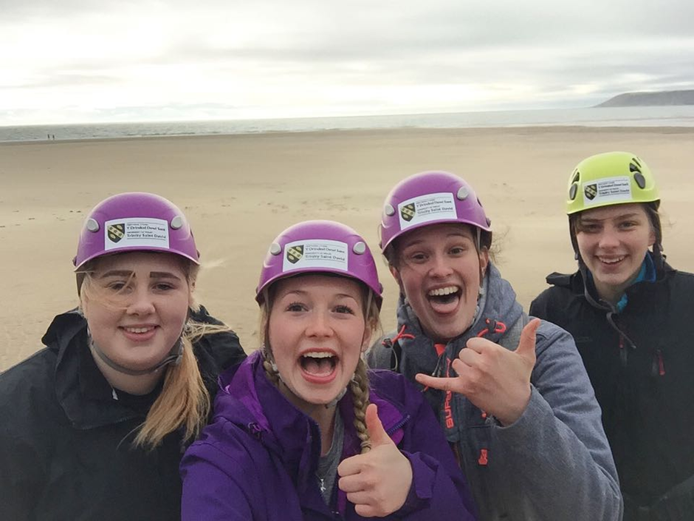

Lyme Bay Synopsis

The weather has been the key source of disaster in recent years. The Lyme Bay disaster of March 1993 was the catalyst that formed the Adventurous Activities Licensing authority. Many factors and events caused the incident to occur, even a year before the tragedy. This trip was intended for sixth form students, who were all novice paddlers with little experience aside from practicing in a pool. In this regard, the three mile canoe trip from Lyme Bay to Charmouth- in conditions not suitable for canoeing- the students were unaware that they were in a situation they were poorly prepared for.

When planning the visit, Ray Baish, a teacher, visited the location a year before. Overall, he was reassured by the confidence of the centre. However, he was not informed of the qualifications or the competence levels the instructors had in the canoeing department. However, John Ellis, who was the group leader, approved of Baish’ recommendation and was also positive. The instructors (Anthony Mann and Karen Gardener) apparently held a British Canoe Union 1-star qualification but did not have the training or competence levels to take people to sea. In fact, none of the instructors had the right qualifications or the right competence levels to take students canoeing inshore. This centre was also not approved by the British Canoe Union.

British Activity holidays centre also examined the centre. They accredited the centre a year before. However, they did examine the land based and pool activities but not the canoeing facilities within the centre. The people who examined the centre had real concerns about its competence but did not report to regulatory body as there wasn’t one at the time. The council also gave permission for the centre to do canoeing lessons in the pool during inclement weather. However, at the time of the event, the Southway group ignored this suggestion and canoed away from the pool. A year before the event, another report (Greenfield and Osborn, 2013) found that 2 of the instructors resigned, due to the safety of the centre and the equipment provided. The company did not respond to these concerns and the manager, Peter Kite, ignored the concerns.

During the week of the event, the students engaged in capsize drills in the pool, but they did not cover the techniques to re-enter the pool. The staff at the time gave little attention and they did not recognise the groups experience. On the day of the tragedy, the winds were recorded at NW 3-4, with the sea slight to moderate the visibility was good. To the west of the harbour, the wind was apparently recorded at WNW and the sea was choppy, an early indication that it was unsafe to canoe on. Another group from the school, doing another activity out at sea returned as the conditions were too rough. None of the canoes were fully equipped. None of the student’s canoes had deck lines or any buoyancy aids. The students only had wetsuits as they requested some and a few had efficient life jackets. They had swimming costumes under their wet suits, despite the 10-degree weather with the heavy winds (Greenfield and Osborn, 2013). They also carried no flares and it was only the instructors that had spray decks.

The teacher who accompanied the group at the time, Norman Pointer, who was also a novice, was given the wrong type of canoe for a novice for sea. It was suggested that the activity would take an overall time up for 2 hours. At the start of the activity, one of the students capsized, but soon re-joined the group as they were in shallow water at the time. No advice was given into how the group should have been set out or organised. Norman Pointer then capsized. Anthony Mann brought him back up, but soon Pointer kept capsizing. Pointer suggested to go back to shore as the group was still in sight and was slowly beginning to disappear from the Manna and Pointer. Mann suggested that he carried on. Mann and Pointer were unable to re-join the group as they eventually disappeared out of sight.

Later in the day, as the weather was starting to worsen, students had to hold on the each other’ rafts as there was no deck lines to tie each other’s rafts together. As there were no spray decks as well, the rafts slowly started to fill with water. The canoes on the outside of the group filled with water, they were soon capsized, and the canoes were left abandoned. Soon all canoes were filled, capsized and abandoned. The winds kept shifting and they strengthened in the late morning, a sign that they should never have done the activity as the condition were poor; especially for novices who shouldn’t have been out there in the first place. 9/11 of the canoes that went out on the activity capsized. 9 of the canoeists were in the water. 8 of the canoeist’s life jackets were not inflated. None of them either wore a helmet. This would result in heat being lost through the head. This would also mean that they would be virtually impossible to spot from the shore. Overtime, the group would start to suffer from hypothermia and exhaustion. The canoes were found 1.5 miles from the shore and from the harbour. Other reports found that the survivors drifted 8 miles out to sea (Eves, 2016).

The group were rescued but later in the evening, 4 of the 11 people that went out to sea sadly lost their lives. It was later understood that Steven Gynes suggested that Karen Gardener (instructor) had more ability than she gave herself, but Mann gave more confidence and competence to what he had. If Karen Gardener showed a bit more confidence than what she had to offer, maybe she might have suggested that the weather conditions were too poor to travel on, or the students skill levels were not good enough to be canoeing out at sea, having their only experience been in the pool. It was also understood that Pointer told Mann to blow the whistle to get everyone back, but Mann refused to do so. The company was prosecuted for corporate manslaughter. The director of the centre, Peter Kite, was jailed for 3 years. The manager at the time of the disaster, Joseph Stoddart was acquitted, after the jury failed to make a majority verdict. When the HSE (Health and Safety Executive) investigated the tragedy, the main root that caused all of this was the lack of organisation to supervise the group, to provide suitable and qualified staff, for the specific activities undergone and to have prepared safety procedures for when the event like this occurred.

During the court proceedings, a conviction of manslaughter was secured after a former employee named Joy Cawthorne, gave evidence that she previously warned the centre months before the tragedy occurred, that a disaster would be imminent, if the centre continued to be disorganised and an hazard risk towards the community. She resigned 3 months before the tragedy occurred, due to these concerns. She also described the confidence levels of the manager, Joseph Stoddart during the court proceedings. She would describe him as a disorganised and trying to keep up all the time. When Miss Cawthorne had realised the very low standard of safety equipment, she complained to Mr Stoddart and he didn’t like it. This was because simple safety equipment such as first aid kits, flares, tow ropes and waterproofs were not even provided. Mr Stoddart told Miss Cawthorne and her boyfriend, Richard Retallick (also a former instructor) that they were both paranoid and that the safety equipment was fine. She didn’t want to be working in a place where the potential of losing someone would occur and having to have that on her CV. She then resigned and the tragedy would then occur. Following this tragedy, the Adventure Activities Licensing Scheme was to be introduced 3 years after the event took place, in 1996. This was a government sponsored scheme, enabling companies that provided adventure activities, for people under the age of 18 to have a license to operate, if their safety management system was satisfactory. The HSE has full responsibility for regulation of the scheme.

Overall, the group were taken to see poorly clothed, they were inadequately equipped, and they were guided by instructors whose competence levels were nowhere near the standard for those students and the type of activity. Having known the conditions of the sea and the surrounding factors, they could have called the activity off, just like what the other group did. The conditions worsened and when students and teachers began capsizing, they ignored the sign that they should have turned back. If the instructors and centre knew and assessed the weather, this tragedy may never have occurred, along with other factors such as poorly equipped and competence and confidence levels of those involved. This event should have been called off during the week, given the levels of the students beforehand. The students only experience was in the pool, where the water is still and shallow. Going out in the sea was a big mistake as the waters were cold, the wind was making the conditions terrible and their skill level was nowhere near the standard, so the instructors competence levels were nowhere near the standard, for them to notice this. Other organisations and groups assessing the centre, didn’t address the lack of safety equipment, resulting in these activities to take place. If the organisations examined the centre and furthermore, disapproved the canoeing centre and their safety restrictions, then maybe this tragedy would never have occurred and instead would have been improved and examined again, until it was appropriate. Finally, the students may have been saved earlier, if the helicopter was directed out for a sea rescue but was given a poor report of the event that was currently happening. Many factors led up to this tragedy and most incidences should have been handled in a different and more effective way. Unfortunately, the weather on the day was the final and critical factor, that led to the tragedy.

References
Eves, D., (2016). Disasters: learning the lessons for a safer world. Routledge.

Greenfield, S. and Osborn, G., (2013). Law and sport in contemporary society. Routledge.

