Aza Zaheer
1710460
Strategic Management
SBMA 7103-LON
Assignment

Introduction
The company chosen by me to do my strategic analysis is Galyons Kitchen and bar. The bar offers a family friendly relaxed atmosphere with the choice for food to cater for all clientele. Whether you would like a burger from our bistor menu or try our chefs fine dining restaurants room there is something for everyone here at galyons. The selection is excellent. Dining options: Brunch, Lunch, Reservations, Seating, Waitstaff, Wheelchair accessible. There is a discount rate for students. A welcome contribution to the boom times down London’s Docklands one must not forget the Reach’s well stocked bar. It is a beautiful and historic pub and accessible to me. Also, it is a Riverside location relaxed ambience, friendly and welcoming. It keeps up with the upcoming events as well like Valentines day, or Bridal shower or come to attend live shows of football.

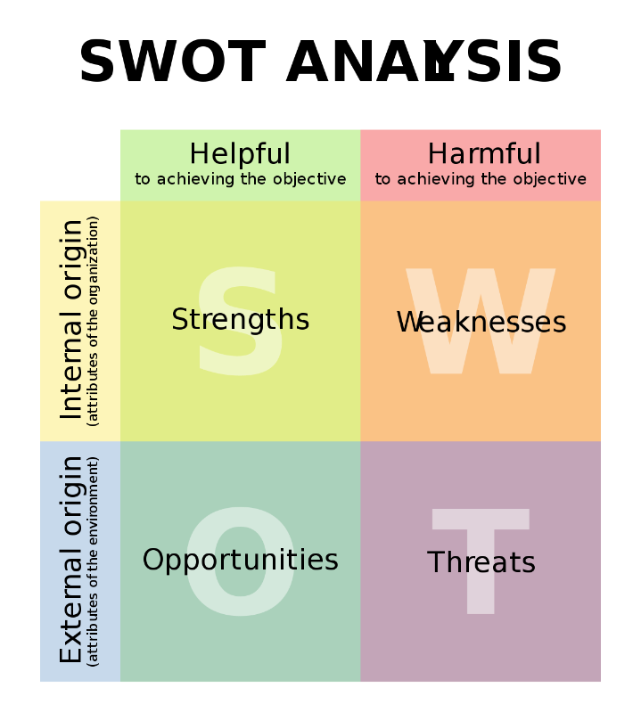
Achievements
Tasty food is the strength of the company’s what they do the best. What becomes a memorable experience becoming the décor and what results eating enjoyable. Other Good points could be the pricing structure for example offering lower priced menu as compared to other restaurants. Slogans such as have two meals and have it before 5p.m. generating traffic of customers when time is slow. The restaurants experienced 3 years of Indian Cuisine all across India. Facilities for free such as WI-FI, space for parking, ordering online, delivering quickly, the interior design being convenient, easier to reach the location. The exterior from outside being tidy and clean. The prices being cheaper against the competition. A new style of servicing in the premises. Offering of a product which none of the restaurants give. The image being a branded one. The menu having the availability of a vast amount of choices on the menu. Employment of an efficient skilled workforce.
Shortcomings
Negative points offered to be stated by turning attention towards the restaurant. Staff awaiting could be one of the weaknesses of the fast food arena. As you rely on them the as the work procedures they provide to you straight away. Some of the other weaknesses could be if one fails to service training, for example exemplifying and showing personnel the ways to prepare food and also its presentation. Inconsistency of supplies which lead to menu item unavailability. Keeping track of recording orders and making stocks through that way and by depending on sale done on basis of system on point which is outdated is a weakness. A firm not knowing rules and laws, management being of weak service poor quality is a bad point. A restaurant having no sources, or stores, flow of cash being poor is a weakness too. For example the fast food one own is totally in early stage of development and unestablished. The funds being provided are limited. Offering something that is much there beforehand. Not having a takeaway. The amount of time spent towards the outlet is much greater.
Chances
Go for chances that assist a profit increase which could be an expansion of several kinds of materials of food and drinks. Making use of changing trends towards consuming hygienic food could mean bringing the attention of healthiest food like salads dressed, or dishes containing organic food. Afternoon provision of providing food could lead to growth timings. Letting people have goods such as salads made of dressing, goods after being baked so for individuals to purchase and have a get thru is a foreseeable chance. Properly delivering and encompassing requirements of people cold be another opportunistic point. With more opportunities coming in people forming partnerships with separate business and margins of high profit. A complex which has just recently opened. Development of housing has been built close by. A competition of an important nature has finished up. A free building is available as an extra option Poole, Kennedy,Oliver,Roderick,Paul,Fallowfield,Hayes,Parkers(2017)
Dangers
If you have similar types of food which is sold by a nearby business is a threat. People have more options to spend their money somewhere else where new type of restaurant are opening. One may give up their business just in case something wrong turns up in dishes of seafood like a shrimp. Competitive price with other rival groups customers coming up with poor testimonials. Factors of production have risen prices such as liabilities. Change of law in Britain, motives, taxes. A sudden increase in rent could take place if your organization is up for lease and at the same time a brand of street with high nature has moved subsequently to the area Cacioppo (2014)

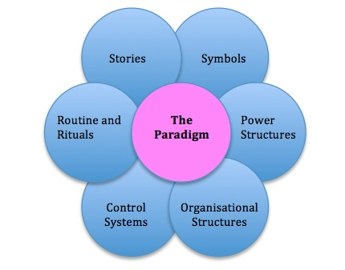

Routines, Rituals
Checking in or checking out i.e. bidding farewell to people visiting the hotel or are being welcomed with relationship to hotels can be routines. Operational dealings consisting of jargon in daily timings is to do with routines. At my hotel such requirement is emphasized where guests requirements are being fulfilled. Making employer’s assist those who are new to the company. Where working with the team kind of culture is promoted and everyone is given a chance to share. Letting the system of budding staff training and skilling on multi basis is done.

Rituals: - Those kind of actions where main beliefs and values to do with culture are maintained. At Gallyons Reach meeting to do with consultative staff ensures that all the main events are informed to the members of staff along with decisions on operational basis or important diversification. Ideas are taken from workforce through these meetings in order to carry out improvements. And also take help from employees in decision of making in numerous tasks.
Value to do with culture being reinforced and could be reminded through taking place of ceremonies which are perceived to be a celebration. Employees being rewarded for fulfilling the expectations of guests who as well as attain feedback which is positive. This is done by recognizing them formally. Being under communication by holding the meeting for performing quality vise is done too. This encourages other staff members to exceed their services they are providing and improve the morale of the team by holding ceremonies of such nature.
Tales.
What matters for the organization stories tell. Essence of past of an organization is filtered with essence. By telling about the personalities who have been rebellion, villainous, or heroic or giving a highlight to events of important nature to members of staff in other sectors t people who have just started and are from outside also to other level of workers too. The main management encourages members of staff to take additional steps to please the visitors of the hotel. It could be a comment stated by guests in which position a problem faced by guests converted an issue into a chance which resulted in good quality performance by the employee. Review from a website which is popularly rated is foremost example of different stories. That are narrated to hotel visitors. Regarding their stay or any sort of problem faced by them and resolved emphatically. Stories tell about the structure of power within a firm about important protocols complying with not fully completed from what the anticipation was. Stories help in collection of information and belief generation and are guardian of beliefs organizations. By telling things about the company they can use this tool to show they are different from their preceding competitors. The reward was highlighted for a General Manager of the hotel who was actually a Porter at the Kitchen., This was because he adopted beliefs of the company as well as the values also following the important behaviors as expected from him
Signs
To be identified companies’ symbols are utilized in a complicated environment of marketing. The form symbols could take shape of could be to do with actors, models, occasions referred traditional, occasions of celebrations, code of dress, monuments etc. To advertise building pictures are used. Quality of symbol is regarded so staff are intended to look like clean and tidy with attractive appearance and well-groomed too. Objectives of strategic nature and operational too are promoted with a symbol stating quality of top class and service of excellent type were quite often implemented at Gallyons. It could be that such phrases could be interpreted in different ways. These terms however need to have a proper understanding otherwise it could cause serious linkage problems. The symbol of G.R. is everywhere told and recognized globally whether it be tissue papers, toilet accessories, bills of guests etc. Reinforcement of the statement mission is done which is to foster an experience of core commitment to all customers all the time as well as to store it in the minds of people and public in general.
Structures of power
In order to lessen non-certainty power has been focused upon in companies and the ability they carry of within its own context. Customers would not be cared for if staff are not a useful resource. Where looking after guests is most important quite a lot of strength lives within the resource of humans.
People striving towards achieving objectives of a corporate type are specifically important to the staff who retain and select them. With properly formed interviews and intellectual, intelligent raised questions and tests a single members of staff is selected all of whom are prematurely though to select people with the correct nature and persona who concentrate hard on their job and work diligently.
Each and every individual working for Gallyons have power. Members of staff are involved in forming decisions and to provide aid in timings when the reputation of the hotels is at stake. Some criticism has been given to such labels to empower the procedures by the management. Critics which says democratization of workforce and participation of workforce are such labels which are every of leading an end wards approach but should be exploited clearly.
There has been quite a lot of positive implications on because of the approach of culture has been used. These effects were reduction in complaints by the guests, responsibility feelings been propagated amongst itself leading to reduction in the turnover of staff. Reputation being held as food, good and improved quality impression of service coming from the team’s side.
Organizational structures.
Improvement in delivery of service and wooing expectations of guests and to monitor the own service provided performance is completely relied on. To attain satisfaction from guests, and revenue returned because of improved work performed at destination because to generate motivate and satisfy what is actually emerging from healthy competition being generated. Levels of hierarchy being few with a structure of flatter nature are preferred at the Hotel rather than structures which are hierarchical and comprise of procedures and policies. This helps in workforce working integrated and to quite many times provide help in coming up with solutions, to improve service and efficiency of business.
Control Systems.
Not only behaviors of staff members is paid attention to but the focus is given to service quality and to be able to meet expectations of guests. It is through training that behavior is informed and told to. Trained staff is inducted and educated and from beginning are told to behave cordially and welcomingly with the guests. This is like a challenge to attain the benchmarking of audit system and since the very commencement staff is guided on giving gestures which are of provisions of service of good quality Quattrochi, Jason (1981).
People can only be engaged in coffee business if they go hand in hand of corporate objectives. Their refresher trained staff at the front are young, nice unique personalities. To make them feel wanted, appreciated is foremost. This is the intention and for that they are cautiously selected. Scope for pinpointing role of job and encouragement of progression of career is the method recognized to tell about employee’s contribution to the better running of organization. This inevitably results in performance of employees in a fruitful way. Showing loyalty and commitment and progressiveness. Restrictions are not given importance around the business. Employees are motivated to be encouraged and creative Ellis (2006).

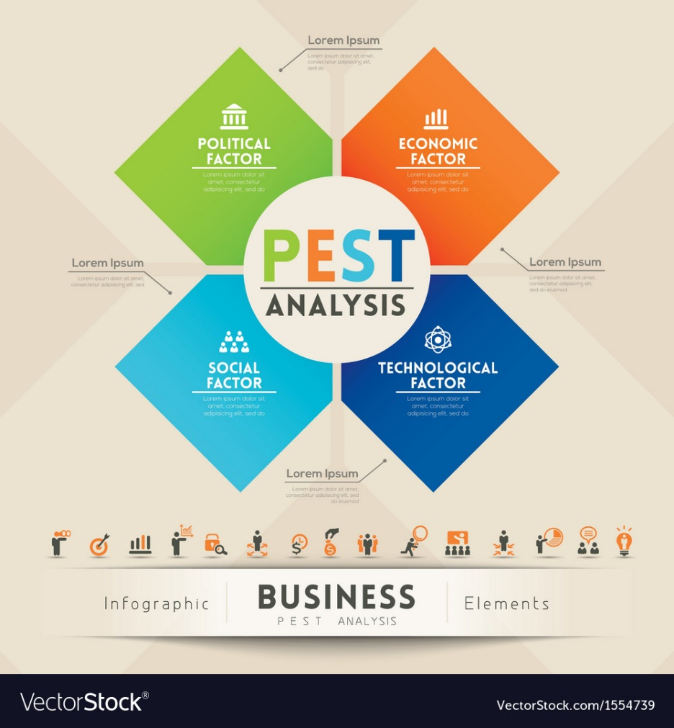

Analysis of a PESTLE to do with the restaurant.
Considering a restaurant of a hypothetical type, lets get it done. Regulations to do with health and reforms of tax could lay an impact on the restaurant, regulations to do with health and taxes have been determined it results in affecting the business that one has. And could let one decide the reaction how its going to be. For restaurants to receive rating of highest kind one has to set the code just in case the system grading with health is going through change.
Policy of Government along with changing of reforms of laws to do with licensing. Wages and salaries being affected because of wage with minimum national being increased. Drinks that are measured regarding influence of legislation and EU. Health regarding guidelines of Government to do with nation and EU. Aspects to do with drinking hinge which are negative and concerns which are to do with Government of National and Local type. Alcohol being on duty leading to an increase in budget. Regulations of various types concentrating on improving people’s health from period to period is because of the influence government has on the business which is because of the industry of restaurant of having an impact greatly through political factors.
Laws of labor being followed, taxes with rules being followed, there is a need to look at the cleanliness of the restaurants.
People could suffer protocols from levels of cholesterol and obesity and issues of stomach because of which food quality and ingredients are checked.
Restaurants mostly failed to take care of their kitchens where food is cooked, and dishes are washed to keep the place neat and clean preservation of food is also done. For maintenance of food standard for stability of policies and imposition of tariffs the government levies some laws of employment and employee’s safety rights for in order to regulate regulations of environment to align with the policy related to environment is done.
Economic: A business can be affected by many exteriors made factors of economic nature, the economic scenario of health and wage of minimum type will together have an impact upon the restaurant. It is hard to control such factors but luckily one can assess and respond back accordingly. One might have to work out to how many employees one can afford if the wage does go up. Socializing income of disposable kind is low although downturn economically among several factors has taken place. Due to increase in wage and increase nationally could lead to an increase in wage. The price of alcohol in promoting it in the supermarket could offered at cut. Increase in pricing of fuel is costs of transport. The industry running business could be affected because of policies to do with fiscal type governed by government. The item of food rating system could be enhanced and that is going to happen if the taxes are imposed on items of the consumer. Profit marginalization could be minimized because of items of foods, rating investments being increased. This is all simply because of the increase in prices of the food products which is simply because rate in inflation has increased.
Various outlets in countries can suffer from a negative impact that is because of the changes economically happening in different countries.
The industry could go through great threat because of the slowly stabilizing expansion across the country economically. The present industry can be successful if economically it is strong. Because of the improving situation in Europe the chain supplying food restaurant is getting to be stronger.
Social
On the restaurant there could be an impact socially and culturally. The policy of bathroom could be affected because of customer being transgender and being greatly accepted. Only two instances of social and cultural factors are outlaid. To do socializing and meet up with friends a place to practice life socially. Easy to approach as pub is situated within the route mainly. Lively atmosphere with music, nights with themes, place for gigs for younger aged consumer. When demographically locally the student population is at increase. All the negative activities being brought under concern. Concerns to do with health being raised. Responsible consumption of alcohol with more advertising on vast media being done. A variety of choice to choose from supermarket of drinks with alcohol readily available for customers. People are getting to be more educated and knowledgeable with increasing consciously health vise with products of food. A look into good made food with the growth in population is an important factor as with population increasing the number of restaurants has also doubled. People check the products of food, used in the preparation of food. This has increased the awareness of people with regard to products of food. Where people expected to be treated with healthy food it is done so but where people are looking for food with fat, the restaurant offer the food of customers choice. People do wish to drive out and go to restaurant which are opened for that very cause.
Technology
Technology always impacts your business. One can rely in a modern system of computer and don’t need paper, pen as per expectedly waiters or can decide to pay by smartphones. Cold beers and ale of chilled nature develop. Nightlife being promoted through media, web internet and networking. Restaurants popularly use IT, television to publicize. To get the attention of customers if informing through advert is expensive restaurant can browse website. This way one gets to have information online. System of inventory in order to keep client updated. Incentivizing clients sending SMS about their well-known chai are also used. The automation of business is also added with some popular chains carrying out R&D actions. Delivering at doorstep has increased and is profitable. By contacting on phone, digitally, online after placing an order, restaurant gives back the product right outside your residence quickly.
Environment
Reference to environmental ecological issues is done which affect the consumer of the restaurant business. Food is nutritious, and regulations have been passed out, with a number of rules to provide healthy food to people. Strategies of sustainable quality along with corporately arranged environment procedures after being monitored are adopted to advance the business organizations. Other than that, changes in climate is a memorable point of industry restaurant business. Atmospheric features are a developing concern and these issues of environment are to quite an extent increasing. By following the environment legal framework of protection businesses could be made to be aware of such threats of environment and resolve the problem of environment and contribute towards securing it.
Legal
-Ban on smoking
-Regulation imposed generally in a strong manner upon drinking at a lower age
-Drinking while driving Rules being charged
-Legislation passed or drinkers being served
-Factors based on legal matters.
-Agency of Government supplying product of food based on quality
-Rules specifically have been implemented with passing of regulations to manage the provision of food in the bazaar Stafford (2003).
Employees welfare, salary concern also forces laws other than the food. For creation of a law heeded environment rules are followed specifically in an area. Food quality has to be high with taking care of employee’s welfare.
Environment
Carrying out recycling, manage the garbage, waste under production being refused within an area located. Showing concern for deliverance upon costs of commodities and how to deal with the transportation Habermas (1991).

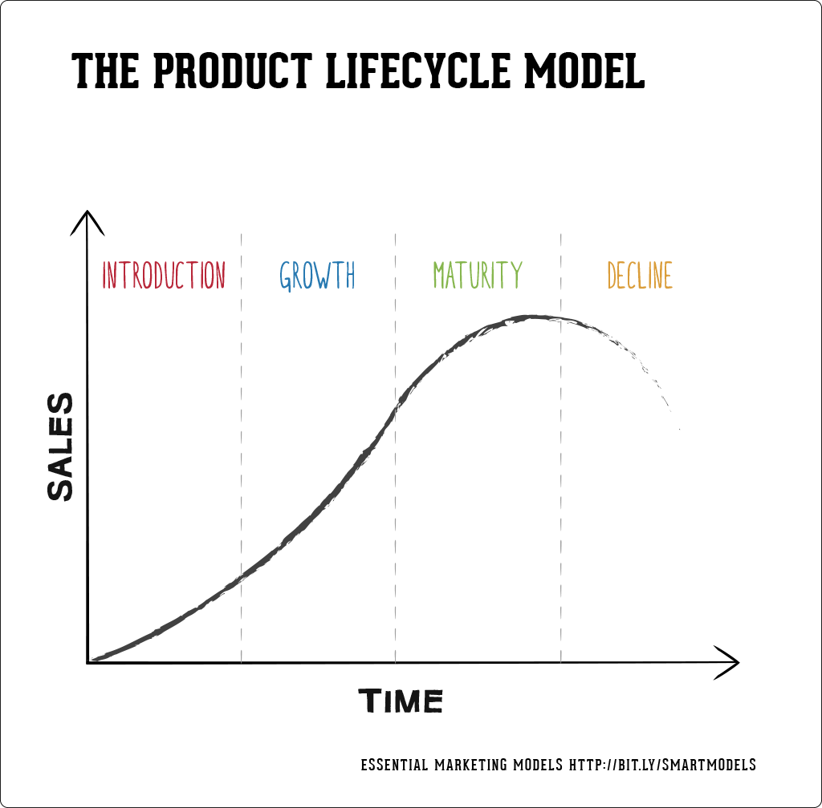

The model on the Life cycle of the product
Stages sequenced from beginning to development to being mature and the declining is a progress a finely finished product makes. It is confronted through challenges and is known as life cycle product. Therefore leaving an impact upon mix of marketing and strategies of marketing and the firm and its parts of its own self as well. One can deduct revenue, and gains through this product life cycle.
Stages of Introduction.
Awareness is produced seeked for, market development takes place. Branding of product level of quality is maintained, Protection of psychological property for e.g. patents accompanied with trademarks are achieved. To establish share in the market penetration of pricing is low when costs of development are to be recovered pricing is skimmed on high basis. Selective distribution is practiced with getting agreement with regards to the commodity from the buyers. Consumers who adopt early and several innovators are targeted for promotion. Education of a particular product along with building awareness of a product are thought provokingly seeked by doing communication in marketing style.
Stages of growth
In this section preference of building brand and share of market vice versa is looked for. Quality of product with features added services rendering support occurs. With no or less competition price is set with a firm enjoying an increase in demand. Channels of Distribution are added as there is an increase in demand with the acceptance made by the customers of the product. Audience are aimed with a broader perspective to enable promotion take place.
Steps of Maturity
There is no more growth taking place at this stage. It is aimed to protect share of market in order to maximize asset gains with competition taking place amongst similar goods and outputs. One can differentiate the goods by enhancing features of product as compared to competitors. With an early bright competition price charged could be lower. Incentives could be provided to encourage selection of preference against competitive product with distribution becoming greatly diverse and mature. Differentiating product could lead to promotion.
Stage of Decline
There are several options available with the declining taking place in the firm. Product maintenance with altering and making new changes and exploring rejuvenating ideas to use it for new reasons. By targeting upon a niche sector doing its harvesting ,costs being minimized and construction of offering it. Taking the inventory and liquidating it or giving it away to a separate firm however finishing the continuation of the product but enabling it to start its continuation in another business company as a product itself.

Characteristics, of introduction, growth, maturity and decline stages.
Product is brought inside the market. A gradual increase in its growth, Profit is not achieved and is nominal. No competition as such. Promotion is done in order to stimulate and make consumer aware, thus increasing demand of the product. The product being new with no source of quality range of price it gets to be distributed in the market. The costs are at an increase, sales slowly volumizing to begin with, hardly any competition, creation of demand, prompt the customers to test the goods. Earning little cash.
The product being already available in the market. Consumers have a habit of using the product. Since the product under trial growth is quick. Customer satisfaction from repeated purchase. Crowd of products produced from the competitors being more attractive and appealing. Leading to reduction in costs levied and competition at an increase.
Economies of measures reduction in costs, increase in volume of sales, A rise in profits, public awareness, fresh participants entering the market the competition at an increase. Higher the rivalry ,lower the price.
With product experiencing curve implications, the amount of quantity of product at an increase, the price of the item is at decrease. A lot of competitors seem to exist in the souq. Consequently, sales are less and hardly any buyers are left. Product seem to decline. Profit is low/ranking of cost upon attainment of forthcoming purchasers is great. The marketing procedure seem to decline because of brand segmentation and it being distributed and promoted efficiently.
There is saturation in the market, but the volume of sales is at peak. With increased competition prices drop down and competition seem to further increase. Industrially gains are minimized. Market share is predominantly stressed upon with creating different brands and diversifying its features Strobeck (2013).
As the product gets deleted from the upfront of the market, there is lesser amount of proliferation of profit coming in. The flow of cash is stopped, and the growth of the products seems to be stunted. No point in doing advertising. Costs sales, profits decline, it is a challenging situation. In an ongoing business product life cycle my product coffee shop went through introduction, growth successively maturity and then exceeding the decline stage respectively Maurin,Chester,Janufeerally (2007)

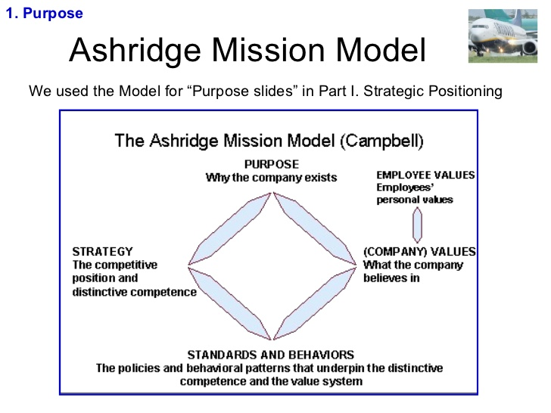

Ashbridge Matrix Model
The organizational Purpose
Shareholder being benefitted by the organization with decisions planned out strategically tend to be focused on achieving returns from shareholders. Satisfaction of all stakeholders is done by all organizations. To behave in a responsible manner toward entrepreneur and stakeholders that’s what company try to commit themselves to. Whether they do it because it is the right thing or reasons based on being altruistic. Organizations of such a type are alert of satisfying their shareholders staff, consumers, macro-atmosphere. Organizations aiming high will keep and contain passionate workforce.
Quality food being served at even prices
People prefer eating food made of organic, ingredients increasingly restaurants are focusing on that. By providing healthy food one is enabling farmers to keep their occupation and one tends to be experiencing the pros of providing organic food because one is making an offer of newly produced meats instead of frozen food which does not taste better. One is able to earn higher costs on provision of ongoing materials, but people nowadays are choosing this type of food going for hygienic choices. It is however driven that the menu on offer is an evolving one.
Environment and Ambience.
Other than doing service of good food there is much more to doing just that running part of the business. Customers are impressed with what they are served which includes atmosphere. As a result, this appropriate feeling of being attended and replied in a good way leave them being relaxed and customers repeatedly visiting as well. People with different preferences go for different options. Some people opt for noisier and some people want quiet scenarios of restaurants.
Having a know how of market you wish to target.
Going for the correct ideology, looking for the adequate locations choosing appealing demographic are quite main categories, which decide if a restaurant is a success or failure. If one is interested in catering towards the people coming for lunch or other forms of groups of people.
If one is more interested in people over there for dining or just people, there for hangout. If one is more attracted to citizens who are senior or are fans of music. It would be sensible to consider whom one is trying to target and have a knowledge of what expectation one as visitor has when making a tour to the restaurant.
Relations to do with customer.
It is quite hard to satisfy each customer but if one attends an irritating diner it will let one’s business flourish. It is to be confirmed that employees should know how to get involved with their visitors, that relies on who the aimed market is. They should be dressed properly and if somebody lodges a complaint the manager of the restaurant should emerge and attend to it. One’s restaurant would create a plus point image even if one is polite and courteous even to a rude customer.
Values of core nature
Dignity
Everyone entering my restaurant is treated with respect whether it is my staff or guests. Highest priority is given to letting the memory be a memorable one and their welfare had been looked after.
Hospitality being an excellent one.
Each morning customers are treated with energy, information and lust and compassion. Hospitality being shown and gracefully honoring the guests.
Connecting culturally and in an authentic manner
The restaurant tends to honor the guests traditionally with the provision of art, food and recreational ambience. Foods with rich culture served and prepared deliciously is provided. A whole lot of history with innovative ideas is created. A unity-oriented atmosphere is established with mutual coordination being shared from our relishing experiences.
Family and Team work
The restaurant has a supportive background. Perceptively the whole staff works together effortlessly like a community and a family. Being responsible ecologically and socially. The practices my restaurant company performs are sustainable. It tends to generate supportiveness and incarnate a socially environmentally friendly society by being more giving, make use of opportunities and by being direct Wild (2004).
Sustaining economically
The restaurant gains high on making an investment with reduced risk and sustaining operational work. It works upon generating progress and advancement and build a constructive place of work and that what it sets its belief upon.
Standard of behavior
Greeting of customer is a warm manner is what is expected from the staff no matter what the circumstances. Employees interacting in a professional manner. Without disrupting the overall workings going on employee should watch their mannerisms. Customers complaints are being dealt with. An employee should resolve a problematic situation in a genuine manner.
Standards of kitchen
Costs should carry out their jobs in such a way which leaves a customer contented. Kitchenette should be well maintained and should strictly follow codes, rules and regulations. Of food and should accommodate when it is busy Topik (2009).
The standards of conduct.
The code to be adhered by hostesses and behaved upon should be permitted. No bullying or gossiping should be allowed. What states hygienically the restaurant should be in. Staff should be made expert in building a clean environment especially when handling of food is done. Must be equipped with hygiene of food to be kept in order to do the job Topik (2014).
Manners.
Etiquette, behavior should be super normal for a great eating out experience.
A business of food and its plans.
In order to behave naturally and logically strategy has to be implemented. It depends if a company wants to be internationally recognized it should define its competitors, its relevant position what advantages competitively. What sort of plans it has. Maybe reach out online, on a website through emailing. Share your data research, go for social media. Work out how to set into a marketing arena influentially and professionally. Also, how to position yourself environmentally and competitively National Coffee Association (2018).

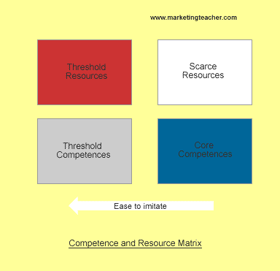

Competencies being linked to Resources.
Revision of necessary nature.
Belonging, assets, name of brand, employees’ skills, resources of two types-tangible, intangible. Practices of best type, proper machinery resources, both industrial and natural. Constructive structures, halls of food. Rights of property, network distribution, labels and trademark how expression is diversified.
Resources being unique
Technology participation, tools of tactical elements of unique type with techno- produce being of an expert nature.
Competencies being at threshold.
Atmosphere of a healthy kind, services, venue of hotel, toolkit equipment, system responsible for production, important relevant network.
Competencies being core.
Belief of customers, working as a team, linkage, being adaptable, being reliable, motivating. Respect and regard, taking an initiative, standards of working, conduct codes, solving problems, disciplining, service to customer being an apt one. Being creative, advertising, promotion, type of quality.
The Web to do with Culture and Model of Asnoff bridge (Analysis done critically).
-Happens to be a perfect method to recognize culture of a particular organization
-Ashbridge tool assists in thinking with regards to its mission in a not very confused bewildered way.
Takes under notice all aspects which are morally significant. With the help of older analysis done by deriving the model and calculating results beforehand, resulting in working out of new formulated dimensions /directions or results Order (2015).

Recommendations
Starters should be provided, accomplishing needs of guests is pinpointed. Must have the ability to retain customers and not loose them because of rigorous competition. Targeting young customers for a long period of time is to be practiced. Customers must be given attention, treated in a friendly, prompt outstanding manner. Consideration of how to serve diner is provided follows.
One should be welcoming, should provide a comfortable atmosphere, and give complimentary things like prawn crackers or finger sticks. Be present to answer guest questions. Be quick in making and placing an order. Must serve hot food, offer refills, handle concerns, offer dessert if required. Clean the dishes, be thankful and wish goodbye.
Conclusion
As a result, culture of coffee is influential, people come to try new flavor, people who can afford coffee are demographically young, concentrated rehabilitated urbanized go for coffee drinking. No more a commodity but a luxury. People go for brands and stores with specialist nature. People prefer flavor over price. Experimentation is processed forward, people can have it while shopping. It is a unique, raises concerns regarding health and is environmentally friendly by selling it through plastic followed by recycling. Also labels of it being nutritious promoting it through schemes with return on deposit leads to an informed decision making. Hot drinks like tea is an option, empty nesters, people aged between 18-44 ,couples go for coffee and is much liked after meal. It’s a meeting place for friends, pub being the most important and distinguished settlements. Landlords can compete to attain these appealing restaurants with the quality of coffee being a remarkable one. It is inviting both genders equally attracting them on solid grounds. Budget is spent to give away chunk of coffee to partners, elderly people too to generate expenditure. Growth and development have taken place in hot drinks business. Investment from overseas into UK is expected. Some have joined the grocery section. People who are conscious of their health can choose mocha, iced tea or coffee. Customer service in a modernize way is provides. Features like instant coffee, design of the shop, tidiness, staff knowledge product are intrinsic to coffee shops. To establish a base of customer exposure of brand is built. As the employment is growing shops offering coffee are converting into breakfast, lunch areas.
By doing research, forecasting, making perceptions coffee shops can expand. Different roasts and product offer different resources of coffee, the wide variety of coffee making it a strength.

References-

1)Cacioppo J.T and Cacioppo S. (2014) Older adults reporting social isolation or loneliness show poorer cognitive function 4 years later. Evidence Based Nursing, 17:59-60.
2)Ellis M. (ed.), Eighteenth-Century Coffee-House Culture. London, Pickering & Chatto, 2006.

3) Habermas J., The structural transformation of the public sphere, The MIT Press, Cambridge Massachusetts, 1991.

4) Maurin, O.; Davis, A. P.; Chester, M.; Myungi, E. F.; Jaufeerally-Fakim, Y.; Fay, M. F. (2007). "Towards a Phylogeny for Coffea (Rubiaceae): Identifying Well-supported Lineages Based on Nuclear and Plastid DNA Sequences". Annals of Botany. Oxford University Press. 100 (7): 1565–1583.

5) National Coffee Association, ‘The History of Coffee’. Available(2018) at: http://www.ncausa.org/i4a/pages/index.cfm?pageid=68

6)Oder, Tom (June 9, 2015). "How coffee changed the world". Mother Nature Network. Narrative Content Group. Retrieved June 8, 2018

7)Poole, Robin; Kennedy, Oliver J; Roderick, Paul; Fallowfield, Jonathan A; Hayes, Peter C; Parkes, Julie (2017). "Coffee consumption and health: umbrella review of meta-analyses of multiple health outcomes". The BMJ. 359: j5024. doi:10.1136/bmj.j5024.

8) Quattrochi-Tubin S. and Jason L.A. (1981) Enhancing social interactions and activity among the elderly through stimulus control. Journal of Applied Behaviour Analysis, 131:159-163.

9) Stafford T. (2003) Psychology in the coffee shop.The Psychologist, 16(7):358-359.

10) Stroebaek P. (2013) Let’s Have a Cup of Coffee! Coffee and Coping Communities at Work. Symbolic Interaction, 36(4):381-39.

11)Topik, Steven; Pomeranz, Kenneth (December 18, 2014). "3.3 Mocha Is Not Chocolate". The World That Trade Created. Routledge. ISBN 9781317453826. Retrieved June 8, 2018 – via Google Books. Although Coffea arabica appeared in a native plant in Ethiopia, the coffee beverage was probably developed around 1400 in the Yemeni city of Mocha.

12)Topik S. (2009) Coffee as a Social Drug.Project MUSE, 71:81-106.

13) Wild, Antony (2004). Coffee: A dark history. Fourth Estate. pp. 217–229. ISBN 9781841156491

