Jacob Evans (2311160)
2311160@student.uwtsd.ac.uk
10/01/2024
Introduction to Web and database concepts (acca4023)
Assignment 1
Contents
Introduction 2
Requirements 2
Implementation 4
Validation 8
Evaluation 9
Self-evaluation 12
References 17
Appendices 17
Appendix A - Index.html 17
Appendix B - Sundowning.html 19
Appendix C – TPWBYT.html 21
Appendix D – TMBTE.html 24
Appendix F – News.html 26
Appendix G – Store.html 28
Appendix H - Jakescustom.css 31

Introduction

This is my attempt of creating a webpage based on my favourite band known as Sleep Token. This report will contain screenshots of my webpage and the HTML and CSS I have made to create this webpage. I have created a navigation bar to each page, included the band logo (a few times), includes album art and albums songs/details.

Requirements
The website was created by myself to showcase my favourite band Sleep Token. The purpose of this website was to provide history/about the band, about the albums they’ve made as well as the the merch they sell and any upcoming news/dates. The intended target audience would be those who already know of the band, as well as a website that can be shown to people who have not heard of the band. When people are to ask, “What is your favourite band?” the reply can be “Sleep Token” with a link to this website.

This website could showcase clips and images of the band that may attract other fans/listeners as this is my favourite band.

Implementation
This is the site diagram I had created to follow when creating this website. I attempted to follow it as best as I could but had some issues when attempting to create an iframe for youtube/spotify on the album pages. I kept one of these iframes in to showcase that spotify was not allowing access.
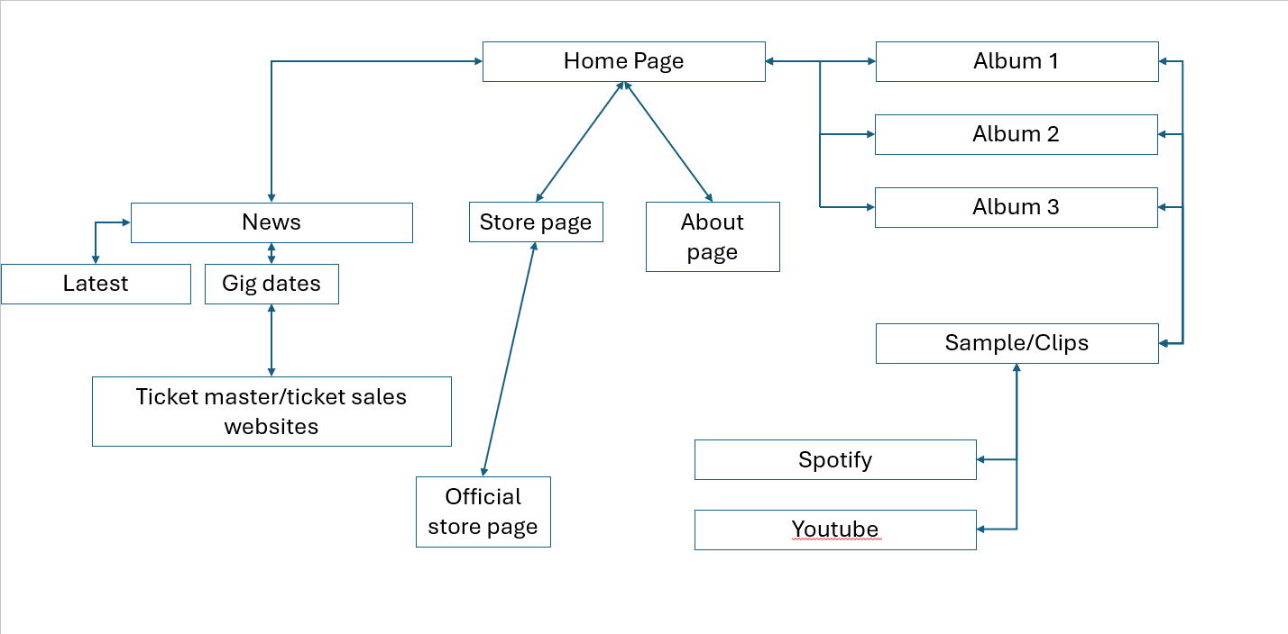

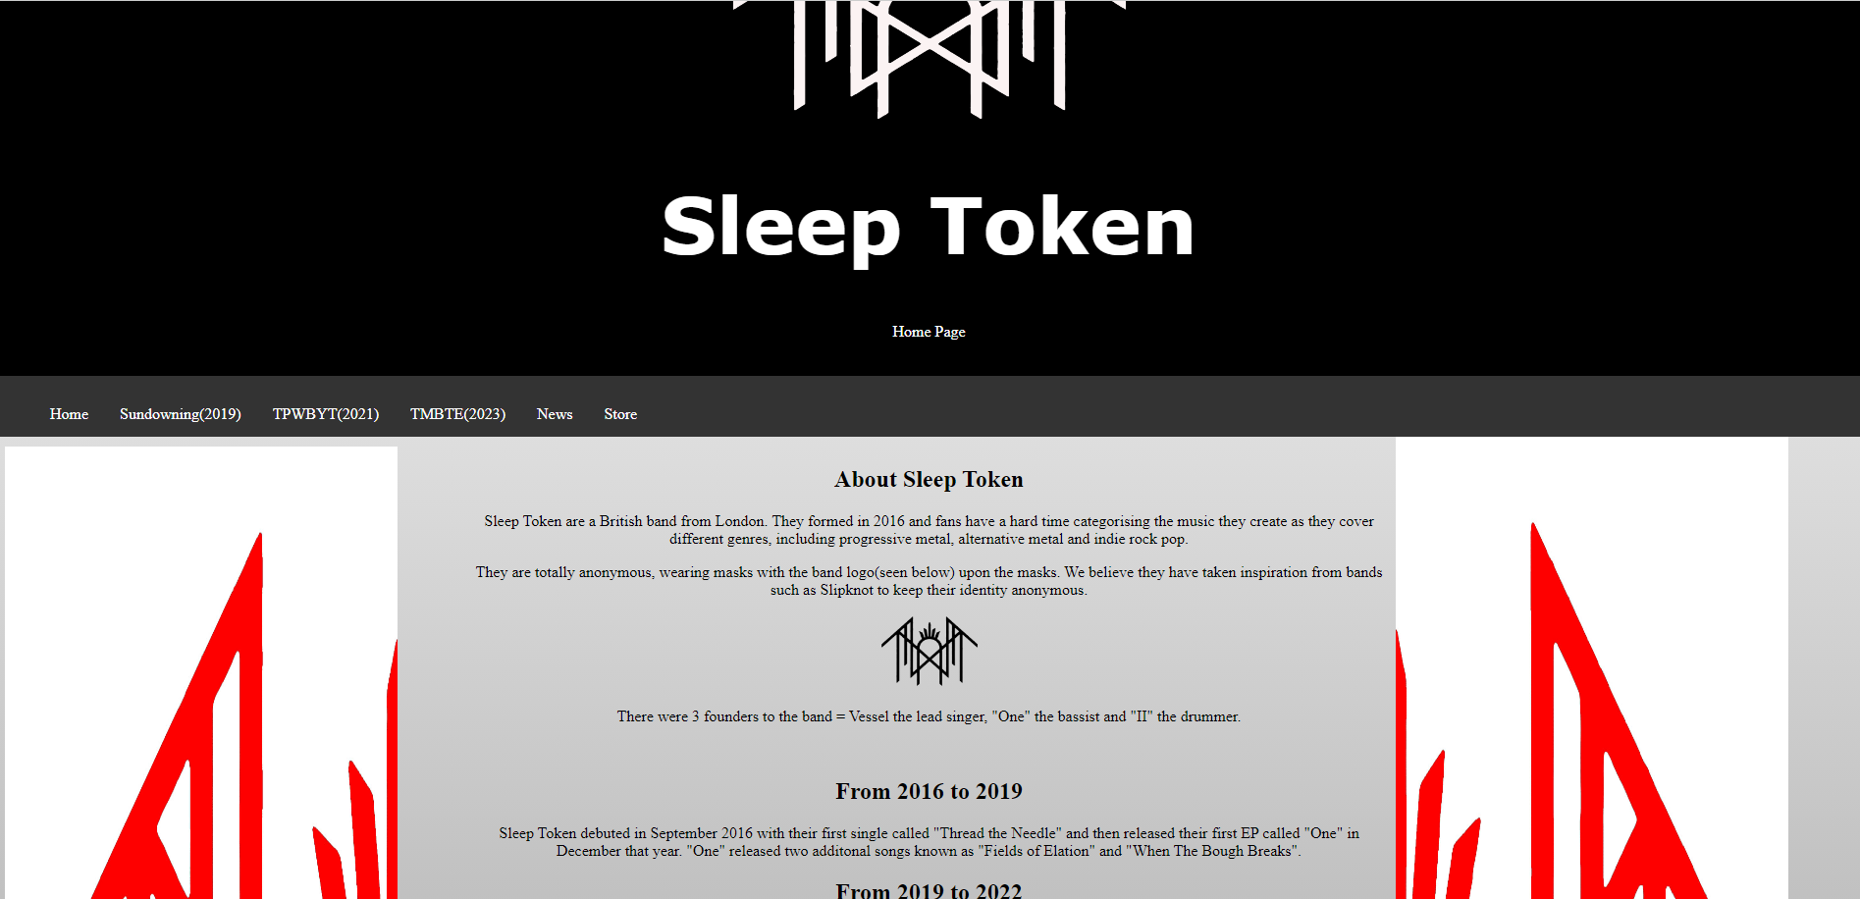
The Index/Home page, index.html.

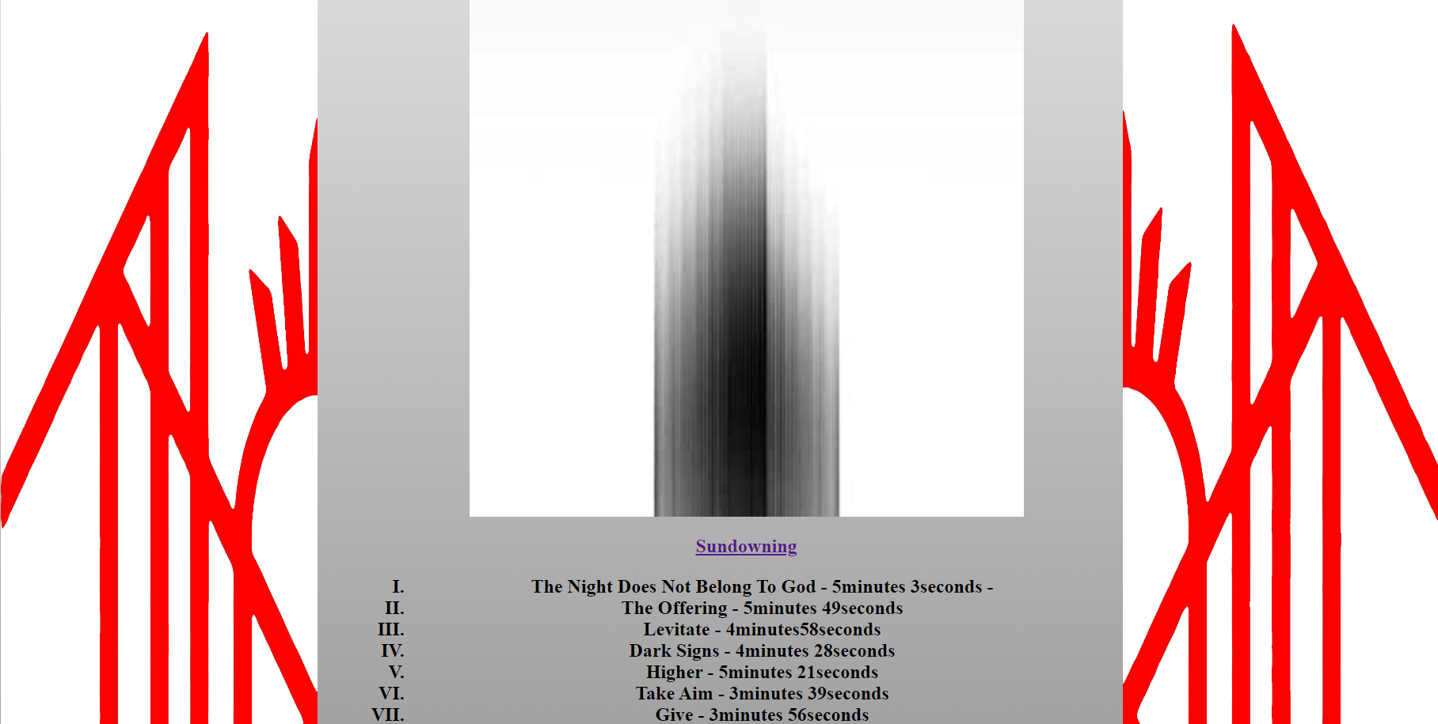
The 2nd page known as sundowning.html, Sundowning their first album.

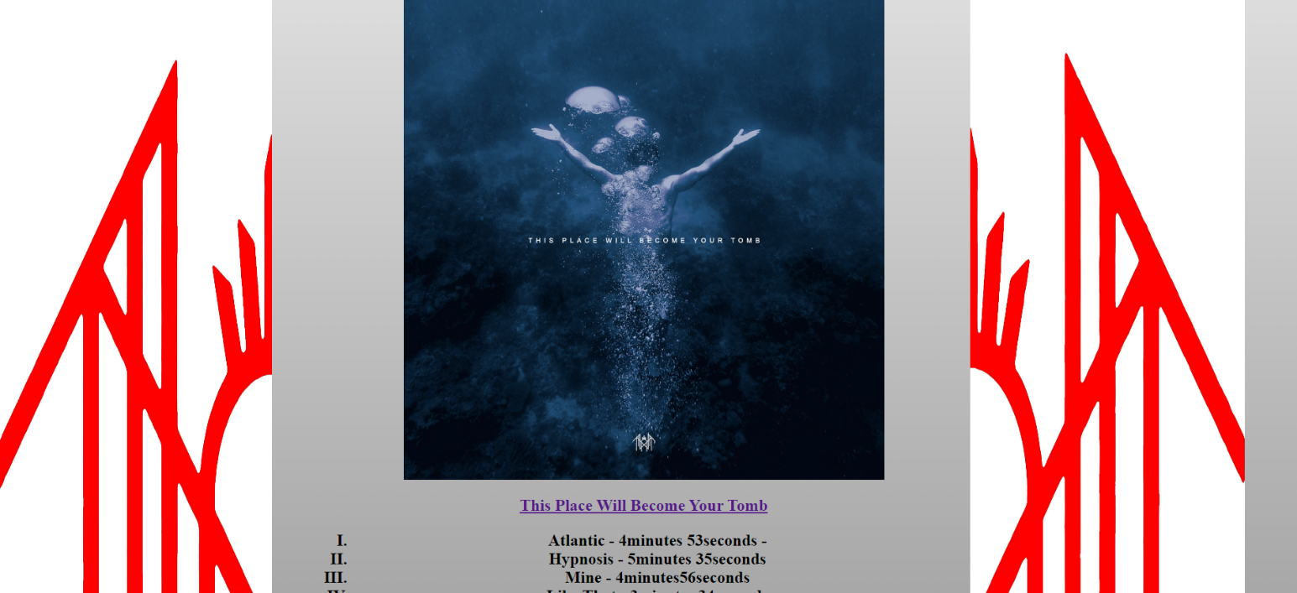
The 3rd page known as TPWBYT.html, based on their 2nd album.

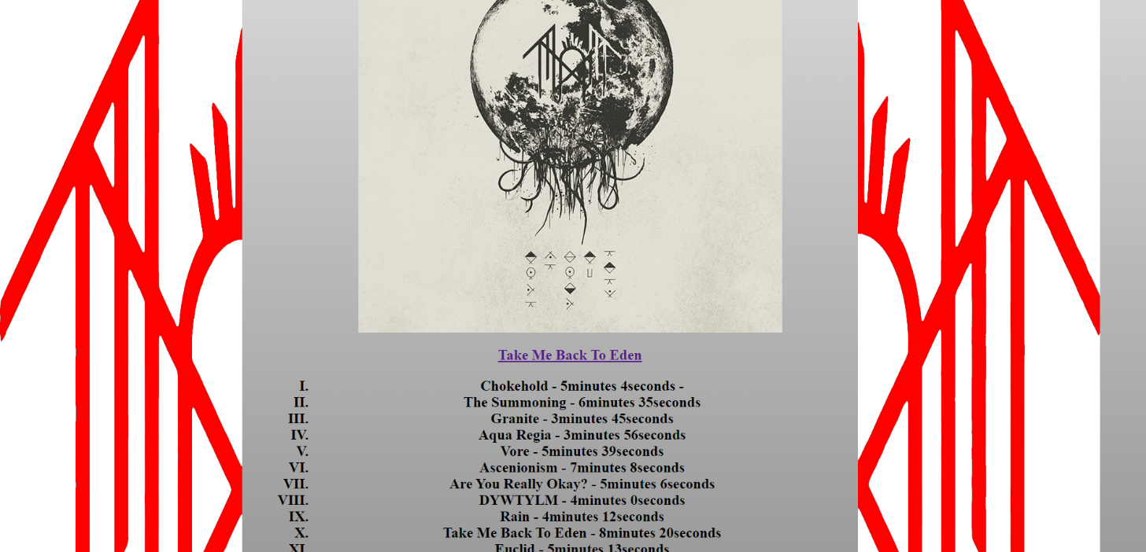
4th page known as TMBTE.html, based on their 3rd and latest album.

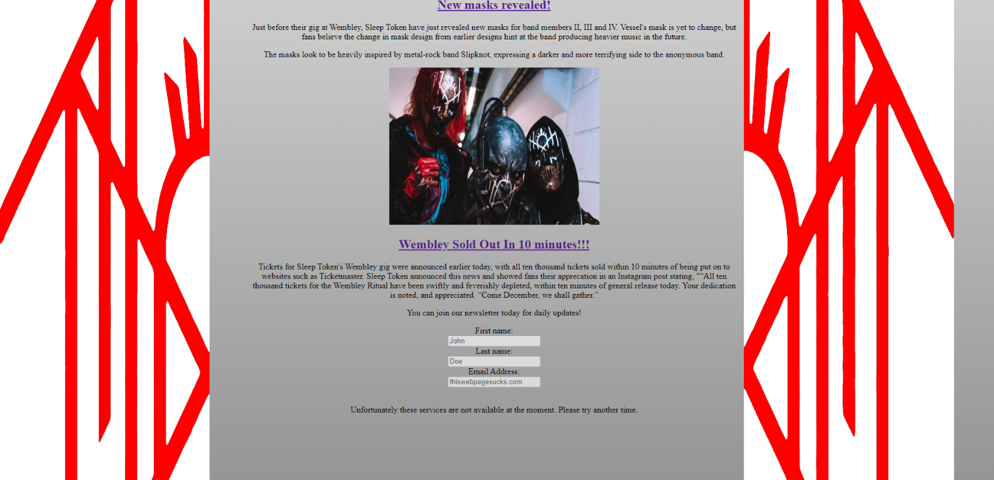
The 5th page, known as News.html, focuses on news updates on the band.

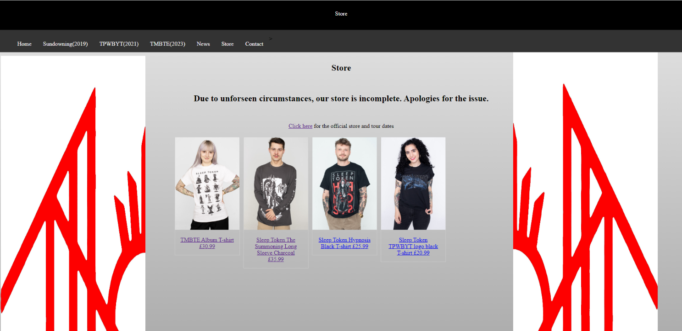
The 6th and last page is the store.html, which is a terrible example of a store made quickly.

Validation
This was my Index validation. I had issues where I had kept using “/>” on the <img src lines assuming that I needed to close the line code with the “/>”. I have since removed these as it has no effect on the webpage itself.
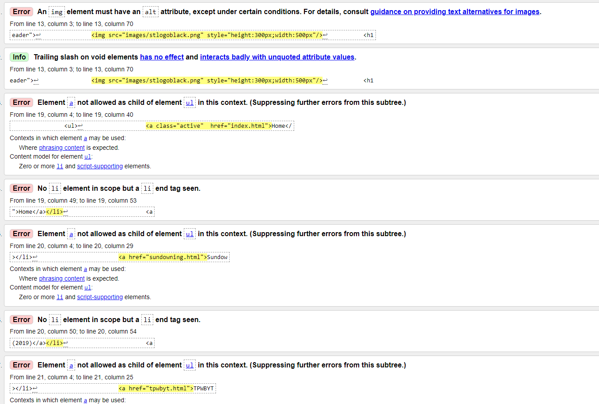
The 2nd issue I had was having a </li> for my navigation bar, but I did not have an open <li>. I’m unsure as to why I even had these </li> in the first place but have since removed them and the navigation bar still works fine.

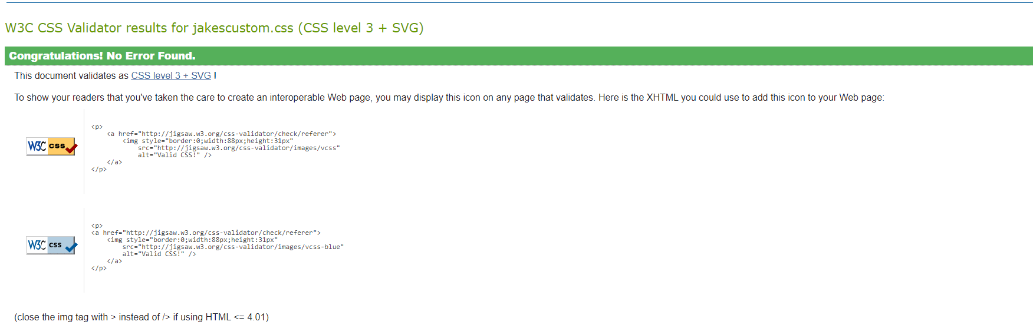
My CSS for jakescustom.css was fine with no errors found at all.

Evaluation

A)
1- Website Usability
The website’s usability is the most important aspect of creating a website, as the usability of a website concentrates on the user’s needs/demands. The website should be simple yet efficient, as too much content or information can put a user off from the website. Creating a simple website has its issues when designing a website[1].
There are 5 principles of Website Usability-
1)Availability – How easy it is for users to access the website. This includes the devices the user is viewing the website on, as a website on a 24inch monitor may not look so good on a 8 inch mobile screen.[1]

2]Clarity – The user has accessed your website for a reason, and therefore that reason (information) should be clear and easily accessible. If the information the user is searching for isn’t clear/visible, then they’ll most likely look at competitors website on the same topic.[1]

3]Recognition – Most website designs are different, but there are key elements that are recognised by users, such as a “home” button. This button should be easily recognisable to increase the usability of the website. If you decide to use a different button/theme for the website, then it will take some time for the user to adapt/learn the new website. Keeping the website simple reduces the time spent learning how to navigate the website.[1]

4]Credibility – There are a lot of fake sources and “dodgy” websites on the internet now. The trust between you as the creator and the user is thin. If the content/website you have made is not credible, then the user will never return to your website, and may warn others. This results in the website being viewed less and recommended less on search engines.[1]

5] Relevance – Relevance is about the content and web design itself. Creating a relevant and “engaging” website involves defining the target audience and deciding what would be useful for the desired audience and making the content as clear and as accessible as possible.[1]
The findings from the “Online corporate communications: website usability and content” state that the largest group decided that the “Websites with greater attention to usability” was the largest cluster with 85.8% of the sample[2].

2) Website Accessibility
“Web accessibility means that websites, tools, and technologies are designed and developed so that people with disabilities can use them.[3]”
Accessibility is how a website works and feels when being used by different users.
There are several disabilities that can affect the accessibility of your website;
- Auditory
- Cognitive
- Neurological
- Physical
- Speech
- Visual
There are things that web designers must think about when creating websites, as more and more people are accessing the web as technology advances. The more users accessing the content, the more traffic/revenue on your website. For example, the website may have flashing images that may cause seizures for epileptics.

Web accessibility also benefits people without disabilities, for example:
- people using mobile phones, smart watches, smart TVs, and other devices with small screens, different input modes, etc..
- older people with changing abilities due to ageing.
- people with “temporary disabilities” such as a broken arm or lost glasses.

In the article “Inclusion is Not an On-and-Off Switch: A Study on Commitment to Accessibility on Museum Websites”, the authors investigated into the differences between “Persons First” language (PF) and “Identity-first” language (IF). The PF is a form of “linguistic etiquette” in which a noun describing what the diagnosis or disability the person has. The IF language makes the disability the focus which equates disabled people together, losing their “individuality”.
The conclusion of this study was that although the data found does not provide a “definitive” picture, it suggests that users prefer there to be online spaces dedicated to accessibility and use the PF language more often, with 80% of the sample[4].
This suggests that most users prefer when a website has accessibility.

3)Search Engine Optimisation
Search Engine Optimisation (SEO) is the way to optimise a website to receive top rankings when users search for results/websites. There are several techniques to optimise the SEO. One way (which is now illegal) was to “keyword stuffing”. Google’s algorithm used to provide the website with the highest number of keywords for the searched result to top ranking and developers would abuse this by “keyword stuffing” with white font. Google have since updated their algorithms.

There are obvious advantages to having a higher SEO. The higher ranking your website’s SEO receives, the more likely that your website will appear on the first result pages of Google/other search engines. This then increases website traffic and thus, increasing possible revenue, sales and advertisement[5].
Below is an example of SEO for “Sleep Token”, as you can see, their official website first pops up (most credible source), then Wikipedia (most popular information site) and then their social media.
If my website was more SEO, with high traffic, my website could end up being below the social media result or possibly even higher.
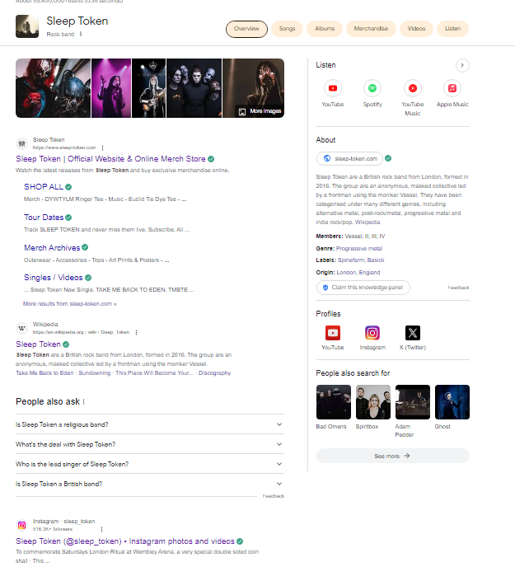

Self-evaluation
Usefulness of my website:
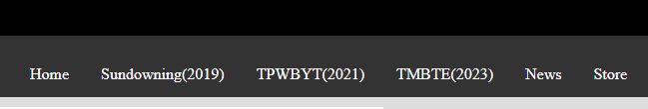
The first thing I would draw attention to is my navigation bar. It is simple, clear and works as intended (you click the page you want to go to; it takes you there). The navigation bar shows which page is highlighted in red to showcase to the user which one they are about to be sent to.

It feels fine to use, as loading times are quick as the contents of each webpage is simple. Images used did not take up much space which allows for quicker load times.
The look, however, is a bit janky. I’m not particularly impressed with it and had a better image of the website in my head. I attempted to centre the navigation bar which would make it look a bit more centre. The right-side logo does not fill the screen as much as the left side logo does (the red and white side columns). These are things I would improve in the future. The images inputted in some places are there to fill the page. I attempted to follow the generic colours of the band (red, white and black) which don’t necessarily make a particularly engaging website (although I’m probably wrong).
The content is simple and visible with no issues with the contrast checker, but I wouldn’t say the website is rather engaging. Provided I concentrated more on the content rather than the creating the website aspect, I believe I could produce much better content on this website. I also wanted to include youtube clips or a spotify playlist of the albums at the bottom of the pages under the album content.
As you can see in the image below, I have left the iframe line in to showcase the issue I had when wanting to add the clip.
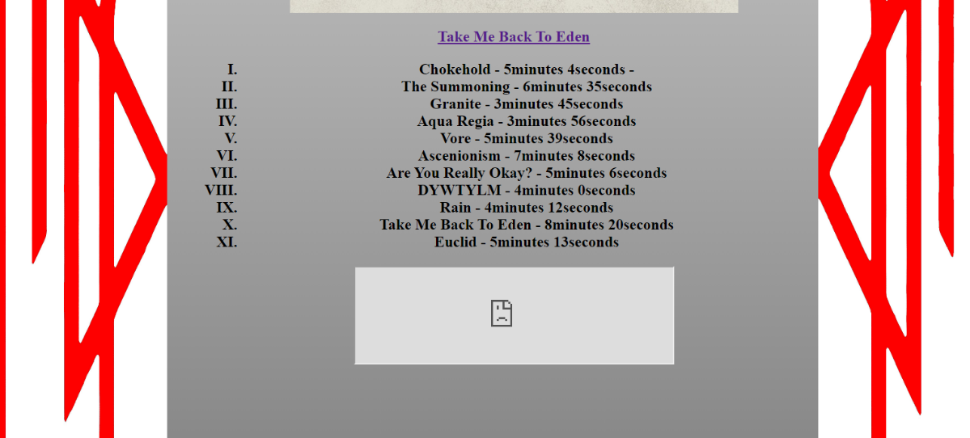

I have added a few links, such as on the albums titles on each page to the amazon store for each album, which I thought might be useful, although linking another store site rather than the Sleep Token store itself might be counter-productive in terms of business.

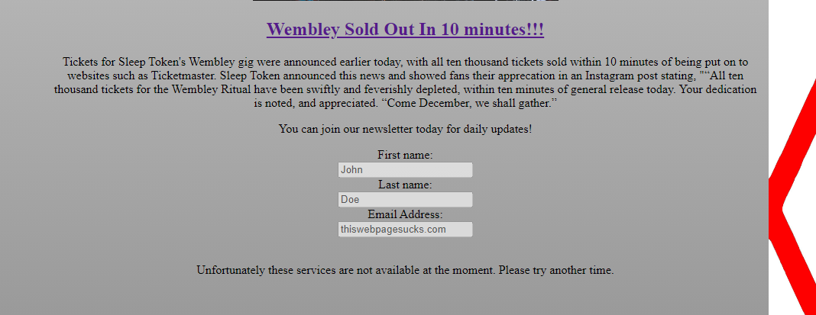
I was quite happy with the form I had created on the “News” page, as seen below;

As I have no idea how to keep the inputted data, I thought I’d showcase it as a technical error with the website, where no details can be submitted. This was used with the “disabled” feature in the forms. I also stated that there was an issue with the store. This would be something I could achieve with more references and practice and would be something I would improve in the future.
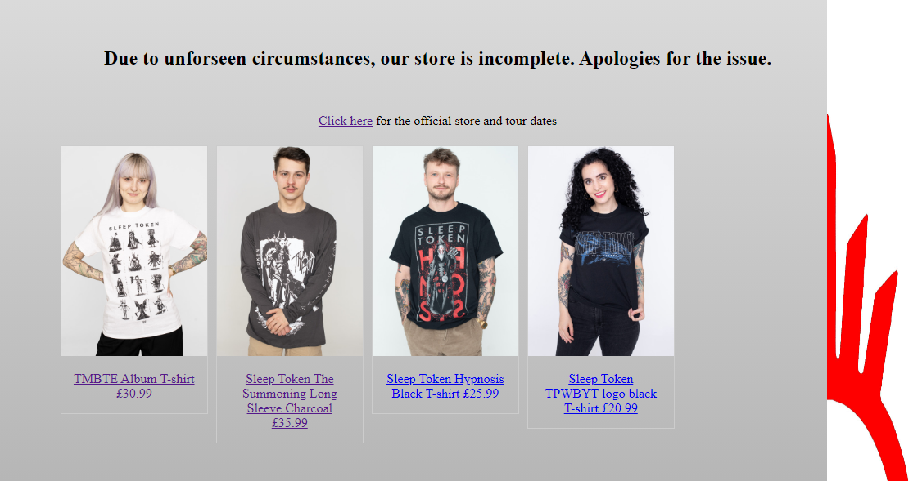
The same can be said about the store contents. As I was running out of time, I only include 4 store items(which are clickable to zoom in on the image). I would improve this webpage by including far more examples of clothing that can be purchased. When clicking on the image, it opens a new tab rather than opening in the same tab. This is something I’d want to improve.

Accessibility of Website:
Using WAVE, there appeared to be only one alert;
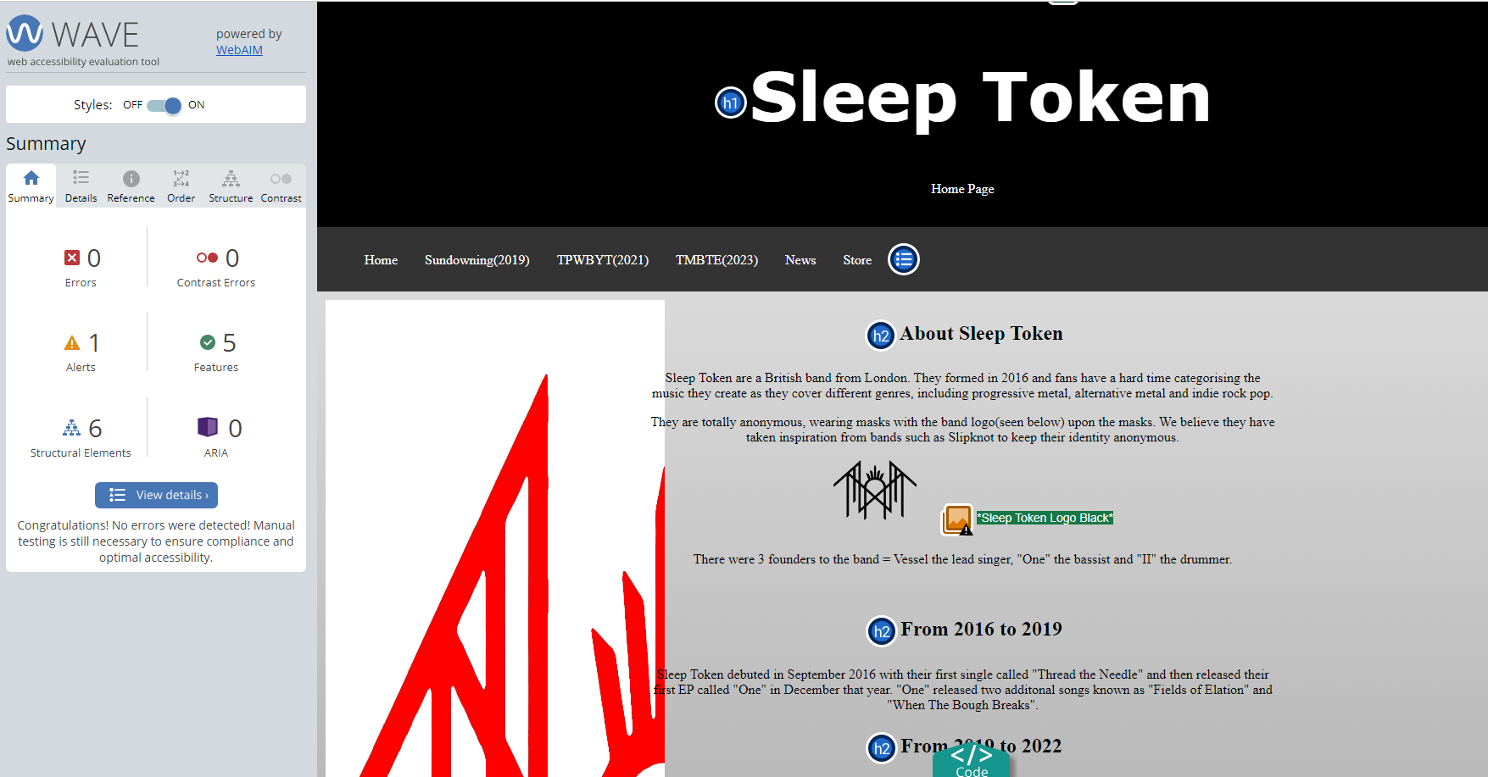
Where I had mistakenly named the two-alternative logo (one black, one white) the same alt reference if the image was no loaded. I have since solved this issue by renaming the top logo as (Sleep Token Logo White), which removed the alert. I received no issues with the contrast checker, suggesting that the grey-background is fine with black font.

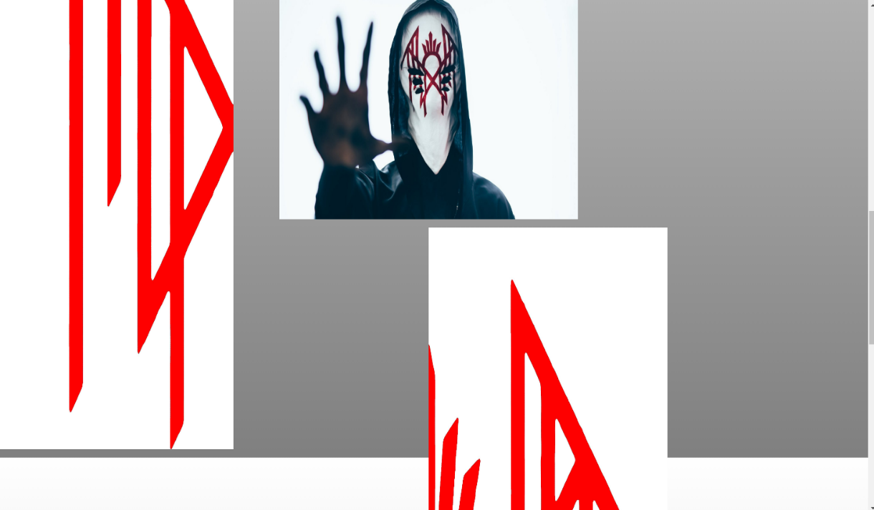
The major issue I noticed when trying my ZIP file on another computer was the image responsive. The website looks and works fine when full-screened, and then looks fine when compressed down to a mobile screen size, but the in-between looks awful.
I noticed when I used a laptop rather than my home PC that the size of the laptop screen made my website look like above, which is not suitable or accessible. This is something I would not to improve on, as I’m not entirely sure how it’s working on screen my size, and then on the most compressed version of the browser, but not in between.

Search Engine Optimisation
Using the checklist/strategies from https://linchpinseo.com/blog/how-to-design-an-seo-friendly-website/, I can see that my website checks some of these strategies.
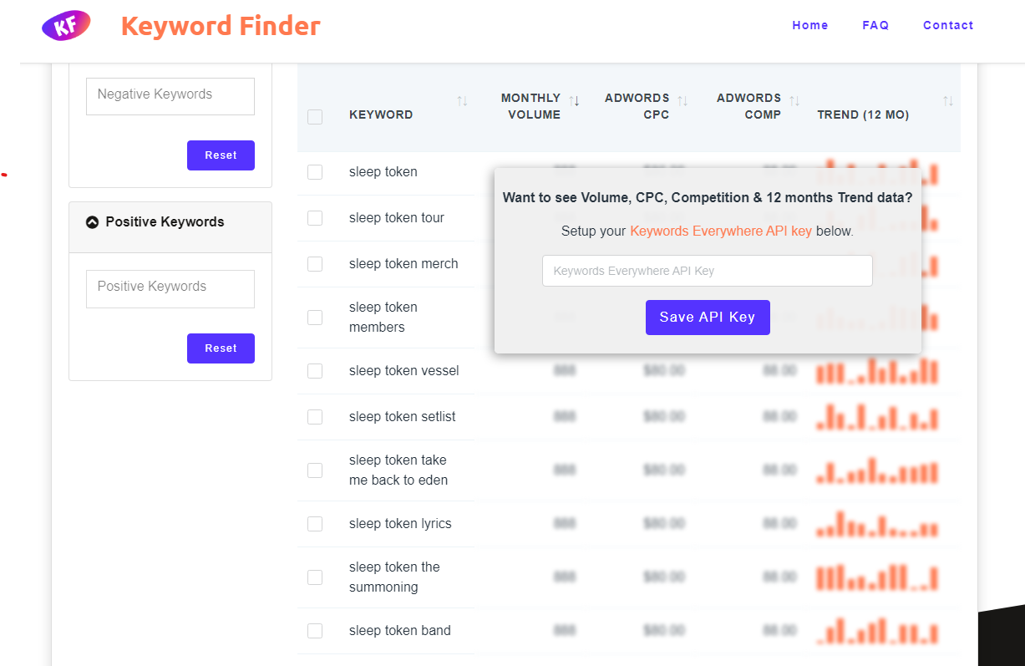

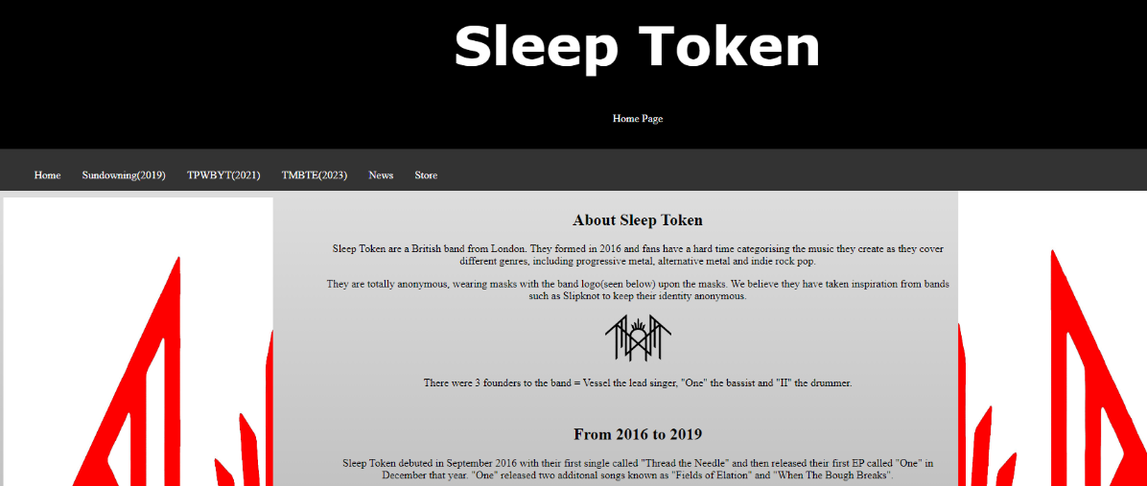
The first strategy is to contain most search keywords possible. Using this (most likely un-reliable) website, I can see the most search keywords at a month volume and trend. If I wanted to increase my SEO, I would need to use more of these keywords in my website. Going through my content, I have noticed that I have used some of the most searched words such as “Sleep Token” (who’d have thought), “Vessel” and “Sleep Token Members”, but I could have used “Merch” and “Tour” to produce more keywords. (You can see below that Sleep Token is mentioned a lot)

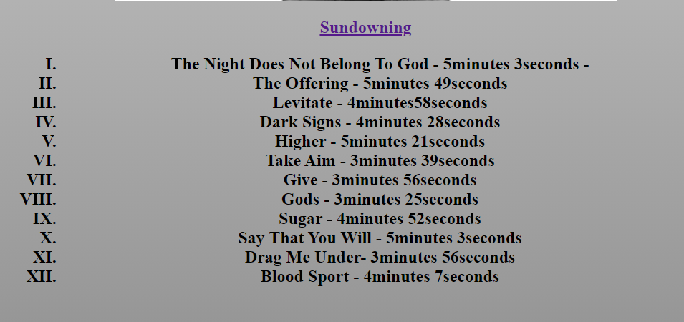
- Using multiple types of content such as images, videos, lists, and text: I have not includes any videos, as I had issues with youtube/spotify. I have used plenty of images, lists and text.
(One example of list created on Sundowning webpage, I have created lists for the songs on each album)
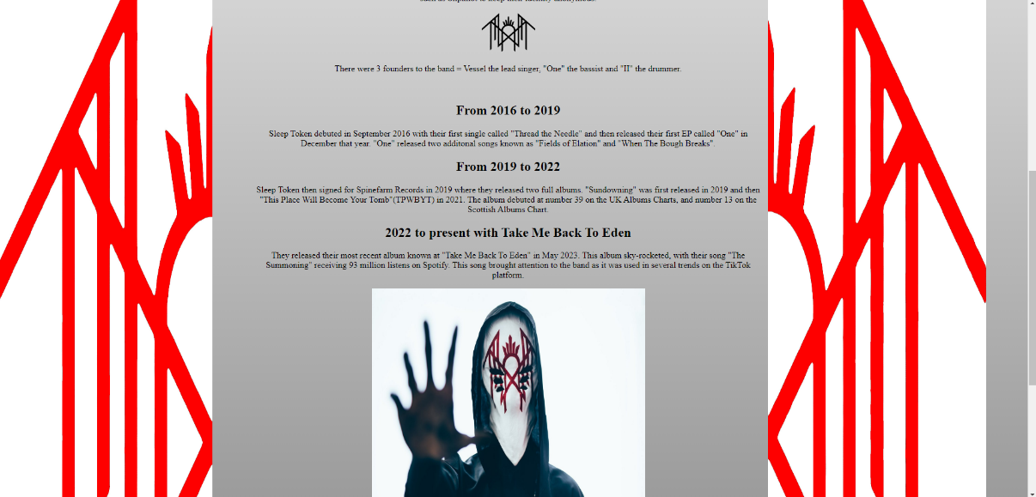

(4 images in this screenshot)
“Creating a responsive website design that provides a great experience across devices.”
“Designing a visually appealing website, represents your brand, and has a consistent look and feel.”
As stated above in the “Usability” and “Accessibility” sections, I have had major issues where I wasn’t completely happy with the design of the website, and it wasn’t completely responsive. Although the pages do represent the band and have a consistent enough look and feel.

References
[1] 9. Team. (-01-15T15:30:59+00:00). The principles of website usability. Available: https://99designs.com/blog/web-digital/website-usability-principles/.
[2] María García García, M. V. Carrillo-Durán and J. L. Tato Jimenez, "Online corporate communications: website usability and content," Journal of Communication Management, vol. 21, (2), pp. 140-154, 2017. Available: https://www.proquest.com/scholarly-journals/online-corporate-communications-website-usability/docview/1895058762/se-2. DOI: https://doi.org/10.1108/JCOM-08-2016-0069.
[3] W. W. A. I. (WAI). (). Introduction to Web Accessibility. Available: https://www.w3.org/WAI/fundamentals/accessibility-intro/.
[4] C. Lazzeretti, "“Inclusion is Not an On-and-Off Switch": A Study on Commitment to Accessibility on Museum Websites," The International Journal of the Inclusive Museum, vol. 14, (1), pp. 107-117, 2021. Available: https://www.proquest.com/scholarly-journals/inclusion-is-not-on-off-switch-study-commitment/docview/2791938819/se-2. DOI: https://doi.org/10.18848/1835-2014/CGP/v14i01/107-117.
[5] Anonymous Anonymous The effect and technique in search engine optimization | IEEE conference publication | IEEE xplore. The effect and technique in search engine optimization | IEEE conference publication | IEEE xplore. Available: https://ieeexplore.ieee.org/abstract/document/9211171.

Appendices

Appendix A - Index.html

<!DOCTYPE html>
<html lang="en">
<head>
<title>Home Page</title>
<meta charset="utf-8">
<meta name="viewport" content="width=device-width, initial-scale=1">
<link rel="stylesheet" type="text/css"
href="jakescustom.css">
</head>
<body id="grad1">

<div class="header">
<img src="images/stlogoblack.png" alt="Sleep Token Logo White" style="height:200px;width:400px">
<h1 class="h1">Sleep Token</h1>
<p style="color:white;font-size:100%;">Home Page</p>
</div>
<div class="topnav">
<ul>
<a class="active" href="index.html">Home</a></li>
<a href="sundowning.html">Sundowning(2019)</a></li>
<a href="tpwbyt.html">TPWBYT(2021)</a></li>
<a href="tmbte.html">TMBTE(2023)</a></li>
<a href="news.html">News</a></li>
<a href="store.html">Store</a></li>
</ul>
</div>

<div class="row">
<div class="column side">
<img src="images/split1.jpg" alt="Leftside of Red Sleep Token Logo" class="img-responsive" style="height:1500px;width:400px">
</div>

<div class="column middle">
<h2>About Sleep Token</h2>
<p>Sleep Token are a British band from London. They formed in 2016 and fans have a hard time categorising the music they create as they cover different genres, including progressive metal, alternative metal and indie rock pop.</p>
<p>They are totally anonymous, wearing masks with the band logo(seen below) upon the masks. We believe they have taken inspiration from bands such as Slipknot to keep their identity anonymous.</p>
<img src="images/stlogo.png" alt="Sleep Token Logo Black" style="height:75px;width:150px">
<p>There were 3 founders to the band = Vessel the lead singer, "One" the bassist and "II" the drummer.</p>
<br><h2>From 2016 to 2019</h2>
<p>Sleep Token debuted in September 2016 with their first single called "Thread the Needle" and then released their first EP called "One" in December that year. "One" released two additonal songs known as "Fields of Elation" and "When The Bough Breaks".
<br><h2>From 2019 to 2022</h2>
<p>Sleep Token then signed for Spinefarm Records in 2019 where they released two full albums. "Sundowning" was first released in 2019 and then "This Place Will Become Your Tomb"(TPWBYT) in 2021.
The album debuted at number 39 on the UK Albums Charts, and number 13 on the Scottish Albums Chart.
<br><h2>2022 to present with Take Me Back To Eden</h2>
<p>They released their most recent album known at "Take Me Back To Eden" in May 2023. This album sky-rocketed, with their song "The Summoning" receiving 93 million listens on Spotify. This song brought attention to the band as it was used in several trends on the TikTok platform.</p>

<img src="images/vessel.jpg" style="height:400px;width:500px" alt="Vessel">
</div>
<img src="images/split2.jpg" alt="Right side of Red Sleep Token Logo" class="img-responsive" style="height:1500px;width:400px">
<div class="column side">

</div>
</div>

</body>
</html>

Appendix B - Sundowning.html

<!DOCTYPE html>
<html lang="en">
<head>
<title>Sundowning</title>
<meta charset="utf-8">
<meta name="viewport" content="width=device-width, initial-scale=1">
<link rel="stylesheet" type="text/css"
href="jakescustom.css">
</head>
<body id="grad1">

<div class="header">
<img src="images/stlogoblack.png" alt="Sleep Token Logo White" style="height:200px;width:400px">
<h1 class="h1">Sleep Token</h1>
<p style="color:white;font-size:100%;">Sundowning (2019)</p>
</div>

<div class="topnav">
<ul>
<a class="active" href="index.html">Home</a></li>
<a href="sundowning.html">Sundowning(2019)</a></li>
<a href="tpwbyt.html">TPWBYT(2021)</a></li>
<a href="tmbte.html">TMBTE(2023)</a></li>
<a href="news.html">News</a></li>
<a href="store.html">Store</a></li>
</ul>
</div>

<div class="row">
<div class="column side">
<img src="images/split1.jpg" alt="Left side Red Sleep Token Logo" class="img-responsive" style="height:1500px;width:400px">
</div>

<div class="column middle">
<img src="images/sundowning.jpg" alt="Sundowning Album Art" style="height:700px;width:700px;"/>
<h2><a href="https://www.amazon.co.uk/Sundowning-Sleep-Token/dp/B07SG9CLQX/ref=sr_1_1?crid=3RWS90GNUVO5O&keywords=sundowning&qid=1705322252&sprefix=sundowning%2Caps%2C83&sr=8-1">Sundowning</a></h2>
<h2><ol class="numbered">
<li>The Night Does Not Belong To God - 5minutes 3seconds - </li>
<li>The Offering - 5minutes 49seconds</li>
<li>Levitate - 4minutes58seconds</li>
<li>Dark Signs - 4minutes 28seconds</li>
<li>Higher - 5minutes 21seconds</li>
<li>Take Aim - 3minutes 39seconds</li>
<li>Give - 3minutes 56seconds</li>
<li>Gods - 3minutes 25seconds</li>
<li>Sugar - 4minutes 52seconds</li>
<li>Say That You Will - 5minutes 3seconds</li>
<li>Drag Me Under- 3minutes 56seconds</li>
<li>Blood Sport - 4minutes 7seconds</li>
</ol></h2>
</div>
<img src="images/split2.jpg" alt="Right side Red Sleep Token Logo" class="img-responsive" style="height:1500px;width:400px">
<div class="column side">

</div>
</div>

</body>
</html>

Appendix C – TPWBYT.html

<!DOCTYPE html>
<html lang="en">
<head>
<title>TPWYBT</title>
<meta charset="utf-8">
<meta name="viewport" content="width=device-width, initial-scale=1">
<link rel="stylesheet" type="text/css"
href="jakescustom.css">
</head>
<body id="grad1">

<div class="header">
<img src="images/stlogoblack.png" alt="Sleep Token Logo White" style="height:200px;width:400px">
<h1 class="h1">Sleep Token</h1>

<p style="color:white;font-size:100%;">TPWBYT (2021)</p>
</div>

<div class="topnav">
<ul>
<a class="active" href="index.html">Home</a></li>
<a href="sundowning.html">Sundowning(2019)</a></li>
<a href="tpwbyt.html">TPWBYT(2021)</a></li>
<a href="tmbte.html">TMBTE(2023)</a></li>
<a href="news.html">News</a></li>
<a href="store.html">Store</a></li>
</ul>
</div>

<div class="row">
<div class="column side">
<img src="images/split1.jpg" alt="Left side of Red Sleep Token Logo" class="img-responsive" style="height:1500px;width:400px">
</div>

<div class="column middle">
<img src="images/tpwbyt.png" alt="TPWBYT Album Art" style="height:700px;width:700px"/>
<h2><a href="https://www.amazon.co.uk/This-Place-Will-Become-Your/dp/B0972Z8CYF/ref=sr_1_1?crid=1YRATFV00ET7A&keywords=this+place+will+become+your+tomb+cd&qid=1705323635&sprefix=this+place+w%2Caps%2C87&sr=8-1">This Place Will Become Your Tomb</a></h2>
<h2><ol class="numbered">
<li>Atlantic - 4minutes 53seconds - </li>
<li>Hypnosis - 5minutes 35seconds</li>
<li>Mine - 4minutes56seconds</li>
<li>Like That - 3minutes 34seconds</li>
<li>The Love You Want - 4minutes 23seconds</li>
<li>Fall For Me - 2minutes 26seconds</li>
<li>Alkaline - 3minutes 34seconds</li>
<li>Distraction - 4minutes 22seconds</li>
<li>Descending - 4minutes 38seconds</li>
<li>Telomeres - 5minutes 7seconds</li>
<li>High Water - 5minutes 13seconds</li>
<li>Missing Limbs - 4minutes56seconds</li>
</ol></h2>

</div>
<img src="images/split2.jpg" alt="Right side of Red Sleep Token Logo" class="img-responsive" style="height:1500px;width:400px">
<div class="column side">

</div>
</div>
</body>
</html>

Appendix D – TMBTE.html

<!DOCTYPE html>
<html lang="en">
<head>
<title>TMBTE (2023)</title>
<meta charset="utf-8">
<meta name="viewport" content="width=device-width, initial-scale=1">
<link rel="stylesheet" type="text/css"
href="jakescustom.css">
</head>
<body id="grad1">

<div class="header">
<img src="images/stlogoblack.png" alt="Sleep Token Logo White" style="height:200px;width:400px">
<h1 class="h1">Sleep Token</h1>
<p style="color:white;font-size:100%;">TMBTE (2023)</p>
</div>

<div class="topnav">
<ul>
<a class="active" href="index.html">Home</a></li>
<a href="sundowning.html">Sundowning(2019)</a></li>
<a href="tpwbyt.html">TPWBYT(2021)</a></li>
<a href="tmbte.html">TMBTE(2023)</a></li>
<a href="news.html">News</a></li>
<a href="store.html">Store</a></li>
</ul>
</div>

<div class="row">
<div class="column side">
<img src="images/split1.jpg" alt="Left side of Red Sleep Token Logo" class="img-responsive" style="height:1500px;width:400px">
</div>

<div class="column middle">
<img src="images/tmbte.jpg" alt="Sundowning Album Art" style="height:700px;width:700px;"/>
<h2><a href="https://www.amazon.co.uk/Take-Back-Eden-Sleep-Token/dp/B0BVTFSWSW/ref=sr_1_1?crid=ZB06YPL5INCV&keywords=take+me+back+to+eden+cd&qid=1705324052&sprefix=take+me+back+to+eden+cd%2Caps%2C72&sr=8-1">Take Me Back To Eden</a></h2>
<h2><ol class="numbered">
<li>Chokehold - 5minutes 4seconds - </li>
<li>The Summoning - 6minutes 35seconds</li>
<li>Granite - 3minutes 45seconds</li>
<li>Aqua Regia - 3minutes 56seconds</li>
<li>Vore - 5minutes 39seconds</li>
<li>Ascenionism - 7minutes 8seconds</li>
<li>Are You Really Okay? - 5minutes 6seconds</li>
<li>DYWTYLM - 4minutes 0seconds</li>
<li>Rain - 4minutes 12seconds</li>
<li>Take Me Back To Eden - 8minutes 20seconds</li>
<li>Euclid - 5minutes 13seconds</li>
</ol></h2>
<iframe src="https://open.spotify.com/album/1gjugH97doz3HktiEjx2vY" width="500" height="300%"></iframe>

</div>
<img src="images/split2.jpg" alt="Right side of Red Sleep Token Logo" class="img-responsive" style="height:1500px;width:400px">
<div class="column side">

</div>

</body>
</html>

Appendix F – News.html

<!DOCTYPE html>
<html lang="en">
<head>
<title>News</title>
<meta charset="utf-8">
<meta name="viewport" content="width=device-width, initial-scale=1">
<link rel="stylesheet" type="text/css"
href="jakescustom.css">
</head>
<body id="grad1">

<div class="header">
<img src="images/stlogoblack.png" alt="Sleep Token Logo White" style="height:200px;width:400px">
<h1 class="h1">Sleep Token</h1>
<p style="color:white;font-size:100%;">News</p>
</div>
<div class="topnav">
<ul>
<a class="active" href="index.html">Home</a></li>
<a href="sundowning.html">Sundowning(2019)</a></li>
<a href="tpwbyt.html">TPWBYT(2021)</a></li>
<a href="tmbte.html">TMBTE(2023)</a></li>
<a href="news.html">News</a></li>
<a href="store.html">Store</a></li>
</ul>
</div>

<div class="row">
<div class="column side">
<img src="images/split1.jpg" alt="Left side of Red Sleep Token Logo" class="img-responsive" style="height:1500px;width:400px">
</div>

<div class="column middle">
<h2>Tragedy at Wembley Stadium!</h2>
<p>Halfway through the show, the band stopped playing and there was silence. The band exited the stage which caused massive confusion amongst the crowd. Vessel and a band manager walked back out on stage and announced that Vessel was having a hard time with his vocal chords and would not be able to sing</p>
<p>The band manager stated that the crowd would need to come together and help. The band re-entered the stage and began playing, where the crowd errupted in song. The band members looked ecstatic. By the end of the show, Vessel had began attempting to sing again, and several fans and sources say that the experience was "one of a kind"</p>

<br><h2><a href="https://www.instagram.com/p/C07U0XRNQf-/?hl=en">New masks revealed!</a></h2>
<p>Just before their gig at Wembley, Sleep Token have just revealed new masks for band members II, III and IV. Vessel's mask is yet to change, but fans believe the change in mask design from earlier designs hint at the band producing heavier music in the future.</p>
<p>The masks look to be heavily inspired by metal-rock band Slipknot, expressing a darker and more terrifying side to the anonymous band.</p>
<img src="images/newmasks.jpg" alt="New Sleep Token Masks" style="height:300px;width:400px;">

<br><h2><a href="https://www.instagram.com/p/Cs_NRtGtZrq/?hl=en">Wembley Sold Out In 10 minutes!!!</a></h2>
<p>Tickets for Sleep Token's Wembley gig were announced earlier today, with all ten thousand tickets sold within 10 minutes of being put on to websites such as Ticketmaster. Sleep Token announced this news and showed fans their apprecation in an Instagram post stating, "“All ten thousand tickets for the Wembley Ritual have been swiftly and feverishly depleted, within ten minutes of general release today. Your dedication is noted, and appreciated. “Come December, we shall gather.”</p>
<p>You can join our newsletter today for daily updates!</p>
<form>
<label for="fname">First name:</label><br>
<input type="text" id="fname" name="fname" value="John" disabled><br>
<label for="lname">Last name:</label><br>
<input type="text" id="lname" name="lname" value="Doe"disabled><br>
<label for="emailaddress">Email Address:</label><br>
<input type="text" id="emailaddress" name="emailaddress" value="thiswebpagesucks.com" disabled><br>
</form>
<br><p>Unfortunately these services are not available at the moment. Please try another time.</p></br>

</div>
<img src="images/split2.jpg" alt="Right side of Red Sleep Token Logo" class="img-responsive" style="height:1500px;width:400px">
<div class="column side">

</div>
</div>

</body>
</html>

Appendix G – Store.html

<!DOCTYPE html>
<html lang="en">
<head>
<title>Store</title>
<meta charset="utf-8">
<meta name="viewport" content="width=device-width, initial-scale=1">
<link rel="stylesheet" type="text/css"
href="jakescustom.css">
</head>
<body id="grad1">
<div class="header">
<img src="images/stlogoblack.png" alt="Sleep Token Logo White" style="height:200px;width:400px">
<h1 class="h1">Sleep Token</h1>
<p style="color:white;font-size:100%;">Store</p>
</div>

<div class="topnav">
<ul>
<a class="active" href="index.html">Home</a></li>
<a href="sundowning.html">Sundowning(2019)</a></li>
<a href="tpwbyt.html">TPWBYT(2021)</a></li>
<a href="tmbte.html">TMBTE(2023)</a></li>
<a href="news.html">News</a></li>
<a href="store.html">Store</a></li>
<a href="contact.html">Contact</a></li>
</ul>
</div>
<div class="row">
<div class="column side">
<img src="images/split1.jpg" alt="Left side of Red Sleep Token Logo" class="img-responsive" style="height:1500px;width:400px">
</div>

<div class="column middle">
<h2>Store</h2>
<br><h2>Due to unforseen circumstances, our store is incomplete. Apologies for the issue.</h2>
<br><p><a href="https://www.sleep-token.com/">Click here</a> for the official store and tour dates</p>
<div class="gallery">
<a target="_blank" href="images/tshirt1.jpg"/>
<img src="images/tshirt1.jpg" alt="TMBTE Cream Tshirt" width="600" height="400">
<div class="desc">TMBTE Album T-shirt £30.99</div>
</div>

<div class="gallery">
<a target="_blank" href="images/tshirt2.jpg"/>
<img src="images/tshirt2.jpg" alt="Sleep Token The Summoning" width="600" height="400">
<div class="desc">Sleep Token The Summoning Long Sleeve Charcoal £35.99</div>
</div>

<div class="gallery">
<a target="_blank" href="images/tshirt3.jpg"/>
<img src="images/tshirt3.jpg" alt="Sleep Token Hypnosis T-shirt" width="600" height="400">
<div class="desc">Sleep Token Hypnosis Black T-shirt £25.99</div>
</div>

<div class="gallery">
<a target="_blank" href="images/tshirt4.jpg"/>
<img src="images/tshirt4.jpg" alt="Sleep Token TPWBYT T-shirt" width="600" height="400">
<div class="desc">Sleep Token TPWBYT logo black T-shirt £20.99</div>
</div>
</div>
<img src="images/split2.jpg" alt="Right side of Red Sleep Token Logo" class="img-responsive" style="height:1500px;width:400px">
<div class="column side">
</div>
</div>

</body>
</html>

Appendix H - Jakescustom.css

.h1 {
font-family: "verdana", Times, serif;
color: white;
font-size: 80px;
}

/*The navigation bar CSS*/

*{
box-sizing: border-box;
}

body {
margin: 0;
}

.header {
background-color: black;
padding: 20px;
text-align: center;
}

.topnav {
overflow: hidden;
background-color: #333;
}

.topnav a {
float: left;
display: block;
color: white;
text-align: center;
padding: 14px 16px;
text-decoration: none;
}

.topnav a:hover {
background-color: white;
color: red
}

/* Seperating page into columns to add side images*/

.column {
float: left;
padding: 10px;
}

.column.side {
width: 25%;
}

.column.middle {
width: 50%;
text-align: center;
}

.row::after {
content: "";
display: table;
clear: both;
}

@media screen and (max-width: 600px){
.column.side, .column.middle {
width: 100%;
}
}

/* For the store*/
div.gallery {
margin: 5px;
border: 1px solid #ccc;
float: left;
width: 180px;
}

div.gallery:hover {
border: 1px solid #777;
}

div.gallery img {
width: 100%;
height: auto;
}

div.desc {
padding: 15px;
text-align: center;
}
.center {
display: block;
margin-left: auto;
margin-right: auto;
width: 50%;
}

.h2{
font-family: "verdana", Times, serif;
color: black;
font-size: 70px;
}
#grad1 {
height: 200px;
background-color: white;
background-image: linear-gradient(white, grey);
}
ol.numbered {
list-style-type: upper-roman;
}

#album1 {
background: url(images/tpwbyt.png);
background-size: 100px 80px;
background-repeat: no-repeat;
}

