University of Wales Trinity Saint David
Wales Institute of Science and Art

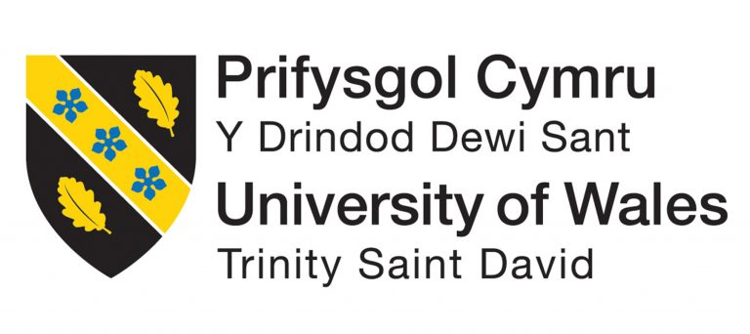

Application of CAE Processes
Structural & Fluid Analysis, ACHA6010

Van Watkins
2104732
Date of Report (12/2024)

Abstract
This report explores using Computer-Aided Engineering (CAE) tools to design and analyse mechanical components. The study focuses on building a realistic assembly of five parts, running simulations to understand their behaviour under operating conditions, and evaluating the structural performance of one key component. The analysis considers thermal effects and fatigue life, leading to iterative improvements that balance strength and weight. To ensure reliability, the project also includes validation through a simplified test case, comparing analytical calculations with simulation results, and studying the effects of mesh size. This report highlights the benefits and challenges of using CAE tools to solve real-world engineering problems by combining simulation with practical methods.

Contents
Abstract 1
Introduction 3
Validation Testing 4
Simplified Case Study - Stress 4
Simplified Case Study - Thermal 5
Error Differences 7
Modelling & Assembly 8
Introduction to Model and Assembly 8
Components 8
Kinematic Simulation & Structural Analysis 9
Kinematic Analysis 9
Thermal Considerations 9
Static Structural 10
Simulation Results 11
Optimisation and Improvement 18
Material Selection 18
Material Discussion 35
Limitations of CAE Tools 37
Mesh Independence 37
Conclusion 39
References 40
Appendices A – Figures 41
List of Tables 43

Introduction
Computer-aided engineering (CAE) tools have become essential in modern engineering, offering powerful ways to analyse and improve designs before physical prototypes are created. These tools allow engineers to simulate real-world conditions, predict components' performance, and make informed design decisions. However, like any tool, they have limitations, such as their dependence on accurate data and difficulty fully capturing complex physical behaviours.
This project focuses on applying CAE tools to design and analyse a mechanical assembly. The work includes creating an assembly with five components, simulating their motion to generate realistic loads, and evaluating the structural performance of one part in detail. The analysis also considers thermal effects and fatigue, helping refine the design for better performance and reduced weight. A simplified test case is analysed analytically and through simulations to back up the results, with additional studies on mesh size and boundary conditions. This report aims to demonstrate the strengths of CAE tools and the importance of validating their results to ensure reliability in real-world applications.

Validation Testing

Simplified Case Study - Stress
To ensure the reliability of the simulations conducted in this study, a simplified validation case was performed. The chosen case involved a cantilever beam subjected to an axial load, a classic problem in structural mechanics with a well-known analytical solution. By comparing simulation results from ANSYS with theoretical calculations, the accuracy of the simulation setup and methodology was assessed.

Problem Definition
The cantilever beam had the following parameters:
- Material: Steel with a modulus of elasticity of 210000MPa and Poisson's ratio of 0.
- Geometry:
  - Length (L): 1m
  - Width (w): 0.05m
  - Thickness (t): 0.005m
- Loads:
  - Uniform Pressure (Pa): 2,750,000
The boundary conditions included a fixed support at one end.

Empirical work
The Bending moment caused by pressure can be calculated using the following equation:
$$Uzmax = \frac{3pL^{4}}{2Ew^{2}t}$$
Substituting the values into the equations, we get:
$$Uxmax = \frac{3 x 2750 x 1^{4}}{2 x 210x{10}^{9} x {0.05}^{2} x 0.005 }$$
$$Uxmax=157.143mm$$

Ansys Simulation

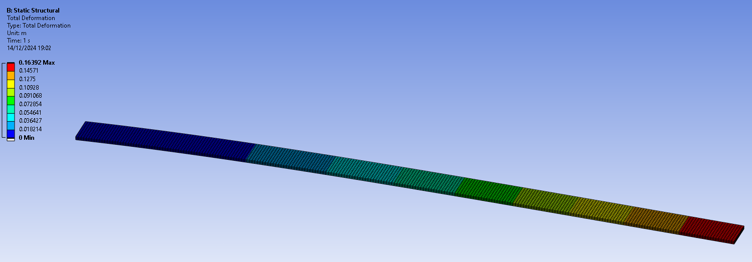
Figure 1 – Total Deformation of Static Structural Validation

Figure 1 shows the total deformation results from a static structural analysis using Ansys. The colour contour indicates deformation under a uniform load. The maximum deflection observed is 163.92mm, which slightly exceeds the analytical solution
The difference between the two results is a 4.3% difference, which is acceptable difference in value.

Simplified Case Study - Thermal
In this study, the thermal validation focuses on a bimetallic strip composed of Invar and Copper. These materials have significantly different thermal expansion coefficients, making the problem sensitive to thermal loading and an ideal candidate for validation.

Problem Definition
The cantilever beam had the following parameters:
- Material: Invar
- Geometry:
  - Length (L): 100m
  - Width (w): 5mm
  - Thickness (ti): 0.5mm

- Material: Copper
- Geometry:
  - Length (L): 100mm
  - Width (w): 5mm
  - Thickness (tc): 0.5mm
- Loads:
  - Thermal Loading (C): 100

Empirical Solution
The analytical solution for validating this thermal loading uses the following equation to calculate the maximum deflection:
$$Uzmax=\frac{6\left(ai-ac\right)\left(ti+tc\right)Tc}{ts^{2}K1}\frac{L^{2}}{2}$$
Where ‘ai’ is the coefficient of thermal expansion of invar, ‘ac’ is the coefficient thermal expansion of copper. K1 is the dimensionless coefficient, which is calculated using the following equation:
$$K1=4+6\frac{tc}{ti}+4{\left(\frac{tc}{ti}\right)}^{2}+\frac{Ec}{Ei}{\left(\frac{tc}{ti}\right)}^{3}+\frac{Eiti}{Ectc}$$
Substituting the values into equation x, this gives a maximum deflection:
$$Uzmax= -7.049mm$$

Ansys solution
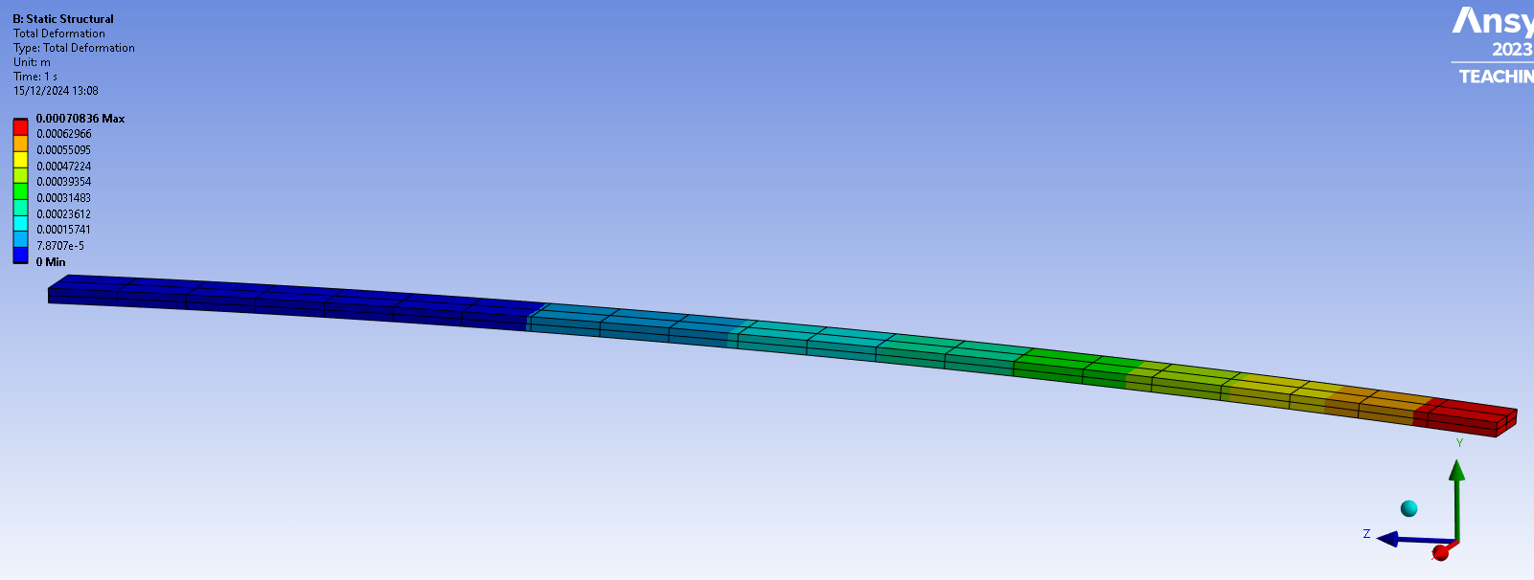
Figure 2 – Total Deformation from Thermal Loading
Figure 2 shows the total deformation results for the bimetallic strip subjected to thermal loading in ANSYS. The colour contour reveals deformation due to the temperature difference.
The maximum deflection seen in the simulation is -0.708mm, as its deflecting downwards. Compared to the empirical solution of -7.08mm. The 10 factor difference can be explained by the fact that the analytical value was derived using dimensions in ‘mm’ whereas the simulation was done in ‘m’, or possibly some other error with units in the simulation process. However the values are off only by a factor of 10, therefore its safe to conclude that the correct simulation and analytical solution have a low error percentage.

Error Differences
One of the most common sources of such significant differences stems from unit scaling errors. The analytical result is presented in millimetres, while ANSYS, by default, outputs results in meters. If the input parameters, such as the thermal expansion coefficients or temperature difference, were not consistently scaled or interpreted, it could significantly underestimate the deflection.
The second area of concern is the coarseness of the mesh. In a problem involving a bimetallic strip, where the deformation occurs gradually along its length, a coarse mesh struggles to capture the curvature accurately. As a result, the maximum deflection at the free end is under-predicted. A finer mesh, especially along the beam’s length, would improve the resolution of the bending deformation and bring the results closer to the analytical solution.

Modelling & Assembly

Introduction to Model and Assembly
This study makes use of a pre-existing mechanical assembly which serves as the foundation for the structural analysis. The assembly consists of components that replicate a simplified internal combustion engine mechanism. By adopting this example, the study avoids the need for extensive model development, allowing a more focused investigation into the simulation, structural behaviour, and optimization of a key component. This approach ensures a balance between realism and practicality, delivering meaningful insights while maintaining computational efficiency.

Components
The assembly used for this analysis includes a piston, a connecting rod, a gudgeon pin, and a crankshaft. The piston, which is the primary component of interest, transfers motion through the connecting rod and gudgeon pin to the crankshaft, where reciprocating motion is converted into rotational motion. The base support provides structural stability, serving as the fixed element to anchor the system. The geometry and positioning of the components were carefully defined to reflect accurate alignment and realistic mechanical interfaces.
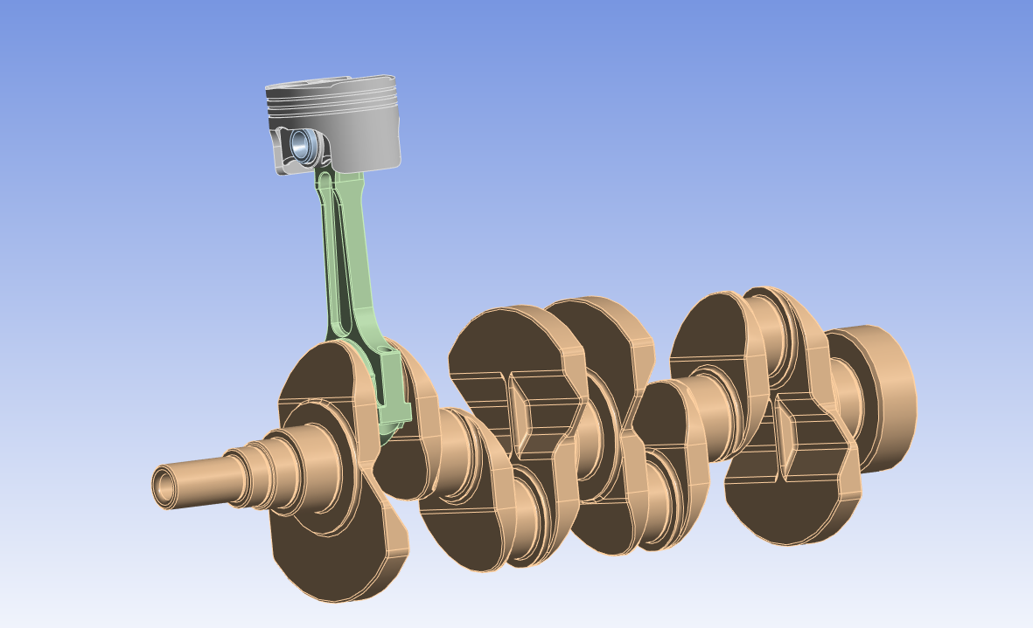
Figure 3 – Mechanism Assembly

Kinematic Simulation & Structural Analysis

Kinematic Analysis
A rigid dynamics simulation was performed to validate the kinematic behaviour of the assembly. The study focused on replicating the motion of the piston, connecting rod, and crankshaft under realistic constraints. To achieve this, body-to-body connections were added to define the interactions between key components.

Setup

Four revolute joints were established to enable rotational motion. The first linked the crankshaft to the connecting rod, driving the rod's motion. The second connected the rod to the gudgeon pin, allowing the pin to pivot. The third linked the gudgeon pin to the piston, enabling the piston to reciprocate as guided by the rod. To anchor the system, a body-to-ground revolute joint fixed the crankshaft's position relative to the global coordinate system, establishing its rotational axis.

A fifth connection, a body-to-ground constraint on the piston skirt, restricted unnecessary motion. It allowed the piston to move only along its vertical axis while preventing it from spinning with the crankshaft. This ensured physical realism and accurate motion transfer in the assembly.

Thermal Considerations
A steady-state thermal simulation was conducted to evaluate the thermal behaviour of the piston under operating conditions. In this phase, all other components in the assembly were suppressed, allowing the focus to remain solely on the piston. The piston was assigned an initial temperature of 22°C to represent ambient conditions before thermal loading was applied.

Setup
Six convection loads were defined at specific locations on the piston, as shown in figure x. Each location had a corresponding film coefficient and ambient temperature to reflect the heat transfer occurring in a realistic engine environment:
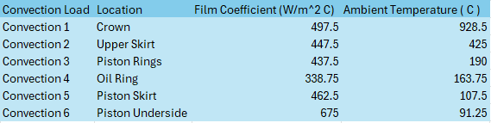
Figure 4 – Table of Thermal Conditions on Piston
These convection loads simulated the heat transfer conditions experienced by the piston during engine operation, with the crown experiencing the highest temperatures due to direct exposure to combustion gases.

Discussion

Static Structural
The final phase of the analysis involved a static structural simulation to evaluate the stress distribution and deformation of the piston under combined thermal and mechanical loading. For this simulation, the motion loads exported from the kinematic study and the temperature results from the steady-state thermal analysis were imported to replicate realistic operating conditions.

Setup
In addition to the imported loads, a pressure load of 10,500,000 Pa was applied to the crown of the piston to simulate the force exerted by combustion gases. This pressure load represented the peak forces experienced during the combustion process. To ensure the simulation could run effectively, a fixed support was applied to the gudgeon pin holes of the piston. This constraint was necessary because the large forces involved in the analysis could not be stabilized using weak springs, which are typically applied by default in the software.
While the fixed support allowed the simulation to proceed, it introduces some limitations regarding the accuracy of the results, particularly in regions around the constraint. The potential consequences of using a fixed support on the gudgeon pin holes will be discussed later in this report to ensure transparency and provide context for interpreting the results.

Simulation Results

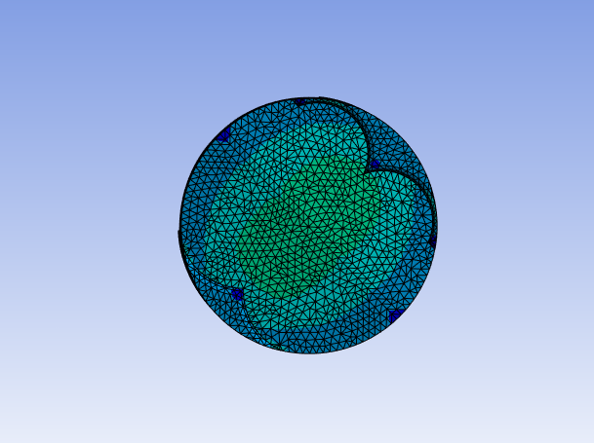
Equivalent Stress
Figure 5 – Equivalent Stress on T6 6061 Piston (1)

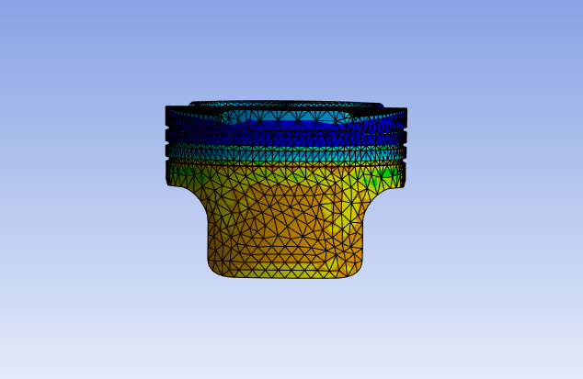
Figure 6 - Equivalent Stress on T6 6061 Piston (2)

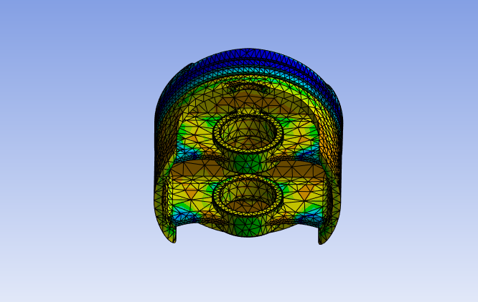
Figure 7 - Equivalent Stress on T6 6061 Piston (3)

The simulation results revealed critical insights into the piston's structural behaviour. The maximum equivalent (von-Mises) stress was found to be 3.6144 × 10⁸ Pa, as shown in the stress contour plots.
The stress distribution gradually increased from the crown to the skirt and underside, with minimum values of approximately 1.1702 × 10⁶ Pa observed in less constrained areas. High-stress regions were predominantly located along the gudgeon pin holes and sharp transitions between the crown and skirt, where stress concentration effects were significant.

Thermal Load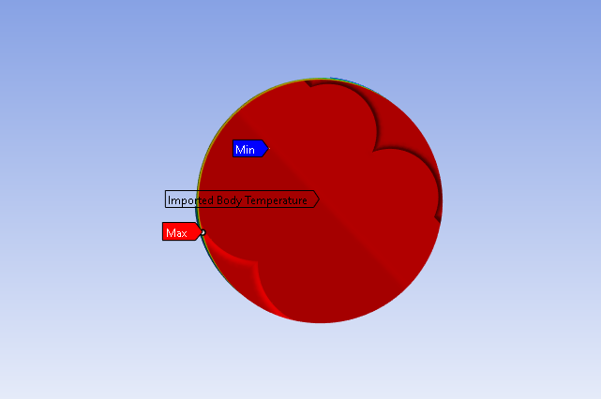
Figure 8 – Thermal Load on T6 6061 Piston (1)

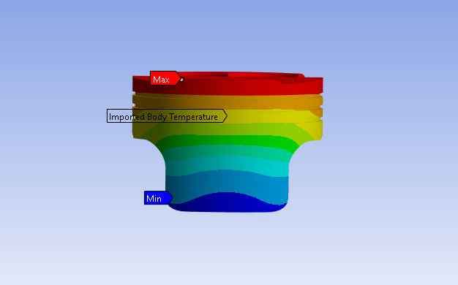
Figure 9 - Thermal Load on T6 6061 Piston (2)

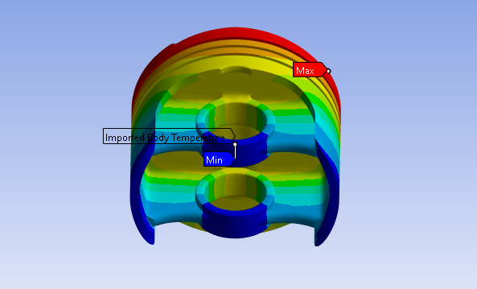
Figure 10 - Thermal Load on T6 6061 Piston (3)
The maximum temperature reached 300.49°C, observed at the crown of the piston, which is directly exposed to the combustion gases.
Conversely, the minimum temperature was 164.38°C, observed at the underside of the piston. The temperature gradient decreases progressively from the crown to the underside, as shown in the thermal contour plots.

Deformation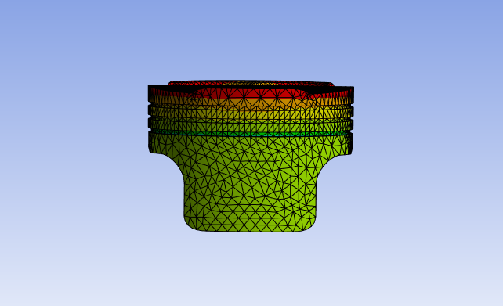
Figure 11 – Total deformation on T6 6061 Piston (1)
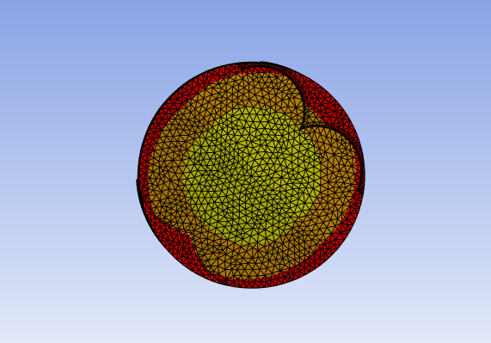
Figure 12 - Total deformation on T6 6061 Piston (2)

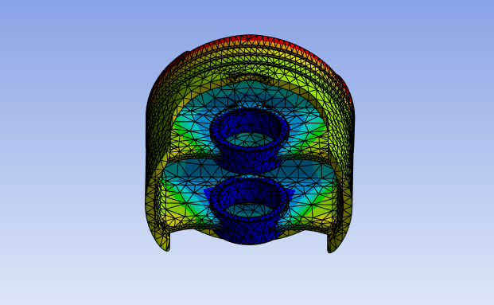
Figure 13 - Total deformation on T6 6061 Piston (3)
The total deformation results revealed that the maximum deformation occurred at the crown of the piston, with a value of 0.00029183 m (0.29183 mm). This deformation is expected due to the high-pressure load applied during combustion and the thermal expansion resulting from elevated temperatures in this region. The deformation gradually reduced towards the piston skirt and underside, where the constraints at the gudgeon pin holes limited movement and provided additional structural support.
.

Optimisation and Improvement

Material Selection
Material selection is crucial for optimizing engine piston performance, durability, and efficiency. While T6 6061 aluminium is widely used for its lightweight and reliable properties, modern engine demands necessitate exploring alternatives with superior characteristics.
This study examines three candidates: 2618 aluminium alloy, 4140 steel, and Ti-6Al-4V titanium alloy. Each offers unique advantages:

- 2618 aluminium enhances strength and fatigue resistance but has higher thermal expansion.
- 4140 steel excels in strength and wear resistance, suited for high loads but adds weight.
- Ti-6Al-4V titanium offers an exceptional strength-to-weight ratio and thermal stability, albeit at higher costs.
The investigation evaluates these materials for stress, deformation, and thermal performance, aiming to identify viable substitutes that exceed the capabilities of T6 6061 aluminium.

Aluminium 2618
Aluminium 2618 is a high-strength, heat-treatable aluminium alloy widely used in aerospace and automotive industries for components subjected to high stress and elevated temperatures. It is a hypoeutectic alloy with low silicon content (typically < 2%), offering excellent fatigue resistance, tensile strength, and good machinability.

Stress (Von-Mises)

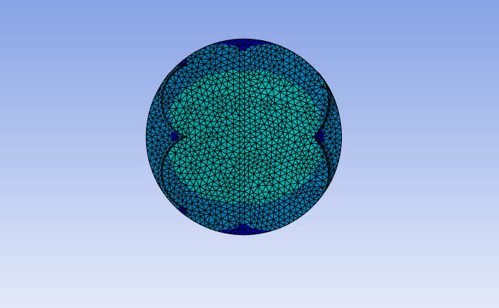
Figure 14 – Stress on 2618 Piston (1)
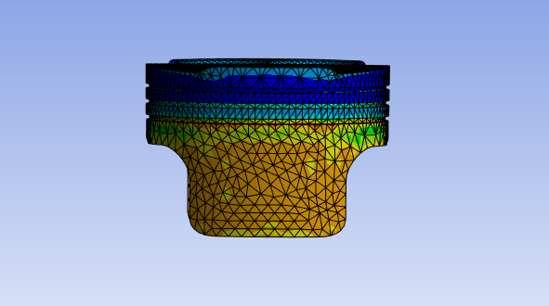
Figure 15 - Stress on 2618 Piston (2)

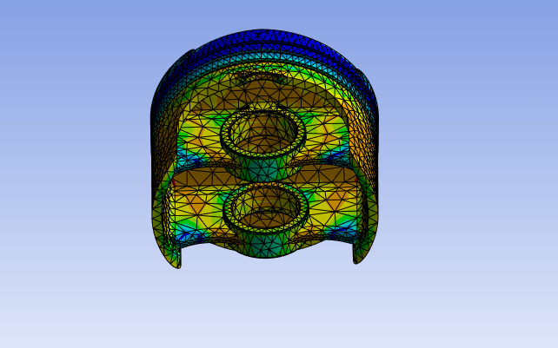
Figure 16 - Stress on 2618 Piston (3)
The von-Mises stress analysis for the piston made of 2618 aluminium highlights areas of concern under the applied loading conditions.
The maximum stress recorded is 4.3196 × 10⁸ Pa (431.96 MPa), exceeding the material's yield strength of approximately 400 MPa. This indicates the potential for localized plastic deformation in critical areas, particularly around the gudgeon pin bosses and regions with geometric discontinuities, where stress concentrations are most pronounced.
Temperature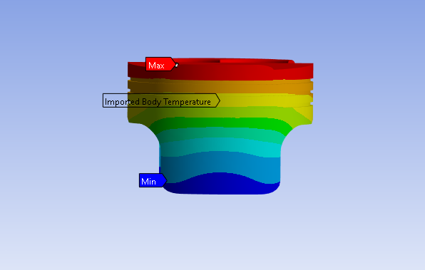
Figure 17 – Thermal Loading on 2618 Piston (1)

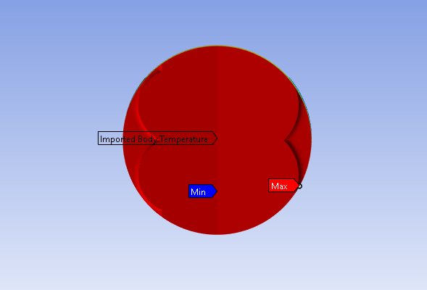
Figure 18 - Thermal Loading on 2618 Piston (2)
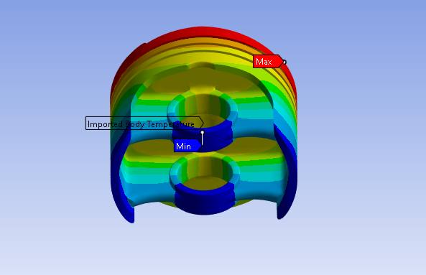
Figure 19 - Thermal Loading on 2618 Piston (3)
The thermal analysis reveals a maximum temperature of 310.31°C at the piston crown, where direct exposure to combustion gases results in the highest thermal load. The minimum temperature of 157.22°C occurs at the lower piston skirt and gudgeon pin holes,

Deformation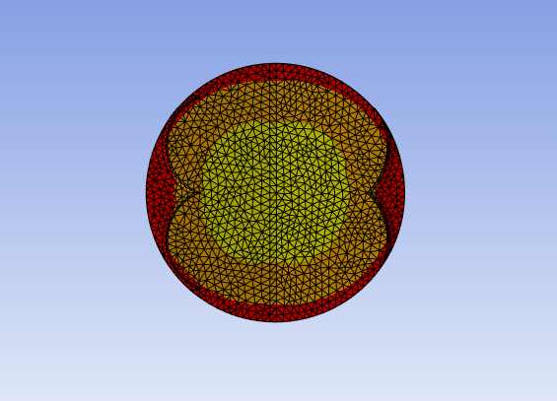
Figure 20 – Total Deformation on 2618 Piston (1)
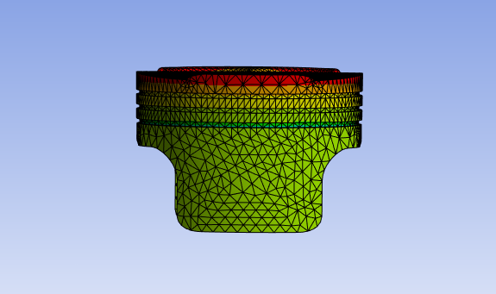
Figure 21 - Total Deformation on 2618 Piston (2)

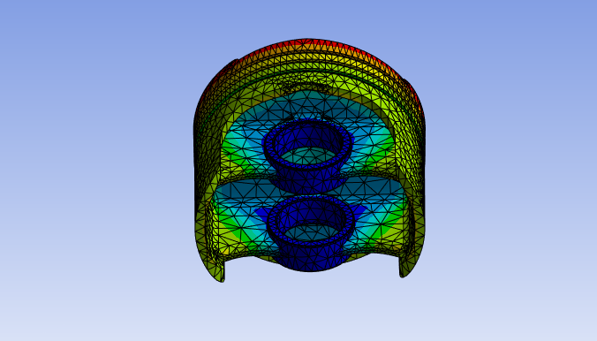
Figure 22 - Total Deformation on 2618 Piston (3)
The results indicate a maximum deformation of 0.00028697 m (0.28697 mm), concentrated at the piston crown, where the combined thermal and mechanical loading is most severe. The minimum deformation is recorded as 0 m at the fixed regions, primarily at the lower skirt and gudgeon pin supports.

Steel 4140
4140 steel is a low-alloy, high-strength steel known for its excellent tensile strength, toughness, and wear resistance. It contains chromium, molybdenum, and carbon, which enhance its mechanical properties, particularly after heat treatment. Its high yield strength (~655 MPa) and durability make it an ideal candidate for engine pistons subjected to extreme mechanical and thermal stresses.

Stress (Von-Mises) 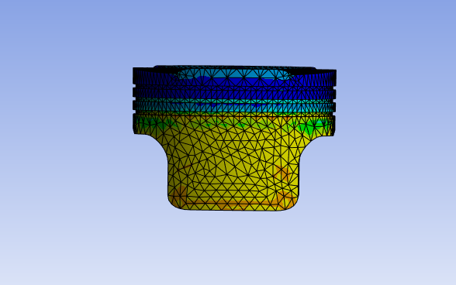
Figure 23 - Stress on 4140 Steel Piston (1)
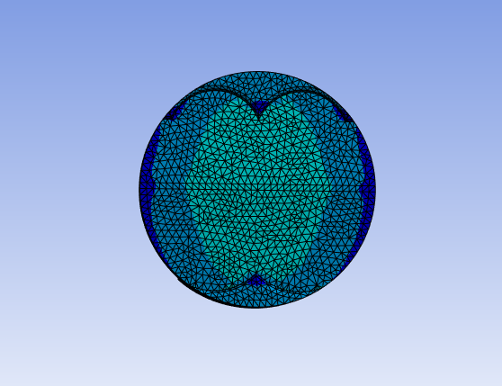
Figure 24 - Stress on 4140 Steel Piston (2)

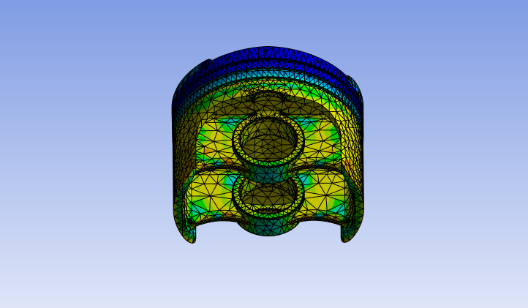
Figure 25 - Stress on 4140 Steel Piston (3)
The analysis reveals a maximum stress of 5.3584 × 10⁸ Pa (535.84 MPa). This value is significant but remains within the yield strength range of 4140 steel, which is approximately 655 MPa in its heat-treated condition.

Temperature

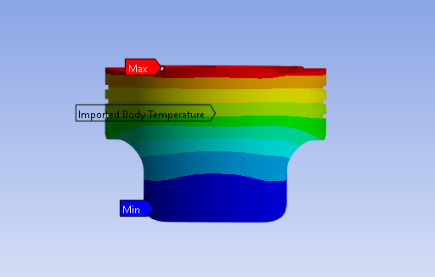
Figure 26 – Thermal Loading on 4140 Steel Piston (1)

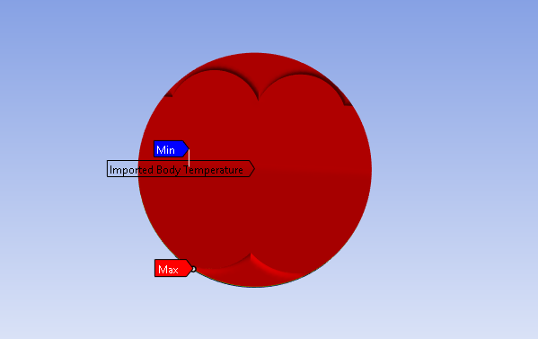
Figure 27 - Thermal Loading on 4140 Steel Piston (2)
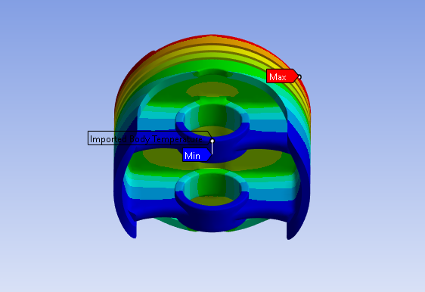
Figure 28 - Thermal Loading on 4140 Steel Piston (3)
The thermal analysis shows a maximum temperature of 418.15°C at the piston crown, where combustion heat is most intense. The minimum temperature of 107.52°C occurs at the lower skirt and gudgeon pin bosses, indicating effective heat dissipation.

Deformation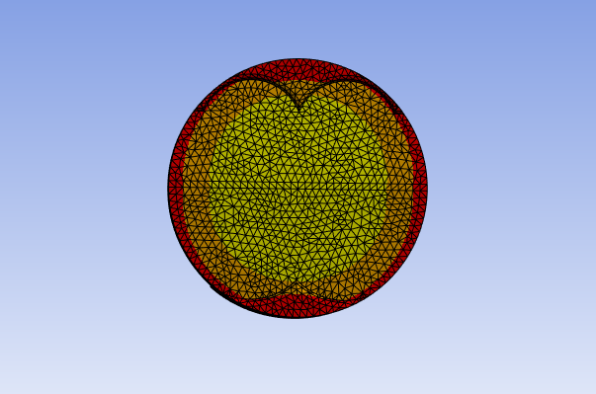
Figure 29 – Total deformation on 4140 Steel Piston (1)
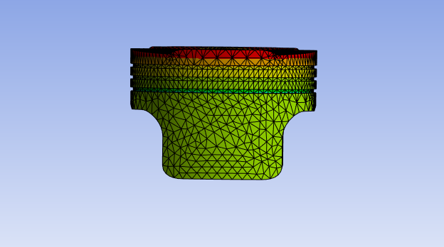
Figure 30 - Total deformation on 4140 Steel Piston (2)

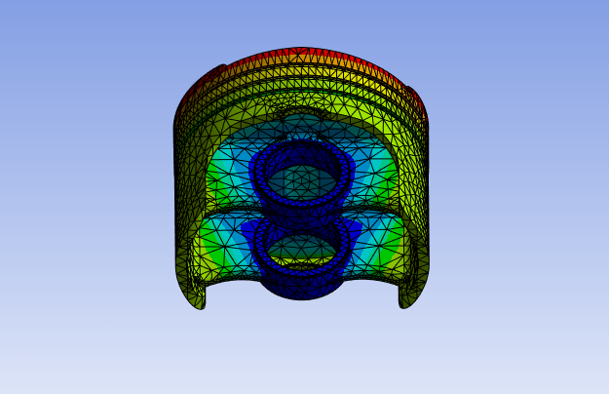
Figure 31 - Total deformation on 4140 Steel Piston (3)
The analysis shows a maximum deformation of 0.20832 mm at the piston crown, where thermal and mechanical loads are highest. Minimal deformation occurs at the lower skirt and gudgeon pin bosses due to structural constraints and reduced thermal exposure. 4140 steel exhibits excellent stiffness and minimal deformation, maintaining dimensional stability under high loads and temperatures. This performance confirms its suitability for high-stress piston applications.

Titanium Ti-6Al-4V
Ti-6Al-4V is a high-performance alloy known for its exceptional strength-to-weight ratio, corrosion resistance, and ability to withstand high temperatures. Its yield strength of approximately 880 MPa and resistance to thermal degradation make it an ideal candidate for high-stress, lightweight piston applications.

Stress (Von-Mises) 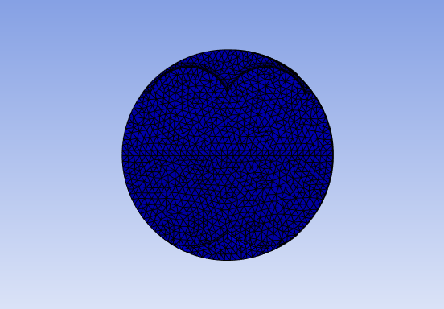
Figure 32 - Stress on Titanium Piston (1)
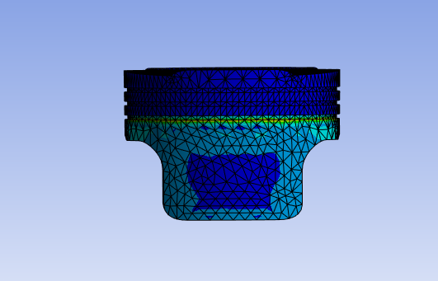
Figure 33 - Stress on Titanium Piston (2)

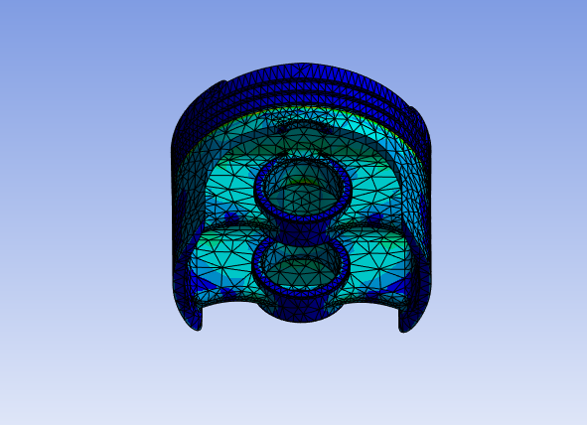
Figure 34 - Stress on Titanium Piston (3)
The analysis shows a maximum stress of 1.173 × 10⁹ Pa, exceeding the yield strength of Ti-6Al-4V (~880 MPa), indicating potential localized plastic deformation.

Temperature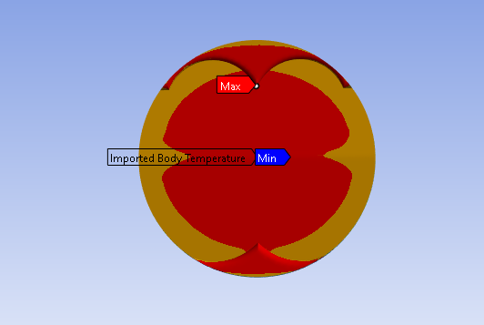
Figure 35 – Thermal Loading on Titanium Piston (1)
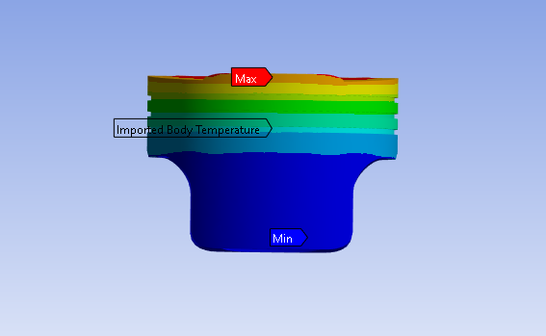
Figure 36 – Thermal Loading on Titanium Piston (2)

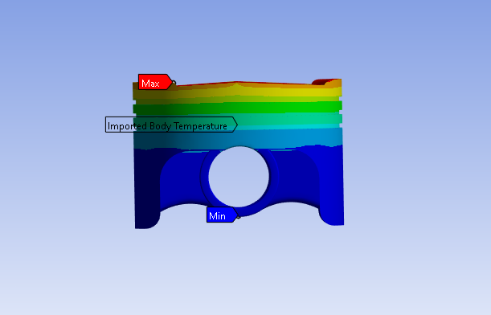
Figure 37 – Thermal Loading on Titanium Piston (3)
The thermal analysis shows a maximum temperature of 643.49°C at the piston crown, where the material is exposed to intense combustion heat. The minimum temperature of 91.4°C occurs at the lower piston skirt and gudgeon pin region, farthest from the heat source.

Deformation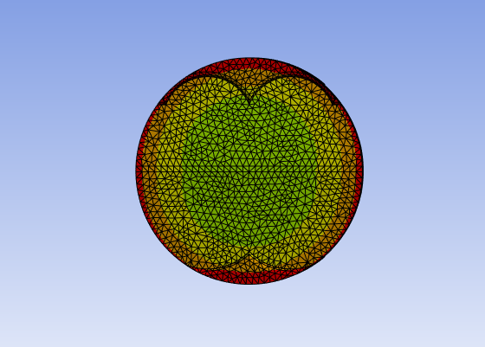
Figure 38 – Total Deformation on Titanium Piston (1)
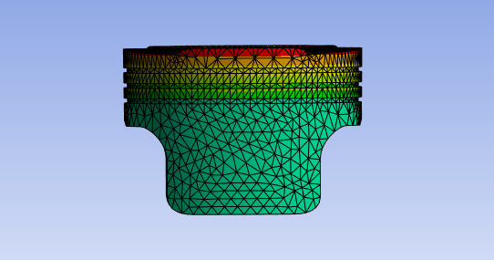
Figure 39 - Total Deformation on Titanium Piston (2)

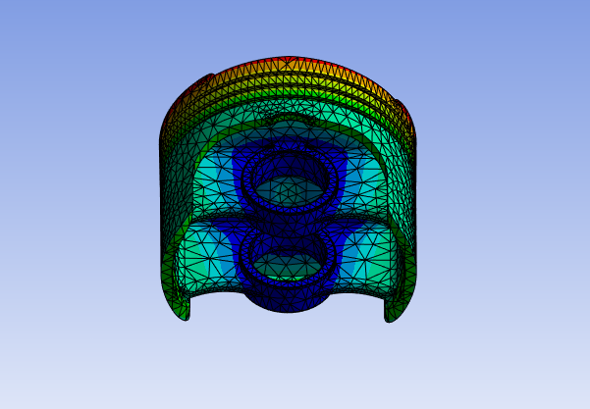
Figure 40 - Total Deformation on Titanium Piston (3)
The total deformation analysis shows a maximum displacement of 0.00020591 m (0.20591 mm), concentrated at the piston crown due to combined mechanical and thermal loads.

Material Discussion
The comparative analysis of 2618 aluminium, 4140 steel, and Ti-6Al-4V titanium reveals key differences in stress, temperature resistance, deformation, and weight, which influence their suitability for piston applications.

Stress Handling
4140 steel outperforms the other materials, with stresses remaining well below its yield strength of 655 MPa. In contrast, Ti-6Al-4V (max stress: 1173 MPa) and 2618 aluminium (max stress: 432 MPa) exceed their yield strengths, indicating potential plastic deformation under high loads. While steel excels in durability, titanium’s superior strength-to-weight ratio remains advantageous for performance applications.

Temperature Performance
2618 aluminium maintains its advantage in thermal conductivity, with a maximum temperature of 310°C, allowing for efficient heat dissipation. 4140 steel withstands higher temperatures (418°C) while maintaining strength but risks heat retention due to its lower conductivity. Ti-6Al-4V exhibits the highest peak temperature (643°C), approaching its operational limits, necessitating effective thermal management to prevent overheating.

Deformation
Both 4140 steel and Ti-6Al-4V exhibit low deformations of 0.208 mm and 0.205 mm, respectively, highlighting their stiffness and ability to retain shape under load. 2618 aluminium shows significantly higher deformation at 0.287 mm, a consequence of its lower stiffness, which can affect long-term dimensional stability.

Weight Considerations
While 2618 aluminium remains the lightest option with a weight of 0.26kg, titanium’s density provides a balanced solution with reduced weight of 0.41kg compared to steel’s 0.74kg. The high density of 4140 steel, while beneficial for strength, adds weight that could reduce engine efficiency in performance applications.

Limitations of CAE Tools

Mesh Independence

Simple Case Study
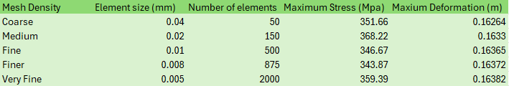
Figure 41 – Table Showing Mesh Parameters alongside respected results
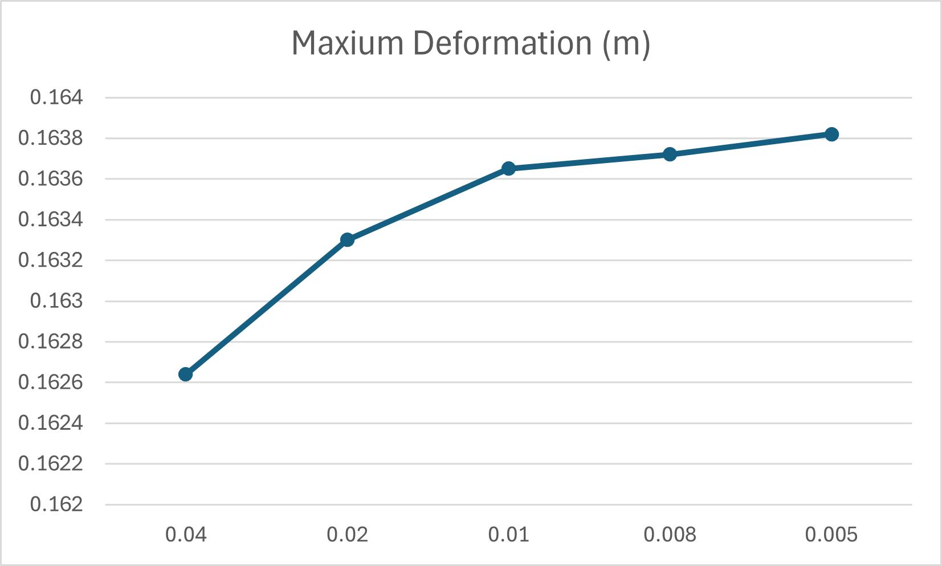
Figure 42 – Maximum Deformation Vs Mesh Count
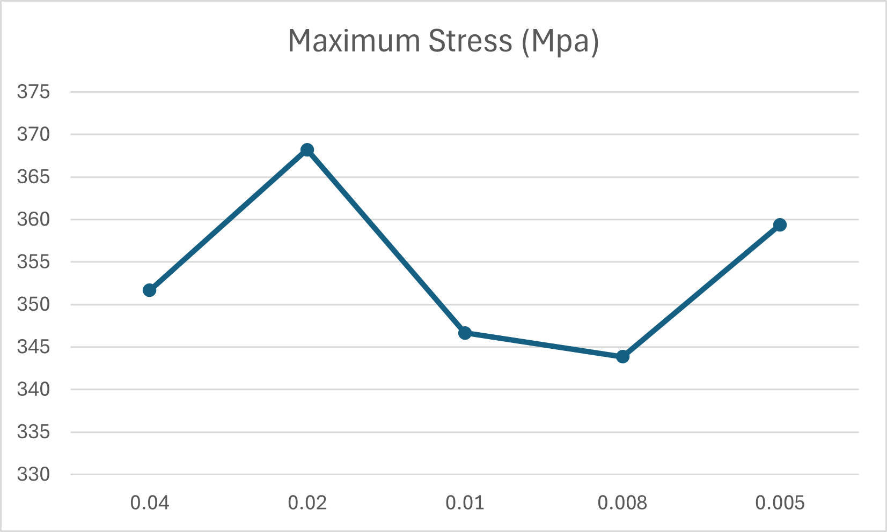
Figure 43 – Maximum Stress vs Mesh Count
The plots for maximum deformation and maximum stress demonstrate the mesh convergence behaviour for the cantilever beam under a uniform load of 2750 Pa.
The maximum deformation plot shows a clear trend of increasing values as the mesh is refined. At element sizes of 0.008m and 0.005m, the deformation stabilizes around 0.1637 m, with a negligible difference between them. This indicates that deformation has reached mesh independence, and further refinement offers no significant improvement.
The maximum stress plot, however, exhibits slight fluctuations. The stress initially rises at 0.02m but stabilizes near 343–344 MPa at element sizes of 0.01m and 0.008m. A minor increase at 0.005m suggests sensitivity to mesh refinement or local numerical effects. Despite this, the stress remains close to convergence.
In conclusion, the 0.01m mesh provides accurate and reliable results for both deformation and stress while balancing computational efficiency. Further refinement offers diminishing returns, making this mesh size optimal for analysis.

Conclusion
The report emphasizes the value of Computer-Aided Engineering (CAE) tools in the design and analysis of mechanical assemblies. By utilizing kinematic, structural, and thermal simulations, real-world conditions were effectively replicated, leading to optimized designs and improved performance. Validation through simplified case studies reinforced the importance of ensuring simulation accuracy and reliability.
While CAE tools demonstrated their capability to provide valuable insights and guide design improvements, challenges such as the impact of mesh quality were identified. These limitations highlight the necessity of combining simulation results with traditional analytical methods for reliable outcomes.

References

- Wasserman, S. (2024). What is CAE? - Engineering.com. [online] Engineering.com. Available at: https://www.engineering.com/what-is-cae/?utm_source=chatgpt.com [Accessed 15 Dec. 2024].
- Dlubal Software (2021). Verification Examples. [online] Dlubal Software. Available at: https://www.dlubal.com/en/downloads-and-information/examples-and-tutorials/verification-examples [Accessed 15 Dec. 2024].
- Selin Cinemre (2024). What is Computer Aided Engineering (CAE)? - Fusion Blog. [online] Fusion Blog. Available at: https://www.autodesk.com/products/fusion-360/blog/what-is-computer-aided-engineering-cae/?utm_source=chatgpt.com [Accessed 15 Dec. 2024].
- https://www.simscale.com/knowledge-base/mesh-sensitivity-cfd/?utm_source=chatgpt.com
- Wassee (2019). What is a mesh independence study? [online] FEA Tips. Available at: https://featips.com/2019/03/31/what-is-a-mesh-independence-study/.

‌

Appendices A – Figures
Figure 1 – Total Deformation of Static Structural Validation 5
Figure 2 – Total Deformation from Thermal Loading 7
Figure 3 – Mechanism Assembly 9
Figure 4 – Table of Thermal Conditions on Piston 12
Figure 5 – Equivalent Stress on T6 6061 Piston (1) 14
Figure 6 - Equivalent Stress on T6 6061 Piston (2) 15
Figure 7 - Equivalent Stress on T6 6061 Piston (3) 15
Figure 8 – Thermal Load on T6 6061 Piston (1) 16
Figure 9 - Thermal Load on T6 6061 Piston (2) 17
Figure 10 - Thermal Load on T6 6061 Piston (3) 17
Figure 11 – Total deformation on T6 6061 Piston (1) 19
Figure 12 - Total deformation on T6 6061 Piston (2) 19
Figure 13 - Total deformation on T6 6061 Piston (3) 20
Figure 14 – Stress on 2618 Piston (1) 22
Figure 15 - Stress on 2618 Piston (2) 22
Figure 16 - Stress on 2618 Piston (3) 23
Figure 17 – Thermal Loading on 2618 Piston (1) 24
Figure 18 - Thermal Loading on 2618 Piston (2) 24
Figure 19 - Thermal Loading on 2618 Piston (3) 25
Figure 20 – Total Deformation on 2618 Piston (1) 26
Figure 21 - Total Deformation on 2618 Piston (2) 26
Figure 22 - Total Deformation on 2618 Piston (3) 27
Figure 23 - Stress on 4140 Steel Piston (1) 29
Figure 24 - Stress on 4140 Steel Piston (2) 29
Figure 25 - Stress on 4140 Steel Piston (3) 30
Figure 26 – Thermal Loading on 4140 Steel Piston (1) 31
Figure 27 - Thermal Loading on 4140 Steel Piston (2) 31
Figure 28 - Thermal Loading on 4140 Steel Piston (3) 32
Figure 29 – Total deformation on 4140 Steel Piston (1) 33
Figure 30 - Total deformation on 4140 Steel Piston (2) 33
Figure 31 - Total deformation on 4140 Steel Piston (3) 34
Figure 32 - Stress on Titanium Piston (1) 35
Figure 33 - Stress on Titanium Piston (2) 35
Figure 34 - Stress on Titanium Piston (3) 36
Figure 35 – Thermal Loading on Titanium Piston (1) 37
Figure 36 – Thermal Loading on Titanium Piston (2) 37
Figure 37 – Thermal Loading on Titanium Piston (3) 38
Figure 38 – Total Deformation on Titanium Piston (1) 39
Figure 39 - Total Deformation on Titanium Piston (2) 39
Figure 40 - Total Deformation on Titanium Piston (3) 40
Figure 41 – Table Showing Mesh Parameters alongside respected results 42
Figure 42 – Maximum Deformation Vs Mesh Count 42
Figure 43 – Maximum Stress vs Mesh Count 43

