Module: Management Engineering Projects
Title: Business Management in Projects
Module Code: ACEA7009
Student Name: Sukhada Kulkarni (2213994)

Table of Contents
Introduction 1
Engagement with literature skills 1
Fundamental principles of project management 1
Key points of project management 3
Knowledge and understanding skills 4
Theories of leadership and Team roles 4
Analysis of case study using SWOT analysis 5
Analysis related to Organisational structure 6
Analysis related to Leadership and management 6
Analysis related to Communication and change management 7
Cognitive and intellectual skills 7
Management procedures 7
Motivational techniques 7
Leadership styles 8
Practical skills 8
Applying concepts and ideas 8
Work breakdown structure 9
Conclusion 9
References 9

Introduction
The project management is considered to be an essential phenomenon for the success of the business and it requires a systematic understanding about the project structure, project plans and executional procedures. These can be analysed by using the leadership models which helps in tackling the issues through the management skills that includes communication, scheduling, risk and quality. In this report we have categorised the project management of the small firm under engagement with literature skills, knowledge and understanding skills, cognitive and intellectual skills and practical skills. All these skills help to identify the essential points of project management based on various theories on leadership, identifying the issues and resolving them by using management techniques. The entire processes or tasks involved in the project management of the small firm can be described by using the work breakdown structure in a detailed manner.

Engagement with literature skills

Fundamental principles of project management
As the projects require more technologies, resources and budget requirements, it is the responsibility of the project managers to ensure that the projects get completed in a successful manner. The project management uses particular knowledge, skills and techniques for delivering the values to the people. Through software application development it is possible to expand the sales performance of the small business firm. The fundamental principles of project management might ensure the success of the project (Kernel, 2020). This might include the following principles.
- Success
- Project manager
- Commitment
- Structure
- Definition
- Transparency
- Communication
- Progress
- Lifecycle
- Culture
- Risk and
- Accountability
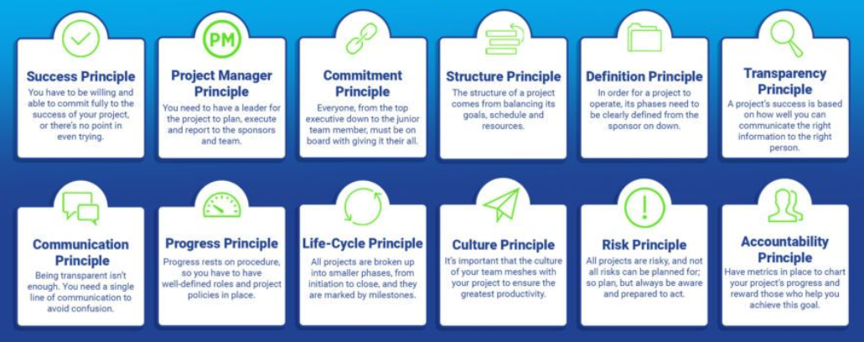
Figure 1. Project management principles
Success - This criterion is based on the completion of project on time and also within the budget constraints. This must also deliver the expectations of the clients and provide quality outcomes.
Project manager – they are responsible for the success of the project and they will obtain sponsorship, resources, allocates the budget, ensuring the management of risks, resource transparency and also smooth operations in all the project aspects. The toolkit of the project manager might comprise the technical knowledge, people skills, communication skills in a good manner and the improvements can be made by upskilling and learning practices in a continuous manner (Ahsan Ali, 2020).
Commitment – all the employees in the project must be committed for achieving the objectives and goals of the project. this is based on the scope, objectives, goals, quality and time.
Structure – the project goal, project resources and time are considered as the three pillars for providing project structure. This must be decided before beginning the project. the time required for the project to complete its objectives is also considered an important structure.
Definition – the project definition is not stated as a one-time activity and they can be re-visited at regular intervals which makes everyone in the team about the project goals and objectives.
Transparency – the foundations of a good and successful project is the transparency and trust. This might represent the openness among the team members, stakeholders, and the customers. By using various tools, it is possible to communicate and share the status of the project with the team members.
Communication – in order to lead the team and motivate the team members by using excellent communication skills.
Progress – a successful project must have a milestone that are defined clearly. Each and every team member must have a clear idea about their achievements, objectives, and goals. It is also necessary to have a proper risk assessment.
Lifecycle – this might include all the stages of the project lifecycle and all the project phases are necessary for the project’s success.
Culture – this organisational culture might support the innovation and development of the project and it is essential for an organisation to adopt the culture for promoting the creativity and quality work.
Risks – this might alter the objectives and results of the project. Identification of risks helps to mitigate the adverse effects of the risk in the project (business, 2022).
Accountability – the project team must be accountable for obtaining the deliverables and success. Based on the milestones, it is possible to measure the performance of the project.

Key points of project management
The main points of the project management might include the three variables which helps in determining the project quality based on scope, cost and time. These three points must be balanced by the project manager for achieving the best project quality within the budget, time and also adhering to the specifications of the project (Cristina T. Cerdeiral, 2019).
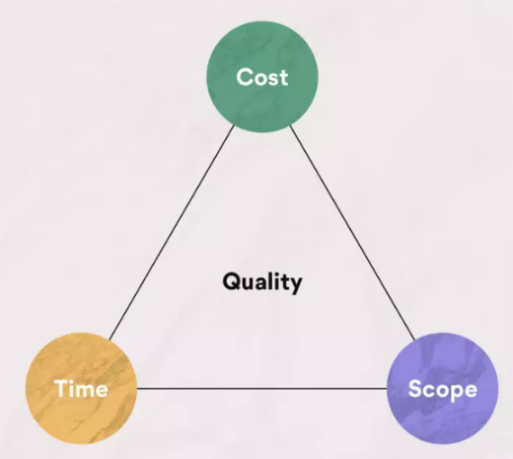
Figure 2. Key points of project management
Scope
This represents the project size based on quality and magnitude of the deliverables of the project. if the project size gets increased it requires more time and cost to complete the project in a successful manner. The project scope might include the following elements.
- Complexity of the project
- Finished products quantity
- Quality of output
- Strength
- Level of detail
- Complexity of features (Chaher Zid, 2020).
Cost
The cost is based on the resources of the project which might include the tools, equipment and support needed for completing the project in a successful manner. The cost of the project might include the following elements.
- Budget
- Number of team members
- Cost of equipment and other facilities
- Opportunities of the project (Chaher Zid, 2020).
Time
The time can be adjusted based on the project specifications in the execution of a project. The time constraints of the project are based on the following elements.
- The overall timeline of the project
- Worked hours in the project.
- Internal goal posts and calendars
- Planning and strategy
- Total number of project phases (Asana, 2022).
The project management methods used for saving resource and time might include waterfall, lean, agile, scrum, Kanban and scrumban technologies.

Knowledge and understanding skills

Theories of leadership and Team roles
Based on the style of leadership, the theories of leadership and team roles has been adapted by the project managers in their business environment. In order to adapt to the challenging times in the business, the project managers have changed the style of leadership (Osman, 2019). The project managers were benefited by using the leadership theories and these theories were based on the assumptions on a specific type of leader. An embarrassment of leadership theories has been formulated for the purpose of defining various styles of leadership. Based on the analysis the following leadership theories were formulated by the managers to excel in them. This might include,
- The great man theory
- The trait theory
- The behavioural theory
- The management theory
- The Contingency theory
- Transformational theory
- The situational theory (Niklas K. Steffens, 2020).
The great man theory
Based on this theory the leadership traits are very intrinsic and they are the earliest leadership theories. According to this theory, the leaders were born and they are not made and they must possess certain qualities that are inborn. The people cannot become as a powerful leader through learning instead they must be born with natural leadership skills (VASILESCU, 2019). This theory might revolve around the great leaders if they are in need. The leadership traits might include the following inborn qualities like,
- Charm
- Judgement
- Intelligence
- Courage
- Aggressiveness
- Persuasion.
The trait theory
This theory is considered to be an extension of the great man theory and it is based on the concept that specific behavioural traits and characteristics were possessed by the influential leaders (Sihame Benmira, 2020). The behavioural traits make them to become as an influential leaders based on several contexts. This also advocates that the effective leaders were made through the natural abilities of the person or individual. The interests and rates of successful leaders might differ from individuals who are not leaders. By using the leadership theory, it is possible to analyse the strengths and weaknesses and this helps to improve the weakness. Most of the business organisation uses the trait theory for the purpose of selecting the best employees for the role of leadership (Emeritus, 2022). The behavioural traits of an effective leader might include the following characters.
- Emotional stability
- Responsibility acceptance
- Competence
- Understanding the challenges
- Thinking oriented on action
- Motivation
- Communication
- Courage and adaptability
- Decision making.
By using the leadership theories, it is possible to improve the skills in order to become an effective leader. It is necessary for the project managers and the team leaders to adapt the leadership styles and lead their project team towards success (Laura Cortellazzo, 2019).

Analysis of case study using SWOT analysis
According to the case study, the small firm that make smoothies and sell them in markets have decided to expand their business and products. As a project manager, it is necessary to consider the following ideas in order to expand the business. According to this idea, there are scenarios developed based on the plans of the owner to expand business at their own initiative (Mostafa Ali Benzaghta, 2021). The company might be subjected to unexpected growth in the sales based on the demands in the market.

Strengths  - Strong brand name  - Loyal customer base  - Unique technologies  - Healthy food products  - Hygienic manufacturing and packaging methods. | Weaknesses  - Inadequate supply chain management.  - Lack of marketing and advertising skills.
Opportunities  - Increasing sales growth  - More profit than expected  - More demands on manufactured products | Threats  - Possibility of new entrants.  - Increased competition in market  - Increased cost of food materials.
Table 1. SWOT analysis

Analysis related to Organisational structure
The structure of the organisation might help the employees about the process of operations that run in the company and how they are managed and the information are shared among the employees. The logistics of the small business firm can be depicted by using the organisational structure. There are some important factors to be considered in order to find the appropriate structure of the organisation. This might include the
- Type of industry.
- The size of the company.
- The goal of the company.
The organisational structure might be of different types based on the type of business they perform. They might be either traditional based or functional based or project based. The small firms like the manufacturing and selling of food products might implement the traditional organisational structure (Eva Martínez-Caro, 2020). As the case scenario has to expand its business in several areas and manufacture new products, the traditional line of organisational structure is implemented.

Analysis related to Leadership and management
The competitive edge can be obtained in the business by investing the development programs and this is achieved by driving the execution of strategy and enhancing the performance of the company whenever changes are made. The development of leadership and management in the company helps in enhancing the engagement of employees, improves the capacity of the company to manage the shortfalls in the pipeline and also reduces the issues and expenses that are linked with the turnover of the business. It is possible to generate new streams of income and helps in improving the satisfaction of customers by the development of leadership programs (Mohamed Alblooshi, 2021).
The roles of leadership and management in the process of business development of expansion is based on the following strategies.
- The engagement of employees in the development of leadership roles helps in improving the performance.
- The employees might perform all their responsibilities based on the engagement of the managers and through leadership development programs, it is possible to provide direction and merge all the business processes together.
- Based on the human factors the success of the organisation can be obtained and this includes the development of skills, changes in behaviour, responsibility, creativity skills and team work activities (Emeritus, 2022).
Through the leadership development programs it is possible to improve the productivity of the business through training programs, identifying the issues and resolving them at appropriate situations.

Analysis related to Communication and change management
The communication process is considered as an important parameter for successfully implementing the change management program in the industry. in the case scenario, the small business firm decides to expand its business process by manufacturing several new products and expanding the business at greater levels. Hence the business process must focus on the process of implementing the change management in the principles and processes of the business. The strategic planning, tools used for delivering the changes in the organisation is described in the change management (sabel-María García‐Sánchez, 2020). The risks in the organisational change can be reduced by using the change management processes.
It is necessary to have effective communication for achieving success in the change management of the business. There are possibilities of consequences in the business process if the internal communication is not utilized in proper manner. This might result in wastage of resources and money, inefficiencies in productivity, failure in meeting the requirements and damages to the reputation (Bob, 2020). The communication strategy for the change management in the business might be based on the following steps.
- Setting out the objectives for communication.
- Undertaking the analysis of stakeholder and defining the customers.
- Developing the key messages.
- Determining the channels of delivery
- Developing the resources and content.
- Ensuring the support of leadership
- Delivering the ongoing communication
- Providing the mechanisms for feedback.

Cognitive and intellectual skills

Management procedures
The management procedures of small business firms must consider the principle areas of success factors and weaknesses in order to manage them efficiently. The expansion of business might benefit the business process by increasing the market share and also the customer base. This can result in cost savings and also improvements in the business operation. The expansion of business process is considered as a stage that helps the business process to reach the development options for generating increased profit. The management must face the problems in expanding the business operations and this also requires several resources (Cristina T. Cerdeiral, 2019). The business expansion must require the process of purchasing new assets, adding the sales personnel, increasing the advertisements, franchises, and providing new products and services to the customers. The main business that are associated with the expansion of business might include the following advantages.
- Concentrate more on developing the new products and brands.
- Increasing the customer base diversification process
- Increasing the awareness regarding brands at international level.

Motivational techniques
There are several strategies for the expansion of business to a greater extent and it is necessary to understand the strategies of business expansion as it can able to change the goals, objectives and circumstances of the company and develop strategies based on that. Based on the type of business expansion the strategies can be framed (Cristina T. Cerdeiral, 2019). if the business process is to be expanded to a new market, it requires different strategy based on the new location of the company. the best strategies in the business expansion process might include,
- Market penetration strategy
- Marketing and promotion
- Expansion into a new market
- Expand the business abroad
- Starting franchise and
- Entering an acquisition agreement.
Based on the benefits of expanding the business process there are possibilities of minimising the external risks based on the changes in market, competition and technology. Through business expansion, the impression of financial viability can be enhanced (Kernel, 2020). Through these motivational techniques, it is possible to achieve the following benefits.
- The new customers were attracted in the market due to the development of new products and services.
- The economies of scale can be created in order to reduce the negative impacts on the products.
- Amortising costs that provide offers for buying products in bulk quantity and reduce the expenses of marketing.
- The market influence can be increased based on the business expansion and market pricing strategies (VASILESCU, 2019).
- The introducing the new products might diversify the protection based on the changes in the market.

Leadership styles
There are several leadership styles in the project management and this might be used for improving the leadership skills. This is classified based on its characteristics like flexibility, autonomy and so on.
Autocratic style – in this the leaders can able to make decisions without obtaining information or input from the team members.
Democratic style – in this the opinion of the colleagues are valued by the leaders in making decisions which helps the employees to feel valued and appreciated (VASILESCU, 2019).
Delegative style. – the employees were given freedom and autonomy by the leaders which makes the workers to set their own schedules and the decisions were made based on that.

Practical skills

Applying concepts and ideas
Based on the expansion of business it is very important to include certain procedures that helps in improving the performance of the company.
- It is very important to set the goals of the business which might be either short or long term and the pathway for reaching the goals must be developed.
- The financial resources must be calculated. It is necessary to rely on the projected profit in the business and the cost of expansion can be determined by the outside experts.
- The potential risks that are linked with the process of expanding the business process can be identified (Chaher Zid, 2020).
- The growth culture has to be created. The management and the staff members of the business process has to be prepared for the modifications that comes in the project while setting the goals.
- The reporting systems must be put in place which helps in deciding the methods of business progress before starting the expansion of business ideas.

Work breakdown structure
This is a project management tool that uses step by step procedure for completing the project by breaking them into smaller pieces (Donato, 2022). This structure includes the milestones, tasks and the project deliverables for accomplishing the objectives of the project. this can be obtained by gathering the relevant data based on the project goals, gathering the key stakeholders and team members of the project, defining the various elements, and adding the additional details.

Conclusion
Based on the analysis of the case scenario, on expansion of the business process, this report has been framed which clearly describes the structure of the projects, project life cycle, various styles of leadership and strategies of leadership. This report provides a detailed summary on the analysis of case study that is related to the organisational structure, leadership skills, management skills, communication strategy and change management. This report provides a detailed analysis on the project management concepts in the small business firm and helps in improving the performance of the project.

References
Ahsan Ali, H. W. R. E. J., 2020. Empirical analysis of shared leadership promotion and team creativity: An adaptive leadership perspective. https://onlinelibrary.wiley.com/doi/abs/10.1002/job.2437.
Asana, 2022. What is the project management triangle and how can it help your team?. https://asana.com/resources/project-management-triangle.
Bob, F. a. J. S. a. M. G., 2020. Communication Strategy Planning In Influencing The Intention To Visit: An Implication To Marketing Management. http://repository.unibi.ac.id/247/.
business, 2022. Project management. https://www.nibusinessinfo.co.uk/content/basic-principles-project-management.
Chaher Zid, N. K. a. A. R. S., 2020. Effective project management approach to attain project success, based on cost-time-quality. https://www.inderscienceonline.com/doi/abs/10.1504/IJPOM.2020.106376.
Cristina T. Cerdeiral, G. S., 2019. Software project management in high maturity: A systematic literature mapping. https://www.sciencedirect.com/science/article/abs/pii/S0164121218302218.
Donato, H., 2022. Work Breakdown Structure (WBS), the Basic Building Block for a Project Plan. https://project-management.com/work-breakdown-structure-wbs/.
Emeritus, 2022. Leadership Theories For Every Manager In 2022. https://emeritus.org/in/learn/leadership-theories-for-every-manager-in-2022/.
Eva Martínez-Caro, J. G. C.-N. F. J. A.-R., 2020. Digital technologies and firm performance: The role of digital organisational culture. https://www.sciencedirect.com/science/article/abs/pii/S0040162519312193.
Kernel, 2020. The Basic Principles of Project Management. https://www.learnovita.com/the-basic-principles-of-project-management-article.
Laura Cortellazzo, E. B. a. R. Z., 2019. The Role of Leadership in a Digitalized World: A Review. https://www.frontiersin.org/articles/10.3389/fpsyg.2019.01938/full.
Mohamed Alblooshi, M. S. S. H., 2021. The relationship between leadership styles and organisational innovation : A systematic literature review and narrative synthesis. https://www.emerald.com/insight/content/doi/10.1108/EJIM-11-2019-0339/full/html.
Mostafa Ali Benzaghta, A. E. M. M. M. I. E. M. R., 2021. SWOT analysis applications: An integrative literature review. https://digitalcommons.usf.edu/globe/vol6/iss1/5/.
Niklas K. Steffens, K. A. M. D. v. K. M. J. P. S. A. H., 2020. Advancing the social identity theory of leadership: A metaanalytic review of leader group prototypicality. https://journals.sagepub.com/doi/pdf/10.1177/2041386620962569.
Osman, U., 2019. A GENERAL OVERVIEW TO LEADERSHIP THEORIES FROM A CRITICAL PERSPECTIVE. https://acikerisim.sakarya.edu.tr/handle/20.500.12619/45545.
sabel-María García‐Sánchez, V. A.-E. D. G.-Á., 2020. Communication Strategies for the 2030 Agenda Commitments: A Multivariate Approach. https://www.mdpi.com/2071-1050/12/24/10554.
Sihame Benmira, M. A., 2020. Evolution of leadership theory. https://bmjleader.bmj.com/content/5/1/3.
VASILESCU, M., 2019. LEADERSHIP STYLES AND THEORIES IN AN EFFECTIVE MANAGEMENT ACTIVITY. https://utgjiu.ro/revista/ec/pdf/2019-04/06_Vasilescu.pdf.

