
A dissertation submitted for the Master of Business Administration (MBA)
Analysis of impact of brand image of ZARA in terms of consumer purchasing behavior
UNIVERSITY OF WALES TRINITY SAINT DAVID

Student Name: Junyan Dong (Kelly) Student Number: P151611
Supervisor: Vic Saunders

2017/9/22

CERTIFICATE OF AUTHENTICITY
ACKNOWLEDGEMENTS

CONTENTS
ABSTRACT 6
1. INTRODUCTION 7
1.1 Brand 7
1.2 Brand image 7
1.3 The relationship between brand image and consumer purchasing behavior 7
1.4 Background of ZARA 8
1.5 Research Rationale 9
1.6 Research objectives 10
2. LITERATURE REVIEW 11
2.1 Introduction 11
2.2 Brand image 11
2.2.1 Brand 11
2.2.2 Brand image 12
2.2.3 The relationship between brand image and clothing purchase 15
2.2.4 Brand image component 15
2.2.5 Brand image model 16
2.3Consumer purchasing behavior 18
2.3.1 Consumer purchasing behavior concept 18
2.3.2 Decision process of consumer purchasing behavior 18
2.3.3 Influences on customer purchasing behavior 19
2.4Relationship between brand image and consumer purchasing behavior 25
2.4.1 Brands and Consumer Purchase Behavior 25
2.4.2 The Impact of Brand Image and Advertisement on Consumer Buying Behavior 26
2.4.3 The relationship between brand image and consumer purchasing behavior 26
2.5Summary of literature review 28
3. METHODOLOGY 29
3.1 Introduction 29
3.2 Research paradigm 29
3.2.1 The assumptions of positivism and interpretivism 29
3.2.2 Comparison of Positivism and interpretivism 30
3.2.3 Positivism paradigm 31
3.3 Research method 31
3.3.1 Advantages of online questionnaire 32
3.3.2 Disadvantages of online questionnaire 32
3.3.3 Disadvantages of methods rejected 32
3.4 Sample 33
3.5 Sample size 33
3.6 Questionnaire design 33
3.7 Piloting the questionnaire 34
3.8 Sending the questionnaire to respondents 35
3.9 Reliability and validity 35
3.9.1 Reliability 35
3.9.1 Validity 35
3.10 Analysis of findings 36
3.11 Limitations of this study 36
4. FINDINGS & ANALYSIS 37
Section 1 Basic personal information of consumer 38
Section 2 Consumer perception and impression toward ZARA 41
Section 3 Influences of brand image of ZARA on consumer purchasing behavior 44
Chi-Square test and Cross-Tabulation analysis 51
Age & Perception of ZARA 52
Gender & Quality 52
Gender & Quality and price perfectly match 53
Correlation analysis 54
5. CONCLUSION & RECOMMENDATION 59
5.1 Objective1: Identify the link between brand image of ZARA and consumer purchasing behavior 59
5.2 Objective2: Analyze features and components of ZARA brand image from the prospective of consumers 60
5.3 Objective 3: Evaluate crucial factors that brand image of ZARA impacts on consumer purchasing behavior to strengthen brand value and brand identity 64
5.4 Objective 4: Provide recommendations for maintaining and shaping brand image to foster brand competitiveness and effectiveness in market position for the update of clothing industry through the guidance for further investigation in the long run. 66
5.4.1 Recommendation for further recommendations in future study 66
5.4.2 Recommendation for ZARA to foster brand image from perspective of consumer purchasing behavior 67
6. REFERENCES 68
7. APPENDICE 77

ABSTRACT
The research is aiming to analyze the influence of brand image of ZARA in terms of consumer purchasing behavior. It focusses on the way of brand image of ZARA impact on consumer purchasing behavior from prospective of relationship of brand image and consumer purchasing behavior, feature and component of brand image of ZARA, crucial factors that impact on consumer purchasing behavior.
Secondary research and insight into literature view mainly involve three aspects. First of all, analysis of brand and brand image figure out a series of concepts which include relations of brand image and clothing purchase, brand image model and components to give a basic understanding of brand image; secondly, explanations of consumer purchasing behavior illustrate decision process and it highlights the diverse influences on consumer purchasing behavior which primarily concentrate on consumer perception; thirdly, relationship between brand image and consumer purchasing behavior summarizes the past research aspects concerning brand image and consumer purchasing behavior that lays the foundation of questionnaire desire and finding and analysis.
Exploratory research has conducted an online survey with quantitative method that consist of a sample of 100 Chinese-based respondents in the process of data collection, the questionnaire bases on the Keller’s brand equity model to be designed, the results of this study have found out and analyzed and conclusions was summarized basing on the comparison and their relevance to the literature review. The basic analysis manifests that brand image of ZARA can influence consumer purchasing behavior in China even though perceptions of ZARA are still complex and unclear to settle, while brand awareness and brand loyalty of ZARA in Chinese market are relatively insufficient in terms of consumer perception and brand performance of ZARA. However, further deep analysis suggests brand association of ZARA makes impact on consumer purchasing behavior and there is existing close relationship among brand association, brand awareness and brand loyalty, with the combination of conclusion of brand feature, components and evaluation of crucial factors, ZARA needs to focus on age and gender differentiation to produce targeted products with high quality and reach a balance of quality and pricing.
This research comes to an end through providing recommendations. For the construction of brand image of ZARA, ZARA should focus on quality and pricing and brining in public relations, in terms of brand management, ZARA needs to improve brand communication and brand awareness; and as for the challenges and competition suffered from similar brands, ZARA can Improve capability of independent innovation to enhance brand identity and brand value. Ultimately, this research also offers suggestions for the future research which can explore more ranges and study extent toward more fields concerning brand image of research blindness with the combination of consumer purchasing behavior.

1. INTRODUCTION

1.1 Brand
In terms of the generalized definition of brand, the brand is an intangible asset that embodies the economic value through the abstract, specific, recognizable mental concepts to reflect difference, thus a comprehensive reflection which takes up certain position on people’s mind (Mooij, 1998), while according to the narrow definition of brand, it is a standard or principle of company’s product and service which owns a two-side nature internally and externally through the standardization of idea, behavior, vision and hearing to form into a recognition system that differ from competitor’s logo, advertisement and others what can consist of company’s special market image (Murphy, 1998), which can be called CIS (corporate identity system) (Keller, 1998). Kotler (2006) introduced the brand as a unique set of feature, interest and service that provides to consumers in the long run.

1.2 Brand image
As an abstract concept for consumer and brand itself, brand image is a complex concept that has not definitely settled a conception so far (Bian & Moutinho, 2011). The brand image can be defined from a lot of aspects, as for consumers, brand image is a reflection of consumer perception to give associations attach on the brand, and it usually refers to the people’s original impression on various factors concerning the brand, such as quality, logo, package, price and reputation (Diamantopoulos, 2011). Levy (1995) thinks that the brand image is a collective of people’s psychology toward images and concepts of various elements of brand, mainly points out the brand knowledge and people’s attitude, Ronoz and Gontman stands in the point of brand strategy, contend that brand image is an associational collective of one kind of product or service differentiation among competition (Nebenzahl & Jaffe, 2013), Sirgy (1986) put forward that brand needs individual image like humans not only determined solely by substantial contents of branding products, but also contains something others which deep into the levels of brand character. Paker (2009) said that the brand image derives from brand management as a method to control management process, while Adam (1991) connects brand image with brand asset which can be added value through a series of symbols.

1.3 The relationship between brand image and consumer purchasing behavior
The relationship between brand image and consumer purchasing behavior has aroused massive attention and research interests from all walks of life toward mutual and changing influence with each other (Solomon, 2014). As with the development of mature brand awareness and changing lifestyle of consumers, it has become an inexorable trend to attach more importance on brand image building which would decide consumer choice and consumption psychology (Podnar, 2013). A strong brand would create meaningful image in consumer’s heart, as an approach to distinguish from competitive advantage and corporate identity, brand image positively affects consumer purchasing behavior due to that it relates closely to the brand identity, performance, feature, culture, and influencing factors of consumer purchasing behavior comprise cultural, social, psychological, individual which have a high association with brand image (Brodie et al, 2013). According to the Biel’s brand image model, there are three dimensions accounting for the elements of brand image, which are the corporate image, product or service image and user image (Goh et al, 2013). It is reported that powerful brand image can exert powerful brand experience that take full advantage of shopping memory to realize branding, the distinguished brand image would lead to the high brand utility which can easy to get consumer’s focus in the market that product homogeneity tends to more serious, the focus is the basis of purchasing preference and purchasing behavior (Koubaa, 2008). Economists points out that feature is the soul of brand, a characteristic brand must leave profound impression in people’s mind that drive them pursuit its step consistently and keep the long-term purchasing desire (Wang & Yang, 2010).

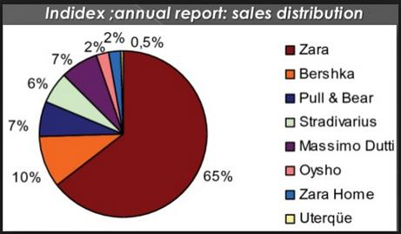
(Source: Nos 2015)

1.4 Background of ZARA
As one of the most representative fast fashion company and the largest high street brand in the world, ZARA has become a symbol of popularity and flagship of fashion trend which creates amazing sales volume and retailer miracles (Lopez & Fan, 2009). ZARA is established in 1975 in Spain which belongs to the INDITEX group since it developed from a clothing shop in small town, it has over 2000 clothing chain store in 87 countries around the world which owns a specialized creation team of more than 200 designers (Gamboa & Gonçalves, 2014). The most splendid brand identity of ZARA is that it digs out a model of precise fashion between the traditional top clothing brand and common clothing (Kapferer, 2012), The Wharton School of the University of Pennsylvania regards ZARA as the company which can guide the future trend not only limit in clothing industry (Hansen, 2012).
ZARA retailer operates more than 2200 stores over 93 countries which has become a representative flagship brand of INDITEX majoring in clothing, bag, accessories, shoes and other business. ZARA is famous for the exploiting new products which lead the fashionable trend and entirely new popular taste in the world and its extravagant design of store decoration and delicate assortment within store environment become the most apparent mark that differs from other fast fashion brand. In Chinese market, ZARA has become the name of light luxury in clothing market, one of its founder, Amancio Ortega said that ZARA could obtain stores within two weeks while the other retailers would take six months, ZARA increases 65 stores in 2015 which plus 50 stores in the region of ZARA Home, Spain is the largest market of ZARA which owns 436 stores, the second biggest market is 193 stores in China, with that France has 129 stores, and Italy and Japan owns 100 stores separately.
In the year of 2016, ZARA manifests a strong tendency to boost sales and profits in UK high street industry, and it was reported that until the 31st, January, 2016, the turnover of INDITEX increases by 8% which has reached 5.35 billion euro and its profit before tax was 583 million pound comparing with only 492 million pound in 2015, and experts assert that the rapid development of ZARA has threatened massive local chain stores like Mark & Spencer which has devoted into increase the online sales level.
While in the last quarter of 2016, the business real estate company CoStar published the most developed retailer list of America, the rank of ZARA shows that the retailer business has being goes down and would last for some time, however, with the changing improvement and recovery of economy in 2017, the discount stores and high street retailers would be comfortable to face with the turnover return, and the fast fashion module of ZARA allows it to create a new development path to boost sales and profits, and it estimates that the turnover of INDITEX would be superior to the rivals like H&M and other similar brands.

1.5 Research Rationale
As a worldwide leading clothing retailer, brand image of ZARA has got massive attention from all walks of life, in the world, ZARA presents the precise impression on consumer’s mind that becomes a symbol and sign of fashion and trend, while in Chinese market, people shows unclear brand awareness and brand association toward ZARA China in terms of the population density and conflicts from the local brands, so it is worth to be paid attention and analyzed to do research to improve its brand reputation and brand value in Chinese market.
Brand image of ZARA is a successful example in the history of brand management, it has welcomed by the global young people with the excellent design but the low price as a designer brand, which exploited a new pathway of high fashion for all common people (Kapferer, 2012), the brand image of ZARA can represent a research model to analyze the influence of brand image in terms of consumer purchasing behavior with the presentation of quality, style, price, fashion appetite, reputation and so on (Willems et al, 2012), and it can figure out the improvement pathway to optimize brand strategy and construct brand image to foster the identity of high street brand and competitiveness of clothing industry through this research of ZARA brand image.
At the same time, with the rapid growth of economy and people’s disposable income, the improvement of gradual consumption ability and structure make the consumption of clothing brand prominent in contemporary market, people concentrates more on brand grade and fashion trend to manifest consumption personality and taste through advocating brand image (Shen et al, 2012). Brand image of ZARA has become the mainstream of clothing consumption because of its unique brand management and branding business model (Hwang & Kandampully, 2012). However, the fierce competition among fast fashion brand and high street clothing store results from massive consumption potential in global clothing industry due to that their main targeted population are all the young from 15 to 35-year-old that may challenge competitive advantage and market position of ZARA (Gabrielli et al, 2013). Therefore, it is imperative for corporate to pay more attention on the construction and management of brand image through the comprehensive analysis of consumer purchasing behavior.

1.6 Research objectives
The purpose of this research is to attempt to answer the following question:
- How does the brand image of ZARA influence consumer purchasing behavior?
1. Identify the link between brand image of ZARA and consumer purchasing behavior;
2. Analyze features and components of ZARA brand image from the prospective of consumers
3. Evaluate crucial factors that brand image of ZARA impacts on consumer purchasing behavior to strengthen brand value and brand identity
4. Provide recommendations for maintaining and shaping brand image to foster rand competitiveness and effectiveness in market position for the update of clothing industry through the guidance for further investigation in the long run.

2. LITERATURE REVIEW

2.1 Introduction
Literature review is a research work that teases former related research outcome and answering the research question under the present research situation. The relationship between brand and consumer behavior has been the focus of many research in the past few years, the purpose of this research is to investigate how the brand image influence consumer purchasing behavior and deep insight the relationship between brand image and consumer purchasing behavior. The first section is to give a comprehensive understating of related resources of brand and brand image, the second section is to review and tease related literature about consumer purchasing behavior and the third section is to discuss hot research topic concerning the relationship between brand image and consumer purchasing behavior, and the last part is to evaluate the above research outcome and viewpoint basing on the latest academic development trend to propose suggestions for future study and give an objective summary of literature review.

2.2 Brand image

2.2.1 Brand

2.2.1.1 Definitions of brand
There are many definitions and explanations surrounding with the terms of brand. According to the superficial meaning of this word and the conceptualization of marketing field, Chi, Yeh, and Huang (2008) think brand covers the understanding of massive business that can be treated as a perpetual sign or imprinted with the good service, and a brand must have a special or distinct company name, it has the most representative trademark of ownership (Hansen & Christensen, 2003). According to the O’Cass (2000), brand is the name of any company or product of the company that consumers stores in their minds consciously or unconsciously to distinguish from other names.
Furthermore, Carruthers (2004) illustrates the brand name becomes the guarantee of quality and reliability for consumers basing on what consumers might purchase products from that brand, and highly-rated brand would lead to higher purchasing intention (Wang, 2006) due to that it influences consumer’s preference and intentions to purchase, and directly impacts on whether consumers are willing to pay for high price and recommend this particular brand to others. According to report of Chang and Albert (1994), marketers often base on product price and feature as the main factor to influence consumer’s price evaluation and purchasing intention, and Alvarez and Caielles (2005) think that consumers have put price or brand as the most important factors of purchasing intention.

2.2.1.2 New concept of brand
After the 1930s, brand was considered as the image created by company through differentiating from other competitors and identifying demands a brand promises to satisfy (Jin & Weber, 2013). Another aspect of brand is that scholars believe brand reputation dominates whether the brand is successful or not (Veloutsou & Moutinho, 2009). While Schmitt (2012) depicted a comprehensive model of five brand-related processes: identify, experience, integrate, signal and connect with the brand. Therefore, a brand is a logo, slogan, signal, characteristic that it is the conception among consumers which in turn would greatly affect their purchasing behaviors (Kapferer, 2008).

2.2.2 Brand image

2.2.2.1 Concept of brand image
Brand image has been firstly put forward during the 1950s, while there have no authoritative definitions of brand image concept so far. Brand image is a glass reflection of the brand personality. Aaker (1997) proposed that brand image is a set of associations which are organized in some meaningful ways, and it is explained from the prospective of consumer whatever in emotional or logical level. According to the Hsieh, Pan, and Setiono (2004), a successful brand image would make consumers recognize the needs satisfied by brand, and add the likeness to buy more products of this brand for consumers, moreover, products or services of company can acquire better positions in the market, keep longstanding competitive advantage and increase market share at the same time (Keller, 2008), Blackwell, Miniard and Engel (2005) depicted the importance of brand image for consumers through creating tangible and intangible associations. In terms of the fact that the choice of consumer’s brand and product bases on the evaluation of brand or brand image, Keller (2008) explained the brand image as a consumer’s negative or positive feeling toward brand when they suddenly are asked to recall the memories of brand, Arslan and Altuna (2010) defined brand image as consumer’s perception or feeling that connects with product, as well as the usage condition, brand value, user file, brand experience and other attributes. Bian and Moutinho (2011) illustrated brand image related to marketing that it is an announcement given by market staffs in order to capture their purchasing intentions toward brand product. Moreover, Lee and Wu (2011) defined brand image as the reflection of faith that consumers toward particular brand through differing memorized qualities and values from other competitors.
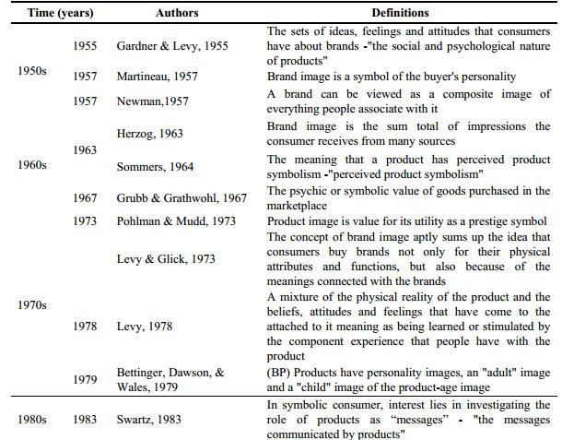
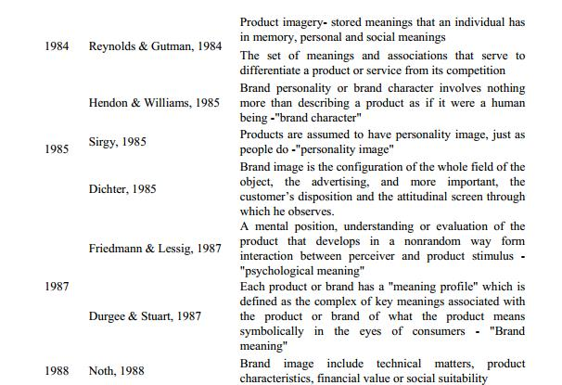
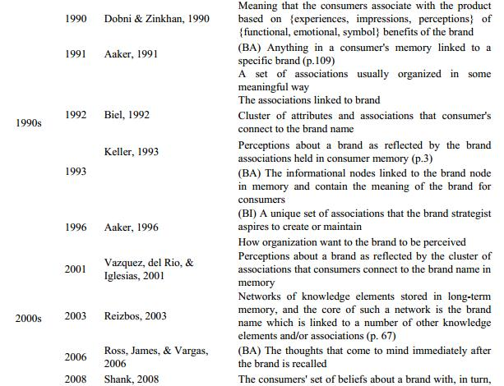
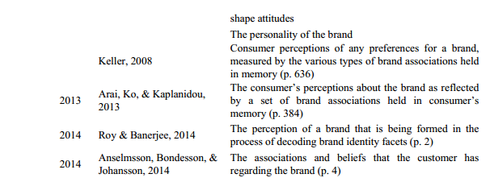
Table2.1The chronological transition of brand image definitions
(Source: Adapted and modified from ‘In search of brand image: a foundation analysis.’ (p.112), by Dobni, D. & Zinkhan, G. M. (1990), Copyright 1990 by the Association for Consumer Research. BP= Brand personality, BA=Brand associations, BI=Brand image)

2.2.2.2 Influences of brand image
For example, Wu and Lo (2009) reported that M&S has holding a stable brand image for many years even though competitors enter the same stage of market, such as Mango, but consumers could find out the different brand images to differentiate. Therefore, brand image has been regarded to have power over consumer’s attitudes and habits which can be compensated through positive purchasing intention, loyalty to brand and so on (Khor, 2010). According to Hsieh, Pan and Setiono (2004), a favorable brand image can help consumers confirm the satisfactory needs which brand provides to increase chance to continue purchasing, so it is imperative for company to sustain splendid brand image through brand strategy and brand management (Park at el, 1986;), furthermore, this judgment leads to a number of empirical research which aim at justifying positive brand image is beneficial to increase purchase (Keller, 2001;Tam, 2007), while it became necessary to analyze brand image component before getting into the impact of brand image.

2.2.3 The relationship between brand image and clothing purchase

2.2.3.1The role of brand image in clothing purchasing
Brand image has played a crucial role in clothing purchasing or other daily commodities, it is the essential driving force of brand equity which means the consumer’s general perception and feeling toward brand and impact on consumer behavior, for the marketing stuff, the aim of marketing activity is to influence consumer’s conscious and attitude toward brand, build brand image in consumer’s heart, and simulate the real consumer purchasing behavior, thus increase sales, and maximize the market share and develop brand equity no matter what the marketing strategies of company.

2.2.3.2 The importance of brand image in clothing purchasing behavior
Brand image has been a crucial concept of consumer behavior study which is a vital factor influencing the clothing purchase of product decision. Keller (1997) manifest that brand image is critical to the clothing purchasing behavior because it has great impact on consumer preference and purchasing intention, as well as they are unwilling to pay for or recommend this brand to others. Therefore, when consumers hold a strong and constructive brand image, whatever the price it is, they would become positive to evaluate the clothing product not only the celebrity it has been left, but also the acknowledgement and representative of high brand equity and trust.

2.2.4 Brand image component
In terms of the importance of brand image in marketing world, teasing component and detail of brand image is favorable to understand concept of brand image given the lack of consensus involving component which creates brand image and brand management (Keller, 1998), as it points out that brand image is regarded as an attitude or behavior that beyond consumer’s physical attributes of brand (Tseng & Tsai, 2011) ,which allow to assume that brand image has components that consist of external and internal elements (Lee, Lee, & Wu, 2011). Moreover, Kamins and Marks (1991) put forward that brand image is the attitude of brand which belongs to one of the components of brand image that impact on consumer purchasing intention. Kolter (1997), Keller (2001) proposed that brand image is a consumer’s viewpoint toward their memories that create brand associations, thus create relations between consumers and brand image. Lin (2009) proposed that the consumer’s overall acknowledgements toward brand can be seen as a component of brand image due to that it bases on the identification of brand products through the combination of information of consumer’s memory meaning with product experiences.
Peng (2010) combines both conceptions of Kamins and Marks (1991) and Lin (2009), and manifested that brand image is a memory of brand attitude and perception created by consumers according to product features. However, the most interesting research is the Park et al (1986), where he classified inner attributes and outer attributes into three components originally, reflecting brand association, value and quality which proposed by Kolter (1997), Keller (2001) , Lin(2009), Peng (2010). These are functionality, symbolism and experientiality.
Keller further discussed components of brand image, include functional image of brand that manifests the inner advantage of product consumption which mainly relates to the product attribute, on the other hand, the symbol image and experience image means the outer advantage of product consumption, which present the demand of individual expression and social acknowledgement of non-product attribute to influence purchasing behavior (Keller, 1993).

2.2.5 Brand image model

2.2.5.1 Conclusions of brand image model
Due to the complexity and contextuality of brand image that consumers grant different implications and contents under different time, place and usage situation, academic scholars put forward different models of brand image from different research angles. Firstly, Aaker (1995) proposed brand equity model that contends brand equity compresses brand loyalty, brand reputation, brand association and perceived quality and other proprietary brand assets (Washburn &Plank ,2002). Secondly, Keller (1998) divides brand knowledge into brand reputation and brand image from the prospective of building brand equity that bases on consumers, the model regards brand image as a comprehensive concept through the reflection of brand association, which can be investigated through product attributes, interests and attitudes and other aspects. Thirdly, Krishnan (1996) model thinks that brand association can be inspected by number of associations, preference of associations, and uniqueness of associations and resources of associations. Fourthly, Biel (1993) model manifests the brand image can be reflected through company image, user image and product or service image, while the start point of depiction is the consumer’s associations toward related attributes of brand. The most breakthrough of Biel’s model is that he initiated to propose the hard factors and soft factors of during brand associations.
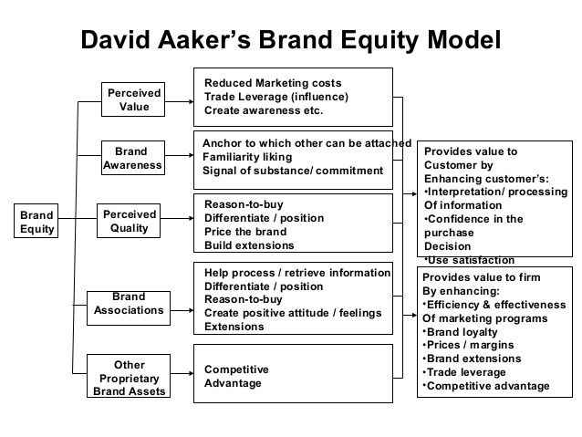
Source: Aaker, D. A. (2012), Building strong brands. London: Simon and Schuster.
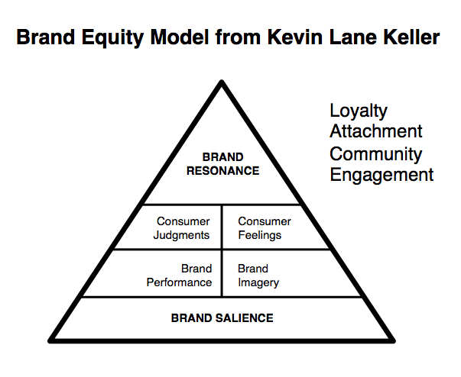
Source: Keller, K. L., Parameswaran, M. G., & Jacob, I. (2011). Strategic brand management: Building, measuring, and managing brand equity. New Delhi: Pearson Education India.

2.2.5.2 Review of brand image model
Lunn (1978) pointed out that model is a simplified description of reality, he thought the useful model needs to satisfy three conditions: model can provide the understanding that concept impacts on behavior and it can integrate several different concepts, as well as the occurrence of model can make communication easy. Therefore, there are advantages and disadvantages to give critical assessment of the above four models. Among of them, Biel’s model is simple, straightforward but systemically and comprehensively to summarize the dimensions of brand image which is the best to conform to the three conditions, and it applies into measure the brand image of durable consumption products, such as car, luxury goods, clothing, and fragrance and so on. Therefore, Biel’s model is the extremely genuine brand image model among the four models. However, the all four models did not refer to the precise elements of brand image, even more they neglect to explain how these factors consist of the entirety of brand image.

2.3Consumer purchasing behavior

2.3.1 Consumer purchasing behavior concept
Durmaz (2014) cited in Cochran (2006) argues that customer is only reason for organization existence, so the market ends with and begin with the market demands which company satisfies through marketing strategies (Furayi, Latusyriska & Wawrzymiak, 2012). Schiffmanand and Kanuk (2000) mentioned that consumer behavior is about the way people make decisions on the basis of available resources, money, effort and time, and Gabbott and Hogg (1998) and Blackwell (2006) et al put forward the integral views that they think consumer purchasing behavior is the process or activity that the individual or group choose and consume products, experience, ideas and services actually, which can even effect a nation’s economy (Blackwell et al, 2006). Consumer demand can be satisfied through arranging marketing strategies.

2.3.2 Decision process of consumer purchasing behavior

2.3.2.1 Definitions of decision process of consumer purchasing behavior
Font-i-furnols and Guerrero (2014) contends meeting consumer’s expectation is the important part to acquire enjoyable purchasing behavior due to that consumer is that last step of productive chain. Purchasing process is the combination of mental and physical activities which ends with an actual buying almost daily (Sheth & Mittal, 2004), therefore, it is imperative to study the relationship between “why we buy” and “what we buy”, and brand plays an important role in the consumer decision-making. Furthermore, consumers have a few factors or attributes influencing their opinions and decision, in particular among the increasingly fierce market, consumers would keep different images of any special brands due to that the influence of consumer attitudes, and they need to make a choice between a series of products and brands, which is often decided by brand image. For instance, when it comes to the high street clothing brand or the most of fast fashion brands in the world, consumers would naturally associate with ZARA, which can explain the high reputation or attractive impression of brand.

2.3.2.2 Roles and stages of decision process of consumer purchasing behavior
According to the Kotler(2003) in the process of purchasing decision, people play different role in the decision process, namely the five functions of initiator, influencer, decider, buyer and user, and from the beginning of purchasing process and prior to the purchase to the after the purchase still continue going on, which include the preparing stage of purchase ( produce demand, acquire information), purchasing process (compare commodities, preference), the usage of postpurchase, evaluation and disposition and so on. Firstly, the initiator is the person who first suggests the idea of buying product or service, and he might collect information to help make decision. Secondly, the influencer belongs to the one of rest of others who tries to persuade in the group concerning the result of decision and usually collect information and attempt to impose their optional standard on the decision. Thirdly, the decider is the person who has power or financial power making final decision whether it needs to buy, what should buy and how to buy or where can buy or not. Fourthly, the buyer means people conducting the exchange and practical purchase, and the last one is user that points out people who consume and use product or service.
Among the five steps of process, problem recognition is the first stage to simulate demands to produce driving force, then consumers would collect information related commodities to enter the second stage to select favored objects that can be called the third stage, the four stage of purchase decision means consumers would consider the proper time, place and amount or payment method to make shopping decision, and the last stage is the postpurchase that consumers would give evaluations toward purchased products which may affect their next purchase behavior and their impression toward brand, and the satisfaction connects with the their former expectations before buying (Keller, 2003). Furthermore, in the marketing field, Blackwell et al (2001) defined consumer behavior is a combination of purchasing and consuming products or services, thus consumer purchasing decision can be concluded seven steps: need recognition, search for information, pre-purchase, evaluation, purchase, consumption, post-consumption evaluation and divestment (Blackwell et al, 2006)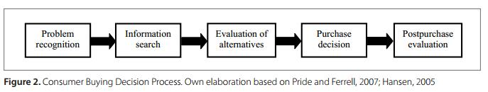

2.3.3 Influences on customer purchasing behavior

2.3.3.1 Measurements of consumer decision-making
Schiffman & Kanuk (2010), Hawkins, Best & Coney (2004) and Assael (2004) mentioned that consumer decision-making can be affected by several measurements, first of all, the measurement of culture, which has the most influence and the most extensive on consumer behaviors so that marketers need to know about the impact of culture, subculture and social class; Secondly, the social measurement needed to be considered due to these factors might affect consumer’s reactions when designing marketing strategies; Thirdly, personal measurement, which includes the age, stage of life cycle, and career, economic circumstance, lifestyle, personality and self-concept affects what consumers purchase; fourthly, psychological measurement, including motive, perception, learning, faith and attitude that might influence consumer’s choice.

2.3.3.2 Aspects of influences on consumer purchasing behavior
Moreover, Schiffman and Kanuk (2006) contended that motivation, personality, perception and attitude make great impact on consumer individual. In the environmental level, the group, family, class and culture are the crucial factors, while from the prospective of decision-making process, marketing stimulus becomes another essential element, and Dodds & William (1991) found that consumer’s perception value is the most important factor of impact on consumer purchasing decision, and Zeithaml (2004) based on the psychological angel to figure out company can directly influence consumer’s psychology, thus would impact on consumer purchasing behavior. Therefore, the influences of customer purchasing behavior can be divided into environmental influences, psychological influences, and social influences.
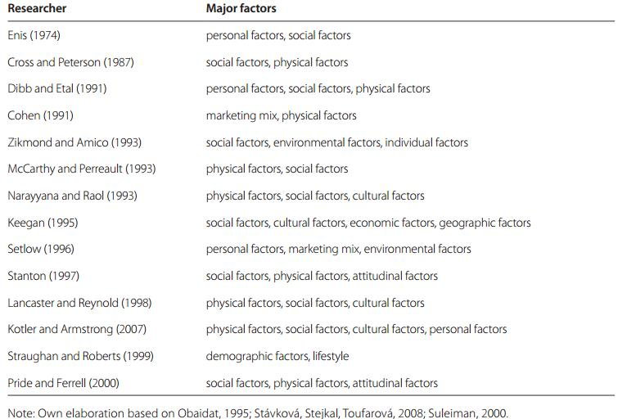
Table2.2 Factors Affecting Consumer Buying Behavior

2.3.3.3 Environmental influences
Environmental influences impact on consumer behavior from the macro prospective that include sociocultual, technological, economic and political. Brassingon and Pettitt (2003) think that consumer behavior faces with diverse pressure from society that might influenced by current trends, popular products and social group, and technological influences compress the quality of product, communication and service, database technology to store consumer’s information which in effect on product development and innovation toward manufacture and marketing, economic and competitive influences point out that economic circumstances can affect consumer’s attitudes as well as their ability and willingness to spend, and price, value for money might lead to recession could decrease consumers purchasing intention, political and legal influences may lead the regulations of product safety and performance from the EU or from national bodies, which links with consumer rights and inherent risks of political pressure.

2.3.3.4 Psychological influences

2.3.3.4.1 Personality
Mott (2017) supposed to think that marketers need take advantage of the psychological tenets that explain and predict people’s purchase in order to succeed in positioning brand as the accurate solution to consumer’s problem or demands. Brassingon and Pettitt (2003) contended the personality, consisting of all features, traits, behaviors and experiences which make people different and distinct from other independent individuals. Company can base on consumer’s personality to conduct marketing research to figure out their commonness, while the link between of personality and purchasing behavior have been confused so far, Kassarjian (1970) found that sensation seekers or people who manifest highly open-minded more tend to make reactions toward violation and image advertisement.

2.3.3.4.2 Learning
Another psychological influence is learning which is closely linked with perception and memory, learning has been defined by Hilgard and Marquis (1961) that it is the more or less permanent change in behavior which occurs as a result of practice, which manifest the objective of learning is to remember what has been learned and to act on it (Brassingon & Pettitt, 2003). Therefore, learning not only affects consumer’s purchasing, but it can guide or teach consumers how to shopping (Mott, 2017), another kinds of learning are the operant or instrumental conditioning, as well as classical conditioning process.

2.3.3.4.3 Motivation
Motivation is a major psychological factor to influence consumer purchasing behavior, according to Hoyer, et al (2009), motivation is defined as “an inner state of arousal that provides energy needed to achieve goal’’. Hamshim and Zammer (2014) shows the importance of motivation on beverage industry, he depicts the motivation comes from the word ’motive’, which means the needs, wants and desires of person, and a motivation occurs when people’s hope can be satisfied and inspired. Consumer purchasing behavior is a process that needs to be motivated, such as brand-name clothing looks stylish, education enables accomplishment and self-improvement to reach self-actualization, just like the pyramid of needs proposed by Abraham Maslow, the more basic of needs, the more priority that consumers drive to fulfill, therefore, products or services and advertisement are the motivator to impulse consumer purchasing behavior (Mott, 2017).

2.3.3.4.4 Attitude
Ramesh (2008) claims that attitude can be defined as a mental favorable or unfavorable tendency toward people, concept, product, brand, service or thoughts, and he thinks the attitude is separated from behavior. On the contrary, according to the Lamb et al (2009), the attitude and faith related with values and consumer’s attitude is the combination of consumers, Lamb defined these factors into three factors concerning the second feeling, the last feeling and the last behavioral intention which are relied on each other to influence consumer’s reactions toward objects. For example, KFC advertises the fried chicken is healthy, and the example of a shift in consumer’s attitudes occurred when the taxpayer-paid government bailouts of big banks that began in 2008 provoked the wrath of America, which provides a lot of opportunities to the small banks (Mott, 2017).

2.3.3.5.5 Perception
Definition of perception
Perception has been regarded as the most vital factors that greatly influence consumer behavior, Consumer perception toward brand is an important aspect of marketing mix (Gabor & Contiu, 2012), Jin and Weber (2013) proposed that brand is regarded as a channel for customers to indentify products and their manufactures. The focus of brand value creation on the individual commodities, companies take advantage of brand to manifest ownership and take charge of the commodities, in turn to help consumers to recognize and figure out commodities.
Consumer perception and brand
There are many studies surrounding with consumer perception and awareness about brand, Keller (1993; 1998) depicts the consumer perceptions toward brand as brand knowledge, including brand image and brand awareness, so according to Keller’s dentition of brand awareness, which means recognition and recall of brand, brand image is the “perception about a brand which is reflected by brand associations and held in consumer’s memory, and these associations relate to the brand and brand quality. Similarity, Aaker (1991; 1996) points out the brand associations are the anything linked with consumer’s memories, not only creating brand image is significant, but also maintain and building brand image is the important part of marking plan of company (Roth, 1995) and brand strategy (Keller, 1993; Aaker, 1991), and Wright and Lynch (1995) found that the common knowledge of consumers toward product and purchasing decision makes huge impact on brand image.
Consumer perceptions and rebranding
Moreover, Solomon et al (2006) think the perception is the course of people’s selection, arrange and interpret stimulus which are adjusted and filtered into consumer’s view about world, and he insists the products and the services are know that you truly know the business would go in the right direction when consumer’s perceptions of the business (Siguaw, 2004), thus all interactions between business and consumers would influence their views and images of business, so in terms of the idea, the high brand equity is good for acquiring competitive advantage (Kotler, 2010), and consumer’s perception connects with consumer satisfaction and product quality to meet consumer’s demand (Light & Kiddon, 2009) through enhancing consumer’s mindset, such as views of brand, feelings, experience, brand image, attitude, belief and attitude (Aaker, 1991), and Romaniuk and Nicholls (2005) holds that brand value and effectiveness of marketing activities undertaken to affect consumer mindset about a brand is measured by the changes of perceptual response through evaluating advertised attributes.
The impact of perception on consumer behavior
According to Kavita Singh (2009), the perception is one of the major psychological factors that impacts on consumer buying process, which is a process of selection and organization of physical environmental stimulus, and provide meaningful experience for the perceiver. Moreover, he manifests that perception engages to reach for, obtain and process in order (Schiffman, Kanuk, Hanse, 2012), and it also represents the psychological process that people acquire information from environment and understand their world (Fill, 2002). Consumers are chosen by the external stimulus to classify and explain the coherent visions of the world around us, and their reactions would be different basing on their explanations and channels of perceived stimulus even if two people expose the same stimulus and under the same conditions.
Perceptual map and consumer behavior
In addition, the impact of perception on consumer behavior can be measured by the perceptual map. In order to introduce a visional technique to display the consumers of average targeted market that how to understand competitive products in the market, perpetual map is proposed to map consumer’s perceptions and understandings toward related two attributes, such as using the determinant attributes, and it can measure the position of product in consumer’s heart which could reflect in the axes (Kards, Cronley, & Cline, 2011) to represent consumer’s perceptions and preferences (Ferrell & Hartline, 2008). As for ZARA, in terms of its brand attributes and features of clothing industry, quality and price have become the most two concentrated considerations for consumers that greatly affect consumer perception, and ZARA stands in the middle position of high price and high couture section which the biggest competitors the H &M, River Island, Mango, TopShop and so on. However, consumer perception is different concerning with the price which has a positive and negative effect on purchasing behavior, while there would be less effect on buying behavior if consumers are uncertain with the quality of products (Urban et al, 1997). Here is the perceptual map for ZARA.
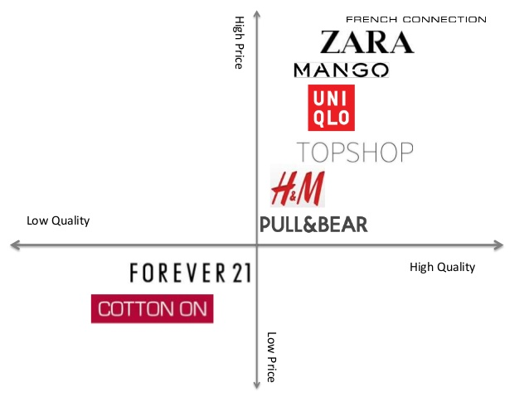
Source: Adapted from ZARA official report 2013 (Http://zarafashion2013.wix.com/zara#!perceptual-map/cr8v)

On the contrary, consumers might connect the low price with the low quality and think the price is an indicator of quality and company which would reduce the quality of product to minimize the cost, and the higher price means the sign of the better quality (Bao. Y, Y & Sheng, S, 2011). Moreover, Zeithami (1998) presents five factors that associate with price-quality relationship. The first factor is that the all information of consumer perception through advertisement and brand reputation rather than the price have the power on purchasing decision. The second factor illustrates consumers who are not aware of the price do not regard price as a quality reference. The third factor is applying the extrinsic cue into consumers who have less knowledge product quality, such as price, brand name and package to purchase the product. The fourth factor is that some consumers utilize the price as a signal of the better quality, but consumer would prefer the lower-price product if there is few difference of price variation on the distribution of products for a puny difference of quality. Therefore, although perceived quality considers the consumer’s evaluation toward product basing on subject signs of judgments to some attributes (Anselmsson et al, 2007), consumer perception toward quality changes over time as a result of augmented information, which demands marketers must track the perception through product alignment and promotion strategy (Zeithaml, 1998).

2.3.3.5 Sociocultural influences

2.3.3.5.1 Social class
According to Zitkus & Puskoriute (2013), the situational factor, personal factor and psychological factor can influence the purchased products, while social factors would be different in the outside that have great impact on consumer’s belief and behavior indirectly or directly due to that they depend on the world around you and how it operates (Kotler and Armstrong, 2008). Firstly, social class is mainly determined by occupation, in some extent, consumers in the same social class manifest the similar purchasing behavior, different social class have different purchasing mode (Pickton & Broderick, 2001), such as people in the high class must have more desires to pursue luxury products and enjoy higher life quality comparing with the low class in society.

2.3.3.5.2 Culture and Subculture
Secondly, culture and subculture are often known as the most widespread influence on consumer behavior due to that it rules consumer’s life style (Solomon, 2011), people in different customs faces with the pressure of values and mindset that involve the business field gradually (Rani, 2014). However, Durmaz, Celik and Oruc (2011) think that subculture means the difference from mainstream culture which connects with racial discrimination.

2.3.3.5.3 Reference group and family
Thirdly, the opinion leaders in the reference group points out the public opinion and personal affection will become power to influence the collective and the public in particular to the online consumption (Yakup & Jablonsk (2012). Fourthly, most marketers hold that family has become one of the most important factors to impact people’s purchasing behavior (Pandey & Dixit, 2011), at least children’s change toward consumption model as with the more focus on the children’s marketing recently (IKEA, 2001).

2.4Relationship between brand image and consumer purchasing behavior

2.4.1 Brands and Consumer Purchase Behavior
Blackwell et al (2001) observed that consumer behavior is a set of activities that consumers own, consume and dispose products and service, Teng, laroche & Huihuang (2007) manifest that the precise purchase intention of brand needs assess any available brands because consumers have different assessment standard when making any purchasing decision, such as brand, price, feature, quality, performance and user friendliness and convenience (Khan et al, 2012). Conner & Armitage (1998) found that the purchase intention can be predicted through reference from the past purchase experience to determine future purchase. D’souza et al (2006) pointed out consumers would purchase the same kind of products and service even share with others if they benefit from the former purchase. And Mhhammad Irfan Tariq et al (2013) illustrate four kinds of purchase intention of consumer behavior, include the absolute plan to purchase brand, consider purchasing brand if someone is thinking over to buy the brand in the future, and absolutely buy the brand.

2.4.2 The Impact of Brand Image and Advertisement on Consumer Buying Behavior
According to Driessen (2005), advertisement is a tool that can help company create and adjust brand image, he further points out company will base on consumer positioning to find proper main target in order to make positive and quick reactions toward company’s advertisement, such as company can create brand image through the public advertisement strategy. Moreover, Saeed et al (2013) analyze the impact of brand image on brand loyalty through Pearson Correlation and Regression analysis and find out there is existing positive remarkable relation between brand image and brand loyalty.
Muhammad Shoaib et al (2012) also figure out the relationship between brand image, advertisement and consumer behavior, and seek the relationship between advertisements of multinational products and consumer purchasing behavior. While Muhammad Irfan Tariq et al (2013) explored the relations with brand image and purchase intentions of teenagers of Pakistan with respect to FMCGs. They found out the positive relations between brand image and purchase intentions.
Beside, Muhammad Mudasar Ghafoor et al (2012) investigated the impact of consumer satisfaction and brand image on brand loyalty and the results shows consumer satisfaction and brand image have the positive influence on brand loyalty. Furthermore, Muhammad Shafiq Gul et al (2010) found out brand image and loyalty has nothing to do with age group, education level and repeated purchase duration, but brand image and loyalty is significant to the brand choice of Tokyo, as with the satisfaction level of product usage and repeated purchase frequency of product.
According to Malik et al (2013), brand image is the essential work for improving business performance due to that brand image is an indirect instrument that can change people’s consumer behavior, and the research result reflects the brand image has the strong remarkable relationship with consumer purchasing behavior. just like the saying with Khan (2012), brand related factors, such as brand knowledge, brand association, behavioral intention, brand advertisement and the past brand experience on the purchase intention of the customers, and they further found that behavioral intention, past experience and purchase intention have the high relations in female than male consumer, but the male consumers have stronger brand relationship than female consumers.

2.4.3 The relationship between brand image and consumer purchasing behavior
There are less research focusing on the relationship between brand image and consumer purchasing behavior that mainly involve the hotel, shop, band and other occasion in the field of service brand, and it constrains impact of several variables that service brand image on service quality, consumer satisfaction, consumer loyalty and so on.
Firstly, concerning the research of product marketing field, brand image of product has important remarkable influence on consumer purchasing behavior because present users, former users and unauthorized users have distinct difference toward perceptions of brand image, so it can be inferred that brand image would make potential impact on the brand purchase. Roth (2009) investigated culture, social economic factors (power distance, uncertainty and risk aversion, individualism and regional social economic development) of different countries create clear effects on the performance of brand image (market share).
Secondly, service brand image also has the outstanding effect on consumer’s consumption behavior, some of which have got empirical testified toward the impact on perceived quality, consumer satisfaction and consumer loyalty. Present research field primarily focus on the shop, hotel, bank and other occasional brands. Lessig (2010) applied canonical correlation analysis into prove the correlation relations between the two group variables between shop brand and consumer loyalty, and contended that brand image can be used to predict consumer loyalty.
Thirdly, Bloeme et al (2011) found out that shop image influences consumer loyalty through the intermediate variables, which is consumer satisfaction. They figured out bank image affects perceived quality in another research, which in turn make indirect influence on consumer satisfaction and consumer loyalty through perceived quality. However, they thought brand image as multidimensional variable to influence consumer loyalty only through the factor of market position when they analyzed relationship between image dimension, quality dimension and satisfaction and loyalty. Kandampully et al (2012) discovered hotel image only relates the one dimension of consumer satisfaction (room management) in the empricial research toward hotel. But the research did not analyze the relations between different dimensions of brand image and loyalty variables. Chang et al (2013) analyzed the influence of shopping store image on the store consumer satisfaction and consumer loyalty, and it turned out that the four dimensions (store facility, convenience, store service, store activities) directly affect the consumer satisfaction and consumer loyatly.
Apart from the above focused research material and concentrated field, Riaz (2015) conducted the empirical study to analyze the impact of brand image on consumer buying behavior in clothing sector, this study surrounds with brand image and consumer awareness to analyze consumer perception and find the impact of consumer buying behavior. The last result shows that male consumers have more brand awareness than female’s. However, it shows that consumer perception has stronger impact on consumer purchase behavior but not brand image and consumer awareness.
Tekin, Yiltay & Ayaz (2016) researched the relationship between brand image and consumer behavior in terms of luxury brand LVMH, it bases on the luxury brand feature and external environment to disclose insight behavior of consumer toward brand image through the method of online questionnaire and interview to analyze consumer’s psychological influences. The result shows that the relationship between luxury brand and consumer behavior is both simplistic and complicated, consumer behavior to purchase luxury products is affected by social status and self-awareness to represent motivation and wealth that have primary position on consumer purchasing decision, so brand image is granted for power to create products or wipe them from consumer market.

2.5Summary of literature review
As with the development of brand strategy and brand management, it has become an inexorable trend to analyze the impact of brand image on consumer purchasing behavior due in terms of the mutual relations between the existing meaning of brand and, study focusing on brand image and consumer behavior would become the imperative condition to sustain competitive advantage of company or environmental position in the market and foster customer relationship management (CRM) to keep longstanding competitiveness and effectiveness. From the review of scholar’s research, it can have been figured out that those research did not make precise classifications separately toward brand image and consumer purchasing behavior, the research range is extremely extensive and mainly involves in the service industry.
Firstly, the concept of brand image is complex and lack of stability that appears to universality. An increasing number of scholars tend to accept and adopt the universal concept of brand image, which regard it as the brand association, and some experts concentrate on product image even equal to the brand image or extend brand image to the corporate image and national image, so they actually attribute all associations which consumers make influence on consumer purchasing behavior to the components of brand image.
Secondly, the measurements of brand image are constrained with less influences which just effective for consumers to get the superficial associations (substance attributes, product type et al) but cannot reach the deep awareness (self-awareness). For example, as the most widely-used brand image model, Biel’s model fails to target precise industry into segmentation and disclose the mutual relation among each component.
Thirdly, how to integrate the two study prospective from company and consumer, especially how to absorb and combine with consumer investigations in the study of concept of brand and image management would be the important directions for future study.

3. METHODOLOGY

3.1 Introduction
Research methodology involves the aim of information collection and data production that closely links with research decision through supporting the prior theoretical background of literature review and later result reflection of data analysis. The main purpose of this chapter is to identify the manner of data collection and generation, as well as the method and steps of process of data analysis.
This chapter can be classified into 4 parts which mainly illustrates the sampling method basing on the discussion of research paradigm and research method to settle down the questionnaire design through piloting test and specific process of sending the questionnaire to respondents, explains the precise efforts and rationale to ensure reliability and validity, as well as the overview of limitations of this research to provide further reference and improvement for study in future.

3.2 Research paradigm
Research paradigm is a mutual faith and contract of all scientists concerning how to understand and solve the questions (Kuhn, 1962), and it is a philosophical framework that guides how scientific research should be conducted, Fox (2013) contends that the paradigm is an established model that accepted by a number of people in community, for example, it could be argued that positivism and interpretivism are the paradigms of research within business.
The justification of research paradigm bases on the research quality and research method, for one thing, the application of questionnaire technique belongs to the quantitative method which is often assumed that quantitative approaches draw on positivist ontologies, for another thing, there are four features accounting for the positivism paradigm, which can be summarized as quantitative, objective, scientific and traditionalist that can provide high reliability and representativeness to settle the precise and accurate view of impact of brand image of ZARA in terms of consumer purchasing behavior.

3.2.1 The assumptions of positivism and interpretivism
Creswell (1994 & 1998) provided a conclusion of the philosophical assumptions of positivism and interpretivism which can be applied into present the comparison of quantitative and qualitative paradigm.
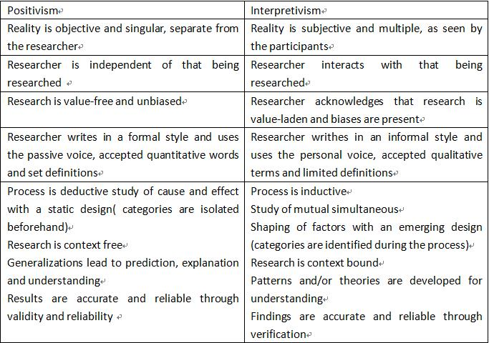
Table 3.1 Assumptions of positivism and interpretivism
Source: Adapted from Creswell (1994, p. 5 ad 1998, p. 75).

3.2.2 Comparison of Positivism and interpretivism
A particular paradigm is partly decided by the research assumptions and influenced by the traditional research discipline, dominant paradigm in research area, as well as the nature of research problem. Therefore, it is worthy to make clear the differences and features between positivism and interpretivism.
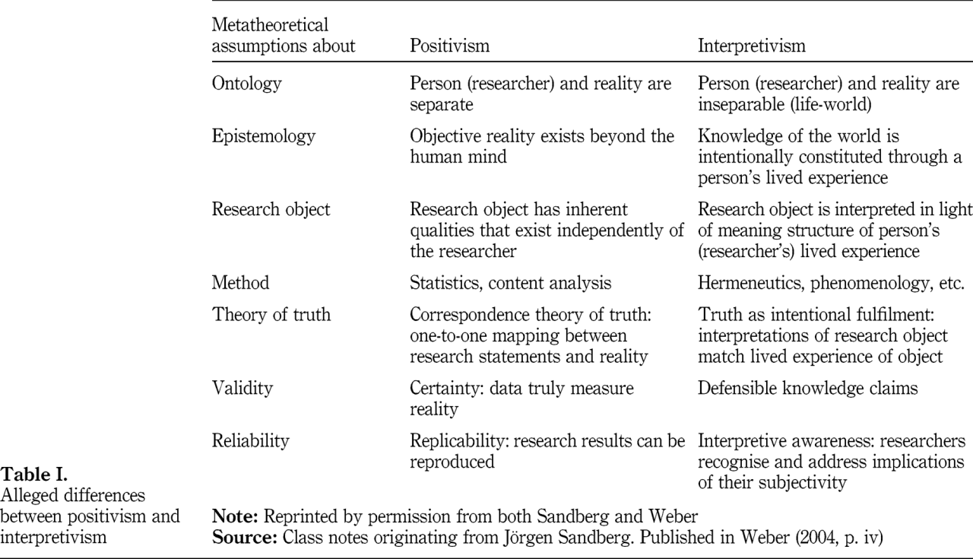
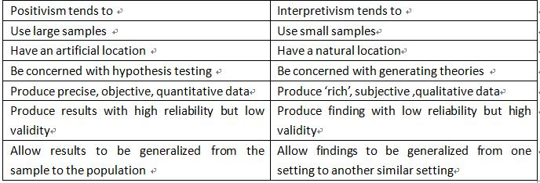
Table 3.2 Features of the two main paradigms
Source: Adapted from Collis & Hussey (2013, p. 62)

3.2.3 Positivism paradigm
For the purpose of this research, it is envisaged that the positivism would be appropriate due to that it acknowledges the only factual knowledge gained through observation is the trustworthy view, including the measurement (Arghode, 2012), and in the positivism research, the function of research is to collect data and analyze through objective methods that lead to the result of research is observable and quantized through statistical analysis (Wahyuni, 2012). Moreover, researchers of positivism are independent without any regulations of human interest that they maintain the least interaction with attendants of research (Scotland, 2012), Crowther and Lancaster (2008) notify that it adopts the deductive method as a common rule which involves the view of focus on the fact, regard the world to be external and objective. Therefore, science is the basis of positivism.

3.3 Research method
As one of the most affordable method to collect qualitative data, online questionnaire is the systematic gathering of data from the target audience characterized by the invitation of the respondents and the completion of the questionnaire over the internet (Zikmund, 2013). Recently, with the development of internet and exploitation of multiple mobile research methods, online questionnaire has become the quickest way to appeal to the positioning population (Bryman & Bell, 2015). However, although the choice of module totally relies on the precise theme, target and aim, online questionnaire is an outstanding option under some circumstances, and in terms of the research paradigm and quantitative research method, online questionnaire is the best option for this research.

3.3.1 Advantages of online questionnaire
One the one hand, firstly, it needs the low costs to collect and process data, the automatic real-time access will make analysis more easier and simplify to apply into utilization (Denscombe, 2014); secondly, it saves time cost to make arrangement smoothly and fast that can provide a convenient channel for audiences (Baltar & Brunet, 2012); thirdly, the flexible design can reduce mistakes through the programmed survey, intricate skip patterns and logic even if they are complex to handle (Wright, 2005); fourthly, privacy protection without interviewer would make audience share true individual information through respond directly online (Granello, & Wheaton, 2004).

3.3.2 Disadvantages of online questionnaire
On the other hand, firstly, online questionnaire constrains the limited sampling and respondent availability due to that some people are unwilling to get used to internet access or respond online survey (Ilieva, 2002); secondly, the possible cooperation problems would force internet users are suffered messages explosion and easily delete researcher’s advances although the higher responses than traditional models (Evans & Mathur, 2005); thirdly, the lack of interviewers would result in the unreliable data and threats of survey fraud which is the most serious weakness of online questionnaire (Burns & Bush, 2000).

3.3.3 Disadvantages of methods rejected
As for the interview method, it has the incomplete process without record, the less focus and prejudice of interviewer would make interviewee upset, and the time consuming and high cost are not suitable for the personal affairs due to the low efficiency (Opdenakker, 2006). In terms of the focus group, it is difficult to adhere to everybody’s answers due to the limitation as a group, and if the conversation lacks of right direction and guidance, members would sacrifice valuable opinions thus lead to a waste time and money (Robinson, 1999). Moreover, the observations cannot solve the past histories or research attitude, and it must demand special expensive equipments to support effective work, the used sampling would involve so much time to wait for chance to study a particular event, and the unknown occurrence happened to observer is the main drawback (Cassell & Symon, 2004). According to the features of case study, a main criticism is that data collected may not be generalized to the wider population, and some cases analysis are not scientific due to that the case study usually belongs to a personality, and it is hard to conclude the specific causality (Yin, 2013).

3.4 Sample
A sample is a collection to view the whole situation that can be selected from the targeted population, and it must be chosen to be representative and meaningful which can reflect the population from which it is drawn in a positivist study (Collis & Hussey, 2013). The research objective is ZARA, and the sample will be selected from the experienced consumer who is familiar with ZARA and fashion trend, or fond of shopping with splendid brand awareness (Cue & Tripa, 2007), and people involved different occupations from diverse fields who have high sharpness and concern with fast fashion brand or high street store to give a better understanding and rich brand knowledge of ZARA.
Purposive sampling is a non-probability sampling method which occurs when researchers base on their judgments to choose sample elements (Barratt et al, 2015), as for the research method and objectives of this research, it is reasonable and effective to use purposive sampling to acquire representative samples to save time and money through subjective measurement (Ghartey, 2014), not only due to the feature and nature of this kind of research design, but also it needs the limited number of respondents as the main data resource (Gy, 2012).

3.5 Sample size
In terms of the former similar research experience and results of academic scholars, the research would select 100 samples to conduct investigation, the justification of sample size can be concluded as the following: firstly, the research paradigm and quantitative research decides this research must use large samples but not the small samples (Levy & Lemeshow, 2013); secondly, the young people taken up a middle position on total population in the fashion clothing industry of the Wuhan City and they are the most targeted population toward ZARA (Scheaffer et al, 2011); thirdly, purposive sampling would not need a great amount of samples, but the relatively less number of samples, the higher accuracy and reliability of the data results, while the excessive sampling will tend to waste time and cost (Etikan et al, 2016).
Stoke (2000) put forward that the sample size is determined by the research purpose to achieve the reliability and validity of data collection, considering the reliable sample is copy of the larger population, but in small size (Fink, 2003), as for the famous brand like ZARA, considering the rate of young population, data of ZARA is a representative sampling from the clothing items to infer the characteristic of all items, and it is hard to calculate the whole accurate distribution of population in the world in terms of its wider brand effect and more complex systemic statistics than other similar brands (Waters, 1994). Therefore, the 100 sample size is an idea option for this research which provides demographic and realistic basis.

3.6 Questionnaire design
Questionnaire was applied into acquire valid responses from the respondents that would help understand their intentions, minds, experiences and habits. This questionnaire was designed to investigate how the brand image of ZARA influences the consumer purchasing behavior from the prospective of basic understanding of ZARA and the relationship between brand image and consumer purchasing behavior.

Questionnaire design needs to be precise, concise and unambiguous and efficient. It is vital for care to be taken to avoid double questions and questions involving negatives, Burgess (2011) contends that questions should be made brief and clear that respondents can answer definitely and easily, and cannot include leading questions which manifest researcher’s individual opinion and specific tendency to disturb the objectivity and accuracy of results of survey. Moreover, questions should be formal to ask for precise answers that do not hide in the implications, and efforts need be spared to get rid of the sensitive, wordy and offensive questions which must revise repeatedly and check out rigidly before delivering to the public.
There are three elements for questionnaire design which can be classified into determining the questions to be asked, select the type for each question and appoint wording, as well as design the question sequence and overall layout. Care was also taken with the version and appearance of questionnaire and instructions were given to respondents to ensure that they knew what to do, pay attention to the convenience and attractiveness of all questions for participants (Brugess, 2011). Timane (2012) advised that the appropriate and relevant instructions can make participants relax and hearten to read to improve response rate and efficiency.
The question on the impact of brand image of ZARA on consumer purchasing behavior based on brand equity model proposed by Keller (2011), meanwhile the question on the basic knowledge of ZARA brand was constructed from previous research carried out by Gopal (2014) and Lemmi (2015) and Saha et al (2015).
This questionnaire consists of 12 closed questions in terms of the positivism paradigm and quantitative nature. The closed questions would be easy for respondents to answer and valuable to give a constant reaction to analyze statistics, and it can save time and excessive resources to help make the process of survey more smoothly, thus could obtain more response rates comparing with the open-ended questions. Four questions were formatted utilizing a LICKERT point scale, where respondents need to tick one answer relying on the extent and attitude toward their realistic conditions that the particular format can capture the sensitive intensity toward the given items and can create the simple sum of questionnaire responses, which is widely-used and quick to ensure reliability and validity for data collection.

3.7 Piloting the questionnaire
It is important to test the questionnaire utility and rationality before collecting data, piloting the questionnaire is the necessary step to identify the meaningless questions for respondents or the biased answers that questionnaire might lead to. Brugess (2011) assert that the aim of piloting work can reduce errors of main survey to maximize the response rate and minimize the likely problems.
As for this online questionnaire method, according to the main collective of positioning populations, the questionnaire should be piloted among a small group which consists of 3 people. The questions should be asked to the respondents of piloting process comprise: Are the instructions clear and precise, how long it takes to accomplish, are questions easy to understand, whether some questions you refuse or unwilling to answer, whether the privacy is protected and respected or not, and whether the respondents have suggestions to add or delete questions, or any improvements on format or wording or not. The feedback and reactions of respondents need be recorded in order to revise and determine the final formal questionnaire after modification and consideration to send out to the main research population.
The questionnaire was piloted on four colleagues in Swansea and a few of changes were made. Question 3, which asked the qualification of consumers, had to be amended to ask the occupation of consumers, and question 12, which compensated the competitive advantages and outstanding features of ZARA brand from the prospective of consumer.

3.8 Sending the questionnaire to respondents
This questionnaire designed 12 questions after the piloting process, and it is expected to utilize the SO JUMP software to send 100 questionnaires through a social media with a link and brief description attached according to the sample size. The manner of questionnaire sending is that sending the useful link out through the internet and meanwhile check the number of questionnaires which can improve the utilization efficiency of resources and to acquire the authentic data smoothly, the return date of one week was given for them to complete, Brugess (2011) suggests that the time slot for online questionnaire survey need not take too much time in a controlled range in terms of the whole work of data checking and later process of data analysis. The sending time of questionnaire would start on 4th August and all online questionnaires will be collected and recalled before 11th August in terms of the time arrangement and personal consideration for different respondents.

3.9 Reliability and validity

3.9.1 Reliability
A variety of research methods will combine the reliability and validity to prove the quality of results of survey work during the measurement procedure when collecting data (Bernard, 2011). Reliability means the consistency that can judge the stability of test scores, which is equal the test of importance of research findings, a reliable research result can be replicable. As for the research method of online questionnaire, although it can save cost, make easy and convenient to appeal to respondents, however, the online channel is also difficult to get access to the research objects directly which may decrease the mutual interactions of research work. Therefore, not only the online channel to collect main data, but also the various ways to obtain secondary data, the piloting test which has eliminated the basis of respondent, and some instructions have been applied into the premise of questionnaire or inserted accompany with the precise questions to help respondent easy to understand as complementary illustrations, as well as the purposive sampling method further manifested specific research objectives, all of which could improve the questionnaire design can ensure the reliability of questionnaire.

3.9.1 Validity
The validity points out the extent that the survey measures right elements that need to be measured, and involves how well the instrument measures the contents of survey work. The research results would be invalid if the research design has an incompact relation with research content and process. This research embodies the clear clue and logistics which bases on the literature review and aims at serving for the research objectives, and the questionnaire avoided the leading or presumptive questions which produce the impartial and unbiased research results, as well as the piloting work to give the pre-test process also make the research work meaningful and perfectly suitable for this research, moreover, the process of data collection and the later work of data analysis were checked and supervised repeatedly under the help of supervisor which has produced the objective and realistic data to ensure the validity of questionnaire with the guidance of supervisor step by step.

3.10 Analysis of findings
As a result of recent information gathering of ZARA, the purpose of this research is to identify how the brand image of ZARA influences consumer purchasing behavior, the researcher is the main data collector of this research. Time slot of data collection is one week and it is planned to use SO JUMP (Chinese survey technique) to conduct online questionnaire survey which would produce the research results automatically in the form of changeable charts or tables to support data analysis, Moreover, basing on the presentation of statistical result, EXCEL and SPSS software will be applied into data analysis further through descriptive illustration and deep analysis to present a complete and precise research outcome that can address the research objectives of this research finally.

3.11 Limitations of this study
Due to the constraint of personal ability and time, this research has the following drawbacks:
- The limitation of sample range. In terms of the drawbacks of research method, the amount of effective questionnaires will be limited and the sample volume is smaller than the massive consumer populations of ZARA.
- The limitation of resource utility and time cost. In terms of the shortage of resources in the research location and the time distribution of dissertation, there might be some problems and difficulties that are neglected due to the lack of professional skills and specialized background, fail to take full advantage of time arrangement, and the value of extra resources and the ability to adapt to this kind of survey mode are still to be further improved.

4. FINDINGS & ANALYSIS
The survey responses have been collected within one week from 4th August 2017 to 11th August 2017, all the samples were successfully reached and there is nothing extra procedure work to be left behind which overall respondents answered on time and complete data was gotten smoothly, it turned out that all questionnaires have been accomplished in full and no mistakes were notified during the process of data collection.
In order to address the analysis of overall findings, basing on the classification of questionnaire (Appendix), the part of finding and analysis can be divided into three sections which occupy aspects of ZARA brand image and consumer purchasing behavior. The first section consisted of four questions providing basic personal information for demographic purpose, the second section refers to consumer perception and impression toward ZARA to give a basic understanding of consumption habit and preference, the third section is the core section of this research design which covers crucial factors associating with brand image and consumer purchasing behavior basing on the Keller’ brand equity model to identify brand awareness, brand association and brand loyalty, as well as Chi square test and Cross-Tubalution analysis, correlation analysis to give more details about brand image of ZARA impact on consumer purchasing behaviour.

Section 1 Basic personal information of consumer
Figure 4.1 Gender of consumer
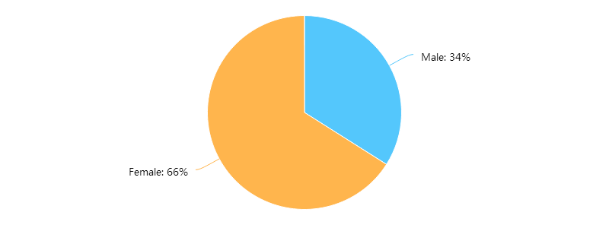
The proportion of gender difference manifests the female consumers occupy 66% of the whole respondents comparing with male consumers only take up 34%. This research result is also reflected in the study proposed by Tekin, Yiltay & Ayaz (2016) who found the same ratio of respondents in terms the 66% female and 34 males among 104 respondents, but it is far less than the gender statistics in the study of Lemmi (2015) who tested the female respondents take up 91% when analyzing brand identity and brand image of ZARA.
It can be inferred that women’s characteristics need to be paid a lot of attention in terms of their nature, personality and preference toward shopping and fashion, in particular to the clothing sector (Myles et al, 2009). Moreover, under the general condition, female consumers are more interested in clothing that they may concentrate more on fashion information and sharp clothing trend comparing with male consumers, just like Khan (2012) found behavioral intention, past experience and purchase intention have the high relations in female than male consumer. However, Riaz (2015) concluded the female and male respondents occupy the half proportion which can be inferred that there will be fewer gaps between gender differences toward fashion brand, as well as the same finding conducted by Isik & Yasar (2015) who explored the relationship between brand image and consumer preference.
Figure 4.2 Age of consumer
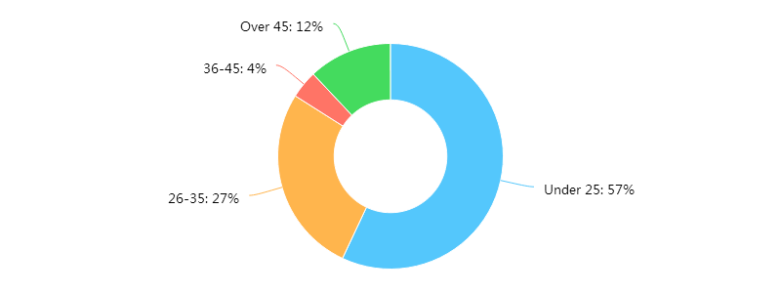
The age distribution of sample presents the specific feature of brand positioning of ZARA brand. it can be seen that 57% young people and 27% middle-aged people consist of the primary consumers of ZARA, which overall 84% proportion illustrates the stable consumer collective of ZARA consolidates people under 35 years old who have sophisticated sensitiveness and high concern to the fast fashion brand and high street store usually, this result also can be found in the study of Isik & Yasar (2015) that over 60% respondents are under 25 and the number of young middle-age people ranks the second place, as well as the study concerning the brand image of H &M conducted by Rahmiati (2016) found that 53.75% young people under 25 are the main consumers of ZARA.
While Tekin, Yiltay & Ayza (2016) discovered that consumers from 25 to 35 prefer to buy ZARA than those under 25 which occupy nearly half of responses considering teenagers do not adapt to the adult clothing brand (Bruce& Hill, 1998). However, it can be inferred that the elder people may increase zeal and enthusiasm to focus on shopping interest and fashion clothing with the development of public information and sharing society or the improvement of people’s life quality and changes of life style (Royo-Vela & Casamassima, 2011). ZARA brand tends to become younger and more popular among the middle-aged population (Wilson, 2012), moreover, it could be attributed that products of ZARA cater to the normal life and common taste gradually, while this result is contrary to the study conducted by Riaz (2015) who found the number of people from 31 to 40 is more than people from 41 to 50 and over 50.
Figure 4.3 Occupation of consumer
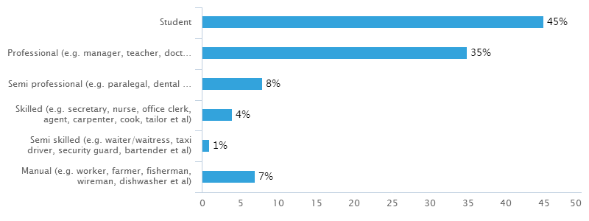
Figure 4.3 points out that students take up 45% among respondent’s occupation comparing with only 1% semi-skilled occupation and 4% skilled occupation, with that professional take up 35% and semi-professional take 8% among occupation group. The results shows that students almost take up half of the sample which can be linked with the age distribution and brand positioning of ZARA consumers because ZARA is radically an advanced and young fashionable clothing brand which conform to student’s personality and growing stage characteristics who like open-minded life to demonstrate special vitality and full energy in their young age (Willems, 2012), this result can be tested in the study of Isik & Yasar (2015) that students take up 22 percentage than employee, entrepreneur and other occupations, as well as Tekin, Yiltay & Ayza (2016) and Rahmiati (2016) discovered that students occupy the large proportion than other kinds of occupations. Moreover, professional people and semi-professional who work in the public sector and company may become the secondary targeted population of ZARA brand which could connect with the middle-aged consumers in terms of the fact that brand style of ZARA meets their demands to pursuit comfort and simplicity which manifest industry characteristics of their role (Kumar & Linguri, 2006).
However, due to the commonly low price and simple style of ZARA brand, there are low-income people to support their consumption level which could make their work relaxed and easy, and which can be found the same result in the study of Riaz (2015) who found employees stands the most number of respondents than students within the clothing sector. Therefore, the occupation of sample reflects the wider distribution and relatively popularity of ZARA products from all walks of life, and apart from the existed and well-known field area, those marginalized and basic occupation actually bury some certain business potential and demographic demands that needs to be further concentrated (Royo-Vela, & Casamassima, (2011).
Figure 4.4 Monthly disposable income of consumer (CNY)
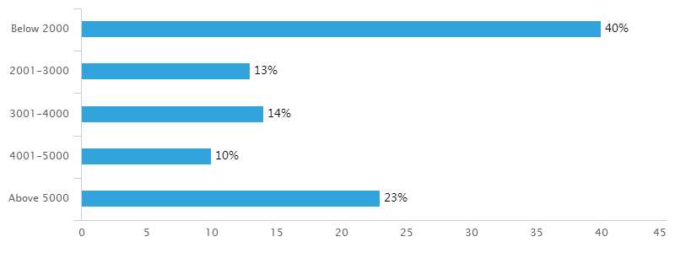
The figure shows that consumer’s monthly disposable income below 2000 take the most proportion which is up to 40%, and the monthly disposable income above 5000 ranks the second place which is 23%, while monthly salary ranges from 2001 to 3000 and 3001 to 4000 take up 13% and 14% respectably, and 10% respondent’s income stays in the range from 4001 to 5000. It turns out that the difference among monthly disposable income closely associates with the age and occupation of consumers.
It can be induced that the large proportion of students illustrates the group have no fixed and precise economic sources, which can be confirmed by Isik & Yasar (2015) and Riaz (2015) who found the lowest income level occupies the most number of people, and proportions of people’s income occupies the middle level of income and people’s income stands the high level of income in China can be tested in the study of Tekin, Yiltay & Ayza (2016) that the upper middle income ranks the first position to purchase fast fashion brand which can be inferred that the main population of ZARA brand in China involves people who have relatively low or middle level of income, which may be influenced by the social status of consumers and ordinary awareness of fast fashion brand in China in terms of the brand feature of ZARA (Tokatli, 2008).
However, with the rapid increase of social economy and the improvement of people’s life standard, there are little significant differentiations among all income groups (Lopez & Fan, 2009), but it is different from the result of Riza (2015) who found the number of respondents tend to decrease regularly with the increase of income, which can be induced that the wider range of income distribution, the more extensive scope of target audience of ZARA brand in China which covers almost all social classes to boost brand reputation and market competiveness consistently in the long run (Berthon et al, 2012).

Section 2 Consumer perception and impression toward ZARA
Figure 4.5 Frequency of visiting ZARA store
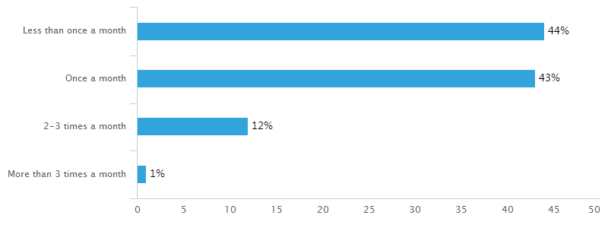
Figure 4.5 shows that highest ratio of 44% consumers visit ZARA store less than once a month which means they may never went to visit ZARA physical stores,with that 43% consumers go to ZARA store once a month, while it needs to pay attention that there are remarkable differences among the option” 2-3 times a month” and “more than 3 times a month” which occupy 12% and only 1% separately.
For one thing, the above results are the contrary to the test of previous study which shows the average distribution of every frequency to purchase fast fashion brand in the study of Tekin, Yiltay & Ayaz (2016), and Riaz (2015) found respondents are likely to purchase many times a year to purchase clothes in the store which stands the highest rank in terms of the most less consumers choose the first and second option. However, Rahmiat (2016) found that respondents keep a lower frequency to purchase H&M in every three months and two months which can be classified into three reasons. First of all, online shopping makes people would like staying at home to click mouse rather than going to the chain stores to select products (Craig et al, 2004); secondly, the less frequency points out the less-known brand reputation of ZARA in Chinese market comparing with local fast fashion brand (Choi et al, 2010); thirdly, apart from the shopping habits of locals and national trading protection policy which lead to the less physical stores in China, there are still some loyal consumers of ZARA even through its brand loyalty needs to reinforce (Lopez & Fan, 2009). For another thing, there are extremely less people choosing ZARA as their regular shopping areas, the brand affinity and brand fusion into the foreign markets should be enhanced greatly.
Figure 4.6 Purchases from Zara
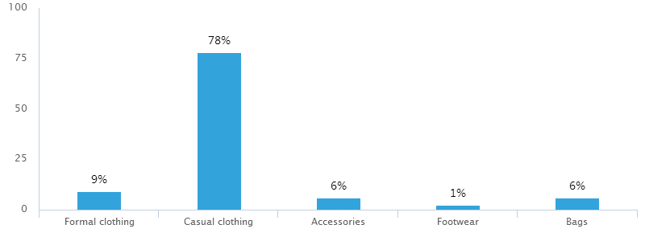
It can be seen from the above figure that the people’s choices to purchase from ZARA perfectly matches the most well-known and mainly products of ZARA brand in most people’s minds and realistic market circumstances. 78% people would buy casual clothing of ZARA which illustrates the overall feature of fast fashion brand because ZARA is famous for casual style which can be found in the study of buyer behavior for fast fashion proposed by Bruce and Daly (2006), the second choice is formal clothing that 9% people would purchase due to that the attractiveness of the low price of formal clothing comparing with luxury brands, and half of people would purchase accessories and the rest half of people may buy bags among total 12% sample considering the possible fashionable popular style and trend of ZARA design and relatively low price comparing other exclusive brands (Barnes & Lea-Greenwood, 2010), in particular to the Shen et al (2014) who researched the impact of consumer’s need for uniqueness on purchase perception found that consumers are more easily motivated by the mutual conception and relationship of low price and other attractiveness toward a specific brand in fast fashion.
Moreover, only 1 people choose footwear of ZARA because this kind of product is less seen in ZARA stores and brand produces less too comparing with H&M and C&A. Therefore, it turns out the rational result to be acknowledged in Chinese market which conforms to popular brand feature of ZARA.
Figure 4.7 Every purchase in average in the ZARA store (CNY)
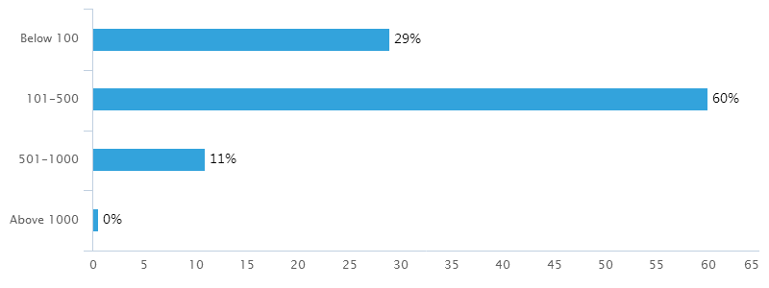
According to the presence of result, it can be concluded that this question relates closely with the purchase staffs from ZARA. On the one hand, 60% people consume money from 101 to 500 RMB which occupy the most population, and people consume money below 100 RMB taking up 29% which is far less than the second option, so there is a distinct difference among consumption levels and almost respondent’s consumption devotes in ZARA stand the relatively lower middle standard that is contrary to the Riaz’s (2015) research on the consumer purchase intention, which has the little change in all consumption levels although a majority of respondents consume less money surrounding the lower levels, but it tends to increase again from the middle consumption level to the high level.
There are three factors accounting for the interpretation of finding. First of all, the overall pricing of ZARA in China is higher than other foreign markets in the world, people who buy clothing especially sweaters or other thick coats need consume more money (Bruce& Daly, 2006); secondly, the price of accessories and bags are lower than the clothing which cause people consume less money, and people are likely to purchase clothing rather than accessories and bags from ZARA (Forney et al, 2005); thirdly, people’s consumption level has stepped into a new stage in China and people’s consumption conscious has transformed that massive population pay attention to the shopping (Joy, 2012), so the majority of consumers could afford fast fashion brand even buy more products in average purchase. On the other hand, the number of people consumes over 500 RMB and 1000 RMB may be affected by the social opinions about fast fashion brand that people are unwilling to devote too much on fast fashion brand or purchase too much from the same brand, another reason is related with the limitation of national average consumption level (Ind, 1997).
Figure 4.8 Perception of the ZARA brand
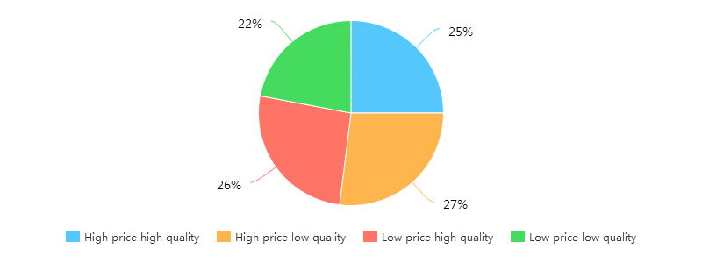
It can be reflected from the figure that 27% respondents think ZARA has the high price but low quality which are the most number of people think in their minds toward ZARA perception, 26% respondents contend ZARA has low price but high quality, with that 25% people notify ZARA owns high price and high quality as well as 22% consumers assert ZARA embodies low price and low quality which ranks the lowest position. In terms of the previous research about ZARA, the perception of ZARA brand is contrary to the former consumer perception toward ZARA. It can be induced that the perception of ZARA brand in China is complex to summarize and hard to settle a determination clearly.
However, Stacer (2013) think that ZARA is a mid-price point lifestyle brand that manages to maintain a consumer base that successfully spans age, socioeconomic and geographic boundaries, and in most western consumer’s mind, the perception of ZARA stays in the low price but high quality (Hall, 2011), while actually according to the research of Stacer (2013), ZARA stands in the middle position of high price and high couture section which the biggest competitors the H &M, River Island, Mango, TopShop and so on even though the quality and pricing of some certain products nearly contend against with luxury brands, for example the H&M.
Moreover, there are three explanations to be analyzed. First of all, the quality and price of ZARA products are unevenness from clothing to accessories which mislead people hold different impressions on ZARA brand( Pettinger, 2004); secondly, the positioning of ZARA makes it conflict with classical consumption level and people’s traditional awareness toward foreign brands in terms of its identity of foreign brand and self-standard in global markets, which lead to the cognitive bias of quality and price (Muzellec & Lambkin, 2006); thirdly, people have complex and ambiguous acknowledgements toward ZARA given ZARA is a relatively youthful brand in the world and its entrance time to Chinese markets, some people may do not know about it even never heard of its brand name (De Chernatony & Cottam, 2006).

Section 3 Influences of brand image of ZARA on consumer purchasing behavior
This section bases on the Keller’s brand image model to give a critical evaluation of crucial factors comprising in each table or figure which assesses the influences of brand image of ZARA on consumer purchasing behavior through the model of Linkert scale.
Table 4.1 Influences on consumer purchasing behavior
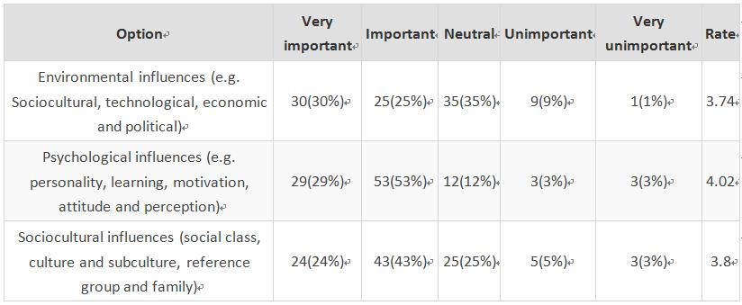
Table 4.1 shows the importance of three factors influence on consumer purchasing behavior, 55% consumers think environmental influences is an important factor and among of which there are still 30% respondents contend environmental factor is the most important among three elements, with that 82% consumers assert psychological influences is important while 29% respondents think it is the most vital one and 67% respondents hold sociocultural influences is significant. It is clear to figure out only 1% people contend environmental influences is totally unimportant comparing with consumers think psychological and socioculural influences both are unimportant which occupy 3% separately.
The figure is to evaluate in a scale from 5 to 1 to identify influences on consumer purchasing behavior (5= Very important, 4= Important, 3= Neutral, 2= unimportant, 1= very unimportant), so the higher rate, the more important position for each factor. It can be also seen that psychological influences stand in the highest rate, with that sociocultural influences got 3.8 rates and environmental factors obtained 3.72 rates, so psychological influences have become an unavoidable factor which overweighs environmental influences and sociocultural influences. Schiffman & Kanuk (2010), Hawkins, Best & Coney (2004) and Assael (2004) mentioned that consumer decision-making can be affected by several measurements, but psychological influences are the most important factor, moreover, Zeithaml (2004) based on the psychological angle to figure out company can directly influence consumer’s psychology, thus would impact on consumer purchasing behavior, and Dodds & William (1991) found that consumer’s perception value is the most important factor of impact on consumer purchasing decision.
However, with the advanced impact of political economy and development of social culture, it needs to focus on that environmental and sociocultural influences have become increasingly vital, which can be figured out in the study proposed by Schiffman and Kanuk (2006) who contended that in the environmental level, the group, family, class and culture are the crucial factors that make great impact on consumer individual, and it can also be tested in the research of Brassingon and Pettitt (2003) who think that consumer behavior faces with diverse pressure from society that might influenced by current trends, popular products and social group, which can distinguish the importance of outside environmental influences (Solomon, 2014).
There are several reasons can interpret this phenomenon. First of all, the purchase process is a psychological reflection which is easily affected by external environment, such as living surroundings, other people’s suggestions and economic status as with the larger gap between the poor and the rich, the cheap and expensive (Bargh, 2002); secondly, open information and social media make messages so convenient and flexible that people could make purchase decision basing on multiple channels to weigh a comprehensive better choice and settle the best decision. (Kacen & Lee, 2002).
Table 4.2 Brand awareness
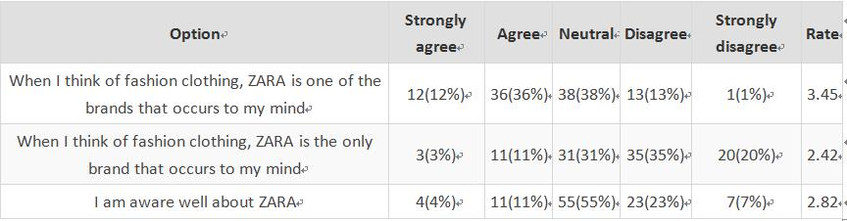
It can be seen from the Table 4.2 that 48% consumers think ZARA is one of the brands that occurs to their minds when thinking of fashion clothing and among of which 12% respondents strongly agree of this, with that 3% respondents contend ZARA is the only brand occurs to their minds when thinking of fashion clothing and overall 14% respondents agree this opinion, and 11% respondents aware well about ZARA which among 4% strongly agree this idea, while there are 20% people strongly disagree ZARA is the only fashion brand and only 1 people strongly agree brand awareness of ZARA as one of the fashion clothing brand.
The figure is to evaluate in a scale from 5 to 1 to identify the brand awareness of ZARA (5= Strong agree, 4= Agree, 3= Neutral, 2= Disagree, 1= Strongly disagree), so the higher rate, the more distinguished brand awareness of ZARA. According to the Keller (1993; 1998), brand awareness is an essential part of brand knowledge which means the recognition and recall of brand, the first option of “ZARA is one of the brands to recall consumer’s mind” was got the highest 3.45 rate comparing with the only 2.82 rate of the second option of “ consumers are aware well about ZARA”, the result presents the same answer conducted by Jannoun (2014) to explore the brand awareness of ZARA, and Lemmi (2015) also found that the brand awareness of ZARA stays in the 3.5 rate among 220 respondents in the study of ZARA brand identity and brand image, and consumer’s acknowledgement extent about ZARA got 3.6 rate comparing with the only 2.82 rate in this research.
Wright and Lynch (1995) found the common knowledge of consumers toward product and purchasing decision makes huge impact on brand image, so the products of ZARA are well-known for some people, and brand knowledge and reputation of ZARA have reached given standards which embodies the certain specific brand awareness in Chinese markets (Sull & Turconi, 2008), but it needs to enhance the public brand awareness further in terms of the less of exclusiveness and uniqueness when it comes to fashion clothing (Lopez & Fan, 2009).
There are several causes can explain this phenomenon, as a worldwide high street fashionable brand, it is no wonder to become one of the familiar clothing brands as for most consumers, ZARA occupies certain competitive position in Chinese clothing market (Black, 2008), but it lacks of outstanding brand identity and exclusive brand image to expand more markets and consolidate competitive advantage due to that ZARA has not spread metropolis totally (Beaudoin et al, 2003), for example, there is only one ZARA store in Wuhan that greatly decrease its market potential and waste brand reputation among central cities of China (Harter et al , 2005).
Table 4.3 ZARA attributes and benefits
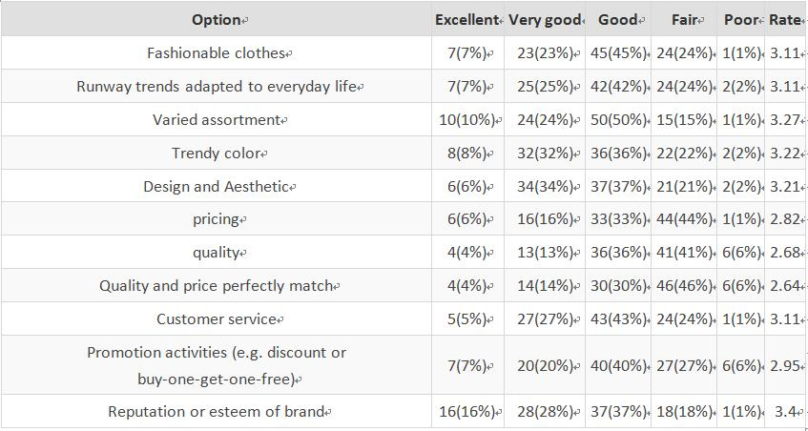
Table 4.3 reflects that 44% respondents think that reputation or esteem of ZARA brand performs very well and among of which 16% consumers think highly of its excellent performance which got the most public praise among of factors, with that 34% consumers contend ZARA products have varied assortment and 40% consumers contend the trendy color and design and aesthetic of ZARA obtained great evaluation that 8% respondents and 6% respondents think ZARA performs the best separately. However, a few consumers think the quality and the match degree of quality and price, as well as the promotion activities of ZARA performs barely satisfactory which occupy 6% poor assessment averagely.
The figure is to evaluate in a scale from 5 to 1 to identify the performance of ZARA attributes and benefits (5= Excellent, 4= Very good, 3= Good, 2= Fair, 1= Poor), so the higher rate, the more distinguished performance of ZARA. It can be figured out from this rate comparison that reputation and esteem of brand got the highest 3.4 rates with that varied assortment obtained 3.27 rates, and trendy color got 3.22 rates with that design and aesthetic acquired 3.21 rates which these four factors beyond 3 rates as the distinguished important factors to assess crucial factors to influence consumer perception and feature of brand image of ZARA.
According to the brand equity model of Keller (2003), attributes and benefits of product or service are the crucial parts of brand association which is the consumer’s perception of memory can reflect brand image. This question aims to evaluate the performance of ZARA brand in China, and reputation or esteem of brand ranks the highest position that may link with the relatively high brand awareness of ZARA in China, and it can be induced that the products of ZARA have precise classification with full range of different types which cater to the fashionable trends and meets consumer’s demands (Bruce & Hill, 1998). Meanwhile the well design and high aesthetic taste are the extra two attractiveness of ZARA brand as a mirror to present the popular brand style and feature, and Peng (2010) combines both conceptions of Kamins and Marks (1991) and Lin (2009) manifested brand image is a memory of brand attitude and perception created by consumers according to product features.
Moreover, in the study conducted by Lemmi (2015) who displayed fashionable, popular, clearly-classified, differentiated as well as great customer service are the distinguished features of ZARA brand, and nearly half of respondents think ZARA brand did not very satisfied in the matching degree of quality and price which ranked the lowest one among all assessing factors, and Lemmi (2015) found both price and quality are the most important factors that will influence consumer’s purchase intention toward clothing brands. Therefore, ZARA brand needs adjust the pricing and improve the quality and products to optimize brand management and marketing strategy basing on the practical conditions of market background and product characteristics due to that both rates of quality and pricing are below 3 (Ghemawat et al, 2003).
Table 4.4 ZARA emotions, judgment and attitude
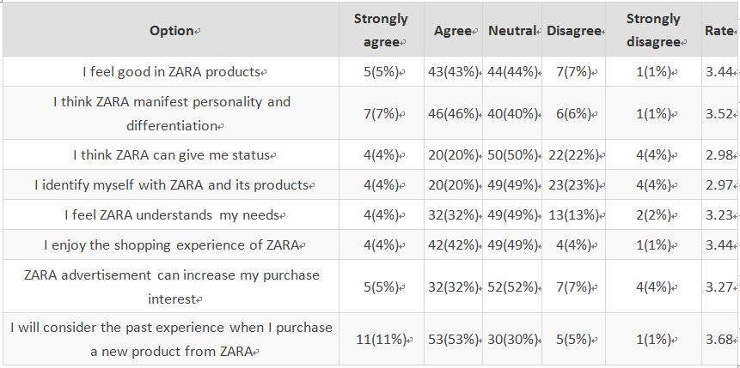
It can figure out that 64% consumers would consider the past experience when purchasing a new product from ZARA, and among of which 11% respondents strongly agree with this, with that 53% consumers think ZARA manifests personality and differentiation and 48% respondents contend they feel good in ZARA products which 7% consumers and 5% consumers strongly agree this opinion respectively. While it needs to focus on that consumers do not think ZARA can provide status and identification, as well as its advertisement increases purchase interest which occupy 4% in the “strongly disagree” level averagely.
The figure is to evaluate in a scale from 5 to 1 to identify consumer perceptions toward ZARA (5= Strong agree, 4= Agree, 3= Neutral, 2= Disagree, 1= Strongly disagree), so the higher rate, the greater influences on consumer purchasing behavior toward ZARA. It turns out that the past experience is the most important factors that influence consumer purchasing behavior which got 3.68 rates, with that differentiation and personality acquired 3.52 rates, and both of good impression and shopping experience obtained 3.44 rates which can also be regarded as distinguished consumer perceptions toward ZARA.
This question is to further explore brand image of ZARA from the prospective of consumer’s comprehensive opinion and impression which make it clear to figure out the relationship between consumer and brand association, Roberts (2004) put forward brand emotion is the cultural implication of brand, and emotional branding is the fastest way to cause consumer’s reactions, emotions and minds, which finally would form into the brand association.
The table clearly reflects the phenomenon that consumers will consider the past experience when purchasing a new product from ZARA has got the highest rate among all assessments, which can be confirmed in the study conducted by Conner & Armitage (1998), they found that the purchase intention can be predicted through reference from the past purchase experience to determine future purchase, and it turns out that respondents usually attaches massive importance on the shopping experience which is easy to associate with previous feelings and self-awareness before buying new products from the same brand (Tungate, 2008), just like Lin (2009) proposed that the consumer’s overall acknowledgements toward brand can be seen as a component of brand image due to that it bases on the identification of brand products through the combination of information of consumer’s memory associating with product experiences (Tokatli, 2008), so it can also be inferred that consumers tend to be rigid and rational toward brand and product to give more considerations with the coming age of “experience economy” (Mazaira et al, 2003).
ZARA manifest personality and differentiation points out the relatively strong brand feature and brand identity make ZARA distinguish from other similar clothing brands which have much space to intensify, and in present times, ZARA has obtained acknowledgement to help display characteristics and uniqueness as a precise way for fast fashion brand conveying to the public (Bonnin, 2002), which can be tested by Krishnan (1996) who thinks brand association can be inspected by number of associations, preference of associations, and uniqueness of associations and resources of associations.
Moreover, overall good impression and a sense of shopping experience could illustrate the shopping atmosphere and feeling which provides basic favorable brand image for most consumers, as with the study by Lemmi (2015) who think shopping atmosphere and customer service have become the most common prospective of consumer’s judgment toward ZARA (Hemphill & Gersen, 2009), so it is beneficial to strengthen customer service and customer experience which can be transformed both into public praise of brand awareness in the long run, and Keller (1993) proposed consumer experience reflects the outer advantage of product consumption, which present the demand of individual expression and social acknowledgement of non-product attribute to influence purchasing behavior.
When it comes to the power of ZARA advertisement, in terms of Driessen (2005), who think advertisement is a tool that can help company create and adjust brand image, and it is difficult for ZARA to give status and understand needs, as well as consumers identify themselves means brand resonance of ZARA brand for Chinese consumers is hard to come into being in terms of the identity of foreign brand and cultural difference (Kumar, 2007), which are contrary to the results shown by Lemmi (2015) that social status is the crucial aspect to distinguish ZARA from other high street brands, therefore, ZARA need focus more on marketing channels to enhance brand image and attractiveness, meanwhile increase connections with customers to improve brand value, culture and awareness basing on local brand positioning (Ghemawat et al, 2003), and it needs to pay more attention on customer service and customer relationship management (CRM) to improve consumer satisfaction toward shopping experience.
Table 4.5 Brand loyalty
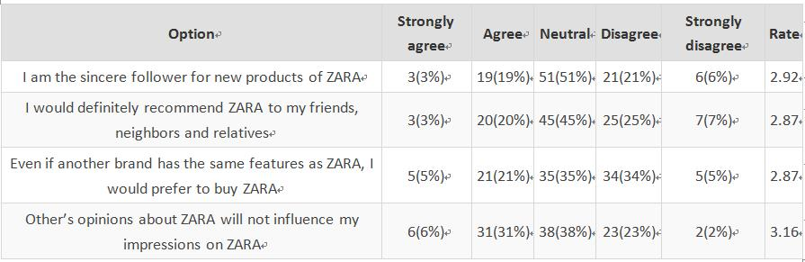
Table 4.9 points out most respondents care less about ZARA brand which produce the common brand loyalty of ZARA among the four options, 22% respondents are the sincere followers for new products of ZARA among of which only 3% consumers strongly agree with this, with that 23% consumers would definitely recommend ZARA to others, and 26% respondents would prefer to buy ZARA regardless of other similar brands and among of which 5% strongly agree this view, while 37% consumers will not change their impressions on ZARA even 6% of which strongly agree with that. However, 7% consumers strongly disagree the recommendations to others about ZARA with only 2% people think people’s mind would definitely influence their opinions of ZARA.
The figure is to evaluate in a scale from 5 to 1 to identify consumer loyalty of ZARA (5= Strongly agree, 4=Agree, 3=Neutral, 2= Disagree, 1= Strongly disagree), so the higher rate, the better consumer loyalty of ZARA. It turns out that the loyalty toward influence of other’s opinion ranks the first position which got 3.16 rates comparing with 2.92 rates of loyalty of sincere follower, and loyalty of recommendations to others which has the same 2.87 rates with loyalty of priority to purchase ZARA.
It mainly discusses more details about brand loyalty of ZARA which has classified into four measurements, it can be figured out that there are little differences among above rates and it can be inferred that the brand loyalty of ZARA belongs in the lower middle level which needs to enhance communications and associations with consumers through effective brand management and brand strategy, which can be confirmed through the study of Lemmi (2015) who displayed 3 consumer’s loyalty extent to ZARA needs improve due to the measurement of 3 rates, she found other’s opinions and attitudes will not influence existed impressions due to the full rate of this option in the study to explore brand image of ZARA.
There are three explanations accounting for the phenomenon. First of all, sincere followers of ZARA are increasing (Ghemawat, 2003), secondly, consumer’s conscious and awareness have greatly improved than before (Tungate, 2008), thirdly, the brand image and feature of ZARA is distinct and clear to be recognized which owns stable a collective of market resources (Mazaira et al, 2003). Brand loyalty of sincere followers for new products of ZARA still have massive potential to strengthen in China in terms of the huge positioning population, as with D’souza et al (2006) pointed out consumers would purchase the same kind of products and service even share with others if they benefit from the former purchase.
Moreover, the preference to choose ZARA regardless of other brands manifests the competitive advantage. First of all, ZARA still faces with huge pressure from home and aboard in the clothing industry (Bonnin, 2002), secondly, there are too many similar high street brands in the world let alone the local brands to occupy Chinese market (Hemphill & Gersen, 2009), thirdly, the nature of fast fashion brand make it difficult to avoid similarity and superposition within the same competition (Choi et al, 2010), at the same time the recommendations to others means the adaptation of ZARA brand needs to enforce and fit in the normal life, which may be largely caused by the limitation of individual brand associations and relatively less-known brand awareness (Kumar, 2007), as well as the unhappy past experience about ZARA brand in terms of that Muhammad Mudasar Ghafoor et al (2012) showed consumer satisfaction and brand image have the positive influence on brand loyalty, therefore, the results of brand loyalty in this research can reflect some features of brand image of ZARA in terms of the fact that Lessig (2010) contended brand image can be used to predict consumer loyalty especially for the clothing brand.
Figure 4.9 Whether Zara brand influence consumer buying behavior
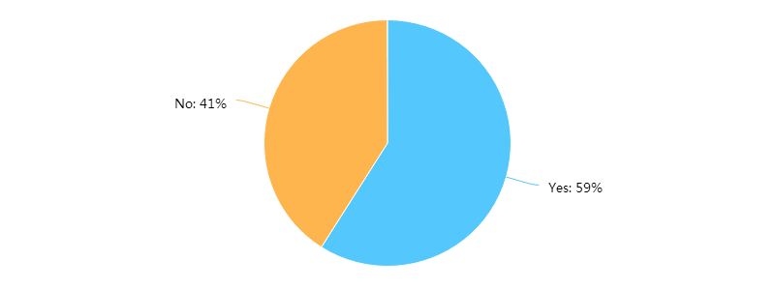
The design of this question is to give a comprehensive understanding of the influence of ZARA brand toward consumer purchasing behavior, it can be shown that almost 60% respondents think ZARA brand can influence their consumptions, which presents the function and significance of this research, and it confirms the certain impact of brand image of ZARA among consumer collectives which could provide a final summary of the whole results. It can be tested by Lemmi (2015) who found that brand identity and brand awareness of ZARA are well perceived in China, while this result is contrary to the study proposed by Riaz (2015) who found consumer perception has strong impact on consumer purchasing behavior but not brand image toward field of clothing brand, and from the research of Tekin, Yiltay & Ayaz (2016), it can be concluded that product and service are the most factors that influence consumer perception toward brand image of clothing brand due to that ZARA belongs to the service industry (De Chernatony & Cottam, 2006).
However, 41% people think ZARA brand will not affect their purchasing behavior that can be attributed to the association of previous analysis of brand awareness, brand attributes, attitudes and benefits, as well as brand loyalty. Therefore, ZARA brand must improve brand effectiveness and competitiveness to strengthen brand image in the future (Sull & Turconi, 2008).

Chi-Square test and Cross-Tabulation analysis
Chi-Square test and cross tabulation analysis is to testify whether both classified variables embody remarkable relations with each other, the Value means the Chi-Square value, df means the degree figure, and ASYMP.sig points out the associated probability which is to measure the associated degree between these two variables, according to the result of Chi-Square test through SPSS and the assessment principle that measurement of correlation result is to observe the value which is the cross of Pearson Chi-Square and Asymp. Sig named Sig value, if the Sig value is less than 0.05, it means there are remarkable differences between two variables, otherwise there are no remarkable influences between two variables.

Age & Perception of ZARA
Having tested basic variables of gender, age, occupation and income whether exist remarkable relations with brand awareness or not, it manifests that age and perception of ZARA have significant correlations.
Table 4.6 Age & Perception of ZARA brand Chi-Square test
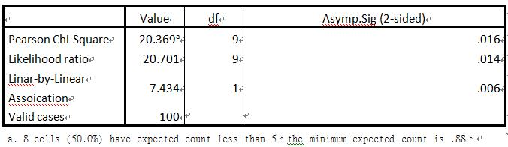

It can be seen from Table 4.6 that the Pearson Chi-Square test manifests the Asymp.Sig (2-sided) is 0.016 which is less than 0.05, therefore, it can be justified that the relationship between age and perception of ZARA brand exists relations of significant correlation. Therefore, ZARA needs to produce more targeted products in terms of brand positioning of different age groups.

Gender & Quality
According to the above mentioned basic principles and measurement of Chi-Square test, having tested basic variables of gender, age, occupation and income whether exist remarkable relations with attributes and benefits or not, it manifests that gender and “quality” have significant correlations.
Table 4.7 Gender & Quality Chi-Square test
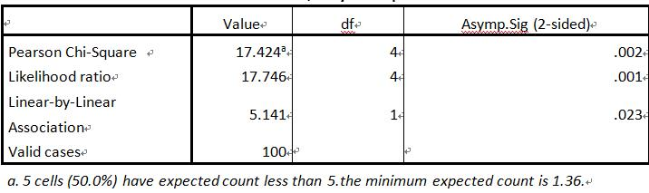
It can be seen from the Table 4.7 that the Pearson Chi-Square test manifests the Asymp.Sig (2-sided) is 0.002 which is less than 0.05, therefore, it can be justified that the relationship between gender and ZARA attributes and benefits exists relations of significant correlation. Therefore, ZARA brand can strengthen the product quality through the differentiation of gender feature and personality.
Table 4.8 Gender & Quality (ZARA attributes and benefits) Cross tabulation analysis
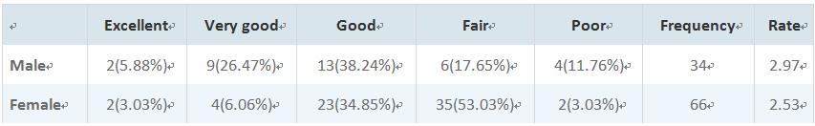
It can be shown from the Table 4.8 that male respondents got 2.97 rates comparing with female consumers obtained 2.53 rates which is corresponding with the Lemmi (2015) who found male respondents think more highly of quality of ZARA products than female, it can be inferred that quality of ZARA brand performs better among male consumers than female consumers in China considering the different perception toward quality of clothing brand.
There are three factors accounting for the reasons. First of all, male consumers usually tend to have less shopping experience than female consumers, which means that they care less quality than female consumers (Kumar & Linguri, 2006); secondly, the product differentiation maybe differ from the fact the quality of men’s wear is better than women’s wear of ZARA brand (Sull & Turconi, (2008); thirdly, female consumers tend to be more rigorous and demanding to purchase clothing than male consumers due to that they are more likely to hold higher requirements toward appearance and beauty considering the wider ranges for choosing proper high-quality products (Liljander, 2009). However, ZARA needs to improve product quality greatly to strengthen competiveness in Chinese market in terms of the fact that quality and price are the most significant factors that influence consumer purchasing behavior (Royo-Vela & Casamassima, 2011), in particular to the improve the quality among female groups.

Gender & Quality and price perfectly match
Meanwhile, according to the test result of Chi-Square test, having verified basic variables of gender, age, occupation and income whether exist remarkable relations with attributes and benefits or not, it manifests that gender and “quality and price perfectly match” also have significant correlations.
Table 4.9 Gender & Quality and price perfectly match Chi-Square test
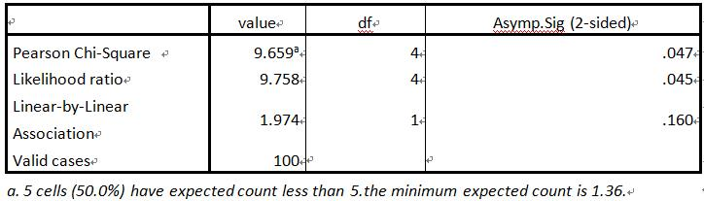
It can be seen from the Table 4.9 that the Pearson Chi-Square test manifests the Asymp.Sig (2-sided) is 0.047 which is less than 0.05, therefore, it can be justified that the relationship between gender and Quality and price perfectly match exists relations of significant correlation. Therefore, ZARA needs adjust pricing into the rational quality level through optimizing marketing strategy and product management scheme in terms of the low rates.

Correlation analysis
Correlation analysis is to measure the close relationship and the extent of intimacy among factors. This research has established several crucial indexes which are not absolutely independent but can affect with each other through SPSS correlation analysis method. The measurement of result mainly observes the extent of Significance (two-sided) which has negative relations with correlation significance, if the Significance (two-sided) is less than 0.01, it manifests the significant correlation, and the Significance (two-sided) is from more than 0.01 to less than 0.05, it manifests general correlation, the if the Significant (two-sided) is more than 0.05, it manifests there are no correlations among tested variables.
In order to explore whether the brand image of ZARA relates with consumer purchasing behavior or not, it needs to concentrate on correlation research to find the significance of relationship among influences on consumer purchasing behavior, brand awareness, ZARA attributes and benefits, ZARA emotions, judgments and attitude as well as brand loyalty.
To make all data clear and specific, it is necessary to renumber all variables which are distributed again in the following figure:

Table4.10 Influences on consumer purchasing behavior & Brand awareness Correlation test
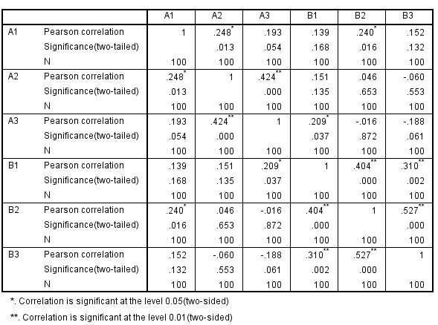
It presents that although almost Pearson correlations exceed 1, nearly all the significance (two-tailed) beyond 0.05. Therefore, in this research, brand awareness of ZARA has no influence on consumer purchasing behavior.
Similarly, after testing the correlation between influences on consumer purchasing behavior and ZARA attributes and benefits, the result shows that ZARA attributes and benefits impact on consumer purchasing behavior, and having tested the correlation between influences on consumer purchasing behavior and ZARA emotions, judgments and attitude, the result tells that ZARA emotions, judgments and attitude have effect on consumer purchasing behavior. Meanwhile, it can also figure out that brand loyalty has no influence on consumer purchasing behavior according to correlation analysis.

Table 4.11 Brand awareness & Brand loyalty Correlation test
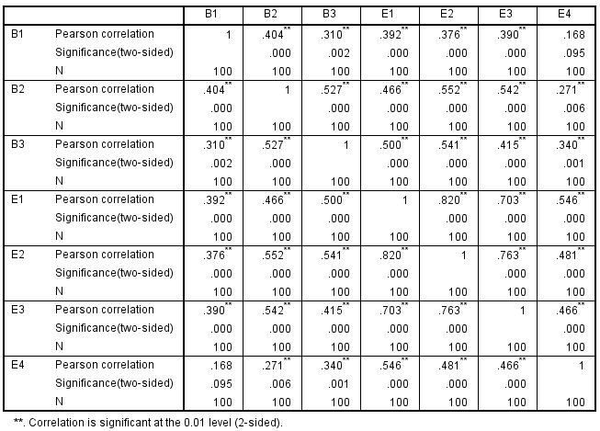
The table shows that Pearson Correlations are big and some of which absolute value approximate 1, almost significances (2-sided) are less than 0.01, so brand awareness and brand loyalty have significant relations with each other at 0.01 level (2-sided).
Table4.12Brand awareness & ZARA attributes and benefits Correlation test
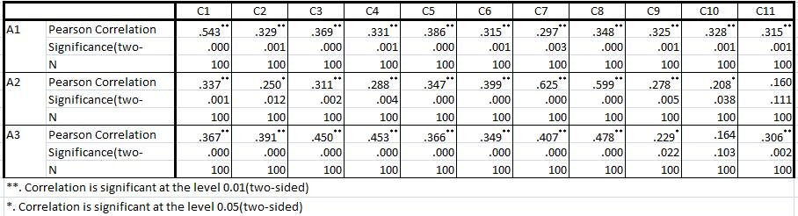
It can found that almost Pearson Correlations are big and almost Significance (two-sided) are less than 0.01, therefore, brand awareness and ZARA attributes and benefits exist remarkable correlations with each other.
Meanwhile, having testified the correlation between brand awareness and ZARA emotions, judgments and attitude, the test result presents that brand awareness and ZARA emotion, judgment and attitude have remarkable correlations, and there are significant correlations between ZARA attributes and benefits & ZARA emotion, judgment and attitude according to the test result.

Table4.13 ZARA attributes and benefits & Brand loyalty Correlation test
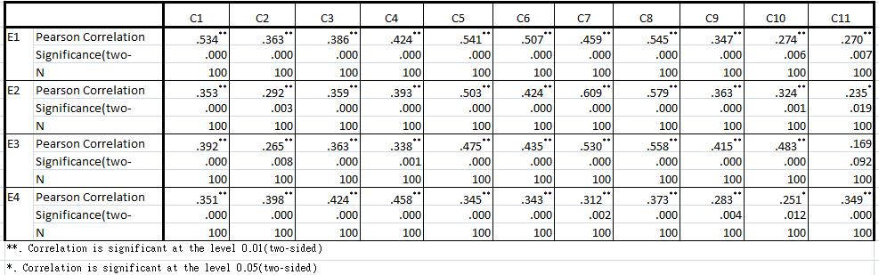
The table conveys that Pearson Correlations are big and almost of factors of Significances (two-tailed) are less than 0.01, so it manifests ZARA attributes and benefits & brand loyalty have significant correlations.
Similarly, the significant correlations can also be figured out among ZARA emotions, judgments and attitude & brand loyalty after application of the same method of Correlation test.

5. CONCLUSION & RECOMMENDATION
This chapter is mainly to conclude finding and analysis which will tease research venation and deal with objectives as a whole, and provide further suggestions for future study. It needs to be focus on the aim of this research, and the purpose is to explore how the brand image of ZARA influences consumer purchasing behavior. The literature suggests that brand image impacts on consumer purchasing behavior from the prospective of band awareness, brand association, brand identity and brand loyalty and so on, and the results of this study manifest that brand image of ZARA impacts on consumer purchasing behavior through a variety of factors which are associated with brand association that can attribute into product attributes, benefits and consumer perceptions. The specific research objectives are the followings:

5.1 Objective1: Identify the link between brand image of ZARA and consumer purchasing behavior
The results of survey figure out that psychological influences make the greatest impact on consumer purchasing behavior, and as one of component of psychological factor, consumer perception toward brand can be reflected by emotions, judgments and attitude, it can summarize that brand association of ZARA can impact on consumer purchasing behavior but would not exert deep influences in terms of the fact that benefits and attributes as well as attitude are the crucial elements of brand association (Keller, 1993), the results of this study are consistent with Keller’s opinion (1993) that brand image of ZARA influences on consumer purchasing behavior through brand association; in addition, the significant correlations between ZARA attributes & ZARA benefits and emotion, judgment & attitude manifest the product feature of ZARA brand impacts greatly on consumer perception; furthermore, both brand awareness and brand loyalty of ZARA would not impact on consumer purchasing behavior in China; and last, there are remarkable relationship among brand awareness, brand association and brand loyalty that affects with each other closely. The results of this finding is consistent with the opinions proposed by Peng (2010), Kamins and Marks (1991) and Lin (2009) concerning the brand image is created by consumers according to brand associations, and it is corresponding with Kotler (1997) and Keller (2001) who think brand associations create relations between consumers and brand image.
While the result of this study is contrary to the findings of Riaz (2015) that brand awareness impacts a lot on consumer purchasing behavior, and there are three factors accounting for this illustration. First of all, brand reputation is less well-known in Chinese market comparing with Riaz’s research that his empirical study focuses on Spain; secondly, as a foreign fast fashion brand, cultural diversity and competition from local clothing brand make ZARA face with the threat of substitute that lead to the low brand identity in Chinese market for some consumers; thirdly, as one of the most popular markets in the world, China involves massive market potential to expand which comprises unexploited and unutilized resources, the market penetration and market expansion of ZARA in Chinese market are still in the growing period to be dig out more greatly in comparison with the stable existing markets in Spain.

5.2 Objective2: Analyse features and components of ZARA brand image from the prospective of consumers
In terms of the concept brand image component proposed by Kolter(1997), Keller(2001), Lin(2009) and Peng (2010), brand image component can be classified into functional image, symbol image and experience image. Therefore, according to the findings, the components of ZARA can be concluded in the following:
This research shows varied assortment and trendy color are the important factors which got high rates in the evaluation of ZARA attributes and benefits that lead to the fact that fashionable, popular and rapid updating speed are the distinct functional images of ZARA, this result conforms to the most results of research, such as Riaz (2015), Roth (2009) and Bruce & Hill (1998) that think ZARA leaves a popular fashionable brand image in the world which leads the trend;
With the aspect of symbol image, in terms of the age distribution and occupation structure, young and casual can be regarded as the crucial elements, with that the gender proportion of all respondents, ZARA is a female-dominated clothing brand, and in terms of the fact that overall good impression and reflection of personality and differentiation got high assessment in ZARA emotions, judgment and attitude, as well as the low rate of advertising interest, it can be concluded that independent of advertisement is an another symbol image of ZARA, this result is consistent with Lemmi (2015) , Chang et al (2013) and Tekin (2016) et al that clothing brand is often female-driven which and especially the high street brand image manifest personality and feature as a mark and sign;
As for experience image, in terms of the fact that complex and unclear conception of ZARA, price and quality lead to controversial assessment, and the high rates of shopping experience and past purchase can induce relaxed good customer service of ZARA, with that the factor of age, occupation and income means the experience image of ZARA relates closely with consumer’s image, while considering the brand reputation and esteem got the highest rates in the consumer perception, ZARA embodied certain reputation in Chinese market, and the low brand identity of ZARA in China leads to the alternative threats from other similar brands. The results of this research are consistent with Lemmi (2015), Goyal (2014) and Bruce (2006) that ZARA China is well perceived but brand awareness and contradiction of quality and price and other negative images need improve a lot, and it also conforms into the research proposed by Kytölä (2013) and Daly (2006) that functional and symbol image of ZARA are commonly-accepted in the world, while its experience image differs from different regions which affected by the brand positioning and band strategy toward local markets.
However, this research also find that the components of ZARA brand image almost conform to its general global image in worldwide people’s mind as with the presentation of its function image and symbol image, while some description of experience image of ZARA is not corresponding with reality and its social evaluation, the most distinguished contradiction is unclear assessment of quality and price even though its distinctive brand features and style can help people easy to be found in the crowd. However, with the increasingly development of age of experience economy (Mazaira et al, 2003), ZARA still faces with fierce competition from its similar brands, such as competitors of its perceptual map even the pressure of changes in whole fashion clothing field, and it challenges the potential danger of stuck in the middle if it cannot deal with alternative homogeny to keep competitive advantage in the future. The results of findings are consistent with Lemmi (2015), Shen et al (2014), Bruce and Daly (2006) that ZARA is a worldwide popular high street brand but it still needs to expand more markets and merge into some regions to improve brand awareness and brand identity as well.
In turn, in terms of the findings of results, the feature of brand image of ZARA can also be concluded as the following:
This research presents different features from functional image, symbol image and experience image. As for the functional image, its trendy color and fashionable nature of clothing brand makes it cater to normal life and keep in step with social trend, and considering the main targeted people are the young and students, its product can satisfy most of young consumer’s pursuit for fashion, this results conform to the findings of Lemmi (2015) and Riaz (2015) that ZARA is a young and casual brand which involves the fresh taste but can adapt to the common daily life;
In the aspect of symbol image, the luxurious decoration but relatively low price comparing with luxury products make ZARA embody the lightly luxurious brand attitude, with that varied assortment makes it combine with diverse style, and the less independence on advertisement means ZARA is good at utilizing multiple marketing channels, this result is consistent with Tekin et al (2016) and Riaz (2015) that the luxurious shopping environment and unattractive ZARA advertisement is the unique attitude of high street brand which can differ from other similar brands;
At last, considering the experience image, in terms of the fact that brand awareness of ZARA cannot impact on consumer purchasing behavior in Chinese market, the brand awareness of ZARA stays in the superficial level, and even though brand association can make impact on consumer purchasing behavior, the not strong relations make brand image of ZARA is hard to deeply root in people’s minds, so brand image of ZARA stays in the improvement stage. This result is consistent with study conducted by Lemmi (2015) that brand awareness of ZARA is highest and strongest in Spanish market rather than any other kinds of markets in the world, and Bloeme et al (2011) also found that brand association of clothing brand is hard to influence greatly on consumer purchasing behavior because it is difficult for a fashionable brand to meet all consumer’s requirements and demands, the deeper consumer perception, the stronger brand image of a brand.
In a word, the results of this research shows that the features of brand image of ZARA are partly tend to be positive in society, and almost reflect consumer perception and existing problems in Chinese market which there are much development space to improve and change. The most remarkable feature of brand image of ZARA is consumer-centered brand relationship reflected from the prospective of product and service. However, although ZARA embodies distinction and popularity at the same time, its brand identity is ambiguous comparing with other similar brands, with the coming trend of new entrance, the relatively low-grade performance of brand awareness and brand loyalty of ZARA is still a big worry to expand and permeate further into Chinese market. The results of this research are corresponding with the research conducted by Riaz (2015), Lemmi (2015), Kytölä (2013) and Goyal (2014) that consumer service and shopping experience are the most distinguished features of ZARA brand, while according to the claims of Lemmi (2015) that brand identity of ZARA is complex to acknowledge and hard to settle for some people comparing with distinct perceptions about quality and price of H&M and C&A.

5.3 Objective 3: Evaluate crucial factors that brand image of ZARA impacts on consumer purchasing behavior to strengthen brand value and brand identity
In terms of the fact that brand association of ZARA impacts on consumer purchasing behavior, the crucial factors can be divided into strong and weak distribution as the following:
This research presents that brand performance of ZARA is tightly associated with brand association from the prospective of consumer. With the aspect of product feature, brand reputation is the most crucial factor which ranks the first position of ZARA attributes and benefits, with that varied assortment and trendy color rank the second and third place. However, the quality and price are the main focuses of ZARA to deal with, and the matching degree of price and quality is the biggest problem to influence consumer purchasing behavior negatively which got the lowest mean. In terms of aspect of consumer perception, the past experience got the highest rates on the ZARA emotions, judgment and attitude which is given priority to consider whether deciding continue purchasing products of ZARA or not, with that personality and differentiation are the main impressions and perceptions for consumers in China, but ZARA cannot give status and identification to consumers which is difficult for them to find identity from ZARA brand in China. This result of research is consistent with theoretical opinions proposed by Keller (1998), Roberts (2004), Lin (2009), Tokatli (2008) that brand performance mainly reflects from its brand reputation and consumer perceptions, and it can also be found the same results of Lemmi (2015), Riaz (2015), Ghemawat et al (2003), Bonnin, (2002) and Hemphill & Gersen, (2009) that brand reputation of ZARA in China and other Asia markets can be identified and consumer experience is the most considerable factor to connect with consumer purchasing behavior which may be affected by the consumer-centered brand nature of ZARA as a service clothing brand.

5.4 Objective 4: Provide recommendations for maintaining and shaping brand image to foster brand competitiveness and effectiveness in market position for the update of clothing industry through the guidance for further investigation in the long run.

5.4.1 Recommendation for further recommendations in future study
Firstly, in terms of the fact that brand image is a dimensional structure, the theory school of brand personality only considers the effect of brand image on consumer perception, but neglect the image that consumers toward product and service as well as the perceptions of company image.
Secondly, in the past ten years, emotional branding has become the effective manner of brand management. Roberts (2004) put forward that brand emotion is the cultural implication of brand, and emotional branding is the fastest way to cause consumer’s reactions, emotions and minds, which finally would form into the brand association and brand loyalty. Under the increasing fierce market competition, brand emotion is the bond between brand and consumers, as well as the key to expand markets. So the future research can explore the relationship between brand image and consumer purchasing behavior from the new prospective of brand emotion.
Furthermore, presently scholars select the study focus of brand image is mainly the brand image of physical product, limits in the applicable study in the certain product fields, such as brand positioning, competitor analysis, but it lacks of the study of concept of service brand and components, so the study extent and category of brand image should extend more field ranges of research blindness with the combination of product and service assortment.
At last, previous research analyzes the relationship between brand image and consumer satisfaction, but it need to be examined if the results of service industry can be applied into other backgrounds (such as manufacturing industry, the real estate industry et al), and it still exsits tiny arguments among different studies even though the positive influence of brand image on consumer satisfaction and consumer loyalty has been proved. Specifically, some research proves the brand image affects not only the consumer loyalty directly, but also affects the other media factors. Therefore, it would be discussed the mutual relations among brand image, consumer satisfaction and consumer loyalty, and figure out more comprehensive indicators of consumer behavior in future study.
Radically, the power of brand buries in the consumer’s mind (Keller, 2000), while the brand awareness granted by consumers might not the same equal to the brand image that company wants to create (Hsieh et al ,2004). The product performance of different brand image strategy and marketing mix strategy finally depend on the consumer’s awareness of brand image or faith, as well as the specific demands that consumers think this image can satisfy. Therefore, it is the focused directions for future study to investigate the effects of varied brand image strategy and marketing mix tactics from the prospective of consumer, and testify the market condition and consumer individual condition created by those effects.

5.4.2 Recommendation for ZARA to foster brand image from perspective of consumer purchasing behavior
- The construction of brand image of ZARA must focus on quality and pricing from gender differentiation and different age group. In terms of findings that gender distribution relates with quality and matching of quality and pricing, and age group connects with perception of ZARA brand. The contradiction of quality and price is the most distinguished existence within ZARA, in terms of the low-grade assessment of pricing and quality, ZARA needs to pay more attention on the texture and other utilized resources when pursing fashion and popularity, improve the quality from the source of industry chain in particular to seize the balance of price and quality with quality guarantee to acquire consumer acknowledgements.
- Bring in public relation in the practice of brand image construction. In terms of the insufficient brand awareness and brand loyalty of ZARA, public relation is an important channel to brand building through newsmaker, public advertisement and other thematic activities. At present, a large number of consumers lack of chances and manners to know more about foreign brands, ZARA can forwardly introduce and propagate itself to convey brand concept and brand culture, enhance brand relations with the public to make brand image impress consumer’s mind deeply, spare efforts to push brand trust and cooperation through strengthening satisfaction and reputation in the long run.
- Attach importance on brand management to improve brand communication. In order to adjust product and service into the ideal brand performance, brand managers of ZARA must base on consumer’s demand and desire to touch their heart and produce brand emotion especially the psychological needs. Moreover, further enhancement of brand personality can foster brand loyalty which would convey brand information accurately to lay the substantial foundation generalize widely-accepted brand image in society.
- Improve capability of independent innovation to avoid brand crisis. The danger of replacement and pressure of emerging competitors threatens ZARA market position and competitive advantage, as a active leader of common fashion, ZARA should always insist original design to strengthen brand feature that not only becomes the advocator of fashion and trend, but also to be the creator of fashion to distinguish brand identity and avoid sensitive controversial issue, such as copying design, on the other hand, maintain brand culture management will create the effect of consumer experience that can help perceive process of band association through touchpoints produced by customer journey.

6. REFERENCES
Aaker, D. A. (2012),Building strong brands, New York: Simon and Schuster.
Aaker, D. A., (1991),Managing Brand Equity: Capitalizing on the Value of a Brand Name. New York: The Free Press.
Aaker, D. A (1991), Managing brand equity, New York: Macmillan.
Aaker, J., Fournier, S., & Brasel, S. A. (2004), ‘When good brands do bad’,Journal of Consumer research, 31:1, pp. 1-16.
Aaker, J. L. (1997), ‘Dimensions of Brand Personality’,Journal of Marketing Research, 34:3, pp. 347-356.
Alvarez Alvarez, B., & Vázquez Casielles, R. (2005), ‘Consumer evaluations of sales promotion: the effect on brand choice’,European Journal of Marketing, 39:1/2, pp. 54-70.
Assael, H. (2004),Consumer Behavior - A Strategic Approarch, Boston: Houghton Mifflin.
Baker, J., Grewal, D., & Parasuraman, A. (1994), ‘The influence of store environment on quality inferences and store image’,Journal of the academy of marketing science, 22:4, pp. 328-339.
Bao, Y., Bao, Y., & Sheng, S. (2011), ‘Motivating purchase of private brands: Effects of store image, product signatureness, and quality variation’,Journal of Business Research, 64:2, pp. 220-226.
Bargh, J. A. (2002), ‘Losing consciousness: Automatic influences on consumer judgment, behavior, and motivation’,Journal of consumer research, 29:2, pp. 280-285.
Barnes, L., & Lea-Greenwood, G. (2010), ‘Fast fashion in the retail store environment’,International Journal of Retail & Distribution Management, 38:10, pp. 760-772.
Beaudoin, P., Lachance, M. J., & Robitaille, J. (2003), ‘Fashion innovativeness, fashion diffusion and brand sensitivity among adolescents’,Journal of Fashion Marketing and Management: An International Journal, 7:1, pp. 23-30.
Berthon, P. R., Pitt, L. F., Plangger, K., & Shapiro, D. (2012), ‘Marketing meets Web 2.0, social media, and creative consumers: Implications for international marketing strategy’,Business horizons, 55:3, pp. 261-271.
Black, S. (2008),Eco-chic: the fashion paradox, London: Black Dog.
Bian, X., & Moutinho, L. (2011), ‘The role of brand image, product involvement, and knowledge in explaining consumer purchase behavior of counterfeits: Direct and indirect effects’, European Journal of Marketing, 45:1/2, pp. 191-216.
Biel, A. L. (1992),‘How brand image drives brand equity’,Journal of advertising research, 32:6, pp. 6-12.
Biel, A. L. (1993),Converting image into equity. Brand equity and advertising: Advertising’s role in building strong brands, London: Psychology Press.
Blackett, T. (1993), ‘Brand and trademark evaluation–what’s happening now?’, Marketing Intelligence & Planning, 11:11, pp. 28-30.
Blackwell, R. D., Miniard, P. W., & Engel, J. F. (2005),Consumer behavior, (10thED), Mason, OH:Thomson Learning.
Bloemer, J., & De Ruyter, K. (1998), ‘On the relationship between store image, store satisfaction and store loyalty’,European Journal of marketing, 32:5/6, pp. 499-513.
Bonnin, A. R. (2002), ‘The fashion industry in Galicia: understanding the'Zara'phenomenon’,European Planning Studies, 10:4, pp. 519-527.
Bravo, R., Montaner, T., & Pina, J. M. (2012), ‘Corporate Brand Image of FinancialInstitutions: A Consumer Approach’,Journal of Product & Management, 21:4, pp. 232-245.
Brodie, R. J., Ilic, A., Juric, B., & Hollebeek, L. (2013), ‘Consumer engagement in a virtual brand community: An exploratory analysis’, Journal of Business Research, 66:1, pp.105-114.
Bruce, M., & Daly, L. (2006), ‘Buyer behaviour for fast fashion. Journal of Fashion Marketing and Management’,An International Journal, 10(3), 329-344.
Bruce, M. K., & Hill, A. J. (1998), ‘Fashion brand preferences among young consumers’,International Journal of Retail & Distribution Management, 26:8, pp. 293-300.
Bryman, A., & Bell, E. (2015), Business research methods, New York: Oxford University Press, USA.
Cachon, G. P., & Swinney, R. (2011), ‘The value of fast fashion: Quick response, enhanced design, and strategic consumer behavior’,Management science, 57:4, pp. 778-795.
Chang, T., & Albert, R. (1994), ‘Price, product information, and purchase intention:An empirical study’,Journal of the Academy of Marketing Science, 22:1, pp.16-27.
Chang, C. H., & Tu, C. Y. (2005), ‘Exploring store image, customer satisfaction and customer loyalty relationship: evidence from Taiwanese hypermarket industry’, Journal of American Academy of Business, 7:2, pp. 197-202.
Chi, H. K., Yeh, H. R., & Yang, Y. T. (2009), ‘The impact of brand awareness on consumer purchase intention: The mediating effect of perceived quality and brand loyalty’,The Journal of International Management Studies, 4:1, pp. 135-144.
Chinomona, R., Okoumba, L., & Pooe, D. (2013), ‘The Impact of Product Quality onPerceived Value, Trust and Students’ Intention to Purchase ElectronicGadgets’,Mediterranean Journal of Social Sciences, 4:14, pp. 463.
Choi, T. M., Liu, N., Liu, S. C., Mak, J., & To, Y. T. (2010), ‘Fast fashion brand extensions: An empirical study of consumer preferences’, Journal of Brand Management, 17:7, pp. 472-487.
Cochran, C. (2006),Become a Customer-Focused Organization, California:Paton Professional.
Conner, M. and Armitage, C. (1998), ‘Extending the theory of plannedbehavior: a review and avenues for further research: Journal of Applied’, Social Psychology, 28:15, pp. 1429-64.
Craig, A., Jones, C., & Nieto, M. (2004),Zara: fashion follower, industry leader, Philadelphia : Business of Fashion Case Study Competition Philadelphia University.
De Chernatony, L., & Cottam, S. (2006), ‘Internal brand factors driving successful financial services brands’,European Journal of Marketing, 40:5/6, pp. 611-633.
Deng, Z., Lu, Y., Wei, K. K., & Zhang, J. (2010), ‘Understanding customer satisfaction and loyalty: An empirical study of mobile instant messages in China’,International journal of information management, 30:4, pp. 289-300.
Denscombe, M. (2014), The good research guide: for small-scale social research projects, London: McGraw-Hill Education (UK).
D’Souza, C., Taghian, M., Lamb, P. and Peretiatkos, R. (2006), ‘Greenproducts and corporate strategy: an empirical investigation’,Society andBusiness Review, 1:2, pp. 144-157.
Douglas, S. P., & Craig, C. S. (1997), ‘The changing dynamic of consumer behavior: implications for cross-cultural research’,International journal of research in marketing, 14:4, pp. 379-395.
Durmaz, Y. (2014), ‘TheInfluence of Cultural Factors on Consumer Buying Behaviour and an Application inTurkey’,Global Journal of Management and Business Research, 14:1,pp. 36-42.
Durmaz, Y., Celik, M. & Oruc, R. (2011), ‘The Impact of Cultural Factors on the ConsumerBuying Behaviors Examined through an Empirical Study’,International Journal ofBusiness and Social Sciences, 2:5: pp. 109-114.
Evans, J. R., & Mathur, A. (2005), ‘The value of online surveys’, Internet research, 15:2, pp. 195-219.
Etikan, I., Musa, S. A., & Alkassim, R. S. (2016), ‘Comparison of convenience sampling and purposive sampling’, American Journal of Theoretical and Applied Statistics, 5:1, pp. 1-4.
Fill, C. (2009),Simply marketing communications: interactivity, communities and content, (5th ED), England: Financial Times Prentice Hall.
Font-i-Furnols, M., & Guerrero, L. (2014), ‘Consumer preference, behavior and perception about meat and meat products: An overview’,Meat Science, 98:3, pp. 361-371.
Forney, J. C., Joo Park, E., & Brandon, L. (2005), ‘Effects of evaluative criteria on fashion brand extension’,Journal of Fashion Marketing and Management: An International Journal, 9:2, pp.156-165.
Furayi, F., Katuszyrisk, M. & Wawrzyniak, A. (2012), ‘An Empirical Study of the FactorInfluencing Consumer Behavior in the Electric Appliances Market’,ContemporaryEconomics, 6:3, pp. 76-86.
Gabrielli, V., Baghi, I., & Codeluppi, V. (2013), ‘Consumption practices of fast fashion products: a consumer-based approach’, Journal of Fashion Marketing and Management: An International Journal, 17:2, pp. 206-224.
Gamboa, A. M., & Gonçalves, H. M. (2014), ‘Customer loyalty through social networks: Lessons from Zara on Facebook’, Business Horizons, 57:6, pp. 709-717.
Goh, K. Y., Heng, C. S., & Lin, Z. (2013), ‘Social media brand community and consumer behavior: Quantifying the relative impact of user-and marketer-generated content’, Information Systems Research, 24:1, pp. 88-107.
Granello, D. H., & Wheaton, J. E. (2004), ‘Online data collection: Strategies for research’, Journal of Counseling & Development, 82:4, pp. 387-393.
Grewal, D., Levy, M., & Kumar, V. (2009), ‘Customer experience management in retailing: an organizing framework’,Journal of retailing, 85:1, pp. 1-14.
Grier, S. A., & Deshpandé, R. (2001), ‘Social dimensions of consumer distinctiveness: The influence of social status on group identity and advertising persuasion’,Journal of Marketing Research, 38:2, pp. 216-224.
Gy, P. (2012), Sampling of particulate materials theory and practice (Vol. 6), Amsterdam: Elsevier.
Hall, S. M. (2011), ‘High street adaptations: ethnicity, independent retail practices, and Localism in London's urban margins’, Environment and Planning A, 43:11, pp. 2571-2588.
Hansen, F., & Christensen, L. B. (Eds.).(2003),Branding and advertising, Copenhagen : Copenhagen Business School Press DK.
Haque, A., Rahman, S., & Haque, M. (2011), ‘Religiosity, ethnocentrism and corporate image towards the perception of young Muslim consumers: Structural equation modeling approach’, European Journal of Social Sciences, 23:1, pp. 98-108.
Haverila, M. (2011), ‘Mobile phone feature preferences, customer satisfaction and repurchase intent among male users’, Australasian Marketing Journal (AMJ), 19:4, pp. 238-246.
Hawkins, D. I., Best, R. J., & Coney, K. A. (2004),Consumer Behavior - Building MarketingStrategy, New York: McGraw-Hill.
Hoyer, W.D. & Macinnis.D.J. (2009),Consumer Behavior, (5th ED), Ontario: Nelson Education, Ltd.Canada.
Hsieh, M. H., Pan, S. L., & Setiono, R. (2004), ‘Product-, corporate-, and country-image dimensions and purchase behavior: A multicounty analysis’,Journal of the Academy of Marketing Science, 32:3, pp. 251-270.
Hwang, J., & Kandampully, J. (2012), ‘The role of emotional aspects in younger consumer-brand relationships’,Journal of Product & Brand Management, 21:2, pp. 98-108.
Ilieva, J., Baron, S., & Healey, N. M. (2002), ‘Online surveys in marketing research: Pros and cons’, International Journal of Market Research, 44:3, pp. 361.
Joy, A., Sherry Jr, J. F., Venkatesh, A., Wang, J., & Chan, R. (2012), ‘Fast fashion, sustainability, and the ethical appeal of luxury brands’,Fashion Theory, 16:3, pp. 273-295.
Kacen, J. J., & Lee, J. A. (2002), ‘The influence of culture on consumer impulsive buying behavior’,Journal of consumer psychology, 12:2, pp. 163-176.
Kamins, M. A., & Marks, L. J. (1991), ‘The perception of kosher as a third party certification claim in advertising for familiar and unfamiliar brands’,Journal of the Academy of Marketing Science, 19:3, pp. 177-185.
Kandampully, J., & Suhartanto, D. (2000), ‘Customer loyalty in the hotel industry: the role of customer satisfaction and image,’ International journal of contemporary hospitality management, 12:6, pp. 346-351.
Kapferer, J. N. (2012),The new strategic brand management: Advanced insights and strategic thinking,London: Kogan page publishers.
Keller, K.L. (2001), ‘Building customer-based brand equity: A blueprint for creating strong brands’,Marketing Science Institute of Cambridge, 10:2, pp. 15-19.
Keller, K. L. (1993), ‘Conceptualizing, measuring, and managing customer-based brand equity’,The Journal of Marketing, 57:1, pp. 1-22.
Keller, K.L. (2003),Strategic brand management, building measuring & managing brand equity, New Jersey: Pearson Prentice Hall.
Khaniwale, M. (2015), ‘Consumer Buying Behavior’, International Journal of Innovation andScientific Research, 24:2,pp. 278-286.
Khor, E.T.(2010), Factors Influencing Consumer Buying Behavior ofLuxury Branded Goods (Doctoral dissertation, Universiti SainsMalaysia).
Kotler,P. (2001), Marketing Management, Boston: Pearson custom publishing.
Kotler, P., & Armstrong, G. (2008), Principles of Marketing (12thED), New Jersey:
Pearson-Prentice Hall.
Kotler, P., & Keller, K. L. (2012),Marketing Management (14thED), New Jersey:Pearson-Prentice Hall.
Kotler, P., Keller, K. L., Brady, M., Goodman, M., & Hansen, T. (2016),Marketing management. London: Pearson Education Ltd.
Kressmann, F., Sirgy, M. J., Herrmann, A., Huber, F., Huber, S., & Lee, D. J. (2006), ‘Direct and indirect effects of self-image congruence on brand loyalty’, Journal of Business Research, 59:9, pp. 955-964.
Krishnan, H. S. (1996), ‘Characteristics of memory associations: A consumer-based brand equity perspective’, International Journal of research in Marketing,13:4, pp. 389-405.
Kumar, N. (2007),Private label strategy: How to meet the store brand challenge,Boston: Harvard Business Review Press.
Kumar, N., & Linguri, S. (2006), ‘Fashion sense’,Business Strategy Review, 17:2, pp.80-84.
Lamb, C.W.; Hair, J.F. & McDaniel, C. (2009),The essential of marketing,Boston: Nelson Education, Ltd.
Lee, H. M., Lee, C. C., & Wu, C. C. (2011), ‘Brand image strategy affects brand equity after M&A’,European Journal of Marketing, 45:7/8, pp. 1091-1111.
Lessig, V. P. (1973), ‘Consumer store images and store loyalties’,The Journal of Marketing, 37:4, pp. 72-74.
Levy, P. S., & Lemeshow, S. (2013), Sampling of populations: methods and applications, New York: John Wiley & Sons.
Lemmi Gonzalez, D. (2015),Correlation between brand Identity and brand Image: Study of Zara in China.
Light, L. and Kiddon, J., (2009), Six Rules for Brand Revitalization, New Jersey: Pearson Education.
Lin, C. (2013), ‘The Effects of Brand Images on Purchase Intention inCatering Industry’,Pakistan Journal of Statistics, 29: 5, pp. 745-754.
Lopez, C., & Fan, Y. (2009), ‘Internationalisation of the Spanish fashion brand Zara. Journal of Fashion Marketing and Management’,An International Journal, 13:2, pp.279-296.
Malhotra, N. K. (2010),Marketing Research, New Jersey: Pearson Education.
Mazaira, A., Gonzalez, E., & Avenda?o, R. (2003), ‘The role of market orientation on company performance through the development of sustainable competitive advantage: the Inditex-Zara case’,Marketing Intelligence & Planning, 21:4, pp. 220-229.
Martinez, E., & Pina, J. M. (2003), ‘The negative impact of brand extensions on parent brand image’,Journal of Product & Brand Management, 12:7, pp. 432-448.
Mokhlis, S. (2009), ‘Relevancy and Measurement of Religiosity in Consumer BehaviorResearch’,International Business Research, 2:3, pp. 75-84.
Muzellec, L., & Lambkin, M. (2006), ‘Corporate rebranding: destroying, transferring or creating brand equity?’,European journal of marketing, 40:7/8, pp. 803-824.
Müge Arslan, F., & Korkut Altuna, O. (2010), ‘The effect of brand extensions on product brand image’,Journal of Product & Brand Management, 19:3, pp. 170-180.
Pandey, S. K., & Dixit, P. K. (2011), ‘The Influence of Culture on Consumer Behaviour’,VSRD International Journal of Business & Management Research, 1:1, pp. 21-28.
Park, C. W., Jaworski, B. J., & Maclnnis, D. J. (1986), ‘Strategic brand concept-image management’,The Journal of Marketing, 50:4, pp. 135-145.
Park, C.W., Macinnis, D.J. and Priester, J. (2006), ‘Beyond attitude:Attachment and consumer behaviour’,Seoul Journal of Business, 12:2, pp. 4-35.
Parker, B. T. (2009), ‘A comparison of brand personality and brand user-imagery congruence’, Journal of Consumer Marketing, 26:3, pp. 175-184.
Pettinger, L. (2004), ‘Brand culture and branded workers: Service work and aesthetic labour in fashion retail’,Consumption Markets & Culture, 7:2, pp. 165-184.
Ramesh, K. (2008),Conceptual Issues in Consumer Behavior, (1stED), Noida: Dorling KindersleyPvt.Ltd India.
Rani, P. (2014), ‘Factors influencing consumer behavior’, International journal of current research and academic review, 2:9, pp. 52-61.
Riaz, H. A. (2015), ‘Impact of Brand Image on Consumer Buying Behavior in Clothing Sector: A Comparative Study between Males and Females of Central Punjab (Lahore) and Southern Punjab (Multan)’,Kuwait Chapter of Arabian Journal of Business and Management Review, 4:9, pp. 24-35.
Rindell, A., Korkman, O., & Gummerus, J. (2011), ‘The Role of Brand Images in ConsumerPractices: Uncovering Embedded Brand Strength’,Journal of Product & Brand Management,20:6, pp. 440-446.
Royo-Vela, M., & Casamassima, P. (2011), ‘The influence of belonging to virtual brand communities on consumers' affective commitment, satisfaction and word-of-mouth advertising: The ZARA case’,Online Information Review, 35:4, pp. 517-542.
Scheaffer, R. L., Mendenhall III, W., Ott, R. L., & Gerow, K. G. (2011), Elementary survey sampling, Boston: Cengage Learning.
Schiffman, L. G., & Kanuk, L. L. (2010),Consumer Behavior, New Jersey: Pearson-PrenticeHall.
Schiffman, L.G.; Kanuk, L.L. & Hansen, H. (2008),Consumer behavior: a European outlook, Essex: Pearson Education Limited.
Scotland, J. (2012), ‘Exploring the philosophical underpinnings of research: Relating ontology and epistemology to the methodology and methods of the scientific, interpretive, and critical research paradigms’, English Language Teaching, 5:9, pp. 9.
Shaw, C. (2007),The DNA of customer experience: How emotions drive value,New York: Springer.
Shen, B., Wang, Y., Lo, C. K., & Shum, M. (2012), ‘The impact of ethical fashion on consumer purchase behavior’, Journal of Fashion Marketing and Management: An International Journal, 16:2, pp. 234-245.
Sherman, E., Mathur, A., & Smith, R. B. (1997), ‘Store environment and consumer purchase behavior: mediating role of consumer emotions’,Psychology and Marketing, 14:4, pp. 361-378.
Solomon, M., Bamossy, G., Askegaard, S. & Hogg, M. (2006),Consumer Behavior,(3rd ED), London:Prentice Hall.
Solomon, M.R. (2011), Consumer Behavior Buying, Having and Being,(9th ED), Boston:Pearson Education.
Solomon, M. R. (2014),Consumer behavior: Buying, having, and being (Vol. 10), New Jersey: Prentice Hall.
Solomon, M. R., & Rabolt, N. J. (2004),Consumer behavior: In fashion,New Jersey: Prentice Hall.
Stern, P. C. (2000), ‘New environmental theories: toward a coherent theory of environmentally significant behavior’;Journal of social issues, 56:3, pp. 407-424.
Sull, D., & Turconi, S. (2008), ‘Fast fashion lessons’,Business Strategy Review, 19:2, pp. 4-11
Tam, K.K., (2007),Effect of Brand Image on Consumer PurchasingBehavior on Clothing: Comparison between China and the UK’sConsumers, Nottingham: University of Nottingham.
Tariq, M., Nawaz, M. R., Nawaz, M. M., & Butt, H. A. (2013), ‘Customer Perceptions about Branding and Purchase Intention: A study of FMCG in an EmergingMarket’,Journal of Basic and Applied Scientific Research, 3:2, pp. 340-347.
Tekin, G., Yiltay, S., & Ayaz, E. (2016), ‘The Effect of Brand Image on Consumer Behaviour: Case Study of Louiss Vuitton-Moet Hennessy’, Internatonal Journal of Academic Value Studies, 2:1, pp.1-24.
Teng, L., Laroche, M., & Zhu, H. (2007), ‘The effects of multiple-ads and multiple-brands on consumer attitude and purchase behavior’,Journal of Consumer Marketing, 24:1, pp. 27-35.
Tokatli, N. (2008), ‘Global sourcing: insights from the global clothing industry—the case of Zara, a fast fashion retailer’,Journal of Economic Geography, 8:1, pp.21-38.
Tseng, C. and Tsai, S. (2011), ‘Effect of consumer environmentalattitude on green consumption decision-making’,Pakistan Journal of Statistics, 27:5, pp. 699-708.
Tuškej, U., Golob, U., & Podnar, K. (2013), ‘The role of consumer–brand identification in building brand relationships’, Journal of Business Research, 66:1, pp. 53-59.
Tungate, M. (2008),Fashion brands: branding style from Armani to Zara,London: Kogan Page Publishers.
Urbany, J. E., Bearden, W. O., Kaicker, A., & Smith-de Borrero, M. (1996), ‘Transaction utility effects when quality is uncertain’, Journal of the Academy of Marketing Science, 25:1, pp. 45-55.
Wang, X., & Yang, Z. (2010), ‘The effect of brand credibility on consumers’ brand purchase intention in emerging economies: The moderating role of brand awareness and brand image’, Journal of Global Marketing, 23:3, pp. 177-188.
Washburn, J.H. and Plank R.E. (2002), ‘Measuring brand equity: an evaluation of a consumer-basedbrand equity scale’,Journal of Marketing Theory and Practice, 10:1,pp. 46-62.
Willems, K., Janssens, W., Swinnen, G., Brengman, M., Streukens, S., & Vancauteren, M. (2012), ‘From Armani to Zara: Impression formation based on fashion store patronage,’ Journal of Business Research, 65:10, pp.1487-1494.
Wu, S. I., & Lo, C. L. (2009), ‘The influence of core-brand attitude and consumer perception on purchase intention towards extended product’,Asia Pacific Journal of Marketing and Logistics, 21:1, pp. 174-194.
Yakup, D. & Jablonsk, S. (2012), ‘Integrated Approach to Factors Affecting ConsumersPurchase Behavior in Poland and an Empirical Study’,Global Journal of Managementand Business Research12:15, pp. 2249-4588.
Zeithaml, V. (1988), ‘Consumer perception Price, Quality and Value:A means end model and synthesis ofevidence’,Journal of Marketing, 52:3, pp. 2-22.
Zikmund, W. G., Babin, B. J., Carr, J. C., & Griffin, M. (2013), Business research methods, Boston: Cengage Learning.

7. APPENDICE

