Personal Brand for Sustainable Employment

Name: Pavlin Enchev
Student Number:2327272
Changemakers: Building your Personal Brand for Sustainable Employment,Institution: University of Wales Trinity Saint David
Date:09.04.2026

Introduction
In this report, attention is paid to the Care Assistant position at Care UK. To be more precise, the advertisement was posted regarding Ayton House at Littlehampton, West Sussex. The position will also involve providing personal care to residents, assisting with meals, motivating them to be more independent, and making their daily lives more fulfilling. I have selected this job because of my values of compassion, dignity, and assisting vulnerable individuals in maintaining a good quality of life. Residential care is also an activity that a social worker can use to acquire practical caregiving skills and positively impact the wellbeing of the older adults. This report has tested my employability for the position by assessing the core competencies required in the health and social care environment and critically analyzing the competencies I possess at the moment. It also addresses my personal brand and professional identity, and outlines the action plan for acquiring the qualifications, experience, and confidence to establish a successful career as a Care Assistant.
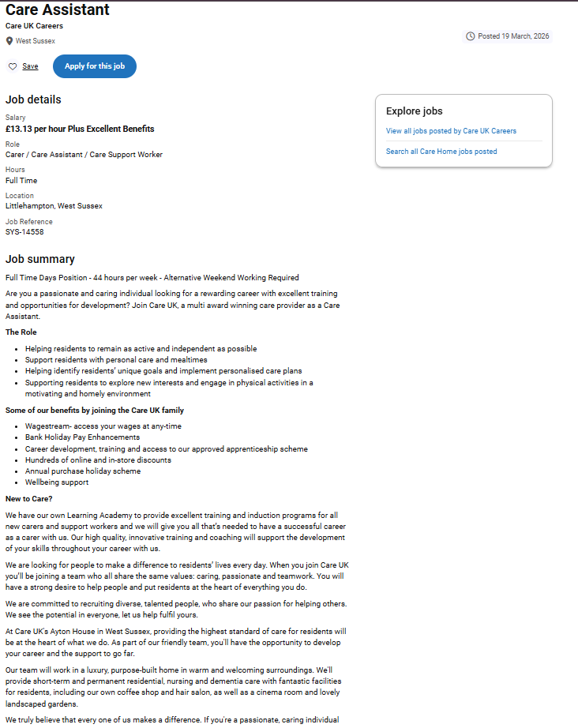
Image 1: Screenshot of Job Advert
Source: Carehome.co.uk. (2025)

Personal Employability Skills Required
A mix of formal study, practical skills in care-giving, and strong values is necessary for the job description of a care worker in the UK, as they are required to assist people with additional needs. According to the UK National Careers Service, care workers assist vulnerable individuals with their day-to-day tasks and aim to help them become as independent as possible (Harrison et al., 2022). They perform tasks such as assisting with personal care, monitoring vital signs, maintaining care records, and reporting concerns to senior staff. The Health and Social Care Level 2 Foundation Apprenticeship or Healthcare Support Worker Level 2 Intermediate Apprenticeship is usually recommended for most aspiring caregivers (Harrison et al., 2022). Employers also ask for an NVQ Level 2 or Level 3 in Health and Social Care, as well as training in safeguarding and medication safety. Employers seek individuals who are sociable, attentive, and respectful (Harrison et al., 2022). They desire employees who are faithful, tolerant, stable, and respect the individuals they work with. Good personal qualities and solid training are required to secure a job in this sector.
Compassion and communication skills are pertinent to the success of a caregiver. Good care giving begins with creating trust with the people one is assisting and communicating effectively with the rest of the team (Pulman & Fenge, 2025). It has been established that trust is created through clear communication and listening (Pulman & Fenge, 2025). It is crucial to speak directly, listen attentively, and use body language. Caring is also important, as nurses and support workers assist sick, disabled, or unhappy people. The NHS 6Cs model states that the primary role in service is care and compassion, demonstrated through empathetic, respectful, and dignified relationships (Hussain, 2023). Communication, dignity, and person-centred support are also sets of other vital skills enumerated on the Skills for Care Core Skills Framework. For example, a support worker working with an aged individual with dementia can comfort them and guide them through every step of each personal care process to help them relax. Therefore, through communication and compassion, practical skills are provided to ensure that care is safe and person-centred.
The second skill is to observe a situation, reason, and take appropriate action if the state of a person changes. Care may occur in unpredictable environments; therefore, workers will need to be vigilant and make quality decisions independently (Pulman & Fenge, 2025). Studies indicate that caregivers need to be alert and observant, as health can deteriorate at any moment, and that small changes can lead to significant consequences (Pulman & Fenge, 2025). Problem-solving and critical thinking skills are also required because employees should evaluate emerging problems and develop fast resolutions (Pulman & Fenge, 2025). These abilities resemble the Kolb Learning Cycle, which explains that people learn best when they are an experienced person who reflects on this experience, thinks, and attempts to use new ideas (Sinha, 2023). For example, when a care worker notices a client who appears confused at a certain moment, they can alert a nurse immediately, as this may indicate infection or dehydration. Through such experiences, care workers become more insightful because they go through them again and reflect on them. This demonstrates that it is not just facts that make one good at one's job, but rather learning every day through lived experiences.
Finally, resilience, adaptability, and proper organisational skills are essential for maintaining high-quality care in challenging settings. The work is usually emotionally strenuous as the care workers assist sick, disabled, or emotionally troubled individuals. Studies indicate that the position is emotional and relationship-oriented, and therefore, employees must cope with the emotional burden (Hussain, 2023). Care professionals, therefore, are not supposed to be emotionally frail and socially secluded. Situation, Task, Action, Result is a model commonly applied in work to explain how individuals solve complex cases (Knabbe et al., 2025). To illustrate, a support worker may state as follows: a client got scared (Situation), the activity was to make the client feel calm (Task), the activity involved using calm words and distractions (Action), and the outcome was that the client felt better (Result). The framework demonstrates adaptability and expertise.
Critical Self-Assessment of My Current Skills Compared to Care Worker Requirements
An essential analysis of my existing competencies against the skills needed to be an employable care worker, based on the UK market, shows that I possess strong underlying qualities and still need to work on certain aspects in a structured manner. To determine my suitability for the position, I used a skills audit and a SWOT analysis and applied reflective learning strategies, including the Gibbs reflective cycle (Ocampo et al., 2023). These instruments enabled me to compare my competencies with those recognised in the health and social care sector. Skills for Care reports that social care workers need communication, dignity, person-centred support, safeguarding awareness, and the capacity to collaborate with others in care settings (Keshavarzi et al., 2022). Although my existing competencies align with some of these competencies, there are still gaps in practice-based clinical training and professional certification.
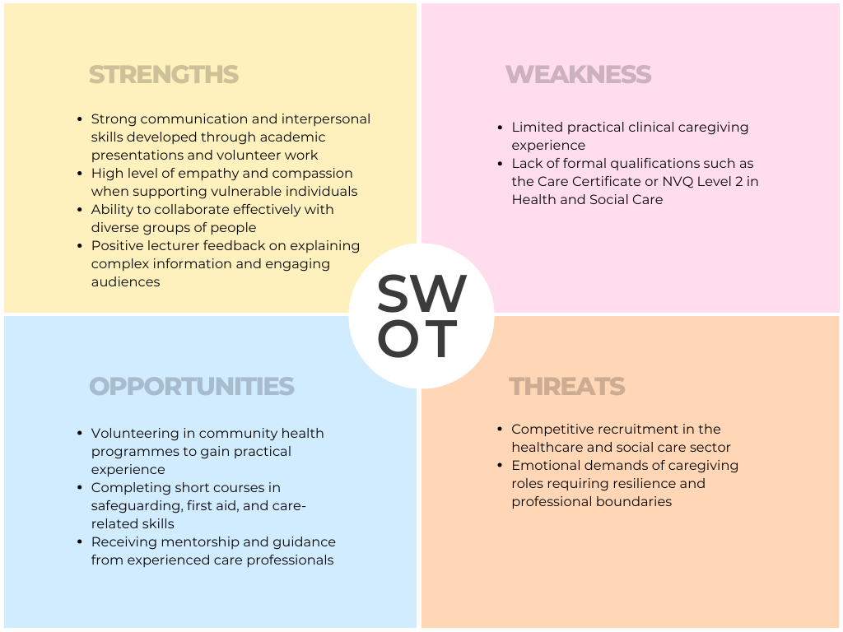
Image 2: SWOT Analysis
A personal SWOT analysis (Image 2) was an organised approach to assessing my employability. I have strong communication skills, empathy, and the ability to collaborate effectively with diverse people. These are skills that have been improved by studying and participating in voluntary activities. In one of the group presentation modules, my lecturer noted my communication skills in explaining complex information, as well as my interaction with the audience. This feedback indicates that my communication skills are highly developed and that being able to communicate with residents, families, and healthcare professionals is a valuable competence. Some of my weaknesses are a lack of practical clinical experience and professional qualifications, such as the Care Certificate or NVQ Level 2 in Health and Social Care, which many employers require. I have had some opportunities; I have volunteered in community health programmes, undertaken short courses in areas pertinent to my career, such as safeguarding and first aid, and received mentorship from senior care providers. Lastly, the threats are competitive healthcare recruitment and emotional caregiving needs, which demand professional limits and strength. By carrying out this analysis, I made a realistic comparison of my current status with the expectations of the profession, whilst also establishing realistic methods to enhance my condition.
Besides the SWOT analysis, I conducted a skills audit, comparing my skills to the competencies identified in health and social care models. This experience demonstrated that I am an excellent interpersonal communicator who requires additional training in technical caregiving activities, such as medication assistance, documentation of care, and protective measures. Research, communication, and groupwork skills have been acquired through my involvement in academic studies. My analytical thinking and presentation skills have been noted by lecturers as useful for communicating patient information and working with multidisciplinary teams. Nonetheless, additional competencies, such as manual handling training, knowledge and awareness of infection control, and care planning, are necessary for practical caregiving roles. These loopholes serve as a reminder that practical experience is important, gained through volunteering and professional training.
The reflective learning process, using the Gibbs Reflective Cycle, also allowed me to assess my readiness for the profession. In one of my voluntary experiences, helping at a local community centre where we carried out weekly activities for older adults, I helped the staff coordinate the social engagement sessions. Description: I assisted in leading out the participants through the group activities and helped one elderly attendee who seemed lost regarding the timetable. Feelings: Firstly, I was not sure of how to react professionally since I had not been trained as a caregiver. Assessment: I was not very worried even though I was unsure of what was going on, but I did listen to the person, and I tried to get the help of a senior volunteer. Analysis: This experience showed that I have empathetic and communicative skills inherent to me, but also showed that I need more professional knowledge of dementia communication strategies. Conclusion: The case supported the significance of personal training in person-centred care. Action Plan: To enhance my competence in such cases, I will undertake short courses in dementia awareness and safeguarding. This approach aligns with professional requirements that healthcare professionals should continually learn through experience.
The Hierarchy of Needs, as developed by Maslow, can also be used to examine my motivation for pursuing a career in caregiving, especially at the self-actualisation level. Maslow suggested that human beings work towards getting personal fulfilment by doing meaningful work and serving people (Yuan et al., 2025). Assistance to vulnerable people is very consistent with such values, since caregiving is based on the desire to enhance the quality of life and dignity. I am not driven only by money, but by purpose. Nevertheless, the Maslow framework also states that people need security and competence (Yuan et al., 2025). Completion of professional qualification and gaining clinical confidence will thus be core milestones in my growth.

Building a Personal Brand and Professional Identity
To stand out in the competitive healthcare and social care job market, one must build a strong personal brand. The three values I am focusing on, which are compassion, reliability, and person-centred care, are the most relevant to my personal brand, and they are also highly aligned with the needs of the Care Assistant role at Care UK. The employment advertisement (Image 1) is oriented to assisting residents to be as active and self-reliant as possible, and to attain their individual objectives and personalised care plans. These principles closely align with my ambition to promote dignity, self-sufficiency, and emotional health for vulnerable adults. My professional identity is based on the idea of building respectful relationships with residents and becoming a caring, close caregiver in turn.

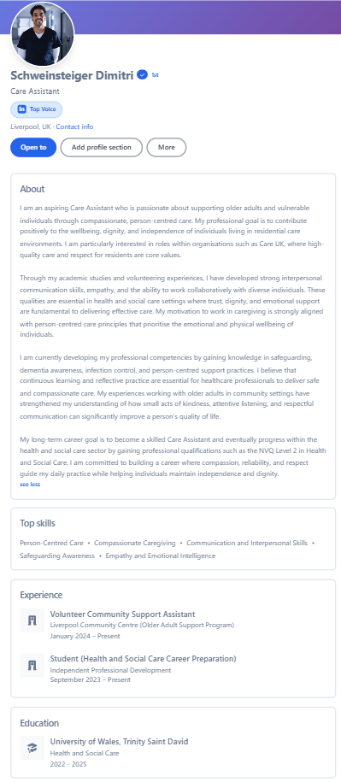
Image: LinkedIn Profile Page for Care Assistant Role
Some of the platforms I will use to sell my professional identity include a professional CV, a LinkedIn profile, and an online portfolio with testimonials of my training and volunteering experience. My LinkedIn profile (Image 3) contains the following in the headline: Care Assistant. Some of the sections that will be included in the profile will be explanations of the relevant volunteering experience, healthcare training courses, and reflective posts that question what one has learnt in caregiving settings. I would also join professional bodies within the former care and dementia support services to increase my professional presence. Social Capital Theory continues to propose that networks and relationships can be a source of knowledge and job opportunities, which, in turn, can perpetuate career opportunities (Wei, 2024). Therefore, being an active member of the Internet community among health and social care professionals will enable me to develop my network and become more marketable.
My unique selling point (USP) is a set of strong interpersonal empathy and reflective learning skills developed through academic training. Even though the majority of entry-level carers are engaged primarily in practical work, I would like to integrate emotional intelligence and reflective practice to improve the quality of care residents receive. This approach is consistent with Holland's Theory of Career Choice, which assumes that an individual is happiest in a job that is congruent with their personality traits (Wei, 2024). My personality fits the Social career type, as defined by Holland, which involves helping, teaching, and supporting people (Wei, 2024). The fact that I will be able to reveal my professional self as a caring and thoughtful practitioner committed to lifelong learning will allow me to form a distinct professional image that is both individual and industry-specific.
Action Plan and Timeline
To achieve a successful career as a Care Assistant, I will need to ensure I have a development plan that addresses my current skills gaps and, in the process, acquires practical experience in the care industry. To make the process easier, I have developed a career development plan based on SMART goals (Specific, Measurable, Achievable, Relevant, and Time-bound). The framework will ensure that all the steps in my progression are possible and that I meet my end-term goal of becoming a professional care assistant in residential care homes. The other theory that will be used in my plan is Bandura's Self-Efficacy Theory, which argues that individuals build confidence through mastery experiences, vicarious learning, and positive feedback (Ouyang et al., 2023). Volunteering, training, and networking will help me enhance my skills in caregiving as I build my confidence for my future.

Career Development Timeline
Timeframe | Goal | Activities | Resources Needed
0–6 months | Gain entry-level care knowledge | Complete online training in safeguarding, dementia awareness, infection control and manual handling | Free NHS or Skills for Care training resources
6–12 months | Gain practical care experience | Volunteer in a local care home or community centre supporting older adults | Local charities, community centres
1–2 years | Obtain formal care qualification | Enrol in NVQ Level 2 in Health and Social Care or complete the Care Certificate | Employer support, apprenticeship scheme
2–3 years | Develop specialist skills | Complete additional training in dementia care, mental health support and person-centred care planning | CPD courses, employer learning academy
3–5 years | Progress within the care sector | Work towards Senior Care Assistant role and consider NVQ Level 3 qualification | Workplace mentorship and training

Table 1: Additional Professional Development Activities
Activity | Description
1 | Attend CPD training workshops related to dementia care and safeguarding.
2 | Build professional networks through LinkedIn groups and care sector forums.
3 | Seek mentorship from experienced carers or supervisors to gain practical advice.
4 | Continue reflective practice using Gibbs’ Reflective Cycle to learn from workplace experiences.
This roadmap will assist me in gradually acquiring the technical and interpersonal skills required to assume the Care Assistant position. Through experience, formal training, and professional networking, I will have the opportunity to advance from entry-level training to higher levels of caregiving responsibility. There is financial support available to obtain these qualifications in the form of NVQ Level 2, which can be acquired through employer apprenticeships or government training schemes promoted by Skills for Care. The other will be mentorship from experienced care staff, who will provide mentoring and learning opportunities.
Conclusion
The report has critically reviewed the employability skills required for the Care Assistant role and compared them with my current skills. As experience has shown, successful care providers should possess a complex of interpersonal competencies, emotional stability, and professional training in areas such as their protection, communication, and person-centred treatment. As my self-assessment shows, I already have high empathy, strong communication, and a willingness to assist vulnerable individuals. However, I still have certain areas to work on, specifically practising caregiving and obtaining a professional qualification in health and social care. The action plan identified in this report offers a systematic way to close these skills gaps. By bringing together competencies that will help make the practice effective, I will progressively develop them through volunteering, professional training, networking, and reflective learning. SMART goal planning and Bandura's self-efficacy theory will be used to ensure that my development plan is realistic and contributes to the continuous development of my profession. In the end, the process has made me more knowledgeable about the career profession and defined the steps to be undertaken to actualise my professional objectives. This has helped me realise that I want to help vulnerable adults, and it has made me want to pursue a satisfying career in health and social care.

References
Carehome.co.uk. (2025, July 25). Care assistant – Ayton House, Littlehampton, West Sussex. https://www.carehome.co.uk/jobs/job.cfm/id/96009038222
Hussain, M. (2023). A review of the implementation of employability interventions through employers to increase entrants into adult social care in Scotland.
Harrison, N., Baker, Z., & Stevenson, J. (2022). Employment and further study outcomes for care-experienced graduates in the UK. Higher Education, 83(2), 357-378.
Knabbe, A., Leiss, D., & Ehmke, T. (2025). Reality-based tasks with complex-situations: Identifying sociodemographic and cognitive factors for solution. International Journal of Science and Mathematics Education, 23(1), 97-120.
Keshavarzi, M. H., Azandehi, S. K., Koohestani, H. R., Baradaran, H. R., Hayat, A. A., & Ghorbani, A. A. (2022). Exploration the role of a clinical supervisor to improve the professional skills of medical students: a content analysis study. BMC Medical Education, 22(1), 399.
Ocampo, F. A., McIntyre, B. G., Massey, D., & Saunders, R. (2025). Nursing student reflections on a research internship: A reflective discussion following the Gibbs' reflective cycle. Nurse education today, 145, 106481.
Ouyang, R. G., Long, Y., Zhang, J. Q., & Cao, Z. (2023). Interventions for improving self-efficacy in patients after stroke based on self-efficacy-related principles of Bandura’s cognition theory: a systematic review and meta-analysis. Topics in stroke rehabilitation, 30(8), 820-832.
Pulman, A., & Fenge, L. A. (2025). Caring and working: developing insights into the world of the working carer. Health & Social Care in the Community, 2025(1), 5541190.
Sinha, E. (2023). ‘Co-creating’experiential learning in the metaverse-extending the Kolb's learning cycle and identifying potential challenges. The International Journal of Management Education, 21(3), 100875.
Wei, R. (2024). Examining the influence of the RIASEC theory within the Holland code on students’ academic performance in their chosen disciplines among the context of higher education. Cogent Education, 11(1), 2391274.
Yuan, R., Luo, C., Liu, Q., Li, X., & He, Y. (2025). Exploring the needs of older adults for social assistive robots: A qualitative analysis based on Maslow's hierarchy of needs. Geriatric Nursing, 66, 103616.

