Name - Shanika hutchinson
ID number - 2619795

Screenshot/Photo 1
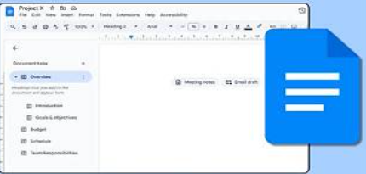
Google docs
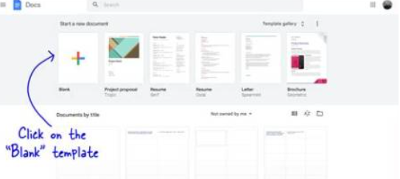


- I use google docs to write assignments and take notes google docs saves automatically so i dont lose work.
- I can share my documents with other people easily
- My favourite thing about google docs is that I can add comments so that myself or anyone knows what to fix or change.
- I access googledocs from either an appstore or Google search.

Screenshot/Photo 2
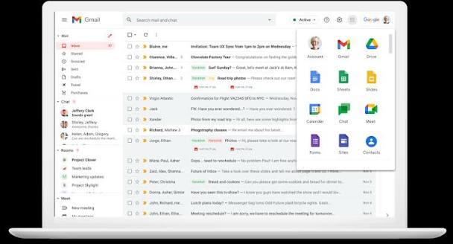
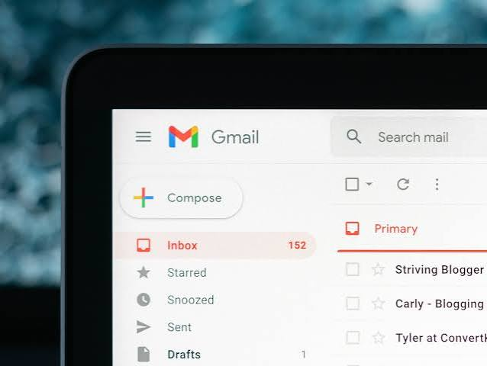
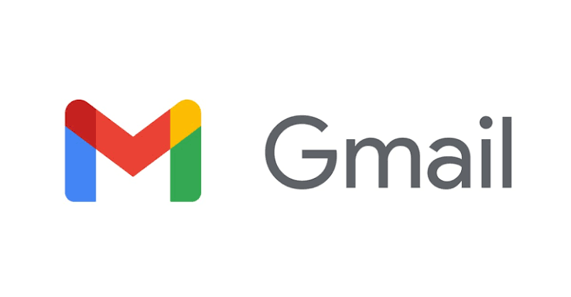
Gmail

- I use Gmail to send and receive university and work emails.
- Gmail helps me keep important messages organised in one place.
- I can search for old emails completely when I need information.
- My favourite thing about gmail is that I can tap on the star symbols to make it easy to find when I need it.

Screenshot/Photo 3

Lucid spark - Mind map
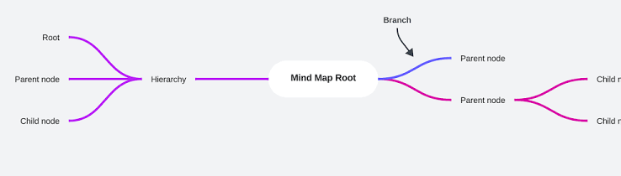
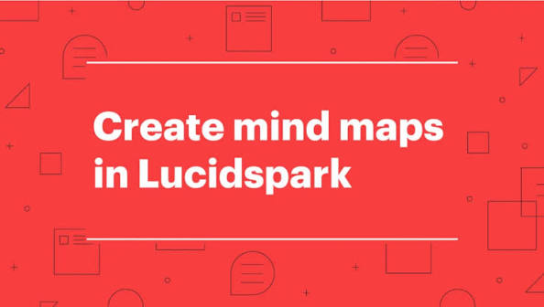

- I use lucid mind maps to organise my ideas, it helps me to plan information and understand information.
- I love that I can create my maps with different shapes, colours and lines because it makes my ideas clear.
- I use mind map to break big topics into smaller parts which makes studying less stressful
- I access lucid mind maps online by searching lucid spark on google.

Screenshot/Photo 4
Canva
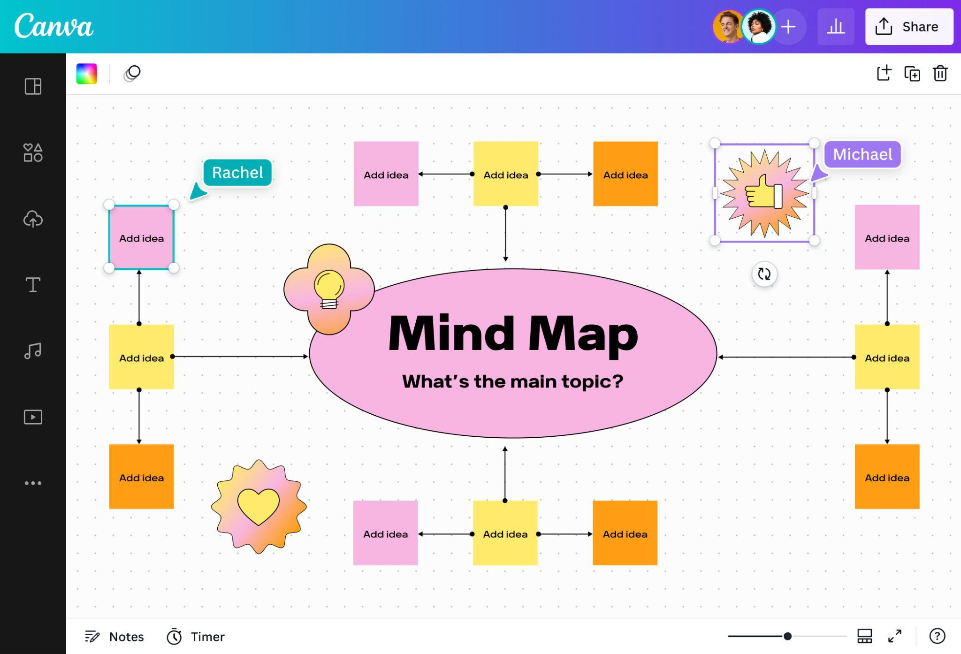
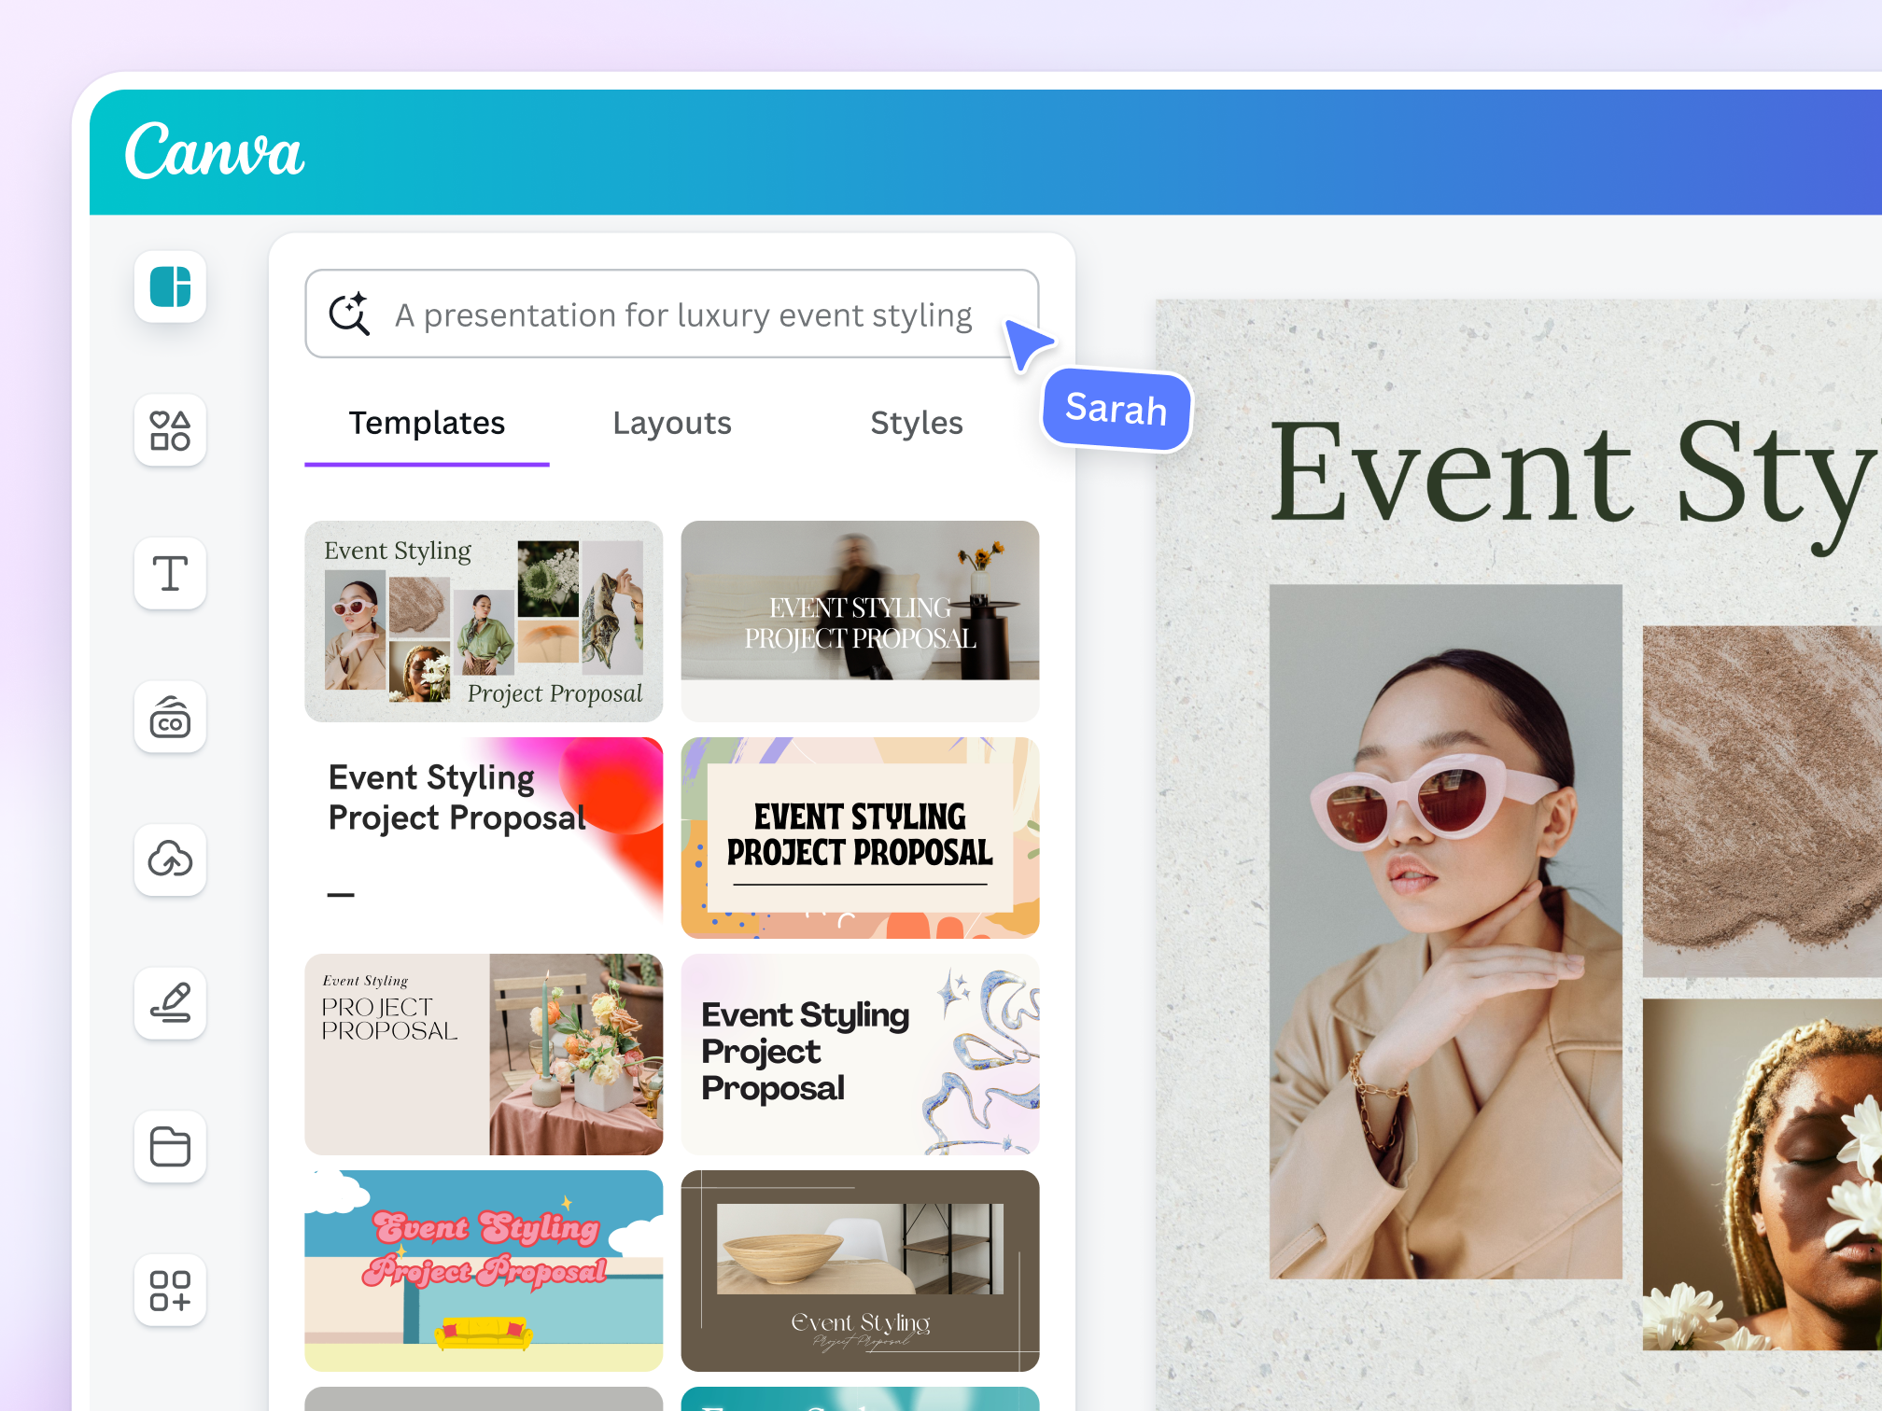
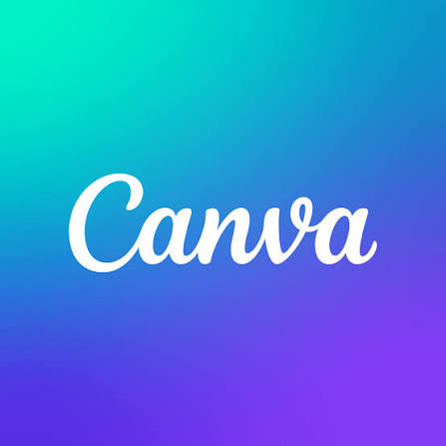
- I use canva to create posters and presentations for class.
- My favourite thing is that canva has templates that make my work look good.
- I can download designs to upload anywhere I want or use it as assignments.
- I can access canva through the app store or by searching on google.

Screenshot/Photo 5
LinkedIn
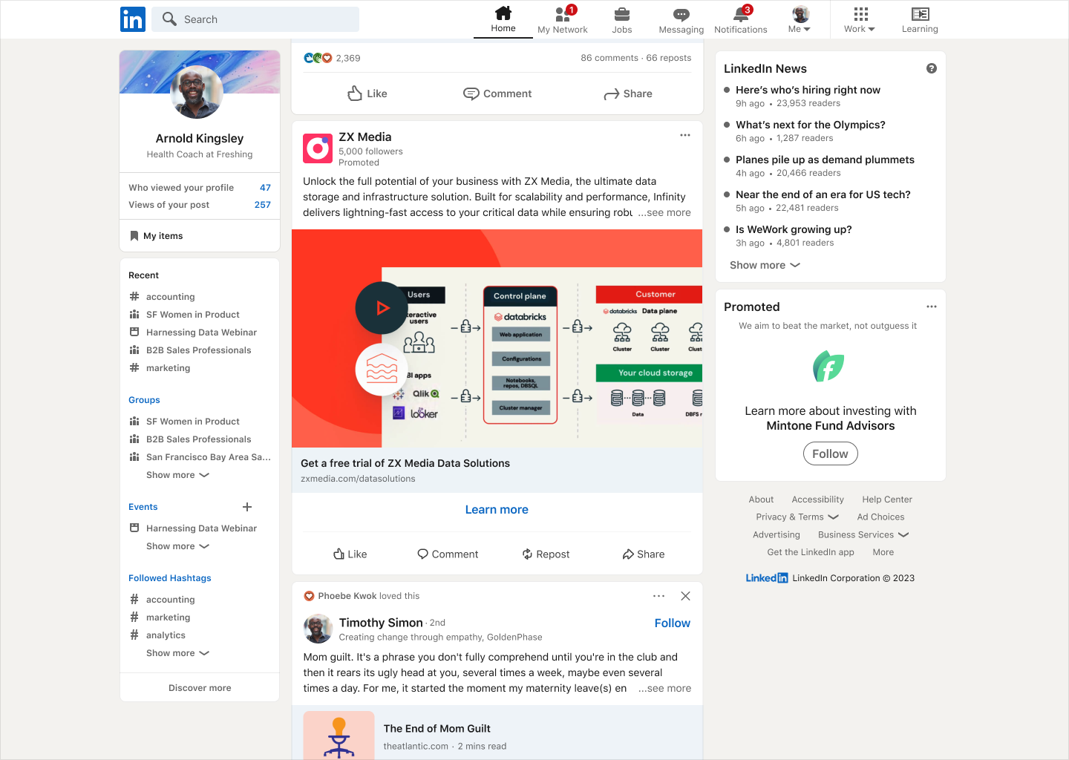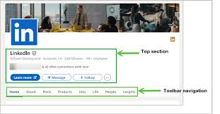
- LinkedIn is a professional social media software platform
- I use linked in to connect with professionals and which helps me learn about different careers.
- My favourite feature is finding job opportunities and building my professional network.
- I can access LinkedIn through the App Store or web browser.

My Short Reflection

.
- I use digital tools to communicate with friends and family and complete my university assignments.

- I feel absolutely confident when I use my mobile phone to send messages and search for information that I need.

- I really want to improve my skills in using different software to help my performance in my everyday life.

- I usually use these tools such as Google docs,Canva, linked in on my phone daily.

- Digital skills are important for me because they will help me with my university studies and future careers,

