bibliography

Part 1: Introduces the origin of Behemoths.

Part 2: Research Legends and The Behemoths of Video Games. And analyze how the design style of these monsters has changed with the development of technology.
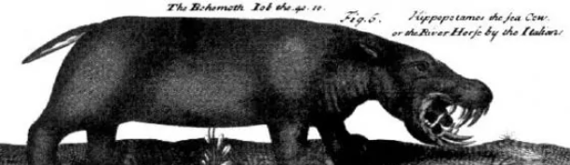
This is the Biblical Behemoths
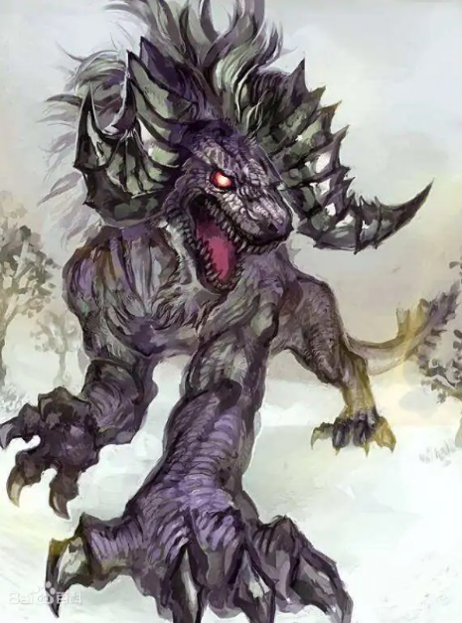
This is Behemoth in the final fantasy of video games

Part 3: Research
Research monsters in various legends and games (myths: Chinese myths, Nordic myths, Greek myths, Bibles) (games: Final Fantasy, Monster Hunter, World of Warcraft). Analysis of the appearance characteristics of monsters in those works, in the design of reference to those animals on earth. and what the animal characteristics used mean.

Part 4: I will combine some character design theories with reference to biology, anatomy, sculptors and related literature. Design a Behemoth on my own.

Part 5：Defining a proposal plan

