SGDM5024
Individual Project
Long Test Track Tow Bar.
T Platt
4-2-2020

Summary.
A new tow bar design was needed for use with the Long Test Track (LTT) facility at MOD Pendine, South Wales. IT was to meet the following requirements:
- Be long enough to reach across the rail section, removing angular forces from the towed load.
- Be capable of shifting a load of approx. 1500kg with a minimum safety factor of 3.
- Collapse by some method to within the wheel base of the tractor; allowing for safe storage and transport.
- Consider the physical use aspect i.e. weight of folding parts with respect to manual handling.
Two designs were considered and compared to the tow bar currently in use on site with one being selected for continuation and completion. Unfortunately, at the time of writing this report now physical production has taken place due to difficulties with material suppliers. Drawings and models have been supplied to the Engineering and Design offices on site so that in the future a working assembly can be produced.

Acknowledgements.

For their assistance with this project, the author would like to thank the following people and teams:
- Darren Sheppard and the Pendine Engineering Workshops Team for their patience, assistance and ideas.
- Lewis Roberts and the Pendine Design Office Team for the use of their workspace, their ideas and knowledge.
- John Williams, Chris Davies and the staff at the college for their assistance, patience and support over the last two years.

Contents
Summary. i
Acknowledgements. ii
Introduction. 1
Literature Review & Background Research. 3
Specification and Testing Plan 6
Product Design Specification (PDS). 6
Testing Plan 9
Project Planning (Gantt/Timing). 11
Gantt Chart Week 1 12
Gantt Chart Week 16 13
Gantt Chart Week 30 14
Solutions. 15
Current Tow Bar 15
Design 1 15
Design 2 16
Design and Implementation. 18
Analysis, Results and Evaluation. 21
Finite Element Analysis (FEA). 23
Conclusion. 26
Recommendations. 27
Bibliography 29
Appendices. 30

Figure 1: Original LTT tow bar. 1
Figure 2: Corrosion on Tow Bar. 2
Figure 3: Section of the Test Track. (Variblast, 2017) 3
Figure 4: Original Tow Bar Model. 4
Figure 5: Original Tow Bar (from above). 4
Figure 6: Gantry Push Trolley (Safety Lifting Gear, 2020). 5
Figure 7: Gantt Week 1. 12
Figure 8: Gantt Week 16. 13
Figure 9: Gantt Week 30 14
Figure 10: Design 1 Open & Folded. 15
Figure 11: Design 2 stored & extended. 16
Figure 12: Design 1. 18
Figure 13: Centre Hinge (left) & Arm Hinge (Right). 19
Figure 14: Arm Support Plate(blue), both positions. 20
Figure 15:Criteria Analysis. 21
Figure 16: FEA Constraints. 23
Figure 17: FEA Stress Indication 24
Figure 18: Displacement Maximum 24
Figure 19: Safety Factor Minimum. 25
Figure 20: Stress concentrations and circular holes (fracturemechanics.org, n.d.) 27

Table 1: Requirements and Solutions. 18
Table 2: Calculated results. 22
Table 3: S355 data (Mead Info, 2015). 23
Table 4: Initial Requirement and design solution. 26

Introduction.

QinetiQ is a defence and aerospace engineering firm which provides test and evaluation facilities for a variety of UK national and international military and civil platforms, systems, weapons and components on land, at sea and in the air including amongst others NATO, UK MOD, ESA and BAE. MOD Pendine is home to the NATO Small Arms and Ammunition Testing Centre as well as the Long Test Track (LTT) facility where larger (weighing approx. 1500kg) items can be tested. The aim of this project is to provide an updated, purpose-built tow bar to be used in conjunction with the LTT.
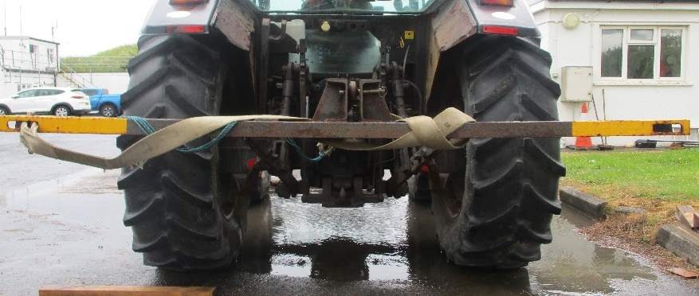
Figure 1: Original LTT tow bar.
The previous model (fig 1); while having a long life (approx. 20 years) has been hampered by not having enough reach (the towed object is located over 2m and 90º out from the centre line of the tow vehicle) and so introduces angular forces to the towed object; resulting in excessive wear to the towing bogy and several instances of jamming of the test piece on the rails. Environmental conditions and lack of maintenance have resulted in considerable corrosion to the tow bar and a general deterioration of the overall condition, an example is seen in fig 2. The level of importance attached to the tow bar is relatively high, the financial value of the projects undertaken at the LTT facility is substantial (several million pounds per year), with many projects run back to back.
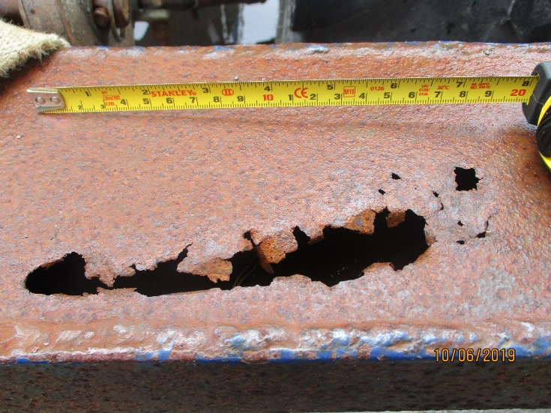
Figure 2: Corrosion on Tow Bar.
Without a functional tow bar to position the test piece, projects become more complicated; or impossible. This project is supervised by the LTT Trials Officer, Engineering Workshops Manager and Design Office Team Leader who are available for advice, consultation and final decisions while the research, design and implementation of the project are the authors responsibility. This is a unique piece, with no anticipated market value in itself and while no time limit has been imposed, it would be beneficial to have a working design in place as soon as feasibly possible. Budgetary requirements will be decided when the design has been costed for from potential suppliers, while not unlimited it is not a primary concern.

Literature Review & Background Research.

Conducting a review of this type of construction was complicated by the fact the most towing operations are not attempted with the towed object offset 90◦ and several meters from the centre line of the towing vehicle as for most ordinary operations the distribution of mass would be inappropriate. This introduces stress into both the towing rig, the tracks and any towed items. As can be seen from figure 3, the raised nature of the track prevents conventional towing.
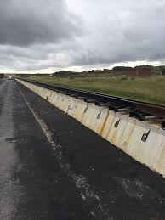
Figure 3: Section of the Test Track. (Variblast, 2017)
The white line seen on the ground in figure 3 is the guide line used by the tractor driver to keep the vehicle as straight as possible while pulling the load. Figures 4 and 5 are a CAD model created for comparison purposes by the author, showing the approximate direction of loading experienced by the current bar, indicated by the yellow arrow.
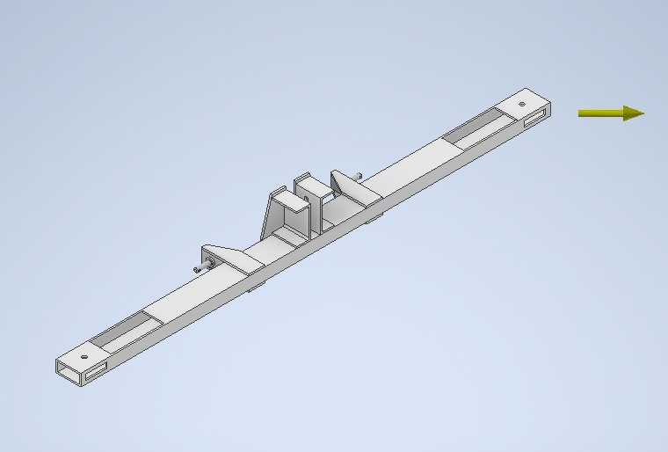
Figure 4: Original Tow Bar Model.
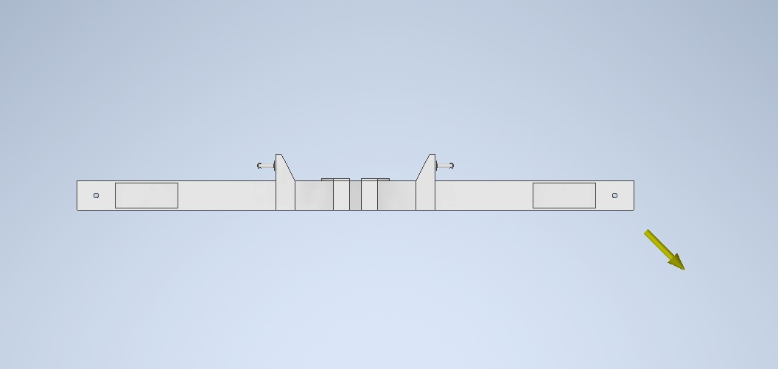
Figure 5: Original Tow Bar (from above).
The use of a tractor to tow the item means that the required torque is not an issue, the vehicle provides far more power then would normally be required to move the towed objects, under normal conditions a conventional tow truck would be able to move the test piece (George, 2008). The test pieces setting on a rail track also meant that steering is not requirement, and can be detrimental. All conventional towing units are designed to allow steering while the requirements here mean that any angular movement of the tractor should not be transmitted to the towing bogey and object.
A study of agricultural equipment shows a wide variety of equipment mounted on a three-point hitch system, many of which fold in some way to a more compact size for movement and storage however none are suitable for towing and so would meet the design requirement as an ‘off the shelf’ item. Additionally, it was found that the method of load movement in a gantry crane would potentially be suitable for use after some modification, with the use of a gantry beam trolley (image 6)
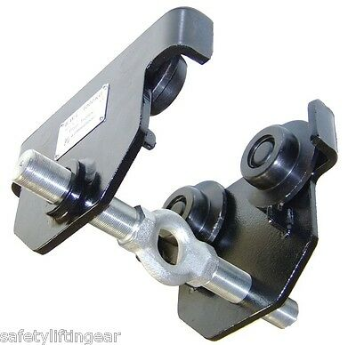
Figure 6: Gantry Push Trolley (Safety Lifting Gear, 2020).
Load spreaders and forklift crane jibs were also considered but these devices would not be able to fold to within the wheel base of the tractor and be used on each side without large scale redesigning.

Specification and Testing Plan
This could also be referred to as an engineering requirement document, (giving more detail than a product requirement specification) helping the engineer or team of engineers decide appropriate courses of action during the design process, expanding on the initial product proposal.

Product Design Specification (PDS).
Performance:
- Pull a mass of approx. 1500kgs with a safety factor of 3.
- A trolley or some other method should be employed so that any angular movement of the tractor is not transferred to the towed object.
- The device should fold or collapse to be stored for transport within the wheel base of the tractor.
Environment:
- The coating and materials should be resistant to European weather conditions and due to the proximity to the sea, salt corrosion and sand abrasion should be considered.
- Temperature ranges: -10˚C - +30˚C.
Product Life Span:
- It can be assumed the tow bar assembly will be in use for at least 5 years.
- Annual maintenance will be conducted with replacement parts fabricated as required.
Life in Service:
- It should be able to tow the load for 1km in each direction 3 times a week for the duration of use.
- Life in service should be assessed against regular inspection to maintain serviceability and safe use.
Target Costs:
- No budget has been set as there is no precedent, costs will be assessed on presentation of the completed design.
Quantity:
- One full assembly initially with the possible manufacture of replacement parts in the future.
Maintenance:
- To be subjected to regular maintenance including pre-use inspection, greasing of moving parts, condition of coating and condition of all load bearing parts.
- Parts requiring lubrication should be accessible within 1 minute without the use of special tools or equipment.
- Spares if required will be ordered or manufactured locally.
- No special tools are required for maintenance.
Size and Weight:
- No weight limit is set although it should be kept as low as practical.
- Extended length should be able to overreach the tracks allowing for centralisation of the towing forces.
- Collapsed length should not exceed the tractor wheel base (2280mm).
- Width not restricted but should be kept to a minimum.
- Height not restricted but maximum possible clearance between the track and bar arm should be maintained when extended.

Manufacturing Processes:
- Manufacturing can be carried out on site by Engineering Workshops, however depending on cost components could be fabricated by specialist workshops.
Aesthetics:
- The form should follow function, there is no aesthetic requirement.
Ergonomics:
- The assembly should function as simply as possible, with consideration for health and safety and manual handling requirements.
- Two people may be required to manually operate the assembly, however if hydraulically assisted then one man should be able to operate the system.
Quality and Reliability:
- Design and materials should be such that when properly maintained and used with the specification a life of a minimum of 5 years should be possible.
- The assembly should not fail before the straps attaching the load.
- If used, the travel trolley should fail before main assembly but after any straps/shearing bolts.
Standards:
- BS 6105 and BSEN 20898(7) Bolts
- BS 6322(2) & BS 4320 Nuts and washers
- BS EN ISO 15614-1
- BS 7664 Painting
Safety:
- Pinch points and trapping areas should be highlighted and if possible covered.
- Weight of parts should be considered for the purposes of manual handling.
Installation:
- It should be possible for one person to attach or remove the assembly from the three-point hitch on the rear of the tractor.
Documentation:
- Manufacturing drawings will be supplied to the Design Office and Workshops.
- A through Life Support Strategy (TLSS) should be put in place and made available to all users by the relevant engineering manager.
Disposal:
- Unserviceable metal parts should be inspected for cause of failure and then separated for recycling or scrap disposal.

Testing Plan
The testing plan would consist of the following:
- CAD modelling used to create a 3D functional model of the proposed tow bar.
- Finite Element Analysis (FEA) would be used in a limited fashion, to show if simulations agreed on where the highest points of stress would be located.
- Manual calculations to predict load conditions such as deflection, moment and stresses/strains.
- Physical testing to be performed on the completed system. Consisting of towing a load of 1500 kgs. Success would be determined by the movement of the load down the tract without failure of any part.
It was determined that standards such as the Lifting Operations and Lifting Equipment Regulations 1998 (LOLER) do not apply as no lifting is performed. While no towing regulations such as EU Regulation 167/2013 (on Type Approval of Agricultural Vehicles) could be found to directly apply it would be prudent to design a testing phase as found in Celik et al’s Design and Structural Optimisation of a Tractor Mounted Telescopic Boom Crane which includes data aquasition from strain gauges and load cells as well as more comlex FEA analysis so that safe use parameters could be determined.

Project Planning (Gantt/Timing).

Below are the project Gantt charts for weeks 1, 16 and 30 corresponding to the start, midpoint and end of the project. The full series of completed Gantt Charts can be found in Appendix 2. It can be seen that there were a number of delays throughout the project;
Weeks 3-5:
- CAD Modelling Design 2 – the start of the 2nd design was delayed; efforts were concentrated on creating a CAD model of the current tow bar and the 1st replacement design. Some time was also lost using the CREO programme currently employed in the design office.
Week 11:
- 2nd Design Discussion – it was intended that a discussion of the designs complete to that date would be carried out with the design office and engineering workshops however due to lack of availability this discussion was delayed and very brief although enough to allow modifications to be made during the allotted period.
Weeks 19-20:
- Materials Cost Estimation – it was not possible to acquire a materials cost estimation. Due to invoicing delays no costings would be supplied the usual suppliers.
Weeks 22-24:
- Production & Testing – to date nothing has been physically produced so cannot be tested.

Gantt Chart Week 1
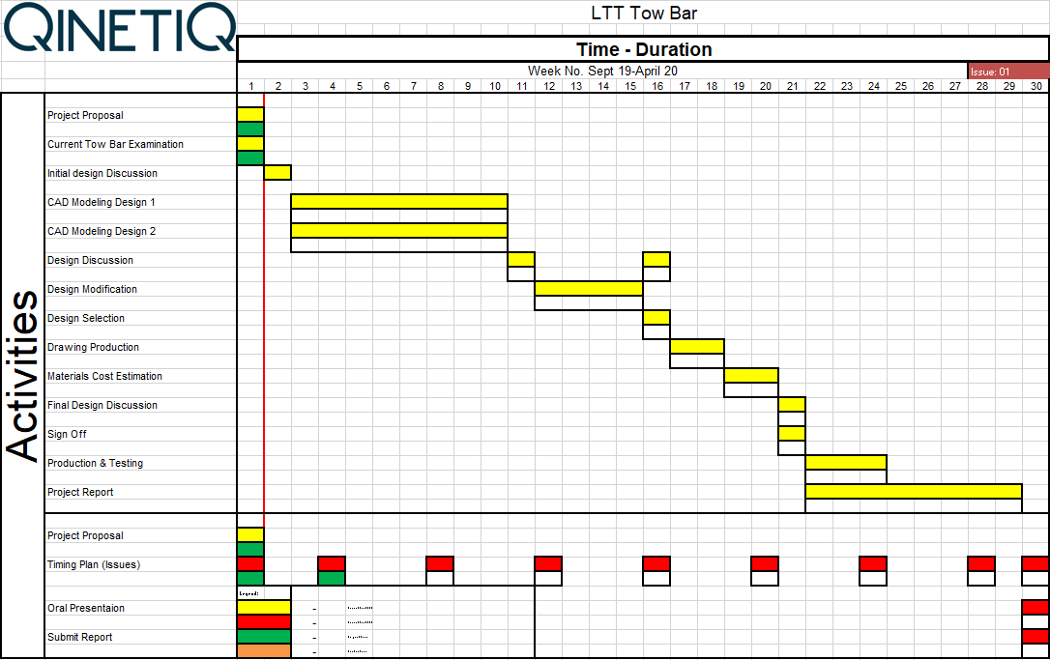
Figure 7: Gantt Week 1.

Gantt Chart Week 16
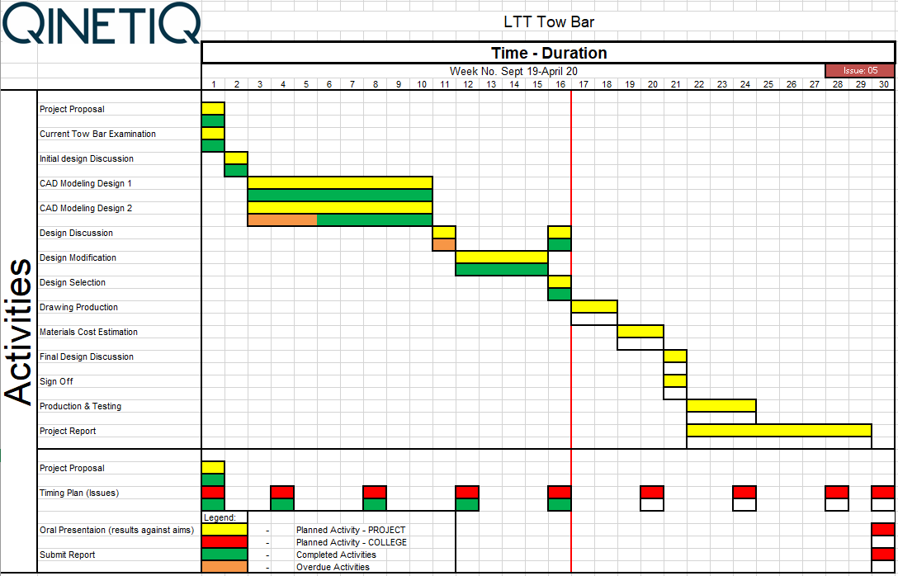
Figure 8: Gantt Week 16.

Gantt Chart Week 30
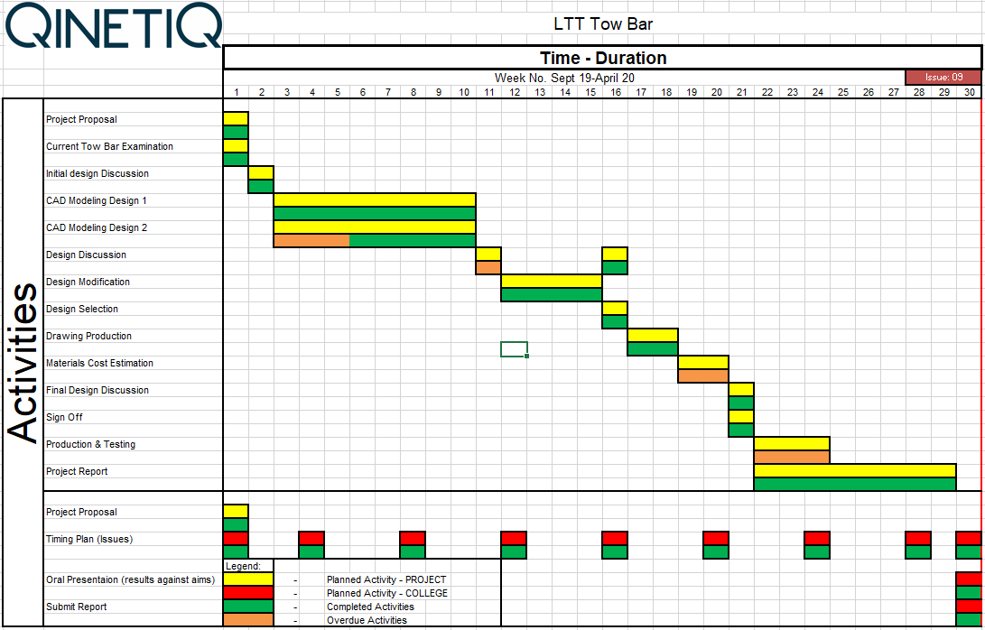
Figure 9: Gantt Week 30

Solutions.
Two solutions were designed which would meet the criteria from the PDS. These have been compared to the original tow bar they are designed to replace and a final design was chosen on consultation with the engineering workshops and design office.

Current Tow Bar
The tow bar can be viewed in figs 1, 4 and 5. It’s long life, simple construction, ease of use and in general good reliability have been hampered by the following points:
- Length: the tow bar is not long enough to reach over the track, resulting in angular forces being imparted to the load during towing.
- Condition: no maintenance or restoration work has been conducted during the tow bars working life time resulting in a deteriorating physical condition i.e. figure 2.
- Documentation: no drawings or technical documentation of any kind exists for the tow bar.

Design 1
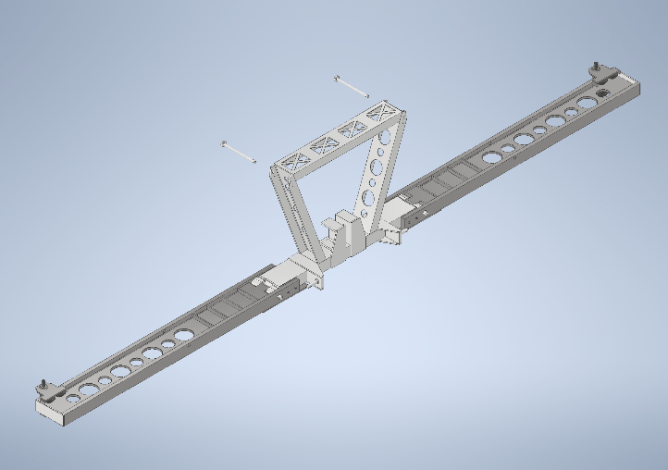 | 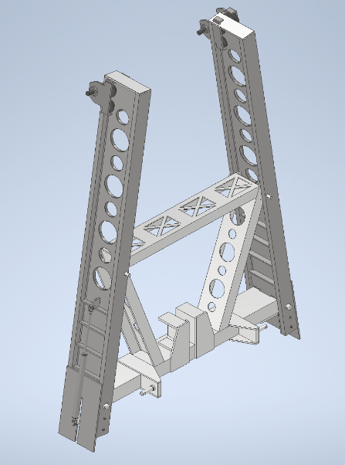
Figure 10: Design 1 Open & Folded.
This design has a central section based on the original tow bar, using thicker sections of a higher-grade steel it will be able to be mounted onto the three-point hitch at the rear of the tractor in the same manner. The arms fold at a hinge point within the wheel base of the tractor allowing for ease of movement and storage. Gas pistons are attached on the underside of the arms, anchored to the central section, to assist with folding. Gantry push trolleys are used to facilitate towing. In the upright position as can be seen in figure 10, the arms are braced against upright sections and held in place by securing pins.

Design 2
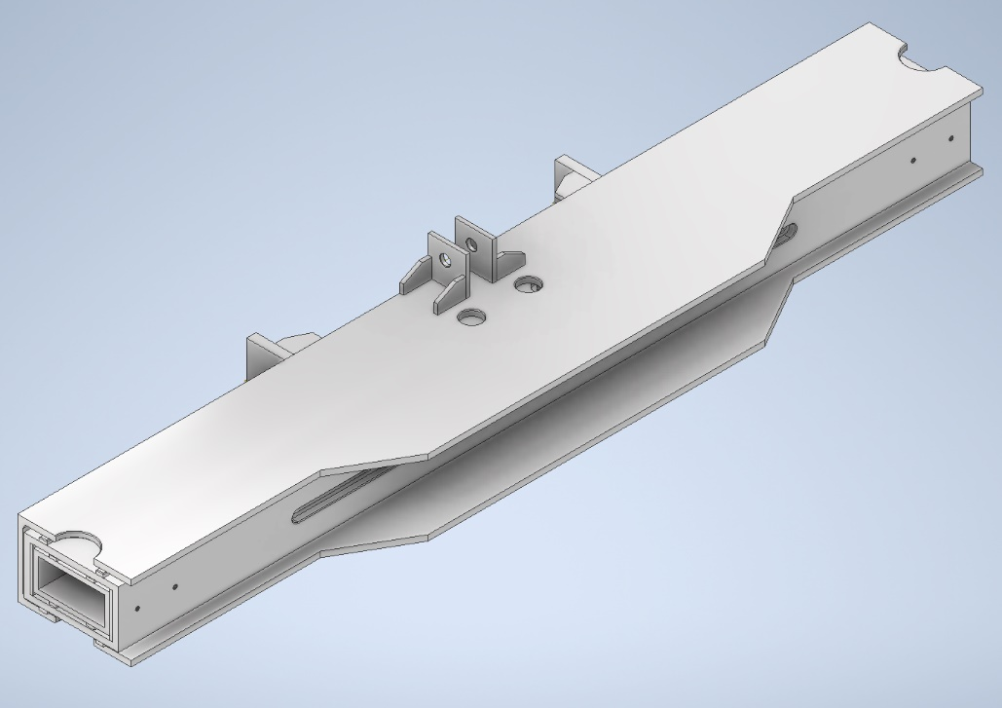

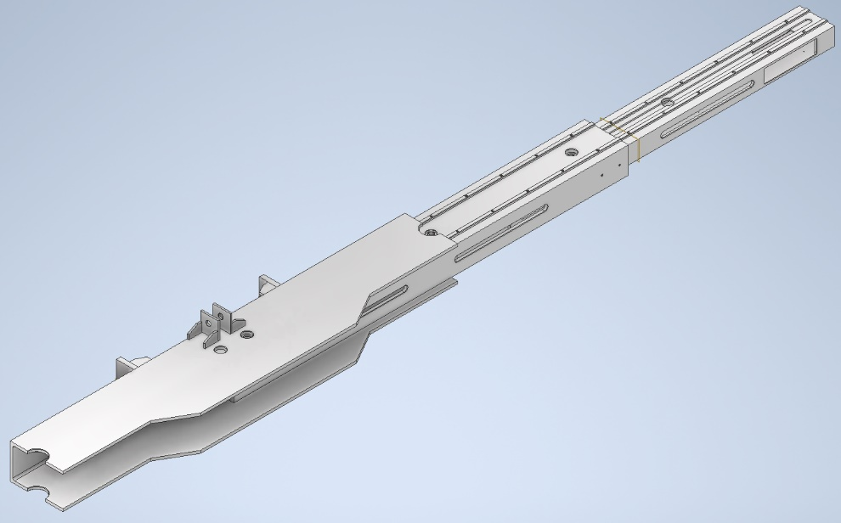

Figure 11: Design 2 stored & extended.
Design 2 was based on an extending tow arm. Here a number of telescoping sections would be used to create the desired reach, with runners and pins facilitating motion and locking in both directions. It would attach to the same three-point hitch as the other tow bar designs. A difficulty encountered with this design was how motion could be assisted by hydraulic or powered units to reduce the need for manual handling. Additionally, gantry trolleys could not be used so another method of facilitating towing would need to be found.

Design and Implementation.

After a discussion with the workshop’s manager, design office team lead and long test track engineering manager, it was decided that design 1, figure 12, would be selected for completion and possible manufacture.
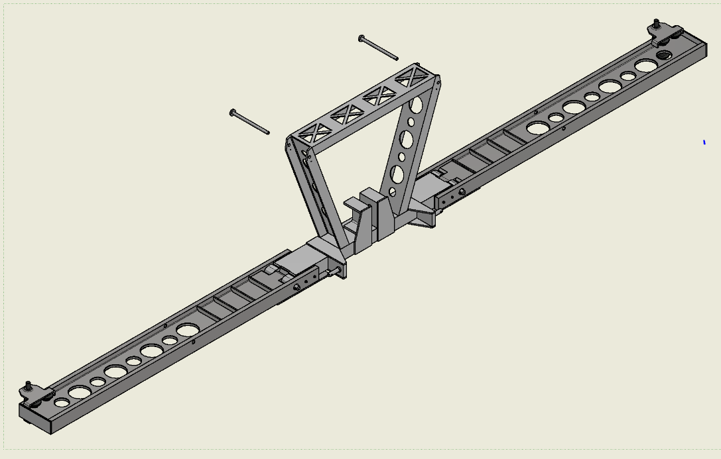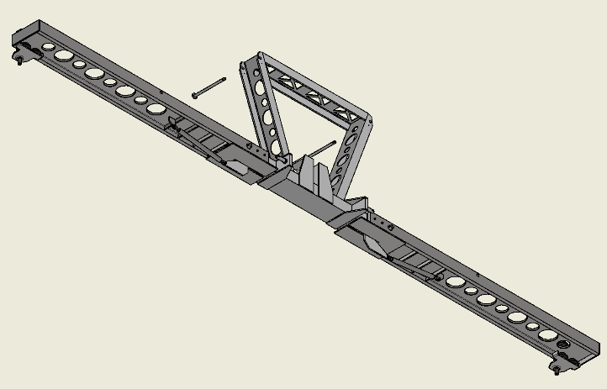
Figure 12: Design 1.
Design 1 has been created in accordance with the initial project proposal (appendix 1), summarised in the table 1.
Requirement | Solution
Full Extension to reach over the rail track. Approx. 2.5m | When extended its overall length will over reach the test tracks rails and a gantry push trolley is used to connect to the load. It collapses by hinges to be within the wheel base of the tractor.
Withstand a load of 1500kg | It has been designed to be strong enough to withstand applied forces.
Fold for storage/transportation to within 2280mm | When folded the design is approx. 1724.07mm at its widest point.
Consider manual handling requirements. | Gas pistons are used to support safe extension and assist in folding the arms for storage. Where possible sections have been cut from the arms and upright support brace to reduce the weight of the overall assembly.
Table 1: Requirements and Solutions.
Due to thicker sections of higher-grade steel (S355) it will in effect be stronger than the original. The hinge is 757.5mm from the midpoint of the tow bar so falls well within the tractors wheel base (1140mm from centre). The materials used are mainly prefabricated structural steels available from any supplier, including universal columns, prefabricated channels, hollow rectangular sections, steel plate (max 10mm thick to allow use of the sites guillotine) and round stock (all pins can be manufactured from one bar of round stock). The only part that may be outsourced for manufacture would be the hinge parts, seen in figure 13, this is due to the dimensions and geometries required.
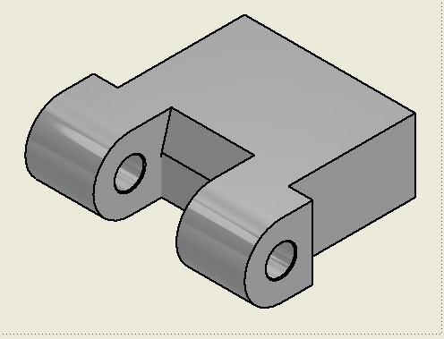 | 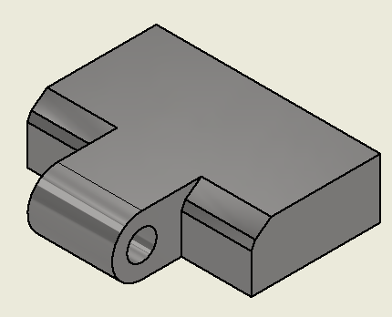
Figure 13: Centre Hinge (left) & Arm Hinge (Right).
All components would be manufactured from a steel of minimum grade S355, a high strength structural steel recommended by the design office team lead for its qualities including its high yield strength (approx.355MN/m²), high tensile strength (UTS, approx. 450MN or greater) and good machining qualities (Mead Info, 2015).
To accommodate safety concerns regarding pinch points the support plate for the arms has been attached to the base of the arms instead of the body, this means that the plates will move with the arms instead of being stationary and reducing the chance that someone will trap anything there, thinking it might be used as a shelf (fig 14)
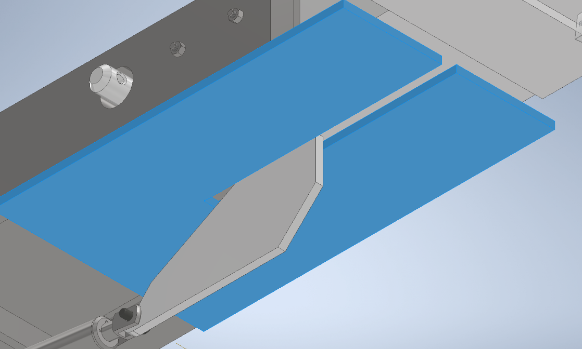 | 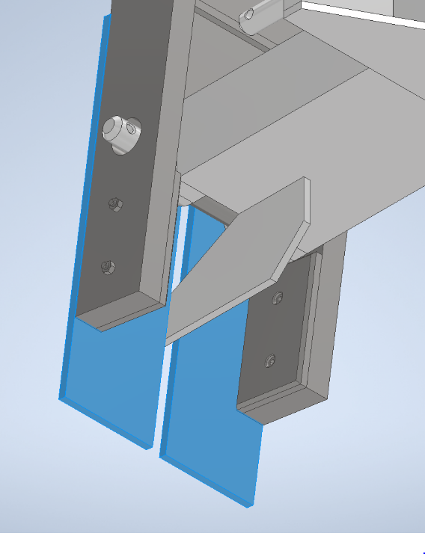
Figure 14: Arm Support Plate(blue), both positions.
Additionally, all moving parts would be painted in warning colours with appropriate warning signage regarding weight and possibility of injury. Gas pistons have also been employed to assist with raising the arms and to act as a brake on extension.

Analysis, Results and Evaluation.

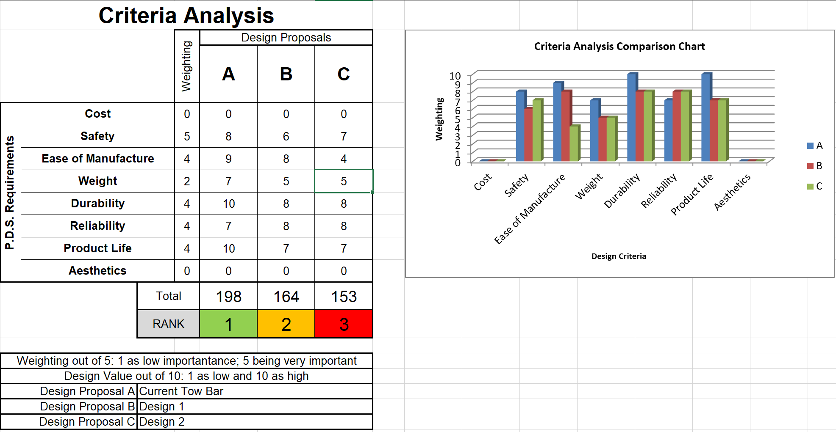Figure 15:Criteria Analysis.
A criteria analysis matrix was used to help compare the proposed designs to the current model as well as the second system which was not selected. As can be seen from figure 15 in the analysis matrix, the cost and aesthetics have both been scored at 0, as no budget was set, the current tow bar was manufactured from available materials and no prices could be obtained from suppliers. Additionally, aesthetics was deemed unimportant. The values for the new designs have been taken from considerations on how they might perform and ease of manufacture. While the current model has scored higher than the two proposed designs it is likely that either or both of the designs would overtake the current design once commissioned.
Design 1 would be considerably easier to manufacture, being largely prefabricated sections that could be bought as stock material. It does however score lower on safety concerns. This is because the arms must be lowered or raised creating possible pinch points, manual handling issues and a possible danger from falling objects should the users lose control of the arm during raising/lowering. An additional benefit of design 1 is the use of gantry trolleys which will accommodate any movement of the tractor, reducing angular forces and the gas pistons fitted could easily be replaced with hydraulic units operated from the tractor, reducing the need for manual handling.
Manual calculations were carried out on for this design, assuming that: due to the fixed central portion the assembly would function like a cantilever with the fixed point at either the centre of the entire assembly or at the hinge point (X_{C}= Centre point; X_{H}= Hinge point), an applied load of 1500kg and a cross sectional area consistent with the universal column used to manufacture the arm sections. These were then compared to results calculated using a spread sheet system supplied by the engineering office seen in figure (the full programme is appendix 5); producing the following results (full manual calculations can be found in appendix 3):
 | Manual | Engineering Spreadsheet
Force: | 14715N | 14715N
$$M_{C}$$ | $$44108.2N$$ | 47797.69
$$M_{H}$$ | $$32961.6N$$ | 35021.96
$$σ_{C}$$ | $$4.157MN/m^{2}$$ | 55.8MN/m²
$$σ_{H}$$ | $$3.107MN/m^{2}$$ | 40.9MN/m²
Deflection from Centre: | $$15.38mm$$ | 16.5mm
Deflection from Hinge: | $$6.42mm$$ | 5.05mm
Hinge Shearing Force | $$10.4×10^{6}$$
Table 2: Calculated results.
While there is variation between the results, the main aberration is seen in the calculated stresses with the spreadsheet calculation being ten times higher. This has been found to be caused be the method of calculating the second moment of area or moment of inertia (I) value this was discussed with the engineering team and although the difference is significant, when using the standard characteristics of S355 steel (Mead Info, 2015) below; the structure will theoretically be able to withstand the load.
Yield Strength | 355 MN/m²
Tensile Strength | 410 MN/m²
Youngs Modulus | 210 GPa
Table 3: S355 data (Mead Info, 2015).

Finite Element Analysis (FEA).
The bending moment diagram in appendix 3 shows it to be located at the centre or hinge point depending on the assumptions used, after discussion with the design and engineering offices it was assumed the centre point as fixed and the hinge point as the most likely area of failure. As S355 was not present in the materials library; ASTM A572 was used, an American standard equivalent of S355. A number of fixed and pin constraints were used to simulate the assembly mounting on a three-point hitch and any allowable movement.
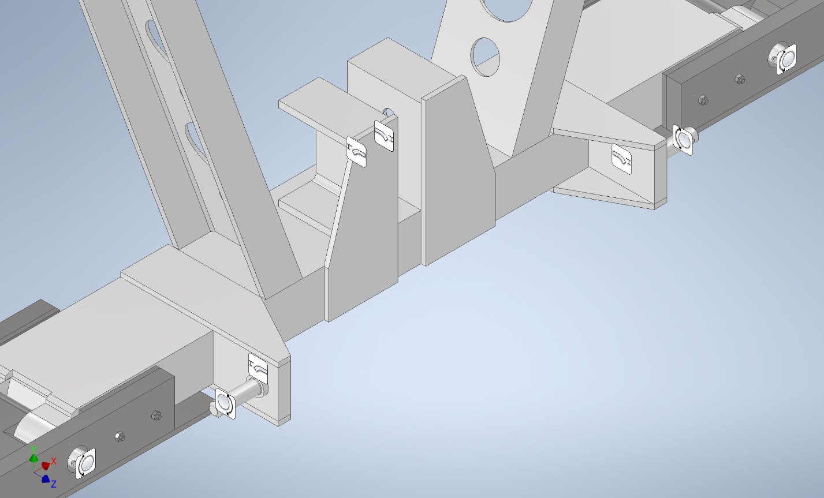 |  | Pin or Rotational Constraint.
 |  | Fixed Constraint.
Figure 16: FEA Constraints.
A load of 14715N (simulates a 1500kg load) with the above constraints resulted in the maximum stress accumulating in the bracing pad located between the central section and the arm flange as shown in figure 17. The only other visible stresses were located at the hinge pin (slight discolouration, right of the Max value label fig17).
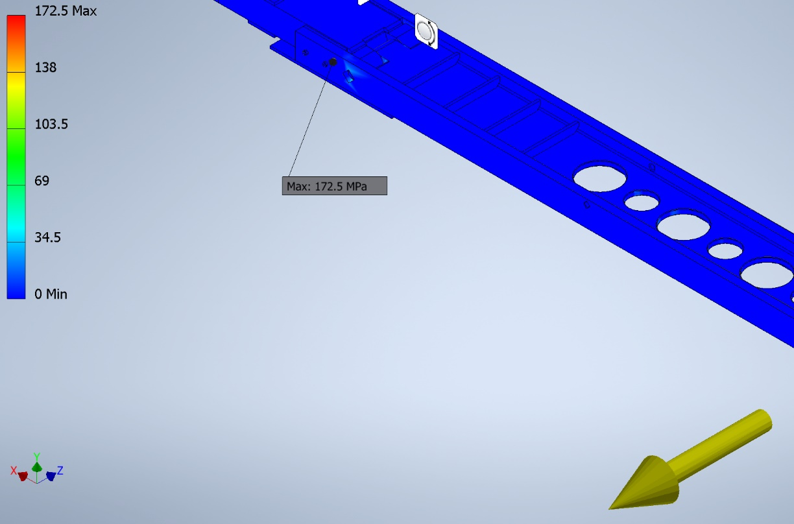
Figure 17: FEA Stress Indication
A stress of 172.5MPa is indicated at this point although the system uses Von Mises stress calculations so the figure in reality would be different. The displacement maximum was in line with the applied load at the furthest end of the arm from the hinge point; it was also smaller than predicted at a total of 2.399 mm (Fig 18).
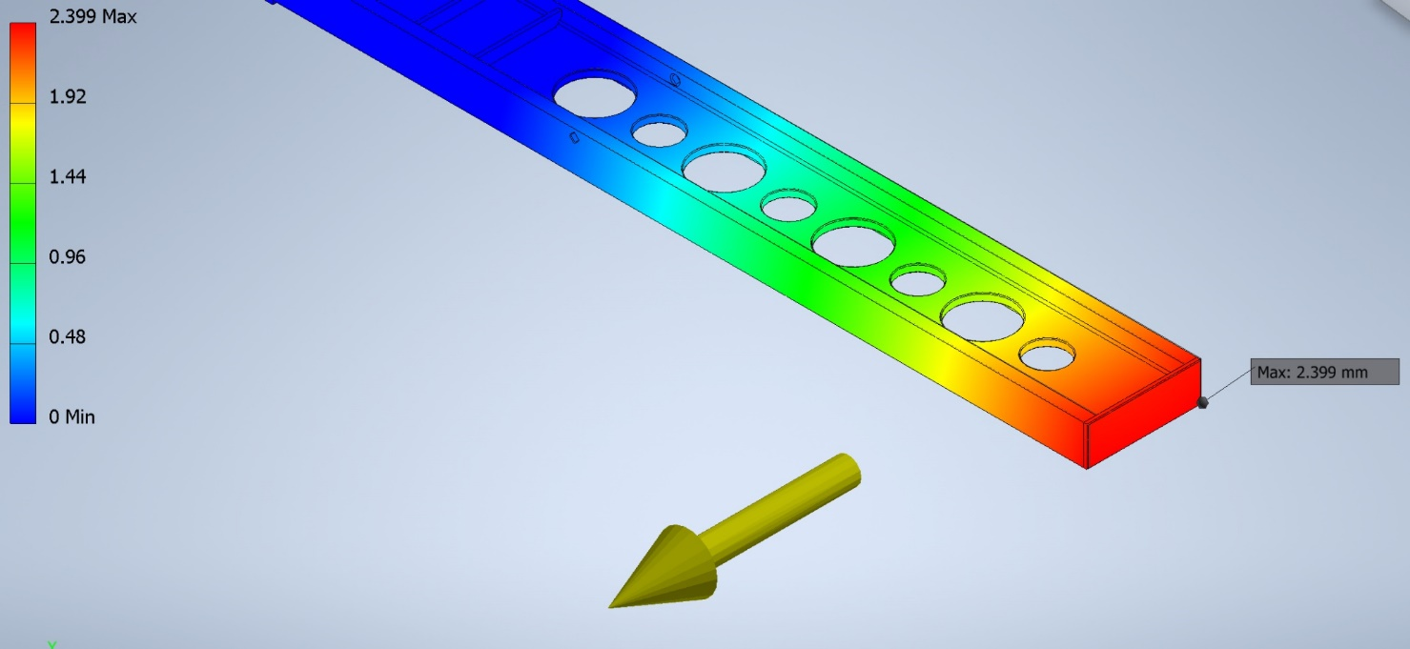
Figure 18: Displacement Maximum
The safety factor was also investigated, the lowest point reached being located at the hinge, in the same point as the max stress, a level of 1.2 was recorded (fig 19). It was decided that the area exposed was so small, sufficiently braced against movement and all surrounding areas showing much higher safety factors that it was decided to continue without modification.
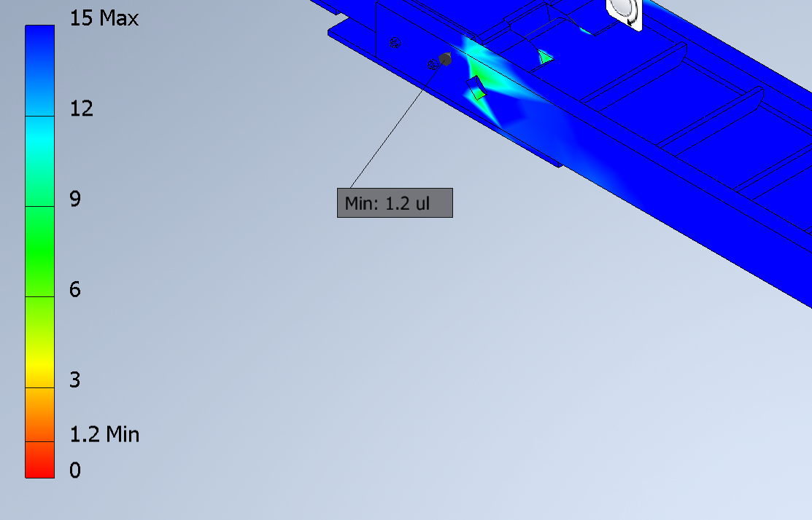
Figure 19: Safety Factor Minimum.
It should also be noted that further refinement of the model, simplifying the assembly and reducing the FEA mesh values would likely create different results.

Conclusion.
The specification stated at the beginning of the project has been met to a certain extent shown below in table 4.
Initial Requirement | Design Solution
Be long enough to reach across the rail section, removing angular forces from the towed load. | Length from centre: 3007.5mm which is long enough to overhang the track. A gantry trolley is employed to move along the rails as needed, preventing angular forces
Be capable of shifting a load of approx. 1500kg with a minimum safety factor of 3. | From the modelling and calculations there is no reason to suspect the assembly would not function as required.
Collapse by some method to within the wheel base of the tractor; allowing for safe storage and transport. | Hinged to fold within the wheel base.
Consider the physical use aspect i.e. weight of folding parts with respect to manual handling | Weight reduction holes cut into the arms and supporting structure where possible. Gas spring pistons used to assist raising or lowering of the arms.
Table 4: Initial Requirement and design solution.
As no physical item has been produced any conclusions can only be speculative. However there has been no indication that the assembly would not function as intended. The pins at the hinge would appear to be the area with the highest possibility of failure so monitoring of this item for deformation/shearing would be prudent. Production could be achieved using existing scrap or surplus metal on site as the original tow bar was; however, it carries the risk of using lower quality of damaged materials.

Recommendations.

An accurate and detailed time table developed with the design and engineering office would have been useful as would more regular meetings to discuss the designs but also the calculations and FEA relating to the model. Initially the model was being developed using CREO software on the design office system however this proved to be impractical and a waste of time as more regular access was available to Autodesk Inventor which is also a more familiar system.
For future improvements to the model, the calculations relating to towing an object on the track could be investigated such as the effects of friction and rolling resistance (not currently available from site engineers).While it is understood from discussion with site engineers that the use of circular holes in weight reduction cause the lowest concentrations of stress (fig 20) compared to other geometric (fracturemechanics.org, n.d.) shapes a better understanding of the mechanics could be sought.
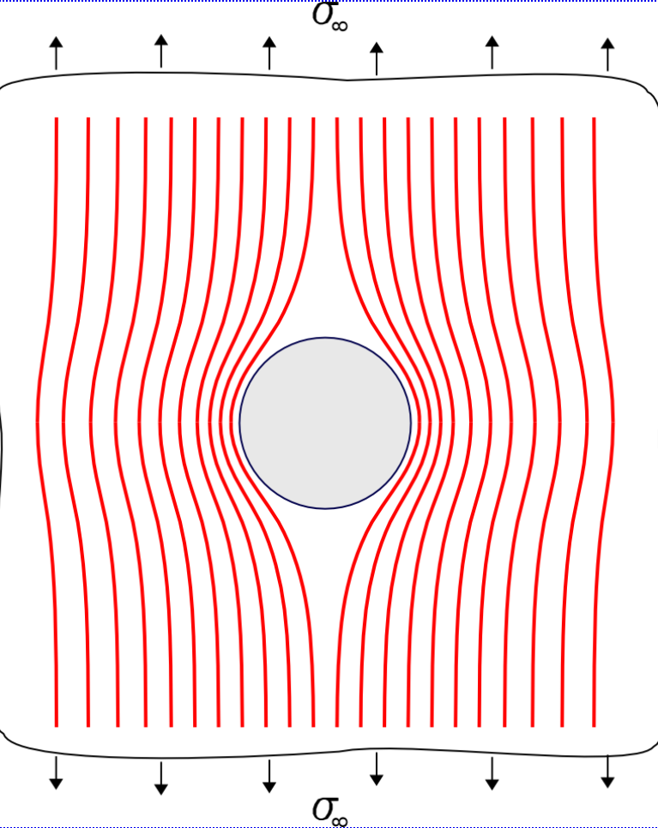
Figure 20: Stress concentrations and circular holes (fracturemechanics.org, n.d.)
Additionally, a better use of the FEA function could be made with the results used to influence the design. Hydraulics could also be investigated, the gas pistons used on the current model could easily be replaced with hydraulic cylinders, removing the need for manual handling although that would then mean the assembly would need to conform to the Provision and Use of Work Equipment Regulations (PUWER). The second design could also be improved upon and completed, this would then provide another potential preferable option to consider should the first prove insufficient or some reason.
In the future it would also be preferable to have access to materials suppliers so quotes for materials and manufacturing could be sought.

Bibliography
Celik, H. K., Rennie, A. E. W. & Akinci, I., 2017. Design and Structural Optimisation of a Tractor Mounted Telescopic Boom Crane. Journal of The Brazilian Society of Mechanical Sciences and Engineering, Volume 39, pp. 909-924.
DartmouthX, 2016. Beams - shear stress and bending stress. [Online]
Available at: https://www.youtube.com/watch?v=CBWoJr9QgEE
[Accessed 10 January 2020].
fracturemechanics.org, n.d. Stress Concentrations at Holes. [Online]
Available at: https://www.fracturemechanics.org/hole.html
[Accessed 19 January 2020].
George, P. E., 2008. auto.howstuffworks.com. [Online]
Available at: https://auto.howstuffworks.com/auto-parts/towing/towing-capacity/information/horsepower-versus-torque2.htm
[Accessed 12 02 2020].
jdomann, 2012. Determining Bending Stress with the Flexure Formula. [Online]
Available at: https://www.youtube.com/watch?v=pRLV5oeim74
[Accessed 03 January 2020].
Mead Info, 2015. Mead Info; Material Properties of S355 Steel - An Overview. [Online]
Available at: https://www.meadinfo.org/2015/08/s355-steel-properties.html
[Accessed 04 February 2020].
Safety Lifting Gear, 2020. www.safetyliftingear.com. [Online]
Available at: https://www.safetyliftingear.com/products/2tonne-beam-trolley-extra-wide-adjustment/bt2tw
[Accessed 05 March 2020].
Variblast, 2017. Variblast.com. [Online]
Available at: https://variblast.com/pendine-range-completion-in-sight/
[Accessed 13 02 2020].

Appendices.

Please see appropriate PDF’s for each appendix.

Appendix 1: Signed Proposal.
Appendix 2: Gantt Charts.
Appendix 3: Manual Calculations for Design 1.
Appendix 4: Drawing Pack for Design 1.

