Adriana Roman
Student ID: 2007914
Software Development
(ACCB4017)
Assessment 1
Part A

Lecturer: Renuga Jayakumar
UWTSD (London)

Table of Contents
PART A 3
A1 3
Figure01.Variables 4
Figure02.Legal variables 5
Figure03.Illegal variable 5
A2 6
Figure04.If/else multiple condition 7
A3 7
Figure05.For loop 8
Figure06.While loop 8
PART B 9
Exercise 1: 9
Flowchart: 9
Figure07.Flowchart of Exercise1 9
Python Code: 10
Output: 11
Figure09.Output of Exercise1 11
Validation: 11
Figure10.Validation of Exercise1 11
Exercise 2 12
Flowchart 12
Figure11.Flowchart of Exercise2 12
Python Code: 13
Output: 13
Figure13.Output of Exercise2 13
Validation: 14
Figure14.Validation of Exercise2 14
Exercise 3 15
Flowchart: 15
Figure15.Flowchart of Exercise3 15
Python Code: 16
Output: 17
Figure17.Output of Exercise3 17
Validation: 18
Figure18.Validation of Exercise3 18
Exercise 4 19
Flowchart: 19
Figure19.Flowchart of Exercise4 19
Python Code: 20
Output: 21
Figure21.Output of Exercise4 21
Reference 22
Appendices 22

PART A

A1

Variables:
Variable is just a memory location where the values are stored. In python, we do not need to declare the type of a variable. It automatically understands which type of variable values it is such as integer, string, tuple, list, etc. We can also change the value of variables during the execution of an application or program.

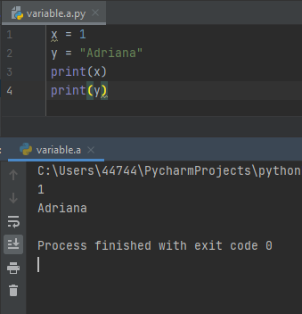

Figure01.Variables

Rules to declare a variable:
The variable name does not start with numbers. It can be started with alphabets or underscore. These variables are case sensitive also so we cannot overwrite them.
See the screenshot below with the legal variable names:
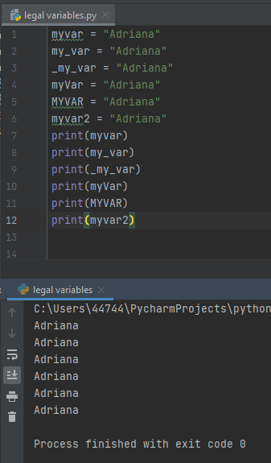

Figure02.Legal variables

In the below screenshot you can see the example will produce in the result an error, because I have used illegal names for the variables:

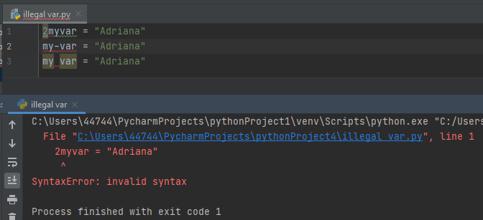

Figure03.Illegal variable

Why it is important:
It plays a very important role in writing a programming code. We can face problems if we store the data directly that is why we use the variables to represent the data. It is the type of way to label the data with a specific name that is understandable by the programmers, other developers, and users.
Strongly-typed language:
We are using a python programming language which is a strong and dynamic type language. Python does not change the type of a value unexpectedly means it does not allow any implicit conversion. If we have integer and string values and we are trying to add these two values, then it does not perform any operation due to different data types.

A2

If/else statement:
It is a type of decision-making statement which decides the flow of execution. If else statement is a conditional statement which is used to check the certain condition. It allows us to check the multiple expressions. If any condition dissatisfies then it goes into the elif part of a code and if all the elif parts do not satisfy any condition, then automatically else block will be executed. There are many types of if-else statements are present such as simple if-else statements or nested if-else. If any if statement satisfies any condition, then it goes into the nested block otherwise goes into the else parts.

Importance:
This is also an important part of the coding to check the particular condition and identify the flow of code that how it is working.
We also use the control statement in our programming code. Multiple conditions will also work with the if-else conditions.

Multiple conditions:
In the below code, we are checking the user input number is positive, negative, or zero. We are using a multiple expression in the if-else to check the condition of a number.

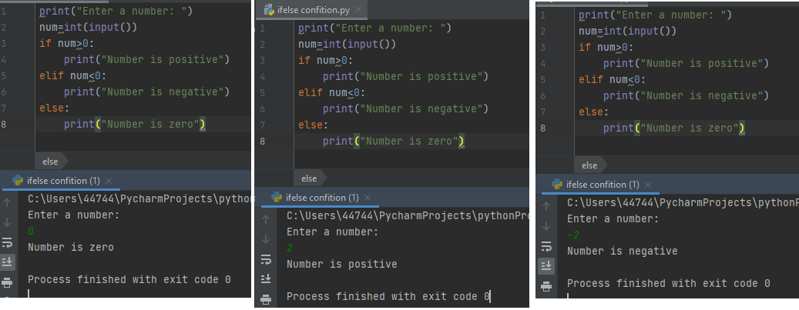

Figure04.If/else multiple condition

A3

Loops:
Looping is used to iterate a certain sequence until the specific condition is met. The repeated task is common in every programming code and we need to write it again and again which increases the programming complexity so by using the loops, we can save time and memory by bypassing some parameters in the loop. In this assignment, we are using a python language.

For loop:
For loop is used to iterate the items in a proper sequence. It is a code that is used to repeat up to n times. For loop is used to execute the block of code that we want to repeat until a certain condition.
In the below screenshot, we are taking a list of integer and string values, and using for loop, we are iterating each value of the list and printing it.
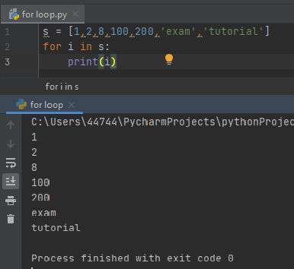

Figure05.For loop

While loop:
It is also just like for loop, but the difference is, while loop depends on the condition that is true or false. It runs the code block multiple time to satisfy a certain condition rather than executing a block of code once.
In the below screenshot, we are using a while loop until a certain condition does not satisfy it, it will execute it.

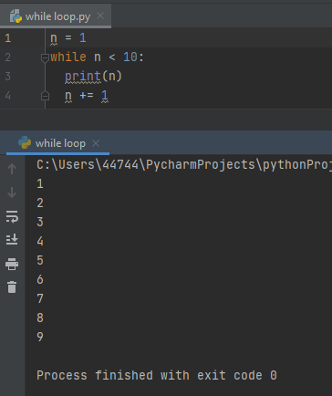

Figure06.While loop

PART B

Exercise 1:

This is a question in which we just need to take a user input from the user on the details on a car which a proper validation checking and commenting.

Flowchart:
This is a flowchart of exercise 1.

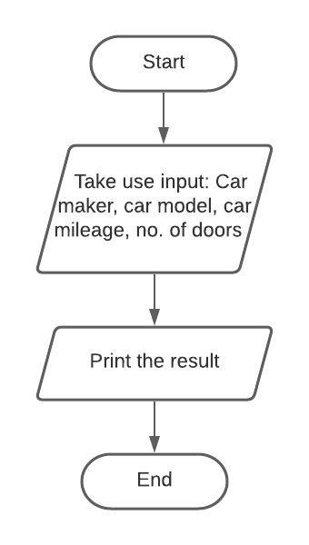

Figure07.Flowchart of Exercise1

Python Code:

This is a python script to take the user input of a car model, car mileage, car make, and number of doors.
#apply validation for taking user input as float
def check_user_input(message): #I used def to define a function for the user
while True: #I used while True to create an infinite loop
try: #I used try to catch and handle the exceptions
user_input = float(input(message))
except ValueError: #the exception found in the try clause are caught and handled with except
print("Not an float ! Please enter again...") #this is what user can see if he is not entering real numbers
else: #allows you to write parts that can only run if there are no exceptions in the try clause
return user_input #return to user input value
break #I used break to escape the loop from while True
#apply validation for taking user input as integer
def check_user_input1(message1):
while True:
try:
user_input1 = int(input(message1))
except ValueError:
print("Not an integer ! Please enter again...") #this is what user can see if he is not entering a positive or negative number
else:
return user_input1
break
#apply validation for string
while True:
car_make=input("Car Maker: ") #the user enter car maker
if car_make.isalpha(): #this will allow users to enter just character from A to Z
break
print("Please enter characters A-Z only") #ths is what user can see if he is entering numbers
while True:
car_model=input("Car Model: ") #the user enter the car model
if car_model.isalpha():
break
print("Please enter characters A-Z only")
mileage=check_user_input("Enter the car mileage: ") #the user enter the car mileage
no_of_doors=check_user_input1("Enter the number of doors in car: ") #the user enter the car number of doors
#Output
print("-----------------------------------------") #create a delimitation
print("Car Maker: ", car_make) #result of the program with car maker
print("Enter the model of car: ", car_model) #rezult of the program with model of car
print("Enter the car mileage: ", mileage) #rezult of the program with car mileage
print("Enter the number of doors in car: ", no_of_doors) #result of the program with number of doors

Output:

This is the output of exercise 1 that the python script is working and how it is providing the output according to the users.
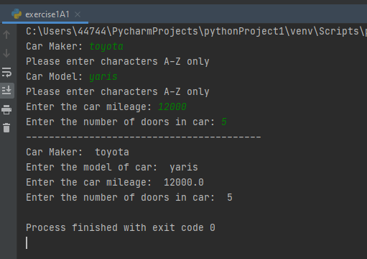

Figure09.Output of Exercise1

Validation:

Here we are checking validation on the user input that whatever the entries the user is entering, that is valid or not. In this question, we are checking the validation on the integer, string, and float values.
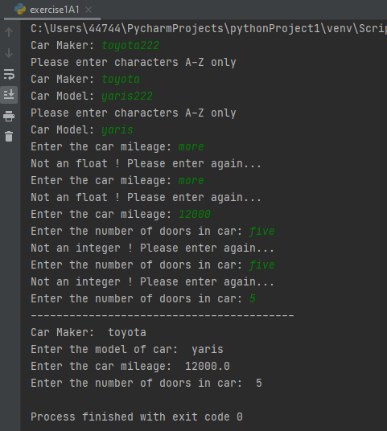

Figure10.Validation of Exercise1

Exercise 2

We are calculating several carrots grows in the vegetable beds using python. This python script is running in the Python IDLE.

Flowchart

This is a flowchart of exercise 2 that how it works and which steps it follows to run the script of a python.

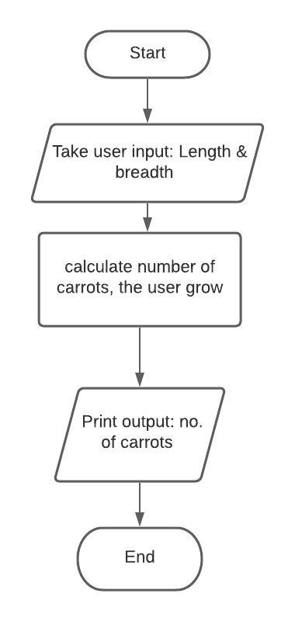

Figure11.Flowchart of Exercise2

Python Code:

#apply validation for taking user input as a integer
def number_input(message): #I used def to define a function for the user
while True: #I used while True to create an infinite loop
try: #I used try to catch and handle the exceptions
user_input = int(input(message))
except ValueError: #the exception found in the try clause are caught and handled with except
print("Not an integer! Please enter again...") #this is what user can see if he is not entering a positive or negative number
else: #allows you to write parts that can only run if there are no exceptions in the try clause
return user_input #return to user input value
break #I used break to escape the loop from while True
#take user input
print("---Enter the value of length & width---") #let the user know he have to insert the showed values bellow
length=number_input("Enter the length of a vegetable bed: ") #the user can enter the value of the vegetable bed length
width=number_input("Enter the width of a vegetable bed: ") #the user can enter the value of the vegetable bed width
#calculate the carrot grows
x=(length//8) #x value for length
y=(width//8) #y value for width
z=min(x,y) # this function return the item with the smallest value in an iterable
print("Number of carrot grows in this bed: ", z**2) #rezult for how many carrots can grow in this vegetable bed

Output:

This is a screenshot of the output of exercise 2 for calculating the number of carrots grows in the vegetable bed.

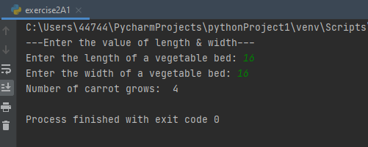

Figure13.Output of Exercise2

Validation:

Now it is validating the user input through exception handling.

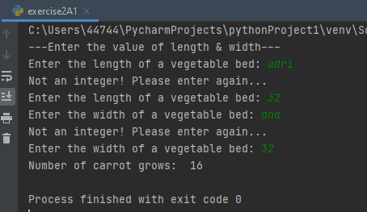

Figure14.Validation of Exercise2

Exercise 3

Here we have to calculate the total price of a product by taking the user input entries and also calculating the total price after applying the 15% discount.

Flowchart:

Now we plot a flowchart to understand that how it will work.
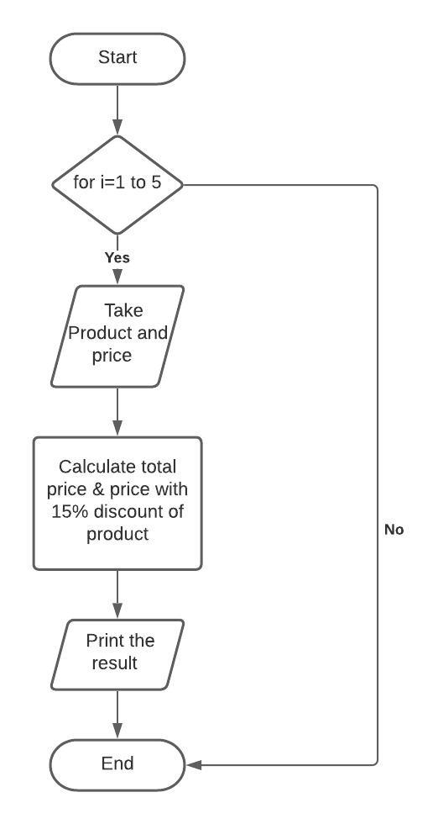

Figure15.Flowchart of Exercise3

Python Code:

#apply validation for taking user input as float or string
def check_user_input(message): #I used def to define a function for the user
while True: #I used while True to create an infinite loop
try: #I used try to catch and handle the exceptions
user_input = float(input(message))
except ValueError: #the exception found in the try clause are caught and handled with except
print("Not an float ! Please Enter Again...")
continue #this statement is used to skip the rest of the code inside the looploop
else: #allows you to write parts that can only run if there are no exceptions in the try clause
return user_input #return to user input value
break #I used break to escape the loop from while True
# take two empty list
product_list = []
price_list = []
# take user input of product and price
for i in range(1, 6): #create a sequence of numbers
while True:
print("Enter product ", i, ":") #user is entering the first,second..... product
product = input(" ")
if product.isalpha(): #this will allow users to enter just character from A to Z
break
print("Please enter characters A-Z only")
print("Enter price", i, ":") #user is entering the price for first, second....product
price = check_user_input(" ")
print("---------------------") #delimitation between rows
product_list.append(product)
price_list.append(price)
# calculate total price
total = sum(price_list)
print("Product Entered") #user can see all tha values he entered above
for i in range(0, len(product_list)): #to access all items of product list
print(product_list[i], " ", price_list[i])
print("Total Price is: ", total) #user can see the total price of the list
# calculate total price with 15% discount
staff_discount = total - ((total * 15) / 100)
print("Total with staff discount:- ", staff_discount) #user can see the total price of the list with staff discount applied

Output:
This is the output of exercise 3 to calculate the prices of a product.

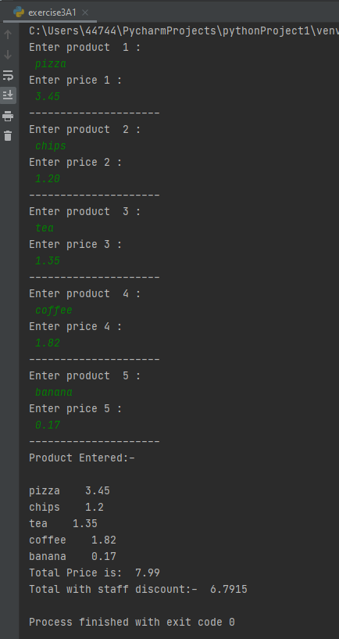

Figure17.Output of Exercise3

Validation:
This is a validation screenshot to check that user input is valid or not.

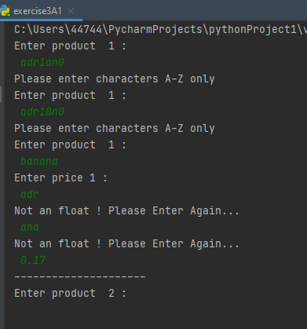

Figure18.Validation of Exercise3

Exercise 4

Flowchart:

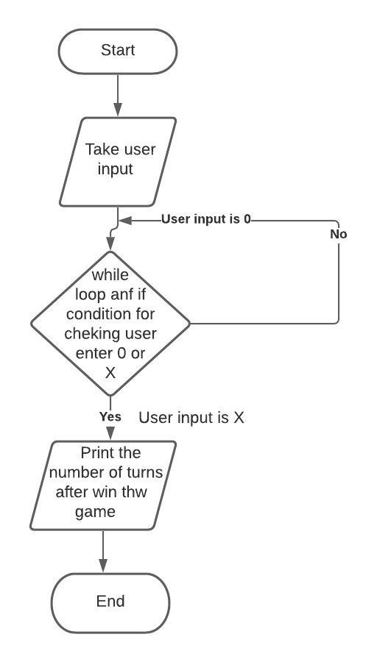

Figure19.Flowchart of Exercise4

Python Code:

treasure = ["0 ", "0 ", "0 ", "0 ", "X "]
no_of_turns = 0
while no_of_turns != 1000:
m = []
treasureLocation = []
print("Choose position: (0,15)") #user have to choose a position from 0 to 15
position = int(input())
# Take random library
import random
for i in range(0, 4): #create a sequence of numbers
v1 = random.choice(treasure)
v2 = random.choice(treasure)
v3 = random.choice(treasure)
v4 = random.choice(treasure)
treasureLocation.append(v1)
treasureLocation.append(v2)
treasureLocation.append(v3)
treasureLocation.append(v4)
k = [v1, v2, v3, v4]
m.append(k)
# check condition
if treasureLocation[position] == "X ":
print("Win! Well done. You took ", no_of_turns, " turns")
break
else:
print("Miss! Unlucky")
print("".join(m[0]))
print("".join(m[1]))
print("".join(m[2]))
print("".join(m[3]))
no_of_turns = no_of_turns + 1

Output:

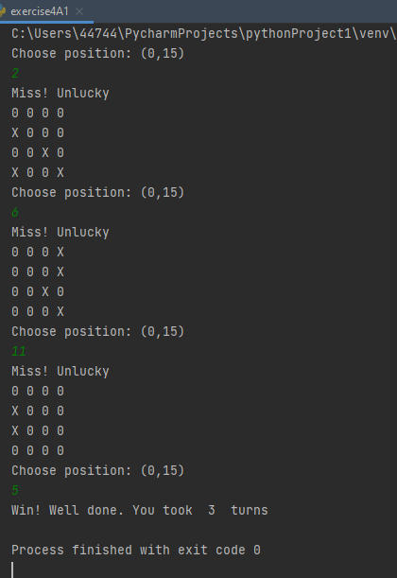

Figure21.Output of Exercise4

Reference

Novak, N., 2019. Python if statements.

Charbonneau, P., 2017. A. BASIC ELEMENTS OF THE PYTHON PROGRAMMING LANGUAGE. In Natural Complexity (pp. 293-307). Princeton University Press.

Miller, B.N., Ranum, D.L. and Anderson, J., 2019. Python programming in context. Jones & Bartlett Learning.

Srinath, K.R., 2017. Python–the fastest growing programming language. International Research Journal of Engineering and Technology, 4(12), pp.354-357.

Appendices

