

University of Wales Trinity Saint David
School of Engineering

Application of Computer Aided Engineering Processes
BEng Motorcycle Engineering
Structural Design and Fluid Analysis ACHA6010

Mya Jane Johns
2103212
December 2023

Figure 1 – University of Wales Trinity Saint David Logo (UWTSD, 2017)
Contents

Introduction 3
CAD Modelling 4
Geometry 5
Preparing for analysis 6
Temperature 7
Static Analysis 8
Deformation 9
Stress 10
Analysis using CAD 12
Positives 12
Precision and Control 13
Visualisation 13
Efficiency and Speed 13
Negatives 13
Human Errors 13
Training 13
Over Reliant 14
Meshing 14
Conclusion 15
References 15

Introduction

The primary objective of this report is to provide a detailed examination of the utilization of CAE processes, particularly in the design, analysis, and optimization of motorcycle components. By harnessing the capabilities of advanced software like Ansys, this study aims to dissect the mechanical behaviours and interactions of motorcycle parts under various operational conditions, including thermal dynamics, static and dynamic stresses, and overall material behaviour.

A case study central to this report is the analysis of an engine system, employing Ansys to investigate the kinematics, statics, and thermal dynamics during the combustion process. The insights garnered from this study are not only pivotal for understanding the operational efficiencies and limitations of the engine components but also for predicting their lifecycle and performance under real-world conditions.

The report is structured methodically to facilitate a comprehensive understanding of each CAE process step. Starting with CAD Modelling, it progresses through sequential phases of the CAE workflow:
- Geometry Preparation: This section discusses the initial steps in setting up the engine system’s geometry for dynamic analysis, emphasizing the importance of precision in the foundational stages of CAE.
- Analysis Preparation: This covers the essential setup and connections required for a thorough and accurate analysis using CAE tools.
- Temperature Analysis: Here, the focus shifts to thermal studies, specifically examining the impact of varying temperatures on piston behaviour.
- Static and Dynamic Analysis: This part delves into kinematic studies and the assessment of static and dynamic responses of components under simulated operational conditions.
- Deformation and Stress Analysis: The report scrutinizes the deformation and stress endured by the piston head, offering insights into material behaviour and component durability.
- The report also critically evaluates the positives and negatives of using CAD in the engineering design process. The advantages such as precision, control, enhanced visualization, and efficiency are weighed against the drawbacks, including the potential for human error, the need for extensive training, and the risk of over-reliance on digital tools.

In conclusion, this report serves as an essential academic piece, providing both theoretical and practical insights into the application of CAE in motorcycle engineering. It aims to equip readers, especially students, and professionals in the field, with a comprehensive understanding of the capabilities and limitations of CAE processes, fostering a balanced and informed approach to motorcycle design and analysis.

The material which was used for this analysis was aluminium.

CAD Modelling

With the modelling system, Ansys was used for a case study on an engine system. The goal was to study the engine's movement (kinematics), its stability when it is not moving (statics), and how heat affects it (thermal dynamics) during combustion. Ansys is useful because it lets us see how different parts of the engine behave under different conditions, like when it gets hot, when fluids move through it, or when it's under pressure. By looking at all these aspects together, we can better understand how they interact during the engine's combustion process. This is important for knowing how components within a system would react to heat, pressure, and loads. By doing this for an engine, it gives a better understanding of the internals of an engine, to give a rough estimate of how long a component's life cycle is.

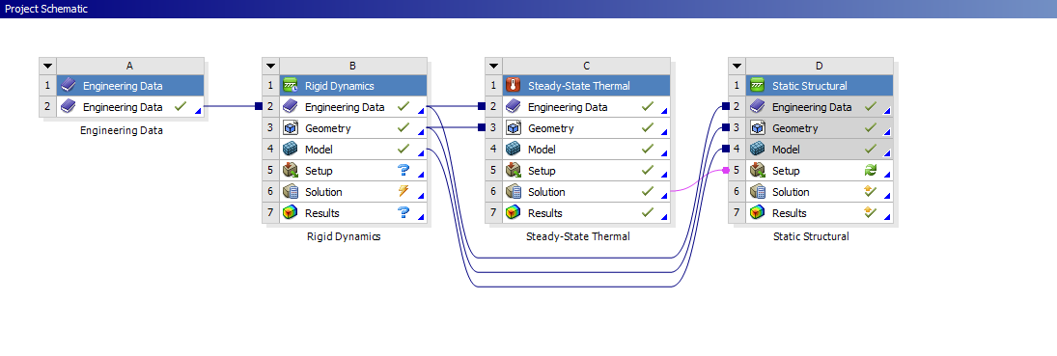
Figure 2: This shows an image of how the case study links together using Ansys. Taken on 21st November 2023

As the study was based on real life, it meant that each part of the system had to be linked together but had its own properties. With the building up of the system using CAD, there can be problems that did occur when creating this systematic study. Below shows the structure and order of the study:

Geometry
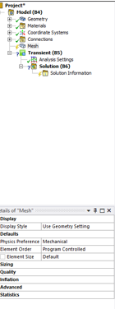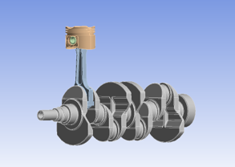

Figure 3: This image shows the geometry preparation without mesh for the rigid dynamics. Taken on 21st November 2023.

Creating a geometry structure for the analysis is important as it gives ANSYS an overview of the environment the product would be living in. To create this, a structured list must be followed which is shown on the left side of the images. This needs to be followed to help make sure it is done correctly.

Preparing for analysis

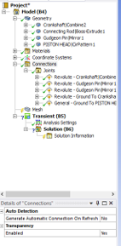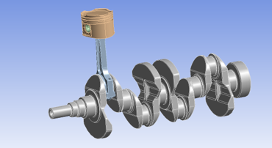

Figure 4: This shows a screenshot of doing connections needed for the analysis for the rest of the study. Taken on 21st November 2023.

When preparing the product to be carried through the analysis, the connections and how the product moves need to be initialised. The connection joints shown on the left make sure that the whole system is in movement but is moving the same way it would in real life. As the camshaft moves, the piston moves up and down but the software animates it with the realistic conditions needed.

Temperature

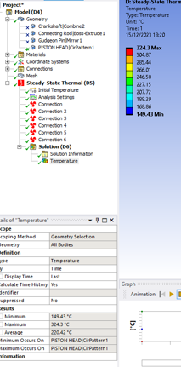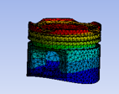

Figure 5: This image shows a screenshot of the thermal study for the piston based on the given temperature and materials.

Knowing the thermal study of the product, this helps know where the heat can affect the product based on where the heat comes from. As shown and because it is a piston, the heat is focused more on the head which is clearly shown in the figure above. This helps the designer know what material is best for it and helps decide if it is the right material or shape.

Static Analysis

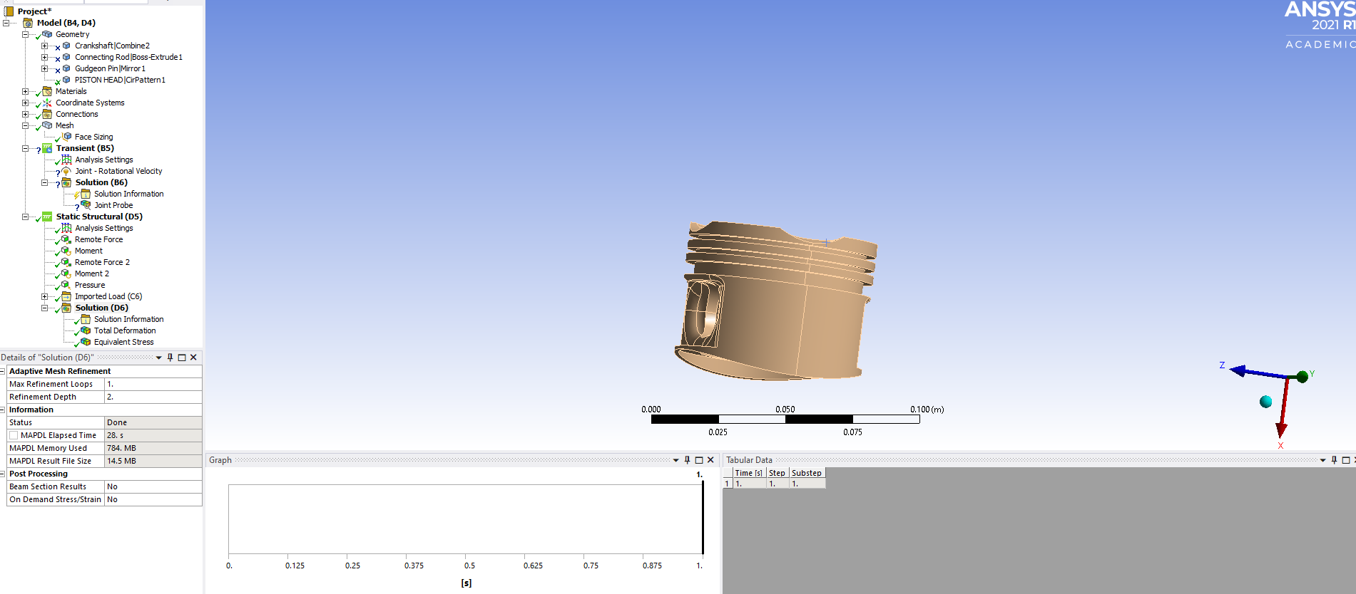

Figure 6: This shows an image of the preparation of the kinematic study. Taken on the 21st November 2023.

The preparation for the kinematic study is important because of the chain the analysis has to be done, this means that the designer has to go back and forth to prepare each study by filling in the data. On the left shows the list that needs to be completed before any of the solutions is shown.

Deformation

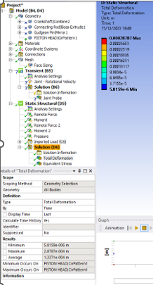
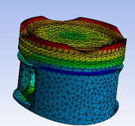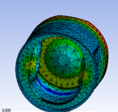

Figure 7: This shows the deformation of the piston head using the previous analysis and data, as all the results add onto each other. Taken on 21st November 2023.

Knowing the deformation of a piston head is important as it helps the designer know if the piston would be able to last a long time at a high temperature. Due to the design of the piston, you can see where the total deformation is based, as the crown is at intense heat, which affects the results.

Stress

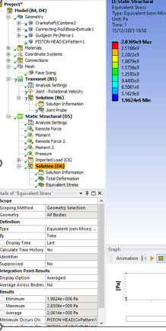
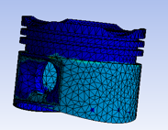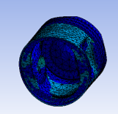

Figure 8: This figure shows the stress analysis of both the top and bottom of the whole piston structure. Taken on 21st November 2023.

Since the piston is constantly moving at high speeds when the vehicle is moving, along with being at intense heat, this means the stress of the material is important. If the piston was to fail during its chosen lifetime, this would cause a fallback as there would be callbacks for the product to be returned. It would be blamed on the engineers, so the product needs to be checked for any deformation or to be redesigned to know that the stress levels would not break the product.

Analysis using CAD

When utilizing Computer-Aided Design (CAD) software, some several advantages and disadvantages should be considered. From a positive perspective, CAD is an invaluable tool for software engineers and designers, offering precise control over measurements and detailed information about the product under development. Its ability to facilitate accurate and detailed designs aids in visualizing the product, improving the overall quality and efficiency of the design process.

On the other hand, there are notable drawbacks to relying solely on CAD. The accuracy of the final component heavily depends on the initial drawings and measurements inputted into the software. This reliance means that any errors or inaccuracies in these initial stages can propagate throughout the design, potentially leading to significant issues in the final product. Furthermore, while CAD provides a digital representation, it may not always account for real-world variables such as material behaviour under different conditions, which can lead to discrepancies between the designed model and the actual product.

Moreover, over-reliance on CAD can sometimes stifle creativity, as designers might find themselves confined to the limitations and presets of the software, overlooking innovative or unorthodox design solutions. Therefore, while CAD is an essential tool in the modern design toolkit, it is crucial to use it as a complement to, rather than a replacement for, traditional design skills and critical thinking.

Positives:
- Precision and Control.
- Able to visualise the scenario.
- Efficiency and Speed.

Negatives:
- Dependent on accurate input.
- Training and learning.
- Being over-reliant.

Positives

Precision and Control

CAD is a good way to get precise and accurate data for real-life data without having to make the real product and do testing, which would end up costing more. It gives engineers a higher advantage for the properties of a product before it is released. This helps reduce the margin of error.

Visualisation

Creating a detailed model helps view the product into what the model can look like. Thus, creating a live image view of how it can look and work within a system. The example of the engine system used above helps show how the piston would react to temperature and pressure when it is going through combustion.

Efficiency and Speed

When analysing studies of a product, using CAD would help create a fast table that shows the data. This means less time is spent in laboratories to research a product on how well it would work in the system. Drawing the engine system using CAD creates a 3D sketch of a realistic image that can be quicker than making. The speed of analysis case study is done within a minute compared to a few weeks.

Negatives

Human Errors

Human error can have a significant impact on the drawbacks of CAD. This can stem from the person drawing the product not measuring it correctly and inaccurately representing it in the design. As a result, the data provided would be insufficient and not reflect the real dimensions or specifications of the intended product. This inaccuracy can lead to flawed prototypes or final products, causing wasted resources and time. Furthermore, if these errors are not identified early in the design process, they can lead to more significant issues during manufacturing or in the functionality of the product, emphasizing the importance of precision and careful review in CAD work.

Training

Learning how to use CAD does create time and a lot of training to know how the system works. The advancement of the system can take a while to process for a beginner. However, with dedication and practice, anyone can master the intricacies of CAD software and effectively apply it to various design and engineering projects.

Over Reliant

Being over-reliant can be a major negative when working along with CAD as it reduces the critical thinking of an engineer and makes them only use computer systems. It creates a high-cost system for engineers which reduces problem-solving skills. Traditional skills would be wasted creating fewer skills that can be transferred into other fields.

Meshing

When preparing data for the analysis of a piston, meshing is a crucial step to accurately measure the surface of each part. Initially, a uniform mesh size could be applied across the piston, dividing it into small, equal sections. However, this approach might introduce anomalies in the data due to the uniformity of the mesh elements, regardless of the complexity or simplicity of different areas of the piston.

Using a large mesh (i.e., fewer, bigger elements) over the piston's surface can compromise data accuracy, as it oversimplifies the model and may not capture the nuances of the piston's geometry. In contrast, employing a finer mesh (i.e., more, or smaller elements) increases the number of divisions on the piston, resulting in smaller triangular elements for analysis. This finer mesh provides a more detailed resolution, yielding more precise and insightful results, especially in areas of high stress or complex geometry.

In my initial analysis, I utilized a mesh with uniformly sized elements, covering large areas of the piston. While this provided a basic level of accuracy, it lacked the finer detail achievable with smaller mesh elements. Recognizing this limitation, I refined the mesh for subsequent stress and deformation analyses. By reducing the size of the mesh elements on the piston's surface, I was able to obtain more detailed and accurate data, particularly in critical areas. This finer meshing strategy enabled a deeper understanding of how the piston would respond under various loading conditions set up in the analysis.

Conclusion

In conclusion, the use of CAD is vitally important for engineers in determining the longevity and durability of products within their respective systems. CAD not only aids in creating robust products capable of thriving in competitive markets, but it also plays a crucial role in forecasting product performance. This predictive capability enables designers to understand and anticipate the implications of their products' performance, ensuring more informed and effective design decisions. By leveraging the precision and analytical power of CAD, engineers can significantly enhance the quality, reliability, and market viability of their products.

CAD helps the workflow within engineering as it brings a whole new way for a product to be analysed without the cost of production. It creates a streamlined process, shown in Figure 2, that all can be processed in a line one after another building up a case study. The emerging technologies of AI, CAD, and 3D printing, all work with each other to create a satisfying relationship for engineering designers and production makers. This advancement in technology helps create an enhanced durability of production.

References

[1] SimScale. (n.d.). What is CAE | Computer-Aided Engineering? [online] Available at: https://www.simscale.com/docs/simwiki/general/what-is-cae-computer-aided-engineering/. (Accessed 29 November 2023)

[2] Raphael, B. and Smith, I.F.C. (2013). Engineering informatics : fundamentals of computer-aided engineering, second edition. Hoboken, N.J.: Wiley. (Accessed 30 November 2023).

[3] Sciencedirect.com. (2010). Thermal Analysis - an overview | ScienceDirect Topics. [online] Available at: https://www.sciencedirect.com/topics/materials-science/thermal-analysis. (Accessed 1 December 2023).

[4] www.sciencedirect.com. (n.d.). Stress Analysis - an overview | ScienceDirect Topics. [online] Available at: https://www.sciencedirect.com/topics/materials-science/stress-analysis. (Accessed 3 December 2023).

[5] www.brighthubengineering.com. (n.d.). What is Kinematics? Kinematics - Design of Mechanisms: Introduction to kinematics. [online] Available at: https://www.brighthubengineering.com/machine-design/6251-kinematics-design-of-mechanisms-introduction/?utm_content=cmp-true (Accessed 7 December 2023)

[6] Salzman, Roy M. “ The Impact of Automation on Engineer/Manufacturing Productivity ”, Arthur D. Little decision resources, November , 1980 (Accessed 10 December 2023).

[7] Maddux, K.C. and Jain, S.C. (1986). CAE FOR THE MANUFACTURING ENGINEER: THE ROLE OF PROCESS SIMULATION IN CONCURRENT ENGINEERING. Advanced Manufacturing Processes, 1(3-4), pp.365–392. doi:https://doi.org/10.1080/10426918608953170. (Accessed 15 December 2023).

[8] Marks , P. , “ Managing Computer‐Aided Engineering Technology ”, AMA Management Briefing, 1983 . (Accessed 16 December 2023).

‌

