

Design and implementation of market management system based on .NET

by
Pan Li

Supervisor: Dr Andrew Baker

MSc Software Engineering

ABSTRACT
In order to improve the management efficiency of shopping malls, it is urgent to provide a web-based information system to complete the online management of each link of shopping malls management. Store of goods management and store management and customer information management is an important part of the store daily management, using the mall management system, can store the goods purchase, sales and inventory good combination, the sales feedback to purchasing department in a timely and effective manner, makes the shopping mall can better achieve reasonable procurement, sales in a timely manner, keep the safety stock and reduce the backlog of goods. Also can carry on the daily maintenance to each store interior.
According to the actual situation encountered in the operation of the shopping mall, this report carries out the overall design of the shopping mall management system, which mainly includes five modules: authority function module, information input module, merchant management module, customer management module, commodity warehousing module and work order management module. In system implementation part of this paper gives the system the implementation of the method and process, this system can provide service for managers, merchants, the merchants in stores, shopping center resources unified planning and management, customer information, timely, accurately reflect the market into, sales and stock of the current state of the work, can effectively manage individual shops and customer information. In the development process, ASP.NET was used as the system development mode, B/S five-layer framework as the system development framework, and Bootstrap as the front-end development framework to complete the design and implementation of mall management.
Table of Contents
ABSTRACT ii
1 Introduction 3
1.1 Aim 5
1.2 Objectives 5
1.3 Structure of the report 5
2 Research and review of literature 6
2.1 ASP.NET technology 6
2.1.1 ASP.NET introduce 6
2.1.2 The characteristics of the ASP.NET 8
2.2 ASP.NET application architecture design 9
2.2.1 IIS server principle and analysis 9
2.2.2 HTTPHandler 9
2.2.3 Handling HTTP requests 10
2.2.4 The web development model based on Ajax 11
2.3 Operation database technology 12
2.3.1 An overview of the ADO.NET 12
2.3.2 At ADO.NET to access the database 13
2.3.3 ADO.NET features 14
2.4 Conclusion 15
3 Research and development (if applicable) 16
3.1 A programming language C SHARP 16
3.2 Microsoft Visual Studio development tools 17
3.3 The Bootstrap front-end framework 18
3.4 SQL Server 20
3.5 Conclusion 21
4 The design of the mall management system 22
4.1 System overall structure design 22
4.2 System function modules in detail design 24
4.2.1 Rights management function module design 24
4.2.2 Information input function module design 25
4.2.3 Business management function module design 25
4.2.4 Customer management function module design 26
4.2.5 Design of the function module of goods in and out 27
4.2.6 Work order management function module design 28
4.3 Conclusion 28
5 Database table structure design 29
6 The realization of market management system 38
6.1 System login implementation 38
6.2 Implementation of the main interface of the system 39
6.3 The realization of system function module 39
6.3.1 The realization of authority management function module 39
6.3.2 The realization of information input function module 40
6.3.3 The realization of merchant management function module 42
6.3.4 The realization of customer management function module 42
6.3.5 The realization of commodity in and out function module 43
6.3.6 The realization of work order management function module 44
6.4 Conclusion 46
7 CONCLUSIONS AND RECOMMENDATIONS 46
7.1 Summary 46
7.2 Conclusion 47
7.3 Recommendations for Further Research 48
8 REFLECTION 49
References 50

Table of Figures
Figure 1 ASP.NET Request Processing Based on Pipeline Model 8
Figure 2 Improved Development Model 10
Figure 3 ADO.NET Object Model 12
Figure 4 Overall System Structure Diagram 23
Figure 5 Login Page 37
Figure 6 Main Page 38
Figure 7 Personnel Authority Management Page 39
Figure 8 Merchant Authority Management Page 39
Figure 9 Entry of Commodity Information Page 39
Figure 10 Entry of Commodity Type Page 40
Figure 11 Entry of Manufacturer Page 40
Figure 12 Entry of Supplier Page 41
Figure 13 Entry of the Merchant Type Page 41
Figure 14 Entry of the Merchant Information Page 42
Figure 15 Customer Information Page 42
Figure 16 Commodity Warehousing Page 43
Figure 17 Outbound Goods Page 44
Figure 18 Commodity Information Page 44
Figure 19 Edit the Repair Order Page 45
Figure 20 Examine and Approve Work Order Page 45

Table of Tables
Table 1 User_Table 29
Table 2 Role_Table 29
Table 3 Goods_Table 30
Table 4 GoodsCat_Table 30
Table 5 Supplier_Table 30
Table 6 Manufactor_Table 31
Table 7 Seller_Table 32
Table 8 SellerCat_Table 32
Table 9 KHInfo_Table 33
Table 10 StockIn_Table 33
Table 11 StockOut_Table 34
Table 12 GoodsInfo_Table 35

1 Introduction
In today's society, efficient market management without information technology. The modernization of the rapid development of information technology for store management has provided a broad stage. Use modern means of management inventory, can be timely and accurately reflect the state of the inventory, ensure the amount of inventory in a reasonable level, to meet customer demand while minimizing inventory, and because the store gathered all kinds of shops, manage the shop is very necessary, so as to keep the advantage in competition.
Store has many kinds of shops, with an increasing number of items, for convenience of shopping malls and stores know inventory management situation, the analysis of customer in integral information, the management business internal situation, for the mall in urgent need of the implementation of a digital store management system. Unlike traditional inventory management mode, all the shops in the mall purchasing behavior is relatively independent, individual shops have their own supply of goods, is responsible for contact the supplier and goods transportation process, and finished goods purchasing. Commodity procurement process is completed, to store in the mall unified management of the warehouse. Due to Shared by stores the individual shops in warehouse, shop store the goods to other shops to store the goods, so the market should be for storage is allocated quota unified individual shops, outbound and warehouse for goods and goods for approval. At the same time, the market also need refinement and specification of goods in the process of management of inventory, storage, dispatch operation process, such as for going to inbound and outbound goods, to the goods loading and unloading time number, name of commodity, quantity, data statistics, such as convenient for stock queries and inventory operations.
For merchants to internal staff leave the examination and approval and the repair operations such as store items.
Store management system is an essential part of enterprise information management. An efficient, accurate, easy to extract important information store management system, for enterprise decision-making and management is very important, can even to a certain extent, decide the success or failure of the enterprise.
Traditional market management by artificial to complete, such as artificial registration card, fill in the form of single application, classification storage of goods, need a lot of manpower material resources. Artificial management way has many shortcomings and any inconvenience caused, such as the waste of human resources, error-prone, confidentiality is poor, cannot reflect the goods and inventory information in time, is not conducive to timely grasp the latest trends of the market. In addition, time is long, will produce a large number of documents and data, to find, update and maintenance is difficult. Individual shops internal management disorder for shops, leave procurement application along with the gender loose, is not conducive to effective and timely solve the problems existing in the shops. A mature and advanced market management system, should provide detailed information for the user and convenient query method, at the same time should be able to provide users with further data analysis, and timely feedback more information to help decision-making, so as to improve enterprise efficiency. Compared with the traditional way of market management, mature and advanced the mall management system should have higher efficiency, stronger confidentiality, and richer functionality. The use of information technology to develop information management system to manage store inventory, will have the crafts incomparable advantages, such as: rapid inquiry, inbound outbound convenient, the reliability high, thereserves big, the secrecy good, etc. These merits can enormously enhance the efficiency of inventory management. Adapting to the development of the market, therefore, to develop a management system can improve the scientific management of shopping malls, has very important practical significance and technical significance.

1.1 Aim
The main purpose of this report is: adopt B/S structure to build shopping malls management system based on web, realize the mall merchants, unified planning and market resources, customer information management. Convenience store managers for goods outbound, inventory and other information of view, some application for examination and approval of shops, convenience stores staff to check the goods sales information, customer information, to the staff leave application for approval. Implements a informatization improve the efficiency of management of mall management system.

1.2 Objectives
The goal is to：
- Determine the mall management system chooses the development of language, the front frame and the database.
- Analysis of the function modules, store management system need to design system's overall framework, and the implementation process in detail design of each function module.
- For each function module design the reasonable structure of the database table, used to store the user input all kinds of information.
- According to the process of realization of each module design completed the construction of the system as a whole and test.

1.3 Structure of the report
The project mainly has three parts. First, established the theory of work is the foundation of the project. Literature review work based on the.net web development work process and principle of the related theories in this paper. The second part introduces in detail the overall store management system architecture design and the design of each function module. Finally, in the third part of the system implementation and results display.
The first chapter summarizes the report, the paper introduces the aim of the report, Objectives and Structure of the report.
The second chapter is the research and literature review, summarizes the web structures, involved in the process of application principle, the model of development as well as to the operation of the database.
The third chapter expounds the mall management system development related theory and technology development.
The fourth chapter to this mall management system carries on the overall structure design, in addition, for each module function is introduced and the process design.
The fifth chapter according to the function of each module by need to store data for the design of the reasonable structure of the database table.
The sixth chapter is specific to store management system implementation, to show the functions page.
The seventh chapter gives a summary of the project, the conclusions and recommendations.
The eighth chapter, the author in the reflection in the process of research.

2 Research and review of literature

2.1 ASP.NET technology

2.1.1 ASP.NET introduce
ASP is the abbreviation of the Active Server Page, meaning "dynamic Server Page". It was developed by Microsoft company instead of an application of the CGI script, and it can interact with databases and other programs, is a kind of simple and convenient programming tools. ASP is a Microsoft technology, is a kind of make the script embedded in a web page can be performed by the Internet server server-side scripting technology. Refers to the Active Server Page (Active Server pages), running in the IIS application.
ASP.NET is Microsoft company launched a new generation of dynamic Web application development platform, [1] is a kind of set up dynamic Web applications of new technology. ASP.NET is part of the.net framework, you can use any. NET language compatible to write ASP.NET application. ASP.NET is an updated version of ASP, both formally close, but essentially have bigger difference. ASP program and web HTML are mixed together, which makes the program look quite messy, is limited by a scripting language of their own conditions, at the time of write ASP program had to call COM components to complete some function. At the same time as the ASP page is interpreted by a script language, which makes the running speed is affected. ASP.NET is not only a simple ASP upgrade, [2] provides a new and more powerful server control structure. ASP.NET provides a unified Web development model, ASP.NET is almost entirely based on components and modular, each page element, objects, and is a component object.
On the development language, ASP.NET abandoned support VB and Jscript language, since ASP.NET is performed, so it has higher efficiency than ASP. ASP.NET used a similar JAVA compilation techniques, the use of efficient page and data caching technology improve the execution efficiency.
Microsoft company designed for ASP.NET powerful code, easy to reuse and sharing, and can be used to compile the class language strategy, so that programmers are more likely to develop Web applications, meet the needs of different customers. ASP.NET is a brand-new cross-language development platform, improve the Window in the application development and deployment. It is an object-oriented programming environment, by minimizing conflicts execute code, thus improve the security of the code execution environment, the developer in the face of different types of application are consistent;
At the same time in accordance with industry standards to generate all communication to ensure based on. NET Framework code can be integrated with any other code [3]. It can be used to produce and implement dynamic, interactive, high-performance Windows service application. It is a kind of simple and convenient programming tools, it can be used to interact with the database or other procedures. The design of this system USES the programming language is C SHARP。

2.1.2 The characteristics of the ASP.NET
ASP.NET is based on the common language of the program running on the server.
ASP instant interpreter as before, but the program will then run on the server side for the first time to compile and execute effect is stronger than the interpretation of the strips a lot, execution efficiency greatly.
Currently used to develop the WEB project by popular platform. NET platform and the J2EE platform, however, relative to the J2EE platform, the. NET platform more advantages, mainly reflected in the following three aspects:
(1) The.net platform more flexible, more powerful development tool function
At present, as Microsoft.net technology development, the.net platform has grown to version 4.5, it provides more and more powerful features, but also makes the development of the project type is becoming more and more difficulty is becoming more and more low.
Especially Microsoft's integrated development environment (IDE) Visual Studio series, provides a number of practical and effective tools, such as the code analysis tool, debugging tools, code management tools and testing tools, etc., these tools make development more easy, greatly improving the efficiency of developers.
(2) Reduces the cost of development
The.net application in Visual Studio integrated development environment and development, can greatly improve the efficiency of application development, thus greatly reduce the cost of the project's development. Easy to read and program code, with rich tool, can also reduce the system maintenance costs. In general need to deploy J2EE platform development program in the UNIX environment, operation and maintenance procedures in the late need more consumption. And.net programs can be directly deployed in Windows Server IIS Server, the lower the cost of operation and maintenance.

2.2 ASP.NET application architecture design

2.2.1 IIS server principle and analysis
ASP.NET request processing is based on the pipeline model. In the model the HTTP request, in turn, is passed to all the modules in the pipe (HttpModule), and then be HTTP handler (an HttpHandler) capture. HTTP handler to handle the Request (Request), and the Response (Response) module of pipelines, again returns to the IIS [4-5], as shown in figure 1.
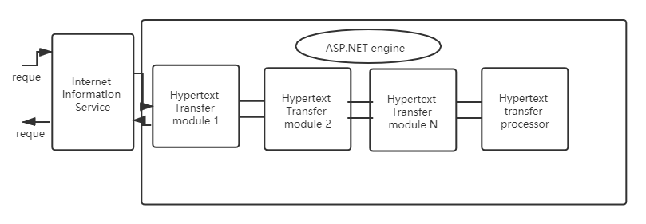
Figure 1 ASP.NET Request Processing Based on Pipeline Model

2.2.2 HTTPHandler
An HttpHandler is truly an HTTP request processing center, in an HttpHandler container, ASP.NET Framework server to the client request page to compile and execute, and attach the information after the processing in the HTTP request stream once again return to the HttpModule. IHttpHandler defines if you want to realize the processing of an HTTP request must be implemented by some system interface.

2.2.3 Handling HTTP requests
When an HTTP request through with HttpModule containers to an HttpHandler, ASP.NET Framework will call an HttpHandler members of the ProcessRequest method to the real processing HTTP requests.
For the aspx page, ASP.NET Framework by default to HttpHandlerFactory to deal with.
When an HTTP request to the HttpHandlerFactory HttpHandlerFactory will provide a an HttpHandler container, by an HttpHandler container to handle HTTP requests. An HTTP request is ultimately to a an HttpHandler containers ProgressRequest method to deal with. The ASP.NET page IhttpHander is realized.
The aspx page is made up of the system. Web. UI. Page derived classes. So every page of asp.net as an HttpHandler processing class. It contains all of the features of the web page, but the whole page, the page is very large, need to deal with the control resolution in the page and the page. Processing page system overhead, and limited functions, efficiency is low. Through the understanding of the principle of ASP.NET, in addition to using the default an HttpHandler processing request, can pass the custom HttpModule or an HttpHandler intercepted the Ajax script request, asynchronous requests and generate the corresponding Ajax engine script, the current data cache and data processing operations such as page differences. It is proposed here. Ashx to implement an HttpHandler. Similar to ashx file. Aspx file, have derived IHttphandler interface, can pass it to invoke an HttpHandler class, eliminating the common. Aspx page controls parsing, and the processing of the page.

2.2.4 The web development model based on Ajax
Based on ASP.NET IIS server and combined with the working principle of Ajax [6] proposed between the user and the server to add a layer, change the traditional way of page is loaded, in the session, the middle layer using JavaScript client-side events in the aspx page. Complete user interface communication with the server. As shown in figure 2.
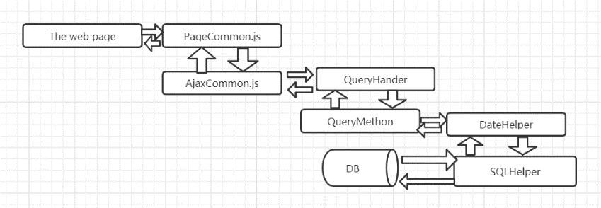
Figure 2 Improved Development Model
On the client side, the web page is made up of Html controls, and in the aspx file writing event-driven programs, when the event is triggered, call PageCommon, js, this document provides a common page call interface, complete page of business processing operations, such as add, delete, modify, query, etc., to complete the communication with the server, the information to the AjaxCommon. Js processing, AjaxCommon using Jquery support for Ajax, asynchronous communication requests to the server, the user's request to submit to the server, complete the communication with the server.
Through the above analysis, it can be seen that the client is made. Aspx, PageCommon. Js, AjaxCommon. Js form the client, the response of the user action no longer request directly to the server. Simple data validation, for example, can be completed by the middle tier. Reduce the server load and improve the operation efficiency.
On the server side, write Queryhandler ashx, Queryhandler by implementing IHttpHandler interface to create a custom HTTP handler, the interface consists of two methods. By calling the method IsReusable IHttpHandlerFactory can query processing program to determine whether can use the same instance to provide services for multiple requests, and the ProcessRequest method will HttpContext instance as a parameter, which makes it able to access the Request and Response objects inside.
Through the above analysis, an HttpHandler is a completely custom Http request, the method of using. Ashx file to invoke an HttpHandler class, eliminating the common. Aspx page controls parsing, and the processing of the page. Improve the efficiency of the program's execution. And through this layer and database access layer to complete the operation of the database. Including QueryMethod define specific business way, encapsulating business method of the application, provide a business operation interface; SQLHelper database access layer, through ADO.NET wraps to the operation of the database, such as query and update. DataHelper provide data of the common processing ways, such as XML processing, database of deletion and query processing;

2.3 Operation database technology

2.3.1 An overview of the ADO.NET
ADO.NET is upgraded by ADO.
ADO full ActiveX Data Objects, it is Microsoft's technology is used to access Data, is the latest technology after the ODBC [8]. But ADO.NET is not a simple upgrade version of ADO, it is a new object-oriented model, it is more suitable for distributed and large than ADO application environment, the platform neutrality, scalability and high performance is better than ADO data access ways. ADO.NET is a group to.net programmer used in public and data collection of object-oriented classes interact, the collection offers a variety of ways to access data in a database and provide the data in the database retrieval, processing and updating the features of ADO.NET, is a. NET indispensable a core technology in [9].
ADO.NET provides two core components, including the. NET Framework data provider and the DataSet. The.net Framework data provider provides some core elements of the ADO.NET process, such as Connection, Command, DataReader, dataadapters. It is mainly used for connection to the database and execute. The DataSet are dataadapters architecture of a data set, is to provide diagrams of high speed buffer memory, it can save the query to the data from the database, and these data can be displayed.
But the DataSet itself does not have the ability to interact with the database, it is independent of any data access data sources, this also is the core aim of the DataSet, it well realize the disconnect access, and whatever is stored in the data from a relational database or an XML document, the data set is through the use of the same program templates are operating, such not only can improve performance, also can avoid the server maintenance data source for a long time and cost.

2.3.2 At ADO.NET to access the database
ADO.NET and ADO.NET is the interface between ASP.NET and database access data source is through. Program is provided with the.net Framework Framework. ADO.NET offers developers a rich data access object, and using these objects, can finish all the operation of ADO.NET. ADO.NET introduces below the data objects [10], its object model is shown in figure 3.
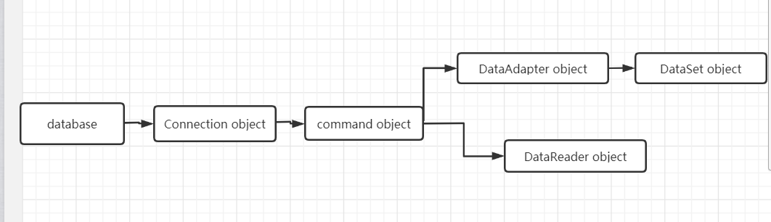
Figure 3 ADO.NET Object Model
(1) Connection object: at the bottom of ADO.NET, is used to connect to the database;
(2) Command objects: architecture on the Connection object, to perform operation Command, data source and returns the results;
(3) Dataadapters object: architecture on Command objects, provides many DataSet to use function, make the channel between the DataSet and data source;
(4) The DataReader object: complete database data read, don't allow other operations, in the environment requires only read, save resources and efficiency;
(5) The DataSet objects: the server database in memory.
Can be seen from figure 3 ADO.NET 5 objects can provide two database access patterns: the first is the use of the Connection and Command objects, this model can not change the database records, can only read the record, applicable to only need to query records; The second is to use the Connection, Command, dataadapters and DataSet objects, this model can undertake various operations on database, use rise more flexible. Two ways to access data in a database principles are the same, compared with the traditional way of ADO access, ADO.NET introduces the DataSet, the DataSet provides high-speed buffer of data relationship, know nothing about the data source, it is not dependent on database independent set, so even close the database connection, the DataSet is still available.
ADO.NET to access the database step [11] as follows:
(1) Establish a database Connection, in this system, the establishment and SQL Server database Connection, so as to create the Connection object;
(2) through the Command object request a data collection;
(3) the data collection for DataSet;
(4) the database connection is closed;
(5) required for operation in the DataSet.

2.3.3 ADO.NET features
(1) Simple flexibility
ADO.NET provides a different file on the data library, so developers can more real-time, more convenient to dialogue with data, regardless of the data format or data source.
(2) scalability
In theory, using ADO.NET technology can access almost all the existing relational database, and the relational file, so to a great extent improve the scalability of ADO.NET.
(3) standardized
Relational database and XML data sources such as ADO.NET to provide a unified access standards, users can easily use ADO.NET technology to connect to the data source, and these data sources are the corresponding operation.
(4) High interactivity
In ADO.NET, the data is through the XML format to store, XML format can be used in a variety of data interface, has become the most thorough data exchange mode, so the data in the middle of the transport process does not require any type.

2.4 Conclusion
In the second chapter, from the ASP.NET technology is introduced, the application architecture and principle of the ASP.NET analysis, database technology in this paper, the operation is based on three aspects introduced. The web system development process and principle of the.net framework.
In the next chapter, elaborates on the programming language used in the actual development, the development environment, the front frame and the database.

3 Research and development (if applicable)

3.1 A programming language C SHARP
C SHARP [12] is an object-oriented language, you need to create classes and objects, its syntax is similar to C, it is to belong to one of the C language family. But C SHARP and has many differences with C, C is an international standard, do not belong to any country or company, and C SHARP is Microsoft's a language development. And C SHARP slam the door in some of the underlying C or more difficult technology, such as Pointers, without these restrictions, C SHARP development is not as flexible as C, C SHARP but paying attention to the development of the packaging and actual application, it is not so complicated C, improve the efficiency of software development [13]. Important is C SHARP is specifically for Microsoft company..net Framework tailor-made program design language, a better combination of C SHARP and. NET Framework [14]. In the current Web development language, C SHARP is one of the most popular. It has the following characteristics [15] :
(1) Grammar is simple
With C SHARP language like C and Java language object oriented advantage, at the same time has a more concise than the C language syntax, it abandoned the C in the complex technology, lower demand for developers, improve the development efficiency.
(2) Rich data types
C SHARP is better than C, C SHARP and Java language rich data types, such as Boolean, byte, ubyte, amass, short, int, uint, long, ulong, float, double, a decimal. These data types are signed and unsigned both formats. A decimal is a new data types of C SHARP, for currency data, it can store 28 decimal Numbers.
(3) The namespace
In the use of C SHARP when creating an application, will use the namespace.
Namespace as class contains, in the namespace can create one or more classes, using keywords using to invoke other namespaces. Use namespace to make programmers more convenient use ADO.NET classes. The base class or custom class in the namespace name can not only prevent conflict [16], but also can implement code reuse and reduce the error code rate.
(4) Tightly integrated with the Web
C SHARP language is the company specifically for Microsoft.net design language, this marks a C SHARP can combine with Web is better than other languages. Programmers can take advantage of the object-oriented knowledge they have hands, and C SHARP components can easily develop Web services, and allow them to be run through the Internet language calls on any operating system. For example, C SHARP will allow direct mapping the XML data structure.
(5) Method can be as parameters
In C SHARP language, can not only to pass data type value, can also pass by reference.
In the reference, you can pass by the constructor or member function parameters.
C SHARP, not just the above advantages, it also can have high security, flexibility and compatibility, intermediate code generation, etc. Use C SHARP as a background to develop language is not second choice. This report adopts C SHARP as a programming language.

3.2 Microsoft Visual Studio development tools
Visual Studio is by far the most popular of the succession of Windows platform application development environment.
Visual Studio has three prominent performance aspects: application development speed, good team work efficiency, the user experience. With Visual Basic language in Visual Studio, convenient and rapid transition to Visual Studio developers from vb6.0 by use this big family, Visual C language is a tool for the developers to use C, Visual C SHARP, Visual Studio's most widely used language, can be used to create a Windows forms applications, user interface and can be used for web page development, function is very powerful.
Visual Studio provides a very convenient user development platform, also provides the help of the test tool to improve the quality of development, speed up the development speed, reduce the error rate of development.
Visual Studio to develop procedures, can the operation of the good in the Windows platform, and in view of the Microsoft SQL Server database provides a large number of interface support, can be very convenient for enterprise application development.

3.3 The Bootstrap front-end framework
The Bootstrap is very popular a web front-end UI framework [17], numerous front-end developers contributing to the Bootstrap code, make more robust Bootstrap framework, function more rich. The Bootstrap front-end framework provides a common CSS components and JavaScript components, enables developers to very convenient use.
The mall management system implemented by this report are based on the front end of the page the Bootstrap front-end, construct the framework of the Bootstrap front-end framework as the target and the most popular application framework has the following advantages of the most widely [18] :
(1) The Bootstrap framework can quickly build a web page
Building the front-end web pages need to write a lot of CSS file, however write CSS file is a complicated work, need accurate design elements of the width and height, and requires developers to have a certain art language, to design a web page. Not only that, if developers do not have rich experience in the CSS code, also can cause a lot of redundant code, for a web front end performance loss is huge. Bootstrap framework can solve the above problem, because the Bootstrap framework component that encapsulates the CSS with CSS class declarations and definitions in the form of developers only need to quote the Bootstrap in HTML tags in the CSS class will be able to achieve elegant layout, such as navigation, buttons, text boxes and other components, so using the Bootstrap framework to be able to use its components to complete the construction of a web page quickly.
(2) The Bootstrap front-end framework to solve the problem of browser compatibility
At present there are five major browsers: Internet Explorer browser, Chrome, Firefox, Safari and Opera browser. Although the W3C defines the HTML code and CSS specification, but these major browsers do not fully carried out in accordance with the standards implementation, so the same CSS styles in different browsers sometimes after different rendering, the application of CSS style HTML tag elements have different performance, but writing compatible browser mainstream 5 kinds of style to write complex hack code, not only need a lot of the difficulties in realizing the test code compatibility and easy to produce the CSS code redundancy and errors, affect the web performance. The Bootstrap CSS within the framework of the front-end components made a compatible with the mainstream browsers and optimization, make each browser performance style is consistent, avoid the compatibility error.
(3) Compared with other front-end framework the Bootstrap front-end framework supports responsive layout
The Bootstrap front frame compared to other front frame, such as framework Elements, one big advantage of YUI Grids framework is to support the response type layout, which can make the web web page properly according to different screen size adaptation. Because users use the terminal type is different in the past, with the users to use the computer to browse the web, with users of mobile browser web pages, computer screen size and screen size difference is very big, so web site developers need to write two sets of web pages, a set of web pages to support the PC version, another set of pages to support the mobile version, no doubt increased the development effort, is not conducive to site maintenance. But the Bootstrap framework supports responsive layout, only need to reference the Bootstrap CSS component framework, web pages can response type according to different size of screen layout, do a web page can fit different screen.
Due to the Bootstrap front frame has the obvious advantages, and therefore has been widely applied in the actual project. So, this report the mall management system designed display page is based on the Bootstrap front end the construction of the framework.

3.4 SQL Server
SQL Server is Microsoft company launched a relational database system. Easy to use, SQL Server database to hardware requirement is not high, can be in good running Windows Server platform, can meet the requirements of most enterprises. More powerful, the data storage platforms accord with the requirement of system builds [19-22]. And the.net platform and SQL Server2012 developers are the same, incompatible situation will not occur.
The use of SQL Server2012 advantage more, specific as follows:
(1) Using Oracle11 databases for a fee, and after-sales service is costly.
Higher requirements to the database server, and SQL Server2012 can free to use, so use SQL Server2012.
(2) Server2012 SQL database supports a variety of development technology on the market, such as the popular development technologies: PHP and JAVA technology, etc., can interact with SQL Server2012 [23-26].
(3) Server2012 SQL database server to server request is not high and compatibility of many, such as Windows, Linux operating system, database application can be deployed and SQL Server2012 [27-28].
(4) SQL database Server2012 was first launched in 1988 the first OS / 2 version.
Still has a long history, the use of time is long, stable and through a variety of system calibration [29-31].
(5) Server2012 SQL database through data protection and access control mechanism to ensure system safety and efficient use [32-35].
(6) SQL database Server2012 installation process have perfect operating hints, use very convenient.

3.5 Conclusion
This chapter introduces the development process used in the related technology, selection of C SHARP programming language. NET web development, the development environment for Visual Studio2013, front page using the Bootstrap system framework design, data information in SQL Server2012 database for storage.The next chapter will discuss how to design the system.

4 The design of the mall management system
In object-oriented software development process, the system design is one of the essential link, it is the key step in the software development process to ensure quality. Design software, said that makes it possible to software quality evaluation. In addition, the software design is the user's requirements accurately the only steps into a software product, is the basis for the follow-up work to develop and maintain software.
Software design work, if you have a developed software system must be unstable.

4.1 System overall structure design
Mall management system adopts B/S structure development [36], this structure is a kind of brand-new network after the rise of the Internet application development model, use the browser as the user use the client. System developed in this model saves the user install the client on the computer, can operate directly using the browser. Most of the application system is focused on the server, system maintenance and upgrade easier. Users only need to use the browser login system, access to the web server and database to interact. Using B/S structure of development, can save the client computer load, at the same time can reduce maintenance and upgrade costs, reduce the development cost of the system.
A store management information system should have the following characteristics: (1) the efficient and convenient. The use of the information management system of the mall, can greatly save managers and users' time, makes the market daily sales statistics become more convenient and quick, store manager and staff can quickly in time to see the goods, can timely to judge goods inventory situation. (2) basic does not need to account for more and resources. The system adopts the man-machine dialogue mode, the operability is greatly increased. Beautiful and friendly operation interface, flexible information query, fast, accurate, safe and reliable data storage. (3) query is convenient, the realization of the mall setting and some internal information query, query can be convenient to realize the condition query inventory information. (4) safe and tight. For users and administrators of input data, the system for data checking, as far as possible eliminate human error, introducing the rights management, different identity of the user login according to the function of the permission to see is not the same. The system runs stably, safe and reliable.
In the design of system, the design should follow the following principles:
(1) the Usability, robustness design system should follow the principle of Usability, robustness, when user input error, should be in the original screen prompt error message, and at the same time should not delete the user of the original information.
If the system is not a serious mistake, can't can not be used, the whole system has some fault tolerance. If an operation of the system need to perform for a long time, the system should use asynchronous processing, can't let users have been waiting for, the user can perform other operations, the system has better usability.
(2) the system reliability design should follow the principle of reliability, the system should use a few reasonable transaction processing mechanism, in the process of data cannot be incomplete, must ensure that data is safe.
(3) the usability design of the system should follow the principle of ease of use, in general, no more than 5 steps for each operating step. When the user input data, can choose not to let the user input, can not let the user input from the database call.
(4) security design system should follow the principle of security, the system should have complete authority management mechanism, the user can only see his own function, without permission of the function point does not display in the system.
(5) the scalability design system should follow the principle of extensibility, the system function design should follow the principle of modular design, the system can easily extend the functionality in the future.
(6) system of maintainability design should follow the principle of maintainability, system code and design documents should be complete, writing code that conforms to the specification, code should have enough comments, make easy maintenance system in the future.
(7) compatibility, portability, design of the system should follow the principle of compatibility, portability, the system should be able to run on different operating system server, on a different server, the function should be no big difference. In follow these principles to the mall management system on the basis of demand analysis, the mall management system for the overall structural design in this paper. Mall management system mainly including rights management, information entry, business management, customer management, merchandise six in-out warehouse management and order management functions. Mall management system overall structure block diagram as shown in figure 4.
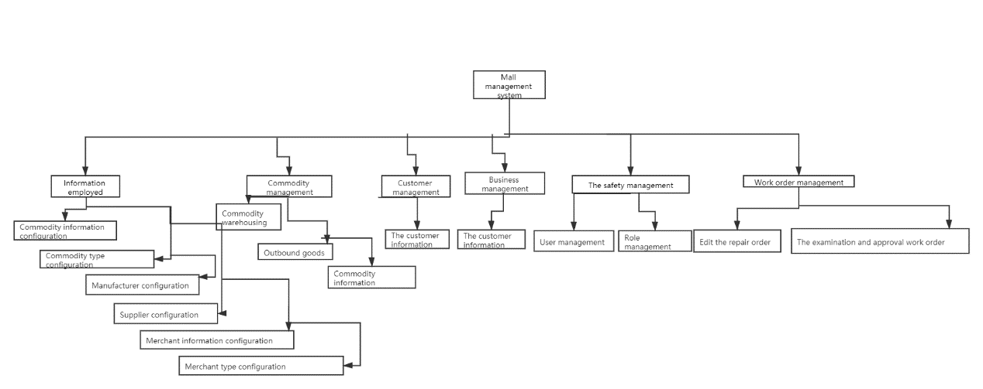
Figure 4 Overall System Structure Diagram

4.2 System function modules in detail design

4.2.1 Rights management function module design
Rights management mainly includes the role authorization management, rights management two major functions.
Role authorization management: the role authorization management is mainly to manage the role of the system, including the role of add, delete, change, check operation.
After the user login system, according to the user and its subordinate role to judge whether there is a rights management function, if has the function of access to rights management page, you can add role, at the same time can also to modify, and delete a character. Click "add" role name after input, determine whether information is correct, if correct save and load databases, reload the page character information and show, if the information is not correct, prompt the user to input.
Role authorization management module can also according to different roles in different permissions allocation, check the need to assign permissions to roles, and click "modify role authorization" all popup menu list, the need to assign permissions menu to add "browse", "add", "edit", "delete", "query", etc.
Rights management: personnel rights management features under merchants all staff role information, and realize the permissions assigned to specific personnel.

4.2.2 Information input function module design
When a merchant to buy goods need inputs commodity information in the system, information recorded mainly includes commodity information recorded, the types of goods entry, manufacturers, recorded and supplier recorded four functions. Commodity information recorded and commodity type recorded respectively increase new commodity name and a new category.
Supplier entry need to fill in the name of the supplier, name, head, head of the mobile phone number and contact address. Manufacturers entry need to fill in the name of manufacturer, name, head, head of the mobile phone number and contact address.

4.2.3 Business management function module design
Business management mainly manage each of the merchants in the market, mainly divided into types of merchants and merchants information recorded two functions of the input, merchants type entry is in order to better management of merchants, in order to facilitate the administrator can also compare the performance of similar businesses or no gap between similar businesses.
Add merchants types of process is as follows: after entering the system administrator, click the menu button to enter "merchants type entry" merchants type entry page, click on the "new merchants type" after the input type information, system information is complete and correct, no problem if the information is saved to the database, if will prompt the user to input information problems.
Merchants information input function administrator and store administrator can log in, add the process of business information is as follows: after users enter the system, click the menu button to enter "merchants information recorded" merchants information entry pages, click on the "new merchants information", fill in the name of merchants, business category, name, head, head of the mobile phone number, affiliated middle floor, subordinate to the number and area and so on.
Complete and then click the "ok" button, the system receives user input, and then determine the completeness and correctness of the information, if the information is complete and accurate, is saved to the database, if the information is not correct, prompt the user to input.

4.2.4 Customer management function module design
The customer management function is mainly to fill in the customer information. When a certain product is shipped out of the warehouse, the customer's mobile phone number to buy the product needs to be entered, and the customer's points need to be automatically updated. In this case, the customer's detailed information needs to be entered first. Add customer information process is as follows: after users enter the system, click on the "customer information" menu button to enter the customer information input page, click on the "new customer information", fill in customer name, customer number, mobile number, customer gender, birth date, the customer integral initial is 0, the default is to fill out. After completion, click "OK" button, the system receives the user's input, and then determines the integrity and correctness of the information. If the information is complete and correct, it will be saved to the database, and if the information is incorrect, the user will be prompted to re-enter.

4.2.5 Design of the function module of goods in and out
The goods purchased or sold in the mall need to be input into the management system of the mall in the form of data. The function module of goods in and out of the mall mainly includes three parts: goods in and out of the mall, goods out of the mall and goods information.
The entry page of goods needs to input the specific information of the goods. Add GRN process is as follows: after users enter the system, click on the "commodity warehousing" menu button to enter the goods warehouse entry page, click on the "new warehouse receipts", in the entry in the name of commodity, the types of goods before choosing the warehousing goods corresponding to the name of commodity, commodity type, enter the goods from the bar code as a unique identifier, input storage quantity, purchase price and shelf-life, choose to buy the goods from the merchants, manufacturers and suppliers. After completion, click "OK" button, the system receives the user's input, and then determines the integrity and correctness of the information. If the information is complete and correct, it will be saved to the database and the current storage time will be recorded. At this time, an entry number will be automatically generated; if the information is incorrect, the user will be prompted to re-enter.
The goods delivery page needs to enter the relevant information of the goods sold. Choose corresponding warehousing goods according to the barcode, click ok after found in the database according to the barcode library information, the name of commodity, commodity type, bar code, shelf-life, into the library merchants echo to the page, and automatically generate outbound order number, user fill in the delivery, the outbound price, outbound customer phone number, click ok, the system receives user input, and then determine the completeness and correctness of the information, if the information is complete and correct, then save to the database, and record the current delivery time, if the information is not correct, prompt the user to input.
The commodity information page mainly lists the details of purchased commodities, including barcode, commodity name, commodity type, inventory, incoming quantity, sales volume, cost, trading volume, shelf life, manufacturer, supplier, warehousing time and delivery time.

4.2.6 Work order management function module design
The work order management is mainly used for the application approval of the merchant's repair report, shop assistant's leave, purchase, etc., including editing work order and examining and approving work order.
Edit the work order page to create a new work order, select the work order type, fill in the floor and the merchant number, and fill in the specific work order content for review by the approver.
On the approval work order page, only the work order that has not been approved and the current logged-in user has approval authority will be displayed. When the current logged-in user clicks "View Details" or "approve work order", it means that he has accepted the approval of the work order, and then other people with approval authority will not be able to view it.
All work orders have a status bar indicating the current status and a more prominent color indicating to make it more intuitive and convenient for users. The status of "pending approval" is marked in light blue, the status of "in progress" is marked in yellow, the status of "withdrawn and invalid" is marked in red and the status of "finished" is marked in dark blue.

4.3 Conclusion
This chapter designs 6 main function modules for the shopping mall management system, which are: authority management function module, information input function module, merchant management function module, customer management function module, commodity warehousing function module and work order management function module. Each function module has a detailed sub-menu.

5 Database table structure design
Combining with the system software flow, we can know that data management is the foundation of the system software operation. So in the design of shopping mall management system, the need to complete the system database development design. Combined with the system data scale, using SQL Server2012 database technology. The database is characterized by small size, high availability, and excellent open source, which can facilitate the daily maintenance of the system. And the database design needs to ensure security, integrity, scalability, can realize the analysis and processing of massive operational data, and strengthen data backup and storage in case of system crash, so as not to affect the normal operation of the system. The actual use of SQL Server2012 can not only provide support for Windows system, but also for Linux operating system. As a major product version, SQL Server2012 provides rich functions, which can use SQL statements to complete system data query and apply different data relationship models such as tree and network. The entire database contains multiple tables of data that can be invoked using a relational library as a platform.
In the actual process of system database design, the corresponding model selection should be completed, corresponding data table and field creation should be realized, and data table creation should be carried out in combination with system requirements.
In the design of the shopping mall management system, it is necessary to use the user table to complete the storage of various login user information, including fields such as user name and password. By reading the data table information, the basic user information can be obtained. The structure of the table is shown in Table 1.
Table 1 User_Table
field name | Data element | Length | Whether can be empty | Primary key or not | foreign key or not | note
user_id | int | 11 | no | Yes | no | The user ID
name | char | 39 | no | no | no | The user name
pwd | int | 11 | no | no | no | The user password
create_time | datetime | 20 | no | no | no | Creation time
update_time | datetime | 20 | Yes | no | no | Update time
In the authority management function module, role table and menu table are required to assign role permissions, and the structure of the table is shown in Table 2。
Table 2 Role_Table
field name | Data element | Length | Whether can be empty | Primary key or not | foreign key or not | note
role_id | int | 11 | no | yes | no | Character ID
name | char | 39 | no | no | no | Character name
node | int | 11 | no | no | no | node
create_time | datetime | 20 | no | no | no | Creation time
update_time | datetime | 20 | yes | no | no | Update time
The tables involved in the information entry function module include commodity table, commodity type table, supplier table and manufacturer table. The structure of the tables is shown in Table 3, 4, 5 and 6.
Table 3 Goods_Table
field name | Data element | Length | Whether can be empty | Primary key or not | foreign key or not | note
goodsId | int | 11 | no | yes | no | Product ID
goodsName | char | 39 | no | no | no | Name of commodity

Table 4 GoodsCat_Table
field name | Data element | Length | Whether can be empty | Primary key or not | foreign key or not | note
catId | int | 11 | no | yes | no | Item type ID
catName | char | 39 | no | no | no | Commodity type

Table 5 Supplier_Table
field name | Data element | Length | Whether can be empty | Primary key or not | foreign key or not | note
supplierId | int | 11 | no | yes | no | Vendor ID
name | char | 39 | no | no | no | Supplier name
managerName | char | 39 | no | no | no | Name of person in charge
phone | char | 20 | no | no | no | Cell phone number of person in charge
address | char | 60 | no | no | no | address

Table 6 Manufactor_Table
field name | Data element | Length | Whether can be empty | Primary key or not | foreign key or not | note
manufactorId | int | 11 | no | yes | no | Manufacturers ID
name | char | 39 | no | no | no | Name of manufacturer
managerName | char | 39 | no | no | no | Name of person in charge
phone | char | 20 | no | no | no | Cell phone number of person in charge
address | char | 60 | no | no | no | address
The tables involved in the merchant management function module include merchant table and merchant type table. The structure of the tables is shown in Table 7 and 8.
Table 7 Seller_Table
field name | Data element | Length | Whether can be empty | Primary key or not | foreign key or not | note
sellerId | int | 11 | no | yes | no | Manufacturer ID
name | char | 39 | no | no | no | Name of manufacturer
type | int | 11 | no | no | yes | Merchant type ID
managerName | char | 39 | no | no | no | Name of person in charge
phone | char | 20 | no | no | no | Cell phone number of person in charge
floor | int | 11 | no | no | no | Subordinate to the floor
address | char | 60 | no | no | no | address
area | float | 11 | no | no | no | Covers an area of

Table 8 SellerCat_Table
field name | Data element | Length | Whether can be empty | Primary key or not | foreign key or not | note
Id | int | 11 | no | yes | no | Merchant type ID
cat_name | char | 39 | no | no | no | Merchants type
The tables involved in the customer management function module include the customer information table, and the structure of the table is shown in Table 2-9.
Table 9 KHInfo_Table
field name | Data element | Length | Whether can be empty | Primary key or not | foreign key or not | note
id | int | 11 | no | yes | no | Customer ID
name | char | 39 | no | no | no | Customer name
birthday | datetime | 20 | no | no | no | Date of birth
sex | char | 2 | no | no | no | gender
phone | char | 20 | no | no | no | Mobile phone no.
carId | char | 13 | no | no | no | The card number
point | char | 20 | no | no | no | integral
create_time | datetime | 20 | no | no | no | Creation time
update_time | datetime | 20 | yes | no | no | Update time
The tables involved in the commodity warehousing function module include the outbound table, the inbound table and the commodity information table. The structure of the tables is shown in Table 10, 11 and 12.
Table 10 StockIn_Table
field name | Data element | Length | Whether can be empty | Primary key or not | foreign key or not | note
stockIn_id | int | 11 | no | yes | no | Warehouse entry no.
goodsId | int | 11 | no | no | yes | Commodity name ID
goodsSn | char | 20 | no | no | no | Bar code
catId | int | 11 | no | no | yes | Item type ID
inAmount | int | 20 | no | no | no | Inventory quantity
cost | int | 13 | no | no | no | Replenish onr's stock price
performer | int | 11 | no | no | yes | Operation of ID
in_time | datetime | 20 | no | no | no | Storage time
sellerId | int | 11 | yes | no | no | Merchant ID
manufactorId | int | 11 | no | no | yes | Manufacturer ID
supplierId | int | 11 | no | no | yes | Vendor ID

Table 11 StockOut_Table
field name | Data element | Length | Whether can be empty | Primary key or not | foreign key or not | note
stockOut_id | int | 11 | no | yes | no | Library single number
goodsId | int | 11 | no | no | yes | Commodity name ID
goodsSn | char | 20 | no | no | no | Bar code
catId | int | 11 | no | no | yes | Item type ID
outAmount | int | 20 | no | no | no | The delivery
price | int | 13 | no | no | no | Sales price
performer | int | 11 | no | no | yes | ID of the operator
out_time | datetime | 20 | no | no | no | Storage time
sellerId | int | 11 | yes | no | no | Merchant ID
KHPhone | char | 20 | no | no | yes | Customer phone number
KHName | char | 39 | no | no | yes | Customer name

Table 12 GoodsInfo_Table
field name | Data element | Length | Whether can be empty | Primary key or not | foreign key or not | note
id | int | 11 | no | yes | no | Information ID
stockOut_id | int | 11 | no | no | yes | Warehouse entry no.
goodsId | int | 11 | no | no | yes | Commodity name ID
goodsSn | char | 20 | no | no | no | Bar code
catId | int | 11 | no | no | yes | Item type ID
saleCount | int | 20 | no | no | no | sales
goodsStock | int | 20 | no | no | no | inventory
saleCount | int | 20 | no | no | no | sales
cost | int | 20 | no | no | no | Unit price of purchase
price | int | 20 | no | no | no | Sales unit price
exp_date | datetime | 20 | no | no | no | Shelf life
sellerId | int | 11 | yes | no | no | Merchant ID
manufactorId | int | 11 | no | no | yes | Manufacturer ID
supplierId | int | 11 | no | no | yes | Vendor ID

6 The realization of market management system
After designing the system, it is necessary to realize the designed system. This chapter mainly realizes the designed system by modules. This system is built on the Visual Studio 2013 development platform and USES SQL Server2012 database to store data.

6.1 System login implementation
Login realization process: The user enters the website address in the browser and enters the system login interface, as shown in Figure 5. Then enter the user name and password in the login interface, and the system determines whether the user name exists. If so, the password entered is encrypted with MD5, and then compared with the password stored in the database. If the password is consistent, enter the main interface of the system, and login is over. If the username does not exist, the user is prompted to re-enter the password if the password is incorrect.
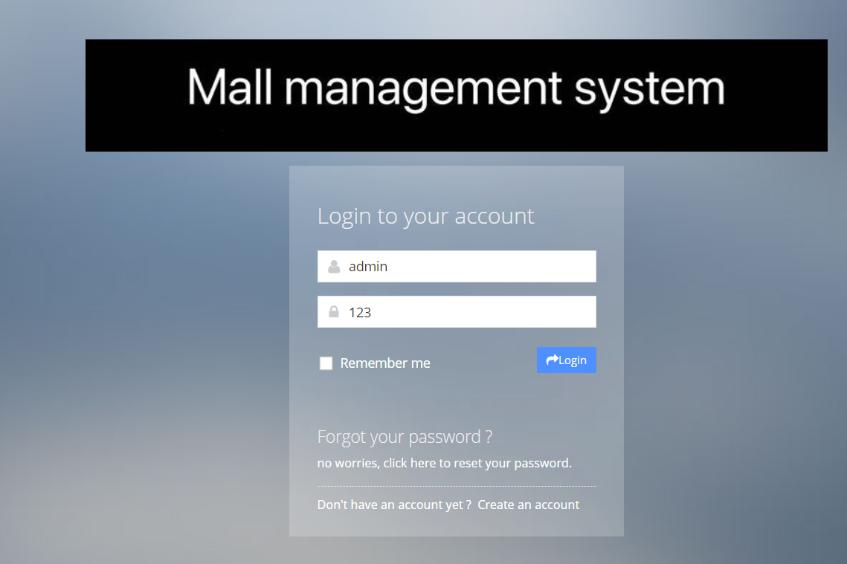
Figure 5 Login Page

6.2 Implementation of the main interface of the system
The main interface of the system is mainly divided into three areas, the top is the head area, the left is the menu table, the right center is the page display area. The implementation interface diagram of the main interface is shown in Figure 6.
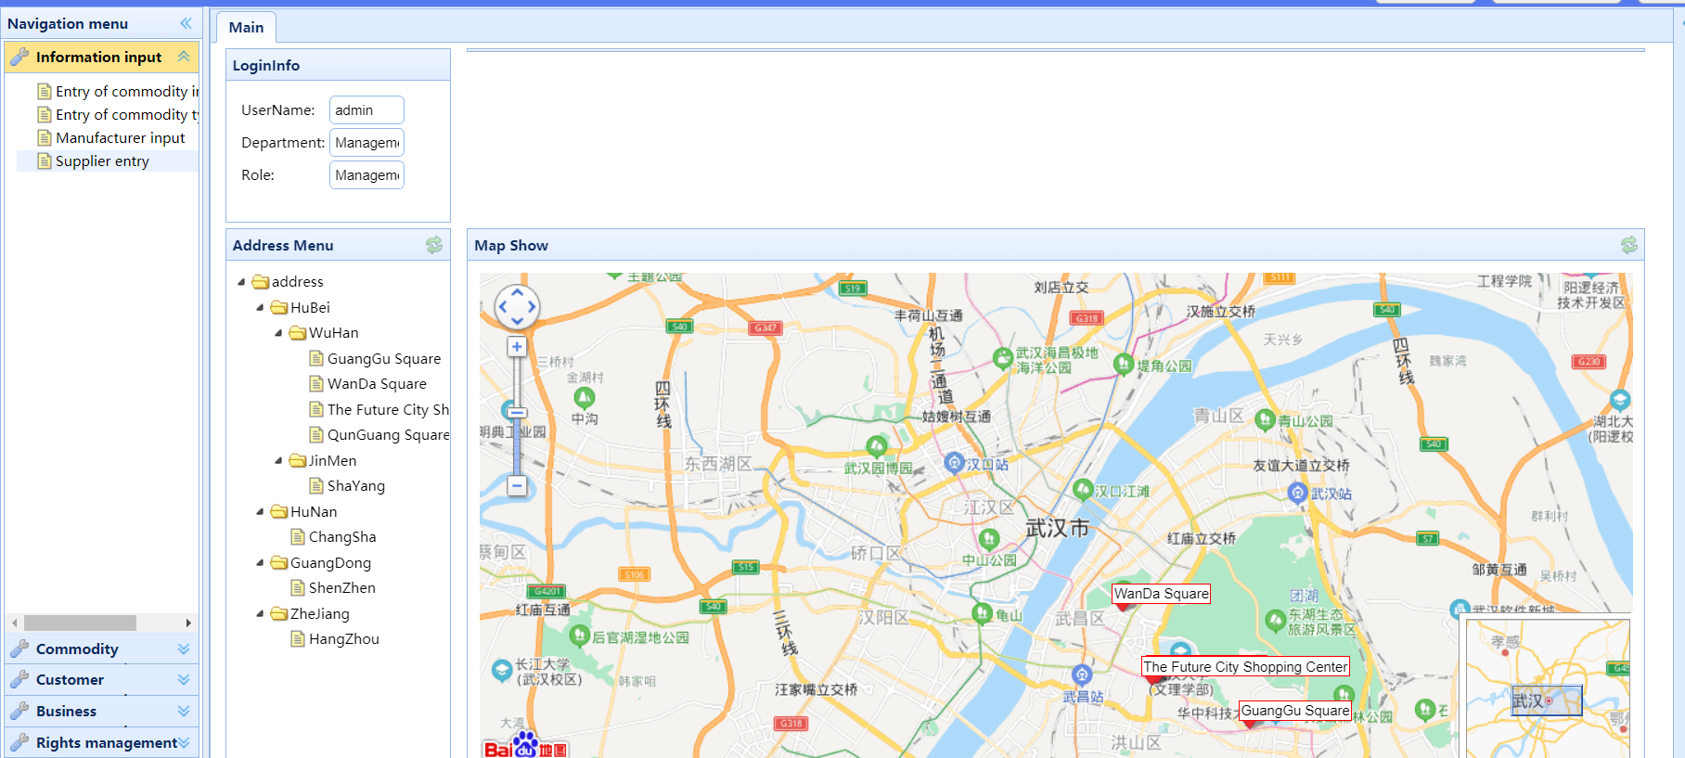
Figure 6 Main Page

6.3 The realization of system function module

6.3.1 The realization of authority management function module
Personnel authority management will list all roles under the current merchant and all users under that role. The interface of personnel authority management is shown in Figure 7. Select the user who needs to assign permissions under this page and click "page permissions" button to assign menu permissions to the specified user.
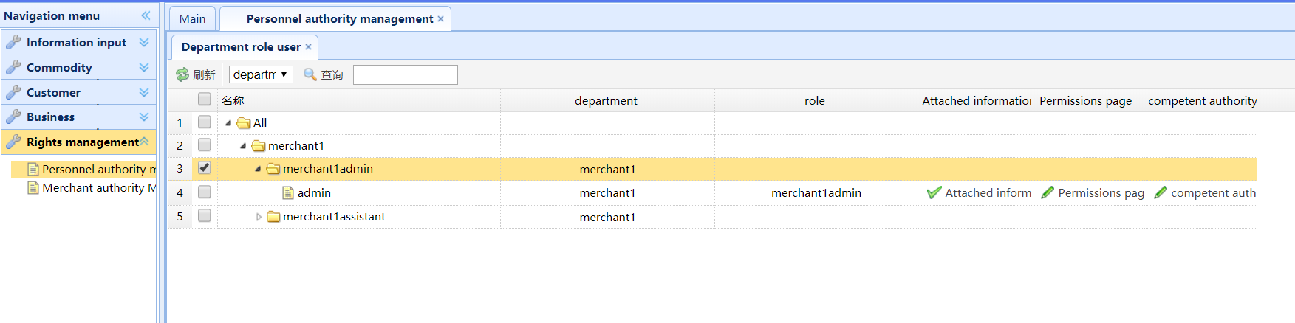
Figure 7 Personnel Authority Management Page
The merchant authority management interface shows all the existing roles, as shown in Figure 8. Click "Add role" to add a new role; select a role and click "Delete role" to delete; click "Edit Role" to modify the corresponding information; click "Modify Role Permissions" to modify the permissions of all users under the role.
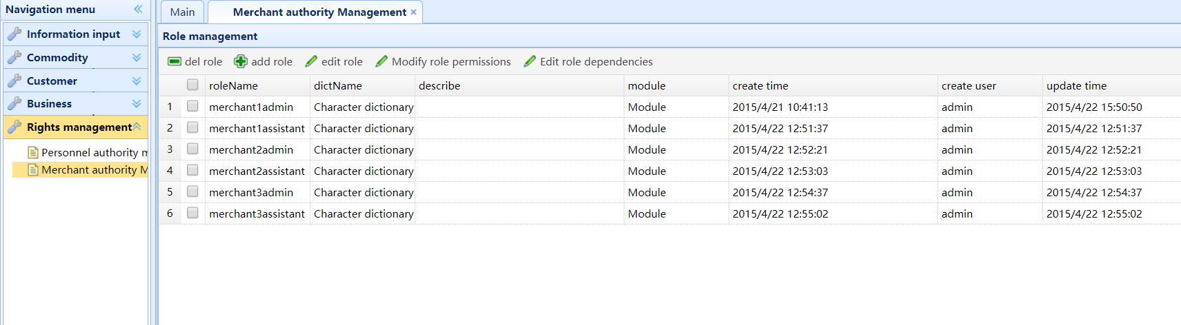
Figure 8 Merchant Authority Management Page

6.3.2 The realization of information input function module
The product information entry interface is shown in Figure 9. Click "New Information" to add new product information.
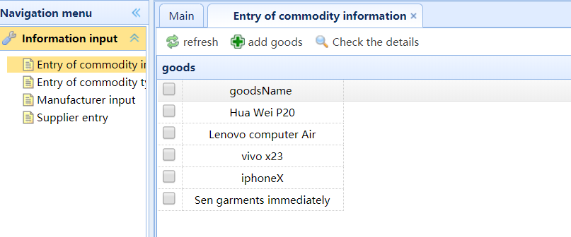
Figure 9 Entry of Commodity Information Page
The entry interface of commodity type is shown in Figure 10. Click "New Information" to add a new item type.
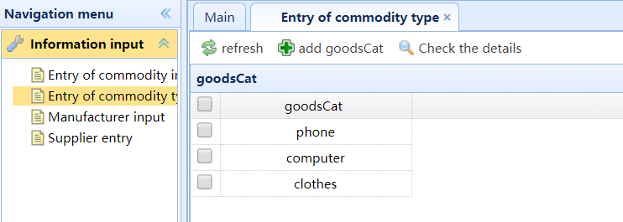
Figure 10 Entry of Commodity Type Page
The input interface of the manufacturer is shown in Figure 11. Click the "Add manufacturer information" button to add manufacturer information.
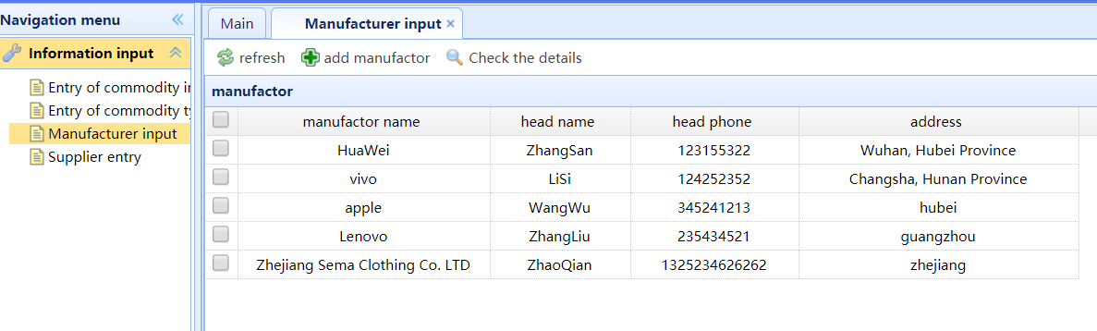
Figure 11 Entry of Manufacturer Page
The supplier entry interface is shown in Figure 12. Click the "Add Supplier information" button to add supplier information.
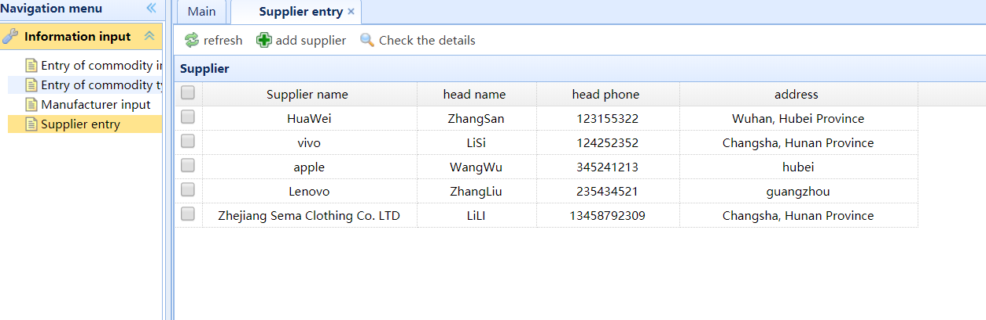
Figure 12 Entry of Supplier Page

6.3.3 The realization of merchant management function module
The merchant type entry interface is shown in Figure 13. Click "New Information" to add the merchant type.
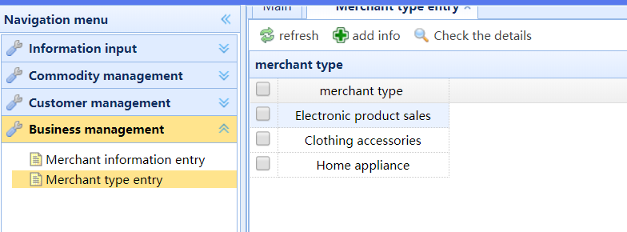
Figure 13 Entry of the Merchant Type Page
The merchant information entry interface is shown in Figure 14. List the name, attribute, person in charge, person in charge's cell phone number, building, number and floor area of all the businesses. Click "New Merchant Information" to add new merchants. Among them, the merchant attribute is an optional drop-down box. The existing merchant type that is loaded and entered is available for login users to select, and the building belongs to is also a drop-down box for users to select.
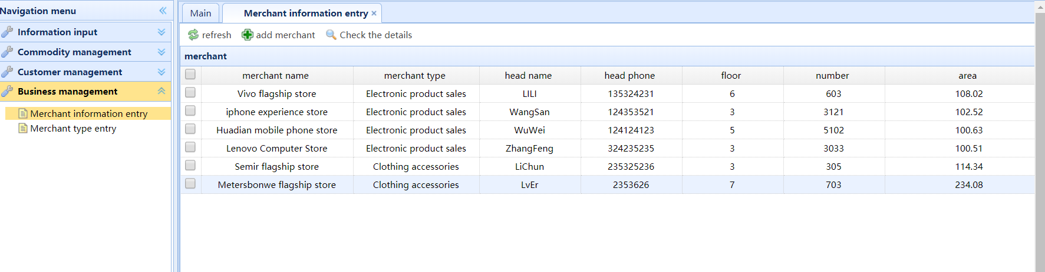
Figure 14 Entry of the Merchant Information Page

6.3.4 The realization of customer management function module
The customer information interface is shown in Figure 15. Display all customers' names, card Numbers, mobile phone Numbers, gender, date of birth, points, and creation time. Click "New Customer Information" to add new customer information. The gender is in the dropdown box for users to choose "male" or "female", and the date of birth is in the calendar for users to click. The initial default of the integral is 0, which is a non-inputable term。
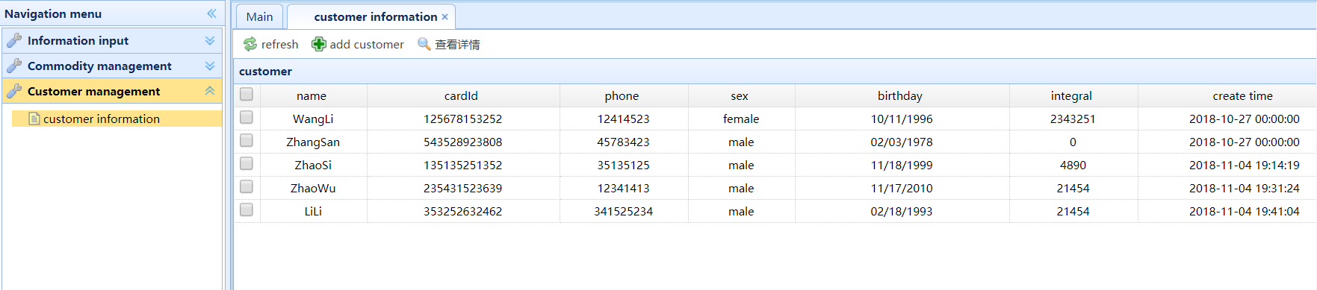
Figure 15 Customer Information Page

6.3.5 The realization of commodity in and out function module
The interface of commodity warehousing is shown in Figure 16. Display the serial number, name of goods, type of goods, barcode, quantity, total price of goods, warranty period, merchant, operator, warehousing time, manufacturer and supplier of each receipt. Click "New entry" to create a new entry. The entry number is non-inputable, and an entry number will be automatically generated. The name, type, manufacturer and supplier of goods are optional drop-down boxes, and the entered options will be loaded.
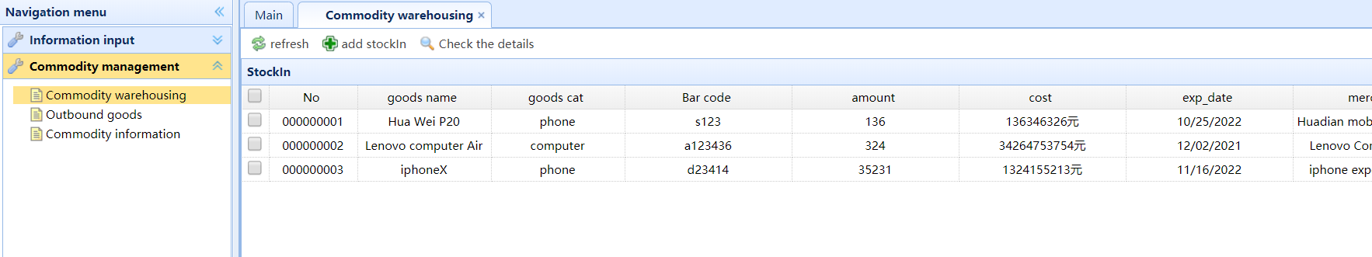
Figure 16 Commodity Warehousing Page
The interface of goods delivery is shown in Figure 17. Display the serial number, name of goods, type of goods, bar code, quantity, total price, warranty period, store-in merchant, cellphone number of customers, name of customers, operator and time of storeout of the warehouse. Click on the "new outbound order," you can create a new outbound order, the first thing you need to enter the bar code need outbound goods, if the bar code is found in the database to outbound order goods can create, if you don't say all incoming goods does not exist in the goods, the user need to input the correct barcode. After the user enters the correct barcode, the detailed information of the barcode, such as name, type, warranty period, store-in-store merchant, etc., will be added. At this time, the store-out order number will be generated automatically, which is not input-able. The user needs to enter the quantity, total price and mobile phone number of the outbound customer. If the customer information corresponding to the entered customer's mobile phone number cannot be found in the database, it means that the customer has not entered the information, which is equivalent to the tourist identity and has no points, and is displayed as "anonymous". If the customer information exists, the customer's name will be displayed and the corresponding points will be accumulated.
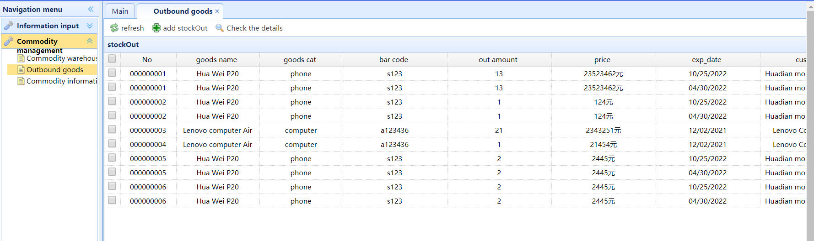
Figure 17 Outbound Goods Page
The product information interface is shown in Figure 18. Display detailed information of goods such as barcode, name, type, inventory, quantity, sales volume, cost, transaction value, warranty period, manufacturer, etc.
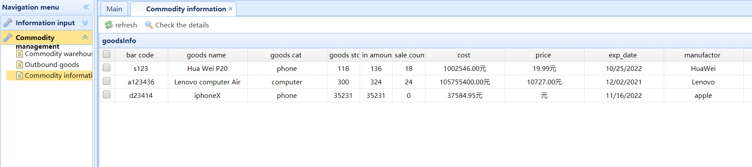
Figure 18 Commodity Information Page

6.3.6 The realization of work order management function module
The editing work order interface is shown in Figure 19. Display the progress of all work orders created by the current logon user. The display information includes work order type, content, place, status, initiator, launch time, approver 1, approver 1, approver 2, approver 2, approver 3 and approver 3. In the drop-down box after the work order type, select the type of work you want to see to filter the approval progress of only one type of work order. Click "New work order" to create a new work order. The type of work order to be applied for should be "merchant report", "purchase" or "clerk ask for leave", and the specific content and the current user's floor should be indicated.
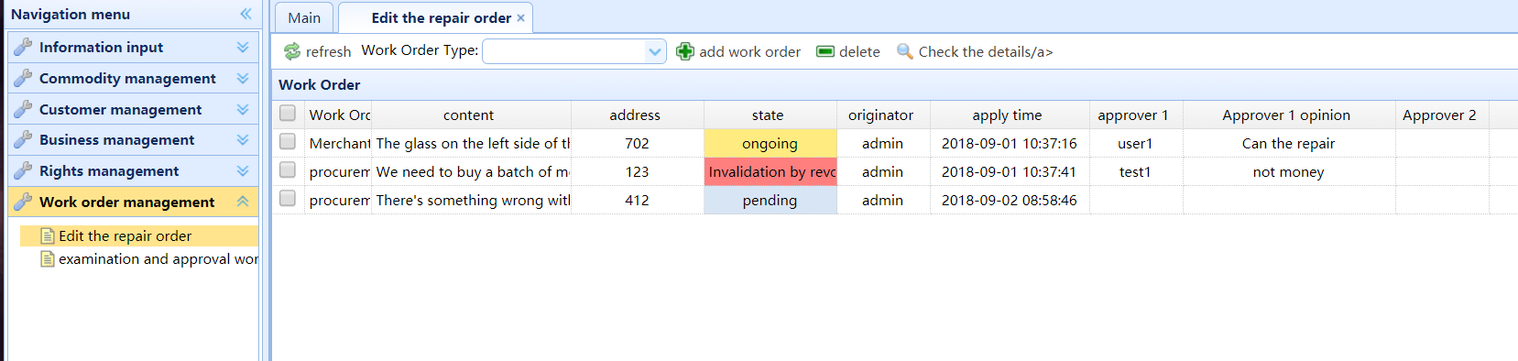
Figure 19 Edit the Repair Order Page
The interface for approving work orders is shown in Figure 20. Display all work orders that the current user has approval authority, and the work order has not been viewed or approved by other users who also have approval authority. The drop-down box can filter a certain type of work order for approval. Select the work order to be approved, click "Work Order for Approval", fill in the approval opinions, and confirm whether the work order application is approved or not. If rejected, the work order will not go through the next examination and approval link, and enter the state of "withdrawn and invalid". The work order application has not been approved, and it needs to be resubmitted according to the approval opinions. If you agree to the work order, it will go to the next approval stage, and the work order information will not be displayed in the current user. When all the approval procedures agree to pass, it means that the work order has been approved and the work order has been completed.
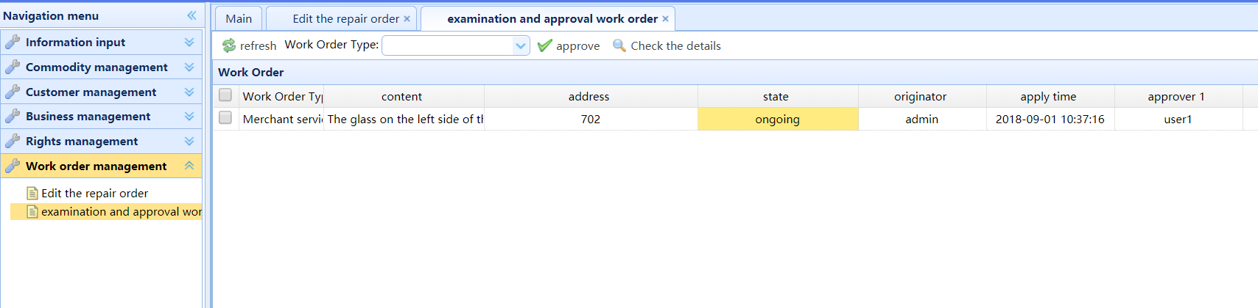
Figure 20 Examine and Approve Work Order Page

6.4 Conclusion
According to the function module design in chapter 4, the mall management system is set up to show the specific implementation effect of each function page.

7 CONCLUSIONS AND RECOMMENDATIONS

7.1 Summary
In the theme part of the report, the existing problems of traditional mall management are proposed, and the purpose and objectives of this report are proposed. On this premise, the web development based on.NET technology literature survey, study the characteristics of ASP.NET technology, application architecture and principle, operating database ADO,NET technical characteristics and steps, as a preparation for the study. Before the system design, the programming language, development tools, front-end framework and database needed in the development are introduced.
In the design and implementation of the shopping mall management system, this paper analyzes the characteristics of the system, and expounds the design principles to be observed in the design of the system, carries out the overall architecture design of the system, and completes the realization of the system according to the function points and database table structure design.

7.2 Conclusion
In the literature review section, ASP.NET technology, the implementation principle of web application architecture and the related research of ADO.NET technology operating database provide the theoretical basis and feasible basis for the design of market management system based on B/S architecture, and provide the knowledge reserve for the software development process, so as to carry out software development in a better way. In the system implementation of this report, ASP.NET is adopted as the system development mode, and the interaction between front and back ends is carried out through Ajax, and ADO.NET is used to connect to the database for adding, deleting, modifying and checking operations.
Part in the research and development methods, this paper expounds the characteristics and advantage of C SHARP programming language, this paper introduces the software development process used in the Visual Studio development tools for the design of the front page choose the Bootstrap framework and introduces the features of advantage, market management system also need to store goods, merchants and customers all kinds of information, so you need to choose the appropriate database for data storage, SQL Server2012 and. NET developers, same incompatible will not happen, and the advantage is more, Therefore, the system USES SQL Server2012 as the data storage platform.
In the design and implementation, according to the characteristics of the mall management system have and need to follow the principle of design, to a total structure design of system, the system is divided into rights management function module, information input module, the functions of business management module, customer management module, the commodity for the function module and six modules work order management module. Each function module has a detailed sub-menu. Design database table structure for the information storage involved in each function point, and complete the implementation of the system.

7.3 Recommendations for Further Research
With the rapid development of Internet, the amount of information grows exponentially. It can be said that the wide application of computers has brought profound changes to economic and social life. Whether the information can be collected and processed in a timely and accurate manner will become a topic of concern. With the continuous update and optimization of information technology, the system should also be implemented real-time optimization and upgrade.
For the purpose of this system, the initial goal is to realize the can specification, the most accurate information for management personnel to provide products and store management information and customer information, and provide standardized, query, modify and management functions, in order to be able to store information management to provide a more efficient and practical management methods, for the commodity information storage, statistics, analysis, store management to provide a more efficient, safe information platform. Due to time and other reasons, there are still many deficiencies in the system need to be improved. In general, the system improvement can be divided into the following aspects:
(1) The interface tone of the system is simple, and the visual sense is prone to fatigue. Therefore, the visual aesthetic optimization of the system also needs further research and design. The interface advocating simple style can not only make people look comfortable, but also relieve working pressure.
(2) Due to the fact that the system has not been put into use, the stability of the system operation cannot be sufficiently grasped at present. Although stability is emphasized in the design, problems in the actual operation are different, so the stability of the system needs to be improved and optimized in the later stage.

8 REFLECTION
At the beginning, I didn't know what functions the system needed and what types of users it needed, so the work didn't go well. Then we investigate the functions of some shopping mall information management systems put into use, and find that the user objects and functions of different emphases are not the same, so we start to analyze the problems existing in the traditional shopping mall management mode.
Survey found for goods loading and unloading, inventory and other information are artificial fill out a form of record, easy filling, time-consuming and laborious easy record leakage problems, in addition there are many different types of in-store shops, store managers can not only all kinds of product sales and inventory situation, head of shops and staff can also check their stores goods information in time, in my store to buy goods and card customer information, etc., according to the feedback data to develop some activities can promote the sale of goods shops, attract new customers. The store also needs to carry out daily shop maintenance and repair report, etc., submit application for repair, and conduct disciplined management of employees. The leave needs to be applied rather than passed orally. Therefore, the management system of the mall is oriented towards users as mall managers and store managers and employees.
Through the research of this topic, I have mastered the construction of web system based on.NET, mastered the syntax of C Sharp, the use method of VS and the operation of database in the implementation. In the future, I will further learn the updated theoretical knowledge and skills related to web system development to prepare for future research work.

References
1. XIANG Caifeng, HANG Yueheng. Design and implementation of enterprise purchase sale storage management information system based on ASP.NET[J]. China Management Information, 2011, 14(3): 35-36.
2. MAO Dexiang, LUO Rongge. Web Application Program Three Layers Models Based on ASP.NET Technology [J]. Microcomputer Applications, 2002, 18(3): 26-29.
3. LV Qingsong. Research and design of hospital management system[J]. Software Development and Design, 2010, (01): 55.
4. Tan MingHong,Wang Cheng. Design and implementation of Ajax framework based on page difference pattern [J]. Microelectronics and computers,2008,25(1):24.
5. Xu Shuai, Jian Qiang. Research and application of Ajax technology based on mobile devices [J]. Communication technology, 2009,42(07):160-162.
6. Liang Min, Wang Wei. Develop Web application based on Ajax technology [J]. Computer knowledge and skills, 2006(2): 119.
7. Ping Zhang. Ajax applications in optimizing Web systems [J]. Communication technology, 2009, 42(02):286-288.
8. MATT J. Web Programming with ASP and COM[M]. Boston, MA: Addison Wesley, 2006:65-66.
9. Liang Hong. ASP.NET Design Tutorial [M]. Shanghai: Shanghai Jiao Tong University Press, 2006:11-12.
10. Xie XinWu. Research on database access technology based on ADO.NET [J]. Information and Computers (Theoretical), 2012, (07): 69-72.
11. Wu Xinhua, Sun jian, XiaoQingHe. ASP.NET 2.0 Network database development [M]. Beijing: Electronic Industry Press, 2008:81-127.
12. Wang Xiaoke, Lv Shuang. C SHARP from introduction to mastery [M]. Beijing: Tsinghua University Press, 2008: 4-5.
13. ZhiJun Wang. Simple Analysis of C and C SHARP [J]. Friends of the science, 2009, (17):146-147.
14. GATREL M, COUNSELL S, HALL T. Design patterns and change proneness: a replication using proprietary C SHARP software[C]. Reverse Engineering, 2009:160-164.
15. Wang Xiaoke, Lv Shuang. C SHARP from introduction to mastery [M]. Beijing: Tsinghua University Press, 2008:4-5.
16. Liu Zhenyan. Web programming based on.NET [M]. Beijing: Electronic Industry Press, 2006:1-6,77-78.
17. Tom Chen. Deep understanding of Bootstrap[M]. Beijing: Machinery Industry Press, 2014.
18. Cheng Lin. Bootstrap in actual combat [M]. Beijing: Machinery Industry Press, 2013.
19. Wang Jinli, Lu DaQian. Design and Implementation of multi-channel notification system in colleges and universities [J]. Journal of Taizhou University, 2017,39(3):13-16.
20. Zhang fei. The architecture and framework design of sports management information system under J2EE technology [J]. Automation and instrumentation, 2016(9): 117-118.
21. X Yang, L Xi. An Intelligent Catering Service Platform Based on the "Android+J2EE"[C]. International Conference on Advanced Information Technology & Sensor Application, 2016(2): 24-27.
22. Lin Yujie, Guan ZhaoXiong. Design and implementation of enterprise document Management System based on lightweight J2EE [J]. Automation and instrumentation, 2017(2) : 143-145.
23. Z Peng. Research and example of the software development method of the association rule based on J2EE architecture[J]. Agro Food Industry Hi Tech, 2017, 28(1): 1538-1542.
24. Li MingHui. Design of college Dormitory Management System based on J2EE [J]. Information technology (it), 2016(6): 69- 72.
25. Ni TianWei, Lin Jinzhu. Research on the Design of college Employment Information management System based on JavaEE. Journal of Chifeng College (Nature),2017,33(12):7-8.
26. B Lu, C Liu, C Li. A J2EE based management information system for higher vocational colleges[J]. International Journal of Smart Home, 2015,9(1): 69-80.
27. Tan Yonghong, Yin Xiangdong. Research on recovery strategy in embedded real-time main memory databases. EURASIP Journal on Embedded Systems, 2016 (1):1-7.
28. Rodolfo A, Pazos R, Marco A, Aguirre L. Comparative study on the customization of natural language interfaces to databases. SpringerPlus, 2016, 5(1):1-30.
29. Mohamed Ben Brahim, Wassim Drira. Spatial data extension for Cassandra NoSQL database. Journal of Big Data, 2016,3(1):1-16.
30. J Shao, X Liu. Database Performance Optimization for SQL Server Based on Hierarchical Queuing Network Model. International Journal of Database Theory & Application, 2015(8): 56-59.
31. Zhang Yan, Zhao Yinyin. Enterprise invoicing management system based on Java and SQL server database. Intelligent Computer and Applications, 2017,18(3): 66-69.
32. Wang LiJuan, Mi xifeng. Research on database design specification and design skills. Computer knowledge and skills, 2015,11(28): 12-13.
33. Yang Fu, Zou Liyan. Sql Server database optimization under JavaEE development environment [J]. Computer knowledge and skills, 2011, 7(31): 111-119.
34. Zhao Jiong, ShengFan, Zhou Jie. Design of equipment fault monitoring and diagnosis system database. Mechanical design and manufacturing, 2014(5): 155-158.
35. ZhongShu Yang, ChenYu liu. A relational database design method based on E-R model. Value engineering, 2014(30): 242-243.
36. YouSheng Zhang. Software architecture [M]. Beijing: Tsinghua University Press, 2004: 57-68.

