  Component One: Student Journal (learning log) 750 words +/- 10%  Contribution to Overall Module Assessment: 25% | Student No: | 2210630
 | Module Title: | Hotel Administration and Front Office
 | Module Code: | BMIH4004
 | Lecturer: | Neil Dyer
For this learning log I used Gibson reflective circle, during my work placement at Premier Inn Edgware, I aimed to gain practical experience in the hotel front office. I understand the key skills required for this role, some of the skills I managed to discover are both soft and hard skills. Which, in my opinion a front-of-house staff, must possess to be successful in the hospitality career.

Initially, I felt a mixture of excitement and nervousness as I started my placement, However, as I gained more experience, I became more confident in my abilities and following the lead of Nitzel and Domzalski (2023) which says knowledge is the key is keeping customers engaged to raise profit in hospitality, I started to appreciate the complexity of the job.

The hotel front-of-house role demands a diverse skill set, including:
Customer service: I had the chance to observe my colleagues dealing with all types of customers, and I enjoyed learning from them different ways to turn around a customer experience. It is important to have great problem-solving skills to handle complaints immediately and place the customer's needs on top of the list of priorities (Rutherford, O’Fallon 2007). My colleague managed her time effectively even when it had a difficult time during the customer complained about the room being too small. By taking the time and moving the reservation around in order to accommodate the guest into a bigger room, even if the Premier Inn is a budget hotel. My colleague shows me the importance of trying our best to keep the customer happy, this operation takes up some time to sort out during a busy check-in hour but I had the chance to jump in and help free up some time by checking in the guests. This led me to another skill which is essential to front-of-house operators.
Multitasking: Front desk staff had to carry out multiple tasks simultaneously, from checking in guests to managing reservations. I noticed how they efficiently prioritised their tasks, ensuring that everything ran smoothly. This skill became even more critical during check-in times.
Communication: Whether I am referring to verbal, nonverbal, written, digital or interpersonal communication this skill was the most important, while I was the face of the hotel. I had to be vigilant in my posture, body language, keep on my smile, and speak in a professional voice, to present the hotel to the guests. This also helped me to form a good connection with my colleagues.
Attention to detail: In the hotel industry making a mistake can be costly and can affect the reputation of the hotel on a very big scale, which can lead to extra jobs in service recovery, which can dry up a hotel's resources and lead a hotel to fail (Hur, Jang 2019).

These skills are the most important, during my experience I noticed this, is the structure of the front-of-house role. The hotel industry is highly competitive, and guest satisfaction is the ultimate measure of success. These skills enable staff to create memorable experiences for guests, leading to positive reviews and repeat business.
According to Corgel (2011) Effective communication was evident in all interactions and the importance to reduce the unpleasant experience and keep guest experience interesting.
From the way my first day of induction I could see how difficult this career can be. From the receptionist handling phone calls to how the general manager provided detailed information about local attractions, clear and concise communication was constant and helped managing the interdepartmental tasks. I had the chance to see it in action when a guest asked for directions to a local attraction, and the general manager not only provided clear directions but also recommended the best transportation and the promotion hours for the sister business the restaurant promotions, giving the guest tips on what time the cocktails promotion starts and sharing his favourite dish, which is also a great price, he was so convincing I had to try it for myself.
As travel continues to recover, and visitor numbers are on the rise globally, each day will present new challenges for front desk operators, this is the reason why ongoing training and keeping up with the trends is important, when working in the hospitality industry especially in the Front of House (Duma 2023).

My time in the front-of-house department has provided valuable insights into the skills required in this role. It has reinforced my understanding that excellent customer service, effective communication, problem-solving abilities, time management, and attention to detail are the key ingredients for success in the hotel front of the house.
Further development of placement experiences help developing skills by seeking opportunities for additional training and hands-on experience (Fanthorpe 2004). I will also continue to reflect on my experiences and seek feedback to continually improve my performance in this crucial role.

Component Two
Contribution to Overall Module Assessment: 25%
Trip Advisor Review Response 150 words +/-10%
Dear Lynne

We are extremely happy that you shared your experience with us here on Trip Advisor. Our team is constantly trying their best to deliver the best services, and when we see they succeeded, it makes us all proud to be part of such an amazing team. We appreciate your kind words toward Glykeria and Lisiana, and they will be thrilled to hear about your review.

Our team works tirelessly to ensure our guests feel right at home, and it's heartwarming to know that their exceptional hospitality made your visit memorable. We're equally delighted that you were satisfied with our services in the Restaurant to. Our kitchen team takes pride in crafting delicious dishes for our guests, and it's fantastic to hear that they hit the mark during your stay.

We truly appreciate your recommendation, and we can't wait to see you again in the future. Your return visit would be the greatest compliment we could receive!

Once again, thank you for choosing us for your stay,

Warmest regards,
Raluca

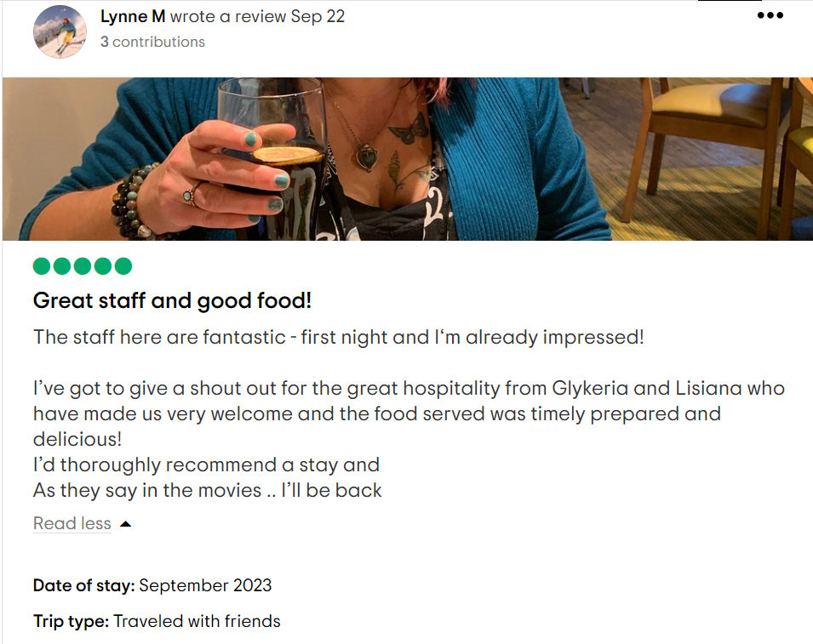

Letter of complaint response 500 words +/- 1-%
 Premier Inn
21st Oct 2023
435 Burnt Oak Broadway London,
Edgware HA8 5AQ England

Dear Mr. Federick,

I hope this message finds you well Mr Federick. I am writing to address your recent stay at our Premier Inn hotel and the concerns you raised in your complaint. First and foremost, I want to express our deepest apologies for the inconveniences you experienced during your visit. We take your feedback seriously and are committed to addressing each of your concerns thoroughly.
Your feedback is valuable to us as it helps us identify areas where we can improve our services. Your comments have been shared with our team, and I would like to provide you with a detailed response to each of the issues you raised.

Breakfast:
We deeply regret that you found the breakfast quality to be unsatisfactory. Our goal is to provide a delightful and appetising meal for our guests to start their day. We have immediately investigated this issue with our kitchen team to ensure that breakfast items are served at the appropriate temperature and maintain their taste and quality. We appreciate your feedback, as it highlights a crucial area where we need to improve.

Noise Disturbance:
We understand how important a peaceful night's sleep is to our guests, and we are genuinely sorry, our team is currently reviewing our room allocation procedures to minimise disruptions like this in the future. We appreciate your patience and understanding in this matter.

Room Cleanliness:
We take great pride in the cleanliness and hygiene of our rooms, and I am deeply disappointed to hear about your experience with room 205. Our housekeeping team has been informed of the lapses you mentioned, particularly the visible strands of hair and the unclean toilet. This feedback has been instrumental in addressing the issue, and we will be conducting additional training to ensure that our rooms meet the highest standards of cleanliness. Please accept our sincere apologies for this unpleasant experience.

We are committed to making the necessary improvements to enhance our services and provide all our guests with a memorable and comfortable stay. Your feedback plays a crucial role in this process, and we are grateful that you brought these matters to our attention.
As our promise is a peaceful night or money back guarantee we will refund you the full price for the room you stayed, for further information please refer to our refunding policy. And as a token of our appreciation for your understanding and to regain your trust, please allow us to invite you to invite you to breakfast on your next visit. Our team will be in touch with you directly to arrange the details of your complimentary stay and ensure that you have a much-improved experience.

Whitbread respect guest needs as they own, please rest assured we will investigate the issue to prevent it happening again in the future. Our team dedication in providing exceptional service to our guests, and your feedback will help us achieve this goal. If you have any further concerns or questions, please feel free to reach out to us directly at Raluca@Whitbread.co.uk or 0871 527 8652

We look forward to the opportunity to welcome you back and provide you with the exceptional stay that you rightfully expect from Premier Inn.

Yours sincerely,

Raluca
Assistant Manager
Premier Inn Management

Component Three:
Contribution to Overall Module Assessment: 50% (1000 words +/- 10%)
Writing in essay format

Element 1 – Pre-Arrival

At the heart of the pre-arrival stage lies the reservation and booking process. This involves handling inquiries, confirming reservations, and managing room assignments. Accuracy and efficiency in managing reservations are essential to ensure that guests arrive to find their accommodations ready (Guest Touch 2023).

Clear and timely communication with guests. This includes providing confirmation emails, information about the hotel's amenities, check-in/check-out times, and any special requests or preferences the guest may have. Meeting and ideally exceeding guest expectations in this stage can significantly impact their perception of the hotel.
Collecting relevant guest information is crucial for personalising the guest experience. This includes details like dietary restrictions, room preferences, and special occasions they may be celebrating during their stay. Gathering and utilising this data helps tailor services to meet individual needs (Hotelier life 2021).
The pre-arrival stage is an opportunity to upsell and cross-sell services and amenities. Whether it's offering room upgrades, spa packages, or restaurant reservations, strategic suggestions can enhance the guest's experience and contribute to the hotel's revenue.
For returning guests, acknowledging their loyalty and recognising them by name can make them feel valued and appreciated. This helps build lasting relationships and encourages repeat visits.
Ensuring the security of guest information, especially payment details, is non-negotiable.

In conclusion, effective management of the pre-arrival stage in the hotel guest cycle demands attention to detail, clear communication, personalization, and a commitment to exceeding guest expectations. When executed correctly, this stage not only ensures a smooth arrival but also sets the foundation for a positive and memorable stay, fostering guest satisfaction and loyalty.
Element 2 – Arrival

Arrival is the stage when the guest visually assesses the hotel and outside building this phase can set the mood for the entire stay, with a profound impact on guest satisfaction and loyalty. To ensure a successful arrival experience, several key elements must be considered.
A clean and well maintained outside area and a warm and efficient welcome is essential, as it sets the tone for the guest's entire stay (Dillard, 2002). Luxury hotels such as The Ritz-Carlton are known for their mastery of personalised greetings, creating a positive atmosphere that often exceeds guest expectations (The Ritz-Carlton, 2023).
Additionally, the readiness of guest rooms plays a critical role. Guests anticipate accommodations that meet high standards and are ready to offer a memorable experience. Providing essential information about the hotel's facilities and nearby attractions further enhances the guest's experience. Industry leaders prioritise making guests feel valued, secure, and well-informed. This commitment not only boosts guest satisfaction but also fosters guest loyalty (Ritz Carlton, 2023).
Efficiency, personalisation, and problem-solving are key factors during the arrival stage. Front-of-house staff who demonstrate these qualities can create a positive first impression, potentially leading to upselling opportunities during the guest's stay (Vallen, 2014).

In conclusion, the arrival stage is a critical juncture in the hotel guest cycle, where the guest's initial experience is shaped. By focusing on these key elements, hotels can set the stage for a memorable and satisfying guest journey, ultimately enhancing guest loyalty and the overall success of the establishment.
Element 3 – Duration of stay

The duration on the guest stay is the most important part in the hotel life cycle, which influence their entire stay at the property. This phase is characterized by several key elements that play a pivotal role in shaping guest satisfaction and loyalty.

During the occupancy stage, hotels must prioritize personalized service to cater to individual guest needs and preferences. This includes addressing guests by name, remembering their preferences, and anticipating their requirements. Luxury hotel chains like The Ritz-Carlton excel in providing personalized services, creating a sense of exclusivity, and enhancing the guest experience (Michelli 2008).
Ensuring that guest rooms are comfortable and impeccably clean is non-negotiable. The quality of the room and its amenities directly impacts a guest's overall satisfaction Hotels must regularly maintain and update room furnishings and ensure spotless cleanliness to maintain, brand standards and keep appliances in visually appealing and working condition.
Issues arise constantly during a guest's stay, what sets exceptional hotels apart is their ability to address and resolve these problems. Front-line staff should be empowered to resolve issues efficiently, whether it's a malfunctioning appliance or a special request.
Many hotel chains, such as Marriott International and Hilton Hotels, operate loyalty programs that reward repeat guests (Marriott International, 2023) (Hilton Hotels & Resorts, 2023). Recognising and rewarding loyalty during the occupancy stage not only fosters a sense of belonging but also encourages guests to return.

In conclusion, the occupancy stage is a critical phase in the hotel guest cycle where guest satisfaction is shaped. By focusing on personalised service, room quality, efficient problem resolution, loyalty recognition, and a wide range of amenities, hotels can create memorable experiences that lead to guest satisfaction, loyalty, and positive reviews.

Element 4 – Departure

The departure stage in the hotel guest cycle is a critical phase where guests conclude their stay and form their final impressions of the hotel. Key elements in the departure stage include:
Streamlining the check-out process because guests value a quick and easy check-out experience, many hotels offer express check-out options, for example, Premier Inn has a check out box where guests can securely place their room card and just go on with their day, allowing guests to settle their bills at the check in the check out process is quick and easy.
Expressing gratitude for the guest's stay and bidding them a warm farewell leaves a positive last impression. Simple gestures such as thanking the guest for choosing the hotel and inviting them to return can enhance guest satisfaction (Vallen 2014).
Ensuring that the final bill is accurate and transparent is essential. Any discrepancies or additional charges should be clearly explained and resolved promptly.
For repeat guests, recognising their loyalty during departure can be impactful. Many hotel chains, including Marriott International and Hilton Hotels, use this opportunity to thank loyal guests and offer rewards (Marriott International, 2023), (Hilton Hotels & Resorts, 2023).
Inviting guests to provide feedback on their stay is valuable for continuous improvement. Some hotels distribute guest satisfaction surveys or encourage guests to share their thoughts on online review platforms (Kandampully & Hu, 2007).
In summary, the departure stage in the hotel guest cycle is an opportunity to leave a lasting positive impression on guests. By ensuring an efficient check-out process, expressing gratitude, addressing billing accurately, recognising loyalty, collecting feedback, fostering guest satisfaction and loyalty.

References

Corgel, JB, Sturman, MC & Verma, R. (2011) The Cornell School of Hotel Administration on Hospitality: Cutting Edge Thinking and Practice, John Wiley & Sons, Incorporated, Hoboken. Available on: ProQuest Ebook Central - Reader Accessed on (5th Oct 2023).
Dillard, C., Browning, L. D., Sitkin, S. B., & Sutcliffe, K. M. (2000) Impression management and the use of procedures at the Ritz-Carlton: Moral standards and dramaturgical discipline. Communication Studies, 51(4), 404-414. https://www.proquest.com/scholarly-journals/impression-management-use-procedures-at-ritz/docview/233198559/se-2 Accessed on (22nd Oct 2023).
Duma, C. (2023) A Day in the life of a front-desk manager, Hotel Owner, Published on Tuesday, 7 February 2023. Available on: A day in the life of a front-desk manager | Hotel Owner Accessed on (5th Oct 2023).
Fanthorne, C (2004) Work Placements, Survival Guide for Students Macmillan, Basingstoke. Available on: Work Placements - A Survival Guide for Students | SpringerLink Accessed on (5th Oct 2023).
Guesttouch (2023) Guest circle. Posted on Posted on June 4, 2021. Vlog, Available online at: Pre-Arrival Guest Messages For Hotels (With Examples) (guesttouch.com) Accessed on (22nd Oct 2023).
Hilton Hotels & Resorts. (2023). Hilton Honors available at: Hilton Honors - Earn Points, Hotel Rewards, and More Accessed on (23rd Oct 2023).
Hotelier Life (2021) The guest Circle in Hotel. Published on 31st January 2021. Available on: THE GUEST CYCLE IN THE HOTEL | HOTELIER LIFE Accessed on (22nd Oct 2023).
Hur, & Jang, S. Shawn (2019) Is consumer forgiveness possible? Examining rumination and distraction in hotel service failures. International Journal of Contemporary Hospitality Management, 31(4), 1567–1587. https://doi.org/10.1108/IJCHM-07-2017-0395 Accessed on (5th Oct 2023).
Ikin Syamsudin Adeani, R. Bunga Febriani, & Syafryadin Syafryadin. (2020) USING GIBBS REFLECTIVE CYCLE IN MAKING REFLECTIONS OF LITERARY ANALYSIS. Indonesian EFL Journal (Online), 6(2), 139–148. https://doi.org/10.25134/ieflj.v6i2.3382 Accessed on (18th Oct 2023).
Jeong, M., & Seonjeong, A. L. (2017) ‘Do customers care about types of hotel service recovery efforts?’ Journal of Hospitality and Tourism Technology, 8(1), 5-18. Available on: https://doi.org/10.1108/JHTT-09-2016-0049 Accessed on (21st Oct 2023).
Kandampully, J., & Hu, H. H. (2007) Do hoteliers need to manage image to retain loyal customers? International Journal of Contemporary Hospitality Management, 19(6), 435-443.
Liat, C. B., Mansori, S., Chuan, G. C., & Imrie, B. C. (2017) ‘Hotel Service Recovery and Service Quality: Influences of Corporate Image and Generational Differences in the Relationship between Customer Satisfaction and Loyalty’ Journal of Global Marketing, 30(1), 42–51. Available on: https://doi-org.ezproxy.uwtsd.ac.uk/10.1080/08911762.2016.1262932 Accessed on (21st Oct 2023).
Marriott International. (2023). Marriott Bonvoy, Members Benefits. Available at: Membership Levels & Benefits | Earn &amp; Redeem Points | Marriott Bonvoy Accessed on (23rd Oct 2023).
Meyer, D. (2009) Setting the Table: The Transforming Power of Hospitality in Business. HarperCollins.
Michelli (2008) The new gold standard: 5 leadership principles for creating a legendary customer experience courtesy of the Ritz-Carlton Hotel Company (1st edition). McGraw-Hill. Available on: ProQuest Ebook Central - Book Details Accessed on (23rd Oct 2023).
Mullins, L, & Dossor, P (2013) Hospitality Management and Organisational Behaviour EBook PDF, Pearson Education, Limited, Harlow. Available from: ProQuest Ebook Central - Reader Accessed on (22th Oct 2023)
Nitzel, D. Domzalski, D. (2023) Hospitality DNA. Career Journeys with Unprecedented Insights from Industry Award Winners, Released on the 3rd May 2023. Available on Audible: Hospitality DNA by Dave Nitzel, Dave Domzalski - Audiobook - Audible.co.uk Accessed on (5th Oct 2023).
Rutherford, & O’Fallon, M. J. (2007) Hotel management and operations (4th ed.) John Wiley. Available at: ProQuest Ebook Central - Book Details Accessed on (18th Oct 2023).
The Ritz-Carlton (2023) Experience. Ritz Carlton, Available at: The Ritz-Carlton Experience (ritzcarlton.com) Accessed on (23rd Oct 2023).
Trianasari, N., Butcher, K., & Sparks, B. (2018) ‘Understanding Guest Tolerance and the Role of Cultural Familiarity in Hotel Service Failures’ Journal of Hospitality Marketing & Management, 27(1), 21–40. Available on: https://doi-org.ezproxy.uwtsd.ac.uk/10.1080/19368623.2017.1329677 Accessed on (21stOct 2023).
Trip Advisor (2023) London Premier Inn Edgware, Reviews, Published on 22nd Sep 2023. Available at: London Edgware Hotels | Book Direct | Premier Inn Accessed on (23rd Oct 2023).
Vallen, G.K. & Vallen, Jerome J. (2021) Check-in check-out: managing hotel operations, 10th edition. Pearson new international. Available on: ISBN-13: 9780137409051. Accessed on (5th Oct 2023).
Zoghbi-Manrique-de-Lara, P., Suárez-Acosta, M. A., & Aguiar-Quintana, T. (2014) Hotel Guests’ Responses to Service Recovery: How Loyalty Influences Guest Behavior. Cornell Hospitality Quarterly’, Journal article 55(2), 152–164. Available on: https://doi-org.ezproxy.uwtsd.ac.uk/10.1177/1938965513513348 Accessed on (21st Oct 2023).

