Professional and Career Development
BMSK 4005
Reflective Portfolio
Lecturer: Dr Buddhi Pathak
Student name: Miss Manjit Kaur Gharu
Student ID: 1814769

Table of contents

Part A
Induction………. page 3
Results of self-awareness test………. page 4 - page 6
Insights gained from tests………. page 7 – page 8
Conclusion………. page 9

Part B
Induction………. page 10
Importance of Recruitment process………. page 11 – page 12
Preparation for mock interview………. page 13- page 14
Results from mock interview………. page 15
Conclusion………. page 16

References………. page 17 – page 18
Appendix………. page 19 – page 19 – page 29
Part A

Introduction
In the first section, this report will define what was learnt in class and the activities completed. With having done several self-awareness tests in class which the results have been Appendix below.
As Professional Career Development is something that should come naturally to an individual, in some cases there are objectives that come in the way of life to make the individual remain reserved. Skills can always be enhanced by recognising your own weaknesses. The relevant methods are used to improve self-awareness. Sometimes it is wise to reflect on yourself to improve self-awareness. This can be from an individual whom has just started in the workplace to someone who is a senior colleague, right the way to the management team. Self-awareness tests can be completed at any point.
The second section will focus on the understanding gained from the tests. This will show examples of how the results relate to the career aspiration and progression. The results will present true reflections of the self-awareness tests which have been Appendix below.

Results of self-awareness test

Professional Development test.
Having completed the professional development test in class the results are shown in Appendix 1. This test was basic knowledge test about career development. It involved 12 questions.

Johari Window
Johari window model was developed by 2 psychologist Joseph Luft and Harry Ingham, both first names were combined to make Johari. This model was created in 1955. The model has 4 quadrants in the Johari window:
- 1, Open area
- 2, Blind area
- 3, Hidden area
- 4, Unknown area
The open area is something that both the individual knows, and others know about you.
The blind area is something others know about you, yet you don’t know this.
The hidden area is something you know about yourself, yet you don’t want others to know this.
The unknown area is something you nor others know about you. (Blake, 2014)
As an in-class activity we paired up and completed a task to learn more self-awareness by questioning other students on the Johari Window. Tasking each other to learn more about open self and blinding self. We completed this with several students.

Myers-Briggs Type Indicator (MBTI) test
This psychometric test is another way to improve your self-awareness. A psychometric test makes you more aware of your skills, knowledge and personality. There are 2 different types: personality test and aptitude test. (Mason, 2019)
The Myers-Briggs Type Indicator (MBTI) test was completed as a task in class. The results are presented in Appendix 2. This test places in you in one of 16 personalities. Katherine Briggs and Isabel Briggs Myers, mother and daughter whom studied personalities. The theories that Carl Jung created was some thing that both mother and daughter were fascinated by. Carl Jung believed humans experienced the world using 4 different functions.
Extraversion vs Introversion
Sensing vs Intuition
Thinking vs Feeling
Judging vs Perception
In 1944 the 1st version of the assessment The Briggs Myer handbook. Since then there has been improved version.
The results are presented once the questions in the test are answered. This is a test used by many companies for hiring and development purposes. (Covey, 2019)

Career Motivation Test

As part of the in-class activity a Career Motivation test was completed. The test was very lengthy, illuminating career goal satisfaction and success. A snapshot report of the test is shown in Appendix 3 below. Career test ask multiple questions, then match the answers on a database of careers. (Robinson, 1997)
A Career Aptitude test was also completed in-class. The results from this is presented in Appendix 4 below. This is another psychometric test which is generally performed at the start of the interview process. This evaluates how the individual will perform certain tasks. (Cheary, 2020)

Employment Legislation
Employment legislation is the rights of employees. Employees are protected by law. There can be several issues that can rise e.g.
- Working hours
- Pay disputes
- Redundancy
- Maternity entitlement
- Health and safety
- Discrimination
- Bullying or harassment
- Data protection, etc
This is just a list of some situations that can occur in the workplace. (Luke, 2018)
An example of why employment legislation is important is if the employer dismissed an employee because she was pregnant. The employee can take the employee to a tribunal for unfair dismissal due to discrimination. (Faragher, 2019)

Insights gained from test

Professional Career Development test
I’m very impressed with the current knowledge I have as presented in the results of this test as shown in Appendix 1. As the test questions were related to work orientated, this is something I deal with as a day to day basis in my current professional role in work.

Johari Window
After completing in class activities on the Johari Window, discovering the more about our own open self and blind self. When completing the activity with several students, open self was something normal. The results were something several other students knew about me which I already knew. Yet blind self was surprising. Blind self showed how different others saw me. Their opinion on blind self was something honest on there behalf, yet unknown to me until this was shared. When asking the other students why this was their opinion, they explained this is the way they saw me as. Also, they have made these judgements according to the way I present myself in class. After several students repeating similar comments on blind self about me, it came clearer to me when examples were given on these discoveries. I had to reflect on the blind self responses as I was not aware of this until informed.

Myers-Briggs Type Indicator (MBTI) test
As shown in Appendix 2, the results from when I took the Myers-Briggs Type Indicator (MBTI) test. My personality type is ENFJ-A, a Protagonist. This result presented elements about me that surprised me, yet others knew looking at the unknown self from the Johari window which I wasn’t aware of. I’m proud of this result.
Protagonist is a word which comes from ancient Greece. It refers to a lead character, possible the hero or champion. Generally, this person would be a leader or an important person. The protagonist person would stand out from others for their skills compared to others. This represents the individual has natural confidence and pride to achieve. (Allen, 2020)

Career Motivation Test
The career motivation test was completed in-class. The results are presented in Appendix 3. The questions in this test were more reality questions in a career basis. When answering the questions, I related more to my current position in work.
The career aptitude test as shown in Appendix 4. The results are presented in 6 categories, Enterprising, Investigate, Artistic, Social, Convectional and Realistic. These 6 categories represent 6 personality types from Hollands model.
John Lewis Holland was an American psychologist who created the Holland Codes. Hollands theory has 6 personality types as stated above, most people fit into these types. (Careers, 2019)

Conclusion
The tests that were completed in class, show more knowledge was gained for self-awareness. Having completed each test was about realising how to learn to be more sincere when answering the questions. It is normal for us not to reflect positive points until questioned. The tests required reflective answers. With the results from the tests showing evidence of how I still can be who I was many years ago. Due to several downfalls and disappointing situations, I lack confidence. Due to this I’ve always taken the back seat and not come forward to voice my opinions. Throughout my working life I’ve been pushed into situations where I’ve had to fight my corner using the law. Having knowledge of employment law is very useful. Employment rights is essential. Having completed the tests, I realise I can still perform to the best of my ability rather than being afraid to speak up.

Part B

Introduction
The following report is focused on the in-class recruitment activities completed. I have highlighted the importance of the recruitment processes. I have also emphasized the important preparations taken prior to the mock interview as well as motions after the mock interview.
I’m currently working in Curry’s PC World. I’ve worked within the business since 2006. Having a lot of experience as well as knowing the business needs, I’m still not in the position of management. My career goals are to become a manager soon.
When self reflecting on myself through the relevant tests completed during the module, I’ve become more aware of my abilities and skills. Having challenged through several different motions, I’ve realised I’m exactly who I was many years ago. (Carter, 2019)
Importance of Recruitment process
Recruitment is a very vital task undertaken by businesses to select the right candidate for the position needed. Recruitment begins when there is a need for the position to be filled in the business. There are stages which are followed to recruitment
Step 1: Before you start looking
Step 2: Preparing a job description and person profile
Step 3: Finding the right candidates
Step 4: Managing the applications process
Step 5: Selecting candidates
Step 6: Making the appointment
Step 7: Induction (JFMLAW, 2014)
Most businesses have a Human Resources Department also known as HR Department which deal with the recruitment of employees. As for small businesses there would the Manager or Directors who take on the responsibility for recruiting employees.
Human Resource Department would deal with hiring employees, training staff as well as dealing with all the legalities of employment e.g. maternity leave, sick pay, performance management, grievance, etc. This department is a very important part of the business as everything is abided lawfully. (Heathfield, 2019)
The importance of a job advert is crucial as this is the first contact to the outside world regards the business needs. The job advert can be posted on social media, e.g. LinkedIn or the job advert has been printed on the staff notice board or intranet e.g. internal recruitment. Both job adverts are important to specify the
- Job title
- Job duties
- Pay and benefits
- Job requirements
- Permanent or Temporary vacancy
These are vital as the person who is interested in applying has a guideline of expectations. (Luther, 2018)
The application documents are just as important. As this would be the first approach to the business, it would be wise to present yourself as a professional. Documents such as the cover letter, personal statement and the curriculum vitae would be the first thing that the employer sees of you. Having well presented documents with enough information on to make you stand out from others whom have applied for the role.
A cover letter goes alongside the curriculum vitae and is a brief letter highlighting the role you have applied for. It’s important to emphasize your key skills which are relevant to the role. The cover letter is a first introduction to the business. Make this look professional as well as short enough to get you point across. (Page, 2020)
A personal statement is a short introduction summary of your skills and experiences. This is an opportunity to stand out with why your skills and experiences are useful for the position applied for. (Heekin, 2019)
A curriculum vitae is a document which allows you to sell yourself by stating all your skills and experiences. Generally, the curriculum is recommended to be approximately no longer than 2 pages. This is due to the fact when business view this through the selecting process, they will scan through the document and just look out for highlighted details rather than the full information on the curriculum vitae. Details to be include in the curriculum vitae would be:
- Contact details
- Profile
- Education
- Work experience
- Skills and achievements
- Interests
- References
Using professional wording rather than slang would be more respectable. Also having a good format layout would be wise. (Smith, 2019)

The above sections discussed, recruitment process to the business would be very important as there would be a need for the position to be filled, lack of staffing can have a negative effect on the business. A job advert would be very important to the business as the sooner the business starts to attract the right applicants the sooner the business can start the next stage which would be selecting applicants to be interviewed. All applications are crucial as this would be the individual’s way of advertising oneself. This is the first opportunity you get to impress the business.

Preparation for mock interview
In preparation for the mock interview it was important to start looking for a job. I searched the internet and the job centre but couldn’t find anything in my local area as I have parenting commitments so I would not want to travel to far. I had to consider all my personal circumstances which would suit the role I was looking for. When searching on my work intranet I came across an ideal vacancy which was suitable for me to apply for. See Appendix 5.
The job advert was for an Assistant Manager at the store I currently work at. I currently am a technician at Curry’s PC World in the Wolverhampton store and am seeking for progression, so this post was perfect. The job advert gave details of what’s needed for the position. Also, the benefits which the company offer are a bonus. These appealed to me and met me personal needs too.
Once the job advert was selected, I started to prepare my cover letter and update my curriculum vitae. The cover letter see Appendix 6 was to give the relevant person in the human resources department an overview of my introduction. This highlighted the job I’m applying for; I brief history of myself and experiences. I highlighted key skills which I have linked to the needs of the position applying for. I also politely required then to contact back to me personally.
When updating my curriculum vitae, I stated all my current core skills and achievements. I also updated my current job. See appendix 7. From this you could see loyalty as I’ve worked long service within the same business.
This whole preparation took several weeks as this took a lot of time to get everything right. As I already knew about the company as a current employee, I didn’t have the need to do much research about the business. I did research and get involved in assistant manager tasks over the period of learning if this position was right for me. I got guidance from the prospects site was recommended in-class. The prospects were very helpful. (Mason, 2019)
An appointment was arranged for the interview. This was very important for me. I printed all the relevant documents for the interview in advance and filed them into a folder. I also made sure I was off on the day as didn’t want any interference. I arranged childcare for this day in advance. The day before the interview all preparations were in place as planned. I planned a smart outfit to wear as this was the first time the interviewer was going to meet me.
On the morning of the interview I arrived early. I was very nervous. I had prepared more than expected so the fact that I arrived early was making me more nervous. This is quite normal; I always get nervous in new situations. A lot of people panic at interviews. I had practised in advance how to stay calm and relaxed. I didn’t want to panic at the interview and fail. I used relevant methods to remain calm, hence all the preparation. (Brooks, 2015)
Results from mock interview
The mock interview went well, see appendix 8 for results and feedback. There were 2 interviewers Stephanie and Doreen. Both were very welcoming. Doreen seem to ask a lot of questions which I answered to the best of my knowledge. Stephanie was making more notes, which was making me want to expand even further on the questions asked. Both results were impressing. The feed back was positive too.
Doreen gave me 82%
Stephanie gave me 80%
As I had made relevant preparation for the interview, I was able to answer questions asked during the interview. Also presented the relevant documentation at the interview showed the interviewers I was well prepared.
Conclusion
Overall, I have learnt more skills in the mock interview preparations as well as the interview itself. As I had taken relevant preparations and research involved the interview was a success. Both interviewers commented and gave good feedback on first impressions. This was very important to me. For me to stand out from other applicants, I would want to make a positive impression.
This whole process would be very useful to my future career development as this would be a learning curve. Every step of the process I related to my actual job role. This is to my advantage as I was able to seek guidance from my seniors in the workplace when needed. This is all part of research, finding new skills and gaining new experiences.
References
Allen, S (2020) What Is a Protagonist? Available at: https://www.grammarly.com/blog/protagonist/ (Accessed on 26th January, 2020)
Blake, B (2014) The Johari Window Model Available at: https://m.youtube.com/watch?v=BWii4Tx3GJk (Accessed on 26th January, 2020)
Brooks, K (2015) 10 Ways to Calm Your Interview Anxiety Available at: https://www.google.co.uk/amp/s/www.psychologytoday.com/gb/blog/career-transitions/201503/10-ways-calm-your-interview-anxiety%3famp (Accessed on 28th January, 2020)
Careers, (2019) Available at: https://www.careers.govt.nzresources/career-practice/career-theory-models/hollands-theory/ (Accessed on 27th January 2020)
Carter, M (2019) Self reflection Available at: https://m.youtube.com/watch?v=SiMkEauwLOs (Accessed on 27th January, 2020)
Cheary, M (2020) Psychometric testing: What you need to know Available at: https://www.google.co.uk/amp/s/www.reed.co.uk/career-advice/psychometric-testing-what-you-need-to-know/amp/ (Accessed on 27th January, 2020)
Covey, S (2019) Myers Briggs (MBTI) Explained – Personality Quiz Available at: https://m.youtube.com/watch?v=2ZF4OM6mrrl (Accessed on 26th January, 2020)
Faragher, J (2019) Pregnant woman wins £28,000 after unfair dismissal at 20 weeks Available at: https://www.personneltoday.com/hr/pregnant-woman-wins-28000-after-unfair-dismissal-at-20-weeks/ (Accessed on 28th January, 2020)
Heathfield, S (2019) What Is a Human Resource? Available at: https://www.thebalancecareers.com/what-is-a-human-resource-1918144 (Accessed on 27th January, 2020)
Heekin, E (2019) Personal statement examples- how to write a personal statement Available at: https://university.which.co.uk/advice/personal-statements/examples-of-how-to-write-a-personal-statement (Accessed on 27th January, 2020)
JFMLAW (2014) 7 Steps to Effective Recruitment Available at: https://jfmlaw.com.au/employment-contracts/7-steps-to-effective-recruitment/ (Accessed on 27th January, 2020)
Luke, H (2018) What is HR Employment Legislation? Available at: https://cmsvoc.co.uk/blog.what-is-hr-employment-legislation/ (Accessed on 28th January, 2020)
Luther, C (2018) What Is a Job Advertisement? Available at: https://work.chron.com/job-advertisement-6654.html (Accessed on 27th January, 2020)
Mason, D (2019) How to prepare for an interview Available at: https://www.prospects.ac.uk/careers-advice/interview-tips/how-to-prepare-for-an-interview (Accessed on 28th January, 2020)
Mason, D (2019) Psychometric tests Available at: https://www.prospects.ac.uk/careers-advice/interview-tips/psychometric-tests (Accessed on 26th January, 2020)
Page, M (2020) What is a cover letter and why are they important? Available at: https://www.michaelpage.co.uk/advice/career-advice/cover-letter-and-cv-advice/why-cover-letters-are-important (Accessed on 27th January, 2020)
Robinson, M (1997) All About Career Tests, Career Testing, and Career Assessment Testing Available at: https://www.careerplanner.com/Career-Articles/All-About-Career-Tests.cfm (Accessed on 27th January, 2020)
Smith, J (2019) How to write a CV Available at: https://www.prospects.ac.uk/careers-advice/cvs-and-cover-letters/how-to-write-a-cv (Accessed on 27th January, 2020)
Appendix 1
Results from Professional Career Development.

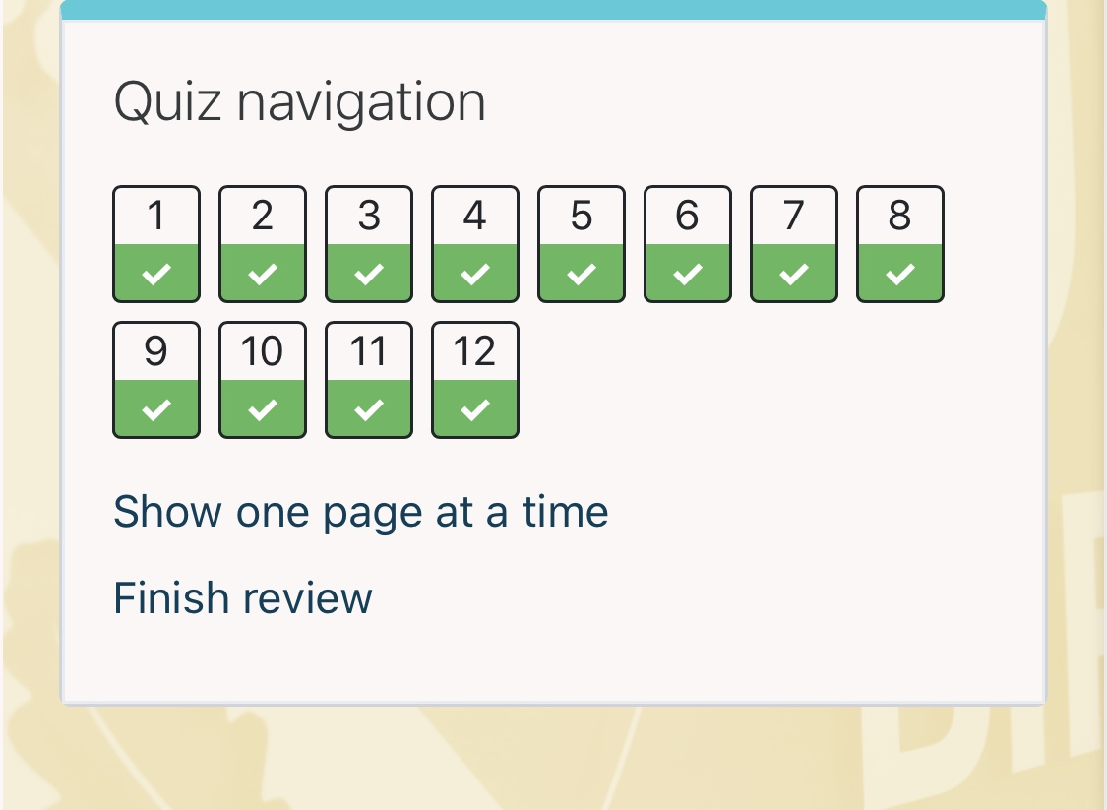

Appendix 2
Results from Myers-Briggs Type Indicator (MBTI)

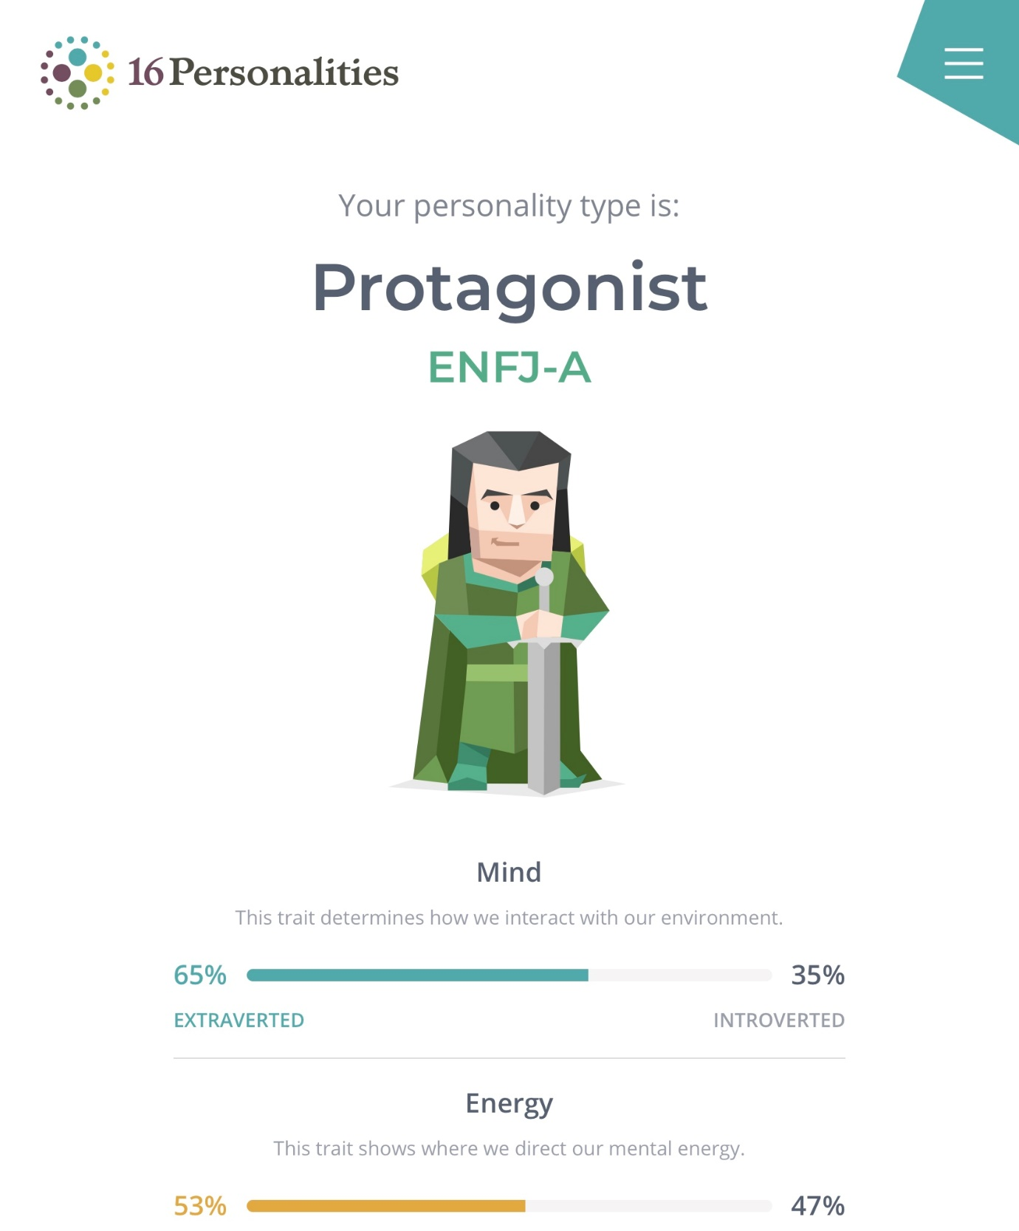

Appendix 3
Results from Career Motivation Test

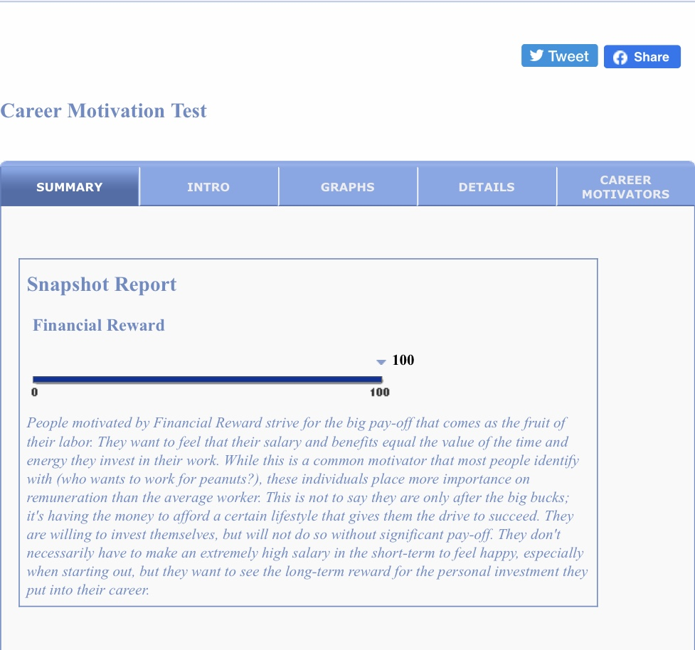

Appendix 4
Results from Career Aptitude Test

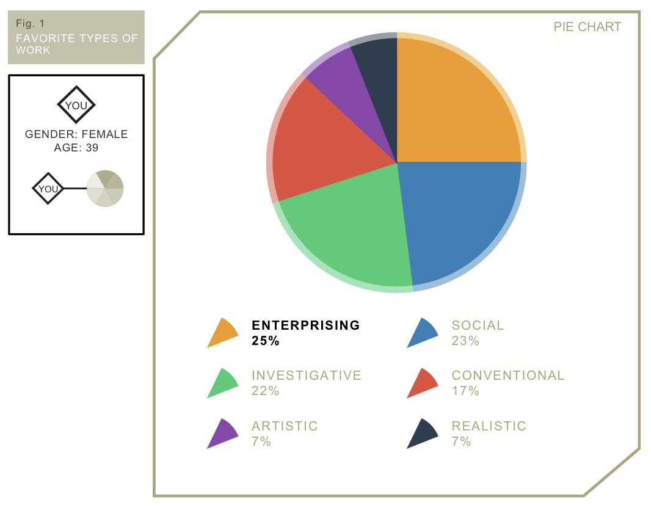

Appendix 5
Position applied for, job advert
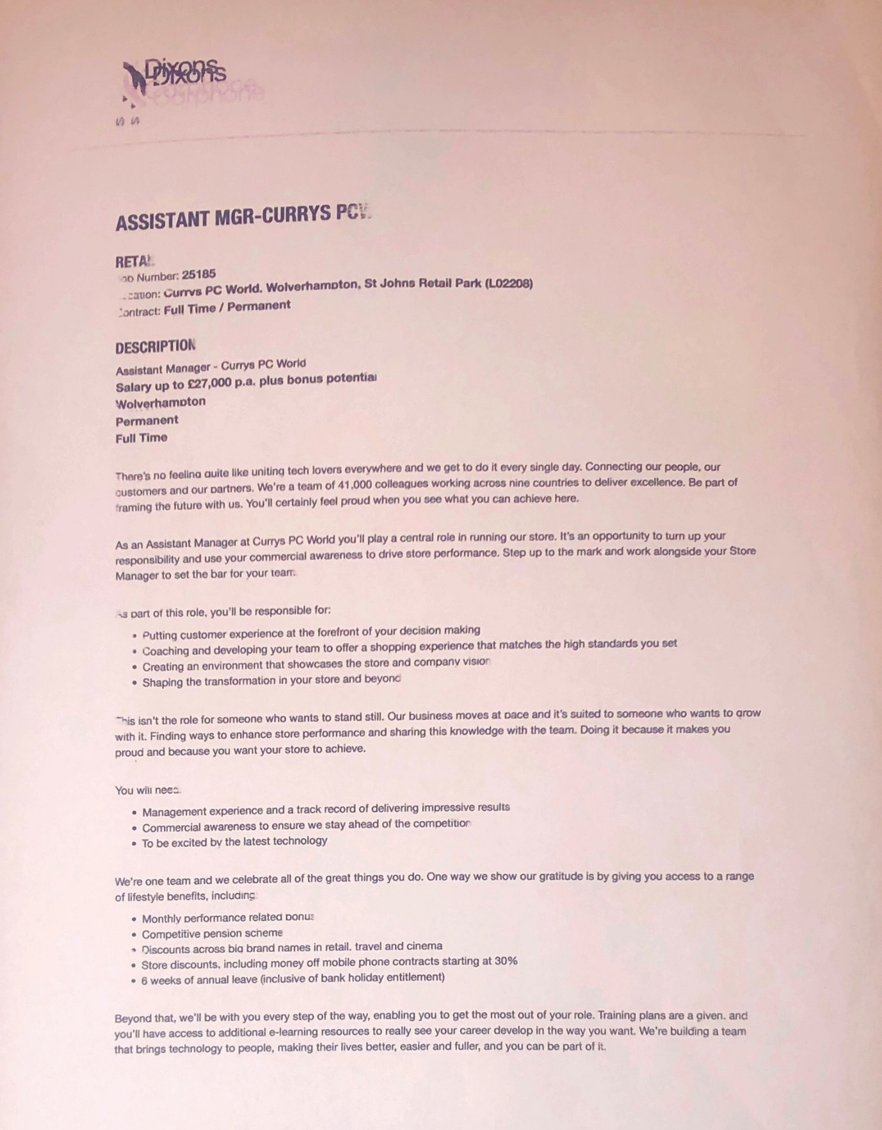

Appendix 6 Cover letter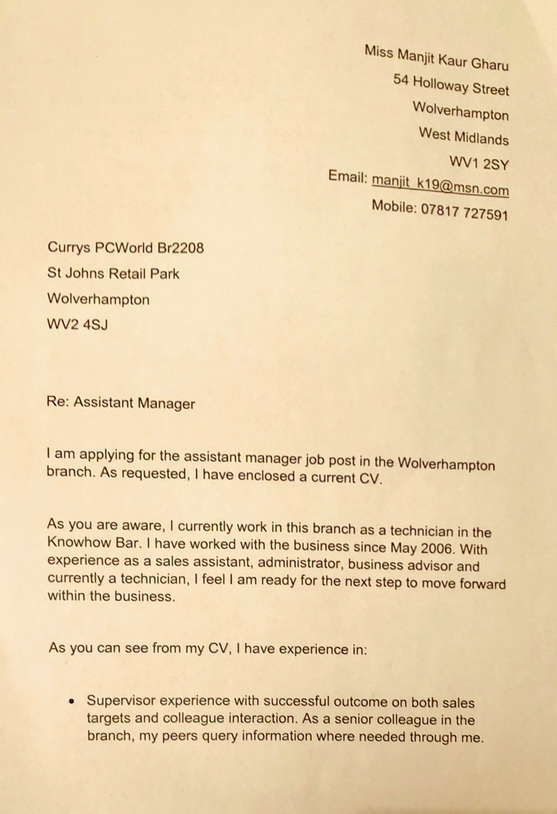
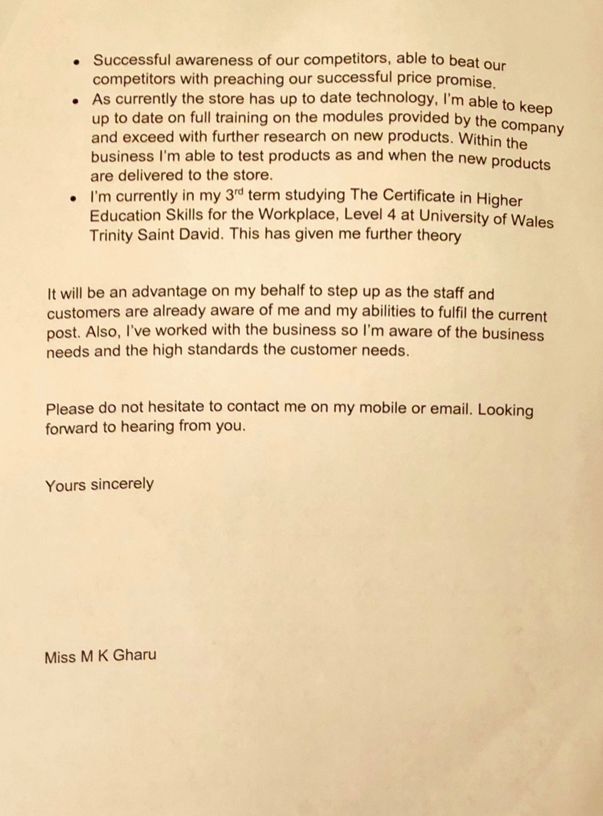

Appendix 7
Curriculum vitae
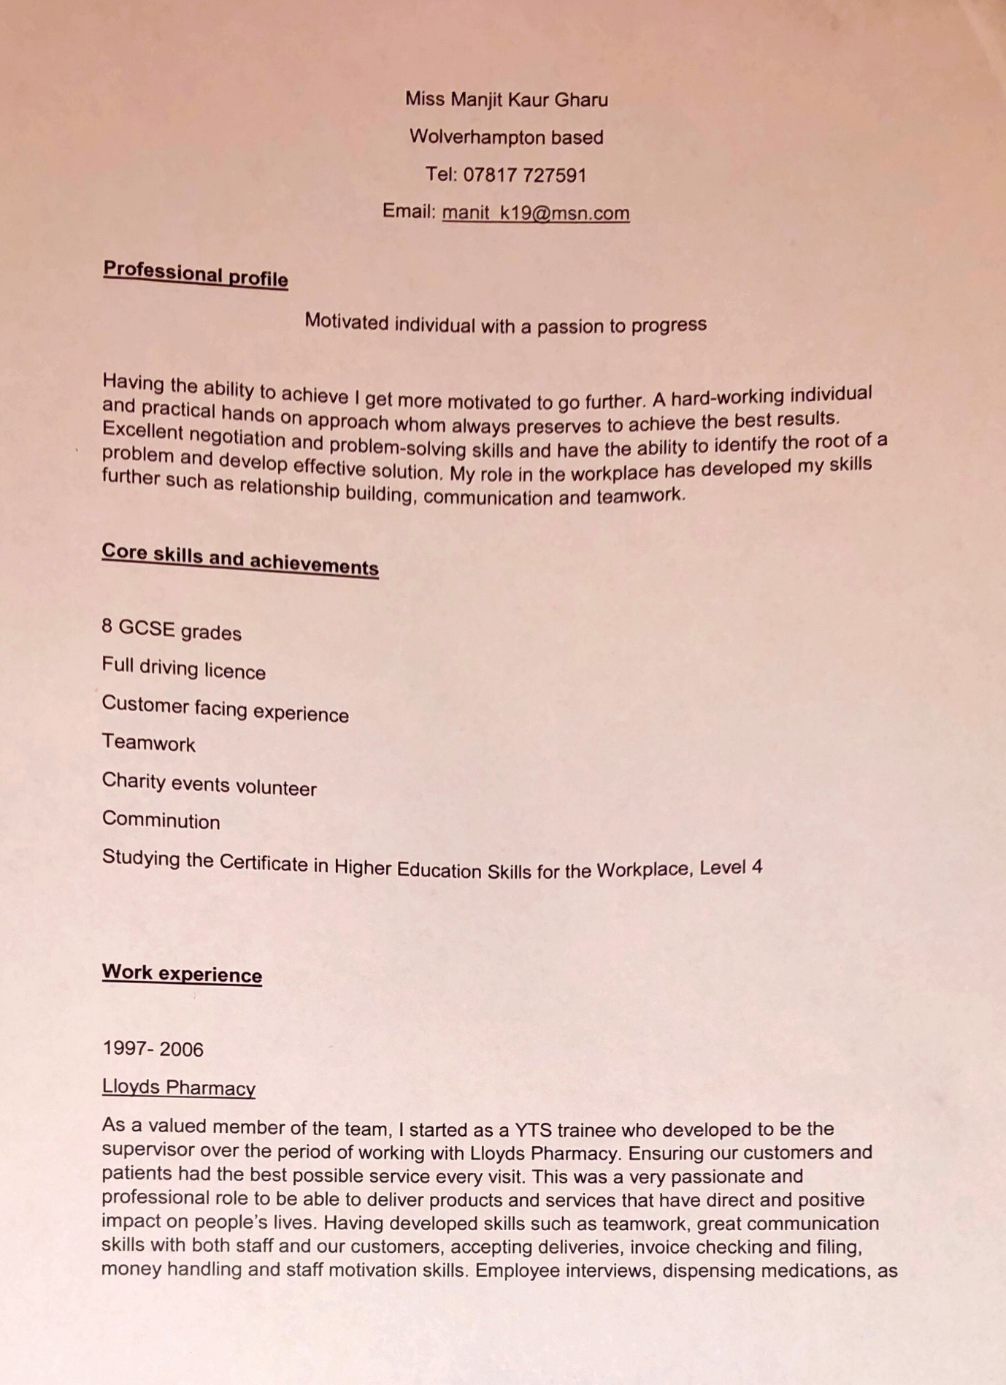

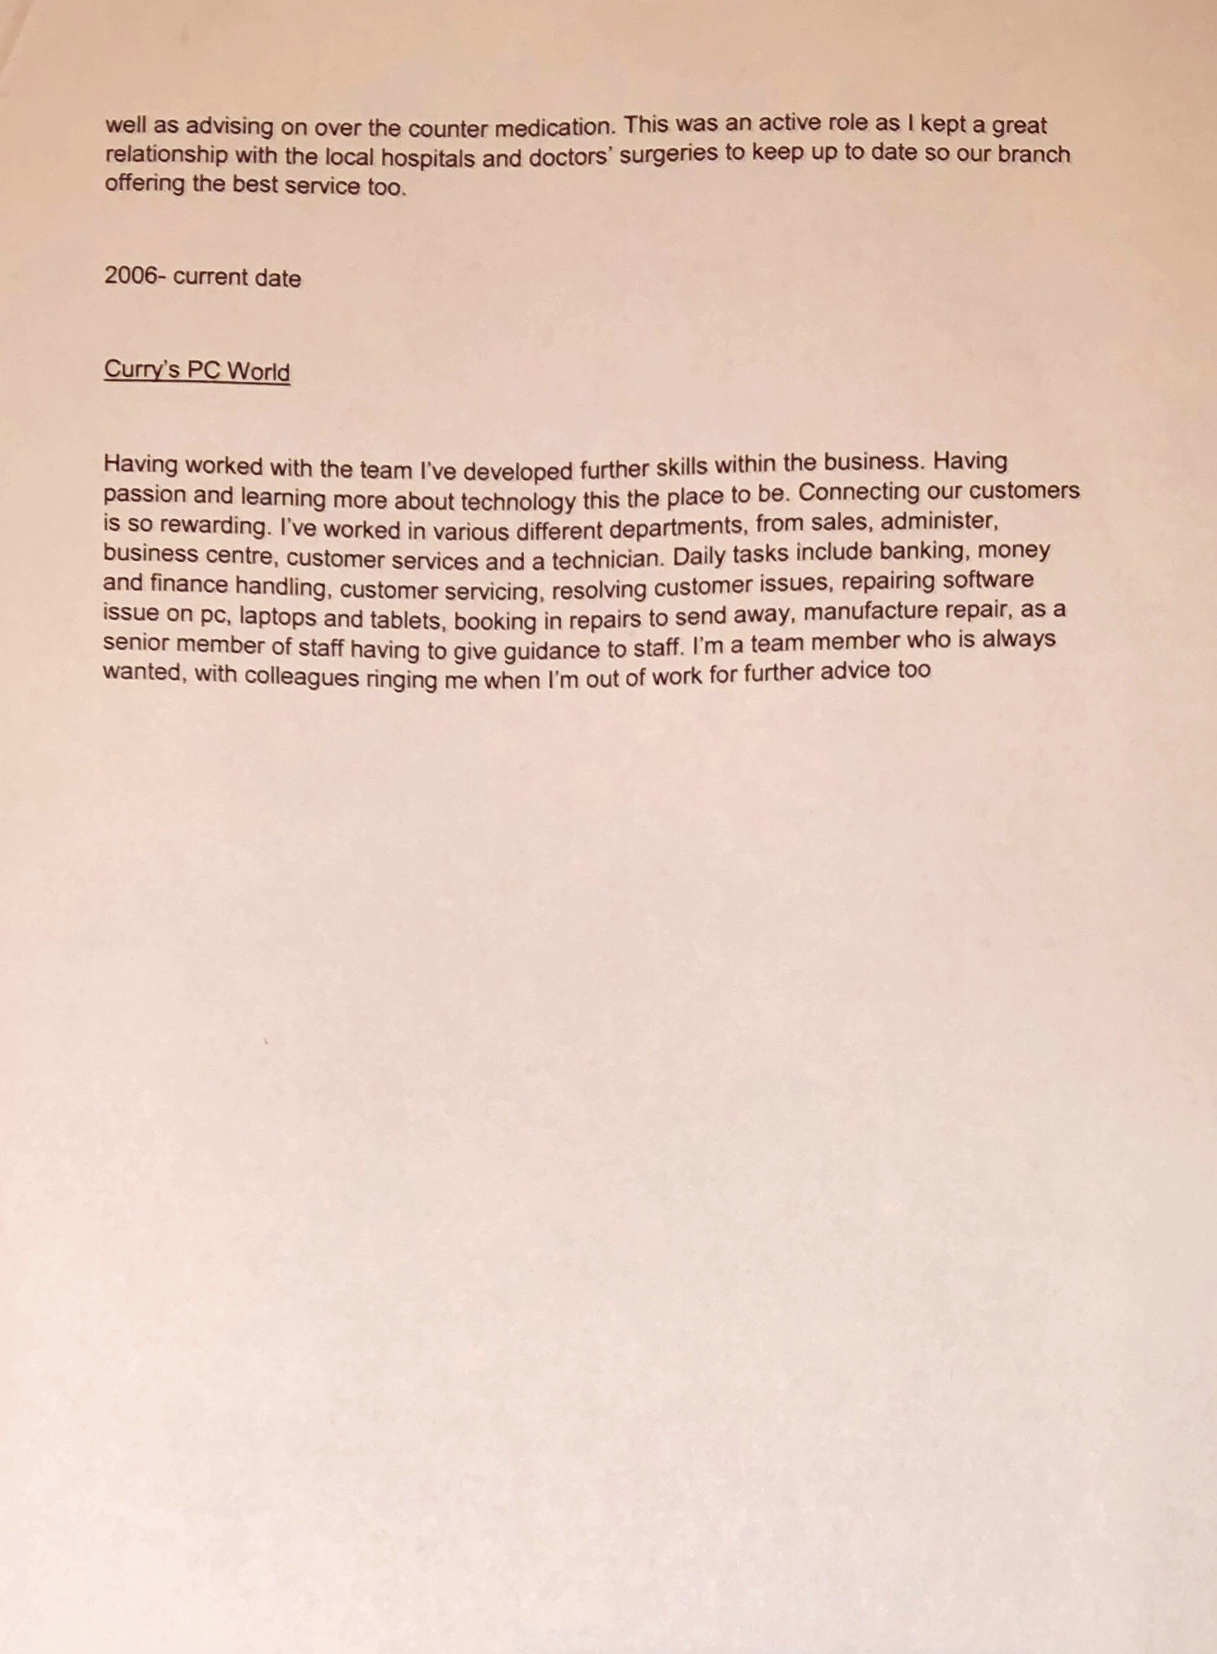

Appendix 8
Interview feedback


