Unit code BMMB7006D

MBA Part-time Distance

Tutor - Anthony Burns

Global Business Challenges

Alison Barker

1708025@student.uwtsd.ac.uk

2.Table of contents -

1.Front page
2.Table of contents
3.Executive summary
4.Introduction
5.Assessment of the business swot analysis
6.Tows matrix analysis
7.Pestel tool analysis
8.Porters 5 forces analysis
9.Porters diamond analysis
10.Conclusion
11.Recomendations
12.Reference list

3.Executive summary
This report investigates the relationship that collaborations have in the world in this case between the high-profile sports shoe and apparel company adidas and singer, producer turned fashion designer Kayne West.
Brands can rely on celebrities to bring recognition and raise the profile of an individual company, building brand awareness to a different social group that the individual already has. This can be beneficial to both parties as long as both parties are happy in this partnership.
Adidas already have the infrastructure and capability to produce high-quality low-price point shoes and apparel for the sporting industry, they already have the trading rights and laws already taken care of, they have a strong physical presence as major sporting events with several famous sports personalities and a range of different sports and brand awareness from being in business for nearly 100 years.
Development in the different types of equipment that professional athletes need to perform well is a major part of this companies’ ethos but the collaboration with celebrities of the field of sport also give this company a slight competitive advantage over other such large rival brands such as Nike.
Analytic tools have been used in this report to prove these points such as PESTLE, SWOT, porters diamond theory and a TOWS analysis.

4.Introduction

The company that I have decided to base my assignment on is the collaboration between adidas and Kayne west, the Yeezy collaboration.
Adidas, a Germany company, was first registered “Gebruder Dassler Schuhfabrik’ by Adi Dassler in 1924, their mission statement was “to provide athletes with the best possible equipment” gold medallists Lina Radka won gold with them in 1928. Adidas.com

The company was reregistered in 1949 “Adi Dassler adidas sportschuhfabrik” employing 50 employees, he registered the iconic three stripes of the adidas brand that has seminomas with the brand, a development with lightweight variations on the football boot became a popular and forerunner of the modern-day football boot in 1954.The three-stripe tracksuit came in 1967

Adi Dazzlers product development was a central element to how he progressed, constantly developing products with the help of professional athletes, implemented redesigning, and also inventing new products to suit the athletes.

The invention of the iconic Telstar football designed specifically for televised games on black and white televisions was an early partnership project, providing the official match ball for every FIFA World Cup™ that followed.

Product development branched out to more sports in the 1970s from mountain climbing to gymnastic leotards, to computerised micropacer trainers in the 80s that provided statistics to assist athletes performance, adidas mantra” listen, test, modify”

In the 1980s the first Collab with hip-hop group Run-D.M.C started the non-athletic street fashion promotions
After the death of the family of Adi Dassler at the end of the 80s, the rest of the surviving family sold their sales in the company, it became a stock corporation, enter Robert louis- Dreyfus new CEO with his partner Christian Tourres, they restructured the company back to the original ideology of product development for athletes, with the acquisition of the Salomon group at the end of the millennium, the group changed its name to adidas-Salomon.

The 2000s came with more reinvention into the sports inspired street wear that is the basis of modern adidas. Fashion designers were added into the mix of designing that adidas marketed to including such designers as, Yohji Yamamoto, Stella mc Cartney, Y-3 and Porsche design sport.
In 2006 Salomon leaves adidas and Reebok joins a massive collaboration between two big brands,

Enter Kayne west after some time at fashion designing the rap artist turned his sights at the shoe market. After initially designing a shoe collection with adidas 2006 that never materialised, Kayne west moved over to competitor Nike, he also collaborated with Reebok and Louis Vuitton, bring out three sneaker styles.
Yeezy materialised and the first collection was released in 2015
After a row about royalties the relationship soured which saw Kayne move back to adidas with a 10 million dollar.

5.Assessment of the business swot analysis

strengths
Kayne wests collaboration with adidas was a major driver in sales for the company with social media promotions funnelling small releases of an iconic brand promoted by influences and social media reps.
The limited supply of Yeezy shoes affected the perception of consumers towards them and made the products more desirable, thus stimulating the purchasing behaviour Nora (2021)

This type of marketing strategy had already been used successfully with wests wife’s family who use the same strategy to promote other industries. His sister-in-law kylie Jenner and used social media marketing strategy to produce her make up brand kylie cosmetics, using a strategy of limited edition and limited numbers of the brand using social media to promote beforehand and then using pop up stores to sell the make-up, a strategy that has been successful to the reality stars extended family.

Another strength of Wests is his popularity and fame made sure that there was already a fan base and audience to bring the natural progression from clothing with his entrance in 2011 before bringing his own style of clothing to Paris fashion week. His wife’s huge social media fan base supported Kayne in the beginnings of his journey developing between his and his wife’s base helped to cross from hip hop artist to a more mainstream fan base.

From this the next natural progression was into the footwear industry which was heavily undoctoring into hip hop culture of the 80s, helped along by adidas infrastructure and manufacturing expertise and tenacity at making high performance shoes was an excellent partnership for both parties involved.
Without any labels, graphics, prints emphasized on the clothing, Yeezy still succeeds in building a remarkable identity by its distinctive design Zhang (2022)

This gave “ye” and Yeezy competitive advantage by using the infrastructures the German brand already had installed. They use a manufacturing facility in Indonesia the adidas Group’s apparel production has risen year-on-year since 2012. To keep costs down, the company outsources almost all its production to independent manufacturing partners, the majority of which are in Asia. over 90 percent of the adidas Group’s apparel was produced in Asia in 2021, statista 2022
Costs are kept low on production and then profits are maximised with products being sold on every continent.
Since 2015 the profits have risen substantially 2011 profits stood at $14,205 million euros in sales after 2015 after season one of Yeezy they shot up to $16,915 which rose to there height of $23,640 million euros in sales in 2018(pre pandemic )

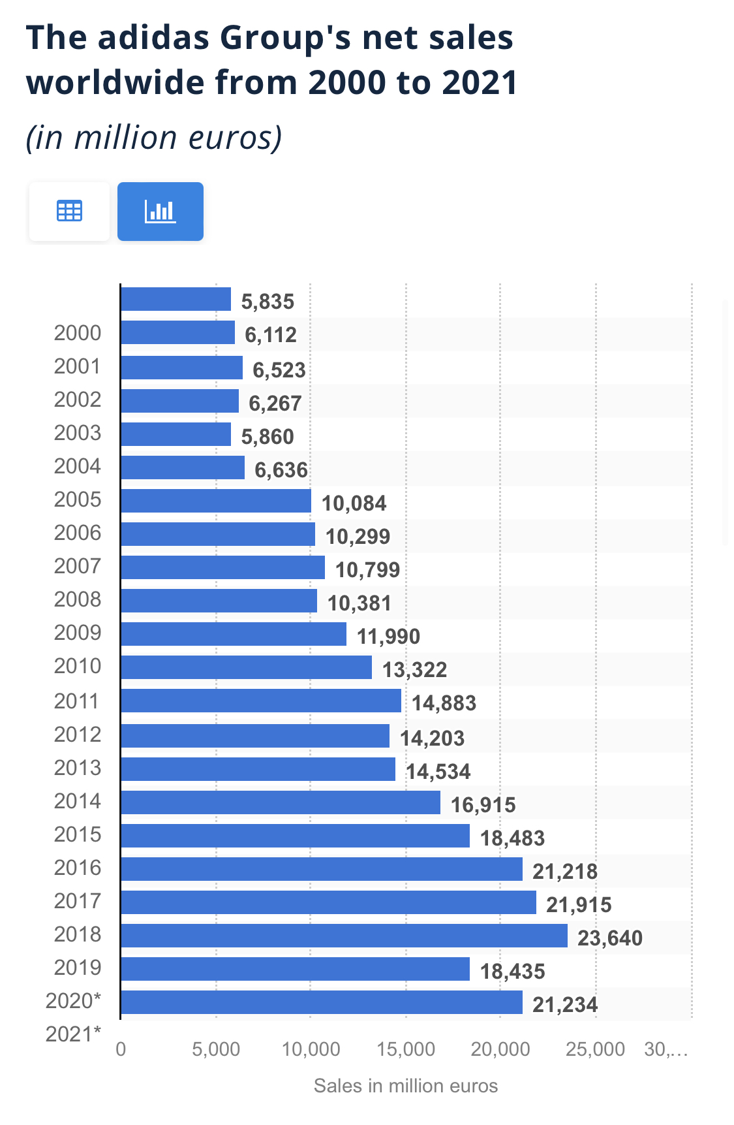

This in turn boosted the worldwide employee numbers from 55, thousand to 65 thousand employees in 2019, this demonstrates substantial growth to the adidas brand due in part to the collaboration with Kanye west.
strengths

Weaknesses
Price can be a seen as a weakness to the branding of Yeezy, also the availability for the shoes line outside of the us is seen as a barrier to purchasing the items.
The production line could also become a problem with such issues of political issues, and natural disasters threatening the importation from Indonesia of the products.
One of the biggest weaknesses is a macro environment weakness where recently after collaborating with Kanye West it was heavily criticized in the public eye for moving slowly in making a statement, and not having a strong reaction to Kanye’s recent racist public outbursts. This was seen as a negative reaction when they lagged in time to formally remove Kanye as a business partner.

Opportunities
The close association with the development of products with professional athletes Is an opportunity that can be developed more. This is a unique selling point that adidas has proved over time to excel at. The potential developments in technology and materials adds to adidas thesis and mission statement "to be the global leader in the sporting goods industry with brands built on a passion for sports and a sporting lifestyle. We are committed to continuously strengthening our brands and products to improve our competitive position."edrawmind (2022)

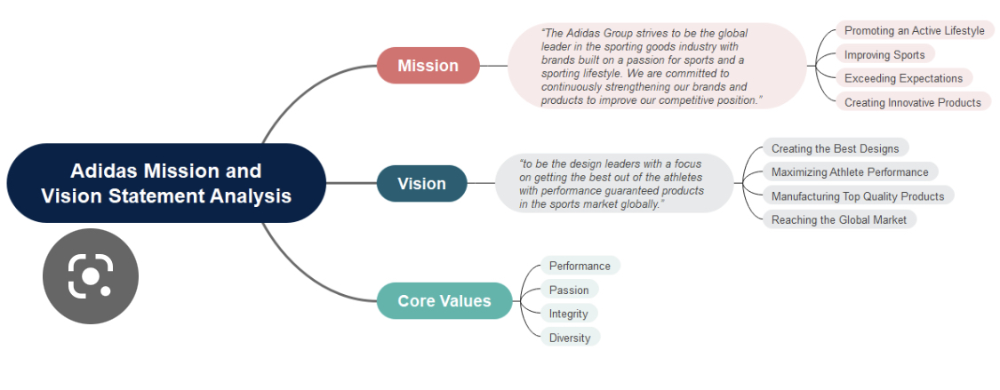

Threats
The major threat is from new and existing competition in the form of global brands Nike a long-established company with three times the profit margins of adidas and the new upcoming brands such as under armour for example.
The problem with adidas not specialising in a particular field and being a leading in a specific field, would they be better to concentrate there clothing and shoe lines to track only or even to keep with the specialisation of professional sports shoes only?
The decision to move the brand forward with collaborations such as west hit a fickle target audience in social media that with changing politics and trends can change in an instant just as just happened with west. Major investment has been abruptly stopped with the sports brand entering a minefield of complications in ending their contractual agreement with west.

6.Tows matrix analysis
Weaknesses to threats
Improvement in working conditions in the Chinese and Indonesian markets including the price of natural resources for the products, the market for recycled materials, and technology related to recycling of used products are issues that can affect pricing of the products that sell in global markets.
Laws on sustainability and buyers’ awareness of materials that are sustainably produced can affect pricing to pressure global brands.
Producing innovative and desirable collections and collaborations with other main global brands can also make the brand more desirable in the consumers mind, pricing with luxury brands in limited editions will enforce this.

Strengths to threats
Pricing can remain high with a desirable footwear brand, especially in collaboration with luxury brands, not all collaborations are successful, and they must be stay aware of public opinion on the brand and celebrity’s that they endorse. Social media plays a big part in enforcing desirability, there online presence must reflect their social stance with collaborations.
The reputation of their footwear and clothing as regarding sustainable issues and the treatment of their employees in the factory setting are paramount to how consumers view a brand. Issues relating to treatment of workers can make or break a brand, at how consumers view their authenticity, and they would be judged on the care they take of their employees.

Weaknesses to opportunities
Seasonal opportunities and new and existing international markets can present excellent opportunities to a global brand such as Adidas. Major events are opportunities for the brand to be seen and viewed on major international sporting events such as the world football competition. Such events as international sporting events on track and field all hold opportunities for this global brand.
Because physical activity is increasingly conducted in an organized manner, sport’s role in society has become increasingly important over the years, not only for the individual but also for public health Malm et al (2019)
Sporting events them selves promote healthy living lifestyles, consumers are buying into the promotion of the healthy lifestyle, after a year with covid-19 a government poll suggested that 8 in 10 adults aged over 18 have decided to modify their lifestyle in 2021, with 7 in 10 adults saying that they are motivated to make healthier lifestyle changes due to coronavirus (COVID-19). Gov.uk (2021)

Strengths to opportunities
Strengths such as online shopping, social media and ease of purchase, make adidas marketing strategy. Their international iconic simple three strip logo is instantly recognisable as a trusted brand. Movement into new markets brings new opportunities with
Collaborations with luxury brands and using social media to release small, limited editions of iconic footwear and clothing lines are a strength. Using there tried and tested method for development and feedback from professional athletes is a. major strength within the brand.

7.Pestel tool analysis

Political factors

A major political factor is the production line being in Indonesia which is a developing economy, although America does support infrastructure and foreign aid to Indonesia
In the west the cop (conference of the parties) meetings, climate change conferences develop strategy’s about growing concerns about issues and laws governing ecological issues one of the most concerning elements is developing economies like Indonesia. For example, COP26 climate talks was at odds with Indonesia's development plans and the global goals, along with Brazil and the Congo these three countries collectively contain 85% of the world's forests. Reuters 2021 issues implemented in cop meetings will ultimately strongly affect Indonesia.

Economic factors
Recessions, covid and world issues affect the economy of the US, post covid economic issues will affect luxury brands that change higher prices while the quality and name of the brand and its financial backing will help the company survive all business will be affected by the economic problems created by covid.

Social factors
Including the professional athletic cliental that adidas works with there is heavy marketing and interaction by social media involved in all large organisations and global brands. Making sure they are responsive to social expectations and norms will help the company keep positive reaffirmations in the public sector.
Kanye West recent outbursts and outspoken comments with racial undertones have hurt the relation ship between adidas and the Yeezy brand. Social media plays a huge role in wests and adidas’s marketing campaigns and this was reflected in the backlash that adidas received after the comments were made.

Technological factors
Here again the technology that goes into the development of the shoe and technological advances in materials will ensure the adidas is continually developing innovate products.
The internet is heavily used to promote, market and for sales of the products for adidas, developing social strategy and the sales base for adidas.com.

Environmental issues
The environmental opportunities for adidas to hone into the sustainable market on materials and develop innovative but sustainable products is a massive challenge to any global organisation. Adidas has implemented there Three Loop Strategy,’ focusing on three categories:
Parley ocean plastics: Primeblue is a performance fabric made in part with Parley Ocean Plastic, while Primegreen is made in part with recycled materials

Circular loop: Product will be worn, worn out and returned to us, each pair moving us closer to a more sustainable future to help end plastic waste.

Regenerative loop: products are made in part with natural and renewable materials

Legal factors
Such issues as international trading laws the fact that the company works from three different venues means that adidas has local and international laws to adhere to. Contracts between Kayne or any collaboration,and adidas also heavily feature.

Conclusion

Adidas as a multi-national company must adhere to cultures and traditional values and working practices globally with the European continent’s ideology of working practices, regarding conditions and pay for workers in Indonesian, additionally there are global restrictions, trading laws and taxes that will affect the trading of the company.
In this regard the company also must think strongly about environmental issues and be mindful how
- The items are produced and how the items can be recycled at the end of there natural life, or are they using recycled materials that themselves are easy to recycle?
- Are adidas looking to prolong the life of their shoes and clothing
- The social aspect of their brand, what will the public think of their collaborations will the company respond quickly if these go wrong, and they need to distance themselves.

Adidas trades at about a half of the sales of their rival Nike, there is a large gap that has potential for adidas to grow into but at the same time adidas has to look out for up-and-coming companies like puma, lululemon and under armour.

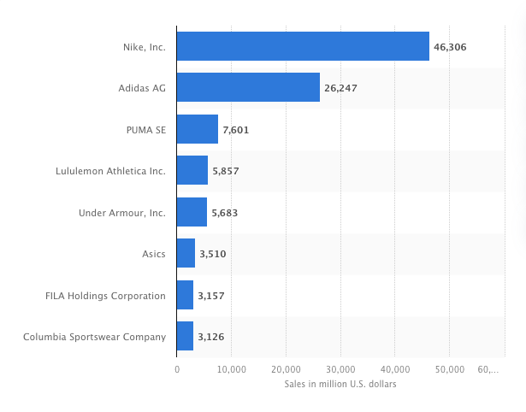
Sales of the biggest athletic apparel, accessories and footwear companies worldwide in 2021
Statista 2021

Adidas states in their own media release that they intend to
- Make and enjoy good returns on Investments in the FIFA world cup, where they noticed good returns on football revenue.
- Investments in American basketball launch in north America
- Recoup losses on the Yeezy collaboration develop new strategy with other leading luxury brands such as Gucci and balenciago.
- Divert investment from Russian channels to instead open markets in Latin and north America
- Revenues in running added by successful running franchises including Adizero and Supernova, which both grew more than 50% during the quarter
- additional highly limited drops as part of the Gucci and Balenciaga partnerships continued to spark excitement around the adidas brand
- adidas continued to invest into the experience across both its physical and digital platforms with several new store openings, including in Rome, Barcelona, and Mexico City, as well as further improvements of its membership program ‘adiClub’
adidas/ press releases (2022)

8.Porters 5 forces analysis
The threat of new entrants consists of the barriers to a multi-national company are seen as the laws, political position, and the scale of the business, all the background that the company has to deal with being global. Including time zones, international trading, national import, and exportation costs, local country by country traditional values and global social norms. Adidas must produce and target different clothing lines to different countries while conforming to different cultures.
Economies of scale are already a bonus for a global company that has grown steadily for almost 100 years, their production of the footwear made in Indonesia then exported around the global is a hurdle for a new entrant. Adidas has a large loyalty base, with collaborations over the years with professional athletes and music icons it ensures a large following with collections with Gucci and Balenciaga. Their positive outlook to move production from the Russian corridor to the north and Latin American markets shows that they have quick reactions to move their operations making sure opportunities are not missed.
Bargaining power of buyers can be enhanced by the orders online as well as their bricks and mortars shopping experience, popup shops can bring the adidas experience to customers with branding and promotions at large national and international events. Adidas has been established as a for runner in professional clothing and footwear for professional athletes, their constant development of original types of materials and development in the style of their product types that can enhance the athletic ability.
Threat of substitute products, with there main outsourcing in the Indonesian and Chinese markets, there are plenty of opportunity to substitute with inferior and mass-produced copies. The other main companies would also be facing these same issues to the same extent. Other industries such as fashion industries would produce and manufacture sporting style goods which could be manufactured for a cheaper would be a threat, these issues are minor with economies of scale that Adidas and Nike have over competitors.
conclusion
Ultimately Nike is currently trading at twice the size of Adidas, after Nike there are several smaller companies that do have the potential to one day become a threat to these two giants. Just the logistics in owning a global brand has a serious amount of organisation and the other smaller brands are nowhere near experienced as the two main players.

9.Porters diamond analysis
Firm strategy, structure and rivalry
Adidas strategy ‘Own the game” is a plan rooted in sport, Our strategic focus is on increasing brand credibility, elevating the experience for our consumer, and pushing the boundaries in sustainability. Adidas 2022
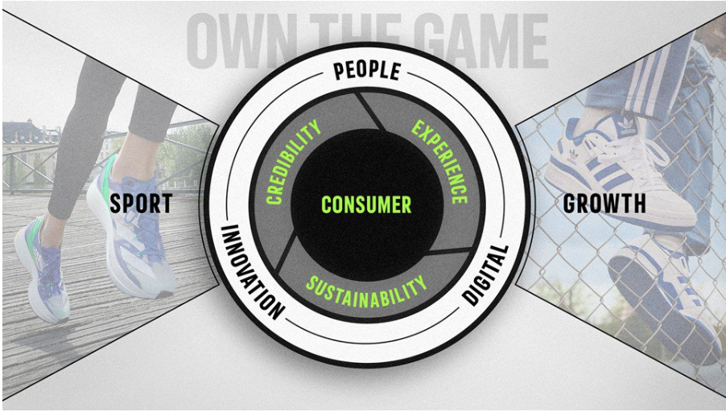
(adidas) strategy is enabled by a mindset of innovation across all dimensions of our business as well as our digital transformation. We own the game and will drive significant growth.
The strategy at adidas includes a social media strategy to drive structural trends in our industry through their preferences and behaviours.
The focus areas include
1.credibility in sport, lifestyle, woman, and partnerships.
2 experiences with a membership programme DTC (direct to consumer) led consumer social sales platforms using key cities to build portfolios and targeting strategic markets.
3.sustainability – commitments to sustainable and reducing the co2 footprint of the products, driving zero – carbon within the company’s operations plus promotion of environmental programs. adidas (2022)
Structure at adidas
The adidas Group consists of three corporate bodies: the Annual General Meeting, the Supervisory Board and the Executive Board Calo (2015) Overall, it can be observed that the Executive Board at the adidas Group solely consists of men, ages ranging from 49 to 61. Based on nationality, two members represent the brand’s originating country, Germany, two Americans and one executive from New Zealand. The adidas Group has notoriety for being a traditional, westernized company in this perspective. Despite this makeup within top-level management, the lower levels of the organizational structure pride itself on maintaining a youthful (average age is approximately 30 years), diversified (employees from 79 different nations) and gender-neutral (50% female) employee base.
The employee base at adidas is a collaborative one with different divisions within the company Closely collaborating with each other. communication s are open with in this organisation, communication seems to be a key component, workers across departments can communicate with each other, fostering Multi-Firm networks and Community-based structures that foster the creation and implementation of innovative business ideas and practices. Corporate Social Responsibility adidas Group The adidas Group directs an immense amount of focus into their corporate social responsibility. Workers at adidas have an internal text messaging hotline system that ca alert workers to new reforms in safety and changes in policies. On the other side of this it can enable workers to ask questions directly, make suggestions and express concerns all the while keeping the participants anonymous.
Adidas v Nike
Rivalry between these brands comes in the form of partnerships Nike sponsoring athletes whereas adidas collaborates more with sports personalities and stars of the music industry. There mindset is slightly different with innovation being at the front of Nike and adidas putting customers at the forefront, creating products according to customers’ needs.
Factor conditions for Indonesia has a high level of workers and high levels natural resources, there is a high level of manual workers in Indonesia compared to industy Leading Indonesian people is not the same as leading Westerners nor is it the same as leading other Asian people. A leadership strategy effective in one culture can be counter-productive in another. Irawanto 2009
Demand conditions
The demand for products from adidas is high with there being two main companies in production and a smattering of smaller companies. With a large section of the market innovation and customer development becomes the focus for the international brands. The market share is large and there is plenty of room for development to grab more of the market share, there consumer base is demanding and is used to receiving excellence in their shoe brand. With the feedback within the company and no fear of reprisals that is opportunity for adidas to look at the products and continually evaluate what their customers and employees are looking for in a vibrant brand that listens to feedback.
Related and supporting industries
With adidas close marketing and collaborations with large fashion houses seems to work well with them. Utilising the business models of exclusive and expensive luxury products can enhance the sales of small production lines exclusive to working with high end fashion. Working alongside such brand houses as Balenciaga and Gucci, adidas can learn how to maximise the presence of expanding on the small retail and exclusiveness of these brands, in doing this and using such retailing as pop up shops to sell exclusive lines with the use of social media to help to make the desire to own the products, adidas can learn how to choose specific lines to promote and optimise their products.
Factors in favour of adidas are that it already exports globally and has an international presence with sporting events that are held on a global scale. Large international sporting events can optimise adidas visibility and they can help feature their products using the sporting events themselves to promote innovation within the professional sporting world.
Government
Governments help in supporting large organisations to involve themselves on a local and national level, through there community engagement efforts adidas aims to create social impact for there communities. Through charitable contributions, volunteering and knowledge sharing, we work hand-in-hand with local organizations in key cities, key sourcing locations and key markets to bring our purpose to life adidas 2022
Using the two drivers’ people and planet supporting the markets cities and sourcing locations in challenging times. These come in the form of projects and long-term partnerships that create social value, with skill based volunteering and financial donations to expert advice and money donations and grants. Reducing waste is also a priority to adidas alongside product donations.
Such things as inclusivity with team pride, united against racism and breaking barriers these are some of the inclusive promotions within the adidas manifesto.
They also have invested in the infrastructure of sporting fields, playgrounds, sports courts, and sports equipment
All these things that there are to enhance the ethos of adidas the government in Porters theory is not there to be an invisible hand but rather a challenger to the behaviours of organisations, to help improve the company as a whole and encourage companies to raise the quality of their businesses making them world leaders in innovation, only by giving back can they achieve this.
Chance
Random events, natural disasters scientific breakthroughs all play a part in adidas culture, with their production company included in the changing political values in Indonesia
Conclusion
Using porters diamond theory we can analysis the viability of companies like adidas to expand, using Indonesia as a base where they are investing into the local infrastructure and at a national level with employment and creating good working practices and good working conditions.
The competitive advantage of production in Indonesia is that the country is labour rich, and the wages are cheap compared to the US, the working conditions differ making longer hours available to the employer thus making less down time at the point of production.
This fact in itself is then passed on to the consumers in the form of high original pricing structure with the capability to reduce in the form of promotional discounts, offering lower price points to attract consumers. The brand has built several sources of competitive advantage which include technology, marketing, supply chain as well as product design and quality. Apart from them, it is investing in sustainability and the creation of sustainable products to increase the popularity of its products and brand. Pratap 2019

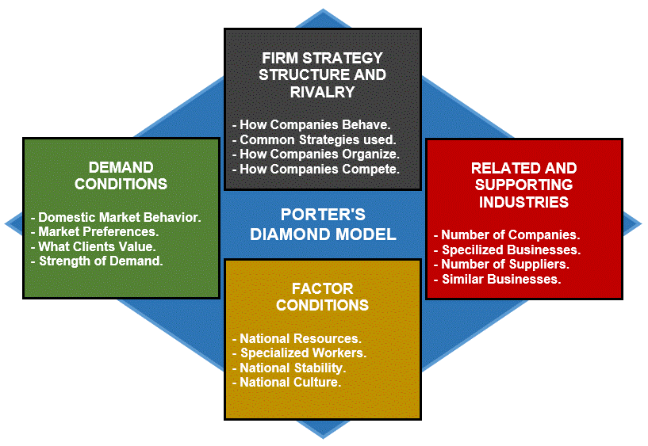

10.Conclusion –
With the collaborations that adidas have committed to using it as a business strategy there are pros and cons with this type of partnership.
Using luxury brands with a global producer of shoes and apparel they have the infrastructure, global laws and trade routes and agreements already set up to produce and distribute the product.
Collaborating as a strategy can be a massive positive experience for both sides of the partnerships if both sides are happy in this partnership. Once one side is not happy there can be a contractual obligation that both parties must adhere to and getting out of these can be a costly exercise. Adidas have looked at these issues as in the conflict with Kayne west and the conflict that Russia currently has with the Ukraine and has reimagined strategy to cope with these two major upheavals.
Focusing on major international events and forging new alliances with luxury brands and moving forward in targeting two other potential areas of the globe that they can move there shopping experience into.
Using there considerable marketing strategy and the collaboration of the famous brands that they collaborate with, using their social media presence with both their own and the collaborating brands marketing to reach a wide audience, developing their online presence.

11.Recommendations
As a larger brand adidas seem to have the large organisation side of there business in order and also, they seem to have developed a more intermit side that shows initiative in the form of business opportunities that adidas uses to its advantage in the form of collaborations with existing companies.
They already have a future business strategy in place to address the changing problems currently being faced in a global business environment.
In their future endeavours with collaborations the company as a whole have to move quicker to make decisions, when contracts are binding with individuals, making a clause to get out quick and liabilities attached.

reference list –

adidas Group- Management, Organizational Structure and CSR Analysis, MICHAEL CALO Nov. 17, 2015
Adidas Mission and Vision Statement Analysis (no date) Edrawsoft. Available at: https://www.edrawmind.com/article/adidas-mission-and-vision-statement-analysis.html (Accessed: December 15, 2022).
Adidas with robust growth in the third quarter as macroeconomic challenges increase (no date) adidas. Available at: https://www.adidas-group.com/en/media/news-archive/press-releases/2022/adidas-robust-growth-third-quarter-macroeconomic-challenges-incr/ (Accessed: December 15, 2022).

Adidas Sources of Competitive advantage
By Abhijeet Pratap / March 15, 2019

Communities (no date) adidas. Available at: https://www.adidas-group.com/en/sustainability/social-impacts/communities/ (Accessed: December 15, 2022).
History (no date) adidas. Available at: https://www.adidas-group.com/en/about/history/ (Accessed: December 15, 2022).

Malm, C., Jakobsson, J. and Isaksson, A. (2019) Physical activity and sports-real health benefits: A review with insight into the public health of Sweden, Sports (Basel, Switzerland). U.S. National Library of Medicine. Available at: https://www.ncbi.nlm.nih.gov/pmc/articles/PMC6572041/ (Accessed: December 15, 2022).
Nora. “How Does Hunger Marketing Strategy Go into Your Head?” Medium, 15 Oct. 2019, medium.com/@tripleynora/https-medium-com-tripleynora-how-does-hunger-marketing-strategy- go-into-your-head-a56b4ac4c5ac. Oct 17, 2021
Person and Fathin Ungku, S.W. (2021) Indonesia signals about-face on COP26 deforestation pledge, Reuters. Thomson Reuters. Available at: https://www.reuters.com/business/cop/indonesia-signals-about-face-cop26-zero-deforestation-pledge-2021-11-04/ (Accessed: December 15, 2022).
Seven in 10 adults are motivated to get healthier in 2021 due to covid-19 (no date) GOV.UK. Available at: https://www.gov.uk/government/news/seven-in-10-adults-are-motivated-to-get-healthier-in-2021-due-to-covid-19 (Accessed: December 15, 2022).

Smith, P. (2022) Sportswear: Largest companies by revenue 2021, Statista. Available at: https://www.statista.com/statistics/900271/leading-sportswear-and-performance-wear-companies-by-sales-worldwide/ (Accessed: December 15, 2022).
Strategy (no date) adidas. Available at: https://www.adidas-group.com/en/about/strategy-overview/ (Accessed: December 15, 2022).

The Successful Strategy of Yeezy in Digital Marketing , Xinyuan Zhang 2019
Tighe, D. (2022) Number of employees of the Adidas Group Worldwide 2000-2021, Statista. Available at: https://www.statista.com/statistics/268427/number-of-employees-of-the-adidas-group-worldwide-since-2000/ (Accessed: December 15, 2022).
Tighe, D. (2022) Adidas Revenue 2000-2021, Statista. Available at: https://www.statista.com/statistics/268416/net-sales-of-the-adidas-group-worldwide-since-2000/ (Accessed: December 15, 2022).
Vyshnavi, P.V. (2022) Nike vs adidas: Who is leading the market?, StartupTalky. StartupTalky. Available at: https://startuptalky.com/adidas-vs-nike/#_Nike_Vs_Adidas:_The_Real_Battle (Accessed: December 15, 2022).

