Module Title:
Assessment 2

Student Name: Nina Sokhan Kalashnikova
Student ID: 2234899

Lecturer name: Ruth Taylor Davies

Slide No: 01
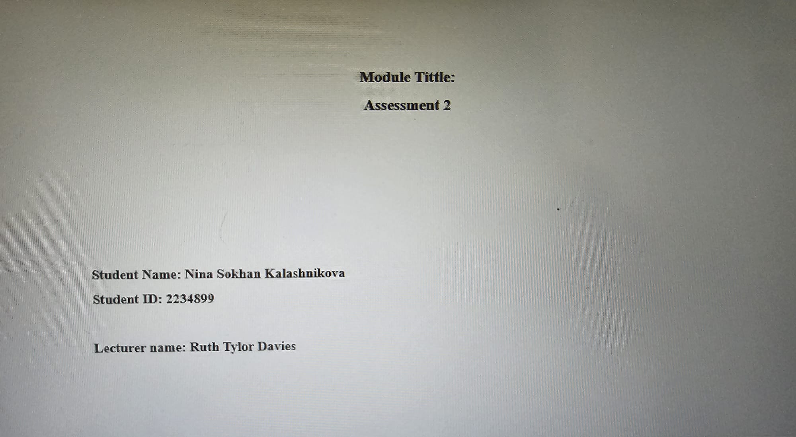

Slide No:02
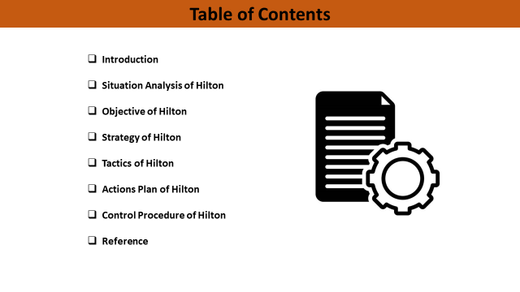
Table of Contents
Introduction 4
Situation Analysis of Hilton 5
Objective of Hilton 7
Strategy of Hilton 8
Tactics of Hilton 10
Action Plan of Hilton 11
Control Procedure of Hilton 13
Reference 14

Slide No: 03
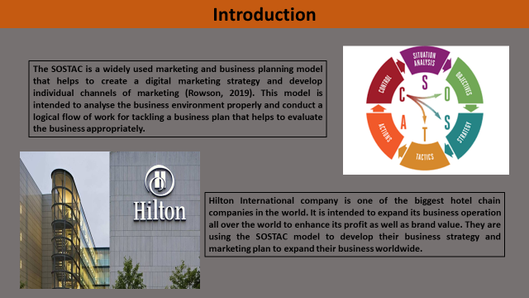

Introduction
The SOSTAC is a widely used marketing and business planning model that helps to create a digital marketing strategy and develop individual channels of marketing (Rowson, 2019). This model is intended to analyse the business environment properly and conduct a logical flow of work for tackling a business plan that helps to evaluate the business appropriately. Hilton International company is one of the biggest hotel chain companies in the world. It is intended to expand its business operation all over the world to enhance its profit as well as brand value. They are using the SOSTAC model to develop their business strategy and marketing plan to expand their business worldwide. The six different elements of SOSTAC are discussed below.

Slide No: 04
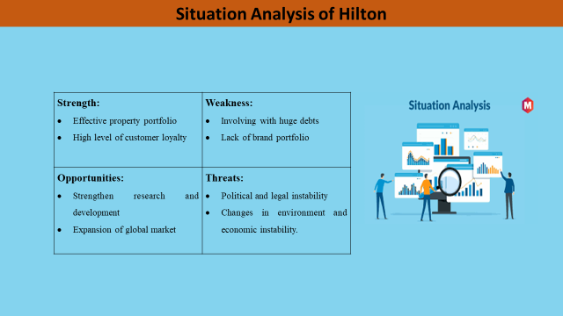

Situation Analysis of Hilton
The first step of the SOSTAC marketing plan is analysis the organization's overview and market situation. Situation analysis is determining the external and internal challenges and opportunities of the company. It also identifies the strength and weaknesses of the business organization to help them to expedite their business operations (Mathew, 2017). it also helps to develop an adequate business plan for the company according to the current situation and practices of the company. It determines the lacking of the company that should be improved to promote the business properly as well as expand globally. The company critically use SWOT analysis to evaluate the business environment, opportunities as well as challenges of the business expansion. SWOT analysis gives the blueprint of the company their potential opportunity and threats (Reed, 2014). It recommended improving their lacking by analyzing present and past information about business organizations. Hilton International is a hotel company which has the largest hotel chain in the world and successfully operates its business activities to compete with other hotels. SWOT analysis of Hilton International Hotel is given below:
Strength:  - Effective property portfolio  - High level of customer loyalty | Weakness:  - Involving with huge debts  - Lack of brand portfolio
Opportunities:  - Strengthen research and development  - Expansion of the global market | Threats:  - Political and legal instability  - Changes in environment and economic instability.

Slide No:05
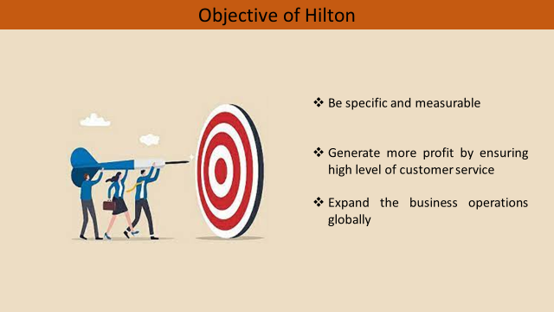

Objective of Hilton
The company requires precise objectives to obtain by implementing the marketing strategy of the business. A precise and clear objective of the company helps to develop a proper business plan to bring optimum outcomes. The objectives of the company should be relevant to its business policy and strategy. The company has different objectives to achieve with its business operations such as company intended to maximize its profit, maximizing wealth and improving the infrastructure of its business organization (Maghfira, 2021). The company can focus to improve their employee engagement as well as expanding their business operation to the world. The objectives of Hilton International are to generate more profit by ensuring a high level of customer service as well as expanding their business operations globally. The company must be developed an actionable and time constraint marketing strategy to create a strong hotel supply chain. By implementing the marketing strategy properly, Hilton International will be able to obtain its objectives.
Slide No: 06
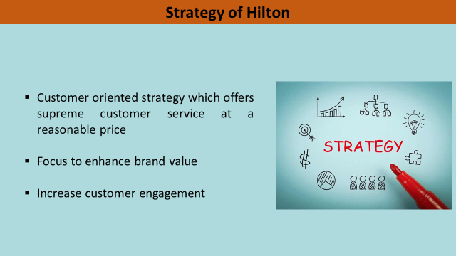

Strategy of Hilton
The success of the company is greatly depended on their strategy and adequate management that is implemented its business strategy properly. The strategy of the business refers to the strategic initiatives taken by the company to develop business operations and improve the lacking of the business. A strategy of the business indicates a proper outline of the business organization that is implemented by top-level management of the company (Morgan, 2015). It helps to create long-term goals or the company with proper guidance and direction. It helps to get a competitive advantage by improving business operations according to customer demand and competitor activities. The strategy is developed to create a strong position in the market as well as expand the business operation to generate a larger profit. The strategy of Hilton Hotel is mainly customer oriented which offers supreme customer service at a reasonable price. As a hotel company, it should be focused on its customers who are the driving force of the business. the quality service of the hotel attracts new customers and enhances customer satisfaction. By skilled and experience hotel staff, the hotel can ensure quality service to the customers. The marketing strategy is focused to enhance brand value and customer engagement (Galli, 2018). It also helps to promote their service to the customers which will help to enhance brand value. Brand value has a great impact on the customer's mind that drives them to select the hotels for their necessaries. And brand value also helps to increase customer engagement and build loyalty in the customer base.

Slide No: 07
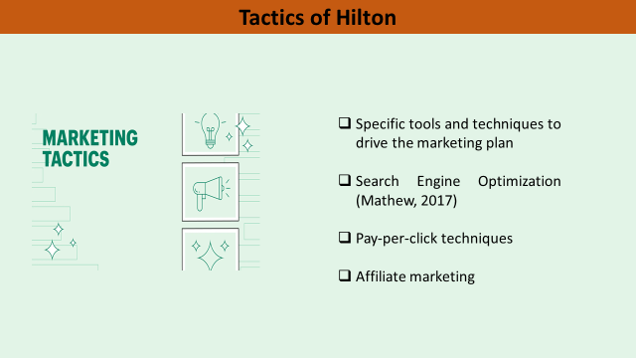

Tactics of Hilton
The tactics of a company refer to specific tools and techniques to drive the marketing plan to obtain the objectives. It also helps to determine specific business actions that will bring the optimum outcomes to the company. It indicates the particular steps that are taken for implementing business strategy properly (Reed, 2014). The tactics of marketing help to reach a huge customer base through several marketing strategies. By improving the Search Engine Optimization of Hilton International Hotel, they can reach their potential customers through online platforms. It will enhance their customer engagement by providing adequate information about their service and facilities for their respected customers. They also implemented pay-per-click techniques to engage more customers from different websites and social media (Pradina, 2022). In this era, people are more active on social media platform which is used for business promotion prominently. They also promote their activities and services via an affiliate marketing strategy. This process will help the Hilton Hotel to promote its services through an online platform by creating ad scenes or promoting its service with the e-commerce platform.

Slide No: 08
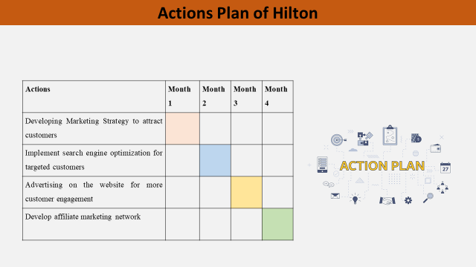

Action Plan of Hilton
After developing a business plan, the success of the business is completely depended on the execution of the business plan properly. At first, the top-level management of the company develops a business strategy according to their predetermined objectives. The top-level management develops the strategy according to the capability and potentiality of the company that helps to implement the business strategy (Maghfira, 2021). the proper coordination of the company is the precondition to implementing the business strategy adequately. And the strategy should be designed properly and precisely so that will be understandable and implementable for the workforce of the company. And proper direction of the management help to implement the business strategy properly. A four-month action plan of Hilton is given below:
Actions | Month 1 | Month 2 | Month 3 | Month 4
Developing Marketing Strategy to attract customers
Implement search engine optimization for targeted customers
Advertising on the website for more customer engagement
Develop affiliate marketing network

Slide No: 09
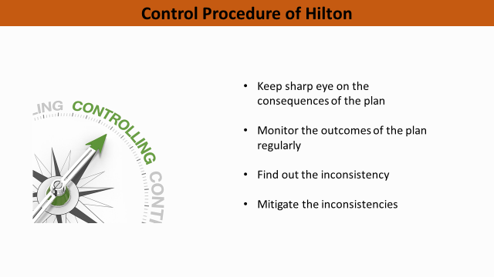

Control Procedure of Hilton
After executing the marketing plan to reach and engage the new customer the hotel management has to keep a sharp eye on the consequences of the plan. The top-level management of the company has to analyse and evaluate the consequences of the marketing plan and determine its relevance to the predetermined goal of the company. They have to monitor the outcomes of the plan regularly and find out the inconsistency if there are any (Galli, 2018). If there are any disruptions in the strategy the company should identify and rectify the problems to drive the strategy towards business objectives. If there are any barriers, the company have to mitigate that to continue the process. By properly monitoring the consequences of the marketing plan the management will be able to obtain the predetermined objectives of the organization. the management of the Hilton International Hotel is playing significant roles to implement the marketing plan properly.

Slide No: 10
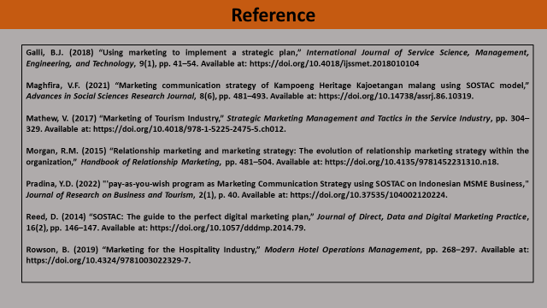

Reference
Galli, B.J. (2018) “Using marketing to implement a strategic plan,” International Journal of Service Science, Management, Engineering, and Technology, 9(1), pp. 41–54. Available at: https://doi.org/10.4018/ijssmet.2018010104.
Maghfira, V.F. (2021) “Marketing communication strategy of Kampoeng Heritage Kajoetangan malang using SOSTAC model,” Advances in Social Sciences Research Journal, 8(6), pp. 481–493. Available at: https://doi.org/10.14738/assrj.86.10319.
Mathew, V. (2017) “Marketing of Tourism Industry,” Strategic Marketing Management and Tactics in the Service Industry, pp. 304–329. Available at: https://doi.org/10.4018/978-1-5225-2475-5.ch012.
Morgan, R.M. (2015) “Relationship marketing and marketing strategy: The evolution of relationship marketing strategy within the organization,” Handbook of Relationship Marketing, pp. 481–504. Available at: https://doi.org/10.4135/9781452231310.n18.
Pradina, Y.D. (2022) "'pay-as-you-wish program as Marketing Communication Strategy using SOSTAC on Indonesian MSME Business," Journal of Research on Business and Tourism, 2(1), p. 40. Available at: https://doi.org/10.37535/104002120224.
Reed, D. (2014) “SOSTAC: The guide to the perfect digital marketing plan,” Journal of Direct, Data and Digital Marketing Practice, 16(2), pp. 146–147. Available at: https://doi.org/10.1057/dddmp.2014.79.
Rowson, B. (2019) “Marketing for the Hospitality Industry,” Modern Hotel Operations Management, pp. 268–297. Available at: https://doi.org/10.4324/9781003022329-7.

Slide No: 11

Note: Do you have anything to ask?

