The effect emotional intelligence and emotion-induced stimuli has on memory recall.
University of Wales Trinity Saint Daivd

Abstract

Findings suggest that emotive information can be recalled better over neutral information due to being encoded differently within memory (Buttafuoco et al., 2018). Based on these findings, the present study seeks to further explore whether emotional intelligence influences the recall of emotion-induced words. Thirty participants took part in the study, 11 males, 18 females and one non-binary (N= 30; M = 1.67; SD = .547). A mixed, multi-factorial design, of between and within-subject factors. The first independent variable measured the emotional intelligence of the participants, a between-subject factor, categorising results into two groups of high or low intelligence based around the mean (M=150.43). The second independent variable utilised emotion-induced stimuli, a within-subjects factor. Three groups of emotive words were gathered from ANEW (Bradley & Lang, 1999); positive, negative and neutral. The dependent variable measured the number of words recalled correctly by each participant. To analyse the data a mixed 2 x 3 ANOVA was used. Although mean scores did reflect the findings of previous studies, there was a lack of significance of interaction or main effects. As discussed, more complex factors should be considered for a deeper understanding of how emotion effects memory (Steinmetz & Kensinger, 2013).

Key words: Emotion, Memory, Emotional Intelligence, Emotion-induced stimuli, Recall, Individual difference

Introduction
Emotion and the effect it has on cognition has been widely studied and found to impact processes such as problem solving, attention and memory (Tyng, 2017). The influential role it plays on specifically on memory has been harnessed for a range of fields such as health and well-being (Dominique et al., 2009), enhancing approaches to learning a second language (MacIntyre & Vincze, 2017; Dewaele et al., 2018) and applied in politics, discovering that an individual’s memory of a candidate can be enhanced by engaging their emotions (Civettini, & Redlawsk, 2009). Findings suggest that emotive information can be recalled better over neutral information due to being encoded differently within memory (Buttafuoco et al., 2018). This theory has been tested using emotion-induced stimuli to explore whether individuals are more likely to recollect stimuli that has an emotive connection (Brierley et al., 2007; Khairudin et al., 2012; Fairfield et al., 2015). Other studies (Miller & Godfroid, 2020; Mavrou, 2021) have taken it a step further and questioned whether there is a link between an individual’s emotional intelligence (EI) and their ability to recall emotion-induced stimuli. Although, there appears to be a theme showing that emotion-induced stimuli are more likely to result in higher scores of recall, results differ between studies with EI scores creating different outcomes, such as neutral words being recalled less by individuals with lower EI scores (Toyota, 2011).
Miller & Godfroid’s (2020) recent findings argued that much research is focused on the effect of positive stimuli, highlighting the adverse effect negative stimuli may have on ‘hot cognition’ (Khajavy et al., 2018; Miller et al., 2018) however for some individuals negative stimuli may be more effective for memory in their studies of learning a second language.
Baños-González et al. (2021) found that advertisements containing ‘COVID-19’ were remembered the most which argues the point of emotion stimulating memory, however the standout emotion was ‘joy’ which reflects the findings that positive emotions are mostly recalled. Based on these findings, the present study seeks to further explore whether emotional intelligence influences the recall of emotion-induced words.

Hypotheses:
H1. Participants with higher scores of EI will recall more emotion-induced stimuli.
H2. Participants with higher EI scores will recall more positive words than participants with lower EI scores.
H3. Participants with low EI scores will recall fewer neutral stimuli.
H0. There will be no significant effect of emotional intelligence on the amount of recall emotion-induced stimuli.

Method
Participants
Thirty participants took part in the study, 11 males, 18 females and one non-binary (N= 30; M = 1.67; SD = .547). All participants were students enrolled to study a Psychology related degree at the University of Wales Trinity Saint David (UWTSD) aged between 18 and 51 (M = 29.97; SD = 9.96) and were recruited voluntarily through an Experiment Management System (EMS).

Design
A mixed, multi-factorial design, of between and within-subject factors. The first independent variable measured the emotional intelligence of the participants, a between-subject factor, categorising results into two groups of high or low intelligence based around the mean (M=150.43). The second independent variable utilised emotion-induced stimuli, a within-subjects factor. Three groups of emotive words were gathered from ANEW (Bradley & Lang, 1999); positive, negative and neutral. The dependent variable measured the number of words recalled correctly by each participant. To analyse the data a mixed ANOVA was used through SPSS.

Materials
Qualtrics software was used to create the first part of the experiment, ran on a laptop. An information sheet (Appendix A) was shown on screen first, which gave a brief description of the experiment and what data would be collected. This was followed by a consent page (Appendix B), this provided participants with data protection, confidentiality and anonymisation information, as well as timings. Participants were asked to read all the information provided, confirm their understanding and agreement, before continuing. Due to emotive nature of the experiment, consideration was made to provide information detailing both factors of emotional intelligence and emotion-induced stimuli, participants were made aware they could stop their participation at any point and withdraw their data.
Emotional intelligence measure – TEIQue-SF
To measure the emotional intelligence the Trait Emotional Intelligence Questionnaire – Short Form (TEIQue-SF) (Petrides & Furnham, 2006) (Appendix C) was used through Qualtrics Survey System for ease of administration, ensuring that all statements and Likert scales matched the original form. The TEIQue- SF measures the global trait emotional intelligence of an individual and is based on the full form of TEIQue (Petrides & Furnham, 2003) consisting of two items from the 15 subscales, aiming to ensure consistency of statements and adequate coverage of the construct. Total number of questions totalled 30, offering statements such as, ‘On the whole, I am pleased with life’ or ‘Others admire me for being relaxed’ asking the participant to work through swiftly and accurately responding to the statements using a 7-point Likert scale (Likert, 1932), ranging from ‘1’, ‘Completely Disagree’ to ‘7’, ‘Completely Agree’, no other scores were allowed and must have been a whole number between 1-7, no decimal points. Any ‘missing’ scores must have been replaced with a middle value of ‘4’ for scoring. Possible total scores ranged from 30 to 210, high scores indicating high emotional intelligence and low scores, low emotional intelligence. Fifteen items were negatively worded and required reverse scoring prior to analysis of data collected (Appendix D). A reliability analysis of the questionnaire produced a Cronbach’s Alpha of .63 (Appendix E), lower result than desirable however still within acceptable reliability score (Hinton et al., 2014; Taber, 2018). After the questionnaire had been completed an information screen asked the participant to move on to the laboratory computer for the next phase of experiment.
Emotion-induced stimuli - Experiment
The second part of the experiment was created through Superlabs software, which consisted of three categories of emotive-induced words, positive, negative and neutral. All words were randomly selected from Affective Norms for English Words (ANEW) (Bradley & Lang, 1999), such as ‘RAINBOW’, ‘TROUBLE’, ‘TAXI’ (Appendix F). Participants were directed through the software to move from the laptop to the laboratory computer which displayed an instructional screen explaining the next phase of the experiment, asking the participant to press ‘space’ when ready to begin. Each section displayed 20 words, positioned in the middle of the screen on a white background, for 200ms each, with a white blank screen shown for 400ms between each word. When all 20 words were displayed the section ended by asking the participant to think of something for one minute, such as a favourite food or a holiday destination, this was timed through Superlab, with the participant unable to skip the process. The screen then automatically to a screen with a textbox, prompting the participant to type as many words as they could remember from the section they have just seen. This was repeated for all three groups of words. Once the participant completed the three sections the screen displayed a debrief screen (Appendix G) explaining the experiment and gave information to the participant if they wish to remove their data, along with thanking them for taking part in the study.

Procedure
Ethical approval was gained, and all researchers adhered to UWTSD (United Trinity Saint David, 2020) and BPS codes of conduct and research guidelines (British Psychological Society, 2021). Participants were recruited through the Experiment Management System and were shown brief information before signing up to the experiment. Researchers ensured that both laptop and laboratory computer were set up ready for experiment, with both Qualtrics survey showing welcome page and computer showing second phase of experiment. Researchers met participants at the laboratory giving simple instructions of beginning at the laptop. The laptop displayed the content created through Qualtrics, starting with the information sheet which briefly explained the experiment and consent information. Consent was gained via Qualtrics in adherence with COVID-19 restrictions and policy. Participants were instructed through the software to read the information and confirm consent, unable to proceed unless all boxes were ticked, and consent agreed. Participants were then asked to provide demographic information, with the option to withhold, in line with ethical guidelines. This then continued to the emotional intelligence questionnaire, which provided the participant with information on how to answer and ensured a score was recorded for all 30 questions. At the end of questionnaire participants were thanked and instructed to move on to the laboratory computer for the next phase of the experiment. The laboratory computer screen showed an introduction to Superlabs task and instructed participants how to proceed. All participants took part in all three conditions, for counterbalancing purposes participants were shown three conditions in a different sequence. Scores of recalled words were totalled out of 20. At the end of the word display section the participants were provided with debrief information on screen and thanked for their participation. Participants were advised on how they could remove their data and asked them to notify the researcher immediately if they wish to do so. To minimise the risk of COVID-19 transmission, researchers ensured that all equipment was disinfected, masks were worn, and experiment slots were booked with this procedure in mind. Anonymity was ensured as participants were greeted by their EMS number, all data was anonymised and remained confidential, before being inputted into SPSS for analysis.
Results
A 2 x 3 mixed design ANOVA was conducted to explore the effect of emotional intelligence (low/high) on the ability to recall emotionally induced stimuli (positive/negative/neutral). The descriptive statistics are defined in Table 1.
Table 1
Means and standard deviations of recall and emotional intelligence scores
 | Emotional Intelligence
Emotion-induced stimuli | Low |  | High |  |  |  | Total
 | M | SD |  | M |  | SD |  | M |  | SD
Positive | 9.37 | 3.90 |  |  | 10.30 | 3.80 |  |  | 9.87 |  | 3.85
Negative | 9.50 | 3.44 |  |  | 9.70 | 4.31 |  |  | 9.60 |  | 3.71
Neutral | 7.60 | 3.00 |  |  | 8.90 | 2.98 |  |  | 8.10 |  | 3.01
The two-way interaction between emotional intelligence and emotionally induced stimuli was non-significant, F (2, 56) = .27, p = .76, np² = .01. The main effects of emotional intelligence (F (1, 28) = 1.12, p = .30, np² = .04) and emotionally induced stimuli (F (2, 56) = 2.25, p = .12, np² = .07) were also found to be non-significant.
The means scores showed more positive emotion-induce stimuli were recalled overall, and that participants with high intelligence performed better. Participants in the low intelligence group score for neutral words was the lowest score, however both groups recalled a similar number of negative words.
All three hypotheses must be rejected, and the null hypothesis accepted due to the non-significant results produced. SPSS outputs included in Appendices.

Discussion
Analysis of the data did not find a significant result, however, means scores did display the common theme throughout the previous literate, suggesting that high scores emotional intelligence produce higher scores of recall, with positive emotion-induced stimuli recalled the most. Interestingly the mean scores also reflected Toyota’s (2011) findings of participants with lower EI scores recalling lower number of neutral stimuli, however this can not be directly compared due to the difference in emotional intelligence questionnaire used.

Limitations
Although the TEIQue-SF was chosen due to being high reliability and successfully used in previous studies, the Cronbach’s alpha score of .63 was less than desirable than the generally accepted score of .70. These general accepted scores have been disputed by Taber (2018), however, in future studies reliability should be improved on, either utilising the full questionnaire or using a new measure.
Considering varied ages of participants, it has been mentioned that age may affect the ability to recall stimuli (Earles et al., 2016; Kapucu et al., 2008) however Grühn et al. (2005) found no age bias, emotion-induced words were remembered better over neutral words but not significant finding between positive and negative which also reflects the current findings.
It has been argued that personality should also be included as a measure, alongside intelligence, as high scores personality traits such as neuroticism or introversion could mean an individual is more likely to recall or respond to emotion-induced stimuli (Janowsky, D. S. (2001). Research has also highlighted that recall may be influenced by personal relevance (Buttafuoco et al., (2017), certain stimuli stands out to an individual (Fink et al., 1996; Worthen et al., 2000), based on Beck’s (1996) schematic theory, implying that if an individual holds a negative schema such as believing they are ‘stupid’ they are more likely to recall the word ‘stupid’ or experience a feeling of familiarity with certain words. This was discussed in Wittekind et al.’s (2014) study on mood-congruent memory (Blaney, 1986), where depressed participants related to stimuli more relevant to themselves which was also supported by previous studies (Moritz et al., 2008; Howe & Malone, 2011). Interestingly Moritz et al. (2005) found that depressed patients recalled fewer neutral words than healthy patients, which mirrors the findings of the current study where the low emotional intelligence group recalled fewer neutral words.
Implications
Findings could be harnessed for deeper exploration into the influence semantic networks and emotion have on memory, which has recently been harnessed to explore depression and recall by Fatima et al., (2021) with the aim to evaluate mental health approaches.
Conclusion
Although mean scores did reflect the findings of previous studies, there was a lack of significance of interaction or main effects. As discussed, more complex factors should be considered for a deeper understanding of how emotion effects memory (Steinmetz & Kensinger, 2013). Further research could also control for current mood state and individual difference such as personality traits, as shown in Baños-González et al.’s study (2021).

References

Baños-González, Rajas-Fernández, M., & Sutil-Martín, D. L. (2021). Analysis of Emotion and Recall in COVID-19 Advertisements: A Neuroscientific Study. International Journal of Environmental Research and Public Health, 18(16), 8721–. https://doi.org/10.3390/ijerph18168721

Beck, A. T. (1996). Beyond belief: A theory of modes, personality, and psychopathology.

Blaney, P. H. (1986). Affect and memory: a review. Psychological bulletin, 99(2), 229.

Bradley, M. M., & Lang, P. J. (1999). Affective norms for English words (ANEW): Instruction manual and affective ratings (Vol. 30, No. 1, pp. 25-36). Technical report C-1, the center for research in psychophysiology, University of Florida.
Brierley, B., Medford, N., Shaw, P., & David, A. S. (2007). Emotional memory for words: Separating content and context. Cognition and Emotion, 21(3), 495-521.
British Psychological Society. (2021) BPS Code of Human Research Ethics https://www.bps.org.uk/news-and-policy/bps-code-human-research-ethics
Buttafuoco, A., Pedale, T., Buchanan, T. W., & Santangelo, V. (2018). Only “efficient” emotional stimuli affect the content of working memory during free-recollection from natural scenes. Cognitive processing, 19(1), 125-132.
Civettini, & Redlawsk, D. P. (2009). Voters, Emotions, and Memory. Political Psychology, 30(1), 125–151. https://doi.org/10.1111/j.1467-9221.2008.00683.x
Dewaele, J.-M., Witney, J., Saito, K., & Dewaele, L. (2018). Foreign language enjoyment and anxiety: The effect of teacher and learner variables. Language Teaching Research, 22, 676–697. doi:10.1177/1362168817692161
Dominique, J. F., Aerni, A., Schelling, G., & Roozendaal, B. (2009). Glucocorticoids and the regulation of memory in health and disease. Frontiers in neuroendocrinology, 30(3), 358-370.
Earles, Kersten, A. W., Vernon, L. L., & Starkings, R. (2016). Memory for positive, negative and neutral events in younger and older adults: Does emotion influence binding in event memory? Cognition and Emotion, 30(2), 378–388. https://doi.org/10.1080/02699931.2014.996530)
Fairfield, B., Mammarella, N., Di Domenico, A., & Palumbo, R. (2015). Running with emotion: When affective content hampers working memory performance. International Journal of Psychology, 50(2), 161-164.
Fatima, A., Li, Y., Hills, T. T., & Stella, M. (2021). DASentimental: Detecting Depression, Anxiety, and Stress in Texts via Emotional Recall, Cognitive Networks, and Machine Learning. Big Data and Cognitive Computing, 5(4), 77.
Fink, G., Markowitsch, H., Reinkemeier, M., Bruckbauer, T., Kessler, J., & Heiss, W. (1996). Cerebral representation of one’s own past: Neural networks involved in autobiographical memory. The Journal of Neuroscience, 16(13), 42754282.
Grühn, Smith, J., & Baltes, P. B. (2005). No Aging Bias Favoring Memory for Positive Material: Evidence From a Heterogeneity-Homogeneity List Paradigm Using Emotionally Toned Words. Psychology and Aging, 20(4), 579–588. https://doi.org/10.1037/0882-7974.20.4.579).
Hinton, P., McMurray, I., & Brownlow, C. (2014). SPSS explained. Routledge.
Howe, M. L., & Malone, C. (2011). Mood-congruent true and false memory: Effects of depression. Memory, 19(2), 192-201.
Janowsky, D. S. (2001). Introversion and extroversion: implications for depression and suicidality. Current psychiatry reports, 3(6), 444-450.
Kapucu, Rotello, C. M., Ready, R. E., & Seidl, K. N. (2008). Response Bias in “Remembering” Emotional Stimuli: A New Perspective on Age Differences. Journal of Experimental Psychology. Learning, Memory, and Cognition, 34(3), 703–711. https://doi.org/10.1037/0278-7393.34.3.703
Khairudin, R., Nasir, R., Halim, F. W., Zainah, A. Z., Shahrazad, W. W., Ismail, K., & Valipour, G. M. (2012). Emotion and explicit verbal memory: evidence using Malay Lexicon. Asian Social Science, 8(9), 38.
Khajavy, MacIntyre, P. D., & Barabadi, E. (2018). Role of the Emotions and Classroom Environment in Willingness to Communicate: Applying Doubly Latent Multilevel Analysis in Second Language Acquisition Research. Studies in Second Language Acquisition, 40(3), 605–624. https://doi.org/10.1017/S0272263117000304
Likert, R. (1932). A technique for the measurement of attitudes. Archives of Psychology, 22 140, 55.
MacIntyre, P. D., & Vincze, L. (2017). Positive and negative emotions underlie motivation for L2 learning. Studies in Second Language Learning and Teaching, 7, 61–88. doi:10.14746/ssllt.2017.7.1.4.
Mavrou. (2021). Emotional intelligence, working memory, and emotional vocabulary in L1 and L2: Interactions and dissociations. Lingua, 257, 103083–. https://doi.org/10.1016/j.lingua.2021.103083
Miller, & Godfroid, A. (2020). Emotions in Incidental Language Learning: An Individual Differences Approach. Studies in Second Language Acquisition, 42(1), 115–141. https://doi.org/10.1017/S027226311900041X
Moritz, S., Gläscher, J., & Brassen, S. (2005). Investigation of mood‐congruent false and true memory recognition in depression. Depression and anxiety, 21(1), 9-17.
Moritz, S., Voigt, K., Arzola, G. M., & Otte, C. (2008). When the half-full glass is appraised as half empty and memorised as completely empty: Mood-congruent true and false recognition in depression is modulated by salience. Memory, 16(8), 810-820.
Petrides, K. V. & Furnham, A. (2003). Trait emotional intelligence: Behavioural validation in two studies of emotion recognition and reactivity to mood induction. European Journal of Personality, 17, 39-57.
Petrides, K. V. & Furnham, A. (2006). The role of trait emotional intelligence in a gender-specific model of organizational variables. Journal of Applied Social Psychology, 36, 552-569.
Steinmetz, K. R. M., & Kensinger, E. A. (2013). The emotion-induced memory trade-off: More than an effect of overt attention?. Memory & cognition, 41(1), 69-81.
Taber, K. S. (2018). The use of Cronbach’s alpha when developing and reporting research instruments in science education. Research in science education, 48(6), 1273-1296.
Toyota, H. (2011). Individual differences in emotional intelligence and incidental memory of words 1. Japanese psychological research, 53(3), 213-220.
Tyng, C. M., Amin, H. U., Saad, M. N., & Malik, A. S. (2017). The influences of emotion on learning and memory. Frontiers in psychology, 8, 1454.
United Trinity Saint David. (2020) Research Ethics & Integrity Code of Practice https://www.uwtsd.ac.uk/research/research-ethics
Wittekind, C. E., Terfehr, K., Otte, C., Jelinek, L., Hinkelmann, K., & Moritz, S. (2014). Mood-congruent memory in depression–The influence of personal relevance and emotional context. Psychiatry research, 215(3), 606-613.
Worthen, J. B., Garcia-Rivas, G., Green, C. R., & Vidos, R. A. (2000). Tests of a cognitiveresource-allocation account of the bizarreness effect. Journal of General Psychology, 127, 11744

Appendices

Appendix A

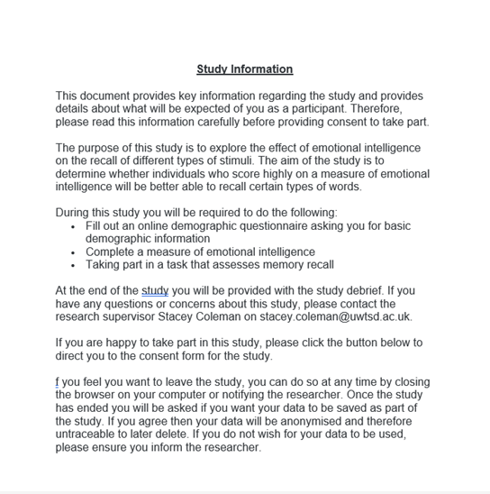

Appendix B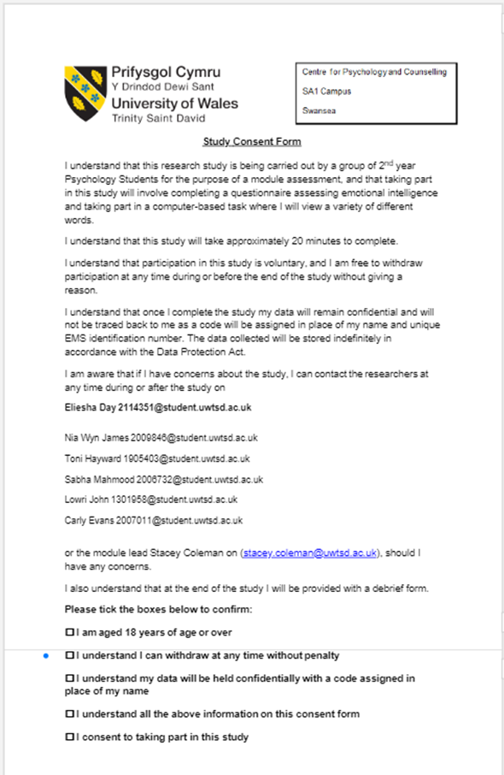

Appendix C
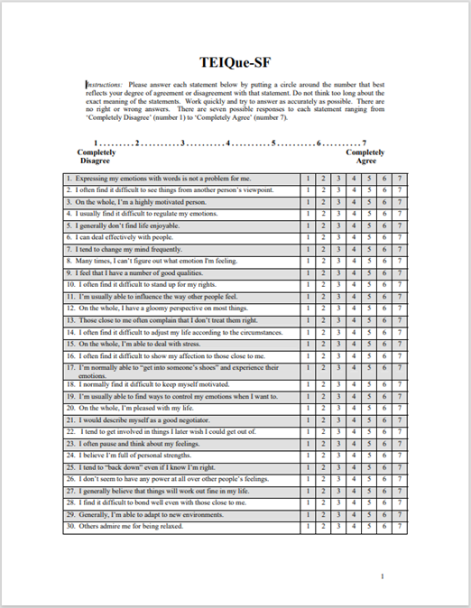

Appendix D
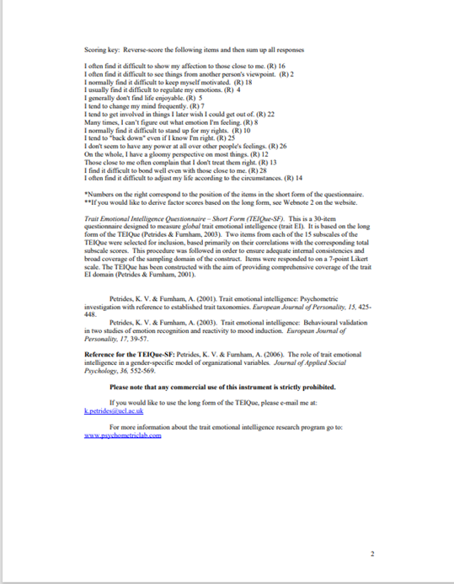

Appendix E

Reliability Statistics
Cronbach's Alpha | Cronbach's Alpha Based on Standardized Items | N of Items
.627 | .602 | 30

Appendix F
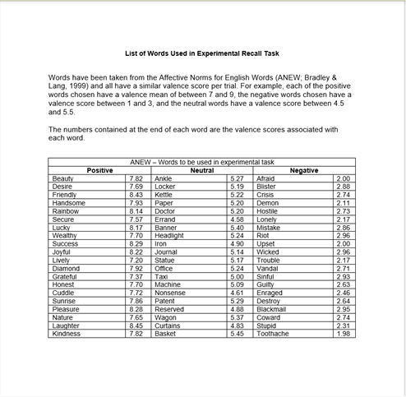

Appendix G
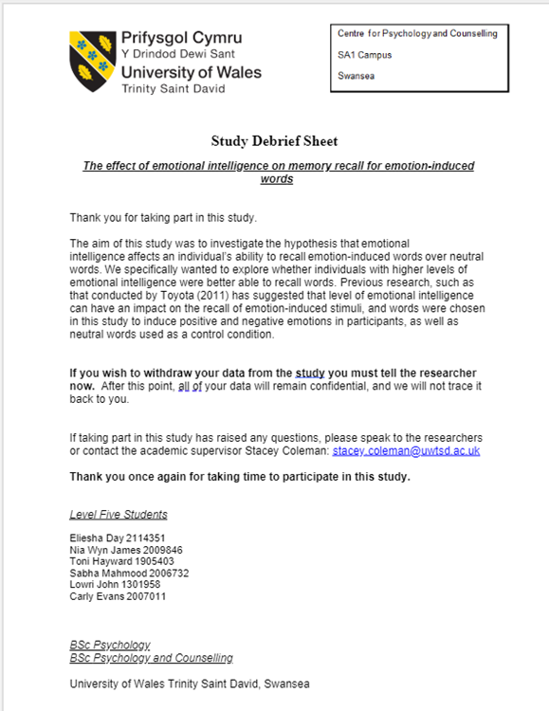

Appendix H

Descriptive Statistics
 | N | Minimum | Maximum | Mean | Std. Deviation | Skewness |  | Kurtosis
 | Statistic | Statistic | Statistic | Statistic | Statistic | Statistic | Std. Error | Statistic | Std. Error
EI_TOTAL | 30 | 130.00 | 197.00 | 150.4333 | 13.25788 | 1.570 | .427 | 4.175 | .833
Valid N (listwise) | 30

Appendix I
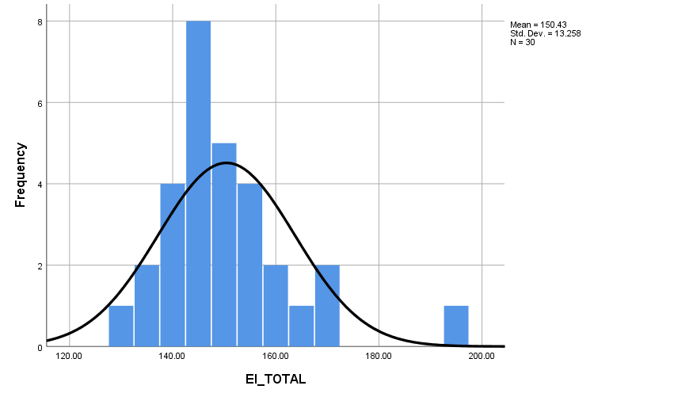

Appendix J

Box's Test of Equality of Covariance Matricesª
Box's M | 6.604
F | .955
df1 | 6
df2 | 2827.326
Sig. | .454
Tests the null hypothesis that the observed covariance matrices of the dependent variables are equal across groups.
a. Design: Intercept + EI_GROUPS
Within Subjects Design: EISTIM

Appendix K

Mauchly's Test of Sphericityª
Measure: MEASURE_1
Within Subjects Effect | Mauchly's W | Approx. Chi-Square | df | Sig. | Epsilon^{b}
 |  |  |  |  | Greenhouse-Geisser | Huynh-Feldt | Lower-bound
EISTIM | .985 | .411 | 2 | .814 | .985 | 1.000 | .500
Tests the null hypothesis that the error covariance matrix of the orthonormalized transformed dependent variables is proportional to an identity matrix.
a. Design: Intercept + EI_GROUPS
Within Subjects Design: EISTIM
b. May be used to adjust the degrees of freedom for the averaged tests of significance. Corrected tests are displayed in the Tests of Within-Subjects Effects table.

Appendix L

Levene's Test of Equality of Error Variancesª
 |  | Levene Statistic | df1 | df2 | Sig.
Positve | Based on Mean | .051 | 1 | 28 | .823
Positve | Based on Median | .067 | 1 | 28 | .798
Positve | Based on Median and with adjusted df | .067 | 1 | 27.986 | .798
Positve | Based on trimmed mean | .063 | 1 | 28 | .804
Negative | Based on Mean | .222 | 1 | 28 | .641
Negative | Based on Median | .207 | 1 | 28 | .652
Negative | Based on Median and with adjusted df | .207 | 1 | 25.024 | .653
Negative | Based on trimmed mean | .216 | 1 | 28 | .646
Neutral | Based on Mean | .140 | 1 | 28 | .711
Neutral | Based on Median | .024 | 1 | 28 | .879
Neutral | Based on Median and with adjusted df | .024 | 1 | 27.986 | .879
Neutral | Based on trimmed mean | .112 | 1 | 28 | .740
Tests the null hypothesis that the error variance of the dependent variable is equal across groups.
a. Design: Intercept + EI_GROUPS
Within Subjects Design: EISTIM

Appendix M

Descriptive Statistics
 | EI_GROUPS | Mean | Std. Deviation | N
Positve | Low | 9.3684 | 3.90456 | 19
Positve | High | 10.7273 | 3.77070 | 11
Positve | Total | 9.8667 | 3.84827 | 30
Negative | Low | 9.5263 | 3.43784 | 19
Negative | High | 9.7273 | 4.31488 | 11
Negative | Total | 9.6000 | 3.71019 | 30
Neutral | Low | 7.6316 | 3.00390 | 19
Neutral | High | 8.9091 | 2.98176 | 11
Neutral | Total | 8.1000 | 3.00975 | 30

Appendix N

Tests of Within-Subjects Effects
Measure: MEASURE_1
Source |  | Type III Sum of Squares | df | Mean Square | F | Sig. | Partial Eta Squared
EISTIM | Sphericity Assumed | 48.087 | 2 | 24.043 | 2.252 | .115 | .074
EISTIM | Greenhouse-Geisser | 48.087 | 1.970 | 24.407 | 2.252 | .115 | .074
EISTIM | Huynh-Feldt | 48.087 | 2.000 | 24.043 | 2.252 | .115 | .074
EISTIM | Lower-bound | 48.087 | 1.000 | 48.087 | 2.252 | .145 | .074
EISTIM * EI_GROUPS | Sphericity Assumed | 5.820 | 2 | 2.910 | .273 | .762 | .010
EISTIM * EI_GROUPS | Greenhouse-Geisser | 5.820 | 1.970 | 2.954 | .273 | .759 | .010
EISTIM * EI_GROUPS | Huynh-Feldt | 5.820 | 2.000 | 2.910 | .273 | .762 | .010
EISTIM * EI_GROUPS | Lower-bound | 5.820 | 1.000 | 5.820 | .273 | .606 | .010
Error(EISTIM) | Sphericity Assumed | 597.758 | 56 | 10.674
Error(EISTIM) | Greenhouse-Geisser | 597.758 | 55.166 | 10.836
Error(EISTIM) | Huynh-Feldt | 597.758 | 56.000 | 10.674
Error(EISTIM) | Lower-bound | 597.758 | 28.000 | 21.348

Appendix O

Tests of Between-Subjects Effects
Measure: MEASURE_1
Transformed Variable: Average
Source | Type III Sum of Squares | df | Mean Square | F | Sig. | Partial Eta Squared
Intercept | 7253.895 | 1 | 7253.895 | 432.981 | .000 | .939
EI_GROUPS | 18.695 | 1 | 18.695 | 1.116 | .300 | .038
Error | 469.094 | 28 | 16.753

Appendix P



