

Lecturer Name: Riaz Bhatti
Student Name: Varzari Cristina
Student ID: 2110951
Module code : LCBB5008
Module Title: Management Economics

Table of Contents
Introduction 3
Main Body 3
Conclusion 7
Reference List 8

Introduction
Management economics or Managerial Economics is the method of application of principles of economics in accordance with the adaptation of decision-making in an organisation. Business problems can be resolved through the help of the theories and principles of Economics based on management economics. The study will identify the reason for the adaptation of IKEA for the discussion. Besides that, it will highlight the demand and market equilibrium along with the factors influencing the same. Price elasticity of demand will be elaborated through the help of the completion of the study. Best pricing strategy for IKEA will be adopted as well.

Main Body
1. Pick a business that you know something about or can find information on. Describe the business and its main product or service.
IKEA has been founded in 1943 in Sweden and it is known for its furniture and home furnishing range. The organisation is continuously expanding all around the world due to its quality products. It is regarded as the 8th most valuable retailer all around the world. There are nearly 458 stores of IKEA in the world. Besides that, the organisation is also operating in 50 E-Commerce markets. It has been reflected that nearly 882 million customers visited IKEA in 2022 (Statista, 2023). The number of online visitors to the website of The Organisation was 5 billion. The amount of revenue generated by IKEA in 2021 was 41.9 billion Euros. It was nearly 5.8% more than in 2020. The current CEO of the IKEA group is Jon Abrahamsson Ring (ikea, 2023).
The reason for the choice of furniture is the growth of the product in the market. The revenue of the furniture market is almost 24.7 billion dollars in 2023. The growth of the market is expected to be 2.89% annually. The largest segment of the furniture market is living room furniture and the volume of this market is almost 5.79 billion dollars in 2023. Most of the revenue that is being generated in the organisation is from the United States. Per person-generated revenue from furniture is almost 348.7 dollars (Statista, 2023).

2. Identify Demand and Market Equilibrium. For each of the factors that influence Demand, describe how your main product or service is affected. Does the factor indicate that demand is increasing or decreasing?
Demand can be defined as the quantity of products or services that customers are willing to purchase at a specific price (Samuelson et al., 2021). The desire of the customers to purchase a product or service can be reflected through the help of the demand. According to the law of demand, if the price of the product is increasing then the demand for the product will reduce. On the other hand, the demand for the product or services will increase with respect to the reduction of the price of the same in the market. For the satisfaction of the law of demand, all of the other factors affecting demand must be constant. These factors can be regarded as the price of substitutes and complements, consumer income, the expectation of the customers as well as number of the buyers. In accordance with IKEA, it can be reflected that if the price of the furniture is increasing then customers will show low demand for the same due to the deterioration in the purchasing power. However, if the price is reduced the purchasing power of the customers will increase automatically. This will help the customers to purchase more number of products from IKEA.

Market equilibrium is the point where the quantity demanded by the customers becomes equal to the quantity supplied by the producers (png, 2022). This will result in a stable market price. In case the supply is higher than the demand for the products in IKEA then it will result in a surplus of the product. On the other hand, if the demand is higher than the supply of the product then a shortage of the products can be identified in the market. Besides that, it has been reflected that the equilibrium price and quantity can change with respect to the modifications in the demand and supply of the product in the market. External factors can also be responsible towards the changes in the equilibrium price and quantity for IKEA.
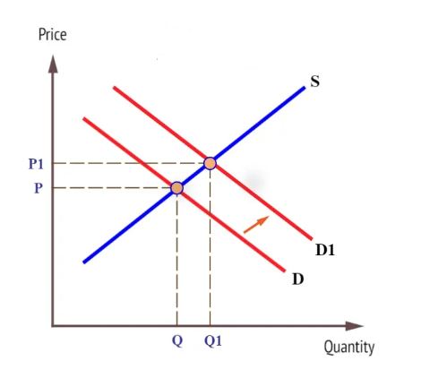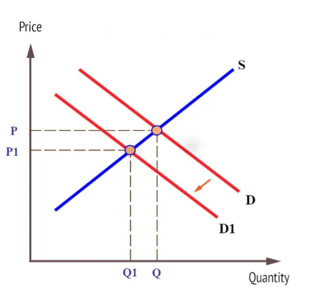
Figure 1: Shift of demand

Price of substitutes: This is regarded as a significant factor for the changes in demand for the products of IKEA. Substitute products are similar kind of elements that are in demand for the customers and these are also capable of satisfying the needs of them. There are different elements that are being utilised for the making of furniture in the market rather than wooden furniture. Engineered wood, plywood, metal and plastic are being used for the manufacturing of furniture. These are sustainable and cost-effective methods for consumers. Thereafter, the low price of substitute products is the reason for the high demand for the same. Due to this reason, customers will reflect the high demand for the substitute products rather than wooden furniture in IKEA. This will be the cause for the deterioration in the demand for furniture in IKEA although there are no changes in the price. Due to the reduction in the price of substitute products, IKEA will face low demand for its product.
Price of complements: Complementary products are goods that are often used together. Changes in the price of complementary products are the reason for the modification of the demand for furniture in IKEA. Complementary goods for furniture can be regarded as their colours. It has been reflected that the price of the same is much higher in the economy which is the reason for the making the furniture expensive. Due to the higher price of the colours of furniture, the overall price of them increases and customers are unable to purchase the same with a high price. This reflects that increase in the price of the complementary product will automatically enhance the overall price of the product which will result in the low demand for the same.

Consumer Income: Consumer income is responsible for affecting the demand for a product in the market. Normal and inferior goods can also be identified through the help of consumer income. In this situation, Normal goods have higher demands with respect to the increase in the income of the customers. However, increasing the income of customers reduces the demand for inferior goods. Furniture of IKEA is normal goods for the customers as an increase in customer income is responsible towards the improvement of the demand for these products. Purchasing power of the customers tends to increase based on the improvement of their income. Thereafter, they will be able to purchase more products which are the reason for the enhancement of the demand for furniture in IKEA based on the elevation of customer income. On the contrary, if the customer income is reduced then the purchasing power will be low which will reflect a reduction in the demand for the product. Median household disposable income was £32300 in 2022 in the UK. Reduction in the income of 0.6% in 2021 has been reflected (Ons, 2023). This is the reason for the deterioration in the demand for furniture from IKEA as the purchasing power has been reducing for the customers.
Consumer tastes & preferences: In case the taste and changes of the customers are modified then the demand for the product will fluctuate as well (William and Stephen, 2021). Customers prefer furniture from IKEA hence the demand for the products is higher in the market. If the customers change their preference to any other sustainable option then the furniture of IKEA will suspect low demand. Besides that, if customers are obtained for other organisations that IKEA then that will be the reason for the reduction in the demand for products in the organisation. Modification in taste and preference of the customer is responsible towards the fluctuation in the demand for products however the price is similar.
Consumer expectations of price: It has been identified if the customers are expecting that the price of certain products will be lower in the future then they reduce the current demand (Jones, 2022). They expect that they will purchase the same product when the price will be low in the future hence the current demand gets deteriorated. On the other hand, if customers sense that the price of furniture of IKEA will go higher in the near future then they will try to purchase the products at the current moment. Due to the Expectations of price will be the reason for the changes in the demand for the product however the price is still constant.
Demographics: An increase in the number of customers for the organisation will automatically enhance the demand for the products in the market. More customers will be desired for furniture from IKEA. The organisation will be able to experience higher demand. However, a reduction in the number of customers will be responsible for the spending of a low amount of money on the product. Demand for furniture from IKEA will get reduced in the market due to the low number of consumers. The current population of the UK is 67.7 million and there is a growth rate of 0.39%. Due to the enhancement of the number of customers, the demand for furniture from IKEA will increase.

3. For each of the factors that influence the Price Elasticity of Demand, describe how your main product or service (described in 2 above) is affected. Does the factor indicate demand is more elastic or more inelastic?
Price elasticity of demand is used for the identification of responsiveness of quantity demanded of a product or service with respect to the changes in its price (Garrone et al., 2019). They are after the formula of price elasticity of demand is the changes in the quantity demanded divided by the changes in the price. In this situation, elastic demand is when the value of the price elasticity of demand is greater than 1 (Economics Online, 2020). Thereafter, it suggests that the small changes in the price of the product are responsible for a large amount of decrease in demand. On the contrary, a small price decrease will reflect a substantial increase in demand for furniture in IKEA due to elastic demand. Inelastic demand is denoted as the situation where the price elasticity of demand is less than 1. It suggests that the changes in the price will result in smaller modifications in the quantity demanded. Consumers are not at all responsive in accordance with the price changes. Lowering the price will help to increase the demand in a smaller portion. On the contrary, an increase in the price will reflect a low amount of reduction of demand among customers. Price for furniture in IKEA is elastic as a little bit of change in the price can help the customers to increase their purchase of products. Higher demand for the products in IKEA can be reflected based on the small price change which makes the demand elastic.
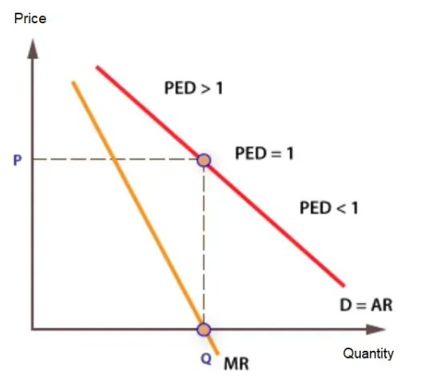
Figure 2: Price elasticity of demand
Substitution Effects: Furniture is regarded as necessary items hence IKEA experiences higher demand for the products. The substitution effect is responsible for the changes in the quantity demanded of products or services based on the modifications of the price of Substitute products. In case, the substitute products of furniture of IKEA are experienced at higher prices then the products of IKEA will become of affordable for the customers. This will help the organisation to increase the number of customers due to the substitution effect without modification in the price of the products of IKEA. On the contrary, if the substitute products are priced in a low manner then customers will move towards the substitute products. This will result in a reduction in the demand for products in IKEA based on the substitution effect.

Income Effects: The income effect suggests the change in the quantity demanded the products and services with respect to the modification in the income or purchasing power of the customers while all the prices of the products remain constant (Baqaee and Burstein, 2023). If the customer income is increasing then they will be capable of purchasing more products which will automatically improve the demand for furniture in IKEA without the modification of the price of the same. On the contrary, if the consumer income is becoming lower than the customers will not be able to purchase more products and the demand will reduce for the furniture of IKEA based on the income effect of the customers.

Given your analysis, what pricing policy should the business employ? Why?
IKEA should employ a competitive pricing strategy for its products in the market as it is responsible for customer attraction and retention. New consumers can easily be attracted to the business due to the low price than the competitors. Customers will find that the products sold by IKEA are of better quality than its competitors although it has a lower price range. This will be the reason for the attraction of new customers along with the retention of the previous consumers. Brand loyalty of the customers can also be increased based on the competitive pricing strategy. Besides that, this is a suitable method for the organisation to enhance its market share among its competitors. A larger portion of the market can easily be captured by the brand through the help of a competitive pricing strategy. On the other hand, this is also responsible for the enhancement of the revenue growth of the organisation due to the high demand among customers. IKEA will be capable of getting a competitive advantage among other organisations in the furniture market due to its low price. Penetration in a new market will be possible by the organisation low as it will offer low prices based on a competitive pricing policy (Gupta et al., 2021). A positive brand image of the organisation can be created among the customers. A competitive pricing strategy is also responsible for the business to respond in accordance with the changes in the market and actions of the competitors. Pricing strategy will provide flexibility to the organisation in the market.

Conclusion
The study has discussed the reasons for the choice of IKEA. Increase in the market share of the brand all over the world is the major reason for the choosing of the business for the discussion. The study has evaluated the concept of demand and market equilibrium. Factors responsible for the changes in demand while the price is the same can be regarded as the price of substitute and complementary products, modifications in the number of customers and their tastes along with income of the same. It has also reflected the concepts of elastic and inelastic demand. Substitution and income effect on the products of IKEA has been elaborated through the completion of the study.

Reference List
Baqaee, D.R. and Burstein, A., 2023. Welfare and output with income effects and taste shocks. The Quarterly Journal of Economics, 138(2), pp.769-834.
Economics Online 2020. Price elasticity of demand Available at: https://www.economicsonline.co.uk/competitive_markets/price_elasticity_of_demand.html/ (Accessed: 24 July 2023).
Economics Online 2020. Shifts in demand Available at: https://www.economicsonline.co.uk/competitive_markets/demand_shifts.html/ (Accessed: 24 July 2023).
Garrone, P., Grilli, L. and Marzano, R., 2019. Price elasticity of water demand considering scarcity and attitudes. Utilities Policy, 59, p.100927.
Gupta, V., Ivanov, D. and Choi, T.M., 2021. Competitive pricing of substitute products under supply disruption. Omega, 101, p.102279.
Ikea 2023. IKEA facts and figures FY21 Available at: https://about.ikea.com/en/newsroom/2021/10/14/ikea-facts-and-figures-fy21 (Accessed: 24 July 2023).
Jones, T., 2022. Business economics and managerial decision making. John Wiley & Sons, Inc..
Ons 2023. Average household income, UK - Office for National Statistics Available at: https://www.ons.gov.uk/peoplepopulationandcommunity/personalandhouseholdfinances/incomeandwealth/bulletins/householddisposableincomeandinequality/financialyearending2022 (Accessed: 24 July 2023).
Png, I., 2022. Managerial economics. Routledge.
Samuelson, W.F., Marks, S.G. and Zagorsky, J.L., 2021. Managerial economics. John Wiley & Sons.
Statista 2023. Furniture - United Kingdom | Statista Market Forecast Available at: https://www.statista.com/outlook/cmo/furniture/united-kingdom (Accessed: 24 July 2023).
Statista 2023. Topic: IKEA Available at: https://www.statista.com/topics/1961/ikea/#topicOverview (Accessed: 24 July 2023).
William, F.S. and Stephen, G.M., 2021. MANAGERIAL ECONOMICS. JOHN WILEY.
Worldpopulationreview 2023. United Kingdom Population 2023 (Live) Available at: https://worldpopulationreview.com/countries/united-kingdom-population (Accessed: 24 July 2023).

