
Damian Thomas
1707773@student.uwtsd.ac.uk

Factory Control 2
Control Technology

Summary.

The objective of this report is to use SIEMENS TIA Portal in conjunction with a Factory IO system displayed on https://www.youtube.com/watch?v=ZIAdX0JeShg and was emulated to demonstrate that it works. The emulated version has been provided alongside this report with the Logic Program used to work all the machinery in the system.
The logic program used to work the Factory IO system is comprised of 30 networks all working alongside each other to ensure it runs as smoothly as possible. Many different functions were used in the main body of the logic program including:
- Counters.
- Time Functions.
- Set and Reset Functions.
Some of these were used to display information on the HMI screens. This information includes:
- Counters of the Lids.
- Counters of the Bases.
- Counters of the Completed Assemblies.
- Counters of the Boxes.
There is also a screen dedicated to the Warnings and Errors that displays when the pre-set limits have been triggered within the system.
The third screen created is the Engineer screen. It is used to implement the number of boxes needed, early warning and final warnings. Once the user sets the limits, the pilot lights on the “Root Screen” and “Alarms and Warnings Screen” will change when the early warning and the final warning have been triggered. Once the required number of boxes has been achieved, the system completely shuts down.
It has also suggested some improvements that could be made which include changing the position of the first Two Axis Pick and Place Machine and to have audible alarms when a warning or error is triggered in its normal working.
Contents

Summary. ii
Table of Figures. 1
1.0 Introduction. 2
2.0 Factory Diagram. 3
2.1 Factory Diagram. 3
2.2 Operational Flow. 4
3.0 Ladder Logic. 5
4.0 Warnings, Alarms and Engineer Screen. 14
4.1 Root Screen. 14
4.2 Warnings and Alarms. 15
4.3 Engineer Screen. 16
5.0 Conclusion. 17

Table of Figures.

Figure 1 – Process Flow Diagram. 3
Figure 2 – Process Flow Diagram. 4
Figure 3 – Networks 1 & 2. 5
Figure 4 – Networks 3 & 4. 6
Figure 5 – Networks 5 – 8. 7
Figure 6 – Networks 9 – 11. 8
Figure 7 – Network 12. 9
Figure 8 – Networks 13 – 16. 10
Figure 9 – Network 17. 11
Figure 10 – Networks 18 – 24. 12
Figure 11 – Networks 25 – 30. 13
Figure 12 – Root Screen. 14
Figure 13 – Alarms and Warning. 15
Figure 14 – Engineer Screen. 16
Figure 15 – Factory IO System. 17

Introduction.

This report will demonstrate four main tasks held within the brief. These are as follows:
- Task 1 – Utilising the components within Factory IO, design a factory process capable of performing the required task.
- Task 2 – Write a Ladder Logic Program to control the factory process.
- Task 3 – Incorporate an HMI device into the factory and program.
- Task 4 – Design and incorporate several screens with navigation controls on to the HMI including Error/Warning and Engineering screen complete with their operation.
It will include a flow chart demonstrating each section of the factory, while also giving a description of what is happening in each section of it.
The factory being used for reference has can be found using the following link:
https://www.youtube.com/watch?v=ZIAdX0JeShg
The system in the video is comprised of:
- Three Emitters – Two for the Blue Blanks, One for the Box.
- One Remover – Removes the Boxes and the Completed Assemblies.
- Two Machining Centres – One for the Lid, One for the Base.
- Two Clamps – One Left Clamp and One Right Clamp.
- Two Axis Pick and Place Machines.
In a real-world application of the factory, the ladder logic would be instrumental in the workings of machinery within the factory. To ensure the factory is run as efficiently as possible would be to automate the system as much as possible. This would include having all of the conveyors start up in sequence, have the Machining Centres operating at the same time and having the choreography of the Two Axis Pick and Place machines correct in each instance. This will be done using SIEMENS TIA Portal, a program used to write logic for multiple components in any given system.

Factory Diagram.
Below is a diagram and operational flow chart showing the process flow of the factory being used in this report.

Factory Diagram.

Machine Centre.
Machine Centre.
2m Conveyor.

2m Conveyor.
2m Conveyor.

2m Conveyor.

Left Clamp.
Left Clamp.

6m Roller Conveyor.

Emitter.
Emitter.
6m Conveyor.
6m Conveyor.
Two Axis Pick and Place.

Right Clamp.
2m Conveyor.

Emitter.
Remover.

Two Axis Pick and Place.

Figure 1 – Process Flow Diagram.
The two emitters, before the machining centres, release the blank plates to go through the full process. The blank goes down the line until it reaches the machining centre. The machining centre would then produce either a lid or a base plate. After this has been completed, the component carries on down the conveyors. Once they reach the clamps, they are held in place until the first two axis pick and place. The pick and place would then begin by getting the lid and then moving it over before putting it down on the base piece. The first left clamp would then raise up allowing the completed assembly to carry on to the next stage. The assembled components stop at the second left hand clamp where it gets picked up by the second two axis pick and place and releases inside of the box emitted by the lower emitter. The box carries on down the roller conveyor until it reaches the remover. It should be noted that only two of the fully assembled components can be placed into the box.

Operational Flow.
Figure 2 – Process Flow Diagram.
Do Nothing.
Box and completed parts are Removed.

Yes
No
No
Yes
No
No
Yes
Yes
Left 2 Clamp To Actuate.
Right Clamp to Release.
Pick and Place to Actuate.
Has Diffuse Sensor… Been Triggered?
Left Clamp To Release and Raise.
Do Nothing.
Left Clamp To Actuate.
Has Diffuse Sensor… Been Triggered?
Has Diffuse Sensor… Been Triggered?
Right Clamp To Actuate.
Do Nothing.
Do Nothing.
Plates enter and exit the machining centre.
Blank Plates Start Emitting.
Boxes Start Emitting.
Conveyors Start in Sequence.
Pick and Place to Actuate.
Has Diffuse Sensor… Been Triggered?
Start

Ladder Logic.
This section will show each line of the Siemens Logic and explain what they are doing in reference to the Factory IO system.
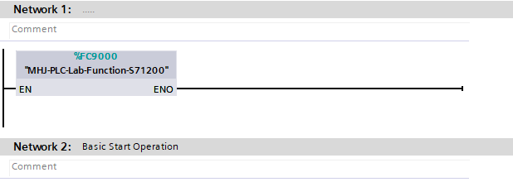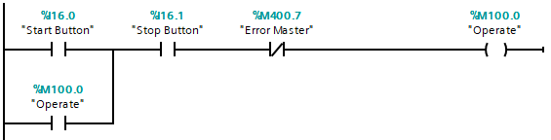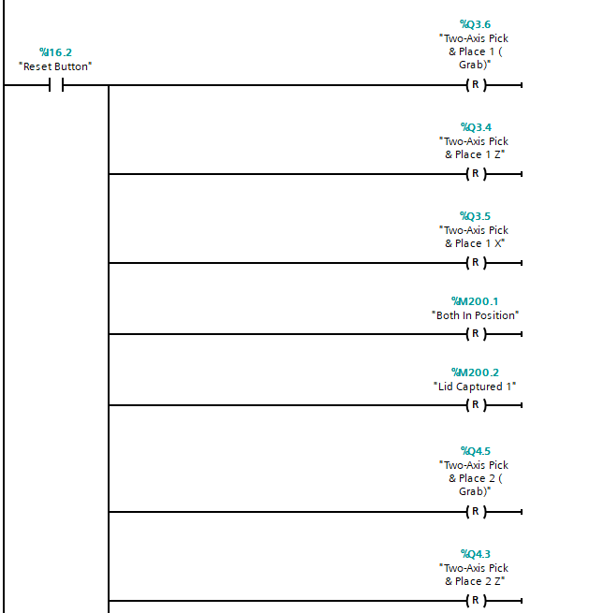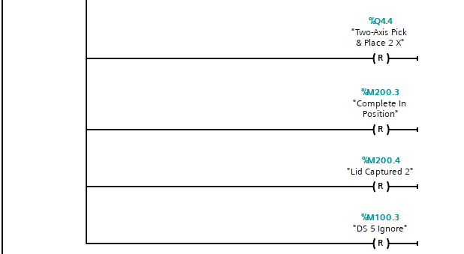
Network 1 links the program to the Factory IO System.
The first part of Network 2 sets up the function of the “Start”, “Stop” and the also has a link for the “Emergency Stop Button.

Figure 3 – Networks 1 & 2.
The second part of the Network links many of the parts used to move the Two Axis Pick & Place to the Reset Button on the control panel.
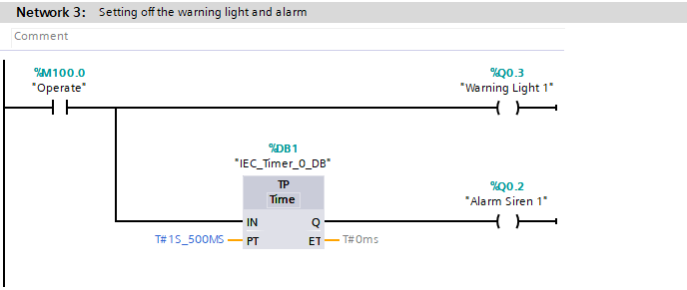
Network three relates to when the Start Button is hit. Once pressed, a siren sounds after 1.5 seconds and activates a warning light.
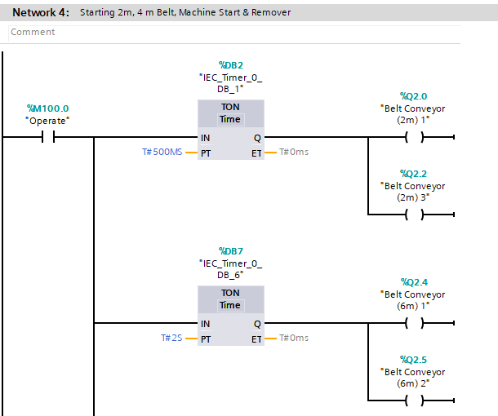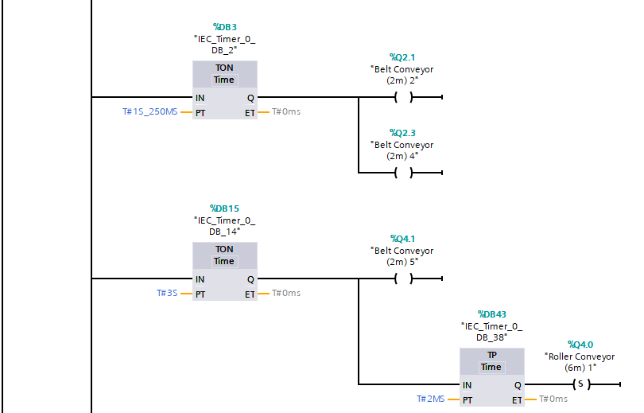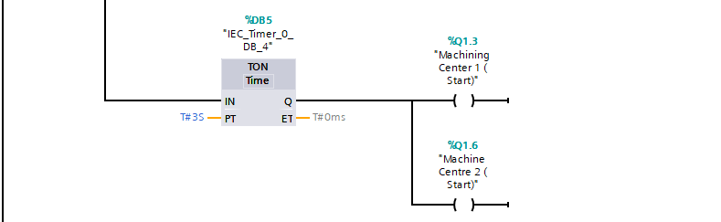
Figure 4 – Networks 3 & 4.
This next Network sets up all the roller conveyors and belt conveyors in a specific sequence. This is done by using “TON” functions and varying times ranging from 0.5 seconds to 3 seconds.
This part uses a Pulse Timer as the conveyor will have to be stopped and started in a later Network.
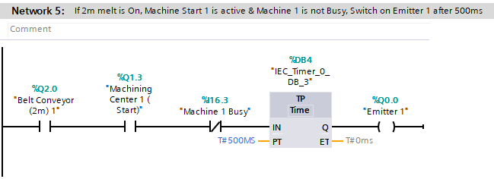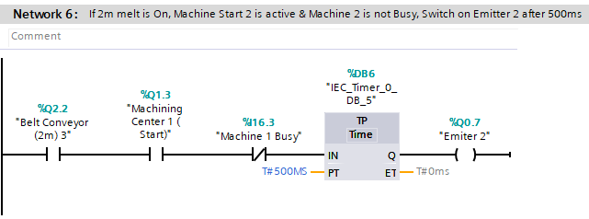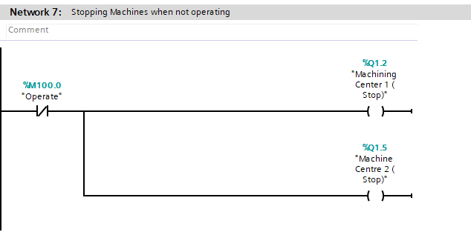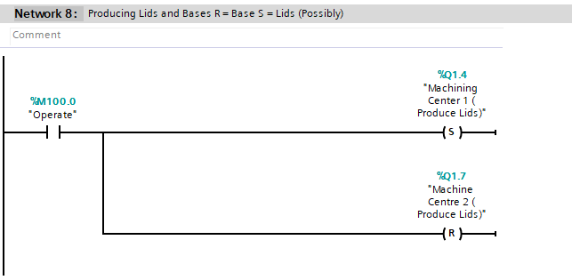
Figure 5 – Networks 5 – 8.
Networks 7 and 8 are both similar. It ensures that new blank plates are released until both Machining Centres have completed the Lids and Bases.
Networks 5 and 6 do the same as each other. They both control the Blank Plate Emitters and only release one when the Machine Centre is not busy, and the conveyors are active.
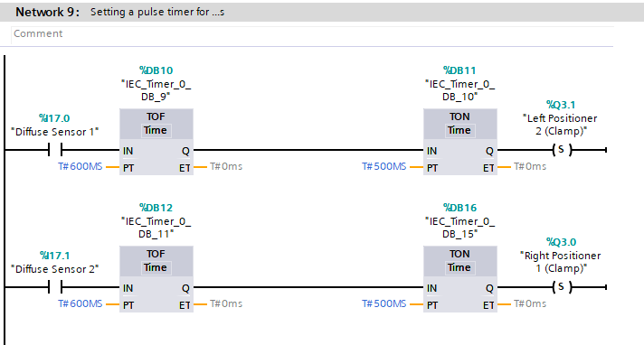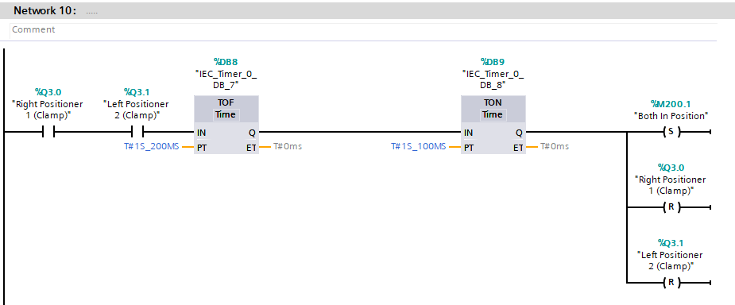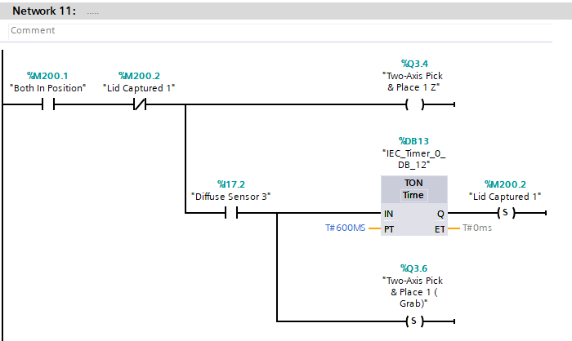
Figure 6 – Networks 9 – 11.
Network 9 and 10 relates to the Left and Right clamps on the conveyor. It tells the factory to clamp the positioner once the sensor has been triggered.
Network 11 is where the first Pick and Place are initiated.
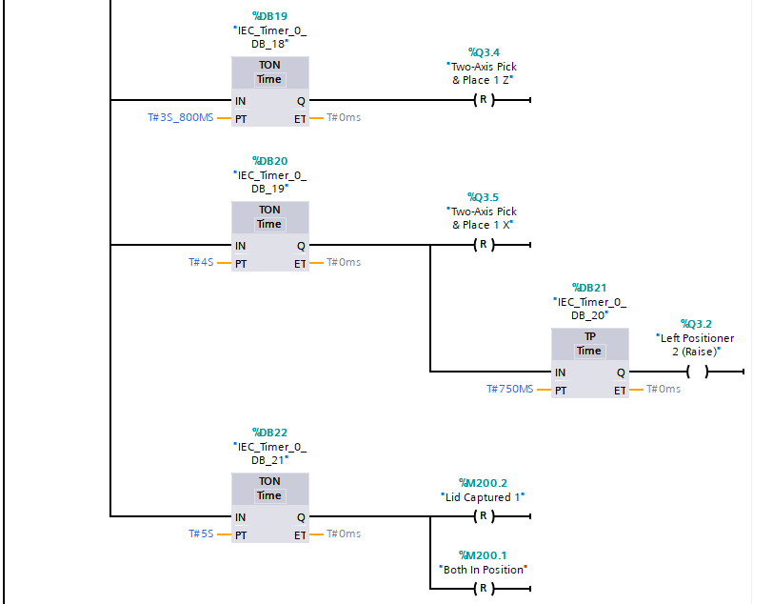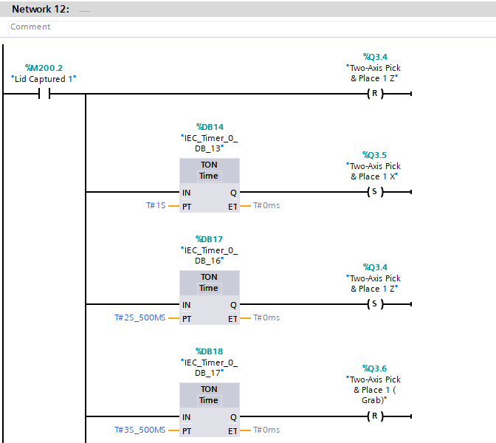
Network 12 is the choreography for the Two Axis Pick & Place. The machine firstly actuates the Z Axis, Initiates the grabber, retracts the Z Axis, actuates the X Axis, Actuates the Z Axis, Releases the grabber, Retracts the Z Axis and finally retracts the X Axis to the resting place.
Figure 7 – Network 12.
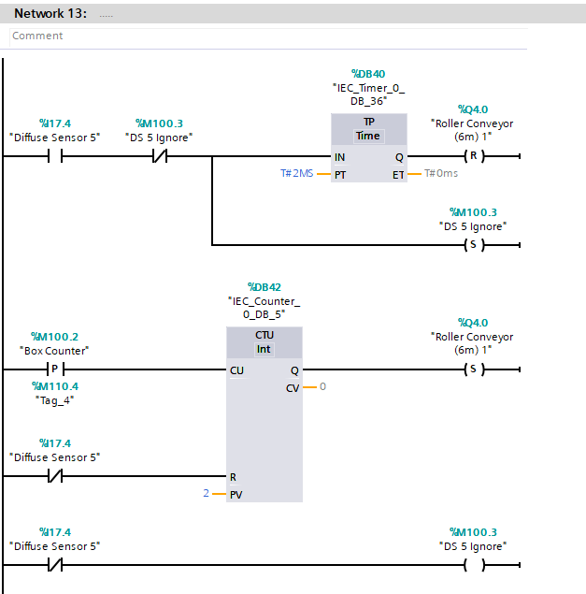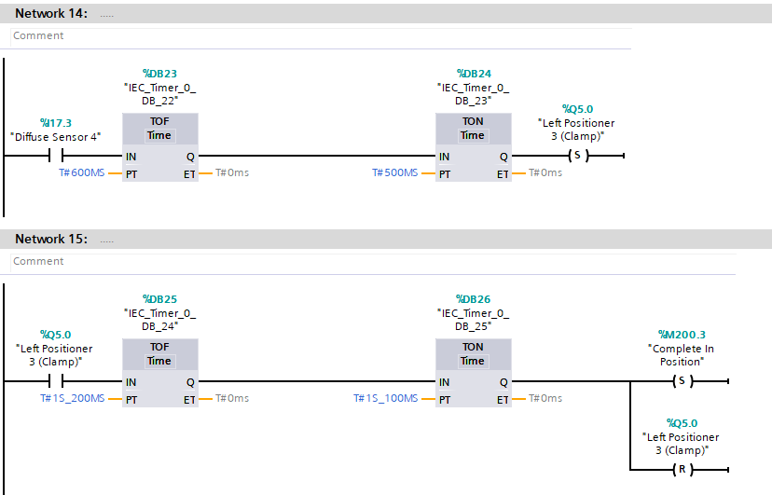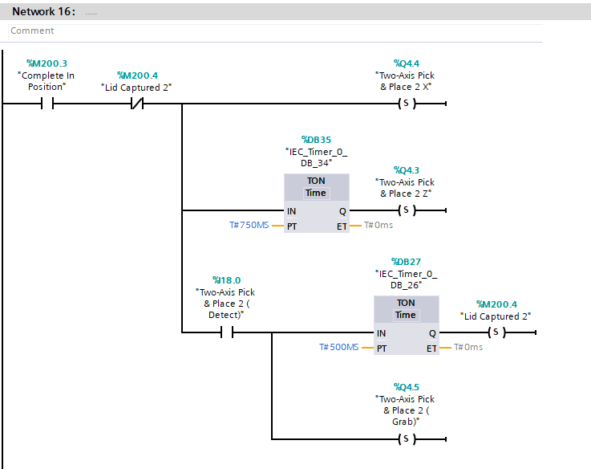
Figure 8 – Networks 13 – 16.
Networks 14 and 15 relate to the final base clamps. Once a Diffuse Sensor 4 is triggered, the clamp holds it in place to make sure that the next Two Axis Pick & Place can move the bases into the boxes. Which begins in Network 16 and carries on into Network 17.
Network 13 is the counter to allow for the boxes to pass through once the two completed components have been placed inside of it. Until that point, it is held in place by Diffuse Sensor 5.
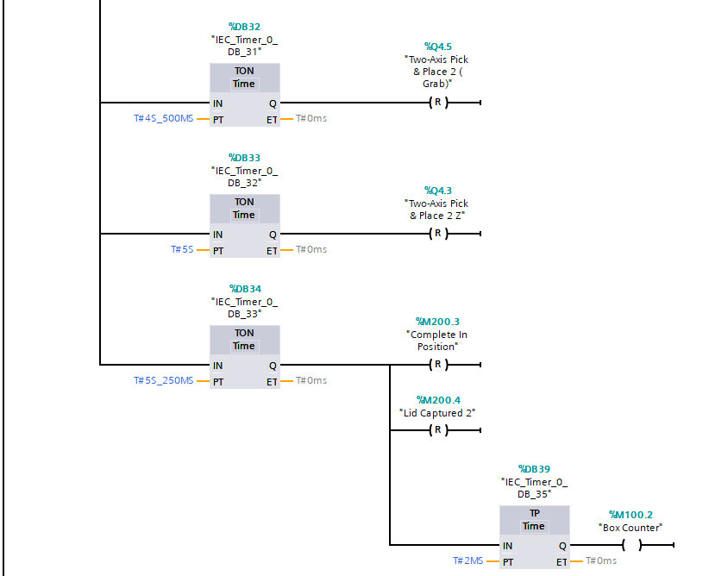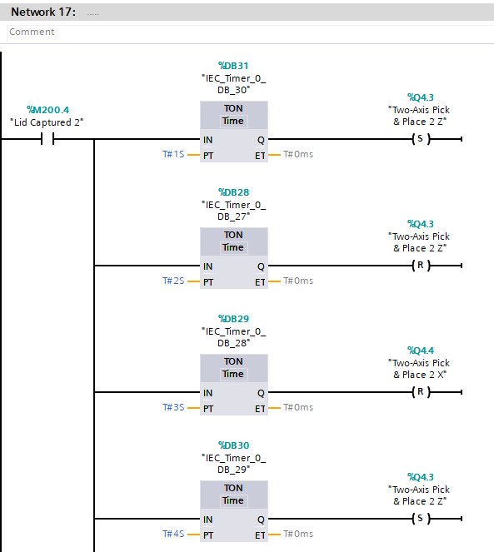
As mentioned previously, Network 17 relates to the Two Axis Pick & Place. It contains the choreography for the second Two Axis Pick & Place. Once the “Lid Captured 2” is positive, the X Axis extends, then the Z Axis also extends. Following that, the grabber is actuated to pick up the bases. The Z Axis then retracts before the X Axis also retracts. It then actuates the Z Axis, Releases the grabber, and then retracts the Z Axis to the rest position.
Figure 9 – Network 17.
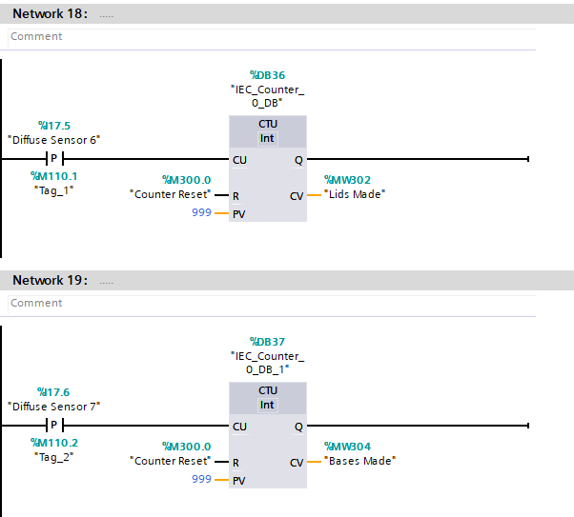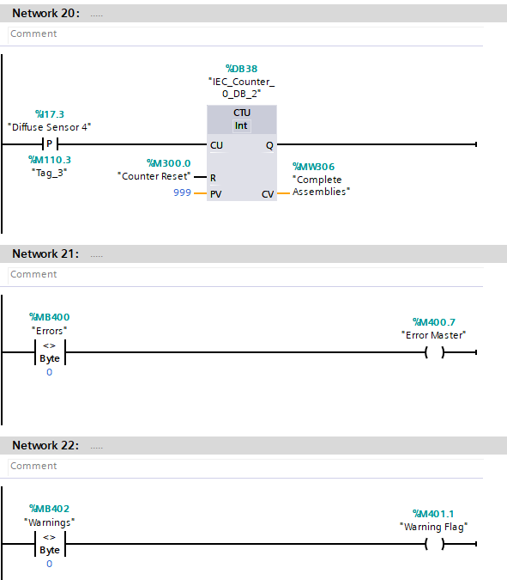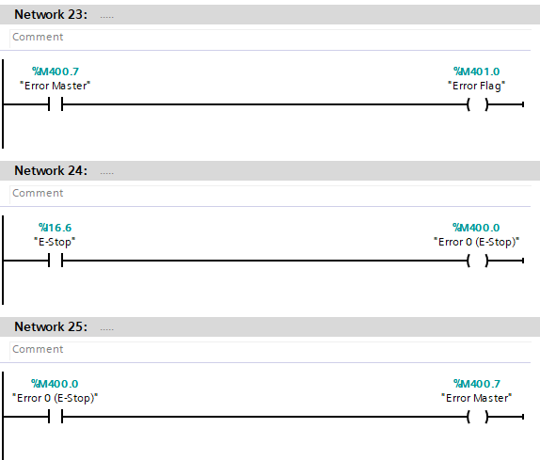
Network 24 links the first error tag to a physical attribute in the Factory IO System and the HMI Screens so that when the Emergency Stop is hit, the system shuts off.
Networks 21, 22, and 23 set up the Warning and the Errors. This would then be displayed on the HMI Screen “Alarms and Errors”.
Networks 18, 19 and 20 all relate to the counter used on the HMI Screen. They have been used to display how many Lids, Bases and Complete Assemblies have been made.
Figure 10 – Networks 18 – 24.
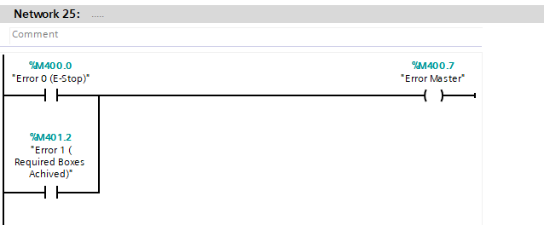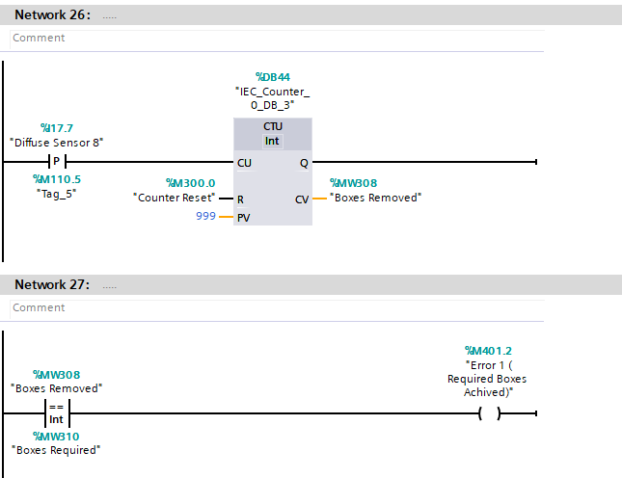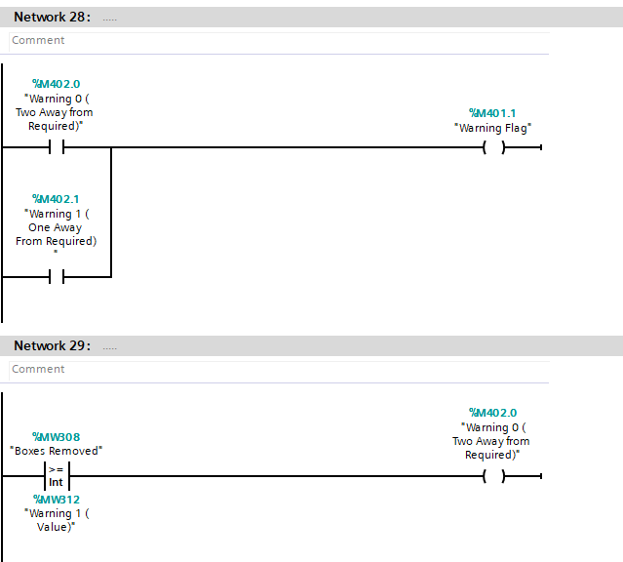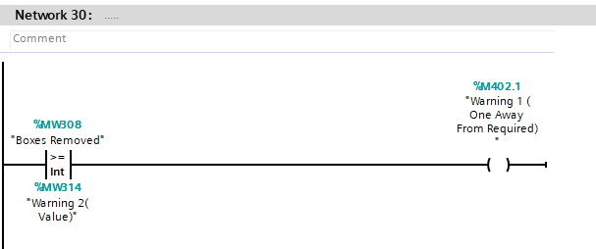
Network 28 is like Network 25 as it connects all the Warnings to the Warning Flag.
Network 27 states that when the Boxes Removed and the Boxes Required (Entered by the user) are the same, the system shuts down entirely.
Network 26 counts all the boxes that get removed from the Factory IO System.
Network 25 connects all the Errors to the “Master Error”. This means that as soon as one Error is flagged, the system shuts down.
Figure 11 – Networks 25 – 30.
Networks 29 and 30 do the same function as Network 27. When the Boxes Removed reaches the two Warning Values, two different lights on one of the screens are activated.

Warnings, Alarms and Engineer Screen.
A Warning, Errors and engineer screen has been provided to accompany the ladder logic and the Factory IO system. Each of the screens have been shown below and will be fully explained.

Root Screen.
The root screen is the main screen used by the operator. It has much useful information relating to the components being made, this includes:
- Start Button.
- Stop Button.
- Emergency Stop Button.
- Counters for the Lids Made.
- Counters for the Bases Made.
- Error and Warning Indicators.
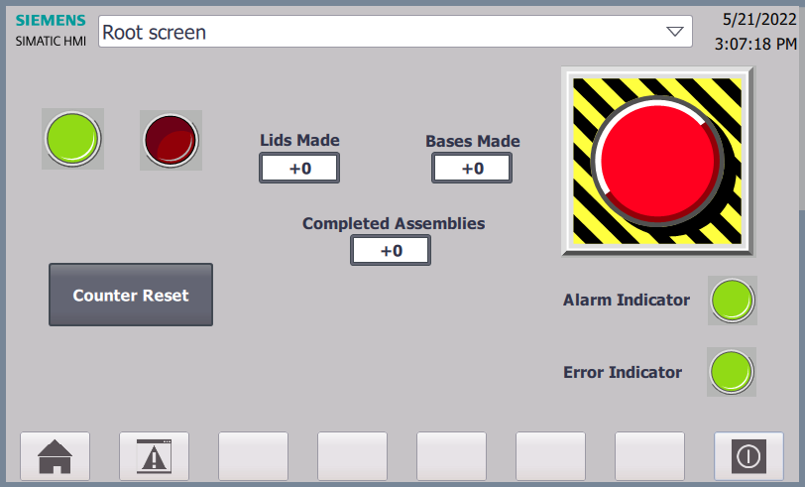
All of these have been included in Figure 12. The counters are directly linked to the program written for the Factory IO.
Figure 12 – Root Screen.

Warnings and Alarms.
The warnings and errors screen relates to any problems that can occurs on the system and give indication to the operator what could be wrong with the system. These should include:
- Emergency Stop Active.
- A warning that the number required is approaching.
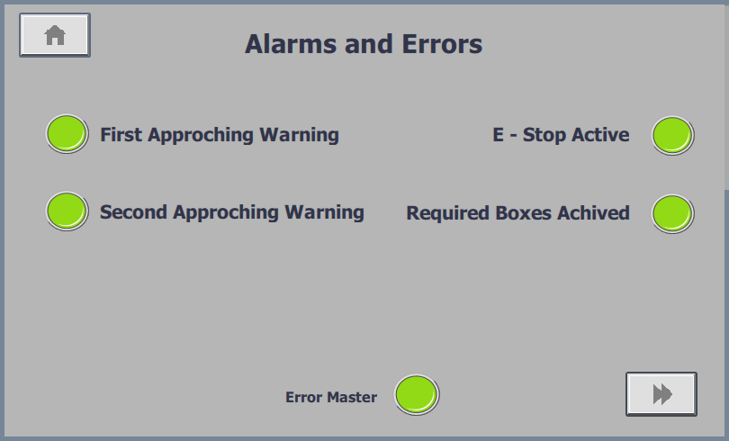
- Alarm for Reaching the Required Amount.
Figure 13 – Alarms and Warning.
The alarms and errors have been linked to the to the root screen, it allows for changing between all the screens. Each of the Pilot Lights change to red when one of them are positive. It also has two buttons that can change to the Engineer Screen and back to the Root Screen.

Engineer Screen.
The engineer screen will contain the following:
- Pre-setting counter Warning numbers and Order Numbers.
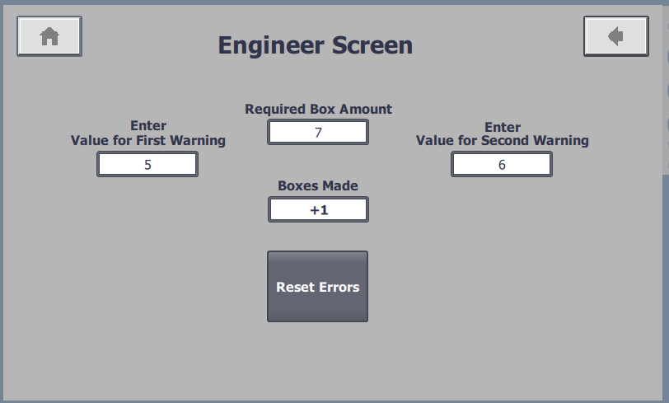
- Pre-setting counter Alarm Numbers.
- Manual reset of Alarms after the issue has been corrected.
Figure 14 – Engineer Screen.
Figure 14 shows the screen that would be used by the operator. They would firstly enter the total boxes needed (each box contains two complete assemblies), then enter the first and second warning value. These are directly linked to the lights in the alarms and warnings screen.

Conclusion.

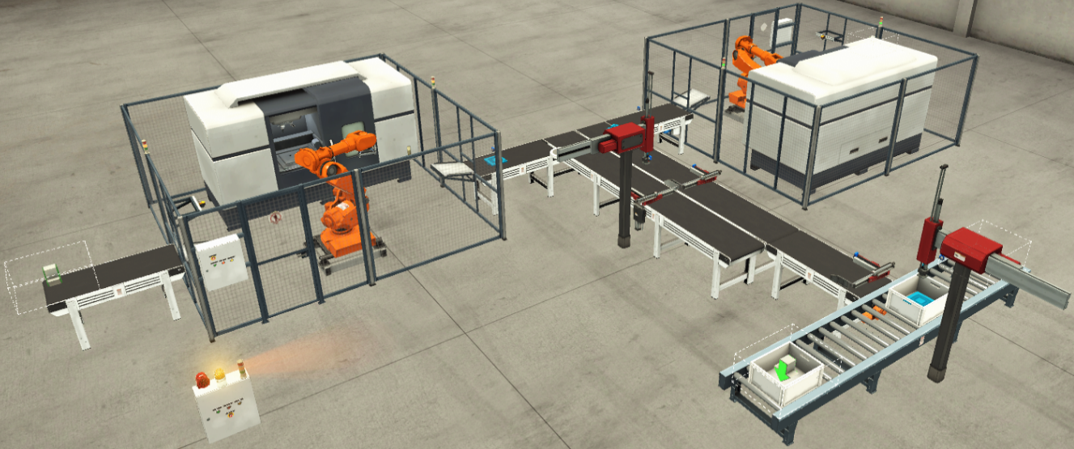
This report has focussed on the development of the Factory IO system as explained in the introduction. It contained several components that had to be controlled using SIEMENS TIA Portal.
Figure 15 – Factory IO System.
Figure 15 is the Factory IO System that was developed because of the requirements in the report brief. It shows the system that is illustrated in Figure 1. As the blank plates are emitted, they gradually go through each stage until they finally make it to the end and are ready for delivery in a real-world application.
Many different functions have been used in the program in order for each of the components work as smoothly as possible. It has also produced three screens to use for operating the system. This means that it can be controlled through the screens and the user can define the:
- Required number of boxes.
- The First Warning.
- The Second Warning.
- An Active Emergency Stop.
- The Required Boxes have been Reached.

Overall, this system has been a success as the bases are made correctly a vast majority of the time. However, this is not always the case due to a positioning error of the first Two Axis Pick and Place machine. When this is sometimes going through the choreography, it doesn’t always fully mesh the Base and Lids together and can cause an error with the count of completed components. Unfortunately, there was no way to amend the problem in this instance as the choreography of the Two Axis Pick and Place machine would not allow for the correct position to be made without changing the logic control for a new position.
This Factory IO system could be improved by repositioning the Clamps and the first Two Axis Pick and Place machine so that the meshing of the completed Bases and Lids could consistently be correct. Another improvement that could be made to the system would be to have an audible siren sound whenever a warning has occurred, as well has the visual one that is already in place on the Alarms and Warnings screens on the HMI. This could also be done for the Errors to signify that one has happened.

