

Programme: MSc Public Health and Social Care in Practice

Module code and Title: LCHS7002 Health Care System Organisation and Leadership

Student Name: Simran Khaitan

Student ID- 2531472

Case Study Analysis Report

Lecturer Name:Dr Pascal Navelle

Words: 5143

Submission Date: 11 August 2026
Table of Contents
Introduction 3
Main Body and Analysis 4
a. Identifying the Problem and Setting the System Context- Applying Systems 4
Thinking and the Rich Picture 4
b. Centralisation or Decentralisation within the Case Study 8
c. Leadership Theories and Application to the Case Study 11
d. Improvement and Lessons Learned 15
Recommendation 17
Conclusion 20
References 21

Introduction
The health and social care organisations work in dynamic and complex environments where leadership, good governance, and integrated systems play a central role in promoting patient safety and high-quality care. Even though there are constant improvements in healthcare operations, avoidable patient safety events continue to pose a major problem in the global context. The case to be used in this report is the Health Services Safety Investigations Body (HSSIB) investigation of the accidental morphine overdose of an 89-year-old patient, Len, who died after giving himself an overdose of prescribed oral morphine sulfate solution (HSSIB, 2022). The enquiry found that despite the ability of the prescribed drug and dosage to be in line with the national clinical guidelines, the medication labelling, communication, patient understanding, and system design failures also played a role in the tragic outcome.
Leadership in health and social care essentially refers to the ability to direct, inspire and provide direction to individuals and teams for the achievement of shared goals which improve the health of patients, quality of care and functioning of the organisation (Harris et al. 2022). Leadership is not merely confined to operational and day-to-day activities but also involves the ability to be a part of a shared vision, be a team member, promote responsibility, and foster a culture of patient safety and continuous improvement. Healthcare organisations usually have governance models that are centralised, decentralised, or a combination of both. A centralised system has advantages in having top-level or national-level centralised strategic decision-making, policy formulation, and organisational control. A decentralised system, meanwhile, hands down the decision-making power to local clinical services and front-line professionals.
Different leadership theories offer useful structures in interpreting organisational reactions to the occurrence of patient safety incidents. Transformational leadership is about motivating employees, promoting innovation, and building a good culture of safety; transactional leadership involves conformity to regulations, performance review and accountability; and situational leadership supports the idea that leadership behaviours should be changed based on the nature of the clinical context and the requirements of the healthcare professionals. The use of these theoretical lenses facilitates the critical analysis of the role played by leadership practices in terms of governance, communication, decision-making, and learning within organisations.
This report critically examines the HSSIB investigation into the accidental overdose of morphine by Len by using leadership theories, principles of governance and systems thinking to determine the causes behind this incident. It analyses the organisational systemic factors that contributed to the medication error, measures the value of centralised and decentralised organisation structures, measures the value of leadership style used within the healthcare system, and comes up with evidence-based recommendations.

Main Body and Analysis

a. Identifying the Problem and Setting the System Context- Applying Systems

Thinking and the Rich Picture
Description of the incident
The case chosen is of Len, an 89-year-old retired electronic engineer who lives independently with his wife. In December 2020, he experienced a fall at home and had severe pain on the right side of his chest and worsening breathlessness. His General Practitioner (GP) made a diagnosis of paracetamol and ibuprofen in line with national guidance after an initial telephone consultation and a follow-up face-to-face assessment, and a ruling out of a chest infection. When Len continued to suffer, the GP subsequently prescribed oral morphine sulfate solution (10 mg in 5 ml) at a lower dose of 1.25-2.5 ml (2.5-5 mg) four hourly as necessary (HSSIB, 2022). Nonetheless, the label on the medicine that depicted the strength of the medicine (10 mg in 5 ml) was interpreted by Len and his wife as the dose, and therefore they took 5 ml (10 mg) three times a day on the same day. The next morning, Len was brought into hospital, unconscious, with a suspected morphine overdose, pneumonia and progressive Charcot-Marie-Tooth disease. The later probe by the Health Services Safety Investigations Body (HSSIB) found the incident was an accidental overdose due to problems in medication labelling and communication and not inappropriate prescribing.
Global Perspective
Medication errors continue to be one of the most prominent issues of patient safety in the world, especially among those of older age, who often have numerous long-term illnesses and polypharmacy. According to the World Health Organisation (WHO), there is at least one death per day and about 1.3 million people get injured each year worldwide due to medication errors (World Health Organization, 2017). Moreover, the annual cost of medication-related harm in the world is estimated to be US$42 billion, which is nearly 1% of the overall health spending in the world. Older patients are at risk especially due to physiological alterations caused by age, renal impairment, complicated medication regimens, and poor health literacy that increase the chances of prescription, dispensing, and administration errors. The WHO responded by establishing the Medication Without Harm Global Patient Safety Challenge that seeks to cut severe avoidable medication-related harm by 50% by improving prescribing, dispensing, patient education, communication, and safer medication systems (WHO, 2022). The case of Len is a representation of these global issues, as it illustrates how medication-related harm is more commonly caused by numerous system failures and not just human error.
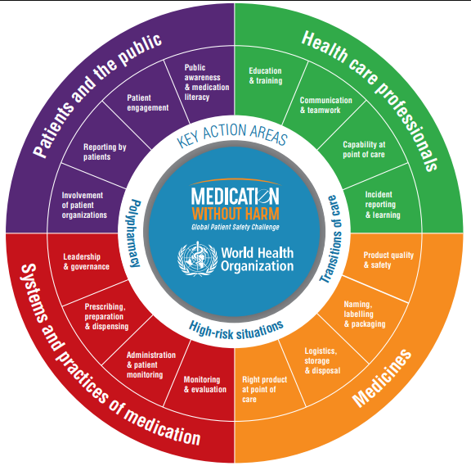
Figure 1: Strategic Framework of the Global Patient Safety Challenge
(Source: WHO, 2022)
National perspective
The problem of medication safety is a significant issue in the NHS. The NHS England Primary Care Patient Safety Strategy (last updated 2026) estimates that, out of the total number of patients in the NHS, about 90% of all contacts are with primary care and in general practice in England alone, there are 20,000 to 30,000 cases of avoidable significant harm each year (Shah, 2024). The second most frequent category of these significant harm events is medication-related incidents, taking place in about 26% of these cases. NHS England further estimates that every episode of avoidable serious harm in primary care costs approximately £5,000, leading to a financial strain of over £83.7 million annually (NHS England, 2024).
Moreover, medication-related harm has been classified as one of the most prevalent patient safety hazards impacting patients in all types of hospitals, in the community and in care homes (Laatikainen et al. 2022). Thus, safer prescribing, dispensing, and medication administration procedures are required. As part of its efforts to encourage better medicine labelling and safe use, the MHRA is still encouraging more robust reporting systems, organisational learning and a more systems-based approach to preventing preventable medication harm, and the NHS Patient Safety Strategy.
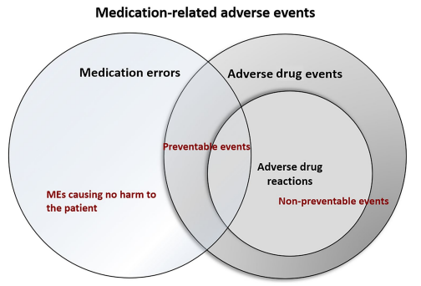
Figure 2: Relation between different medication-related adverse events
(Source: Laatikainen et al. 2022)

Underlying problems
The investigation determined some linked system vulnerabilities that led to the accidental overdose of Len. There were communication failures wherein the dosage guidelines were printed on the dispensing label on the outside box, yet the manufacturer prominently printed the medicine strength on the bottle, which was misinterpreted. Assumptions by Len and his wife about dosage and lack of patient education, coupled with the lack of a formal medication counselling process, all contributed to the risk of error. These results indicate that the event was caused by a sequence of system malfunctions and not one clinical error.
Governance level
Governance roles in the healthcare system on various levels were involved in the incident. Safe prescribing, dispensing, and patient counselling were the duties of the GP practice and the community pharmacy at the local level. Locally, Integrated Care Systems (ICSs) manage the quality of services, patient safety and the application of NHS standards among providers at the local level. On the national level, patient safety strategies are laid down by NHS England, medicine safety and labelling are controlled by the Medicines and Healthcare products Regulatory Agency (MHRA), the manufacturers use compliant packaging, and the Health Services Safety Investigations Body (HSSIB) examines incidents in patient safety to encourage organisational learning and system-wide improvement.
Systems thinking
Systems thinking perceives the occurrence of patient safety incidents as a consequence of the interplay between several elements in a healthcare system and not necessarily the behaviour of one person. The accidental overdose in the case of Len was a result of the combined action of the prescription practices, the packaging of medications, dispensing, communication, the patient's understanding, and organisational governance. All the elements impacted one another, leaving loopholes in the safety measures established to avert medication errors. The use of a systems thinking approach emphasises the need to enhance communication, medication labelling, patient education, and collaboration across healthcare organisations to mitigate preventable harm and optimise patient safety outcomes.

Rich picture
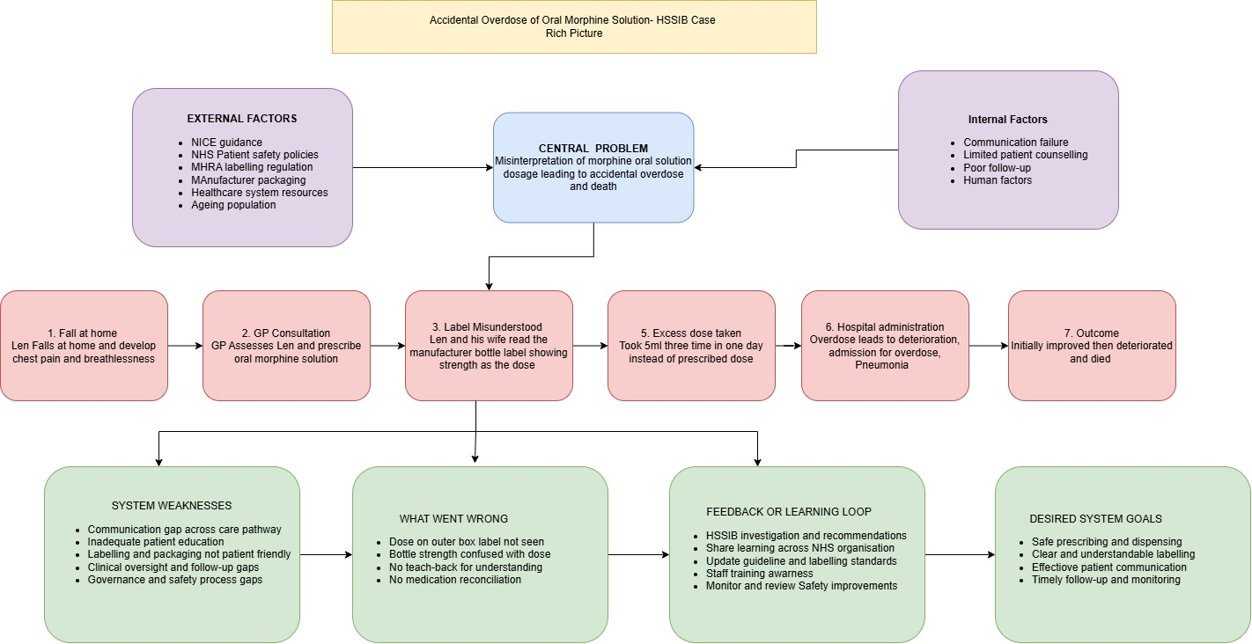

b. Centralisation or Decentralisation within the Case Study
Centralisation
Centralisation is a type of organisation where strategic decision-making, policy formulation, and operational control are established in superior levels of management or national authorities (Altamimi et al. 2023). Centralised systems are used in healthcare to achieve consistency, accountability, and standardisation by introducing clinical guidelines, governance frameworks, as well as required regulatory standards to all healthcare organisations (Asamoah, 2025). In the NHS, NHS England, the National Institute of Health and Care Excellence (NICE) and the Medicines and Healthcare products Regulatory Agency (MHRA) are organisations that set national standards of prescribing, patient safety plans, and medicine controls which practitioners are supposed to adhere to.
In particular, NICE offers evidence-based guidance on opioid prescribing and pain management, whereas MHRA issues regulations on medicine labelling and licensing to guarantee patient safety (MHRA, 2025). Centralised governance enhances fair healthcare provision in that patients access care depending on the nationally recognised healthcare standards irrespective of geographical location.
Decentralisation
Decentralisation is the process where power and decision-making are devolved by the central government and administrative units to local healthcare organisations and frontline professionals (Zarychta et al. 2026). This model allows clinicians to customise healthcare services to meet the needs of individual patients and promote professional autonomy, responsiveness, and innovation. In the NHS, national policies are used to give general guidance, yet GPs, pharmacists, nurses, and multidisciplinary teams use professional judgement to evaluate patients, prescribe medications, provide counselling, as well as monitoring the results of the treatment. Integrated Care Systems (ICSs) also facilitate the process of decentralisation by allowing the local organisations to align the services with the needs of the population on a regional level (NHS England, 2022). Decentralised decision-making can be especially useful in complicated clinical conditions where unique patient factors, comorbidities, and preferences have to be taken into consideration. Nevertheless, decentralisation brings diversification of clinical practice and communication, making good governance, personnel competence, and organisational learning even more critical in providing equal patient safety in all healthcare environments.
Critical analysis
The HSSIB investigation shows that both centralised and decentralised factors worked concurrently during the care pathway of Len. On the national level, this prescribing decision of the GP indicated a centralised healthcare system since it was prescribed in accordance with NICE guidelines that suggested a low dose of oral morphine to be used in severe pain in older adults with low renal function. Equally, manufacturing and labelling of medicine were under MHRA regulations, and NHS England had instituted national patient safety policies aimed at reducing medication-related harm. Regardless of such centralised controls, care was mostly implemented through decentralised decision-making. The GP also evaluated the symptoms of Len on her own, diagnosed that the patient required stronger analgesia, and chose an opioid dose which was required based on clinical judgement.
The community pharmacy was to dispense the medicine and make sure that the dosage instructions were properly communicated to the patient. The investigation discovered that Len and his wife used the bottle label of the manufacturer, which indicated the strength of the medicine (10 mg in 5 ml) instead of the dispensing label on the outer package bearing the instructions of the prescribed dosage. Such a communication failure exemplifies the way in which clinical practice that is decentralised may be sabotaged in cases of inadequate local safety processes. After the death of Len, the Health Services Safety Investigations Body (HSSIB) took a systems approach to patient safety risk identification, as opposed to blaming individual clinicians.
The investigation identified that communication between national prescribing advice, pharmacy dispensing habits, patient knowledge, and organisational communication have all played a role in the incident. Hence, this case is indicative of a hybrid governance system where national policies suited, but local implementation and communication policies did not align to guarantee the administration of medication safely.
Advantage
Centralised governance, along with decentralised clinical practice, has some benefits in terms of patient safety. Clinical guidelines formulated nationally by NICE encourage the use of evidence-based prescribing to curb unnecessary practice variability and help to decrease the risk among the most vulnerable patient groups (NICE, 2023). The MHRA has centralised control over medicines to ensure that they comply with required standards of quality, safety and labelling before they are used in clinical practice (MHRA, 2025). The case of Len clearly shows that the GP responded correctly by increasing the dose of morphine to reflect his age and kidney deficiency as a testament to the power of professional autonomy within the national guidance.
Disadvantage
Despite this strength, the case also depicts the key limitations that are involved in the interaction between centralised and decentralised systems. Patient safety cannot be assured by national prescribing standards if the communication and implementation at the local level do not work. The dispensing label with the correct dosage instructions was on the outer box and not on the bottle. Hence, the information about the strength of the medicine could be confused with the dosage instructions. Besides this, there was limited patient counselling and poor follow-up that decreased the chances of detecting the misunderstanding prior to the occurrence of harm.
Critical evaluation
There is evidence that enhancing the work of the central governance and frontline clinical teams is the key to the reduction of medication-related harm. NHS England estimates that 20,000-30,000 incidents of avoidable significant harm in primary care happen each year, of which about 26% relate to medication incidents (NHS England, 2024). The NHS Staff Survey 2024 found that most healthcare workers are confident in raising concerns about patient safety (NHS England, 2024a). However, staff and workloads still remain a problem and impact on communication, learning and safe practice. HSSIB also found that existing safety barriers could be improved by improving the quality of medicine labelling, patient education and multidisciplinary communication.

c. Leadership Theories and Application to the Case Study
Transformational Leadership
Transformational leadership involves guiding and encouraging healthcare providers towards a common vision as well as encouraging innovation, cooperation and constant change (Raoush, 2023). Transformational leaders promote organisational learning, challenge status quo practices by employees, and prioritise patient-centred care (Gautam et al. 2026). In healthcare facilities, this type of leadership is also closely linked with enhanced patient safety, enhanced employee engagement, and creation of a positive safety culture.
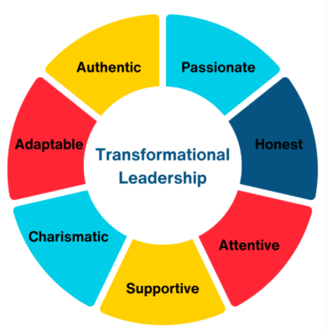
Figure 3: Aspects of Transformational leadership
(Source: Gautam et al. 2026)
Transformational leadership would have enhanced various aspects of the care pathway for Len in the HSSIB case. Though the GP correctly prescribed morphine as per the national clinical guidelines, transformational leadership would have gone beyond compliance and ensured a culture where healthcare providers were keen to make sure that patients were well-informed on how to take high-risk medications. Multidisciplinary interaction among GPs, pharmacists, and community nurses could have been encouraged by leaders to strengthen medication counselling and confirm patient comprehension with methods such as the teach-back method (MH Jagodage et al. 2024). The HSSIB investigation had deduced that the case was due to interacting system failures and not personal negligence. Transformational leadership reinforces these systems view through promoting openness, psychological safety, and continuous quality improvement. Hence, transformational leadership would have been suitable in enhancing patient safety during the care process of Len.
Transactional Leadership
Transactional leadership is founded on the systematic management process, expectations, tracking of performance and adherence to rules and procedures. Transactional leaders ensure the stability of an organisation by making employees comply with organisational policies, professional standards and regulatory requirements (Khairy et al. 2023). In clinical governance, practice standardisation, and adherence to evidence-based guidelines, this leadership style is significant in healthcare organisations. The aspects of transactional leadership were observed during the care of Len. The GP ordered oral morphine with a lower dosage in line with NICE guidelines on elderly patients with renal impairment, indicating compliance with the national prescribing guidelines. In the same way, community pharmacy adhered to standard dispensing practices, including affixing the dosage instructions on the outer layer of medication packaging, whereas medicine manufacturers adhered to the current regulatory labelling standards. These activities were in line with organisational policies and professional regulations.
Nevertheless, the case also serves as an illustration of the constraints of using transactional leadership only. The policies and procedures were adhered to properly, yet they failed to make sure that Len and his wife understood the dosage instructions appropriately. Procedural compliance was stressed without considering the understanding of the patient on how to take the medicine safely. Transactional leadership is more inclined towards compliance with rules instead of active communication with the patient, learning within the organisation, or active involvement of the patient.
Situational Leadership
Situational leadership suggests that leaders need to adjust their leadership style to the competence, confidence and needs of people in a particular situation (Wang et al. 2024). Instead of being guided by one style of leadership, situational leaders change their behaviours depending on new clinical situations, the nature of patients and organisational issues (Ghallab and Sallam, 2026). The case of HSSIB shows why adaptive leadership is a necessity when operating in a complex healthcare setting. Len was an aged patient with Charcot-Marie-Tooth disease, having reduced renal efficiency, constant pain and growing shortness of breath, and was thus especially susceptible to drug-induced injury.
Even though the GP was right in increasing the morphine dosage due to these clinical factors, other situational leadership behaviours would have been applied during the prescribing process. To illustrate, healthcare workers might have given greater medication counselling to Len, shown him how to use the oral syringe, ensured comprehension using the teach-back technique, and scheduled a follow-up appointment shortly after starting opioid therapy due to his age and the perceived vulnerability. Another implication of situational leadership is that it promotes interdisciplinary teamwork in cases where patient needs are becoming complicated. The misunderstanding could have been detected earlier before the overdose due to better coordination between the GP and the pharmacist, community nursing services and the family members.
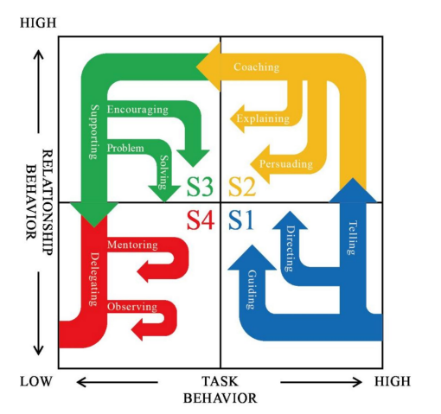
Figure 4: Situational leadership theory model
(Source: Wang et al. 2024)
Critical comparison
The leadership theories offer valuable yet diverse contributions to the safety of patients. Transactional leadership was able to make sure that the prescribing guidelines and standard regulations were adhered to but was not adequate to avoid communication breakdown or to ensure patient comprehension. Situational leadership acknowledged that care had to be adapted depending on Len's age, comorbidities, and vulnerability, which assisted in more personalised communications and monitoring. Nevertheless, the most appropriate one is transformational leadership as it unites patient-centred care, multidisciplinary cooperation, organisational learning and continuous quality improvement.

Supporting evidence
According to the NHS Staff Survey 2024, organisations with positive leadership behaviours had better safety cultures, higher staff willingness to report incidents and improved teamwork (NHS England, 2024a). In the same manner, the World Health Organisation underlines that the key to minimising preventable patient harm is the presence of effective leadership based on the concepts of systems thinking, the culture of learning, and constant quality improvement (Altaf and Jacob, 2026). It was also found in the HSSIB investigation that medication-related harm is most effectively avoided by enhancing communication, organisational learning and system design as opposed to blaming individuals.

d. Improvement and Lessons Learned
Leadership and governance interaction
The HSSIB study shows that the dynamics of leadership and governance are essential to effective patient safety. Governance offers the policies, regulations and accountability measures that govern safe clinical practice, and leadership impacts the manner in which governance frameworks are translated into the daily healthcare delivery. Governance mechanisms were apparent in the case of Len, wherein national prescribing guidance and medicine regulation by the Medicines and Healthcare products Regulatory Agency (MHRA) and NHS patient safety policies were in place. Such governance mechanisms ensured that the GP prescribed a patient with low-dose morphine who was old and had impaired renal function.
Nevertheless, leadership was not effective in converting these requirements of governance into safe patient care. Strong clinical leadership involves healthcare practitioners going beyond procedural compliance to foster multidisciplinary collaboration, open communication and ensuring that patients are active participants in their care (Almughamisi et al. 2025). The HSSIB investigation made the conclusion that the incident was caused by the interplay of system deficiencies, instead of personal negligence, and leadership strategies should be employed that enhance organisational learning and ongoing quality improvement. Thus, patient safety starts with good governance, yet it requires good leadership to see the governance structures implemented effectively in clinical practice.

Problems identified
In the investigation, several intertwined issues were found that all led to the accidental overdose of Len. To start with, there was a lack of communication between the patient and healthcare professionals. Though the pharmacy had added the right dosing instructions to the dispensing label on the outer container, Len and his wife trusted the label on the bottle of medicine, which showed the strength of the medicine, but not the dose prescribed. This misconception was not detected as there was no organised procedure to ensure that the patient knew how to take the medication the right way.
Second, the packaging of the medicine was confusing as it indicated the concentration of morphine more than the dosage instructions on the package. Third, the education of patients was poor, especially taking into consideration the fact that Len was old, had various health conditions and was at a high risk of medication-related harm. Fourth, the lack of follow-up due to a small number of contacts post-opioid therapy decreased the chances of identifying early signs of inappropriate medicine use.
Lastly, the communication between prescribers and pharmacists, patients, and family members was disjointed, undermining the entire safety system. The results highlight that medication safety is influenced by effective communication, coordinated care, and robust organisational systems, as opposed to just proper prescribing.
Evidence-based improvements
Several evidence-based interventions would minimise the risk of occurrence of similar incidents occurring in the future. First, healthcare organisations can enhance patient education by offering the teach-back method, which is when a patient restates medication instructions in their own words, as a way of understanding. The studies show that teach-back enhances medication compliance and decreases errors in administration, especially in older adults who have complicated treatment plans (Alilu et al. 2024).
Second, there should be enhancement of medicine packaging and labelling. HSSIB can advised manufacturers to make dosing-measuring devices that precisely measure all the available doses of the medication, and that the labels of the medication should clearly differentiate between the dose and the strength of the medicine. Third, community pharmacists are encouraged to offer systematic medication counselling every time prescriptions of high-risk drugs like opioids are being dispensed, and patients and caregivers are informed about the dosage regimens and the proper utilisation of the measuring tools (White et al. 2025).
Another recommendation that healthcare organisations should increase the use of electronic prescribing systems that are combined with clinical decision-support tools to minimise prescribing and dispensing errors (Calvo-Cidoncha et al. 2022). Moreover, early follow-up visits once opioid treatment is initiated would allow medical workers to determine the ability to manage pain, adverse events, and comprehend the misunderstandings of the medication in question before it is too late. Lastly, organisations are advised to keep on promoting a Just Culture and to encourage the staff to report medication incidents and near misses without the fear of blame to facilitate ongoing organisational learning and patient safety improvement (Van Baarle et al. 2022).
Lessons learned
The HSSIB inquiry reveals that patient safety incidents are not caused by one error but rather arise due to a combination of interacting system vulnerabilities. Despite adherence to the national prescribing guidance, the lack of communication, labelling of medicines, patient education, and follow-up provided the circumstances within which an accidental overdose could take place. The case underscores the need to incorporate efficient leadership and governance, systems thinking and multidisciplinary cooperation to reinforce patient safety. Continuous learning, incident reporting, cross-professional communication, and active patient and family engagement in medication management should be considered the primary concerns of healthcare organisations to minimise avoidable harm and promote the sustainability of quality improvement.

Recommendation
The results of the HSSIB inquiry reveal that the prevention of medication-related harm needs coordinated enhancements both at the leadership and governance level, as well as communication, technology, organisational learning, and stakeholder collaboration. It is suggested that the following recommendations should be implemented to enhance patient safety and reduce the chances of such incidents in the future.
Leadership
A blend of transformational, distributed and clinical leadership should be embraced by healthcare organisations to enhance patient safety and organisational learning. A culture of openness, continuous improvement, and patient-centred care should be encouraged by promoting transformational leadership, which will help healthcare professionals to recognise the safety risks and share learning without fear of criticism (Ahmed et al. 2024). General Practitioners (GPs), pharmacists, nurses, and other professionals working on the frontline should be empowered through distributed leadership to make a contribution to medication safety decisions as part of multidisciplinary teams, taking into account that the responsibility of patient safety lies with all individuals. Continuing professional development should include leadership development programmes on patient safety, human factors, and emotional intelligence to promote decision-making and enhance multidisciplinary collaboration (Brennan et al. 2025).
Governance
To improve medication governance, healthcare organisations should improve accountability, monitoring and organisational learning. Frequent audits on medication safety are recommended to review the quality of prescribing, dispensing activities, and the level of patient education about high-risk medications like opioids (Navadia et al. 2023). Medication errors should be reported in the incident reporting systems, which should be simplified and promoted so that they can be reported as early as possible. Structured learning systems also need to be adopted in organisations where patient safety incidents are analysed through systems-based approaches instead of individual blame being assigned (Delikhoon et al. 2022). Moreover, the governance structures must make sure that the recommendations provided by the Health Services Safety Investigations Body (HSSIB), NHS England and the Medicines and Healthcare products Regulatory Agency (MHRA) are converted to everyday clinical practice by conducting a regular review of policies and training of staff.
Communication
To minimise medication-related harm, communication should be improved. The teach-back technique should be applied on a regular basis by healthcare professionals, and patients and caregivers should be asked to clarify the instructions about the medications in their own words before leaving the healthcare facility (Cheng et al. 2023). When dispensing high-risk medicines, community pharmacists should offer structured medicine counselling such as demonstrations of measuring devices and explanations of the difference between the strengths of medicines and prescribed dosages. The prescribing process should be supported with shared decision-making to make sure that the patients are familiar with the treatment options, potential side effects, and safe administration of medication. Patient information materials should also be formulated by healthcare organisations in simple, accessible language to enhance health literacy, especially with the elderly and vulnerable groups of patients.
Systems Integration
The use of digital technologies has to be implemented across different healthcare facilities to enhance medication safety. The electronic prescribing systems must have clinical decision-support tools that can produce an alert to high-risk drugs, vulnerable patients and abnormal dosages. Primary and secondary care should use the Electronic Medicines Administration Records (eMAR) to enhance documentation and communication among healthcare professionals (Karnehed et al. 2022). Where necessary, barcode verification systems should also be in place to minimise the number of dispensing and administration errors by making sure that the correct medicines are dispensed to individual patients. Secondly, manufacturers are encouraged to work with regulators to enhance the packaging and labelling of medicines in order to have the dosage instructions displayed more prominently than the concentration of the medicine.
Continuous Improvement
Continuous quality improvement should be incorporated in the strategies of patient safety in healthcare organisations. The real-time monitoring of medication incidents, prescribing patterns, patient safety indicators, and organisational performance should be organised in terms of safety dashboards. Plan-Do-Study-Act (PDSA) cycles should be used to systematically review patient safety incidents to assess the efficacy of improvement efforts and encourage ongoing organisational learning (Yu et al. 2026). Clinical audits should be conducted regularly to evaluate adherence to prescribing guidelines, medication counselling standards and patient education practices (George et al. 2022).
Stakeholder Engagement
To enhance patient safety and sustainability, there must be active involvement of all stakeholders in medication management. Patients and their families are supposed to be identified as partners of healthcare delivery through encouraging them to ask questions, participate in decision-making in treatment, reporting any issues with medication use. Multidisciplinary communication should be reinforced among General Practitioners, pharmacists, nurses, and community healthcare professionals to provide consistent medication advice in all care settings (Primeau et al. 2024). The manufacturers of medicine should go on to advance the packaging of medicines and dose-measuring machines on the basis of evidence of patient safety.

Conclusion
This report critically appraised the case of the Health Services Safety Investigations Body (HSSIB) regarding the accidental morphine overdose of Len, an 89-year-old patient, the death of which was caused by a combination of a chain of interrelated system failures as opposed to improper clinical prescribing. Despite adherence to national prescribing direction, the lack of strength in medication labelling, communication, patient education, organisational processes, and multidisciplinary coordination led to the misinterpretation of dosage instructions and consequent medication error. The enquiry reveals that the occurrence of patient safety incidents can hardly be ascribed to individual persons, but rather originates from interactions among individuals, processes, technology, organisational culture, and governance systems.
The report also assessed the role of centralised and decentralised healthcare systems, showing that the national governance systems developed proper clinical standards, whereas the local systems of implementation processes did not ensure the safety of medication administration. Moreover, the use of transformational, transactional and situational theories of leadership indicated that effective patient safety relies not only on adherence to policies but also on active leadership that encourages collaboration, organisational learning and the ability to communicate with patients in a certain manner. Out of these methods, transformational leadership was found to be the most appropriate in helping to maintain a positive safety culture and continuous quality improvement.
The use of systems thinking allowed a significant perspective of how communication breakdowns, medicine packaging, human factors, and disseminated responsibilities all have led to the incident. This point of view supports the need to examine healthcare systems in their entirety and not blame individual healthcare professionals. The proposed recommendations, such as providing stronger leadership, better governance, better communication with patients, more extensive utilisation of digital technologies, continuous quality improvement, and more involvement of stakeholders, are practical strategies to minimise medication-related harm.

References
Ahmed, Z., Ellahham, S., Soomro, M., Shams, S. and Latif, K., 2024. Exploring the impact of compassion and leadership on patient safety and quality in healthcare systems: a narrative review. BMJ open quality, 13(Suppl 2).doi:10.1136/bmjoq-2023-002651
Alilu, L., Pazirofteh, S., Habibzadeh, H. and Rasouli, J., 2024. The impact of teach-back training method (TBTM) on treatment adherence in hemodialysis patients: a randomized controlled trial. Annals of Medicine and Surgery, 86(5), p.2723.http://dx.doi.org/10.1097/MS9.0000000000001906
Almughamisi, A.F., Alshehri, A.A.M., Alandijani, M.A., Alqarni, S.D., Alshehri, F.H., Alshehri, K.H., Alnefaie, A., Alshehri, A., Alrajhi, M., Albalawi, H. and Alqurashi, A., 2025. Multidisciplinary team group effort in healthcare; the role of emergency, clinical, and administrative professionals in improving outcomes and hospital performance. Saudi J Med Pharm Sci, 11(10), pp.928-41.https://doi.org/10.36348/sjmps.2025.v11i10.002
Altaf, A. and Jacob, E., 2026. Reducing human error in global healthcare: leadership, learning, and system resilience. European Journal of Public Health, 36(Supplement_3), pp.iii21-iii23.https://doi.org/10.1093/eurpub/ckag053
Altamimi, H., Liu, Q. and Jimenez, B., 2023. Not too much, not too little: Centralization, decentralization, and organizational change. Journal of Public Administration Research and Theory, 33(1), pp.170-185.https://academic.oup.com/jpart/article-abstract/33/1/170/6549741
Asamoah, D., 2025. The role of health services regulation in healthcare delivery. Electr J Med Dent Stud, 14(1), pp.42-48.https://doi.org/10.29333/ejmds/16003
Brennan, E.S., Rehman, U., Sarwar, M.S., Bekker, K.A., Cowen, J., Bekker, J. and Brennan, P.A., 2025. Human factors application, decision making, team working and leadership in Surgical Oncology. European Journal of Surgical Oncology, 51(6), p.109679.https://doi.org/10.1016/j.ejso.2025.109679
Calvo-Cidoncha, E., Camacho-Hernando, C., Feu, F., Pastor-Duran, X., Codina-Jané, C. and Lozano-Rubí, R., 2022. OntoPharma: ontology based clinical decision support system to reduce medication prescribing errors. BMC medical informatics and decision making, 22(1), p.238.https://doi.org/10.1186/s12911-022-01979-3
Cheng, G.Z., Chen, A., Xin, Y. and Ni, Q.Q., 2023. Using the teach-back method to improve postpartum maternal-infant health among women with limited maternal health literacy: a randomized controlled study. BMC Pregnancy and Childbirth, 23(1), p.13.https://doi.org/10.1186/s12884-022-05302-w
Delikhoon, M., Zarei, E., Banda, O.V., Faridan, M. and Habibi, E., 2022. Systems thinking accident analysis models: A systematic review for sustainable safety management. Sustainability, 14(10), p.5869.https://doi.org/10.3390/su14105869
Gautam, S., Nazir, M.A. and Zhu, X., 2026. Leadership, organisational culture and workforce engagement in the NHS: a qualitative study of healthcare management dynamics. Journal of Health Organization and Management, pp.1-23.https://gala.gre.ac.uk/id/eprint/52570/11/52570%20NAZIR_Leadership_Organisational_Culture_And_Workforce_Engagement_In_The_NHS_%28AAM%29_2026.pdf
George, N.E., Shukkoor, A.A., Joseph, N., Palanimuthu, R., Kaliappan, T. and Gopalan, R., 2022. Implementation of clinical audit to improve adherence to guideline-recommended therapy in acute coronary syndrome. The Egyptian Heart Journal, 74(1), p.4.https://doi.org/10.1186/s43044-021-00237-7
Ghallab, A. and Sallam, F., 2026. The Effect of Situational Leadership on Healthcare Service Quality Through Crisis Management and Resources Availability: The Moderating Role of Leader Experience. Risk Management and Healthcare Policy, p.589078.https://doi.org/10.2147/RMHP.S589078
Harris, R., Fletcher, S., Sims, S., Ross, F., Brearley, S. and Manthorpe, J., 2022. Developing programme theories of leadership for integrated health and social care teams and systems: a realist synthesis. Health and Social Care Delivery Research, 10(7), pp.1-118.DOI 10.3310/WPNG1013
HSSIB., 2022. Unintentional overdose of morphine sulfate oral solution. [online] Available at: https://www.hssib.org.uk/patient-safety-investigations/unintentional-overdose-of-morphine-sulfate-oral-solution/investigation-report/?utm [Accessed 3 Aug. 2026].
Karnehed, S., Erlandsson, L.K. and Norell Pejner, M., 2022. Nurses’ perspectives on an electronic medication administration record in home health care: qualitative interview study. JMIR nursing, 5(1), p.e35363.https://doi.org/10.2196/35363
Khairy, H.A., Baquero, A. and Al-Romeedy, B.S., 2023. The effect of transactional leadership on organizational agility in tourism and hospitality businesses: The mediating roles of organizational trust and ambidexterity. Sustainability, 15(19), p.14337.https://doi.org/10.3390/su151914337
Laatikainen, O., Sneck, S. and Turpeinen, M., 2022. Medication-related adverse events in health care—what have we learned? A narrative overview of the current knowledge. European journal of clinical pharmacology, 78(2), pp.159-170.https://doi.org/10.1007/s00228-021-03213-x
MH Jagodage, H., McGuire, A., Seib, C. and Bonner, A., 2024. Effectiveness of teach‐back for chronic kidney disease patient education: a systematic review. Journal of Renal Care, 50(2), pp.92-103.DOI: 10.1111/jorc.12462
MHRA., 2025. Medicines and Healthcare products Regulatory Agency. [online] GOV.UK. Available at: https://www.gov.uk/government/organisations/medicines-and-healthcare-products-regulatory-agency [Accessed 3 Aug. 2026].
Navadia, K.P., Patel, C.R., Patel, J.M. and Pandya, S.K., 2023. Evaluation of medication errors by prescription audit at a tertiary care teaching hospital. Journal of Pharmacology and Pharmacotherapeutics, 14(4), pp.275-284.https://doi.org/10.1177/0976500X231222689
NHS England., 2022. What Are Integrated Care systems? [online] NHS England. Available at: https://www.england.nhs.uk/integratedcare/what-is-integrated-care/ [Accessed 3 Aug. 2026].
NHS England., 2024. NHS England » Primary care patient safety strategy. [online] England.nhs.uk. Available at: https://www.england.nhs.uk/long-read/primary-care-patient-safety-strategy/ [Accessed 3 Aug. 2026].
NHS England., 2024a. NHS England » National Guardian’s Office update and priorities for 2024/25. [online] England.nhs.uk. Available at: https://www.england.nhs.uk/long-read/national-guardians-office-update-and-priorities-for-2024-25-2/ [Accessed 3 Aug. 2026].
NICE., 2023. National Institute for Health and Care Excellence: Clinical Guidelines. [online] Nih.gov. National Institute for Health and Care Excellence (UK). Available at: https://www.ncbi.nlm.nih.gov/books/NBK11822/ [Accessed 3 Aug. 2026].
Primeau, C., Chau, M., Turner, M.R. and Paterson, C., 2024, August. Patient experiences of patient–clinician communication among cancer multidisciplinary healthcare professionals during “breaking bad news”: A qualitative systematic review. In Seminars in oncology nursing (Vol. 40, No. 4, p. 151680). WB Saunders.https://doi.org/10.1016/j.soncn.2024.151680
Raoush, A., 2023. Transformational leadership impact on innovative behaviour as perceived by healthcare workers in private hospitals in Jordan. Cogent Business & Management, 10(3), p.2265606.https://doi.org/10.1080/23311975.2023.2265606
Shah, K., 2024. Publication of NHSE Patient Safety Strategy for Primary Care - NHS Resolution. [online] NHS Resolution. Available at: https://resolution.nhs.uk/2024/11/28/publication-of-nhse-patient-safety-strategy-for-primary-care/ [Accessed 3 Aug. 2026].
Van Baarle, E., Hartman, L., Rooijakkers, S., Wallenburg, I., Weenink, J.W., Bal, R. and Widdershoven, G., 2022. Fostering a just culture in healthcare organizations: experiences in practice. BMC Health Services Research, 22(1), p.1035.https://doi.org/10.1186/s12913-022-08418-z
Wang, X., Liu, Y., Peng, Z., Li, B., Liang, Q., Liao, S. and Liu, M., 2024. Situational leadership theory in nursing management: a scoping review. BMC nursing, 23(1), p.930.https://doi.org/10.1186/s12912-024-02582-9
White, A., Thompson, E.L., Kim, S., Osei, J.A., Fulda, K.G. and Xiao, Y., 2025. Enhancing the role of community pharmacists in medication safety: a qualitative study of voices from the frontline. Pharmacy, 13(4), p.94.https://doi.org/10.3390/pharmacy13040094
WHO., 2022. Medication without harm. [online] World Health Organization. Available at: https://www.who.int/initiatives/medication-without-harm [Accessed 3 Aug. 2026].
World Health Organization., 2017. WHO launches global effort to halve medication-related errors in 5 years. [online] www.who.int. Available at: https://www.who.int/news/item/29-03-2017-who-launches-global-effort-to-halve-medication-related-errors-in-5-years [Accessed 3 Aug. 2026].
Yu, X., Wang, X., Yang, Y., Hou, W. and Wang, Z., 2026. Effectiveness of a Plan-Do-Study-Act cycle-based quality control circle in enhancing the research capacity of operating room nurses a pre-post intervention study. BMC nursing.https://doi.org/10.1186/s12912-026-04566-3
Zarychta, A., Andersson, K. and Bossert, T., 2026. Frontline decision autonomy under decentralization: Evidence from health sector reform. PloS one, 21(5), p.e0343736.https://doi.org/10.1371/journal.pone.0343736

