Critical Investigation

To critically reflect on Individual Development Plans (IDP’s) and Pupil Centred Planning (PCP) I have conducted a forcefield analysis to demonstrate how ALN Reform in Wales will call for a restructuring of the Pastoral Lead role in my workplace.
My main role is Speech and Language teacher in a large all through school (three to sixteen years old). I teach over two hundred secondary aged pupils every week, who have a variety of additional learning needs. Secondly, I am a Pastoral Lead which requires me to closely support and monitor twenty statemented pupils. My Force Field Analysis demonstrates that this is an extremely time consuming and pressurised role. Several times a year I revise my pastoral learners and speech and language pupils progress and targets. Together we review their Individual Education Plans (IEP), which my workplaces call Pupil Action Plans, and set new targets for their progression. I also question them in detail to gather information for their IDP which, I then complete ready for the ALNCO to conduct Annual Reviews. I also provide daily support for their social, emotional and behavioural needs, and develop relationships with their parents/carers.
For this assignment I will first critique reform, then PCP, which is used to inform IDP’s, before finally using the results and the findings of my Force Field Analysis and literature, to inform an Action Plan on how to enact positive change within my workplace.
Having taught ALN pupils throughout all Key Stages (3-16 years) for nearly twenty-three years and believe that it is time for a comprehensive change, as the current system can be complex, bewildering, lengthy and adversarial process. The Times Education Supplement has described reform as the biggest in a generation (Maddern 2012). The then minister for Education and Skills, Huw Lewis, in his forward to the 2014 White Paper, was unequivocal about the need for comprehensive change. He called the assessment process “bureaucratic and costly, as well as insufficiently child-centred or user friendly.” He went on to discuss how needs are identified late and interventions are poorly implemented and not effective. Families felt that getting the correct support and advice was a “battle”. Daucey’s (2014) research briefing for ALN in Wales discusses how the Welsh Government recognised that the current system was “no longer fit for purpose”. I believe that the 30-year-old model is outdated and a modern approach to multi agency practice is overdue. ALN support needs to be adapted to support learners in their education journey and inform life choices.
The 2003 the Welsh Assembly and ELLS committee started a policy review in response to Estyn’s, The Audit Commission and, Cambridge Education Associates recommendations. It concluded that despite the SEN Code of Practice for Wales (2004), there was a “postcode lottery” in Wales in relation to provision (2006). I agree with the decision to overhaul the system and the 11 Core Aims so that ALN learners will be more enabled to overcome barriers to learning and achieve their full potential. It is time that ALN learners are treated as equals and their “needs, views, wishes and feelings are placed at the heart of the process.” (SSCE Cymru).
A more ‘person-centred-approach’ is needed, where all ALN learners have a statutory right to support through an IDP. After twenty-three years of ALN teaching I am aware that learners, carers and society have a better understanding and acceptance of ALN which could be acknowledge by the Warnock Report (1978). Young learner’s participation was legally supported in the UNCRC 1989, and The Children Act (H M Government, 1989) also emphasised children’s rights to a voice in matters that concern them. May (2004) highlighted that the SEN code of Practice (DFE, 1994) also stressed pupil participation and giving children a voice as early as 2001. (DFES, 2001). I believe it is time for all to participate more in assessment, planning and the development of partnerships so together, we can build a greater sense of trust in all ALN agencies and their decisions.
Not surprisingly, the reforms in Wales have unfortunately been delayed; possibly due to Donaldson Reforms (2014). Williams (Sept,2019) said, “there was insufficient time to get the new rules in place.” I agree with her comment that “it is a crucial piece of legislation…” and it is vital “… to get this right.”.
Denise Triger, SnapCymru (2019), chief executive, stated that “The system has been in chaos for years”. Currently 105,000 (23%) of school age pupils in Wales are identified as having ALN, of which, 88% have their needs met through school support (SA/SA+), and around 12% have Local Authority Statements. Through reforms all ALN learners will have their needs met under a school or college maintained IDP (Flagg, 2019)
Triger believes in the principles of reform and learners needs being met by schools, as we know more about our pupils, but she feels that “schools are not ready in capacity and resources, and most will say there are insufficient funds.” (SnapCymru, 2019)
Critically reflecting on these figures and reform within my own school, pastoral leads are concerned that we are ill prepared for the potential deluge of pupils, paperwork and legal issues. Currently 150 have Statements shared between 8 pastoral leads, and 370 are school action or school action plus. Reforms dictate that all pupils who receive any form of intervention will require an IDP. Therefore, this will place, as Triger discussed, pressures on resources, funding and call into question legal issues surrounding families wishes for the child to have the right to support. Law (2012) discusses if statutory assessment is removed, thus placing pressures on schools to identify needs, schools will not go into ‘battle’ with parents, but it could lead to potential litigation. Sarah Teather (2012) Minister for Child and Families, at the time, said reforms that “too many parents have faced bureaucratic barriers, …., and we will empower parents and young people, giving them greater control over the services they receive.”
Concerns and questions amongst colleague’s centre around schools deciding when a disability * is an additional learning need and will these decisions cause an increase in Additional Learning Needs (ALN) pupil numbers, and, put even more financial pressures on school budgets.
The ALN Transformation Programme (2019) suggests the new ALN system will not add to the number of learners or cost authorities more. With a £20 million funding package and existing budgets, schools and authorities will be enabled to make better evidence based decisions, reduce potential conflicts and ultimately lead to improvements in the quality of provision. Flagg’s (2019) perspective is that reforms will improve collaborations between LA’s and Health Boards, so early, timely and effective interventions are made. He hopes for improved fairness, transparency and information for families.

Theory and Practice
In my professional opinion the theories of Vygotsky (1929) and Piaget (1970) are important for Pastorals to understand to fulfil their roles.
(Zone of Prox Dev – figure 2)
Firstly, Vygotsky (1929) formulated a unique paradigm for ALN education in the Twentieth Century which informs aspects of ALN teaching today. Vygotsky’s approach is based on inclusivity, positive differentiation, scaffolding and the sharing of expertise and resources are ideas that are reflected in current ALN practice. The CHAT Theory of Child Development (Zaporozhets & Elkonin 1971) was based on social constructionist approaches to continuous cognitive development and the influences of social interaction. A Vygotskian teacher, and my colleagues, should encourage interaction with skilled professionals and think carefully about their expectations and the promotion of self-help, or independent IEP/IDP (Action Plan) targets and objectives.
Piaget’s (1936) approach is founded on connections between biological and cognitive processes (nature and nurture). He felt the child learner was independent and cognitive development was based on set stages where children think, reason and understand differently at different periods of their lives. Piaget’s theories are also significant to Pastorals as they inform our understanding of the development and intellectual growth of ALN learners. We should encourage self-discovery, spontaneous interaction and assimilation.
Critically reflecting on these theories, I conclude that within my workplace it is a necessity that pastoral leads use a balanced combination of Vygotsky and Piaget. With ALN reforms, PCP and the IDP target setting and review processes in mind, pastoral leads should be encouraging differentiation and inclusivity. Pastorals can only scaffold progress and development of higher mental functions and social skills by having time to share knowledge with colleagues, to talk to, listen to and monitor pupils. Time which we do not have. Pastorals need to focus on the learners’ strengths and guide the development of new social, intellectual and independent skills to prevent the development of secondary difficulties.

PCP and Pupil Voice
I have considered and reflected on the arguments about reform and thus far agree that it is time for facilitating a shift in power toward pupil centred practice and family/agency collaboration. In Newton’s (2019) study about Educational Psychologists (EP) and pupil views she discusses how with the “current climate of reform more attention than ever is being given to the active role of the child in their education and in the decision making which affects them”.
McCombs & Whistler (TEAL, 2010) are correct when they discuss how reform is needed so that the learner has the power to master their own world through the natural process of learning. I believe in placing my learners needs and views at the ‘heart’ of my teaching because they then find the learning process more meaningful and relevant to their own lives and interests. I am of the view that they then become actively engaged in creating, understanding and connecting to knowledge. Their motivation and learning increases when they are co-creators in the learning process.
I concur with Aaronsohn’s (TEAL, 2000) theories about learners who meet with success and assuming new responsibilities gain confidence and feel good about themselves. He goes further in his discourse about how achievement increases when they attribute success to their own effort and abilities, not just luck. Newton (2019) argues that creating roles such as Children’s Commissioner demonstrates the value society now places on the voice of the child, following the Children’s Act (HM Gov, 1989). Aston & Lambert (2010) reported that children’s views about their involvement in decisions was that “society does not want young people to have a voice”.
TSANA also concurs with PCP and discusses human rights principles of education professionals recognising the worth and potential of learners (TSANA 2015). Estyn (2018) believe that schools acknowledge the importance of PCP and pupil voice in ALN reforms. Newton (2019) draws on Sanderson, Lundy and May when describing PCP. It is “a process of continual listening, and learning; focussed on what is important to someone now, and for the future; and acting upon this in alliance with their family and friends” Sanderson (2000). Lundy (2007) suggests that adults have shown concerns about placing control in children’s hands will undermine adults power and threaten the stability of the education system. Whereas May (2005) suggests the political stance is one of professionals as facilitators or gatekeepers and outcomes of this are that the adult can determine the nature of the conversation, the frequency and the interpretation of the response.
I believe that listening and understanding learners needs helps practitioners/agencies to deliver a more cohesive and purposeful curriculum/interventions. My Force Field Analysis (figure 1) clearly shows how pastoral leads struggle to uphold PCP principles and fulfil our duty of care. We have no time to question and listen to learners or reflect on their progress and achievements for annual review purposes, thus worry about the legal responsibilities and ramifications of this. Harding & Atkinson (2009) suggest that these one-off meetings are problematic when recording the voice of the child, especially those with communication difficulties. Whereas, Fielding (2004) argues that teachers often speak for learners when gathering views.
Estyn (2018) provide examples of good practice that schools can learn from including Cowbridge School* in Torfaen where PCP is central to school ethos and drives curriculum planning. Also, Williamstown Primary* who became a ‘Person Centred Champion School’. Positive parental comments include “That was the best review I have been to!” and “I feel like we were talking about my son, not the document”. Torfaen PRU* was also quoted as an example of positive PCP approaches and cohesive, meaningful partnerships. The Estyn case studies show that involving pupils in target setting and learning objectives can empower the learner, improve their wellbeing and attitudes to learning. (* see appendecies)
My force field analysis demonstrates that my workplace could also learn from Gorffa Special School, Carmarthenshire, and St Marys Catholic Primary School, Wrexham, because they have adapted to change by creating a vision for reform that is based on a communication system that provides staff with necessary, essential and relevant information about pupils. In both schools, PCP is highly valued which has resulted in engaged and confident learners who happily share ideas about how staff can support them (Estyn Readiness Report, 2018).
However, TSANA (2015) discusses how it is inappropriate to use teachers as communication aids (pastoral leads), and that a balance of unbiased support is needed. They believe in using support staff instead as they feel they have a more in-depth understanding of learners’ needs. They also suggest that greater consideration should be given to assessing the competency of young learners being involved in decision making could be linked to Fraser & Gillick competencies.
In my role as Pastoral Lead I have several concerns regarding PCP, pupil voice and reforms which are critically reflected by several authors, theories and surveys. CRAE (2013) question how genuine views of learners are and the problems around ‘tokenism’; (say what you want to hear). My Force Field Analysis reflects the findings of several authors views because Pastorals in my workplace do not have regular contact or relationships with their learners. Mannion (2007), stresses considering alternative perspectives and relationships between learners and teachers and the effect on participation. Norwich et al (2006,) comments on issues surround accountability and limits to gathering their views. The SEN Code of Practice (DFES 2001) emphasised that age, maturity, capability and language skills should be considered and that there is a subjective and diverse range of practice. McKay (2014), Soar et al (2005) and Lewis et al (2007) comment on variables in practice and the lack of learner’s ability to express themselves was greatly relevant to the engagement of learners and assumptions made by those gathering information of pupils’ views. My Force Field Analysis demonstrates that within my workplace differences are inevitable due to pupil numbers, number of pastoral leads, their skill, styles and methods, personalities, relationships, experience, training and learner’s communication and language skills. Hartas (2011) suggests learner’s involvement may be unrealistic, and can be viewed negatively, which in turn, they then feel they cannot or chose not to participate. Newton (2019) quotes several authors such as Warshak (2004) who suggests that “hearing a child’s voice” is a complex notion (p382). Also, Skivenes & Strandbu (2006) concur that concepts about pupil voice are vague and that variations in ability and participation result in a range of outcomes. Finally, she says Hobbs et al (2000) discuss the imbalance of power between professionals and learners. Skivenes & Strandbu (2006) also suggest that learner’s capabilities to make decisions are not fully developed and can be dependent on the views of adults. Todd (2012) believes understanding learners’ views can be challenging and Ingram (2013) reflects this idea of interpreting and understanding views as being a complex process, as ALN can limit communication and the ability to indicate preferences and needs. Fox (2015) believes it can be helpful to consider Article 12 of the UNCRC (United Nations 1989) when considering learners capacity to voice their opinions on the help they should be given.
Research is available about PCP (Ashton&Lambert 2010, Hartas&Lindsay 2011, McKay 2014, Sharp 2014) and listening to children (Mannion 2007, Todd 2012). However, articles and research about the difficulties, we as practitioner’s encounter are limited. My workplace should consider the ‘Mosaic Approach’ (Clark & Moss 2001) which combines interviews, video, green screen, photographs, observation, family views as it can be used to assist those with communication difficulties. Even though it can be time consuming, learners will respond well (Woods & Farell, 2006). My Force Field Analysis shows there is a clear force against this change as there is a lack of wanting to take on the ideas and methods of others.

Benefits
Considering all the difficulties in PCP the benefits are wide ranging. These include –
- Learners perceiving themselves as powerful which enables resilience and adaptability (Sharp, 2014)
- Active learners (Mckay, 2014)
- Inclusivity (Messiou, 2002)
- Enhanced relationships and active participants (Steele, 2005)
- Enlightenment for practitioners (Warshak, 2004)
- Understanding of own needs (DFES, 2001)
However, my Force Field Analysis clearly shows that within my workplace not all of these benefits are apparent or will come to fruition as pastoral leads have no quality time with the pupils they are compiling data about. Whatever the benefits or difficulties of PCP maybe, it is essential that learners feel empowered by ALN reforms, and that they are actively able and encouraged/assisted to have meaningful input into what support they need to overcome social, educational and physical barriers.

IDP’s
Irrespective of the severity or complexity of their needs all learners with ALN will be provided with IDP’s from the earliest stages to lay positive foundations for future development. Reflecting critically within my workplace the IDP should be the basis for development of their potential and Pastoral Leads should focus on what the learner can do rather than what they can’t. As an ALN teacher, I agree with Rodina’s (2007) paper on Vygotsky’s theories and how the main task in ALN education is to provide support for the intact functions to enable learners to reach their potential.
TSANA (2015) reflect on how the IDP should be an adaptable, portable, living document that effectively caters for all needs and must not be a watered-down version of a Statement. To avoid this problem in my workplace, pastoral leads need more time to become more aware of individual needs and requirements and have more intensive interactions with learners. Without spending quality time with learners, the IDP targets, implementation and provision are worthless.
I agree with reforms encouraging a quicker process but have found that although it only takes a few hours to complete or update an IDP for review, it is the initial process of gathering, uploading and inputting data that is highly problematic as it takes a considerable amount of time and effort.
In my professional opinion, Pastoral leads should focus on setting smart targets and objectives that encourage skills around what the learner can do rather than what they can’t, which can be reviewed easily. I agree with TSANA’s (2015) argument that priorities and outcomes should be specific, measurable, achievable and realistic, and that the IDP should consider learners emotional and social wellbeing. This is however a skilled and time-consuming task which, to avoid what SnapCymru (p4, 2017) say will lead to watered down targets, my Force Field Analysis clearly shows that a force for change in my workplace is for pastoral leads to have more time with learners, parents and agencies.
In my professional and Pastoral opinion successful IDP’s and provision will rely on time to build relationships with and talk to learners and parents, development of staff ALN knowledge and understanding, quality templates, guidance documents, in-depth details and information.
Newtons (2019) study refers to several issues with IDP’s such as –
- Genuine verses tokenistic views (Children’s Rights Alliance for England CRAE, 2013)
- Alternative listening and consultation methods and the relationships involved (Mannion, 2007)
- Lack of learner’s participation (SEN Code of Practice DFES, 2001)
- Limits to gathering learner’s views and taking these views into account (Norwich et al, 2006)
- Variation in schools and Local Authorities practices (McKay 2014, Soar et al, 2005)
From a professional point of view, issues also include –
- Lack of training and information
- Lack of departmental and staff communication
- Lack of time
- Inconsistencies in methods used
My forcefield analysis forces for change are also reflected in SnapCymru’s (p4, 2017) consultation with parents.
- Lack of staff knowledge of complex needs which means the IDP will be unfit for purpose
- Lack of training and agency guidance/support
- Lack of funding and school budgets which could lead to a stripping out of provision and learners slipping through the system
- Lack of funding will lead to a bad deal from schools and many parents would prefer a Local Authority IDP
In conclusion, reflecting on theory, reform, data and my Force Field Analysis, leads me to conclude that due to ALN reforms, that I agree are necessary and overdue, my workplace needs to implement an action plan to address the restructuring of the pastoral lead. A Pastoral role is not about –
- Discipline
- An occasional happening
- Only intended to remedy deficiencies in individual pupils
- Compiling paperwork
It should be about –
- A continuous process of care, evaluation and assessment
- Partnerships, welfare, communication systems
- Preventing secondary difficulties
- Counselling skills, group discussions, developing in-depth knowledge of the learner
- Being a role model, beacon of hope, stability and care
- In loco parentis
The word education is derived from the Latin ‘educare’ meaning to lead out. The temptation for practitioners is to drum in. I believe effective ALN learning requires learners’ willingness to learn and be actively engaged and attentive. Nurture is being pushed to the back of the queue in favour of achievement. Pastorals can only play a small part in creating a richer psychological world for learners but with more time and better systems of care, target setting and monitoring my workplace could become more adapt at enabling ALN learners to overcome their individual and varied barriers to learning and achieve their full potential, so they can become independent, active citizens.

Action Plan
- Specific time (off teaching timetable) so Pastoral Leads can –
- Meet with learners monthly
- Monitor targets/progression
- Gather information for targets and IDP
- Compile paperwork for IDP and Annual Reviews
- Meet with colleagues and class teachers
- Be allocated the same pupils every year to develop better relationships and understanding of ALN learners needs
- Visit other schools to see best practice –
- Pastoral role
- Compiling learner data
- Filling out IDP
- Senior management to take on the ideas of Pastoral Leads
- Senior management to provide more consistent training to pastoral leads

Finally, myself and my Pastoral colleagues feel strongly the best plan of action is for the role of the Pastoral Lead to become a separate position with several Leads for each year group.

Word count - 3750

Appendices

* Crownbridge School - The school’s approach on an individual pupil level includes one-page profiles, ‘important to’ and ‘important for’ information, ‘what’s working / even better if’ information, strengths and challenges, personalised targets, action planning and communication charts. This information is captured through a range of review meetings with parents and partner agencies. There are clear school-based expectations for PCP that are understood by all teachers. Senior leaders are well informed about the quality of PCP approaches across the school and create focused action plans to maintain and improve standards. Pupils make good progress towards individual targets over a sustained period. Parent feedback is positive.
* Williamstown Primary - The SENCO received two days of training with a focus on the Planning Alternatives to Hope (PATH) approach having a positive impact on provision and standards. Through talking more with pupils and their families, staff develop a greater understanding of each child and their interests. As a result, staff are better equipped to offer activities that support pupils’ interests and improve pupil engagement in learning. Staff found it easier to complete statement reviews and received extremely positive feedback. Staff and parents report that their relationships are better. Parents particularly appreciate the positive comments about their child.
* Torfaen PRU - The ILP is a central point of reference and information for all agencies involved with an individual, for example social services, health services or the youth offending service. All agencies contribute to and update the ILP, which has led to a more co-ordinated approach and positive feedback from pupils and their parents. The OPP is key to individual education plans (IEPs) and annual review meetings and drives all meetings with parents and outside agencies. Pupil voice and parent participation are a critical part of the process and they are consulted at each stage.

Figure 1
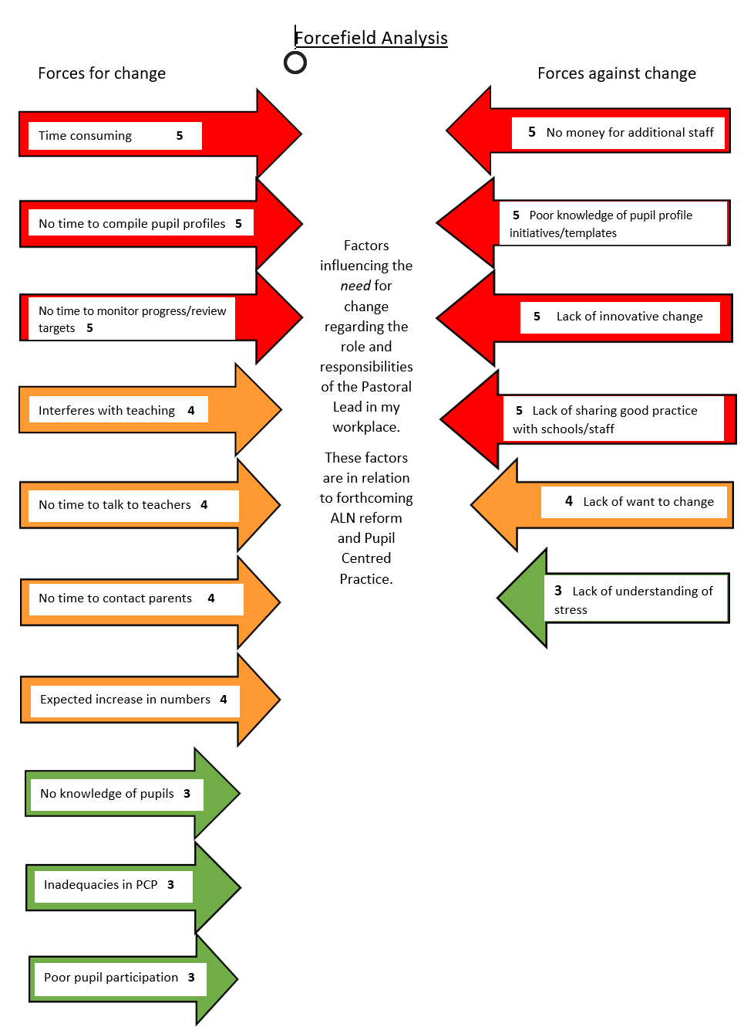

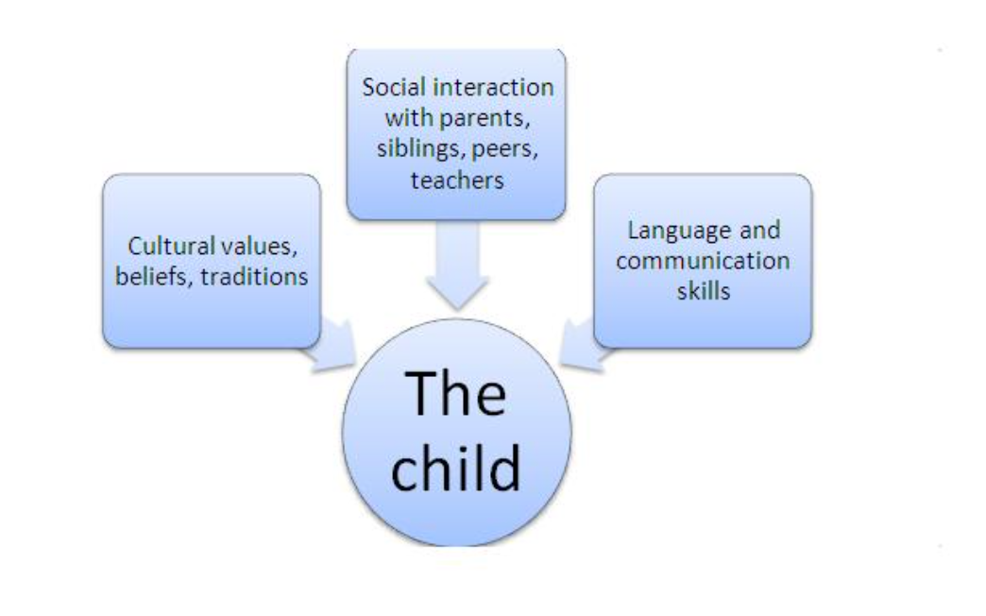
Figure 2

Zone of proximal development
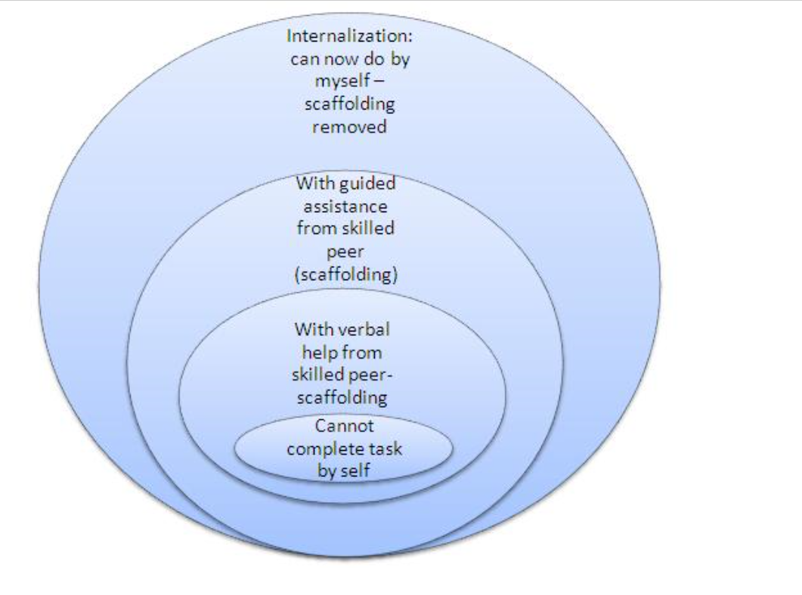

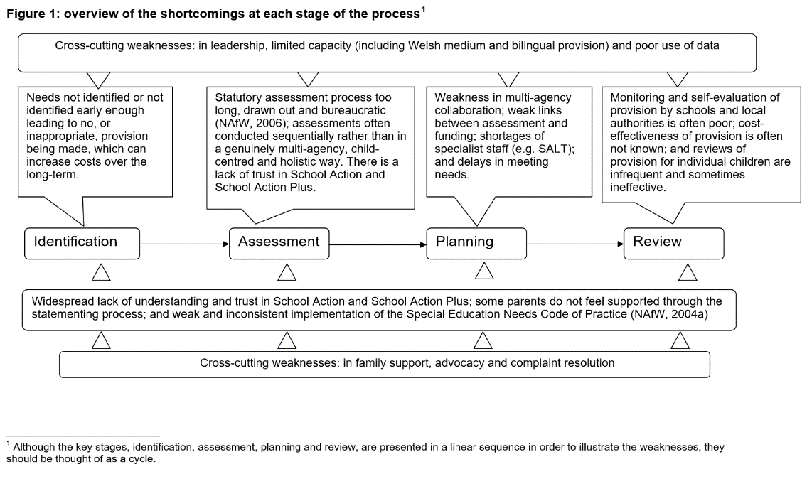
Figures: Dr Hotom, D. Dr Lloyd-Jones, S. Watkins, J (2012). Programme of Action Research to inform the Evaluation of the Additional Learning Needs Pilot: Interim report on the cost of the statutory reform of special educational needs provision: WAG, Cardiff

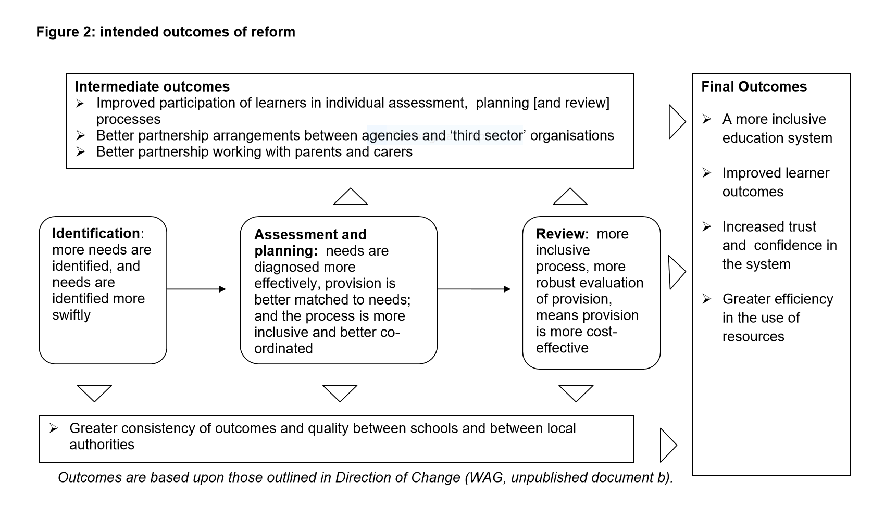

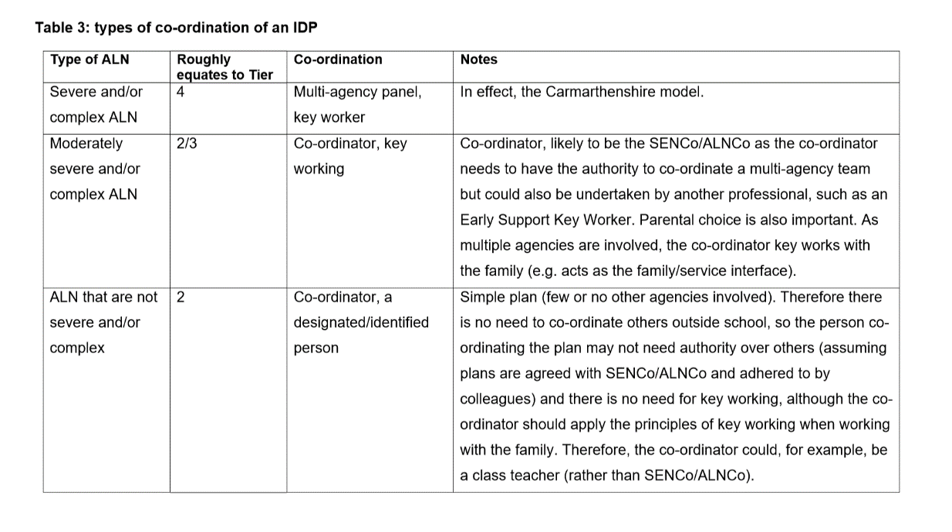

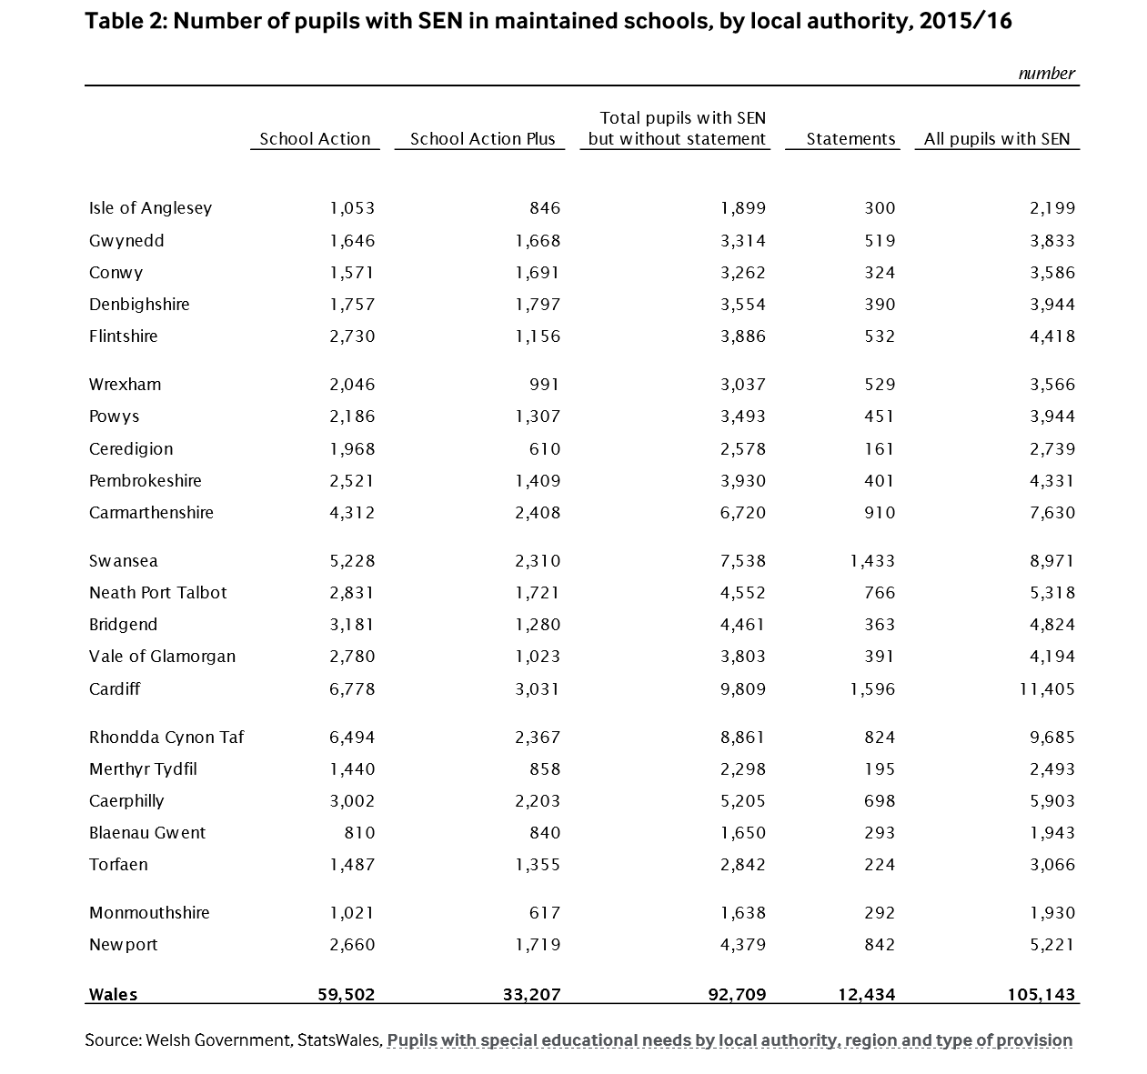
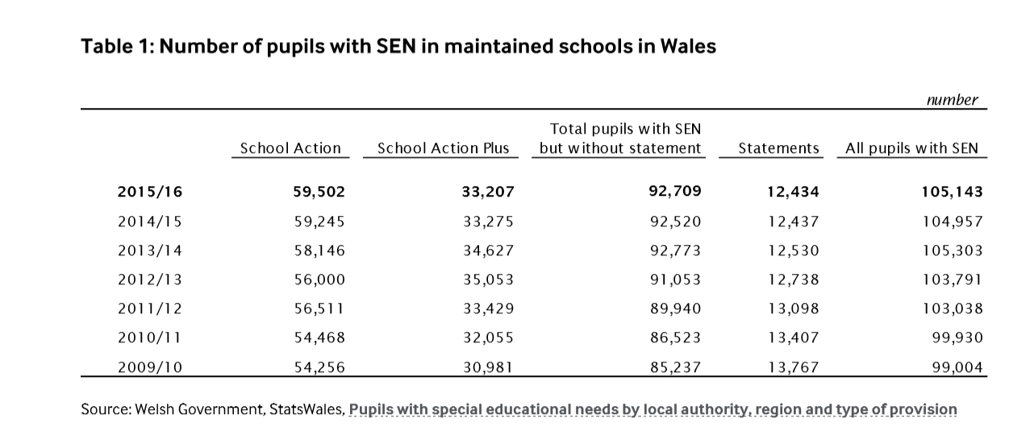

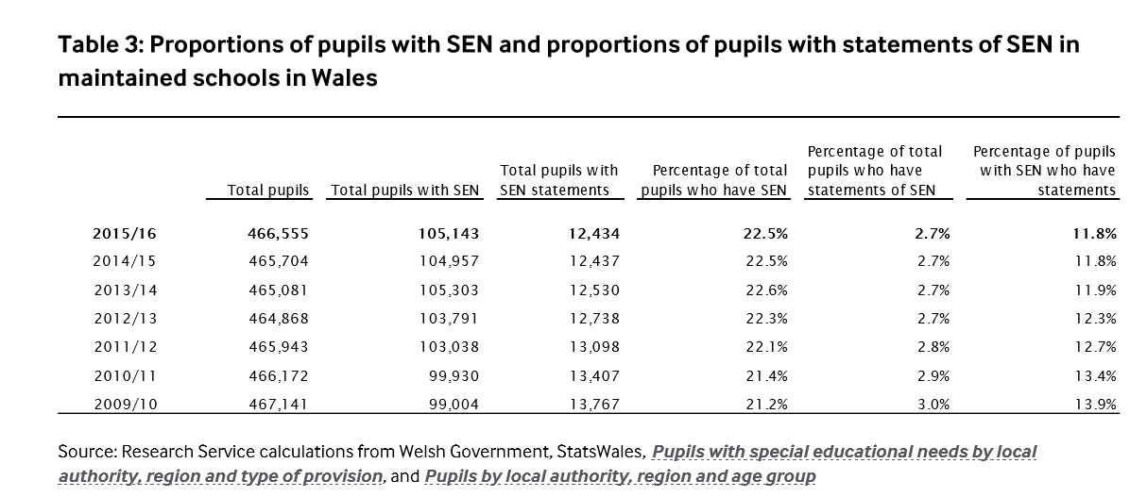

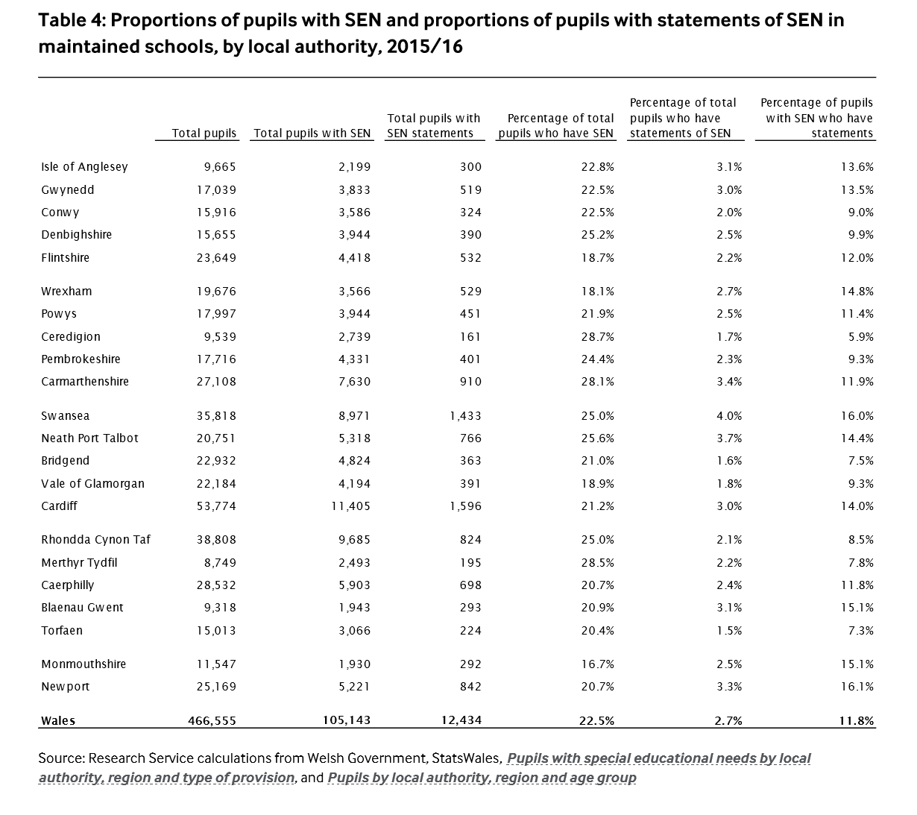

Critical Investigation Bibliography

Ashton, H, & Lambert, N. (2010). Young people’s views about their involvement in decision making: Educational Psychology in Practice, 26(1), 41-51
Clark, A. & Moss, P. (2001). Listening to young children: the mosaic approach: London, National Children’s Bureau and Joseph Rowntree Foundation
Cook-Sather, A. (2006). Sound, presence and power: ‘student voice’ in educational research and reform: Curriculum Inquiry
Corley, M. (2010). TEAL – Teaching Excellence in Adult Literacy - Centre Fact Sheet No 6: Student-Centred Learning: AIR
CRAE (Children’s Rights Alliance for England) (2013). State of Children’s Rights in England Review of Government United Nations Recommendations for Strengthening Children’s Rights in the UK. 10th Report. London: Children’s Rights Alliance for England
Daniel, H. & Hedegaard, M. (Eds) (2011). Vygotsky and special needs education: rethinking support for children and school: London: Continuum
Dauncey, M. (2015). National Assembly for Wales Research Paper: Special Educational Needs (SEN) / Additional Learning Needs (ALN) in Wales: WAG, Cardiff
Dauncey, M. (2016). Research Briefing: Additional Learning Needs (ALN) in Wales: WAG, Cardiff
Dauncey, M. (2018). Research Briefing – Act Summary: Additional Learning Needs and Educational Tribunal (Wales) Act 2018: WAG, Cardiff
DFE SEN Support. (2015). Research evidence on effective approaches and examples of current practice in good and outstanding schools and colleges: Department for education, Coventry University
Dr Hotom, D. Dr Lloyd-Jones, S. Watkins, J (2012). Programme of Action Research to inform the Evaluation of the Additional Learning Needs Pilot: Interim report on the cost of the statutory reform of special educational needs provision: WAG, Cardiff
Estyn. (2018). Readiness for Additional Learning Needs Reforms: WAG, Cardiff
Fielding, M. (2004). Transformative approaches to student voice: Theoretical underpinnings, recalcitrant realities: British Educational Research Journal, 30(2), 295-311
Fox, M. (2015). ‘What sort of person ought I to be?’ – Repositioning EP’s in light of the Children’s and Families Bill (2013): Educational Psychology in Practice, 31(4), 382-396
Great Britain. (1996). Education Act 1996: Gov, UK
Great Britain. (2000). Learning Skills Act 2000: Gov, UK
Harding, E & Atkinson, C. (2009). How EP’s record the voice of the child. Educational Psychology in Practice, 25 (2), 125-137
Hartas, D, & Lindsey, G. (2011). Young people’s involvement in service evaluation and decision making: Emotional and Behavioural Difficulties, 16(2), 129-143
Hartshorne, M. (2011). I CAN – Helps children communicate – I can Talk Series- Issue 10 – Speech, Language and Communication in Secondary Aged Pupils: ICAN, University of Sheffield
Harvey, L. (2017). Report to Overview and Scrutiny Committee 1 – Report to the Interim Corporate Director – Education and Family Support- (ALN) Reform: Bridgend. Gov
Hobbs, C et al. (2000). Consulting with children and young people: Enabling educational psychologists to work collaboratively. Educational and Child Psychology, 17(4), 107-155
Implementing the Additional Learning Needs and Education Tribunal (Wales) Act. (2018). A guide to the timeframes for implementing individual development plans for children of compulsory school age and under: WAG, Cardiff
Ingram, R. (2013). Interpretation of children’s views by educational psychologists: dilemmas and solutions: Educational Psychology in Practice, 29(4), 335-346
Jolley, A. (2018). Report to the Interim Corporate Director for education and Family Support – Additional Learning Needs (ALN) Reform: Bridgend. Gov
Lewis, A et al. (2007). The experiences of disabled pupils and their families: British Journal of Special Education
Llewellyn, M. Duggan, B. Graham, S. McDonald, M. (2018). Research on experiences of service families with children with Additional Learning Need in Education in Wales – SSCE Cymru – Welsh Institute for Health and Social Care, University of South Wales and Arad Research: University of Wales, Cardiff
Lundy, L. (2007). “Voice” is not enough: Conceptualizing Article 12 of the United Nations Convention on the Rights of the Child: British Research Journal, 33(6), 927-924
Mannion, G. (2007). Going spatial, going relational: Why “listening to children” and children’s participation needs reframing: Discourse: Studies in the Cultural Politics of Education, 28(3), 405-420
May, H. (2005). Whose participation is it anyway? Examining the context of pupil participations in the UK. British Journal of Special Education, 32(1), 29-34.
May. H. (2003). The engagement of children with learning difficulties in mainstream primary classrooms: Education-line
McKay, J. (2014). Young people’s voices: Disciplining young people’s participation in decision making in special education needs: Journal of Educational Policy 29(6), 760-773
Messiou, K. (2002). Marginalisation in primary schools: Listening to children’s voices: Support for Learning, 17(3), 117-121
National Assembly for Wales. (2018). Additional Learning Needs and Educational Tribunal (Wales) Act 2018: WAG, Cardiff
Newton, M. (2016). Educational Psychologists’ Practice: Obtaining and Representing Young people’s Views: Cardiff University
Norwich, B et al. (2006) Evaluating Children’s’ Participation in SEN Procedures: Lessons for educational psychologists: Educational Psychology in Practice
NPTC, (2019). Neath Port Talbot Inclusion Service Local Implementation Plan: NPTC. Gov
Pereira, Z. (2017). Afasic Cymru – Voice for Life Consultation on the Additional Learning Needs and Educational Tribunal (Wales) Bill
Piaget, J. (1936). Origins of intelligence in the child. London: Routledge & Kegan Paul.
Pozniak, H. (June 2018). For schools that welcome high proportions of pupils from venerable or disadvantaged backgrounds, a strong pastoral support network can be a game changer: Daily Telegraph
Rodina, K A. (2007). Vygotsky’s Social Constructionist View on Disability: A Methodology for Inclusive Education
Sanderson, H. (2000). Person Centred Planning: Key Features and Approaches.
Sharp, R. (2014). Ready, steady, action: what enables young people to perceive themselves as active in their lives? :Educational Psychology in Practice, 30(4), 347-364
Skivenes, M, & Strandbu, A. (2006). A child perspective and children’s participation. Children, Youth and Environments, 16(2), 10-27
Soar, K et al. (2005). Pupil involvement in special educational needs disagreements resolution: Some perceived barriers to including children in mediation: British Journal of Special Education, 32(1), 35-41
SSCE Cymru. (2015). Guide for Schools: University of Wales, Cardiff
Steele, R. (2005). How the rights-based approach to development contributes to building citizenship in childhood and adolescence: Rights Information Network
TEAL PAPER. (2000). Student Centred Learning, North Central Regional Laboratory: WAG, Cardiff
Todd, L. (2012). Critical dialogue, critical methodology: Bringing the research gap to young people’s participation in evaluating childrens services: Children’s Geographies, 10(2), 187-200
TSANA. (2014). Task and Finish Group on Additional Learning Needs Reform – TSANA Final Report: TSANA
TSANA. (2015). Discussion Paper for ALN Task and Finish Group Meeting: TSANA
UWTSD.ac.uk, Perspectives on the Reform of ALN Wales, 2019
Wadsworth. B.J. (1971). Piaget’s Theory of Cognitive Development. An Introduction for Students of Psychology and Education: McKay
Warshak, R. (2004). Payoffs and pitfalls of listening to children: Family Relations, 52,373-384
Watkins, C. Buckle, K. Dodds, A. (2000). TTA- Teacher Training Agency – NAPCE – Standards for Pastoral Leads: TTA
Welsh Government – WAG (2016). ALN Changes for Wales – Consultation Responses: WAG, Cardiff
Welsh Government – WAG, (2015). Draft Additional Learning Needs Code: WAG, Cardiff
Welsh Government – WAG, (2019). The Additional Learning Needs (ALN) Transformation Programme – Frequently Asked Questions: WAG, Cardiff
Welsh Government for Wales. (2015). Person-Centred practice in Education: A guide for early years, schools and colleges in Wales: WAG, Cardiff
Welsh Government for Wales. (2017a). Draft Additional Learning Needs Code: WAG, Cardiff
Welsh Government for Wales. (2017b). Pupils with special educational needs by sector and year: WAG, Cardiff
Welsh Government for Wales. (2017c). Academic achievement by pupil characteristics: WAG, Cardiff
Welsh Government for Wales. (2017d). Absenteeism from schools by pupil characteristics: WAG, Cardiff
Woods, K. A. & Farrell, P.T. (2006). Approaches to Psychological Assessment by Educational Psychologists in England and Wales: School Psychology International, 27(4), 387-404
Zaporozhets, A V & Elkonin D B. (1971). The psychology of preschool children: Oxford, England
Websites
www.earlysupportwales.org.uk
http://learning.gov.wales
www.senedd.assembly/wales
www.senedd.gov.wales/about
www.senedd.wales/docs
http://gov.wales/aln
http://edyourself/org/articles/senchangeswales
http://www.assembly.wales
http://www.ccwales.org.uk
http://www.gov.wales/consultations/education
http://www.sinclairslaw.co.uk
www.assembly.wales/research

