
Certificate of Higher Education Skills for the Workplace
(Health and Social Care)
Assessment 2

Module: ................................................................................................... introduction to Public Health
Module code: ........................................................... ............................LCHS4008
Lecturer(s): .............................................................................: Mr Muhmmad Aliyu
Assignment Title: ......................................................... Report on a Health Issue
Word-count: ........................................................................................Report – 1500
Words Submission deadline: .........................................................23rd April 2025

Table of Contents

1. Introduction .................................................................................................. ......
2. The UK Public Health Contex................................................................................
2.A. Local Statistics (UK Focus) ...............................................................................
3. Causes and Effects of Alzheimer’s Disease........................................................
3. A-Global Statistics and International Context.......................................................
4. Social Determinants of Health and Influencing Factors.......................................
5. Prevention Strategies and the Role of Health and Social Care Professionals..............
6.Conclusion....................................................................................................................
7-References............................................................................................................................

1. Introduction
Alzheimer’s disease, the most common form of dementia, represents a growing global and national public health concern. As a progressive neurodegenerative disorder, it impairs memory, cognition, communication, and behaviour, leading to a loss of independence and a decline in quality of life. With an ageing population and increasing life expectancy, the prevalence of Alzheimer’s is expected to rise, placing increasing strain on health and social care services (WHO, 2023).

This report examines Alzheimer’s disease through a public health lens, exploring its causes and effects, national and international statistics, the influence of social determinants, and prevention strategies. It also highlights the crucial role of health and social care professionals in addressing this complex issue.

2. The UK Public Health Context

Alzheimer’s disease has significant implications for public health in the UK. The economic burden is estimated at over £34 billion annually, accounting for healthcare, social care, and unpaid caregiving costs (Alzheimer’s Research UK, 2023). Public health services seek to improve well-being and reduce inequalities, delivered through collaboration between the NHS, local authorities, and national agencies such as the UK Health Security Agency. The Health and Social Care Act 2012 reinforced this partnership, with an emphasis on community-based care responsive to local needs.
According to Alzheimer’s Society (2024), around 900,000 people in the UK currently live with dementia, with Alzheimer’s accounting for 60–70% of cases. This number is projected to
exceed one million by 2030. Regional disparities persist: while England has more than 700,000 diagnosed cases, rural and deprived areas face barriers to timely diagnosis and support (ONS, 2023).

2.A. Local Statistics (UK Focus)
In 2022, dementia and Alzheimer’s disease were the leading causes of death in England and Wales, responsible for 11.4% of all deaths (ONS, 2023). In Wales, over 48,000 people currently live with dementia, a figure expected to rise by 60% by 2040 (Public Health Wales, 2023).The NHS Long Term Plan aims to address these challenges by promoting early diagnosis, dementia-friendly communities, and structured care pathways such as the NHS Dementia Well Pathway. Campaigns such as Dementia Friends also seek to reduce stigma. However, persistent challenges—including funding shortfalls, workforce pressures, and regional inequalities—continue to hinder progress.

3. Causes and Effects of Alzheimer’s Disease

Alzheimer’s disease is associated with abnormal protein build-up in the brain, including amyloid plaques and tau tangles, which disrupt neuronal communication and lead to cell death (Alzheimer’s Society, 2023). The exact cause remains unknown, but genetic, biological, and environmental risk factors are involved.

Unmodifiable risk factors include:
Age (risk increases after 65)
Genetics (in some early-onset cases)

Modifiable risk factors include:
Cardiovascular disease (e.g., hypertension, high cholesterol)
Type 2 diabetes
could be prevented through healthier lifestyles and supportive environments.

Alzheimer’s typically progresses through stages, from mild memory loss to severe cognitive decline, disorientation, and complete dependence. Families and carers often face emotional, physical, and financial strain. At a societal level, the disease contributes to rising hospital admissions, pressure on long-term care, and demand for specialist services.

3.A Global Statistics and International Context

Globally, over 55 million people live with dementia, with Alzheimer’s accounting for 60–70% of cases (WHO, 2023). Around 10 million new cases are diagnosed annually, making dementia the seventh leading cause of death worldwide. The burden is especially severe in low- and middle-income countries, where awareness, diagnosis, and care infrastructure are limited.

Comparative evidence shows that countries with strong dementia strategies—such as Sweden and the Netherlands—achieve better outcomes by prioritising community-based care, early diagnosis, and investment in carer support. In contrast, the UK continues to face systemic inequalities, despite progress made through initiatives such as the Prime Minister’s Challenge on Dementia (Prince et al., 2014). • Smoking and alcohol misuse
• Sedentary lifestyle and poor diet
• Social isolation
Livingston et al. (2020) estimate that around 40% of dementia cases
Document purpose This report presents the findings of research commission by Alzheimer’s Society to update the Dementia UK (2007), report. It provides a synthesis of best available evidence for the current cost and prevalence of dementia. It aims to provide an accrue understanding of dementia prevalence and cost in the UK to assist in policy development, influencing, commissioning and service design.

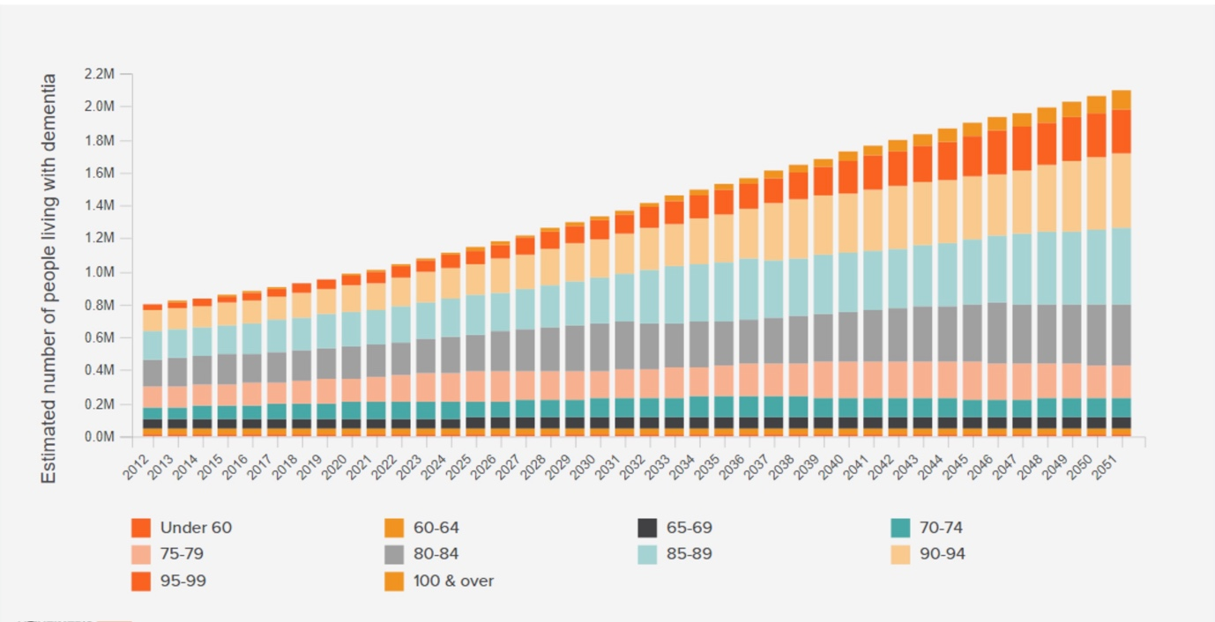Prince, M et al (2014) Dementia UK: Update Second Edition report produced by King’s College London and the London School of Economics.

4. Social Determinants of Health and Influencing Factors

Social determinants such as income, education, housing, ethnicity, and healthcare access strongly influence the risk and management of Alzheimer’s disease (Marmot et al., 2020). Individuals in deprived communities often experience later diagnoses and limited access to support services.
Educational attainment is particularly important. Lower levels of education are linked to reduced “cognitive reserve,” increasing dementia risk. Poverty, unemployment, and poor housing conditions also correlate with unhealthy behaviours and restricted access to preventive healthcare. Environmental factors such as pollution and lack of green space may further elevate risk.
Ethnic minority groups—including Black and South Asian communities—often face stigma, language barriers, and cultural misunderstandings, delaying diagnosis and access to care (Truswell, 2019). Furthermore, unpaid carers, who provide the majority of dementia care, often face economic hardship and health inequalities themselves.

To ensure equity, practitioners must adopt culturally competent approaches, provide accessible information, and tailor interventions to diverse community needs.

5. Prevention Strategies and the Role of Health and Social Care Professionals

Although there is no cure for Alzheimer’s, public health efforts focus on prevention and early intervention. Strategies include:
1. Health promotion – encouraging physical activity, healthy diets, smoking cessation, and social engagement.
2. Early identification – recognising and documenting early signs of cognitive decline.
3. Referral – directing clients to memory clinics and support services.
4. Advocacy – supporting dementia-friendly communities and policy development.

Health and social care professionals are central to these efforts. Effective communication is essential: Egan’s Skilled Helper Model (2014) highlights the value of empathetic listening and goal-oriented support, while tools like SBAR (Situation, Background, Assessment, Recommendation) support interprofessional communication.
Practice is also guided by legislation such as the Equality Act 2010 (ensuring reasonable adjustments for disability) and the Data Protection Act 2018, underpinned by the Caldicott Principles for confidentiality.
Ongoing professional development (CPD) ensures practitioners remain updated on research, best practice, and emerging technologies. Reflective practice (Jasper, 2013), inter professional learning, and dementia-specific training all contribute to more effective, person-centred care.

6. Conclusion

Alzheimer’s disease is a major public health challenge, driven by complex biological, social, and environmental factors. Its prevalence is increasing, with disproportionate impacts on vulnerable groups and unpaid carers.
This report has critically examined Alzheimer’s disease within UK and global contexts, highlighting its causes, effects, and the importance of social determinants. It has also emphasised the role of prevention, early diagnosis, and the essential contribution of health and social care professionals.
Three priorities stand out for future practice:
1. Reducing health inequalities by addressing the social determinants of dementia.
2. Expanding early diagnosis and intervention through accessible, culturally competent services.
3. Strengthening professional capacity through CPD, reflective practice, and advocacy for dementia-friendly policies.
As a developing professional, I aim to integrate these principles into my practice—fostering inclusivity, addressing inequalities, and advocating for person-centred care. While a cure remains elusive, compassion, prevention, and professional collaboration are powerful tools for improving quality of life for people living with Alzheimer’s and their families.

References

1-Alzheimer’s Research UK (2023) Dementia statistics hub. [Online] Available at: https://www.alzheimersresearchuk.org/about-dementia/info-statistics/ [Accessed: 13 April 2025].
2-Alzheimer’s Society (2023) What is Alzheimer’s disease? [Online] Available at: https://www.alzheimers.org.uk/about-dementia/types-dementia/alzheimers-disease [Accessed: 13 April 2025].
3-Alzheimer’s Society (2024) Dementia in the UK: Key facts and statistics. [Online] Available at: https://www.alzheimers.org.uk/about-us/news-and-media/facts-media [Accessed: 13 April 2025].
4-Egan, G. (2014) The Skilled Helper: A Problem-Management and Opportunity-Development Approach to Helping. 10th ed. Belmont, CA: Brooks/Cole.
5-Jasper, M. (2013) Beginning Reflective Practice. 2nd ed. Andover: Cengage Learning.
6-Livingston, G., Huntley, J., Sommerlad, A., Ames, D., Ballard, C., Banerjee, S., Brayne, C., Burns, A., Cohen-Mansfield, J., Cooper, C., Costafreda, S.G., Dias, A., Fox, N., Gitlin, L.N., Howard, R., Kales, H.C., Kivimäki, M., Larson, E.B., Ogunniyi, A., Orgeta, V., Ritchie, K., Rockwood, K., Sampson, E.L., Samus, Q., Schneider, L.S., Selbæk, G., Teri, L. and Mukadam, N. (2020) ‘Dementia prevention, intervention, and care: 2020 report of the Lancet Commission’, The Lancet, 396(10248), pp. 413–446. doi: 10.1016/S0140-6736(20)30367-6 [Accessed: 13 April 2025].
8-Marmot, M., Allen, J., Boyce, T., Goldblatt, P. and Morrison, J. (2020) Health equity in England: The Marmot Review 10 years on. London: Institute of Health Equity. Available at: https://www.instituteofhealthequity.org/resources-reports/marmot-review-10-years-on [Accessed: 13 April 2025].
9-Office for National Statistics (ONS) (2023) Dementia and Alzheimer’s disease remains the leading cause of death in the UK. [Online] Available at: https://www.ons.gov.uk/peoplepopulationandcommunity [Accessed: 12 April 2025].
10-Prince, M., Knapp, M., Guerchet, M., McCrone, P., Prina, M., Comas-Herrera, A., Wittenberg, R., Adelaja, B., Hu, B., King, D., Rehill, A. and Salimkumar, D. (2014) Dementia UK: Update. 2nd ed. London: Alzheimer’s Society.
11-Public Health Wales (2023) Dementia in Wales: 2023 update. Cardiff: Public Health Wales NHS Trust. Available at: https://phw.nhs.wales [Accessed: 13 April 2025].
12-Truswell, D. (2019) Dementia, Race and Ethnicity: Addressing Health Inequalities. London: Jessica Kingsley Publishers.

13-World Health Organization (WHO) (2023) Dementia fact sheet. [Online] Available at: https://www.who.int/news-room/fact-sheets/detail/dementia [Accessed: 13 April 2025].

