  Component One:  What are the key skills required when working in the housekeeping team? 750 words (+/- 10%)  Contribution to Overall Module Assessment: 25% | Student No: | 2208665
 | Module Title: | Operating Hotel Facilities
 | Module Code: | BMIH4006
 | Lecturer: | Lisa Knight
A key division in the hotel sector, housekeeping oversees upholding cleanliness and guaranteeing customer happiness. Using examples from the industry as well as personal thoughts, this paper examines the crucial abilities needed when working in a cleaning team. The relevance of the abilities of attention to detail, time management, communication, physical stamina, and problem-solving in providing great service and influencing the success of hospitality organisations is highlighted. The use of theoretical knowledge in real-world situations is also looked at, with an emphasis on its importance and influence on the sector.
Attention to detail: Paying attention to details is one of the most important housekeeping abilities. This entails being precise in the cleaning and organisation of the rooms, paying great attention to little things that can significantly impact the enjoyment of the guests. For instance, making sure that the room is precisely organised, all amenities are restocked, and every surface is pristine. I have learnt to pay attention to even the smallest details, like putting towels in a dependable and aesthetically pleasing way or finding a bit of dust in an unnoticed location. I have been able to constantly offer guests a high quality of cleanliness and comfort by using this talent.
Time management: Especially during times of high occupancy, housekeeping crews frequently have strict timetables to meet. In order to guarantee that activities are completed effectively and on time, time management skills are essential. It includes arranging work schedules, organising jobs based on significance and urgency, and improving workflows. I have been in predicaments when cleaning numerous rooms in a short amount of time was necessary, and fulfilling deadlines required effective time management. I was able to increase production and uphold a high degree of cleanliness by devoting the right amount of time to each activity and using time-saving strategies, such distributing work among team members.
Communication abilities: A housekeeping staff needs to be able to communicate effectively and clearly. To guarantee efficient operations, this calls for communication not only with team members but also with other departments, including the front desk or maintenance (Back, Tulsky, and Arnold, 2020). Task coordination, problem solving, and updating on the status of the room are all made easier by effective communication. In my experience, effective communication has a favourable effect when working with colleagues to split tasks and coordinate efforts. By keeping the lines of communication open, they can respond quickly to customer needs and guarantee effective teamwork (Cuic Tankovic, Kapeš, and Benazić, 2023).
Physical endurance: Cleaning can be physically taxing, needing endurance and strength to carry out a variety of duties include carrying heavy things, standing for extended periods of time, and navigating confined spaces (Yusuf & Irwanti, 2021). Maintaining productivity and avoiding injuries need having the physical endurance to withstand the demands of the job. My own experience has taught me the value of keeping physical fitness and using the right lifting techniques to reduce the possibility of strain or tiredness.
Problem-solving abilities: Housekeeping personnel frequently face unforeseen difficulties, such as demands from visitors, maintenance problems, or a lack of supplies (Nielsen, and et.al., 2023). In such circumstances, having the capacity for critical thought and finding workable answers is essential. For instance, if a stain is challenging to get rid of, you could need to try out various cleaning methods or enlist the help of more seasoned coworkers (Alsarayreh, 2023). I have been able to overcome challenges and offer acceptable answers by honing my problem-solving abilities, assuring visitor contentment, and preserving the general effectiveness of the cleaning department.
To provide excellent cleanliness and uphold a healthy atmosphere for visitors, theoretical knowledge of suitable cleaning processes, sanitation standards, and the efficient use of cleaning chemicals, can be immediately applied. Housekeepers can optimise their time and resources and boost productivity and cost effectiveness for the institution by learning the fundamentals of effective workflow management.
The hospitality business places a special emphasis on essential housekeeping crew abilities for several reasons. First off, housekeeping is crucial in determining how satisfied and overall happy guests are during their stay. A pleasant first impression is created and added to the reputation of the company by tidy, well-maintained rooms. The abilities listed above immediately contribute to upholding high standards for cleanliness, guaranteeing the comfort of guests, and exceeding their expectations.
Second, effective housekeeping procedures are necessary to keep the establishment running smoothly. Process streamlining, delay reduction, and disruption avoidance are made possible by good time management, attention to detail, and problem-solving abilities. This has a direct effect on the establishment's overall effectiveness and its capacity to quickly attend to the needs of visitors.
The key competencies that have been covered are essential for success in the housekeeping team, to sum up. Professionals may produce superior cleaning, guarantee effective operations, and increase client happiness by using these talents. Housekeeping workers can constantly satisfy industry requirements and contribute to the success of the hospitality business thanks to the combination of theoretical knowledge and practical experience.

Word Count | 823

Component Two:
Contribution to Overall Module Assessment: 25%
In this scenario – You have just been promoted to team leader for a floor within the hotel. A guest complains that on their arrival, their room had not been properly cleaned. Create an action plan and answer the following questions.

Problem | Why did it happen? | What are you going to do? | How will you prevent this from happening in the future? | What measures would you introduce to improve team effectiveness?
Duvet cover with stains | The linen was not properly washed | Apologise, and check if any of my colleagues can change it, if not I do it myself | Do the final check rigorously | Invest in the team and provide training
Dirty towels | That is how they arrived from the washing company | Apologise and change them | Speak with the team and ask them to check before putting them | Get smarter with technology
Bathroom mirror is not wiped | One of the housekeepers forgot to do it | Apologise and clean it | Check who cleaned the room and speak with her/him | Establish effective communication
Carpet has stains | Previous guest dropped something on it | Apologise and offer to move them, so it could be cleaned | Check the carpets regularly | Reword excellent team work, offer motivations
Curtains are ripped | Ware and tare, or previous guest did it | Ask one of the housekeepers to change it as soon as possible | Ask the team to check them every day | Encourage communication

Component Three:
Contribution to Overall Module Assessment: 50%
Your task is to create and prepare a presentation following the detailed scenario provided below.

As the floor housekeeping manager and given the recent guest complaints you need to put together a basic training presentation for your colleagues within the housekeeping team to get the best out of them, ensure that brand standard is being achieved and that Health and Safety procedures are also being followed.

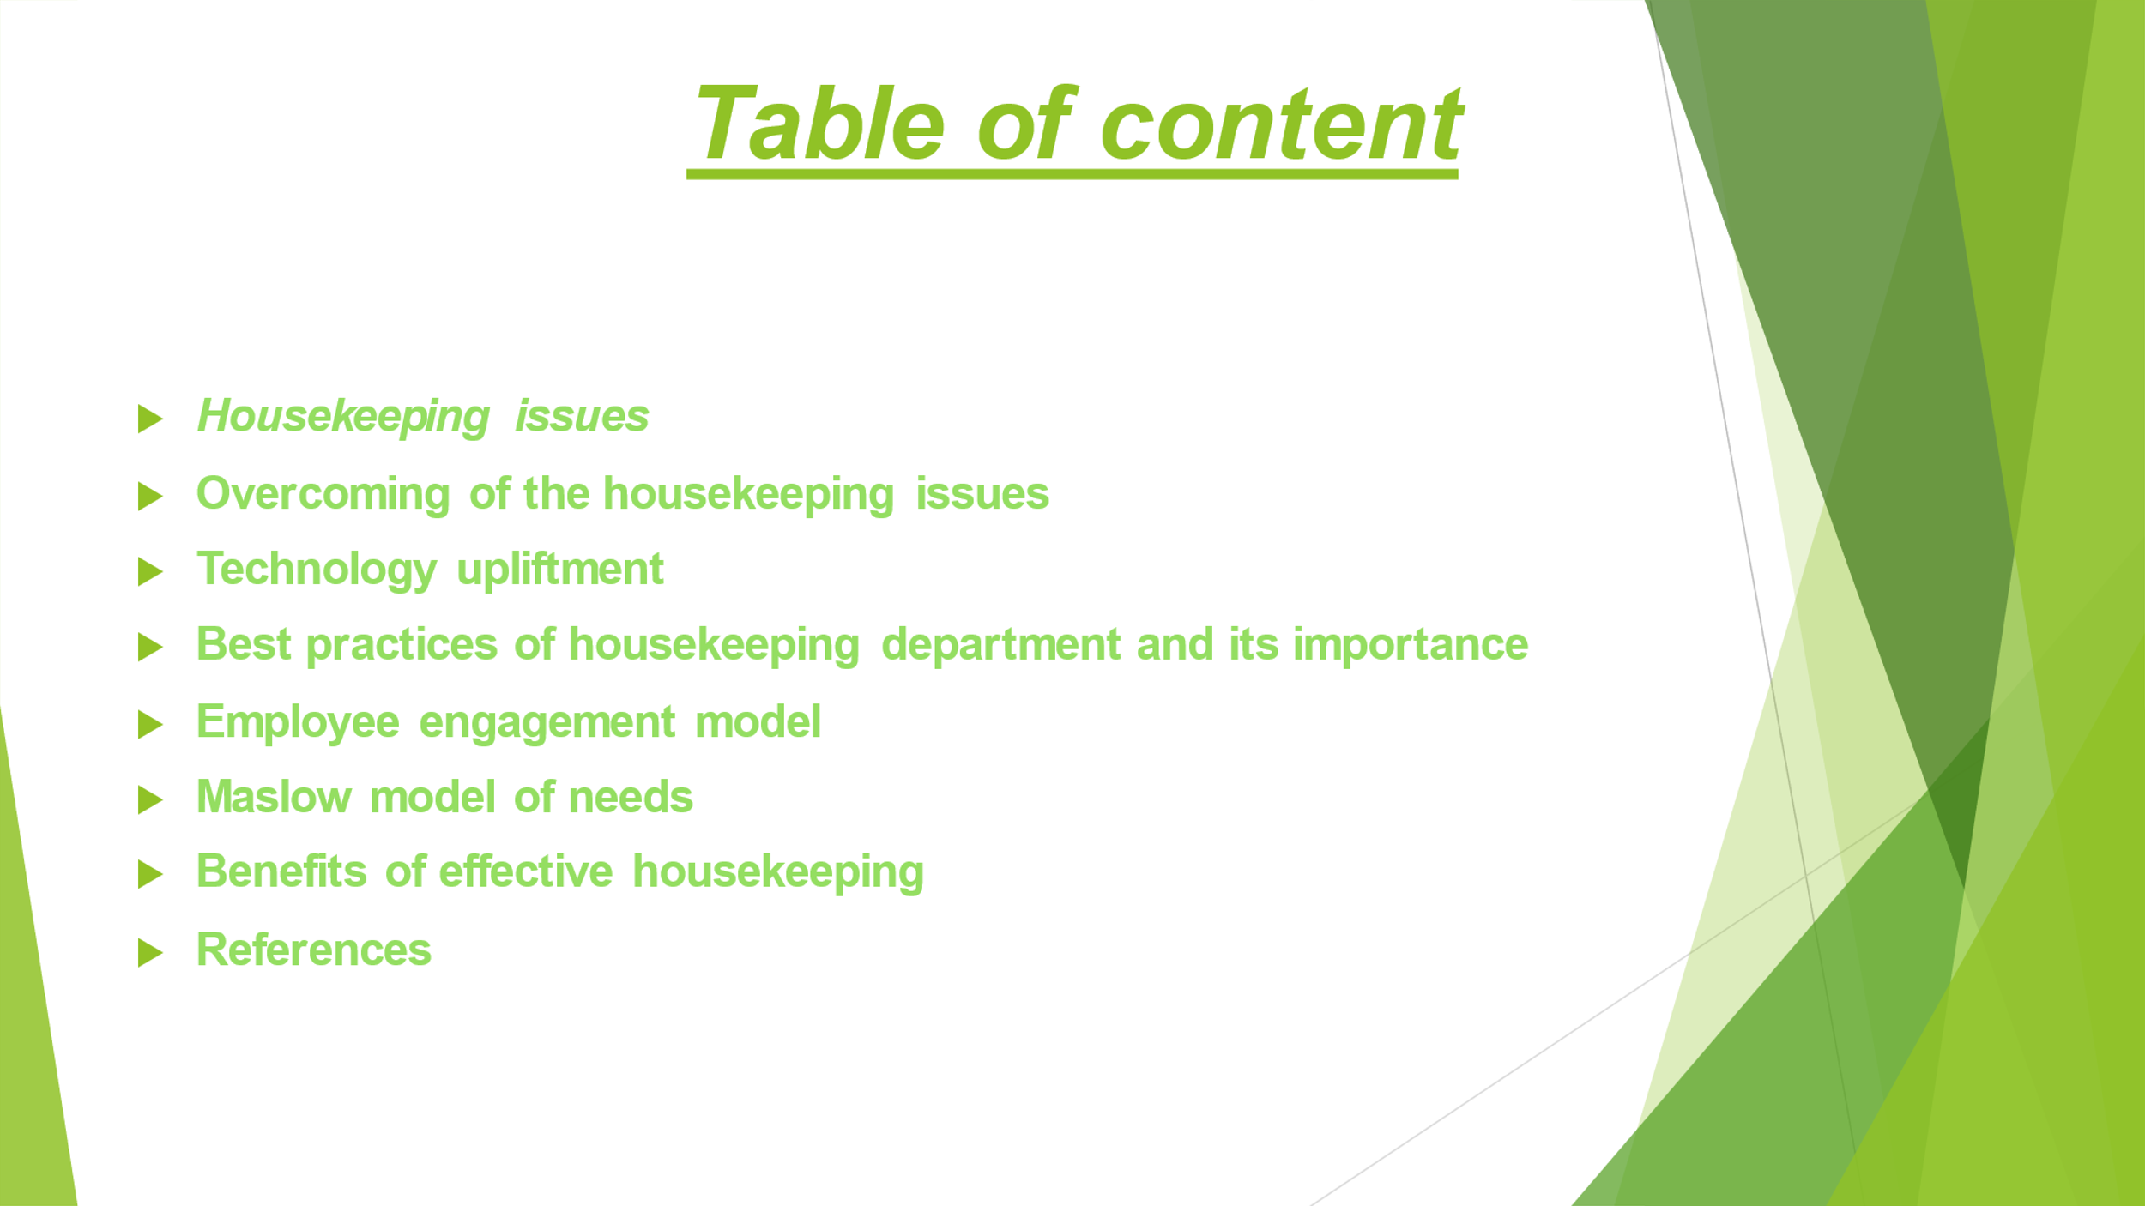

Training Notes:
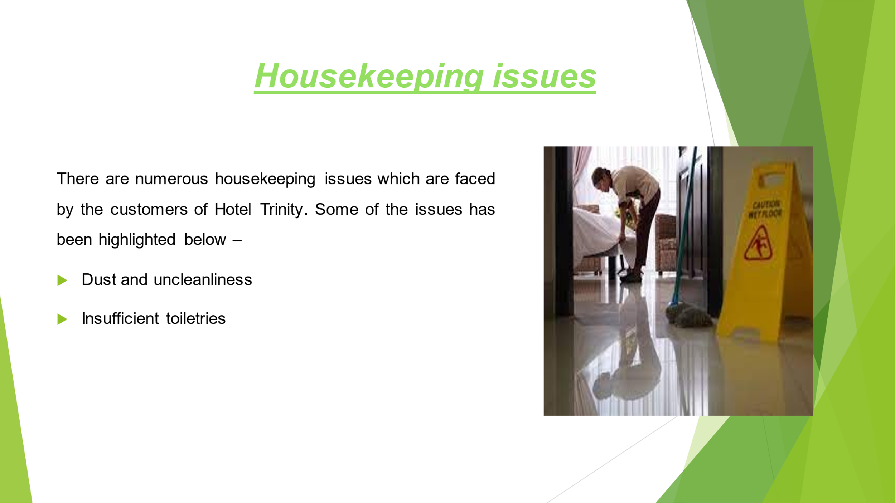

Training Notes:
- These days customers are expecting high standards which inspecting their rooms (Taipale and Taipale, 2019). So, if they find any area unclean and dusty, they think that the housekeeping department is cutting areas in their cleaning.
- A lack of sufficient toiletries such as shampoo, soap, toothpaste, shower gel, toilet paper etc. in a hotel room is a big turn off for the guest (Gupta, 2018).

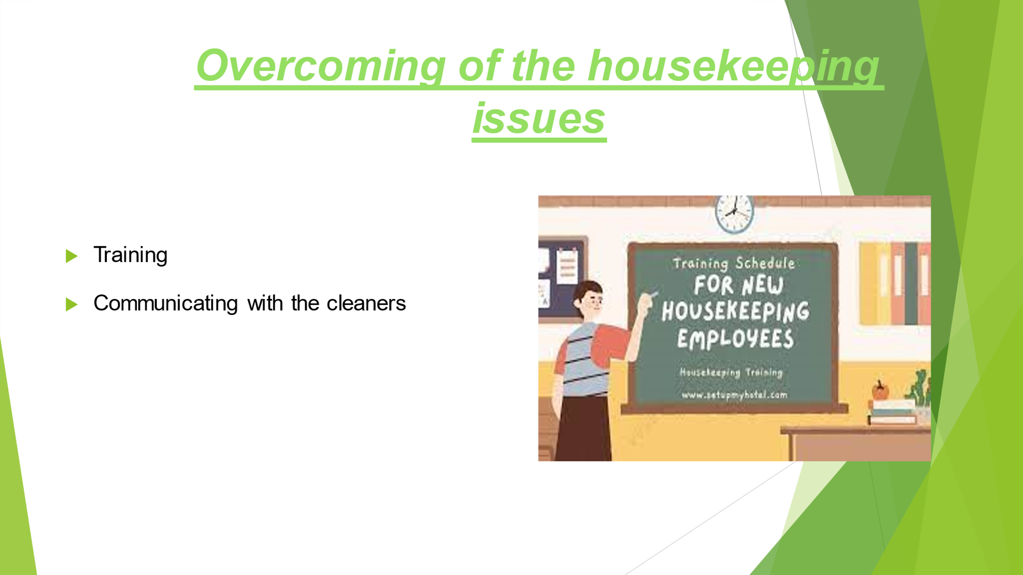

Training Notes:
In order to provide devastating experience to the guest and to retain them it is very important for Hotel Trinity to take measures to overcome the issues faced by the housekeeping department. Some of the measures which has been taken by the hotel has been mentioned below –
- In order to keep the room clean and tidy it is very important to communicate the importance of cleanliness with the cleaners (Nimri and et.al., 2020).
- Every employee who is working in the housekeeping department must be provided with the adequate training to keep up with the guest.

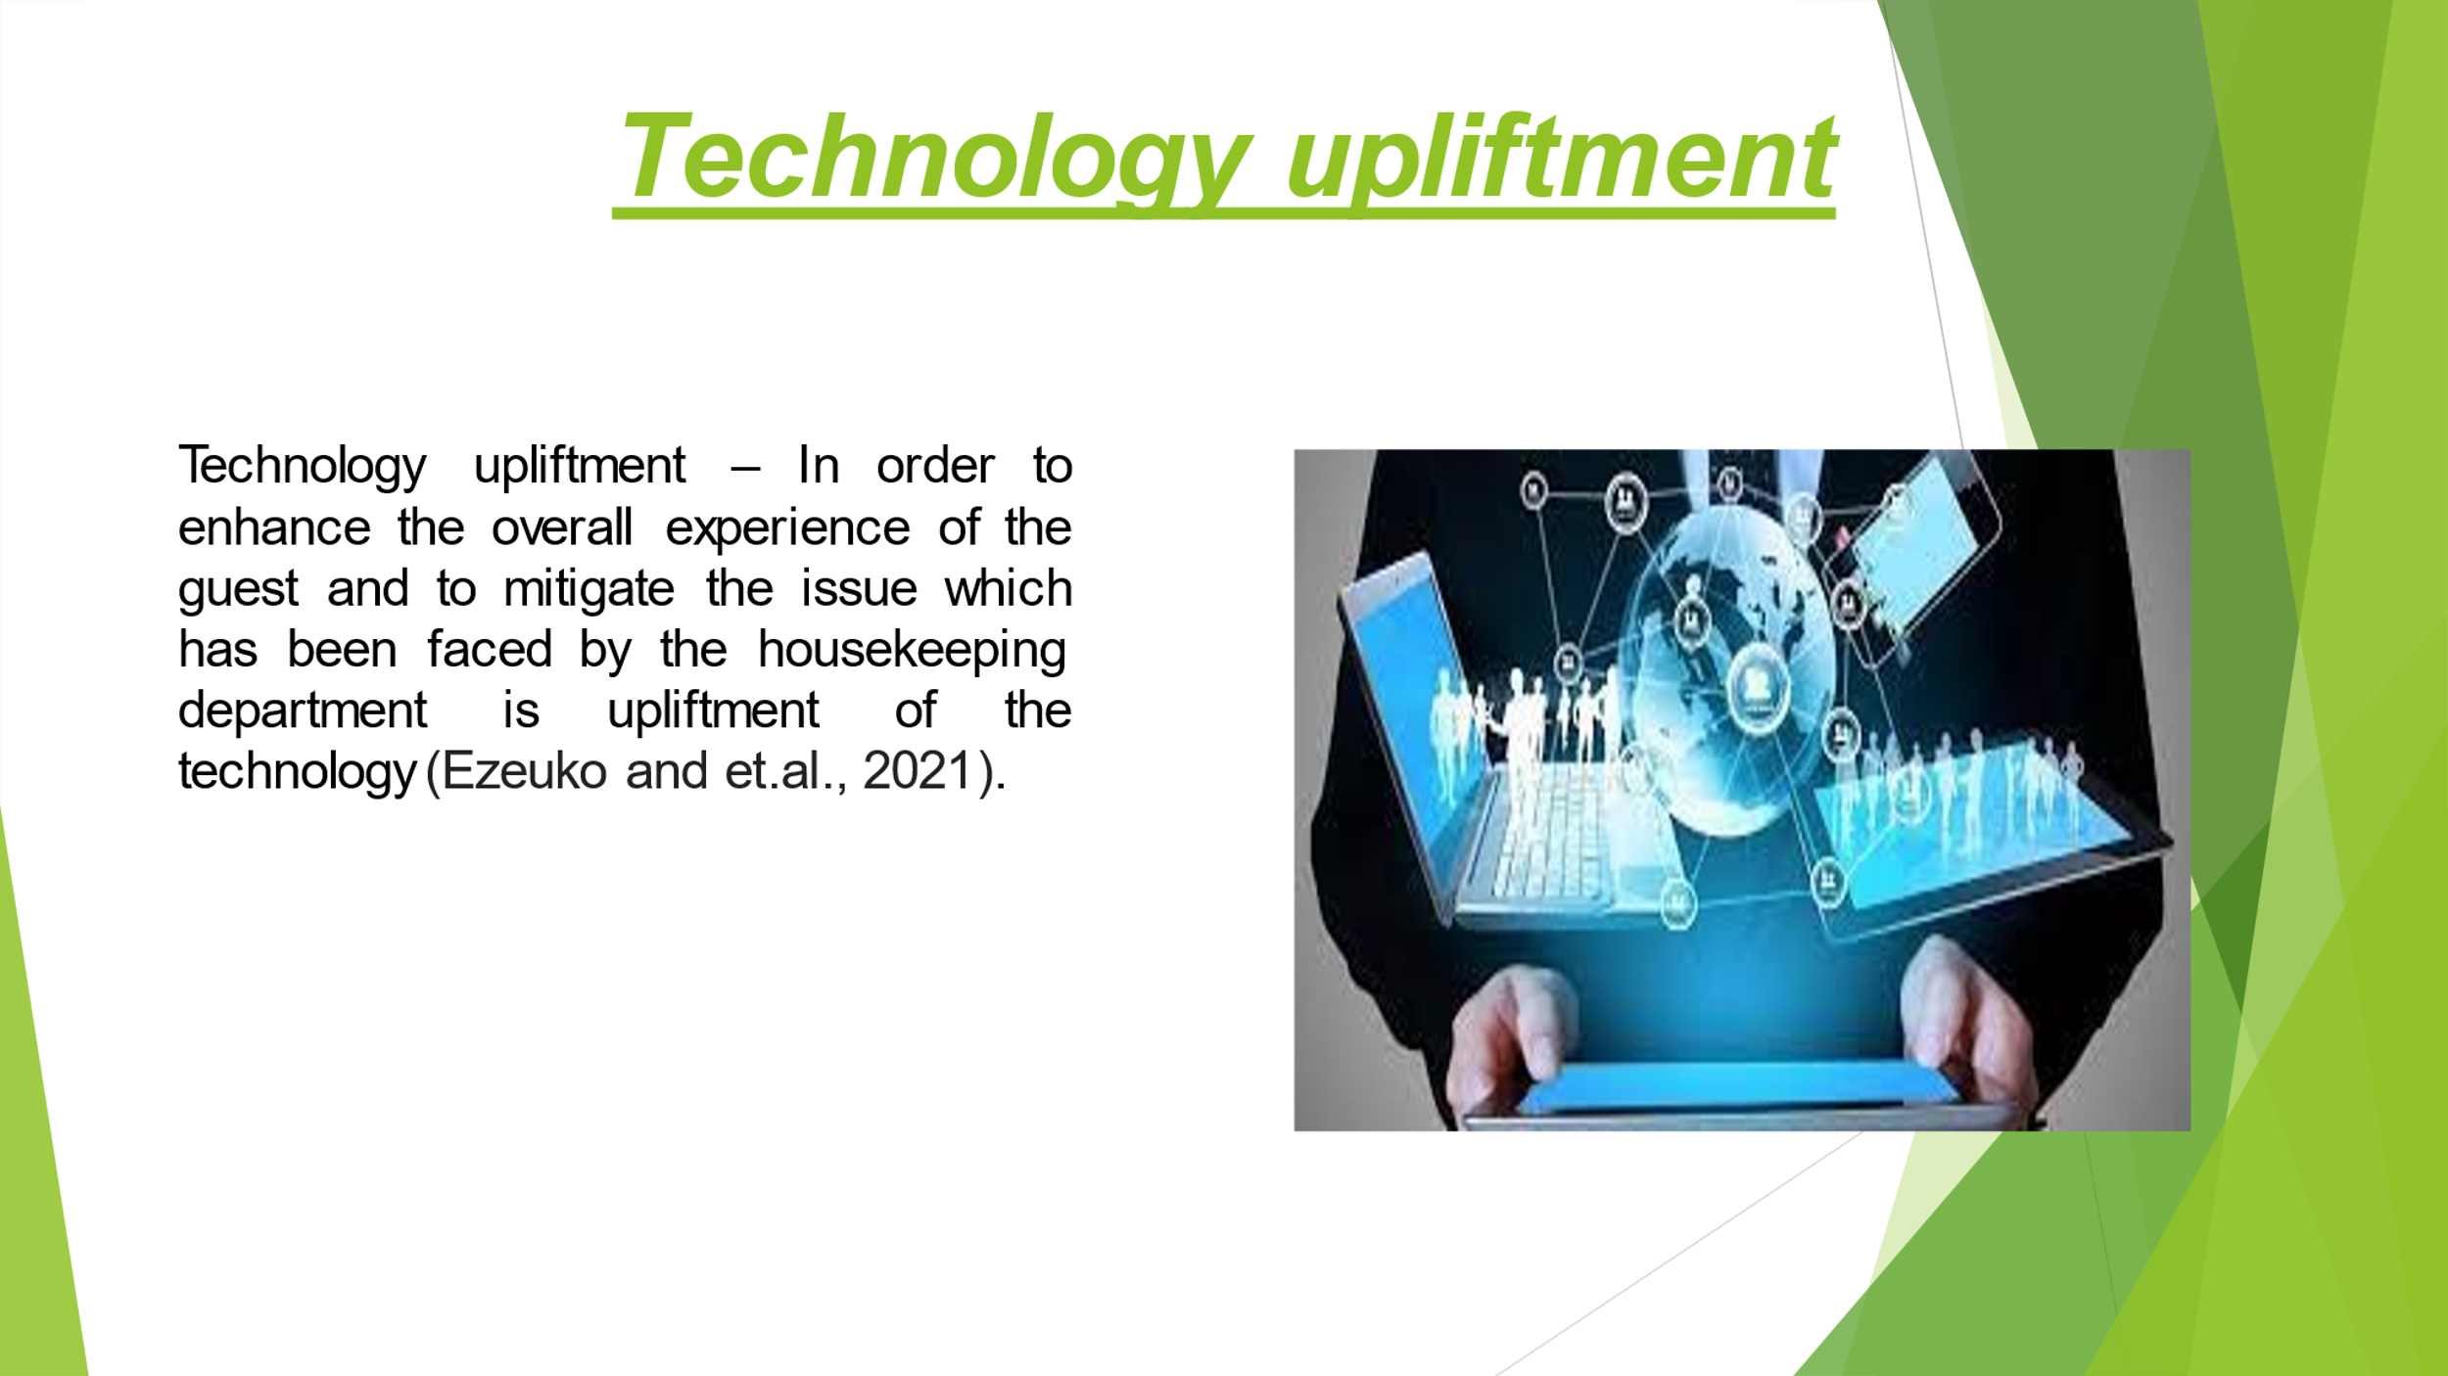

Training Notes:
The technological advancement will help the hotel in gaining the data as well as documentation which are required to provide clean and tidy environment. It will also help in optimizing the cleaning workflows.

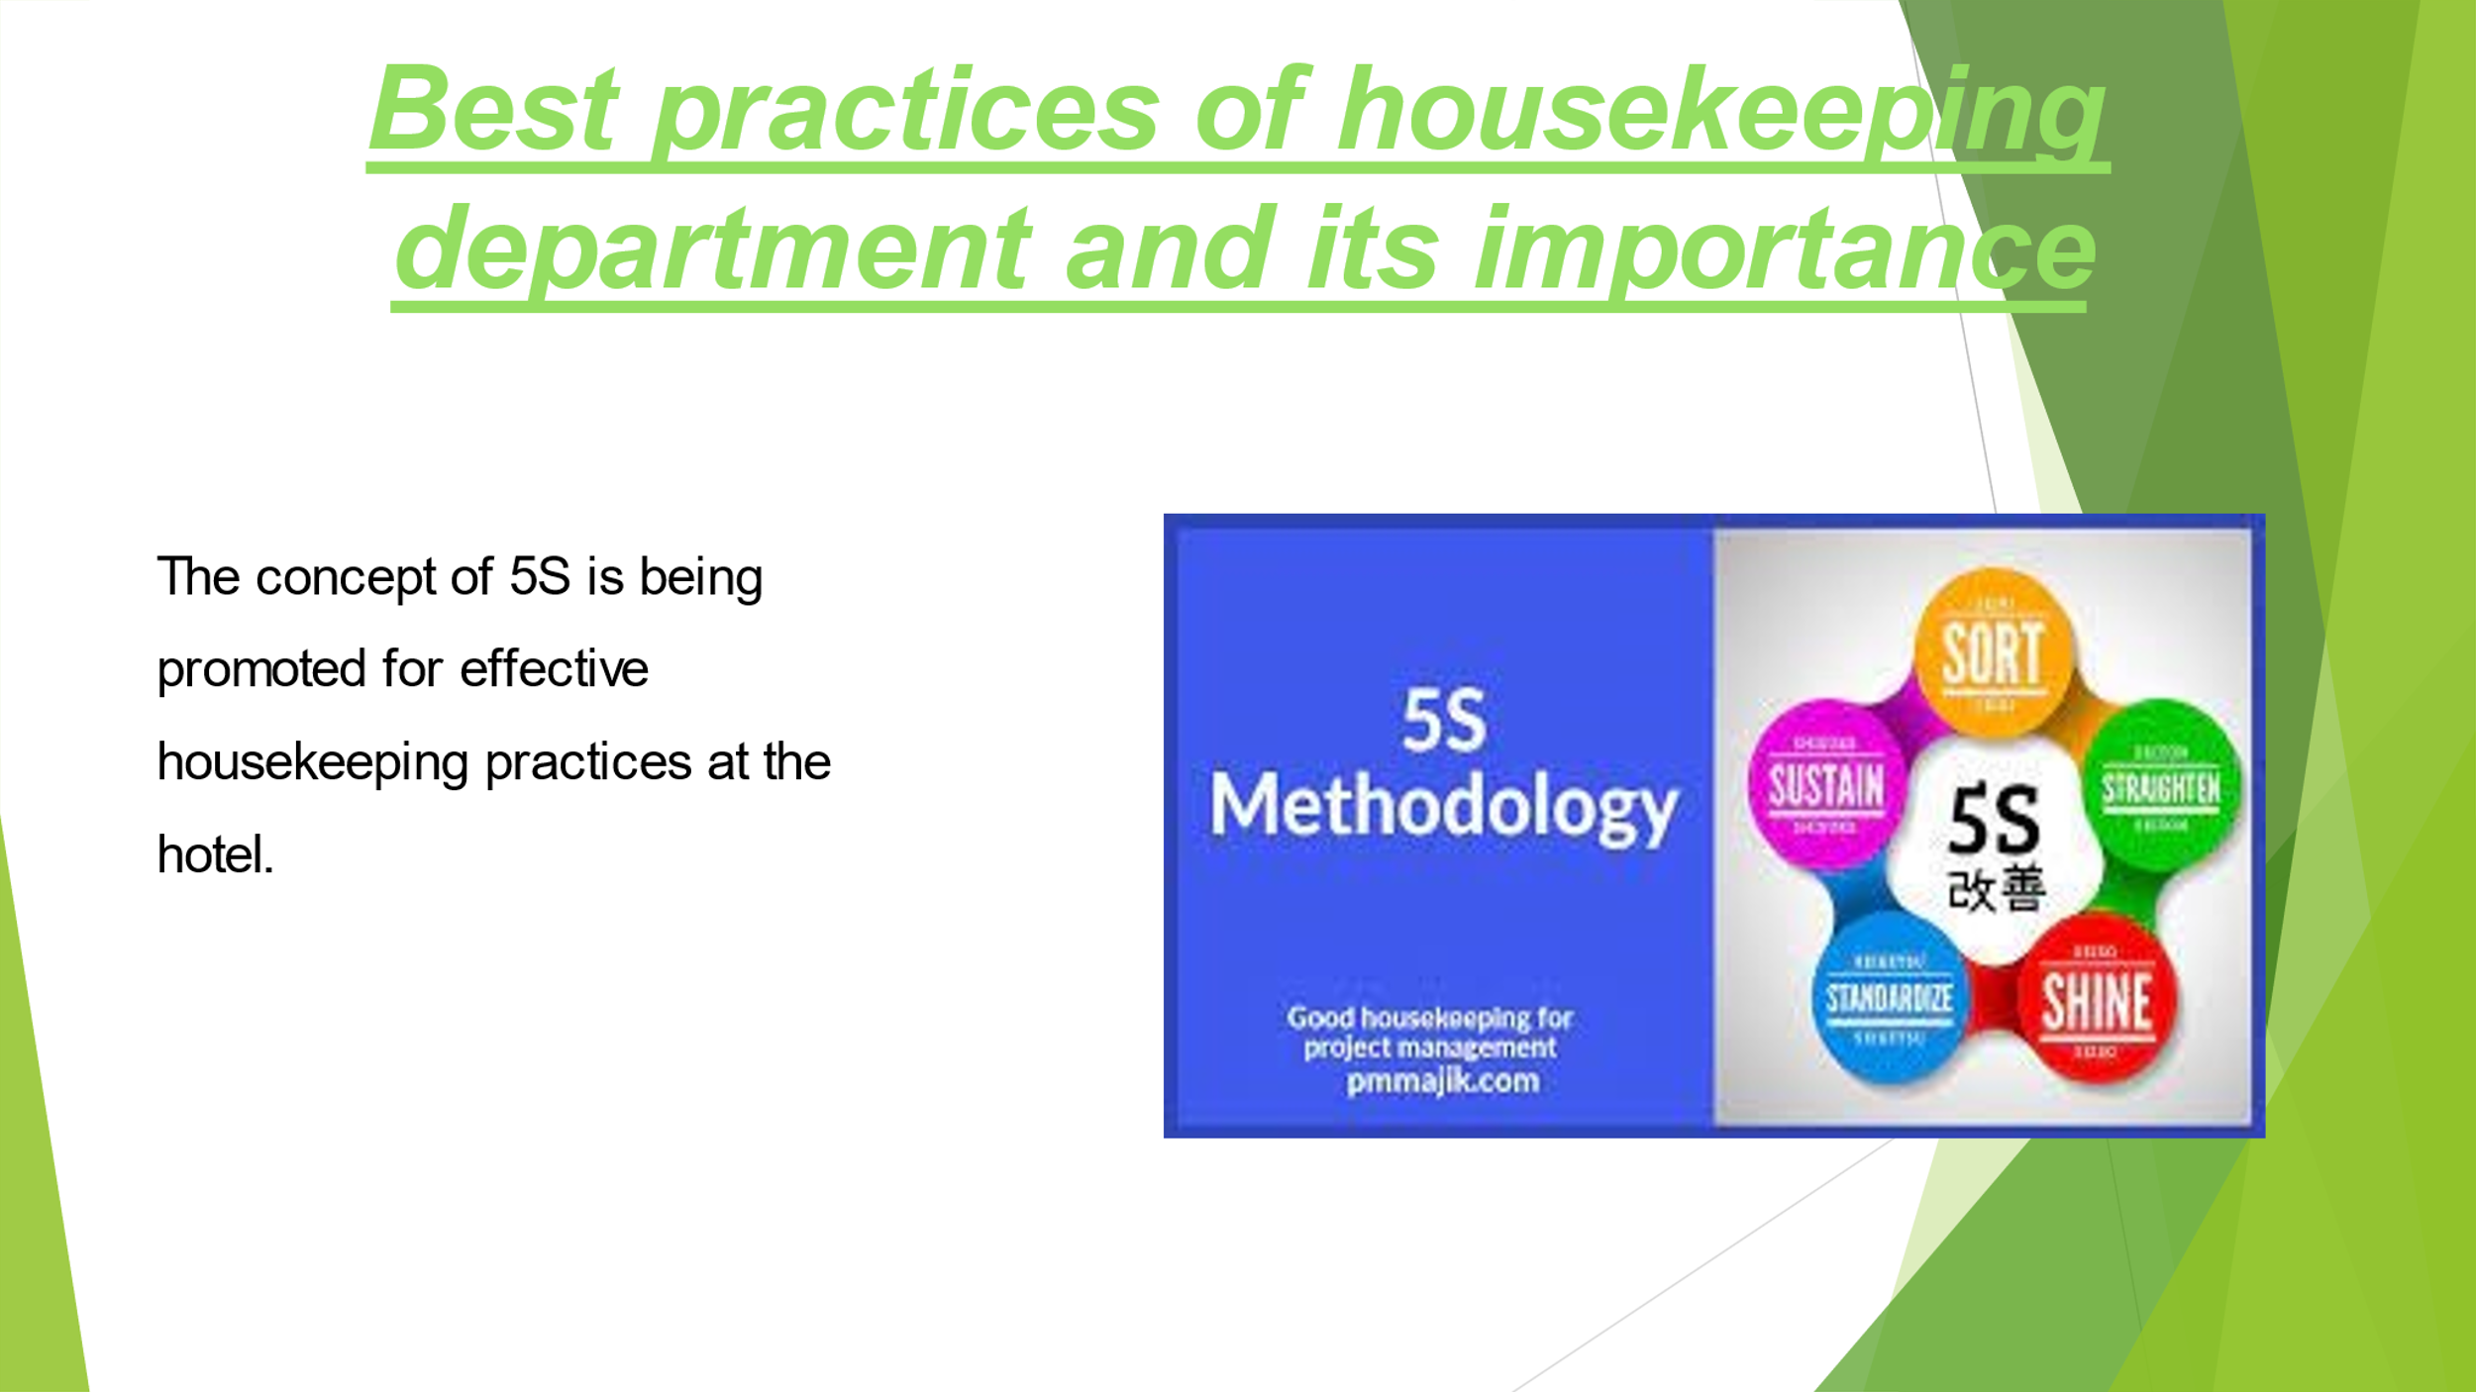

Training Notes:
It includes five complementary principles of organisation, neatness, Standardization, Discipline as well as Cleanliness (Shahane and Fernandes, 2021). It is a management tool for effective housekeeping practices at the hotels.

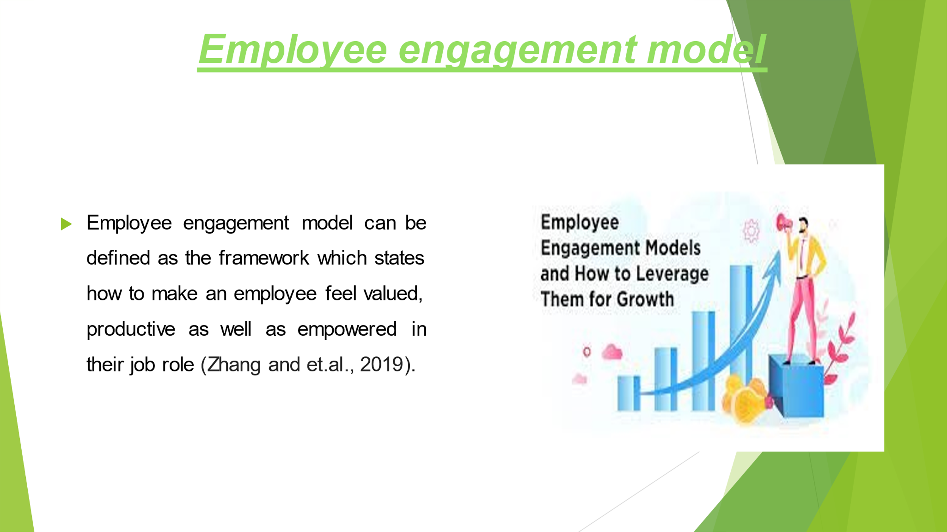

Training Notes:
The employees are considered as the backbone of the culture at every organisation. In simple words, it can also be stated as the roadmap which outlines how an organisation can assist its staff members, feel satisfied, cared, valued, and respected at the workplace (Ohlin and West, 2023)

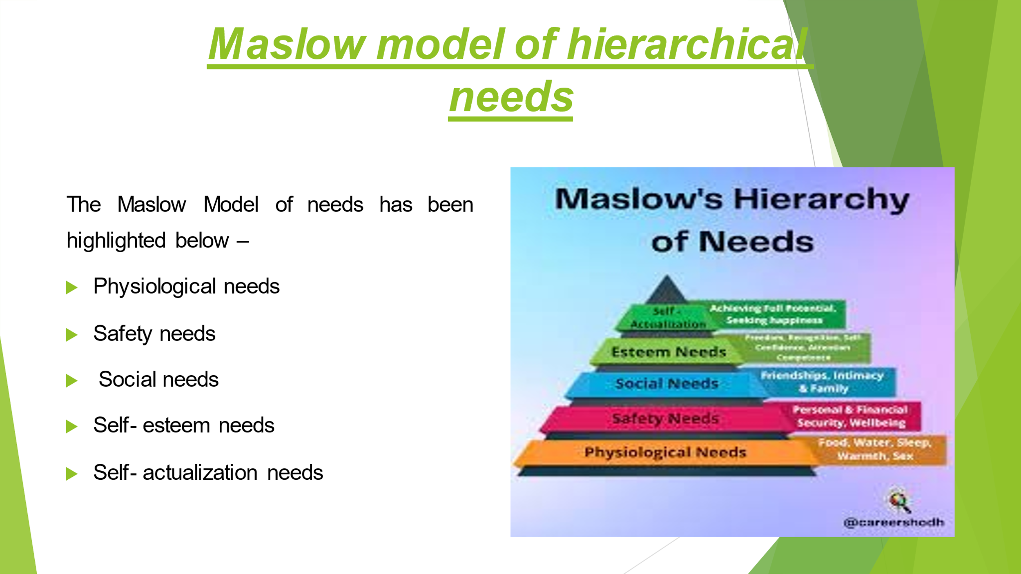

Training Notes:
The Maslow model mainly focuses on the hierarchy of the need and its application of the experience of the employee at the workplace (Wachter, 2020). The model states that in order to enhance the performance and efficiency of the employees all their basic needs must be satisfied
- It is the basic need for food, shelter, air, clothing, and sleep etc.
- It is the need which is related to the health, property, job security etc.
- The need is related to friendship, sense of connection and belonginess from the society.
- It is the need which is linked with gaining respect as well as confidence.
- It refers to the need which is linked with full utilisation of the potential of an individual.
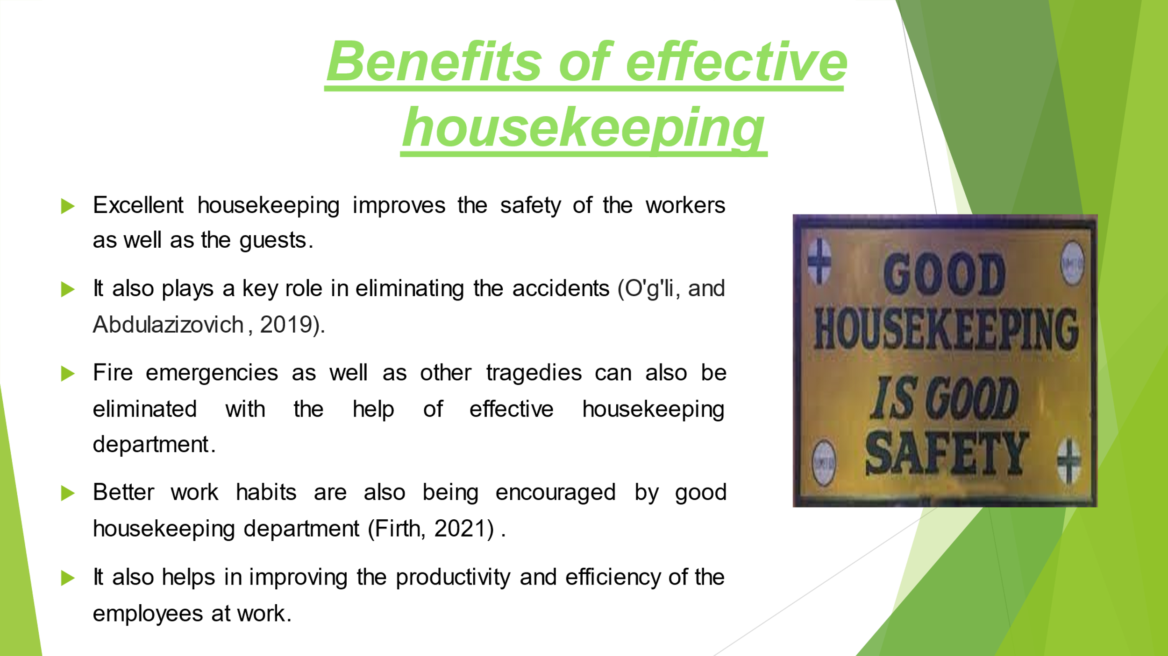

Training Notes:
Good housekeeping is a place where everything is in proper place. There are several benefits which are associated with the effective housekeeping. Some of these benefits has been highlighted below

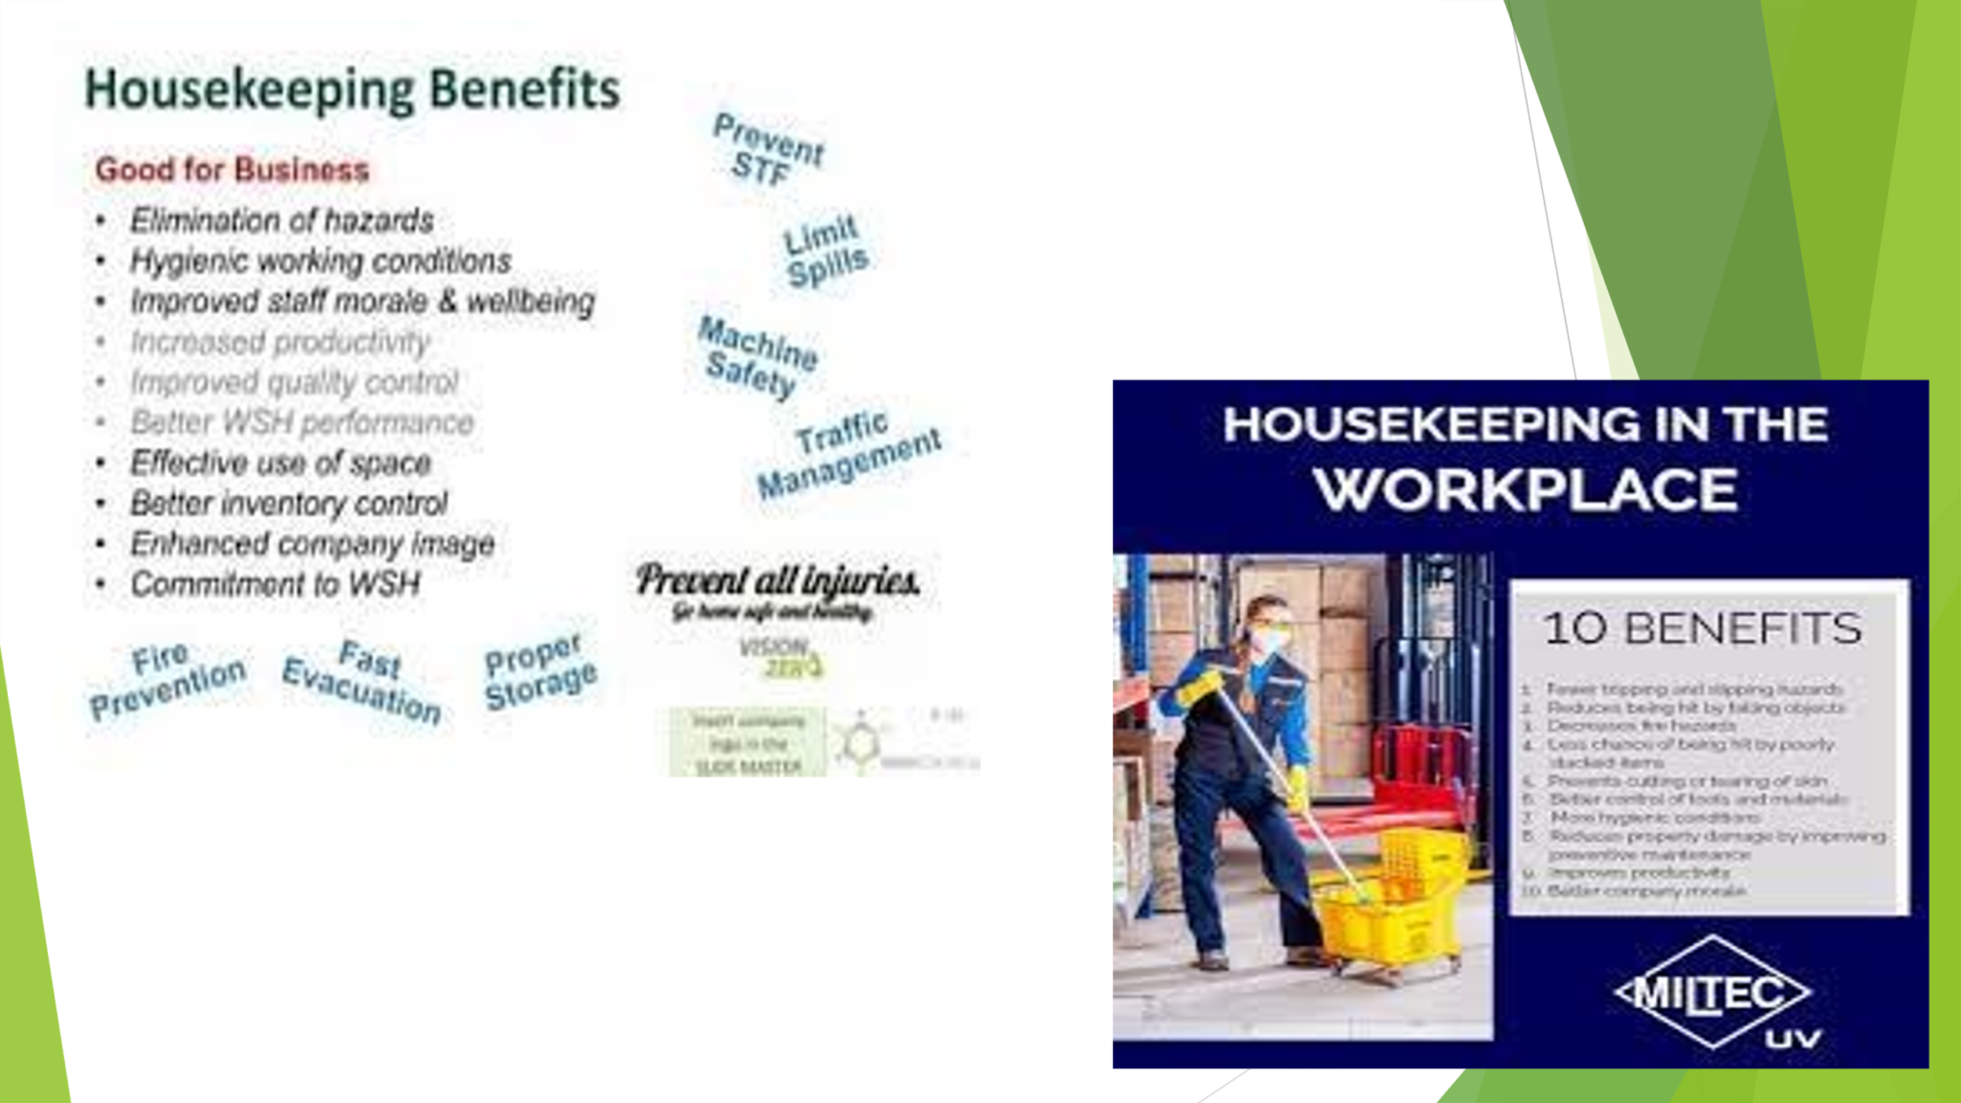

Training Notes:
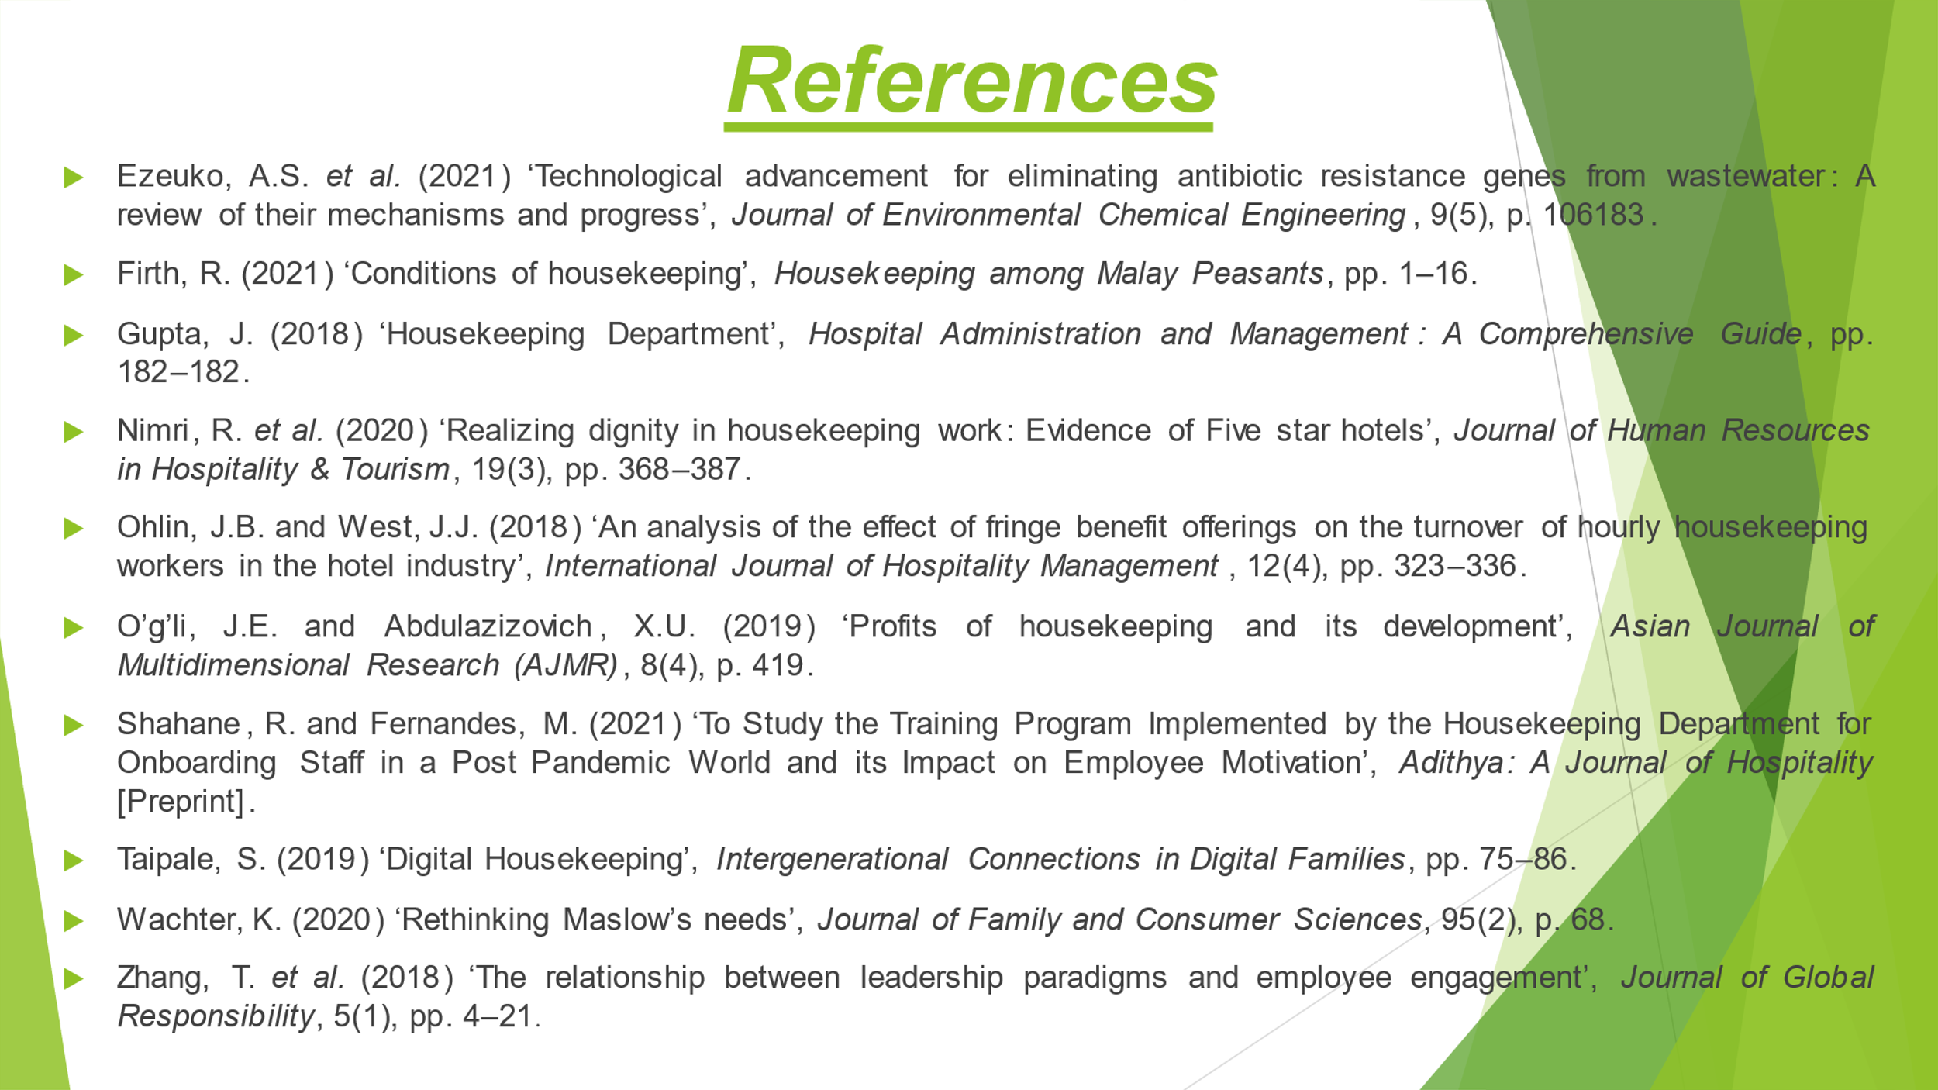

Training Notes:

References

COMPONENT ONE:
Alsarayreh, R.S. (2023) ‘The effect of technological skills on developing problem solving skills: The moderating role of academic achievement’, International Journal of Instruction, 16(2), pp. 369–388.
Back, A., Tulsky, J.A. and Arnold, R.M. (2020) ‘Communication skills in the age of covid-19’, Annals of Internal Medicine, 172(11), pp. 759–760.
Cuic Tankovic, A., Kapeš, J. and Benazić, D. (2022) ‘Measuring the importance of communication skills in tourism’, Economic Research-Ekonomska Istraživanja, 36(1), pp. 460–479.
Nielsen, T., Holst-Stensborg, H. and Nielsen, L. (2022) ‘Strengthening problem-solving skills through occupational therapy to improve older adults’ occupational performance - A systematic review’, Scandinavian Journal of Occupational Therapy, 30(1), pp. 1–13.
Yusuf, M. and Irwanti, N.K. (2021) ‘Implementation of 5s in the pantry housekeeping of hotels to increase work productivity’, Proceedings of the First International Conference on Economics, Business and Social Humanities, ICONEBS 2020, November 4-5, 2020, Madiun, Indonesia, pp. 281–287.

COMPONENT TWO:
Aagaard, L.K. (2022) ‘When Smart Technologies enter household practices: The gendered implications of Digital Housekeeping’, Housing, Theory and Society, 40(1), pp. 60–77.
Alcalde-González, V., Gálvez Mozo, A. and Valenzuela Bustos, A. (2021) ‘No Clean Rooms, no hotel business: Subversion tactics in Las Kellys’ struggle for dignity in Hotel Housekeeping’, Annals of Tourism Research, 91, p. 103315.
Buljac-Samardzic, M., Doekhie, K.D. and van Wijngaarden, J.D. (2020) ‘Interventions to improve team effectiveness within health care: A systematic review of the past decade’, Human Resources for Health, 18(1).
Mayaswari, N.M., Sihombing, I.H. and Sabudi, I.N. (2020) ‘The effect of work-life balance on the work productivity of Housekeeping employee’, Proceedings of the International Conference on Business and Management Research (ICBMR 2020) [Preprint].
Suwandana, I.G. (2019) ‘Role of transformational leadership mediation: Effect of emotional and communication intelligence towards teamwork effectiveness’, International research journal of management, IT and social sciences, 6(2), pp. 52–62.

COMPONENT THREE:
Ezeuko, A.S. et al. (2021) ‘Technological advancement for eliminating antibiotic resistance genes from wastewater: A review of their mechanisms and progress’, Journal of Environmental Chemical Engineering, 9(5), p. 106183.
Firth, R. (2021) ‘Conditions of housekeeping’, Housekeeping among Malay Peasants, pp. 1–16.
Gupta, J. (2018) ‘Housekeeping Department’, Hospital Administration and Management: A Comprehensive Guide, pp. 182–182.
Nimri, R. et al. (2020) ‘Realizing dignity in housekeeping work: Evidence of Five star hotels’, Journal of Human Resources in Hospitality & Tourism, 19(3), pp. 368–387.
Ohlin, J.B., and West, J.J. (2018) ‘An analysis of the effect of fringe benefit offerings on the turnover of hourly housekeeping workers in the hotel industry’, International Journal of Hospitality Management, 12(4), pp. 323–336.
O’g’li, J.E. and Abdulazizovich, X.U. (2019) ‘Profits of housekeeping and its development’, Asian Journal of Multidimensional Research (AJMR), 8(4), p. 419.
Shahane, R. and Fernandes, M. (2021) ‘To Study the Training Program Implemented by the Housekeeping Department for Onboarding Staff in a Post Pandemic World and its Impact on Employee Motivation’, Adithya: A Journal of Hospitality [Preprint].
Taipale, S. (2019) ‘Digital Housekeeping’, Intergenerational Connections in Digital Families, pp. 75–86.
Wachter, K. (2020) ‘Rethinking Maslow’s needs’, Journal of Family and Consumer Sciences, 95(2), p. 68.
Zhang, T. et al. (2018) ‘The relationship between leadership paradigms and employee engagement’, Journal of Global Responsibility, 5(1), pp. 4–21.

