

M4X01508

INTRODUCTION TO COMPUTER PROGRAMMING

Lottery number generation and management

By
Rebecca Ryall
1705433


Contents
Table of figures 2
Introduction 3
Why use a loop? 3
Testing 5
Test 1 : Six random numbers not in ascending order 5
Test 2 : Testing for no duplications and ascending order(normal) 5
Test 3 : Testing for all six lottery numbers acceding order (normal) 6
Test 4 :Manual input of number (2) six times with randomly generated number underneath 6
User documentation 7
First step 7
Second step 7
Third step 7
Four step 7
Technical documentation (code) 8
Conclusion 10
References 11
Appendix 12
Appendix 1 Flowchart 12
Lottery numbers 13
Generate new lottery numbers 14
Numbers in ascending order 15
Appendix 2 Moscow 16

Table of figures
Figure 1 test one 5
Figure 2 test two 5
Figure 3 test three 6
Figure 4 test four 6

Introduction
This Assignment comprises of successfully creating code that allows the user to generate six lottery numbers, like the one that are used in corner stores which allows the customers to ask for a set of random picked number known as a lucky dip. The reason behind why the program is needed is to make it possible for the customer to have a set of random numbers, instead of them having to rely on their own chosen set of numbers but being able to leave it up to random selection. The differences in the code that’s to be created is that the numbers will be in ascending order unlike the store program and allow the user to have multiple set of numbers if not happy with the first set or if they want to do multiple lucky dips at a time. This lottery number picker does not allow duplications in the random numbers that are generated, the report also contains a flowchart showing how the code is constructed and a Moscow diagram to show the planning of the code before its built giving the reader an insight of the ideas and preparation that was taken to complete the task.

Why use a loop?

First, there is more than just one type of loop, but the following examples will be identifying two of the main forms which are, a While loop and a For loop. The For loop and while loop are both used for different parts of code depending on which is needed.
For loop
The for loop is used when the number is known, the amount needed or number of times the code is wanted to continue to loop around until the set number is hit.
While loop
The while loop is used when you are not sure on the amount of times the loop is needed to go around, so the loop will continue to go through the code over and over until a condition is met.
It is very easy to get stuck in a loop if there is not exit strategy, the code can continue to loop for infinity. The best example of when a loop is needed is if you create a game, a guessing game to be more specific the user is asked to guess the computers lucky number and for them to enter the number they believe it to be. Now without a loop the player would only get one chance to guess the right number this don’t sound like much fun or fair. If the game had a while loop the player could continue to guess as many times as they like, but then again making it to easy which isn’t much of a game. If you applied a for loop you could give the player a set amount of chances to guess the number, allowing the game to function fairly but also with enough difficulty to keep it interesting. The best reason to use a loop is to shorten the code but to still reach the end goal instead of rewriting the code multiple times. To get it to do the same task would be taking up time and space in the code a loop allows the code to be reused multiple times without continually typing it up and allowing you to set the amount of times is more efficient and cost affective [1].

Testing

Test 1 : Six random numbers not in ascending order
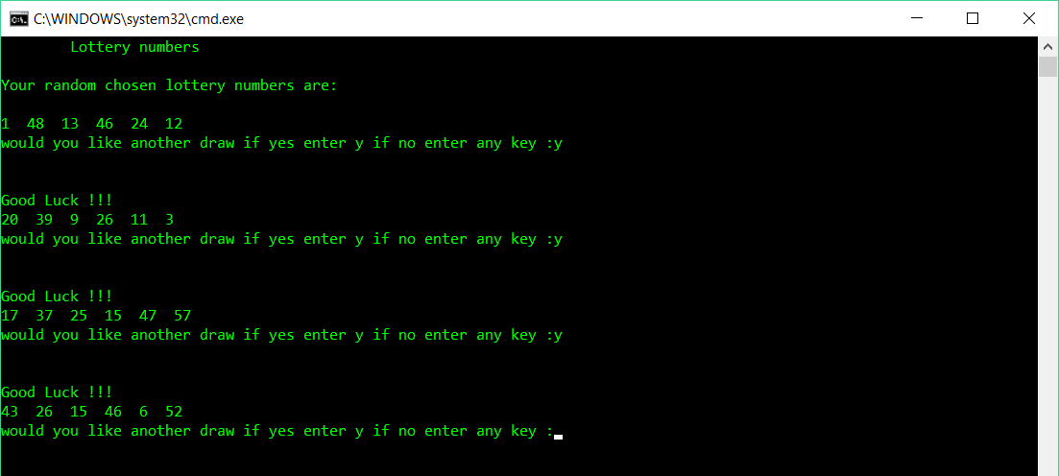Figure 1 test one

Test 2 : Testing for no duplications and ascending order(normal)
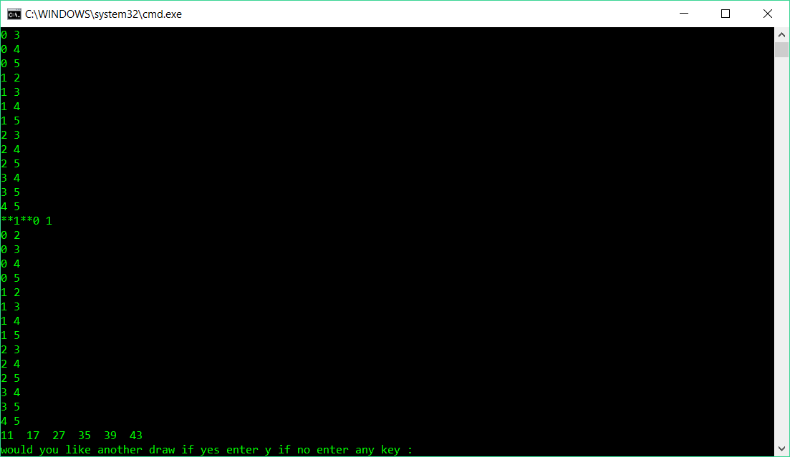
Figure 2 test two
duplications found and changed and all in ascending order

Test 3 : Testing for all six lottery numbers acceding order (normal)
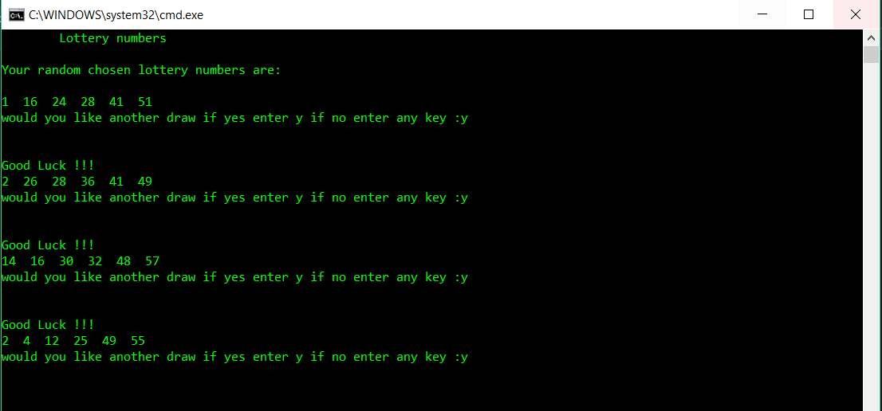
Figure 3 test three
All six numbers showing in order

Test 4 :Manual input of number (2) six times with randomly generated number underneath
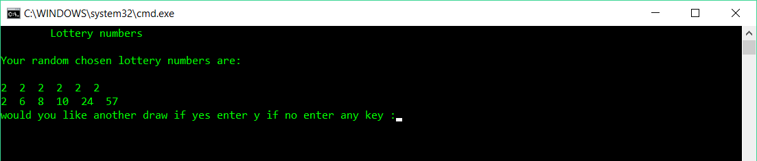Figure 4 test four

User documentation

First step
To run the program press ctrl and F5 to get it start.

Second step
Then a window will appear on the screen, showing you the six numbers, it will prompt a response asking “would you like another draw”.
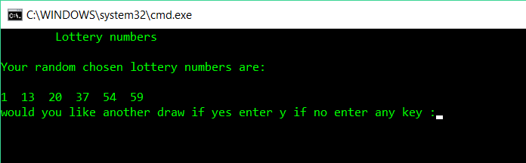

Third step
If you enter ‘y’ the program will proceed to give you another set of number but still showing the original set and prompting another response.
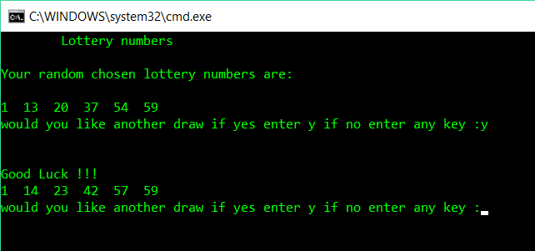

Four step
If you enter any other key letter other then ‘y’, it will display a goodbye message and that is the end of the program.
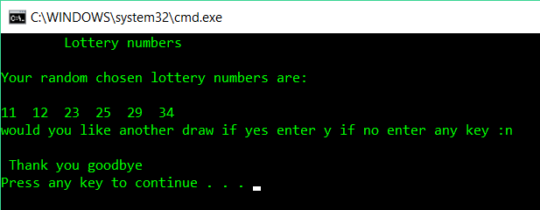

Technical documentation (code)
#include<stdio.h>
#include<stdlib.h>
#include<time.h>

void main()
{
int i, j; // loop counters
int myrand[6];// set array to six // test {2, 2, 2, 2, 2, 2 };
int low = 1;// lowest number on lottery
int high = 59; // highest number on lottery
char choice = 'y';// stores if user wants another game
int flag =1; // flag used to enter loop
int temp; // temper variable to sort number
srand(time(NULL)); // seed random with system clock

printf(" Lottery numbers \n\n"); // display title on screen to user

printf("Your random chosen lottery numbers are: \n\n");// display title on screen to user

while (choice == 'y')// loop to go though code again to get new set of lottery numbers {
flag = 1; //
for (i = 0; i < 6; i++) //generate six random numbers
{
myrand[i] = rand() % (high - low + 1) + low;
//printf("%d ", myrand[i]);
}

while(flag ==1)// flag has to =1 to enter while loop
{
flag =0;// flag initially set to 0
for (j = 0; j < 5; j++)//check for duplicates
{
for (i = j + 1; i < 6; i++)
{
// test for duplication printf("%d %d\n",j,i);
if (myrand[j] == myrand[i])//if duplicate found
{
myrand[i] = rand() % (high - low + 1) + low;//generate a new number to replace duplicate
flag = 1;
// test for duplication printf("**%d**", flag);
}
}
}

for (j = 0; j < 5; j++)// bubble sort
{
for (i = j + 1; i < 6; i++)
{
if (myrand[j] >myrand[i] )
//if the number at array position j is larger than array position i, swap j and i
{
temp = myrand[j];
myrand[j] = myrand[i];
myrand[i]=temp
}
}
}
}

for (i = 0; i < 6; i++)//print numbers on screen (now in ascending order)
{
printf("%d ", myrand[i]);
}
printf("\nwould you like another draw if yes enter y if no enter any key :");// display on screen to user

scanf(" %c", &choice); // allows user to enter one letter

if (choice == 'y')//user will be given another turn
{
printf("\n\nGood Luck !!! \n");// displays on screen only if user enters y
}

else
{
printf("\n Thank you goodbye \n"); // displays on screen when user enters any key other then y
}

}
}

Conclusion
The overall conclusion is that the code is successful in completing the task that was assigned in this assignment. The code generates six random number without any duplications and all in ascending order. It has been tested multiple times and able to show that the code has clearly recognized a duplication and generates a new number and replace the existing number then following that check it completes a secondary check to make sure no duplications have been made again before showing the numbers on screen for the user. A following test was made to make sure the numbers were being allocated at random and not set manually once completed then demonstrated a third test which produced proof that the six random numbers where in fact random and in ascending order.

References

[1] J. Liberty and B. Jones, Sams teach yourself C++ in 21 days. Sams, 2005.

Appendix

Appendix 1 Flowchart
main

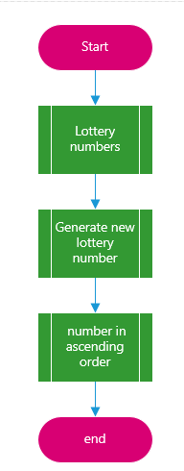

Lottery numbers
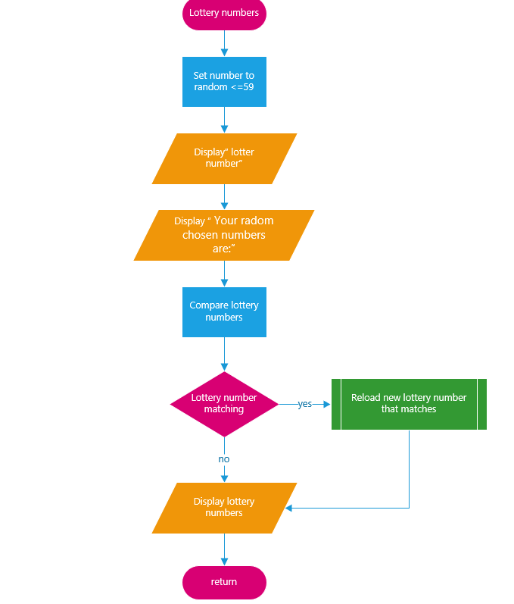

Generate new lottery numbers
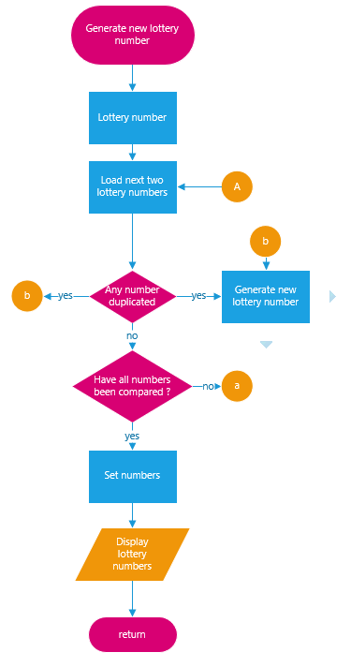

Numbers in ascending order
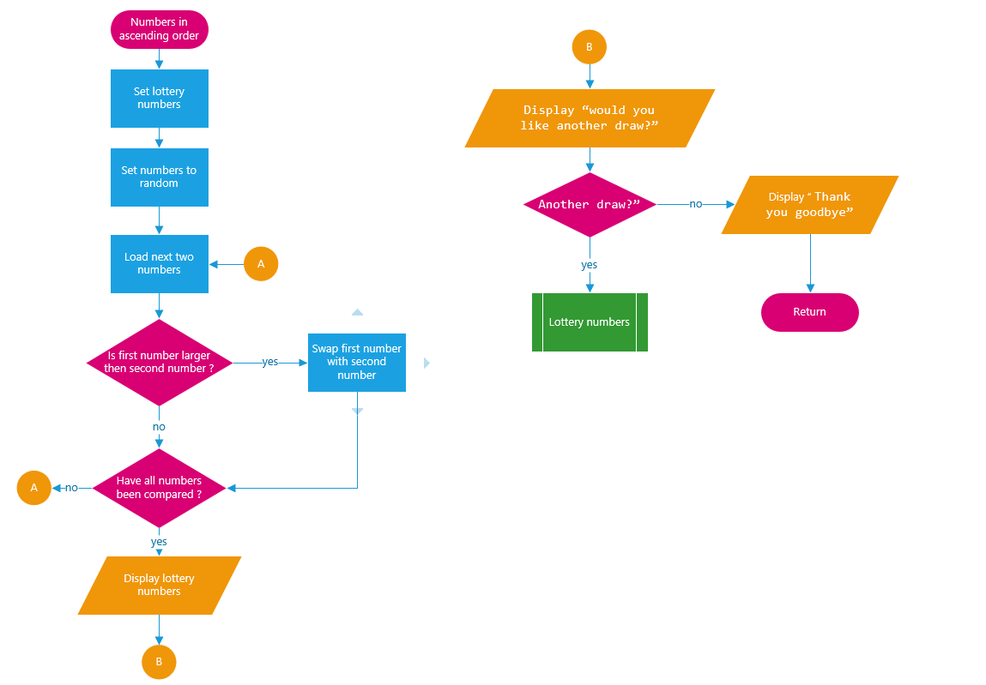

Appendix 2 Moscow

Must | Should
Six numbers | Asked for another set of numbers
Six numbers in a line | Six random numbers

Could | Won’t
No duplications | Coloured background
Ascending order | Bonus ball
Option for another set of six numbers | Each individual number different colours

