Prose piece 1 – Characterisation.

Paul bit into his chilli-dog as he walked away from the stand. The hot dog stand (as a philosophical concept) had always seemed to him to be the epitome of the American experience. Whenever he walked past one, through the billowing, salt-infused steam, he felt like he’d arrived. Really arrived. It was a scene he’d played and replayed in his mind since childhood; walking from Columbus Circle across to Central Park, eating a chilli dog. Of course it hadn’t been so defined when he was young, he hadn’t known the names of all the places, the landmarks. He just knew that one day, he’d live in New York. Now he was actually there, and had been for a little more than a year. The thing that struck him most was how the relative serenity of the park in comparison with the bustling boulevards, streets and avenues of the city, was in reality still more turbulent than the main streets of his home town of Leicester.

He suddenly realised that since he’d returned to New York after a quick trip home for the funeral that he’d been coming to the park more often, it felt like it was a good place to remember his Father. When Paul was a child he’d often take him to Manor Field for a game of football. It was the closest park to where they lived and was about the same distance from home as the general hospital where his Dad had worked, but in the opposite direction. He was an orderly at the hospital, he always told Paul how how he loved his job and that he got the chance to play a part, however small in saving lives and helping people. How proud he’d been at Paul’s graduation from De Montfort University and how he was fit to burst when Paul had told him he’d won an internship at Mount Sinai Hospital in New York. He finished his lunch and threw the wrapper in a nearby bin. He leaned against a low wall at the edge of the path, completely ignoring the row of benches next to it.

He was restless. It had been difficult enough when Sophie had decided at the last moment not to go with him to America and yet even that pain paled into insignificance at the loss of his Father. Somehow the loss of that one person had left him feeling both alone and at the same time acutely aware that he was in a city of more than 8 million people. ‘I’m alone,’ he thought, ‘Mum’s alone. Sophie’s alone.’

‘Hey, Paul!’ A familiar voice called to him from along the tree-lined path.

Prose piece 2 – Short Story

Father Christmas broke my daughter’s wrist

It was mid-October and the death throes of summer were in full swing. It was that time of year when the temperature soars back up by 10 degrees and you start to think that summer might last until Christmas and perhaps we’ll have a mild and short winter this year. Harmony was with her friends in the pool, complaining about being too hot as usual. “Can we go to the river Dad?” Honestly, when I took her swimming in the river she constantly wished we had a pool at home, now we’d got one she just wanted to go to the river. Kids!

I took them some Vimto lollies that I’d made in plastic cups, I don’t know if I was more concerned with keeping them cool, reliving my own childhood, or introducing French children to Vimto. Harmony held her lolly up to the sun and watched it intently as drops of purple slowly ran down and dripped into the water. I knew that look, her cogs were turning. “Is there somewhere we can go ice skating Dad?” She’s got an uncanny ability to stretch any line of thought to its extreme.

“I don’t know, I’ll have a look.” I went back into the house to search for ice-rinks on the internet.

When we had first moved to France I didn’t speak any French at all but after eight years I’d managed to pick up enough to get by. Often though, when I was faced with a new situation I’d have to research new vocabulary, this was one of those times. “What’s ice rink in French?” I mumbled as I looked on my computer. “Patinoire.” came the trusty reply from Google Translate. ‘Trusty’ was a relatively new adjective I could apply to that particular resource, when we’d first arrived it was still in it’s infancy and more than once after consulting it, I’d unknowingly referred to for example, a hydraulic ram as a ‘water sheep.’ Although I can’t blame Google for everything, even after taking it out of the equation my brain couldn’t always be trusted, like on the occasion I told Harmony’s teacher, as I dropped her at school, that I’d put a chicken in her bag in case she got cold. I thought I was telling the teacher I’d put a jumper in Harmony’s bag, I hadn’t yet learned the importance of the difference between short ‘u’ and long ‘ou’ in French. A quick search revealed that there was an ice rink only fifteen kilometres from us, I found the website and checked the opening times; ‘Open November to March’ was in bold type at the top of the page. Why do they only open in Winter? Who has ever thought to themselves, in February, ‘It’s just not cold enough here, I wonder if I can find somewhere even colder to go.’ Of course this was addended by the recurring thought; ‘Only in France!’

I went back outside, “There’s an ice rink in Romorantin,” I told her, “but it doesn’t open for another couple of weeks.” A frantic, half-whispered conversation ensued between Harmony and her friends. I hardly understood a word of what they were saying but I still knew what was coming next.

“Can Tracy, Emma and Armand come?”

“If their parents say it’s OK, yes.” This might be a good time to mention that prior to this I’d been ice skating a grand total of once in my life, thirty five years ago. So two weeks later, on a Sunday afternoon, I drove around collecting her friends and we headed off to Romo’ to go skating. When we arrived I managed to pay our entrance fees and hire skates for everyone without embarrassing myself by asking for pairs of ‘cold water knife boots’ or similar (a small but important, personal triumph) and we went down to the ice. I clung to the side rail for dear life and very soon found myself alone, but with about a hundred other people, my daughter and her friends included, hurtling passed me at breakneck speed as they sometimes gracefully, sometimes comically, but always confidently whooshed around the ice. After a few moments though I realised I wasn’t really alone, at various points around the side rail were other people, other parents and guardians to be precise, all with the same look as me on their faces. You know the one; tight jawed defiance as you try desperately to look relaxed while knowing without any shadow of a doubt that at any moment you’re going to end up on the ground if you even consider loosening your grip on that sturdy hand rail. Backside first if you’re lucky but face first being infinitely more likely. It was the longest two hours of my life, until the following Sunday.

Harmony really took to ice skating and wanted to go every weekend, sometimes on our own, sometimes with various of her friends. And as time went on, one by one, each of the parents that had previously hung on to the rail as grapes do to a vine, was plucked away by their respective offspring and cast into the menacing freedom of the open ice. Of course these situations are never completely full of amateurs, if your own nine year old whizzing past you isn’t humiliating enough then the local ice hockey team are always on hand to deepen your feelings of inadequacy. Time was now approaching the end of November, summer had given up the fight and the oppressive greyness of winter ruled the land. Harmony’s thoughts naturally turned to Christmas and she started to ask, “Do you think Father Christmas might bring me some ice skates Dad?” Oh, how i wanted to say, “No, his elves don’t know how to make ice skates.” If she had her own she’d want to go all the time, at least as things were I got a week to recover between my torturous two hours of glacial humiliation.

But she kept hinting and I’m a parent so sure enough when Christmas morning came, Santa had left her, amongst other things (that he’d hoped would be sufficiently distracting) a pair of white leather ice skates. “Yessssss!” she exclaimed as she excitedly ripped the wrapping paper and threw it toward the pile which by this time was almost high enough to obscure her completely from my view. “Is the ice rink open today, Dad?”

“No sweetheart, there’s nowhere open on Christmas Day” I replied.

“It’s open tomorrow though.” came a voice from my wife who had already checked the website, no doubt with the intention of securing for herself a bit of peace, the day after the mayhem of the Christmas celebration. I glanced across to her with that look that says ‘I want a divorce.’ She smiled back at me, it was a smile of victory.

Christmas Day went, as it usually does and Boxing Day arrived. Harmony was up early (again) and pestering to go skating, she wanted to try out her new skates. Luckily for me the ice rink didn’t open until 1:00PM so I had a few hours to prepare for it. When we arrived it was relatively quiet, Harmony had made some new friends as there were quite a few children who went skating every weekend and I, by this time had built up enough confidence to go around the edge of the ice as far as the cafe, where I could sit and drink hot chocolate with the other parents who had gained similar skills. I even let go of the hand rail occasionally, but never for long. There was the usual bustle of people in the cafe aiming to be served as quickly as possible so they could get the tables closest to the bar but today we all had the joy of Christmas cheer added to the relief of being able to sit down on something warm, rather than falling onto something cold and hard. I’d only been in there a few minutes when Harmony came in with one of her new friends, she was holding her right wrist with her left hand. “I fell,” she said “my wrist doesn’t feel right.” I looked down and what I saw wasn’t particularly ‘wrist shaped,’ more like her hand had become joined to her lower arm by a mottled red, liquid-filled balloon.

“Oh dear” I said, “I think we’d better take you to hospital to get that looked at. Thank you for bringing her to me, Celine” I added to her friend, quickly swapping languages.

In a masterpiece of town planning, the hospital in Romorantin is less than five minutes away from the ice rink. We went straight there and after a short wait were seen by a nurse and sent to the X-ray department. After she’d had the X-ray we went back to the waiting room and after a while a doctor came and confirmed that her wrist was broken and would need to be set in plaster. Coincidentally it was the same doctor that had seen her a few weeks earlier, when she’d trapped her finger in the door of the car. “You’ve done a much better job this time” she told Harmony, “you only needed a bandage before.” She knew children well it seems, because to Harmony, as with a peculiarly large number of children, this was a good thing. She couldn’t wait to tell her relatives back in the UK about it and to invite all her friends around so they could look at her newly acquired, pottery sleeve.

Poetry piece 1 – Defamiliarisation

Waiting Room

A group made from solitude, of silence and calm,
belies tension, in the air as on the face.
Alternate chairs are left vacant, as though this stress demands
an expansion of personal space.
No one dare speak, respiration so loud,
To confirm there is life in the seats.
Otherwise the occupants are like gravestones themselves,
although hard and strong their heart beats.

Then the silence is broken as a scene from a nightmare,
with clipboard in hand, a name, a demand
from starched dress, painted lips and dyed hair.
Each looks to another like amnesia has spread,
and none can remember what name they were bred
And at last, one rises to meet his doom
as he exits the dentist’s waiting room.

Poetry piece 2 – Lineation

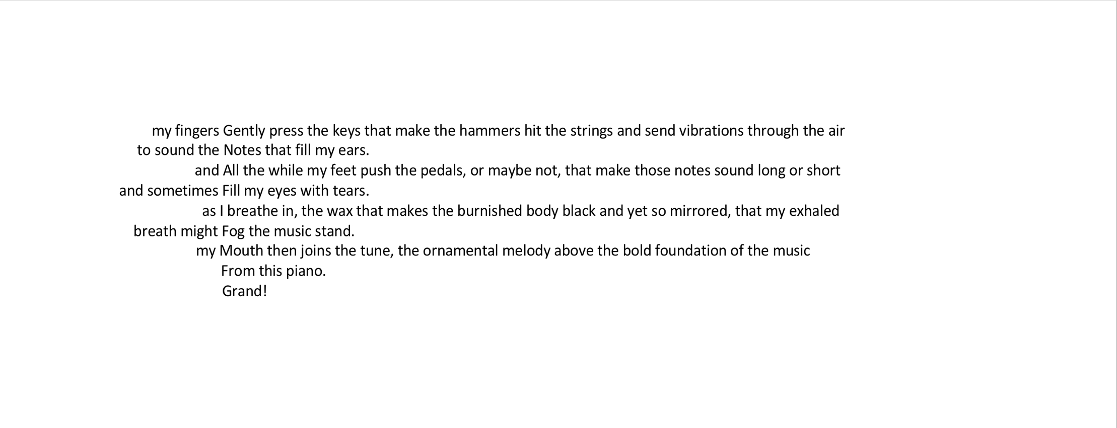
Pianoscape

Critiques on my own work

Father Christmas…
This was fairly typical of my writing in that the story wrote itself. I often find that the words just appear on the page with me having little more to do with the process other than the act of writing itself, I rarely analyse the broad strokes of my work beforehand and instead tend to concentrate on details in subsequent drafts. As with all the work I have done since starting this module however, I have also incorporated into that, which seems to be a part of my natural process, the techniques I am learning and due to that I can objectively see an improvement in my work.

In this case I was mostly relating real life events so I was perhaps a little constrained in that way but I tried to make it interesting for the reader with the use of descriptive imagery both metaphorical and by using the ‘show don’t tell’ rule. And also by making the story relatable while at the same time giving the reader a little bit of work to do if they want to make the most of the humour, particularly if the reader doesn’t speak French! There is of course room for improvement in the writing, one of the main things that ‘jumps out at me’ is that the story seems to feel ‘rushed’ towards the end. I am not sure if that was due to the constraints of time, word count or a combination of both of those things along with other limiting factors, including technical knowledge and talent!

Pianoscape

This is without question the most detailed piece of work I have ever undertaken and again I would not have been able to attempt anything remotely like this before this module. I have included it in the portfolio as a screenshot because the ‘shape’ of the poem is as important as the content and I needed to be sure it would look to every reader exactly as it does to me.

The poem uses a regular metre in order to make it more musical. The capitalised word close to the start of each line indicating the first stressed syllable or ‘down beat’ (musically speaking) of that line. It is preceded each time by differently metred, unstressed feet as a ‘lead-in’ which gives the poem a syncopated feel and makes it ‘swing.’ I have also used an unusual number of beats per line (fifteen) in order to stop it sounding too rigid and ‘square.’

The poem stems from the lesson on the ‘spine of the poem,’ keeping a consistant theme throughout, and ‘keeping it concrete,’ ie. making references only to specifics rather than abstract concepts and so uses only descriptive imagery, and does not use any metaphor or simile.

Of course for a completely objective critique I should comment on how the work can be improved but after re-writes that went into double figures and several hours spent purely on lineation and punctuation, I am struggling to find any more improvements I could have made. That does not mean of course that it can not be improved further and I welcome any and all constructive comments.

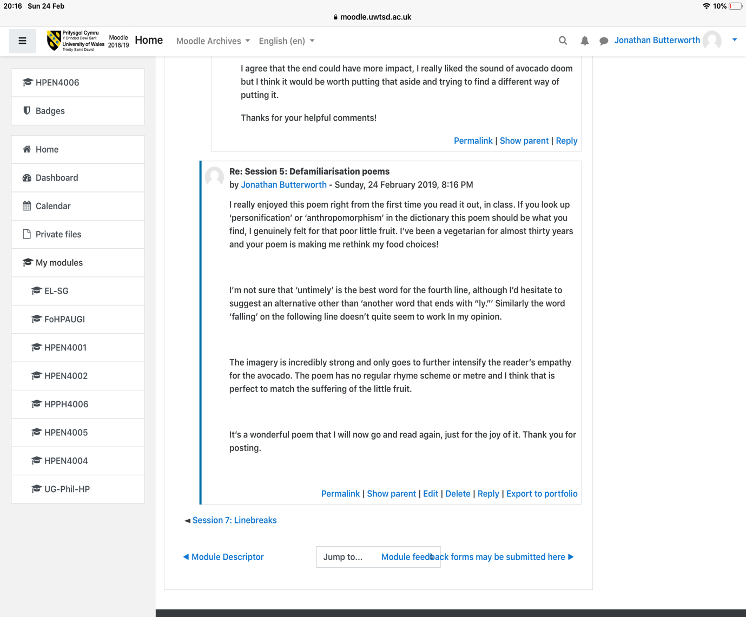
Critiques on the work of others



