Aim: A critical analysis of the role that community policing plays in shaping public perceptions of the police in the UK.

- Objective 1: To examine how community policing strategies are implemented within selected UK police forces and the extent to which they prioritise public engagement.
- Objective 2: To explore the impact of community policing on public perceptions of trust, confidence and legitimacy in policing.
- Objective 3: To critically assess the limitations and challenges of community policing in influencing public perceptions, including barriers such inconsistent practices, resource pressures or misaligned public expectations.

Chapter 4 - Findings
4.1 Introduction
This chapter presents the findings from the questionnaire conducted as part of this study examining the extent to which community policing shapes public perceptions of the police in the United Kingdom. The questionnaire generated 117 responses from individuals aged 18 and above and included both closed and open-ended questions designed to capture quantitative and qualitative perspectives on neighbourhood policing. Presenting results clearly and systematically allows researchers to demonstrate how empirical findings address research objectives and contribute to wider academic discussion (Biggam, 2026). A structured approach to analysing data also helps identify patterns within responses and ensures conclusions are grounded in evidence (Saunders, Lewis and Thornhill, 2023).

The chapter is organised according to the three research objectives outlined earlier in the dissertation. First, the findings examine how community policing strategies are implemented within local communities, focusing on engagement, visibility and operational priorities. The second section explores the impact of community policing on public perceptions of trust, confidence and legitimacy. Finally, the chapter considers the perceived limitations and challenges that may affect the effectiveness of community policing. Throughout the analysis, empirical findings are interpreted alongside the literature discussed in Chapter Two in order to compare participants’ experiences with existing research on policing and public trust.

4.2 Participant Characteristics

Understanding the characteristics of participants provides important context when interpreting survey results (Swaen, 2016). Respondents were first asked to indicate their age group.

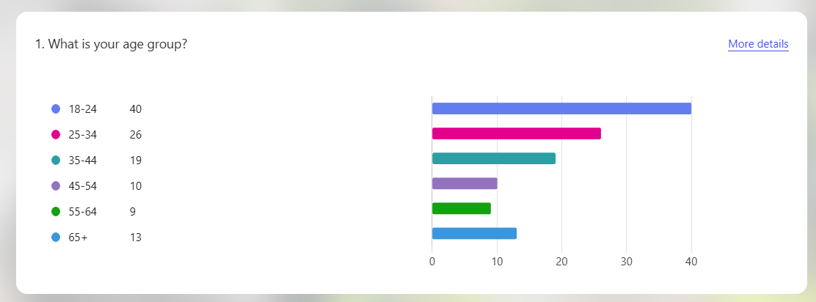

The results demonstrate a broad distribution of participants across several age categories. The largest proportion of respondents were aged between 18 and 24 (40 respondents), followed by those aged 25–34 (26 respondents) and 35–44 (19 respondents). Smaller numbers were aged 45–54 (10 respondents), 55–64 (9 respondents) and over 65 (13 respondents). These results indicate that younger adults represent a substantial proportion of the sample, which is consistent with research suggesting younger individuals are more likely to participate in online surveys (Saunders, Lewis and Thornhill, 2023). However, the inclusion of respondents across multiple age groups provides a range of perspectives on community policing.

Respondents were also asked which police force area they currently reside in.

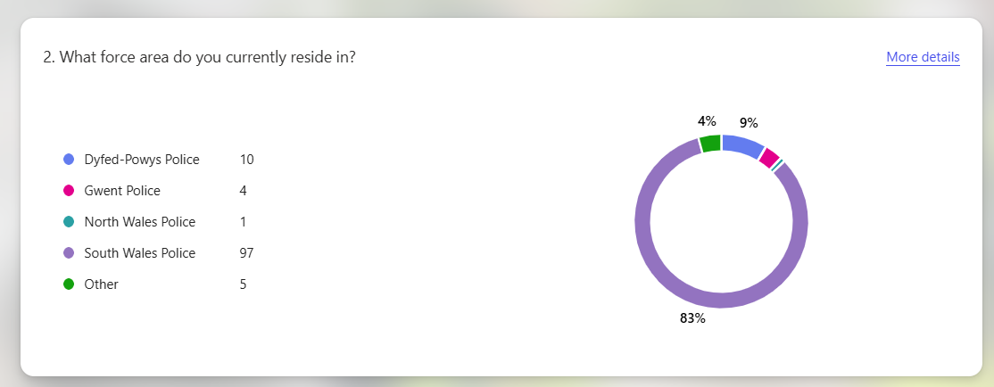

The findings show that the majority of respondents live within South Wales Police (97 respondents), representing approximately 83% of the sample. Smaller numbers reported residing within Dyfed-Powys Police (10 respondents), Gwent Police (4 respondents), North Wales Police (1 respondent) and other areas (5 respondents). This distribution reflects the networks through which the questionnaire was circulated and means the findings are particularly relevant to the South Wales policing context, although they still provide useful insight into broader public attitudes towards community policing.

4.3 Implementation of Community Policing and Public Engagement

The first research objective examined how community policing strategies are implemented within local areas and the extent to which they prioritise public engagement. One indicator of engagement is the level of direct contact between the public and neighbourhood policing teams.

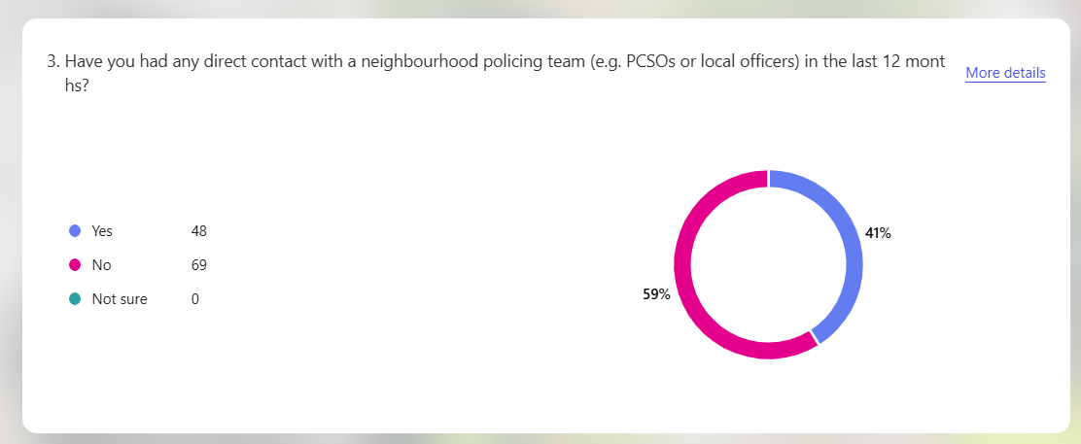

Participants were asked whether they had experienced direct contact with a neighbourhood policing team, such as Police Community Support Officers (PCSOs), within the previous twelve months. The results indicate that a majority of respondents (69 individuals, or 59%) had not experienced any direct contact during this period. In contrast, 48 respondents (41%) reported that they had interacted with a neighbourhood policing team. These findings suggest that many members of the public do not regularly experience direct interaction with neighbourhood officers.

Respondents who reported contact with neighbourhood officers were asked to rate their experience on a scale of one to five.

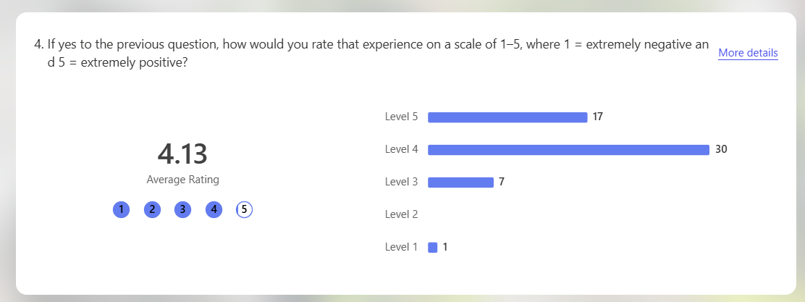

The findings demonstrate that interactions with neighbourhood officers were generally positive. The average score was 4.13 out of five, with most respondents selecting ratings of four or five. Only one respondent rated their experience as one. This indicates that when engagement occurs it is generally perceived positively, suggesting that interactions with neighbourhood officers may strengthen police–community relationships.

Police visibility was further explored by asking respondents when they had last seen a police officer or PCSO on foot patrol in their local area.

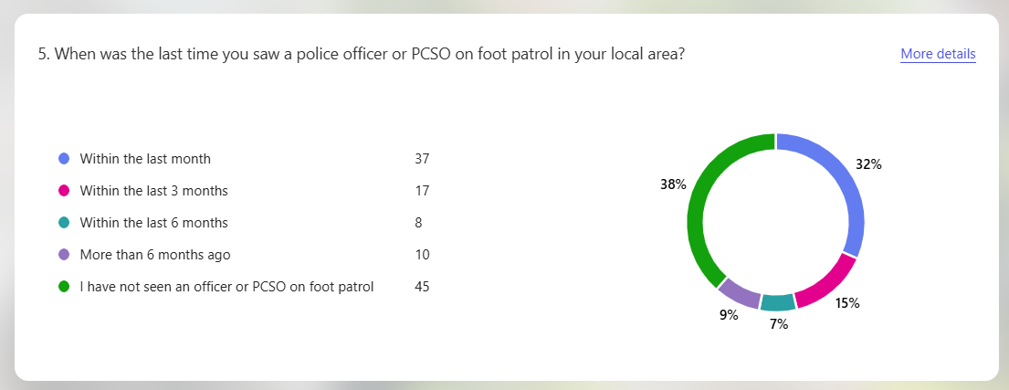

The results reveal varying levels of police visibility. Thirty-seven respondents (32%) reported seeing a police officer or PCSO within the previous month. However, a substantial proportion of respondents reported limited visibility, with 45 respondents (38%) stating that they had never seen a police officer or PCSO on foot patrol in their area. Smaller numbers reported seeing officers within the previous three months (17 respondents), six months (8 respondents) or more than six months ago (10 respondents). These findings suggest that police visibility varies significantly between communities.

Participants were also asked about the importance of PCSOs within neighbourhood policing.

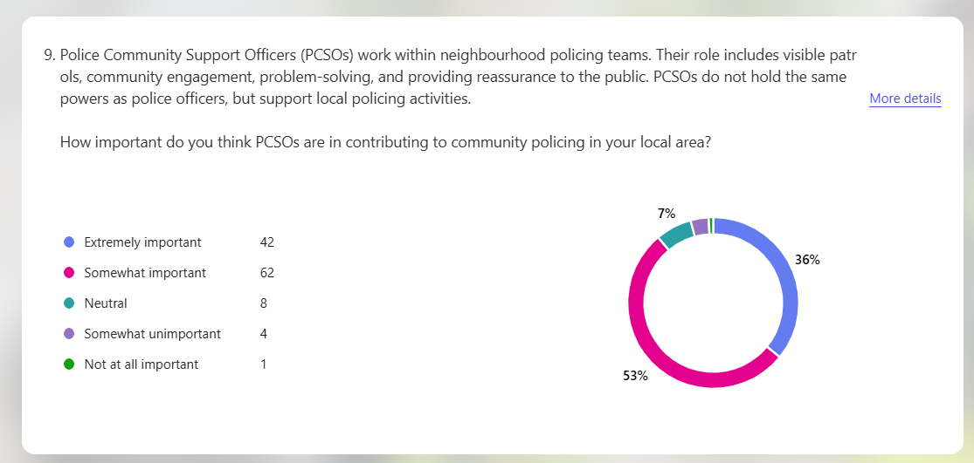

The results indicate strong support for the role of PCSOs. A total of 104 respondents considered PCSOs either extremely important or somewhat important within neighbourhood policing, while only a small number viewed the role as unimportant. This highlights the value placed on visible community-focused policing roles that facilitate engagement and communication between police and the public.

Further insight into public expectations of neighbourhood policing was gained by asking respondents what they believed were the main priorities of their local neighbourhood policing teams.

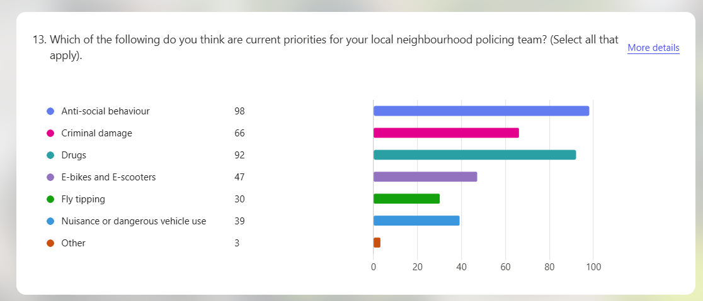

The findings suggest that the public associates neighbourhood policing primarily with addressing community-level issues that directly affect local quality of life. Antisocial behaviour was selected by 98 respondents, drugs by 92 respondents and criminal damage by 66 respondents. Issues such as burglaries, fly-tipping and nuisance behaviour were also mentioned but less frequently. This suggests that community policing is widely associated with addressing visible local problems affecting communities.

These findings reflect wider research on neighbourhood policing in the UK. In their analysis of community policing developments, Innes et al (2020) argue that neighbourhood policing was designed to enhance visibility, engagement and local problem-solving. However, they also highlight that the model has experienced variations in implementation due to resource pressures and competing operational priorities. Similarly, the Police Foundation emphasises that increasing demand on police services can reduce the time officers have available for proactive community engagement (Muir et al, 2022). These pressures may help explain why many respondents reported limited direct contact with neighbourhood officers despite recognising the importance of community policing roles. Policy initiatives aimed at increasing neighbourhood policing capacity have therefore emphasised the need to improve visibility and community engagement (Starmer, 2025).

These findings suggest community policing aims to prioritise engagement and visibility within communities, but implementation may vary depending on local resources and operational demands.

4.4 Impact of Community Policing on Trust, Confidence and Legitimacy

The second objective examined how community policing influences public perceptions of trust, confidence and legitimacy in policing.

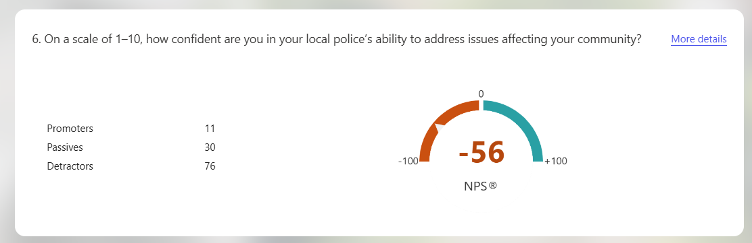

Respondents were asked to rate their confidence in their local police’s ability to address community issues on a scale of one to ten. The results indicate moderate levels of confidence overall, with the Net Promoter Score producing a negative score of -56. This indicates that lower confidence ratings outnumbered higher ones.

Despite this, respondents generally indicated that they would cooperate with the police when necessary.

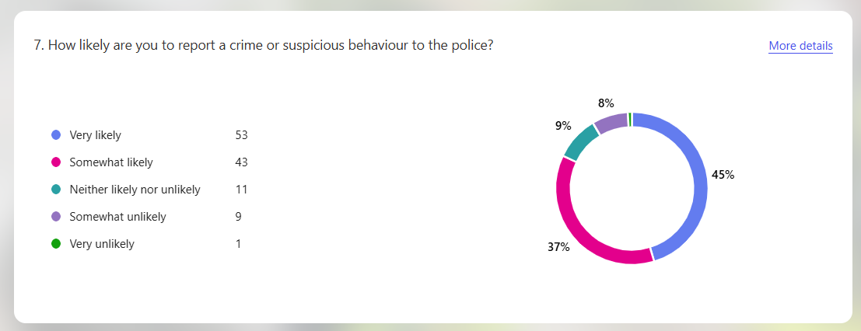

The majority of respondents stated that they would be willing to report crime or suspicious behaviour. Fifty-three respondents reported that they would be very likely to report crime, while 43 indicated they would be somewhat likely to do so. Only a small number of respondents stated that they would be unlikely to report crime. These results suggest that although confidence levels may be moderate, public willingness to cooperate with the police remains relatively strong.

Qualitative responses provided further context for these findings, with participants explaining the reasons behind their likelihood of reporting crime.

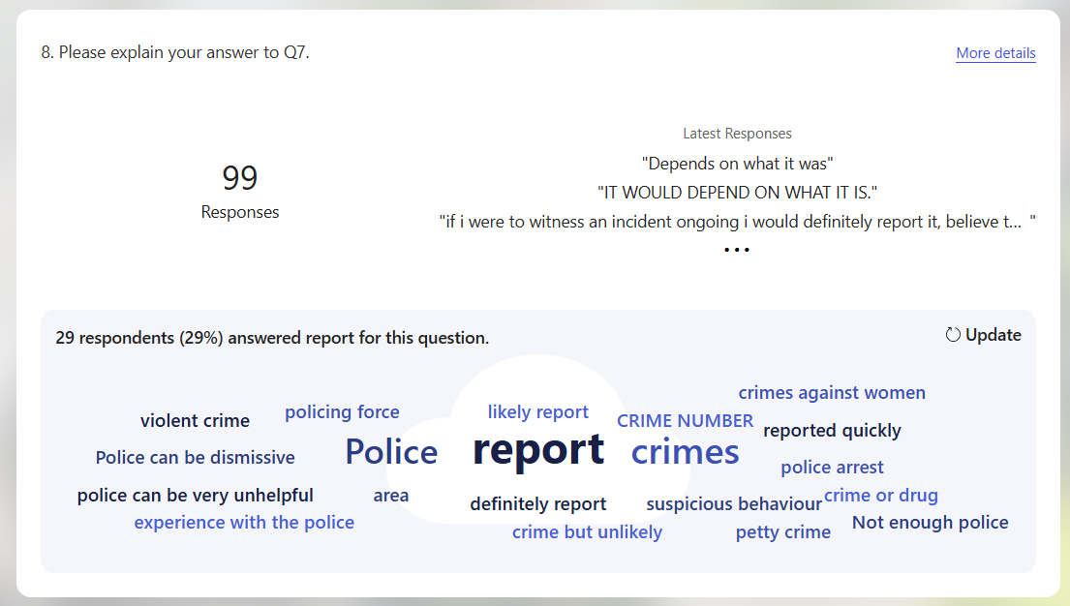

The qualitative responses reveal a noticeable trend that many respondents stated their decision would depend on the nature and seriousness of the incident. Several responses included phrases such as “depends on what it was”, suggesting that participants differentiate between more serious offences, such as violent crime or crimes against vulnerable individuals, and lower-level issues such as petty crime or minor antisocial behaviour. Some respondents stated they would report incidents involving immediate harm, while minor offences were less likely to be reported unless they were persistent or directly affected them.

A smaller number of responses referenced previous experiences with the police, with some participants expressing concerns that the police can be dismissive or unhelpful, which may reduce the likelihood of reporting certain incidents. These findings suggest willingness to cooperate with police may depend on perceptions of offence seriousness and confidence that the report will result in action. This reflects wider research which indicates that public cooperation with policing is often shaped by perceived police effectiveness and responsiveness (Bradford et al, 2025).

Participants were also asked to rank the methods they would most likely use to report crime or concerns to the police.

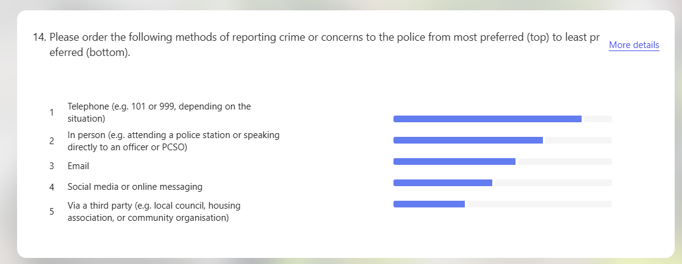

The results demonstrate that traditional reporting methods remain the most preferred. Telephone contact, such as calling 101 or 999 depending on the situation, was ranked as the most common reporting method, followed by speaking directly to officers in person. Digital communication methods, including email or social media messaging, were ranked lower. This suggests that despite increasing digitalisation within policing, many members of the public still prefer direct or traditional forms of contact with police services.

Respondents were also asked whether they believed that police understand the needs of their community.

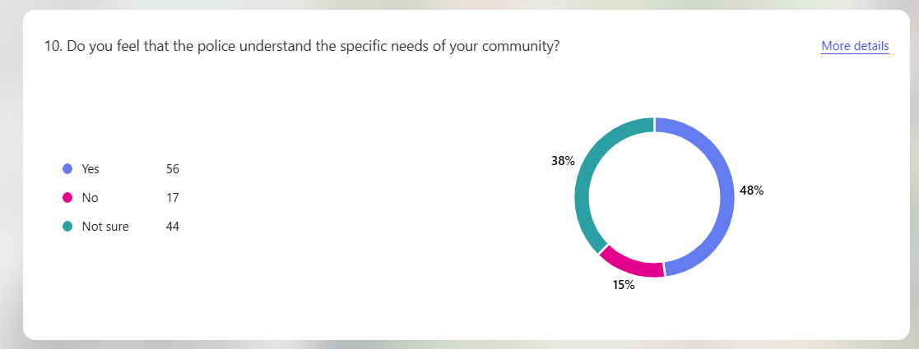

The results show that 56 respondents believed that police understand the needs of their community, while 44 respondents were unsure and 17 respondents believed that police do not understand community needs. This suggests that while a proportion of respondents perceive policing to be responsive to community concerns, there remains uncertainty regarding how effectively police understand local issues.

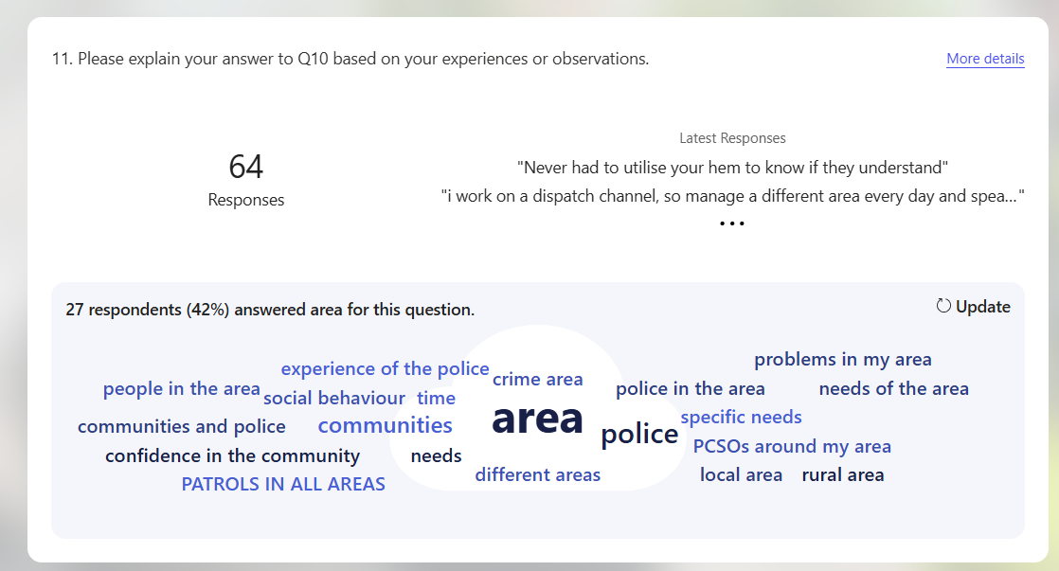

Participants were also asked to expand on their views regarding whether police understand the needs of their community. The qualitative responses highlighted recurring concerns relating to antisocial behaviour, local crime and police visibility. Analysis of the responses also showed that 27 participants (approximately 42%) referenced issues relating to their local “area”, suggesting concerns about the level of police presence within their communities. Several respondents indicated that police visibility influenced whether they believed officers understood local issues. For example, one respondent stated that officers “are visible in the area and deal with issues such as antisocial behaviour.” In contrast, others suggested that limited patrols affected their perceptions, with one participant stating they “hardly ever see officers on patrol anymore.” This trend suggests that perceptions of whether police understand community needs are closely linked to visibility and engagement within local areas. This aligns with research suggesting that regular interaction between police and communities can improve perceptions of responsiveness and legitimacy in policing (Bradford et al, 2025).

Participants were also asked whether community policing improves trust between the police and the public.

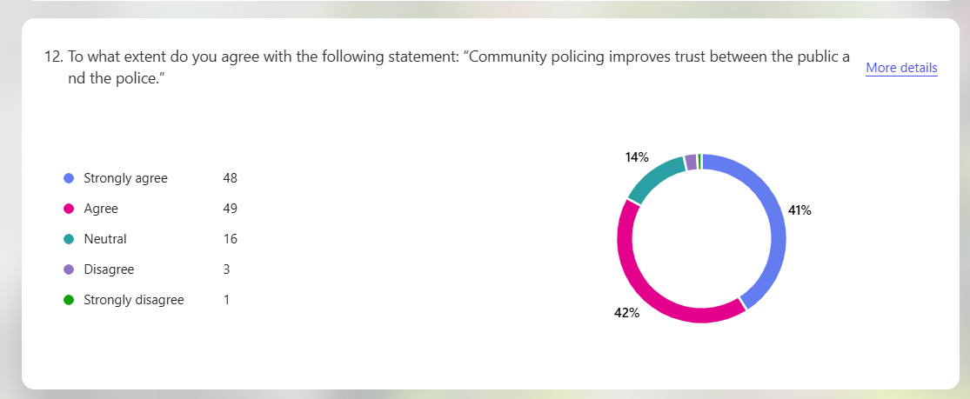

The findings demonstrate strong support for this view. A total of 97 respondents either agreed or strongly agreed that community policing improves trust between the police and the public, while only four respondents disagreed. This indicates that community policing is widely viewed as strengthening police–community relationships.

Respondents were also asked to rank factors they believed were most important for building public trust in the police.

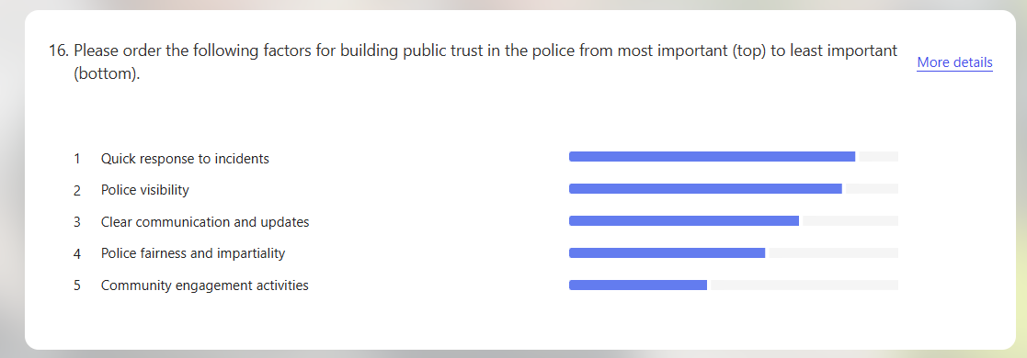

The results show that quick responses to incidents, police visibility and clear communication were ranked as the most important factors influencing trust. Community engagement activities were also considered important but ranked slightly lower. These findings highlight the importance of both operational effectiveness and communication in shaping public perceptions of policing, which aligns with evidence suggesting that visible policing, responsiveness and engagement are key factors influencing public confidence (College of Policing, 2025).

These findings are consistent with wider research on public confidence in policing, with surveys suggesting that only around 40% of people in England express confidence in their local police force (Dodd, 2024). National survey data indicates that confidence in policing varies across communities, with many individuals uncertain about the ability of police to effectively address local crime (ONS, 2025). Similarly, the Independent Office for Police Conduct reports that perceptions of fairness, transparency and accountability significantly influence public trust (IOPC, 2025). Academic research further suggests that procedural justice and legitimacy play a central role in shaping public confidence in policing (Bradford et al, 2025). The results of this study therefore suggest that community policing may strengthen public trust when it enables meaningful engagement between police and communities.

4.5 Limitations and Challenges Affecting Community Policing

The final objective examined the perceived limitations and challenges affecting community policing.

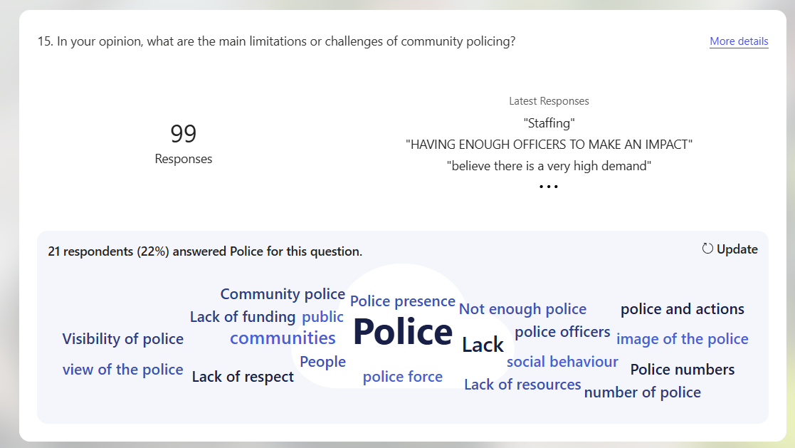

Participants were asked to identify what they believed were the main challenges facing community policing. The qualitative responses revealed several recurring themes. Analysing patterns within qualitative responses helps identify key issues emerging from the data (Grad Coach, 2022). A prominent trend within the responses related to concerns about police resources. Many respondents referred to staffing shortages and increasing workloads, suggesting that neighbourhood policing may be affected by wider operational pressures. For example, one participant stated that “there are not enough officers to cover everything”, while another suggested that officers are often “too busy responding to other incidents to spend time in the community”. These responses indicate a perception that reactive demands on policing may limit opportunities for proactive engagement with local communities.

Concerns about police visibility were also frequently mentioned. Several respondents stated that they rarely encounter neighbourhood officers in their local areas, with one participant commenting that they “hardly ever see police on patrol anymore”. Others suggested that community policing may be difficult to deliver effectively if officers do not have sufficient time to engage with residents and address local concerns. This suggests that expectations of community policing may not always align with operational realities.

These perceptions reflect wider structural challenges within policing. The State of Policing assessment highlights that increasing demand pressures are placing significant strain on police resources and reducing opportunities for proactive engagement with communities (HMICFRS, 2025). Similarly, research from the Police Foundation emphasises that modern policing requires balancing reactive operational responsibilities with preventative community policing strategies (Muir et al, 2022). Without sufficient resources and organisational support, neighbourhood policing initiatives may struggle to achieve their intended impact.

4.6 Chapter Summary

This chapter has presented and analysed the findings from the questionnaire survey in relation to the study’s three research objectives. The results indicate that while community policing is widely recognised as an important approach for building trust and strengthening relationships between police and communities, direct engagement between neighbourhood officers and members of the public appears to be relatively limited (Hough, 2020). Many respondents reported infrequent contact with neighbourhood policing teams and inconsistent police visibility within their communities.

Despite these challenges, participants generally expressed strong support for the principles of community policing and recognised its potential to improve trust between the police and the public. The findings also highlight the importance of police visibility, responsiveness and communication in shaping public perceptions of policing.

However, respondents also identified several challenges affecting the implementation of community policing, including resource pressures and increasing operational demand. These findings suggest that although community policing remains central to policing strategies in the UK, its effectiveness in shaping public perceptions depends on consistent implementation and sufficient resources for community engagement.

Reference List

- Biggam, J. (2026) Succeeding with your Master’s dissertation : a step-by-step handbook. 6th edn. Maidenhead: Open University Press. Available at: https://ezproxy.uwtsd.ac.uk/login?url=https://www.vlebooks.com/product/openreader?id=TrinityStD&accId=8886856&isbn=9780335253661&uid=^u.
- Bradford, B, Weirich, C, Rowlands, D and Crawford, A. (2025) ‘Public confidence in the police: using opinion survey data to explore the current ‘moment’ in British policing’, Policing and Society, 35(7), pp. 883–900. Available at: https://doi.org/10.1080/10439463.2025.2508198.
- College of Policing (2025) Improving public confidence in the police: An evidence-based guide. Available at: https://assets.college.police.uk/s3fs-public/2025-01/Improving-public-confidence-in-the-police-guide.pdf?VersionId=XpjDwAk0rd7AjDXNdBY75ImCNWDJJ_7k (Accessed: 4th March 2026).
- Dodd, V. (2024) ‘Only 40% of people in England trust their police force, research reveals’, The Guardian. Available at: https://www.theguardian.com/uk-news/2024/apr/18/only-40-of-people-in-england-trust-their-police-force-research-reveals (Accessed: 5th March 2026).
- Grad Coach (2022) Qualitative Coding Tutorial: How To Code Qualitative Data For Analysis (4 Steps + Examples). Available at: https://www.youtube.com/watch?v=8MHkVtE_sVw (Accessed: 5th March 2026).
- HMICFRS (2025) State of Policing: The Annual Assessment of Policing in England and Wales 2024-25. Available at: https://hmicfrs.justiceinspectorates.gov.uk/publication-html/state-of-policing-the-annual-assessment-of-policing-in-england-and-wales-2024-25/ (Accessed: 6th March 2026).
- Hough, M. (2020). Good Policing: Trust, Legitimacy and Authority. Bristol University Press. Available at:
https://doi.org/10.46692/9781447355083.
- Independent Office for Police Conduct (2025) IOPC Public Perceptions Tracker Summary Report, Financial Year 2024/25. Available at: https://www.policeconduct.gov.uk/publications/public-perceptions-tracker-summary-report-202425 (Accessed: 5th March 2026).
- Innes, M, Roberts, C, Lowe, T and Innes, H. (2020) Neighbourhood policing : the rise and fall of a policing model. Oxford University Press. Available at: https://doi.org/10.1093/oso/9780198783213.001.0001.
- Muir, R, Higgins, A, Halkon, R and Walcott, S. (2022) A New Mode Of Protection, The Police Foundation. Available at: https://police-foundation.org.uk/policingreview2022/wp-content/uploads/srpew_final_report.pdf (Accessed: 3rd March 2026).
- Office for National Statistics (2025) Perception and experience of police and criminal justice system, England and Wales: year ending March 2025. Available at: https://www.ons.gov.uk/peoplepopulationandcommunity/crimeandjustice/articles/perceptionandexperienceofpoliceandcriminaljusticesystemenglandandwales/yearendingmarch2025 (Accessed: 5th March 2026).
- Saunders, M, Lewis, P and Thornhill, A. (2023) Research methods for business students. 9th edn. England: Pearson Education Limited. Available at: https://www.researchgate.net/publication/240218229_Research_Methods_for_Business_Students.
- Starmer, K. (2025) New measures to put neighbourhood bobbies back on beat, GOV.UK. Available at: https://www.gov.uk/government/news/new-measures-to-put-neighbourhood-bobbies-back-on-beat (Accessed: 3rd March 2026).
- Swaen, B. (2016) How to Write a Results Section | Tips & Examples. Scribbr. Available at: https://www.scribbr.co.uk/thesis-dissertation/results-section/ (Accessed: 28th February 2026).

