

BA BUSINESS MANAGEMENT

International Business Communications
Assessment 1

Module: International Business Communications
Code: LCBB6001
Lecturer: Dr Alfred Mensah
Name: Dimitar Stefanov Cherganski

Student ID: 2133011

SUBMITTED ON 15 August 2024

Table of Contents
Expanding Liberty Wines Ltd 3
Introduction 3
Inclusive Introduction to the Context of British Business Communications 3
Introduction to the Selected Organization 4
Evaluation of the UK and Two EU Countries based on Hofstede.com Cultural Dimensions 5
Conclusion and Recommendations under Hofstede Country Comparison Tool 7
Germany 8
Netherlands 9
Comparison and Recommendation 10
Recommendation 11
Conclusion 11
References 12

Expanding Liberty Wines Ltd, a
British Multinational Company into the European Union

Introduction

In the current global business environment, expanding into new markets is essential for the growth and sustainability of multinational corporations. The European Union (EU) represents a beautiful region for British companies due to its economic stability, diverse consumer base, and relatively close geographic and cultural proximity. Expanding into an EU country necessitates meticulously evaluating multiple aspects, such as cultural disparities, language obstacles., and labour market conditions (Ghemawat, 2017). This essay will explore these aspects, focusing on a specific British multinational company and evaluating two potential EU countries for expansion: Germany and the Netherlands. The goal is to recommend the most suitable country for the company's expansion, ensuring a favourable environment for all stakeholders involved.

Inclusive Introduction to the Context of British Business Communications

British business communications are characterised by a unique blend of formality, politeness, and indirectness, reflecting British society's broader cultural values. Communication in British business often involves a careful balance between being clear and direct while maintaining a degree of reserve and understatement. This technique is firmly grounded in the cultural context, emphasising modesty and avoiding overt self-promotion or confrontation (Lewis, 2018).

In the British business environment, meetings and negotiations are typically conducted with a high level of politeness, and there is often an emphasis on consensus-building and collaboration. British professionals avoid aggressive bargaining tactics and prefer to reach agreements through mutual understanding and compromise (Hall and Hall, 1990). This can sometimes result in communication that may appear vague or non-committal to those from more direct communication cultures.

Another key feature of British business communication is the importance placed on written communication. Emails, reports, and formal letters are often used to confirm verbal agreements and record decisions. The tone of written communication tends to be formal and courteous, with careful attention paid to detail and correctness (Samovar et al., 2017).

Understanding these nuances is crucial when British companies seek to expand into international markets, particularly within the diverse cultural landscape of the EU. The ability to adapt British communication styles to align with the cultural expectations of the host country can significantly influence the success of international business operations. As British companies expand into the EU, they must know how their communication practices might be perceived and the potential adjustments needed to foster effective and respectful interactions in different cultural contexts.

Introduction to the Selected Organization

The selected organisation for this analysis is Liberty Wine Ltd, a British multinational corporation specialising in the wine industry. It was established in 2004; the company has grown to become a global leader in its sector, with operations in over 40 countries. Its success has been driven by a commitment to innovation, customer satisfaction, and strategic international growth (Johnson et al., 2017). Currently, the company is looking to expand its operations within the EU, leveraging the opportunities offered by this large and economically integrated market.

Evaluation of the UK and Two EU Countries based on Hofstede.com Cultural Dimensions

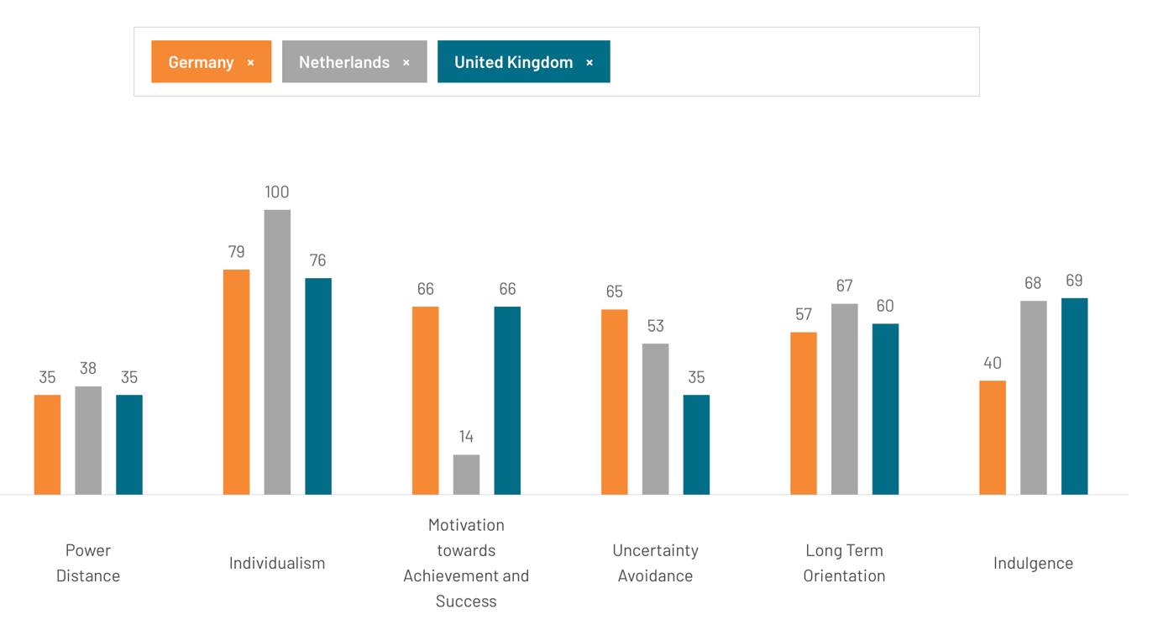

Understanding cultural differences is essential for any business expansion, particularly in multinational operations. Hofstede's cultural dimensions provide a framework for analysing these differences, enabling companies to effectively align their strategies with local cultural norms. This evaluation compares Germany, the Netherlands, and the United Kingdom using Hofstede's cultural dimensions, providing insights for a British company considering expansion into these European markets.

Power Distance

Power Distance refers to the extent to which less powerful members of organisations accept and expect that power is distributed unequally (Hofstede, 2011).
All three countries exhibit low Power Distance scores, indicating a preference for egalitarianism and decentralised decision-making processes. This similarity suggests that a British company would find it relatively easy to integrate its management practices in Germany and the Netherlands, as both countries share the UK's preference for consultation and equality in the workplace.

Individualism

Individualism measures the degree of interdependence a society maintains among its members (Hofstede, 2011).
The United Kingdom scores highest in Individualism, followed closely by the Netherlands and Germany. This indicates that all three countries highly value personal autonomy and individual responsibility. The solid individualistic culture in these countries suggests that business strategies should focus on personal achievement and empowerment, which aligns well with the British approach.

Motivation towards Achievement and Success

Motivation towards Achievement and Success pertains to a societal preference for achievement, heroism, assertiveness, and material rewards for success (Hofstede, 2011).
Germany and the United Kingdom share a high score, reflecting a competitive and success-oriented culture. The Netherlands, however, scores much lower, indicating a society that values quality of life, care for others, and consensus over competition. While Germany's business culture may require a minor adjustment for a British company, entering the Dutch market might necessitate a shift towards more inclusive and cooperative business practices.

Uncertainty Avoidance

Uncertainty Avoidance reflects how culture members feel threatened by ambiguous or unknown situations and have created beliefs and institutions to avoid these (Hofstede, 2011).
Germany scores high on Uncertainty Avoidance, indicating a strong preference for clear rules, structured environments, and a high level of predictability. The Netherlands is moderate, while the UK's low score suggests a more relaxed attitude towards ambiguity and risk. A British company expanding into Germany must emphasise careful planning and adherence to rules, whereas operations in the Netherlands could benefit from a balanced approach between structure and flexibility.

Long-Term Orientation

Long-Term Orientation deals with how a society maintains some links with its past while dealing with the present and future challenges (Hofstede, 2011).
The Netherlands scores highest in Long-Term Orientation, indicating a culture that values long-term planning, perseverance, and thrift. Germany also values these aspects but slightly less, while the UK's moderate score reflects a balance between short-term and long-term considerations. For a British company, this implies that Germany and the Netherlands would expect long-term strategic planning, with the Netherlands showing a stronger inclination towards sustainability and future rewards.

Indulgence

Indulgence refers to how people try to control their desires and impulses (Hofstede, 2011).
The UK and the Netherlands are more indulgent societies, allowing relatively free gratification of basic human drives. Germany, with a lower score, leans towards restraint and control. This suggests that marketing and consumer engagement strategies in Germany might need to be more conservative and focused on functional benefits, while in the UK and the Netherlands, strategies that emphasise enjoyment, leisure, and gratification could be more successful.

Conclusion and Recommendations under Hofstede Country Comparison Tool

With its high scores in uncertainty avoidance and masculinity, Germany offers a business environment that values structure, competition, and long-term orientation. A British company should adopt a formal, rule-based approach emphasising quality and reliability.

The Netherlands presents a balanced environment, with high Long-Term Orientation and Indulgence scores, indicating a market that values future planning and enjoying life. However, the low Masculinity score suggests a more inclusive and consensus-driven approach. A British company might need to adopt more cooperative and socially conscious business practices.

The UK's cultural proximity to Germany and the Netherlands, combined with its lower Uncertainty Avoidance and higher Indulgence, suggests a more flexible and dynamic business environment. Strategies promoting Individualism and personal responsibility would align well across all three countries, especially in the UK.

In deciding between Germany and the Netherlands for expansion, the Netherlands may offer a more culturally aligned and adaptable environment for a British company, particularly in its shared emphasis on Individualism and indulgence. However, Germany's structured and competitive environment could also be advantageous, depending on the company's strategic goals.

Germany

Country Facts and Cultural Differences

Germany is the largest economy in Europe and the fourth largest globally, making it a significant player on the international stage (CIA World Factbook, 2023). The country is known for its strong industrial base, particularly in manufacturing, engineering, and automotive industries. Culturally, Germany highly values efficiency, precision, and orderliness. This is reflected in its business environment, where processes are often highly structured, and decisions are based on careful analysis and long-term planning (Hofstede, 2011).

The German language is predominantly spoken, and while English is widely understood, especially in business contexts, proficiency in German can be crucial for building strong relationships and navigating the local market effectively (Samovar et al., 2017). The social context in Germany is characterised by a high degree of Individualism, where personal responsibility and self-reliance are emphasised. However, a strong sense of community and social welfare influences workplace dynamics and expectations (Trompenaars and Hampden-Turner, 2012).

Possible risks in Germany include a highly competitive market with well-established local and international players. The regulatory environment is also stringent, with strict labour laws and compliance requirements (Deutsche Bank Research, 2021). However, the labour market is robust, with a highly skilled and diverse workforce, particularly in technical and engineering fields (Statista, 2022).

By applying Hofstede's cultural dimensions to Germany, we already know that the country scores high on uncertainty avoidance, indicating a preference for clear rules and structured environments. It also has a relatively high power distance, meaning hierarchy is respected in organisational settings. However, individualism is also prominent, suggesting that employees value autonomy and personal achievements (Hofstede, 2011).

Communication Barriers

Communication in Germany is typically direct, clear, and concise. Germans value straightforwardness and expect the same from their business partners. This can sometimes challenge British companies, where communication might be more nuanced or indirect (Lewis, 2018). Additionally, the emphasis on formality and adherence to protocols in Germany can lead to misunderstandings if not adequately managed. British business leaders must adapt their communication style to align more with German expectations, ensuring clarity and avoiding ambiguity (Hall and Hall, 1990).

Netherlands

Country Facts and Cultural Differences

The Netherlands is a smaller but economically vibrant country with a strong tradition of international trade. Known for its open and progressive society, the Netherlands has a highly diverse population and a business environment characterised by flexibility, innovation, and a strong emphasis on sustainability (OECD, 2023). The Dutch economy is highly developed, with key sectors including finance, logistics, and technology (World Bank, 2022).

Most speak Dutch, but English is also widely used, especially in business settings, making communication easier for English-speaking companies (Samovar et al., 2017). The social context in the Netherlands is marked by egalitarianism and a strong emphasis on work-life balance. The Dutch value consensus in decision-making processes, reflected in the business culture, where collaboration and mutual agreement are prioritised (Trompenaars and Hampden-Turner, 2012).

The risks associated with entering the Dutch market include a highly competitive environment and potential challenges in navigating the regulatory landscape, which is geared towards protecting workers' rights and promoting sustainable business practices (OECD, 2023). However, the labour market is favourable, with a well-educated and internationally oriented workforce (Statista, 2023).

According to Hofstede's cultural dimensions, the Netherlands scores low on power distance, indicating a preference for flat organisational structures and participative decision-making. It also has a high score in Individualism, similar to Germany, but with a strong emphasis on the collective good. Uncertainty avoidance is relatively low, suggesting a greater tolerance for ambiguity and a more relaxed approach to rules and regulations (Hofstede, 2011).

Communication Barriers

Communication in the Netherlands is generally open, direct, and informal. The Dutch appreciate honesty and transparency in business dealings, which aligns well with British communication styles (Lewis, 2018). However, the emphasis on consensus and the need for broad agreement in decision-making can slow down processes, which might be frustrating for British managers who are used to more hierarchical and decisive structures. Additionally, while English is widely spoken, there can still be subtle cultural differences in communication that must be navigated carefully (Hall and Hall, 1990).

Comparison and Recommendation

Comparative Analysis

When comparing Germany and the Netherlands, both countries offer significant expansion opportunities, but they also present distinct challenges. Germany's large economy and industrial strength make it an attractive market, but its structured and formal business environment may require significant adaptation from a British company (Ghemawat, 2017). On the other hand, the Netherlands offers a more flexible and open business culture, with a strong emphasis on innovation and sustainability, which could align well with the values of a British multinational looking to expand in a progressive environment (Trompenaars and Hampden-Turner, 2012).

The Netherlands may present fewer barriers due to the widespread use of English and the more informal and open communication style. However, the consensus-driven decision-making process could be a potential challenge for British managers. Germany's more formal and direct communication style might require more adaptation, but it also offers clarity and efficiency once the British company becomes accustomed to it (Lewis, 2018).

Recommendation

Based on the analysis, the Netherlands appears to be the more suitable country for expansion. The alignment in communication styles, the widespread use of English, and the progressive business environment provide a conducive atmosphere for the British multinational to thrive (OECD, 2023). Moreover, the Netherlands' emphasis on innovation and sustainability could offer significant synergies with the company's values and long-term goals.

To overcome communication challenges, the British company should invest in cultural training for its managers and employees to better understand Dutch communication norms and decision-making processes. Additionally, fostering an inclusive workplace culture that values consensus and collaboration will be essential for success in the Dutch market (Trompenaars and Hampden-Turner, 2012).

Conclusion

In conclusion, expanding into the European Union offers significant opportunities for British multinational companies but also requires careful consideration of cultural, social, and economic factors. This essay has evaluated Germany and the Netherlands as potential expansion destinations, considering their cultural differences, communication barriers, and labour market conditions. While both countries offer strong prospects, the Netherlands is recommended as the more favourable option due to its alignment with British business practices, open communication culture, and progressive business environment. By addressing potential communication challenges and fostering an inclusive workplace, the company can establish a successful and sustainable presence in the Netherlands, contributing to its long-term growth and global success.

References

CIA World Factbook (2023). Germany - The World Factbook. Available at: [https://www.cia.gov/the-world-factbook/countries/germany/](https://www.cia.gov/the-world-factbook/countries/germany/) (Accessed: 10 August 2024).

Deutsche Bank Research (2021). Germany: Regulatory Environment. Available at: [https://research.db.com](https://research.db.com) (Accessed: 10 August 2024).

Ghemawat, P. (2017). Redefining Global Strategy: Crossing Borders in a World Where Differences Still Matter. Harvard Business Review Press.

Hall, E.T. and Hall, M.R. (1990). Understanding Cultural Differences: Germans, French and Americans. Yarmouth, ME: Intercultural Press.

Hofstede, G. (2011). Culture's Consequences: Comparing Values, Behaviors, Institutions, and Organizations Across Nations. 2nd ed. Sage Publications.

Johnson, G., Scholes, K., and Whittington, R. (2017). Exploring Corporate Strategy: Text and Cases. 10th ed. Pearson Education.

Lewis, R.D. (2018). When Cultures Collide: Leading Across Cultures. 4th ed. Nicholas Brealey Publishing.

OECD (2023). Netherlands Economic Survey 2023. OECD Publishing. Available at: [https://www.oecd.org/economy/surveys/netherlands-economic-survey/](https://www.oecd.org/economy/surveys/netherlands-economic-survey/) (Accessed: 10 August 2024).

Samovar, L.A., Porter, R.E., McDaniel, E.R., and Roy, C.S. (2017). Communication Between Cultures. 9th ed. Cengage Learning.

Statista (2022). Germany: Employment by Economic Sector 2022. Available at: [https://www.statista.com/statistics/375965/employment-by-economic-sector-in-germany/](https://www.statista.com/statistics/375965/employment-by-economic-sector-in-germany/) (Accessed: 10 August 2024).

Statista (2023). Netherlands: Employment by Economic Sector 2023. Available at: [https://www.statista.com/statistics/375977/employment-by-economic-sector-in-the-netherlands/](https://www.statista.com/statistics/375977/employment-by-economic-sector-in-the-netherlands/) (Accessed: 10 August 2024).

Trompenaars, F. and Hampden-Turner, C. (2012). Riding the Waves of Culture: Understanding Diversity in Global Business. 3rd ed. McGraw-Hill.

World Bank (2022). Netherlands Economic Overview. Available at: [https://data.worldbank.org/country/netherlands](https://data.worldbank.org/country/netherlands) (Accessed: 10 August 2024).

Top of Document

