Work Based Project

Reflective Journal

Module code: ACBA5009



Student: Max James

Student Number: 1900822

Lecturer: Deborah Hughes

Word count:
Table of Contents
CHAPTER 1 3
1.0 Abstract / Introduction 3
1.1 Proposed Research Title 3
1.2 Introduction 3
1.3 Objectives 3

CHAPTER 2 4
2.0 Literature Review 4
2.1 Change in Hierarchy / Structure 4
2.11 Office Structure within the Infrastructure Department 5
2.2 Current Projects 6
2.3 COVID 19 – Emergency Projects 6
2.4 Conclusion of Known Information 7

CHAPTER 3 7
3.0 Research Methodology 7

CHAPTER 1

1.0 Abstract / Introduction

1.1 Proposed Research Title
‘’Is going out to consultants for multi-disciplinary services more cost effective as a pose to undertaking those duties in house’’.

1.2 Introduction
Going out to consultants for multi-disciplinary services has become the common theme within Pembrokeshire County Council. Undertaking projects in house have recently become diminished and the way in which projects are executed now begins by commissioning a team of multi-disciplinary consultants to undertake duties which were previously all done in house. The rationale behind this change was instigated by resource issues, with employees within the infrastructure department reaching full capacity. The commissioning of external consultants was initially minimalistic, where it was foreseen as the last resort when employees had reached capacity. An augmenting workload combined with members of staff leaving, led onto the way in which the office runs currently, where multi-disciplinary services are undertaken by consultants. This dissertation will examine whether commissioning consultants for multi-disciplinary services is more cost effective as a pose to the previous traditional way of running a project, where duties would be completed fully in house.

1.3 Objectives
Within this dissertation, the main aim is to conclude which way is more cost effective in terms of the multi-disciplinary duties required within a project, whether that’s undertake the duties in house or commission external consultants. The assumption will be made that the multi-disciplinary team compromises of the following disciplines:
- Architects
- Engineers
- Quantity Surveyors
- Planners.
Recent projects such as educational schemes have shown an increase in fees regarding the multi-disciplinary duties as mentioned above.
Based on this the hypothesis is that “Fees will continue increased across the 21st century schemes due to multi-disciplinary services being commissioned externally”.
The objectives will be the following:
- To use data to determine the cost variances between in house services as a pose to external consultant appointments.
- Prove any variances / increases in 21st century project fees are down to multi-disciplinary services being undertaken by external consultants.

CHAPTER 2

2.0 Literature Review

2.1 Change in Hierarchy / Structure
Focusing on a three yearly timeframe, the hierarchy and overall structure of the Infrastructure Department within Pembrokeshire County Council has changed drastically. The departments hierarchy used consist of 2 managers in which they reported to the Director of Infrastructure, below the two managers was a multi-disciplinary team consisting of Architects, Architectural Technicians, Quantity Surveyors, Project Managers, Structural Engineers, Mechanical & Electrical Engineers, and an Energy Manager. Although the team still holds a range of those disciplines, the team is built up predominantly by Project Managers who manage the consultants, and a business case is being put forward to employ more Project Managers again. The current hierarchy has been listed below, demonstrating the current layout within the office:

As the hierarchy lists below, there are currently 5 Project Managers who sit under the ‘Construction Team Leaders’. The ‘Construction Team Leaders’ are also Project Managers by trade and are experienced within the discipline. The supervisors below the build-up of Project Managers are NEC Supervisors who act as a clerk of works once projects are on site.
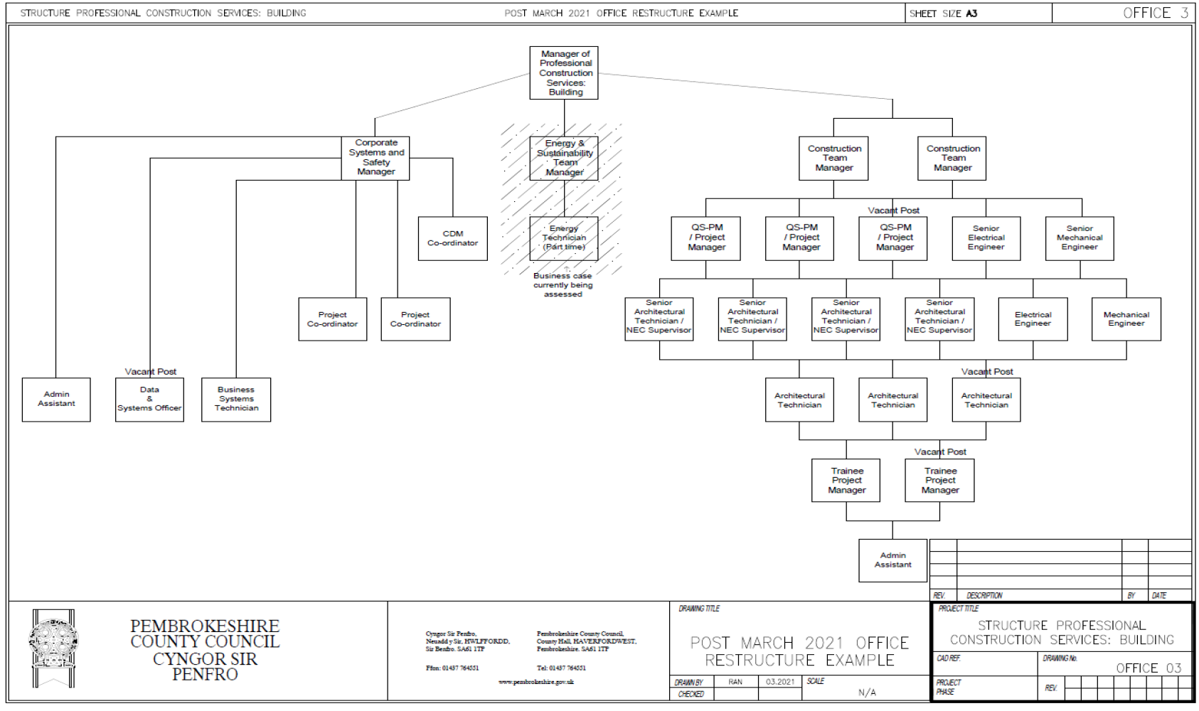

2.11 Office Structure within the Infrastructure Department

2.2 Current Projects
Within the Infrastructure department the projects are segregated into three main categories:
- Education
- Regeneration
- Housing
The regeneration portfolio of work is a recent addition to the department which compromises of listed buildings being retrofitted to various extents. Solitary, the Housing and Education portfolios have increased in size over the last 3 years therefore with the change in structure along with the new addition of Regeneration projects employees’ capacities have reached 100%. The recent addition of the Regeneration portfolio contributes to the conspicuous change the department has reverted to.

2.3 COVID 19 – Emergency Projects
The increasing portfolio of work is the main driver behind the change and in addition to this, COIVD-19 played a factor. COVID-19 has affected the Construction Industry as a whole, with supply chain management being the forefront. Contractors were unable to procure basic materials which has foreseen to play a factor in the uplift on material prices (Marsh, 2022). Aside from the common theme of the uplift in material prices, an additional emergency project was required which compromised of retrofitting an existing building into a temporary field hospital to deal primarily with COVID-19 patients as the hospitals were reaching full capacity in the peak of the pandemic. This project coming into the realm resulted in required resource from our department which the below table demonstrates:
Discipline | Number Required | Input | Capacity %
Project Manager | 1 | Project Manage the scheme on a day-day basis. | 100%
Quantity Surveyor | 1 | Undertake QS duties including interim valuations | 100%
Architectural Technicians | 2 | Produce drawings for Contractor to undertake fitout. | 60%
Quantity Surveyor | 1 | Undertake preliminary costs, procure items of work and complete interim valuations | 60%
Assistant Quantity Surveyor | 1 | Assisting the senior QS on day-to-day duties. | 60%

The above table is an indicative overview of the capacities of members within the office required to undertake this piece of work. This work was reactive and was of course not anticipated or planned therefore it resulted in more strain upon the department.

2.4 Conclusion of Known Information
As can be seen from the above, there are various contributary factors which have resulted in the change within the Infrastructure department. This dissertation aims to evaluate whether going out to consultants for multi-disciplinary services is more cost effective as a pose to undertaking those duties in house. The dissertation will cover the aims listed within 2.0 of the report, using the evaluation factors listed.

CHAPTER 3

3.0 Research Methodology

