Student Name: Beatris Abazian

Student Number: 1809924

Module Number: 4005

Module Name: Professional Career Development

Module Lecture: Sylvia Hoffman

CONTENTS

INTRODUCTION 3

SELF-EVALUATION 3

WORLD OF EMPLOYMENT 5

SWOT 7

LEARNING STYLES 9

PERSONAL DEVELOPMENT PLAN 10

CONCLUSION 10

REFERENCES 11

APPENDIX 12

INTRODUCTION

This portfolio paper aims to introduce you to my reflection on my understanding, achievements, evaluation reviews, learning styles and theories of an effective professional career development. The demonstration of the strategies of a personal reflection, which I am going to try and my personal career development plan of action. I would like to share my understanding, knowledge and skills needed for successful and effective future employment. Reflective analysis on my personal advantages and disadvantages, areas and strategies for further development and improvement. Establishing goals, personal and professional as well as developing a personal plan of action based on my qualities and abilities to become a successful of my chosen field of work.

SELF-EVALUATION

What is self-awareness? This is the ability to understand our inner states. This includes evaluation, thoughts, judgment, feelings, logical conclusions and so on. The benefits include enriched emotional intelligence, greater empathy and listening skills; improved critical-thinking and decision-making skills, enhanced leadership abilities and better communication and relationships (www.quora.com).

During the summer of 2018 I did had an opportunity to become a student. As I always wanted to obtain a degree in the UK I decided not to miss that chance. Initially I wanted to do computer science but all the places were taken. I was really disappointed at first and wanted to give up. After some consideration and reflecting on the whole situation I decided to take a chance at other wonderful prospects and registered myself for level 4 of Certificate in Higher Education: Skills for the Workplace in University of Wales Trinity Saint David, London Campus. The University is well known and very conveniently located near my present job so the campus is easily reachable. As mentioned above, I always wanted to study in order to have a better life, both professional and personal. To have more opportunities to grow and progress professionally.

- Why I choose to study now?

Due to family and health issues I wasn’t able to take that important step earlier. Seeing that opening I took my chance. Now, looking back, reflecting on the whole outcome I am very happy that I did not give up. I met so many nice and intelligent people and I refresh and satisfy my knowledge gaps. I had a very good luck with the lecturers. Most of them are good professionals, very engaging, presenting us with interesting subjects and case studies, asking questions and trying to make us think creatively and logical.

- What influenced me?

I can answer this question with two words – the knowledge. I have always been a very curious person. My previous studies are mechanical engineering and finance. Mechanics are the one I really do love because you can create a lot of things using your imagination and innovative thinking. My secondary school final project was constricting a real life windmill. I remember how excited I was when I started to work on this task. It was difficult and satisfying at the same time. I learnt a lot about my abilities, strengths and weaknesses. Working in team for some parts of the project surprised me and thought me and the same time that I am very consistent and logical. My second degree is Accounting and Financing, which I did obtain because I had to. I finished it but never work in this field simply because I did not enjoy it. To be really honest, I find the accounting a bit boring, despite the fact that numbers never lie. I hold a certificate of personal secretary and I have working experience at that position for two and a half years. I was very young at the time, straight after school, without any experience. This job thought me a lot about professionalism, ethics and the importance of good communication and quick problem solving and decision-making. This was a high point of my lifeline. I learned a lot and created some very useful habits, such as listening without interruption, managing tasks in order of their importance, managing people and stay calm under pleasure. All these skills helped me a lot. In fact, they are still helping me in difficult situations like doing the assignments.

I did have my low periods in my life but I overcame them with great determination and strong motivation. My previous working experience thought me never to give up, even if the results are not satisfying. Motivation, plan and supportive regime and rules always lead to achieving personal and professional goals.

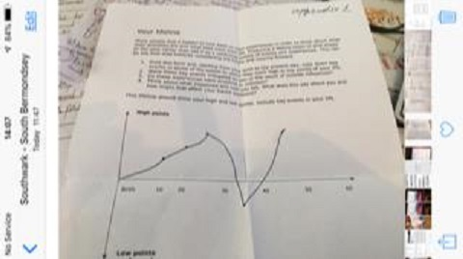
Figure 1. Life Line

- Exam options ahead

My current goal is to combine successfully several things. Trying to juggle everything –full time study and work, finance, family, job related events, plans and ideas. Acquiring problem-solving and decision-making skill at a young age helps me a lot in my present situation. I can approach my daily tasks with confidence, professionalism and respect for others. At the moment life is quite challenging but I am very positive that this will lead to very comfortable and successful future. I just need to stay focused and motivated. I truly believe that everything in our lives happen for a reason, at the right time and place. Every lesson, good or bad, teaches us something.

Further education is a must for me in order to reach my goals and dreams. The help and support that I receive during the study in the University is very much appreciated. People are very helpful and professional and just observing them helps me learn how to behave in certain situations.
I am a very positive person, “my glass is always half full” (common phrase).
I am also focused and determined and I do believe that this will be a big plus for achieving my goals. However, I have to consider my lack of experience in that field. I have never had a job interview in the UK. I think this could be an obstacle in my future search and professional realization as an employee.

Looking back on my life I can identify a few personal achievements. The first one is overcoming my fear of open water. Unfortunately, due to problems with my eyesight, I was very insecure in the past. However, with hard work and by taking one step at a time, like swimming in open waters lessons and futher practice I managed to gain a lot more confidence and succeed. And in 5-10 years I believe that I will be able to enjoy swimming again like I did before.

The second biggest achievement in my life is learning English. It took me quite some time but in the end I think I did well. Considering this is my third language and I am a self-thought learner I do believe that I have done well following my goal and finding ways to achieve it. Of course, the language is improving every day and in a near future I can see myself much more confident with writing and hope to be able to say that I am fully satisfied and hapy within outcome.

WORLD OF EMPLOYMENT

I understand that if I want to be valuable for an employer I need to show them that I am:
- Trustworthy
- Aware of health and safety in the workplace
- Good listener
- Quick learner
- Punctuality and flexibility are of high value
- Excellent communicator
- Good team player
- I have strong core values
- Demonstrate good time management
- Attention to detail
- Self-management and stability
- Positive attitude and networking skills.

I would like to give an example from my former cleaning business.
At the start I did not have a lot an experience and I had to organize a cleaning service for an event for a six-month period.
I started with making a short questionnaire.
In the beginning the customer was a bit annoyed but answered some of the questions. After 10-15 minutes it was more than clear that he was very impressed by all the little details I asked and started to be more specific and calm. We went trough all the requirements and at the end he was really happy because I did paid attention and listed very carefully and manage to apply in very professional manner .After that conversation I realized that I need to stay calm in any situation in order to achieve my goal. In this example signing the contract. Because I managed to stay positive and demonstrate flexibility and understanding of his needs (good listener) he was very satisfied. I did receive a very good recommendation and a many more contracts because of my good organizational, and listening skills.

This was my first experience as a self-employed person and I can honestly say that in difficult times I always recall this episode, which is continuing to remind me to focus and stay motivated.

One of my golden rules is to surround myself with nice and positive people. Make a plan and stick to it. Even the simple act of waking up early in the morning at the precise time and making my bed gives me a feeling that I am ready to do great things. It is the beginning of a wonderful and adventures day full of good surprises. Self-motivation is a must for anyone determined to achieve his or her goals.

SWOT

The acronym SWOT is stands for:
Strengths and Opportunities, which are internal factors
And
Weaknesses and Treats, which are external factors.
Now I am going to expose all of my good and bad qualities.

My strengths: Organizing, problem solving and decision making, time management, attention to detail, excellent communication skills, good listener.

What is organizational skill?
“The ability to use time, energy, resources, etc. in an effective way to achieve goals” (Cambridge Dictionary, 2019). In other words, to be organized at the work place means to put files in order, to priorities different projects, schedule and time manage them in order to complete certain tasks with good end results. Good organizations allow employees to stay focused, help them to increase productivity and efficiency. The biggest aim is to effectively manage time and help the whole process run smoothly. Key elements of good organization are the following:
- Goal setting
- Prioritizing
- Scheduling
- Delegating

Goal setting refers to the process of knowing what exactly is needed and how to be explained clearly and in detail. In addition, goal setting includes deadlines, values, prices, etc.

Problem solving and decision-making
I am a very strong-minded person, with a quick eye and ability to understand the whole situation at a glance. Asking questions related to the specific problem and trying to keep conversation in difficult situation only around solving is my extremely strong side. I can stay focused for a long time and try to prioritize the different problems and their impact on the subject. I have always been able to deal with a certain situation and achieve a good outcome. Trying to keep all the personnel as happy as possible. Seeing that I do not give up and keep focused motivates them to continue, give them a strengths to belive,contribute, achieve and make all of us good team players.

Time management is also one of my many strengths. Since the beginning of my studies at University of Wales Trinity Saint David I have managed to achieve 100% attendance which gives me the understanding that I really do care about what my future and the fact that I did improve that skill.

My weaknesses are also quite a few. One of them is my English language writing. English is my third language and it is very different from my native Bulgarian. We do have a different alphabet. I believe that this course can help me a lot to improve my academic writing skills. Nowadays working places use computers and handwriting is not that essential because of the automated options to correct the words. Improving this skill will help me to be more professional in my emails, easier understood and help me overcome my fear of making a fool of myself in front of my future colleagues.
The other weakness, which does apply only at the University of Wales Trinity Saint David, is my referencing. I was not being very careful during this lecture and it is still causing me problems. I have to say that there is a big change since I started the course and doing some after class exercises, but there is stillroom for improvement.

My opportunities – I do have an opportunity to become a manager coordinator in the big cleaning company near my living area, in the near future and I am willing to take my chances Actually, this was exactly the reason I started this course in the first place. This will help me to overcome my fear or writing in English and show to my future colleagues my strengths and abilities. It will also give me an opportunity to work in teams and perform different tasks in order to achieve better quality and customer service. And, to gain more confidence and exertions and chances and opportunities to grow with in company.

My Threats – little confidence and low lack of believe in my existing and future colleagues, in their readability and responsibility. Over the summer holidays a lot of my team members were away and I was afraid that this would reflect very negatively on my performance at the University. With this in mind I do plan to evolve my self in activities like team building which will improve my socializing and trust grows in other team players.
As a result of doing this analysis I do have clearer picture how to approach my colleagues about different tasks. I know that I am very present at work but I must admit that some of my team colleagues have very impressive and creative ideas, which sometimes I feel are much better than mine.
By working in this environment I do have a very good chance to improve more some of my strengths and to continue to develop my weaknesses.

LEARNING STYLES

There are different styles of learning and theories.
Understanding the away I learn will help me the various factors related to the carrier path and desire to reach my goal quicker. Everybody have a preferred way of learning known as a learning style. There are no right or wrong learning styles but understanding how I prefer to learn will help me to reach my full potential faster and develop further.

So what are the learning styles?
According to Honey and Mumford there are 4 different styles (www.theclassroom.com).
- Activists - prefer to do the things on the go
- Reflectors – people who prefer to think and analyze things before doing them
- Theorist – think methodically to do things properly, deep understanding
- Pragmatists – people who are looking into faster ways of solving the problem in the most effective way

Firstly, I have to understand my personal learning style, how to build a learning plan in order to become more aware of my strengths and weaknesses, to be able to focus on areas where I am not very balanced. To become a good manager I need to also understand my team’s learning style. This will help me to maximize their engagement and motivation. By knowing team players strengths will help to inspire them to be more effective and willing to do some extra steps in order to achieve teams goals.
According to our in-class activity (Appendix 3) I am a pragmatist, but also theorist and reflector. I do think that this combination is an excellent outcome. Personally I was very surprise from those results. It showed that I could rely on my self to make the right decision, which will help me to be successful at my future workplace.

People can also learn:
- Visually - reading, writing, diagrams;
- Auditory – listening;
- Kinesthetically- slides or short movies
According to in-class exercise (Appendix1) I am an auditory learner. Once I hear something I remember it straight away. It does help me a lot in my line of work to prevent unwanted outcome. And paying attention to what people are asking and understanding their needs saves time and provides better communication.

PERSONAL DEVELOPMENT PLAN

I will try to explain in a clear way what are my goals in short and long term.
As a self thought and self-employed person I did had a lot experience and gained strategy and knowledge thought years. Having a mentor/lecturer in my case, showing me different theoretical ways of approaching and not missing vital detail, what and how to attain in order to become professional. Thus will form my mind and attitude towards my chosen career path.

In short term, very short, I would like to finish and graduate successful Level 4 Certificate in High Education Skills for the Work Place. And if all goes as planed I would like to continue my education in University of Wales Trinity Saint David but under other very desirable subject for me, Computer Science.
To achieve this goal I was constantly juggling my everyday responsibilities and arrangements and University. Some of in innervations that will bring impact in my career development are – group studies, group classes, group exercises and assessment clarification and understanding. I have been trying to successfully succeed in all this fields, personal, student and working life. Working full time and studying put my time managing skill on a very good use. I would like to be able to express my personal understandings of the subject I have been studying in order be able to apply and develop additional all the new skills I gained.

My long-term goal is to continue and finish my future Computer science degree and to be able to find exiting and creative business where I can demonstrate and apply all this wonderful and very useful skills, which I learnt and gain throughout my studies so far. Secondly to be able to support my family and make their demands and dreams reality.`
Further developing of my team working skill in combinations with my excellent problem solving and decision making skills will give me an opportunity to become stronger candidate for my chosen field of work. It will make me to stand out, cover most of the asks and very appreciated from every employer.
I did finish Mechanical secondary school with honors also; I do have a degree of Accounting and Finance collage
I am professionally trained personal secretary with two and a half years of experience. When I did start my professional working life I did not had much self-respect and confidence. But after finish this secretary course and find a job straight away I was given a chance from my ex employer and the other team member to work on that skills and at the end I was able to develop and maintain
Those skills. With a lot of feedback from my ex colleagues and my personal friends I was able to move forward very quickly and I had a chance to start developing a new sills for the workplace.

Since 1996, the year I came to the United Kingdom, I have always been a self-employed person. I used to have my own cleaning company, but due to some health issues I had to give it up and move forward.
I did obtain professional certificates Level 1 and Level 2 for domestic and commercial cleaning. Also I do have a certificate in professional stenography and typewriting. I am trained in Health and Safety for a cleaning industry and First Aid, Hospitality and Customer service. All these courses taught me that communication, organization, listening and team working are very important. I had an opportunity to explore my own abilities and strengths. They showed me some of my weaknesses, which I try to develop and gain knowledge at the same time.

I have been doing different jobs and worked at different positions in my old business to get a real understanding of different levels, problems which are occurring and things to consider in order to be successful. Working in different positions helped me to gain valuable skills and experience- communication, creativity, working and doing complex logistics, ability to conduct. Some of them I did master, some of them need to be develop further. I have always tried to be a positive influence and set reachable goals for my team workers and myself.
I believe that all these years of work combined with studying do contribute a lot for my future and helped me to expand some of my strengths and improve my weaknesses.

CONCLUSION

I believe that in this paper/portfolio I was able to demonstrate and clearly identify all my skills and gained knowledge, ability to reflect on and of events, meanings and action need it to be taken in order to prevent future unwanted outcomes. To analyze my personal strengths and weaknesses in logical manner and support them with a realistic professional development plan. I hope I showed good understanding and evaluating of the skills and knowledge which contribute towards working effectively. Readiness for a future employment based on my personal development plan, strengths and weaknesses analysis, the ability to communicate clearly and effective relationships in the working place based on established employment goals.
I truly believe that once I finish the University I will find a better and much more substantial and creatively orientate position and will be able to fulfill my desire for a brighter and satisfying future.

REFERENCES

htpp://www.quora.com/(Accessed: 25thJuly 2019)

htpp://www.cambridgedictionary.com/(Accessed:1st September 2019)

htpp://www.theclassroom.com/(Accseessed:2nd September 2019)

APPENDIX 1

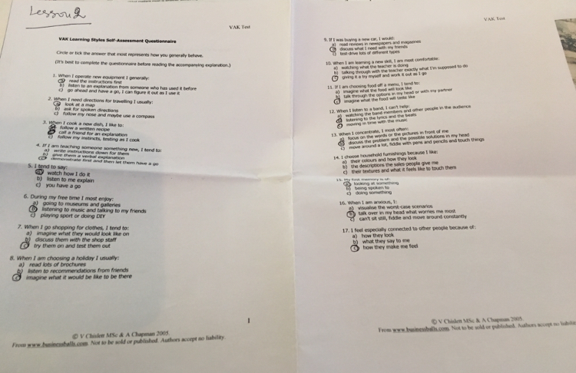

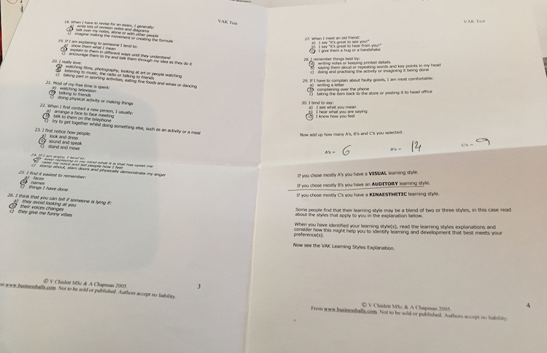

APPENDIX 2

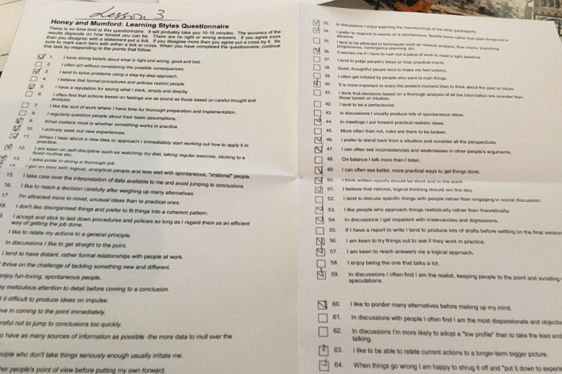

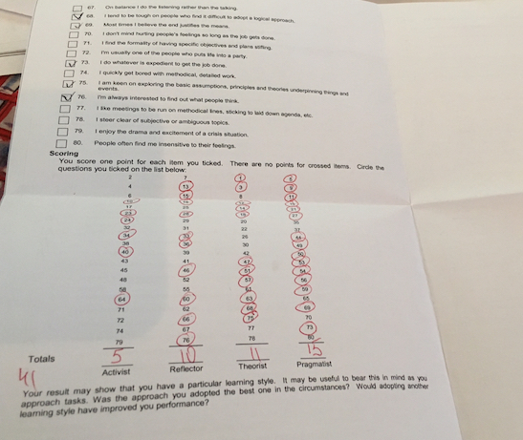

APPENDIX 3

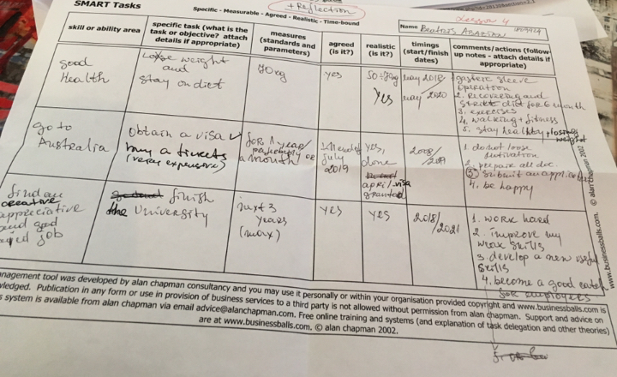

APPENDIX 4



