Name: Anisah Bi
Student Number: 2432005
Module Code: LCHS4003
Module Title: Introduction to Health and Social Care
Lectures Name: Azida Zainol
Assignment Title: Task One Poster and Task Two Essay

Contents
Task 1: Poster 3
Task 2: Essay 4
References 6

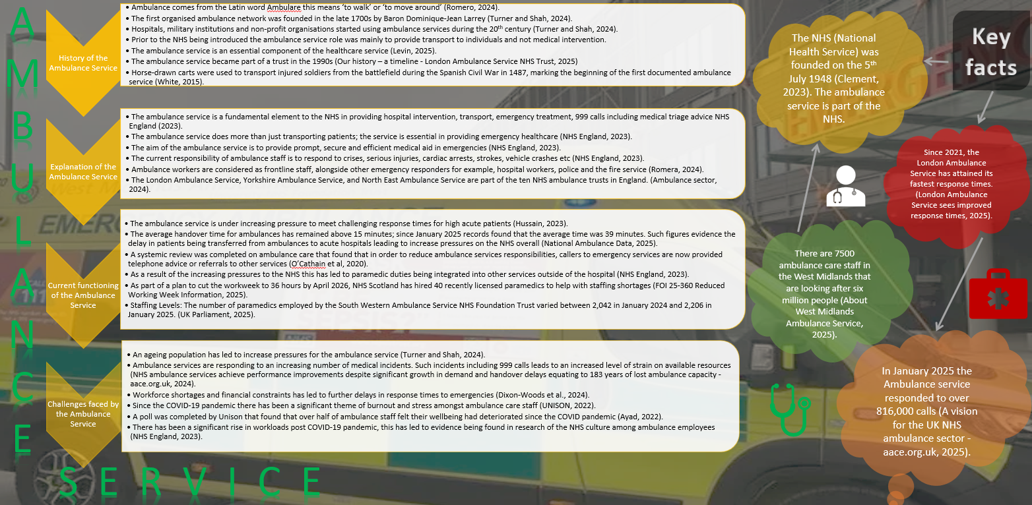
Task 1: Poster

Task 2: Essay

This essay aims to take on a critical approach to highlight the current functioning of the National Health Service (NHS) whilst also drawing upon the foundations of the service including the historical background. A significant social change in British history was achieved in 1948 when the NHS was introduced (Clement, 2023). This manifested England’s commitment to universal healthcare ensuring equality, justice and accessibility (Department of Health and Social Care, 2023).

The NHS was founded during a critical period in British history following the Second World War where there was widespread poverty and ill health amongst the population (Clement, 2023). The increasing necessity for social reform was created during a time where there was inequality among British society (Diniejko, 2011). Access to quality healthcare was determined by an individual’s income, class title or their charitable contributions, therefore this led to marginalised groups consisting of the working class and those in poverty (Diniejko, 2011).

Aneurin Bevan was a key figure who pushed forward his ideologies of the NHS in society (history tools, 2024). Bevan (1952) stood up for the social inequalities that existed in accessing quality health treatment, his key arguments highlighted that the quality of treatment should not be determined by an individual’s social class. Bevan (1952) was key in the introduction of the NHS in 1948, this service provided free healthcare funded by general taxes.

There are three key principles that led to the establishment of the NHS: free healthcare service for all, treatment of everyone’s needs and health treatment based on clinical necessity rather than financial means (Lister, 2023). The introduction of the NHS marked a significant shift from systemic inequalities to an accessible service for society (Our History, 2019). Once the NHS was in action this led to medical professionals who had once opposed the service due to its costs to supporting the same service.

The NHS continues to be famously known as the largest health service financed by the public (Arnold and Jefferies, 2025). The NHS service in England, Scotland, Wales and Northern Ireland promote similar principles however operate independently (What can integrated care systems in England learn from the devolved nations? 2014).
The current structure of the NHS consists of Integrated Care Systems, local NHS trusts and NHS England. The structure offers services in the community, mental health, primary (General practitioners, dentists, opticians) and secondary care (hospitals) settings (Kings Fund, 2023).

Despite its profound value the NHS continues to face its challenges in contemporary society. Such challenges are as a result of an ageing population, rise in chronic diseases including the accessibility to improved medical technology (Dunn et al., 2023). The lack of funding for the NHS has led to an increase in wait times and staff shortages (Appleby et al., 2017). This has led to the promotion of ideologies to privatise the NHS however it can be argued that this would contradict the principles the NHS was founded upon.

The COVID-19 pandemic led to further strain for the NHS, the service was not robust enough to sustain funding or manage the increasing employee burnout (Majeed et al., 2020). Such issues would need to be addressed to protect the future of the NHS by calling out policies, addressing the financial strains and public investments.

In conclusion, the NHS was established as a democratic change in England at a time where there was inequality in accessing health services post World Ward II (Health, 2025). However, currently the NHS is dealing with organisational pressures despite its historical achievements. The NHS experiences key challenges with providing essential services in contemporary society versus the economical strains of keeping up with a service relying on governmental funding (Belderbos, 2025).

References

A vision for the UK NHS ambulance sector - aace.org.uk (2025). Available at: https://aace.org.uk/a-vision-for-the-uk-nhs-ambulance-sector/.
About West Midlands Ambulance Service (2025). Available at: https://www.wmas.nhs.uk/about-us/ (Accessed: 16 October 2025).
Ambulance sector (2024). Available at: https://nhsproviders.org/resources/nhs-activity-tracker-202425/february-2025/ambulance-sector? (Accessed: 17 October 2025).
Appleby, J., Dunn, P. and Marmot, M. (2017) The NHS at 70: What next? London: The King’s Fund.
Arnold, S. and Jefferies, D. (2025) The NHS Budget and How It Has Changed. [online] Available at: https://www.kingsfund.org.uk/insight-and-analysis/data-and-charts/nhs-budget-nutshell [Accessed 17 Oct. 2025].
Ayad, F. (2022) Ambulance pressures taking a significant toll on staff, says UNISON | News, Press release | News. Available at: https://www.unison.org.uk/news/press-release/2022/04/ambulance-pressures-taking-a-significant-toll-on-staff-says-unison.
Belderbos, H. (2025) The financial strain on the NHS: Current challenges and the road ahead. [online] Open Access Government. Available at: https://www.openaccessgovernment.org/the-financial-strain-on-the-nhs-current-challenges-and-the-road-ahead/194548/ [Accessed 17 Oct. 2025].
Beveridge, W. (1942) Social Insurance and Allied Services. London: HMSO.
Bevan, A. (1952) In Place of Fear. London: Heinemann.
Clement, M. (2023) The founding of the NHS: 75 years on - History of government. [online] Available at: https://history.blog.gov.uk/2023/07/13/the-founding-of-the-nhs-75-years-on/ [Accessed 17 Oct. 2025].
Commons Library (2023) Capacity pressures in health and social care in England. [online] Available at: https://commonslibrary.parliament.uk/capacity-pressures-in-health-and-social-care-in-england/ [Accessed 17 Oct. 2025].
Dixon-Woods, M., Summers, C., Morgan, M., et al. (2024) The future of the NHS depends on its workforce. BMJ, 384 (384). Available at: https://www.bmj.com/content/384/bmj-2024-079474.
Department of Health and Social Care (2023) The NHS Constitution for England. [online] Available at: https://www.gov.uk/government/publications/the-nhs-constitution-for-england/the-nhs-constitution-for-england [Accessed 17 Oct. 2025].
Diniejko, A. (2011) A Chronology of Social Change and Social Reform in Great Britain in the Nineteenth and Early Twentieth Centuries. [online] Available at: https://victorianweb.org/history/socialism/chronology.html [Accessed 17 Oct. 2025].
Dunn, P., Ewbank, L. and Alderwick, H. (2023) Nine major challenges facing health and care in England. [online] The Health Foundation. Available at: https://www.health.org.uk/reports-and-analysis/briefings/nine-major-challenges-facing-health-and-care-in-england [Accessed 17 Oct. 2025].
FOI 25-360 Reduced Working Week Information (2025). Available at: https://www.scottishambulance.com/contact-us/freedom-of-information/foi-requests/foi-25-360-reduced-working-week-information/? (Accessed: 17 October 2025).
Global Banking School (2024) How is the UK healthcare sector shaping up for the future?. [online] Available at: https://globalbanking.ac.uk/blog/how-is-the-uk-healthcare-sector-shaping-up-for-the-future/ [Accessed 17 Oct. 2025].
Hussain, Z. (2023) What is happening with NHS ambulance delays? BMJ, 380: p142. doi:https://doi.org/10.1136/bmj.p142.
Health (2025) Health and Social Care Secretary speech on health inequalities. [online] GOV.UK. Available at: https://www.gov.uk/government/speeches/health-and-social-care-secretary-speech-on-health-inequalities [Accessed 17 Oct. 2025].
history tools (2024) Aneurin Bevan: The Visionary Behind Britain‘s National Health Service. [online] Available at: https://www.historytools.org/stories/aneurin-bevan-the-visionary-behind-britains-national-health-service [Accessed 17 Oct. 2025].
Institute for Government (2024) Fixing public services: NHS. [online] Available at: https://www.instituteforgovernment.org.uk/publication/fixing-public-services-labour-government/nhs [Accessed 17 Oct. 2025].
King’s Fund (2023) The structure of the NHS in England. [online] Available at: https://www.kingsfund.org.uk [Accessed 30 Sep. 2025].
King’s Fund (2024) Tight budgets, tough choices: the outlook for NHS finances. [online] Available at: https://www.kingsfund.org.uk/insight-and-analysis/long-reads/tight-budgets-tough-choices [Accessed 17 Oct. 2025].
Lister, J. (2023) Bevan’s Founding Principles for NHS Have Stood the Test of Time. [online] Keep Our NHS Public. Available at: https://keepournhspublic.com/bevans-founding-principles-for-nhs-have-stood-the-test-of-time/ [Accessed 17 Oct. 2025].
Levin, J. (2025). Emergency Medicine in the Modern World. Oxford: Oxford University Press.
London Ambulance Service sees improved response times (2025). BBC News, 11 September. Available at: https://www.bbc.co.uk/news/articles/cvg4mljvm9ko.
Majeed, A., Maile, E.J. and Bindman, A.B. (2020) ‘The primary care response to COVID-19 in England’s National Health Service’, Journal of the Royal Society of Medicine, 113(6), pp. 208–210.
National Ambulance Data (2025). Available at: https://aace.org.uk/wp-content/uploads/2025/03/National-Ambulance-Data-to-January-2025-Final-Draft-V2.pdf.
NHS ambulance services achieve performance improvements despite significant growth in demand and handover delays equating to 183 years of lost ambulance capacity - aace.org.uk (2024). Available at: https://aace.org.uk/news/nhs-ambulance-services-achieve-performance-improvements-despite-significant-growth-in-demand-and-handover-delays-equating-to-183-years-of-lost-ambulance-capacity/? (Accessed: 17 October 2025).
NHS Confederation (2014) What can integrated care systems in England learn from the devolved nations? [online] Available at: https://www.nhsconfed.org/publications/what-can-integrated-care-systems-england-learn-devolved-nations [Accessed 17 Oct. 2025].
NHS England (2023) About ambulance services. Available at: https://www.england.nhs.uk/urgent-emergency-care/about-uec/about-ambulance-services/ (Accessed: 17 October 2025).
NHS Confederation (2024) Invest to change: capital investment in the NHS. [online] Available at: https://www.nhsconfed.org/publications/invest-change [Accessed 17 Oct. 2025].
NHS England (2023) Paramedics working in new ways. Available at: https://www.england.nhs.uk/blog/paramedics-working-in-new-ways/ (Accessed: 17 October 2025).
NHS Providers (2024) The financial task: tackling the NHS productivity challenge. [online] Available at: https://nhsproviders.org/resources/stretched-to-the-limit-tackling-the-nhs-productivity-challenge/the-financial-task [Accessed 17 Oct. 2025].
O’Cathain, A., Knowles, E., O’Hara, R., Murtagh, M.J., Nicholl, J., Henwood, M. and Edwards, A. (2020) Exploring the role of telephone advice in reducing ambulance use: a mixed-methods systematic review, Health Services and Delivery Research, 8(19). Available at: https://doi.org/10.3310/hsdr08190 (Accessed: 17 October 2025).
Open Access Government (2024) The financial strain on the NHS: Current challenges and the road ahead. [online] Available at: https://www.openaccessgovernment.org/the-financial-strain-on-the-nhs-current-challenges-and-the-road-ahead/194548/ [Accessed 17 Oct. 2025].
Our history – a timeline - London Ambulance Service NHS Trust (2025). Available at: https://www.londonambulance.nhs.uk/about-us/our-history/our-history-a-timeline/.
Our History (2019) The Birth of the National Health Service: A revolutionary moment in British history. [online] Available at: https://www.ourhistory.org.uk/the-birth-of-the-national-health-service-a-revolutionary-moment-in-british-history/ [Accessed 17 Oct. 2025].
Rivett, G. (1998) From Cradle to Grave: Fifty Years of the NHS. London: King’s Fund.
Romero, L. (2024). A History of Medical Transport. London: MedHist Publications.
The Medic Portal (2024) Challenges facing the NHS. [online] Available at: https://www.themedicportal.com/application-guide/the-nhs/challenges-facing-the-nhs/ [Accessed 17 Oct. 2025].
Turner, R. and Shah, M. (2024). Paramedic Practice and Pre-Hospital Care. 2nd ed. Cambridge: HealthLine Press.
UNISON (2022) Ambulance pressures taking a significant toll on staff. Available at: https://www.unison.org.uk/news/press-release/2022/04/ambulance-pressures-taking-a-significant-toll-on-staff-says-unison/ (Accessed: 17 October 2025).
Webster, C. (2002) The National Health Service: A Political History. Oxford: Oxford University Press.
White, R. (2015) Emergency services: History of the ambulance. Available at: https://www.bbc.co.uk/historyoftheambulance (Accessed: 17 October 2025).
Written questions and answers - Written questions, answers and statements - UK Parliament (2025). Available at: https://questions-statements.parliament.uk/written-questions/detail/2025-05-07/50746? (Accessed: 17 October 2025).

