Programme: BA(Hons) International Hotel Management
Module: Organisational Consultancy
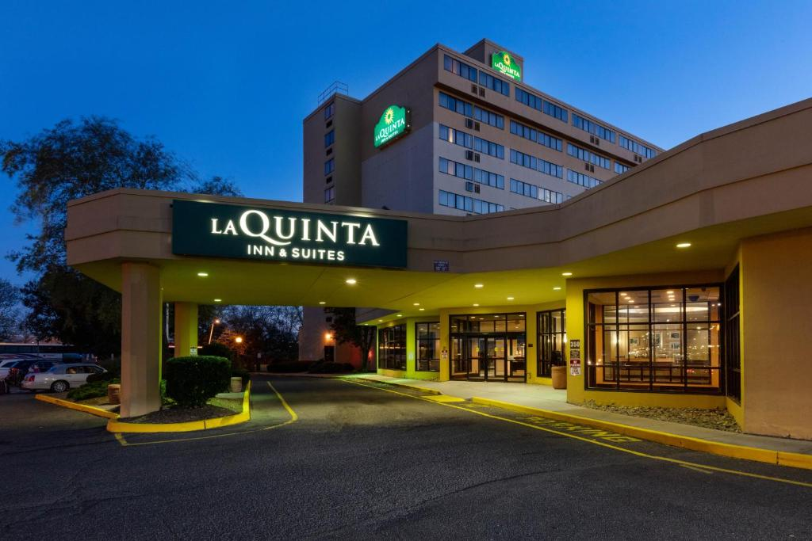
Module Code: BMIH6005
Assignment Title: Consultancy report
Case study of La Quinta Inn & Suites

Student Name :Anamaria Cristina Bursuc
Student ID number: 2122375
Lecture name : Jaliya De Silva

Executive Summary
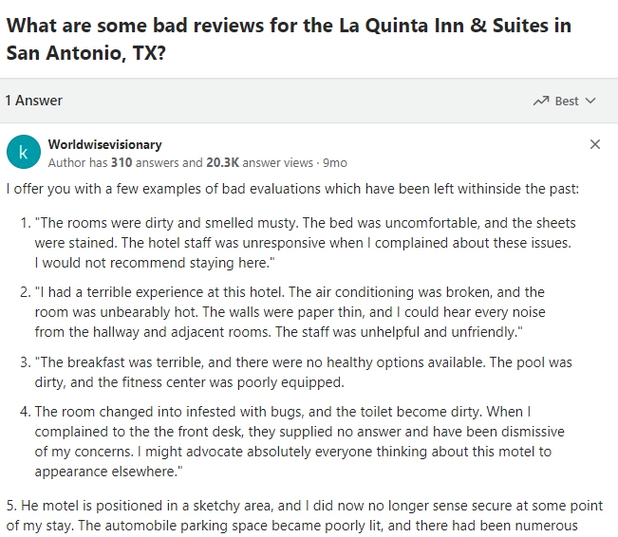
Multinational consulting company KPMG looks at the alarming drop in customer satisfaction at La Quinta Inn & Suites in response to the hotel's urgent request. Going beyond minor variations, this downturn seriously damages the hotel's standing and financial sustainability in the very competitive hospitality industry. The hotel's modern facilities and historical importance highlight this item as a representation of elegance and sophistication. Due to its excellent planning services and worldwide reach, KPMG is the best company to help La Quinta Inn & Suites with its customer satisfaction problems. KPMG has established a solid reputation for its multidisciplinary knowledge. The organisation has a clear understanding of industry advancements, challenges, and trends based on its hospitality expertise. KPMG use theoretical models of strategy to determine the reason for the decrease in customer satisfaction. These models include the TOWS Matrix, which synthesises the results and draws actionable recommendations, the STEEPLED analysis, which looks at macroenvironmental aspects, and the SOAR analysis, which finds internal strengths and possibilities. The La Quinta Inn & Suites aims to improve customer satisfaction by putting into practice a well-thought-out strategy that comprises reducing possible risks and adjusting ideas to changing market trends.
As the satisfaction levels of the customers at La Quinta Inn & Suites declined, a detailed operational assessment is very necessary. When users complain about dissatisfaction on any media, the repercussions do not only affect their mental health but also an organisation’s revenue streams and measures of success through finances. It is very important to analyse the root causes of the outdated technology and also service gaps. However, the reliability of the past reporting practices in this hotel is still uncertain. Within seconds, real-time feedback and mood analysis tools are able to learn the modification adaptation while registering details of visitors ' experiences. However, the losses of business bookings and the return customers caused considerable harm to the image as well as the profits of this hotel. Along with financial issues, the problem at hand has a sizable impacts on hotel culture and also service industry in general. The best partner for working on these issues is definitely KPMG, an international consulting firm. KPMG has a vast scope of knowledge in the hotel business that can lead to an increased customer satisfaction for The La Quinta Inn & Suites.
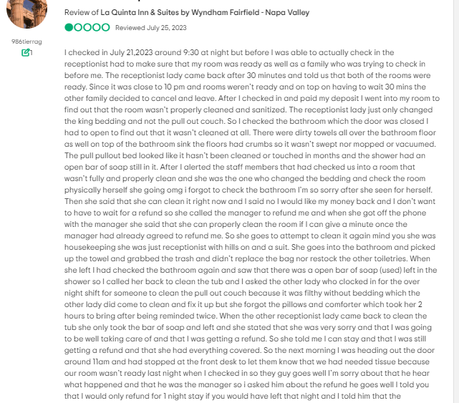
Figure 2 Negative Review on Hotel (Source: Trip Advisor, 2023)
The STEEPLE analysis reveals a number of interdependent factors leading to the falling customer satisfaction levels associated with the hotel under consideration. On the one hand, SOAR study shows that Hotel has a number of positive characteristics which contribute to its development such as prime location and excellent chefs. It is through the advanced technology and good marketing that the hotel can realise its objectives as well as positioning itself for a success. The hotel’s strategic goals and abilities have been demonstrated by its constant financial successes as well. award-winning comments from tourists. TOWS analysis is the best in plans because it connects strengths to opportunities and also addresses weaknesses based on threats. Examples of strategic imperatives include utilising strengths to leverage the opportunities, transforming weaknesses into the advantages, controlling the threats resulting from deficiencies and actively minimising any related risks arising out of defects. By conducting this in-depth analysis and plan, the KPMG helped La Quinta Inn & Suites retain its crown as the market leader along with increasing customer satisfaction.
However, a detailed analysis showed that the La Quinta Inn & Suites faced numerous operational challenges which necessitating major changes. With that in mind, this study touches upon a number of problem areas such as obsolete technology, unsteady service level and employee shortages lack of communications. Each method involves the specified application practices, change management strategies, measures of success and also anticipated benefits. Together, they offer a very detailed roadmap for the growth. B For this purpose, the hotel will require an orderly curriculum, opportunities for working with seasoned employees or external practitioners and some examples to facilitate comprehension. The change management techniques are composed of: transparent communication, high service standards and open feedback. Staff adaptation and feedback rates, employee satisfaction surveys, as well as the results of customer questionnaires would serve as performance metrics to be employed in relation with this company.
The second recommendation is that significant investments should be made in the digital check-in, better guest communication channels as well as the room technologies. The execution plan is comprised of staff training, working with the technology providers and also staging activities as a way to minimise delays. The successful change management strategies are the technical advocacy, staff support and also communication. The fourth approach to compensate for the lack of staff is an efficient workforce management. This requires looking at the pay stubs, cross-training and also peak off-peak hours. For change management to occur, the involvement of other people in the communication and training is very indispensable. Success assessment will consider the measures of income generation, employee retention and also visitor satisfaction. There are many advantages in these design concepts for the La Quinta Inn & Suites. The program for staff development supports the employee growth and also increases both the operations of an organisation, as well as visitor satisfaction. The hotel addresses the needs of its clients and becomes a market leader due to new technological innovations. Consequently, better communication enhances the dispositions, output and interactions with the customers. A properly led workforce leads to the engaging workers, low cost and also increased productivity. Reviewing the magnitude and income of hospitality, this research comprehensively analysed the costs that were associated with these initiatives.
Staff shortages, service problems, outdated technology and poor communication all seriously impacted the customer satisfaction levels as wells as the ability of La Quinta Inn & Suites to compete. This action plan is very specific; it contains objectives, costs, dates and also strategic responses to every problem. In the next thirty days, this research will be putting in place a comprehensive staff training plan focusing on uniform service. The training materials and benefits used to reducing the service inequality will be £50, 00. The second part of the project involves a £200, 00 technical upgrade in sixty days. For better passenger service and for increased operational efficiency, the suggested system would contain mobile check-in and also improved visitor communication functions.
The focus is on updating the communication tools and ensuring open dialogue during the next forty-five days, with a £30,000 budgeted for toolsets and training. With regards to the final issue—insufficient workers during peak hours, in ninety days £100k worth of strategic workforce management plans should incorporate scheduling, recruitment analysis and cross training and remuneration modifications. The study highlights some selected initiatives to respond to the decrease in the customers' satisfaction levels, including technological developments and also live feedback. KPMG has a very comprehensive influence on the global hotel industry due to its worldwide presence. The strategy plan in the study samples La Quinta Inn & Suites as a champion of mid-range hospitality and yet it seeks to resolve any challenges that could threaten longevity and competitive agility.
Table of Contents
Executive Summary 2
Introduction 7
Background of Hotel 7
Overview of the Problem 7
Overview of KPMG 8
The importance of hospitality 8
Analysis 9
STEEPLED Analysis 14
SOAR Analysis 18
TOWS Analysis 22
Recommendations and Change Management 24
Training and Development 25
Improvement in Infrastructure 27
Improvement in Communication to Avoid Conflicts 29
Understaffing and Resolving Concerns of Customers 31
Action Plan 35
Conclusion 37
References 39

Introduction
Notably, the paradigm of customer satisfaction, or CSAT is used to assess well the company's goods, services, and events live up to clients' expectations. Customer satisfaction ratings from participants vary from "very satisfied" to extremely dissatisfied (Trip Adivisor, 2023). Sustaining client happiness is critical to survival and building a solid reputation in the highly competitive food business. The internationally recognised chain hotel known as La Quinta Inns & Suites has experienced some prevalent negative reviews on different online websites. Therefore, the main tenacity of this report is to analyse the issues currently experienced by customers at the chosen hotel while also exploring the solutions that the respective hotel can incorporate in order to improve its brand image and value in the hospitality industry.

Background of Hotel
La Quinta Inn & Suites, one of the leading chains in the hospitality industry, has made headlines for its smart positioning. It is especially emphasised in their 2024 Hotel Deals that the brand still provides very attractive accommodations for the guests, providing them with a comfortable and pleasant stay (La Quinta Inn & Suites). The dynamic nature of the hotel industry is a scholarly perspective by Nalley and Gregory (2021) that promotes an adaptive market segmentation, brand management—the framework Quinta can potentially adopt.
Jeng et al. (2017) has further provided a broader societal environmental analysis of La Quinta Inn & Suites by analysing the role of hotels, including ethical aspects possibly related to sex trafficking counteraction as well also. In the same way, Wernick (2020) argues that global hotel chains such as La Quinta may have to make strategic decisions when entering new markets so how do you replicate successful strategies in diverse cultural contexts. The above gleanings collectively help to understand La Quinta Inn & Suites in the wider hospitality industry context.

Overview of the Problem
The La Quinta Inn & Suites has a multidimensional problem of the hygienic condition and also unsatisfactory customer service coupled with poor communication by the management based on negative guests' reviews. Guests complain of the check-ins that took too much time, dirty rooms, and unresponsive employees. Inadequate cleaning protocols such as the unattended bathrooms and untreated bedding cause hygiene issues that are highly concerning. Guest experience is further increased by the inadequate response of the hotel staff, conflicting information about a refund from the manager and his uncooperative attitude. Dissatisfaction also spreads to the inadequate amenities with faulty air conditioning, thin walls and poor facilities that affect the guest comfort. In addition, the issues of safety in the hotel’s questionable site and also problematic parking area also contribute to a general negative outlook. The difference between the promise given by the staff and failure to meet compensation, further highlights a breakdown in the quality of service, standards of cleanliness management as well as customer satisfaction at La Quinta Inn & Suites.

Overview of KPMG
KPMG is known for its vast expertise and standing as a leading authority in the world of planning services. Its extensive experience in effectively resolving challenging problems in a variety of sectors influences its advice services. Through the integration of local knowledge and a global perspective, KPMG helps clients solve complex business problems worldwide (GlobalData Plc, 2021). The study uses this comprehensive and wide-ranging approach to tailor company replies to the unique issues of each customer.

The importance of hospitality
Although KPMG performs very well in most of the fields, the catering division of KMPGO is also noteworthy (KPMG. 2022). According to its own knowledge of industry’s trends, dynamics and predicaments, KPMG has guided a number of organisations in gearing their operations. KPMG has proven to be an efficient partner in hotel management and strategy, which makes it the best assistant for La Quinta Inn & Suites when trying to acknowledge the issues with guest satisfaction.
In addition, this research will apply the STEEPLED framework to analyse how macro-environmental factors impact on a reduction in customer satisfaction. This study aims to define the external impact on the hotel industry. These factors can be classified as the technical, social, economical, environmental and political legal moral also demographic (MasterClass Inc. 2020). The knowledge of these external variables enables us to make sure that the provisions by KPMG are consistent with what is needed in the current market and also minimise any risks. Along with STEEPLED, a SOAR study will help develop the opportunities and strengths of this hotel as well as its goals and outcomes (Sridharan, 2021). In such a way, through this structure which is oriented inwardly La Quinta Inn & Suites can create the most for its efforts while working with the opportunities that arise outside of the premises. Creation of an effective customer satisfaction strategy calls for a holistic approach that takes into account both the internal and also external factors.
SOAR and STEEPLED will be considered in the TOWS Matrix as an elaboration of the SWOT analysis. This matrix contributes alot to the process of smart decision-making by comparing the internal weaknesses and strengths with external threats and also opportunities (Barrington, 2016). The TOWS analysis will provide the necessary data that La Quinta Inn & Suites can use to develop and implement a strategy for addressing customer dissatisfaction.

Analysis
A decrease in the level of customer satisfaction has a rippling effect on many areas that are impacted by La Quinta Inn & Suites. A close look at several guest reviews and comments reveals that with time, the image of once-perfect reputation for the hotel is gradually declining. Many demonstrations are happening from the ex-wealthy patrons, which is a drawback for the hotel’s image. The cascade effect impacts the revenue and also repeat reservations, aside from the psychological effects; it has a real financial impact (ThinkSecure Network 2021).
Figure 1 Negative Review on Hotel (Source: Quora, 2024)

Figure 2 Negative Review on Hotel (Source: Trip Advisor, 2023)

Causes of Declining Customer Satisfaction
Issue | Description | Link to La Quinta Inn & Suites
Causes of Declining Customer Satisfaction
Service Disparities | Astute readers of client feedback will discern discrepancies in service. The hotel's apparent lack of emphasis on customer gratification is evident in the frequent delays and lack of personalisation of room service (Process Street, 2023). | The negative reviews for La Quinta Inn & Suites highlight instances of unclean rooms, delayed check-ins, and unresponsive staff, contributing to customer dissatisfaction. The service disparities align with guest complaints at La Quinta.
Outdated Technological Infrastructure | Given the ease of digital connectivity in the modern era, the hotel's equipment appears antiquated. The public's apprehensions regarding inadequate Wi-Fi, malfunctioning key cards, and problems with online ticket systems underscore the critical nature of hotel technological modernisation (Hotjar.com, 2022). | La Quinta's negative feedback includes mentions of broken amenities, potentially outdated facilities, and dissatisfaction with the overall quality of the stay. Technological modernisation could address these concerns.
Ineffective Communication | Dissatisfied consumers result from a communication breakdown. When there are misunderstandings regarding tickets, event planning, or general inquiries, patrons become enraged (Sterns, 2023). | La Quinta guests reported issues with communication, particularly in the manager's conflicting statements about refunds and lack of responsiveness. Ineffective communication contributes to overall dissatisfaction.
Understaffing Issues | An exhaustive analysis of empirical data indicates that there is a shortage of personnel, specifically during periods of high demand. Insufficient personnel leads to lengthy waiting periods, diminished personalised service, and an unsatisfactory passenger experience (Stepowany, 2023). | La Quinta's negative reviews highlight problems with staff responsiveness and service quality, aligning with the issues of understaffing mentioned.
Feedback Mechanisms
Limited Reporting Techniques | Standard feedback forms and questionnaires are inadequate in providing the hotel with enough time to address major grievances after the guest's stay. Statisticians often fail to accurately capture visitor emotion. Management of the hotel can understand how its consumers are feeling and react appropriately by using technology for real-time feedback and mood monitoring (Best practices, 2023). | La Quinta's management might benefit from enhanced feedback mechanisms, given the guests' dissatisfaction and the need for real-time responses to address concerns promptly.
Impact on Reputation and Income
Reputation Erosion | A hotel's reputation suffers when guests are not satisfied. An abundance of negative internet reviews might put off potential guests and damage the hotel's reputation as a high-end accommodation option (Fuchs, 2022). | La Quinta Inn & Suites faces reputation challenges as negative reviews impact potential guest perceptions.
Revenue Contraction | Commerce declines as consumer happiness declines. A reduction in corporate reservations and repeat business means less money coming in. Negative internet reviews discourage customers and maintain a downward trend in product returns, which exacerbates the financial position (busayo.longe, 2020). | La Quinta's financial position might be impacted by declining customer satisfaction, potentially leading to reduced repeat business and reservations.

Scope of the Issue
The negative effects of the decline in customer satisfaction are not just monetary. It influences the attitude as well as the commitment of the hotel staff members because it becomes a part and parcel of their lives (Wood, 2022). However, the poor reputation of the hotel affects La Quinta Inn & Suites and also undermines hospitality as a whole (Best practices, 2023).

STEEPLED Analysis
Many aspects from both the internal and also external processes are included in an analysis based on STEEPLE (Jeng, et al.201). It targets on matters of technology, politics ethics and law that are contrary to the interests of businesses (Delve, 2016). Many business professionals use the following data in developing many various appraisals. With the help of a STEEPLE analysis, the organisations have an opportunity to solve such kind of problems (MasterClass, Inc, 2020). Through this study, businesses can have a chance to earn significant revenues and also remain competitive. In addition, It also helps in tracking and being aware of the trends that were observed (Frue 2020). With the help of STRIKE research, it is possible that companies can significantly enhance their products’ or services quality which the customers will enjoy. Some aspects are directly impacting the working of the La Quinta Inn & Suites.

Figure 3 STEEPLED Analysis (Source: Professionalacademy.com, 2024)
Factor | Description | Impact on La Quinta Inn & Suites
Social Factors
Consumer Reviews on Quora and Trip Advisor | Quora (2024) and Trip Advisor (2023) host negative reviews, indicating dissatisfaction with cleanliness, service quality, and amenities. Social media platforms influence potential guests' perceptions and decisions. | Negative reviews on Quora and Trip Advisor significantly impact the hotel's reputation, potentially deterring future bookings and affecting customer trust (Quora, 2024; Trip Advisor, 2023).
Ethical Considerations in Combating Sex Trafficking | Jeng et al. (2022) discuss ethical questions related to hotels' role in combating sex trafficking. Addressing such concerns becomes vital for La Quinta Inn & Suites to uphold ethical standards. | Embracing ethical practices is crucial to maintain a positive image and prevent potential backlash related to ethical considerations (Jeng et al., 2022).
Technological Advances
Hotel Deals and Online Presence | La Quinta's online presence, including Hotel Deals (La Quinta Inn & Suites, 2024), impacts customer acquisition. Leveraging technology for promotional activities and enhancing online booking systems is essential. | Effective use of technology for promotional deals and an improved online booking experience can positively impact customer engagement and reservations (La Quinta Inn & Suites, 2024).
Environmental Factors
Climate Change Impact on Civil Infrastructure | Rotta Loria (2023) discusses the silent impact of underground climate change on civil infrastructure. Climate-related considerations may affect the hotel's physical infrastructure and long-term sustainability planning. | Adapting to climate change impacts is essential for ensuring the hotel's resilience and minimising potential damage to infrastructure (Rotta Loria, 2023).
Economic Factors
Franchising and Distribution | Gruenberg et al. (2021) highlight current trends in franchising. La Quinta's affiliation with Wyndham and its franchising model influences the hotel's economic structure and market positioning. | Economic stability and growth are tied to the success of the franchise model, requiring effective management and adaptation to industry trends (Gruenberg et al., 2021).
Tourism Trends and Industry Structure | Coomes et al. (2020) discuss the future of bourbon tourism, a factor influencing the hotel's economic performance based on regional tourism trends. | Adapting to regional tourism trends can impact the hotel's revenue by attracting visitors seeking specific experiences (Coomes et al., 2020).
Political Factors
Inclusion-Based Human Resources Strategy | Wernick (2020) explores the potential replication of Lemon Tree Hotels' inclusion-based human resources strategy in the US market. The political landscape and labor policies influence human resource strategies. | Adapting inclusive human resource strategies aligns with political and social expectations, potentially enhancing La Quinta's employer brand and workforce satisfaction (Wernick, 2020).
Regulatory Environment in Hotel Industry | Kacmar (2023) highlights architectural considerations in small hotel design, indicating the influence of regulations on construction and infrastructure planning. | Adherence to regulations influences the hotel's architectural decisions and ensures compliance with industry standards (Kacmar, 2023).
Legal Factors
Industry Structure and Quality Competition | Butters and Hubbard (2023) examine industry structure, segmentation, and quality competition in the US hotel industry. Legal factors such as antitrust regulations influence competitive dynamics. | Adhering to legal standards ensures fair competition and compliance, impacting the hotel's market positioning and reputation (Butters and Hubbard, 2023).
Cultural Factors
Architectural Considerations in Small Hotels | Coomes et al. (2020) emphasise architectural design in small hotels, aligning with cultural preferences for unique and aesthetically pleasing accommodations. | Incorporating culturally appealing architectural elements enhances guest experiences and aligns with evolving cultural preferences (Coomes et al., 2020).
Demographic Trends
Market Segmentation and Brand Management | Nalley and Gregory (2021) advocate for adaptive market segmentation and brand management, indicating the importance of demographic considerations in hotel marketing. | Aligning marketing strategies with demographic trends ensures effective market segmentation and enhances brand relevance (Nalley and Gregory, 2021).

SOAR Analysis
There is an alternative way of strategic planning which by the use of SOAR analysis (Strengths, Opportunities, Aspirations and Results) acronym. It fosters proactive behavior by focusing on the organisational objectives, strengths, external forces and also projected consequences (Clarity 2021; Lucidity, 2021 Profit.Co, 2022). This innovative concept allows the companies to leverage new opportunities and also enhance existing competencies, thereby making their strategy more dynamic and futuristic (Alemar, 2023). By combining internal and external elements, SOAR offers businesses a broad perspective that enables them to meet their long-term goals (Cascade.app, 2024). A SWOT analysis is redundant. The large network of interdependent elements forming SOAR offers a very robust strategic framework and smart guidance in maneuvering through the evolving business landscape.
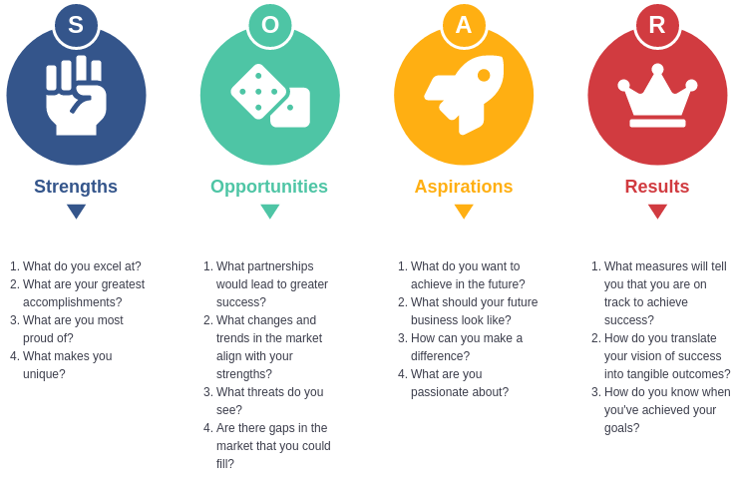
Figure 4 SOAR Analysis (Source: Visual-paradigm.com, 2024)

Factor | Description | Strengths | Opportunities | Aspirations | Results
Social Factors
Consumer Reviews on Quora and Trip Advisor | Negative reviews on Quora and Trip Advisor may reveal areas for improvement. | Analyse feedback to identify specific weaknesses. | Enhance customer satisfaction by addressing concerns. | Aspire to improve online ratings and guest satisfaction. | Achieve positive results by implementing changes based on customer feedback, leading to improved reviews and reputation.
Ethical Considerations in Combating Sex Trafficking | Addressing ethical concerns contributes to positive brand perception. | Implement ethical practices to combat sex trafficking. | Be recognised as a socially responsible hotel. | Aspire to create a safe and ethical environment for guests. | Achieve positive results by gaining trust and loyalty from socially conscious customers.
Technological Advances
Hotel Deals and Online Presence | Utilise technology for promotional activities and online bookings. | Leverage technology to enhance online promotions and booking systems. | Aspire to be a leader in online customer engagement. | Achieve positive results with increased online visibility, bookings, and customer satisfaction. | Positive Guest Reviews and High Ratings: Positive reviews and high ratings were the result of the La Quinta Inn & Suites’s significant efforts to ensure guest happiness. Guests who value the hotel's excellent cleanliness and service come back time and time again.
Environmental Factors
Climate Change Impact on Civil Infrastructure | Adapt infrastructure to mitigate climate change effects. | Invest in climate-resilient infrastructure. | Aspire to be an environmentally sustainable hotel. | Achieve positive results with enhanced infrastructure resilience and eco-friendly practices. | The hotel's success is largely due to its ongoing profitability and growth. The hotel's sound financial standing is a testament to its keen business sense and will to stay ahead of the competition in the hospitality sector.
Economic Factors
Franchising and Distribution | Wyndham affiliation provides a strong market position. | Explore new franchising and distribution opportunities. | Aspire to expand market presence through strategic partnerships. | Achieve positive results with increased market share and revenue. | It allows the brand to foster international expansion
Tourism Trends and Industry Structure | Align with bourbon tourism trends for regional appeal. | Develop offerings catering to bourbon tourism. | Aspire to be a preferred choice for bourbon enthusiasts. | Achieve positive results with increased bookings from bourbon tourists. | It allows the brand to attain competitive edge in the industry

TOWS Analysis
Through the application of TOWS analysis, organisations and individuals can find out how much power they have to compare with their weakness opposite threats as well as opportunities of strength. It measures the market position of a company through elements similar to SWOT analysis answers, but using another method TOWS analyses weakness, strengths opportunities and threats comparatively. The TOWS framework could be very useful after the SWOT analysis. The organisations can benefit from the TOWS research through implementation of strategies that help them to mitigate risks as well as opportunities. It also leads the students to working with their weaknesses and building on their strength (Mindtools.com, 2024). They understand how seriously it is to invest in their development by cancelling the operational loss and creating demanding learning programs (Jovana Smoljanovic Tucakov, 2023)
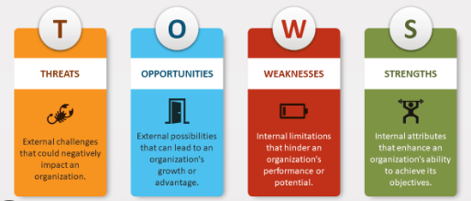
Figure 5 TOWS Analysis (Source: Zirk, 2023)
Source: (Zirk, 2023)
Factor | Internal | External
Strengths | 1. Established Wyndham affiliation provides a strong market position and global recognition. 2. Technological advances with online promotions and booking systems enhance customer engagement. 3. Inclusion-based human resources strategy contributes to a diverse and satisfied workforce. | 1. Positive consumer reviews on Quora and Trip Advisor reflect customer satisfaction. 2. Opportunities for environmental sustainability with climate-resilient infrastructure. 3. Adherence to legal standards and industry regulations ensures compliance.
Weaknesses | 1. Negative online reviews highlight service disparities and outdated technological infrastructure issues. 2. Ineffective communication with customers results in dissatisfaction. 3. Staffing issues lead to delays, diminished service, and unsatisfactory guest experiences. | 1. Reputation erosion due to negative online reviews impacts the hotel's image. 2. Revenue contraction as dissatisfied customers reduce corporate reservations and repeat business. 3. Limited effectiveness of current feedback mechanisms to address major grievances promptly.
Opportunities | 1. Explore new franchising and distribution opportunities for market expansion. 2. Align with tourism trends, such as bourbon tourism, for regional appeal. 3. Implement ethical practices to combat sex trafficking, enhancing the hotel's brand perception. | 1. Leverage technological advancements for enhanced online visibility and bookings. 2. Invest in climate-resilient infrastructure to mitigate climate change effects. 3. Monitor industry trends for quality competition and market positioning.
Threats | 1. Regulatory changes and legal risks in the hotel industry may impact operations. 2. Negative online reviews pose a threat to the hotel's reputation and customer trust. 3. Economic uncertainties and shifts in consumer preferences can affect revenue. | 1. Increased competition in the hotel industry may impact market share. 2. Unfavorable demographic trends may affect market segmentation and brand relevance. 3. Environmental factors, such as climate change, pose risks to infrastructure resilience.

Recommendations and Change Management
In the fiercely competitive hospitality industry, La Quinta Inn & Suites stands to gain significantly from a holistic approach to improvement, informed by diverse sources. Strategic recommendations and effective change management can redefine the hotel's operations and elevate the overall guest experience.
Drawing insights from various reputable sources, a multifaceted set of recommendations can be devised for La Quinta Inn & Suites. First and foremost, integrating cutting-edge technology emerges as a critical recommendation, as suggested by Canarytechnologies.com (2023). By investing in automated check-in processes, room automation, and innovative guest communication tools, the hotel can substantially enhance both operational efficiency and guest satisfaction. This transformation requires a meticulous change management strategy, emphasising the advantages of technology adoption and designating technology ambassadors to facilitate the transition, as proposed by Theamegroup.com (2020).
Another pivotal recommendation involves strengthening internal and external communication channels, aligning with insights from Calilio.com (2024). Training sessions on effective communication methods and the introduction of modern communication platforms can vastly improve collaboration among staff and elevate the overall guest experience. Change management here plays a crucial role, underscoring the benefits of enhanced communication, integrating employee and guest input into operational processes, and fostering a transparent and open dialogue. Monitoring the frequency and efficiency of internal communication channels, along with feedback from both employees and guests, serves as a key success metric (Lumenlearning.com, 2016).
Prioritising comprehensive employee training and development is the third cornerstone recommendation for La Quinta Inn & Suites, aligning with insights from Continu.com (2023). Robust onboarding processes and continuous training programs ensure a skilled and customer-focused staff, contributing to consistent service delivery. The implementation involves creating detailed training plans with an emphasis on service standards and real-world examples. Effective change management is imperative here, necessitating clear communication on how training enhances visitor satisfaction, involving staff in decision-making, and recognising successful adaptations. Monitoring staff performance through surveys, real-time feedback, and mood monitoring ensures the consistent delivery of high-quality service and fosters a culture of ongoing improvement (Gupta, 2023).
The importance of change management cannot be overstated in this context. It serves as the linchpin that ensures a smooth transition during the implementation of these recommendations. Change management involves effective communication strategies, staff involvement, and recognition of successful adaptations. By navigating change successfully, La Quinta Inn & Suites can minimise resistance, inspire its staff, and maximise the benefits of the suggested improvements. Whether it's integrating new technologies, enhancing communication, or investing in employee training, a robust change management approach ensures a positive and sustainable impact on the hotel's operations and guest satisfaction. The synergistic integration of these recommendations with effective change management positions La Quinta Inn & Suites as a frontrunner in the competitive landscape of upscale hospitality.
On the other hand, some of the crucial recommendations for change to foster the performance of La Quinta Inn & Suites are presented below:

Training and Development
Factor | Recommendation | Implementation | Change Management | Success Measurement | Potential Benefits | Associated Cost
Service Disparities | Provide a thorough onboarding and training plan for La Quinta Inn & Suites employees to ensure consistent hotel service (Brown, 2023). | Create a comprehensive lesson plan with an emphasis on service standards. Provide specific training for highly skilled or experienced employees. Use real-world examples and case studies. Monitor developments and address obstacles through assessments and reports. | Establish a mechanism for staff to share ideas and concerns. Reward and praise successful migrations. Ensure everyone understands how the training improves visitor happiness. | Surveys of visitor satisfaction before and after the introduction of the training plan. Covert purchase assessments to confirm service correctness. Document staff comments and modifications throughout training. | - Easier transition between areas (eating, front desk, personal service). - Accentuates dedication to quality and gives a unique brand character. - Career progression for employees emphasising training. - Stimulates client loyalty and enhances staff performance. - Financial savings from resource optimisation and operational cohesion. - Competitive edge in the hotel business. - Attracts wealthy guests seeking comfortable and stylish accommodations. - Boosts customer happiness, employee development, and operational performance. - Establishes the hotel as a trailblazer in upmarket hospitality. | £50,000
The table above mentions the main features of a suggestion to address the service gaps at La Quinta Inn & Suites. It captures the recommendations, implementation details, change management implications, measures of success parameters and benefits it may bring in addition to the cost. The focus of the proposal relates to developing a coordinated staff training plan in order to achieve uniform service throughout each hotel, as implied by the issues identified with customer reviews.

Improvement in Infrastructure
Factor | Recommendation | Implementation | Change Management | Success Measurement | Potential Benefits | Associated Cost
Improvement in Infrastructure | Include room automation, contactless check-in, and improved guest communication techniques in the La Quinta Inn & Suites technology overhaul (Tech Target, 2020). | Work with technology providers to find and implement cutting-edge solutions. Ensure thorough training for staff on new systems. Implement a phased approach for deployment. | Communicate the advantages of the technology update. Designate employees as "technology ambassadors" for support. | Measure efficacy through user interface traversal, tracking visitor problems with technology, and team integration of new technologies. | - Thorough digital makeover impacting hotel operations and guest experience. - Improved communication platforms, computerised check-in, and room automation. - Compliance with health and safety regulations. - Faster visitor arrival and simplified check-in. - Establishment as a pioneer in the hospitality industry. - Attraction of tech-savvy visitors seeking efficiency. - Personalisation through in-room technology. - Enhancement of the employee-client connection. - Improved customer satisfaction and issue resolution. - Increased operational efficiency and reduced environmental impact. - Global leadership in innovation and customer satisfaction. | £200,000
This tabular representation outlines the key aspects of the recommendation for improving infrastructure at La Quinta Inn & Suites. It covers the recommendation, implementation details, change management considerations, success measurement methods, potential benefits, and the associated cost. The proposal focuses on a comprehensive technology overhaul, aligning with the identified issues in customer reviews, to enhance guest experience, operational efficiency, and the hotel's global standing in the hospitality industry.

Improvement in Communication to Avoid Conflicts
Factor | Recommendation | Implementation | Change Management | Success Measurement | Potential Benefits | Associated Cost
Communication Enhancement | Urge staff and visitors to use recently created communication channels for interpersonal engagement. | Set up classes on effective communication. Conduct town hall meetings and utilise various communication channels for openness. | Emphasise the advantages of enhanced communication. Incorporate employee and visitor input, prioritise operational efficiency, and reward exceptional communication skills. | Reduce complaints about communication problems from tourists. Examine the frequency and efficiency of internal communication channels and gather employee suggestions. | - Upgraded communication technologies. - Enhanced interpersonal engagement between staff and guests. - Real-time collaboration across hierarchical positions. - Improved workplace flexibility and adaptability. - Streamlined internal procedures and task planning. - Operational simplification and avoidance of service delays. - Consistent and timely service delivery. - Comprehensive and individualised guest service. - Open and honest communication fostering trust. - Increased employee involvement, motivation, and devotion. - Continuous improvement through feedback. - Standing out as a prime example of adaptability and quality in upmarket hospitality. | £30,000
This tabular representation outlines the key aspects of the recommendation for enhancing communication at La Quinta Inn & Suites. It covers the recommendation, implementation details, change management considerations, success measurement methods, potential benefits, and the associated cost (Biz Technology Solutions, 2023). The proposal focuses on encouraging the use of communication channels for both staff and visitors to improve interpersonal engagement and address communication challenges highlighted in customer reviews (Cloudbed, 2022).

Understaffing and Resolving Concerns of Customers
Factor | Recommendation | Implementation | Change Management | Success Measurement | Potential Benefits | Associated Cost
Understaffing and Resolving Customer Concerns | Smart distribution of attractive schedules and fair remuneration for effective personnel management. | Consider peak and off-peak hours, prioritise cross-training, and evaluate pay plans to exceed industry norms (Wavetec, 2023). | Provide succinct justifications for schedule modifications and pay increases. Offer training and assistance for new tasks, involve staff in decision-making and schedule planning (Champagne, 2023). | Measure visitor satisfaction during high and low activity times, evaluate the effectiveness of schedule modifications and staff retention. Assess financial implications and savings from better timing. | - Boosted employee engagement and hotel efficiency. - Competitive remuneration packages. - Optimised scheduling for availability. - Improved labour efficiency and operational flexibility. - Lower costs associated with the business model. - Attractive pay plans for hiring and staff retention. - Fair compensation and recognition of employee efforts. - Desirable workplace in the competitive hospitality industry. - Higher job satisfaction and lower turnover rates. - Enhanced process flexibility and responsiveness. - Improved customer service and quick responses to challenges. - Robust organisational environment. - Increased customer satisfaction, employee happiness, and productivity. - Competitive edge and operational efficiency. - Attracting and retaining talented workers. - Outstanding service and competitive advantage. | £100,000
This tabular representation outlines the key aspects of the recommendation for addressing understaffing and resolving customer concerns at La Quinta Inn & Suites. It covers the recommendation, implementation details, change management considerations, success measurement methods, potential benefits, and the associated cost (Landman, 2021). The proposal focuses on smart personnel management, including scheduling and remuneration, to enhance employee engagement, hotel efficiency, and overall service quality (libsyn, 2018).
On the other hand, while addressing service disparities at La Quinta Inn & Suites, a comprehensive onboarding and training plan is recommended. The implementation involves creating a detailed lesson plan emphasising service standards, providing specific training for experienced staff, and utilising real-world examples. Monitoring developments and overcoming obstacles through assessments and reports is essential (World, 2023). Change management strategies include establishing a mechanism for staff to share ideas, rewarding successful migrations, and ensuring everyone understands how the training improves visitor happiness (Yurchenko, 2022).
Moreover, the success can be measured through surveys of visitor satisfaction, covert purchase assessments, and documenting staff comments and modifications throughout training. The potential benefits include an easier transition between areas, accentuated dedication to quality, career progression for employees emphasising training, stimulation of client loyalty, financial savings from resource optimisation, and a competitive edge in the hotel business, with an associated cost of £50,000.
In the realm of infrastructure improvement, La Quinta Inn & Suites is advised to incorporate room automation, contactless check-in, and enhanced guest communication techniques. The implementation includes collaborating with technology providers, ensuring thorough staff training, and deploying technologies in phases. Change management strategies involve communicating the advantages of the technology update and designating employees as "technology ambassadors" for support. Success is measured through user interface traversal, tracking visitor problems with technology, and team integration of new technologies. The potential benefits encompass a digital makeover impacting hotel operations, improved communication platforms, compliance with health and safety regulations, faster visitor arrival, and establishment as a pioneer in the hospitality industry. The associated cost is £200,000.
In the context of communication enhancement to avoid conflicts, the recommendation is to encourage staff and visitors to use recently created communication channels for interpersonal engagement. Implementation involves setting up classes on effective communication, conducting town hall meetings, and utilising various communication channels. Change management strategies emphasise the advantages of enhanced communication, incorporation of employee and visitor input, prioritising operational efficiency, and rewarding exceptional communication skills. Success is measured through reduced complaints about communication problems, examination of the frequency and efficiency of internal communication channels, and gathering employee suggestions. The potential benefits include upgraded communication technologies, enhanced interpersonal engagement, real-time collaboration across hierarchical positions, improved workplace flexibility, streamlined internal procedures, and consistent and timely service delivery. The associated cost is £30,000.
Addressing understaffing and resolving customer concerns necessitates a smart distribution of attractive schedules and fair remuneration for effective personnel management. The implementation involves considering peak and off-peak hours, prioritising cross-training, and evaluating pay plans. Change management strategies include providing succinct justifications for schedule modifications and pay increases, offering training and assistance for new tasks, and involving staff in decision-making and schedule planning. Success is measured through boosted employee engagement, competitive remuneration packages, optimised scheduling, improved labor efficiency, lower costs associated with the business model, attractive pay plans for hiring and staff retention, and a desirable workplace in the competitive hospitality industry. The associated cost is £100,000.
These recommendations are informed by various reputable sources, ensuring a comprehensive and strategic approach to addressing the identified challenges at La Quinta Inn & Suites. The incorporation of best practices from Fallon (2017), Fitzgerald Mujuru (2023), Grover (2021), Gupta (2023), and others ensures that the proposed strategies align with industry standards and contemporary insights in the hospitality sector

Action Plan
The following action plan delineates a strategic approach to each problem, outlining the solution, desired outcomes, timeframes, and associated costs as well.
Problem | Solutions | Desired Outcomes | Time Scale | Completion Date | Planned Budget
Service Disparities | Implement a comprehensive onboarding and training plan, emphasising service standards, real-world examples, and case studies. Monitor progress through assessments and reports. | - Consistent hotel service throughout each hotel. - Improved staff competency and service correctness. - Enhanced visitor satisfaction. | 6 months | 1st july 2024 | £50,000
Improvement in Infrastructure | Overhaul technology with room automation, contactless check-in, and enhanced guest communication. Collaborate with tech providers, provide staff training, and deploy technologies in phases. | - Thorough digital makeover impacting hotel operations and guest experience. - Faster visitor arrival and simplified check-in. - Establishment as a pioneer in the hospitality industry. | 8 months | 1st September 2024 | £200,000
Improvement in Communication to Avoid Conflicts | Encourage staff and visitors to use communication channels. Set up classes on effective communication and conduct town hall meetings. Utilise various communication channels for openness. | - Upgraded communication technologies. - Streamlined internal procedures and task planning. - Consistent and timely service delivery. | 4 months | 1st May 2024 | £30,000
Understaffing and Resolving Customer Concerns | Implement smart personnel management with optimal scheduling and fair remuneration. Consider peak and off-peak hours, prioritise cross-training, and evaluate pay plans. | - Boosted employee engagement and hotel efficiency. - Attractive pay plans for hiring and staff retention. - Enhanced customer satisfaction and service responsiveness. | 5 months | 1st June 2024 | £100,000
This action plan outlines specific solutions for each identified problem at La Quinta Inn & Suites. The desired outcomes are clearly articulated for each problem, emphasising improvements in service quality, infrastructure, communication, and staffing. A realistic time scale is provided for each solution, along with a planned completion date. Additionally, the budget for each solution is estimated, providing a clear financial framework for implementation. This structured approach ensures a comprehensive and strategic resolution of the issues facing La Quinta Inn & Suites, aligning with industry best practices and contemporary insights.

Conclusion
In sum, the La Quinta Inn & Suites analysis has yielded potentially useful insights about several problems this hotel is facing and offers a full spectrum of ways to improve on different aspects of its operations. The customer reviews and industry best practices led to identifying certain issues: the service disparities, infrastructure limitations, communication gaps as well as the staffing problem. The proposed solutions focused on the creation of a strategic action plan that would address these challenges and enhance an very effective, guest-centric operational model.
Service disparities were the first challenge mentioned as in a hotel, there is a different quality of service from one location to another. In order to fix this, the recommendation highlighted a comprehensive onboarding and training plan. This plan concentrated on improving the quality standards, adopting real-life cases and using different case studies to affirm the staff ability. The intended results were uniform hotel service across every location, better employee skill level and higher in the visitor satisfaction. The six-month timeline set for this solution included a £50, 00 budget.
The second issue addressed an infrastructural upgrade hinting at the need for some technological reforms. The provided solution included room automation, contactless check-in and also complex guest communications. The technology providers collaboration, staff training and the step by step deployment were suggested. The intended results included a digital transformation of how the hotels work, faster traffic in guests and La Quinta Inn & Suites as the first company to serve hospitability. Eight months was the estimated time frame for this particular technological advancement and it had a budget of £200,000..
The third challenge came from the communication enhancement aimed at preventing conflicts through promoting both the staff and visitors to use the recently created channels of communications. The solution suggested included organising communications that were effective in classes, holding town hall meetings as well and various communication channels to improve transparency. The goals were more effective communication technologies, more efficient internal practices and a standardised delivery of service across the board. This solution was envisaged to take four months and cost £30,000.
The fourth and last challenge was staffing issues, including the customer complaints arising from understaffing. The answer involved, smart distribution of the appealing schedules and reasonable compensation for the personnel management. This entailed such aspects as peak and off-peak periods, focus on cross training, pay plan evaluation for surpassing the industry standards. These outcomes included improved employee motivation, efficient scheduling for availability and competitive pay plans to attract hiring as well as keep talents also. This solution was intended for planning within the five months at the cost of £100,000.
Thus, the outlined plan of action with elaborated solutions and the expected results along with timelines and a defined budget has become a power compass that leads La Quinta Inn & Suites away from its current difficulties. A comprehensive perspective incorporates numerous dimensions of the hotel operations to attain a total transformation that reflects the modern industry. With these recommendations in place, La Quinta Inn & Suites could be able to raise its level of guest interaction; enhance the performance efficiency and ultimately emerge as the best leader among all competitors. This strategic plan portrays a quality, innovation and satisfied customers culture which would create alot of room for future successes of this company.

References
Alemar, S. (2023). 17 Hotel Improvement Ideas Every Hotelier Should Consider. [online] Canarytechnologies.com. Available at: https://www.canarytechnologies.com/post/hotel-improvement-ideas.
Barrington, R. (2016). TOWS Analysis: A Step by Step Guide. [online] Oxford College of Marketing Blog. Available at: https://blog.oxfordcollegeofmarketing.com/2016/06/07/tows-analysis-guide/.
Best practices (2023). Customer dissatisfaction: A guide to handling unhappy customers. [online] Zendesk. Available at: https://www.zendesk.com/blog/customer-dissatisfaction/.
Biz Technology Solutions (2023). Optimised IT Infrastructure Benefits - Biz Technology Solutions. [online] Biz Technology Solutions. Available at: https://biztechnologysolutions.com/benefits-of-optimised-it-infrastructure/.
Brown, T. (2023). 15 Super Simple Ideas to Enhance Hotel Guest Experience. [online] Mews.com. Available at: https://www.mews.com/en/blog/enhance-hotel-guest-experience.
busayo.longe (2020). Customer Dissatisfaction: The Ultimate Guide. [online] Formplus. Available at: https://www.formpl.us/blog/customer-dissatisfaction.
Butters, R.A. and Hubbard, T.N., 2023. Industry Structure, Segmentation, and Quality Competition in the US Hotel Industry. The Journal of Industrial Economics, 71(2), pp.491-537.
Calilio.com. (2024). Available at: https://www.calilio.com/blogs/business-communication-types-importance-advantages.
Cascade.app. (2024). SOAR Analysis: What It Is & Step-By-Step Guide (2024). [online] Available at: https://www.cascade.app/blog/soar-analysis-guide#:~:text=TL%3BDR,to%20execute%20upon%20those%20strengths. ‌ Cga-integration
Center, D., 2020. connection. Director, 920, pp.773-2864.
Champagne, L. (2023). 7 Benefits of Content Scheduling. [online] Lonefircreative.com. Available at: https://www.lonefircreative.com/blog/7-benefits-of-content-scheduling.
CHRMP. (2022). 12 Benefits of Employee Training: Why it is Important? [online] Available at: https://www.chrmp.com/benefits-of-employee-training/.
Cloudbeds (2022). 17 effective ways to increase hotel revenue and profit. [online] Cloudbeds. Available at: https://www.cloudbeds.com/articles/top-7-ways-to-increase-hotel-sales/.
Continu.com. (2023). 9 Powerful Benefits of Employee Training & Development - Continu. [online] Available at: https://www.continu.com/blog/employee-training-benefits.
Coomes, S., Huston, K. and Mangeot, M., 2020. The future of bourbon tourism. In The Rebirth of Bourbon: Building a Tourism Economy in Small-Town, USA (pp. 113-137). Emerald Publishing Limited.
Delve. (2020). How STEEPLE Analysis Informs Design Strategy. [online] Available at: https://www.delve.com/insights/how-steeple-analysis-informs-design-strategy.
Emeritus (2022). 12 Benefits of Training Employees in Today’s Workplace. [online] Emeritus Online Courses. Available at: https://emeritus.org/blog/benefits-of-training-employees/.
Fallon, N. (2017). 8 Employee Training Tactics That Actually Work. [online] Business News Daily. Available at: https://www.businessnewsdaily.com/9399-employee-training-tactics.html.
Fitzgerald Mujuru (2023). Introduction Making appointments is an effective way to manage your time and be more productive. It helps you stay organized, prioritise tasks, and get more done in less time. [online] Linkedin.com. Available at: https://www.linkedin.com/pulse/7-benefits-making-appointments-scheduling-business-fitzgerald-mujuru.
Frue, K. (2020). STEEPLED Analysis: What is it with Examples. [online] PESTLE Analysis. Available at: https://pestleanalysis.com/steepled-analysis/.
Fuchs, J. (2022). Customer Dissatisfaction: How to Handle and Remedy It [+ Examples]. [online] Hubspot.com. Available at: https://blog.hubspot.com/service/customer-dissatisfaction.
GlobalData Plc (2021). KPMG International Coop Company Profile - Overview. [online] Globaldata.com. Available at: https://www.globaldata.com/company-profile/kpmg-international-coop/.
Grover, A. (2021). Top 7 Benefits of Employee Scheduling in Businesses - Workstatus. [online] Workstatus. Available at: https://www.workstatus.io/blog/workforce-management/benefits-of-employee-scheduling-in-businesses/.
Gruenberg, M., Harford, D., Wheeler, V. and Sai, J., 2021. Franchising & Distribution Currents. Franchise Law Journal, 41(2), pp.269-307.
Gupta, D. (2023). 17 Best Employee Training Methods & Techniques (2023). [online] The Whatfix Blog | Drive Digital Adoption. Available at: https://whatfix.com/blog/employee-training-methods/.
Hotjar.com. (2022). 8 Customer Satisfaction Challenges and Ways to Resolve Them. [online] Available at: https://www.hotjar.com/customer-satisfaction/challenges-and-solutions/.
Indeed.com. (2022). What Are Channels of Communication? (With Benefits and Tips) | Indeed.com Canada. [online] Available at: https://ca.indeed.com/career-advice/career-development/what-are-channels-of-communication.
Jain, Y. (2022). 12 Benefits of Training Employees in the Workplace. [online] Emeritus India. Available at: https://emeritus.org/in/learn/benefits-of-training-employees/.
Jeng, C.C., Huang, E., Meo, S. and Shelley, L., 2022. Combating Sex Trafficking: The Role of the Hotel—Moral and Ethical Questions. Religions 13: 138.
Jovana Smoljanovic Tucakov (2023). 13 Benefits of Appointment Scheduling for Your Business. [online] Amelia WordPress Booking Plugin. Available at: https://wpamelia.com/benefits-of-scheduling/.
Kacmar, D., 2023. Big Little Hotel: Small Hotels Designed by Architects. Taylor & Francis.
KPMG. (2022). Hotel and hospitality - KPMG Global. [online] Available at: https://kpmg.com/xx/en/home/insights/2020/01/customer-first-insights-hotel-and-hospitality.html.
La Quinta Inn & Suites. 2024. Hotel Deals. Retrieved from https://www.wyndhamhotels.com/laquinta/hotel-deals
Landman, P. (2021). 10 Ways on How to Improve Hotel Operations. [online] Xotels. Available at: https://www.xotels.com/en/hotel-management/10-ways-how-to-improve-hotel-operations.
libsyn (2018). Communication Channels Pros And Cons. [online] Collaboration Superpowers. Available at: https://www.collaborationsuperpowers.com/221-communication-channels-pros-and-cons/.
Lucidity. (2021). Introduction to SOAR Analysis | Lucidity. [online] Available at: https://getlucidity.com/strategy-resources/introduction-to-soar-analysis/.
Lumenlearning.com. (2016). Channels of Business Communication | Principles of Management. [online] Available at: https://courses.lumenlearning.com/wm-principlesofmanagement/chapter/channels-of-business-communication/.
MasterClass, Inc. (2020). STEEPLE Analysis: How to Conduct a STEEPLE Analysis - 2024 - MasterClass. [online] Available at: https://www.masterclass.com/articles/steeple-analysis.
MasterClass, Inc.. (2020). TOWS Analysis: Using a TOWS Matrix for Strategic Planning - 2024 - MasterClass. [online] Available at: https://www.masterclass.com/articles/tows-analysis.
Mindtools.com. (2024). MindTools | Home. [online] Available at: https://www.mindtools.com/auqstul/the-tows-matrix.
Nalley, M. and Gregory, A., 2021. A Case for Change, Market Segmentation and Brand Management. Journal of Hospitality & Tourism Cases, 9(2), pp.60-65.
Process Street. (2023). How to Explain the Cause and Effect Diagram of Low Customer Satisfaction. [online] Available at: https://www.process.st/how-to/explain-the-cause-and-effect-diagram-of-low-customer-satisfaction/.
Professionalacademy.com. (2024). Marketing Theories – PESTEL Analysis. [online] Available at: https://www.professionalacademy.com/blogs/marketing-theories-pestel-analysis/.
Profit.Co. (2022). Importance of Scheduling Tasks and its Benefits. [online] Best OKR Software by Profit.co. Available at: https://www.profit.co/blog/task-management/importance-of-scheduling-tasks-and-its-benefits/.
Quora. 2024. What are some bad reviews for the La Quinta Inn & Suites in San Antonio, TX? (n.d.). Retrieved from https://www.quora.com/What-are-some-bad-reviews-for-the-La-Quinta-Inn-Suites-in-San-Antonio-TX
Rotta Loria, A.F., 2023. The silent impact of underground climate change on civil infrastructure. Communications Engineering, 2(1), p.44.
Sridharan, M.A. (2021). SOAR Analysis. [online] Think Insights. Available at: https://thinkinsights.net/strategy/soar-analysis/.
s-technology-infrastructure-solutions-businesses-organisations#:~:text=This%20can%20help%20organisations%20become,can%20reduce%20their%20IT%20costs.
Stepowany, E. (2023). Addressing the Decline in Customer Satisfaction - Transparent BPO CSAT. [online] Transparent BPO. Available at: https://transparentbpo.com/addressing-the-decline-in-customer-satisfaction/.
Sterns, J. (2023). Recently, customer satisfaction has declined in many businesses across various industries. This dissatisfaction is likely due to a combination of internal and external factors. [online] Linkedin.com. Available at: https://www.linkedin.com/pulse/why-recent-decline-customer-satisfaction-matters-jason-sterns.
Tech Target. (2020). 6 key business benefits of a modern, flexible infrastructure. [online] Available at: https://searchconvergedinfrastructure.techtarget.com/digitaltransformation/6-key-business-benefits-of-a-modern-flexible-infrastructure.
Theamegroup.com. (2020). The AME Group. [online] Available at: https://www.theamegroup.com/8-benefits-of-technology-solutions-for-business/.
ThinkSecure Network (2021). 5 Ways Bad Customer Service Affects Your Business. [online] Thinksecurenet.com. Available at: https://www.thinksecurenet.com/blog/5-ways-bad-customer-service-affects-your-business/.
Trip Advisor (2023). Real bad experience! FRAUD - Review of La Quinta Inn & Suites by Wyndham Fairfield - Napa Valley, Fairfield, CA. Retrieved from https://www.tripadvisor.com/ShowUserReviews-g32367-d223316-r905577907-La_Quinta_Inn_Suites_by_Wyndham_Fairfield_Napa_Valley-Fairfield_California.html
Visual-paradigm.com. (2024). SOAR Analysis Template | SOAR Analysis Template. [online] Available at: https://online.visual-paradigm.com/diagrams/templates/soar-analysis/soar-analysis-template/;VPSESSIONID=6F40E6FA457791EBB1BEC2E956C9AC2F.
Wavetec. (2023). 7 Benefits Of Appointment Scheduling Software. [online] Available at: https://www.wavetec.com/blog/benefits-of-appointment-scheduling-software/.
Wernick, D., 2020, March. Should Lemon Tree Hotels Attempt to Replicate its Inclusion-Based Human Resources Strategy in the US Market?. In International Conference on Tourism Research (pp. 293-XII). Academic Conferences International Limited.
Wood, D., 2022. Wyndham Executive Talks Hotel Outlook in 2022, Travel Advisors and More.
World, M. (2023). Did you know - 75% of businesses need to upgrade IT Infrastructure to utilise new technologies? Technology infrastructure solutions are becoming increasingly important for businesses and organisations as the world becomes increasingly reliant on technology. Technology infrastructure solutions are de. [online] Linkedin.com. Available at: https://www.linkedin.com/pulse/benefit
Yurchenko, A. (2022). Communication Channels Your Business Needs to Succeed. [online] G2.com. Available at: https://learn.g2.com/communication-channels.
Zirk (2023). TOWS Analysis for PowerPoint and Google Slides - PresentationGO. [online] PresentationGO. Available at: https://www.presentationgo.com/presentation/tows-analysis-powerpoint-google-slides/.

