Assignment two – Sustainable Economics
Introduction
This report will be exploring a lot of aspects to do with sustainable economics. ‘Sustainability means meeting our own needs with compromising the ability of future generations to meet their own needs. Also, within natural resources we also need social and economic resources.’ (Alberta, 2021) A sustainable economy is one that is resilient and provides a good quality of life for everyone. ‘It stays within the limits of the planet and helps keep global warming within the well below 2°C threshold.’ (Godinot, 2022) The two main global risks which this report will be focusing on will be Climate change and also Net zero.
‘Climate change is the long-term shift in average weather patterns across the world. Since the mid-1800’s, humans have contributed to the release of carbon dioxide and other greenhouse gases into the air. This causes global temperatures to rise, resulting in long-term changes to the climate’. (Office, 2022)
Net Zero is, ‘the amount of greenhouse gases such as carbon dioxide that are in the atmosphere is no longer more than what is taken out’ (Newsom, 2019 ) Net zero is also being able to achieve an overall balance between emissions produced and emissions taken out of the atmosphere. (Commentary, 2019)
Global Risks Report
The global risk report series tracks global risks perceptions among risk experts and world leaders in business, government, and civil society. The global risk report is published each year. The report is spread across five different categories and explores:
- Economic
- Environmental
- Geopolitical
- Societal
- Technological
Climate Change and Net Zero
According to the Global Risks Report. During the 2021 United Nations Climate Change Report (COP26) they managed to be successful in getting 197 countries to align on the Glasgow Climate Pact, and also many other landmark pledges. But unfortunately, all of the agreements which the 197 countries signed up too and committed to are expected to miss the 1.5°C goal established in the 2016 Paris Climate Agreement and increase the risks from a disorderly climate transition. (Forum, 2022) Climate Change continues to be perceived as the gravest threats to humanity.

Outcomes of COP26. The main outcomes of the COP26 meeting and agreements were:
- India pledged to reach net zero emissions by 2070 and announced a target of 50% renewable energy by 2030. All the largest emitters have now agreed to start phasing out fossil fuels
- 46 countries pledged to transition from coal to clean power by 2040.
- 104 countries pledged to a 30% cut in methane emissions by 2030. Methane accounts for 30% of historical global warming.
- 141 countries that account for 91% if the world’s forests pledged to end deforestation by 2030. (Forum, 2022)
Sustainable Development Goals
‘The United Nations Sustainable Development Goals (SDGs) are targets for global development adopted in September 2015, set to be achieved by 2030. All countries of the world have agreed to work towards achieving these goals.’ The sustainable development goals are: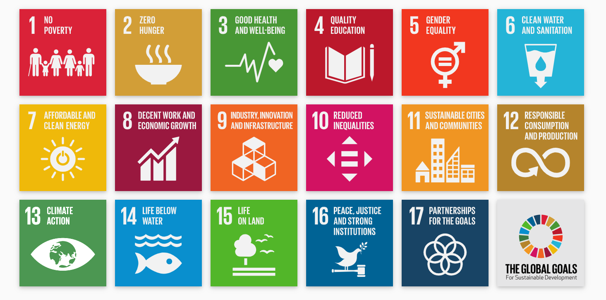

As you can see there is a wide variety of goals which are Global goals which need to be achieved by 2030. All of the Global goals were launched in 2018. (Goals S. D., 2018) The goals which are going to be focused on in this report is going to be:
- Climate action
- Sustainable cities and communities
Sustainable cities and communities
The United Nations has defined 10 targets and 15 indicators for the eleventh sustainable development goal. These targets and indicators are put in place by the United Nations to be able to track the worlds aims and to be able to track whether these targets are going to be achieved or not.
Some of the targets which the United Nations have put in place for the eleventh goal are:
- Target 1 - Safe and affordable housing
  - By 2030, ensuring access for all to adequate, safe and affordable housing and basic services and upgrade slums.
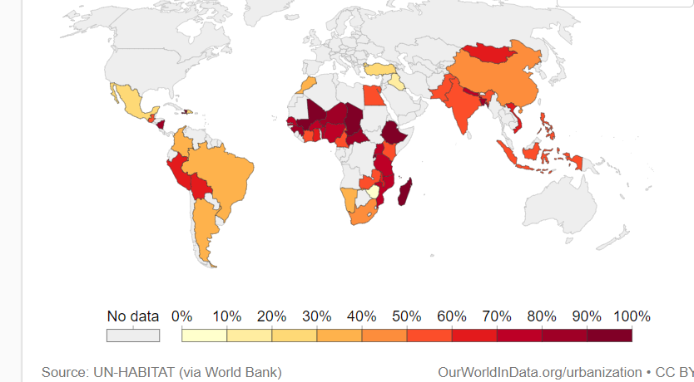

This map shows the share of the urban population living in the slums in the 1990’s.

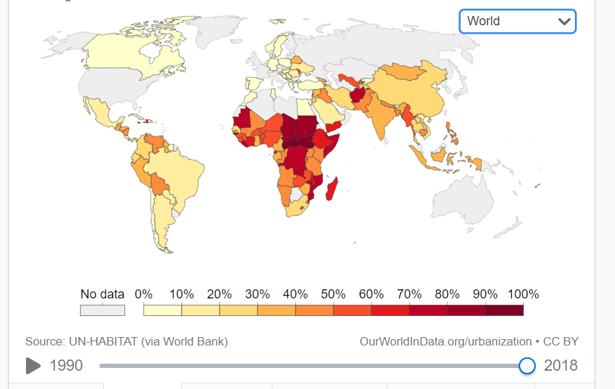

This map shows the share of the urban population living in the slums in the year 2018.

(Goals S. D., 2018)
The difference between these two maps is that there in a very higher population of the world who are now living in the slums. This would be due to inflation of bills, mass unemployment and an ever-growing population wanting to move to the cities, but they are unable to find housing which they will be able to comfortably live in and to be able to be financially stable.
- Target 2 - Affordable and sustainable transport systems
  - By 2030 provide access to safe, affordable accessible and sustainable transport systems for all. (Goals S. D., 2018)
- Target 3 – Inclusive and sustainable urbanization
  - By 2030, enhance inclusive and sustainable urbanization and capacity for participatory integrated and sustainable human settlement planning and management in all countries’ (Goals S. D., 2018)

- Target 4 – Protect the world’s cultural and natural heritage
  - Strengthen efforts to protect and safeguard the world’s cultural and natural heritage (Goals S. D., 2018)
- Target 5 – Reduce the adverse effects of natural disasters
  - By 2030 significantly reduce the number of deaths and the number of people affected and sustainability decrease the direct economic losses relative to global gross domestic product caused by disasters, including water-related disasters, with a focus on protecting the poor, and people in vulnerable situations. (Goals S. D., 2018)
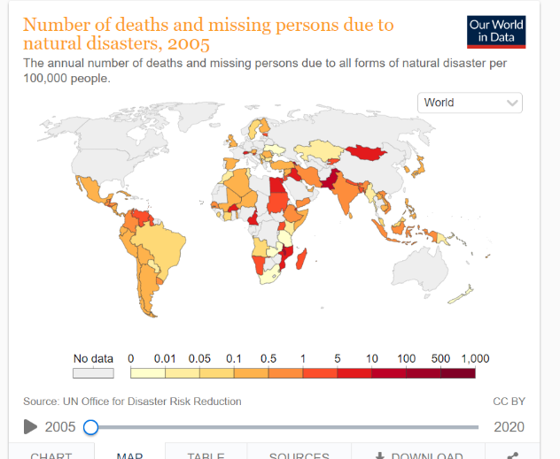

The map shows the number of deaths and missing persons due to natural disasters in 2005.

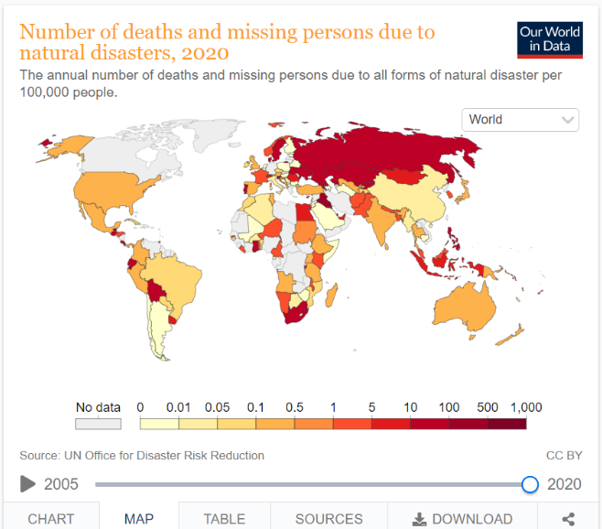

The map shows the number of deaths and missing persons due to natural disasters in 2020.

(Goals S. D., 2018)

When looking at the difference between these maps in 2005 there wasn’t a very high percentage of the darker colours which means less people had died/gone missing in 2005. But, in 2020 this was not the case there was a lot more of the map coloured and preferably in the darker red colour which means 1,000 per 100,000 people.
- Target 6 – Reduce the environmental impacts of cities
  - By 2030, reduce the adverse per capita environmental impact of cities, including by paying special attention to air quality and municipal and other waste management. (Goals S. D., 2018)
- Target 7 – Provide access to safe and inclusive green and public spaces.
  - By 2030 provide universal access to safe, inclusive, and accessible, green, and public spaces, in particular for women and children older persons and persons with disabilities. (Goals S. D., 2018)
By looking at all of the sustainable goals which the United Nations put in place when they put the 2030 deadline in place it is clear that, sustainable cities and communities are very important to everyone, you would think that in the year 2022 that these would already be in place for everyone, but unfortunately this is not the case. With the coloured maps which are shown the Sustainable cities and communities’ things are only getting worse for countries.
Climate Action
The second sustainability goal which this report will be looking into is, climate action. The United Nations explains that: ‘Affordable, scalable solutions are now available to enable countries to leapfrog to cleaner, more resilient economies. The pace of change is quickening as more people are turning to renewable energy and a range of other measures that will reduce emissions and increase adaptation efforts.’ (Goals S. D., 2022)
There is also a lot of targets to go with within this goal.
- Target 1 – Implement then UN framework convention on Climate Change.
  - One of the main targets within target 1 is that the Green Climate Find mobilisation of $100 billion. The meaning of this is to be able to commit to this to be able to build a framework convention for Climate change. Also, unlike a lot of the other Sustainable Development Goals this target requires $100 billion annually by 2020 from all sources. (Goals S. D., 2022)
- Target 2 – Promote mechanisms to raise capacity for planning and management.
  - The purpose of this target is to be able to promote mechanisms to raise the capacity for effective climate change related planning and management in least developed countries, this is the goal by 2030.
By looking into these targets within this goal it is obvious that everyone needs to work together and work fast and with a large sum of $100Billion annually to be to beat climate change.

The U. K’s journey to The Sustainable Development Goals
During this report we have been exploring two goals:
- Goal 11 – Sustainable cities and communities
- Goal 13 – Climate Action

The United have set out a list on how they will achieve Goal 11 - Sustainable cities and communities. They will do the following to be able reach the goal:
- Reduce greenhouse gas emissions to net zero by 2050.
- Grow and evolve our sectors domestically and globally in particular those sectors most affected by COVID-19.
- Enhance the cohesiveness of their communities and nations including through major event and ceremonial occasions and reduce inequalities of participation in society particularly among young people.
- Support economic growth in Wales
- Build confidence in the transport network as the country recovers from COVID-19 and improve transport users experience, ensuring that the network is safe, reliable, and inclusive.
- Tackle climate change and improve air quality by decarbonising transport
- Improve the environment through cleaner air and water minimise waste and thriving plants and terrestrial and marine wildlife.
- Reduce the likelihood and impact of flooding and coastal erosion on people, businesses, communities and the environment
- Modernise and integrate defence capabilities by taking a whole force approah
Modernise and integrate defence capabilities by taking a whole force approach to our people and increasing the use of technology and innovation
Transform and manage Defence
Shape the international order and ensure the UK is a force for good in the world by: supporting sustainable development and humanitarian needs; promoting human rights and democracy; and establishing common international standards
Make the UK safer and more resilient to global threats
Raise productivity and empower places so that everyone across the country can benefit from levelling up
More, better quality, safer, greener and more affordable homes
End rough sleeping through more effective prevention and crisis intervention services, and reduce homelessness by enabling local authorities to fully meet their statutory duties
A sustainable and resilient local government sector that delivers priority services and empowers communities
Increase the efficiency, effectiveness and accountability of government through modernisation and reform, including through the work of the government Functions
Ensure the the benefits of the Union are clear, visible, and understood by all citizens
Secure a safe, prosperous and resilient United Kingdom by coordinating national security, crisis response, and the implementation of the Integrated Review

Critically analyse concepts such as the green economy and sustainable economics;
- Critically appraise how differing sectors approach sustainable development
- Debate the consequences of developing economies sustainably

References
Alberta, U. o. (2021). What is sustainability? Alberta: University of Alberta.
Commentary. (2019, April 30). What is net zero? Retrieved from The London School of Economics and Political Science : https://www.lse.ac.uk/granthaminstitute/news/what-is-net-zero/
Forum, W. E. (2022). The Global Risks Report 2022. World Economic Forum.
Goals, S. D. (2018). Measuring progress towards the Sustainable Development Goals. Retrieved from Sustainable Development Tracker: https://sdg-tracker.org/
Goals, S. D. (2022). Take urgent action to combat climate change and its impacts. Retrieved from Sustainability Development Goals: https://sdg-tracker.org/climate-change
Godinot, S. (2022). Sustainable Economies. Retrieved from WWF: https://www.wwf.eu/what_we_do/sustainable_economies/
Newsom, R. (2019 , June 12). Greenpeace. Retrieved from What is 'net zero' and how can we get there?: https://www.greenpeace.org.uk/news/explained-theresa-mays-net-zero-plan-wtf-is-it-will-it-be-any-good/?source=GA&subsource=GOFRNAOAGA034J&gclid=EAIaIQobChMIxpf1k4nB9wIVg49oCR0wxQbUEAAYAiAAEgLMNvD_BwE
Office, M. (2022). What is climate change? Retrieved from Met Office: https://www.metoffice.gov.uk/weather/climate-change/what-is-climate-change

