Rick Turner (2520197)

Date: 17/11/2025

L4 Introduction to web and database concepts – acca4023
Data and Information Systems

Contents
Introduction 2
Requirements 2
Implementation 3
Home Page 3
Membership 4
Training 5
Merchandise 6
Validation 6
HTML 6
CSS 7
Evaluation 8
Evaluation criteria 8
Usability 8
SEO 8
Accessibility 10
CTC Website evaluation 10
Usefulness/Usability 10
Search Engine Optimisation 12
Accessibility 13
Website comparisons 16
Usability 17
Accessibility 19
SEO 19
Mobile friendliness 19
Conclusion 20
References 20
Appendices 21
Home Page 21
Membership 22
Training 25
Merch 27
CSS – CTC-Style 29

Introduction
This report reviews a website coded in HTML for a triathlon club, evaluating usability, accessibility, and Search Engine Optimisation (SEO). It also compares two similar websites to assess overall user experience (UX).

Requirements
The website promotes Carmarthen Triathlon Club, aiming to attract new members from ages 18+, provide training information, and guide users on joining and purchasing kit.

Implementation

Home Page
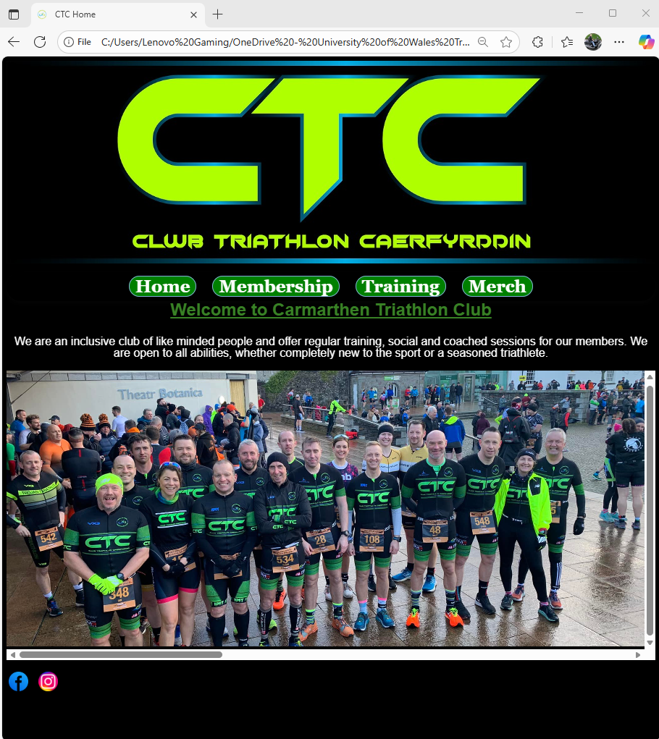

Membership
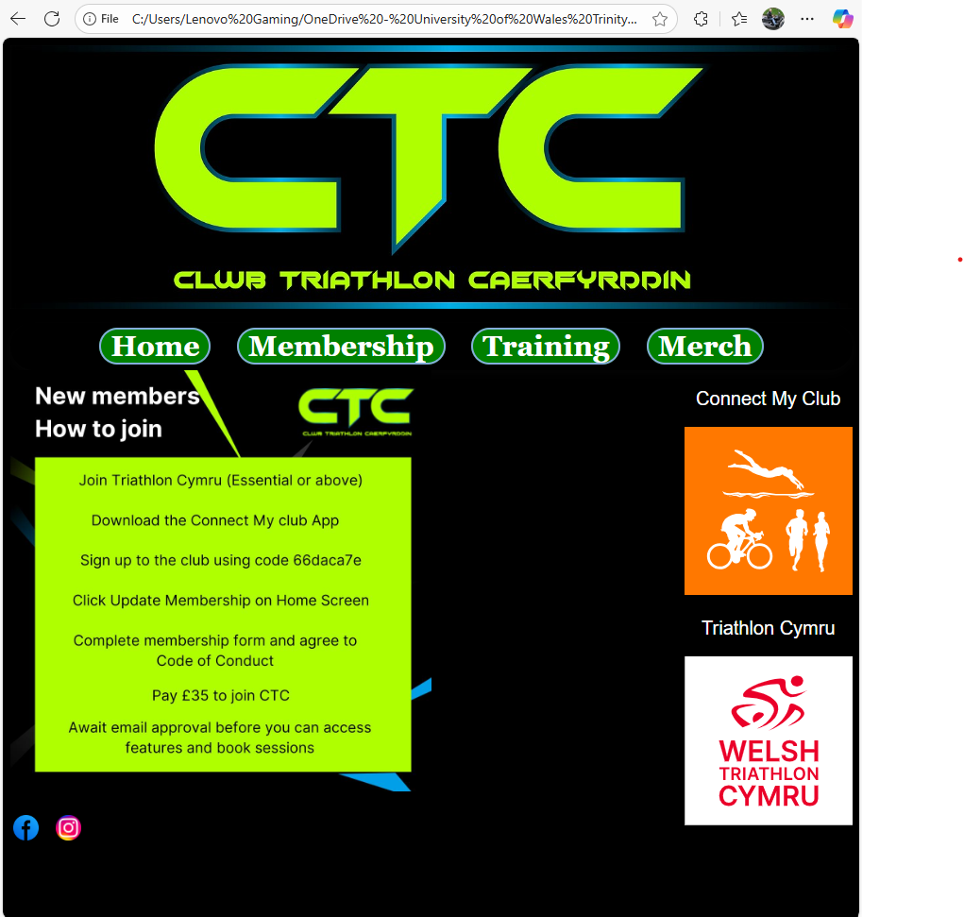

Training
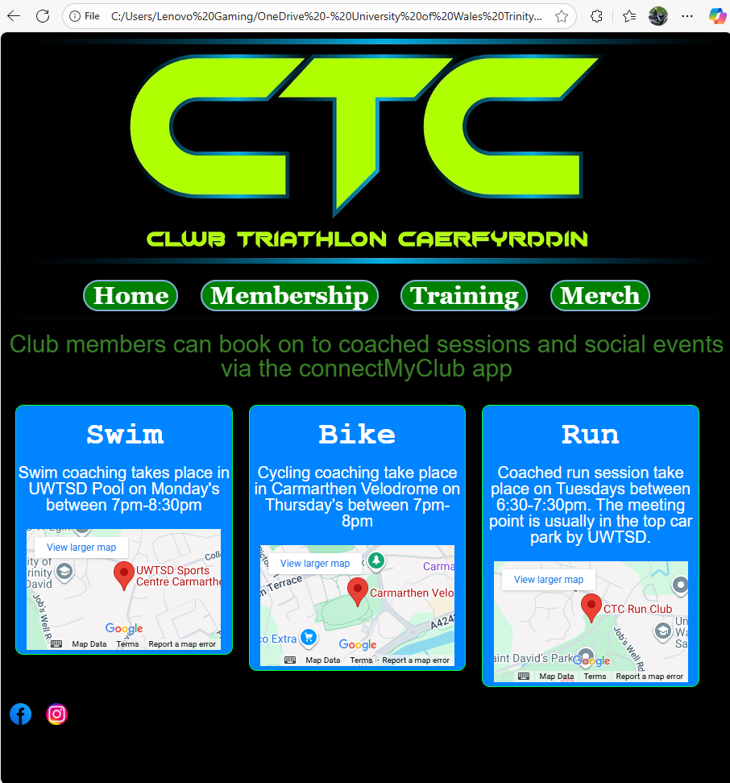

Merchandise
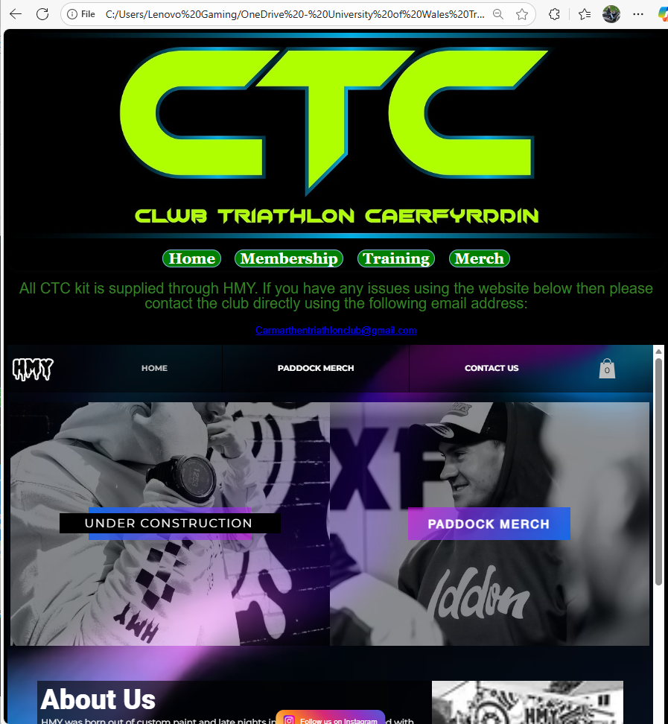

Validation

HTML
The homepage of the site has been validated using http://validator.w3.org/ with the results and solutions displayed below.

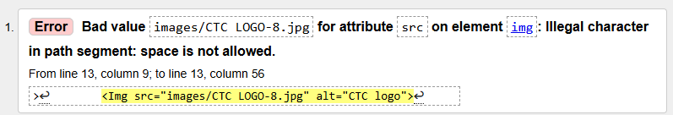
- Image renamed with space removed. HTML code for source amended to reflect this change – error resolved
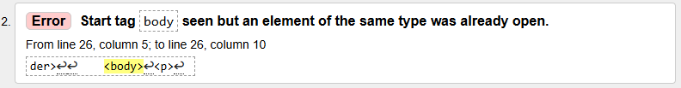
- Code checked, only 1 instance of <body> found with the correct closing statement accounted for also.
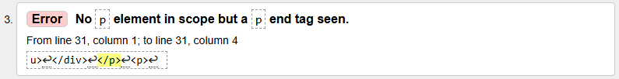
- <P> removed from code – error resolved
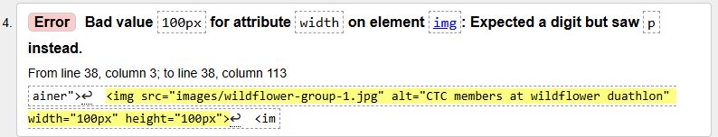
- This error appeared multiple times. The px text was removed from all width and height elements which resolved all issues – error resolved
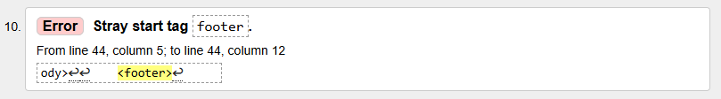
- Code checked, only 1 instance of <footer> found with the correct closing statement accounted for also.

CSS
CSS validation was completed using http://jigsaw.w3.org/css-validator/.
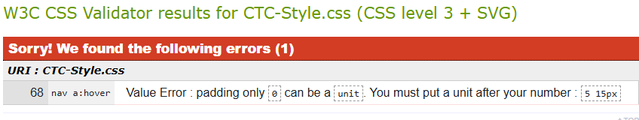
- Added px text for both units to validate the padding required – error resolved

Evaluation

Evaluation criteria
When evaluating websites there are numerous considerations around the efficacy of the site. There are 3 core aspects which will be explored in this report and these are:
- Usability
- Search Engine Optimisation (SEO)
- Accessibility

Usability
When considering how usable a website is, there are some considerations that developers need to take into account, but the overarching principle is what is the user experience (UX) when they are visiting the web pages. Websites that are confusing, not easy to navigate or have slow loading content can result in loss of users. Conversely, websites that are easily navigated can assist with UX and improve the success in digital marketing. [1]
A study carried out on library website highlighted that confusing terminology, poor navigation clarity and search functionality are key aspects in improving overall website useability. [2] This study, while only focusing on one website, adds credence to that a primary consideration for enhanced UX is ease of navigation. Ultimately, if users are not able to navigate a website easily, they are more likely to become frustrated and lose interest in websites.

SEO
SEO is a process of improving traffic to websites from search engines. If successful, websites are more likely to organically rank higher in search results pages (SERPs).
SEO is important to increase the visibility and access to websites. A higher visibility on search engines is likely to increase footfall to websites and increase user’s trust in a website. [3] Improved trust and traffic to websites will have a direct impact on the equity of the brand, this will in turn further improve SEO performance.
There are several processes that can improve SEO and an example of these can be seen in Fishkin’s SEO’s pyramid as displayed below.
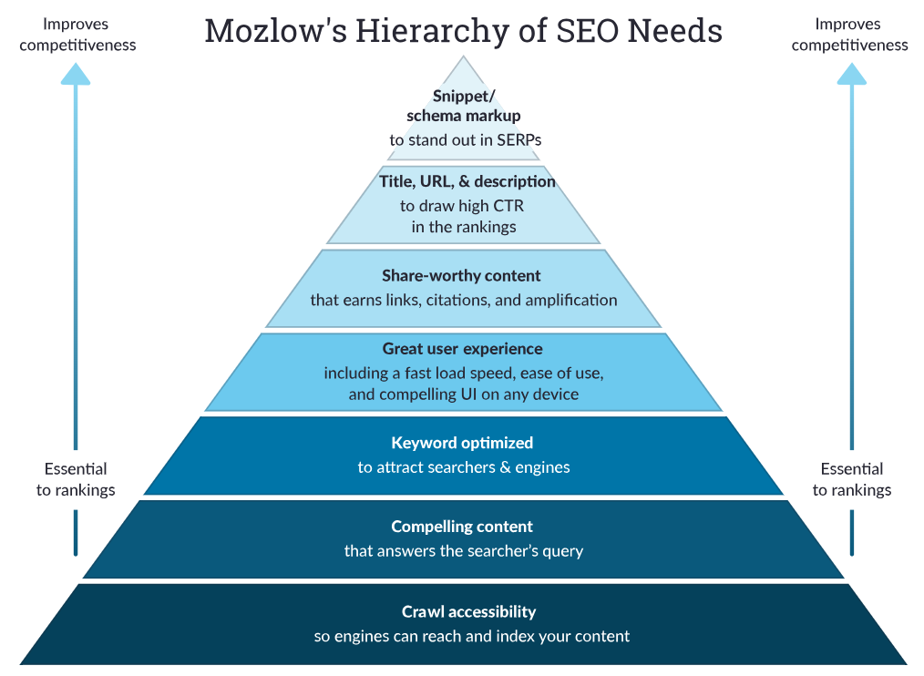
Figure 1. Fishkin’s “Moslow’s Hierarchy of SEO Needs” [4]

Reviewing the above illustration, there is some cross-pollination between Useability and SEO, these are in the UX, Compelling and Share worthy content sections, however, as illustrated the core foundation that need to be addressed in the first instance is crawl accessibility.
Web crawlers search for websites and analyse various aspects, but of note for this project is the HTML file being analysed. As such, the use of meta tags in coding remains critical to SEO performance.
A study published in 2003 has shown that SEO performance can have a positive impact on off-site and on-site brand equity, [5] therefore it is possible to conclude that Brand Equity and SEO performance an intrinsically connected.

Accessibility
Accessibility is important in website design, if not for any other reason other than to increase the number of persons that can utilise the website. The global benchmark for web accessibility has been developed by the W3C Web Accessibility Initiative and is underpinned by 4 main principles. These are that the website is:
Perceivable: Content must be presented in ways users can perceive (e.g., alt text for images, captions for videos).
Operable: Users must be able to navigate and interact (e.g., keyboard accessibility, clear focus indicators).
Understandable: Information and UI must be easy to comprehend (e.g., consistent navigation, readable text).
Robust: Content must be compatible with assistive technologies (e.g., screen readers). [6]
Some Common errors for accessibility can include:
- Inappropriate or non-existent alternative text on images
- Poor contrast between background and text
- Poor website navigation
- Neglection of compatibility with mobile devices [7]

A study conducted at Hull University displayed that web page accessibility in their chosen sector of study was very poor. Only 19% of the sites reviewed passed all priority 1 accessibility checks with 81% having at least one critical error. The most common error was that of missing alternative text for images, with other common errors including missing frame times and other alt text in various other areas. [8]
While this study was conducted in 2004 and may not have taken into consideration more modern aspects of accessibility, such a mobile devices and varying screen sizes, the primary cause of issues was alternative text failures. This suggests, that despite a 20-year time gap since the publication of the journal, there continues to be an issue with alternative text utilisation in website design.

CTC Website evaluation

Usefulness/Usability
General overview of site
My website has basic information on the Triathlon Club. The primary goals of the website were to raise awareness of the club’s existence, give direction how to join the club, provide information on training and supply links to social media.
The layout of the pages are simplistic in nature. The site is designed to be user friendly to people of all ages and therefore does not require overly complex navigation. The navigation section remains consistent across all pages of the website and is simplistically labelled to allow the user to understand what each page contains.
Each page has a bespoke reason for existing and allows users to navigate to the section that they are interested in. The social media links are also available on each page. This allows users the ability to navigate directly to social media where up to date information is available. As most people joining a triathlon club are looking for a community and like-minded individuals to train with, it was important to include this aspect at every opportunity.
The website is clearly branded with a colour theme of the club which is black and green. When completing in races and events, the black and green of the triathlon club is a standout feature and therefore it was important to push this as part of the brand.
Recommendations for development –
- Consideration could be given to resizing the header image to make it smaller and more compatible with smaller screens.
- Freezing the navigation and header image at the top of the screen may be useful as it would allow users to continually have access to the navigation bar irrespective of where they are on the page.
- Consideration to be given to adding a specific page for contact details. This would allow the user to directly navigate to key contact information for the club as opposed to relying on hyperlinks in the footer
Home Page
The home page is adorned with the striking Carmarthen Triathlon Club logo. This is to give the user clear indication that they have hit the right site. This is followed by information on what the club is about and provides images of the club members at various events. The intention is provide visitors with the feeling of a community club and display the support and camaraderie they may expect if they join.
Recommendations for development –
- I believe the use of a java script to automate the scrolling of club images would be beneficial as the current layout requires users to manually scroll through the images which they may not be inclined to do.
Membership
The membership page provides direction on how to join the club along with associated links required. There are images which are hyperlinked to relevant websites which will allow users to identify what unfamiliar apps and websites branding looks like to provide familiarity.
Recommendations for development –
- Review the layout of the page following testing to understand if the links to other pages could be better positioned to improve the UX

Training
The training page has 3 distinctive columns displaying information in relation to coaching for each discipline in triathlon. The embedding of google maps at the meeting points of each coached session is very useful and will allow users to easily obtain navigation via google to meeting points.
Recommendations for development –
- The columns size varies on the content. To make the site more aesthetically pleasing consideration could be given to making all columns the same height.
Merch
The merchandise page has the website that provides all club merchandise embedded within the page. This was designed to allow users to view club merchandise without navigating away from the website. Currently the partner website is down for maintenance, but club contact details have been provided to mitigate the risk of the partner website not working.
Recommendations for development –
- A link that pops out in a new window to the partner website may be more useful for some users and may remove some confusion. It would also remove the current issue of being reliant on the partner website being live.

Search Engine Optimisation
The website includes metatags that support SEO performance. Each page has a unique title in the code, tailored to its content. Keywords embedded in the code relate to the triathlon club and the sport more broadly. Notably, terms like “Ironman” and “Ironman Wales,” a major UK event held near Carmarthen, are included to attract interested visitors. Headers are used throughout the site to help web crawlers identify key content, especially on the homepage. All images feature alternative text, improving both accessibility and SEO

Accessibility
Using http://juicystudio.com/services/luminositycontrastratio.php, I was able to assess to colour of the text on the website against the background

My results were as follows:
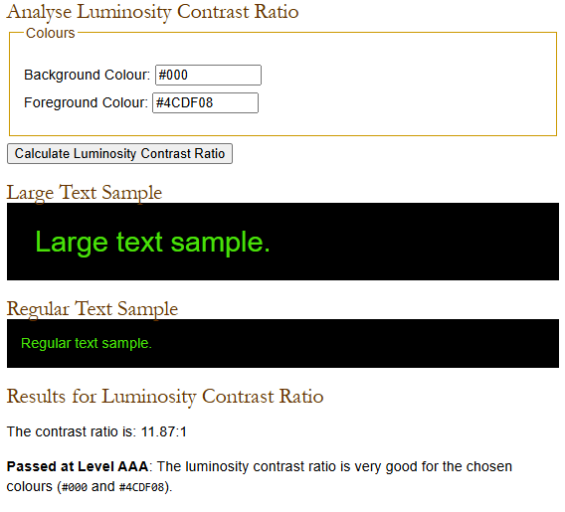

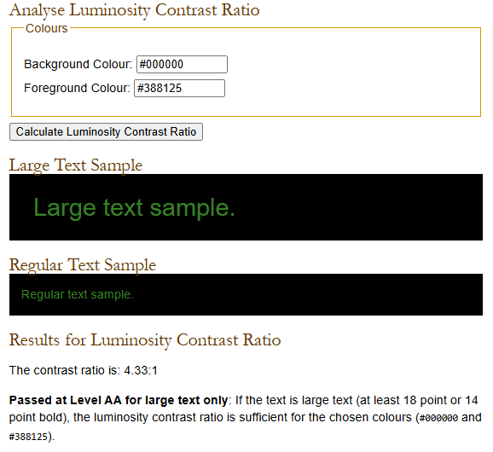

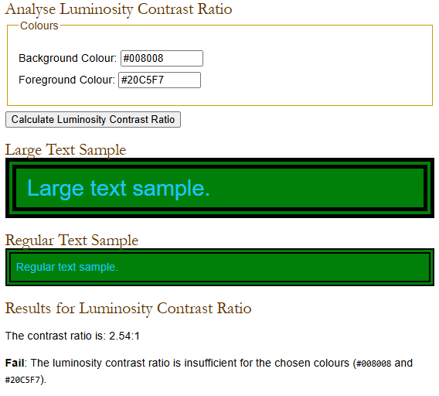
In view of the above, adjustments were made to the colour to be more visible to all users and this is reflected in the code. The last screenshot is the colour palette used for the navigation section. Navigation is key to website success and a such adjustments to the colours have been made.
I also cross checked the colour scheme in WCAG - Contrast Checker and returned the following result. While I acknowledge the potential fail in colour difference, from reviewing the grayscale the writing is readable for people with colour blindness.
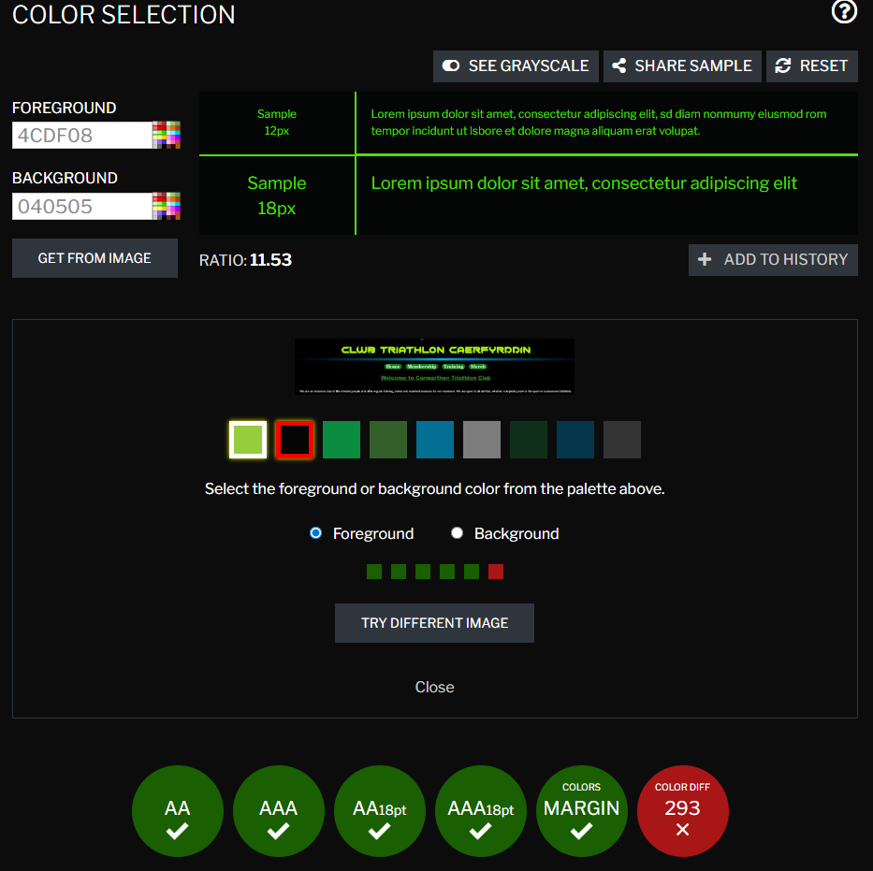

From reviewing the HTML code, I have ensured that all images have alternative text to improve accessibility also.

Website comparisons
I have chosen two triathlon club websites to compare, namely Ammanford Triathlon Club (https://www.atac.club) and Porthcawl Triathlon Club (www.porthcawltriathlonclub.com).
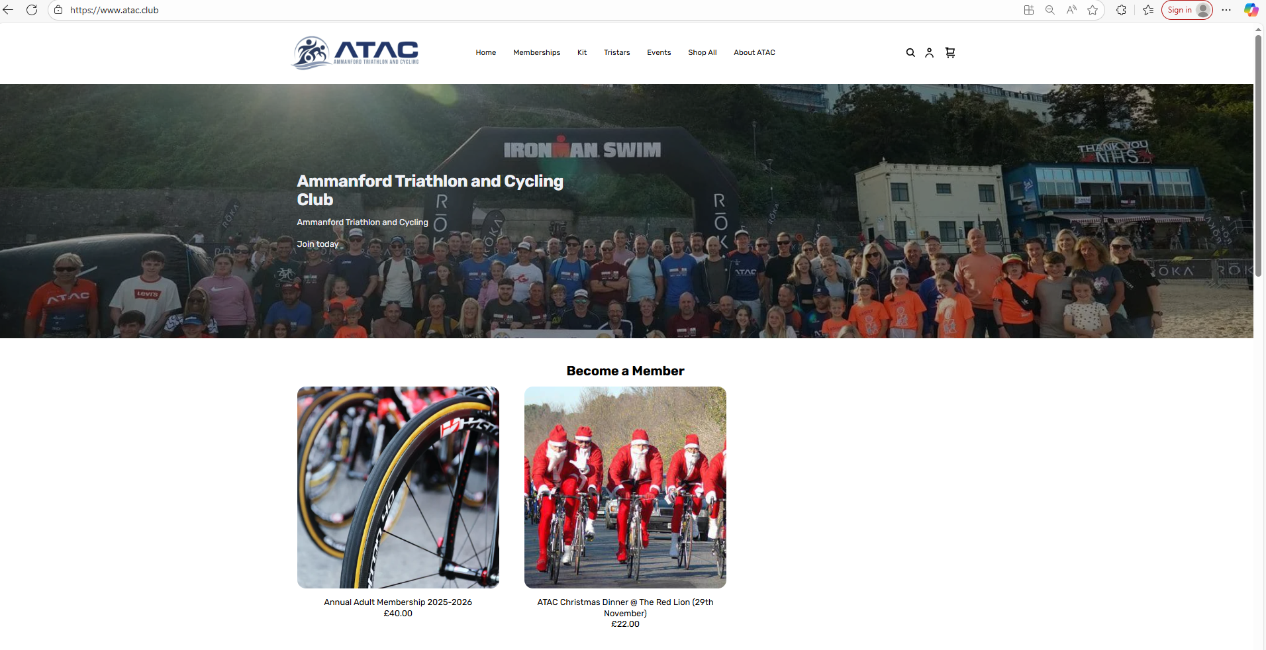
Figure 2. ATAC homepage [9]
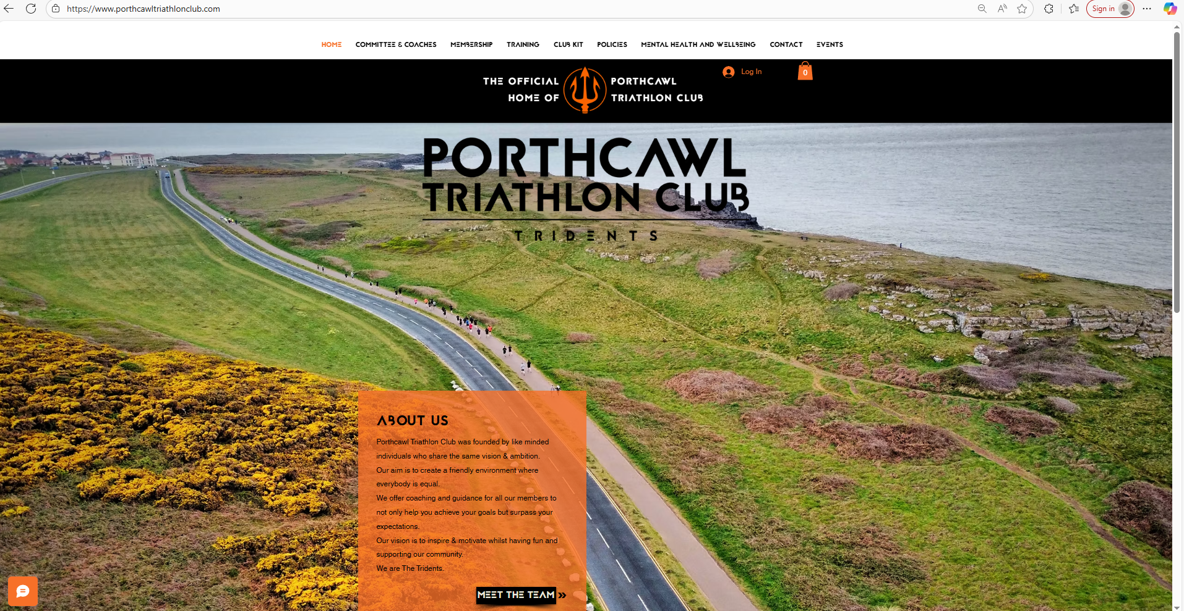
Figure 3. Porthcawl homepage [10]

Usability
Both websites are user friendly and are easy to navigate. The colour schemes of both websites are conducive to their club colours which is a good branding element. The content of each page is good although there is notably more information on Porthcawl’s website.
The homepage of Porthcawl’s website gives far more information and the flow is easy to follow. Contact information for social media platforms is easily accessible via hyperlinks on each site but is easier to locate on Porthcawl’s website.
While Porthcawl’s page is more appealing due to the use of eye-catching images, there are some pages on the site where this detracts away from the content and make some of the text difficult to read.

Accessibility
Using WAVE to assess the website the results for the home page are below:
Ammanford | Porthcawl
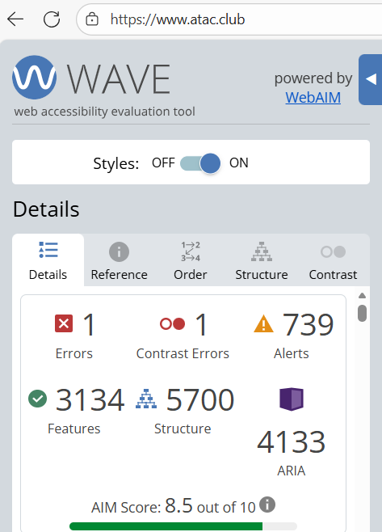 | 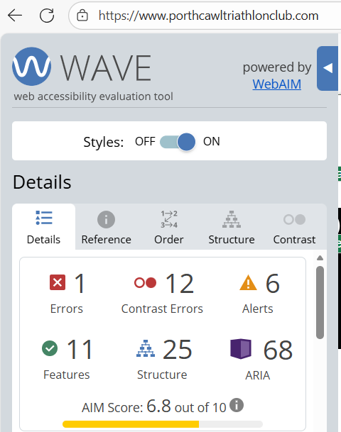

While there are significantly more issues on the Ammanford webpage, there are a limited number of contrast errors comparative to Porthcawl’s which is likely to have had a greater impact on the overall scoring.

SEO
Both websites makes use of title tags in their coding which assist with SEO performance. There is no meta description tag in the coding and limited use of meta name tags in the websites which may hinder SEO performance. Both sites make use of several Open Graph protocol tags which would assist in sharing the website on social media platforms.

Mobile friendliness
Both sites are mobile friendly and arguably perform better on smaller screens. There is a slight delay in loading time for Ammanford’s site, but this does not significantly affect the UX. Both websites are easy to navigate in this medium and the flow of information is good.

Conclusion
While there are some obvious accessibility issues in the Porthcawl website, overall, it far outperforms the Ammanford website on ease of use, layout and stylistically. The website has good use of imagery which is eye catching and draws user attention. Each page on the site has different images which keeps user attention while still providing information.

References

[1] | K. T. Heemakshi Sharma, “The Importance of Website Usability in Digital Marketing- A Review,” International Journal of Innovative Research in Computer Science & Technology, 2023.
[2] | I. V. Ochoa, “Navigation Design and Library Terminology: Findings from a User-Centered Usability Study on a Library Website,” vol. 39, no. 4, pp. 1-15, 2020.
[3] | C. Melinn, “What is SEO and how does it work?,” Digital Marketing Institute, 28 04 2025. [Online]. Available: https://digitalmarketinginstitute.com/blog/what-is-seo. [Accessed 14 11 2025].
[4] | R. Fishkin, “The Beginner's guide to SEO,” Moz, [Online]. Available: https://moz.com/beginners-guide-to-seo. [Accessed 14 11 2025].
[5] | C. Jun-Cheng and S. Sénéchal, “The reciprocal relationship between search engine optimization (SEO) success and brand equity (BE): an analysis of SMEs,” European business review, vol. 35, 2023.
[6] | p. c. N. 2. MS Co-pilot.
[7] | “!0 most common web accessbility issues to solve,” BrowserStack, 1 August 2025. [Online]. Available: https://www.browserstack.com/guide/common-web-accessibility-issues. [Accessed 14 11 2025].
[8] | R. W. a. R. Rattray, “ UK hotel web page accessibility for,” Tourism and hospitality research, vol. 5, 2005.
[9] | “Ammanford Triathlon Club,” [Online]. Available: https://www.atac.club/. [Accessed 17 11 2025].
[10] | “Porthcawl Triathlon Club,” [Online]. Available: https://www.porthcawltriathlonclub.com/. [Accessed 17 11 2025].

Appendices

Home Page
<!DOCTYPE html>
<html lang="en">
<head>
<meta charset="UTF-8">
<meta name="viewport" content="width=device-width, initial-scale=1.0">
<meta name="keywords" content="Ironman, Triathlon, Ironman Wales, Carmarthentri">
<title>CTC Home</title>
<link rel="stylesheet" href="CTC-Style.css">
<link rel="icon" type="image/x-icon" href="https://vx-3.com/cdn/shop/collections/carmarthen-triathlon-logo.png?v=1641897242">
</head>
<header>
<div id="CTC-Toplogo">
<Img src="images/CTC-LOGO-8.jpg" alt="CTC logo">
</div>
<div id="Navigation">
<nav>
<a href="CTC-Homepage.html">Home</a>
<a href="Membership.html">Membership</a>
<a href="Training.html">Training</a>
<a href="CTC-Merch.html">Merch</a>
</nav>
</div>
</header>
<body>
<div id="first-para">
<h3>
<u><b>Welcome to Carmarthen Triathlon Club</b></u>
</h3>
</div>
<p>
We are an inclusive club of like minded people and offer regular training, social and coached sessions for our members.
We are open to all abilities, whether completely new to the sport or a seasoned triathlete.
</p>
<div class="scrolling-container">
<img src="images/wildflower-group-1.jpg" alt="CTC members at wildflower duathlon" width="100" height="100">
<img src="images/CTC-IMW-2024.jpg" alt="CTC Group Photo at Ironman Wales" width="100" height="100">
<img src="images/swim-beach-1.jpg" alt="CTC members Group Photo on beach" width="100" height="100">
</div>
</body>
<footer>
<a href=https://www.facebook.com/Carmarthentri/ target="_blank"><Img src="images/facebook-logo.png" alt="Facebook Logo"></a>
<a href=https://www.instagram.com/carmarthentriathlonclub target="_blank"><Img src="images/IG-logo.png" alt="Instagram Logo"></a>
</footer>

Membership
<!DOCTYPE html>
<html lang="en">
<head>
<meta charset="UTF-8">
<meta name="viewport" content="width=device-width, initial-scale=1.0">
<meta name="keywords" content="Ironman, Triathlon, Ironman Wales, Carmarthentri">
<title>CTC Membership</title>
<link rel="stylesheet" href="CTC-Style.css">
<link rel="icon" type="image/x-icon" href="https://vx-3.com/cdn/shop/collections/carmarthen-triathlon-logo.png?v=1641897242">
</head>
<header>
<div id="CTC-Toplogo">
<Img src="images/CTC-LOGO-8.jpg" alt="CTC logo">
</div>
<div id="Navigation">
<nav>
<a href="CTC-Homepage.html">Home</a>
<a href="Membership.html">Membership</a>
<a href="Training.html">Training</a>
<a href="CTC-Merch.html">Merch</a>
</nav>
</div>
</header>

<body>

<style>
img.joining {
height: 50%;
width: 50%;
text-align: center;
}
</style>
<img class="joining" src="images/joining.jpg" width="300" height="300">

<aside id="useful-links">

<p>
Connect My Club
</p>
<a href=https://members.connectmyclub.co.uk/registration/ target="_blank"><Img src="images/connectMyClub.png" alt="Connect my club Logo"></a>
<p>
Triathlon Cymru
</p>
<a href=https://www.britishtriathlon.org/membership/ target="_blank"><Img src="images/welsh-triathlon-logo.svg" alt="Triathlon Cymru Logo"></a>
</aside>
</body>

<footer>

<a href=https://www.facebook.com/Carmarthentri/ target="_blank"><Img src="images/facebook-logo.png" alt="Facebook Logo"></a>
<a href=https://www.instagram.com/carmarthentriathlonclub target="_blank"><Img src="images/IG-logo.png" alt="Instagram Logo"></a>

</footer>

Training
<!DOCTYPE html>
<html lang="en">
<head>
<meta charset="UTF-8">
<meta name="viewport" content="width=device-width, initial-scale=1.0">
<meta name="keywords" content="Ironman, Triathlon, Ironman Wales, Carmarthentri, Triathlon Training">
<title>CTC Training</title>
<link rel="stylesheet" href="CTC-Style.css">
<link rel="icon" type="image/x-icon" href="https://vx-3.com/cdn/shop/collections/carmarthen-triathlon-logo.png?v=1641897242">
</head>
<header>
<div id="CTC-Toplogo">
<Img src="images/CTC-LOGO-8.jpg" alt="CTC logo">
</div>
<div id="Navigation">
<nav>
<a href="CTC-Homepage.html">Home</a>
<a href="Membership.html">Membership</a>
<a href="Training.html">Training</a>
<a href="CTC-Merch.html">Merch</a>
</nav>
</div>
</header>
<body>
<p>
<div id="first-para">
Club members can book on to coached sessions and social events via the connectMyClub app
</div>
</p>
<div class="row">
<div class="column">
<h1>Swim</h1>
<p>
Swim coaching takes place in UWTSD Pool on Monday's between 7pm-8:30pm
</p>
<iframe src="https://www.google.com/maps/embed?pb=!1m18!1m12!1m3!1d2464.1544164084603!2d-4.328103022861436!3d51.85813697189516!2m3!1f0!2f0!3f0!3m2!1i1024!2i768!4f13.1!3m3!1m2!1s0x486ee1e953760459%3A0x10a25199e287a7aa!2sUWTSD%20Sports%20Centre%20Carmarthen!5e0!3m2!1sen!2suk!4v1761583564020!5m2!1sen!2suk" width="90%" height="90%" style="border:0;" allowfullscreen="" loading="lazy" referrerpolicy="no-referrer-when-downgrade"></iframe>
</div>
<div class="column">
<h1>Bike</h1>
<p>
Cycling coaching take place in Carmarthen Velodrome on Thursday's between 7pm-8pm
</p>
<iframe src="https://www.google.com/maps/embed?pb=!1m18!1m12!1m3!1d2464.3353779588956!2d-4.315137099999999!3d51.854832699999996!2m3!1f0!2f0!3f0!3m2!1i1024!2i768!4f13.1!3m3!1m2!1s0x486ee72baddd23e9%3A0x862866b3cce53660!2sCarmarthen%20Velodrome!5e0!3m2!1sen!2suk!4v1761583499863!5m2!1sen!2suk" width="90%" height="90%" style="border:0;" allowfullscreen="" loading="lazy" referrerpolicy="no-referrer-when-downgrade"></iframe>
</div>
<div class="column">
<h1>Run</h1>
<p>
Coached run session take place on Tuesdays between 6:30-7:30pm. The meeting point is usually in the top car park by UWTSD.
</p>
<iframe src="https://www.google.com/maps/embed?pb=!1m18!1m12!1m3!1d2464.105941684856!2d-4.335093722861426!3d51.8590220718953!2m3!1f0!2f0!3f0!3m2!1i1024!2i768!4f13.1!3m3!1m2!1s0x486ee10079988a8b%3A0xa8f7a00c63d8b158!2sCTC%20Run%20Club!5e0!3m2!1sen!2suk!4v1761583956183!5m2!1sen!2suk" width="90%" height="90%" style="border:0;" allowfullscreen="" loading="lazy" referrerpolicy="no-referrer-when-downgrade"></iframe>
</div>
</div>

</body>

<footer>
<a href=https://www.facebook.com/Carmarthentri/ target="_blank"><Img src="images/facebook-logo.png" alt="Facebook Logo"></a>
<a href=https://www.instagram.com/carmarthentriathlonclub target="_blank"><Img src="images/IG-logo.png" alt="Instagram Logo"></a>
</footer>

Merch
<!DOCTYPE html>
<html lang="en">
<head>
<meta charset="UTF-8">
<meta name="viewport" content="width=device-width, initial-scale=1.0">
<meta name="keywords" content="Ironman, Triathlon, Ironman Wales, Carmarthentri">
<title>CTC Merch</title>
<link rel="stylesheet" href="CTC-Style.css">
<link rel="icon" type="image/x-icon" href="https://vx-3.com/cdn/shop/collections/carmarthen-triathlon-logo.png?v=1641897242">
</head>
<header>
<div id="CTC-Toplogo">
<Img src="images/CTC-LOGO-8.jpg" alt="CTC logo">
</div>

<div id="Navigation">
<nav>
<a href="CTC-Homepage.html">Home</a>
<a href="Membership.html">Membership</a>
<a href="Training.html">Training</a>
<a href="CTC-Merch.html">Merch</a>
</nav>
</div>

</header>
<body>
<p>
<div id="first-para">
All CTC kit is supplied through HMY. If you have any issues using the website below then please contact the club directly using the following email address:
</div>
</p>
<p>
<a href="mailto:Carmarthentriathlonclub@gmail.com">Carmarthentriathlonclub@gmail.com</a>
</p>
<iframe width="100%" height="800" src="https://www.hmycustoms.co.uk/" title="HMY" frameborder="0" allow="accelerometer; autoplay; clipboard-write; encrypted-media; gyroscope; picture-in-picture; web-share" referrerpolicy="strict-origin-when-cross-origin" allowfullscreen></iframe>
</p>

</body>

<footer>
<a href=https://www.facebook.com/Carmarthentri/ target="_blank"><Img src="images/facebook-logo.png" alt="Facebook Logo"></a>
<a href=https://www.instagram.com/carmarthentriathlonclub target="_blank"><Img src="images/IG-logo.png" alt="Instagram Logo"></a>
</footer>

CSS – CTC-Style
/* Header Styling */
#CTC-Toplogo{
width: 100%;
height: 100%;
}

header img {
width: 100%;
height: 10%;
object-fit: cover;
}

/* Body Styling */

body {
background-color:black;
color: white;
font-family: Courier;
font-size:20px;
line-height:1em;
}
/* Banner Styling */

#Banner {
width: 100%;
height: 150px;
}

img {
width: 100%;
height: 100%;
object-fit: cover;
}

/* Nav Styling */

#Navigation {

color: rgb(76, 223, 8);
font-family: georgia;
font-size: 30px;
line-height: 30px;
font-weight: bold;
box-shadow:0 4px 8px rgba(10, 10, 10, 0.377);
padding: 10px;
margin-top: 10px;
text-align: center;
border-radius: 80px;
}

nav a{
color: white;
background-color: green;
margin: 0 10px;
padding: 0 10px;
text-decoration: none;
border-radius: 30px;
transition: 0.3s;
border: 2px solid rgb(133, 173, 219);
}

nav a:hover {
color: rgb(115, 0, 128);
background-color: green;
font-size: 30px;
line-height: 30px;
margin: 0 10px;
padding: 5px 15px;
text-decoration: none;
border-radius: 5px;
transition: 0.3s;
border: 2px solid rgb(133, 173, 219);
}

/* Front page formatting */
#first-para {
font-family: Arial, Helvetica, sans-serif;
font-size: 30px;
line-height: 30px;
color: rgb(76, 223, 8);

Padding-bottom: 10px;
text-align: center;
}

p {
font-family: Arial, Helvetica, sans-serif;
font-size: 20px;
line-height: 20px;
color: white;
text-align: center;
}

/* Scrolling images formating */

div.scrolling-container {
background-color: #070707;
overflow: auto;
white-space: nowrap;
width: 100%;
height: 500px;

}

div.scroll-container img {
padding: 10px;
width: 10px;
height: 10px;
background-size: cover;
}

/* FB logo formatting */

#footer-logo {
width: 50%;
}

footer img {
width: 3%;
height: 3%;
padding: 3px;
padding-top: 20px;
}

/* Training page formatting */

.column {
background-color: rgb(0, 132, 255);
text-align: center;
float: left;
margin: 0 10px;
width: 30%;
height: 90%;
border-radius: 10px;
border: 1px solid rgb(0, 255, 42);
}

/* Clear floats after the columns */
.row:after {
content: "";
display: table;
clear: both;
}

/* Membership page */

/* Connect my club image resize */

#useful-links {
float:right;
width: 20%;
}

