
Dissertation Proposal
“How has the digital medium revolutionized marketing for SMEs”
Student Name:
Student ID:

Table of Contents
Introduction 1
Review of pertinent literature 2
Research Strategy and Methodology 3
Logistical and ethical consideration 4
A planned timetable 5
References 6

Introduction
It has been decided by the researcher to give this project the working title “How has the digital medium revolutionised marketing for SMEs? The title shows what the researcher wants to discover.
Digital marketing is felt to be very current, with the rapid growth in social media and access to superfast broadband, it is an area that has huge potential. This research will look to see if these opportunities are being utilised by the small to medium sized businesses being scrutinised in this study. Once this information has been collected the researcher will be able to see whether the secondary data available shows the same results as the data which has been gathered and analysed first hand?
The area to be covered by this dissertation relates primarily to marketing, and how it has been revolutionised by the development of digital marketing with the emphasis on small to medium sized businesses.
Shown below are the points that form the basis to the research undertaken.
What changes have SMEs made to the way in which they market their businesses, since digital media became accessible to everyone?
Which forms of digital media have been incorporated into the marketing strategy of these businesses?
Are the businesses aware of the value of using social media to interact with customer and to what level?
Has this changed the way they spend their marketing budgets?
How have these changes impacted their customers and the businesses relationship with their customers?
Has the way they trade been affected? (Selling online for example.)
The research will look at around fifty organisations to get first hand data, relating to their experiences of marketing in the digital world. It is intended to view the various digital mediums and the benefits offered to both customers and the organisation, the primary focus being on the business.

Review of pertinent literature
This section of the proposal will provide the reader with research and findings which are relevant to the chosen subject. Three sources have been selected to show why this dissertation is both current and relevant.
Firstly, a research paper undertaken by the Department of Innovation and Skills (September 2015) has been used to research the progress in the use of the various forms of digital marketing by 800 small businesses surveyed over several years. The quotes below are an indication of the relevance of this paper in this research project.
“Almost all SMEs use the internet for business purposes, but intensity varies with increasing size…”
“…the most common use of the internet is emailing customers, but e-commerce was much less prevalent…”
This will form the foundation on which to develop our first-hand research, which will involve contacting a number of businesses, to see if and how things have changed over the last five years. The researcher will then be able to compare the findings.
Here is an excerpt from a survey of small businesses conducted by the Open University Business School written by Dr Rob Baldock and Dr Richard Blundel.
“the spread of digital technologies has had a particularly dramatic impact on small businesses of all kinds, helping to create new markets and re-shape business models.”
A book Internet and Digital Marketing for SMEs: 30 Things You Need to Know by Michael Anderson provides another quote which inspires the research into this subject and the hunger to see whether this is indeed the case.
“Old world marketing is finished”
In the words of Michael Porter from an article ‘Strategy and the Internet’ (2001) in the Havard Business Review the use of digital marketing is no longer an ‘if’, the researcher wants to show whether this is the case in small to medium businesses.
“The key question is not whether to deploy Internet technology—companies have no choice if they want to stay competitive—but how to deploy it.”
These and other resources provide the groundwork for this dissertation, and the catalyst to the further research of the subject. It can be seen from the excerpts above that the trend towards digital marketing is there, what this research intends to discover is whether this trend has filtered through to the small to medium sized businesses and what form that revolution has taken.

Research Strategy and Methodology
Methodology is an important part of the dissertation process, along with the use of the relevant tools. These are the factors that will form the structure of the dissertation.
It is intended to use both primary and secondary sources. The primary data will be quantitative and collected by the researcher using questionnaires. Research has been conducted into the best way of designing a questionnaire with the aim of getting the best quality data. This will allow the researcher to follow a structure that falls in line with the secondary information available, this will make the comparison and contrast of data more relevant.
The secondary data has been collected from an assortment of sources. These sources include books, journals, surveys and online data. This data will be compared with the findings of the primary research to see if the reality does concur with the secondary data analysis.
Quantitative data, is seen as the best method for the collection of information for this project, as this study deals with facts and figures, the information gathered is objective and not subjective as is the case with qualitative analysis.
Qualitative is said to be analysis that uses subjective judgment based on unquantifiable information, whereas quantitative analysis refers to economic, business or financial analysis that aims to understand or predict behaviour or events through the use of mathematical measurements and calculations, statistical modelling and research.
The tools to be used to compile and compare this data will include, tally charts, spreadsheets, graphs and charts

Logistical and ethical consideration
The logistics of conducting this research must be considered, these include time taken, the financial outlay and access to the required study subjects.
The subjects selected for participation in the study are small to medium sized businesses. It is intended to send out 60 questionnaires. In order to try and safeguard 50 completed forms an additional 10 will be sent out. The return of forms is not in the researchers control but as seen an attempt has been made to compensate for any failures. Access to the business owners should be easily available, as addresses are available online.
Cost implications include printing, postage and stationery, in the case of 60 questionnaires being issued, 120 stamps, 120 envelopes will be required, 60 being stamped addressed envelopes for the return of the questionnaires along with 220 sheets of A4. Laser printing facilities are available in house; this provides the most economical print.
Time considerations, include the design and preparation of questionnaires, addressing and filling the envelopes. Critical to the success is the design, it is essential that the right questions are asked and a structured response option, so that the data collected is relevant and high quality. The factor which is outside the researchers control is the speed at which completed surveys are returned.
Ethical factors have been considered in the selection of participants. In this case as the targets of the research are small to medium sized business owners, it is not expected that any of the participants will fall into the underage or vulnerable categories.
Literature will be supplied with the questionnaires providing information as to who the researcher is, why the data is being collected and what that data will be used for. Those taking part will be given the opportunity to decline and will also be assured of their anonymity. The researcher will include a note of thanks with all the questionnaires sent out, to show their gratitude for the businesses participation. Participants will be asked to sign a document confirming that they are happy to take part and return the completed document with the questionnaire in the stamp addressed envelope included.

A planned timetable
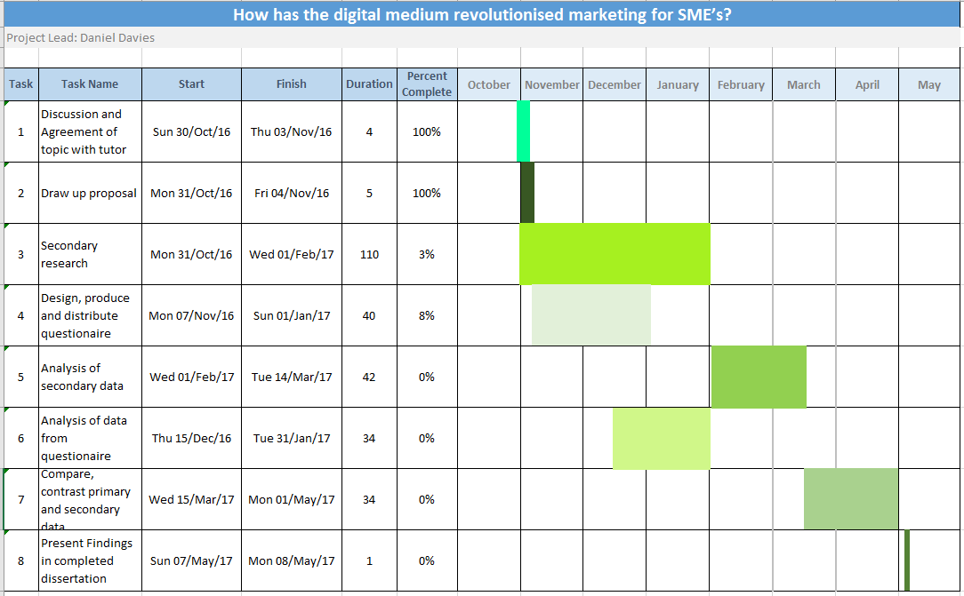
This section includes a timeline for the project. It covers a period from the selection of the research area, the choice of title to the final presentation of the finished dissertation. The data includes the projected start and finish dates for each task, the number of days taken for each task and the percentage currently completed. The timetable is in the form of a Gantt chart.

References
Blundel, R., Gray, C. & Baldock, R., 2014. Quarterly Survey of Small Business in Britain, Milton Keynes: The Open University: Business School.
BMG Research and Durham University, 2015. Digital Capabilities in SMEs: Evidence Review and Re-survey of 2014 Small Business Survey respondents, Durham: s.n.
Bourke, J., Kirby, A. & Doran, J., 2016. Survey & Questionaire Design: Collecting Primary Data to Answer Research Questions. Kindle Edition ed. s.l.:Oak Tree Press.
Chaffey, D. & Ellis-Chadwick, F., 2012. Digital Marketing Strategy, Implementation and Practice. 5th ed. Harlow: Pearson.
Crossfield, J., 2010. Big ideas for small business.. B&T Magazine, 60(2717), pp. 21-21.
Demishkevich, M., 2015. Small Business Use of Internet Marketing: Findings from Case Studies. [Online]
Available at: http://scholarworks.waldenu.edu/cgi/viewcontent.cgi?article=2339&context=dissertations
[Accessed 04 11 2016].
Dini, P. et al., 2008. Beyond interoperability to digital ecosystems: regional innovation and socio-economic development led by SMEs. International Journal of Technological Learning, Innovation and Development, 1(3), pp. 410-426.
Eddy, N., 2013. Small Businesses' Investment in Digital Marketing Rises. eWeek, 30 04, pp. 9-9.
Hargrave, S., 2013. How SMEs can make the best use of social media. The Guardian, 12 12.
Nathan, L., n.d. The Ultimate Digital Transformation Guide for SMEs. Kindle Edition ed. s.l.:s.n.
Organisation for Economic Co-operation and Development , 2000. Realising the Potential of Electronic Commerce for SMEs in the Global Economy. [Online]
Available at: http://citeseerx.ist.psu.edu/viewdoc/download;jsessionid=72F1E833987264AE829156E4EDA2B8CE?doi=10.1.1.136.4094&rep=rep1&type=pdf
[Accessed 04 11 2016].
Porter, M. E., 2001. Strategy and the Internet. Harvard Business Review, Issue 2001 .
PR Newswire, 2014. Small Businesses Avoid Social Media and Digital Marketing Because It's 'Too Complicated' and 'Time Consuming'. PR Newswire US, 01 10.
Ritz, W. & Wolf, M., 2015. Digital Marketing Strategy Adoption and Success for Small Businesses: An Examination of DIY Beheaviors. Society for Marketing Advances Proceedings, pp. 112-113.
Windrum, P. & Berranger, P. d., n.d. The adoption of e-business technology by SMEs. [Online]
Available at: http://citeseerx.ist.psu.edu/viewdoc/download?doi=10.1.1.310.1981&rep=rep1&type=pdf
[Accessed 04 11 2016].

