

LEVEL 5 – COMPONENT 2

Programme: | BA (Hons) Leadership and Management Skills for the Workplace
Module: | Developing and Managing Individuals and Teams
Module code: | LCLM5002 | Student Name: | Zain Mubarik
Module Leader: | Dr Doreen Nyaa Amundam | Student Number: | 2424488
Assignment Title: | Component 2- Individual Report | Word count: | 2191

Report focus. This report uses Marks & Spencer as the selected UK company and emphasises the Department Manager role from the accompanying presentation to connect contemporary HR practice to real store-level implementation.

Contents
1. Introduction 3
2. Specific factors affecting HR priorities at M&S 3
2.1 Meeting up with technological advancement 3
2.2 Talent acquisition and retention 4
2.3 Diversity, equity and inclusion (DEI) 4
3. Evaluation of contemporary HR practices 5
4. Critical evaluation of departmental managers and urgent implementation 7
5. Conclusion and recommendations 8
References 9

1. Introduction
This report comes to the assessment of how Marks and Spencer (M&S) must grow and handle people and teams based on three urgent HR issues: technological development, talent acquisition and retention, and diversity, equity and inclusion (DEI). The case of M&S is interesting since it is a giant UK retailer where 63,000 co-workers support the needs of close to 30 million customers annually, in addition to reforming profitable growth through digital and operational transformation (Marks and Spencer plc, 2026a; Marks and Spencer Group plc, 2025a). The conversation is based on the role of the Department Manager since these managers bring the HR policy into the experience of recruitment, the quality of the onboarding, fairness in the rota, coaching, the adoption and inclusion of digital technology in stores.

2. Specific factors affecting HR priorities at M&S

2.1 Meeting up with technological advancement
In the case of M&S, it is not just a systems issue, but a people capability issue in regard to meeting technological advancement. It is evident that there is a digital pace in 2025 annual report: the group revenue has reached 13.8 billion, adjusted profit before tax has grown to 875.5 million, and 54% of the orders are made through the app, compared to 44% the year before (Marks and Spencer Group plc, 2025a). These trends imply that the performance of a store is becoming more dependent on online inventory, mobile-based fulfilment, data utilization and omni-channel service. The department managers should thus be more digitally literate, inventory systems and leading changes. Greater evidence enhances this pressure. According to the World Economic Forum (2025), one of the key causes of job and skill transformation is the change in technology, whereas Montero Guerra et al. (2023) demonstrate that digital transformation has an impact on attraction, development and retention. In the case of M&S, the problem is exacerbated by digital addiction: the digital incident reflected in 2025/26 results turn out that technology capability also encompasses such aspects as resilience and recovery, not only adoption (Marks and Spencer plc, 2025b).
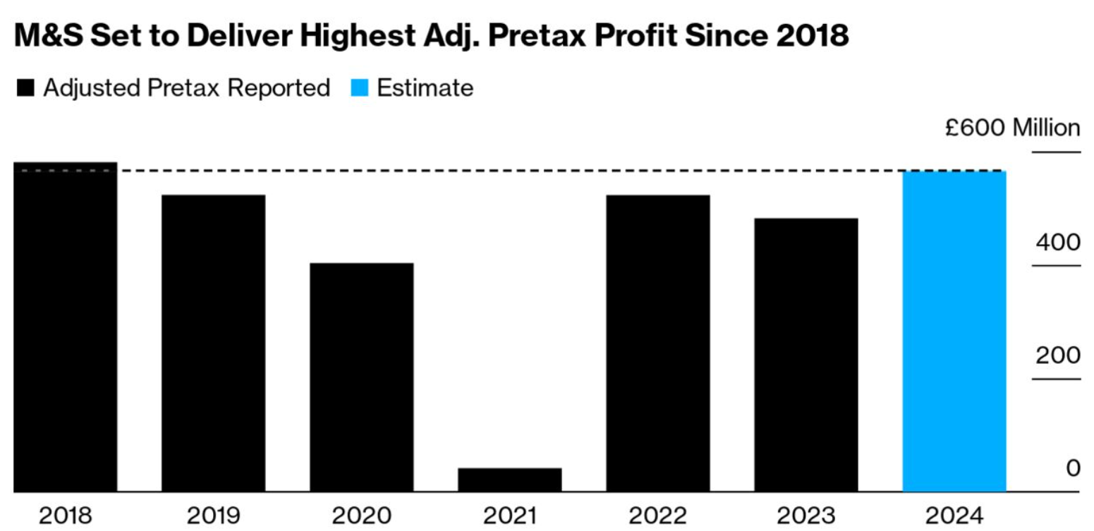
Figure 1: M&S revenue and adjusted profit before tax (Bloomberg 2023).

2.2 Talent acquisition and retention
Acquisition and retention of talent is also a strategic move since competitiveness of retailing is based on the ability to hire service-oriented, commercially and digitally dynamic employees in a crammed labour market. According to CIPD data, 83 percent of the organisations who tried to recruit reported challenges and most prevalent was upskilling current employees (CIPD, 2024a). This is important to M&S since the store positions integrate customer service, stock control, digital fulfilment and leadership, but are vulnerable to wage pressures with other retailers. The issue is not just drawing talents but retaining them to become competent. According to CIPD (2024a), increased L&D usage, better career clarity, increased pay and wellbeing provision are used to address retention. M&S has already retaliated by giving UK retail worker colleagues a 6.4% pay increase in 2026 that includes an increase in the customer assistant pay to at least 13.41 an hour and increasing pay investment in four years to over 350 million (Mark and Spencer plc, 2026b). Salary however is not enough. Fairness, development, flexibility and quality of line-management are also influencing retention (CIPD, 2026). Here, in a front-line retailer, predictable scheduling, enabling supervision, perceptible progress and an engaging employee value proposition exist (Theys and Barkhuizen, 2022).

2.3 Diversity, equity and inclusion (DEI)
The third aspect is that DEI is both a moral and a logistical concern because the workforce profile of M&S, customers and employer brand imply that inclusion is a moral concern. More precisely, M&S mentions that nearly 70 percent of its colleagues are women and 81.8 percent of the workforce consists of hourly-paid store colleagues, which can explain why the representation patterns still determine the pay outcomes (Marks and Spencer Group plc, 2025b; Marks and Spencer plc, 2026c). The April 2024 snapshot median gender pay gap was reported to be 5.5 percent and the median is expected to be the same in 2025, although the mean decreased a notch lower because more women are now represented in senior positions (Marks and Spencer plc, 2024; Marks and Spencer plc, 2026c). M&S has also incorporated DEI interview questions, mandatory discrimination-based training on staff hiring and introduced the EMERGE development initiative to colleagues of ethnic minority backgrounds; 37 colleagues have gone through the programme in 2025, 14 of whom have been store team managers (Marks and Spencer Group plc, 2025b). The important point is that at M&S, DEI is not merely a target matter, but a matter of whether progression, voice and opportunity is a regular occurrence across shops and operations.
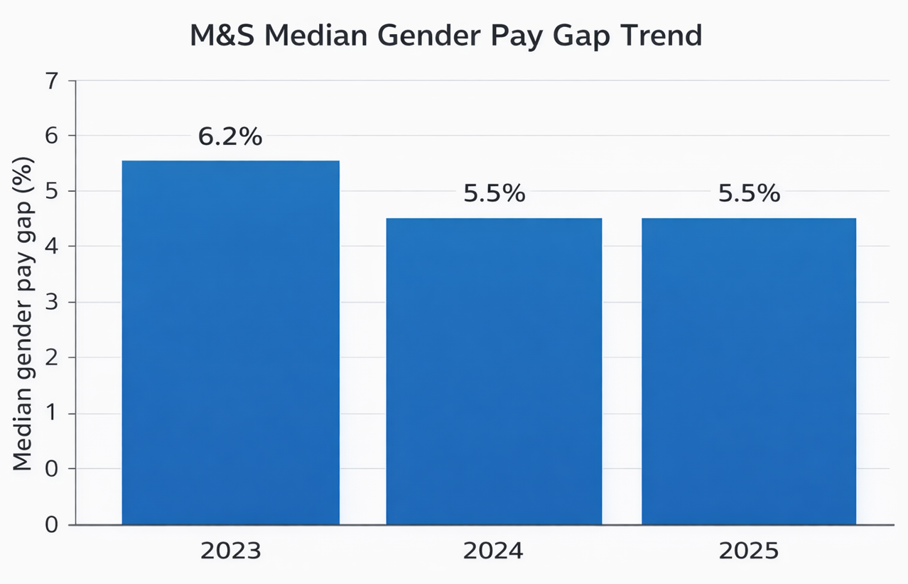
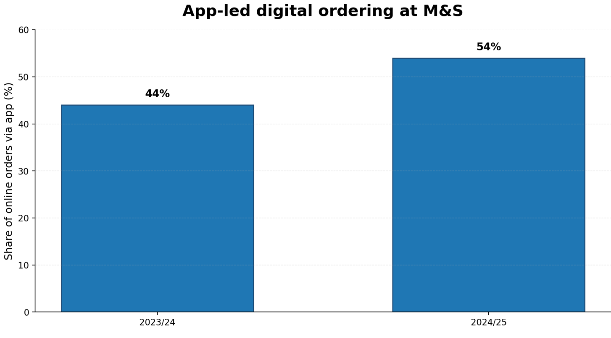
Figure 3: M&S median gender pay gap trend (Marks and Spencer plc 2024; 2026c)
Figure 2: App-led digital ordering at (M&S Marks and Spencer Group plc 2025a)

3. Evaluation of contemporary HR practices
Modern HR practice in connection with technological progress is to start with strategic workforce planning as opposed to ad hoc training. According to Nastase et al. (2025), strategic HRM during the digital age should balance the adoption of technology, development of capabilities and organisation design. In the case of M&S, an effective reaction would incorporate a talent-based labor landscape, online aptitude requirements on the principal role, specific learning journeys and people analytics to determine areas of weakness. Similar opinions are presented by OECD (2025) where matching and adaptability are recognized to be enhanced by a skills-first approach but only in the case when employers establish clear skills frameworks, trustful skills intelligence and leadership involvement. It is more powerful than training on one-off system since this is the way of connecting change to the visible role demands. The implementation constraint is implementation: skills-first language will not be of much use when managers do not have time, the quality of the data is poor or HR systems are not linked to store operations.
The second current trend is the utilization of AI and data-enabling recruiting technologies. CIPD, 2024a established that 66 percent of organizations involved in resourcing with AI had better hiring efficiency. In the case of M&S this would assist in the mass recruitment and vacancy forecasting. However, efficiency does not mean quality or fairness. Rigotti and Fosch-Villaronga (2024) demonstrate that AI recruitment systems increase risks that surround discrimination, privacy and non-transparent decision-making. In the case of a consumer facing brand like M&S, a biased process would harm the DEI objectives as well as spoiling the image of the employer. It is more strongly argued that AI must be supportive and not definitive: helpful in administration and in scheduling, but secondary to organised human judgement in shortlisting and selection.
The best practices to consider in order to deal with talent acquisition and retention are not individual intervention but rather a combination of both. To start with, an enhanced employee value proposition is important as EVP models have integrated reward, development, working environment and purpose in a manner that promotes attraction and retention (Theys and Barkhuizen, 2022). M&S can establish this with compensation, discounts, pension, wellness support and more transparent retail sector careers. Second, hiring based on skills can help increase access by hiring based on service behavior, digital potential and learning agility instead of specifying previous experience in the sector overly (OECD, 2025). Third, internal mobility and L&D are important since retention is better when employees feel progression; CIPD (2024a) depicts that both are used more frequently. Fourth, flexibility should be understood. Even though one of the most widespread solutions to recruitment challenges is increased flexibility, a retailer cannot afford to offer most store colleagues office-style hybrid working (CIPD, 2024a). Predictable scheduling, equitable distribution of rotes, shift-swapping schemes and open family-friendly practices are the more appropriate practice at M&S (Marks and Spencer Group plc, 2025b).
In the case of DEI, the most effective practices of the day include organized inclusive recruitment, inclusive leadership development, targeted intervention of progression, and measurable outcomes. M&S already reflects the aspects of this model with bias-based hiring training, DEI questions during interviews, mentoring groups and specific development under EMERGE (Marks and Spencer Group plc, 2025b). CIPD (2024a) also mentions increasing application of inclusive leadership training to managers. But the worth of these practices will be determined by whether it will alter the results. Included in the well-being, Liu et al. (2024) demonstrate that inclusive leadership enhances well-being by showing respect, recognition, support and developmental feedback. This makes it very applicable to retail teams where managers treat people daily which determines whether they remain and advance. When the DEI practice concentrates on the awareness activity, but neglects the decision on promotion, developmental access, and who quits business first, then it is weak. Systemic and not symbolic is, therefore, the best DEI practice at M&S.
Table 1: Contemporary HR response matrix for M&S
Factor | Most suitable HR practice | Why it fits M&S | Critical risk if weakly implemented
Technology | Skills-based workforce planning and targeted digital learning | Links digital retail growth to role capability | Training completion without real competence
Talent | EVP, predictable flexibility and internal mobility | Addresses attraction and retention in frontline retail roles | Higher pay without stronger progression or management quality
DEI | Structured recruitment, inclusive leadership and targeted progression | Improves fairness, voice and long-term representation | Symbolic targets without change in promotion and leaver rates

4. Critical evaluation of departmental managers and urgent implementation
The critical role of departmental managers is whether HR strategy is proved or not when policy comes into daily work. At M&S, the managers have an opportunity to influence several variables that determine the experience of employees: the design of shifts, frequency of coaching, the quality of onboarding, the use of digital tasks, and psychological safety. Central HR cannot be left to do urgent implementations. But being urgent must not be unproductive. The first managerial need is the quick local diagnosis. Individual departments are to come up with a brief people plan in 90 days that defines their digital skills resources, positions that are difficult to fill, attrition hotspots in the first year of employment, inclusion issues and risks in succession. This is important since the challenge in a food hall does not lie with the same challenge in fashion, beauty or support functions.
The second imperative is to incorporate modern HR practices in day-to-day management. In the case of technology, the managers ought to divide into regular learning sessions with protection, short task-based demonstrations, and check competence im live working. On talent, they ought to enhance the candidate experience, speed up structured onboarding, conduct stay conversations and internal opportunities visible. In the case of DEI, structured interview questions ought to be employed, developmental opportunities ought to be distributed equally, and exclusionary behaviours ought to be opposed. According to Liu et al. (2024), developmental feedback enhances well-being; in other words, in practice, this means that a shift to reactive supervision can be substituted by regular coaching. The reality is that there is a necessity in daily consistency, rather than in campaigns that only come in occasionally.
Third, the managers of the departments must have clear responsibilities. The relevant measures that M&S managers would have entailed would be time-to-fill, 90-day turnover, digital capability module completion, internal fill rates, absence, and engagement pulse results. Where applicable in law, ethics, patterns of progress and living among demographic groups should be examined as well. It is, however, evident that compliance theatre can be a danger when excessive KPIs are introduced. It is possible to reach training targets as their capability is weak.
Lastly, the managers themselves must be supported in case urgency is to be a realistic factor. According to OECD (2025), leadership participation and multi-teamwork is the main factor in integrating new practices, and M&S already possesses centralized DEI/wellbeing infrastructure (Marks and Spencer Group plc, 2025b). The managerial barrier is the practical barrier. The managers of the departments are to operate in the framework of labor budgets, customer pressure and weekly sales goals, without coaching, simple dashboards, access to HR partners and senior reinforcement; otherwise, there will be uneven execution.

5. Conclusion and recommendations
The HR priorities of M&S are linked together. Digital capability and resilience are essential to technological progress; the quality of reward, development and management retention is the key to talent retention, and the DEI quality is based on the presence of the opportunity and voice in daily decisions. The best modern practices are hence integrated, evidenced based and manager enabled as opposed to isolated activities. That is why departmental managers are the decisive connection of the corporate will and sustainable business performance. This is the place where one gains an edge.
- Institutionalize 90-day departmental people plans to diagnose digital skill gaps, which are at risk of retention, and inclusion issues, and are reviewed by senior store leadership monthly.
- Skills-first recruitment and governed AI should be utilized as a supporting tool only with the help of structured interviews, clear criteria and audit of fairness.
- Enhance the value proposition of the frontline employees by providing competitive compensation, predictable flexibility, better clarity of progression pathways and internal development visibility.
- Hold departmental managers responsible for a balanced people scorecard that includes digital capability, early turnover, internal mobility and inclusive team climate.

References
Bloomberg (2023) M&S restores dividend as profit jumps and Merry Christmas beckons. Available at: https://www.bloomberg.com/news/articles/2023-11-08/m-s-restores-dividend-as-profit-jumps-and-merry-christmas-beckons
CIPD (2024a) Resourcing and talent planning report 2024. London: Chartered Institute of Personnel and Development. Available at: https://www.cipd.org/globalassets/media/knowledge/knowledge-hub/reports/2024-pdfs/8662-resource-and-talent-planning-2024-report-web.pdf
CIPD (2024b) Flexible working: The business case. London: Chartered Institute of Personnel and Development. Available at: https://www.cipd.org/globalassets/media/knowledge/knowledge-hub/tools/2024-pdfs/8557-flexible-working-business-case-evidence-feb24.pdf
CIPD (2026) Employee turnover and retention. Available at: https://www.cipd.org/uk/knowledge/factsheets/turnover-retention-factsheet/ (Accessed: 9 March 2026).
Liu, Y., Fang, Y., Hu, L., Chen, N., Li, X. and Cai, Y. (2024) 'Inclusive leadership and employee workplace well-being: the role of vigor and supervisor developmental feedback', BMC Psychology, 12(1), 540. https://doi.org/10.1186/s40359-024-02029-5.
Marks and Spencer Group plc (2025a) Annual Report and Financial Statements 2025. London: Marks and Spencer Group plc. Available at: https://corporate.marksandspencer.com/sites/marksandspencer/files/2025-05/Marks-and-Spencer-Group-plc-Annual-Report-and-Financial-Statements-2025_INTERACTIVE_FINAL.pdf
Marks and Spencer Group plc (2025b) ESG Report 2025. London: Marks and Spencer Group plc. Available at: https://corporate.marksandspencer.com/sites/marksandspencer/files/2025-05/Marks-and-Spencer-Group-plc-ESG-Report-2025.pdf
Marks and Spencer plc (2024) Gender Pay Gap Figures April 2024. London: Marks and Spencer plc. Available at: https://corporate.marksandspencer.com/sites/marksandspencer/files/marks-spencer/results-reports-webcasts-and-presentation/gender-pay-gap-figures-april-2024.pdf
Marks and Spencer plc (2025b) Half Year Results for the 26 Weeks Ended 27 September 2025. London: Marks and Spencer plc. Available at: https://corporate.marksandspencer.com/newsroom/press-releases/half-year-results-26-weeks-ended-27-september-2025
Marks and Spencer plc (2026a) Corporate website: Welcome to M&S. Available at: https://corporate.marksandspencer.com/ (Accessed: 9 March 2026).
Marks and Spencer plc (2026b) M&S invests in colleagues with inflation-beating 6.4 per cent pay increase. Available at: https://corporate.marksandspencer.com/newsroom/press-releases/ms-invests-colleagues-inflation-beating-64-cent-pay-increase (Accessed: 9 March 2026).
Marks and Spencer plc (2026c) Gender Pay Gap Report 2025. London: Marks and Spencer plc.
Montero Guerra, J.M., Danvila-del-Valle, I. and Méndez-Suárez, M. (2023) 'The impact of digital transformation on talent management', Technological Forecasting and Social Change, 188, 122291. https://doi.org/10.1016/j.techfore.2022.122291.
Nastase, C., Adomnitei, A. and Apetri, A. (2025) 'Strategic Human Resource Management in the Digital Era: Technology, Transformation, and Sustainable Advantage', Merits, 5(4), 23. https://doi.org/10.3390/merits5040023.
OECD (2025) Empowering the Workforce in the Context of a Skills-First Approach. Paris: OECD. Available at: https://www.oecd.org/en/publications/empowering-the-workforce-in-the-context-of-a-skills-first-approach_345b6528-en.html
Rigotti, C. and Fosch-Villaronga, E. (2024) 'Fairness, AI & recruitment', Computer Law & Security Review, 53, 105966. https://doi.org/10.1016/j.clsr.2024.105966.
Theys, N.A. and Barkhuizen, E.N. (2022) 'The development of an employee value proposition framework for the South African water board sector', SA Journal of Human Resource Management, 20, a1944. https://doi.org/10.4102/sajhrm.v20i0.1944.
World Economic Forum (2025) The Future of Jobs Report 2025. Geneva: World Economic Forum. Available at: https://www.weforum.org/publications/the-future-of-jobs-report-2025/

