

Dissertation
Topic: Employee engagement and its impact on service quality in the UK hotelier industry: A case study of Premier Inn.
Student Name: Maria Boscanean
Student ID: 2021937

Declaration
I thus certify that this dissertation, is my own original work and that all references and sources consulted during the study have been properly cited. I certify that no other certificate or qualification has been applied for with this work. All other contributions to this work are duly acknowledged. I acknowledge that plagiarism has serious repercussions and attest that this dissertation is the result of my own sincere and independent research.

Maria Boscanean
Abstract
The research has explored the relationship between employee engagement and quality of service in the UK hospitality sector with an emphasis on Premier Inn. Besides, in the literature review section, the overall impact of employee engagement on guest satisfaction and service quality in the hospitality industry has been discussed thoroughly. The assessment of employee engagement levels and their relationship to customer satisfaction and service quality has been aided by surveys. The findings have indicated that increased staff engagement is positively correlated with enhanced guest experiences, problem-solving skills, service quality, and overall guest experiences. The research results provided practical approaches that Premier Inn and the hospitality industry as a whole can utilise to improve service quality through employee engagement optimisation. This can be effective in increasing their competitiveness in the ever-changing and dynamic hospitality landscape. Quantitative data has been analysed in this study through conducting the survey among the 30 employees. The employee engagement level in Premier Inn is very good as per the survey findings. Therefore, good employee engagement level at Premier Inn helps to maintain clear communication channels that positively impacts on the service quality as expressed in the results. Besides that, Improved service quality is the reason for gust loyalty and good brand image, increased number of customers in this business organisation as revealed by the findings section.

Acknowledgements
I want to express my appreciation for the advice and teaching I received from my university's professors and mentors. I am also indebted to my fellow classmates, who have consistently assisted me in obtaining more data necessary to complete this study. I shall be grateful to my university officials and mentors who have always provided me with guidance as I conducted my study. I appreciate all of your steadfast support, everyone.
Table of Contents
Chapter One: Introduction 9
1.1 Introduction 9
1.2 Research Background 9
1.3 Problem statement 10
1.4 Aim, objectives, research questions, Hypothesis, prepositions 10
1.5 Research Rationale 11
1.6 Methodology 12
1.7 Scope of the topic 13
1.8 Structure of the dissertation 13
1.9 Summary 13
Chapter Two: Literature Review 15
2.1 Introduction 15
2.2 The level of employee engagement within various segments in the hospitality industry 15
2.3 The Impact of employee engagement on service quality in the Hospitality Industry 17
2.4 The impact of service quality on guest satisfaction in the hospitality industry 18
2.5 Literature Gap 20
2.6 Summary 20
Chapter 3: Research Methodology 21
3.1 Introduction 21
3.2 Research onion 21
3.3 Research paradigm 22
3.4 Research Approaches 22
3.5 Research choice 23
3.6 Research Strategy 23
3.7 Data collection and tools 23
3.8 Data interpretation 24
3.9 Sampling method 24
3.10 Time horizon 25
3.11 Ethical considerations 25
3.12 Research Limitations 25
3.13 Gann chart 26
3.14 Summary 26
Chapter Four: Findings and Analysis 27
4.1 Introduction 27
4.2 Findings 27
4.3 Discussion 54
4.4 Summary 55
Chapter Five: Conclusion and Recommendations 57
5.1 Introduction 57
5.2 Conclusion of the research issues based on chapter 4 57
5.3 Conclusion of the research problem 58
5.4 Summary of the research findings 58
5.5 Original Contribution of the Research 59
5.6 Limitation 60
5.7 Recommendations 60
5.8 Summary 62
References 63
Appendix One: Gantt chart 68
Appendix Two: Questionnaire 69
Appendix Three: Survey Results 71

Chapter One: Introduction

Introduction
Improving service quality is a major challenge for the UK hotel industry, of which Premier Inn is a prime example. Considering the critical role that employee engagement plays in shaping service standards, the goal of this study is to thoroughly evaluate employee engagement levels in a variety of Premier Inn segments. The aim of the study is to identify the complex dynamics influencing the hospitality experience by examining the close relationship between staff engagement, service excellence, and guest satisfaction.

Research Background
One of the top brands in the UK hotel business, Premier Inn is a division of Whitbread PLC. Since its founding in 1987, Premier Inn has expanded to become one of the biggest and most respected hotel chains, earning a reputation for offering reasonably priced, superior lodging. Premier Inn, which has a large presence all over the UK, places a strong emphasis on the comfort, convenience, and reliable service of its guests. The company's state-of-the-art facilities, highly skilled workforce, and customer-focused philosophy all demonstrate its dedication to excellence. Premier Inn keeps establishing standards by providing a wide variety of lodging options to satisfy the demands of its customers (premierinn, 2023).The rationale behind this investigation is the conviction that a comprehensive comprehension of these connections can be advantageous to Premier Inn. Therefore, it will also add significant perspectives to the wider discussion on maximising the level of service in the hospitality industry (Newbery, 2023). Understanding the effectiveness of employee engagement is essential to improve the performance level of the employees. This will generally enhance the service quality leading the company towards good profitability though increased customer satisfaction rate. The interrelation between the employee engagement and its effect on employee performance is significant to analyse though this study.

Problem statement
Employee engagement is very important for enhancing the profitability in any business. Premier Inn is facing issues related to the reduced level of service quality and guest satisfaction. This problem is linked with the employee engagement levels. This business group needs to mitigate issues related to poor employee engagement to enhance the guest satisfaction and improve service quality. With a particular focus on Premier Inn, this study aims to address important aspects of the hotelier industry in the United Kingdom in a multifaceted and pivotal manner. First and foremost, it seeks to evaluate employee engagement levels among various Premier Inn segments, offering a comprehensive understanding of employee dynamics. The study aims to clarify the relationship between employee engagement and service quality by identifying the complex interrelationships that influence the overall experience of guests. Thirdly, the research attempts to provide insights that can direct strategic decisions for improving customer loyalty by investigating the impact of the level of service on guest satisfaction. The study's ultimate goal is to provide Premier Inn and the industry at large with useful information that will help them better understand how employee engagement, customer service, and guest satisfaction interact to maintain competitiveness in the ever-changing hospitality market (Ampofo et al., 2023).

1.4 Aim, objectives, research questions, Hypothesis, prepositions
Aim
To understand the impact of employee engagement in the enhancement of service quality in the UK hotelier industry, focus on the case of Premier Inn.
Objectives
1. To assess the level of employee engagement within various segments of Premier Inn through the survey with the hotel staff.
2. To examine the impact of employee engagement (EE) on the service quality of Premier Inn.
3. To examine the impact of service quality on guest satisfaction of Premier Inn hotels.
Questions
1. What are the various levels of employee engagement within different segments of Premier Inn hotels?
2. How does employee engagement contribute to better service quality in Premier Inn hotels?
3. What are the impacts that employee engagement has on the satisfaction of guests at the Premier Inn hotels?

1.5 Research Rationale
The need to close a significant gap in the literature and support the strategic development of the UK hotelier industry exemplified by Premier Inn motivates this study. Although earlier research has recognized the significance of employee engagement, there are few thorough studies that are especially suited to Premier Inn's particular operational environment. Through a thorough examination of employee engagement in various organisational segments, this research aims to offer specific insights that go beyond general conclusions (Rosa et al., 2023). The reasoning is based on the knowledge that staff motivation, fulfillment, and engagement levels are intrinsically linked to Premier Inn's dedication to providing high-quality services. Understanding the complex relationships between staff engagement and quality of service is critical in an extremely competitive sector where consumer experiences are critical (Ribeiro et al., 2023). Therefore, to complete the triangle of variables affecting Premier Inn's overall success, the study also attempts to identify the downstream effect of the level of service on guest satisfaction. It is anticipated that the results will provide Premier Inn and the industry at large with useful information that will inform evidence-based tactics (Hendriks et al., 2023). These strategies will be aimed at improving employee engagement procedures, raising service standards, and eventually increasing guest satisfaction. The rationale behind this research is based on the conviction that a comprehensive investigation of these connections will enhance the scholarly understanding of worker engagement. Therefore, it will provide practical guidance for hoteliers aiming for excellence in a dynamic and competitive hospitality industry. Overall, the research justification highlights the study's immediate practical significance and positions it as a significant contribution to the improvement of operations and strategic decision-making at Premier Inn and, consequently, the larger UK hotelier sector (Jamieson et al., 2023).

Methodology
The research approach, which incorporates layers like research paradigm, strategy, tactics, and ethical issues, is based on Saunders' research onion framework. The research paradigm of choice is positivism, which is supported by a deductive research methodology. Using a straightforward random sampling technique, the study uses a survey as its research strategy to gather primary data from thirty participants. It is decided to use the cross-sectional time horizon for effective data compilation. Participants' consent and safe data storage are two ethical factors that are upheld. Notwithstanding its drawbacks, the methodology guarantees a methodical and reliable way to look into engagement among staff in the hospitality sector.

Scope of the topic
It is critical to comprehend how employee engagement affects service quality in the UK hotel sector, specifically at Premier Inn. In the modern business world, where a satisfied customer base is essential, this study provides an important new understanding of the complex interplay between staff engagement and superior customer service. structure of the dissertation. This research solely examines the hotelier sector in the United Kingdom, using Premier Inn as the main case study. The study explores how employee engagement affects customer satisfaction and service quality in this particular national setting, offering specific insights and suggestions for improving service excellence and competitiveness in the UK hospitality industry (Hendriks et al., 2023).

Structure of the dissertation
The dissertation has five main chapters and is organized in an organized manner. The Introduction lays out the background and the goals of the study. The literature review examines current theories and research on guest satisfaction, service quality, and employee engagement. The study design, gathering data, and analysis processes are described in detail in the methodology. The results display the management insights and survey results. The results are summarized, their implications are discussed, and practical recommendations for Premier Inn and the larger hospitality sector are made in the Conclusion. This methodical approach guarantees a thorough investigation of the study's questions and adds significant knowledge to the field.

1.9 Summary
The results have the potential to provide strategic direction for Premier Inn and other industry players, guiding focused efforts to boost staff satisfaction and raise service standards. In the end, this study not only tackles a relevant business issue but also adds significant insights to the larger conversation about promoting employee engagement for long-term growth in the cutthroat hospitality sector (Karatepe and Kim, 2023).

Chapter Two: Literature Review

2.1 Introduction
The literature review is one of the crucial parts of the research that involves various types of knowledge and information to effectively formulate the study. Concerning that, the literature review refers to the process of academic writing which consists of various pieces of information and knowledge to make an extensive understanding regarding a specific subject or topic. With respect to that, the literature review gains significant importance as it enables students and researchers to identify different aspects and explore required knowledge about the specific context. Apart from that, this also helps acquire deep knowledge and understanding of several theories as well.

2.2 The level of employee engagement within various segments in the hospitality industry
Concept of employee engagement
According to Sun and Bunchapattanasakda, (2019), the concept of employee engagement is intensely involved in the context of Human Resources that determines the interest level and dedication level of the employees towards their work. Concerning that, the employees who are engaged in their work become more efficient and productive which can ensure their professional success. A higher level of employee engagement is very beneficial for the upliftment of the performance of the organisation through which they can feel their importance within the organisation. Saks, (2019) stated that leaders take various initiatives to enhance the engagement level of the employees to increase their satisfaction and happiness within the firm.
Frontline employees
As stated by Prentice et al., (2019), a high engagement level in the frontline employees is very important for providing inclusive services to the customers. Besides, the front desk staff, housekeeping and others are the major staff on the frontline who are very responsible for being engaged in their work effectively in order to smoothly run the operation. With respect to that, a high level of engagement among the frontline staff is mandatory as they directly communicate with the guests to enhance their overall experience.
Middle management
Book et al., (2019) stated that employees belonging to the middle management are intensely involved in employee engagement. With respect to that, the supervisors and managers are considered as the middle management in the hospitality industry and they are supposed to be engaged in their work at a high level. These employees work as a middleman who maintains the interconnections between the upper-level and frontline staff. Besides, the engagement of the middle managers facilitates the motivation and morale of the employees.
Upper management
As mentioned by Marneros et al., (2020), the directors, owners and general managers are the members of upper management in the hospitality industry. Concerning that, the engagement level of the upper management is expected to be high as they are the prime members who formulate the entire organisational design. Apart from that, their extensive engagement is very important in the process of decision-making, managing employees and handling operations in an effective way.
Supporting employees
According to Ruel and Njoku, (2021), there are various supporting employees within the hospitality industry who make a significant contribution to the enhancement of the business service by their high engagement level. In this context, the marketing managers, finance and Human Resource are considered as the supporting staff who needs to be engaged moderately in maintaining the organisational efficiency.

2.3 The Impact of employee engagement on service quality in the Hospitality Industry
Higher quality of service
As stated by Olimovich et al., (2020), the ultimate quality of the services in the hospitality industry can be maintained and enhanced by having happy employees within the organisations. With respect to that, a high level of employee engagement is the key factor in increasing the happiness level of the employees within their workplace through which they can become motivated and interested towards the work. Besides, this enables the employees to be more efficient in their responsibility of providing quality services to the customers. In this context, Dooley et al., (2020) mentioned that the guest can become able to be provided with inclusive guest service by the employees.
Effective communication with the guests
Chathoth et al., (2020) argued that interaction with the guests in an effective way is one of the essential responsibilities of the workers within the hospitality industry. In this context, customers expect friendly and pleasant behaviour from the staff of the accommodation services. Consequently, it becomes easy for the happy and engaged employees to interact with the guests in a friendly and welcoming manner. Along with that, a personalised service is provided to the customers by the employees due to having a high level of employee engagement in the organisation. In addition to that, Wellton and Lainpelto, (2021) stated that this creates a positive brand image for the organisation and enhances trust and credibility among the customers.
Solving the problems of guests
According to Jones and Comfort, (2020), employees are very much responsible for resolving critical problems faced by the customers during their stay at the accommodation organisation. With respect to that, highly engaged employees are motivated and encouraged to take the responsibility to actively listen to the problems of the customers. Besides, based on the intensity and severity of the problems of the guests, the staff are supposed to provide effective resolutions that can satisfy the needs of the customers. Concerning that, the organisations obtain various benefits from engaging the employees towards their responsibilities at a high level.
Creating a good customer experience
As mentioned by Alnawas and Hemsley-Brown, (2019), creating a good customer experience requires delivering inclusive services to the guests throughout their stay at the hotel. Concerning that, this involves the requirements of engaging happy employees in the process of making a good customer experience. With respect to that, the high level of employee engagement is very beneficial for the enhancement of loyalty among the employees which motivates them to provide customers with various satisfactory services. Consequently, Alnawas and Hemsley-Brown, (2019) argued that this helps maintain the reputation of the organisation in the market and facilitates the return of the customers as well.

2.4 The impact of service quality on guest satisfaction in the hospitality industry
Enhances reliability
As stated by Ringle et al., (2020), the overall quality of services provided by the employees within the hospitality sector especially determines the satisfaction level of the guests. With respect to that, a pure and precise service is intensely expected by the guests from an accommodation organisation. In this context, a good quality of services is very effective for creating a positive impression of the organisation along with the employees as well as increasing the credibility level of the organisational service. Besides, evaluating the quality of services provided by the hotel staff, guests can extensively rely on the accommodation organisation which increases the return booking as well.
Empathy
Elche et al., (2020) mentioned that being empathetic is one of the essential qualities that employees should have within the hospitality industry. Concerning that, guests can come with various types of problems with the front desk staff that they face during their stay. In this scenario, the employees should be empathetic and genuinely feel their problems to bring effective solutions. Consequently, a happy employee can easily become engaged in the process of satisfying guests with satisfactory resolution. This adds more value in enhancing customer experience and guests also feel valued and respected by the friendly and familiar nature of the employees within the hospitality industry.
Responsiveness
Kim and Han, (2022) argued that there are various types of services that guests expect throughout their stay in the accommodation organisation. Besides, they are supposed to be treated well as they are very valuable and respected in the hospitality industry. For this reason, the employees of the hospitality company must be responsive and possess a friendly nature in mitigating any types of issues faced by the guest. In addition to that, through this service, the reliability and image of the employees of the organisation are enhanced. Consequently, the satisfaction level of the guest increased and they created a positive impression about the organisation within their mind as well.
Assurance
According to Rossanty et al., (2021), guests want assurance regarding their safety and security during their entire stay within the hotel. In this context, a high level of employee engagement fosters the sense within the staff of making guests assured about their safety and security. Along with that, they also assure guests to provide pleasant service for what they are paying. This creates a friendly and positive relationship with the guests that stimulates the satisfaction level of them.

2.5 Literature Gap
Literature gap consists some missing pieces or inadequate information on the specific research topic. This indicates the areas that have scopes for further research as those areas are unexplored. The entire research regarding employee engagement involves several gaps and deficiencies that the researcher has faced. Concerning that, the researcher did not get proper data about employee engagement in relation to providing high quality guest service due to not having adequate knowledge about the hospitality industry. Besides, the study of the impact of service quality on the satisfaction of guest requires further research by the researcher to enhance its credibility.

2.6 Summary
Employee engagement is one of the essential factors in the hospitality industry. Besides, the literature review section has included the level of employee engagement within the hospitality industry along with its significance. With respect to that, the way employee engagement helps organisations enhance their service quality has been mentioned in this section. In addition to that, understanding the importance of maintaining service quality for uplifting the satisfaction level of the guests within this sector is another significant aspect of this literature review as well.

Chapter 3: Research Methodology

3.1 Introduction
Methodology is the systematic framework that assists the researcher in setting up the structure of the research proceedings. In addition to this, research methodology allows the researcher to get the knowledge that is required for the development of the hypothesis and ways that can be achieved. Apart from this, methodology facilitates the time limit within which the study needs to be completed with a desirable result.

3.2 Research onion
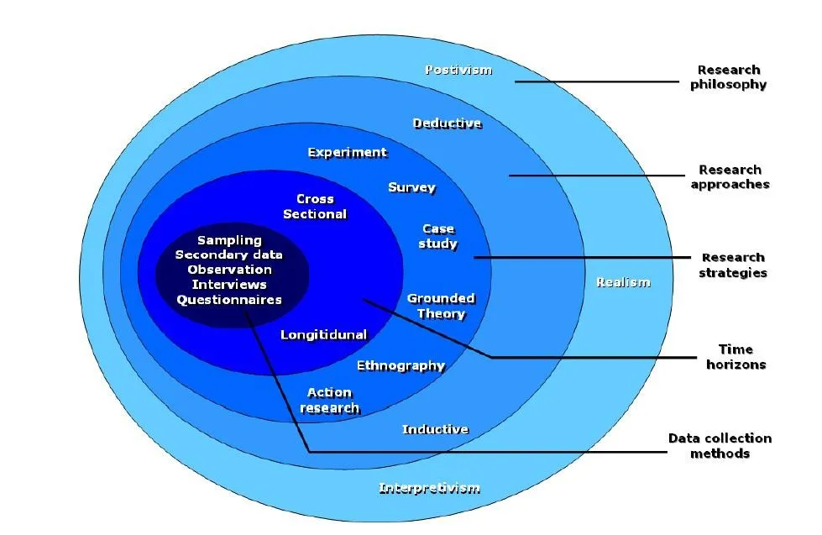
Figure: Saunders research onion
Source: (Thesismind, 2023)
Research Onion was developed in 2007 by Saunders and this framework has several layers for the research operations. This is the reason it resonates with the structure of the onion and is called Saunders's research onion (Thesismind, 2023). Saunders's research onion is a systematic framework that helps the researcher get a clear knowledge of the research proceedings and the methodology strengthens the basics of the research work. Apart from this, this framework represents various layers that facilitate the compilation of the research within a specific period.

3.3 Research paradigm
Research paradigm is the beliefs and norms that are concerned with the research processes. This research paradigm is divided into many sectors that incorporate positivism, objectivism, and constructivism respectively (Orth and Macada 2021). Objectivism is responsible for social factors and constructivism refers to the understanding of the knowledge by learning from the study. The researcher in this research study has selected positivism as the paradigm of the research process. Positivism helps the researcher in the development of the research hypothesis and the evaluation of the research process.

3.4 Research Approaches
The research approach is the collection of information that will facilitate the learning for the development of the research processes. Research approaches are of two types one is a deductive research process and another is an inductive research process. The inductive research process allows the researcher to formulate a theory for the study and focuses on the collected data for evaluation. Apart from this, the deductive research approach is the study of preexisting research theories and the researcher has selected this as the deductive approach compliments the positivism philosophy (SCIENCEDIRECT, 2023).

3.5 Research choice
Research choice in the Saunder research onion enables the researcher to gather both qualitative and quantitative data. This choice facilitates the gathering of data in a single framework that makes the research work easy and effective for the researcher. The research choices are of three types, especially like mono method, mixed method and multimethod (Robertson, 2020). The mixed method allows the study of qualitative and quantitative data whereas the mono method helps to study only one type of data. The researcher in this study has selected the mono method as only primary data accumulation is required for the study. The researcher in this study has selected the mono method as quantitative data accumulation is required for the study.

3.6 Research Strategy
Research strategy is one of the important steps of the research onion that incorporates the process that will carry the research further. In relation to this, the research choice is divided into several parts that include experimental study, survey, case study, and action research (Iovino, and Tsitsianis, 2020). Experimental research includes strategies for creating new research findings and the case study is based on previous research procedures. The researcher in this research has chosen the survey as survey helps to gather data easily and effectively as well and this assists in the accumulation of quantitative data.

3.7 Data collection and tools
Data collection is the process of gathering information from the participants thus, data collection helps in the understanding of the information irrespective of the variables (Mardiana, 2020). In relation to this, the researcher has selected the data by using the Google form through a survey. This enables the researcher to get data that are raw and richer information and opinions. The researcher has prepared few questionarrie to gain the feedback from the survey participants. The survey was based on the 30 members who were randomly selected. An average result can be drawn by getting reviews covering all segments of the participants. This data is considered as much reliable and valid by the researcher.

3.8 Data interpretation
Data interpretation is the process of using various methods to review the gathered information and get a desirable conclusion from the study. In addition to this, the data interpretation facilitates the researcher to critically evaluate their research findings with the help of various tools. The interpretation of the infraction assists the researcher in getting a clear idea of the quantitative data and the process of analysing the data (Researchgate, 2023).

3.9 Sampling method
Sampling is the process of selecting the desired participants for the research procedures. Sampling is one of the significant steps to understanding and getting unbiased data for the study. The researcher in this research work has selected the simple random sampling method (Bianchi, 2021). Considering this, the simple random sampling method helps the researcher to get unbiased data from the randomly selected thirty participants to gain extensive knowledge and preference about the research topic. Taking random sampling provides a major advantage of choosing the option of equal probability. Analysing all of this positive aspect this method is most convenient and easy to implement. Total 30 responses were taken which is a medium sample size for the survey. This number has provided more accurate and vast range of data required for the research. Large sample size has been avoided while doing the research, as minority sub group is not present in the members and impractical outcomes may be resulted by that.

3.10 Time horizon
The time horizon defines the required time for the compilation of each research process. Concerning this, the time horizon is dividends in two major subdivisions one is cross-sectional and the other is longitudinal. The longitudinal time horizon includes a repetitive collection of the data over time and the researcher has selected a cross-sectional time horizon which helps to collect the data within a specific time.

3.11 Ethical considerations
Ethical considerations are a set of principles that are maintained and followed by the researcher in the research proceedings. The researcher in this research has taken consent from the participants to avoid any kind of legal issues in the future (Maguire,2021). This makes the research more credible and reliable apart from this, the data has been securely stored in the password-protected cloud storage.

3.12 Research Limitations
The researcher faced difficulties while conducting the survey and getting desirable results from this. Apart from this the researcher also did not get permission to get access to various websites that will be beneficial for the researcher. There were no sufficient books in the library that helped the researcher in the study.

3.13 Gann chart
Mentioned in the appendix.

3.14 Summary
The methodology is the systematic process of research procedures and in this framework, Saunders’s research method has been followed by the researcher. Considering this, the research methodology has incorporated several steps and the researcher has chosen positive as a research philosophy for the completion of the research study. Deductive research approaches have been selected by the researcher to study the preexisting data regarding the study. A survey has been conducted in this study to understand the primary data and gather information from it. Ethical considerations have also been taken by the researcher to make the process credible and avoid any kind of legal steps.

Chapter Four: Findings and Analysis

4.1 Introduction
The chapter on findings and analysis will explore the outcomes of a survey that was carried out at Premier Inn. It will provide insights into employee roles, tenure, engagement perceptions, and the effects these have on customer satisfaction and service quality. The thorough analysis looks at participants' points of view and pinpoints important areas where employee engagement tactics and service quality improvement in the hospitality industry need to be strengthened.

4.2 Findings
Figure 1
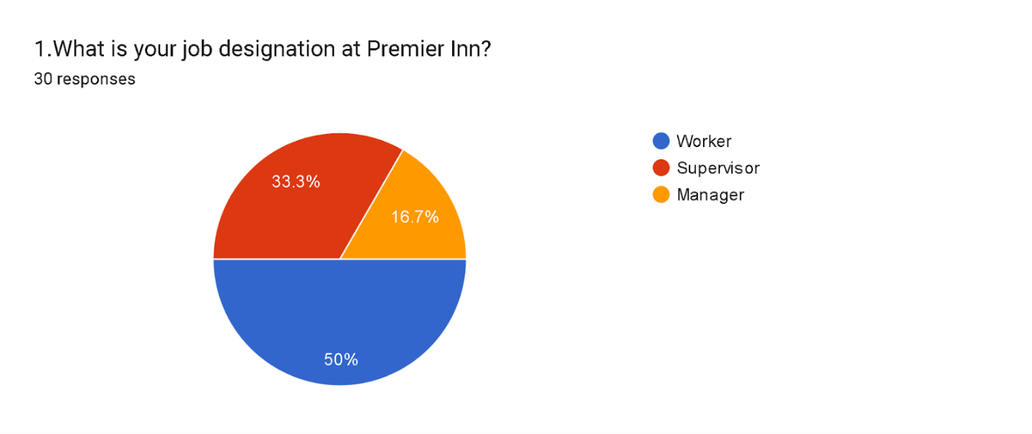
Source: Google
Timestamp | 1.What is your job designation at Premier Inn?
13/12/2023 11:49:26 | Worker
13/12/2023 11:49:53 | Supervisor
13/12/2023 11:50:12 | Manager
13/12/2023 11:50:44 | Worker
13/12/2023 11:51:11 | Worker
13/12/2023 11:51:36 | Manager
13/12/2023 11:51:57 | Supervisor
13/12/2023 11:52:17 | Manager
13/12/2023 11:52:37 | Worker
13/12/2023 11:52:57 | Worker
13/12/2023 11:54:59 | Supervisor
13/12/2023 11:59:30 | Worker
13/12/2023 11:59:50 | Supervisor
13/12/2023 12:00:07 | Supervisor
13/12/2023 12:00:25 | Manager
13/12/2023 12:03:56 | Supervisor
13/12/2023 12:04:14 | Worker
13/12/2023 12:10:48 | Supervisor
13/12/2023 12:18:40 | Worker
13/12/2023 12:18:59 | Supervisor
13/12/2023 12:19:24 | Worker
13/12/2023 12:19:46 | Supervisor
13/12/2023 12:20:03 | Manager
13/12/2023 12:20:19 | Worker
13/12/2023 12:20:35 | Worker
13/12/2023 12:20:50 | Worker
13/12/2023 12:21:07 | Worker
13/12/2023 12:21:29 | Worker
13/12/2023 12:21:46 | Supervisor
13/12/2023 12:22:04 | Worker

Analysis
The survey that was performed shows that 50% of the participants represent workers, 33.3% represent supervisors and the rest 16.7% are managers within Premier Inn. Such form of distribution shows a hierarchical structure in the organisation having a greater proportion of workers as compared to supervisors as well as managers. This can impact the employee engagement levels among various segments since their perspectives vary from time to time. Thus, knowing these dynamics is important to assess the overall employee engagement and its impact.
Figure 2
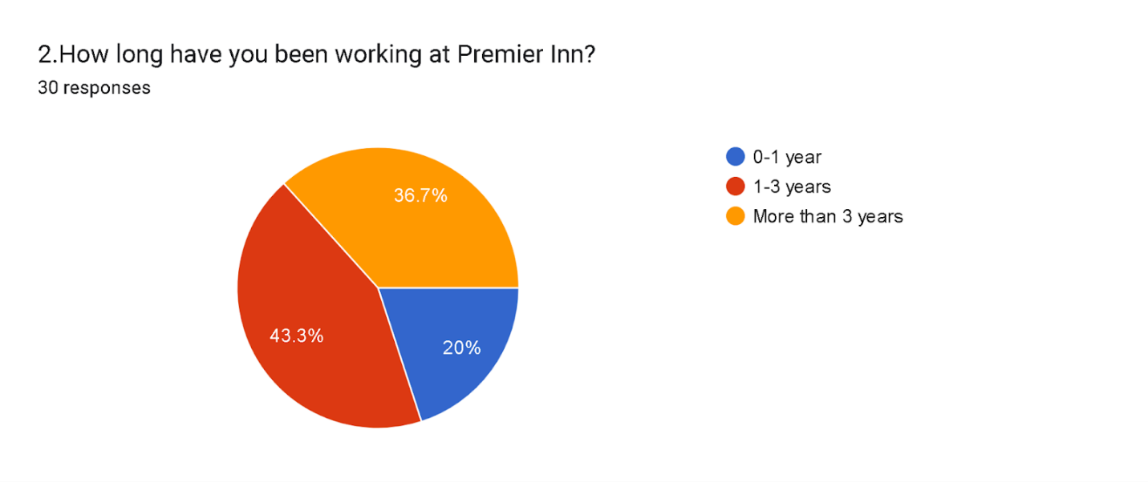
Source: Google
Timestamp | 2.How long have you been working at Premier Inn?
13/12/2023 11:49:26 | 0-1 year
13/12/2023 11:49:53 | 1-3 years
13/12/2023 11:50:12 | More than 3 years
13/12/2023 11:50:44 | 1-3 years
13/12/2023 11:51:11 | 1-3 years
13/12/2023 11:51:36 | 0-1 year
13/12/2023 11:51:57 | More than 3 years
13/12/2023 11:52:17 | 1-3 years
13/12/2023 11:52:37 | 1-3 years
13/12/2023 11:52:57 | 0-1 year
13/12/2023 11:54:59 | 1-3 years
13/12/2023 11:59:30 | 1-3 years
13/12/2023 11:59:50 | More than 3 years
13/12/2023 12:00:07 | 1-3 years
13/12/2023 12:00:25 | More than 3 years
13/12/2023 12:03:56 | More than 3 years
13/12/2023 12:04:14 | More than 3 years
13/12/2023 12:10:48 | More than 3 years
13/12/2023 12:18:40 | 1-3 years
13/12/2023 12:18:59 | 0-1 year
13/12/2023 12:19:24 | 0-1 year
13/12/2023 12:19:46 | 1-3 years
13/12/2023 12:20:03 | More than 3 years
13/12/2023 12:20:19 | 1-3 years
13/12/2023 12:20:35 | More than 3 years
13/12/2023 12:20:50 | More than 3 years
13/12/2023 12:21:07 | More than 3 years
13/12/2023 12:21:29 | 1-3 years
13/12/2023 12:21:46 | 1-3 years
13/12/2023 12:22:04 | 0-1 year

Analysis
The above figure shows that 20% of the participants have been working for 0-1 years, 43.3% for 1 to 3 years and the rest 36.7% for more than 3 years. Such breakdown shows a stable workforce with a large proportion of workers having experience of more than 3 years. Hence, the level of experience as well as knowledge in the organisation is high which influences the employee engagement levels and its effect on the service quality. Therefore, knowing their varying perspectives from experiences is essential to evaluate the service quality and guest satisfaction.
Figure 3
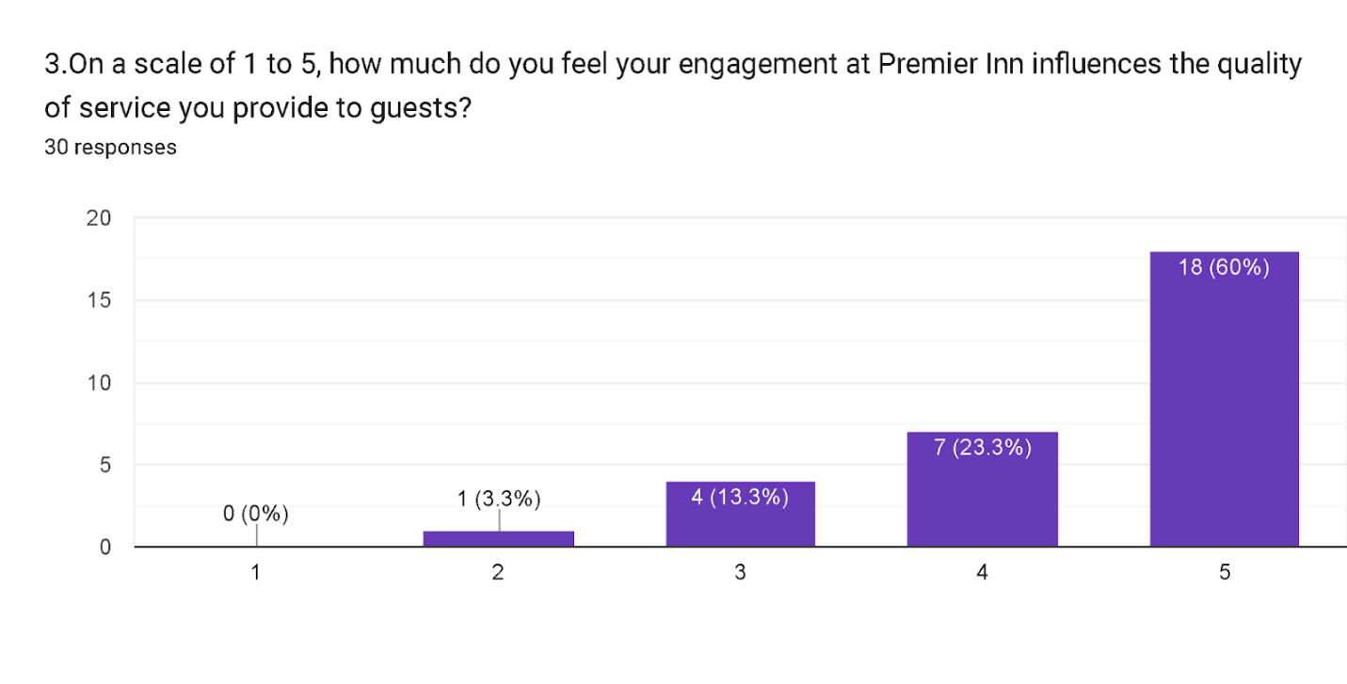
Source: Google
Timestamp | 3.On a scale of 1 to 5, how much do you feel your engagement at Premier Inn influences the quality of service you provide to guests?
13/12/2023 11:49:26 | 3
13/12/2023 11:49:53 | 4
13/12/2023 11:50:12 | 5
13/12/2023 11:50:44 | 5
13/12/2023 11:51:11 | 4
13/12/2023 11:51:36 | 5
13/12/2023 11:51:57 | 4
13/12/2023 11:52:17 | 5
13/12/2023 11:52:37 | 5
13/12/2023 11:52:57 | 5
13/12/2023 11:54:59 | 4
13/12/2023 11:59:30 | 5
13/12/2023 11:59:50 | 4
13/12/2023 12:00:07 | 3
13/12/2023 12:00:25 | 5
13/12/2023 12:03:56 | 5
13/12/2023 12:04:14 | 4
13/12/2023 12:10:48 | 3
13/12/2023 12:18:40 | 2
13/12/2023 12:18:59 | 4
13/12/2023 12:19:24 | 5
13/12/2023 12:19:46 | 3
13/12/2023 12:20:03 | 5
13/12/2023 12:20:19 | 5
13/12/2023 12:20:35 | 5
13/12/2023 12:20:50 | 5
13/12/2023 12:21:07 | 5
13/12/2023 12:21:29 | 5
13/12/2023 12:21:46 | 5
13/12/2023 12:22:04 | 5

Analysis
The above figure highlights the engagement ratings which influences the quality of service provided to customers. From the graph, it can be seen that the majority of the participants rated 5 which suggests a rigid belief within workers as their engagement brings higher impact in service quality. Also, the high percentage of ratings show a greater perception which employee engagement provides a major role to enhance service quality. Such alignment among the engagement as well as service quality shows promising results since it helps the objective of examining the effect within Premier Inn.

Figure 4
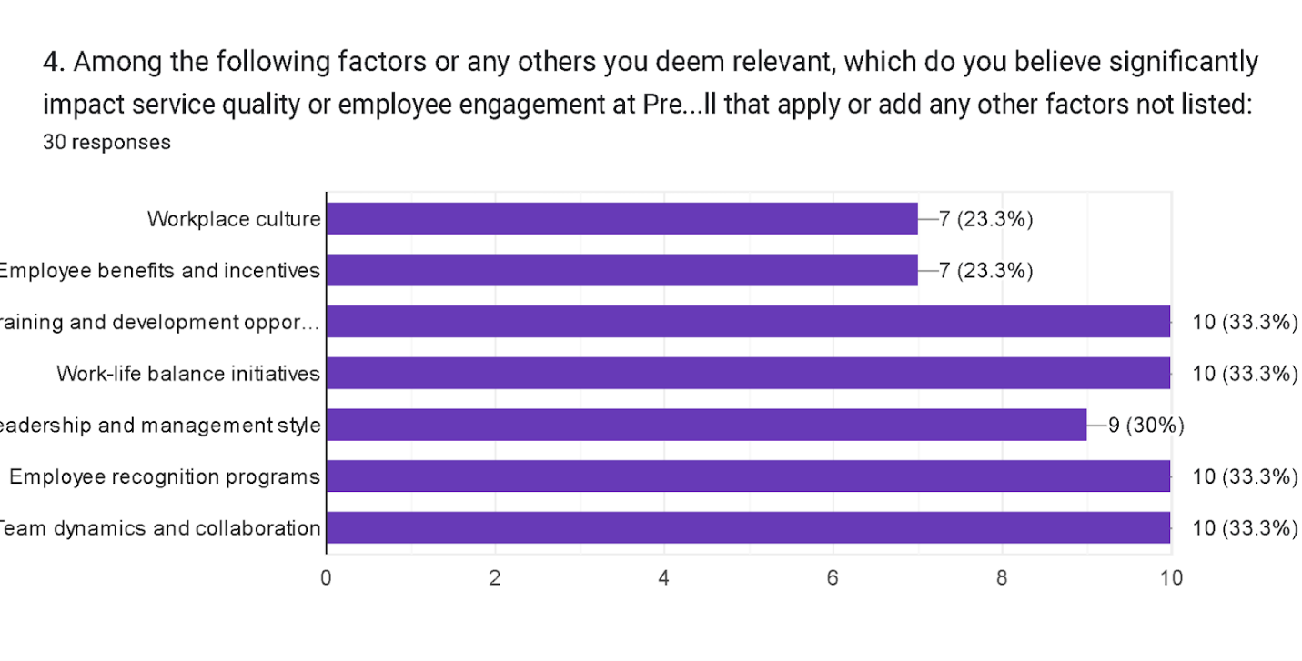
Source: Google
Timestamp | 4. Among the following factors or any others you deem relevant, which do you believe significantly impact service quality or employee engagement at Premier Inn? Please select all that apply or add any other factors not listed:
13/12/2023 11:49:26 | Workplace culture
13/12/2023 11:49:53 | Employee benefits and incentives, Training and development opportunities
13/12/2023 11:50:12 | Work-life balance initiatives, Leadership and management style
13/12/2023 11:50:44 | Workplace culture, Employee benefits and incentives
13/12/2023 11:51:11 | Employee recognition programs, Team dynamics and collaboration
13/12/2023 11:51:36 | Workplace culture, Employee benefits and incentives
13/12/2023 11:51:57 | Work-life balance initiatives, Leadership and management style
13/12/2023 11:52:17 | Training and development opportunities, Work-life balance initiatives
13/12/2023 11:52:37 | Training and development opportunities, Work-life balance initiatives, Leadership and management style, Employee recognition programs
13/12/2023 11:52:57 | Workplace culture, Employee benefits and incentives, Leadership and management style, Employee recognition programs
13/12/2023 11:54:59 | Workplace culture, Employee benefits and incentives, Training and development opportunities, Work-life balance initiatives, Leadership and management style, Employee recognition programs, Team dynamics and collaboration
13/12/2023 11:59:30 | Workplace culture
13/12/2023 11:59:50 | Training and development opportunities
13/12/2023 12:00:07 | Leadership and management style
13/12/2023 12:00:25 | Employee benefits and incentives
13/12/2023 12:03:56 | Work-life balance initiatives
13/12/2023 12:04:14 | Employee recognition programs
13/12/2023 12:10:48 | Training and development opportunities, Employee recognition programs, Team dynamics and collaboration
13/12/2023 12:18:40 | Training and development opportunities, Work-life balance initiatives
13/12/2023 12:18:59 | Leadership and management style, Employee recognition programs, Team dynamics and collaboration
13/12/2023 12:19:24 | Team dynamics and collaboration
13/12/2023 12:19:46 | Training and development opportunities, Work-life balance initiatives
13/12/2023 12:20:03 | Training and development opportunities, Work-life balance initiatives, Leadership and management style, Employee recognition programs
13/12/2023 12:20:19 | Workplace culture, Employee benefits and incentives, Training and development opportunities, Work-life balance initiatives, Leadership and management style
13/12/2023 12:20:35 | Team dynamics and collaboration
13/12/2023 12:20:50 | Team dynamics and collaboration
13/12/2023 12:21:07 | Team dynamics and collaboration
13/12/2023 12:21:29 | Employee recognition programs, Team dynamics and collaboration
13/12/2023 12:21:46 | Employee recognition programs
13/12/2023 12:22:04 | Team dynamics and collaboration

Analysis
The above survey results, there are various factors which were shown to be relevant that impacted the service quality and employee engagement within Premier Inn. It can be seen that 33.3% have considered work-life balance, rewards and recognition and training to be the major factors. Such findings highlight the dynamic nature of factors which are dedicated to the service quality as well as employee engagement in the company. Therefore, knowing the perceived effect of such factors has become important to come up with strategies to level up the service quality followed by employee engagement by aligning with the objectives.
Figure 5
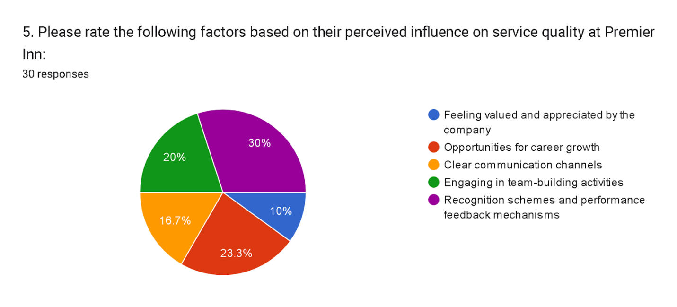
Source: Google
Timestamp | 5. Please rate the following factors based on their perceived influence on service quality at Premier Inn:
13/12/2023 11:49:26 | Feeling valued and appreciated by the company
13/12/2023 11:49:53 | Opportunities for career growth
13/12/2023 11:50:12 | Clear communication channels
13/12/2023 11:50:44 | Engaging in team-building activities
13/12/2023 11:51:11 | Recognition schemes and performance feedback mechanisms
13/12/2023 11:51:36 | Recognition schemes and performance feedback mechanisms
13/12/2023 11:51:57 | Opportunities for career growth
13/12/2023 11:52:17 | Recognition schemes and performance feedback mechanisms
13/12/2023 11:52:37 | Opportunities for career growth
13/12/2023 11:52:57 | Clear communication channels
13/12/2023 11:54:59 | Feeling valued and appreciated by the company
13/12/2023 11:59:30 | Clear communication channels
13/12/2023 11:59:50 | Clear communication channels
13/12/2023 12:00:07 | Engaging in team-building activities
13/12/2023 12:00:25 | Opportunities for career growth
13/12/2023 12:03:56 | Opportunities for career growth
13/12/2023 12:04:14 | Recognition schemes and performance feedback mechanisms
13/12/2023 12:10:48 | Engaging in team-building activities
13/12/2023 12:18:40 | Opportunities for career growth
13/12/2023 12:18:59 | Engaging in team-building activities
13/12/2023 12:19:24 | Recognition schemes and performance feedback mechanisms
13/12/2023 12:19:46 | Clear communication channels
13/12/2023 12:20:03 | Engaging in team-building activities
13/12/2023 12:20:19 | Opportunities for career growth
13/12/2023 12:20:35 | Recognition schemes and performance feedback mechanisms
13/12/2023 12:20:50 | Recognition schemes and performance feedback mechanisms
13/12/2023 12:21:07 | Recognition schemes and performance feedback mechanisms
13/12/2023 12:21:29 | Recognition schemes and performance feedback mechanisms
13/12/2023 12:21:46 | Engaging in team-building activities
13/12/2023 12:22:04 | Feeling valued and appreciated by the company

Analysis
The above figure highlights the factors depending on the perceived influence on service quality at Premier Inn. There have been multiple ratings which included feeling valued, career opportunities, open communication, engagement and many more. Such ratings show the wide factors which workers believe to be impactful for service quality in the company. Therefore, the focus on recognition as well as career opportunities show that workers see them as influential to develop service quality. Therefore, knowing these influences has become critical to address key areas which can also elevate the overall service quality at the hotel.
Figure 6
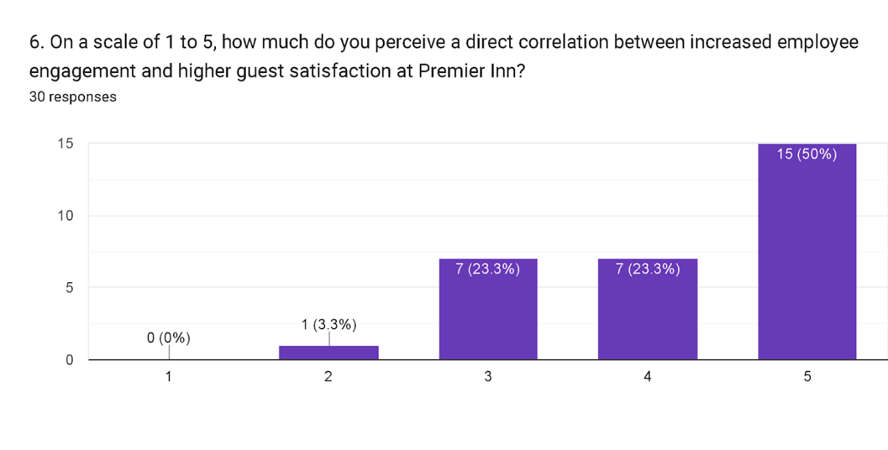
Source: Google
Timestamp | 6. On a scale of 1 to 5, how much do you perceive a direct correlation between increased employee engagement and higher guest satisfaction at Premier Inn?
13/12/2023 11:49:26 | 3
13/12/2023 11:49:53 | 4
13/12/2023 11:50:12 | 5
13/12/2023 11:50:44 | 5
13/12/2023 11:51:11 | 4
13/12/2023 11:51:36 | 3
13/12/2023 11:51:57 | 5
13/12/2023 11:52:17 | 3
13/12/2023 11:52:37 | 3
13/12/2023 11:52:57 | 5
13/12/2023 11:54:59 | 3
13/12/2023 11:59:30 | 5
13/12/2023 11:59:50 | 4
13/12/2023 12:00:07 | 3
13/12/2023 12:00:25 | 4
13/12/2023 12:03:56 | 2
13/12/2023 12:04:14 | 5
13/12/2023 12:10:48 | 3
13/12/2023 12:18:40 | 4
13/12/2023 12:18:59 | 5
13/12/2023 12:19:24 | 5
13/12/2023 12:19:46 | 4
13/12/2023 12:20:03 | 5
13/12/2023 12:20:19 | 5
13/12/2023 12:20:35 | 5
13/12/2023 12:20:50 | 5
13/12/2023 12:21:07 | 5
13/12/2023 12:21:29 | 5
13/12/2023 12:21:46 | 4
13/12/2023 12:22:04 | 5

Analysis
The above survey data shows that 50% of the participants see a direct correlation among higher employee engagement as well as guest satisfaction within Premier Inn hotels. Whereas, 23.3% rated 4 and 3 while the rest 3.3% rated it a 2. This distribution highlights a positive response that further suggests a rigid belief within workers in the positive relationship among engagement and client satisfaction. Hence, the majority of the ratings show a variety of perception that has been aligning with the objective of evaluating the effect of employee engagement on guest satisfaction within Premier Inn.
Figure 7
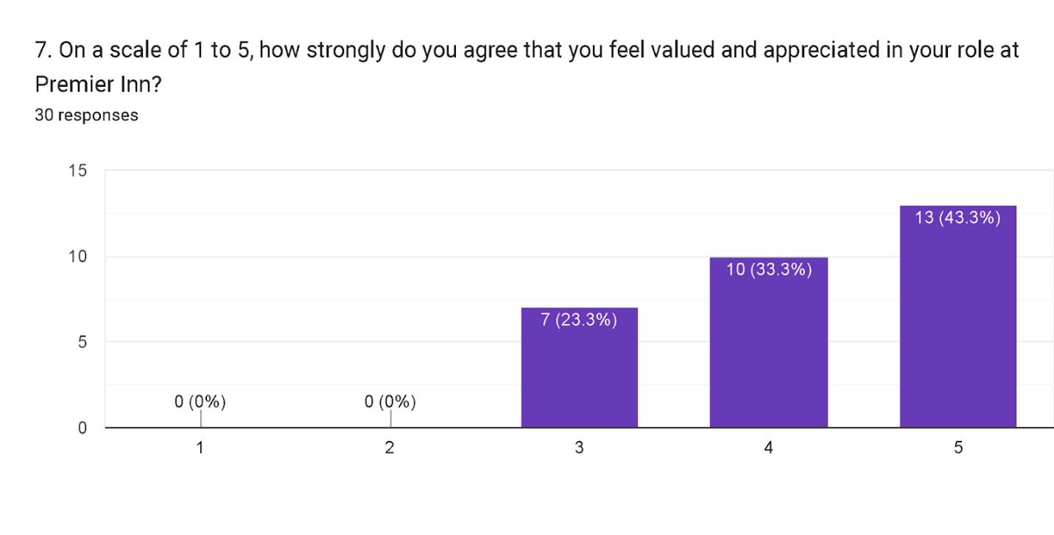
Source: Google
Timestamp | 7. On a scale of 1 to 5, how strongly do you agree that you feel valued and appreciated in your role at Premier Inn?
13/12/2023 11:49:26 | 4
13/12/2023 11:49:53 | 4
13/12/2023 11:50:12 | 5
13/12/2023 11:50:44 | 3
13/12/2023 11:51:11 | 3
13/12/2023 11:51:36 | 5
13/12/2023 11:51:57 | 3
13/12/2023 11:52:17 | 5
13/12/2023 11:52:37 | 4
13/12/2023 11:52:57 | 4
13/12/2023 11:54:59 | 3
13/12/2023 11:59:30 | 4
13/12/2023 11:59:50 | 4
13/12/2023 12:00:07 | 4
13/12/2023 12:00:25 | 5
13/12/2023 12:03:56 | 5
13/12/2023 12:04:14 | 4
13/12/2023 12:10:48 | 3
13/12/2023 12:18:40 | 3
13/12/2023 12:18:59 | 5
13/12/2023 12:19:24 | 5
13/12/2023 12:19:46 | 4
13/12/2023 12:20:03 | 5
13/12/2023 12:20:19 | 3
13/12/2023 12:20:35 | 5
13/12/2023 12:20:50 | 5
13/12/2023 12:21:07 | 5
13/12/2023 12:21:29 | 5
13/12/2023 12:21:46 | 4
13/12/2023 12:22:04 | 5

Analysis
The above graph shows that 43.3% of respondents rated feeling values as well as appreciated in Premier Inn as they gave it a 5. Whereas 33.3% rated 4 and 23.3% rated a 3. Such data shows generally positive feedback from the workers related to their perceived value as well as appreciation in the hotel. Also, the majority of the rating highlight a widespread belief that when workers feel valued, it can bring positivity in their engagement levels which will further improve service quality. As a result, understanding as well as maintaining such a sense of appreciation is very important to foster a motivated as well as committed workforce within Premier Inn.
Figure 8
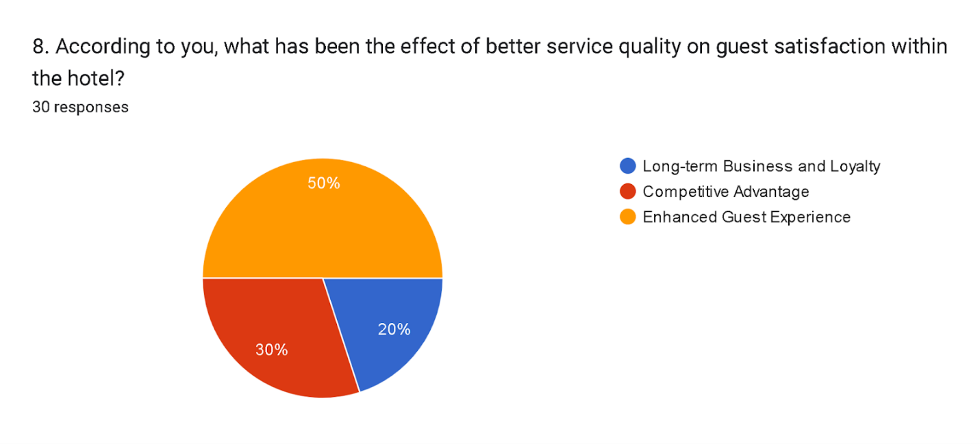
Source: Google
Timestamp | 8. According to you, what has been the effect of better service quality on guest satisfaction within the hotel?
13/12/2023 11:49:26 | Long-term Business and Loyalty
13/12/2023 11:49:53 | Competitive Advantage
13/12/2023 11:50:12 | Enhanced Guest Experience
13/12/2023 11:50:44 | Competitive Advantage
13/12/2023 11:51:11 | Long-term Business and Loyalty
13/12/2023 11:51:36 | Long-term Business and Loyalty
13/12/2023 11:51:57 | Enhanced Guest Experience
13/12/2023 11:52:17 | Competitive Advantage
13/12/2023 11:52:37 | Enhanced Guest Experience
13/12/2023 11:52:57 | Enhanced Guest Experience
13/12/2023 11:54:59 | Competitive Advantage
13/12/2023 11:59:30 | Competitive Advantage
13/12/2023 11:59:50 | Long-term Business and Loyalty
13/12/2023 12:00:07 | Enhanced Guest Experience
13/12/2023 12:00:25 | Competitive Advantage
13/12/2023 12:03:56 | Enhanced Guest Experience
13/12/2023 12:04:14 | Long-term Business and Loyalty
13/12/2023 12:10:48 | Competitive Advantage
13/12/2023 12:18:40 | Enhanced Guest Experience
13/12/2023 12:18:59 | Enhanced Guest Experience
13/12/2023 12:19:24 | Enhanced Guest Experience
13/12/2023 12:19:46 | Competitive Advantage
13/12/2023 12:20:03 | Enhanced Guest Experience
13/12/2023 12:20:19 | Enhanced Guest Experience
13/12/2023 12:20:35 | Enhanced Guest Experience
13/12/2023 12:20:50 | Enhanced Guest Experience
13/12/2023 12:21:07 | Enhanced Guest Experience
13/12/2023 12:21:29 | Enhanced Guest Experience
13/12/2023 12:21:46 | Competitive Advantage
13/12/2023 12:22:04 | Long-term Business and Loyalty

Analysis
The above figure highlights the effect of better service quality towards guest satisfaction at Premier Inn where half of the participants have selected enhanced guest experience. This data shows the dynamic impact of developed service quality which can influence long-term business relationships as well as loyalty. Hence, this can lead to the attainment of a competitive advantage in the sector as well as development of guest experience. Hence, knowing such effects is crucial to align the service quality improvements with the goal to maximise client satisfaction within the hotel sector.
Figure 9
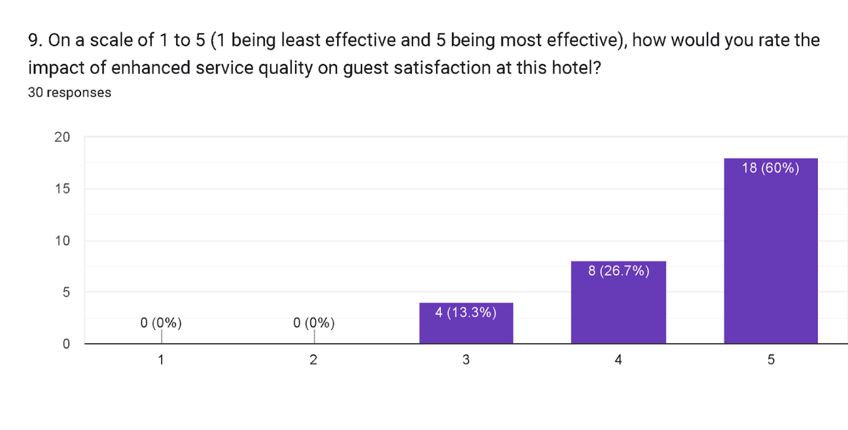
Source: Google
Timestamp | 9. On a scale of 1 to 5 (1 being least effective and 5 being most effective), how would you rate the impact of enhanced service quality on guest satisfaction at this hotel?
13/12/2023 11:49:26 | 4
13/12/2023 11:49:53 | 4
13/12/2023 11:50:12 | 5
13/12/2023 11:50:44 | 5
13/12/2023 11:51:11 | 5
13/12/2023 11:51:36 | 5
13/12/2023 11:51:57 | 3
13/12/2023 11:52:17 | 5
13/12/2023 11:52:37 | 5
13/12/2023 11:52:57 | 4
13/12/2023 11:54:59 | 3
13/12/2023 11:59:30 | 5
13/12/2023 11:59:50 | 4
13/12/2023 12:00:07 | 4
13/12/2023 12:00:25 | 4
13/12/2023 12:03:56 | 5
13/12/2023 12:04:14 | 5
13/12/2023 12:10:48 | 4
13/12/2023 12:18:40 | 5
13/12/2023 12:18:59 | 3
13/12/2023 12:19:24 | 5
13/12/2023 12:19:46 | 3
13/12/2023 12:20:03 | 5
13/12/2023 12:20:19 | 5
13/12/2023 12:20:35 | 5
13/12/2023 12:20:50 | 5
13/12/2023 12:21:07 | 5
13/12/2023 12:21:29 | 5
13/12/2023 12:21:46 | 4
13/12/2023 12:22:04 | 5

Analysis
Based on the above survey results, it can be seen that the majority of the respondents have rated the effect of enhanced service quality within the hotel a 5. Such a huge positive response shows a strong belief among the participants regarding the impact of developed service quality on guest satisfaction. Most of the high ratings highlight a wider perception which improved service quality dedicated to enhanced client satisfaction after assessing the effect of service quality on guest satisfaction within Premier Inn. Therefore, the workers are confident that when their service quality has improved, it has greatly helped the hotel business significantly.
Figure 10
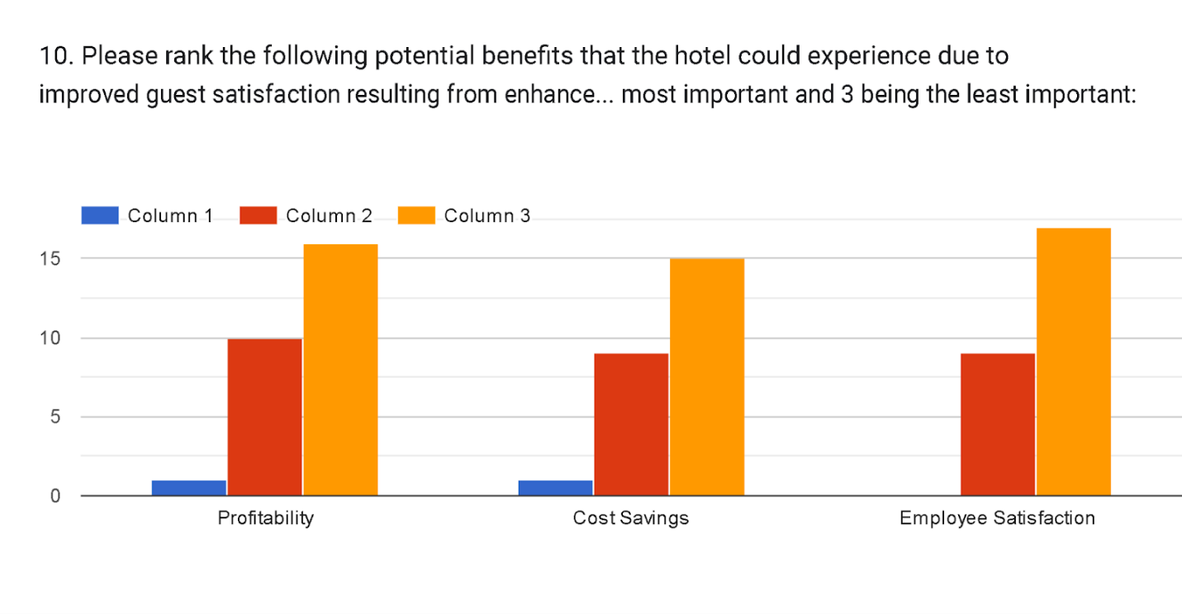
Source: Google
Timestamp | 10. Please rank the following potential benefits that the hotel could experience due to improved  guest satisfaction resulting from enhanced service quality, assigning a number from 1 to 3 to  each benefit based on its importance, with 1 being the most important and 3 being the least  important: [Profitability] | 10. Please rank the following potential benefits that the hotel could experience due to improved  guest satisfaction resulting from enhanced service quality, assigning a number from 1 to 3 to  each benefit based on its importance, with 1 being the most important and 3 being the least  important: [Cost Savings] | 10. Please rank the following potential benefits that the hotel could experience due to improved  guest satisfaction resulting from enhanced service quality, assigning a number from 1 to 3 to  each benefit based on its importance, with 1 being the most important and 3 being the least  important: [Employee Satisfaction]
13/12/2023 11:49:26 | Column 2 | Column 2 | Column 3
13/12/2023 11:49:53 | Column 3 | Column 3 | Column 3
13/12/2023 11:50:12 | Column 3 | Column 3 | Column 3
13/12/2023 11:50:44 | Column 2 | Column 3 | Column 3
13/12/2023 11:51:11 | Column 2 | Column 3 | Column 2
13/12/2023 11:51:36 | Column 3 | Column 2 | Column 2
13/12/2023 11:51:57 | Column 3 | Column 3 | Column 3
13/12/2023 11:52:17 | Column 2 | Column 2 | Column 3
13/12/2023 11:52:37 | Column 3 | Column 1 | Column 3
13/12/2023 11:52:57 | Column 3 | Column 3 | Column 2
13/12/2023 11:54:59 | Column 2 | Column 2 | Column 2
13/12/2023 11:59:30 | Column 2
13/12/2023 11:59:50 |  |  | Column 3
13/12/2023 12:00:07 |  |  | Column 2
13/12/2023 12:00:25 |  | Column 2
13/12/2023 12:03:56 | Column 1
13/12/2023 12:04:14 | Column 3
13/12/2023 12:10:48 | Column 3 | Column 2 | Column 3
13/12/2023 12:18:40 | Column 3 | Column 3 | Column 3
13/12/2023 12:18:59 | Column 2 | Column 3 | Column 2
13/12/2023 12:19:24 | Column 3 | Column 3 | Column 3
13/12/2023 12:19:46 | Column 2 | Column 2 | Column 2
13/12/2023 12:20:03 | Column 3 | Column 3 | Column 3
13/12/2023 12:20:19 | Column 3 | Column 3 | Column 3
13/12/2023 12:20:35 | Column 3 | Column 3 | Column 3
13/12/2023 12:20:50 | Column 3 | Column 3 | Column 3
13/12/2023 12:21:07 | Column 3 | Column 3 | Column 3
13/12/2023 12:21:29 | Column 3 | Column 2 | Column 3
13/12/2023 12:21:46 | Column 2 | Column 2 | Column 2
13/12/2023 12:22:04 | Column 2 | Column 3 | Column 2

Analysis
The above figures show that the participants ranked the benefits of enhanced guest satisfaction which resulted from enhanced service quality. This ranking shows that the participants believe worker satisfaction as the most significant benefit. This is also followed by profitability as well as cost savings. Therefore, knowing such perceived advantages has become crucial for Premier Inn to align with their strategies with the priorities of its staff. The insights that have been gained shows the potential to guide Premier Inn to optimise their operations as well as enhance their overall performance.

4.3 Discussion
Based on the survey analysis presented in the findings, various gaps within the literature review have been addressed. The literature review has focused on the importance of employee engagement among different levels of the company, especially in the hotel sector including its effect on service quality. However, the secondary study has lacked some specified empirical information from the setting of Premier Inn. Therefore, the survey results have addressed such gaps by offering accurate insights regarding the perceptions as well as the attitudes of workers in Premier Inn. This process has helped to shed light on their engagement levels as well as its effect on service quality and client satisfaction.
The results have highlighted that a majority of the respondents have identified themselves as workers, with only a small position represented as supervisors and managers. Such breakdown aligns with the secondary finding’s focus on the importance of engagement at different organisational levels since it shows the importance of frontline workers. These workers directly interact with customers followed by the middle and upper management whose engagement is vital to foster a positive workplace. Hence, such a process has closed the gap in the literature section by offering particular data on the distribution of workers in the hotel as well as their effect on service quality. Additionally, the survey results related to the influence of employee engagement on service quality and client satisfaction have directly bridged the gap by offering empirical evidence within the company. The majority of the respondents have rated high engagement levels as bringing a higher impact on service quality. This has indicated a rigid belief among the workers in the positive relationship among engagement and guest satisfaction. Such evidence has supported the literature’s conceptual findings by offering real-world insights of the necessity of engagement within the hotel sector. Also, the survey findings have specified the factors which workers believe influence the quality of services that includes feeling valued, career growth and open communication channels. Such results directly bridge the gap in the secondary findings by offering solid proof of the factors which workers in Premier Inn believes as impactful. Such form of empirical proof enriches the theoretical framework of the literature review after grounding it in the setting of the hotel. This also includes highlighting the factors which workers believe to be crucial to enhance their service quality.

4.4 Summary
The findings add to the body of research by emphasising the value of learning and growth, recognising the way service quality affects customer happiness and outlining the advantages that hotels may reap from enhanced client satisfaction and staff engagement. However, the survey results offer a useful basis for further investigation and have useful ramifications for Premier Inn as well as additional hotels that want to improve employee involvement and customer service to raise visitor satisfaction.

Chapter Five: Conclusion and Recommendations

5.1 Introduction

5.2 Conclusion of the research issues based on chapter 4
Employee engagement is a significant matter that every business requires to consider for efficiency in business operations. Good employee communication and cooperation help to achieve business objectives faster and promote organisational growth. This research has been continued with the review of various literary sources regarding the impact of employee engagement on service quality which is responsible for guest satisfaction. According to the results of the survey employee engagement is crucial for improving the service quality of Premier Inn. Therefore, the analysis section also has described that better employee engagement fosters customer satisfaction. It is effective to provide personalised service that directly or indirectly impacts the reputation of Premier Inn. Better service quality can improve the number of loyal customers, help to gain competitive advantage, and aid in meeting guest expectations. Consequently, the revenue of the hotel can be increased, cost savings can be possible and employee turnover also can be managed. In the hospitality sector, employee engagement is a key factor in assessing how committed and interested staff members are in their jobs. The Findings of the above study can align with other similar studies of the hospitality industry and successfully highlights the importance of employee engagement. It is a crucial factor in order to gain the satisfaction from the clients and also it helps to improve the service quality. According to this survey findings where maximum people who voted was workers stated how important it is for an organisation. This research also finds similarities with other study on same field that the knowledge of employee also contributes a lot in order to gain a higher level in client’s satisfaction. Therefore, it is important to keep the employee always motivated and engage to improve the overall organisational performance.

5.3 Conclusion of the research problem
Employee engagement leads to increased productivity and efficiency, which benefits the organisation's overall performance. This kind of engagement is especially important in the context of the hospitality industry for different employee segments. Since frontline staff members, such as housekeepers and front desk agents, are directly in charge of interacting with guests, it is imperative that they have high levels of engagement in order to deliver inclusive services. Middle management, which consists of managers and supervisors, keeps frontline and upper-level employees connected, which boosts morale and motivation among the workforce. In addition to formulating organizational design, upper management represented by trustees and general managers plays a crucial role in making choices and effective operations. In the hotel sector, employee engagement has a significant effect on the caliber of services provided. A higher degree of employee engagement raises the bar for service quality. Happy, driven, and proficient in delivering high-quality services, engaged staff members contribute to an inclusive visitor experience. In the hospitality industry, guest communication is of utmost importance.

5.4 Summary of the research findings
In the hospitality industry, guest communication is of utmost importance. Engaged staff members behave in a warm and pleasant manner, offering individualised services that improve brand perception and build credibility and trust with clients. Resolving issues for visitors is another area where employee engagement matters. The review of the literature highlights how motivated engaged staff members are to actively hear about and resolve customer issues, offering workable solutions that meet needs and raise customer satisfaction levels overall. Positivism philosophy has been utilised to complete the research work with efficiency. A survey strategy has been used to gather information about the employee engagement level of the Premier Inn hotel. This investigation into employee engagement in the hospitality sector, with a particular emphasis on Premier Inn.

5.5 Original Contribution of the Research
This research has made a noteworthy contribution to both administration and academia, by providing insights into the complex relationship between employee engagement and service quality in the hospitality industry. The results are a useful tool for researchers and professionals who want to maximise employee engagement tactics to improve service quality and competitiveness. Through, deeply analysisng the different levels of employee engagement and they it is impacting on the service quality, this study has provided a greater understanding. The research methodology with the help of Saunders’s research onion have ensured the quality of the study. This dissertation therefore, have improved the theoretical knowledge of researchers through clearly highlighting all the factors that mainly shape the customers’ satisfaction throughout the hospitality industry.

5.6 Limitation
This research has limitations in spite of its diligent efforts. Because the survey was only carried out at Premier Inn, the results' applicability in different settings is limited. Potential response bias is introduced by the use of self-reported data. The cross-sectional design of the study limits the capacity to prove causation. Time and access restrictions also had an impact on how much information was gathered. It is imperative to acknowledge these limitations in order to interpret the results and comprehend the extent to which the study's findings can be applied.

5.7 Recommendations
Employee motivation
Employee motivation is the key process of increasing the employee's engagement in the organisation. Thus, it is necessary to keep the employees motivated by meeting their basic needs of the employees as stated in the theory of Maslow's hierarchy of needs (Hamill, 2023). According to the theory, the basic needs of the employees such as safety and security concerns need to be met. Apart from this, the physiological needs of the employees as well as their self-confidence need to be increased to make them motivated in their workplace. In addition to this, all of these concerns are to be resolved to make them incorporated into the firm and increase employee engagement.
Employee Training
Training and upgrading the employee's skills are necessary to make the employees feel engaged in the organisation. In relation to this, the employees feel incorporated into the organisation when the firm arranges training programmes for the development of the employees. This directly facilitates the accountability of employee productivity and makes them efficient enough for their future career goals (SHRM, 2023). Training enhances the self-confidence of the employees and increases employee engagement in the firm. Apart from this, training enhances the understating of the skills required for the employee and also recognises the skill gaps of the employees. Thus, training helps in the overall development of the employees and their engagement with the firm.
Communication
Communication enhances employee engagement and increases teamwork in the organisation. In relation to this, employee engagement facilitates quality communication in the firm as it helps the employee to get connected with the subordinate and make bonds with the manager. This directly facilitates the work culture and the employees get more opportunities in the firm. Taking communicating measures and including activities that increase the communication in turn facilitates employee engagement in an organisation (Kalogiannidis 2020). Apart from this, communication helps the employees to get familiarity with the work environment thus, increasing the engagement of the employees with the firm.
Employee well being
Concerning the wellbeing of the employees and taking care of their needs increases the bond between the employee and the organisation. This directly affects the employees' thinking and makes them feel valued in the organisation. Employee engagement is stimulated by the behaviour of the leaders towards them and the way the firm treats their employees (Heinz, 2023). Apart from this, giving the salaries of the employees within a specific time motivates them and keeps them engaged. Gestures like providing them security and safety also increases the reliance of employees with the firm as well as keep them engaged energetically in the workplace.

Improving organisational culture and taking feedback
Organisational culture plays an important role in maintaining employee engagement in the workplace. An enhanced organisational culture facilitates the working ethics of the firm as well as makes the employees reliable to the organisation. This also enhances the image of the firm in front of the employees and increases employee retention in the organisation (OAK, 2023). In addition to this, taking feedback back from the employees and understanding their problems makes the employee engagement effective. This eventually conveys the positive atmosphere in the work culture and increases employee engagement in the company.

5.8 Summary
Premier Inn, demonstrates how crucial it is to determine the caliber of services provided and overall guest satisfaction. Employee engagement at all levels frontline, middle, and upper contributes to smooth operations, good communication, and problem solving, all of which improve the customer experience. The research confirms that cultivating a high level of employee engagement is essential to upholding service excellence, generating favorable brand perceptions, and establishing enduring customer trust. These results highlight the strategic significance of giving employee engagement programs top priority for long-term success in the competitive and dynamic hospitality industry.

References
Saks, A.M., (2019). Antecedents and consequences of employee engagement revisited. Journal of Organizational Effectiveness: People and Performance, 6(1), pp.19-38.
Ampofo, E.T., Ampofo, C., Nkrumah, S. and Ameza-Xemalordzo, E.B., (2023). The effect of supervisor’s abuse on hotel employees’ job satisfaction, affective organizational commitment and work engagement. Journal of Quality Assurance in Hospitality & Tourism, 24(4), pp.429-452.
Gonzalez-De-la-Rosa, M., Armas-Cruz, Y., Dorta-Afonso, D. and García-Rodríguez, F.J., (2023). The impact of employee-oriented CSR on quality of life: Evidence from the hospitality industry. Tourism Management, 97, p.104740.
Hendriks, M., Burger, M. and Commandeur, H., (2023). The influence of CEO compensation on employee engagement. Review of Managerial Science, 17(2), pp.607-633.
Jamieson, M.K., Govaart, G.H. and Pownall, M., (2023). Reflexivity in quantitative research: A rationale and beginner's guide. Social and Personality Psychology Compass, p.e12735.
Karatepe, O.M. and Kim, T.T., (2023). Job crafting and critical work-related performance outcomes among cabin attendants: Sequential mediation impacts of calling orientation and work engagement. Tourism Management Perspectives, 45, p.101065.
Newbery, C., (2023). How to improve employee engagement: six strategies that really work. [Online] Available at: https://www.ciphr.com/advice/how-to-improve-employee-engagement/[Accessed 26 october 2023].
premierinn, (2023). official website. [Online] Available at: https://www.premierinn.com/gb/en/home.html[Accessed 27 october 2023]
Ribeiro, N., Gomes, D., Oliveira, A.R. and Dias Semedo, A.S., (2023). The impact of the work-family conflict on employee engagement, performance, and turnover intention. International Journal of Organizational Analysis, 31(2), pp.533-549
Orth, C.D.O. and Maçada, A.C.G., (2021). Corporate fraud and relationships: a systematic literature review in the light of research onion. Journal of Financial Crime, 28(3), pp.741-764.
Mardiana, S., (2020). Modifying Research Onion for Information Systems Research. Solid State Technology, 63(4), pp.5304-5313.
Iovino, F. and Tsitsianis, N., (2020). The methodology of the research. In Changes in European energy markets (pp. 79-95). Emerald Publishing Limited.
Bianchi, L., (2021). Exploring ways of defining the relationship between research philosophy and research practice.
Robertson, S., (2020). Module 4: Research Design: Collecting and Interpreting The Data of Everyday Social Reality. Foundations in Sociology I.
Maguire, D., (2021). Influences on Ethical Decision Making in Organisations (Doctoral dissertation, Dublin, National College of Ireland).
Kalogiannidis, S., (2020). Impact of effective business communication on employee performance. European Journal of Business and Management Research, 5(6).
Hamill, D. L., (2023). What is employee engagement — and why it’s more than a buzzword. [Online] Available at: https://www.limeade.com/resources/blog/how-to-improve-employee-engagement/ [Accessed 5 NOVEMBER 2023].
Heinz, K., (2023). How to Improve Employee Engagement: 16 Effective Tips. [Online] Available at: https://builtin.com/employee-engagement/how-to-improve-employee-engagement [Accessed 5 NOVEMBER 2023].
OAK, (2023). How To Improve Employee Engagement with 10 Simple Ideas. [Online] Available at: https://www.oak.com/blog/improve-employee-engagement/ [Accessed 5 NOVEMBER 2023].
Researchgate, (2023). Research Onion: A Systematic Approach for Designing Research Methodology. Part One. [Online] Available at: https://www.researchgate.net/publication/368874144_Research_Onion_A_Systematic_Approach_for_Designing_Research_Methodology_Part_One [Accessed 5 NOVEMBER 2023].
SCIENCEDIRECT, (2023). Positivism. [Online] Available at: https://www.sciencedirect.com/topics/social-sciences/positivism [Accessed 5 NOVEMBER 2023].
SHRM, (2023). 7 Tips to Increase Employee Engagement Without Spending a Dime. [Online]Available at: https://www.shrm.org/hr-today/news/hr-magazine/1016/pages/7-tips-to-increase-employee-engagement-without-spending-a-dime.aspx [Accessed 5 NOVEMBER 2023].
Thesismind, (2023). Analysis of Saunders Research Onion. [Online] Available at: https://thesismind.com/analysis-of-saunders-research-onion/ [Accessed 5 NOVMBER 2023].
Sun, L. and Bunchapattanasakda, C., (2019). Employee engagement: A literature review. International Journal of Human Resource Studies, 9(1), pp.63-80.
Prentice, C., Ma, E. and Wong, I.A., (2019). Performance driven outcomes—The case of frontline employees in the hospitality sector. Journal of Hospitality Marketing & Management, 28(1), pp.101-123.
Book, L., Gatling, A. and Kim, J., (2019). The effects of leadership satisfaction on employee engagement, loyalty, and retention in the hospitality industry. Journal of Human Resources in Hospitality & Tourism, 18(3), pp.368-393.
Marneros, S., Papageorgiou, G. and Efstathiades, A., (2020). Identifying key success competencies for the hospitality industry: the perspectives of professionals. Journal of Teaching in Travel & Tourism, 20(4), pp.237-261.
Ruel, H. and Njoku, E., (2021). AI redefining the hospitality industry. Journal of Tourism Futures, 7(1), pp.53-66.
Olimovich, D.I., Bakhtiyorovich, T.M. and Salimovna, N.G., (2020). Improving of personnel training in hotel bussines. Academy, (2 (53)), pp.18-19.
Chathoth, P.K., Harrington, R.J., Chan, E.S., Okumus, F. and Song, Z., (2020). Situational and personal factors influencing hospitality employee engagement in value co-creation. International Journal of Hospitality Management, 91, p.102687.
Jones, P. and Comfort, D., (2020). The COVID-19 crisis and sustainability in the hospitality industry. International journal of contemporary hospitality management, 32(10), pp.3037-3050.
Alnawas, I. and Hemsley-Brown, J., (2019). Examining the key dimensions of customer experience quality in the hotel industry. Journal of Hospitality Marketing & Management, 28(7), pp.833-861.
Nunkoo, R., Teeroovengadum, V., Ringle, C.M. and Sunnassee, V., (2020). Service quality and customer satisfaction: The moderating effects of hotel star rating. International Journal of Hospitality Management, 91, p.102414.
Elche, D., Ruiz-Palomino, P. and Linuesa-Langreo, J., (2020). Servant leadership and organizational citizenship behavior: The mediating effect of empathy and service climate. International Journal of Contemporary Hospitality Management, 32(6), pp.2035-2053.
Kim, J.J. and Han, H., (2022). Saving the hotel industry: Strategic response to the COVID-19 pandemic, hotel selection analysis, and customer retention. International Journal of Hospitality Management, 102, p.103163.
Rossanty, Y., Nasution, M.D.T.P. and Irawan, I., (2021). Determinants of Customer Service Quality on Hotel Guest Satisfaction in the Samosir Tourism Area with a Structural Equation Modeling Approach. Budapest International Research and Critics Institute-Journal (BIRCI-Journal), 4(1), pp.189-203.
Qiu, S., Dooley, L.M. and Xie, L., (2020). How servant leadership and self-efficacy interact to affect service quality in the hospitality industry: A polynomial regression with response surface analysis. Tourism Management, 78, p.104051.
Wellton, L. and Lainpelto, J., (2021). The intertwinement of professional knowledge culture, leadership practices and sustainability in the restaurant industry. Scandinavian Journal of Hospitality and Tourism, 21(5), pp.550-566.
Alnawas, I. and Hemsley-Brown, J., (2019). Examining the key dimensions of customer experience quality in the hotel industry. Journal of Hospitality Marketing & Management, 28(7), pp.833-861.

Appendix One: Gantt chart
Features | 1st week | 2nd week | 3rd week | 4th week | 5th week | 6th week | 7th week | 8th week | 9th week | 10th week | 11th week | 12th week | 13th week | 14th week | 15th week
Choosing research topic
Picking the aim
objectives
Literature Review
methodology
Finding Analysis
resources
Discussion
improvements
Conclusion
Submission

Appendix Two: Questionnaire
1.What is your job designation at Premier Inn?
Worker
Supervisor
Manager
2.How long have you been working at Premier Inn?
0-1 year
1-3 years
More than 3 years
3.On a scale of 1 to 5, how much do you feel your engagement at Premier Inn influences the
quality of service you provide to guests? (1 = Not influential, 5 = Highly influential)
4. Among the following factors or any others you deem relevant, which do you believe
significantly impact service quality or employee engagement at Premier Inn? Please select all
that apply or add any other factors not listed:
Workplace culture
Employee benefits and incentives
Training and development opportunities
Work-life balance initiatives
Leadership and management style
Employee recognition programs
Team dynamics and collaboration
Other (Please specify, if not listed)
5. Please rate the following factors based on their perceived influence on service quality at
Premier Inn:
Feeling valued and appreciated by the company
Opportunities for career growth
Clear communication channels
Engaging in team-building activities
Recognition schemes and performance feedback mechanisms
6. On a scale of 1 to 5, how much do you perceive a direct correlation between increased
employee engagement and higher guest satisfaction at Premier Inn? (1 = No correlation, 5 =
Strong correlation)
7. On a scale of 1 to 5, how strongly do you agree that you feel valued and appreciated in your
role at Premier Inn? (1 = Strongly Disagree, 5 = Strongly Agree)
8. According to you, what has been the effect of better service quality on guest satisfaction within the hotel?
Long-term Business and Loyalty
Competitive Advantage
Enhanced Guest Experience
9. On a scale of 1 to 5 (1 being least effective and 5 being most effective), how would you rate the impact of enhanced service quality on guest satisfaction at this hotel? (1 = Never, 5 = Very Frequently).
10. Please rank the following potential benefits that the hotel could experience due to improved guest satisfaction resulting from enhanced service quality, assigning a number from 1 to 3 to each benefit based on its importance, with 1 being the most important and 3 being the least important:
a. Increased Revenue and Profitability
b. Cost Savings
c. Employee Satisfaction and Retention

Appendix Three: Survey Results
Figures

.

Appendix Four:
Participation Consent Form
University of Wales Trinity Saint David (London Campus)
Winchester House
11 Cranmer Road
London – SW9 6EJ
Tel: +442075667600
Email: info.london@uwtsd.ac.uk
londonstudentservice@uwtsd.ac.uk



 | Rhif Adnabod Cyfranogwr:  Participant Identification Number: | 5
FFURFLEN GANIATÂD CYFRANOGIAD | PARTICIPATION CONSENT FORM
Teitl Y Prosiect: / Project Title: Employee engagement and its impact on service quality in the UK hotelier industry: A case study of Premier Inn.
Enw'r Ymchwilydd / Name of Researcher: Maria Boscanean

1 | I confirm that I have read and understand the information sheet dated on December 1st 2023, for the above study. I have had the opportunity to consider the information, ask questions and have had these answered satisfactorily. |  |  | V
2 | I understand that my participation is voluntary and that I am free to withdraw at any time, without giving any reason. |  |  | V
3 | I understand that any information given by me may be used in future reports, articles or presentations by the research team. |  |  | V
4 | I understand that my name will not appear in any reports, articles or presentations. |  |  | V
5 | I agree to take part in the above study. |  |  | V
Name of Participant |  | Victoria Dercaci | Signature  Dercaci
Researcher |  | Maria Boscanean | Signature  Boscanean

You may decline to participate in this study. You may end your participation in this study at any time. If you decide to remain anonymous, maintaining your anonymity will be a priority and every practical precaution will be taken to disguise your identity. If you prefer anonymity, there will not be any identifying information on audiotapes or transcripts of this or any interview. No one will hear any audiotapes or see any transcripts without your prior consent. All materials generated from this or any interview will remain confidential.
When completed please return in the envelope provided. One copy will be given to you and the original to be kept on the file of the research team at:

NAME & ADDRESS OF RESEARCHER
Maria Boscanean
University of Wales Trinity Saint David (London Campus)
Winchester House
11 Cranmer Road
London – SW9 6EJ
Tel: +442075667600
Email: info.london@uwtsd.ac.uk
: londonstudentservice@uwtsd.ac.uk

Appendix Five:
Participant Information Sheet


 | Rhif Adnabod Cyfranogwr:  Participant Identification Number: | 5
FFURFLEN GANIATÂD CYFRANOGIAD | SAMPLE PARTICIPANT INFORMATION SHEET
Teitl Y Prosiect: / Project Title: Employee engagement and its impact on service quality in the UK hotelier industry: A case study of Premier Inn.

Dear Sir/Madam,

My name is Maria Boscanean and I am a 3rd year student in the School of Business, Finance and Management (London Campus), Faculty of Business and Management in University of Wales Trinity Saint David, United Kingdom. At present, I am conducting a research on Employee engagement and its impact on service quality in the UK hotelier industry: A case study of Premier Inn. The purpose of this research is to examine how employee engagement affects customer satisfaction and service quality, offering specific insights and suggestions for improving service excellence and competitiveness in the UK hospitality industry, using Premier Inn as the main case study.

I would like to invite you to participate in my research project by answering the attached short questions developed by the researchers. Those questions will assess your opinions, experiences, knowledge, suggestions and views. Through your participation in the interviews, I hope to ascertain my research purpose to get the best opinion from you. I believe your opinion will be extremely helpful to me to carry out this research.

All questions will be kept strictly confidential to the researchers involved and at NO time will individual questions will be released to the general public. This gives you a chance to express your views on your programme a confidential and anonymous forum and still be able to make a difference. Your participation in this study is completely voluntary so you can withdraw from the questionnaire at any stage.

Please note, questionnaire should take no more than 30 minutes to complete but however, there is no time constraint. There are also no right or wrong answers. Attached to this letter along with the questionnaire there is a consent form where you will better understand researchers intension As this is a new project, your feedback is also important to me and I would be much obliged if you could also complete the feedback sheet along with the questionnaire. I understand that your time is at a premium, but your opinions are very valuable to me.
After careful and precise analysis of the data obtained from this questionnaires/interviews, I will be happy to provide you with a copy of the findings at your request. The results of this questionnaire will hopefully enhance my understanding of current level of knowledge and future findings. The results of the research will be feedback to Director of Studies, Supervisor, University and British Library.

I thank you in advance for your time and participation. If any questions do arise, feel free to contact me at your convenience.

NAME & ADDRESS OF RESEARCHER
Maria Boscanean
University of Wales Trinity Saint David (London Campus)
Winchester House
11 Cranmer Road
London – SW9 6EJ
Tel: +442075667600
Email: info.london@tsd.ac.uk
londonstudentservice@tsd.ac.uk

Appendix Six:
APPLICATION FOR ETHICAL APPROVAL

In order for research to result in benefit and minimise risk of harm, it must be conducted ethically. A researcher may not be covered by the University’s insurance if ethical approval has not been obtained prior to commencement.

The University follows the OECD Frascati manual definition of research activity: “creative work undertaken on a systematic basis in order to increase the stock of knowledge, including knowledge of man, culture and society, and the use of this stock of knowledge to devise new applications”. As such this covers activities undertaken by members of staff, postgraduate research students, and both taught postgraduate and undergraduate students working on dissertations/projects.

The individual undertaking the research activity is known as the “principal researcher”.

Ethical approval is not required for routine audits, performance reviews, quality assurance studies, testing within normal educational requirements, and literary or artistic criticism.

Please read the notes for guidance before completing ALL sections of the form.

This form must be completed and approved prior to undertaking any research activity. Please see Checklist for details of process for different categories of application.

SECTION A: About You (Principal Researcher)
1 | Full Name: |  | Maria Boscanean
2 | Tick all boxes that apply: |  | Member of staff: | ☐ | Honorary research fellow: | ☐
 | Undergraduate Student | ☒ | Taught Postgraduate Student | ☐ | Postgraduate Research Student | ☐

3 | Institute/Academic Discipline/Centre: | ACADEMIC DISCIPLINE OF BA (Hons) BUSINESS MANAGEMENT INSTITUTE OF INNER-CITY LEARNING (IICL)
4 | Campus: | LONDON
5 | E-mail address: | 20219375@student.uwtsd.ac.uk
6 | Contact Telephone Number: | 07385599599
 | For students:
7 | Student Number: | 2021937
8 | Programme of Study: | BA (Hons) Business Management
9 | Director of Studies/Supervisor: | Asad Jaffari

SECTION B: Approval for Research Activity
1 | Has the research activity received approval in principle?  (please check the Guidance Notes as to the appropriate approval process for different levels of research by different categories of individual) |  | YES | ☒ | NO | ☐
 |  |  |  |  | Date
2 | If Yes, please indicate source of approval (and date where known): Approval in principle must be obtained from the relevant source prior to seeking ethical approval | Research Degrees Committee |  | ☐
2 |  | Institute Research Committee |  | ☐
2 |  | Other (write in)  By the Supervisor |  | ☒

SECTION C: Internal and External Ethical Guidance Materials
 | Please list the core ethical guidance documents that have been referred to during the completion of this form (including any discipline-specific codes of research ethics, location-specific codes of research ethics, and also any specific ethical guidance relating to the proposed methodology). Please tick to confirm that your research proposal adheres to these codes and guidelines. You may add rows to this table if needed.
1 | UWTSD Research Ethics & Integrity Code of Practice | ☒
2 | UWTSD Research Data Management Policy | ☒
3 | [List any other relevant documents here] | ☐

SECTION D: External Collaborative Research Activity
If there are external collaborators then you should gain consent from the contact persons to share their personal data with the university. If there are no external collaborators then leave this section blank and continue to section E.
1 | Institution
2 | Contact person name
3 | Contact person e-mail address
4 | Is your research externally funded? |  | YES | ☐ | NO |  | ☒
5 | Are you in receipt of a KESS scholarship? |  | YES | ☐ | NO |  | ☒
6 | Are you specifically employed to undertake this research in either a paid or voluntary capacity? | Voluntary | YES | ☐ | NO | ☒
7 |  | Employed | YES | ☐ | NO | ☒
8 | Is the research being undertaken within an existing UWTSD Athrofa Professional Learning Partnership (APLP)? | If YES then the permission question below does not need to be answered. | YES | ☐ | NO |  | ☒
9 | Has permission to undertake the research has been provided by the partner organisation? | (If YES attach copy)  If NO the application cannot continue | YES | ☐ | NO |  | ☒

Where research activity is carried out in collaboration with an external organisation
10 | Does this organisation have its own ethics approval system? | YES | ☐ | NO | ☒
 | If Yes, please attach a copy of any final approval (or interim approval) from the organisation (this may be a copy of an email if appropriate).

SECTION E: Details of Research Activity
1 | Indicative title: | Employee engagement and its impact on service quality in the UK hotelier industry: A case study of Premier Inn.
2 | Proposed start date: | 30th of November 2023 | Proposed end date: | 15th of December 2023
Introduction to the Research (maximum 300 words per section)
Ensure that you write for a Non-Specialist Audience when outlining your response to the points below:
- Purpose of Research Activity.

- Proposed Research Questions.

- Aims of Research Activity.
- Objectives of Research Activity.
Demonstrate, briefly, how Existing Research has informed the proposed activity and explain
- What the research activity will add to the body of knowledge
- How it addresses an area of importance.
3 | Purpose of Research Activity  The purpose of the research is to identify the complex dynamics influencing the hospitality experience by examining the close relationship between employee engagement, service excellence, and guest satisfaction.  (this box should expand as you type)
4 | Research Question  1. What are the various levels of employee engagement within different segments of Premier Inn hotels?  2. How does employee engagement contribute to better service quality in Premier Inn hotels?  3. What are the impacts that employee engagement has on the satisfaction of guests at the Premier Inn hotels?  (this box should expand as you type)
5 | Aims of Research Activity  The aim of the research is to understand the impact of employee engagement in the enhancement of service quality in the UK hotelier industry, focus on the case of Premier Inn.  (this box should expand as you type)
6 | Objectives of Research Activity  1. To assess the level of employee engagement within various segments of Premier Inn through the survey with the hotel staff.  2. To examine the impact of employee engagement (EE) on the service quality of Premier Inn.  3. To examine the impact of service quality on guest satisfaction of Premier Inn hotels.  (this box should expand as you type)
Proposed methods (maximum 600 words)
Provide a brief summary of all the methods that may be used in the research activity, making it clear what specific techniques may be used. If methods other than those listed in this section are deemed appropriate later, additional ethical approval for those methods will be needed. You do not need to justify the methods here, but should instead describe how you intend to collect the data necessary for you to complete your project.
7 | For this study, the researcher has opted for the mono method. This decision stems from the requirement of solely relying on quantitative data accumulation to address the research objectives effectively.  (this box should expand as you type)
Location of research activity
Identify all locations where research activity will take place.
8 | The questionnaire will be sent effectively to workers, managers, and administration employees, from Premier Inn Hotels in Uk.  (this box should expand as you type)
Research activity outside of the UK
If research activity will take place overseas, you are responsible for ensuring that local ethical considerations are complied with and that the relevant permissions are sought. Specify any local guidelines (e.g. from local professional associations/learned societies/universities) that exist and whether these involve any ethical stipulations beyond those usual in the UK (provide details of any licenses or permissions required). Also specify whether there are any specific ethical issues raised by the local context in which the research activity is taking place, for example, particular cultural and/or legal sensitivities or vulnerabilities of participants. If you live in the country where you will do the research then please state this.
9 | N/A  (this box should expand as you type)

10 | Use of documentation not in the public domain: Are any documents NOT publicly available? | NO | ☒
10 |  | YES | ☐
11 | If Yes, please provide details here of how you will gain access to specific documentation that is not in the public domain and that this is in accordance with the current data protection law of the country in question and that of England and Wales.  (this box should expand as you type)

 | Does your research relate to one or more of the seven aims of the Well-being of Future Generations (Wales) Act 2015? | YES | NO
12 | A prosperous Wales | ☐ | ☒
13 | A resilient Wales | ☐ | ☒
14 | A healthier Wales | ☐ | ☒
15 | A more equal Wales | ☐ | ☒
16 | A Wales of cohesive communities | ☐ | ☒
17 | A Wales of vibrant culture and thriving Welsh language | ☐ | ☒
18 | A globally responsible Wales | ☐ | ☒
19 | If YES to any of the above, please give details:
 | (this box should expand as you type)

SECTION F: Scope of Research Activity
 | Will the research activity include: | YES | NO
1 | Use of a questionnaire or similar research instrument? | ☒ | ☐
2 | Use of interviews? | ☐ | ☒
3 | Use of focus groups? | ☐ | ☒
4 | Use of participant diaries? | ☐ | ☒
5 | Use of video or audio recording? | ☐ | ☒
6 | Use of computer-generated log files? | ☐ | ☒
7 | Participant observation with their knowledge? | ☐ | ☒
8 | Participant observation without their knowledge? | ☐ | ☒
9 | Access to personal or confidential information without the participants’ specific consent? | ☐ | ☒
10 | Administration of any questions, test stimuli, presentation that may be experienced as physically, mentally or emotionally harmful / offensive? | ☐ | ☒
11 | Performance of any acts which may cause embarrassment or affect self-esteem? | ☐ | ☒
12 | Investigation of participants involved in illegal activities? | ☐ | ☒
13 | Use of procedures that involve deception? | ☐ | ☒
14 | Administration of any substance, agent or placebo? | ☐ | ☒
15 | Working with live vertebrate animals? | ☐ | ☒
16 | Procedures that may have a negative impact on the environment? | ☐ | ☒
17 | Other primary data collection methods. Please indicate the type of data collection method(s) below. | ☐ | ☒
 | Details of any other primary data collection method:  (this box should expand as you type) | ☐ | ☒
If NO to every question, then the research activity is (ethically) low risk and may be exempt from some of the following sections (please refer to Guidance Notes).

If YES to any question, then no research activity should be undertaken until full ethical approval has been obtained.

SECTION G: Intended Participants
If there are no participants then do not complete this section, but go directly to section H.

 | Who are the intended participants: | YES | NO
1 | Students or staff at the University? | ☐ | ☒
2 | Adults (over the age of 18 and competent to give consent)? | ☒ | ☐
3 | Vulnerable adults? | ☐ | ☒
4 | Children and Young People under the age of 18? (Consent from Parent, Carer or Guardian will be required) | ☐ | ☒
5 | Prisoners? | ☐ | ☒
6 | Young offenders? | ☐ | ☒
7 | Those who could be considered to have a particularly dependent relationship with the investigator or a gatekeeper? | ☐ | ☒
8 | People engaged in illegal activities? | ☐ | ☒
9 | Others. Please indicate the participants below, and specifically any group who may be unable to give consent. | ☐ | ☒
 | Details of any other participant groups:  (this box should expand as you type) | ☐ | ☒

Participant numbers and source
Provide an estimate of the expected number of participants. How will you identify participants and how will they be recruited?
10 | How many participants are expected? | 30  (this box should expand as you type)
11 | Who will the participants be? | Employees of the Premier Inn Hotel from London.  (this box should expand as you type)
12 | How will you identify the participants? | By position held in company.  (this box should expand as you type)

 | Information for participants: | YES | NO | N/A
13 | Will you describe the main research procedures to participants in advance, so that they are informed about what to expect? | ☒ | ☐ | ☐
14 | Will you tell participants that their participation is voluntary? | ☒ | ☐ | ☐
15 | Will you obtain written consent for participation? | ☒ | ☐ | ☐
16 | Will you explain to participants that refusal to participate in the research will not affect their treatment or education (if relevant)? | ☐ | ☐ | ☒
17 | If the research is observational, will you ask participants for their consent to being observed? | ☐ | ☐ | ☒
18 | Will you tell participants that they may withdraw from the research at any time and for any reason? | ☒ | ☐ | ☐
19 | With questionnaires, will you give participants the option of omitting questions they do not want to answer? | ☒ | ☐ | ☐
20 | Will you tell participants that their data will be treated with full confidentiality and that, if published, it will not be identifiable as theirs? | ☒ | ☐ | ☐
21 | Will you debrief participants at the end of their participation, in a way appropriate to the type of research undertaken? | ☒ | ☐ | ☐
22 | If NO to any of above questions, please give an explanation
 | (this box should expand as you type)

 | Information for participants: | YES | NO | N/A
24 | Will participants be paid? | ☐ | ☒ | ☐
25 | Is specialist electrical or other equipment to be used with participants? | ☐ | ☒ | ☐
26 | Are there any financial or other interests to the investigator or University arising from this study? | ☐ | ☒ | ☐
27 | Will the research activity involve deliberately misleading participants in any way, or the partial or full concealment of the specific study aims? | ☐ | ☒ | ☐
28 | If YES to any question, please provide full details
The participants will be informed about the research and will be answered to any questions they may have related to the research.

(this box should expand as you type)

SECTION H: Anticipated Risks

Outline any anticipated risks that may adversely affect any of the participants, the researchers and/or the University, and the steps that will be taken to address them.

If you have completed a full risk assessment (for example as required by a laboratory, or external research collaborator) you may append that to this form.
1 | Full risk assessment completed and appended? |  | Yes | ☐
1 |  |  | No | ☒
2 | Risks to participants  For example: sector-specific health & safety, emotional distress, financial disclosure, physical harm, transfer of personal data, sensitive organisational information
 | Risk to participants:  No risks  (this box should expand as you type) | How you will mitigate the risk to participants:  (this box should expand as you type)
3 | If research activity may include sensitive, embarrassing or upsetting topics (e.g. sexual activity, drug use) or issues likely to disclose information requiring further action (e.g. criminal activity), give details of the procedures to deal with these issues, including any support/advice (e.g. helpline numbers) to be offered to participants. Note that where applicable, consent procedures should make it clear that if something potentially or actually illegal is discovered in the course of a project, it may need to be disclosed to the proper authorities
N/A

(this box should expand as you type)
4 | Risks to the investigator  For example: personal health & safety, physical harm, emotional distress, risk of accusation of harm/impropriety, conflict of interest
 | Risk to the investigator:  N/A  (this box should expand as you type) | How you will mitigate the risk to the investigator:  (this box should expand as you type)
5 | University/institutional risks  For example: adverse publicity, financial loss, data protection
 | Risk to the University:  N/A  (this box should expand as you type) | How you will mitigate the risk to the University:  (this box should expand as you type)
6 | Environmental risks  For example: accidental spillage of pollutants, damage to local ecosystems
 | Risk to the environment:  N/A  (this box should expand as you type) | How you will mitigate the risk to environment:  (this box should expand as you type)

 | Disclosure and Barring Service
 | If the research activity involves children or vulnerable adults, a Disclosure and Barring Service (DBS) certificate must be obtained before any contact with such participants. | YES | NO | N/A
7 | Does your research require you to hold a current DBS Certificate? | ☐ | ☐ | ☒
8 | If YES, please give the certificate number. If the certificate number is not available please write “Pending”; in this case any ethical approval will be subject to providing the appropriate certificate number.

SECTION I: Feedback, Consent and Confidentiality

1 | Feedback  What de-briefing and feedback will be provided to participants, how will this be done and when?
The Questionnaires will be sent online or on paper support.

(this box should expand as you type)
2 | Informed consent  Describe the arrangements to inform potential participants, before providing consent, of what is involved in participating. Describe the arrangements for participants to provide full consent before data collection begins. If gaining consent in this way is inappropriate, explain how consent will be obtained and recorded in accordance with prevailing data protection legislation.
Participation consent form will be provided prior to questionnaire.

(this box should expand as you type)
3 | Confidentiality / Anonymity  Set out how anonymity of participants and confidentiality will be ensured in any outputs. If anonymity is not being offered, explain why this is the case.
Confidentiality will be strictly kept. Anonymity Will be offered.
(this box should expand as you type)

SECTION J: Data Protection and Storage

 | Does the research activity involve personal data (as defined by the General Data Protection Regulation 2016 “GDPR” and the Data Protection Act 2018 “DPA”)? | YES | NO
1 | “Personal data” means any information relating to an identified or identifiable natural person (‘data subject’). An identifiable natural person is one who can be identified, directly or indirectly, in particular by reference to an identifier such as a name, an identification number, location data, an online identifier or to one or more factors specific to the physical, physiological, genetic, mental, economic, cultural or social identity of that natural person. Any video or audio recordings of participants is considered to be personal data. | ☐ | X
 | If YES, provide a description of the data and explain why this data needs to be collected:
2 | (this box should expand as you type)
 | Does it involve special category data (as defined by the GDPR)? | YES | NO
3 | “Special category data” means sensitive personal data consisting of information as to the data subjects’ –  (a) racial or ethnic origin,  (b) political opinions,  (c ) religious beliefs or other beliefs of a similar nature,  (d) membership of a trade union (within the meaning of the Trade Union and Labour Relations (Consolidation) Act 1992),  (e) physical or mental health or condition,  (f) sexual life,  (g) genetics,  (h) biometric data (as used for ID purposes), | ☐ | X
 | If YES, provide a description of the special category data and explain why this data needs to be collected:
4 | (this box should expand as you type)

 | Will data from the research activity (collected data, drafts of the thesis, or materials for publication) be stored in any of the following ways? | YES | NO
5 | Manual files (i.e. in paper form)? | ☐ | ☒
6 | University computers? | ☐ | ☒
7 | Private company computers? | ☐ | ☒
8 | Home or other personal computers? | ☐ | ☒
9 | Laptop computers/ CDs/ Portable disk-drives/ memory sticks? | ☒ | ☐
10 | “Cloud” storage or websites? | ☐ | ☒
11 | Other: (Specify) Data will be stored in personal computer during a short period of time when the research is taking place, and then destroyed. The PC is secure and running an antivirus program, and locked with finger print and password not shared with anybody. | ☒ | ☐
12 | For all stored data, explain the measures in place to ensure the security of the data collected, data confidentiality, including details of backup procedures, password protection, encryption, anonymisation and pseudonymisation:
 | Data will be stored in a secure PC with only the researcher access, which is running an antivirus and is updated to date and only programs which use data encryption will be used for online corespondence. E.g. Whatsapp)

 | Data Protection
 | Will the research activity involve any of the following activities: | YES | NO
13 | Electronic transfer of data in any form? | ☐ | ☒
14 | Sharing of data with others at the University outside of the immediate research team? | ☐ | ☒
15 | Sharing of data with other organisations? | ☐ | ☒
16 | Export of data outside the UK or importing of data from outside the UK? | ☐ | ☒
17 | Use of personal addresses, postcodes, faxes, emails or telephone numbers? | ☐ | ☒
18 | Publication of data that might allow identification of individuals? | ☐ | ☒
19 | Use of data management system? | ☐ | ☒
20 | Data archiving? | ☐ | ☒
21 | If YES to any question, please provide full details, explaining how this will be conducted in accordance with the GDPR and Data Protection Act (2018) (and any international equivalents, where appropriate):
Secure with encryption transfer sources will be used.

(this box should expand as you type)
22 | List all who will have access to the data generated by the research activity:
The researcher

(this box should expand as you type)
23 | List who will have control of, and act as custodian(s) for, data generated by the research activity:
The researcher

(this box should expand as you type)
24 | Give details of data storage arrangements, including security measures in place to protect the data, where data will be stored, how long for, and in what form. Will data be archived – if so how and if not why not.
During the research for a short period of time, the data will be stored in the computer where only researcher has access and destroyed after.

(this box should expand as you type)
25 | Please indicate if your data will be stored in the UWTSD Research Data Repository (see https://researchdata.uwtsd.ac.uk/ ). If so please explain. (Most relevant to academic staff)
N/A

(this box should expand as you type)
26 | Confirm that you have read the UWTSD guidance on data management (see https://www.uwtsd.ac.uk/library/research-data-management/) | YES | ☒
27 | Confirm that you are aware that you need to keep all data until after your research has completed or the end of your funding | YES | ☒

SECTION K: Declaration
The information which I have provided is correct and complete to the best of my knowledge. I have attempted to identify any risks and issues related to the research activity and acknowledge my obligations and the rights of the participants.

In submitting this application I hereby confirm that I undertake to ensure that the above named research activity will meet the University’s Research Ethics and Integrity Code of Practice which is published on the website: https://www.uwtsd.ac.uk/research/research-ethics/
1 | Signature of applicant: | Maria Boscanean Boscanean | Date:  28 November 2023

For STUDENT Submissions:
2 | Director of Studies/Supervisor: | Dr Asad Abbas Jaffari | Date:  11/12/2023
3 | Signature: |  | Date:  11/12/2023

For STAFF Submissions:
4 | Academic Director/ Assistant Dean:
5 | Signature:

Checklist: Please complete the checklist below to ensure that you have completed the form according to the guidelines and attached any required documentation:
☒ | I have read the guidance notes supplied before completing the form.
☒ | I have completed ALL RELEVANT sections of the form in full.
☒ | I confirm that the research activity has received approval in principle
☒ | I have attached a copy of final/interim approval from external organisation (where appropriate)
☒ | I have attached a full risk assessment (where appropriate) ONLY TICK IF YOU HAVE ATTACHED A FULL RISK ASSESSMENT
☒ | I understand that it is my responsibility to ensure that the above named research activity will meet the University’s Research Ethics and Integrity Code of Practice.
☒ | I understand that before commencing data collection all documents aimed at respondents (including information sheets, consent forms, questionnaires, interview schedules etc.) must be confirmed by the DoS/Supervisor, module tutor or Academic Director.

RESEARCH STUDENTS AND STAFF ONLY
All communications relating to this application during its processing must be in writing and emailed to pgresearch@uwtsd.ac.uk , with the title ‘Ethical Approval’ followed by your name.
You will be informed of the outcome of your claim by email; therefore it is important that you check your University and personal email accounts regularly.
STUDENTS ON UNDERGRADUATE OR TAUGHT MASTERS PROGRAMMES should submit this form (and receive the outcome) via systems explained to you by the supervisor/module leader.

This form is available electronically from the Academic Office web pages: https://www.uwtsd.ac.uk/academic-office/appendices-and-forms/

