Developing Workplace Critical Thinking

2019

By Stelian-Mihai Berendei
Student I.D.1706156

Host Julie Thomas
Organisation UWTSD
Publication Date 03/05/2019

Executive Summary

This report is prepared to investigate the impact of values, beliefs and attitudes in the workplace. These will be critically analysed, and relevant theories and models will be used to support the arguments in this report.
This report critically analyses the theories of management that are reflected in the candidate's values and beliefs. This report analyses the efficiency and benefits of the management that led to values and beliefs in the organisation, as well as their employees ' influences.
The resources that support this report consist of textbooks, journals, reliable sites and theories.

Contents Page Page No

- Terms of References………………………….4
- Procedure……………………………………….5
- Findings…………………………………………6-13
- Conclusion……………………………………..14
- Recommendations…………………………….15
- Appendices……………………………………..16,17
- Acknowledgements……………………………18
- References……………………………………….19,20

1.0Terms of References

The report has been requested for Julie Thomas, on May 3th, 2019 and the purpose of writing this report is to critically analyses the impact of values, beliefs and attitudes in the workplace. The report will help to demonstrate the benefit of values and beliefs in the organisation. Stelian-Mihai Berendei has written the report on 03th May 2019.

2.0 Procedure

This report was inspired by books from the academic, cultural and intercultural business, books that have been rented from the University of Wales Trinity Saint Davies Library or read online, online journals, theories and reliable websites.

3.0 Findings
3.1 Critically analyse the impact of values, beliefs and attitudes in the work place

Critical thinking is the analysis, evaluation and synthesis of information received by an individual from another point of view and this process drive to another level of thinking. Critical thinking moves a subject away from ambiguity suspend the judgement and make him think in a more structured way. Critical thinking cultivates a new attitude that embraces scepticism doubling the understanding using reasoning the evidence.
(Pynn, 2019)
There are strategies for critical thinking, and these strategies show the logical gaps, lies, and all the hided content naturally if the subject can drive the information received truth a minimum set of rules. There are 7 rules to followed become a good critical thinker. (Elder and Pau, 2019)
The first problem raised must be: What Is the primary purpose of the material analysed? He is starting whit that and must continue to investigate by some other questions, like What is right about the information? What is terrible, and why? he will get into a point where he must think about alternatives and other interpretation for the issue. The material that is analysed by the subject can hide assumption, for that reason the article must be dissected piece by piece. All this process must lead to another level where he must listen to what others said about the material, has to see what the strength are and about the weaknesses around the content.
Critical thinking is clear, rational and free. It is not based on the accumulation of information, but on the development of the capacity to process the information. Under the umbrella of critical thinking come the following capacities:
to identify, understand and make logical connections between ideas and arguments,
to detect reasoning errors in arguments and presentations,
to solve problems with increased difficulty,
to understand the relevance and importance of ideas,
to identify the context and implications of an argument or idea,
to identify, build and understand the justifications behind opinions, arguments, or beliefs
to build new arguments and ideas based on what has been accumulated so far
to distinguish between facts, opinions and value judgments

A student who possesses these qualities can more easily solve problems, can better understand any text or argument from any matter without having to hold huge amounts of information. Critical thinking is an essential quality in both personal and professional life. First, it facilitates the transmission of one's own ideas and the understanding of others' ideas, making communication more beneficial and productive. Moreover, it accelerates the assimilation of new information and the derivation of its consequences. These skills are essential in any field of work.
Skills are universal and can help in understanding scientific and social concepts. Along with creativity, critical thinking is crucial in innovation, research and development.
From critical thinking skills development does not only benefit the trained individuals but also the society they are part of. Critical thinking heals a society of prejudice and passivity, making political and social concepts more accessible and making participants more aware and involved.
Many of us would be tempted to believe that the values are abstraction, if not simple “declarations ". What matters is the efficiency, which is measured in figures; However, the values are not quantifiable. Thus, even if in the daily activity we rarely reflect on the values that substantiate all our actions and can be observed. In the company, the values play a decisive role, irrespective of their specific content and awareness: they govern decisions, procedures and processes. In short, all the actions of the people.
Any organisation has a more or less sub wise set of values that put the fundamental processes on the move. The values that managers rely on decision-making and internal rules of conduct define how employees interact with each other and with current and potential customers. They have a double impact: directly, on the quality of the business and indirectly, at the level of the market perception, the attractiveness of the products and services offered.
The general attitude of the members of an organisation to work is of particular importance within an organisation, are a direct determinant of the individual performance and the connections of the resulting organisation.
As people have two personalities, an intimate one and a relationship, so does the organisation has two realities, one of the relationship-what is shown to others about the organisation or what the leadership wants to see and a hidden, “True ", what members believe and feel the organisation about That. The organisational culture of the relationship targets the surface symbols that are deliberately used to create an image (myths): Mission statement, annual reports and balances, uniforms, badges, decorations, merit diplomas, etc. Special organisational culture targets depth symbols – the concrete manifestations of how the activity is carried out. It is here the distinction between the shining face of “ad " and the reality in the field.

3.2 Critically analyse the impact of values, beliefs and attitudes in the work place.

Beliefs are the perceptions we have about ourselves, about others, and how we expect things to happen. Beliefs are thoughts about who we are. Beliefs are deep thoughts that derive from the values and beliefs.
Values are about how we learned to think and about people how they should behave in terms of integrity, quality and honesty.
Attitudes are ways to interact with other people and situations that we have learned, based on the beliefs, values and premises they hold. React to our location and our behaviour can reflect our attitude. Nevertheless, we can control our behaviour, which does not reflect our beliefs and values. Which, to comprise a diverse culture and ethics as a successful manager, we need to path our behaviour positively.
Our beliefs are formed from the moment we were born, by instinct, by what we see, through what we learn; Our beliefs grow with us or change as intensity; And then it turns into values, and these two things that influence our personality; Make us adopt a confident attitude towards everything that surrounds us and the people with whom they interact or not.
Each of us comes from different cultures, and we have our perception of everything that surrounds us, based on growth and the values of the community. The fringe of what we have experienced in childhood and the foundations that have shaped our beliefs and values will always remain throughout life, and no one makes exceptions. Throughout life, we will form opinions and beliefs about education, which we, therefore, bring to today's learning.

3.3 How can organisations influence employees to perform well?

For example, in this report, the researcher makes an analysis based on the beliefs and valued he has; About the medical system; The medical system did not convince the researcher that it is really intended to heal people; On the contrary, it is only designed to keep people addicted to this system which is actually “a factory to make money ", but unfortunately it is not for the benefit of the people.
However, the researcher is part of the medical system, being a researcher; The researcher works in the laboratory and is also a witness to experiments on humans;
When it invented a new drug, it should be tested on people to see the adverse and beneficial effects. Of course, in jobs that the researcher has is appreciated and has a positive attitude towards the workplace.
The researcher set aside personal beliefs about the medical system and adopted a positive attitude. Moreover, it works for organizational beliefs and vision values. Therefore, the goal is to achieve a corporate vision, not a personal view. However, in an environment where beliefs and values cannot be sustained, they have left aside because their simple application means lack of professionalism.
So it is not obligatory to agree with something, in particular, to achieve satisfaction and success, it is about the right place with the right attitude.
To summarize, even if the attitude is generally comprised of beliefs and values; We must apply emotional intelligence to exert our work professionally, also if in our minds it is a fierce struggle, because our beliefs do not belong to your workplace; We must respect each other's opinions and only by leaving aside our faith we can keep away any debates with those who do not share the same beliefs. However, we are all human and with the highest will in the world one day we can function in a way that might not be the best way to cope with the condition.

3.4 Describe the theory, evaluate its effectiveness in the organisation and identify any additional theories that could enhance the organisation’s performance.

Fred Fielder thought that there was a close connection between the traits of a leader and his results. According to him, certain leadership traits helped in a specific situation and thus the leadership had to change according to the circumstances encountered. The player's emergency theory involves three concepts that demonstrate that there is no better way to manage an organization. The leader needs to be perceptive and identify what style of management is best suited to achieving the organization's goals, in a unique and less favourite partner situation (LPC), the scale that measures the orientation of managers’ management.
The researcher, as part of the medical system, supports the impact and relevance of the above theory, thanks to the manager who inspires and believes in the people he leads, and this makes the staff grow professionally and personally and, of course, with a high rate production. It is also essential to work with managers who care about employees and cherish them as individuals and improve productivity. The current leadership inspires confidence because it always has time to communicate with staff and encourages communication in the organization because only so can get the critical point in the workplace.

3.5 Pearson’s RED critical thinking model
A company that sells beauty products to women directly to beauty salons encountered a problem with one of the products, which seemed to be minor. The hairstyle has complained of a particular dye for hair because it provides adverse effects for clients. The agent responsible for this location advised the hairdresser to ask for more information for the line manager because he does not have enough information about this product. The sales representative concluded that it is handy to request the line manager to send instructions for using the product in an email.
As a reasonable request, directors have checked with the company's representatives, who also confirmed that the product needs more technical information to use because incorrect use of the product can have adverse effects. The line manager sent a lot of technical details to the hairdresser through an email.
But sending technical information by email did not have any effect. The hairdresser still complained of the same problem asking for more information about the product, and this caused the sales to stagnate, not only on this product but generally because the company was not ready to provide support in terms of the use of products that sells.
To find out what happens the company managers have set meetings with the hairdresser to understand their frustrated. Through these meetings, managers learned that the hairstyle does not feel comfortable during the sale process with the representative they sent.
What they wanted, though they weren't fully understood, was to talk to someone from the company a peer, who might show them to use this hair dye. The hairstyle did not need a salesman, but a coach.
Recognizes assumptions: Managers have assumed that sales representatives have sufficient information and tools to conclude a sale and to please the customer. What missed managers was not asking for feedback from clients so that they could find out whether they were met or not.
Evaluate arguments: The managers admitted that meeting with supervisors, one of them recommended a person who can provide a workout on the use of cosmetic products. The suggestion was not accepted because of the reasonably high costs involved in the process. Others have noted that it is more efficient and cost-effective to send information by email or sales representative. Managers recalled that they had a similar problem long ago and found that the hairstyle does not have full confidence in the information received unless they have a peer with whom they can verify that this information is correct. The managers admitted the mistake made, focusing on choosing the cheapest solution to solve a difficult problem.
Draw conclusions: Managers used the information they had from the sales representative and complaints received from customers without viewing the entire picture and without considering that people do not always ask clearly what they need, and the manager as professional should have been one step ahead of everyone and predict the next move. If the directors reviewed the scene and analyzed the problem more seriously and respectfully, they counted customer requirements and opinions. The problem could be solved without consequences. Managers could have identified the problem from the very beginning. However, this is not an isolated case, many companies are lead in this way with a massive flaw in critical thinking, and the consequences are catastrophic.

3.6 Toulmin’s model

The terms of the model suggested by Stephen Toulmin (conclusion, justification, motives) are interdependent as in classical argument but are meant to aim out that, in simple reasoning, it is much to prove: the conclusion cannot be tested, except appeal and the reasons are justified.
There is, for Stephen Toulmin, another type of argumentation, called material, which complements the analytic form. He thinks that, in a few cases, the conclusion is necessary for reasons based on justification.
Conclusion or sentence to be argued;
Bases D (data), also called means of foundation;
On the justification of J (whereas), namely general sentences guaranteeing the derivation of the conclusion on the grounds of the inference rules. We specify that the reason is made by the person arguing;
Additional guarantees B (on the basis) supporting general sentences J;
Sentences with the modal M operator (possibly assuming), which, adding a rating (an appreciation or a limitation), shows to what extent the conclusion remains valid;
Conditions of reservation or exemption R (unless provided, etc.) related to the operator of modal M. Reservation is the condition (clause) based on which the conclusion loses its validity.

4.0 Conclusion

Critical thinking is an essential quality in both personal and professional life. Firstly, it promotes the transmission of its ideas and understanding of the concepts of others, which makes communication much more beneficial and productive. Besides, it accelerates the assimilation of new information and the derivation of their consequences. These competencies are essential in any field of activity.
Skills are universal and can help understand scientific and social concepts. In addition to creativity, critical thinking is essential for innovation, research and development.
Finally, the development of critical thinking does not only benefit trained people, but also the society they belong to. Critical thinking heals a community of prejudices and positivity, which makes the political and social concepts more accessible and empowering participants to inform and engage.

5.0 Recommendations

In our many roles, our beliefs, values and attitudes are continually intersected with others; Colleagues, friends, family and customers. Unconscious resonate much better with people who share the same beliefs and values as we do. It is evident that harmonising our values systems is what makes a successful relationship, be it personal or professional.

6.0 Appendices

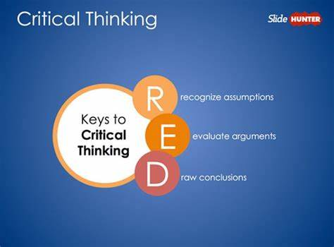

(Bing.com, 2019)

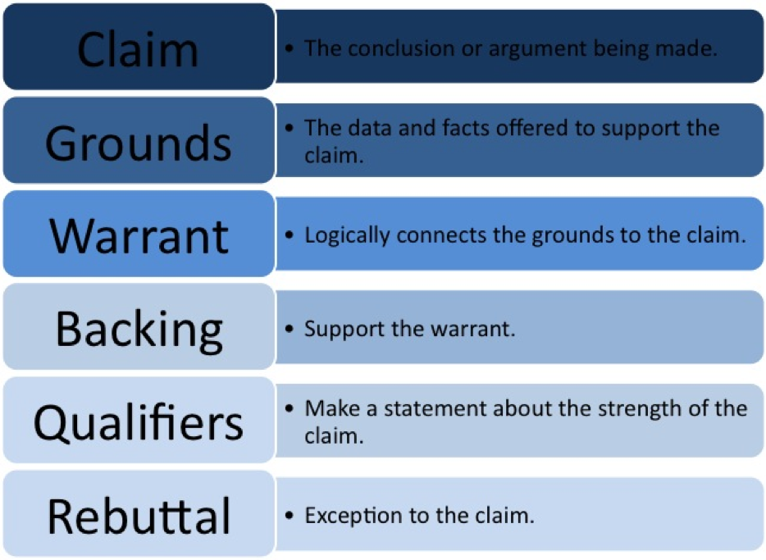

(Bing.com, 2019)

7.0 Acknowledgements

Thanks to all the people involved in the development of technology, which certainly facilitated our work and communication methods. Thank you for those who work in bookstores and help us any time it takes with the same smile on your face. Thanks to the lectors who have much tact and patience with us. Thanks to the authors who debated the topics we need. Thanks to everyone who uploaded internet works, books, magazines, is an excellent source of inspiration for us — thousands of thanks to the people involved.

8.0 References
Armstrong, M. (1993). Managing reward systems. 1st ed. Buckingham: Open University Press.
Bing.com. (2019). Pearson’s red critical thinking model definition - Bing. [online] Available at: https://www.bing.com/images/search?view=detailV2&id=3E8B9A1BF9BC03142A2D950B79E563AFEA712656&thid=OIP.j871LHd9u9VhSN_opW0oBAHaDO&mediaurl=https%3A%2F%2Fi0.wp.com%2Fwww.qaspire.com%2Fimages%2Fcriticalthinkingredmodel.png&exph=255&expw=585&q=pearson%e2%80%99s+red+critical+thinking+model+definition&selectedindex=0&ajaxhist=0&vt=0&eim=1,2,6 [Accessed 2 May 2019].
Buttle, F. (n.d.). Customer relationship management. Burligton: Elsevier LTD.
Buttle, F. (n.d.). Customer relationship management. Burligton: Elsevier LTD.
Changingminds.org. (2019). Toulmin's Argument Model. [online] Available at: http://changingminds.org/disciplines/argument/making_argument/toulmin.htm [Accessed 2 May 2019].
Chatfield, T. (2018). Critical Thinking. 1st ed. London: Sage Publications Inc.
Chatfield, T. (2018). Critical Thinking. 1st ed. London: Sage Publications Inc.
Cheverton, P. (2004). Key account management in financial services. Sterling, VA: Kogan Page.
Cheverton, P. (2004). Key account management in financial services. Sterling, VA: Kogan Page.
Cottrell, S. (n.d.). Critical thinking skills. 3rd ed. Red Globe.
Doppler, K. and Lauterburg, C. (2001). Managing Corporate Change. Berlin, Heidelberg: Springer Berlin Heidelberg.
Doppler, K. and Lauterburg, C. (2001). Managing Corporate Change. Berlin, Heidelberg: Springer Berlin Heidelberg.
Elg, M., Ellström, P., Klofsten, M. and Tillmar, M. (2015). Sustainable development in organizations. Cheltenham (UK): Edward Elgar.
Elg, M., Ellström, P., Klofsten, M. and Tillmar, M. (2015). Sustainable development in organizations. Cheltenham (UK): Edward Elgar, p.25.
Elg, M., Ellström, P., Klofsten, M. and Tillmar, M. (2015). Sustainable development in organizations. Cheltenham (UK): Edward Elgar.
Elg, M., Ellström, P., Klofsten, M. and Tillmar, M. (2015). Sustainable development in organizations. Cheltenham (UK): Edward Elgar, p.25.
Epstein, R. and Rooney, M. (2017). Critical thinking. Socorro, NM: Advanced Reasoning Forum.
Greene, I. (2005). Money, how to get it!, How to keep it!. San Diego, Calif.: P.S.I. Publishers.
Greene, I. (2005). Money, how to get it! How to keep it! San Diego, Calif.: P.S.I. Publishers.
Holloway, J., Lewis, J. and Mallory, G. (1995). Performance measurement and evaluation. 1st ed. London: Sage.
Holloway, J., Lewis, J. and Mallory, G. (1995). Performance measurement and evaluation. 1st ed. London: Sage.
Klimsza, L. (2013). Introduction to ethics (hermeneutic aspects of values). Ostrava: University of Ostrava, p.52.
Klimsza, L. (2013). Introduction to ethics (hermeneutic aspects of values). Ostrava: University of Ostrava, p.52.
Mullins, L. (1999). Management and Organisational Behaviour. 5th ed. London: Pitman.
Mullins, L. (1999). Management and Organisational Behaviour. 5th ed. London: Pitman.
Solomon, M., Marshall, G., Stuart, E., Mitchell, V. and Barnes, B. (2009). Marketing, Real People, Real Decisions. 5th ed. Edinburgh: Pearson Education Inc.
Solomon, M., Marshall, G., Stuart, E., Mitchell, V. and Barnes, B. (2009). Marketing, Real People, Real Decisions. 5th ed. Edinburgh: Pearson Education Inc.
Whalley, A. (2013). Obtaining and Retaining Customers – Part II Customer Retention. 1st ed.
Whalley, A. (2013). Obtaining and Retaining Customers – Part II Customer Retention. 1st ed.
YouTube. (2019). Pearson's RED Model of Critical Thinking. [online] Available at: https://www.youtube.com/watch?v=8-V4voD_E5A [Accessed 2 May 2019].
Zerres, C., Zerres, M. and Baran, R. (2014). Customer Relationship Management (CRM).
Zerres, C., Zerres, M. and Baran, R. (2014). Customer Relationship Management (CRM).

References

- Pynn, G. (2019). CRITICAL THINKING - Fundamentals: Introduction to Critical Thinking [HD]. [online] YouTube. Available at: https://www.youtube.com/watch?v=Cum3k-Wglfw [Accessed 29 Mar. 2019].
- Elder, L. and Pau, R. (2019). 7 Habits of Highly Effective Thinkers. [online] YouTube. Available at: https://www.youtube.com/watch?v=IFWbxZrjWhM [Accessed 29 Mar. 2019].

