Presentation Speaker Notes

Alisha Powell – 1806288

Introduction

What is marketing?
Marketing is when a business or company promote their product to boost impressions and to also target the correct audiences.
There are many ways to promote a small uprising business such as
- Advertising on social media which is low costing but highly effective
- Creating structured You-Tube videos which vary in price but are highly effective.
- Event or conference – dependent on a set budget and how many delegates attend.
- Website building – dependent on budget/highly effective if structured well.
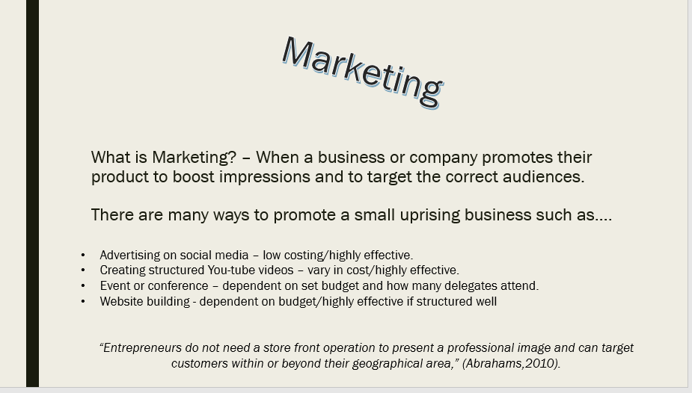
“Entrepreneurs do not need a store front operation to present a professional image and can target customers within or beyond their geographical area,” (Abrahams,2010).

There are various ways to promote a small business however looking thoroughly into this, it has become clear that the chosen advertising options are;
- Website building – if structured well and advertised well the business will blossom,
- Advertising on social media – which is low costing and highly effective.
The reasons why these are the chosen two is that we can manage all social media and website activities ourselves.
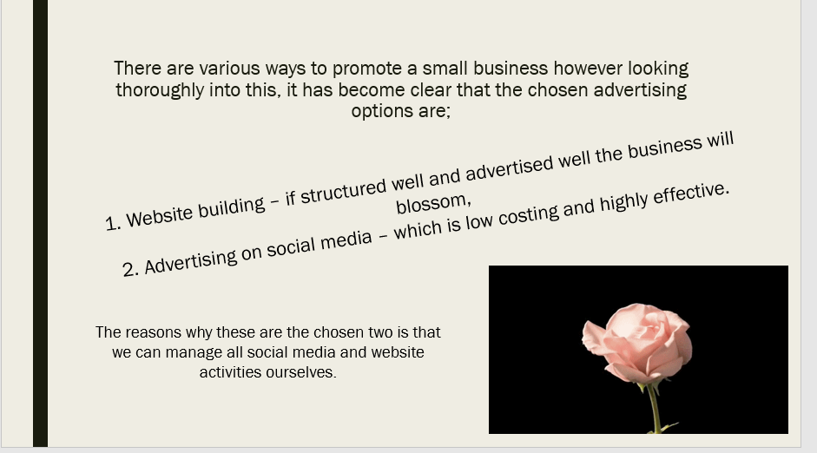

The 7 Ps Marketing Mix
Marketing mix is an important concept of marketing (Riaz and Tanveer, referring to Kotler, Armstrong, Wong and Saunders 2008), described the marketing mix as a set of manageable marketing tools that are used by a business to inform the targeted market. Marketing mix is also known as the 4 Ps i.e. Product, Price, Place of distribution and Promotion, the primary elements of a marketing strategy, McCarthy (1960) was first to highlight the 4 Ps
Product – An item or object sold by a company.
Promotion – A group of activities formed to advertise/market the company, to successfully hit all targeted audiences.
Price – When a business sells products to its consumers at a fair price.
Place – When a company decides to pick a beneficial channel for the busiest traffic.
People – Everyone who plays a part in the service such as employees and customers.
Process – The process of how the product is delivered.
Product | Promotion |  | Price | Place | People | Process | Physical Evidence
Fashionable women’s clothing.  “Providing High Quality fashion at a Great Price at a Fast Speed.” |  | - Building a structured up to date website to attract all areas of the market  - Social media advertising – low costing, highly effective. | The idea is to initially find great quality, up to date, trendy fashion at a low cost to sell on within a profitable margin. | The chosen place of interest is an online presence on social media and owning a website domain to attract all areas of the market. | - Managers  - Packers  - Delivery driver  - Admin  - Advertiser | - Purchased from wholesalers  - Advertised on social media  - Purchased through the website  - Packed  - Delivered | - Receipts  - Celebrity endorsement  - Reviews  - Likes on social media
Physical Evidence – A scenario of which the service/product is delivered, and when the company and customer engage.
Table 1:

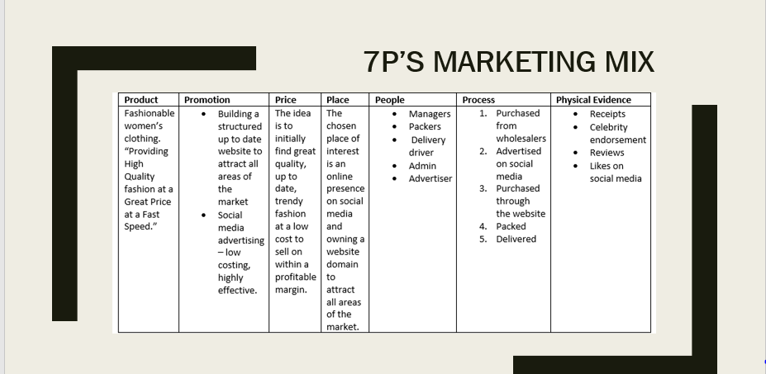

Overall purchasing fashionable great quality women’s clothing at a low cost and selling them on for more of a profitable margin will foreseeably see a profit in the long run. Structured websites that are up to date may attract a large area of the market worldwide, a lot of people use the internet in the 21st century therefore we can alternatively hit all areas of the market cost effectively. The chosen place of interest is having a strong online presence to maintain strong connections and to also manage all accounts/complaints etc, independently. There are a few members in the team not many are needed to set up a small business, with expansion in the future further employees may be needed. The process of the service will be fast and easy, purchased from wholesalers, advertised on social media, purchase on the website with alerts to maintain fast service, packed and delivered, with choosing the online method we can hit all areas of the market cost effectively. For the physical evidence sides of things, the idea is to have receipts for individual orders, Positive reviews on social media, on the website and also celebrity endorsements.

References
Abrahams, R.M. (2010). The Successful business Plan: Secrets & strategies (5th ed.). Palo Alto, CA: The Planning Shop
Riaz, Waheed and Tanveer, Asif (n.d) “Marketing mix, not Branding,” Asian Journal of Business Management Sciences, Vol. 1 No.11 pp.43- 52

