University of Wales Trinity Saint David
Wales Institute of Science and Art


Electronic Circuits Testing and
Applications

Electrical Control Systems

Daniel Jack Briggs
2312568
Date
Contents
1 Task 3 1
1.1 Scope Time Division Calculations (3) 1
1.2 Function Generator output square wave (3) 2
1.3 Capacitor charge and discharge wave marked at correct points. (3) 2
1.4 Basic Capacitor Calculations (3) 3
1.5 Capacitor discharge table (2) 3
1.6 Plot log(V) Gradient (2) 3
1.7 Gradient Calculations and Compare(4) 3
1.7.1 Gradient Calculations 3
1.7.2 Comparison table 3
1.8 Capacitor Uses (5) 4
1.9 Inaccuracies Question (4) 4
2 References 5

Task 3

Scope Time Division Calculations (3)
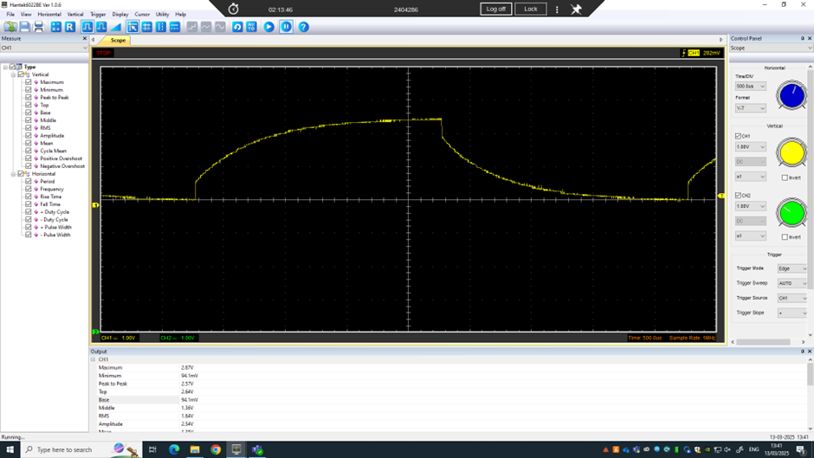
$$time=\frac{1}{frequency}=\frac{1}{250}$$
$$\frac{1}{250}÷10=0.0004=400μs$$
Rounded up to 500μs to meet the options in the program.

Function Generator output square wave (3)
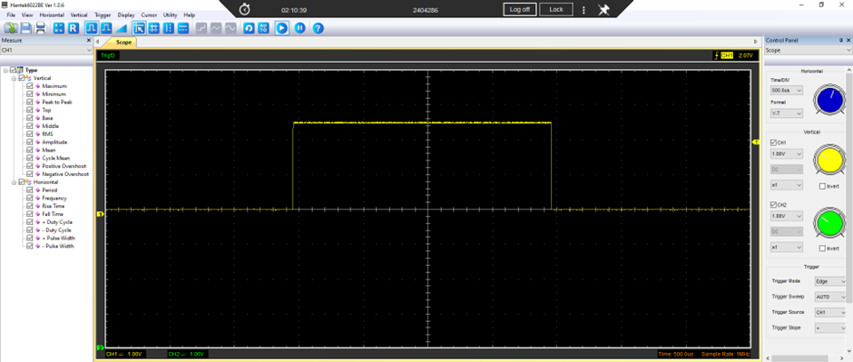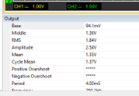

Capacitor charge and discharge wave marked at correct points. (3)
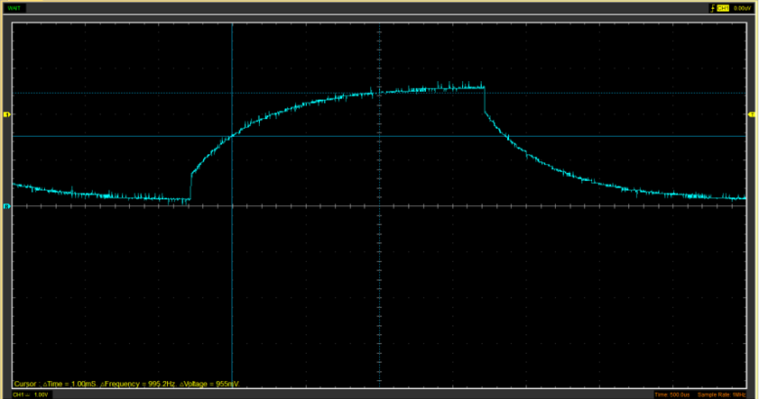
$$Time=\frac{Charge Volts}{63.2}=\frac{Discharge Volts}{36.8}$$
$$Charge Volts=\frac{1}{63.2}=0.016 V$$
$$Discharge volts=\frac{1}{36.8}=0.027 V$$

Basic Capacitor Calculations (3)
$$C=\frac{T}{R}$$

Capacitor discharge table (2)
Time (s) | Voltage (V) | ln (V) | dy = y2 – y1 | dx = x2- x1 | dy/dx
 |  |  | dy = ln(V)2-ln(V)1 | dx = Time2 – Time1
0.001851 | 2.1333 | 0.758 | x | x | x
0.001886 | 1.7569 | 0.564 | -0.3764 | 3.5E-05 | -10754.28571
0.001921 | 1.5373 | 0.430 | -0.2196 | 3.5E-05 | -6274.285714
0.001957 | 1.349 | 0.299 | -0.1883 | 0.000036 | -5230.555556
0.001992 | 1.1922 | 0.176 | -0.1568 | 3.5E-05 | -4480
0.002027 | 1.0353 | 0.035 | -0.1569 | 3.5E-05 | -4482.857143
0.002063 | 0.9098 | -0.095 | -0.1255 | 0.000036 | -3486.111111
0.002098 | 0.8157 | -0.204 | -0.0941 | 3.5E-05 | -2688.571429
0.002133 | 0.7216 | -0.326 | -0.0941 | 3.5E-05 | -2688.571429

Plot log(V) Gradient (2)
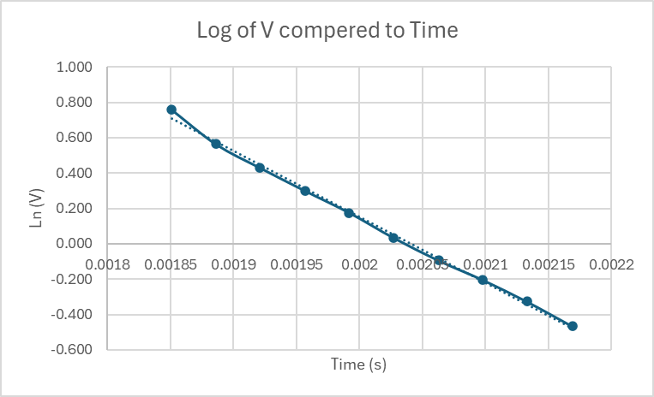

Gradient Calculations and Compare(4)

Gradient Calculations

Comparison table
 | Capacitance | Delta | Percentage difference
Actual | 1 µF | x | X
Marker Calculation
Gradient Calculation

Capacitor Uses (5)

Inaccuracies Question (4)
The scopes may not be as accurate as when they were new because lots of students have used them over the years and will have wear and tear, also the circuits we used are old and some of them have got damaged components, so we had to find the components that worked even if that component was not that accurate. The wires were long and added small resistance to the circuit. Instead of being at the correct length.

References
(Format to Harvard style as per handbook)

