Strategic Management for SMEs BMSW6104

Company name :


Student name : Igancio Perez Blanco
Student ID: 2129210
Lecturer name: Xavier Matieni



Table of context

- Table of context…………………………………………………………..Pg 2
- Executive summary ……………………………………………………...Pg 3
- Background of the company ( Firepring )………………………………Pg 4
- Internal and external environment of Firespring Internal Environment Pg 4
- Web culture……………………………………………………………….Pg 5-6
- ( Internal environment ) used of VRIO ( Resources and capabilities )….Pg 6-7
- SWOT analysis……………………………………………………………Pg 7- 8
- ( External environment ) used of Pestel ( competitors )………………….Pg 8-9
- Porte’s 5 forces……………………………………………………….Pg 9-10- 11
- Opportunities and threats of international expansion…………………Pg 12
- Summaries the internal and external analysis………………………...Pg 12
- What types of strategies are going to use the company? ………….Pg 12
- Growth strategy (Ansoff’s product/market growth matrix …………….. Pg 13-14
- Use of shareholders analysis …………………………………………..Pg 14 -15-16
- Recommendations for Firespring for future developments …………Pg 16-17
- Conclusion ……………………………………………………………… Pg17
- References list …………………………………………………………..Pg 18-

Executive summary

I would like to present this report which will have a variety of information and tools that will be organized in order of importance. The objectives of this report are to know what an SME’s is, how to create new strategies to achieve growth for companies, and finally how to be critical, and how to evaluate and analyse graphically. Before starting this report, I would like to take a case study as an example explaining the meaning of a medium-sized company.
This case study shows us how 3 cafes compete in an area of ​​the city of London. Each of these cafes has its originality when it comes to selling their products. To make it easier I will call them cafeterias 1, 2, and 3. Cafeteria 1 provided lightning-fast service. Cafeteria 2 offered a place where you could feel tranquillity and peace, a place to rest, and finally, cafeteria 3, offered different coffees which had different unique flavours that did not exist in the market. The 3 coffee shop owners met at an annual barista convention and began to discuss their businesses, talking about strengths and weaknesses. It is a bit ironic that these 3 owners who compete in the same market talk about their businesses. Watching this case study, I could see that each business had its strengths but also weaknesses and these weaknesses and strengths are related to a series of factors that companies must deal with day by day to not lose their position in the market. This clear example has shown me how the use of tools such as Web Cultural ,SWOT, Porter's 5, and Pestel analysis are tools that companies must use and carry out to avoid having challenges in the future. Reading the case study I realized the meaning of SMEs, in this case they are small companies which have billing levels below a series of limits.
In this report, an American company will be used as an example which has been working for years in the printing, marketing, and website development sector also this company has between 89 to 200 employees. I have chosen this company because of its history; it is a company that has been in the market for more than 20 years.
Now I would like to introduce the background of this company.

Background of the company.
This company started in 1992; it started as a printing company but over time it became a company that created websites for other printing companies. This company had a division in which printing and websites were separated. But they reunited in 2015, creating the largest marketing communications firm in the Midwest. This is a company that has faced difficulties and has celebrated its victories and successes, this has been for more than 25 years. The most impressive thing about this company is that it helps non-profit organizations improve and grow. Knowing the history of this company that has been on the market for more than 20 years, I would like to say that from my point of view it is a merit to have a company afloat for so long, as I have already mentioned before, this company has had its ups and downs, but they have continued to move forward. This company has remained standing thanks to its values ​​and culture, many companies are successful because they have missions, values ​​and objectives that identify them. In this case, Firesprinte has a series of values ​​and a great culture that I would like to share in this report. This company has a website which is a page intended to help small non-profit businesses. At the same time, this company offers services which are commercial printing, creative marketing and help with web development. This company offers personalized quotes depending on the type of work that the client requests.

Now, I would like to analyse the internal and external environment of this company. To analyse the environment, it must be classified into layers. These layers are the organization (internal environment), competitors, industry or sector and macro environment (external environment). This analysis will start with the culture and values ​​of the company.

Internal and external environment of Firespring
Internal Environment
Appraisal of the organization (values, objectives, culture and goals .To analyse the company culture, I would like to use web culture.

Web culture.
This tool is developed in 4 parts which are:
1 story: As I had previously commented in the background of the company.
2 Rituals and routines: In this part, I have searched its website which shows that it has a series of values ​​that many companies lack, and this is because it is a medium company. Unlike large companies that try to capture the attention of consumers through their values ​​that are created for a monetary purpose, this company has values ​​that make it more welcoming for workers and clients since is a company that has a small number of employees, these focus more on welcoming and valuing the worker through trust. A quote that I liked and which I think shows the values ​​of this company is this: ‘It doesn’t take a rocket scientist to figure out that if we take great care of our people, our people will take great care of our clients’ (Firespring, 2020)
3 Symbols: As its name indicates, the company symbol, in this case, is Firesprint.
4 Organizational structures: This company has a functional structure, which means that it is made up of departments according to their abilities. The departments are Commercial Printing, Creative Marketing and Web Development. This structure is excellent because it has a good communication channel, employees specialized in their areas and finally efficiency.
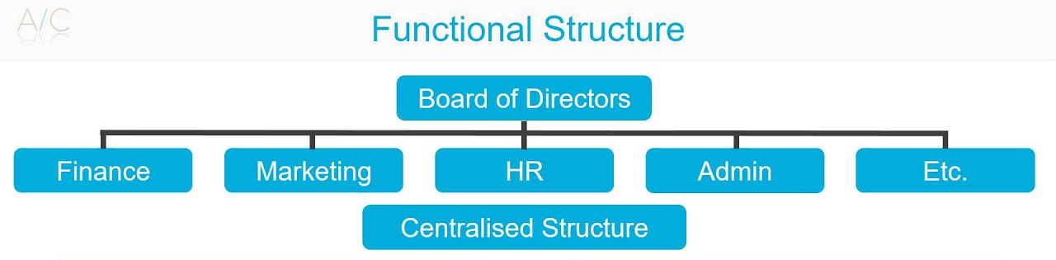
5 Control system: This is a vital part of an organization's culture model. Here, the company manages employee performance, and goals, recognition, and rewards can be established. The importance of performance management is to provide feedback.
6 power structure: This part is key because here we can see different types of power structures that in this case are formal and informal. These structures must be linear since they have to support the cultures and ideas of the companies. ( Personio , 2020)

- Goals of Firespring
The goal of this company is to use creativity to create solutions that help in marketing and printing technology to help nonprofits thrive.
VRIO ANALYSIS
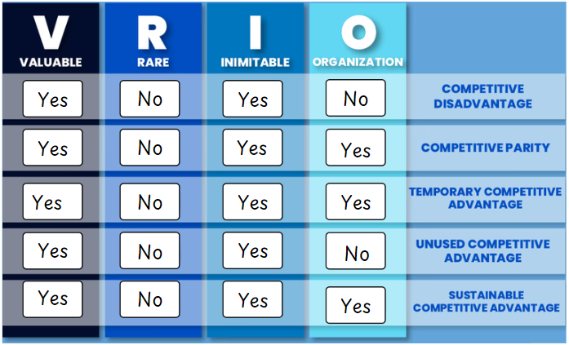( igancio , 2024)
I will use VRIO to analyse the internal environment of Firespring. This tool is made up of 4 parts which are:
Value: As previously mentioned, this company has more than 20 years of experience. This experience creates a series of elements that customers value, these elements are teamwork, quality of work and the success and well-being of customers. All of this is to help non-profit companies that are just starting through a website which explains the steps they should take in the marketing sector.
Rarity: The rarity of this product is the help it offers to companies since no company would do something like that.
Imitability: Imitability in this case refers to a resource that this company has. Analysing this company, the resources that this company has are both tangible and intangible.
Intangible: Its main resources are the seminars that they offer online, tools and guides different types of marketing services , web development and blogs. Also, its experiences and knowledge which is one of the most important resources since it has allowed this company to stay afloat, its data (information) everything that they have collected over the years.

Tangible: Machines, materials, etc., the capabilities that these machines have to achieve the company's objectives. Its employees are one of the resources, these employees have gained experience over the years working with this company which generates capabilities.
Organisation: This company has a good organization since it has received many awards, such as being one of the 100 companies that have generated impact. Another award they received was from Forbes since this company fulfilled its commitment and purpose amid the pandemic. (Johnson, 2024)
With the VRIO tool, I have been able to see the resources and capabilities of this company.
To achieve success and an advantage over the competition, this company must have a competitive advantage. That is why this company focuses on having different resources that the competitors do not have and in this case, it is the use of ecological materials (eco-friendly). Later, I would like to explain these resources, which will be explained in the PESTEL analysis section.
After having analysed the internal with VRIO, I would like to use the SWOT analysis tool to target its Strengths, Weaknesses, Opportunities and Threats

SWOT analysis.
Strengths: This company has many strengths, so I would like to discuss them below.
- Management is one of its strong points, as this company manages: Events, committees, fundraising management, etc.
- Helps non-profit organizations.
- Has a free page that helps companies create and manage a website.
- They can request not to pay taxes.
- Access to subsidies.
- Credibility.
Weakness:
- Non-profit organizations that do not pay taxes are not allowed to conduct political campaigns or lobby.

- Competitors.
- Companies that want to imitate your style and culture.
- Expenses
Opportunities:
- One of the opportunities that this company is using is the computing sector, digital marketing strategies, staying up to date with digitization.
- Looking to new horizons with international expansions.
- Hiring of new generations. Against new talents in the market.
- Management of legal documents (contracts, document management by use of software). Opportunities of new technologies to facilitate the administration of the company
Threats :
- Appearance of products or offers that are more affordable than Firespring.
- Appearance of competitors.
- Changes in customer behaviour.
- Problems with supplies.
- Appearance of a pandemic.
- Threat of data breach through cybersecurity.
Now I would like to analyse the external environment with PESTEL analysis and Porte 5

External environment.
PESTEL ANALYSIS
Political: In this case for the Firespring company, political factors can influence monetary aspects. For example, policies that can affect the foreign market and tax policies. In this case, as we had previously commented, the company's website is a non-profit website. But this website depends on funding, since being a non-profit, what Firespring does is ask for help through donations. If these donations can be affected by politics, since if some kind of

problem arises in politics, this help can be eliminated, and they would have to look for another source of income. (Firespring, 2017)
Economic: In the economic factor we can see that this company has a significant impact on different organizations, which generates good income since this company works with state-owned companies. (Firespring, 2024d) . But this can also have negative aspects, such as high interest rates and, finally, fiscal policies.
Social: In this part the company exposes its culture and values, which means that it can capture the attention of future customers through these. This can be classified into age factors, professional activities (the interest of the company) and population growth. These
factors can help the Firespring company to classify its customers, and they will understand their customers since they know what motivates them.
Technological: Technology can be a double-edged sword, as it can have its advantages and disadvantages. In this context, this company has used technology excellently, as it is the medium it uses to work, communicate and create new content. In this context, we can see how the web pages, its printing area and integrated marketing.
Environment: This fact is important because it has gained importance in recent years, which is why this company has adapted and improved its equipment to reduce waste levels to a minimum. This company takes the environment into account. They use ecological materials and recycle. A phrase that shows the importance that this company has with the environment is that the environment is the responsibility of all companies. (Firespring, 2023c)
Legal: Firespring likes to protect its customers, so it is very aware of the policies and laws. In this case, this company has a section that talks about its privacy policy, how it protects its customers' data, how it collects data, etc. (Firespring, 2023d)
Now I would like to analyse the competitors of this company using Porter's 5 forces.

PORTER’S 5 FORCES
By applying this tool we can see the competitors of this company, the company with this tool can analyse new products and analyse investment evaluations.
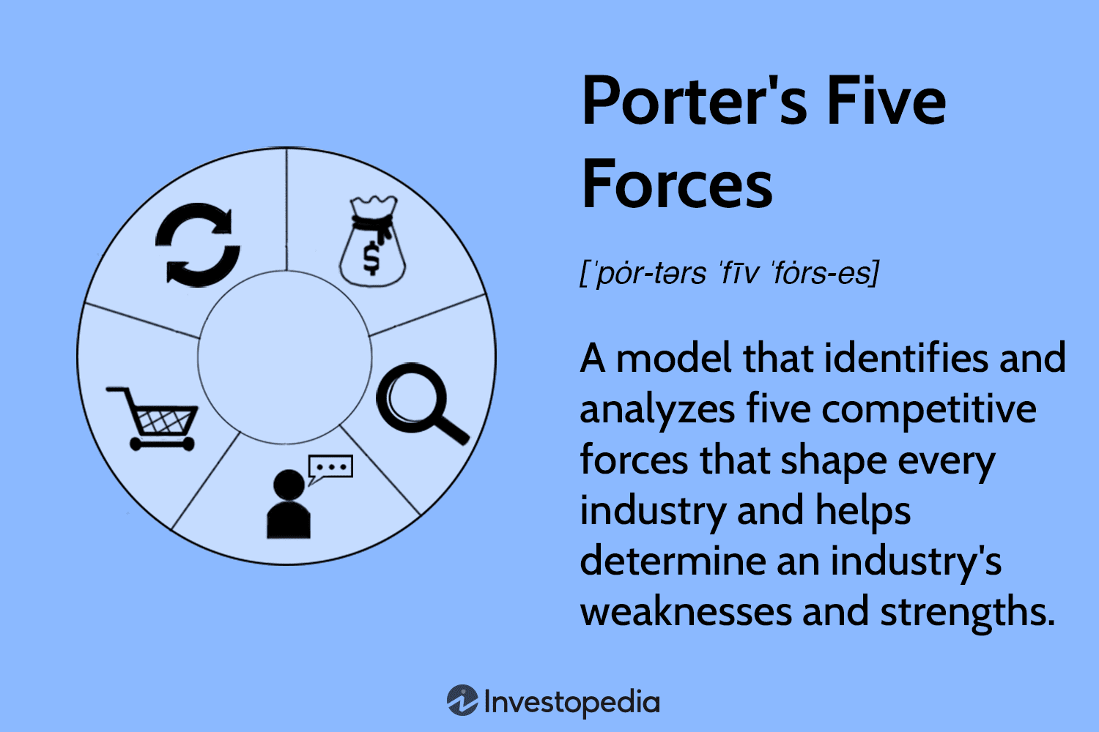
- 1.Competitive Rivalry
Competitors: Based on searches these are the companies that most resemble Firespring and these are the possible alternatives (competitors) to Firespring .
Marketing 360: It is a cloud-based marketing platform for small and medium-sized businesses. This tool allows organizations to run social media advertising campaigns, conduct search engine optimization strategies, and evaluate the performance of their digital marketing initiatives.
Britix24: Bitrix24 is an online work platform that caters to businesses of all sizes, from small to large. It offers over 35 tools, including CRM, task management, Kanban boards, Gantt charts, messaging, video calling, file storage, and workflow automation, among others.
Morweb.org: Morweb is a CMS platform designed for nonprofits, offering a complete set of easy-to-use tools, support, and eye-catching web design to help these organizations
manage and expand their online presence. This comprehensive solution goes beyond being just software. (Danao, 2024)
- 2. Suppliers Power
The suppliers of this company are those who provide Firespring with the materials to carry out its prints since this company has printing presses and produces brochures and advertising. The supplies are ink cartridges, drum kits, staple cartridge ect.The suppliers are companies that produce these eco-friendly materials. Since this company does its best to reduce environmental pollution. In this case, the supplier's power would be the one that supplies these eco-friendly products.

- 3 Buyer Power.
The customer is the one who has the last word, the customer has more power when this market does not have many customers and has many sellers, but this is not the case. I want to give an example of how Firespring is one of the best companies and why customers choose this company. This company carried out a marketing project for a company which made a 180-degree turn when they applied this marketing strategy for this company. They succeeded thanks to research and most importantly listening to and meeting the company's objectives.
I would like to make a table which classifies the strengths and weaknesses of these companies.

- 4. Threat of Substitution and Threat of New Entrants
In this case the threats of this company could be these 3 companies.
Competitors Analysis.
Competitors: Marketing 360 Strengths: It combines different tactics between online and offline media, helping to produce experiences and work, as well as increasing engagement.
Weaknesses: One of the weaknesses can be multiple exposures on channels, which can cause customer saturation, and leads to a decrease in the strategy. There is also the risk of trying to cover the entire digital space, which can destroy the brand message. (Romero, 2024)
Competitors: Britix24 Strengths: Agility when carrying out a process, intelligent relationship management thanks to marketing and sales automation. weaknesses: This page does not have a good interface which creates complexity and makes it look cluttered.
Competitors: Morweb.org Strengths: To help non-profit organization, customers can be helped through different channels such as phone, email, and support centers . weaknesses: This page does not offer comprehensive customer analysis; this may be a weakness as this may result in a lack of resources.
(Morweb, 2024)
After having analyzed the environment of this company, I would also like to analyse the opportunities that this company has in the international sector.

Opportunities and threats of international expansion.
The first opportunity is the global markets: this company can benefit by expanding its services around the world.
The advantage that this company has by providing a non-profit web page can make it advertise and the reputation it has, this would generate the possibility of generating an increase in sales abroad.
Another opportunity is technological evolution. These technologies can offer opportunities if they are used correctly.
But not everything that glitters is gold, international expansion can also have its threats. This can be due to cultural differences in the market since the company has its values ​​and culture as a pillar, which can be very pleasing for the international market. Another threat is cost and resource limitations. It could also be a trade barrier due to regulations.
These would be the advantages and disadvantages of an international expansion.
Summaries the internal and external analysis.
Now I would like to summarize what we have seen, as this will give us a brief overview of what we have been analysing. The objective of this is to carry out a growth strategy for this company which will have an impact on the market. To carry out any strategy we must first analyse the company's environment internally and externally. Next, I would like to briefly summarize what we have seen.
Internal analysis:
- Use of web culture to find out what the company's values, objectives and culture are.
- Use of VRIO to find out its resources and capabilities.
- Use of SWOT analysis to internally analyse the company.
External analysis:
- Use of Pestel to analyse and monitor external factors that may affect the company.
- Use of Porter's Five forces to analyse external competitors.

What types of strategies are going to use Firespring ?
To create a good strategy, you must create a strategy at the business level. What I mean is that to do that, you must analyse the market. To do that, you must look at the competition. Firespring uses a strategy that does market studies, which allows it to analyse competitors and take advantage of this. The benefits of this market analysis are reducing risks and costs, exploring failures, successes, finding opportunities and trends (Firespring, 2024e) . This company also has a strategic marketing plan which is achieved thanks to the teamwork of this company to achieve a common goal. For this, this company carries out.
Company strategies and growth
Now, I would like to propose a new growth strategy for the long-term future. To do this I will use Ansoff’s product/market growth matrix . This table will allow me to analyze both internally and externally the markets to penetrate an existing market. The novelty of this product is how you can leave a market to enter another one that is not related to it. This market change can generate new income and new opportunities. I have chosen this tool that is based on analysing the opportunities that exist in the market and that are related
to strategic selections. As I mentioned before, one of the strategies of this company is to analyse the market, so it seemed like an excellent option to me.
The Ansoff Matrix
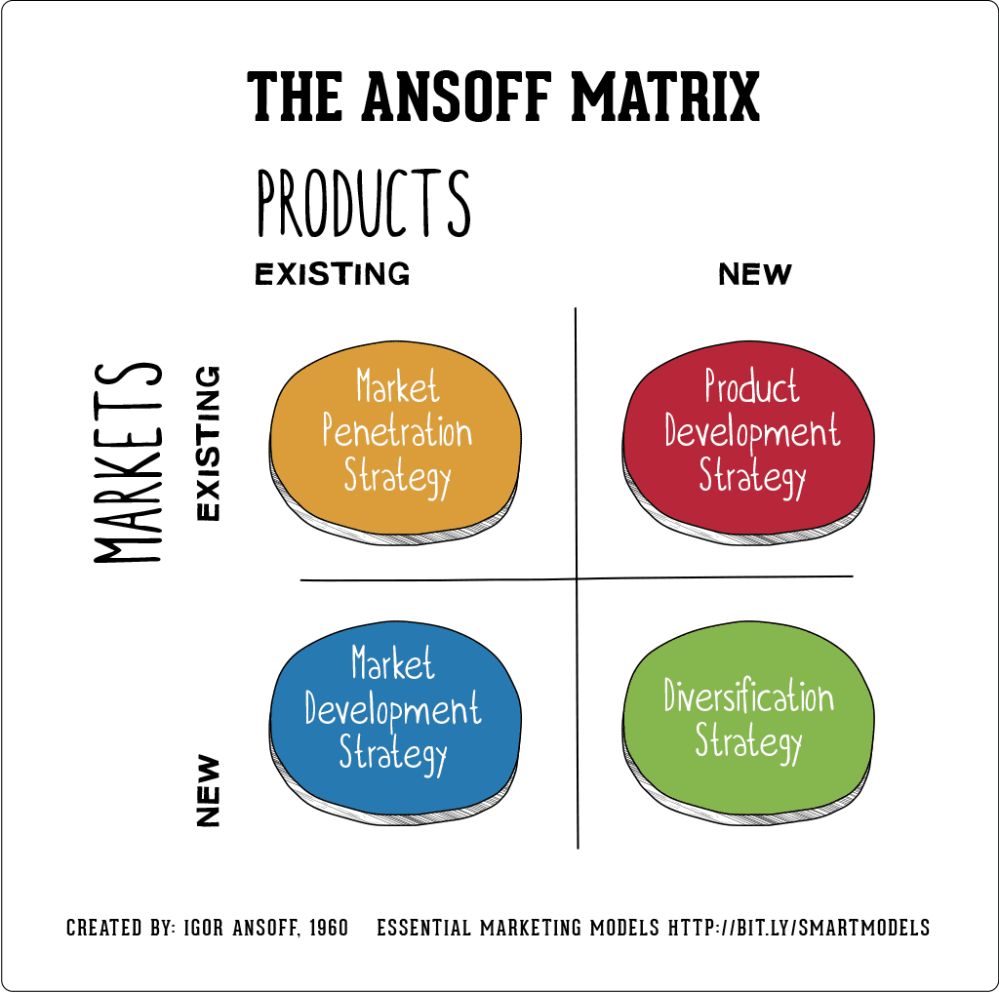 (Hanlon, 2021)
The first part of this chart is market penetration.
Market Penetration strategy : In this approach we can see that the goal is to increase the existing service through sales. This can lead to new marketing strategies to attract more people, compare a competing company or join (mature market) and most importantly price and promotions that make the customer feel secure.
Market Development Strategy : Here the company can explore new markets, the aim of this is to sell more to different customers. To achieve this, you can analyse the geographic market in the company's home country and abroad. For that it would be good to do a PESTEL analysis, this analysis was done previously, and the company is potentially for international expansion.
Product Development Strategy : In this case, you can sell different services to the same customer to increase the productive service, or you can develop existing services. To make these productive services possible, you can reduce the production time of the product or service, improve the quality of communication between the customer and the company, and improve the channel system, such as updating the system through email.
Diversification Strategy : This part is partly risky, and the goal of this is to use different existing services or products that you can sell to different customers.
(Growjo, 2019) , (The Strategy Institute, 2024)
To carry out a good strategy, it is also necessary to look at the acceptable parts of this company, since a project like this cannot be carried out without knowing who will be involved. I would like to perform a Stakeholder analysis.
Stakeholder Analysis
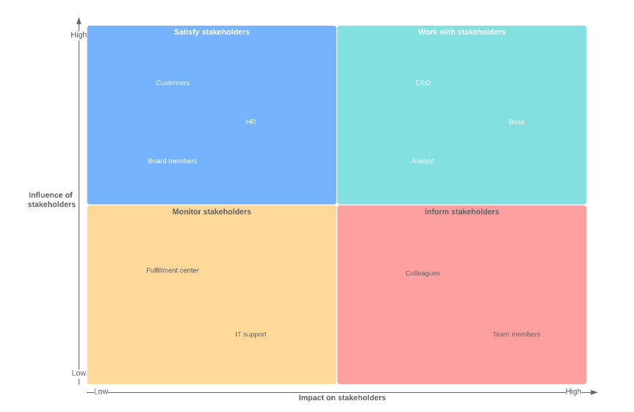

(Tractivity, 2022)
This analysis is made up of 3 parts: Identify, Categorize, and Prioritize.
- Identify : Everyone who is related to the company will be a stakeholder: for example, External Stakeholder: Consumers (customers), government, federal government, competitors (Marketing 360, Britix24 and Morweb.org), Suppliers (green materials and other types of resources). Internal Stakeholder: Workers (managers, directors, primary employees, etc.) and shareholders (allied companies that have a percentage of the company).
At this stage, it would be excellent to ask the stakeholders what they think about the growth strategy. This would help to have a broader vision and opinion when deciding, but normally the ones who have the last word are the internal stakeholders (CEO and management groups).
- Categorize: Here the level of interest and the power of each stakeholder are classified.
High Power and High Interest: CEO, Steering Groups (Internal), Investors, and External Shareholder.
High Power and Low Interest: Customers and Employees.
Low Power and High Interest: Testers and Investors
Low Power and Low Interest People: Customers and Employees
- Prioritize :In this part, must understand the stakeholders. In this case, I would like to explain to them the reason for this growth strategy and the impact it will have on them, which in this case would be a positive impact. Apply different strategies to gain their support, since all parties are important for this growth.
In my opinion, I think that stakeholders depend on different factors to offer their help in the growth strategy of a company like Firespring. Even if it has a reputation, like any company, it has its risks. To avoid potential problems, a plan must be developed that has their ideas and values, and with which the stakeholders who are going to make an investment and have power agree.

I would like to add the impact of a possible internationalization that could affect a company, which in this case would be Firespring.
SMEs face significant challenges when implementing strategic directions, including limited resources, financing difficulties, and market volatility. To address these, SMEs should form strategic partnerships, focus on niche markets, and adopt agile strategies that allow for quick adaptation. Investing in technology, innovation, and talent development is crucial, as is enhancing financial management and exploring diverse funding options. Strengthening market intelligence, prioritizing sustainability, and improving operational efficiency will also support growth. Additionally, internationalization introduces complexities like cultural differences and regulatory variations, requiring flexible, localized strategies and robust research to succeed globally.
Before finishing this report I would like to give some recommendations to Firespring for future development plans.
Recommendations for Firespring for future developments
Small and medium-sized enterprises (SMEs) face unique challenges when implementing strategic directions. These challenges include limited resources, difficulty accessing finance, vulnerability to market fluctuations, and often a lack of specialized expertise. To overcome these challenges and foster future development, SMEs should consider the following strategic recommendations:
Leverage Strategic Partnerships and Alliances : collaborations form strategic alliances with other businesses, including larger companies, to access new markets, share resources, and gain expertise.

Adopt Agile and Flexible Strategies : agility: maintain a flexible strategic plan that allows the business to pivot quickly in response to market changes. This involves regular review and adjustment of strategies based on real-time data and market feedback.
Scenario Planning: develop multiple scenarios and contingency plans to prepare for potential disruptions, ensuring the business can respond effectively to unforeseen challenges.

Invest in Technology and Innovation :digital transformation . Prioritize investment in digital tools and platforms that improve efficiency, enhance customer engagement, and enable data-driven decision-making. This includes CRM systems, digital marketing, and e-commerce platforms.
Continuous Innovation: Foster a culture of innovation where employees are encouraged to contribute ideas for new products, services, or processes. Establish a structured process for evaluating and implementing these ideas.

Conclusion
This module has taught me how small and medium-sized organizations have an amazing impact on the market. An example of this is that in 2022 in the UK 5.5 million companies will be small or medium-sized. The importance of these small companies is one of the drivers of the world economy. I have also explored different tools to analyse companies such as internal: Cultural Web, SWOT, VRiO. External: PESTEL and Porter's 5. I have also learned the use of analysis through these tools which in the future will allow me to analyse companies. One of the objectives of this report is to know the type of strategy used by the analysed company and implement a growth strategy for it. In conclusion, these small companies can take the step to become large companies, and they will depend on their pillars such as culture and values ​​to take the step forward.

REFERENTS LIST

- Blogris (2021). How Much Will Print Advertising Cost Your Business?. Available at: https://www.banana-print.co.uk/blog/print-advertising-costs/#:~:text=In%20either%20scenario%2C%20businesses%20can
(Accessed 17 Aug. 2024).
- Britix24 (2024). Bitrix24 - Free online workspace for your business. Available at: https://www.bitrix24.uk/?utm_source=google&utm_medium=cpc&utm_campaign=21201899951-166914809411&gad_source=1&gclid=Cj0KCQjwq_G1BhCSARIsACc7NxpmneZb07ObUKvi96dvYf3ro2JtcpEmntz6Pr110DwGG2YP1bZd2OAaAh5hEALw_wcB
(Accessed 14 Aug. 2024).
- Coursera Staff (2023). Market Analysis: What It Is and How to Conduct One. Available at: https://www.coursera.org/articles/market-analysis.
- Danao, M. (2024). Porter’s five forces: Definition & how to use the model. Available at: https://www.forbes.com/advisor/business/porters-five-forces/.
- Firespring (2017). 6 Ways to Help Your Nonprofit Adjust to a New Political Climate . Available at: https://firespring.com/solutions-for-nonprofits/6-ways-to-help-your-nonprofit-adjust-to-a-new-political-climate/
(Accessed 14 Aug. 2024).
- Firespring (2020). Core Values. Available at: https://firespring.com/powered-by-purpose/core-values/
(Accessed 8 Aug. 2024).
- Firespring (2023a). Integrated Marketing, Printing and Websites. Available at: https://firespring.com/#:~:text=Firespring%20provides%20strategic%20guidance%20activated
(Accessed 8 Aug. 2024).
- Firespring (2023b). Privacy Policy | Firespring. Available at: https://firespring.com/policies-and-security/privacy/
[Accessed 14 Aug. 2024].
- Firespring (2023c). Springing Toward Sustainable Printing. Available at: https://firespring.com/commercial-printing/springing-toward-sustainable-printing/
(Accessed 14 Aug. 2024).
- Firespring (2024a). Commercial Printing. Available at: https://firespring.com/commercial-printing/.
- Firespring (2024b). Company Culture. Available at: https://firespring.com/powered-by-purpose/company-culture/
(Accessed 9 Aug. 2024).
- Firespring (2024c). Marketing & Nonprofit. Available at: https://firespring.com/resources/ (Accessed 14 Aug. 2024).
- Firespring (2024d). New York commercial real estate dynasty gets a whole new digital look. Available at: https://www.firespring.com/work/nebraska-ded.html
(Accessed 14 Aug. 2024).
- Firespring (2024e). Strategic Planning | Targeted Marketing. Available at: https://firespring.com/creative-marketing/strategy/strategic-planning/#:~:text=With%20a%20strategic%20marketing%20plan (Accessed 17 Aug. 2024).
- Forbes (2021). Jay Wilkinson | Founder & CEO - Firespring | Forbes Business Council. Available at: https://councils.forbes.com/profile/Jay-Wilkinson-Founder-CEO-Firespring/06615d65-4e52-46b2-8785-dc14db8d8146
(Accessed 13 Aug. 2024).
- Gov.UK (2022). Business Population Estimates for the UK and Regions 2022 . Available at: https://www.gov.uk/government/statistics/business-population-estimates-2022/business-population-estimates-for-the-uk-and-regions-2022-statistical-release-html.
- Growjo (2019). Firespring: Revenue, Competitors, Alternatives. Available at: https://growjo.com/company/Firespring
(Accessed 17 Aug. 2024).
- Hanlon, A. (2021). The Ansoff Model. Available at: https://www.smartinsights.com/marketing-planning/create-a-marketing-plan/ansoff-model/.
- Huston, H. (2020). The Benefits of Forming a Nonprofit Company.Available at: https://www.wolterskluwer.com/en/expert-insights/the-benefits-of-forming-a-nonprofit-company.
- Johnson, N. (2024). Real Leaders®️ Unveils Its 300 Top Impact Companies List of 2024 - Firespring. Available at: https://firespring.com/news/real-leaders%EF%B8%8F-unveils-its-300-top-impact-companies-list-of-2024/
(Accessed 13 Aug. 2024).
- Kenton, W. (2024). How to Perform a SWOT Analysis. Available at: https://www.investopedia.com/terms/s/swot.asp.
- Marketing 360 (2024). Marketing 360. Available at: https://www.marketing360.com/.
- Morweb (2024). Morweb. Nonprofit CMS, Website Themes & Design Software. Available at: https://morweb.org/
(Accessed 14 Aug. 2024).
- Personio (2020). How Do You Use the Cultural Web Model to Define Corporate Culture? Available at: https://www.personio.com/hr-lexicon/cultural-web-model/.
- Romero, A. (2024). Marketing Digital 360: Pros y contras que debe conocer para tener éxito - My CMS. Available at: https://laguiadesevilla.es/marketing-digital-360-pros-y-contras-que-debe-conocer-para-tener-exito/
(Accessed 14 Aug. 2024).
- The Strategy Institute (2024). The Ansoff Matrix: A Powerful Tool for Business Strategy and Growth. Available at: https://www.thestrategyinstitute.org/insights/the-ansoff-matrix-a-powerful-tool-for-business-strategy-and-growth.
- Tractivity (2022). What Is Stakeholder Analysis? Definition, Examples and Template. Available at: https://www.tractivity.co.uk/blog/stakeholder-analysis#:~:text=Stakeholder%20analysis%20is%20the%20process.
- United Nations Global Compact (2020). Our Finances | UN Global Compact. Available at: https://unglobalcompact.org/about/finances.
Velopi (2021). Define a Strategy: Expansion Method Matrix and More. Available at: https://www.velopi.com/blog/pmi-pmp-free-project-management-resource-strategy/

