Programme of Study – Doctorate in Professional Practice

Prior Learning Assessment and Recognition
BMPF7109

Student – Michaela Schriek 2212288

Lecturer – Sarah Loxdale

Contents
Curriculum Vitae 3
Job Description 6
7
Programme Manager Roles and Responsibilities 10
Quality Assurance Manager Roles and Responsibilities 11
Learning Objectives 13
Introduction 14
WHAT - Analyse the experiential learning relevant to current practice 15
SO WHAT - Evaluate the learning in the context of the research proposal and future practice 20
NOW WHAT - Examine the future course of action and the usability of the learning in the wider context 23
References 28

Curriculum Vitae Annotated in red font.
 | Michaela Schriek MSc L&M, L7 ILM Dip L&M, BA (Hons), FIoL, FRSA
 | Mobile: 07904 787 999
 | Email: michaela.schriek@gmail.com
 | Profile
MSc in Leadership and Management
BA (Hons) degree in Business Enterprise
ILM approved Leadership & Management Trainer
Qualified Independent NVQ &VRQ Assessor and Internal Verifier for four ILM centres
Experienced Leadership & Management Coach & Trainer
Experienced Enterprise Tutor & Trainer
Multi-lingual (technically speak 6 languages plus English) and IT competent.
Organised, highly motivated, and result -orientated problem solver.
Proven ability to work in unison with staff, entrepreneurs’ volunteers, and board of directors. (I was a Chairman of the civilian committee for an RAF squadron.)
Excellent communication skills on all levels
 | Education
 | Doctorate in Professional Practice  MSc Leadership and Management  ILM Level 7 Diploma in L&M  Internal Verifier Unit Level 4  Assessor Unit Level 4  ILM Level 5 Certificate in Management  BA (Hons) in Enterprise  AAT (Association of Accounting Technicians)  City & Guilds in Information Technology  Diploma - Croatian medical school (Equivalent | University of Wales Trinity Saint David  University of South Wales  University of South Wales  Coleg Morgannwg  Coleg Morgannwg  Institute of Leadership and Management  University of Glamorgan  Coleg Glan Hafren  Bridgend College  of 14 “A” levels (British Council Ratified) | 2022 WIP  2018  2017  2013  2013  2011  2008  2003  2000  1993
Employment
DipHE and BA Programme Manager, University of Wales Trinity Saint David  My duties have been expanded to encompass looking after the Diploma and BA students as well as Certificate students. The complete team has grown to 8 members, and we still deliver in 7 locations across South Wales. This role covers the managing of the operational aspects of the course delivery and looking after around 100 students at any given time. Quality assurance of teaching materials, exam boards, programme validation and all other tasks required for the smooth delivery of the programme are also part of this role.  CertHE Programme Manager, University of Wales Trinity Saint David  In addition to my lecturing duties, I have been given the responsibility for a stand-alone CertHE programme. Duties cover the 7 strong lecture team and programme delivered in 7 locations, exam boards and liaising with 2 external examiners, standard of teaching material, delivery, and assessment. |  |  | 2023-present  2021-present
External Quality Assurer EQA, ILM & City and Guilds  EQA for centres around Wales delivering Leadership, Management and Coaching qualifications.  As an EQA, my duties are to monitor the quality of assessment delivered by the centres, to ensure ILM and C&G qualifications are delivered in line with our regulatory requirements, while providing my centres with guidance, support and current industry expertise. |  |  | 2019-2021
Quality Assurance Manager, University of Wales Trinity Saint David  In addition to my lecturing duties, I have been given the responsibility for quality assurance of the CertHE and BA program I am currently involved with. |  |  | 2020-2021
Lecturer, Trinity Saint David University P/T  Delivering a CertHE programme across South Wales venues. The difference with this programme being that we get to take it to the community and in doing so provide an accessible provision to communities. Assessing and internal verification across cohorts and levels. |  |  | 2014-present
Trainer /Assessor, Learndirect P/T  Working with Learndirect to deliver Level 4 Certificate in Management to newly promoted Band 5 managers in HM Prisons. Although the programme is national, I was only responsible for South Wales area. This included Swansea, Cardiff, Usk and Prescoed prisons. Bridgend prison has been privatised so it didn’t fall under the HMPS run prisons. I was responsible for around 30 officers. |  |  | 2013 -2014
Assessor and Internal Verifier for Leadership & Management, Enterprise, Coaching & Mentoring courses, Freelance  Assessing and internally verifying assignments for Leadership, Management, Enterprise and Coaching and Mentoring Levels 2-5 inclusive. |  |  | 2008-2015
Lecturer in Leadership & Management, Enterprise, Coaching & Mentoring courses, Freelance  Lecturer in Leadership, Management, Enterprise, Coaching and Mentoring Levels 2-5 inclusive. Including Enterprise courses for Ethic Minority Women and delivering Leadership qualification to gifted young adults through Careers Wales. |  |  | 2006-2015
Hobbies & interests
Reading and continuously learning new things.
Membership
Fellow of the Institute of Leadership; FIoL
Fellow of the Royal Society of Arts; FRSA
HEA Membership application is currently in process
Publications
“Principles of Assessment” (2015)
Schriek, M. (2015) Principles of Assessment. United States: Createspace

“Certificate in Higher Education Skills for the Workplace Student Yearbook” (2017)
Maund, A., Schriek, M., Tinkler, P., (2017) Certificate in Higher Education Skills for the Workplace Student Yearbook, Sage
References
Available on request

Job Description
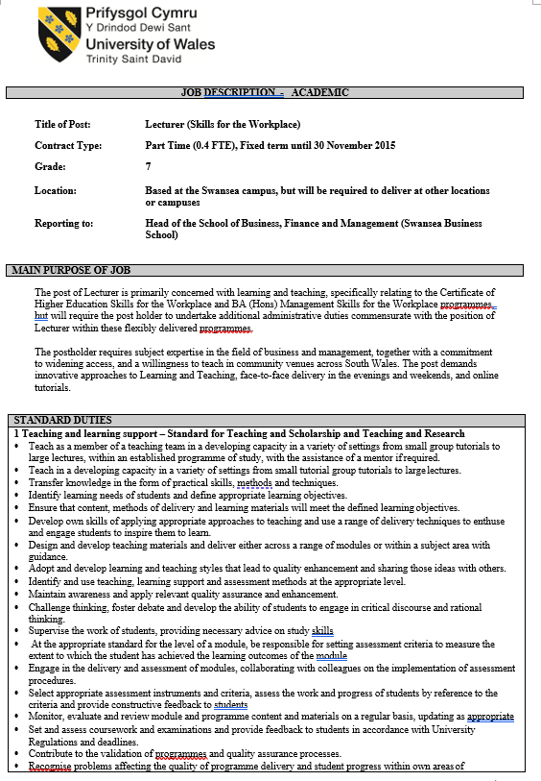

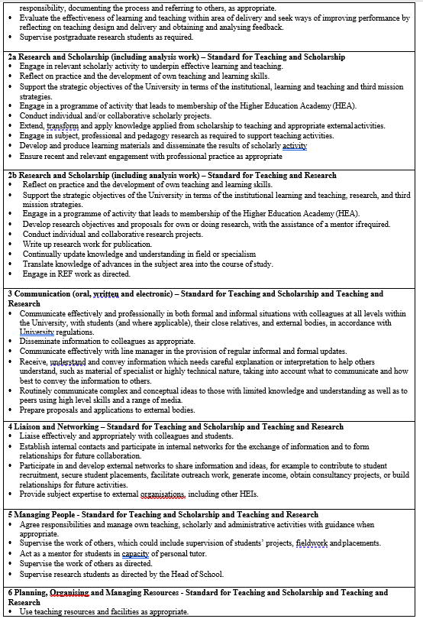
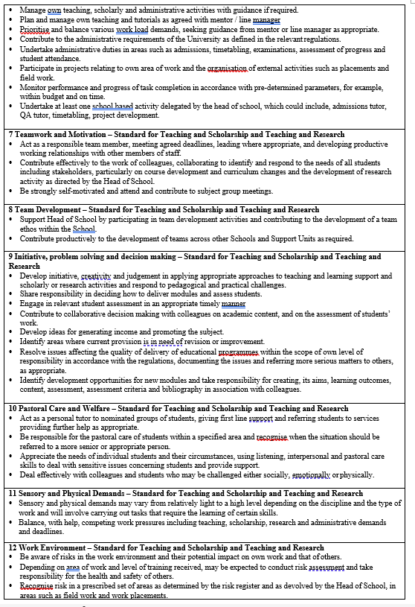
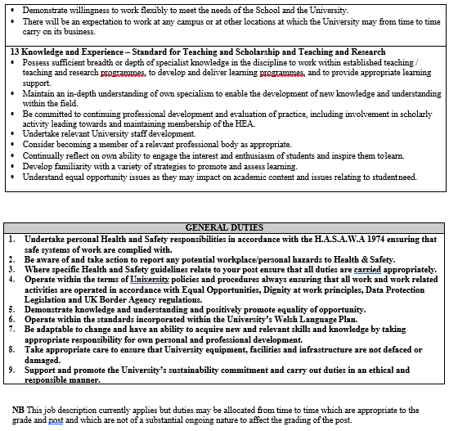

The organisation I work for is a university and my job is a lecturer. In addition to this job, I also have a role of a Programme Manager for an undergraduate programme. Job description provided at the point of employment is based on a generic document which has been adapted for the job on the particular programme I work on.
My role used to be that of a Quality Assurance Manager (QAM), and although it was upgraded to Programme Manager after two years, the QAM was never replaced so my current role, in effect encompasses both roles. Both role descriptions have been included for this reason.
At the beginning of September 2023, my role increased to encompass the role of the Programme Manager for the DipHE and a full BA course as well. My full role description hasn’t been supplied yet so for that reason, it has not been included in this section.

Programme Manager Roles and Responsibilities

- Take overall responsibility for the smooth running and organisation of the programme and ensure that Applied Leadership and Management Outreach adheres to UWTSD regulations policies and procedures.
- Co-ordinate the work of the team and informally deal with any day-to-day issues; report any significant issues to Academic Directors.
- Ensure that formal university channels of communication (e.g., university email, Teams, Moodle) are used for both primary contact methods and learning and teaching of students.
- Work with the tutors to design and implement an effective recruitment strategy, including co-ordination of interviews, open evenings, and induction days.
- Manage existing venue relationships and look for new opportunities for programme development.
- In conjunction with the Quality Assurance Manager develop badging and professional membership opportunities for students. QAM role has been absorbed into the Programme Manager role.
- Lead on external engagement for the programme e.g., agents, venue managers, SAGE, military, third sector etc.
- Work with Academic Directors on resolving staffing issues, resource allocation, forward planning for teaching and the cohort allocation plan.
- Liaise with registry and Academic Directors on the arrangement of examination boards and ensure that tutors comply with registry requirements in terms of marks entry, verification, and attendance at examination boards.
- Liaise with central departments such as finance, student services, marketing, corporate communications, learning resources, registry, and the academic office in relation to student and programme issues.
- Attend examination boards, verification events and liaise with external examiners and ILM personnel.
- Oversight of organisation of ILM Graduation event and other events, such as the residential weekend.
- Support the Quality Assurance Manager in ensuring compliance with UWTSD’s quality assurance practice (e.g., programme monitoring and review, assessment planning, marking, moderation and feedback, external examination, unfair practice, extenuating circumstances, withdrawal, interruption of studies). QAM role has been absorbed into the Programme Manager role.
- Liaise with Academic Directors on student complaints and staffing issues.
- Lead on the planning and arrangement of staff student committees in line with UWTSD regulations.
- Have overall responsibility in ensuring the completion of the NSS annually.
- Participate in Academic Discipline Boards, Staff development activities and other meetings required by Academic Directors and Dean of the Institute.

Quality Assurance Manager Roles and Responsibilities

- Take responsibility for the quality assurance of the programme and ensure that Skills for the Workplace Outreach (SfWP) adheres to UWTSD quality assurance regulations, policies, and procedures (this includes communicating QA updates to tutors and ensuring all tutors comply).
- Act as liaison between the SfWP programme, the IMH Quality Office and Academic Office, providing them with key annual information as requested (e.g., Annual Review Report and External Examiner Agreements and Response to reports).
- Work with the Programme Manager and tutors to design and implement an effective recruitment strategy, including co-ordination of interviews, open evenings, and induction days.
- Ensure compliance with the online admissions process in conjunction with the Programme Manager and Level 4 Year Tutor. These roles have now been combined into one.
- Ensure the registration of new students to ILM and claiming of ILM certificates for successful students.
- Contribute to the organisation of the ILM graduation event.
- Liaise with Programme Manager on badging and professional membership (e.g., ILM for students). As the ILM Center coordinator, this is part of my role.
- Monitor enrolment status of all students and ensuring timely enrolment of students at all levels via the Year Tutors. Year tutor roles have been abolished.
- Ensuring, via the year tutors, that all students have access to IT resources including Moodle.
- Ensuring, via the year tutors, that all students are aware of the support offered by student services and have appropriate testing e.g., needs assessments conducted.
- Work with tutors and the Programme Manager to ensure consistency across cohorts in terms of learning and teaching, deadlines etc.
- Ensure that all tutors follow IMH attendance monitoring processes by using University forms, entering these on the attendance system and forwarding paper copies of attendance forms to the Institute Office.
- Ensure that all tutors adhere to the Moodle minimum standards for the university.
- Ensure that all assessments match the assessment pattern detailed in validated modules and that learning outcomes can be fully addressed through assessment methods.
- Ensure that all assessments are prepared using the University’s template for levels 4, 5 and 6, and are internally and externally verified using appropriate forms.
- Maintain a record of assessment deadlines and take responsibility for the Skills for the Workplace Outreach Feedback Tracking document.
- Ensure that Turnitin is used for all written assessment submission and feedback is provided via grade mark electronically for students within 20 working term time days.
- Develop, in conjunction with the Programme Manager, a moderation schedule for each level, ensuring that a sample of all module assessments are moderated, and a moderation form completed prior to sending a sample (together with appropriate documentation) to the External Examiner.
- Organise an annual standardisation exercise for ILM.
- Ensure that tutors enter marks by the marking deadline and that all marks are checked prior to the exam board.
- Attend exam boards and meet with External Examiners for the programme and ILM.
- Liaise with tutors and Programme Manager to collate and report issues on attendance, withdrawal, non-submission and unfair practice.
- Coordinate the unfair practice procedure for the SfWP programme in conjunction with the IMH Carmarthen unfair practice coordinator and academic office.
- Work with the Academic Directors to identify and arrange staff development relating to Quality Assurance.
- Participate in Academic Discipline Boards, Staff development activities and other meetings required by Academic Directors and Dean of the Institute.

Learning Objectives

Learning objectives for this assignment have been mapped into Borton’s Reflection model (1970).
Other reflection models such as Gibbs (1988), Kolb (1975) or Driscoll (1994) have been considered but decided against due to their restrictive nature.
By simply asking What? So what? And Now what? Borton (1970), allows for the freedom of expression while providing the structure for the reflection that is required.

Borton Reflective model (1970) | Learning objectives
WHAT? | Analyse the experiential learning relevant to current practice
SO WHAT? | Evaluate the learning in the context of the research proposal and future practice
NOW WHAT? | Examine the future course of action and the usability of the learning in the wider context

Introduction

My career has been in education for the last 17 years. As can be seen from the Curriculum Vitae in the previous section, the roles spanned private and public sector.
Spending a year teaching prison officers in prisons of South Wales under the umbrella of Her Majesties Prison Service has been a unique experience in people behaviour and effective management. What we, as the general public, don’t understand is just how understaffed and under-resourced this service actually is. HMPS officers who were newly promoted to Band 5 were all required to complete a management qualification in order to justify their promotions. What became very obvious, very quickly, is that they were experts in people management. They just needed a recognised qualification to confirm it. The officers were often in a very unfavourable ratio of one officer to ten prisoners. By default, the ones that stayed in the profession, quickly developed coping mechanisms to diffuse potential conflicts and prevent them for escalating into full riots. They also developed coping mechanisms to keep themselves mentally stable and resilient. One of these techniques was humour. This was my first, first-hand experience of how effective Gallows humour (Freud,1927) can be, viewed from the side of professionals and not a member of general public.
Gallows humour used by police, firefighters, ambulance crews, military and rescue services cannot always be fully understood by a member of general public who hasn’t had the same experiences. General public would find this humour extremely insensitive whilst it is crucial for the mental resilience and wellbeing of the emergency services professionals.
E.g. When the survivors of HMS Sheffield, sunk in 1982 in the Falklands War, were awaiting rescue, they were reported to have sung the Monty Python song, "Always Look on the Bright Side of Life"
In 2018, a Massachusetts firefighter was reprimanded for a response to a call about a cat stuck in a tree. The firefighter told the caller that the cat would probably make its own way down as he had never seen a cat skeleton in a tree before. Lee (2018)

Humour is rebellious (Freud,1927) but also fickle. The same sentence, word or facial expression can cause different reactions and emotions in different contexts, settings, situations and can mean different things based on the tone, volume and facial expression that accompanies it. Differences are also cultural, and language based as well as based on personal preferences within those cultural or language settings. Each person is different and has a different opinion on what is funny and what isn’t. So, can this wild thing be tamed? Can it be used for good? Should it be used at all?
Humour is a human behaviour written into our DNA code and not using it would be like asking people not to use their speech pattern or to blink in a different sequence. It is possible to learn but it is false and forced and unnatural. The thought process would still be present, and people would still find things funny so it would not be possible to eradicate it. Authenticity is important in all walks of life and industries but in education where relationships are crucial, it is an imperative.
Authentic teachers invest a lot of effort into nurturing meaningful connections, which can lead to personal and professional growth, collaboration, and students’ success. And presence of humour does not necessarily mean absence of seriousness.
'There's a thing in culture where they think the opposite of seriousness is humour. It's not. The opposite of seriousness is triviality. Comedy is very rarely trivial. It's a profound and important part of being human.' Perry (2023) as quoted in Davies (2023)

WHAT - Analyse the experiential learning relevant to current practice

Each day I learn new things that make me question if I actually know what I believe I know. True knowledge doesn’t appear to be solid, instead it is a fluid entity that grows when we learn something new, and changes shape every time it is applied to a new context. It fits into what we already know and adapts as our context changes. Horn (1968) argues that “Fluid Intelligence” is shapeless and can “flow into” a wide array of cognitive activities such as solving abstract reasoning problems but once this “Fluid Intelligence” is paired with experience, formal education, and intelligence of culture, it becomes “Crystalised Intelligence”.
Horn’s (1968) research has been informed by Cattell (1963) who first coined the phrases five year prior.
However, since the “Fluid Intelligence” is the capability to solve new, previously unknown, reasoning problems by using skills such as comprehension, problem solving and learning, I believe this is where the biggest impact can be achieved in education. Once it becomes “Crystalised” by experience and culture, it can often provide obstacles to learning as the learner will call on previous experiences of a situation without necessarily understanding why the situation unfolded as it did. The variables are, at this point, unknown to the learner, and therefore the experience might be misinterpreted or mis-remembered.
Eg. Students often puzzle over why a certain approach worked with Colleague A in a certain situation but had a totally different outcome when applied to Colleague B in a different situation. Without understanding the variables between colleagues and situations fully, their experience can be “crystalised” by one successful application.
If they apply the same approach to seemingly similar situations, they might not always achieve the same result but will not be able to amend it without learning what variables are possible and what outcomes they will lead to.
Cattell (1963) himself admitted that “Intelligence” is the ability to learn”, so “crystalising” the knowledge seems to be hindering the intelligence.
Experiencing life in one culture and then applying the same approach in another culture could have unexpected and unwanted consequences, and in the world that is now more connected than ever, and multi-cultural teams are a norm, this can be detrimental.
Luft and Ingham (1955) with their Johari window model, pose that the area of unknown is without limits so we cannot define what we don’t know as by definition – we don’t know it. The objective would be to achieve the state of Conscious Incompetence (Burch, 1970) first, as only then we can start addressing the gaps in our body of knowledge.
Ruffalo (2021) comments that we are all products of our environment, and my early environment was filled with books and laughter. Both parents are book lovers who are lifelong learners, and I was drawn to stories and books from very young age. My mother has the most incredible laughter and my father loves making her laugh. I remember our neighbours commenting that regardless of what they were doing, when they heard my mother laugh – it would make them giggle. I was about 7 years old then, and clearly remember being confused as to why the neighbours would laugh just because my mum was laughing. They didn’t hear what my dad said so what were they laughing at?
It was years before I realised that laughter and books were, and still are, MY normal, but not necessarily everyone else’s. This inspired the quest for finding out more about the infectiousness of laughter and its effect on people. Humour is part of my behaviour and I have used it without a conscious thought all my life. But can it be learned? Can it be taught to others? Can it be taught with? Would it be beneficial in an educational setting?
In my teens I was growing up in a country torn by war. As a young girl, I used all my wits to stay safe. It was important to learn to read peoples behaviours, assess situations and decide who I could trust and who I should stay away from. Of course, I didn’t know it at the time, but humour was one of the tools I used on many occasions to defuse a potentially dangerous situation. The city was full of heavily armed soldiers, domestic and foreign, who were almost always drunk and feeling invincible. Being a teenage girl in that city at that time, was a lesson in human behaviour.
My parents kept up the laughter and humour within the home and looking back, it was probably a defence mechanism, that kept us sane and mentally strong.
Looking back, I learned that laughter attracts laughter, and that humour can be used as a tool to lower stress and improve the state of mind.
My current practice is higher education where I lecture on a Leadership and Management programme. Leadership and Management was a conscious choice of topic. It attracted me because it was about people, behaviour, motivation, and ambition within a workplace environment. I studied Business Enterprise at the BA level but felt that it was not quite what I was interested in. It wasn’t until my last year that I realised that I was more drawn to the modules that were people oriented and less interested in finance, systems, and other aspects of business. That inspired a choice of programme for my MSc to be Leadership and Management. Working in education, teaching people how to lead people, is my life. And being an authentic person, I have always used humour in my dealings with colleagues and students alike. It is such a part of me, I wouldn’t know what to do without it.
Humour is an emotionally driven behaviour, and as McPherson (2010) suggests:’ we remember emotionally driven events better than boring ones.’ Cognitive psychologist McKay and his team conducted a series of studies and concluded that:” …emotions play role at various stages of remembering (encoding) information, consolidating memories and during the recall, at a later date”. (McKay et al,2004)
Ohman and Mineka (2001) suggest a theory that this phenomenon has an evolutionary purpose. They claim that;” … as emotions tend to operate beyond our conscious control, their intuitive nature gives us an early warning against impeding threats or dangers in our external environment”. By remembering situations that caused negative emotions, we strive to avoid being in the same situation again. On the other hand, by associating safe situations with positive emotions, we aim to replicate those in order to stay safe.
This process of avoiding negative situations and attempting to replicate positive ones is by definition – learning.
The cognitive processing of humour involves the right hemisphere of human brain (Svebak & Apter, 1987), and is, very similar to how our brains process creativity (O’Quin & Derks, 1997) and problem solving (Goldstein, Harmon, McGhee & Karasik, 1975; Johnson, 1990). All these processes require a successful manipulation of ideas (Belanger, Kirkpatrick & Derks, 1988). Since the use of humour and problem-solving activities involve the same psychological process, it seems that one can be used to jump start the other. In education, the use of humour in teachings can improve problem solving skills, and creativity of students (Berk, 2003; Birhle, Brownell & Powelson, 1986; Brownell & Gardener, 1989; Brownell, Michel, Powelson & Gardener, 1983).
In my current practice, I use humour and creativity to jump start the problem-solving skills for the Problem Solving and Decision-Making Assignment, which we deliver during our residential weekend annually. I have a few exercises that I tend to use for this; one being to list all the uses for a paper clip. This always gets the creative juices flowing and it also causes laughter when people shout out unusual and unexpected uses, such as “lock-pick” or “hold your knickers up when the elastic goes” being a couple of examples given by students.
Getting them to be creative first in an exercise that is seemingly unrelated to the current module, lowers their stress levels and gets them to join in, laugh together, share a moment of fun. This in turn makes them more relaxed and more engaged when the session resumes. Once we start talking about the problem-solving module, I will often refer to the exercise and quote what the students have said, which instantly makes them smile or giggle and reminds them to be creative and think outside the restrictions but also gives them a moment away from the teaching material to digest the information given.
Feedback from students seems to suggest that this approach is well received:
F1 “…gives you that cool off couple of minutes where i can absorb that information you’ve given me. So yeah, that can sink in before you start giving me more information, so that works better for me with banter and humour definitely and also retain the information when I go away because I’ll think back and replay things in my mind”.
F2 “… gives you that space where you can retain information, you know you’ve got a breather”.
F3 “…You haven’t got stuff being fired at you, you can take that information in, better, when you’ve broken it up a little…”

SO WHAT - Evaluate the learning in the context of the research proposal and future practice

Throughout this reflective endeavour, it transpires that there are certain patterns present in my attitude and behaviour; I am fun loving person and I love learning about everything, from formal courses to individual people. Learning patterns are governed by the strong relationship between learning behaviour, knowledge and learning motivation. (Vermunt & Endedijk, 2011). I am also a pragmatist (Fleming, 1995) and learn best when I can understand the theory behind it but have a chance to apply it to practice. This has been helpful to my studies and my jobs as a lot of them are structured by policies and quality standards so in order to be effective, I needed to learn the theory behind the processes. I am creative which affords me a lateral way of thinking when it comes to problem solving. I am intrinsically motivated and driven by achievement. I am also people focused with primary focus on individuals, closely followed by the focus on teams with the task being last on the list. Adair (1973)
This combination of love for learning, fun and working with people in education has inspired the interest in using humour as a tool, in a planned manner to make education fun for other people. It has been driving my active research for the last 8 years. As a lifelong learner I now understand that there is no such thing as a more or less interesting subject – only a more or less interesting teacher. I can clearly recall attending sessions that were so utterly boring that I mentally checked out and lost a few hours of my life assembling a shopping list in my head or mentally redecorating a random room in my house, while the speaker was talking. Well, I can clearly recall the beginnings of those sessions, not so much the endings.
As Forsyth (2017) advises that:” The speaker who doesn’t strike oil in ten minutes should stop boring!”
It proved to be a huge waste of time and resources as I gained nothing from those sessions. I can only imagine that the speaker wasn’t fulfilled by that experience either; faced by a room full of glassy-eyed people. But it doesn’t have to be that way. Just because something is important, it doesn’t have to be boring. Moreover, if it is important, we should make sure that people are engaged enough to hear it, consider it, learn it, remember it and know how to apply it.
As john Cleese, the founder of Video Arts (1972) explained: “People learn very little when they are bored and absolutely nothing when they are asleep”.
Positive psychology (Ruch and Hofmann ,2107) supports the notion that humour can help us preserve our mental health, and more, by using the humour to build mental resilience which makes us better balanced individuals and therefore easier to work with, socialise and interact with and work for. Laughter can then, not only keep us emotionally stable, but it can help us grow stronger and more resilient.
Provine (2001) suggests that laughter is a “most direct communication between people”, a “brain-to-brain” in something he calls a “limbic lock”. This involuntary reaction to an external stimulus that involves highly complex neural systems and produces laughter is what brings people closer. This explains why laughter comes to us easier if we are in the company of people, we feel comfortable with, family, friends, close colleagues.
Humour as a primal function of primates is ever present. It is part of our behavioural code, and it shouldn’t be denied or ignored. It should be developed and used to help us connect and be more socially available.
Freud (1927) comments that “humour has something liberating about it; but it also has something of grandeur and elevation, which is lacking in the other two ways of obtaining pleasure from intellectual activity” while recognising the benefits of humour as a defence tool “in which a person adopts a humorous attitude towards himself in order to ward off possible suffering”.
A number of scholars have advocated that teachers incorporate (affiliative and healing, Schoenewolf, 2015; Riggio, 2015) humour into their classrooms (Berk, 1996; Berk & Nada, 1998; Brown, 1995; Cornett, 1986; Davies & Apter, 1980; Johnson, 1990; Kher, Molstad & Donahue, 1999; Ziegler, Boardman & Thomas, 1985). Humour, then, can be seen as a potential management tool to be used within the learning environments such as classroom or workplace training sessions (Berk, 2003), alike, to make learning process more enjoyable and more effective (Provine, 2000).
As I mentioned earlier, humour has always been a part of my practice and I would struggle to teach without it, but it was only when students started giving me positive feedback and specifically mentioning my use of humour, that I realized how much it was noticed and welcomed.
Some examples of feedback received over the last few years demonstrates this point: ” People may not always remember what they were taught but they will remember how they feel and you can engage people with a feeling of trust and humor is a good way to do it. That’s a good way to bring people back into the classroom or back into a training environment.”
F1 “…If somebody’s just straight faced, reading from a book you, kind of, zone out but if it comes to a funny part you, kind of, pay more attention because there’s humour there.”
F2 “… I come here but I don’t come here just to learn, its more than that. It is the social aspect as well….” And “…it’s because of the happy environment, it’s also about the bond you’ve made with the other people, you don’t want to let anyone down, so even if you think aww I could stay in front of the TV tonight, but you won’t you’ll come to class”.
F3 “…: I think as you get older you find it harder as well, for us to have to come back and do learning now at our ages it’s scary. And you panic, and I think that’s when you got a funny teacher, you think yeah, I can do this!”

It is, however, important to use the “right type” of humour, what Riggio (2015) identifies as Affiliative Humour, also recognized by Schoenewolf (2015) as Healing humour. It is the type that allows the audience to recognize themselves in it. It is laughing with people rather than laughing at them. This type creates social bonds and encourages trust while lowering stress and creating a more enjoyable experience for learners and lecturers.
A study of Humour in Adult Learning, carried out in 1995 by Joyce Saltman of Columbia University, discovered that positive humour, especially when pertinent to the material, can, “help establish a climate conducive to adult learning, defuse stress, provide an effective message delivery system aiding retention of information, break down barriers between facilitators and learners, and foster cohesiveness.” (Saltman, 1995)
Theory seems to suggest that people learn best and pay attention when they are emotionally stimulated (Desberg and Shulman, 1970). This emotional response doesn’t have to be spontaneous; it can be purposefully created in the learning environment by utilizing humour and fun activities that will increase attention and longevity of memories.
“Anyone can be funny,” Chesser (2013) says. “It’s about being yourself and being in the moment. If you work with the material in the moment, you can be improvisational and create humour.”
Although, not everyone feels like they can be funny on que, if we accept the promise that humour is a tool, then it can be planned and used as appropriate.
Games, quizzes, videos, and any other activities that break up the monotony of a lecturer talking to sides, can therefore be used to insert a lighter note to the session and possibly provide a break from the information overload so the learners can take a moment to digest the information they have been given.
Sessions can be pre-planned to include these playful moments so that the onus is not on the speaker to say something funny to re-engage the cohort.

NOW WHAT - Examine the future course of action and the usability of the learning in the wider context

The literature establishes the link between the use of humour to lower stress and create a positive emotional response that encourages the rooting of memories, a more successful recall of memories at a later date and increased creativity.
Humour can increase our abilities to be creative, problem solve, be more mentally resilient and be a more agreeable company to be in. This in itself warrants further research into the use of humour in the educational setting.
Although I am interested in humour in the education sector and have been teaching using humour for years, I also understand that this is MY normal. My theory is that humour can be applied to a wider HE educational setting with positive results, but in order to achieve this, it would have to be field tested first.
Next step was to test the receptiveness of fellow educators to this theory. I approached my academic director about reserving a slot in the forthcoming meeting, which would give me an opportunity to present my theory to a small sample of the educators’ population and provided me with a useful testing phase of my research idea.
At the meeting involving around 15 lecturers, senior lecturers, associate professors, and academic directors, I presented the idea of using humour for the benefit of students and teacher. This provided me with an audience from a wide selection of ages, genders, courses, cultures, and personalities.
I involved everyone in an exercise designed to take them out of their comfort zone and make them feel silly. To their credit, everyone participated which was beyond my expectations.
By performing an act of mimicking a tree, everyone stood up and waved their arms around. Judging by their facial expressions, the participants felt confused, silly, self-conscious, and a few resorted to humour and laughter to mitigate this discomfort.
I followed by explaining that the reason for this was to increase their levels of Endorphins by making them relaxed, Dopamine by making them feel silly, Oxytocin by making them trust me and Serotonin by making them do a little physical exercise. Physical movement of raising one’s arms above their head also acted as a lung expander, allowing more oxygen into the lungs, bloodstream, and the brain, thus making everyone a little bit more alert.
A slight increase of, previously mentioned, chemicals in the brain, has numerous benefits for the educators and learners such as: relaxed environment, lower stress, sharper focus, increased engagement, better memory, improved social bonds, increased motivation, improved creativity and problem-solving abilities and a more enjoyable experience of the session, which in turn would improve attendance and engagement, to name but a few.
After the exercise, the audience appeared engaged and there were smiling faces looking back at me. Part of the engagement was anticipation of what was to follow; if we started out as trees, what else is she likely to do or say.
To test my idea that -Humour is a tool to be used as and when deemed appropriate and can therefore be planned and included into the material before hand – I included pre-selected jokes into the power point slides a regular interval to give the audience a break from the theory and to see if it encourages engagement. I maintained eye contact, as much as I could with 15 people and used jokes such as:
“Why do you never see elephants hiding in the trees?”, “Because they are very good at it”.
“Why did the tomato turn red?”, “It saw the salad dressing”.
Afterwards, I asked for feedback. I understand that these people will be my harshest critics as their life consist of attending presentations and delivering presentations to others, so their expert power (French and Raven,1959) made them perfect first test subjects.
The feedback has been anonymised by omitting the names altogether, although full names can be supplied if required.
F1
You were a little bundle of positive energy that brought light and life into a very stuffy room, so thank you 😊 A very interesting and punchy session where you spoke from the heart, and I think this resonated with everyone present.
I’d love to have a copy of your presentation too, if possible, so I can share your ethos in some of my sessions!

Again, many thanks
F2
It was a very clear presentation, and fun.

Observations
Everyone engaged, no one questioned why they should engage, no one asked to be exempt, why? They might have. So how you invited everyone to participate made a difference to ensure 100% participation.

The chosen object, a tree - an object that does not relate to anyone persons positionality, an individual would not normally identify as a tree or routinely model the behaviour of a tree. So, this was a great choice of object to move individuals out of their comfort zone.

The chosen object also served the purpose to get people to stand, be calm, then sway with the wind/breeze (I choose to be a Palm tree!), loosen up and improve breathing. You then explained what happened to us very well while we were all attentive and smiling, although a little hot because of the warm day.

Fun stuff, hope this helps.
F3
Thank you so much for coming forward to do your presentation yesterday. It was a really good mix of a practical approach but also with the beginnings of a potential research project. As I mentioned I think you should consider developing it and presenting on 14th September. I personally found it really engaging and think a wider audience would as well.

F4
I really enjoyed your session - you kept us engaged with your humour and enthusiasm. I'm a great fan of positive psychology and thoroughly agree with including elements of play and humour in our teaching.

F5

I thought it was an excellent presentation – really enjoyed, got everyone involved and was thought provoking too!

F6
Personally, I found the delivery very engaging, you captured people’s attention from the outset. You adopted a very friendly manner which the audience seemed to enjoy.

What was really good was that the approach you adopted enabled you to demonstrate and embed into the minds of others how the positive approach (adopting fun and humour) can result in an entertaining session where the students are captivated and engaged. Very cleverly designed, and well delivered sessions.

If people only take away one thing let’s hope it’s the simple message of smiling😊, but I think they will take away a lot more.

Food for thought I believe😊

Well done, I loved it.

I was subsequently invited to deliver the same presentation to a group of researchers within the university. This provided me with a second phase testing of my research idea. This audience was hand-picked by the organisers for their research efforts and abilities which made them a very critical audience.
The feedback received was once again very encouraging. One of the senior researchers emailed me to say:” It was a really enjoyable day and I think successful day and you were part of the reason why so congratulations to you for such an engaging presentation. It suggests your study is interesting and worthwhile.”

Given that the literature establishes a clear connection between humour and increase in learning and that the feedback from my small sample of educators was extremely encouraging, I would certainly argue that there is room for further research and more testing. I aim to develop this topic into a doctoral level research project and if it proves truly beneficial to educators and learners alike, I would love to be a part of rolling it out to the rest of the university as a start and then, who knows, maybe even further afield.

References

Adair, J., E., (1973) Action Centred Leadership, McGraw-Hill
Belanger, H. G., Kirkpatrick, L. A., & Derks, P. (1998). The effects of humor on verbal and imaginal problem solving. Humor: International Journal of Humor Research, 11(1), 21–31.
Berk, A., R., (2003), Professors are from mars, Students are from snickers, Stylus Publishing, LLC
Berk, R.A., & Nada, J.P. (1998). Effects of jocular instructional methods on attitudes, anxiety, and achievement in statistics courses. Humor: International Journal of Humor Research, 11.
Bihrle, A., Brownell, H.H. & Powelson, J.A. (1986), Comprehension of humourous material by left and right brain-damaged patients, Barin and Cognition, 5,399-411

Bittel, L. R. (1987). The complete guide for Supervisory Training and Development. Addison-Wesley.
Borton, T. (1970). Reach, touch and teach. Hutchinson.
Brown, J. (1995). Funny you should say that: Use humor to help your students. Creative Classroom, 9, 80_81
Brownell, H.H., & Gardner, H.,(1989), Neuropsychological insights into humour. In J. Durant &J. Miller (Eds.), Laughing matters (pp.17-34) New York: Wiley
Brownell, H.H., Michel, D, Powelson, J.A. & Gardner, H (1983), Surprise but not coherence: Sensitivity to verbal humour in right hemispheric patients, Brain and Language, 18, 20-27
Burch, N. (1970). Stages of Competence. Stages of Competence; Gordon Training International. [accessed 29.3.2023]
Burton, N. (2018), The Problem of Knowledge, A synthetic overview of the theory of knowledge and epistemology, Psychology Today, June 2018 issue
Cattell, R. B. (1963). "Theory of fluid and crystallized intelligence: A critical experiment". Journal of Educational Psychology. 54: 1–22.
Chesser,L., (2013) Comedy in the Classroom: 50 Ways to Bring Laughter Into Any Lesson, Opencollege.edu
Cleese, J., (1972) VideoArts; available at https://www.videoarts.com/the-video-arts-story/ [accessed 15 September 2023]

Cornett, C.E. (1986). Learning through laughter: Humor in the classroom. Bloomington, IN: Phi Delta Kappa Educational Foundation
Davies, A.P., & Apter, M.J. (1980). Humor and its effects on learning in children. In P.E. McGhee & A.J. Chapman (Eds.), Children’s humor (pp. 237_253). New York: Wiley
Davies, A., (2023) Grayson Perry: a serious sense of humour, Art UK
Desberg, S.& Shulman, L. S. (1970). “Reconstruction of educational research” Review of Educational Research, June 1970.
Driscoll, M. P. (1994). Psychology of learning for instruction. Allyn & Bacon
Forsyth, P., (2017). Seriously Funny: Using Humour to Enhance Presentations, Bookoon, The eBook company.
French, J. R. P., Jr., & Raven, B. (1959). The bases of social power. In D. Cartwright (Ed.), Studies in social power (pp. 150–167). Univer. Michigan.
Freud, S. (1927) Humour. The Standard Edition of the Complete Psychological Works of Sigmund Freud 21:159-166
Gibbs G (1988). Learning by Doing: A guide to teaching and learning methods. Further Education Unit. Oxford Polytechnic.
Goldstein, J., H., Harmon, J., McGhee, P., E., & Karasik, R (1975), Test of an information processing model of humour; Physiological response changes during problem and riddle solving, Journal of General Psychology, 92,59-68
Horn, John L. (1968). "Organization of abilities and the development of intelligence". Psychological Review. 75 (3): 242–259.
Johnson, A.M. (1990). Sex differences in the jokes college students tell. Psychological Reports, 68,851_854.
Kahneman, D (2011). Thinking, Fast and Slow, Penguin Books.
Kher, N., Molstad, S., & Donahue, R. (1999). Using humor in the college classroom to enhance teaching effectiveness in ‘dread courses. College Student Journal, 33, 400_408
Kohlberg, L. (1958). The Development of Modes of Thinking and Choices in Years 10 to 16, University of Chicago
Kolb, D. A., & Fry, R. (1975). Toward an applied theory of experiential learning. In Theories of group process. John Wiley.
Lee, B., (2018), Firefighter reprimanded for response to woman who reported cat in tree, Telegram& Gazette, Issue 3rd March 2018
Likert, R. (1932). A technique for the measurement of attitudes. Archives of Psychology, 140, 1–55.
Luft, J., & Ingham, H. (1955). “The Johari window, a graphic model of interpersonal awareness.” Proceedings of the Western Training Laboratory in Group Development.
Mackay, D.G., Shafto, M., Taylor, J.K., Marian, D.E., Abrams, L and Dyer, J.R. (2004), Relations between emotion, memory, and attention, Memory & Cognition. 32(3). 474-488.
McLelland, D., C. (2010). Human motivation. Cambridge University Press.
McPherson (2010), The role of emotion in memory, Planning to Remember, Wayz Press, US
Öhman, A., & Mineka, S. (2001). Fears, phobias, and preparedness: Toward an evolved module of fear and fear learning. Psychological Review, 108(3), 483–522.
O’Quin, K. & Derks, P. (2011). Humor and Creativity. 10.1016/B978-0-12-375038-9.00116-3.
Provine, R.R. (2001). Laughter: a scientific investigation. Penguin Books.
Provine, R. (2002). The Science of laughter. Psychology Today, 33 (6), 58-62
Riggio, R., E., (2015) The 4 Styles of Humour, Psychology Today
Ruch W., Hofmann J. (2017) Fostering Humour. In: Proctor C. (eds) Positive Psychology Interventions in Practice. Springer, Cham
Ruffalo, M. (2021). Are We All Mere Products of Experience? Psychology Today, August 2021.
Saltman, J. M. (1995). Humor in Adult Learning. Teachers College, Columbia University, 1995 - Adult Education.
Schoenewolf, G., (2015) 7 Kinds of Humor and What They Mean, PsychCentral
Scott, M. J. (1980). Gap Analysis Project. University of Idaho.
Schon, D., A., (1983). The Reflective Practitioner: How Professionals Think in action. Temple Smith
Seppala, E., & King, M. (2017). Emotional Intelligence - Having Work Friends Can Be Tricky, but It’s Worth It. Harvard Business Review.
Strong, C., A., (1923) A Theory of Knowledge, The Macmillan Company
Svebak, S., & Apter, M. J. (1987). Laughter: an empirical test of some reversal theory hypotheses. Scandinavian Journal of Psychology, 28(3), 189–198.

Vermunt, J. D., & Endedijk, M. D. (2011). Patterns in teacher learning in different phases of the professional career. Learning and Individual Differences, 21(3), 294–302
Ziegler, V., Boardman, G., & Thomas, M.D. (1985). Humor, leadership, and school climate. Clearing House, 58, 346_348.

