

ALPHA DESIGNS
Feasibility Report

Prepared by:
Abigail Johnson

Dated: 17th of January 2024

Feasibility Report
Project Reference: Jayne Pierson School of Art, Fashion, and Design.
Project Number: 6063

Prepared by: ALPHA Designs
Reporting period: Oct 2023 – Jan 2024
Client: ACE Capital Projects Ltd

Report Number: 0001
Site Location: Bethany Square Car Park, Bethany Square, 87 Station Rd, Port Talbot SA13 1PQ.

Site Location Plan

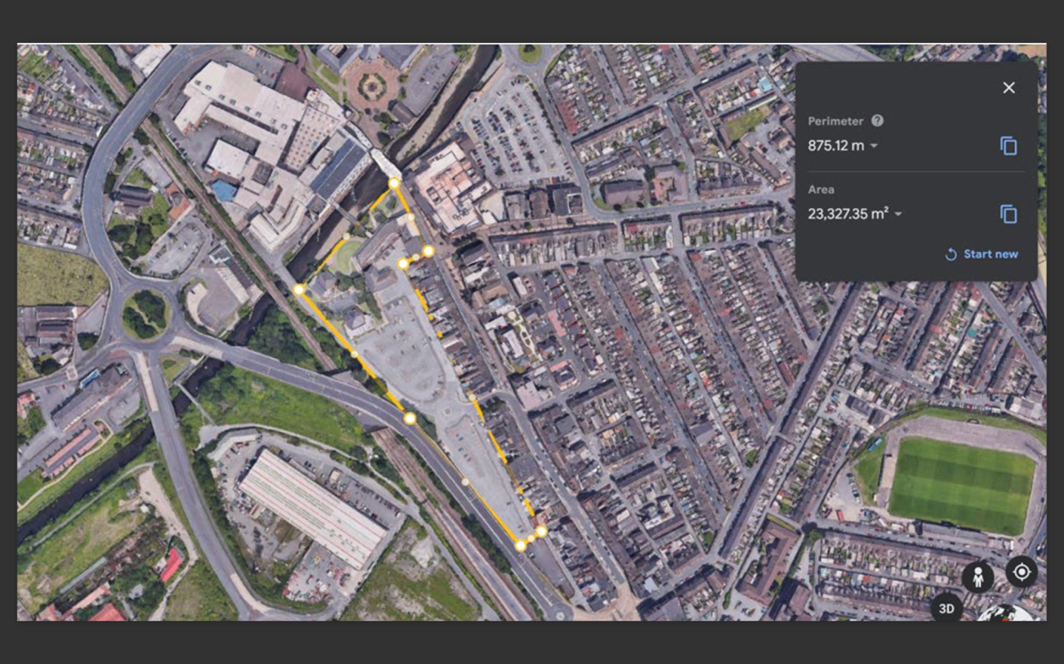

Masterplan
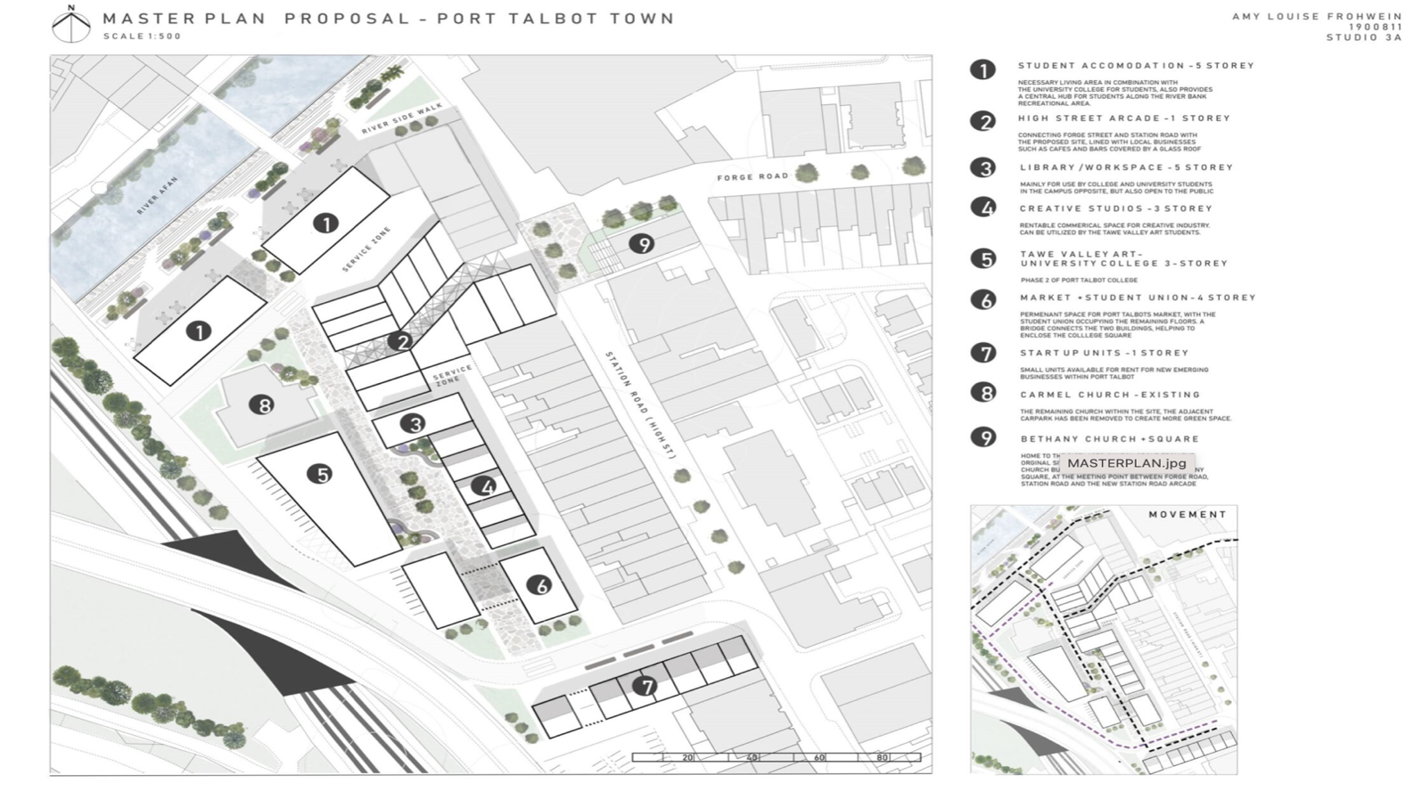

1 Introduction

Alpha designs has been chosen as one of the project teams for ACE Capital Projects LTD in October 2022. We have been asked to carry out a feasibility study for constructing a new educational facility which is part of a redevelopment scheme in Port Talbot. This facility is the first stage of a multistage project for which land has already been acquired and masterplans/architectural proposal concepts have been provided. The building will be named after Jayne Pierson who is an award-winning fashion designer who stands contribute towards funding.

1.1-1.2 Scope of feasibility/ Consideration

This three-storey high, educational facility is the second stage of the already existing Port Talbot College which is located on the opposite side of the railway track. This project aims to increase the student demographic which will be quite beneficial for both large and small businesses.

The building will not only serve as an education facility but will also be a new base for Jayne’s business with space allocated for her own private studio. The building will also have a space accessible to the public that will serve as an exhibition space this will then increase community development allowing the college and its members to integrate.

The target market being primarily students will also allow for the increase of social venues: bars, clubs, and entertainment centres, this will then force the area to develop or expand more economically with the development of this multistage project. The site is also a five-minute walk from the city centre (Aberafan Shopping Centre).

Constructing this college also creates jobs for persons in Port Talbot whether it be academic, administrative, maintenance, etc.

Public transportation is quite accessible from the site, with the train station and bus stop being only a six-minute walk away, allowing for easy and sustainable transportation access to and from the college.

2 Background Information

2.1 Supplied information

ACE Capital Projects LTD provided the following information:

- They stated that they had already acquired the land required for the entire project not just phase 1.
- Funding will be provided from themselves, Jayne Piercing and the Arts Council for Wales.
- The client has also provided masterplans and architectural proposals which contain exact sizing.
- Require us to make full considerations on the project’s environmental impact.
- It was also revealed that being that we are the first phase of the master plan the client requests that we complete and have this project operational by August 2025. The feasibility of this completion date will be assessed by the end of this document.

2.2 Use of Building

Past Use
The site location over the years has transformed tremendously, this is shown is the historic maps assessed on Digi maps in figures 2,3,4,5.

Figure 2
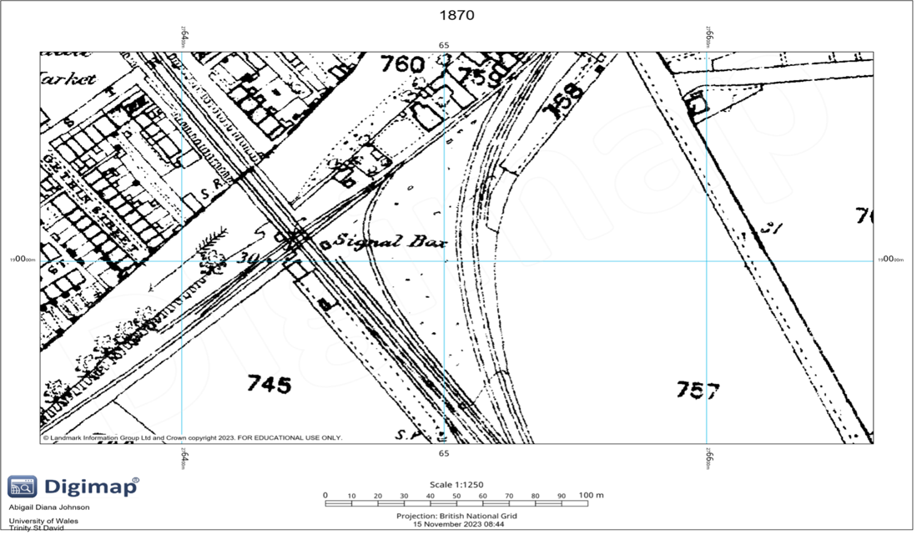
An image of a historic map of the site location in 1870

Figure 3
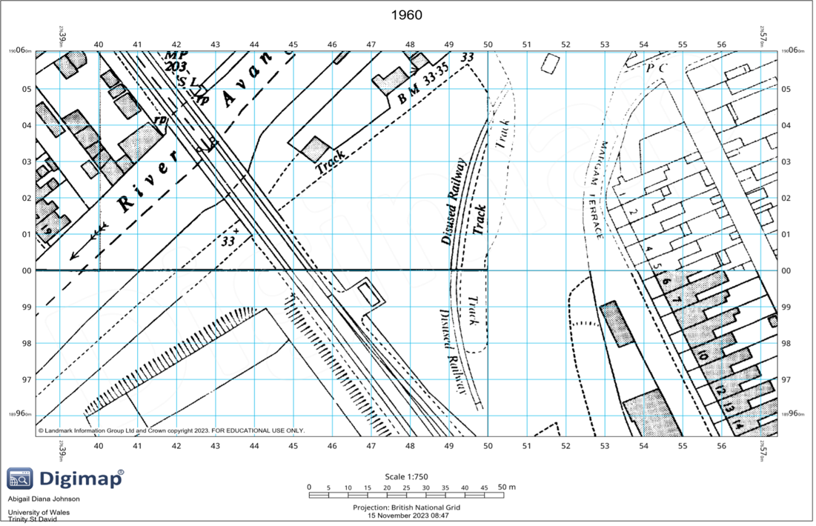
An image of a historic map of the site location in 1960

Figure 4
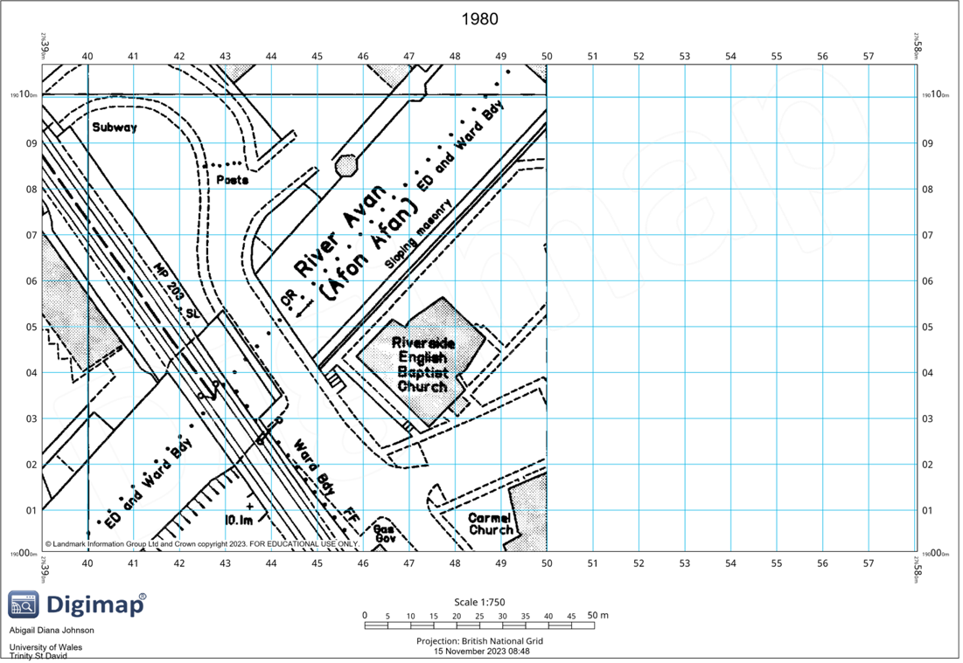
An image of a historic map of the site location in 1980 pt1

Figure 5
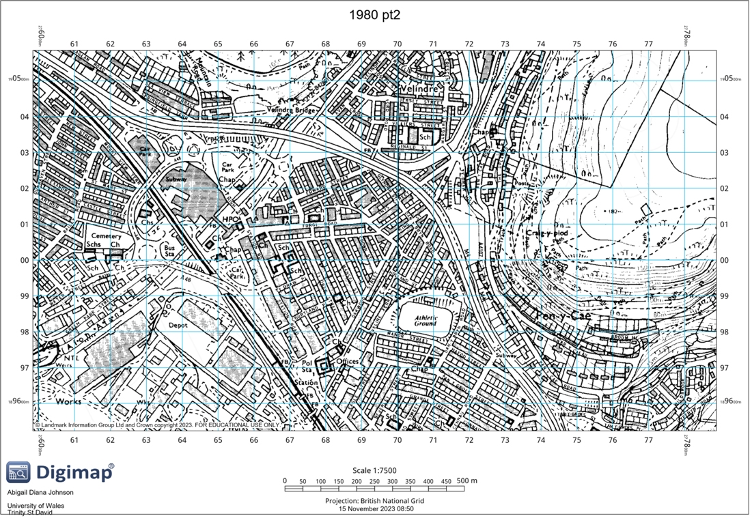
An image of a historic map of the site location in 1980 pt2

Figure 2 is the earliest pictorial record that was found online of the area, it shows that in 1870 a railway track ran directly through the area as well as a small structure (signal box) was erected on site.

In 1970 the railway line was disused, but the old track elements remained, the signal box was removed however another structure was built this is shown in figure 3.

However, by this time a housing scheme called the Margam Terrace was constructed providing housing for the area. In 1980 figure 4 and 5, the railway tracks are no longer seen therefore they were removed, and the structures that we see today have been constructed i.e. the churches where the railway tracks once ran through.

Therefore, with all these changes and different elements being constructed on it is no longer a greenfield site but a brownfield site for which proper investigation (ground/soil) will be conducted to ensure that there is no left over or remaining material from the railway tracks.

Current use

The site’s current use is that of a carpark, the Bethany Square Carpark with a church (Carmel Bethany Presbyterian Church) adjacent to it, this is seen in figure 6. There may need to be consideration made because the church will remain after construction which may lead to various con concerns such as: religious affiliation concerns, scheduling clashes and even noise disturbance.

Through careful consideration here are some recommendations:

Noise disturbance: clear noise level guidelines will be established for both parties as well as design and materials can be adjusted or updated to increase sound proofing.

Religious Affiliation Concerns: Both parties will need to collaborate and come to a reasonable common ground that will allow both to feel respected whilst still being allowed to express themselves.

Scheduling Clashes: Clearly define the operating hours for both the school and the church as well as establishing protocols for after-hours access.

However, most problems that may arise from the proximity of these buildings will mostly be solved by way of proper communication and planning.

Figure 6
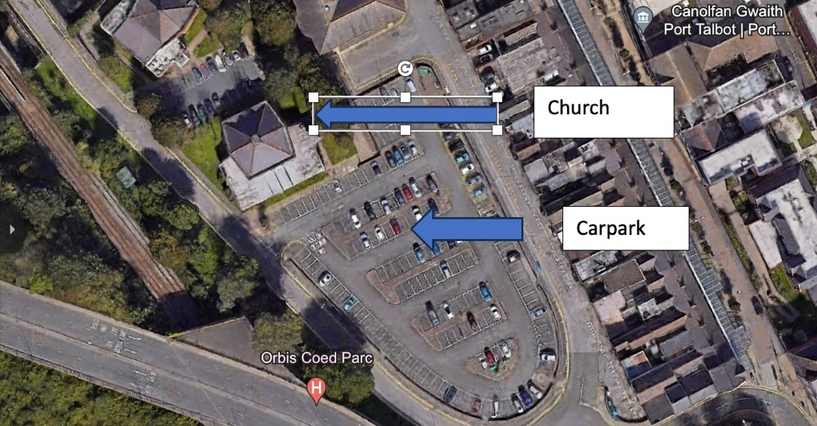
Aerial image showing the site location with the adjacent church.

