
APPENDIX GA36c

LEVEL 6 ASSESSMENT SPECIFICATION

Student name: | Muhammad Faris Bin Latif | Student ID number: | 1805200
Programme: | Bachelor Degree in Applied Computing
Module: | Distributed Enterprise Applications
Module code: | M6X01094 | Contribution to Overall Module Assessment (%): | 50%
Lecturer: | Dr Tim Bashford | Internal Verifier: | Gaynor Thomas
Assignment Title: | Distributed Concepts | Word count (or equivalent): | 2500
Submission deadline: | 28/01/2019 | Return date of provisional marks & written feedback: | 25/02/19

Title: Distributed Enterprise Applications – Distributed Concept
Contents
1 Introduction 2
1.1 What is Microsoft’s Windows Communication Foundation? 2
1.2 Why Do Microsoft Introduces WCF? 3
2 How To Host a WCF Service? 7
2.1 ABCs of WCF 9
2.2 Principles And Process Of Metadata Exchange In WCF 10
3 Data Contracts 12
3.1 Service Contract 12
3.2 Operation Contract 12
3.3 Data Contract 13
3.4 Message Contract 13
3.5 Fault Contract 14
4 Data Exchange Patterns 15
4.1 Request/Response 15
4.2 One-way 15
4.3 Duplex 16
4.4 Asynchronous 17
4.5 Peer to Peer 17
5 How WCF Enables and Supports Interoperability 18

Introduction

What is Microsoft’s Windows Communication Foundation?
Windows Communication Foundation (WCF) was introduced by Microsoft Corporation in 2006. WCF is a framework that can be used to build enterprise application software, more so for the Service-Oriented Applications which use the Service-Oriented Architecture (SOA). The new generation Enterprise Applications require the software developers to re-engineer their application architecture. The new SOA allows application developers to develop bigger and more complex application, but they need new methods and tools to achieve this goal.

As described by Michael Montgomery and Juval Lowy in their book titled Programming WCF Services, 4th Edition, WCF is a software development kit for developing and deploying services on Windows and WCF is much more — it is literally a better .NET [1].
Multiple Applications in Different Servers

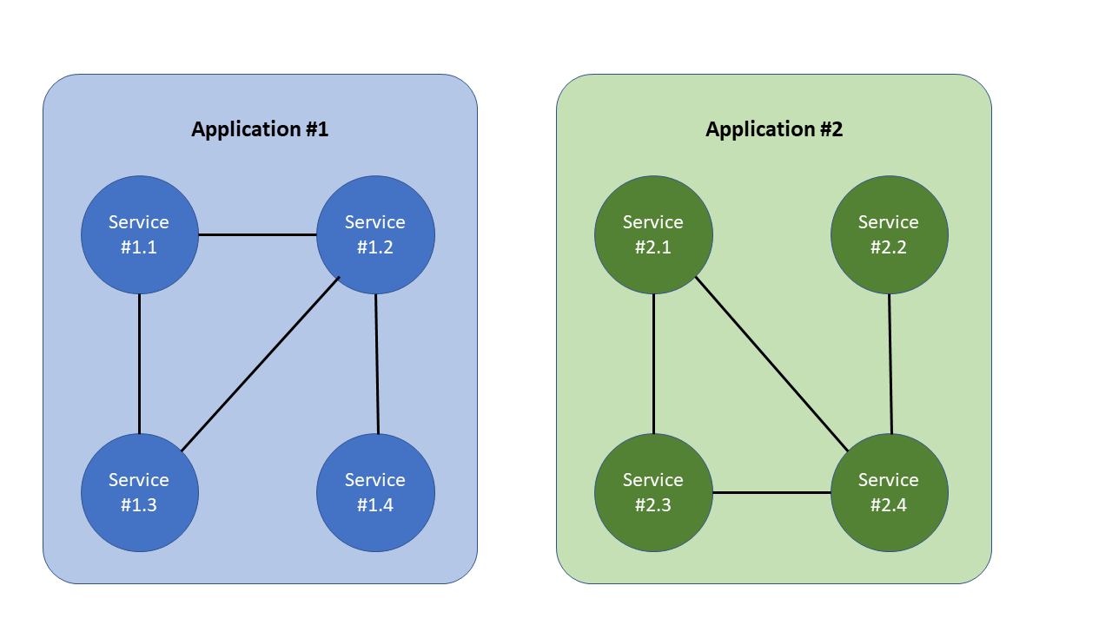

Figure 1: Service-Oriented Architecture Applications

First, Microsoft Corporation introduced .NET framework for application developer to develop enterprise applications. Initially the applications developed using the .NET would only work in the Microsoft’s environment such as Windows XP or Windows Server. Over time, as enterprise applications became more complex and sophisticated, the demand for the applications to work within other environments beside Microsoft’s environment forced Microsoft’s Corporation to introduce WCF in their .NET Release 3.0. The first release of WCF provided many useful facilities for the developer to develop application services, such as hosting, service instance management, asynchronous calls, reliability, transaction management, disconnected queued calls, and security [1].

Later, in .NET Release 4.0 and Release 4.5, Microsoft Corporation included other additional communication facilities in their WCF offering such as additional binding for UDP and WebSocket.

Why Do Microsoft Introduces WCF?

Today, a software developer is facing the challenge to develop an enterprise application that can be very complex within a very short time frame. The enterprise application has to work in a heterogenous environment (servers, PCs, mobile devices, etc.) which runs on different operating system (OS) provided by multiple vendors or service providers. To tackle the task, the software developers are moving away from the traditional software architecture and moving into Service-Oriented Architecture (SOA). In SOA, an application can consist of one or many services where any of the services can send and receive messages from any other services within the application or any other services grouped in other external applications.

According to Microsoft’s online documents on Service-Oriented Application with WCF, WCF is a framework for building service-oriented applications. Using WCF, an application can send data as asynchronous messages from one service endpoint to another. A service endpoint can be part of a continuously available service hosted by Internet Information Services (IIS), or it can be a service hosted in an application. An endpoint can be a client of a service that requests data from a service endpoint. The messages can be as simple as a single character or word sent as XML, or as complex as a stream of binary data. A few sample scenarios include:
- A secure service to process business transactions.
- A service that supplies current data to others, such as a traffic report or other monitoring service.
- A chat service that allows two people to communicate or exchange data in real time.
- A dashboard application that polls one or more services for data and presents it in a logical presentation.
- Exposing a workflow implemented using Windows Workflow Foundation as a WCF service.
- A Silverlight application to poll a service for the latest data feeds.

The earlier .NET framework i.e. Release 1.0 and Release 2.0, already allow the application software to communicate with each other’s. However, it was a major task for the developer to undertake in order to send and receive messages between endpoints. Introduction of WCF makes the development of endpoints much easier than ever. In summary, WCF is designed to offer a manageable approach to creating Web services and Web service clients [2].

WCF’s Features
What makes WCF becoming a more preferred applications development framework are the features that WCF can offer. WCF is designed to offer a manageable approach to creating Web services and Web service clients. Following are the features that WCF has [2]:
- Service Orientation
While using the Web Service (WS) standard offered b WCF, the application developers are able to create Service-Oriented Applications that is based on the Service-Oriented Architecture. The new architecture gives the services in one application the advantage of being loosely-couples instead of hard-coded message path between one application to another. The loosely-coupled feature allows any services on any platform to communicate and exchange messages as long as they adhere to the defined contracts and/or rules [2].
- Interoperability
WCF implementation is using industry standard created for Web Services to enable the interoperability [2].
- Multiple Message Patterns
WCF allows the endpoints to exchange message in many different patterns and the most common one is the request-reply pattern. In this pattern, endpoint “A” will send a request for information from another endpoint “B” and endpoint “A” expects a reply from endpoint “B” will reply. Other pattern will allow an endpoint to send information to one or more patterns without expecting any reply. This pattern type commonly known as broadcast message [2].
- Service Metadata
WCF framework currently supports various publishing service metadata. These Metadata are using industry standards formats such as WSDL, XML Schema and WS-Policy. At the same time these Metadata can be published over various transaction protocols such as HTTP and HTTPS or using the Web Service Metadata Exchange standard [2].
- Data Contracts
WCF framework is design and built using the .NET Framework, thus, it includes code-friendly methods of supplying the contracts that application developer can enforce and the most is the data contract. Microsoft Visual C# or Visual Basic application developer can create classes to handle data that represent a data entity with properties that belong to the data entity, which allows the developers to easily work with any form of data [2].
- Security
WCF framework allow application to encrypt the messages before sending it out and the recipient must authenticate itself before it can access the data. This will to protect privacy and ensure the data is safe and genuine. The application developer can implement the security feature using common standards such as SSL or WS-SecureConversation [2].
- Multiple Transports and Encodings
With WCF framework, messages exchange between endpoints can be done using already matured, built-in transport protocols and encoding such sending text in encoded SOAP messages using the HyperText Transfer Protocol (HTTP) over the Internet. WCF also allow the endpoints to use other transport protocol such as TCP, named pipes, or MSMQ in an encoded format or an optimized binary format [2].
- Reliable and Queued Messages
To ensure the recipients will always receive their message even cases where messages are lost in transmission, WCF framework supports reliable message exchange platform using reliable sessions control. Application developer can use WS-Reliable Messaging and using MSMQ . The lost message will be resent if need be [2].
- Transactions
WCF framework offers three transaction models for the application developer to choose. They are:
- WS-AtomicTtransactions,
- APIs in the System.Transactions namespace,
- Microsoft Distributed Transaction Coordinator [2].
- AJAX and REST Support
With the continuously evolving Web 2.0 technology, WCF offer the application developer to develop application using Representational State Transfer (REST) software architectural style for creating web services. WCF can be configured to process "plain" XML data that is not wrapped in a SOAP envelope. WCF can also support both specific XML formats, such as ATOM (a popular RSS standard), and non-XML formats, such as JavaScript Object Notation (JSON) [2].
- Extensibility
WCF’s architecture has a number of extensibility points, which allows the developers to customize the behavior of a service, if required [2].

With all the features that WCF framework is offering, developer can now develop application that can exchange information within the application or with other applications seamlessly. Thus, they can produce more complex and sophisticated application.

How To Host a WCF Service?

There are two ways to host a WCF service:

- Host the WCF service inside a Managed Application:
The steps to define the WCF service in a Managed Application are:
- Embed the code for the service inside the managed application code.
- Define an endpoint for the service either imperatively in code, declaratively through configuration, or using default endpoints.
- Create an instance of a ServiceHost.
Then creates and opens the listener for the service in order to start receiving messages.
To stop receiving messages, close the service by calling the CommunicationObject.Close on the ServiceHost.

- Hosting the WCF in a Managed Windows service:
WCF service can be hosted in a managed Windows service in the following environments:
- Internet Information Service (ISS).
- Windows Process Activation Service (WAS) [5].

Create A Self-Hosted Service
Following are the steps to implement a self-hosted service in a console application:

Step #1: Create a new console application:
  - Open Visual Studio and select New > Project from the File menu.
  - In the Installed Templates list, select Visual C# or Visual Basic, and then select Windows Desktop.
  - Select the Console App template. Type SelfHost in the Name box and then choose OK.

Step #2: Right-click SelfHost in Solution Explorer and select Add Reference. Select System.ServiceModel from the .NET tab and then choose OK.

Step #3: Double-click Program.cs or Module1.vb in Solution Explorer to open it in the code window, if it's not already open. Add the following statements at the top of the file:

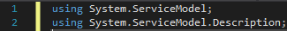

Step #4: Define and implement a service contract. The following example defines a HelloWorldService that returns a message based on the input to the service.
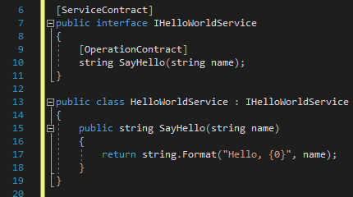

Step #5: At the top of the Main method, create an instance of the Uri class with the base address for the service.

Step #6: Create an instance of the ServiceHost class, passing a Type that represents the service type and the base address Uniform Resource Identifier (URI) to the ServiceHost(Type, Uri[]). Enable metadata publishing, and then call the Open method on the ServiceHost to initialize the service and prepare it to receive messages.

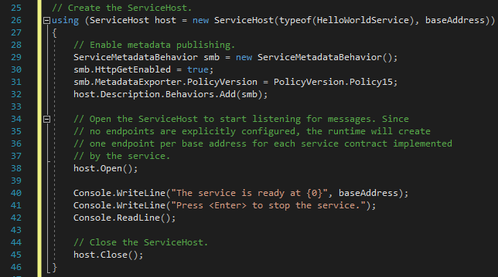

Step #7: Press Ctrl+Shift+B to build the solution.

ABCs of WCF
For a developer to send and receive a message using WCF, the developer must establish the communication path between the message sender and the recipient. To establish the communication path, the developer has to follow these steps: Address-Binding-Contract [3]. These steps are also called ABCs of WCF.

Step #1: Define the Address (A)
An Address is where the service is hosted i.e. the location of the service. It can be an IP Address, server name, URL and etc, and can be on any platforms. The developer must specific the address which may consist of:
- Transport Schema, e.g. HTTP, net.tcp, net.pipe, net.msmq, etc.
- Server Location, e.g. docs.microsoft.com, google.com, etc.

Ref. ID | Transport Protocols | Example Address
1 | HTTP | http://localhost:8001/Service
2 | HTTPS (secure) | https://localhost:8001/Service
3 | TCP | net.tcp://localhost:8001/Service
4 | PEER Network | net.p2p://localhost
5 | Named Pipes | net.pipe://localhost/Service
6 | Microsoft Message Queue | net.msmq://localhost
Table 1: List Of Transport Protocols

Ref. ID | Transport Protocols | Description
1 | HTTP | Protocol for communication over the web (uses TCP at a lower level).
2 | TCP | High performance communication in WCF. Good for intranet scenarios.
3 | Named Pipe | Fast and reliable communication between client and server running on the same machine.
4 | MSMQ | Used when the client enqueues a message that a service can then consume later.
Table 2: List of Transport Protocol and Their Common Usage

By combining the Transport Schema and Server Location, WCF can send the message to the exact and correct recipient.

Step #2: Define the Binding (B)
Binding is the procedure how the message to be handled between the Service and Client. There are two channels in the channel stack that are involved in the binding process, i.e. the Transport Channel and the Protocol Channel. The channel stack is a series of channels that a message passes through during runtime.

Step #3: Contract (C)
Contract is an agreement between the client and server on content and structure of the message being exchanged. There are two types of contracts being used, i.e.
- the Data Contract that defined the message’s structure and
- the Message Contract is the content of the message.

Principles And Process Of Metadata Exchange In WCF
There are two options for an application to publish their metadata:
- HTTP-GET protocol.
- Dedicated Endpoint [4].

- Metadata Exchange using HTTP-GET protocol:
There are two ways to enable WCF to provide metadata automatically over HTTP-GET protocol by adding the local aspect of the service or behavior. The methods can be:

- Administratively
An example of Configuration file with the defined the Behaviour:

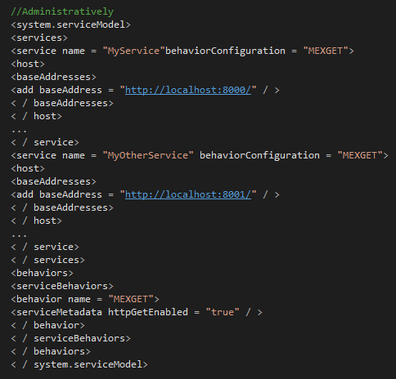

- Programmatically.

An example how to define metadata exchange behaviour programmatically:

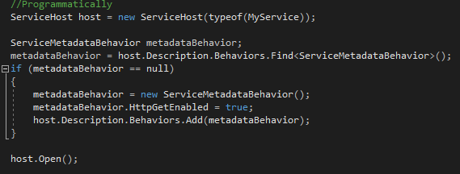

- Metadata Exchange using Dedicated Endpoint.
Metadata exchange between the server and recipient can also be achieved using dedicated Endpoint.

Example:

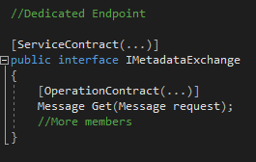

Data Contracts
WCF has fives type of Contracts that an application developer can use. They are:
- Service Contract
- Operation Contract
- Data Contract
- Message Contract
- Fault Contract

The following describes each of the contracts with some examples how the application developer can use the different type of contracts.

Service Contract
A Service Contract defines the operations which are exposed by the service to the outside world. A service contract is the interface of the WCF service and it tells the outside world what the service can do. It may have service-level settings, such as the name of the service and namespace for the service [6].

Example of Service Contract:

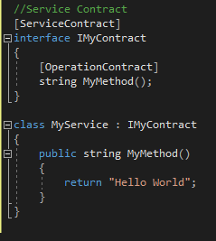

Operation Contract
An Operation Contract is defined within a Service Contract. It defines the parameters and return type of an operation. An operation contract can also define operation-level settings, like as the transaction flow of the operation, the directions of the operation (one-way, two-way, or both ways), and fault contract of the operation [6].

Example of Operation Contract:

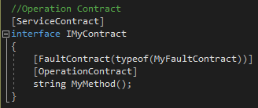

Data Contract
A Data Contract defines the data type of the information that will be exchange between the client and the service. A Data Contract can be used by an Operation Contract as a parameter or return type, or it can be used by a message contract to define elements [6].

Example of Data Contract:

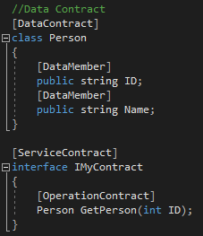

Message Contract
When an Operation Contract required to pass a message as a parameter or return value as a message, the type of this message will be defined as message contract. A Message Contract defines the elements of the message (like as Message Header, Message Body), as well as the message-related settings, such as the level of message security.
Message Contracts give you complete control over the content of the SOAP header, as well as the structure of the SOAP body [6].

Example of Message Contract:
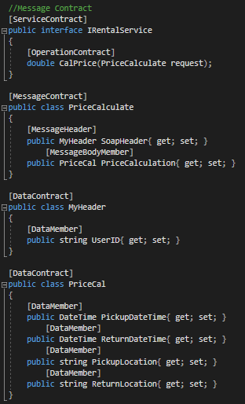

Fault Contract
A fault contract defines errors raised by the service, and how the service handles and propagates errors to its clients. An operation contract can have zero or more fault contracts associated with it [6].

Example of Fault Contract:

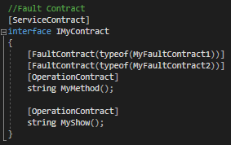

Data Exchange Patterns
WCF framework allows the endpoints to exchange data in the form of messages in different patterns. There various type of pattern support by WCF and they are:
- Request/Response
- One-way
- Duplex
- Asynchronous
- Peer-To-Peer
The following explain each different type of data exchange pattern.

Request/Response
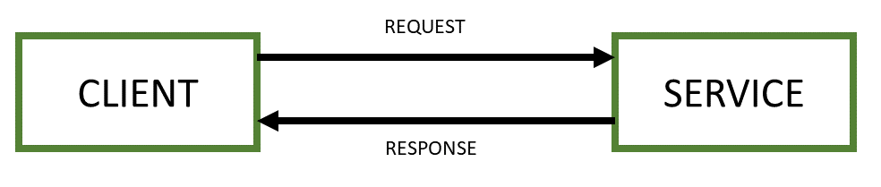

Figure 2: Request/Response Data Exchange Pattern

Request/Response is the most common Data Exchange Pattern. In this pattern an endpoint acts as the client sends a request to another endpoint acts as the server. The client waits for the response and will not stop the processing until the server send back the response. For example, if the client a sends a request to get the name of all users then the service in the server will process the request and the client must wait for a response until the service in the server sends a result. Then only the client is free to execute next request. In the situation where the developer does not use the void keyword then the processing will also take longer time. In order to enable this Data Exchange Pattern, the developer can set the property of the pattern IsOneWay=false [7].

One-way
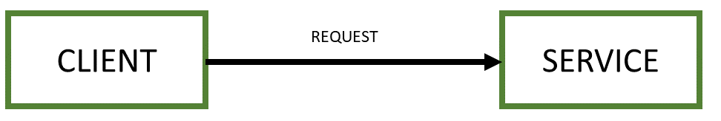

Figure 3: One-way Data Exchange Pattern

One-way is another form of Data Exchange Pattern, where an endpoint acts as the client sends a request to another endpoint that acts as the server providing the service. In the One-way Data Exchange Pattern, the client does not wait for the response from the server and free to process a new request immediately after sending a request. Normally application developer uses this One-way Data Exchange Pattern when the application does not require any response and usually this can avoid a situation where the client has to wait perpetually if the server does not send back a response. In order to enable this Data Exchange Pattern, the developer can set the property of the pattern IsOneWay=true. To avoid message congestion when the server takes longer time to process the request, the developer can set to keep the request in a message queue. Once the server is free, it can dispatch the request from the queue and process it accordingly [7].

Duplex
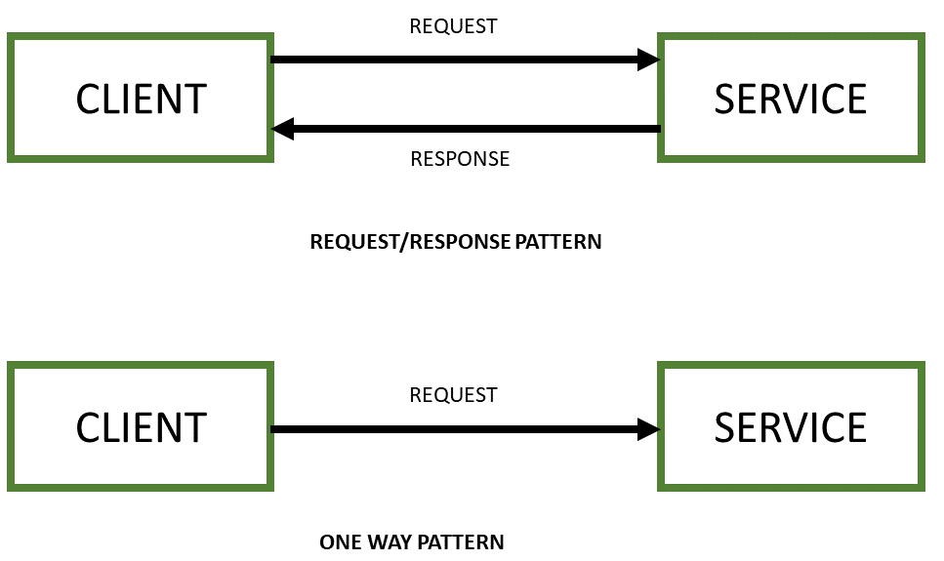

Figure 4: Duplex Data Exchange Pattern

A Duplex Data Exchange Pattern is when the application uses both Request/Response and One-way Data Exchange Pattern to complete a full transaction. In this type of Data Exchange Pattern an endpoint acts as the client sends a request to another endpoint that acts as the server providing the service. The client will wait for the response from the server endpoint, then send another request to the server endpoint. But for the second request, the client does not wait for any response from the server and free to process a new request immediately after sending the second request. Normally application developer uses this Duplex Data Exchange Pattern when the client endpoint wants to acknowledge the server endpoint that the client endpoint already received the response [7].

Asynchronous
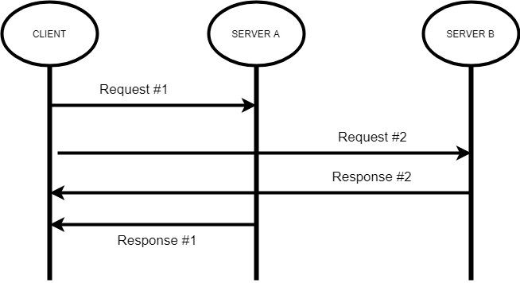

Figure 5: Asynchronous Data Exchange Pattern

Asynchronous Data Exchange Pattern is when a client endpoint sends a request to a server endpoint and expect a response from the server endpoint but does not wait for the response. The client may or may not send another request to any other endpoint before the client receive any response. This type of data exchange is similar to Request/Response Data Exchange Pattern but the response may come after the client endpoint send another request to the same or any other server endpoint. And the responses may come at any sequence. For example, a client endpoint sends a request #1 to a service “A” in the server “A”. Before the server “A” able to send the response for the request #1, the client may send another request #2 to a service “B” in server “B” and server “B” may send the response “2” to the client before the server “A” send the response #1. This type of Data Exchange Pattern may be complex but it improves the total through put for the entire eco-system.

For this long running processes which are neither marked as one-way operation nor a duplex service, is call asynchronous method [8].

Peer to Peer

Peer-to-peer (P2P) computing or networking is a distributed application architecture that partitions tasks or workloads between peers. Peers are equally privileged, equipotent participants in the application processing. They are said to form a peer-to-peer network node [9]. The concept of P2P Data Exchange Pattern is that when there is a request for a data processing, there are several network nodes which have data processing capability sharing the processing workload. All the nodes may or may not have the same processing capability. The end result will be transmitted back to the requesting node or may be pass on to another for further processing. This type of Data Exchange Pattern is not similar to the client-server data processing concept. The advantage of the P2P Data Exchange Pattern is that the entire eco-system capability will be used to optimise the total final data processing output.

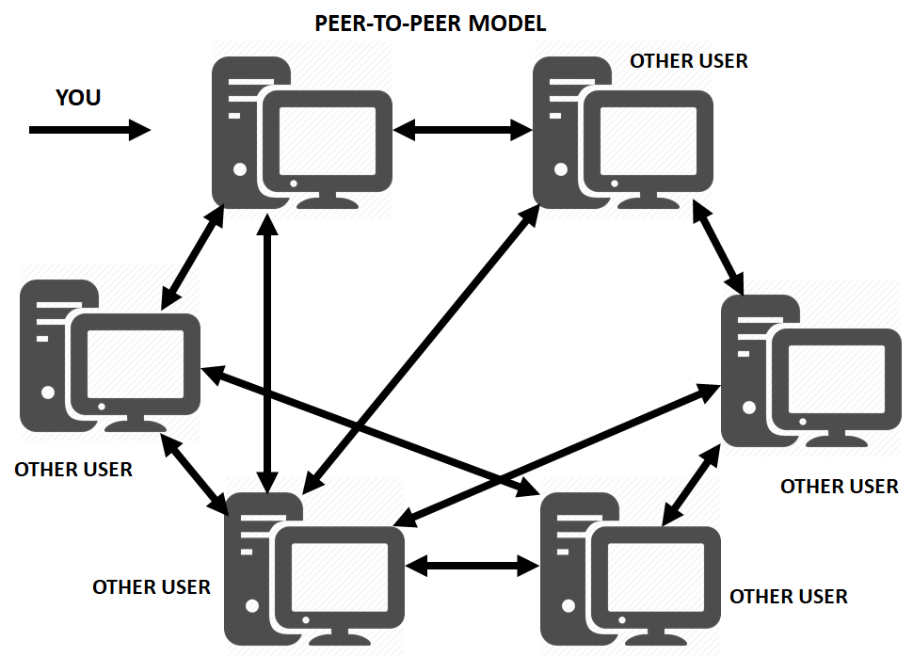

Figure 6: Peer-To-Peer Data Exchange Pattern

How WCF Enables and Supports Interoperability

Windows Communication Foundation (WCF) offers a number of Web services protocols and up to the application developer to pick and choose to their preference. WCF capable to support for:
- Web services (WS) infrastructure protocols using channels.
- Web services (WS) application protocols through the contracts feature [10].

The interoperability for infrastructure protocols is achieved using the WS-* specifications and the application developer can configure the WCF channels using binding elements.

Ref. No. | Specification/Document | Link
1 | HTTP 1.1 | RFC 2616
2 | SOAP 1.1 HTTP Binding | Simple Object Access Protocol (SOAP) 1.1
3 | SOAP 1.2 HTTP Binding | SOAP Version 1.2 Part 2: Adjuncts (Second Edition)
Table 3: WS-* Infrastructure Protocols Implemented By WCF Binding Elements

The interoperability for application protocols is achieved using:
- XML Schema description language 1.0 (XSD).
- Web Services Description Language (WSDL) 1.1.

References:

1 | Michael Montgomery, Juval Lowy, “Programming WCF Services, 4th Edition”, O'Reilly, [Online].  Available: https://www.oreilly.com/library/view/programming-wcf-services/0596526997/ch01s08.html.
2 | Alicia Li, Next Turn, Maira Wenzel, Aymeric A, Genevieve Warren, “What Is Windows Communication Foundation – Features of WCF”, [Online].  Available: https://docs.microsoft.com/en-us/dotnet/framework/wcf/whats-wcf
3 | Ramesh Kartik, “ABCs of WCF”, 2014.[Online].  Available: https://www.c-sharpcorner.com/UploadFile/rkartikcsharp/abc-of-wcf/
4 | Juval Lowy, “Metadata Exchange at Programming WCF Services”, [Online].  Available: https://www.oreilly.com/library/view/programming-wcf-services/0596526997/ch01s08.html
5 | M. Erlend, G. Warren, M. J. M. Hoffman, L. Latham, T. Pratt, M. Wenzel and Y. S. Jjin, “How to: Host a WCF service in a managed app”, 2018. [Online].  Available: https://docs.microsoft.com/en-us/dotnet/framework/wcf/how-to-host-a-wcf-service-in-a-managed-application.
6 | Shailendra Chauhan, “Understanding different types of WCF Contracts” 2013. [Online]. Available: https://www.dotnettricks.com/learn/wcf/understanding-different-types-of-wcf-contracts
7 | Divya Sharma, “Message Exchange Pattern in WCF,” C#Corner, 2014. [Online].  Available: https://www.c-sharpcorner.com/UploadFile/225740/message-exchange-pattern-in-wcf/.
8 | Rahul Rajat Singh, “Tutorial on Message Exchange Patterns and Asynchronous Operations in WCF”, 2013. [Online].  Avialable: https://www.codeproject.com/Articles/569866/TutorialplusonplusMessageplusExchangeplusPatternsp
9 | Amir Jalilifard, “Peer to Peer File Sharing Through WCF” 2018. [Online].  Available: https://www.codeproject.com/Articles/614028/Peer-to-Peer-File-Sharing-Through-WCF#PeertoPeerConcepts
10 | Alicia Li, Nex Turn, Miara Wenzel, Erlend, Mike Jones, “I Web Services Protocols Interoperability Guide”, 2017. [Online].  Available: https://docs.microsoft.com/en-us/dotnet/framework/wcf/feature-details/web-services-protocols-interoperability-guide

