

Master of Business Administration

International Marketing: Principles and Practices

LCMB7026

Student Name: Ranjitkumar Jivabhai Keshvala

Student ID: 2532564

Lecturer Name: Tushara Balendran

Assessment Component 1: Individual Report

INTERNATIONAL MARKET ENTRY STRATEGY AND MARKETING MIX OF TOYOTA: A COMPARATIVE ANALYSIS OF JAPAN AND THE UNITED KINGDOM

USE OF GENERATIVE AI IN ASSESSMENT
RESEARCH | For this assessment, you can use Generative AI to support you in research, including searching for bibliography, using tools to summarise, compare and  interrogate materials. | Yes ☒  No ☐
STRUCTURE | For this assessment, you can use Generative AI to support you in structuring your submission, including creating a draft argument structure, identifying parts  and headings, etc. | Yes ☐  No ☒
PROOFREADING | For this assessment, you can use Generative AI to check your own text/creation for grammatical and syntactical mistakes, including rephrasing of your  own work within specific standards. | Yes ☒  No ☐
WRITING | For this assessment, you can use Generative AI to create text for submission. | Yes ☐  No ☒
CREATIVE | For this assessment, you can use Generative AI to create creative materials, such as images. | Yes ☒  No ☐
PROGRAMING | For this assessment, you can use Generative AI to create and check code. | Yes ☐  No ☒
NONE | For this assessment, you are not allowed to use any type of Generative AI support. This includes research support, structure support, writing/proofreading  support and creative support. | ☐

Generative AI Acknowledgement

I note, in accordance with the assessment guidelines, the use of Generative AI (Gen AI) and electronic tools in preparing this assignment.
Research: Generative AI tools were used in the research process: search, summarise, compare, question and explore relevant academic and other research materials. Reliability and quality are assured for the information and sources discovered in this process and before being used in this assignment. Suitable referencing of all sources made.
Proofreading: I used Grammarly to proof read my work and correct grammar, spelling, punctuation, sentence structure and syntactical accuracy. I checked all the proposed suggestions and finalized the phrases and contents of my assignment.
Creative materials: Where relevant, application of Canva to create and produce visual/creative materials for assignment. It was only a tool to enhance the look and presentation of my artwork.
I am responsible for the content of this assignment including research, analysis, interpretation, arguments, conclusions, referencing and presentation of the assignment. I have read the final version and confirmed it is my own understanding and work and meets the assessment requirements and academic honesty.

Executive Summary
The paper critically examines Toyota's international marketing strategy by comparing its marketing operations in Japan with the UK. It discusses the political, economic, socio-cultural, technological, environmental and legal factors that impact on Toyota's marketing strategies through a PESTEL analysis and Hofstede's Cultural Dimensions are used to analyse cross-cultural differences that impact on consumer behaviour. The STP (segmenting, targeting and positioning) strategy and international marketing mix (7Ps) of Toyota are also compared with the other two countries. Toyota's market entry strategy into the United Kingdom is evaluated and critically analysed by examining the reasons for choosing to enter the U.K. market, its benefits and challenges. Real business examples are also provided to evaluate the ethical issues relating to Toyota's marketing practices. The results are used to make evidence-based recommendations to enhance Toyota's marketing performance abroad. The second section is a reflective account that draws on Gibbs' Reflective Cycle, shows an understanding of the research, analysis and preparation of the report, and identifies learning outcomes and future professional development. The report brings together the latest academic studies, industry reports and quantitative market data to give a complete analysis of Toyota's international marketing strategy.

Table of Contents
Introduction 6
Company Background 6
Comparative Analysis of the Macro Environment 7
Hofstede's Cultural Dimensions 9
STP Analysis 12
Marketing Mix (7Ps) 15
Market Entry Strategy 19
Ethical Issues in Toyota's Marketing Mix 20
Recommendations 21
Section 2: Reflective Account 22
Conclusion 24
Reference List 26

Introduction
International marketing allows multinational organisations to reach markets outside of their own country by adjusting the product, marketing mix and business operations to suit the differing economic, political and cultural environments (De, 2022). Toyota Motor Corp has managed to carve out a global presence by harmonising standardisation with adaptation at the local level. The report makes a critical comparison of Toyota's marketing strategy for international marketing in Japan and the United Kingdom and looks at the macro-environment, cultural factors, STP strategy, marketing mix, market entry strategy and ethical marketing in both countries. The report ends with some strategic recommendations for Toyota and a reflective analysis of the research and report writing process in terms of Gibbs' Reflective Cycle.

Company Background
Established in 1937, Toyota Motor Corp. has grown to become one of the world's biggest automakers with operations in over 170 countries and regions (Alam, 2025). It produces cars, buses, hybrid, plug-in hybrid, battery electric and hydrogen fuel-cell vehicles under various brands such as Toyota, Lexus, Daihatsu and Hino (Toyota, 2026a). The Toyota Production System, or TPS, is the long-term corporate philosophy that Toyota has adopted, stating that continuous improvement (Kaizen), waste reduction and quality management are the keys to sustaining a Toyota competitive advantage (Palhau et al. 2024). Toyota was able to stay as one of the largest automotive manufacturers in the world, with consolidated revenue of roughly ¥48.0 trillion (about US$315 billion) and global car sales over 10.8 million, according to the company's FY2025 Annual Report (Toyota, 2026b). The demand for reducing emissions in transportation remains high, with hybrid electric vehicles comprising a significant competitive advantage (Alanazi, 2023).
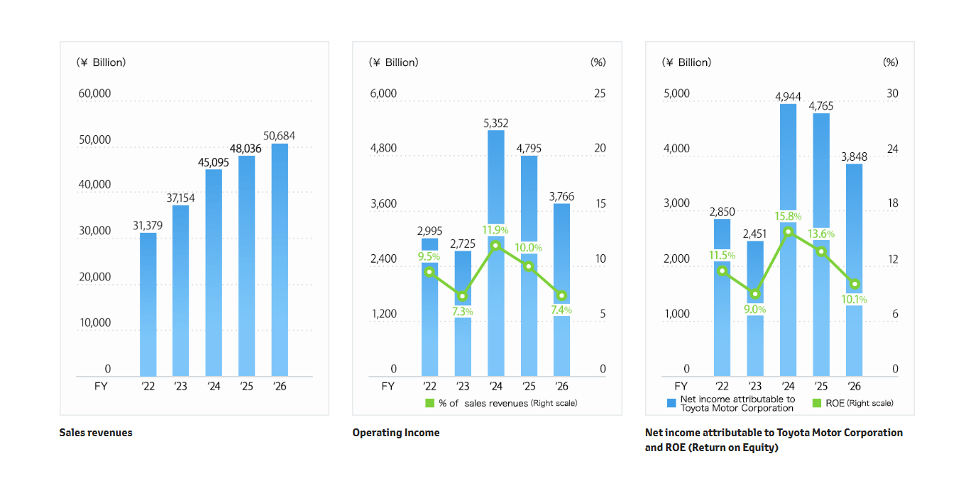
Figure 1: Revenue and sales of Toyota
(Source: Toyota, 2026b)
Toyota's headquarters, research and development centre, and biggest production base are still in Japan, and one of Toyota's most strategic European markets is the United Kingdom (Aoki, 2026). Toyota entered the UK through its UK manufacturing operation, Toyota Motor Manufacturing UK (TMUK), in 1992 and now has vehicle production at Burnaston in Derbyshire and engine production at Deeside in North Wales (Toyota, 2026). The plants have already been operational for over five years, consistently delivering over five million vehicles since then, in the face of the evolving automotive scene even in the UK, from Brexit to the emergence of electric vehicles.

Comparative Analysis of the Macro Environment
For multinational organisations, the macro-environment has a major impact on the opportunities to market and the potential risks to be faced, as well as the demand for the product or service (Drabik, 2022). PESTEL analysis helps Toyota analyse the external factors that will influence its strategic position in Japan and the UK.
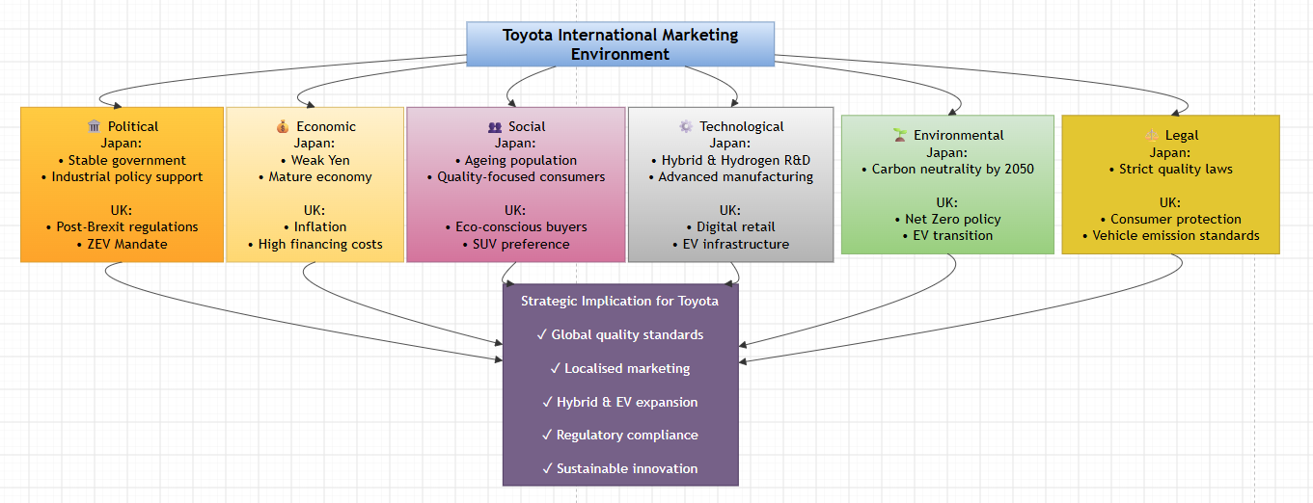
Figure 2: PESTEL Analysis
(Source: Self-created)
The six external factors that affect Toyota's international marketing strategy are shown in the framework. A comparison of each dimension draws attention to the need for standardisation and localisation in marketing strategies.
Political (Both Favourable)
The Japanese political landscape is very favourable for Toyota because the auto industry plays a significant role in the country's economic development, and industrial policy still plays a strong role in the promotion of technological innovation (Heppines and Munir, 2026). Political uncertainty is minimised through the home market as well, because Toyota is so familiar with it. The UK is also politically secure, although Brexit has raised other customs and regulatory challenges for automotive supply chains (Masterman, 2022). However, the Zero Emission Vehicle (ZEV) Mandate in the UK sets a policy trajectory for the transition towards ZEVs, with a commitment of 33% of new car sales to be ZEVs by 2026, followed by 80% by 2030 (GOV, 2026). As such, the political environment is favourable in both countries, with Japan being more familiar with the institutions and the UK having more policy incentives for ZEVs.
Economic (Mixed)
The Japanese car market is still significant and has a high-income level, with its nominal gross domestic product for the year 2024 reaching around US$4.19 trillion (Thedailystar, 2026). However, the growth of real GDP in 2025 was just 1.1%, and is expected to be 0.8% in 2026, which shows a lack of underlying growth (IMF, 2026). Household purchasing power may also be dampened by inflation and ongoing cost-of-living pressures.
The recent momentum of the UK economy is slightly higher: real GDP rose by 1.3% in 2025 and GDP by 0.6% in Q1 2026 (ONS, 2026). Nevertheless, the costs of financing and living costs may limit discretionary purchases. In both markets, Toyota continues to see a commercially viable but economically low demand. The maturity of Japan dampens volume growth while the comparatively robust growth of the UK offers more potential demand but more price sensitivity.
Social Factors (Japan Moderately Favourable; UK Favourable)
Social and demographic changes are important determinants of vehicle choice in both countries. Japan is one of the most aged countries in the world, with around 30% of the population being over 65 years old (Sakamoto, 2025). This is because the ageing population puts pressure on the need for dependable, safe, and fuel-efficient vehicles that need little maintenance. The social environment in Japan is mixed. In 2025, its population dropped to 123.05 million (down 2.5% from 2020), causing a structural constraint on domestic vehicle demand (STAT, 2026). In fact, there are aspects where consumers grow older and demand more for safe, reliable and accessible mobility, the aspects in which Toyota has more strengths.

Electrified mobility has greater potential in the UK. In 2025, 528,000 ZEVs were newly registered, representing 23% of total new car registrations, and this number rose 24%, compared to 2024 (GOV, 2026a). As such, both countries are concerned with safety, quality and reliability; however, Japan's population is ageing and shrinking, while the UK's demand growth is characterised by electrification.

Hofstede's Cultural Dimensions
International marketing is also greatly influenced by culture, as it affects the values, buying patterns, and communication preferences of the consumers. The Cultural Dimensions offer a structured set of tools that allow comparison between national cultures and help understand how MNCs adapt their marketing strategies across countries (Vlasenko, 2023). Toyota is required to strike a balance between consistency and adaptation to the local market, as shown by the Hofstede comparison, which highlights notable differences between Japan and the United Kingdom in all six of the cultural dimensions. Japan's cultural scores are compared with those of the United Kingdom in the chart below. The biggest gap is in uncertainty avoidance, long-term orientation, and indulgence, which is why Toyota has to have different marketing strategies in the two markets.
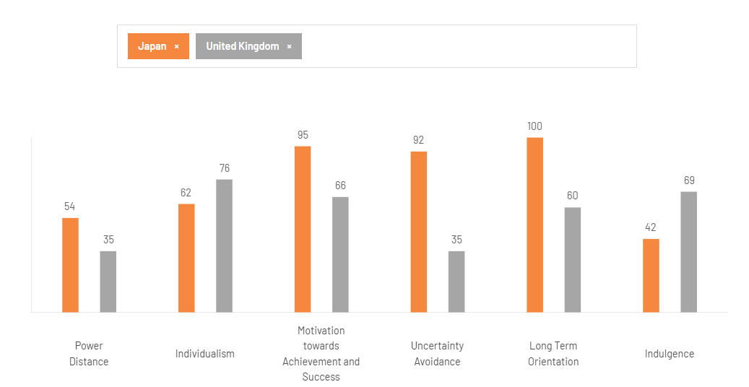
Figure 3: Country Comparison
(Source: Theculturefactor, 2026)

Technological Factors (Favourable in both markets)
Japan offers Toyota a significant technological edge with its advanced manufacturing system and expertise in hybrid, hydrogen, robotics, and mobility technology. Japan is still a world leader in robotics, in advanced manufacturing and in innovation of hydrogen fuel cells, and Toyota has been spending a substantial amount of money on hydrogen research and development, about ¥1.3 trillion annually (Mreport, 2026). Toyota's technological investment is so large that it enables continuous product and process innovation. It is also transforming to connected, automated, shared and electrified; that is its global 2025 results (Toyota, 2026c).
The UK's technology landscape is also favourable, especially for EV adoption. As of 1 April 2026, there were 119,080 public EV charging stations in the country (27,372 of which were rapid or faster chargers) (GOV, 2026b). This decreases the infrastructure challenges for electrification. The difference is, however, that Toyota has greater manufacturing and R&D benefits in Japan, and greater market-facing benefits in the UK, as it relates to EV infrastructure and digital mobility (Hietanen, 2022).
Environmental (Favourable Opportunity)
Both countries offer opportunities for Toyota's electrified portfolio due to environmental trends. Japan's 2050 carbon neutrality policy has been pushing for cleaner mobility, which in turn supports Toyota's hybrid and hydrogen initiatives (Japan, 2026). The Japanese government has pledged to become carbon neutral by 2050, which is a push for cleaner mobility and, in turn, has aided Toyota's hybrid and hydrogen plans. The UK has also pledged to achieve net zero and is issuing more significant direct incentives for car manufacturers via the ZEV Mandate (Commonslibrary, 2026). The UK target is to move from 22% in 2024 to 80% in 2030, putting significant pressure on both the market and regulation for Toyota to grow its BEV share (GOV, 2026).
The key similarity is that both markets will reward lower-emissions mobility; the key difference is the pace and force of the transition. This means environmental forces are good for businesses but bad for strategy: the desire for cleaner cars is commercially beneficial for Toyota, but lack of BEV development is strategically challenging the UK competitiveness of the business.
Legal (Favourable)
The vehicle safety, emissions and conformity standards are both very high standards, which helps to reinforce Toyota's quality and reliability reputation. The existing regulatory framework in Japan is well known to Toyota and is similar to its quality control systems. Brexit creates a more complex regulatory landscape in the UK. Great Britain now has its own type-approval system, with M and N category vehicles needing complete GB or UKNI type approval for production for sale from February 2026 (Vehicle, 2026). These results in higher compliance obligations, but sound safety and environmental measures also assure credible manufacturers and build confidence among consumers. In conclusion, legal conditions are generally good in both countries, with Japan offering more regulatory experience and the UK offering more compliance challenges.
Similarities and Differences
Similarities: Japan and the UK have high vehicle safety and environmental standards, advanced automotive industries, high incomes, and are politically stable. Both governments are proponents of lower-emission mobility, and consumers are also looking for Toyota's proven quality, safety and reliability in both markets. Both markets are also ripe for technological development, which allows Toyota to take advantage of electrification and connected mobility.
Differences: Toyota is familiar with the Japanese market, has manufacturing capabilities and advantages for R&D, while Japan has population reduction and slow economic growth. The UK is more advanced on electrification with more EV infrastructure, but has more regulatory complexity after Brexit and more pressure to roll out BEVs. Hence, Toyota should focus on demographic adaptation and technological depth in Japan and speed up the marketing of BEVs in the UK, digital marketing and marketing sustainability.
Culture comparison and implications for marketing
Japan has a higher Power Distance (54) than the UK (35), which suggests that they accept hierarchy and authority more than the UK (Theculturefactor, 2026). Toyota can therefore focus on engineering excellence and heritage, and institutional trust in Japan, while UK communication can take a more customer-centric approach. Preferences for personal choice and self-expression (Individualism) are higher in the UK (76) than in Japan (62). Toyota therefore focuses on the lifestyle value and customisation of ownership in the UK, with family reliability and long-term relationships in Japan. Toyota has a strong focus on achievement, technological leadership, precision and Kaizen, reflecting the very high Masculinity (95) level of Japanese society relative to the UK (66). The biggest difference is in the area of Uncertainty Avoidance, where Japan rates 92, and the UK rates 35.
They are more concerned about reliability, information and risk reduction, so Toyota puts more emphasis on technical assurance and after-sales service to meet the expectations of Japanese customers. The score of Japan's Long-Term Orientation (100) is also consistent with Toyota's long-term commitment to hybrid, hydrogen and next-generation mobility, whereas the score of the UK (60) is relatively higher for immediate value (Saragih and Muharam, 2023). Lastly, the UK's higher Indulgence (69) compared to Japan's (42) lends itself to more lifestyle and emotional branding opportunities. However, Hofstede's model tends to generalise national cultures because it does not account for regional and generational differences and uses older cultural information (Osiobe et al. 2025).

STP Analysis
The STP strategy of Toyota is the combination of consistency and adaptation in different parts of the world. The company's fundamental business philosophy, quality, reliability and innovation, is the same in all markets, but some customer segments, target markets and positioning are adapted to the economic situation, consumer preferences, and cultural differences in Japan and the United Kingdom. Such an adaptive strategy will help Toyota stay competitive and meet the local market.
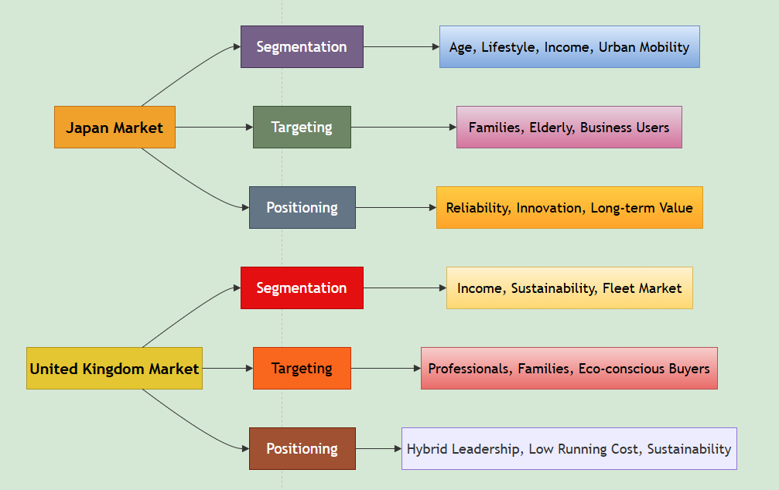
Figure 4: STP Framework
(Source: Self-created)
The framework shows how Toyota has a unified global brand and how they segment and positions itself within the global market, taking into account the customer characteristics across the two countries: Japan and the United Kingdom.
Segmentation
Toyota segments its markets in various ways in Japan and the UK. Demographically, the ageing population in Japan is vital, as are older consumers, families and safety-conscious households, whereas the UK offers opportunities to working professionals, families and business/fleet users (Gustafson and Clark, 2026). The geographical factor is that dense urban areas are more favourable for compact and fuel-saving vehicles due to limited parking, whereas rural areas have a higher demand for versatile vehicles (Chinen et al. 2024). In the UK, there are urban-rural differences and regional accessibility to charging stations that play a role in segmentation. Toyota can thus sell compact hybrid cars in high-density cities in Japan and more aggressively sell SUVs and electrified vehicles in the regions in the UK.
Psychographically, Japanese consumers' higher uncertainty avoidance (92) makes them receptive towards products associated with reliability, security, technical certainty and clear product ownership. Individualism (76) and indulgence (69) are on the rise in the UK, encouraging segments looking for a lifestyle, convenience and sustainable mobility, and this is especially true of the UK. This illustrates that Toyota's segmentation is not just demographic; it reflects the link between the characteristics of people and their cultural and behavioural motivations.
Targeting
Toyota uses a differentiated targeting strategy in the two countries. In Japan, the growth segments are families, older consumers, and urban users who are looking for reliable, compact and efficient mobility. Toyota is focused on families, professionals, consumers who care about the environment and fleet operators in the UK, and hybrid and electric vehicles are the key to their value proposition (Pappas et al. 2023). Therefore, the difference is not so much the nature of the emphasis, as the strategy; demographic ageing and reliability were the concerns in Japan, whilst sustainability, lifestyle and fleet value were the concerns in the UK.
Positioning
Toyota's local emphasis of its position is consistent on a global level with quality, reliability, safety and technological innovation. Its Japanese heritage and engineering trustworthiness give it a positioning that focuses on reliability in long-term mobility in Japan (Autio, 2024). Toyota is more focused on hybrid knowledge, reduced emissions, efficiency, and mobility in the UK. This adaptation is being done strategically since it is a connection between Toyota's brand equity and other local customer priorities.
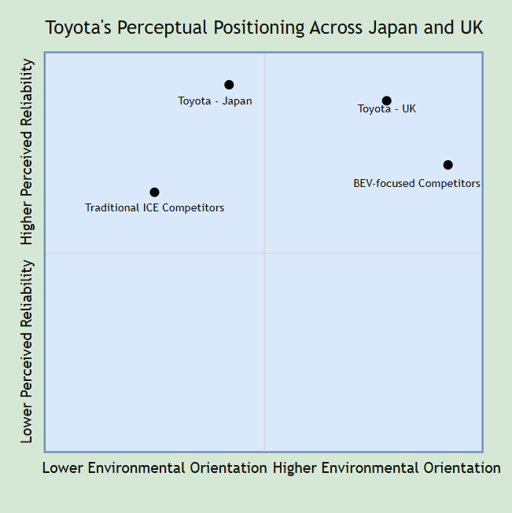
Figure 5: Perceptual Framework
(Source: Self-created)

Marketing Mix (7Ps)
The 7Ps marketing mix is an additional extended marketing mix that can be used to design and build marketing strategies by considering the Product, Price, Place, Promotion, People, Process and Physical Evidence (Kabak and Sevim, 2024). It assists organisations to meet customer needs and take into account market conditions when developing their value proposition. International companies will find the framework to be helpful for strategic adaptation in various cultural and economic contexts.
Toyota uses a glocalisation approach, having a recognised brand internationally, while tailoring marketing mix components to what is found in Japan and the UK, in respect of the economic environment, consumer preferences and regulations. The company's commitment to quality, safety and innovation has not changed, but each of the 7Ps has its degree of localisation to maximise customer value and competitive advantage.
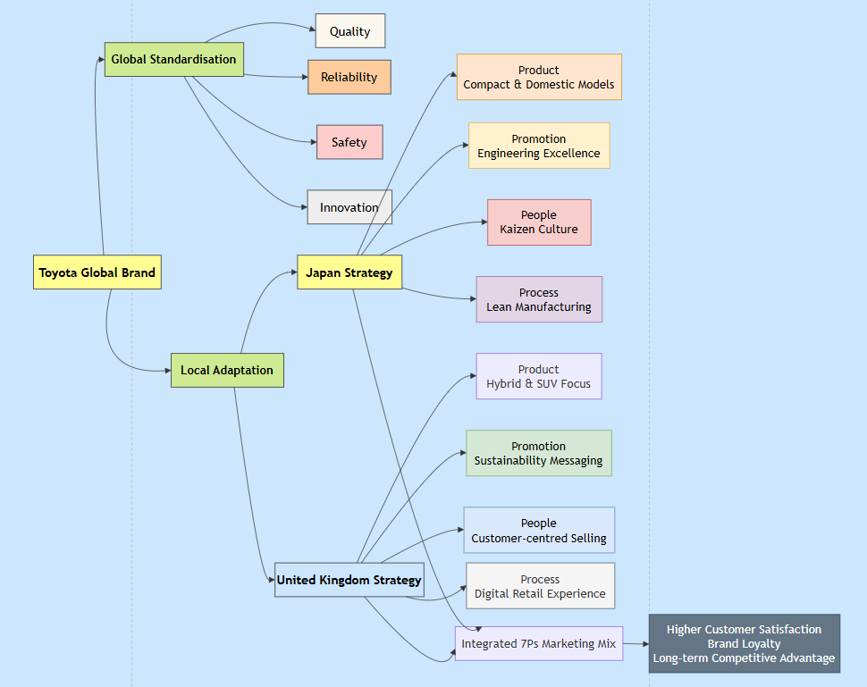
Figure 6: Marketing Mix Framework
(Source: Self-created)
The framework shows Toyota's balanced strategy for global standardisation/ local adaptation based on the seven elements of the marketing mix in the United Kingdom and Japan.
Product
Toyota has a wide range of products in both countries, but the product strategy depends on the respective local markets' needs. The company sells compact cars, hybrid vehicles, luxury Lexus models and mobility solutions for cities around the world in Japan. There are also various models available for domestic consumers, which are not available abroad, and are specific to Japan's road conditions and customer preferences. Toyota's UK product lineup is more geared towards hybrid passenger cars and SUVs, such as the Yaris Hybrid, Corolla Hybrid, C-HR Hybrid and RAV4 Hybrid. The focus on the product fits the growing consumer demand for low-emission vehicles and government initiatives aimed at transport decarbonisation (Linkov, 2025). Hybrids are Toyota's main selling point, but the UK is also seeing an increase in battery electric vehicles. The UK product strategy is more heavily weighted towards environmental regulation than domestic consumer tradition, whereas this is not the case for Japan.
Price
Toyota have a value-based pricing approach instead of a low-price-based approach. Domestic production cuts down on logistics expenses and allows Toyota to keep competitive prices while providing state-of-the-art technology and quality products in Japan. Consumers tend to have a longer time horizon for reliability and are less price sensitive for Toyota (Zhang and Ihara, 2025). In the UK, however, factors like import costs, taxes, and exchange-rate moves, plus tougher environmental laws, all affect prices. Hybrid cars are generally more expensive than standard petrol models, but Toyota touts their benefits of better fuel efficiency and reduced maintenance expense as benefits of their lifetime ownership cost (Soszynska et al. 2024). It is a strategy favoured especially by households and fleet operators, which want to maximise cost-effectiveness throughout the life of the vehicle, rather than just the purchase price.
Place
Toyota has established a very efficient distribution network in both countries. It has a vast nationwide network of dealerships and its own manufacturing and supply chain (Abdeldayem et al. 2023). Manufacturers, suppliers and dealerships are able to work closely together and have products available quickly, with reliable after-sales service. The UK distribution strategy consists of Toyota Motor Manufacturing UK and a network of authorised dealers throughout England, Scotland, Wales and Northern Ireland. Digital channels have grown vital, with customers being able to arrange vehicles, finance and book servicing online before coming to a dealership (Kanojia and Rathore, 2025). Toyota's UK distribution system, therefore, is more blended than the domestic market in relation to customer engagement through both digital and physical means.
Promotion
Toyota's marketing tactics are vastly different. Advertising in Japan promotes engineering excellence, safety, innovation, and brand heritage, which strengthens brand quality, durability and social contribution. Promotion is now becoming more focused in the UK on sustainability, hybrid technology and lower running costs, with the use of TV, social media and digital marketing to promote environmental benefits (Putra et al. 2024). Another boost to Toyota's responsible mobility image is sponsorships and involvement in the community, which mirror the emphasis, placed by consumers on environmental performance in their purchase decisions.
People
Human resource scales vary significantly between the markets for Toyota. Toyota Motor Corporation's presence in Japan is particularly strong, with approximately 73,133 employees in the country as of March 2026, contributing to the company's manufacturing, R&D, and business activities (Toyota, 2026). Toyota Motor Manufacturing UK employs around 3,000 people, including agency staff, at its vehicle manufacturing plant in Burniston and engine manufacturing plant in Deeside in the UK, and Toyota's UK headquarters employs over 400 people (Toyotauk, 2026). Both markets adopt Toyota's Production System and focus on employee development, but the size and work of the employees are different; while the majority of employees in Japan are in the manufacturing process, the ones in the UK are more concentrated on manufacturing, sales, marketing and customer-oriented activities.
Process
Toyota's Process is another strength in the competition, and the Toyota Production System is the foundation of lean production, quality assurance, and waste reduction, in both markets. The Standardised processes are more consistent concerning product quality, and the customer-facing processes are more locally adapted (Kaltiainen, 2025). While UK customers are increasingly demanding flexible journeys online, digital or in person, Japanese dealerships focus on structured and relational purchases and after-sales care. Toyota's omnichannel approach thus makes it easier to access the products and services without compromising service quality.
Physical Evidence
Toyota's premium, yet accessible brand image is promoted in both markets by professional staff, clean showrooms and a consistent brand image, all known as the Toyota Physical Evidence. As expectations around sustainability and knowledge of EVs grow, dealerships are now increasingly installing EV charging facilities, sustainability information and digital displays. Cultural expectations of professionalism and trust focus more on dealerships in Japan giving better hospitality services, service quality and fostering long-term relationships (Ashta et al. 2025). These local adaptations add to the credibility without compromising Toyota's worldwide brand consistency.
Toyota's similarities/differences in 7Ps
There are still some significant parallels between Toyota's operations in Japan and the UK. In both markets, the product strategy focuses on quality, safety, reliability and electrification and is not directed towards low-cost competition. Both markets adopt the use of an authorised dealer network, trained employees, and Toyota's quality-focused processes. Likewise, the regular use of the brand and quality of physical facilities create the Toyota global brand.
However, there are significant differences that reflect the conditions in the local markets. Japan is more interested in small cars, durability and after-sales service, due to the ageing population, the high uncertainty avoidance and the high density of urban areas. The UK, on the other hand, focuses more on SUVs, hybrid/electrified mobility, digital buying and sales with sustainability themes. Toyota's customer experience in the UK is therefore more reliant on a range of omnichannel engagement, environmental messaging and fleet value. The core 7Ps are globally consistent, whereas the elements of the marketing mix which are more customer-oriented, such as Product, Promotion, People and Process, are more strongly adapted to the local market.

Market Entry Strategy
Toyota came into the United Kingdom via foreign direct investment (FDI), with Toyota Motor Manufacturing UK (TMUK) opening in 1992. Instead of exporting, the company built manufacturing plants locally at Burnaston (vehicle assembly) and Deeside (engine production). The move was part of Toyota's strategy of lowering transport costs, streamlining its supply chain and adapting more effectively to local customer preferences, whilst complementing the company's long-term investment in Europe (Katajamäki, 2024). Toyota's investment policy has borne fruit over the years by producing over five million vehicles through TMUK, which shows the success and sustainability that these investments have brought.
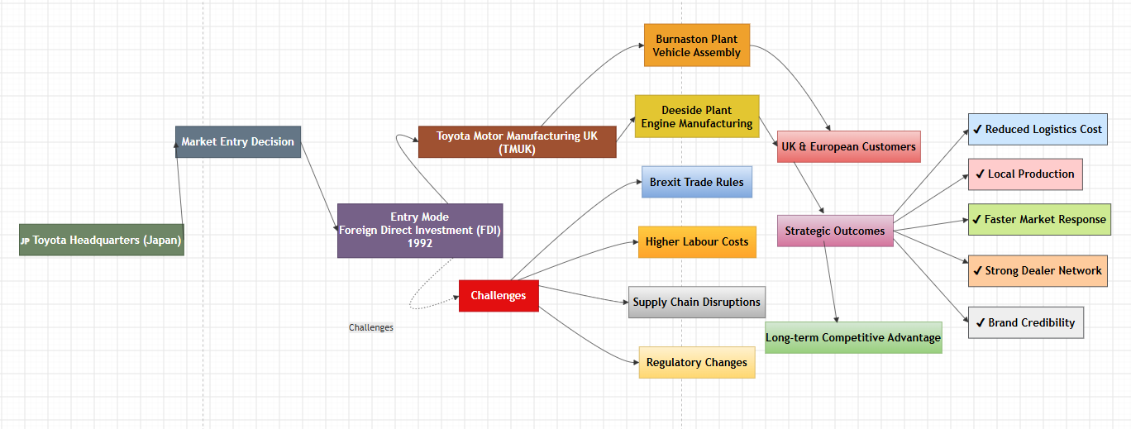
Figure 7: Market Entry Framework
(Source: Self-created)
The diagram shows the route taken by Toyota to enter the market by FDI, allowing for local production, closer integration in supply chains and greater responsiveness to the demand for the UK and European market. Foreign direct investment has provided many competitive benefits (Li et al. 2022). This decreases reliance on imports, reduces delivery time and ensures easier relationships with suppliers and dealerships. The manufacturing projects have also increased Toyota's brand credibility as an employer and contributor to regional economic development in the UK, improving stakeholder relationships. Moreover, local operations allow Toyota to adapt to the ever-evolving customer preferences, such as the increase in demand for hybrid vehicles andlow-emissionss vehicles.
This strategy also comes with major risks, though, for Toyota. Capital investment is high, so there is a high level of financial risk, and operating costs are susceptible to inflation, a shortage of labour, and changes in energy prices (Ahmadi et al. 2026). Furthermore, Brexit imposed customs processes and rules of origin, which made supply chain management more difficult and costly for manufacturers targeting European markets.

Ethical Issues in Toyota's Marketing Mix
Toyota's Product strategy is also an example of good ethical marketing, as they promote lower-emission hybrid cars and the efficiency improvements that they can measure; for instance, the 2025 Aygo X Hybrid has an 85g/km CO₂ and has an 18% reduction in its lifetime carbon footprint compared to the previous model (Toyota, 2026a). Second, its Process/Promotion practices incorporate environmental management and communication of the environmental impacts to customers and stakeholders, backed by Toyota GB's 2026 environmental policy (Toyota, 2026b).
However, two practices pose ethical problems. First, in 2023, the ASA ruled against Toyota's Promotion after a complaint was made that advertisements showing the company's SUVs driving through natural environments were considered to promote environmentally irresponsible behaviour and thus were banned in the format shown (ASA, 2026). Second, Toyota's Promotion makes the claim of "environmental", which needs to be handled with care due to the UK advertising rules, which require environmental claims to be substantiated and in line with the product's complete life cycle if applicable.

Recommendations
Japan
- Create age-friendly mobility: Toyota should offer more compact cars, as well as cars that are friendlier to older drivers and have better safety equipment, for Japanese consumers. Toyota should increase mobility solutions for older customers by 15% by 2030, with ease of use and driver-assistance technology and local dealer support.
- Invest more in next-generation tech: Toyota should step up funding for hybrid, hydrogen, and connected mobility tech while keeping BEV research ongoing, as Japan has a technological advantage (Dzienis and McCaleb, 2025). The 2030 R&D goal should be to improve battery efficiency, vehicle safety, and autonomous driving capability.
United Kingdom
- Quicken BEV positioning: Toyota should accelerate the expansion of BEV product lines and increase the promotion of sustainability while promoting ZEV transition in the UK. Toyota must increase the proportion of its new car sales in the UK that are BEVs to at least 30% by 2030, backed by better charging and total-cost-of-ownership data.
- Enhanced digital marketing and servicing plus fleet marketing: Toyota needs to build online configuration, finance, servicing and personalised communication into its suite, plus focus on business fleet. The company must reach a 20% rise in qualified digital leads by 2029, and expand its collaboration with fleet operators interested in buying lower-emission vehicles.

Section 2: Reflective Account
Reflection plays an important role in PG learning as it promotes critical analysis of professional practice and a drive for ongoing improvement (Mufid, 2025). Gibbs' Reflective Cycle was chosen for this report as it offers a systematic way to analyse experiences, look at strengths and weaknesses and create future action plans.

Figure 8: Gibbs' Reflective Cycle
(Source: Self-created)
Description
This assignment aimed to analyse Toyota's international marketing strategy by comparing the company's activities in the UK and Japan. The research process started with finding data from several academic journals, the corporate publications of Toyota, government reports, and industry sources. Great care was taken to ensure that the analysis was supported by recent evidence and numerical data to enhance the quality and credibility of the analysis. Just as the title suggests, it was not a theoretical discussion of concepts; it was an attempt to consider the application of the concepts in Toyota's business context and to compare and contrast the similarities and differences between the two countries.
Feelings
This was a challenging task at the start of the assignment, as I needed to combine a variety of marketing frameworks into a single report, whilst allowing the report to have a comparative element all along. Reliable and current evidence also needed to be identified, and this involved careful selection of the source to minimise the impact of rapid changes in automotive markets, driven by technological innovation, environmental regulation and changing consumer expectations. As the research was ongoing, my confidence grew, as I could easily understand the impact of cultural, economic and political differences on international marketing decisions by approaching them comparatively. Analysing Toyota also gave me a sense of the value of global uniformity with local customisation for multinational companies. The writing of an extensive amount of information was challenging; however, the report format kept the information organised, ensuring logic while writing.
Evaluation
A feature of my style that I felt was helpful was using a lot of recent academic and industry evidence. The numerical data assisted the analysis of the theoretical frameworks and minimised the amount of unsupported opinion. Throughout the report, comparing Japan and the United Kingdom fostered deeper thinking about the two nations than producing two separate country descriptions. The use of PESTEL and Hofstede was especially useful as macro-environment and cultural factors were complementary in explaining the marketing decisions made by Toyota. The same applies to the link between STP and the 7Ps, which strengthened the relationship between customer behaviour and marketing strategy, leading to a more integrated discussion. Some problems arose while conducting the research, however.
Current market statistics were available from a variety of sources; comparisons needed to be made with great care before choosing the most reliable sources of evidence. There was also a necessity for continual revisions to keep the report analytical rather than explanatory, because of the required balance between description and critical evaluation.
Analysis
This assignment highlighted that the successful marketing of the product in the international markets requires an understanding of the external environment and consumer behaviour. The report revealed that no single model is adequate for analysis of the international markets individually. Rather, a combination of frameworks offers a greater sense of business strategy.
The task also emphasised the need for evidence-based decision-making. Toyota does not copy any solution that was effective in one country to another and incorporates its marketing mix based on regulation, culture and consumer expectations. This strengthened my belief in the need to be strategic and flexible when it comes to international marketing, but not lose the brand uniformity that is important across the globe. As a researcher, I realised that I had to account for the different interpretations of the topic rather than believing anything on its own merits.
Academic journals also showed a range of perspectives on globalisation and local adaptation, which made me feel a need to defend and justify my findings, instead of assuming anything. This method enhanced the credibility and objectivity of the report. Besides, I gained more understanding of ethical marketing. The ethical evaluation of Toyota's responsible actions and the criticism raised on the company proved that ethical decision-making is not just a legal matter, but also very much a matter of reputation and trust in the company.
Conclusion
Overall, my knowledge of international marketing strategy and the academic theory application was greatly enhanced in preparing this report. Developed critical interpretation of evidence and comparative knowledge of international markets and environments in business. The assignment also helped sharpen my research skills and made me use top-notch literature, company reports, and quantitative market data to bolster arguments for strategy.
Action Plan
First, I will enhance my capacity to analyze big data by sharpening skills in understanding market intelligence and business analytics. This will allow me to provide more extensive quantitative evidence in the future to support my strategic recommendations. Second, I should expand my knowledge and understanding of international marketing by reading more modern academic literature on the topics of digital marketing, sustainability, and global consumer behavior. Having an awareness of current trends will improve academic performance and professional decision-making. Lastly, I will keep working on my critical writing skills, this time in a more synthetic manner than descriptive. In future assignments, I will start to gather evidence earlier, be more systematic in comparing multiple perspectives, and have more time to edit to improve the integration of theory and practical application.

Conclusion
This report illustrated that Toyota's global marketing success is built upon the capacity to harmonize and adapt, depending on the local market conditions. The comparison of Japan and the United Kingdom revealed significant differences in the political, economic, and cultural environment, which affect Toyota's STP strategy, the marketing mix, and market entry decisions. The company has built up an enviable competitive position with its innovations, product quality and sustainability, but continued investment in electrification, digital marketing and supply chain resilience will be necessary for the future expansion of its business. In reflecting on the research process, I again reinforced my analytical, critical thinking and evidence-based decision-making abilities, which were indeed crucial to the real-world application of international marketing practice in line with academic theory.

Reference List
Abdeldayem, M., Aldulaimi, S.H., Abu-AlSondos, I.A., El Mokdad, S.S. and Baqi, A., (2023), October. Assessing the role of Toyota distribution and logistical network in the context of global challenge mitigation. In 2023 9th International Conference on Optimization and Applications (ICOA) (pp. 1-6). IEEE. https://www.academia.edu/download/111097474/Assessing_the_Role_of_Toyota_Distribution_and_Logistical_Network_in_the_Context_of_Global_Challenge_Mitigation.pdf
Ahmadi, A., Jalaee, S.A. and Zayandehroodi, M., (2026). Assessing and managing inflation risk in funding investment projects. International Journal of Finance & Managerial Accounting, 13(48), pp.205-218. http://www.ijfma.ir/article_24286_7b71cd05d1201966672ed91687adaa03.pdf
Alam, C.M., (2025). Toyota’s Autonomous Driving Technology: Comprehensive Overview of Future Opportunities and Challenges. 北九州市立大学法政論集, 52(3・4 合併号), pp.49-79. https://kitakyu.repo.nii.ac.jp/record/2000326/files/(HR005234CA)CHOWDHURY%20Mahbubul%20Alam.pdf
Alanazi, F., (2023). Electric vehicles: Benefits, challenges, and potential solutions for widespread adaptation. Applied sciences, 13(10), p.6016. https://www.mdpi.com/2076-3417/13/10/6016
Aoki, K., (2026). Managerial actions using historical values for tackling hyper‐competitive environments: The case of Toyota. Strategic Management Journal, 47(6), pp.1640-1670. https://sms.onlinelibrary.wiley.com/doi/pdf/10.1002/smj.70069
ASA, (2026). ASA Ruling on Toyota (GB) plc https://www.asa.org.uk/rulings/toyota--gb--plc-a23-1191673-toyota--gb--plc.html
Ashta, A., Stokes, P., Hughes, P. and Visser, M., (2025). Japanese cross-cultural management in Indian business-to-business marketing situations: A study of evolving intra-Asian differences in cultural values. Journal of Business-to-Business Marketing, 32(3), pp.307-326. https://research.lancaster-university.uk/files/418208068/JBBM_submission_blinded_accepted_version.pdf
Autio, F., (2024). Envisioning the Future by Design: Toyota’s Show Cars at the 1969 and 1970 Tokyo Motor Shows. Journal of Design History, 37(1), pp.54-69. https://academic.oup.com/jdh/article-pdf/37/1/54/57604784/epad028.pdf
Chinen, K., Matsumoto, M. and Chinen, A., (2024). Navigating the landscape of autonomous buses: insights in Ibaraki, Japan. Sustainability, 16(8), p.3351. https://www.mdpi.com/2071-1050/16/8/3351
Commonslibrary, (2026). Electric vehicles and infrastructure https://commonslibrary.parliament.uk/research-briefings/cbp-7480/
De Mooij, M., (2022). Global marketing and advertising: Understanding cultural paradoxes. SAGE Publications Ltd. https://www.academia.edu/download/8323021/590136127.pdf
Drabik, I., (2022). The impact of international macro environment factors on the internationalization of Polish enterprises. Ekonomia I Prawo. Economics and Law, 21(2), pp.335-353. https://apcz.umk.pl/EiP/article/download/37355/32616
Dzienis, A.M. and McCaleb, A., (2025). Digital and green transitions and automotive industry reconfiguration: evidence from Japan and China. Journal of Contemporary Asia, 55(4), pp.618-644. https://www.tandfonline.com/doi/pdf/10.1080/00472336.2024.2384704
GOV, (2026). Updates to the Vehicle Emissions Trading Schemes (VETS) Order 2023 https://www.gov.uk/government/publications/vehicle-emissions-trading-schemes-vets-order-2023-updates/updates-to-the-vehicle-emissions-trading-schemes-vets-order-2023
GOV, (2026a). Vehicle licensing statistics, United Kingdom: 2025 https://www.gov.uk/government/statistics/vehicle-licensing-statistics-2025/vehicle-licensing-statistics-united-kingdom-2025
GOV, (2026b). Public electric vehicle charging infrastructure statistics: 1 April 2026 https://www.gov.uk/government/statistics/electric-vehicle-charging-infrastructure-statistics-1-april-2026/public-electric-vehicle-charging-infrastructure-statistics-1-april-2026
Gustafson, A. and Clark, H.R., (2026). The Environment Takes a Back Seat: A Content Analysis of Persuasive Appeals in Electric Vehicle Advertisements. Sustainability, 18(9), p.4286. https://www.mdpi.com/2071-1050/18/9/4286
Haines-Doran, T., (2024). The financialisation of car consumption. New Political Economy, 29(3), pp.337-355. https://www.tandfonline.com/doi/pdf/10.1080/13563467.2023.2254727
Heppines, A.C. and Munir, F., (2026). ANALYSIS OF INDONESIA’S ECONOMIC DEPENDENCE ON JAPAN IN THE AUTOMOTIVE SECTOR: A CASE STUDY OF IMPORTS OF CAR RAW MATERIALS AND ENGINE COMPONENTS FOR THE PERIOD 2021–2024. Journal of International Relations and Public Policy, 2(2), pp.54-78. https://andeslubspublisher.com/jirpp/article/download/79/86
Hietanen, E., (2022). Managing omnichannel customer experience through customer journeys in the automotive industry. https://lutpub.lut.fi/bitstream/handle/10024/163907/Hietanen_Emma.pdf?sequence=1&isAllowed=y
IMF, (2026). IMF Executive Board Concludes 2026 Article IV Consultation with Japan. https://www.imf.org/en/news/articles/2026/04/02/pr-26105-japan-imf-executive-board-concludes-2026-article-iv-consult
Japan, (2026). Together for Action: Japan’s Initiatives for Achieving the Common Goal of Net Zero by 2050. https://www.japan.go.jp/kizuna/2024/01/together_for_action_japan_initiatives.html
Kabak, S. and Sevim, E., (2024). An expanded marketing mix perspective on medical tourism. International Journal of Health Management and Tourism, 9(1), pp.90-110. https://dergipark.org.tr/en/download/article-file/3826268
Kaltiainen, E., (2025). Global brand localization leading and managing processes at the local level. https://www.theseus.fi/bitstream/handle/10024/904270/Kaltiainen_Elina.pdf?sequence=3
Kanojia, K. and Rathore, T., (2025). Digital marketing strategies for small businesses. International Journal of Innovations in Science, Engineering And Management, pp.38-45. https://ijisem.com/journal/index.php/ijisem/article/download/219/196
Katajamäki, C., (2024). Navigating transformative shifts in the automotive supply chain: building resilient and sustainable supply chains to adapt to EV-induced changes. https://www.theseus.fi/bitstream/handle/10024/870838/Katajamaki_Chizuko.pdf?sequence=2
Li, J., Van Assche, A., Li, L. and Qian, G., (2022). Foreign direct investment along the Belt and Road: A political economy perspective. Journal of International Business Studies, 53(5), pp.902-919.
https://link.springer.com/content/pdf/10.1057/s41267-021-00435-0.pdf
Linkov, J., (2025). Who Makes the Most Reliable New Cars?. Consumer Reports, March, 5. https://www.salinasubaru.com/static/brand-subaru/consumer_reports/2026/PDF/WhoMakestheMostReliableNewCars_2026.pdf
Masterman, R., (2022). Brexit and the United Kingdom's Devolutionary Constitution. Global Policy, 13, pp.58-68. https://onlinelibrary.wiley.com/doi/pdf/10.1111/1758-5899.13064
Mreport, (2026). Toyota tops R&D spending with ¥1.37 trillion, marking 16 consecutive years of growth, survey finds. https://www.mreport.co.th/en/news/industry-movement/160-toyota-rd-spending-2025
Mufid, M., (2025). The role of teachers as facilitators of critical learning: A literature review of reflective pedagogy approaches in the 21st century. Archipel: Journal of Indonesian Interdisciplinary Studies, 1(3), pp.36-43. https://ojsap.com/index.php/archipel/article/download/22/21
ONS, (2026). Gross Domestic Product (GDP) https://www.ons.gov.uk/economy/grossdomesticproductgdp
Osiobe, E.U., Al Noor, S., Malallah, S., Rauf, R.I., Abdullah, K.H., Sofyan, D., Hammood, W.A. and Aliesawi, S.A., (2025). Commonalities or Variations among Dimensions: An Analysis of Regions based on Hofstede's Six Cultural Pillars. https://papers.ssrn.com/sol3/Delivery.cfm?abstractid=5191098
Palhau, M., Sá, J.C., Ávila, P., Dinis-Carvalho, J., Rodrigues, C. and Santos, G., (2024). Toyota Way–the Heart of Toyota Production System and Its Impact on Sustainable Company Growth. Quality Innovation Prosperity, 28(3), pp.23-45. https://www.qip-journal.eu/index.php/QIP/article/download/2073/1423
Pappas, A., Fumagalli, E., Rouziou, M. and Bolander, W., (2023). More than machines: The role of the future retail salesperson in enhancing the customer experience. Journal of Retailing, 99(4), pp.518-531. https://www.academia.edu/download/108207708/2023_xx_JR_More_than_Machines.pdf
Putra, A.S., Zein, F.Y. and Herdian, R.B., (2024). Beyond the marketing hype: analysis of communication campaigns of electric vehicles eco-friendly image and battery waste concerns. Jurnal Spektrum Komunikasi, 12(1), pp.13-27. https://journal.stikosa-aws.ac.id/index.php/spektrum/article/download/653/358
Sakamoto, R., (2025). Aging in Southeast Asia and Japan: challenges and opportunities. Geriatrics & Gerontology International, 25(7), pp.837-854. https://onlinelibrary.wiley.com/doi/pdfdirect/10.1111/ggi.70062
Saragih, D.A. and Muharam, H., (2023). The Impact of Price, Promotion, and Service Quality on Customer Satisfaction: The Mediating Role of Brand Image in Toyota Car Product. Journal of Social Studies Arts and Humanities (JSSAH), 3(3), pp.134-138. https://journal.unpak.ac.id/index.php/proceedings/article/viewFile/9950/5153
Soszynska, P., Saleh, H., Kar, H., Iyer, L.V., Viana, C. and Kar, N.C., (2024). Driving the future: an analysis of total cost of ownership for electrified vehicles in north america. World Electric Vehicle Journal, 15(11), p.492. https://www.mdpi.com/2032-6653/15/11/492
STAT, (2026). News Bulletin June 25, 2026 https://www.stat.go.jp/english/info/news/20260625.html
Theculturefactor, (2026). Country Comparison. https://www.theculturefactor.com/country-comparison-tool?countries=japan%2Cunited+kingdom
Thedailystar, (2026). IMF Projects Japan’s GDP to fall to world’s 5th after India in 2025 https://www.thedailystar.net/business/news/imf-projects-japans-gdp-fall-worlds-5th-after-india-2025-3603206
Toyota, (2026). Overview https://global.toyota/en/company/profile/overview
Toyota, (2026). TMUK’s 25 Objects – 1: The Spade https://mag.toyota.co.uk/toyota-manufacturing-25-objects-spade/
Toyota, (2026a). Sales, Production, and Export Results https://global.toyota/en/company/profile/production-sales-figures/?padid=ag478_from_header_menu
Toyota, (2026a). The new Toyota Aygo X: Europe’s first A-segment hybrid https://media.toyota.co.uk/the-new-toyota-aygo-x-europes-first-a-segment-hybrid
Toyota, (2026b). Financial Highlights & Financial Performance https://global.toyota/en/ir/finance/
Toyota, (2026b). Toyota (GB) PLC – Environment & Energy Policy https://www.toyota.co.uk/content/dam/toyota/nmsc/united-kingdom/discover-toyota/sustainability/governance/Environment-and-Energy-Policy-Public.pdf
Toyota, (2026c). Sales, Production, and Export Results for 2025 (January-December) https://global.toyota/en/company/profile/production-sales-figures/202512.html
Toyotauk, (2026). Toyota in the UK https://www.toyotauk.com/toyota-in-the-uk/overview-of-toyota-in-the-uk
Vehicle, (2026). GB Type Approval Scheme https://www.vehicle-certification-agency.gov.uk/vehicle-type-approval/gb-type-approval-scheme
Vlasenko, T., (2023). Dimensions of the analysis of the organizational culture of multinational companies. Collection of papers new economy, 1(1), pp.110-125. https://www.conference.oikosinstitut.org/files/2023/zbornik.pdf#page=119
Zhang, Q. and Ihara, T., (2025). Comparative cost analysis of FCVs, BEVs, and ICVs: A consumer perspective in Japan. Applied Energy, 382, p.125231. https://papers.ssrn.com/sol3/Delivery.cfm?abstractid=4962426

