UNIVERSITY OF WALES TRINITY SAINT DAVID
CLOUD COMPUTING

The Completed Worksheets 1 to 6 – Assessment 1

AUTHOR: CLAUDIU OCTAVIAN ALBUS
STUDENT ID: 1809254

London
2021

Table of Conten ts

- Workflow 1____________________________________________________________1
- Workflow 2____________________________________________________________3
- Workflow 3____________________________________________________________5
- Workflow 4____________________________________________________________9
- Workflow 5____________________________________________________________10
- Workflow 6____________________________________________________________15
- Workflow 7____________________________________________________________18
- Workflow 8____________________________________________________________21
- Workflow 9____________________________________________________________24
- Workflow 10___________________________________________________________26
- Workflow 11___________________________________________________________28
- Workflow 12___________________________________________________________31
- Workflow 13___________________________________________________________32
- Workflow 14___________________________________________________________34
- Workflow 15___________________________________________________________37
- Workflow 16___________________________________________________________38
- Workflow 17___________________________________________________________41
- Workflow 18___________________________________________________________45
- Workflow 19___________________________________________________________47
- Workflow 20___________________________________________________________49
- Workflow 21___________________________________________________________52
- Workflow 22___________________________________________________________53
- Workflow 23___________________________________________________________57
- Workflow 24___________________________________________________________60
- Workflow 25___________________________________________________________62
- Workflow 26___________________________________________________________65
- Workflow 27___________________________________________________________66
- Workflow 28___________________________________________________________69
- Workflow 29___________________________________________________________72

Knime - Beginner’s Luck
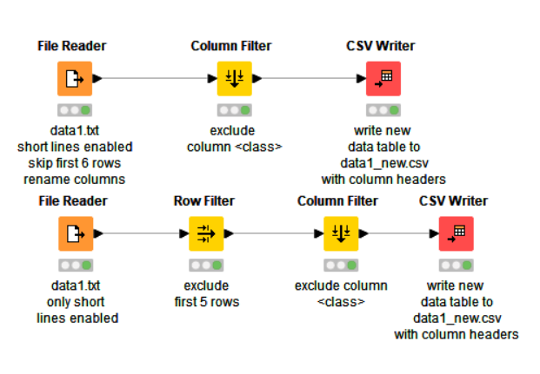
Workflow 1: Chapter 2 Exercise 1

File reader node
Enter the dataset location into the reader node.

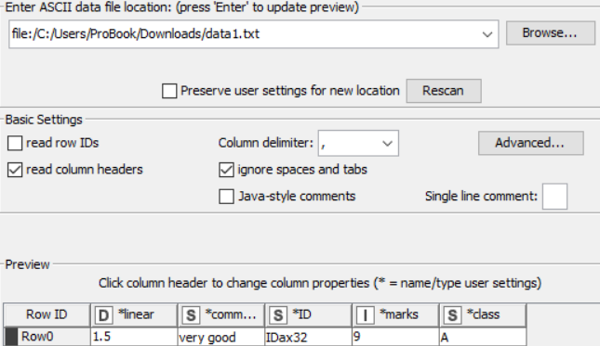

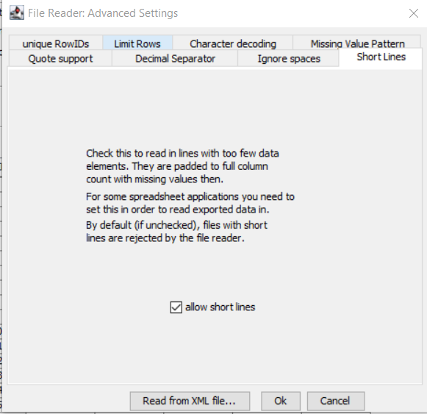

Column Filter node
In column filter node, include all the columns.
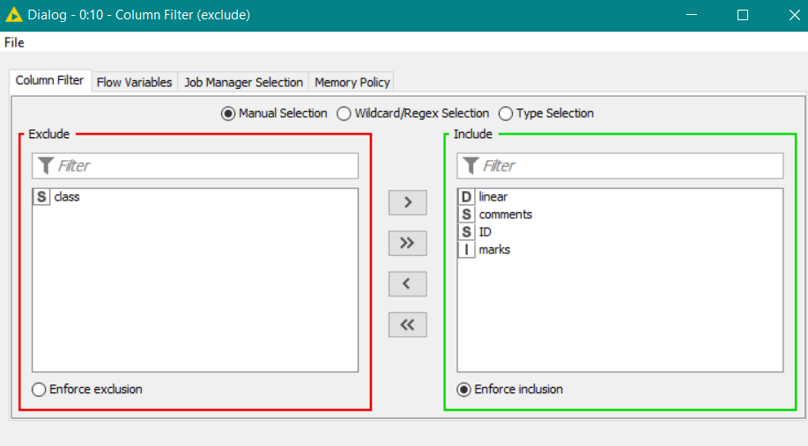

CSV Writer node
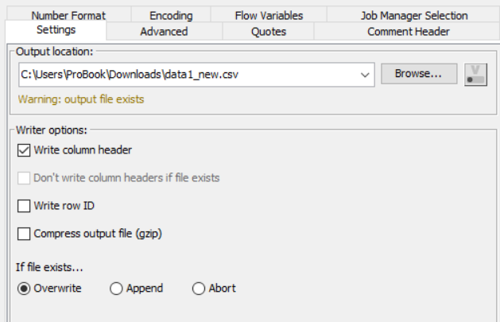
Enter the destination file URL, select column header.

Workflow 2: Chapter 2 Exercise 2

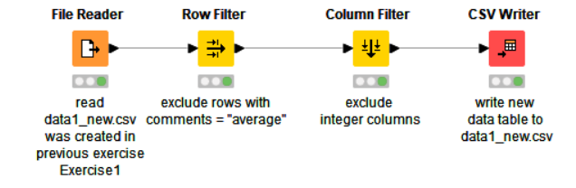

File Reader node

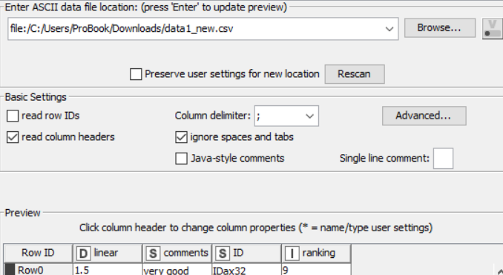

Row filter node
In row filter node choose the column “comments”, select use pattern matching, type average in the text field.
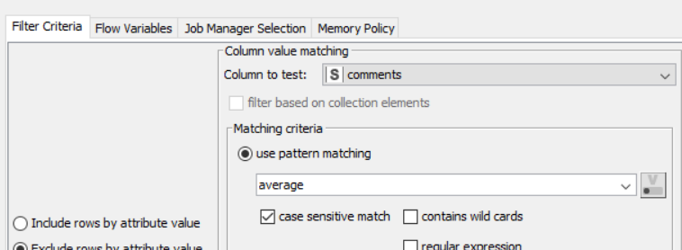

Column filter node
Select type selection and deselect ‘Number’ option. It will filter all the integer data type columns.

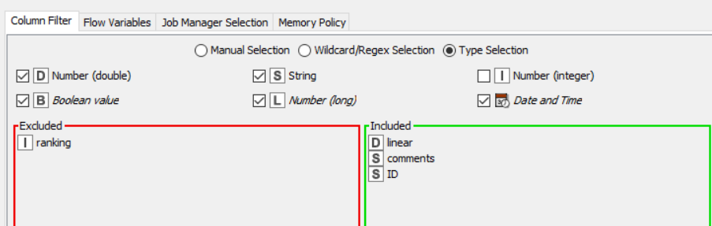

CSV Writer node
Select write column header and press ok.

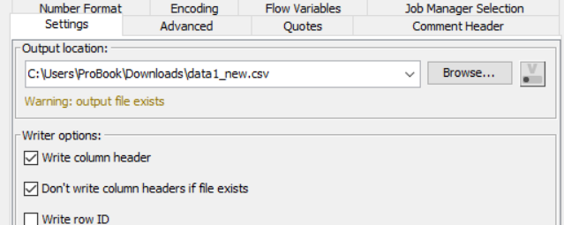

Workflow 3: Chapter 3 Exercise 1

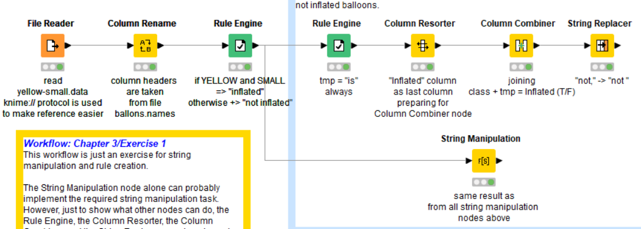

File reader node

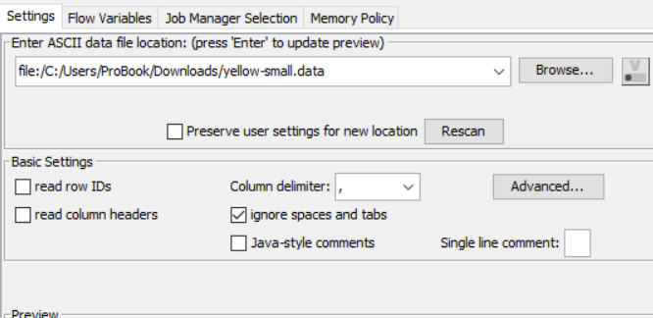

Column Rename node
Select each column one by one and rename it.

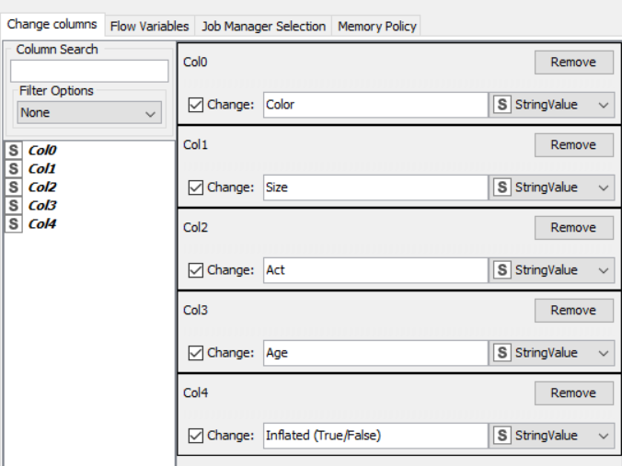

Rule engine node
Create a new column as class which has ‘color= yellow’ and ‘size = small’.

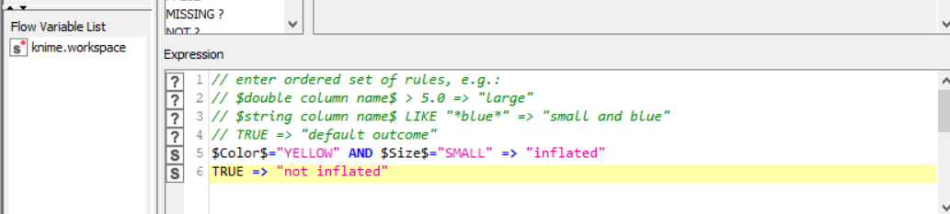

Rule engine node
Create a new column with name ‘temp’ and all the values of it will be “is”.
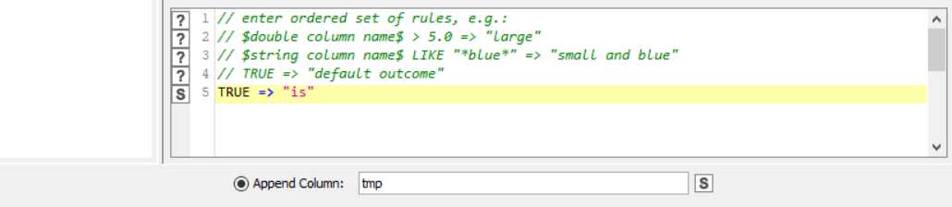

Column resorter node
Arrange the columns according to the given order.
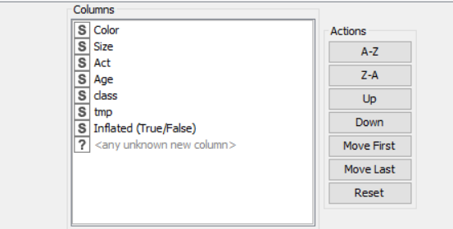

Column Combiner Node
Set the replace delimiter option by name to append the column as full sentence and combine the ‘class’, ‘tmp’ and ‘inflated’ columns.

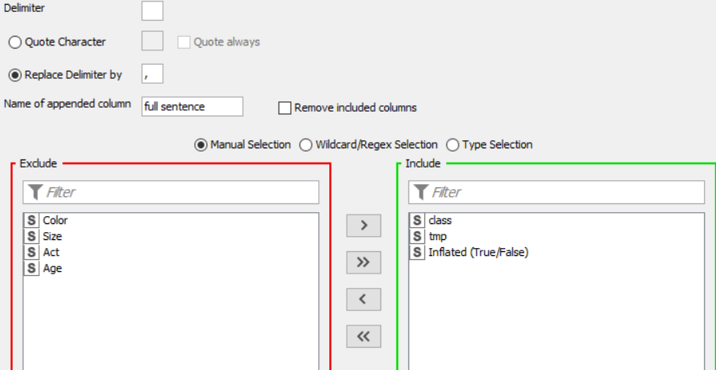

String replacer node
Under Target column select full sentence. Select wildcard pattern and replace ‘not,’ to ‘not’.
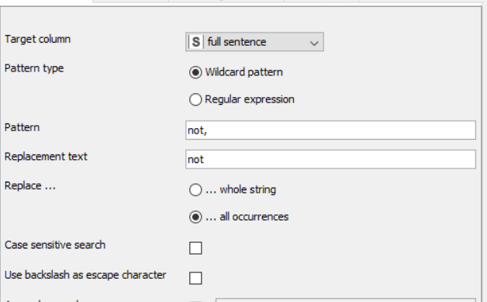

String manipulation node
String manipulation node make things simpler. Just put the below given pattern in the expression section.

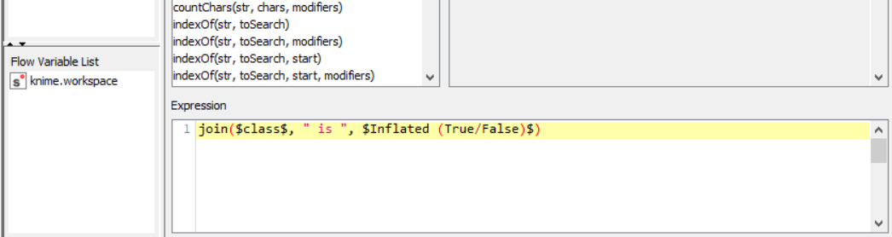

Workflow 4: Chapter 3 exercise 2

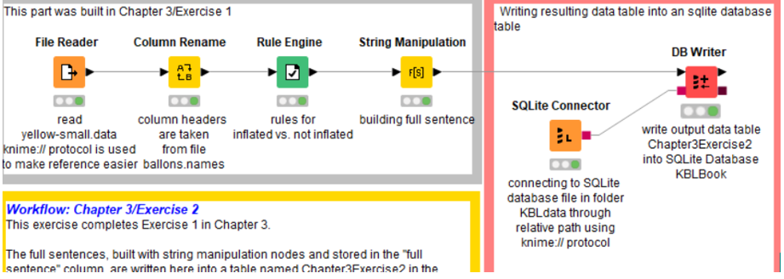

File Reader, column rename, rule engine and string manipulation node are same from the last exercise.

SQLite connector node
Under the SQLite connector node, select SQLite and under path enter the URL of the location where SQLite database exists.
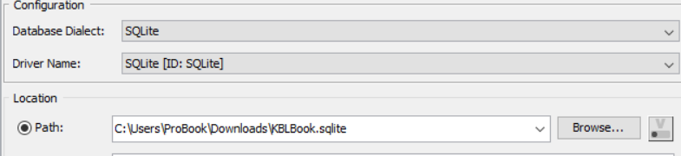

DB writer Node
Select the table Chapter3 exercise 2 in the table section and select all the columns to be stored in the database.
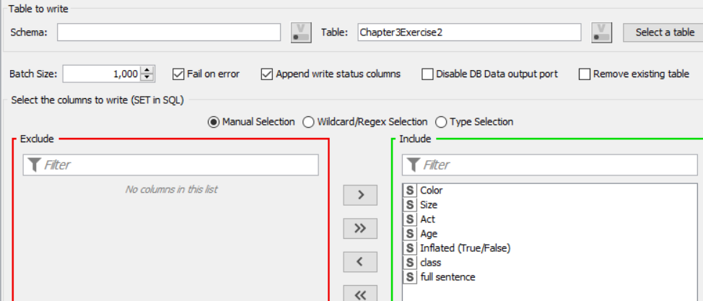

Workflow 5: Chapter 3 exercise 3

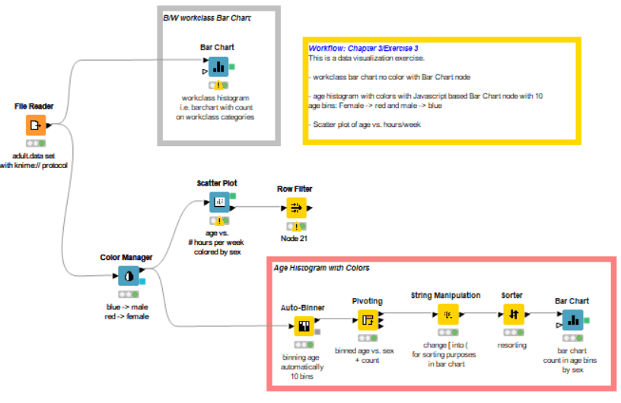
File reader node

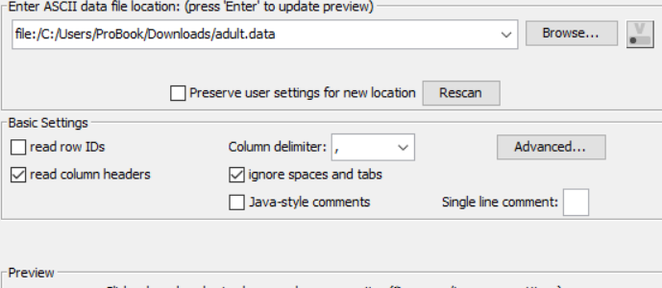
Bar Chart node
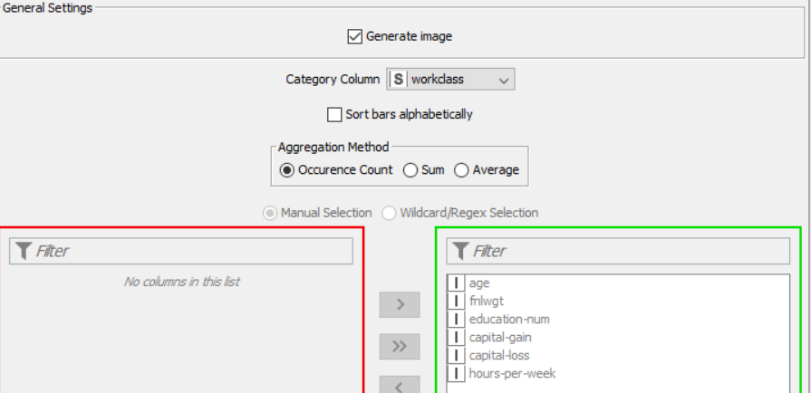

Select category column as ‘workclass’ and aggregation method as ‘occurrence count’. The result from the Bar Chart can be seen below:
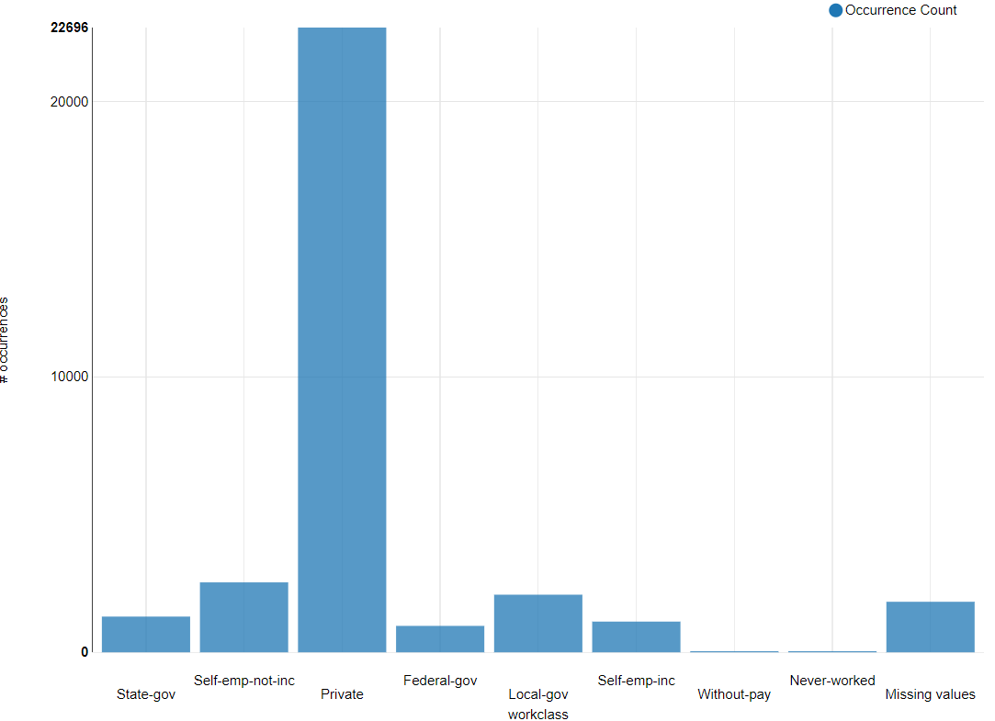

Color manger node
Select the column named ‘sex’ and choose the color for both genres as red and blue.
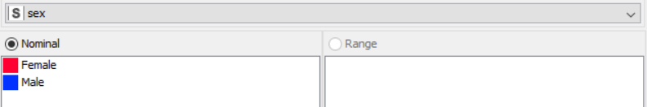
Scatter plot node
Choose column age for x axis and hours-per-week for y axis.
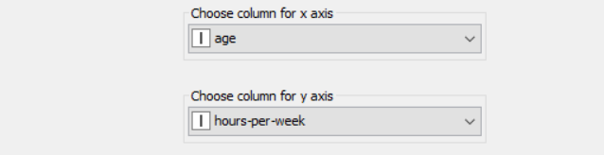

Scatter plot is given below.

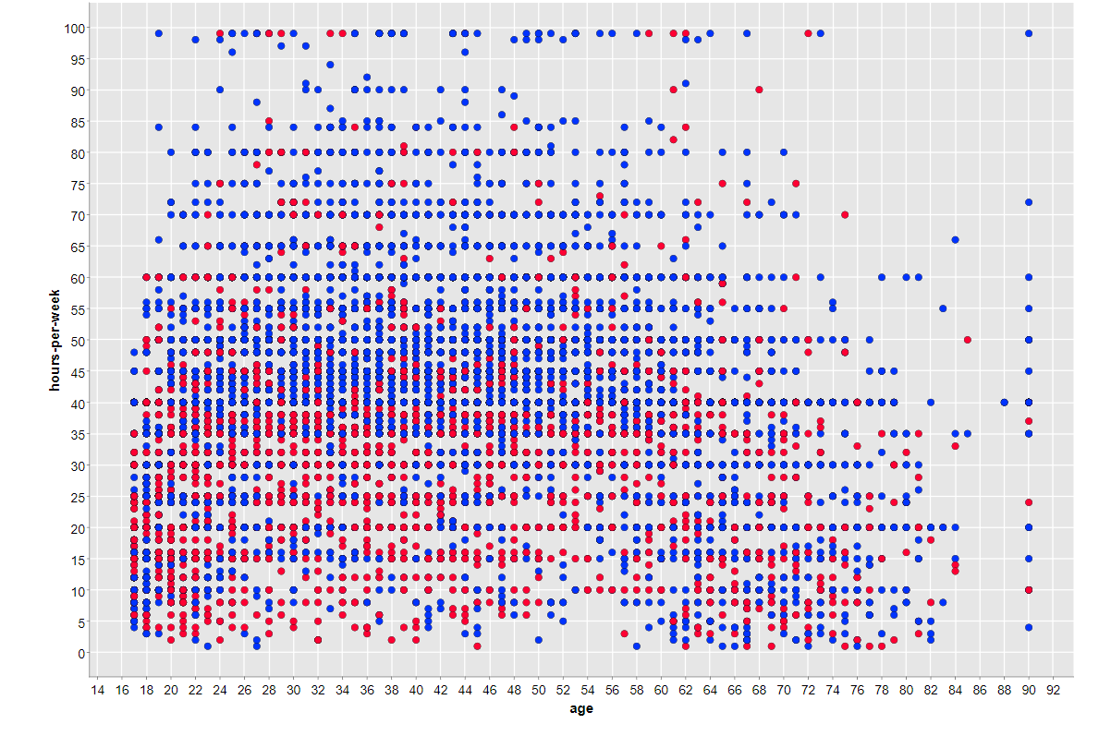

Row filter node
Select the column Selected (scatter plot) and the pattern matching type for true.
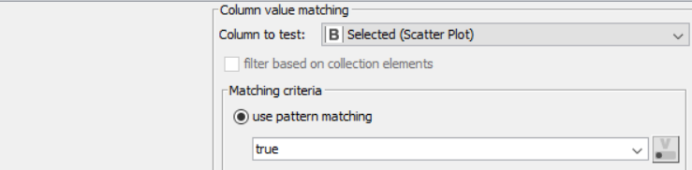
Auto binner node
Only select the age column, choose fixed number of bins option and type the number of bins as 10. Under bin naming select “borders”.

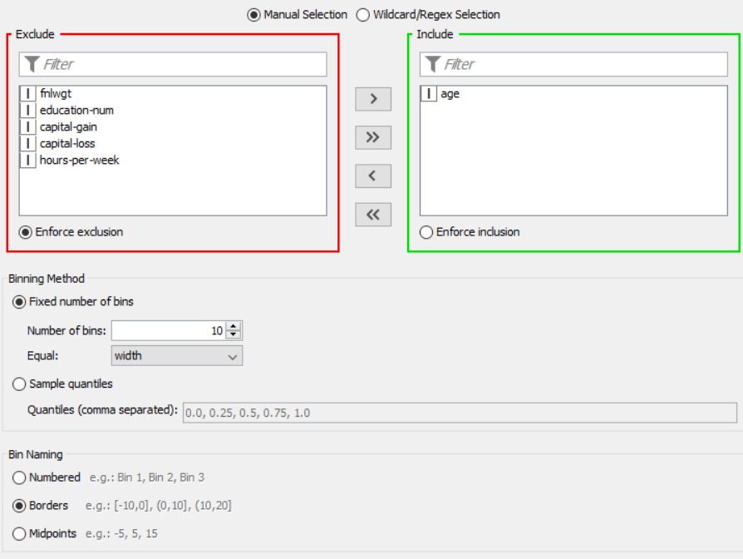

Pivoting node
Under the groups tab choose age, then under pivot tab choose sex column, under manual aggregation select “age” column.
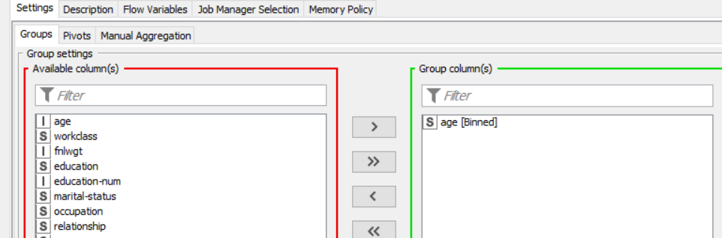
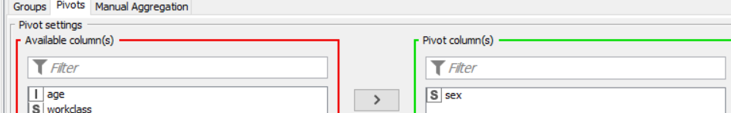

String manipulation

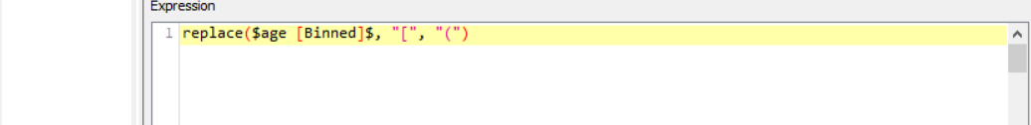

Sorter node
Click on add a rule and choose age [binned] as column and click on ascending.
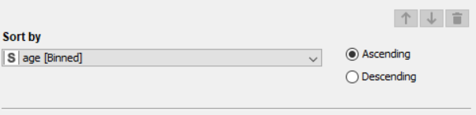

Bar chart node
Select the category column as age[binned], choose average as aggregation method and add column on the inclusion section.

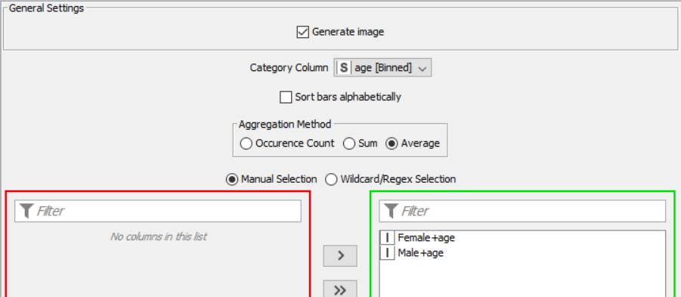

Workflow 6: Chapter 4 Exercise 1
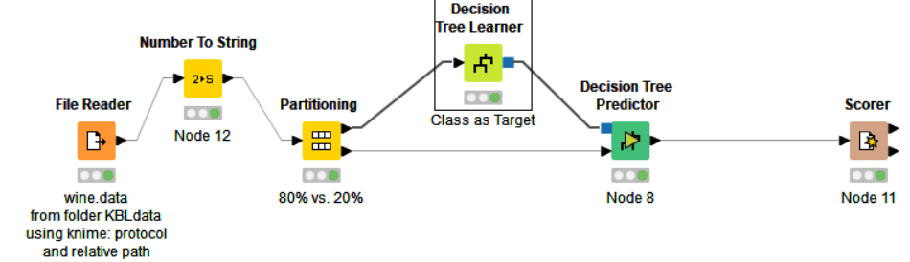

File reader node

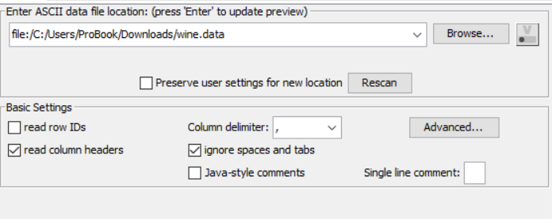
Number to string node
Convert the column class from integer to string by including it into number to string node.

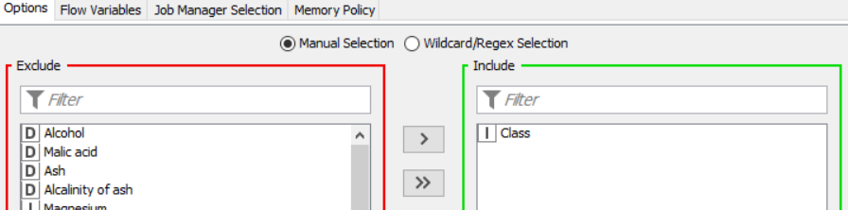

Partitioning node
Choose relative and type 80 in the field. Select Draw randomly and select ‘Use random seed option’.
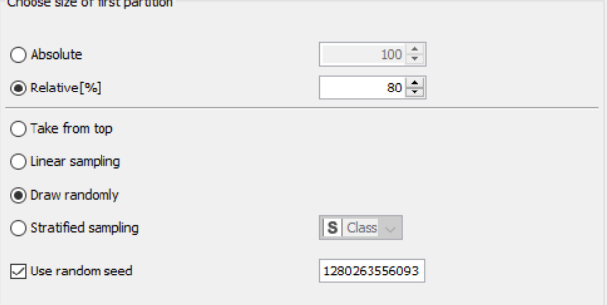

Decision tree learner node
This means no branch will be pruned. Rest of the settings are by default. This node will learn a decision tree model on the 80 percent training data.

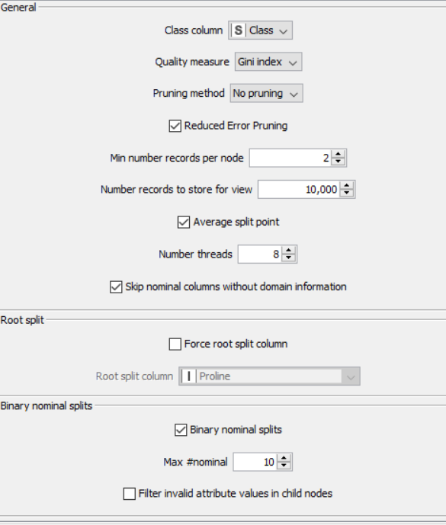

Decision tree predictor node
Connect PMML model from decision tree learner node and 20 percent test data from partitioned data from partitioning node.
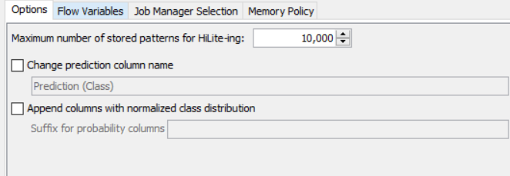

Scorer node
Connect decision tree predictor node’s output to scorer node and selection first column as class and second column as prediction class.
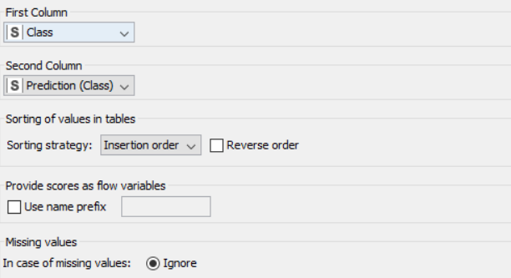

Workflow 7: Chapter 4 exercise 2

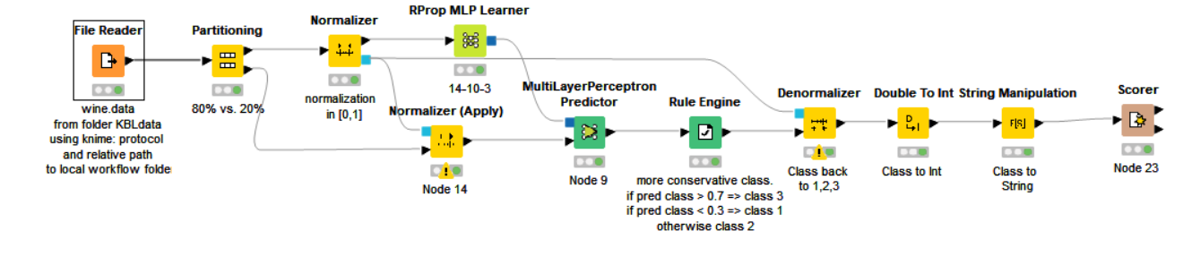

File reader node

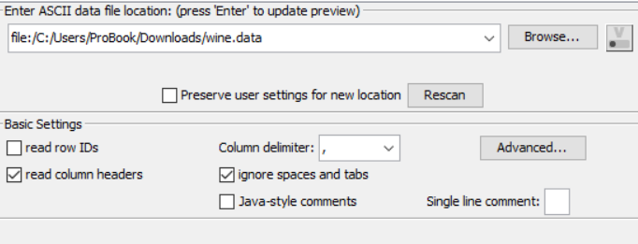

Partitioning node
Attach the output from File reader node to the Partitioning node. Create a partition of 80 percent by drawing samples randomly using the random seed value.

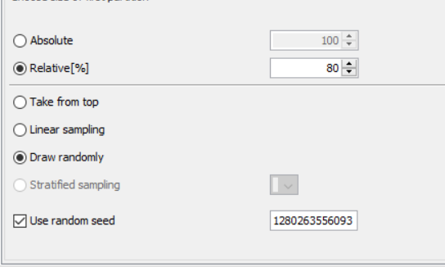

Normalizer node
Normalize all variable within 0.0 to 1.0 range using min-max normalization.
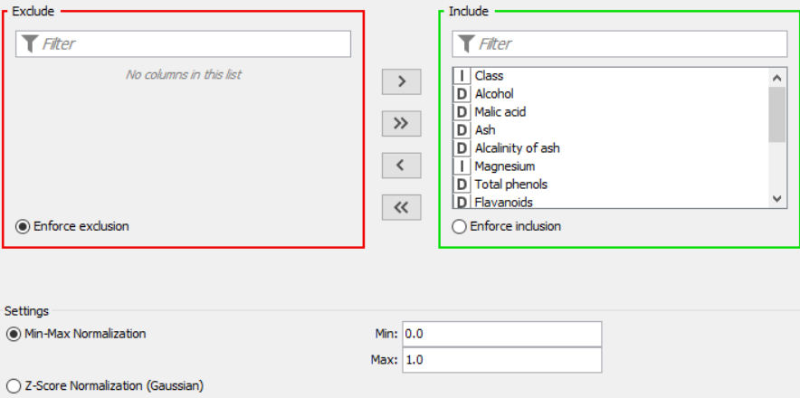

Rprop MLP learner
Output of normalization node is attached to Rprop MLP learner with 100 iterations, 1 hidden layer and 10 neurons per hidden layer.

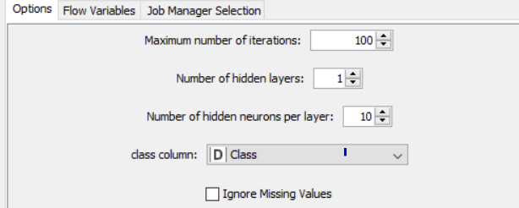

Multi-layer perceptron predictor
Output from Rprop MLP predictor node and normalization node it is sent to the Multi-layer perceptron Predictor node to make a prediction.
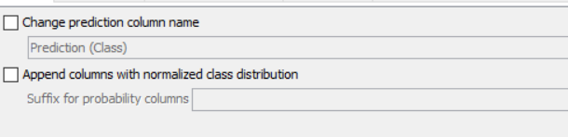

Rule Engine node
Rules are created to set the value of the class as 1 if is less than 0.3.
Value of 2, if prediction is between 0.3 and 0.7, or 3 if prediction is greater than 0.7.

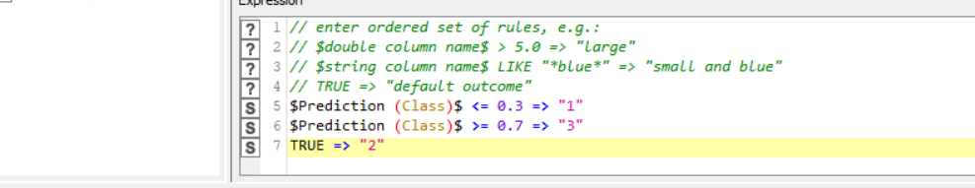

Denormalization node
Normalization model and output of Rule Engine node it is sent to Denormalization node.

Decimal to int
This node is used to convert decimal value to int. The class can be converted to int.
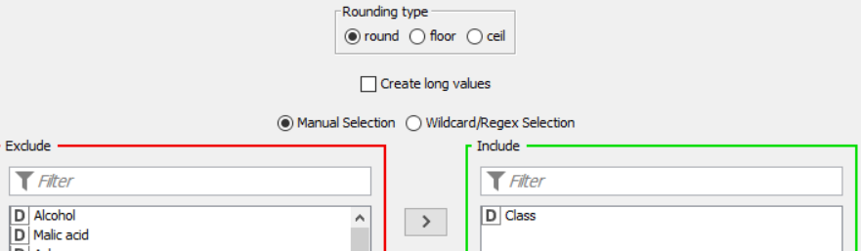

String manipulation
This node is used to convert class variable into string.
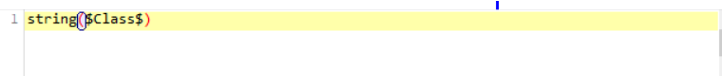

Scorer
Once we have the output from string manipulation node, the output can be formed from scorer node by choosing first column as class and second column as prediction.
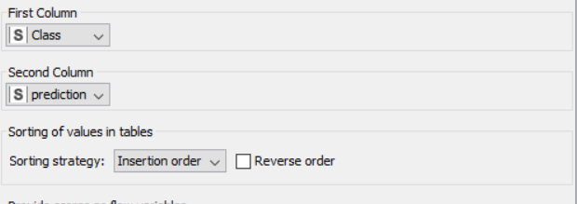

Workflow 8: Chapter 4 exercise 3
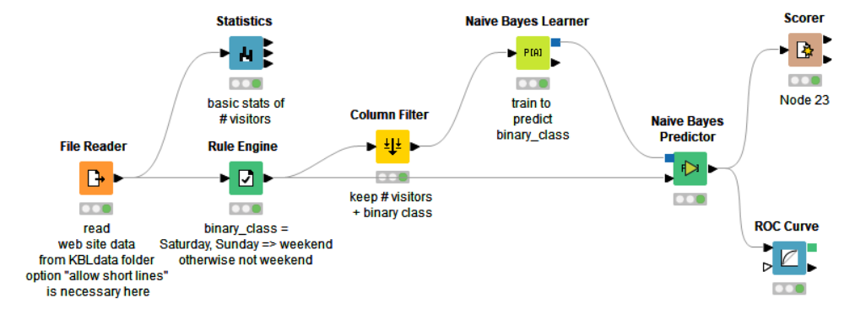

File reader node

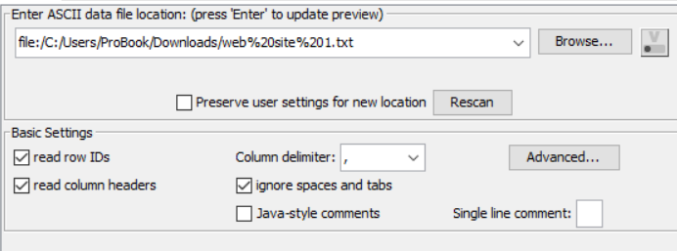

Rule Engine node
Insert the equation to set Saturday and Sunday as weekend and the rest not as weekend.
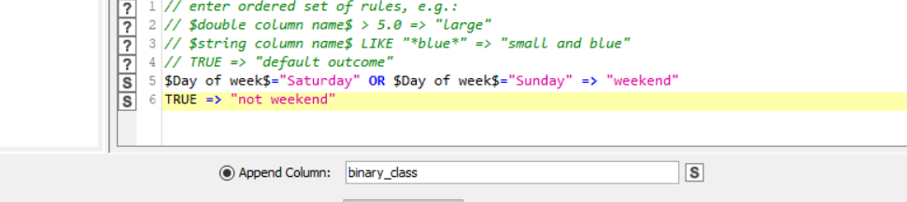

Statistics node

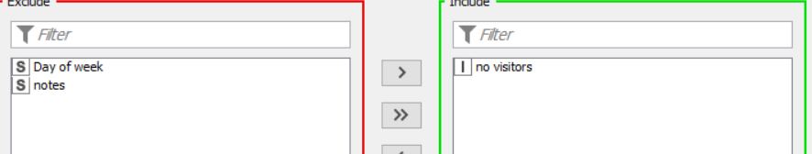

Column filter
Filter all columns other than binary class and no visitors in column filter node.
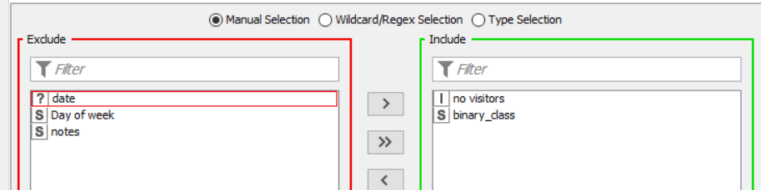
Naive bayes Learner node
Select ‘binary_class’ and classification column and set relevant values of other parameters.
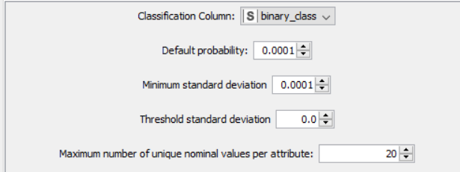

Naive bayes predictor node
This node is used to predict the class label according to the model trained in naive bayes learner node on ‘binary_class’ column.

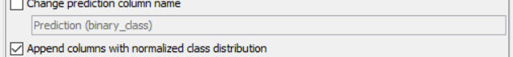

Roc Curve node
This Roc curve takes input form naive bayes predictor node and produce ROC curve on p(binary_class=weekend) to get the error rate.
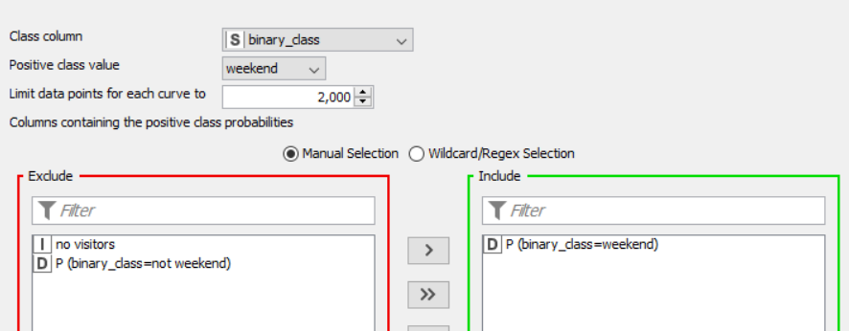

Scorer node
This scorer node gives the overall accuracy value from of the trained model on ‘binary_class’ attribute as first and prediction column as second.
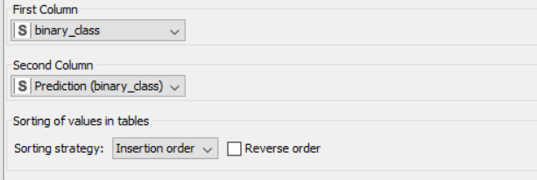

Workflow 9: Chapter 5 Exercise 1

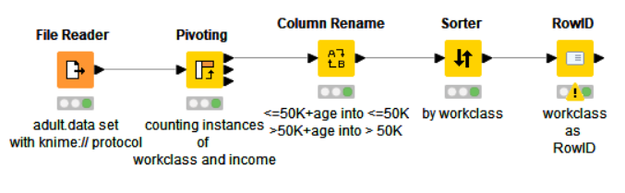

File Reader node

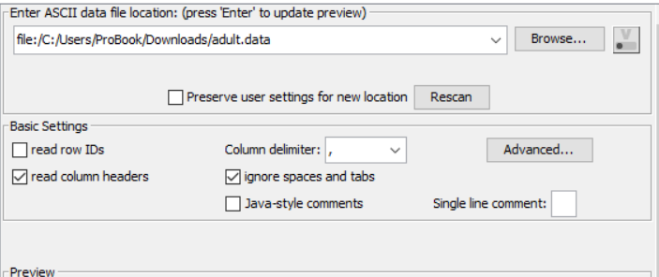

Pivoting Node
Select workclass as group column. Under pivot tab choose income column, under aggregation column count the occurrences of age column.

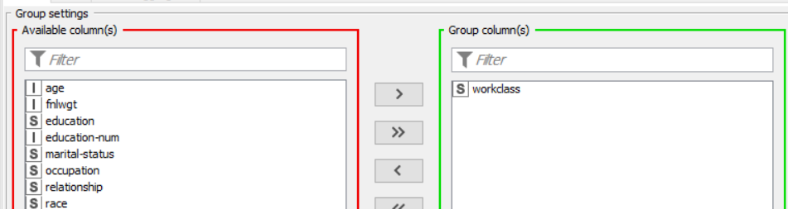

Columns rename node
Rename the column of each income category as specified in the image below.
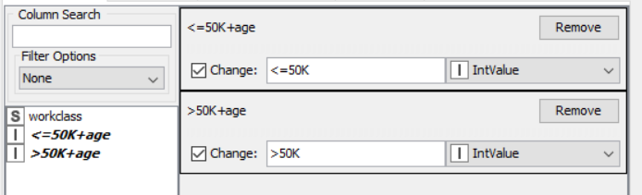

Sorter node
To sort pivot table based on workclass column use sorter column and specify ascending.
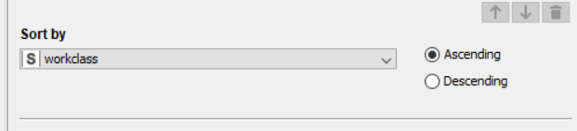

Row Id node
To make workclass as the primary key of the table, use Row ID node. Specify the column as workclass.
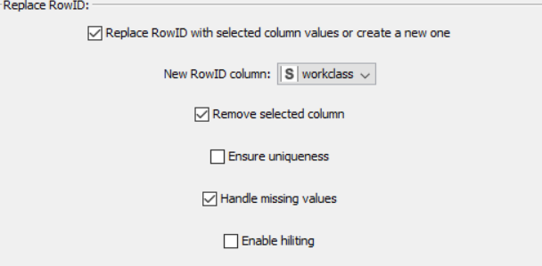

Workflow 10: Chapter 5 Exercise 2
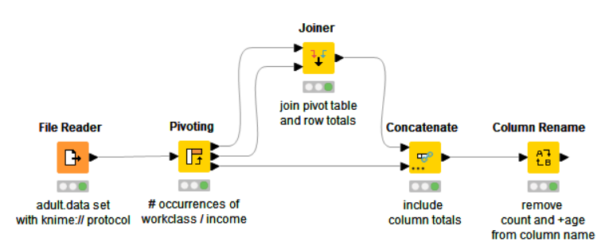

File Reader node

Pivoting Node
Select workclass as group column. Under pivot tab choose income column, under aggregation column count the occurrences of age column

Joiner node
This node is used to join the output of grouping on income bracket and the aggregated count of age column.

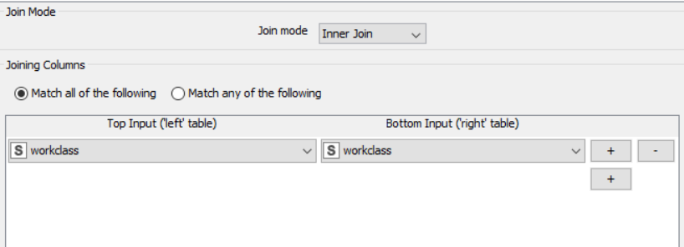
Concatenate Node
To add the sum of all these columns, concatenate the sum from pivot node to the output of joiner node using concatenate node.

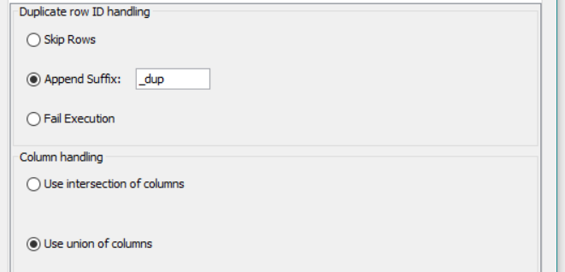

Columns rename
Change the name of columns using Column rename node. Select the column from the left-hand panel and change the name according to the requirement.
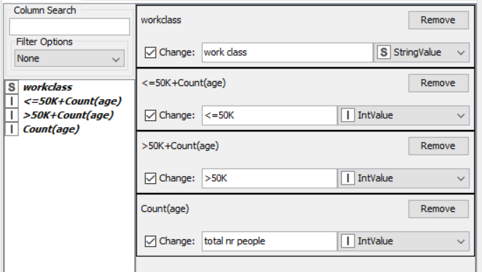

Workflow 11: Chapter 5 Exercise 3
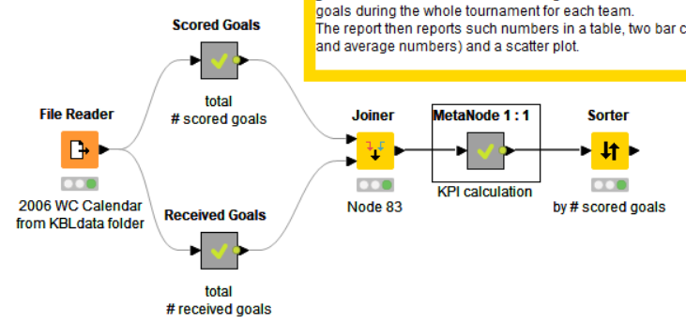

File reader node

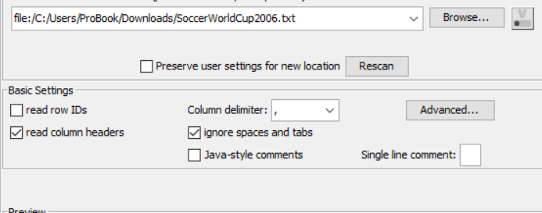
Scored Goal Meta Node
It is a combination of multiple nodes which ends up giving the total number of goals scored by each team in all the played matches.
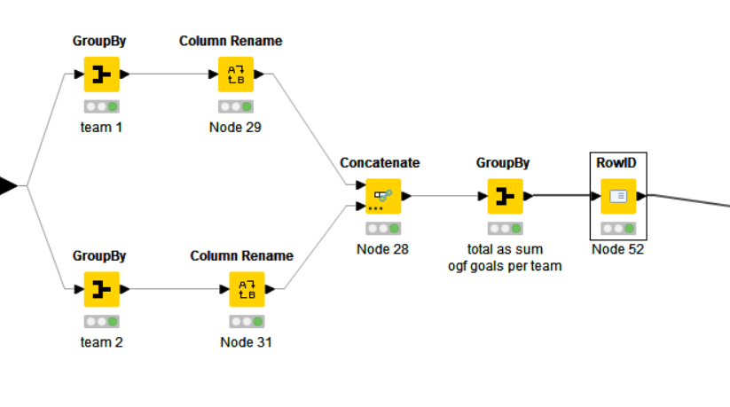
Received goals meta node
Works in a simpler manner as scored goal meta node, but instead is calculating the total number of goals for each team.

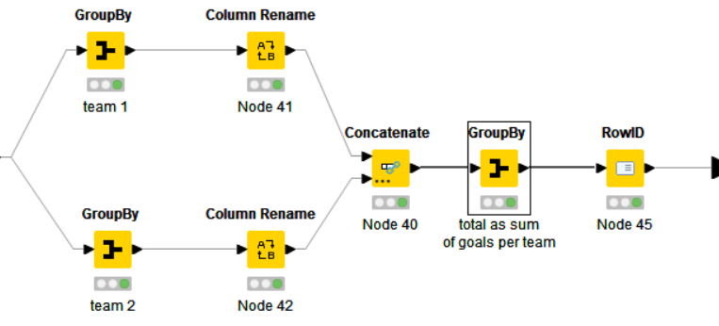

Joiner node
The output of the meta nodes is joined to produce the table.

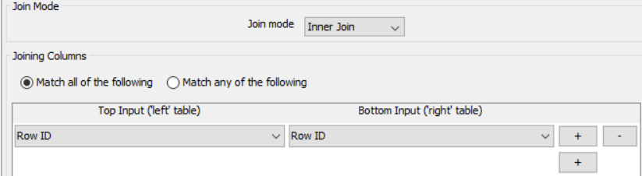

KPI calculation node
This node is used to calculate the average number of goals scored, the average number of goals received and to calculate a KPI.
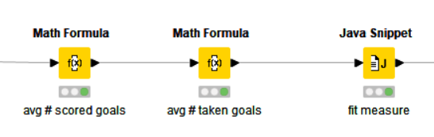
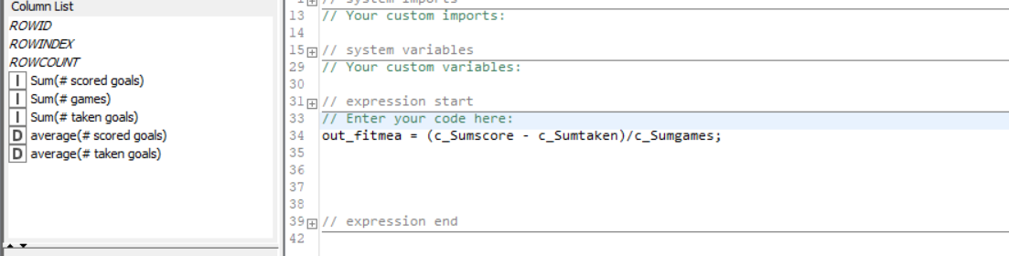

Sorted Node
At the end, the data is sorted according the number of goals scored by each team in a descending order.
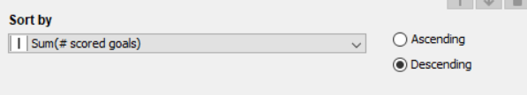

Workflow 12: Chapter 6 Exercise 1

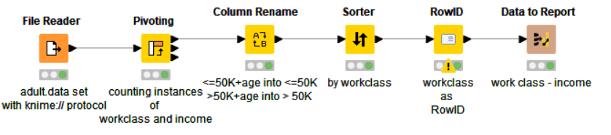
The current workflow is similar with the one from Workflow 9: Chapter 5 exercise 1.

Data to report node
This node is used to export the image of the input data. In this case the output from Row Id is exported as a ‘png’ file.
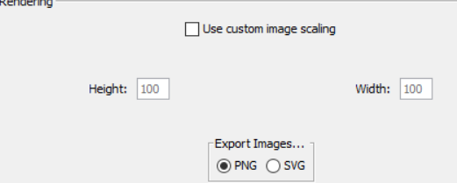

Knime - Advanced Luck
Workflow 13: Chapter 2 Exercise 1
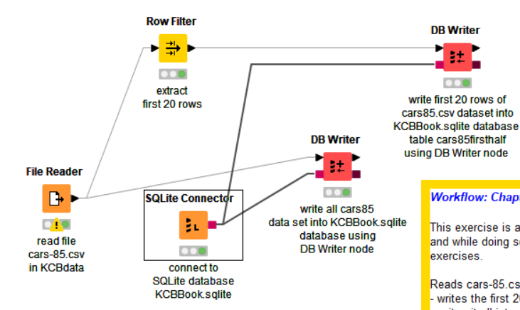
File Reader node
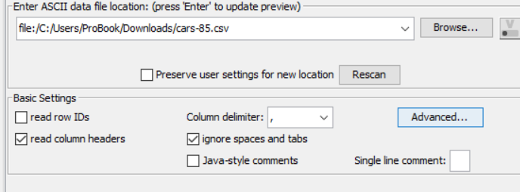

SQLite connector node
Connect with the required SQL database using SQLite connector node.

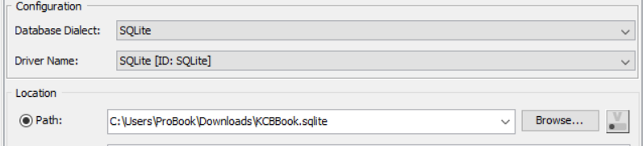

Row Filter node
Select option to include the rows by number from the left-hand section.
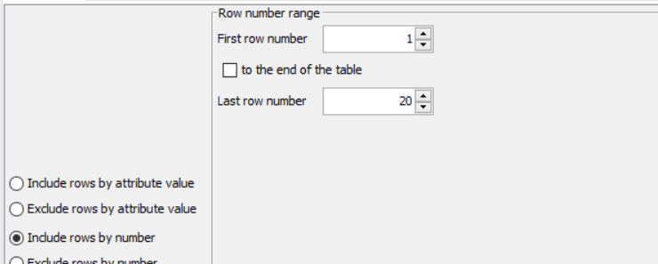

DB Writer Node
Select the relevant table from the DB writer node.

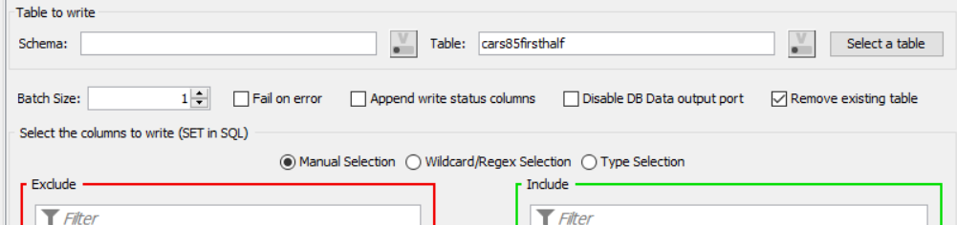
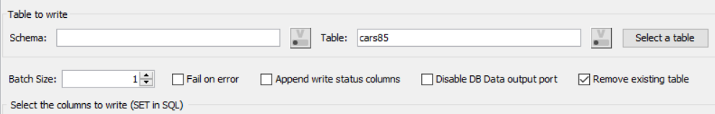

Workflow 14: Chapter 2 Exercise 2

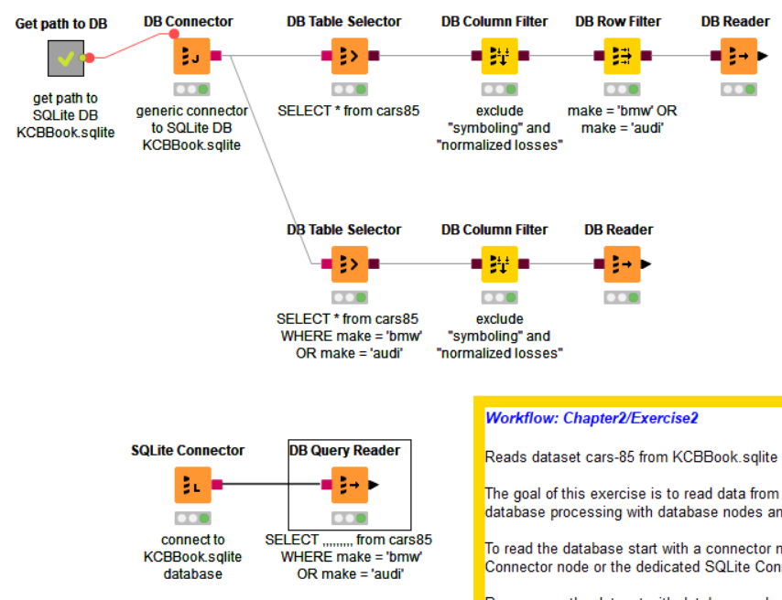

Get path to DB node
List files node is used to get all files inside the folder. Using Table row to variable node, convert row’s data as variables.
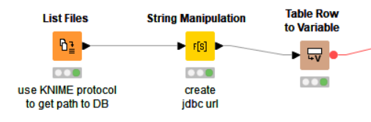

DB connector node
This time instead of explicitly mentioning the URL of database we are getting the URL from a flow variable which is referred to the URL path of DB connector node.
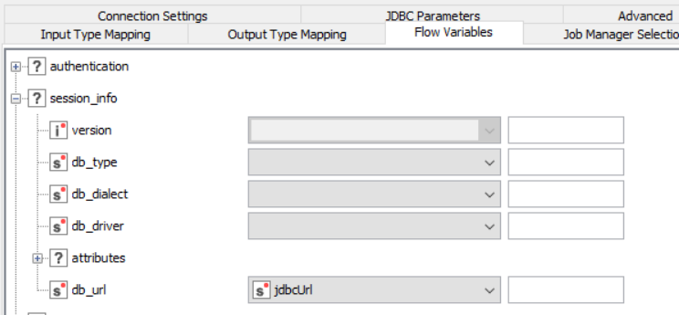

DB table selector
Using this node, we select the relevant table.
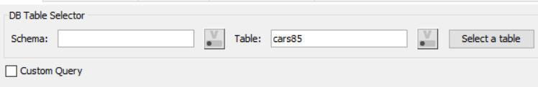

DB column filter
Using this filter, the required columns from DB table.
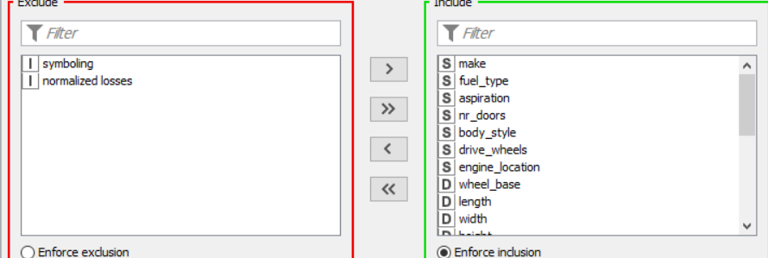

DB row filter
Use DB row filter and specify the condition.
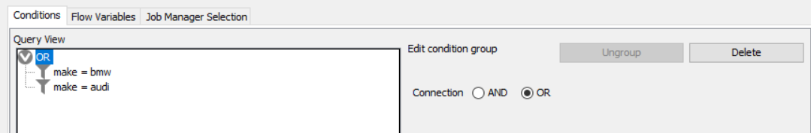

Row filtering can also be done by reading the table from the database.
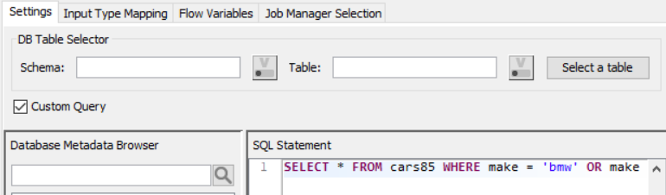

DB reader node
It is used to convert DB table into a Knime table.

DB query node
This node makes life easy by allowing to quote the whole query and then retrieving data from the database.

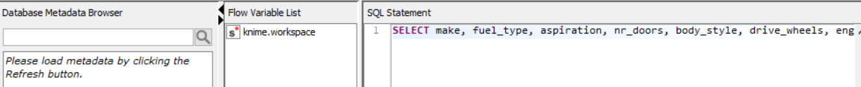

Workflow 15: Chapter 2 Exercise 3
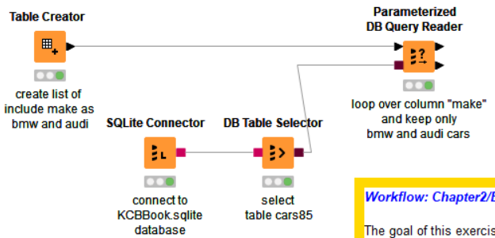

Table Creator
Create a table with 2 rows Audi and BMW.
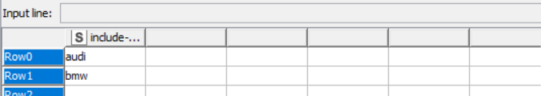

SQLite Connector
Insert the path of the SQL database into the node.
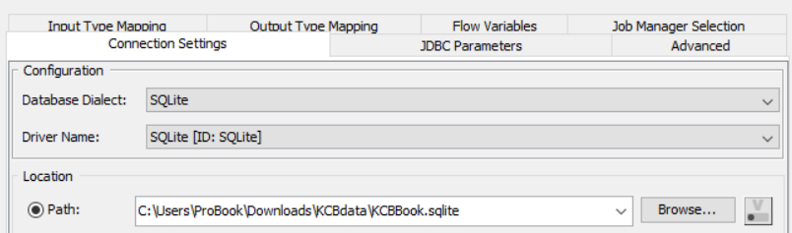

DB table selector
Select the table of required from the Database.
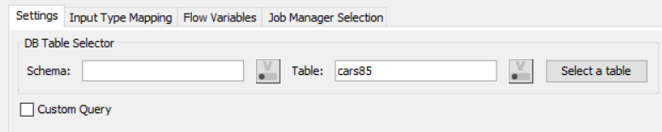

Parameterized DB query Reader

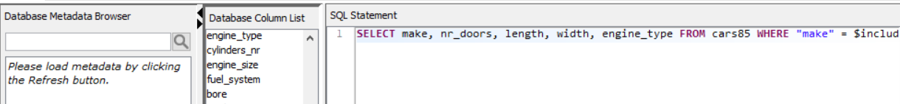

Workflow 16: Chapter 3 Exercise 1

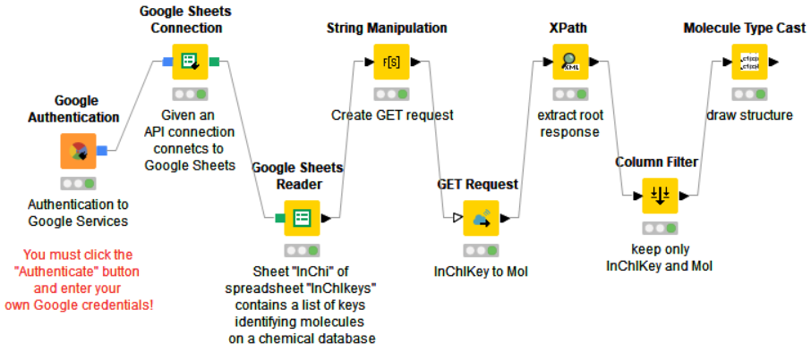

Google Authentication
Enable connection between Google drive and Knime using Google authentication.
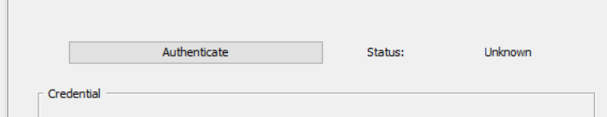
Google Sheets Connector
Google sheet connector allow us to connect to all the sheets that are on the drive.

Google sheets reader
This node allows us to read a specific spread sheet from the drive.
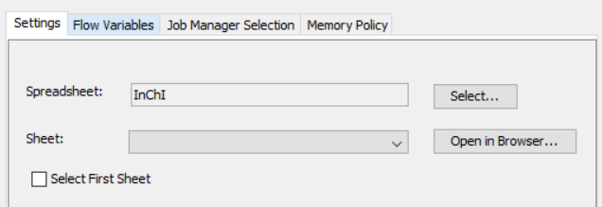

String manipulation
Append the data from the spread sheet to make it a URL that can be further requested.

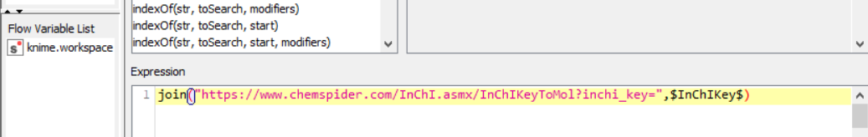

Get request node
This node allows to connect and extract data from any URL. URLs created from string manipulation node are requested using ‘get’ method and XML of each node.

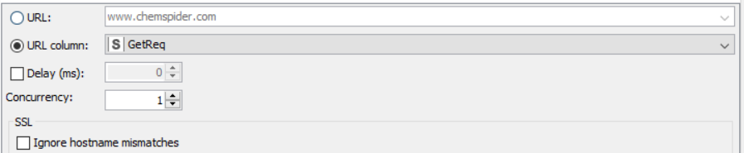

Xpath node
Xpath node allow to extract any element from a HTML page’s XML.
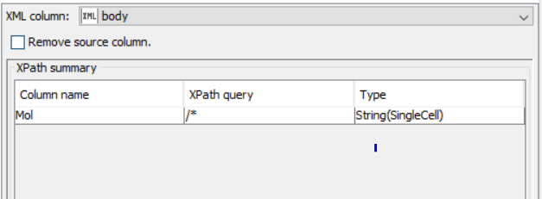

Column Filter node
This node will filter all irrelevant columns and forward only the columns that are necessary.
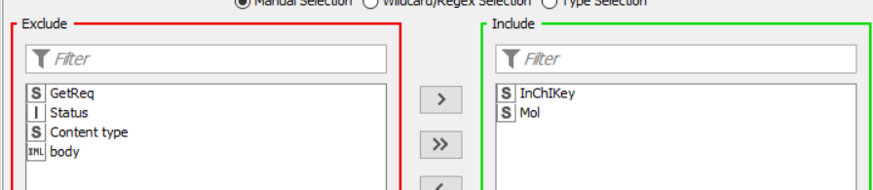

Molecule Type cast
This type casting allows to convert a string column into a column of molecule type, so that it can be readable easily.

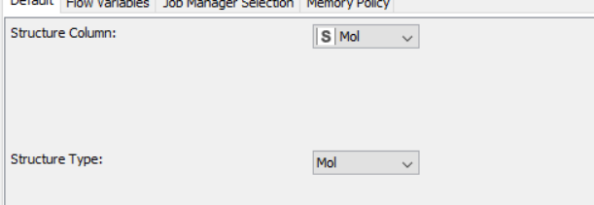

Workflow 17: Chapter 4 Exercise 1
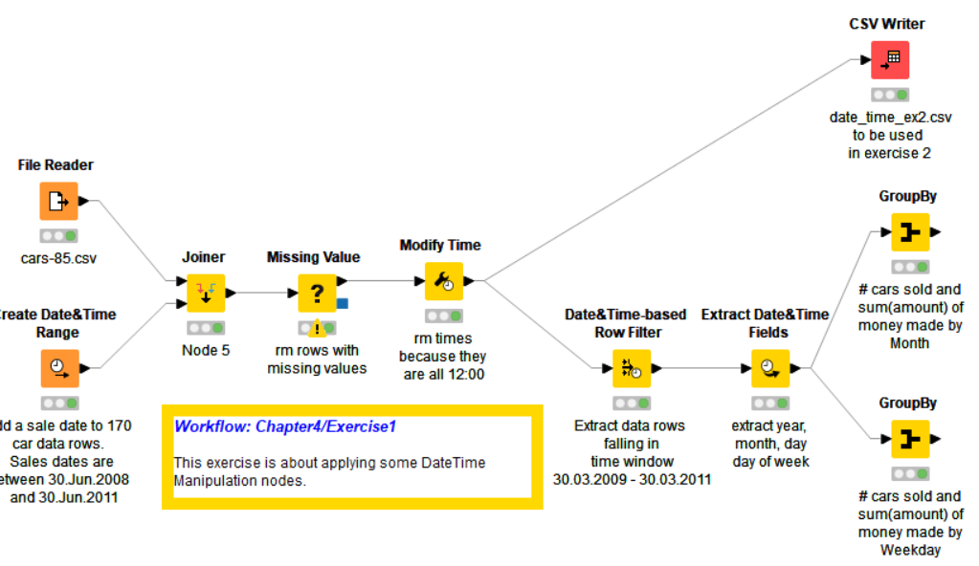

Create Date and time range node
This node is used to create Random date and time data starting from and ending at a specific date and time.
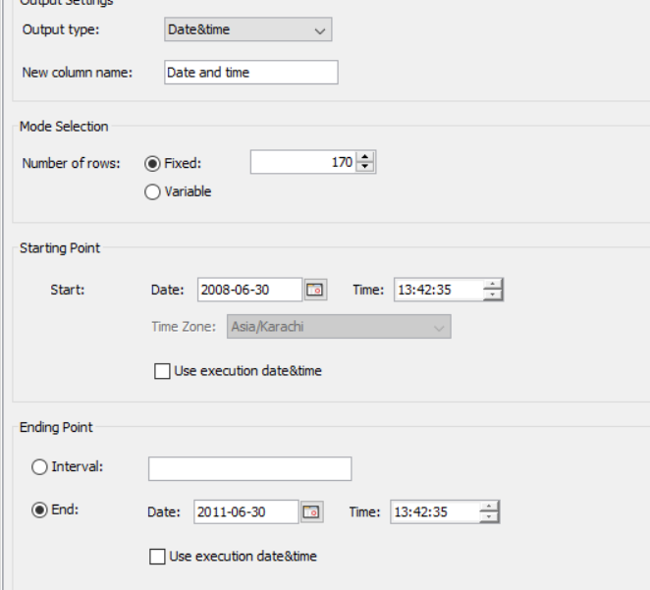
Joiner node
Join both Date and timetable and File reader table using a left outer join, meaning all the data from file reader node will be included after the join.
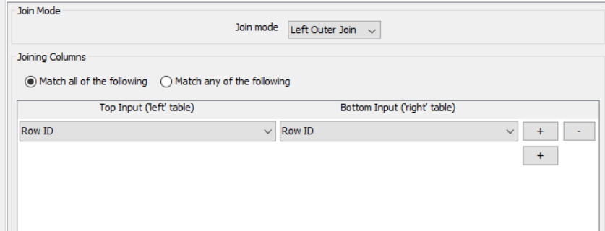

Missing value
Using this node, we are removing all the rows that have missing value for date and time column.
Whenever missing value is encountered remove that row.
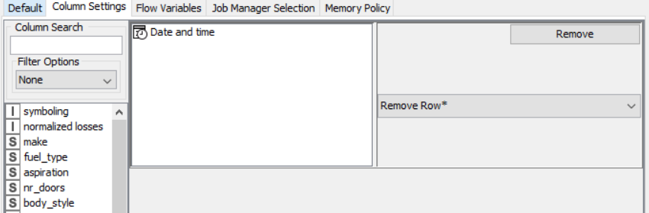

Modify Date
This node is used to remove the time from the date and time column leaving only date behind.
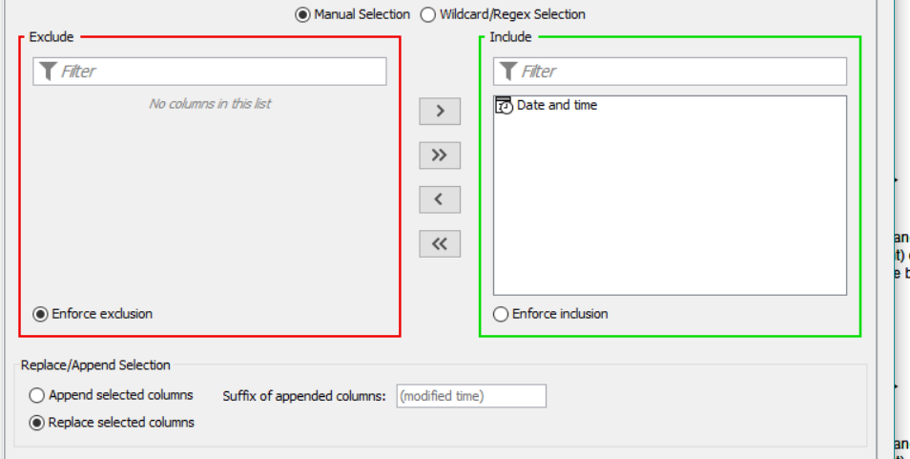

CSV Writer
Specify the path where you want to save the file.

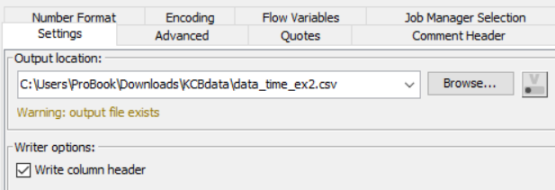

Date and time - Row Filter
To filter rows based on the date column.
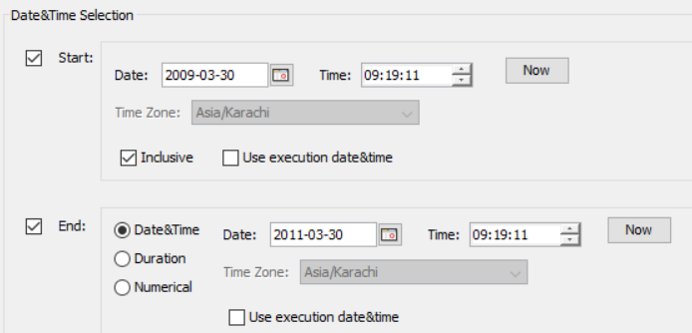

Extract date and time fields
In this case, extract the year, the month, the date, and day from the date and time column.
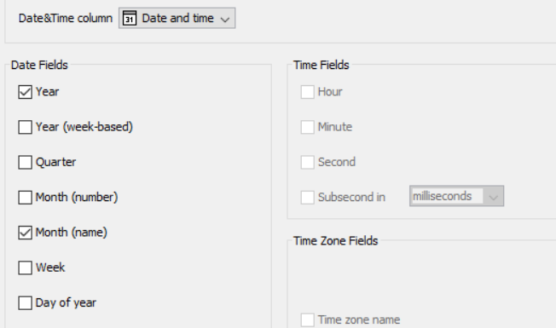

Group by
This node gives the aggregation of number of cars sold based on the month, the day and the price.

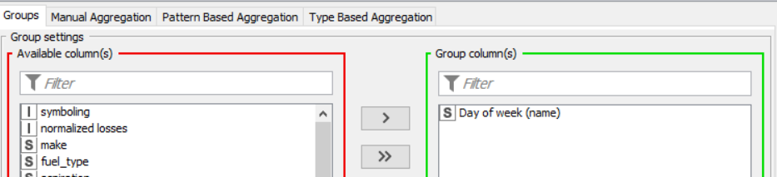

Workflow 18: Chapter 4 Exercise 3

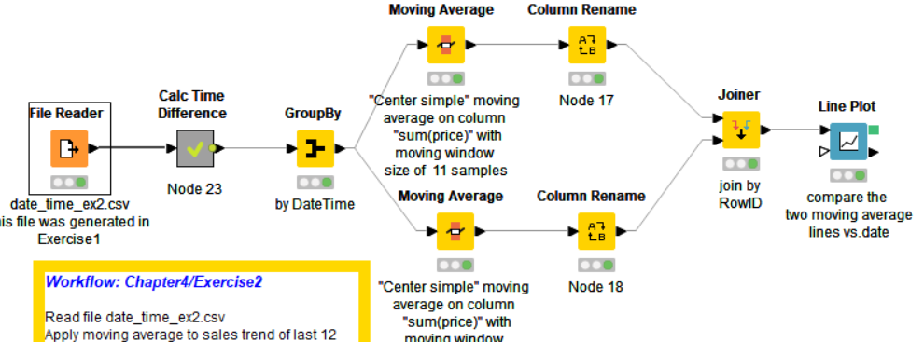

Calculate Time difference
This meta node is used to filter and keep data earlier then 12 months from the current date.

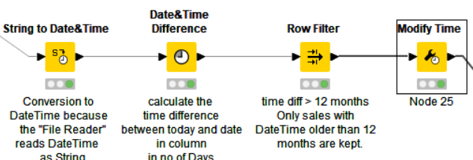

Group by node
It is used to show the sum of prices for all the cars sold each day.

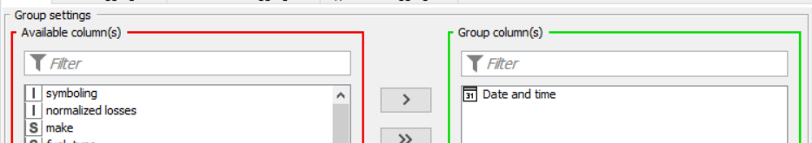

Moving average
This node is used to calculate moving average with reference to the number of samples specified.

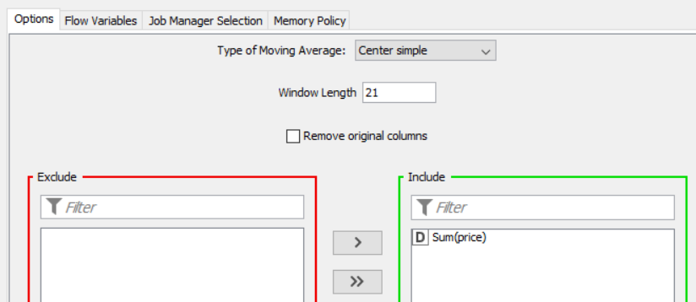

Columns rename
Rename the moving average column to 11 and 21 based upon the number of samples used.
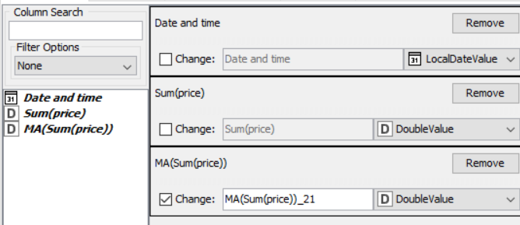

Joiner node
Join data from both the tables 11 and 21 moving average, so that it can be compared later in line plot.
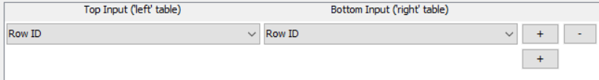

Line plot node
Create a line plot on the moving average values and compare the result.
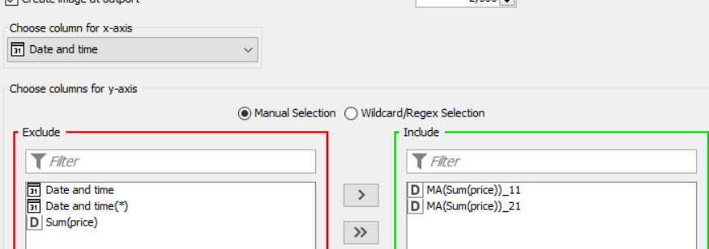

Workflow 19: Chapter 5 Exercise 1

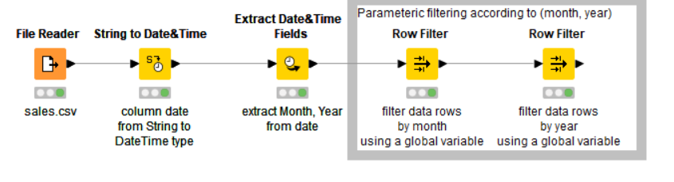

String to Date and time node
Convert the date field into date and time.
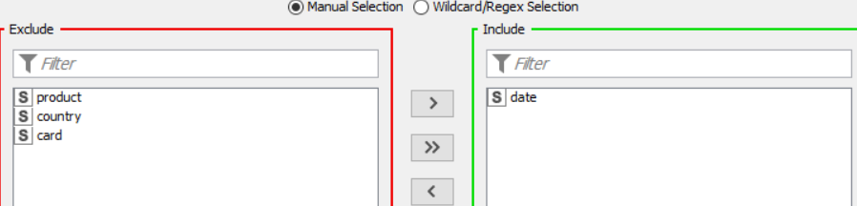

Extract date and time fields
Extract Year and month from date and time field using Extract date and time fields node.

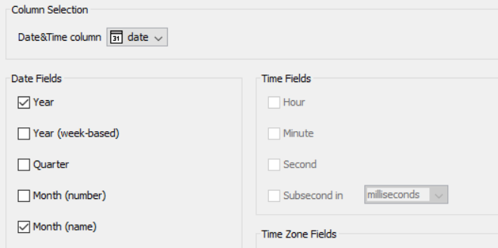

Row filter
To filter the rows that has month as March and year as 2010.

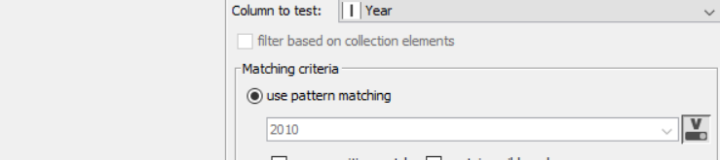
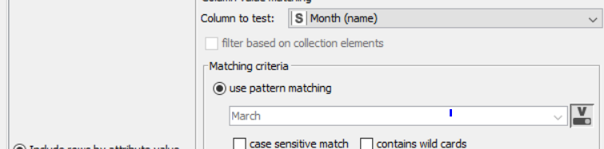

Workflow 20: Chapter 5 Exercise 2

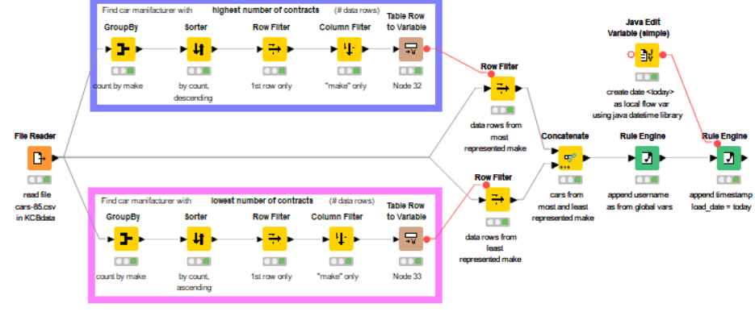

Group by node

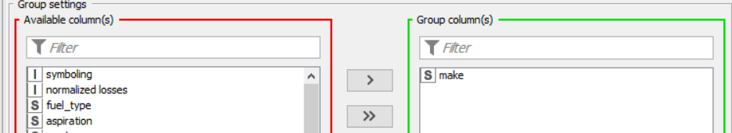
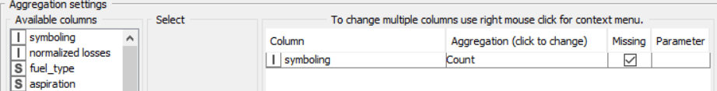

Sorter node
Arrange the data column count(symboling) in to ascending to get the lowest number of contract and descending to get the highest number of contracts.
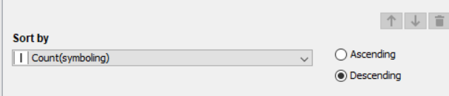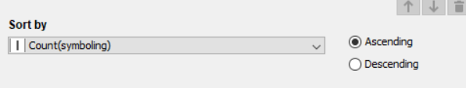
Row filter
Using row filter node to get the first row of the data table for both the tables.
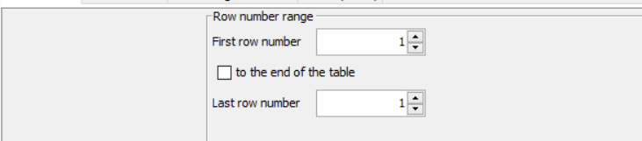

Column filter

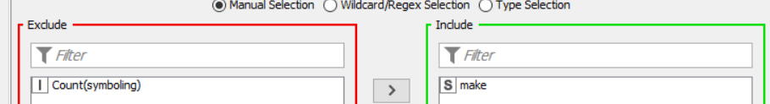

Table row to variable
Using this node, convert the rows of each column into variable, so that they be used in the later stages.
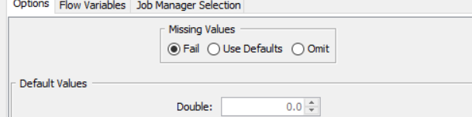

Row filter
Data processed in the Table row is passed to Row filter node and using flow variables to set as use pattern matching field in row filter.
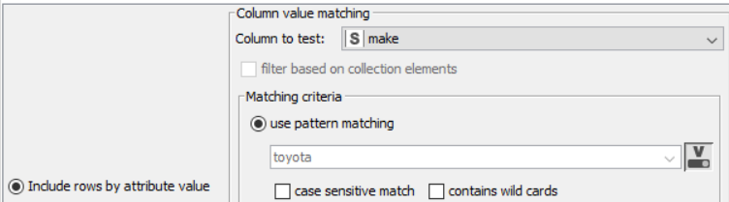

Concatenate node
To merge the data of both highest and lowest car makers, use concatenate node.
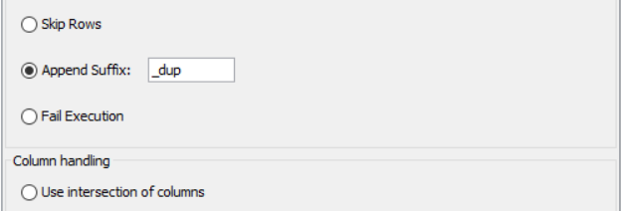

Rule engine node
Use rule engine node to add a new column with ‘my_name’ as the value for each row.
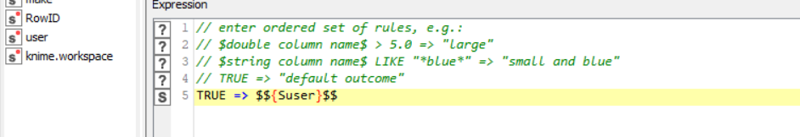

Java variable node
Use java variable node to create a new variable with current date as value.
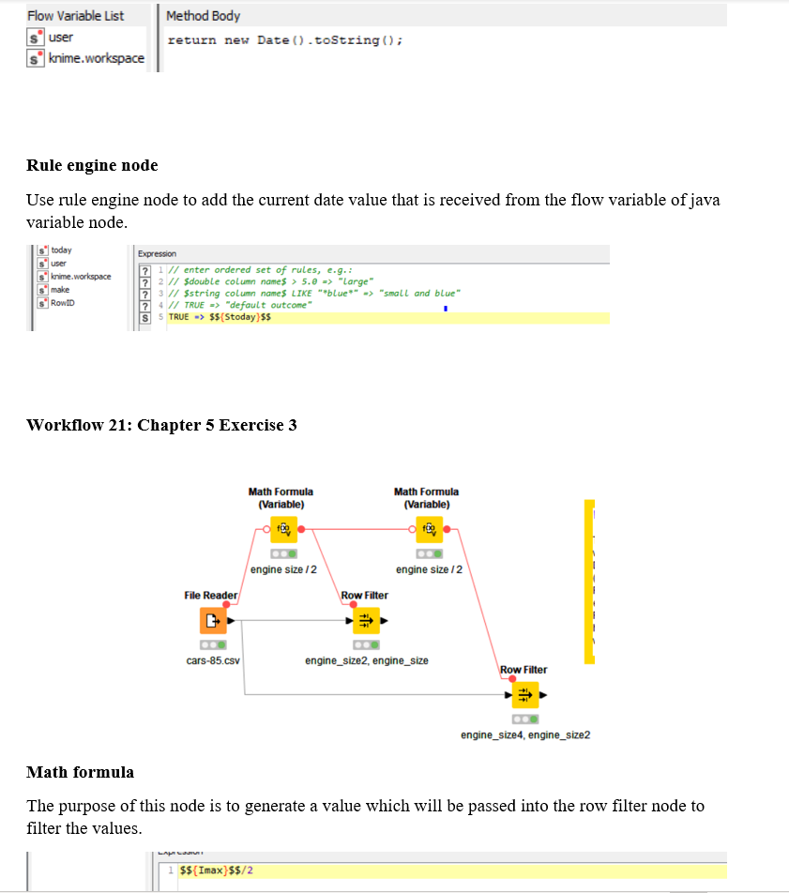

Row filter node
This row filter node is used to filter the rows based on the lower and upper bound value.
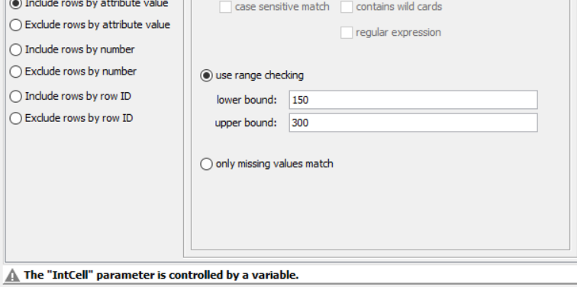

Workflow 22: Chapter 5 Exercise 4

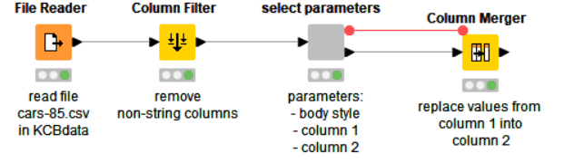
Column filter node
The Column filter node was used to filter the column as a string.
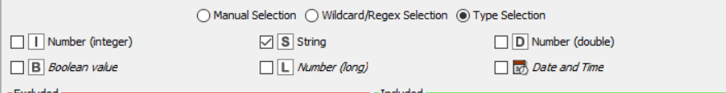

Select parameter node
Used to select the body type and the columns to process further.

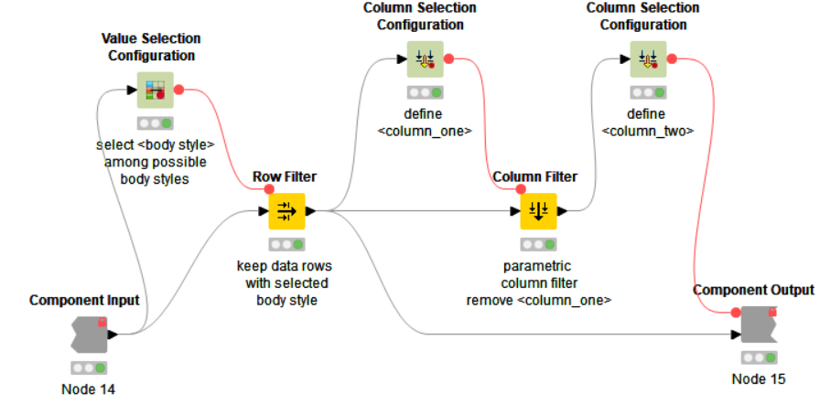

Once the component is opened, the first node that was used is the value selection configuration
node.

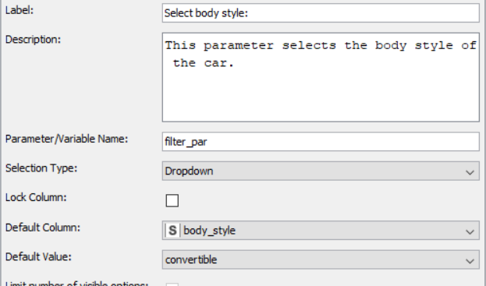

This node gives label to the component followed by Default column and default value of that column.
Using ‘flow variables’, the convertible value of body style is forwarded to the row filter node.
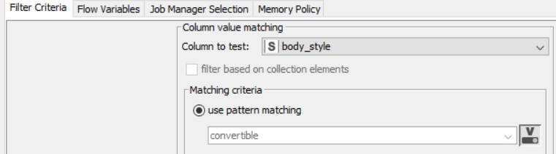
Next using column selection configuration node, choose label as column 1 and default value of Dropdown.

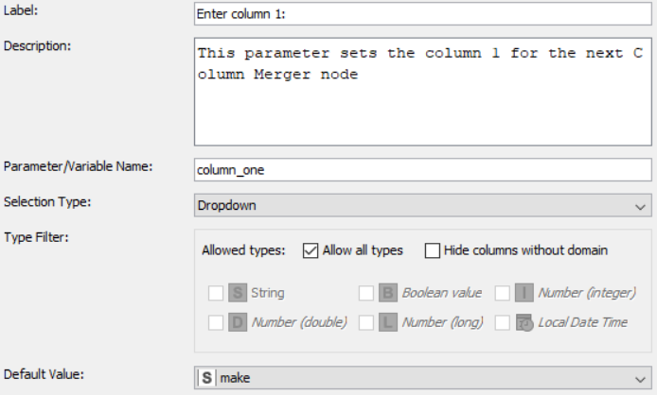

Next with column filter node filter all the columns except the ‘aspiration’.

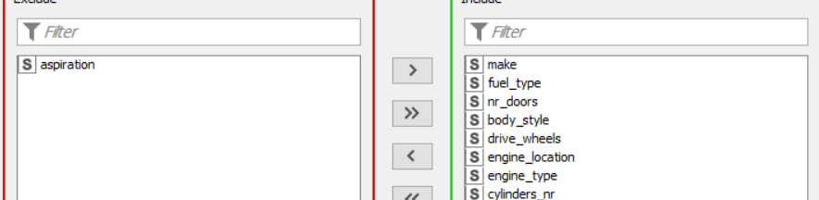

Using Column selection configuration, create a new column and choose the default value.

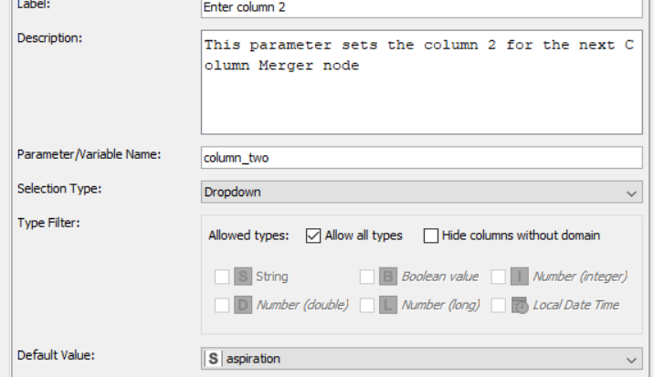

Column merger
Merge the data from both the columns 1 and column 2, using this node.



