

Assessment 1 – Reading Task Template
PART 1: Upload your photo of your A3 in-class notes here:
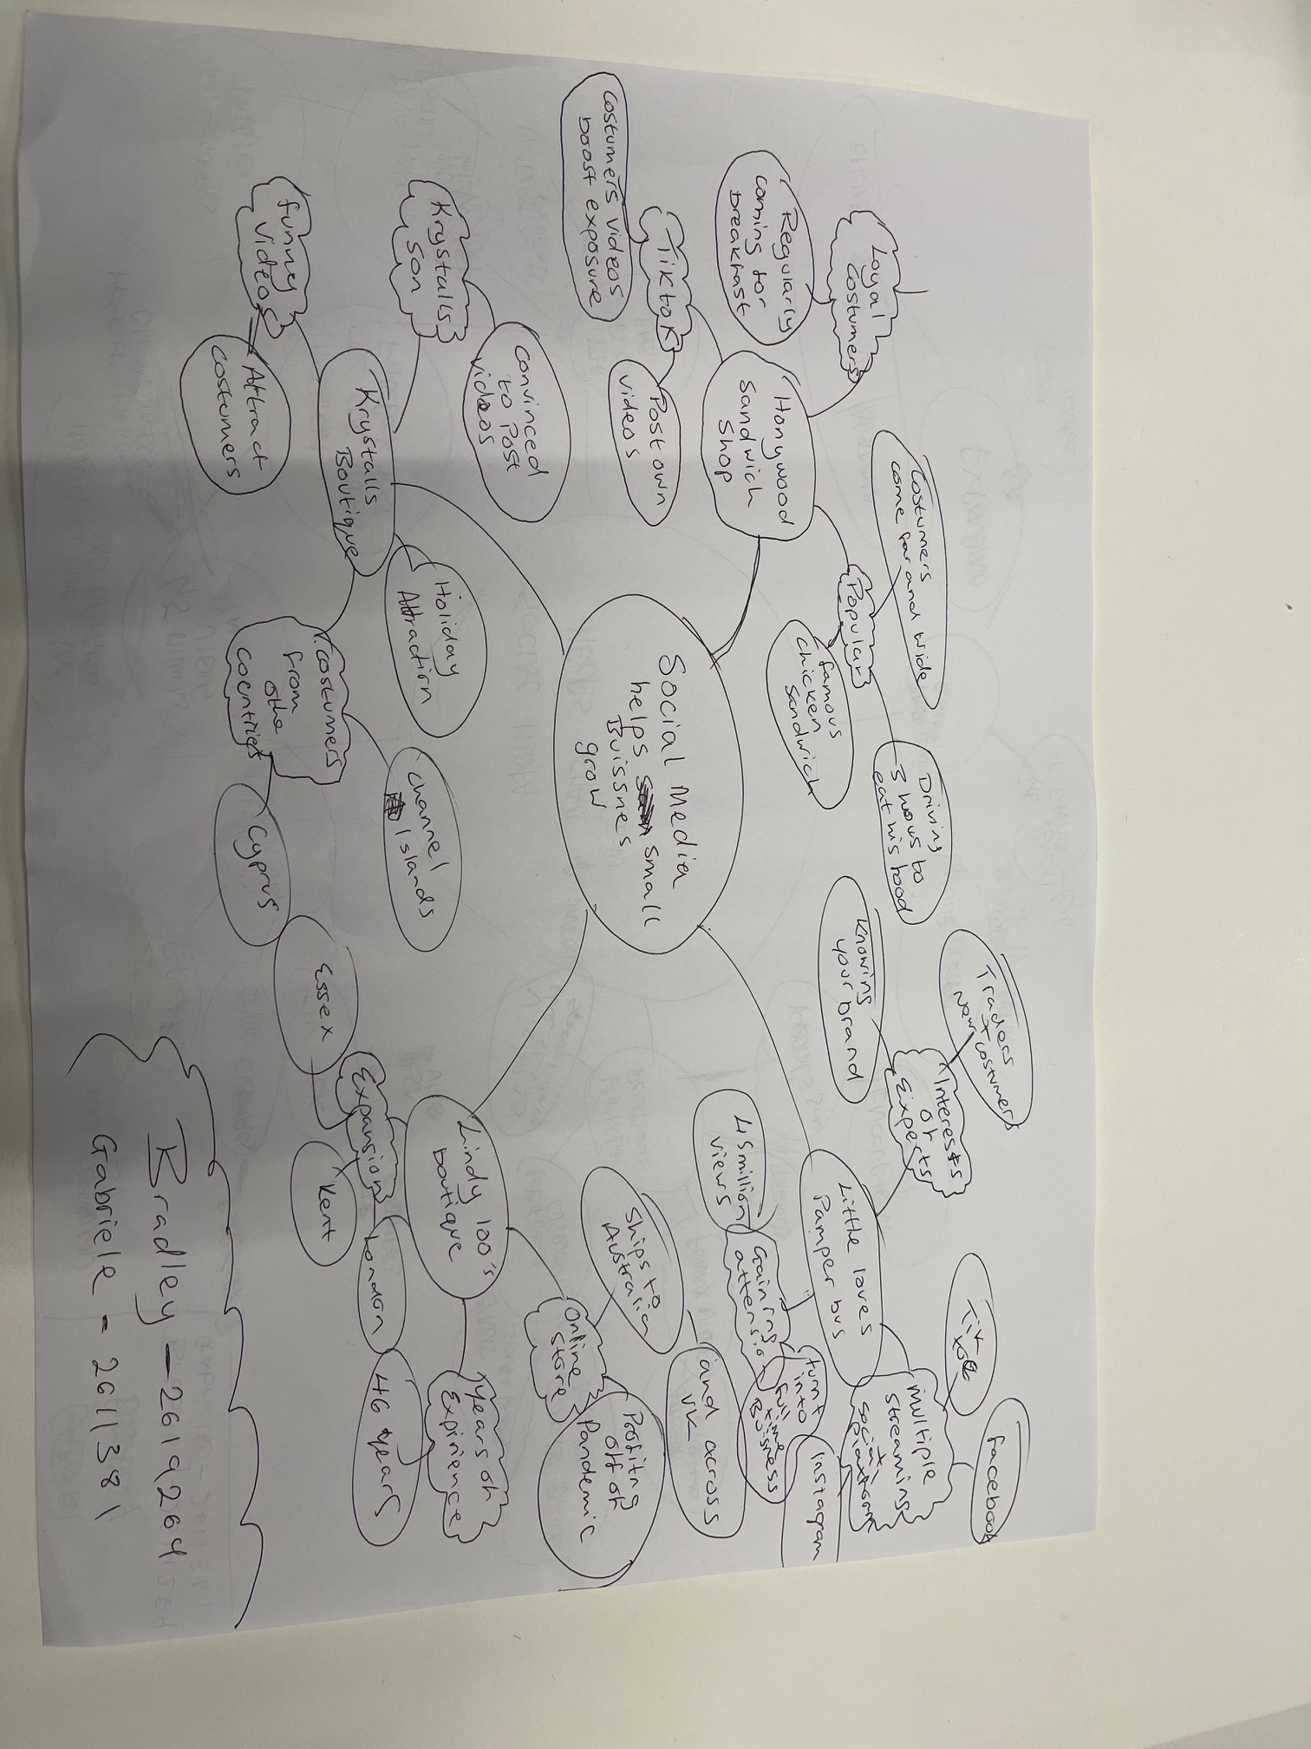

PART 2:
- Answer every question below in 1-3 full sentences.
- Use your own words. Do not use generative AI to answer these questions.
- Include a specific detail from the text when asked.
REMINDER
- The main idea is the overall message of the whole text.
- A key point helps to explain the main idea.
- A specific detail or example from the text shows that the key point is true.

- What is the main idea of the whole text?

The main idea of the text is that social can help small business grow their
exposure.

- What is one key point that supports the main idea, and which specific example from the text shows this?

Regular customer support help improves the business when they post on their personal social media’s I’ve gathered this information from the following statement “it is the content posted by its costumers that has boosted its bottom line

- What is a different key point that supports the main idea, and which specific example from the text shows this?

Families’ knowledge of social media helps convince small business owners to post videos and pictures. Ive come to this conclusion from Krystals boutique when her son convinced her to promote her business on social media.

- Which part of the text do you think is most important, and why?

I believe the most important part of this text is the fact the growth of social media from small businesses can impact how customers see the business and promote the service they offer the reason why I see this as the most Important is because it’s mentioned throughout the entire article that social media has helped each business in different ways.

Reflection:
- What did you find difficult in this task (including in-class components), and why was it difficult?

Understanding the difference between the keys points and the main idea is the most difficult thing I had to overcome when taking on this task. Why I found this difficult is because identifying the main idea out of an entire article while overlooking key points takes time and patience is myself.

- What helped you with this difficulty, and how did it help you?

Skimming the article rather than just reading the article helped a lot and I found it a easier to come back to the key points after giving the article a quick read rather than studying the article thoroughly.

